Software Corp
ParkHere
Software Requirements Specification

by Temi Ilori

CIS 4374, Information Systems Project Management
Section 19148, Fall 2026
Instructor: Otto Dobretsberger
University of Houston
September 17, 2026

Table of Contents

1. Introduction

1.1 Purpose
This document describes the requirements for ParkHere, a mobile application being developed by Software Corp. This document establishes the problem, the competitive landscape, the product concept, and who the product is for.
1.2 Product Scope
ParkHere helps drivers in downtown Houston find, reserve, and pay for parking in real time, and it compares prices across providers so the driver can see the cheapest available option in one place. A companion admin dashboard gives parking facility operators visibility into occupancy, revenue, and demand patterns.

1.3 Definitions and Abbreviations
- SRS. Software Requirements Specification, this document.
- On-street parking. Metered spaces along a public street, managed in Houston by the ParkHouston program.
- Off-street parking. Privately or municipally operated garages and surface lots.
- Operator. The business that owns or manages a garage or lot.
- Closed network. A parking app that only displays inventory from operators it has signed agreements with.

2. Vision and Scope

2.1 How this project was acquired
This project originated inside Software Corp rather than arriving as a client request. In early 2026 the company was doing discovery work with two independent garage operators in the downtown area and in conversations with the operators, they raised the same complaint without being asked. They were sitting at partial occupancy on weekdays while drivers circled the same blocks looking for spaces, and they had no way to reach those drivers because the reservation apps they were listed on showed only a fraction of the market.
Software Corp ran an informal review of the parking applications serving downtown Houston to test whether that gap was real. It was, and no existing product was closing it. The company elected to fund the work internally as its own product rather than as contract work, so that the platform can list any operator rather than being tied to a single client. ParkHere was approved as an internal product initiative in September 2026.

2.2 About Software Corp
Software Corp is a small Houston based software company that builds tools for local urban mobility and small operator businesses. The company works on products where the difficulty is not the technology but the fragmentation of an existing market, and where a single well designed interface can replace several partial ones. ParkHere is its first consumer facing product.
The project is led by a single product manager who owns requirements, scope, stakeholder communication, and delivery, with development capacity assigned as the project moves into implementation.

2.3 Project overview
ParkHere is a mobile application that lets a driver in downtown Houston see every nearby parking option in one place, compare them by what they will actually cost, and reserve and pay in the app. A companion web dashboard gives parking facility operators visibility into occupancy, revenue, and demand.

3. Problem Statement
Parking in downtown Houston is not a scarcity problem. It is an information problem. On any given weekday there are metered spaces on the street, municipal garages, and dozens of privately operated lots within a few blocks of most destinations, all priced differently and all advertised in different places.
The driver cannot see them together. To make an informed choice today, someone heading downtown has to open the city meter app, then a reservation app, then possibly a second reservation app, and mentally compare rates across three interfaces while driving or before leaving the house. Most people do not do this. They park at the first thing they find, or they default to the one app they already have installed, and they routinely pay more than they need to.
The cost of that friction is paid twice. Drivers overpay and circle. Operators of the cheaper or less visible facilities sit at partial occupancy because no one knows they are there.

4. Existing Software Landscape
Four products currently compete for a downtown Houston driver's attention. Each one solves part of the problem and none of them solve the comparison problem.
Competitor | What it does well | Where it falls short for a downtown Houston driver | Coverage
ParkHouston | Official city app for on-street metered parking. Covers roughly 9,200 metered spaces citywide. Pay by zone number, extend a session remotely, get alerts before it expires. | Built for meters first. App Store reviews repeatedly describe slow load times, server errors, and zones showing as unavailable when spaces are visibly open. No way to compare a meter rate against a nearby garage. | On-street
SpotHero | Reserve and prepay garages and lots in advance. Compares garages and rates near a destination and advertises savings of up to 50 percent for booking ahead. | Only shows inventory in its own network. A cheaper garage across the street is invisible if that operator partners with someone else. No on-street coverage at all. | Garages and lots
ParkWhiz | Powers the official reservation map on the Downtown Houston district website, so it carries real credibility with venue and event traffic. | Same closed-network problem. The district site itself notes that other options exist through Parking.com and SpotHero, which quietly admits no single map is complete. | Garages and lots
Parking.com | Operator-backed inventory with monthly and daily options in the downtown core. | Weakest discovery experience of the four. Assumes the driver already knows which facility they want. | Garages and lots

4.1 What the research shows
Three findings came out of this review.
- The market is split down the middle. ParkHouston owns on-street. SpotHero, ParkWhiz, and Parking.com fight over off-street. No product covers both, so no product can tell a driver whether the meter or the garage is the better deal right now.
- Every off-street competitor runs a closed network, which means each app shows a partial map and presents it as if it were complete. The Downtown Houston district's own parking page quietly confirms this by noting that its map covers ParkWhiz inventory and that other options exist elsewhere.
- Reliability is an unforced weakness. Public reviews of the official city app describe slow performance, server errors, and spaces reported as unavailable when they are visibly open. A competitor that is simply dependable has room to win on that alone.

4.2 Where that leaves an opening
The gap is aggregation plus price transparency. A driver does not want another parking network. They want one screen that shows every nearby option, on-street and off-street, sorted by what it will actually cost them.

5. How ParkHere Will Be Different
ParkHere is a parking price comparison and reservation app for downtown Houston. The driver enters a destination and a time window. ParkHere returns every parking option within walking distance, on-street and off-street together, sorted by total cost, with walking distance and availability shown next to each one. The driver reserves and pays in the app and arrives with a confirmed spot.

5.1 Primary differentiator
Price comparison across providers is the core of the product, not a feature of it. Competitors ask which of our spaces do you want. ParkHere asks what is the cheapest way for you to park here right now, and answers it honestly even when the answer is a meter rather than a reservation.

5.2 Supporting capabilities under consideration
- Real-time availability rather than static listings.
- Reservation and in-app payment with a digital pass at the gate.
- Session extension and expiry alerts for metered parking.
- An operator dashboard with occupancy, revenue, and demand analytics.
- Event-aware pricing around Toyota Center, Daikin Park, Shell Energy Stadium, and the George R. Brown Convention Center, where demand and rates spike predictably.

6. Target Users

6.1 Drivers
- Downtown commuters who park in the same district five days a week and are the most sensitive to a few dollars a day compounding over a month.
- Event and venue traffic arriving in a concentrated window, unfamiliar with the area, and currently the most likely to overpay.
- Occasional visitors coming downtown for appointments, courthouse business, or dining, who park there rarely enough that they have no learned routine.

6.2 Parking facility operators
Independent garage and lot operators who are not surfaced well by the existing closed networks, and who care about filling spaces that currently sit empty. They are the second customer, and the admin dashboard is built for them.

7. Scope Boundaries
- In scope. Downtown Houston only, defined as the area inside the 610 Loop's downtown core served by the Downtown Houston district.
- In scope. iOS and Android mobile apps for drivers, and a web dashboard for operators.
- Out of scope for release one. Other Houston districts such as the Medical Center, Montrose, and the Heights.
- Out of scope for release one. Airport and monthly parking products.
- Out of scope for release one. Enforcement, citations, and ticket payment.

8. Use Cases
The following use cases are the first attempt at the functional behavior of ParkHere. This set will grow and be elaborated over the course of the semester, with preconditions, main and alternate flows, and exception handling added for each as the SRS develops.
ID | Use case | Primary actor | Description
UC-01 | Create an account | Driver | Registers with an email address or a federated sign-in, then adds a license plate.
UC-02 | Sign in | Driver | Authenticates and lands on the search screen. Saved vehicle and payment method load with it.
UC-03 | Search for parking near a destination | Driver | Address, venue, or a dropped pin, plus arrival time and duration. Returns everything nearby, meters and garages both.
UC-04 | Compare options by total cost | Driver | Prices every result for the full duration, service fee included, and sorts cheapest first. One list, not two.
UC-05 | Filter and sort results | Driver | Narrows by walking distance, covered, accessible, EV charging, height clearance. Can re-sort by distance instead of price.
UC-06 | View facility details | Driver | Operator, rate schedule, entrance, hours, photos. Flags reservable versus pay-on-arrival.
UC-07 | Reserve a space | Driver | Holds a space for a chosen arrival time and duration. Checks live inventory before taking payment.
UC-08 | Pay for a reservation | Driver | Charges a stored or newly entered payment method and issues a receipt.
UC-09 | Start an on-street metered session | Driver | Confirms the zone and duration, pays the meter rate. No reservation involved.
UC-10 | Extend an active session | Driver | Adds time remotely while already parked. Capped by the facility's maximum stay.
UC-11 | Receive an expiry alert | Driver | Warns before a session runs out, with a one-tap extend.
UC-12 | Cancel or change a reservation | Driver | Cancels or edits an upcoming booking. Refund follows the operator's policy.
UC-13 | Present a digital pass at entry | Driver | QR code at the gate, or plate recognition where the facility supports it.
UC-14 | View parking history and receipts | Driver | Past sessions and downloadable receipts. Doubles as proof of payment when contesting a citation.
UC-15 | Register a facility | Operator | Submits facility details, capacity, and entrances. Verified before the listing goes live.
UC-16 | Update rates and availability | Operator | Changes pricing and how many spaces are released to the platform. Includes event-day rates.
UC-17 | View the occupancy and revenue dashboard | Operator | Current occupancy, bookings, revenue, and demand by day and hour.
UC-18 | Export a transaction report | Operator | Transaction-level export for a chosen date range, for reconciliation.

9. Work Breakdown Structure
The work breakdown structure below decomposes ParkHere into its major functional components, three levels deep, mapped directly to the use cases defined in Section 8 rather than treated as a separate abstract exercise.
1.0 Authentication & Account Management
1.1 Login
Tasks: Email/password login; federated sign-in (Google/Apple); session token management
1.2 Registration
Tasks: Driver account creation; license plate association; email verification
1.3 Account Settings
Tasks: Password reset flow; profile editing; session persistence
2.0 Parking Search & Comparison
2.1 Search Interface
Tasks: Destination/address/venue search; map pin drop; arrival time and duration input
2.2 Comparison Engine
Tasks: Aggregate on-street and off-street listings; total cost calculation; cheapest-first sorting
2.3 Filtering & Facility Details
Tasks: Filter by distance/accessibility/EV/height clearance; facility detail view; reservable vs. pay-on-arrival flagging
3.0 Reservations, Sessions & Payments
3.1 Reservation Flow
Tasks: Real-time inventory check; space hold/booking logic; cancel or modify reservation
3.2 Metered Session Flow
Tasks: Zone/session start; session extension; expiry alerts
3.3 Payment Processing
Tasks: Payment method storage; transaction processing and receipts; digital pass/QR generation
4.0 Operator Dashboard & Facility Management
4.1 Facility Onboarding
Tasks: Facility registration form; verification workflow; entrance/capacity setup
4.2 Rate & Availability Management
Tasks: Rate schedule editor; space release controls; event-day pricing rules
4.3 Reporting & Analytics
Tasks: Occupancy dashboard; revenue and demand analytics; transaction export tool

10. Project Timeline and Schedule
The timeline below sequences the four major WBS components into a delivery schedule. Phases overlap slightly where independent workstreams, such as the mobile search experience and the operator dashboard, can be built in parallel rather than strictly one after another.
Phase | Start | End | Duration
Requirements & Planning | Sep 1, 2026 | Sep 14, 2026 | 2 weeks
Authentication & Accounts | Sep 15, 2026 | Sep 28, 2026 | 2 weeks
Parking Search & Comparison | Sep 15, 2026 | Oct 12, 2026 | 4 weeks
Reservations, Sessions & Payments | Oct 6, 2026 | Nov 2, 2026 | 4 weeks
Operator Dashboard & Facility Mgmt | Oct 13, 2026 | Nov 9, 2026 | 4 weeks
Integration Testing & QA | Nov 10, 2026 | Nov 30, 2026 | 3 weeks
Launch Prep & Deployment | Dec 1, 2026 | Dec 4, 2026 | 4 days
Public Launch (milestone) | Dec 5, 2026 | Dec 5, 2026 | —

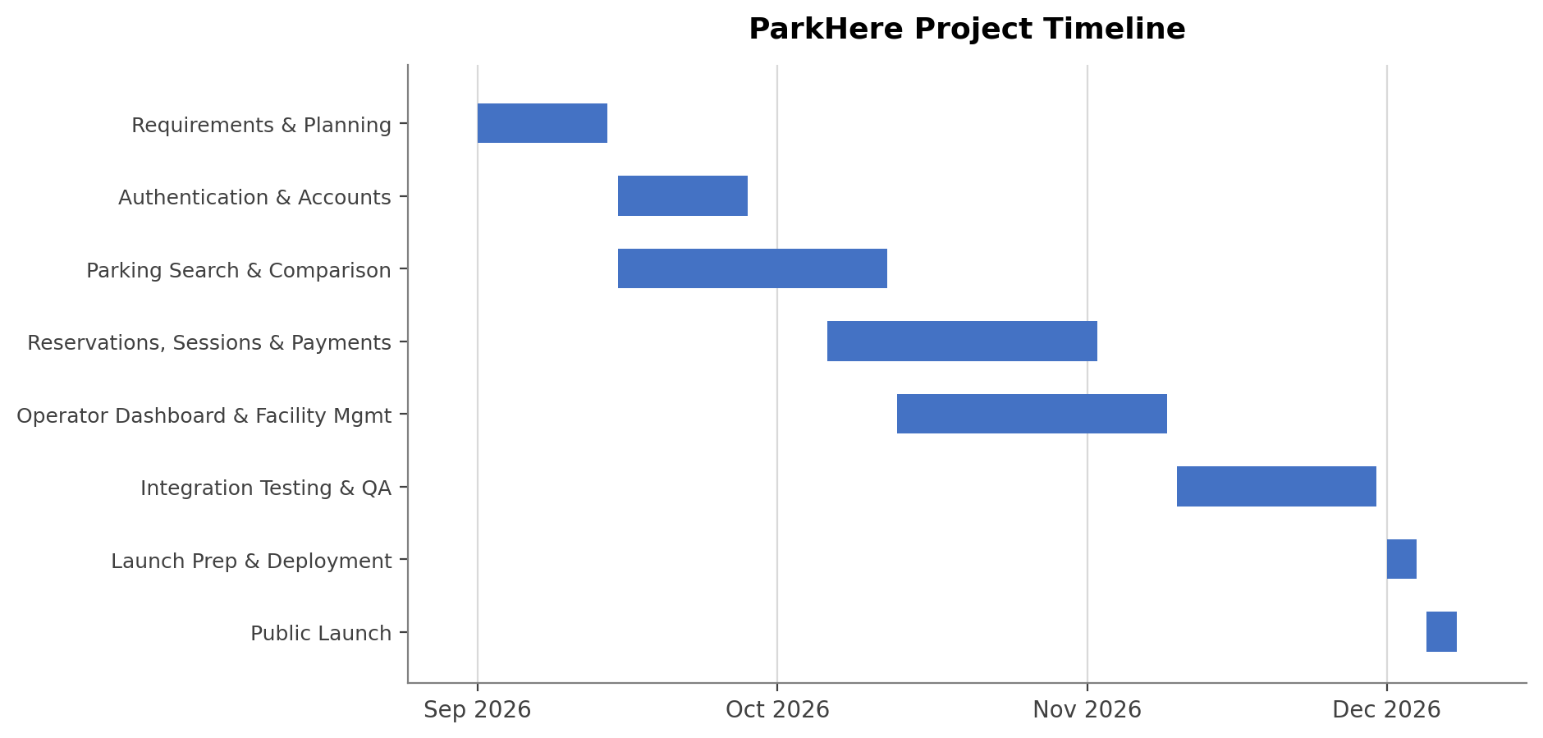
Figure 1. ParkHere draft project timeline (Gantt chart).

11. Product Backlog and Sprint 1 Plan (Trello)
The backlog below was built in Trello, organized into the four categories required for this assignment (Login, UI, Backend, Reporting), with items drawn directly from the use cases in Section 8 and the components in the Section 9 work breakdown structure. A fifth list, Sprint 1, holds the items selected for the first sprint. Board screenshots follow, split across two images since the full board does not fit in one screen.
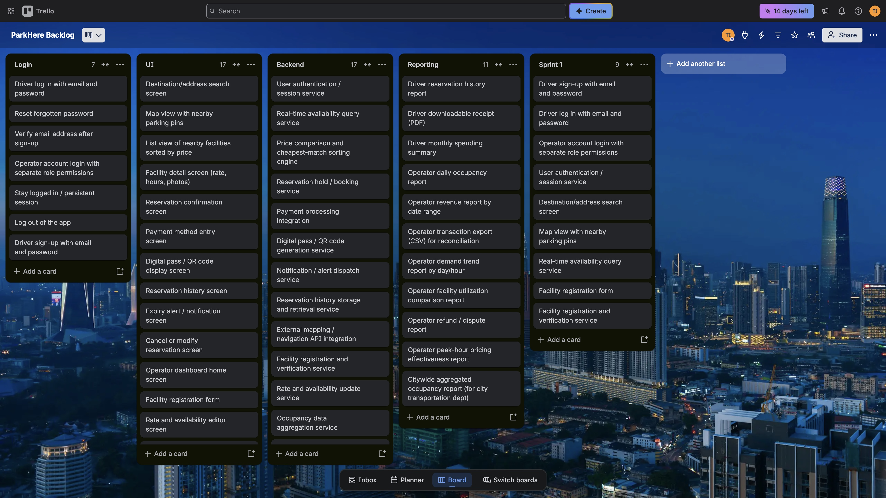
Figure 2. ParkHere product backlog board in Trello (Login, UI, Backend, Reporting, Sprint 1), part 1 of 2.
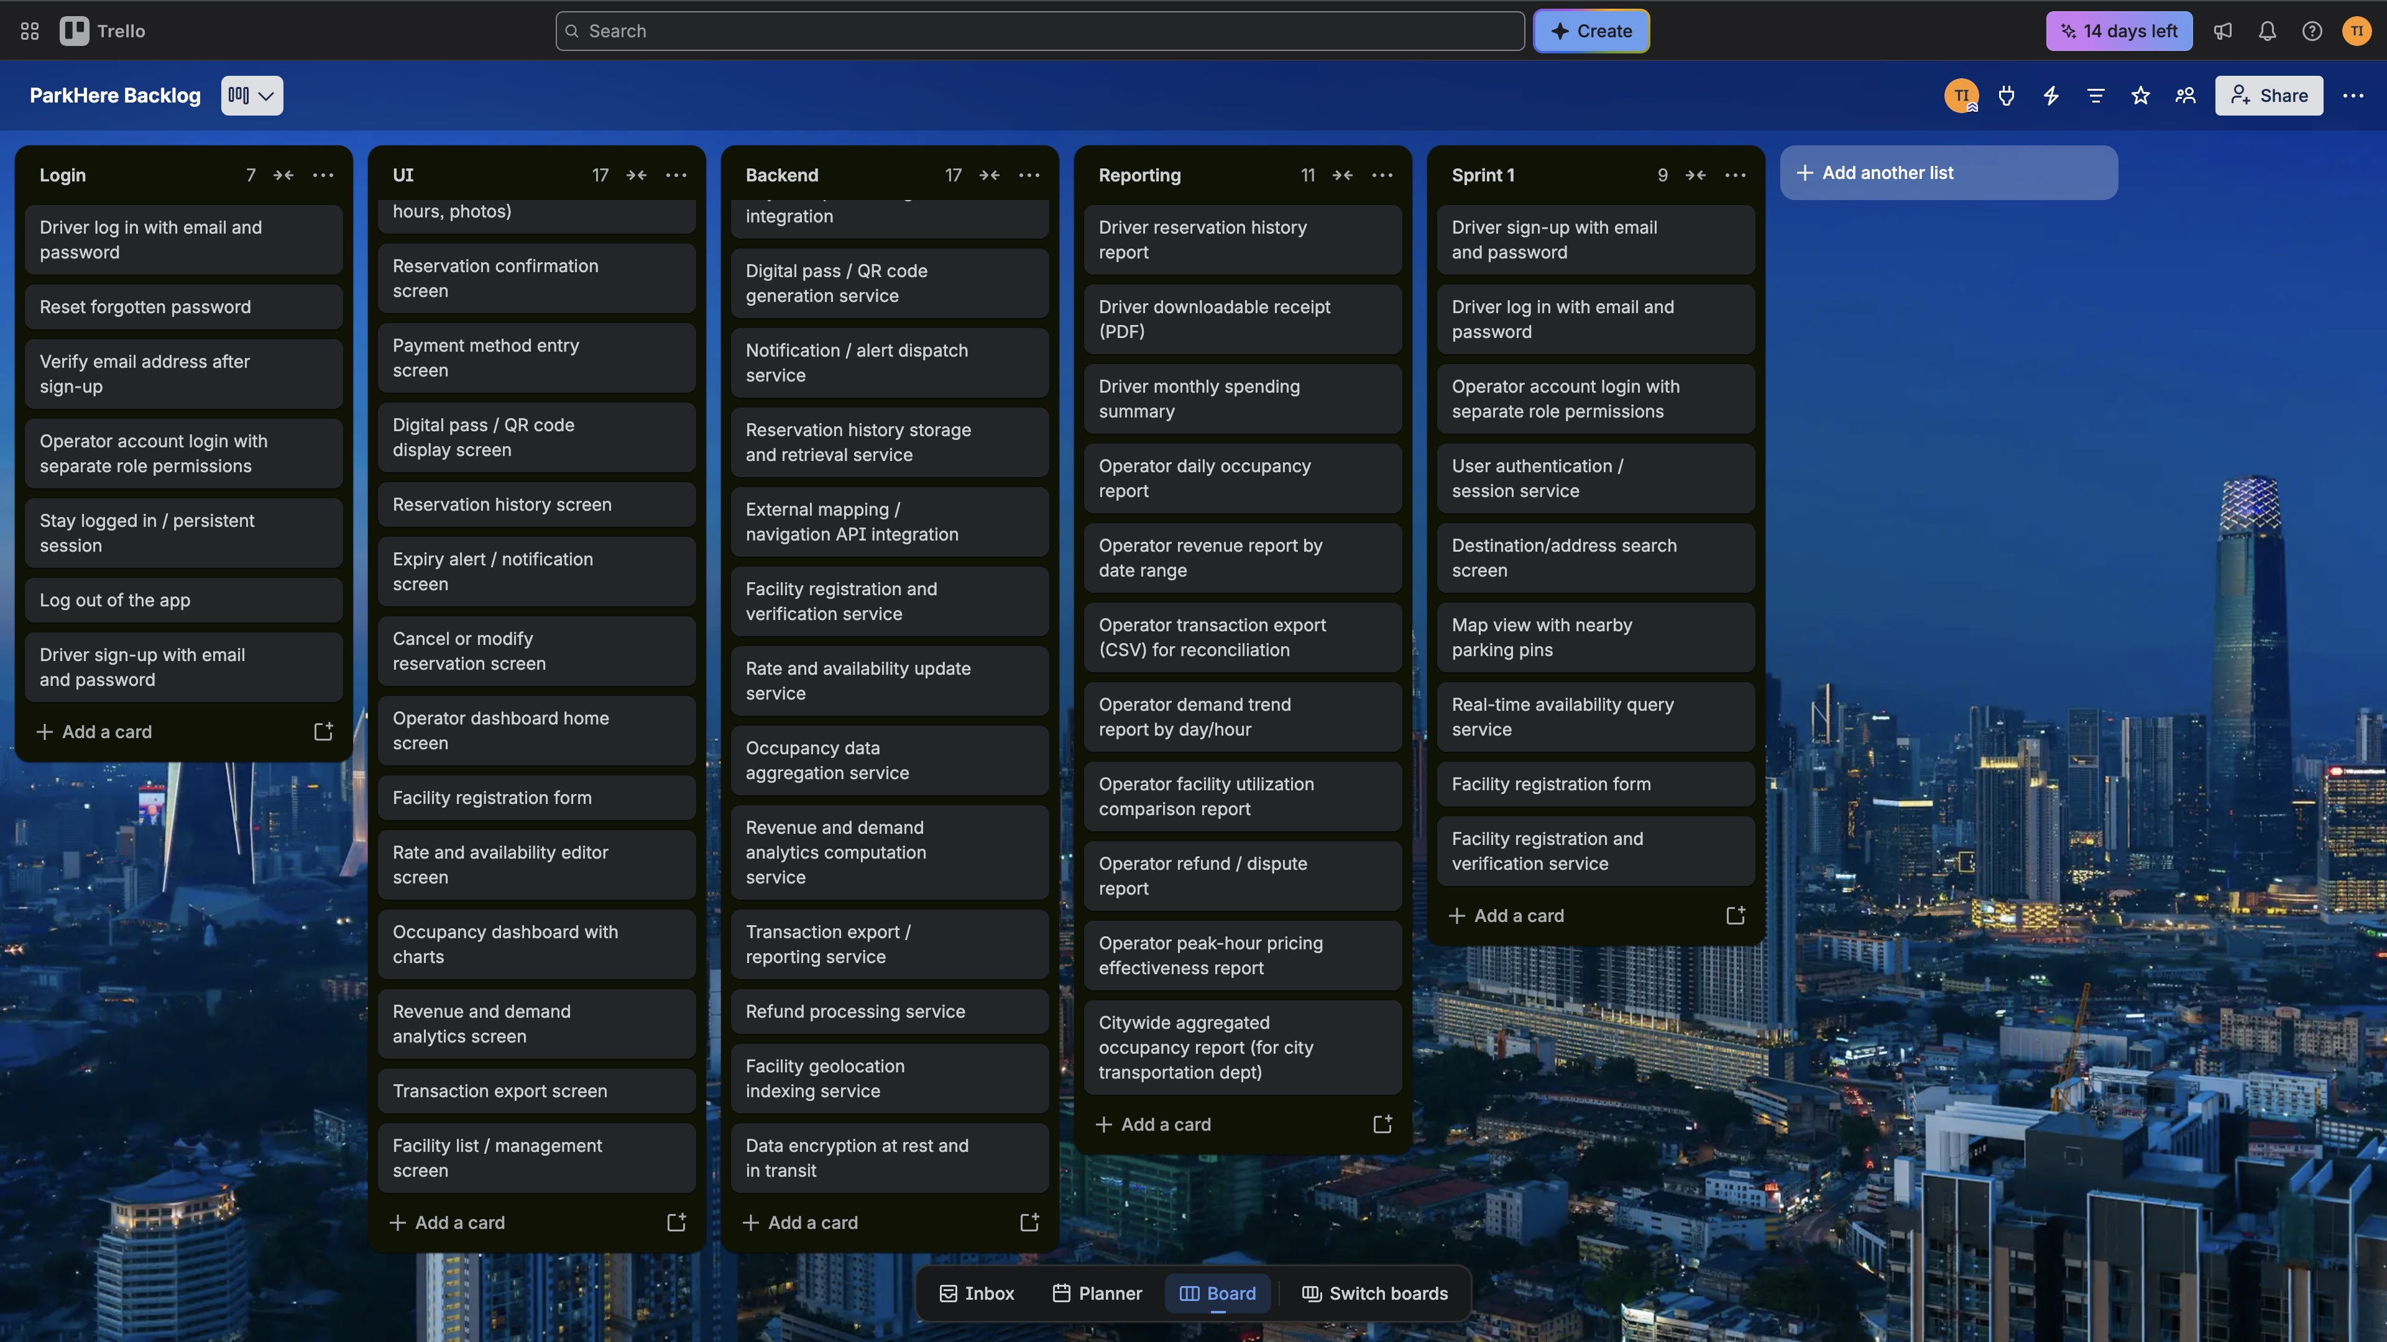
Figure 3. ParkHere product backlog board in Trello, continued (part 2 of 2).

12. Risk Management

12.1 Risk Identification
Risks below are grouped into the four required categories, with at least four risks identified per category based on ParkHere's actual architecture and schedule from Sections 9 and 10.
Technical Risks
- Third-party mapping/navigation API outage or rate limiting disrupts search results.
- Facility occupancy data becomes inaccurate if a facility's reporting integration lags or fails.
- Payment integration fails to meet PCI-DSS requirements before launch.
- Price comparison engine returns incorrect cheapest-match results due to a sorting bug.
- System cannot sustain 1,000 concurrent users under real load.
Schedule Risks
- Reservations & Payments phase overruns its 4-week estimate.
- Operator Dashboard work is blocked waiting on Backend/API completion.
- Integration Testing surfaces major defects late, threatening the Dec 5 launch.
- Stakeholders request new features mid-sprint (scope creep).
- Thanksgiving break reduces available working days right before QA.
Financial Risks
- Payment processing/PCI compliance costs exceed budget assumptions.
- Third-party API costs (mapping, notifications) scale faster than expected with usage.
- A stretched timeline drives added development cost.
- Infrastructure/hosting costs are underestimated relative to the uptime and concurrency requirements.
- Refund and dispute volume is higher than planned, raising processing costs.
People Risks
- Single PM is a point of failure with no backup decision-maker.
- Turnover on the Payment Integration team delays that component.
- Miscommunication between Mobile/Web teams and Backend/API team over shared API contracts.
- Parking operators are slow to provide onboarding data, blocking facility registration.
- New team members ramping up mid-project need onboarding time not budgeted in the schedule.

12.2 Risk Register
The register below formalizes all twenty identified risks with probability, impact, ownership, and a response strategy, well above the ten-entry minimum.
ID | Description | Category | Prob. | Impact | Owner | Response Strategy | Status
R01 | 3rd-party mapping/navigation API outage or rate limiting disrupts search. | Technical | Med | High | Mapping & Location Team | Mitigate: fallback provider, cache recent results. | Open
R02 | Facility occupancy data inaccurate if a facility's reporting integration lags. | Technical | Med | High | Backend/API Team | Mitigate: flag stale data, fall back to manual updates. | Open
R03 | Payment integration fails to meet PCI-DSS requirements before launch. | Technical | Low | High | Payment Integration Team | Avoid: use a PCI-compliant processor (e.g. Stripe). | Open
R04 | Price comparison engine returns incorrect cheapest-match results. | Technical | Med | Med | Backend/API Team | Mitigate: automated tests on sorting edge cases. | Open
R05 | System cannot sustain 1,000 concurrent users under real load. | Technical | Med | High | Backend/API Team | Mitigate: load-test pre-launch, design for horizontal scaling. | Open
R06 | Reservations & Payments phase overruns its 4-week estimate. | Schedule | Med | High | Project Manager | Mitigate: track vs. Gantt weekly, reallocate early. | Open
R07 | Operator Dashboard blocked waiting on Backend/API completion. | Schedule | Med | Med | Project Manager | Mitigate: freeze API contracts early, build against a stub. | Open
R08 | Integration Testing surfaces major defects late, threatens Dec 5 launch. | Schedule | Med | High | QA & Testing Team | Mitigate: test incrementally per component, not only at the end. | Open
R09 | Stakeholders request new features mid-sprint (scope creep). | Schedule | High | Med | Project Manager | Mitigate: change-control process, queue for a future sprint. | Open
R10 | Thanksgiving break reduces working days right before QA. | Schedule | High | Low | Project Manager | Accept: timeline already reserves buffer days. | Open
R11 | Payment/PCI compliance costs exceed budget assumptions. | Financial | Low | Med | Project Manager | Mitigate: confirm processor pricing in writing upfront. | Open
R12 | 3rd-party API costs scale faster than expected with usage. | Financial | Med | Med | Project Manager | Monitor: usage alerts, review vendor invoices monthly. | Open
R13 | A stretched timeline drives added development cost. | Financial | Med | Med | Project Manager | Mitigate: tie schedule extension to explicit budget review. | Open
R14 | Infrastructure/hosting costs underestimated vs. uptime/concurrency NFRs. | Financial | Med | Med | Backend/API Team | Mitigate: benchmark hosting cost against NFR targets first. | Open
R15 | Refund/dispute volume higher than planned, raising processing cost. | Financial | Low | Low | Project Manager | Accept: monitor via the refund/dispute report. | Open
R16 | Single PM is a point of failure with no backup decision-maker. | People | Med | High | Project Manager | Mitigate: document decisions, give a lead backup authority. | Open
R17 | Turnover on the Payment Integration team delays that component. | People | Low | High | Payment Integration Team | Transfer: rely on processor docs/support over tribal knowledge. | Open
R18 | Miscommunication between Mobile/Web and Backend/API over API contracts. | People | Med | Med | Project Manager | Mitigate: freeze API contracts before frontend work starts. | Open
R19 | Operators slow to provide onboarding data, blocks facility registration. | People | Med | Med | Project Manager | Mitigate: set a data deadline in the onboarding agreement. | Open
R20 | New team members ramping up need unbudgeted onboarding time. | People | Low | Med | Project Manager | Accept: build a ramp-up buffer into the first sprint. | Open

13. Communication Plan

13.1 Meeting Cadence
- Mobile Application Team: daily 15-minute standup.
- Web Application Team: daily 15-minute standup.
- Backend/API Team: daily 15-minute standup.
- Mapping & Location Services Team: twice-weekly sync (Tue/Thu).
- Payment Integration Team: weekly sync, plus ad hoc compliance/security reviews.
- QA & Testing Team: daily standup during active sprints; joins sprint review and retro.
- Cross-team Sprint Review & Retrospective: end of each sprint (biweekly).
- Stakeholder/Sponsor Update: weekly, the same cadence as this project's required weekly video update.
- PM 1:1s with team leads: weekly.

13.2 Reporting Methods
- Daily standups: verbal status in the team channel; blockers escalated immediately to the PM.
- Sprint burndown: tracked directly from the Trello board (Section 11).
- Weekly written status report: sent to stakeholders, covering scope, schedule, budget, and top risks.
- Risk register: reviewed and updated weekly by the PM; new high-impact risks are called out in the status report.
- Escalation path: critical blockers go to the PM immediately, who relays them to the affected team lead within one business day.

14. Document Revision History
Version | Date | Summary of changes | Author
0.1 | Sept 10, 2026 | Initial draft. Vision and scope including project origin and company introduction, problem statement, existing software landscape, differentiation, target users, scope boundaries, and eighteen draft use cases. | T. Ilori
0.2 | Sept 15, 2026 | Added Work Breakdown Structure (Section 9) and a draft project timeline with Gantt chart (Section 10). | T. Ilori
0.3 | Sept 22, 2026 | Added product backlog (Login, UI, Backend, Reporting) and Sprint 1 plan built in Trello, included as Section 11. | T. Ilori
0.4 | Sept 29, 2026 | Added Risk Management (Section 12: risk identification and risk register) and Communication Plan (Section 13). | T. Ilori

15. Sources Consulted
- ParkMobile, ParkHouston program and Houston parking pages, parkmobile.io.
- ParkHouston listing and public user reviews, Apple App Store.
- SpotHero downtown Houston destination pages, spothero.com.
- Downtown Houston district parking and navigation page, downtownhouston.org.

