Software Corp
ParkHere
Software Requirements Specification

by Temi Ilori

CIS 4374, Information Systems Project Management
Section 19148, Fall 2026
Instructor: Otto Dobretsberger
University of Houston
September 17, 2026

Table of Contents

1. Introduction

1.1 Purpose
This document describes the requirements for ParkHere, a mobile application being developed by Software Corp. This document establishes the problem, the competitive landscape, the product concept, and who the product is for.
1.2 Product Scope
ParkHere helps drivers in downtown Houston find, reserve, and pay for parking in real time, and it compares prices across providers so the driver can see the cheapest available option in one place. A companion admin dashboard gives parking facility operators visibility into occupancy, revenue, and demand patterns.

1.3 Definitions and Abbreviations
- SRS. Software Requirements Specification, this document.
- On-street parking. Metered spaces along a public street, managed in Houston by the ParkHouston program.
- Off-street parking. Privately or municipally operated garages and surface lots.
- Operator. The business that owns or manages a garage or lot.
- Closed network. A parking app that only displays inventory from operators it has signed agreements with.

2. Vision and Scope

2.1 How this project was acquired
This project originated inside Software Corp rather than arriving as a client request. In early 2026 the company was doing discovery work with two independent garage operators in the downtown area and in conversations with the operators, they raised the same complaint without being asked. They were sitting at partial occupancy on weekdays while drivers circled the same blocks looking for spaces, and they had no way to reach those drivers because the reservation apps they were listed on showed only a fraction of the market.
Software Corp ran an informal review of the parking applications serving downtown Houston to test whether that gap was real. It was, and no existing product was closing it. The company elected to fund the work internally as its own product rather than as contract work, so that the platform can list any operator rather than being tied to a single client. ParkHere was approved as an internal product initiative in September 2026.

2.2 About Software Corp
Software Corp is a small Houston based software company that builds tools for local urban mobility and small operator businesses. The company works on products where the difficulty is not the technology but the fragmentation of an existing market, and where a single well designed interface can replace several partial ones. ParkHere is its first consumer facing product.
The project is led by a single product manager who owns requirements, scope, stakeholder communication, and delivery, with development capacity assigned as the project moves into implementation.

2.3 Project overview
ParkHere is a mobile application that lets a driver in downtown Houston see every nearby parking option in one place, compare them by what they will actually cost, and reserve and pay in the app. A companion web dashboard gives parking facility operators visibility into occupancy, revenue, and demand.

3. Problem Statement
Parking in downtown Houston is not a scarcity problem. It is an information problem. On any given weekday there are metered spaces on the street, municipal garages, and dozens of privately operated lots within a few blocks of most destinations, all priced differently and all advertised in different places.
The driver cannot see them together. To make an informed choice today, someone heading downtown has to open the city meter app, then a reservation app, then possibly a second reservation app, and mentally compare rates across three interfaces while driving or before leaving the house. Most people do not do this. They park at the first thing they find, or they default to the one app they already have installed, and they routinely pay more than they need to.
The cost of that friction is paid twice. Drivers overpay and circle. Operators of the cheaper or less visible facilities sit at partial occupancy because no one knows they are there.

4. Existing Software Landscape
Four products currently compete for a downtown Houston driver's attention. Each one solves part of the problem and none of them solve the comparison problem.
Competitor | What it does well | Where it falls short for a downtown Houston driver | Coverage
ParkHouston | Official city app for on-street metered parking. Covers roughly 9,200 metered spaces citywide. Pay by zone number, extend a session remotely, get alerts before it expires. | Built for meters first. App Store reviews repeatedly describe slow load times, server errors, and zones showing as unavailable when spaces are visibly open. No way to compare a meter rate against a nearby garage. | On-street
SpotHero | Reserve and prepay garages and lots in advance. Compares garages and rates near a destination and advertises savings of up to 50 percent for booking ahead. | Only shows inventory in its own network. A cheaper garage across the street is invisible if that operator partners with someone else. No on-street coverage at all. | Garages and lots
ParkWhiz | Powers the official reservation map on the Downtown Houston district website, so it carries real credibility with venue and event traffic. | Same closed-network problem. The district site itself notes that other options exist through Parking.com and SpotHero, which quietly admits no single map is complete. | Garages and lots
Parking.com | Operator-backed inventory with monthly and daily options in the downtown core. | Weakest discovery experience of the four. Assumes the driver already knows which facility they want. | Garages and lots

4.1 What the research shows
Three findings came out of this review.
- The market is split down the middle. ParkHouston owns on-street. SpotHero, ParkWhiz, and Parking.com fight over off-street. No product covers both, so no product can tell a driver whether the meter or the garage is the better deal right now.
- Every off-street competitor runs a closed network, which means each app shows a partial map and presents it as if it were complete. The Downtown Houston district's own parking page quietly confirms this by noting that its map covers ParkWhiz inventory and that other options exist elsewhere.
- Reliability is an unforced weakness. Public reviews of the official city app describe slow performance, server errors, and spaces reported as unavailable when they are visibly open. A competitor that is simply dependable has room to win on that alone.

4.2 Where that leaves an opening
The gap is aggregation plus price transparency. A driver does not want another parking network. They want one screen that shows every nearby option, on-street and off-street, sorted by what it will actually cost them.

5. How ParkHere Will Be Different
ParkHere is a parking price comparison and reservation app for downtown Houston. The driver enters a destination and a time window. ParkHere returns every parking option within walking distance, on-street and off-street together, sorted by total cost, with walking distance and availability shown next to each one. The driver reserves and pays in the app and arrives with a confirmed spot.

5.1 Primary differentiator
Price comparison across providers is the core of the product, not a feature of it. Competitors ask which of our spaces do you want. ParkHere asks what is the cheapest way for you to park here right now, and answers it honestly even when the answer is a meter rather than a reservation.

5.2 Supporting capabilities under consideration
- Real-time availability rather than static listings.
- Reservation and in-app payment with a digital pass at the gate.
- Session extension and expiry alerts for metered parking.
- An operator dashboard with occupancy, revenue, and demand analytics.
- Event-aware pricing around Toyota Center, Daikin Park, Shell Energy Stadium, and the George R. Brown Convention Center, where demand and rates spike predictably.

6. Target Users

6.1 Drivers
- Downtown commuters who park in the same district five days a week and are the most sensitive to a few dollars a day compounding over a month.
- Event and venue traffic arriving in a concentrated window, unfamiliar with the area, and currently the most likely to overpay.
- Occasional visitors coming downtown for appointments, courthouse business, or dining, who park there rarely enough that they have no learned routine.

6.2 Parking facility operators
Independent garage and lot operators who are not surfaced well by the existing closed networks, and who care about filling spaces that currently sit empty. They are the second customer, and the admin dashboard is built for them.

7. Scope Boundaries
- In scope. Downtown Houston only, defined as the area inside the 610 Loop's downtown core served by the Downtown Houston district.
- In scope. iOS and Android mobile apps for drivers, and a web dashboard for operators.
- Out of scope for release one. Other Houston districts such as the Medical Center, Montrose, and the Heights.
- Out of scope for release one. Airport and monthly parking products.
- Out of scope for release one. Enforcement, citations, and ticket payment.

8. Use Cases
The following use cases are the first attempt at the functional behavior of ParkHere. This set will grow and be elaborated over the course of the semester, with preconditions, main and alternate flows, and exception handling added for each as the SRS develops.
ID | Use case | Primary actor | Description
UC-01 | Create an account | Driver | Registers with an email address or a federated sign-in, then adds a license plate.
UC-02 | Sign in | Driver | Authenticates and lands on the search screen. Saved vehicle and payment method load with it.
UC-03 | Search for parking near a destination | Driver | Address, venue, or a dropped pin, plus arrival time and duration. Returns everything nearby, meters and garages both.
UC-04 | Compare options by total cost | Driver | Prices every result for the full duration, service fee included, and sorts cheapest first. One list, not two.
UC-05 | Filter and sort results | Driver | Narrows by walking distance, covered, accessible, EV charging, height clearance. Can re-sort by distance instead of price.
UC-06 | View facility details | Driver | Operator, rate schedule, entrance, hours, photos. Flags reservable versus pay-on-arrival.
UC-07 | Reserve a space | Driver | Holds a space for a chosen arrival time and duration. Checks live inventory before taking payment.
UC-08 | Pay for a reservation | Driver | Charges a stored or newly entered payment method and issues a receipt.
UC-09 | Start an on-street metered session | Driver | Confirms the zone and duration, pays the meter rate. No reservation involved.
UC-10 | Extend an active session | Driver | Adds time remotely while already parked. Capped by the facility's maximum stay.
UC-11 | Receive an expiry alert | Driver | Warns before a session runs out, with a one-tap extend.
UC-12 | Cancel or change a reservation | Driver | Cancels or edits an upcoming booking. Refund follows the operator's policy.
UC-13 | Present a digital pass at entry | Driver | QR code at the gate, or plate recognition where the facility supports it.
UC-14 | View parking history and receipts | Driver | Past sessions and downloadable receipts. Doubles as proof of payment when contesting a citation.
UC-15 | Register a facility | Operator | Submits facility details, capacity, and entrances. Verified before the listing goes live.
UC-16 | Update rates and availability | Operator | Changes pricing and how many spaces are released to the platform. Includes event-day rates.
UC-17 | View the occupancy and revenue dashboard | Operator | Current occupancy, bookings, revenue, and demand by day and hour.
UC-18 | Export a transaction report | Operator | Transaction-level export for a chosen date range, for reconciliation.

9. Work Breakdown Structure
The work breakdown structure below decomposes ParkHere into its major functional components, three levels deep, mapped directly to the use cases defined in Section 8 rather than treated as a separate abstract exercise.
1.0 Authentication & Account Management
1.1 Login
Tasks: Email/password login; federated sign-in (Google/Apple); session token management
1.2 Registration
Tasks: Driver account creation; license plate association; email verification
1.3 Account Settings
Tasks: Password reset flow; profile editing; session persistence
2.0 Parking Search & Comparison
2.1 Search Interface
Tasks: Destination/address/venue search; map pin drop; arrival time and duration input
2.2 Comparison Engine
Tasks: Aggregate on-street and off-street listings; total cost calculation; cheapest-first sorting
2.3 Filtering & Facility Details
Tasks: Filter by distance/accessibility/EV/height clearance; facility detail view; reservable vs. pay-on-arrival flagging
3.0 Reservations, Sessions & Payments
3.1 Reservation Flow
Tasks: Real-time inventory check; space hold/booking logic; cancel or modify reservation
3.2 Metered Session Flow
Tasks: Zone/session start; session extension; expiry alerts
3.3 Payment Processing
Tasks: Payment method storage; transaction processing and receipts; digital pass/QR generation
4.0 Operator Dashboard & Facility Management
4.1 Facility Onboarding
Tasks: Facility registration form; verification workflow; entrance/capacity setup
4.2 Rate & Availability Management
Tasks: Rate schedule editor; space release controls; event-day pricing rules
4.3 Reporting & Analytics
Tasks: Occupancy dashboard; revenue and demand analytics; transaction export tool

10. Project Timeline and Schedule
The timeline below sequences the four major WBS components into a delivery schedule. Phases overlap slightly where independent workstreams, such as the mobile search experience and the operator dashboard, can be built in parallel rather than strictly one after another.
Phase | Start | End | Duration
Requirements & Planning | Sep 1, 2026 | Sep 14, 2026 | 2 weeks
Authentication & Accounts | Sep 15, 2026 | Sep 28, 2026 | 2 weeks
Parking Search & Comparison | Sep 15, 2026 | Oct 12, 2026 | 4 weeks
Reservations, Sessions & Payments | Oct 6, 2026 | Nov 2, 2026 | 4 weeks
Operator Dashboard & Facility Mgmt | Oct 13, 2026 | Nov 9, 2026 | 4 weeks
Integration Testing & QA | Nov 10, 2026 | Nov 30, 2026 | 3 weeks
Launch Prep & Deployment | Dec 1, 2026 | Dec 4, 2026 | 4 days
Public Launch (milestone) | Dec 5, 2026 | Dec 5, 2026 | —

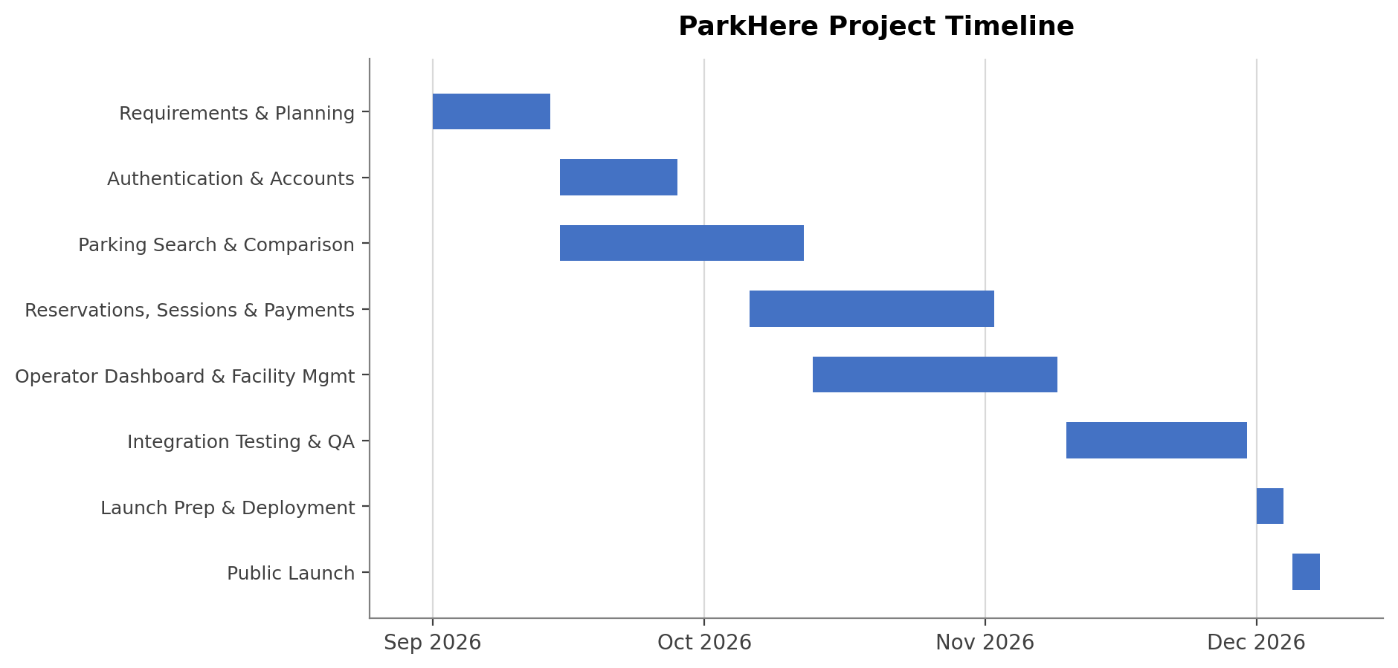
Figure 1. ParkHere draft project timeline (Gantt chart).

11. Document Revision History
Version | Date | Summary of changes | Author
0.1 | Sept 10, 2026 | Initial draft. Vision and scope including project origin and company introduction, problem statement, existing software landscape, differentiation, target users, scope boundaries, and eighteen draft use cases. | T. Ilori
0.2 | Sept 15, 2026 | Added Work Breakdown Structure (Section 9) and a draft project timeline with Gantt chart (Section 10). | T. Ilori

12. Sources Consulted
- ParkMobile, ParkHouston program and Houston parking pages, parkmobile.io.
- ParkHouston listing and public user reviews, Apple App Store.
- SpotHero downtown Houston destination pages, spothero.com.
- Downtown Houston district parking and navigation page, downtownhouston.org.

