Software Corp
ParkHere
Software Requirements Specification

by Temi Ilori

CIS 4374, Information Systems Project Management
Section 19148, Fall 2026
Instructor: Otto Dobretsberger
University of Houston
October 29, 2026

Table of Contents

1. Introduction 3
1.1 Purpose 3
1.3 Definitions and Abbreviations 3
2. Vision and Scope 4
2.1 How this project was acquired 4
2.2 About Software Corp 4
2.3 Project overview 4
3. Problem Statement 4
4. Existing Software Landscape 5
4.1 What the research shows 5
4.2 Where that leaves an opening 5
5. How ParkHere Will Be Different 6
5.1 Primary differentiator 6
5.2 Supporting capabilities under consideration 6
6. Target Users 6
6.1 Drivers 6
6.2 Parking facility operators 6
7. Scope Boundaries 6
8. Use Cases, User Stories, and Non-Functional Requirements 7
8.1 Use Cases 7
8.2 User Stories 8
8.3 Non-Functional Requirements 9
9. Work Breakdown Structure 10
10. Project Timeline and Schedule 11
11. Product Backlog and Sprint Plan (Trello) 13
11.1 Backlog Changes Since Version 0.3 14
11.2 Sprint Plan 14
12. Risk Management 15
12.1 Risk Identification 15
12.2 Risk Register 17
13. Communication Plan 18
13.1 Meeting Cadence 18
13.2 Reporting Methods 19
14. Roles and Resources 19
14.1 Team Roster and Allocation 19
14.2 Assumptions 20
14.3 External Stakeholders 20
15. Resource and Cost Plan 20
15.1 Approach 20
15.2 Labor Cost by Role 21
15.3 Non-Labor Costs 21
15.4 Budgeted Monthly Cashflow 22
16. RACI Matrix 23
17. Stakeholder Analysis 25
17.1 Power–Interest Grid 25
17.2 Stakeholder Register and Engagement Plan 26
18. Project Charter 28
19. Team Charter 29
20. Document Revision History 30
20.1 Reasons for Changes in Version 0.6 31
20.2 Reasons for Changes in Version 0.7 32
21. Sources Consulted 32

1. Introduction

1.1 Purpose
This document describes the requirements and the project plan for ParkHere, a mobile application being developed by Software Corp. It establishes the problem, the competitive landscape, the product concept, and who the product is for, and it holds the planning material that turns those requirements into a delivery plan: use cases, user stories, and non-functional requirements (Section 8), the work breakdown structure (Section 9), the schedule (Section 10), the backlog and sprint plan (Section 11), risks (Section 12), communication (Section 13), roles (Section 14), cost (Section 15), responsibilities (Section 16), stakeholders (Section 17), and the project and team charters (Sections 18 and 19).
1.2 Product Scope
ParkHere helps drivers in downtown Houston find, reserve, and pay for parking in real time, and it compares prices across providers so the driver can see the cheapest available option in one place. A companion admin dashboard gives parking facility operators visibility into occupancy, revenue, and demand patterns.

1.3 Definitions and Abbreviations
- SRS. Software Requirements Specification, this document.
- On-street parking. Metered spaces along a public street, managed in Houston by the ParkHouston program.
- Off-street parking. Privately or municipally operated garages and surface lots.
- Operator. The business that owns or manages a garage or lot.
- Closed network. A parking app that only displays inventory from operators it has signed agreements with.
- WBS. Work Breakdown Structure, the hierarchy of project work in Section 9.
- RACI. Responsible, Accountable, Consulted, Informed, the responsibility matrix in Section 16.
- User story. A short statement of what a user needs, written from the user's point of view (Section 8.2).
- NFR. Non-functional requirement, a measurable quality target such as response time or availability (Section 8.3).
- PCI-DSS. Payment Card Industry Data Security Standard, the security standard for systems that handle card payments.
- Sprint. A two-week work period with a defined goal, listed in Section 11.
- Stakeholder. A person or group who is affected by ParkHere or can affect it (Section 17).
- Power–Interest Grid. A four-box chart that sorts stakeholders by how much power they have over the project and how much interest they have in it (Section 17.1).
- Charter. A short agreement that sets out the purpose and rules of the project (Section 18) or the team (Section 19).

2. Vision and Scope

2.1 How this project was acquired
This project originated inside Software Corp rather than arriving as a client request. In early 2026 the company was doing discovery work with two independent garage operators in the downtown area and in conversations with the operators, they raised the same complaint without being asked. They were sitting at partial occupancy on weekdays while drivers circled the same blocks looking for spaces, and they had no way to reach those drivers because the reservation apps they were listed on showed only a fraction of the market.
Software Corp ran an informal review of the parking applications serving downtown Houston to test whether that gap was real. It was, and no existing product was closing it. The company elected to fund the work internally as its own product rather than as contract work, so that the platform can list any operator rather than being tied to a single client. ParkHere was approved as an internal product initiative in September 2026.

2.2 About Software Corp
Software Corp is a small Houston based software company that builds tools for local urban mobility and small operator businesses. The company works on products where the difficulty is not the technology but the fragmentation of an existing market, and where a single well designed interface can replace several partial ones. ParkHere is its first consumer facing product.
The project is led by a single product manager who owns requirements, scope, stakeholder communication, and delivery, with development capacity assigned as the project moves into implementation.

2.3 Project overview
ParkHere is a mobile application that lets a driver in downtown Houston see every nearby parking option in one place, compare them by what they will actually cost, and reserve and pay in the app. A companion web dashboard gives parking facility operators visibility into occupancy, revenue, and demand.

3. Problem Statement
Parking in downtown Houston is not a scarcity problem. It is an information problem. On any given weekday there are metered spaces on the street, municipal garages, and dozens of privately operated lots within a few blocks of most destinations, all priced differently and all advertised in different places.
The driver cannot see them together. To make an informed choice today, someone heading downtown has to open the city meter app, then a reservation app, then possibly a second reservation app, and mentally compare rates across three interfaces while driving or before leaving the house. Most people do not do this. They park at the first thing they find, or they default to the one app they already have installed, and they routinely pay more than they need to.
The cost of that friction is paid twice. Drivers overpay and circle. Operators of the cheaper or less visible facilities sit at partial occupancy because no one knows they are there.

4. Existing Software Landscape
Four products currently compete for a downtown Houston driver's attention. Each one solves part of the problem and none of them solve the comparison problem.
Competitor | What it does well | Where it falls short for a downtown Houston driver | Coverage
ParkHouston | Official city app for on-street metered parking. Covers roughly 9,200 metered spaces citywide. Pay by zone number, extend a session remotely, get alerts before it expires. | Built for meters first. App Store reviews repeatedly describe slow load times, server errors, and zones showing as unavailable when spaces are visibly open. No way to compare a meter rate against a nearby garage. | On-street
SpotHero | Reserve and prepay garages and lots in advance. Compares garages and rates near a destination and advertises savings of up to 50 percent for booking ahead. | Only shows inventory in its own network. A cheaper garage across the street is invisible if that operator partners with someone else. No on-street coverage at all. | Garages and lots
ParkWhiz | Powers the official reservation map on the Downtown Houston district website, so it carries real credibility with venue and event traffic. | Same closed-network problem. The district site itself notes that other options exist through Parking.com and SpotHero, which quietly admits no single map is complete. | Garages and lots
Parking.com | Operator-backed inventory with monthly and daily options in the downtown core. | Weakest discovery experience of the four. Assumes the driver already knows which facility they want. | Garages and lots

4.1 What the research shows
Three findings came out of this review.
- The market is split down the middle. ParkHouston owns on-street. SpotHero, ParkWhiz, and Parking.com fight over off-street. No product covers both, so no product can tell a driver whether the meter or the garage is the better deal right now.
- Every off-street competitor runs a closed network, which means each app shows a partial map and presents it as if it were complete. The Downtown Houston district's own parking page quietly confirms this by noting that its map covers ParkWhiz inventory and that other options exist elsewhere.
- Reliability is an unforced weakness. Public reviews of the official city app describe slow performance, server errors, and spaces reported as unavailable when they are visibly open. A competitor that is simply dependable has room to win on that alone.

4.2 Where that leaves an opening
The gap is aggregation plus price transparency. A driver does not want another parking network. They want one screen that shows every nearby option, on-street and off-street, sorted by what it will actually cost them.

5. How ParkHere Will Be Different
ParkHere is a parking price comparison and reservation app for downtown Houston. The driver enters a destination and a time window. ParkHere returns every parking option within walking distance, on-street and off-street together, sorted by total cost, with walking distance and availability shown next to each one. The driver reserves and pays in the app and arrives with a confirmed spot.

5.1 Primary differentiator
Price comparison across providers is the core of the product, not a feature of it. Competitors ask which of our spaces do you want. ParkHere asks what is the cheapest way for you to park here right now, and answers it honestly even when the answer is a meter rather than a reservation.

5.2 Supporting capabilities under consideration
- Real-time availability rather than static listings.
- Reservation and in-app payment with a digital pass at the gate.
- Session extension and expiry alerts for metered parking.
- An operator dashboard with occupancy, revenue, and demand analytics.
- Event-aware pricing around Toyota Center, Daikin Park, Shell Energy Stadium, and the George R. Brown Convention Center, where demand and rates spike predictably.

6. Target Users

6.1 Drivers
- Downtown commuters who park in the same district five days a week and are the most sensitive to a few dollars a day compounding over a month.
- Event and venue traffic arriving in a concentrated window, unfamiliar with the area, and currently the most likely to overpay.
- Occasional visitors coming downtown for appointments, courthouse business, or dining, who park there rarely enough that they have no learned routine.

6.2 Parking facility operators
Independent garage and lot operators who are not surfaced well by the existing closed networks, and who care about filling spaces that currently sit empty. They are the second customer, and the admin dashboard is built for them.

7. Scope Boundaries
- In scope. Downtown Houston only, defined as the area inside the 610 Loop's downtown core served by the Downtown Houston district.
- In scope. iOS and Android mobile apps for drivers, and a web dashboard for operators.
- Out of scope for release one. Other Houston districts such as the Medical Center, Montrose, and the Heights.
- Out of scope for release one. Airport and monthly parking products.
- Out of scope for release one. Enforcement, citations, and ticket payment.

8. Use Cases, User Stories, and Non-Functional Requirements
This section describes what ParkHere has to do and how well it has to do it. The use cases in 8.1 describe the behavior for each kind of user. The user stories in 8.2 restate each use case from the user's point of view and name the sprint that delivers it (Section 11). The non-functional requirements in 8.3 set measurable quality targets that the risks (Section 12) and the testing work (WBS 5.1) refer back to. Version 0.6 added three use cases, UC-19 to UC-21, for work that was already in the WBS and the backlog but had no use case behind it: password reset, operator sign-in, and refund and dispute review.

8.1 Use Cases
ID | Use case | Primary actor | Description
UC-01 | Create an account | Driver | Registers with an email address or a federated sign-in, then adds a license plate.
UC-02 | Sign in | Driver | Authenticates and lands on the search screen. Saved vehicle and payment method load with it.
UC-03 | Search for parking near a destination | Driver | Address, venue, or a dropped pin, plus arrival time and duration. Returns everything nearby, meters and garages both.
UC-04 | Compare options by total cost | Driver | Prices every result for the full duration, service fee included, and sorts cheapest first. One list, not two.
UC-05 | Filter and sort results | Driver | Narrows by walking distance, covered, accessible, EV charging, height clearance. Can re-sort by distance instead of price.
UC-06 | View facility details | Driver | Operator, rate schedule, entrance, hours, photos. Flags reservable versus pay-on-arrival.
UC-07 | Reserve a space | Driver | Holds a space for a chosen arrival time and duration. Checks live inventory before taking payment.
UC-08 | Pay for a reservation | Driver | Charges a stored or newly entered payment method and issues a receipt.
UC-09 | Start an on-street metered session | Driver | Confirms the zone and duration, pays the meter rate. No reservation involved.
UC-10 | Extend an active session | Driver | Adds time remotely while already parked. Capped by the facility's maximum stay.
UC-11 | Receive an expiry alert | Driver | Warns before a session runs out, with a one-tap extend.
UC-12 | Cancel or change a reservation | Driver | Cancels or edits an upcoming booking. Refund follows the operator's policy.
UC-13 | Present a digital pass at entry | Driver | QR code at the gate, or plate recognition where the facility supports it.
UC-14 | View parking history and receipts | Driver | Past sessions and downloadable receipts. Doubles as proof of payment when contesting a citation.
UC-15 | Register a facility | Operator | Submits facility details, capacity, and entrances. Verified before the listing goes live.
UC-16 | Update rates and availability | Operator | Changes pricing and how many spaces are released to the platform. Includes event-day rates.
UC-17 | View the occupancy and revenue dashboard | Operator | Current occupancy, bookings, revenue, and demand by day and hour.
UC-18 | Export a transaction report | Operator | Transaction-level export for a chosen date range, for reconciliation.
UC-19 | Reset a forgotten password | Driver | Requests a reset link by email and sets a new password.
UC-20 | Sign in as an operator | Operator | Authenticates to the web dashboard with an operator account. The account is tied to the operator's own facilities only.
UC-21 | Review refunds and disputes | Operator | Lists refund requests and disputed charges for the operator's facilities so each can be resolved.

8.2 User Stories
Each use case has one user story. The Sprint column says which sprint in Section 11 delivers it. Stories US-19 to US-21 belong to the use cases added in version 0.6.
ID | User story | Use case | Sprint
US-01 | As a driver, I want to create an account with my email or a Google or Apple sign-in and add my license plate, so that I do not re-enter my details every time. | UC-01 | 1
US-02 | As a driver, I want to sign in and land on the search screen with my vehicle and payment method already loaded, so that I can start searching right away. | UC-02 | 1
US-03 | As a driver, I want to search by address, venue, or dropped pin with an arrival time and duration, so that I see every option near where I am going. | UC-03 | 1
US-04 | As a driver, I want every result priced for my whole stay and sorted cheapest first, so that I can pick the lowest total cost without checking two apps. | UC-04 | 2
US-05 | As a driver, I want to filter results by walking distance, covered parking, accessibility, EV charging, and height clearance, so that I only see spaces that work for me. | UC-05 | 2
US-06 | As a driver, I want to open a facility and see its rates, hours, entrance, and whether I can reserve, so that I know what to expect before I go. | UC-06 | 2
US-07 | As a driver, I want to reserve a space for a chosen time, so that I know I will have a spot when I arrive. | UC-07 | 3
US-08 | As a driver, I want to pay for a reservation in the app and get a receipt, so that I do not have to pay at the gate. | UC-08 | 3
US-09 | As a driver, I want to start a metered street session from my phone, so that I do not need coins or a kiosk. | UC-09 | 3
US-10 | As a driver, I want to add time to my session remotely, so that I do not have to walk back to the meter. | UC-10 | 3
US-11 | As a driver, I want an alert before my session runs out with a one-tap extend, so that I avoid a citation. | UC-11 | 4
US-12 | As a driver, I want to cancel or change an upcoming reservation, so that a change of plans does not cost me the full price. | UC-12 | 4
US-13 | As a driver, I want to show a QR code at the gate, so that I can enter without a ticket. | UC-13 | 3
US-14 | As a driver, I want to see my past sessions and download receipts, so that I have proof of payment if I need to contest a citation. | UC-14 | 4
US-15 | As an operator, I want to register my facility with its capacity and entrances, so that it can be listed once it is verified. | UC-15 | 1
US-16 | As an operator, I want to change my rates and how many spaces I release to the platform, so that I can respond to events and demand. | UC-16 | 3
US-17 | As an operator, I want to see current occupancy, bookings, revenue, and demand by day and hour, so that I can price my facility better. | UC-17 | 4
US-18 | As an operator, I want to export transactions for a date range, so that I can reconcile them with my own books. | UC-18 | 4
US-19 | As a driver, I want to reset my password by email, so that I can get back into my account if I forget it. | UC-19 | 1
US-20 | As an operator, I want to sign in to the dashboard with an operator account, so that I only see and manage my own facilities. | UC-20 | 1
US-21 | As an operator, I want to review refund requests and disputed charges, so that I can resolve them and see their effect on revenue. | UC-21 | 4

8.3 Non-Functional Requirements
These are measurable quality targets. They are planning assumptions for this project, and they would be confirmed with the executive sponsor before launch. The related risk column points to the register in Section 12.
ID | Area | Requirement | Related risk
NFR-01 | Response time | Search and comparison results return within 3 seconds for 95% of requests. | R22
NFR-02 | Availability | The service is available 99.5% of the time each month. | R14
NFR-03 | Capacity | The system supports 1,000 concurrent users. | R05
NFR-04 | Payment security | ParkHere does not store card numbers. Payments go through a PCI-DSS compliant processor, and data is encrypted in transit and at rest. | R03, R11
NFR-05 | Data freshness | Availability data is less than 5 minutes old, or the facility is flagged as stale. | R02
NFR-06 | Platform support | iOS and Android, current and previous major versions. Operator dashboard on current Chrome, Safari, and Edge. | None

9. Work Breakdown Structure
The work breakdown structure below decomposes ParkHere into six components, three levels deep. Components 1.0 to 4.0 are the product features and map to the use cases in Section 8. Components 5.0 and 6.0 were added in version 0.6 for work that was already in the schedule and the cost plan but missing from the WBS: testing, security and launch, and project management.
1.0 Authentication & Account Management
1.1 Login
Tasks: Email/password login; federated sign-in (Google/Apple); session token management; operator role-based login
1.2 Registration
Tasks: Driver account creation; license plate association; email verification
1.3 Account Settings
Tasks: Password reset flow; profile editing; session persistence
2.0 Parking Search & Comparison
2.1 Search Interface
Tasks: Destination/address/venue search; map pin drop; arrival time and duration input
2.2 Comparison Engine
Tasks: Aggregate on-street and off-street listings; total cost calculation; cheapest-first sorting
2.3 Filtering & Facility Details
Tasks: Filter by distance/accessibility/EV/height clearance; facility detail view; reservable vs. pay-on-arrival flagging; data freshness indicator
3.0 Reservations, Sessions & Payments
3.1 Reservation Flow
Tasks: Real-time inventory check; space hold/booking logic; cancel or modify reservation
3.2 Metered Session Flow
Tasks: Zone/session start; session extension; expiry alerts
3.3 Payment Processing
Tasks: Payment method storage; transaction processing and receipts; digital pass/QR generation; refund processing
4.0 Operator Dashboard & Facility Management
4.1 Facility Onboarding
Tasks: Facility registration form; verification workflow; entrance/capacity setup (pulled forward to Sprint 1)
4.2 Rate & Availability Management
Tasks: Rate schedule editor; space release controls; event-day pricing rules
4.3 Reporting & Analytics
Tasks: Occupancy dashboard; revenue and demand analytics; transaction export tool; refund and dispute review
5.0 Testing, Security & Launch
5.1 Integration & Performance Testing
Tasks: Incremental QA each sprint; integration test plan and execution; load and performance tests against the 1,000 user target; defect triage and regression testing
5.2 Security & Compliance
Tasks: PCI-DSS assessment of the payment processor; penetration test; encryption and data protection review
5.3 Deployment & Launch
Tasks: Release candidate; production deployment and monitoring; app store submission; launch go/no-go decision
6.0 Project Management
6.1 Planning & Requirements
Tasks: SRS maintenance; project and team charters; backlog and sprint planning; schedule and budget baseline
6.2 Monitoring & Control
Tasks: Weekly status and risk register review; change control; budget tracking against the baseline
6.3 Stakeholder Communication
Tasks: Stakeholder analysis; sponsor updates; partner operator liaison and facility data collection; sprint reviews and retrospectives

10. Project Timeline and Schedule
The timeline below sequences the work from the WBS in Section 9 into a delivery schedule, and the WBS column shows which component each phase belongs to. Phases overlap where independent workstreams, such as the mobile search experience and the operator dashboard, can be built in parallel. Three things changed in version 0.6. Facility Onboarding (WBS 4.1) moved to September 15 so that operators can register facilities in Sprint 1, which is the response to risk R19. Incremental QA now runs from September 29, when the QA lead joins, so each sprint's work is tested as it is finished and not only in November (risk R08). The stretch reports are their own phase in Sprint 5 so they can be cut first if the schedule tightens (risk R23).
Phase | WBS | Start | End | Duration
Requirements & Planning | 6.1 | Sep 1, 2026 | Sep 14, 2026 | 2 weeks
Authentication & Accounts | 1.0 | Sep 15, 2026 | Sep 28, 2026 | 2 weeks
Facility Onboarding | 4.1 | Sep 15, 2026 | Sep 28, 2026 | 2 weeks
Parking Search & Comparison | 2.0 | Sep 15, 2026 | Oct 12, 2026 | 4 weeks
Incremental QA (each sprint) | 5.1 | Sep 29, 2026 | Nov 9, 2026 | 6 weeks
Reservations, Sessions & Payments | 3.0 | Oct 6, 2026 | Nov 2, 2026 | 4 weeks
Operator Rates, Dashboard & Reporting | 4.2, 4.3 | Oct 13, 2026 | Nov 9, 2026 | 4 weeks
Stretch Reports (cut first) | 4.3 | Nov 10, 2026 | Nov 23, 2026 | 2 weeks
Integration Testing & QA | 5.1, 5.2 | Nov 10, 2026 | Nov 30, 2026 | 3 weeks
Launch Prep & Deployment | 5.3 | Dec 1, 2026 | Dec 4, 2026 | 4 days
Public Launch (milestone) | 5.3 | Dec 5, 2026 | Dec 5, 2026 | —

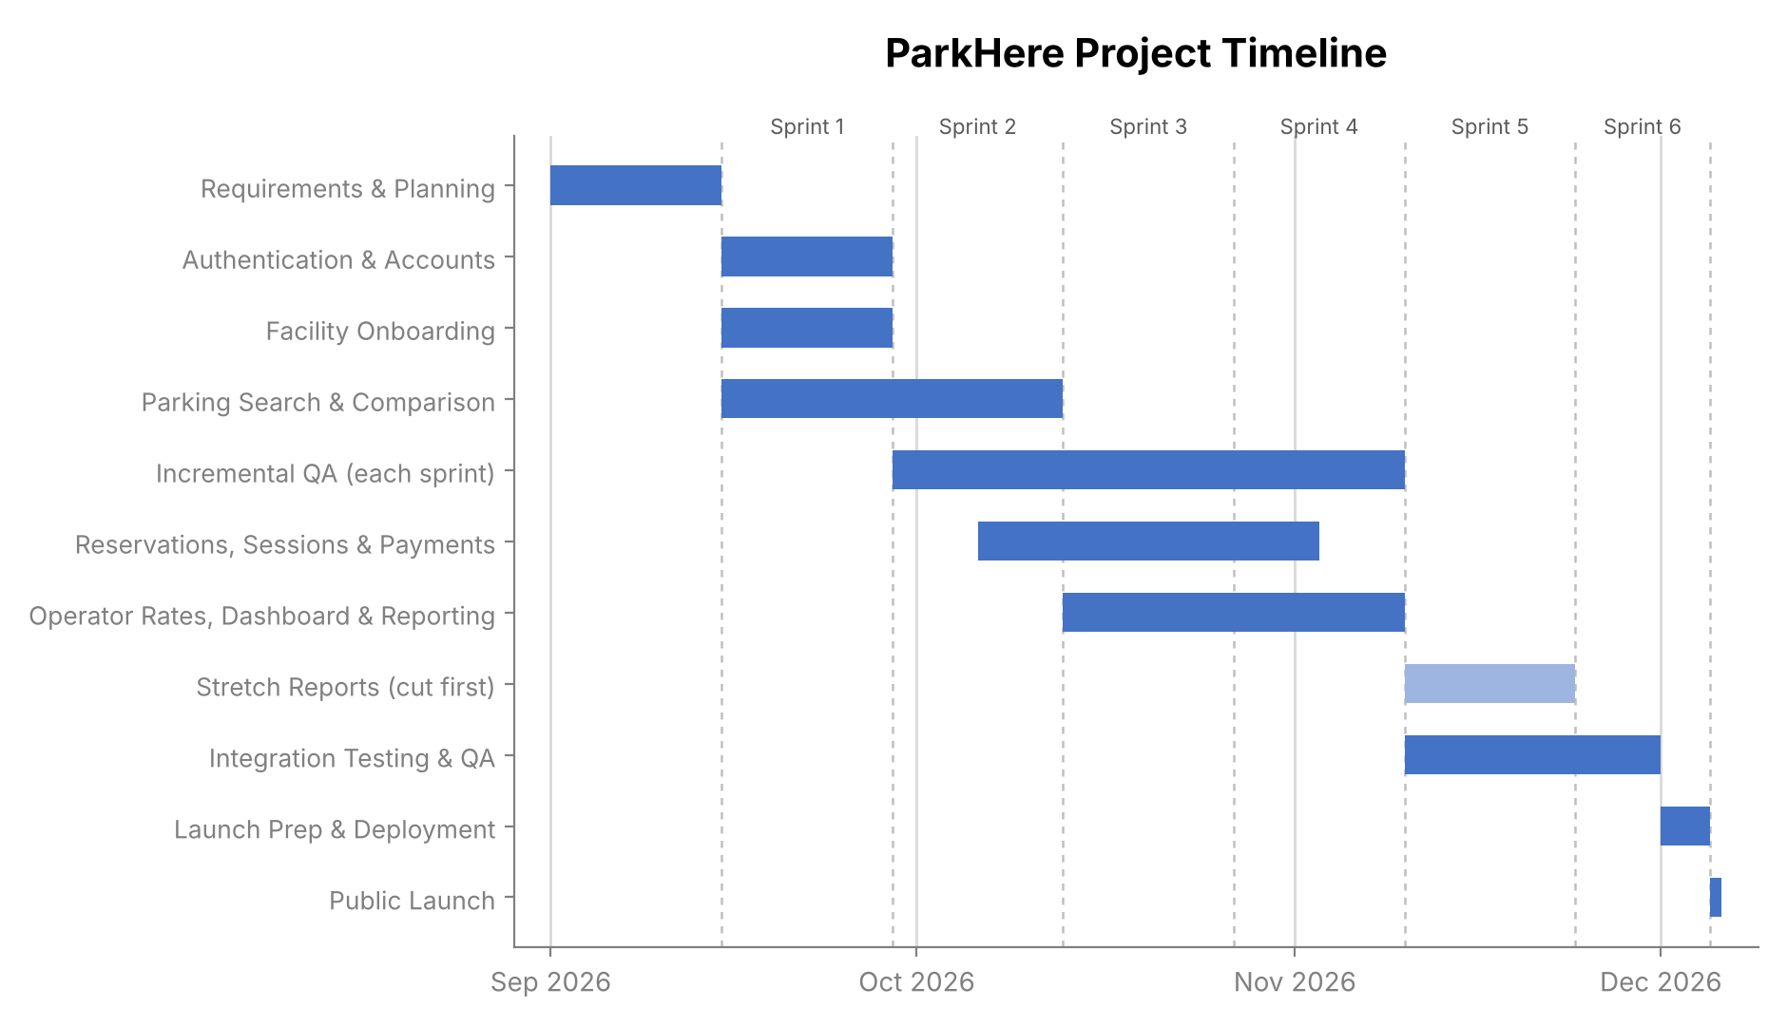
Figure 1. ParkHere project timeline (Gantt chart) with sprint boundaries, updated in version 0.6. The lighter bar is stretch work.

11. Product Backlog and Sprint Plan (Trello)
The backlog was built in Trello and organized into the four categories required for this assignment (Login, UI, Backend, Reporting), with items drawn from the use cases in Section 8 and the work breakdown structure in Section 9. The two screenshots below show that board as it stood at version 0.3, with 52 cards and Sprint 1 selected. The board itself has not been updated for version 0.6, so the tables in 11.1 and 11.2 are the current backlog and sprint plan, and they take priority over the screenshots wherever the two differ.
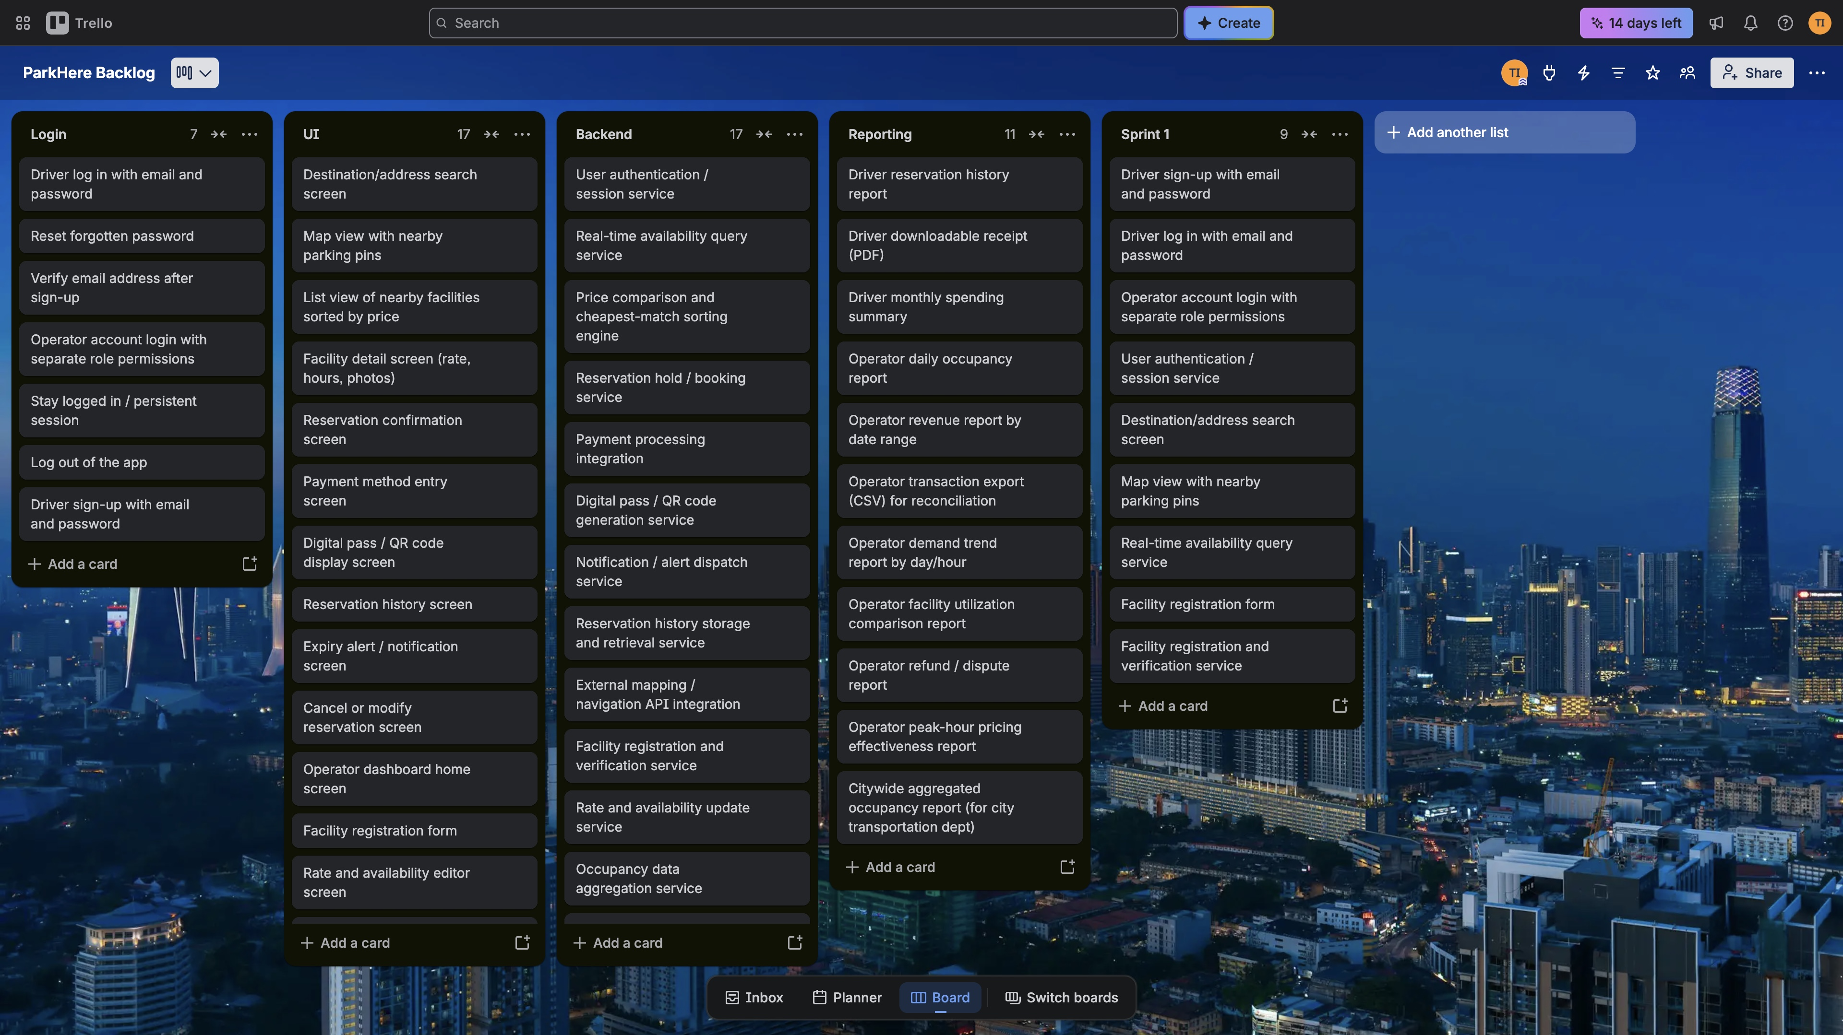
Figure 2. ParkHere product backlog board in Trello at version 0.3 (Login, UI, Backend, Reporting, Sprint 1), part 1 of 2.
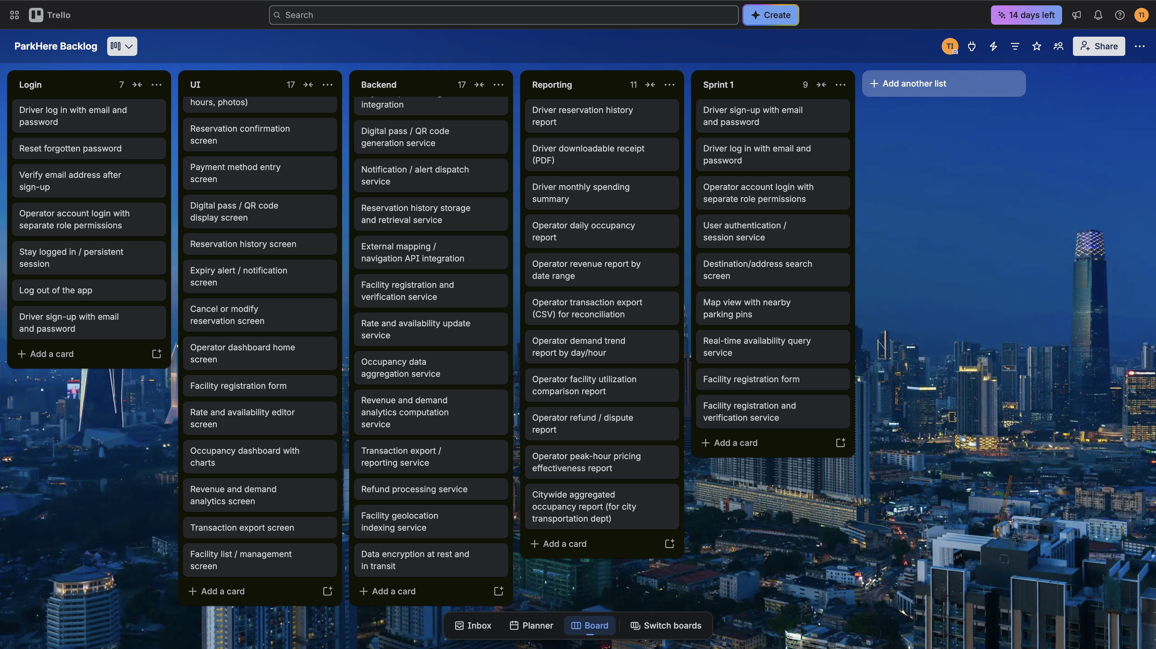
Figure 3. ParkHere product backlog board in Trello at version 0.3, continued (part 2 of 2).

11.1 Backlog Changes Since Version 0.3
Eight cards were added and one was renamed, which takes the backlog from 52 to 60 cards: Login 7, UI 21, Backend 21, and Reporting 11. Each added card covers a use case, requirement, or risk response that had no card.
Change | List | Card | Reason
Added | UI | Filter and sort controls | UC-05 had no card.
Added | UI | Start and extend metered session screen | UC-09 and UC-10 (WBS 3.2) had no card.
Added | Backend | Metered session service | Backend for UC-09 and UC-10.
Added | UI | Data freshness indicator | NFR-05 and risk R02.
Added | Backend | Availability data freshness check and stale flag | NFR-05 and risk R02.
Added | Backend | Load and performance test suite | NFR-03, risk R05, and WBS 5.1.
Added | Backend | Uptime monitoring and alerting | NFR-02 and risk R14.
Added | UI | Operator refund and dispute review screen | UC-21 and risk R15. The refund report and service already existed.
Renamed | Reporting | “Citywide aggregated occupancy report (for city transportation dept)” is now “Downtown-wide aggregated occupancy report” | Section 2 shows ParkHere is a Software Corp project with no city transportation department behind it.

11.2 Sprint Plan
Work is organized into six two-week sprints that follow the Section 10 schedule. Sprint 6 is shorter, November 24 to December 4, because of Thanksgiving, and takes no new cards.
Sprint | Dates | Goal | Cards | What is in it
1 | Sep 15 to Sep 28 | A driver can sign up, sign in, and see nearby parking. An operator can register a facility. | 13 | Login: all 7 cards. UI: search screen, map view, facility registration form. Backend: authentication and session service, availability query, facility registration and verification.
2 | Sep 29 to Oct 12 | A driver can compare, filter, and open facilities. Search stays fast and data stays fresh. | 9 | UI: list view by price, facility detail, filter and sort controls, data freshness indicator. Backend: price comparison engine, mapping and navigation API, geolocation indexing, data encryption, availability freshness check.
3 | Oct 13 to Oct 26 | A driver can reserve, pay, and start or extend a session. Operators can manage rates and availability. | 13 | UI: reservation confirmation, payment method entry, digital pass display, start and extend session, operator dashboard home, rate and availability editor, facility list. Backend: reservation hold and booking, payment integration, digital pass generation, metered session service, rate and availability update, occupancy aggregation.
4 | Oct 27 to Nov 9 | Reservation history, alerts, and cancellation. Operator reports and refund review. | 18 | UI: reservation history, expiry alerts, cancel or modify, occupancy dashboard, revenue and demand analytics, transaction export, refund review. Backend: notification dispatch, reservation history service, revenue analytics service, transaction export service, refund processing. Reporting: driver reservation history, driver receipt, operator daily occupancy, operator revenue, operator transaction export, operator refund and dispute.
5 | Nov 10 to Nov 23 | Load and uptime checks, then stretch reports if time allows. | 7 | Backend: load and performance test suite, uptime monitoring and alerting. Stretch reports (cut first): driver monthly spending summary, operator demand trend, facility utilization comparison, peak-hour pricing effectiveness, downtown-wide occupancy.
6 | Nov 24 to Dec 4 | Fix defects, build the release candidate, deploy, and launch. | 0 | No new cards. Defects, release candidate, deployment, and launch.
Total |  |  | 60

Three scheduling choices are worth stating. Sprint 1 grew from the original nine cards to thirteen, because the other four login cards (reset password, email verification, persistent session, log out) are small and belong with the sign-in flow. The five stretch reports sit in Sprint 5, after the core operator reports in Sprint 4, so they are the first thing cut if integration testing needs the time. Within Sprint 4, the reservation cards (cancel or modify, expiry alerts, history, and refunds) are due by November 2, the end of the Reservations phase, and the operator reporting cards run to November 9.

12. Risk Management

12.1 Risk Identification
Risks below are grouped into the four required categories, with at least four risks identified per category based on ParkHere's actual architecture and schedule from Sections 9 and 10. Risks R21 to R23 were added in version 0.6, after the staffing, schedule, and non-functional requirements were tightened. Risk R24 was added in version 0.7 after the stakeholder analysis in Section 17.
Technical Risks
- Third-party mapping/navigation API outage or rate limiting disrupts search results.
- Facility occupancy data becomes inaccurate if a facility's reporting integration lags or fails.
- Payment integration fails to meet PCI-DSS requirements before launch.
- Price comparison engine returns incorrect cheapest-match results due to a sorting bug.
- System cannot sustain 1,000 concurrent users under real load.
- Search and comparison results take longer than the 3 second target (NFR-01) as data and traffic grow.
Schedule Risks
- Reservations & Payments phase overruns its 4-week estimate.
- Operator Dashboard work is blocked waiting on Backend/API completion.
- Integration Testing surfaces major defects late, threatening the Dec 5 launch.
- Stakeholders request new features mid-sprint (scope creep).
- Thanksgiving break reduces available working days right before QA.
- Stretch reports compete with defect fixing in the final sprints.
- App store review takes longer than the days left before the December 5 launch.
Financial Risks
- Payment processing/PCI compliance costs exceed budget assumptions.
- Third-party API costs (mapping, notifications) scale faster than expected with usage.
- A stretched timeline drives added development cost.
- Infrastructure/hosting costs are underestimated relative to the uptime and concurrency requirements.
- Refund and dispute volume is higher than planned, raising processing costs.
People Risks
- Single PM is a point of failure with no backup decision-maker.
- Turnover on the Payment Integration team delays that component.
- Miscommunication between Mobile/Web teams and Backend/API team over shared API contracts.
- Parking operators are slow to provide onboarding data, blocking facility registration.
- New team members ramping up mid-project need onboarding time not budgeted in the schedule.
- A specialist rolls off the project before integration testing finishes, leaving defects in their area without an owner.

12.2 Risk Register
The register below formalizes all twenty-four identified risks with probability, impact, ownership, and a response strategy, well above the ten-entry minimum. Responses for R02, R05, R08, R10, R16, R19, and R20 were updated in version 0.6 so that they point to the actual sprint, requirement, and staffing decisions.
ID | Description | Category | Prob. | Impact | Owner | Response Strategy | Status
R01 | 3rd-party mapping/navigation API outage or rate limiting disrupts search. | Technical | Med | High | Mapping & Location Team | Mitigate: fallback provider, cache recent results. | Open
R02 | Facility occupancy data inaccurate if a facility's reporting integration lags. | Technical | Med | High | Backend/API Team | Mitigate: flag data as stale after 5 minutes (NFR-05), fall back to manual updates. | Open
R03 | Payment integration fails to meet PCI-DSS requirements before launch. | Technical | Low | High | Payment Integration Team | Avoid: use a PCI-compliant processor (e.g. Stripe). | Open
R04 | Price comparison engine returns incorrect cheapest-match results. | Technical | Med | Med | Backend/API Team | Mitigate: automated tests on sorting edge cases. | Open
R05 | System cannot sustain 1,000 concurrent users under real load. | Technical | Med | High | Backend/API Team | Mitigate: load and performance suite in Sprint 5 (NFR-03), design for horizontal scaling. | Open
R06 | Reservations & Payments phase overruns its 4-week estimate. | Schedule | Med | High | Project Manager | Mitigate: track vs. Gantt weekly, reallocate early. | Open
R07 | Operator Dashboard blocked waiting on Backend/API completion. | Schedule | Med | Med | Project Manager | Mitigate: freeze API contracts early, build against a stub. | Open
R08 | Integration Testing surfaces major defects late, threatens Dec 5 launch. | Schedule | Med | High | QA & Testing Team | Mitigate: QA tests each component every sprint from Sep 29, not only at the end. | Open
R09 | Stakeholders request new features mid-sprint (scope creep). | Schedule | High | Med | Project Manager | Mitigate: change-control process, queue for a future sprint. | Open
R10 | Thanksgiving break reduces working days right before QA. | Schedule | High | Low | Project Manager | Accept: Sprint 6 is short and takes no new cards. | Open
R11 | Payment/PCI compliance costs exceed budget assumptions. | Financial | Low | Med | Project Manager | Mitigate: confirm processor pricing in writing upfront. | Open
R12 | 3rd-party API costs scale faster than expected with usage. | Financial | Med | Med | Project Manager | Monitor: usage alerts, review vendor invoices monthly. | Open
R13 | A stretched timeline drives added development cost. | Financial | Med | Med | Project Manager | Mitigate: tie schedule extension to explicit budget review. | Open
R14 | Infrastructure/hosting costs underestimated vs. uptime/concurrency NFRs. | Financial | Med | Med | Backend/API Team | Mitigate: benchmark hosting cost against NFR targets first. | Open
R15 | Refund/dispute volume higher than planned, raising processing cost. | Financial | Low | Low | Project Manager | Accept: monitor via the refund/dispute report. | Open
R16 | Single PM is a point of failure with no backup decision-maker. | People | Med | High | Project Manager | Mitigate: document decisions; Wei Chen is the named backup (Section 14). | Open
R17 | Turnover on the Payment Integration team delays that component. | People | Low | High | Payment Integration Team | Transfer: rely on processor docs/support over tribal knowledge. | Open
R18 | Miscommunication between Mobile/Web and Backend/API over API contracts. | People | Med | Med | Project Manager | Mitigate: freeze API contracts before frontend work starts. | Open
R19 | Operators slow to provide onboarding data, blocks facility registration. | People | Med | High | Project Manager | Mitigate: data deadline before Sep 15 in the onboarding agreement, plus weekly check-ins. | Open
R20 | New team members ramping up need unbudgeted onboarding time. | People | Med | Med | Project Manager | Mitigate: onboarding checklist and a ramp-up buffer in the first sprint. | Open
R21 | A specialist rolls off before integration testing, leaving defects in their area without an owner. | People | Med | Med | Project Manager | Mitigate: mapping lead and payment lead stay through Nov 30 (Section 14). | Open
R22 | Search and comparison results exceed the 3 second target (NFR-01). | Technical | Med | Med | Backend/API Team | Mitigate: cache recent results, check response time every sprint. | Open
R23 | Stretch reports compete with defect fixing in the final sprints. | Schedule | Med | Low | Project Manager | Avoid: cut stretch reports first. | Open
R24 | App store review takes longer than the days left before the Dec 5 launch. | Schedule | Med | High | Mobile Application Team | Mitigate: follow store guidelines from Sprint 1 and submit the release candidate on Dec 1. | Open

13. Communication Plan

13.1 Meeting Cadence
- Mobile Application Team: daily 15-minute standup.
- Web Application Team: daily 15-minute standup.
- Backend/API Team: daily 15-minute standup.
- Mapping & Location Services Team: twice-weekly sync (Tue/Thu).
- Payment Integration Team: weekly sync, plus ad hoc compliance/security reviews.
- QA & Testing Team: daily standup from September 29, when the QA lead joins; joins sprint review and retro.
- Cross-team Sprint Review & Retrospective: end of each two-week sprint (Sep 28, Oct 12, Oct 26, Nov 9, Nov 23), and Dec 4 for the shorter final sprint.
- Stakeholder/Sponsor Update: weekly, the same cadence as this project's required weekly video update, including spend against the Section 15 baseline.
- PM 1:1s with team leads: weekly.
- Partner operator check-ins: weekly during Sprints 1 and 2, to confirm facility data is on track (risk R19).
- Stakeholder review: the PM revisits the stakeholder analysis (Section 17) at each sprint review and updates the scores if a stakeholder's power or interest has changed.

13.2 Reporting Methods
- Daily standups: verbal status in the team channel; blockers escalated immediately to the PM.
- Sprint burndown: tracked directly from the Trello board (Section 11).
- Weekly written status report: sent to stakeholders, covering scope, schedule, budget against the baseline, and top risks.
- Change requests: any request that changes scope, schedule, or budget is logged by the PM and decided by the executive sponsor, who is accountable for budget (Section 16).
- Risk register: reviewed and updated weekly by the PM; new high-impact risks are called out in the status report.
- Escalation path: critical blockers go to the PM immediately, who relays them to the affected team lead within one business day. Anything that threatens the December 5 launch or the contingency reserve goes to the executive sponsor.

14. Roles and Resources
ParkHere is staffed by one project manager and the six teams already named in the Communication Plan. Names are fictional and skill levels are planning assumptions. Allocation is the share of a full-time schedule a person spends on ParkHere while they are on the project. People join when their part of the work starts in the Section 10 schedule instead of all starting on day one, so the active window column shows each person's first and last day.

14.1 Team Roster and Allocation
Role | Name | Team | Skill level | Allocation | Active window
Project Manager | Temi Ilori | Project Management | Senior | 100% | Sep 1 to Dec 4
Lead Mobile Developer | Daniel Reyes | Mobile Application | Senior | 100% | Sep 15 to Dec 4
Mobile Developer | Priya Nair | Mobile Application | Mid | 100% | Sep 15 to Dec 4
Lead Web Developer | Sofia Marlowe | Web Application | Senior | 100% | Sep 15 to Dec 4
Web Developer | Jamal Carter | Web Application | Mid | 100% | Sep 15 to Dec 4
Lead Backend Engineer | Wei Chen | Backend/API | Senior | 100% | Sep 15 to Dec 4
Backend Engineer | Amara Obi | Backend/API | Mid | 100% | Sep 15 to Dec 4
Backend Engineer | Luis Ortega | Backend/API | Junior | 100% | Oct 6 to Dec 4
Mapping & Location Engineer | Hannah Brooks | Mapping & Location Services | Senior | 75% | Sep 15 to Nov 30
Mapping & Location Developer | Tomas Vega | Mapping & Location Services | Mid | 50% | Sep 15 to Oct 12
Payment Integration Lead | Omar Haddad | Payment Integration | Senior | 75% | Oct 6 to Nov 30
Payment Integration Developer | Grace Liu | Payment Integration | Mid | 50% | Oct 6 to Nov 2
QA Lead | Ruth Adeyemi | QA & Testing | Senior | 100% | Sep 29 to Dec 4
QA Engineer | Ben Foster | QA & Testing | Mid | 100% | Oct 13 to Dec 4

14.2 Assumptions
For skill levels, Senior means 7 or more years of professional experience, works independently, and mentors others. Mid means 3 to 6 years and works independently on well-defined tasks. Junior means 0 to 2 years and needs regular review and guidance.
Start and end dates follow the phases in Section 10. Until September 14 only the project manager is on the project, since that phase is requirements and planning. The Mobile, Web, and Backend teams start on September 15 with Authentication and Search. Mapping starts the same day. The mapping lead stays through November 30 to fix location-related defects found in integration testing, but the second mapping developer is only needed for Search, which ends October 12. The Payment team starts October 6 with the Reservations, Sessions and Payments phase, and the payment lead stays through November 30 to support PCI work and integration testing. The QA lead starts September 29, the day after Authentication wraps up, and the second QA engineer starts October 13 when the Operator Dashboard phase begins. The junior backend engineer also joins October 6, which is part of why ramp-up time shows up as risk R20. Mapping and Payment people are part time (75% and 50%) because that specialist work is only needed in certain phases.
Wei Chen is the backup decision-maker if the project manager is unavailable, which is the mitigation for risk R16. Each team lead meets the project manager one on one every week (Section 13), which is how decisions stay documented. Keeping the mapping and payment leads through November 30 is the response to risk R21, specialists rolling off before integration testing ends.

14.3 External Stakeholders
Two groups outside the project team are not costed in Section 15, but the plan depends on both of them. They are two of the ten stakeholders in the analysis in Section 17.
Stakeholder | Role in ParkHere | Involvement
Executive sponsor (Software Corp leadership) | Funds the project and approves changes to scope, schedule, or budget. | Weekly update. Accountable for budget and the launch go/no-go decision (Section 16).
Partner garage operators (the two independent operators from Section 2.1) | Supply facility data and use the operator dashboard. | Weekly check-ins in Sprints 1 and 2 (Section 13). Facility data due before September 15 (risk R19).

15. Resource and Cost Plan

15.1 Approach
This is a bottom-up cost plan. Each person is costed from the hours they are on the project and an hourly rate, and non-labor costs are added line by line. Software Corp is funding ParkHere internally, so this plan works as the budget request to leadership and as the baseline to track actual spend against.
Rates are blended, fully loaded hourly figures of $85 (Project Manager), $95 (Senior), $70 (Mid), and $50 (Junior). I assumed about 30 percent on top of salary for benefits and overhead and a 2,080 hour year, which puts the salaries behind these rates at roughly $136,000 for the project manager, $152,000 for Senior, $112,000 for Mid, and $80,000 for Junior. For comparison, the Bureau of Labor Statistics reports May 2025 median pay of $135,980 for software developers and $102,320 for project management specialists. Hours assume eight-hour days, weekdays only, excluding Labor Day (September 7) and Thanksgiving (November 26 and 27). That gives 66 working days across the project, which is 21 in September, 22 in October, 19 in November, and 4 in December. A person's hours are their working days in their active window times 8 times their allocation. A 10% contingency reserve sits on top of labor and non-labor costs and is meant to cover schedule risk R06 and financial risks R11 through R14.

15.2 Labor Cost by Role
Role | Rate | Allocation | Working days | Hours | Labor cost
Project Manager (Temi Ilori) | $85/hr | 100% | 66 | 528 | $44,880
Lead Mobile Developer (Daniel Reyes) | $95/hr | 100% | 57 | 456 | $43,320
Mobile Developer (Priya Nair) | $70/hr | 100% | 57 | 456 | $31,920
Lead Web Developer (Sofia Marlowe) | $95/hr | 100% | 57 | 456 | $43,320
Web Developer (Jamal Carter) | $70/hr | 100% | 57 | 456 | $31,920
Lead Backend Engineer (Wei Chen) | $95/hr | 100% | 57 | 456 | $43,320
Backend Engineer (Amara Obi) | $70/hr | 100% | 57 | 456 | $31,920
Backend Engineer (Luis Ortega) | $50/hr | 100% | 42 | 336 | $16,800
Mapping & Location Engineer (Hannah Brooks) | $95/hr | 75% | 53 | 318 | $30,210
Mapping & Location Developer (Tomas Vega) | $70/hr | 50% | 20 | 80 | $5,600
Payment Integration Lead (Omar Haddad) | $95/hr | 75% | 38 | 228 | $21,660
Payment Integration Developer (Grace Liu) | $70/hr | 50% | 20 | 80 | $5,600
QA Lead (Ruth Adeyemi) | $95/hr | 100% | 47 | 376 | $35,720
QA Engineer (Ben Foster) | $70/hr | 100% | 37 | 296 | $20,720
Total labor |  |  |  | 4,978 | $406,910

15.3 Non-Labor Costs
Item | Sep | Oct | Nov | Dec | Total
Cloud hosting and infrastructure | $900 | $1,500 | $2,400 | $600 | $5,400
Mapping/navigation API usage | $400 | $800 | $1,200 | $300 | $2,700
Payment processor setup and test fees | $0 | $500 | $500 | $0 | $1,000
PCI-DSS compliance assessment | $0 | $0 | $4,000 | $0 | $4,000
Security penetration test | $0 | $0 | $6,000 | $0 | $6,000
Load and performance testing service | $0 | $0 | $1,500 | $0 | $1,500
Notification service (push/SMS) | $0 | $200 | $400 | $100 | $700
Dev tooling and licenses | $350 | $350 | $350 | $90 | $1,140
App store developer accounts | $0 | $124 | $0 | $0 | $124
Total non-labor | $1,650 | $3,474 | $16,350 | $1,090 | $22,564
App store fees are Apple's $99 annual developer membership and Google's one-time $25 Play Console registration. The other non-labor lines are my planning estimates, not vendor quotes. The load and performance testing service in November was added in version 0.6 for the load test in WBS 5.1 and the 1,000 user target in NFR-03.

15.4 Budgeted Monthly Cashflow
Monthly spend follows the days each person is on the project in each month. September is small because only the project manager works until the build starts on the 15th. October is the peak because several phases overlap, and December is small because the project closes with launch on December 5. The cumulative column shows the full budget at the end of the project, and the contingency column is 10% of labor plus non-labor for that month, rounded to the dollar.
Month | Labor | Non-labor | Contingency (10%) | Monthly total | Cumulative
September | $73,520 | $1,650 | $7,517 | $82,687 | $82,687
October | $165,170 | $3,474 | $16,864 | $185,508 | $268,195
November | $142,780 | $16,350 | $15,913 | $175,043 | $443,238
December | $25,440 | $1,090 | $2,653 | $29,183 | $472,421
Total | $406,910 | $22,564 | $42,947 | $472,421 | $472,421

16. RACI Matrix
R (Responsible) does the work. A (Accountable) is the single owner who signs off. C (Consulted) gives two-way input. I (Informed) gets one-way updates. A/R means the same group does the work and owns it, and a dash means not involved. Every row has exactly one Accountable. Columns are the project manager from Section 14, the six teams from Section 13, and the Software Corp executive sponsor.
Activity | PM | Mobile | Web | Backend | Mapping | Payment | QA | Sponsor
Requirements and SRS updates (WBS 6.1) | A/R | C | C | C | C | C | C | C
Backlog and sprint planning (WBS 6.1) | A/R | C | C | C | C | C | C | I
Authentication and accounts (WBS 1.0) | I | R | R | A/R | – | – | C | I
Parking search and price comparison (WBS 2.0) | I | R | R | A/R | R | – | C | C
Map and navigation integration (WBS 2.1) | I | R | R | C | A/R | – | C | I
Reservations and sessions (WBS 3.0) | I | R | R | A/R | C | C | C | I
Payment processing and PCI compliance (WBS 3.3, 5.2) | C | C | C | C | – | A/R | C | I
Operator dashboard and facility management (WBS 4.1, 4.2) | I | – | A/R | R | C | C | C | C
Operator reporting and analytics (WBS 4.3) | I | – | R | A/R | – | C | C | C
Non-functional requirements and load testing (WBS 5.1) | I | C | C | R | – | – | A/R | I
Integration testing and QA sign-off (WBS 5.1) | I | C | C | C | C | C | A/R | I
Security review and penetration test (WBS 5.2) | I | C | C | A/R | – | R | C | I
Risk register maintenance (WBS 6.2) | A/R | C | C | C | C | C | C | I
Weekly status reporting to stakeholders (WBS 6.3) | A/R | C | C | C | C | C | C | I
Partner operator data and liaison (WBS 6.3) | A/R | – | C | C | – | – | – | I
Stakeholder analysis and engagement (WBS 6.3) | A/R | I | I | I | C | C | I | C
Budget tracking and change requests (WBS 6.2) | R | I | I | C | – | C | I | A
Deployment and launch preparation (WBS 5.3) | C | R | R | A/R | I | C | C | I
Launch go/no-go decision (WBS 5.3) | R | C | C | C | C | C | C | A

17. Stakeholder Analysis
This section identifies the people and groups who affect ParkHere or are affected by it, and decides how much attention each one needs. It uses the Power–Interest Grid. Power is how much a stakeholder can change the outcome of the project, and interest is how much they care about it. Each stakeholder is scored from 1 to 10 on both and placed in one of four groups. The scores are my own judgment based on the project facts in Sections 2 to 16, not measured data.

17.1 Power–Interest Grid
The grid below plots the ten stakeholders. The line at 5 on each scale splits it into four groups, and each group gets a different approach.
- Manage closely (high power, high interest). Involve them in decisions and keep them closely informed.
- Keep satisfied (high power, low interest). Give them enough attention to keep their confidence without overloading them.
- Keep informed (low power, high interest). Give them regular updates and listen to their feedback.
- Monitor (low power, low interest). Keep contact light and watch for changes.
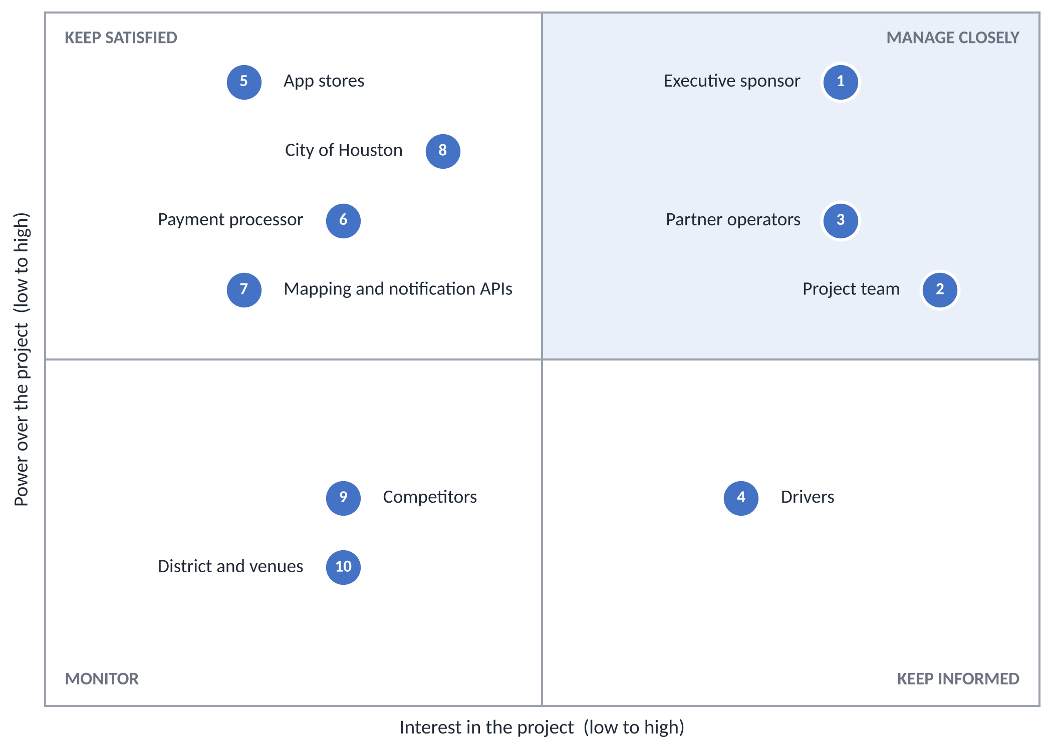
Figure 4. Power–Interest Grid for ParkHere stakeholders. The numbers match the register in 17.2.

17.2 Stakeholder Register and Engagement Plan
The register lists each stakeholder with the scores behind the grid, what they care about, how the plan engages them, and who owns the relationship. The meetings and reports named here are the ones in Section 13.
# | Stakeholder | Power / Interest | Group | What they care about | How we engage them
1 | Executive sponsor (Software Corp leadership) | 9 / 8 | Manage closely | Launching on Dec 5 within budget. Accountable for budget and the go/no-go decision (Section 16). | Weekly update with spend against the baseline. Decides every change to scope, schedule, or budget. Owner PM.
2 | Project team (the six teams and the PM) | 6 / 9 | Manage closely | Clear priorities, a workable schedule, and a fair workload. | Daily standups, sprint reviews and retrospectives, and weekly 1:1s with the team leads. Ground rules in the team charter (Section 19). Owner PM.
3 | Partner garage operators (two independent operators) | 7 / 8 | Manage closely | Filling empty spaces, and a dashboard that shows occupancy and revenue. They supply the facility data for onboarding (R19). | Weekly check-ins in Sprints 1 and 2. Facility data due before Sep 15. Their feedback shapes the dashboard. Owner PM.
4 | Drivers (commuters, event traffic, visitors) | 3 / 7 | Keep informed | The cheapest available spot, an accurate total price, and a pass that works at the gate. | Needs come from the research in Sections 4 and 6 and the user stories in 8.2. Reached through the app store listing at launch. Owner PM.
5 | Apple App Store and Google Play | 9 / 2 | Keep satisfied | Apps that follow their review rules and payment policies. | Follow store guidelines from Sprint 1. Submit the release candidate on Dec 1 so review fits before launch (R24). Owner Mobile lead.
6 | Payment processor (for example Stripe) | 7 / 3 | Keep satisfied | A compliant integration and proper use of their service. | Use a PCI-compliant processor and confirm pricing in writing up front (R03, R11). Weekly Payment team sync. Owner Payment lead.
7 | Mapping, navigation, and notification providers | 6 / 2 | Keep satisfied | Usage within their limits and terms. | Usage alerts and a monthly invoice review (R12), plus a fallback provider (R01). Owner Mapping lead.
8 | City of Houston and the ParkHouston program | 8 / 4 | Keep satisfied | On-street meter zones and rates. ParkHouston is also a competitor (Section 4). | Confirm where on-street zone and rate data come from before the metered session cards in Sprint 3 (UC-09). Watch for policy changes. Owner PM.
9 | Competing parking apps (SpotHero, ParkWhiz, Parking.com) | 3 / 3 | Monitor | Their own market share. They may change prices or features. | Monitor only. The PM raises a change request if a competitor's move affects scope. Owner PM.
10 | Downtown Houston District and event venues | 2 / 3 | Monitor | Visitor parking information and event-day traffic. | Monitor only. Matters most if event-aware pricing (Section 5.2) moves into scope. Owner PM.

18. Project Charter
The project charter is a one-page agreement between the executive sponsor and the project manager. It states why ParkHere exists, what it will deliver, when, and for how much, and who can decide what. Its figures come from Sections 2, 7, 10, 12, and 15. A copy is also saved as a PDF in the project repository.
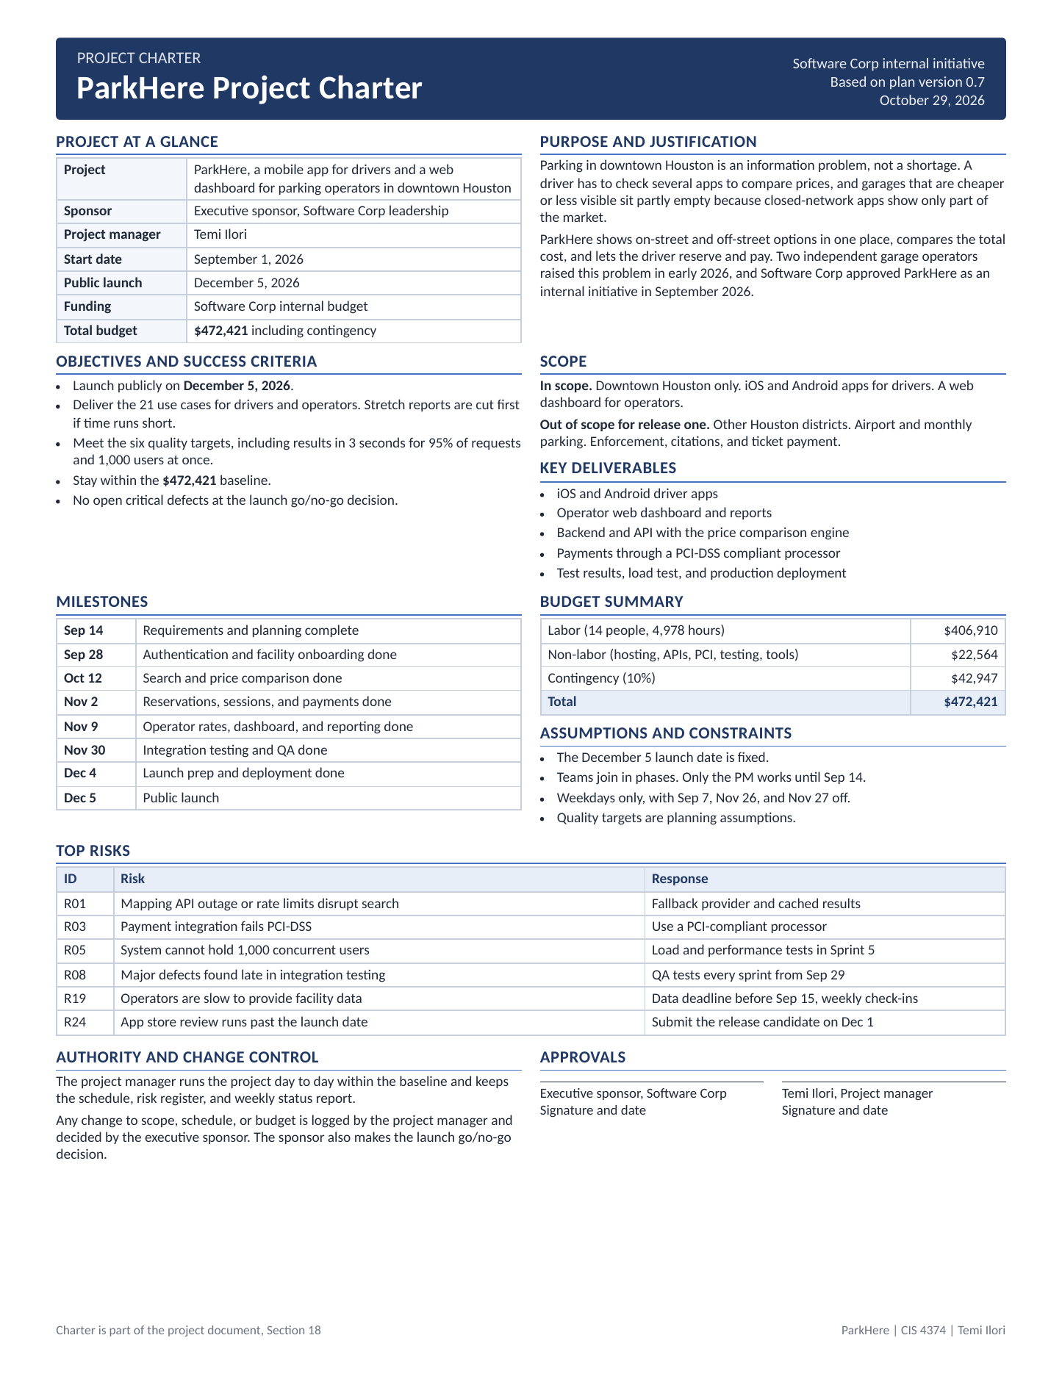
Figure 5. ParkHere project charter.

19. Team Charter
The team charter is the team's working agreement. It names the 14 people, how they meet and decide, how they handle disagreement, and what counts as done. Its content comes from Sections 13, 14, and 16. A copy is also saved as a PDF in the project repository.
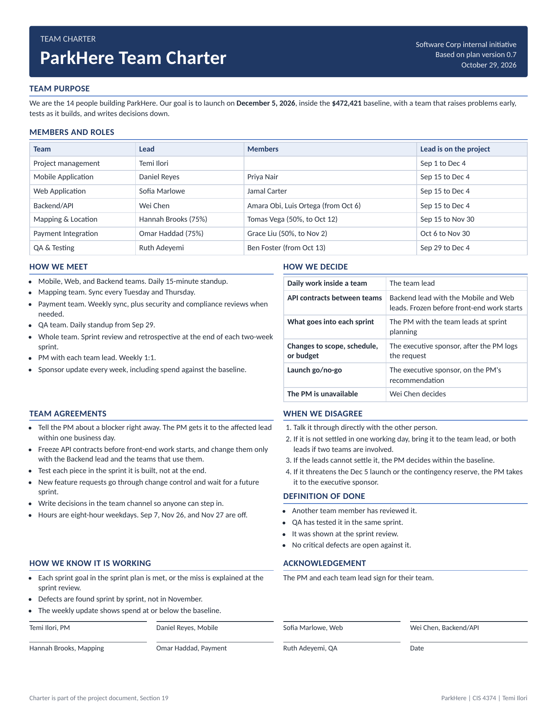
Figure 6. ParkHere team charter.

20. Document Revision History
Version | Date | Summary of changes | Author
0.1 | Sept 10, 2026 | Initial draft. Vision and scope including project origin and company introduction, problem statement, existing software landscape, differentiation, target users, scope boundaries, and eighteen draft use cases. | T. Ilori
0.2 | Sept 15, 2026 | Added Work Breakdown Structure (Section 9) and a draft project timeline with Gantt chart (Section 10). | T. Ilori
0.3 | Sept 22, 2026 | Added product backlog (Login, UI, Backend, Reporting) and Sprint 1 plan built in Trello, included as Section 11. | T. Ilori
0.4 | Sept 29, 2026 | Added Risk Management (Section 12: risk identification and risk register) and Communication Plan (Section 13). | T. Ilori
0.5 | Oct 8, 2026 | Added Roles and Resources (Section 14), Resource and Cost Plan with monthly cashflow (Section 15), and RACI matrix (Section 16). Staffing and cost are phased to the Section 10 schedule. | T. Ilori
0.6 | Oct 13, 2026 | Updated the whole plan for consistency. Added user stories and non-functional requirements and three use cases (Section 8), expanded the WBS to six components (Section 9), rebuilt the timeline and Gantt chart (Section 10), replaced the sprint plan with six sprints and a 60-card backlog (Section 11), added risks R21 to R23 and updated seven responses (Section 12), and updated the communication plan, roles, cost plan, and RACI matrix (Sections 13 to 16). Total budget is now $472,421. Reasons for each change are in 20.1. | T. Ilori
0.7 | Oct 29, 2026 | Added the stakeholder analysis with a Power–Interest Grid (Section 17), the project charter (Section 18), and the team charter (Section 19). Added risk R24 and a RACI row for stakeholder engagement, and updated the purpose, definitions, WBS task lists, communication plan, and Section 14.3 to match. The budget is unchanged at $472,421. Revision history and sources are now Sections 20 and 21. Reasons for each change are in 20.2. | T. Ilori

20.1 Reasons for Changes in Version 0.6
This table records what changed in this version and what led to each decision.
Section | Change | Why
1 | Purpose rewritten for the whole plan. Definitions added for WBS, RACI, user story, NFR, PCI-DSS, and sprint. | The document had grown past requirements into a project plan, and later sections use these terms.
8 | Use cases grew from 18 to 21. User stories (21) and non-functional requirements (6) added. | The WBS and backlog had password reset, operator sign-in, and refund review with no use case. The 3 second, 1,000 user, and 5 minute figures were in the risks but never stated as requirements.
9 | Added 5.0 Testing, Security & Launch and 6.0 Project Management. Five existing task lists extended. | Testing, PCI, penetration test, deployment, and project management were scheduled and costed but not in the WBS.
10 | Phase table now lists the WBS component and has 11 rows. Gantt redrawn with sprint boundaries. | Facility Onboarding moved to Sep 15 (R19). Incremental QA starts Sep 29 (R08). Stretch reports are separate so they can be cut (R23).
11 | Backlog 52 to 60 cards. Six-sprint plan added. Trello screenshots labeled as version 0.3. | The board was not updated, so the tables are the current record. Each added card traces to a use case, NFR, or risk.
12 | Risks R21 to R23 added. Responses updated for R02, R05, R08, R10, R16, R19, R20. R19 impact raised to High and R20 probability to Med. | Responses now match the sprints, NFRs, and staffing. R19 matters more because onboarding now starts in Sprint 1.
13 | QA standup from Sep 29, sprint review dates, spend against baseline, partner operator check-ins, change request rule, escalation to the sponsor. | Matches the new sprint dates and the accountabilities in Section 16.
14 | Mapping lead extended to Nov 30. 14.3 External Stakeholders added. | Integration testing runs to Nov 30 and location defects need an owner (R21). The sponsor and partner operators are not costed but needed to be named.
15 | Labor up $10,260 and non-labor up $1,500 (load testing). Contingency up $1,176. Total from $459,485 to $472,421. | The extra mapping lead hours and the load test service are the only cost changes. All monthly figures were recomputed.
16 | Three rows added (load testing, security review, partner operator liaison). WBS labels added to every row. | Each activity now matches a WBS component. Every row still has one Accountable.
Title page, 20 | Date set to October 13, 2026. Version 0.6 added to the revision history. | Version control.

20.2 Reasons for Changes in Version 0.7
This table records what changed in this version and what led to each decision. Nothing in the cost plan changed.
Section | Change | Why
Title page, 1 | Date set to October 29, 2026. The purpose names Sections 17 to 19, and three terms were added to the definitions (stakeholder, Power–Interest Grid, charter). | The document describes its own contents, so it has to list the new sections.
9 | WBS 6.1 now lists the project and team charters. WBS 6.3 now lists the stakeholder analysis. | This is project management work that was missing from the task lists. There is no cost change because the project manager is already costed full time.
12 | Risk R24 added, for 24 risks in total. | The app stores are a high-power stakeholder and submission is planned for Dec 1 to 4, one day before launch. A slow review could push the launch.
13 | Stakeholder review added to the meeting cadence. | Keeps the analysis current as power and interest change.
14 | Section 14.3 points to the stakeholder analysis. | The two groups named there are two of the ten stakeholders.
16 | New RACI row for stakeholder analysis and engagement, for 19 rows. | Every activity in the WBS should have an owner. The PM is accountable and the sponsor is consulted.
17 to 19 | Stakeholder analysis, project charter, and team charter added. | This week's assignment. The charters reuse the dates, budget, and roster already in Sections 10, 14, and 15.
20, 21 | Revision history and sources renumbered. Two sources added. | The new sections were inserted before them.

21. Sources Consulted
- ParkMobile, ParkHouston program and Houston parking pages, parkmobile.io.
- ParkHouston listing and public user reviews, Apple App Store.
- SpotHero downtown Houston destination pages, spothero.com.
- Downtown Houston district parking and navigation page, downtownhouston.org.
- U.S. Bureau of Labor Statistics, Occupational Outlook Handbook, Software Developers, Quality Assurance Analysts, and Testers, bls.gov.
- U.S. Bureau of Labor Statistics, Occupational Outlook Handbook, Project Management Specialists, bls.gov.
- Apple Developer Program membership fee, developer.apple.com.
- Google Play Console developer registration fee, support.google.com/googleplay.
- Mendelow power-interest matrix (Aubrey Mendelow, 1991), mutomorro.com/tools/mendelow-power-interest-matrix.

