ANALYSIS OF THE IMPACT OF DIGITAL MARKETING IN SALES PERFORMANCE IN ECOMMERCE SMEs IN LAGOS, NIGERIA

BY

ALABI, FAITH FIYINFOLUWA
(21CH029943)

A PROJECT PROPOSAL SUBMITTED TO THE
DEPARTMENT OF COMPUTER AND INFORMATION SCIENCES, COLLEGE OF SCIENCE AND TECHNOLOGY, COVENANT UNIVERSITY OTA, OGUN STATE.

IN PARTIAL FULFILMENT OF THE REQUIREMENTS FOR THE AWARD OF THE BACHELOR OF SCIENCE
(HONOURS) DEGREE IN COMPUTER SCIENCE.

JUNE, 2025

CERTIFICATION
I hereby certify that this project was carried out by Alabi Faith Fiyinfoluwa in the Department of Computer and Information Sciences, College of Science and Technology, Covenant University, Ogun State, Nigeria, under my supervision.

Dr. Jonathan Oluranti ___________________________
Supervisor Signature and Date

Prof. Atinuke A. Oni ___________________________
Head of Department Signature and Date

DEDICATION
I thank God Almighty for His guidance, protection, grace, strength, courage, and provision throughout this project. I want to also express gratitude to my parents, Dr. and Dr Mrs. Paul Alabi, who have dedicated their lives to supporting me in every conceivable way.

ACKNOWLEDGEMENTS
First and foremost, I thank God, as He has taken all through my journey to completion of this work. I also want to thank my family, Dr and Dr Mrs. Alabi and my brother Zion for their unwavering provision and support. Likewise, I am thankful to Dr. Oluranti Jonathan, my supervisor, for his direction and oversight in this project and the head of the Department of Computer and Information Science, Professor Aderonke Oni for her guidance.

TABLE OF CONTENTS
CONTENT PAGES
CERTIFICATION ii
DEDICATION iii
ACKNOWLEDGEMENTS iv
TABLE OF CONTENTS v
LIST OF FIGURES viii
LIST OF TABLES x
ABBREVIATIONS xi
ABSTRACT xii
CHAPTER ONE: INTRODUCTION 1
INTRODUCTION 1
1.1 Background of the Study 1
1.2 Statement of the Problem 2
1.3 Research Questions 3
1.4 Research Hypothesis 3
1.5 Aim and Objectives of the Study 3
1.6 Methodology 4
1.7 Significance of the Study 5
1.8 Limitations of the Study 5
1.9 Operational Definition of Terms 5
1.10 Project Outline 7
CHAPTER TWO: LITERATURE REVIEW 8
2.1 Preamble 8
2.2 Traditional and Digital Marketing 8
2.2.1 Traditional Marketing 8
2.2.2 Digital Marketing 9
2.3 Digital Marketing in E-Commerce 10
2.3.1 Strategies of Digital Marketing 11
2.3.2 Digital Marketing and Sales Performance 14
2.3.3 Sales Performance Metrics 14
2.4 Small and Medium Businesses 16
2.5 Review of Related Works 17
2.6 Challenges of Digital Marketing in Small and Medium Businesses 18
2.7 Theoretical Review 18
2.7.1 Information System Success Model 18
2.7.2 Unified Theory of Acceptance and Usage of Technology 21
2.7.3 Integration of ISSM and UTAUT 24
2.8 Theoretical Implications 25
2.9 Summary of Findings 26
CHAPTER THREE: METHODOLOGY 27
3.1 Preamble 27
3.2 Conceptual Framework 27
3.3 Research Approach 37
3.4 Research Design 37
3.4.1 Study population and sampling 38
3.5 Data Collection 38
3.5.1 Method of collection 39
CHAPTER FOUR: RESULTS AND DISCUSSION 40
4.1 Preamble 40
4.2 Descriptive Statistics 40
4.2.1 Information Quality 40
4.2.2 System Quality 42
4.2.3 Service Quality 43
4.2.4 User Satisfaction 44
4.2.5 System Use 45
4.2.6 Behavioural Intention 47
4.2.7 Net Benefits 48
4.2.8 Performance Expectancy 49
4.2.9 Effort Expectancy 50
4.2.10 Social Influence 52
4.2.11 Conversion Rate 53
4.2.12 Customer Acquisition Cost 55
4.2.13 Competitive Advantage 56
4.2.14 Return of Advertising Spend 57
4.2.15 Engagement Metrics 59
4.2.16 Facilitating Conditions 60
4.3 Measurement Model 61
4.3.1 Outer Loadings 61
4.3.2 Indicator Reliability 63
4.3.3 Discriminant Validity 63
4.4 Structural Model 64
4.4.1 Hypothesis Table 66
4.4.2 Coefficients of Determination 68
4.5 Discussion 68
CHAPTER FIVE: SUMMARY, CONCLUSION AND RECOMMENDATIONS 71
5.1 Summary 71
5.2 Conclusion 72
5.3 Recommendations 72
REFERENCES 74
APPENDIX 78

LIST OF FIGURES

FIGURE | TITLE OF FIGURE | PAGES
‎2.1 | ISSM Model | 21
2.2 | UTAUT Model | 24
‎3.1 | Conceptual Framework | 31
‎4.1 | Frequency of Information Quality Question 1 | 41
‎4.2 | Frequency of Information Quality Question 2 | 41
4.3 | Frequency of Information Quality Question 3 | 41
4.4 | Frequency of System Quality Question 1 | 42
‎4.5 | Frequency of System Quality Question 2 | 42
‎4.6 | Frequency of System Quality Question 3 | 43
‎4.7 | Frequency of Service Quality Question 1 | 43
‎4.8 | Frequency of Service Quality Question 2 | 44
4.9 | Frequency of Service Quality Question 3 | 44
4.10 | Frequency of User Satisfaction Question 1 | 45
‎4.11 | Standard Deviation of User Satisfaction Question 1 | 45
‎4.12 | Frequency of User Satisfaction Question 1 | 46
4.13 | Frequency of User Satisfaction Question 3 | 46
‎4.14 | Frequency of User Satisfaction Question 2 | 46
‎4.15 | Frequency of User Satisfaction Question 1 | 47
‎4.16 | Frequency of Behavioural Intention Question 1 | 47
‎4.17 | Frequency of Behavioural Intention Question 3 | 48
‎4.18 | Frequency of Net Benefits Question 1 | 48
‎4.19 | Frequency of Net Benefits Question 3 | 49
‎4.20 | Frequency of Net Benefits Question 2 | 49
4.21 | Frequency of Performance Expectancy Question 3 | 50
‎4.22 | Frequency of Performance Expectancy Question 2 | 50
‎4.23 | Frequency of Performance Expectancy Question 1 | 50
‎4.24 | Frequency of Effort Expectancy Question 1 | 51
‎4.25 | Frequency of Effort Expectancy Question 2 | 51
‎4.26 | Frequency of Effort Expectancy Question 3 | 52
‎4.27 | Frequency of Social Influence Question 1 | 52
4.28 | Frequency of Social Influence Question 3 | 53
4.29 | Frequency of Social Influence Question 2 | 53
4.30 | Frequency of Conversion Rate Question 1 | 54
‎4.31 | Frequency of Conversion Rate Question 2 | 54
‎4.32 | Frequency of Conversion Rate Question 3 | 54
4.33 | Frequency of Customer Acquisition Cost Question 1 | 55
4.34 | Frequency of Customer Acquisition Cost Question 2 | 55
‎4.35 | Frequency of Customer Acquisition Cost Question 3 | 56
‎4.36 | Frequency of Competitive Advantage Question 1 | 56
4.37 | Frequency of Competitive Advantage Question 2 | 57
4.38 | Frequency of Competitive Advantage Question 3 | 57
4.39 | Frequency of Return of Advertising Spend Question 2 | 58
‎4.40 | Frequency of Return of Advertising Spend Question 3 | 58
‎4.41 | Frequency of Return of Advertising Spend Question 1 | 58
‎4.42 | Frequency of Engagement Metrics Question 2 | 59
‎4.43 | Frequency of Engagement Metrics Question 1 | 59
‎4.44 | Frequency of Engagement Metrics Question 3 | 60
‎4.45 | Frequency of Facilitating Conditions Question 1 | 60
‎4.46 | Frequency of Facilitating Conditions Question 3 | 61
‎4.47 | Frequency of Facilitating Conditions Question 2 | 61
‎4.48 | PLS-SEM Results | 65

LIST OF TABLES
TABLE | TITLE OF TABLE | PAGES
3.1 | Indicator-Measurement Table | 31
‎4.1 | Outer Loading Model | 62
‎4.2 | Construct of Reliability and Validity | 63
4.3 | Discriminant validity using Fornell and Larcker’s Criterion | 64
4.4 | Hypothesis Table with bootstrapping | 66
4.5 | Coefficients of Determination | 68

ABBREVIATIONS
AVE Average Variance Extracted
BI Behavioural Intention
CLV Customer Lifetime Value
CPC Cost per Conversion
CTR Click-through Rate
EE Effort Expectancy
IQ Information Quality
ISSM Information Systems Success Model
KPIs Key Performance Indicators
NB Net Benefits
PE Performance Expectancy
PLS Partial Least Squares
PPC Pay per Click
ROI Return on Investment
RPC Revenue per Click
SEM Search Engine Marketing
SEO Search Engine Optimization
SERPs Search Engine Results Pages
SMEs Small and Medium Enterprises
SMM Social Media Marketing
SPSS Statistical Package for Social Sciences
SQ Service Quality
SU System Use
SYQ System Quality
US User Satisfaction
UTAUT Unified Theory of Acceptance and Use of Technology

ABSTRACT
This paper examines how digital marketing helps in improving the sales performance of small and medium-sized enterprises e-commerce (SMEs) in Lagos, Nigeria. Among the tools SMEs are more and more using in digital marketing are social media, search engine optimization (SEO), email marketing, and paid online advertising, as digital marketing further changes the landscape of how businesses engage with their customers. Nevertheless, the connection between the usage of these digital strategies and quantifiable sales results is a little ambiguous and particularly in the Nigerian context of SMEs. In the bid to fill this gap, the research employs an integrated model that combines the Unified Theory of Acceptance and Use of Technology (UTAUT) and the Information Systems Success Model (ISSM). These models assist in the measurement of the behavioural aspects like the performance expectancy, effort expectancy and also the system-based aspects like the system quality, information quality and the user satisfaction. The present study used a thorough questionnaire that is administered to a set of sampled e-commerce SMEs in Lagos and analysed using SmartPLS to determine the structural and measurement model. Findings have shown performance expectancy; system quality and service quality have large impact on behavioural intention and user satisfaction which positively affect system use and perceived net benefits. Remarkably enough, quality of information negatively affected the user satisfaction, and this implies that the focus on user centric presentation of information should be promoted. The study has found out that despite it being a potent tool of SMEs, digital marketing is only effective when coupled with system reliability, perceived usefulness, as well as strategic adoption. This study can guide the SMEs that want to make the best use of digital marketing investments, as well as present the localized perception of digital adoption in a competitive e-commerce situation.

Keywords: Digital Marketing, Sales Performance, Small and Medium-Sized Enterprises (SMEs), E-commerce, Unified Theory of Acceptance and Use of Technology (UTAUT), Information Systems Success Model (ISSM), SmartPLS.

CHAPTER ONE

INTRODUCTION

Background of the Study
As the world of business has successfully integrated to the use of digital marketing to boost sales and profits at a peak level, the importance of digital marketing grows daily especially among the Small and Medium Enterprises in Lagos, using tools and strategies such as social media marketing and Search Engine Optimization (SEO), to reach larger audiences. Despite its growing importance, there is still a need to examine how these strategies directly impact sales performance, especially for SMEs.
Digital marketing is the practice of promoting e-commerce companies' goods and services through online digital technology, such as mobile devices, display ads, and digital platforms like Google, Instagram, Twitter, and many more. Before Digital marketing, Traditional marketing was used. It is a conventional process of marketing used to encourage the use of products and services of a commercial entity (Bist et al., 2022).
Businesses can more effectively advertise and sell their goods and services to a wider audience by utilising digital marketing. Businesses of all sizes can utilise this technology to advertise their products online, and marketers can connect with potential customers from anywhere at any time. Since then, small business growth, efficiency, and competitiveness have been linked to digitalisation. Digital platforms have become an essential marketing tool for modern businesses due to its capacity to reach a larger audience, emotionally connect with consumers, and expedite the purchasing process (Guru & Asifulla, 2023).
Enabling companies of all sizes additional tools to advertise their goods and services online is the main objective of digital marketing. Advertisers can reach potential clients anywhere, at any time, by utilising digital marketing, which eventually boosts company competitiveness, sales performance, and growth. Digitalisation has enormous promise for small businesses, allowing them to use social media and digital marketing to draw in new clients and keep hold of current ones (Murali & Sardar, 2023).
Despite the integration of e-commerce businesses from traditional marketing to digital marketing, the direct connection between digital marketing strategies and their ability to drive profits and improve sales performance has not been thoroughly established. By merging the Information System Success Model and Unified Theory of Acceptance and Use of Technology models, this study aims to address the gap between digital marketing and sales performance, examining the connection between these strategies and identifying which digital marketing approaches are most effective in driving profit. This integration will result in the development of a tailored conceptual model that maps out the relationship between the adoption of digital marketing from UTAUT and the success outcomes from ISSM in terms of increased sales performance, providing a structured framework for analysing the impact of digital marketing on e-commerce SMEs.

Statement of the Problem
Even as small and medium e-commerce businesses fully adopt digital marketing and various tactics, including content marketing, email marketing, social media marketing, online advertising, search engine optimisation (SEO), search engine marketing (SEM), and website, etc., It is still unclear how the use of digital marketing affects the sales performance of the organizations (Ilesanmi & Oyedepo, 2023). This disengagement creates uncertainty for SMEs in allocating marketing budgets effectively and strategically.
Furthermore, there is an obvious gap in research regarding how factors such as user satisfaction, system quality and performance expectancy influence the use and effectiveness of digital marketing platforms, especially in the SME sector. A lot of the existing literature focuses on larger and generalized markets, forgetting the small and medium sized enterprises in local contexts.
This study aims to address these gaps by analysing the impact of digital marketing on sales performance in the e-commerce industry in Lagos, Nigeria. By integrating the UTAUT and ISSM models, the research evaluates the behavioural and system-based factors that affect digital marketing adoption and rate of success. This approach will help to provide more relevant insights for SMEs using the digital landscape in Lagos, Nigeria.

Research Questions
- What role do the ISSM measures; information quality, system quality, and service quality play in enhancing the sales performance of digital marketing platforms?
- How does the adoption of digital marketing tools influence sales performance, and what is the impact of UTAUT factors such as effort expectancy, performance expectancy, and social influence on this relationship?
- To what extent do effort expectancy, performance expectancy, and social influence predict the adoption of digital marketing technologies among sales teams in e-commerce businesses?
- How do information quality, system quality, and service quality affect user satisfaction and continuous use of digital marketing systems in driving sales performance?

Research Hypothesis
H1: Information Quality significantly influences User Satisfaction
H2: System Quality positively impacts User Satisfaction
H3: Service Quality significantly affects User Satisfaction
H4: User Satisfaction positively influences Net Benefits
H5: Performance Expectancy positively influences Behavioural Intention
H6: Effort Expectancy has a significant effect on Behavioural Intention
H7: Behavioural Intention positively influences Actual Use
H8: User Satisfaction significantly affects Behavioural Intention

Aim and Objectives of the Study
The aim of this study is to assess the effectiveness of digital marketing strategies in enhancing sales performance for the following e-commerce SMEs in Lagos, Nigeria; Konga, Jiji, Slot, and Jumia, by identifying the most impactful digital channels and examining the role of data analytics and customer engagement in achieving profitable growth.
The objectives of this study are to:
- develop an integrated model for the study.
- collect primary data from businesses using digital marketing based on the proposed model.
- evaluate the utilization of digital marketing and its effects on increasing sales performance using the integrated model above.
- provide suggestions to businesses based on the study findings on how to enhance their digital marketing initiatives and raise sales performance.

Methodology
- To conduct an inclusive literature review on digital marketing in e-commerce, sales performance metrics and information system theories to develop a model for studying the relationship between digital marketing strategies and sales performance in e-commerce SMEs by combining elements from the proposed models, Information Systems Success Model (ISSM) and Unified Theory of Acceptance and Use of Technology (UTAUT).
- To gather quantitative data on digital marketing practices, adoption levels and sales performance by creating and using a structured questionnaire with close-ended questions on digital marketing usage, perceived effectiveness and sales metrics for analysis, gathering the information from the following Lagos-based e-commerce SMEs: Konga, Jiji, Slot, and Jumia.
- To analyse the survey data using SPSS and to test the integrated model by evaluating the relationships between digital marketing strategies, adoption factor, and sales performance using the Structural Equation Modelling (SEM) with Smart-PLS, to get statistical insights on the impact of digital marketing strategies on sales performance.

Significance of the Study
As digital marketing becomes a compulsory element of being in the e-commerce industry, there are also challenges that come along with it, coupled with the fact, that the effectiveness of the different digital marketing strategies and channels haven’t been defined and the effectiveness of digital marketing in contrast to traditional marketing hasn’t bridged. This research is beneficial to marketers and marketing agencies by helping them to design more impactful and directed campaigns for their clients, by using the insights made from this study on the effectiveness of digital marketing compared to the traditional marketing methods previously used. It is also useful to the academics and researchers, for by using the elements of the Information Systems Success Model (ISSM) and the Unified Theory of Acceptance and Use of Technology (UTAUT), the study provides a conceptual model for understanding the relationship between digital marketing strategies and sales performance.
Overall, this research serves as a bridge in the knowledge gap by providing actionable insights that will improve the success rate of digital marketing efforts in the e-commerce sector, and it will provide a framework for future studies in the field of digital marketing and e-commerce.

Limitations of the Study
This study focuses on the impact of digital marketing on sales performance, and it is concerned with the business owners, sales and marketing managers, data analysts and IT personnel, and the customer relationship managers of different e-commerce SMEs in Lagos, Nigeria. It is crucial to note that moderating factors (such as age, gender, religion, etc) of the predictors of some construct were not considered in this study’s approach.

Operational Definition of Terms
- E-commerce: is the use of the internet, web browsers as mobile apps in the transaction businesses. It is described as the practice of conducting commercial dealings via the World Wide Web (Guru & Asifulla, 2023)., it encompasses the purchasing and trading of merchandises and amenities over the Global Web (Guru & Asifulla, 2023).
- Digital Marketing: Digital marketing is a category of marketing that endorses goods, services, and brands by using digital platforms and technologies. SEO, PPC advertising, social media marketing, email marketing, content marketing, and other media strategies are all included under this general phrase (Olaolu & Shuara, 2024).
- Sales Performance: The overall efficacy of a company's sales force is known as sales performance. It evaluates the performance of the sales team as well as that of individual representatives. Performance is evaluated by looking at how well teams and individuals sell and meet their goals (Robinson, 2024).
- Traditional Marketing: Traditional marketing refers to all of the marketing know-how’s that existed prior to the current age of digital marketing: Traditional marketing is any form of advertising that uses offline media to reach a target audience, Traditional marketing methods include billboards, mailers, TV and radio advertising, and print ads in newspapers and other physical forms of communications (Mailchimp, 2024).
- Search Engine Optimization: The practice of improving a website's visibility in the world of evergreen search engines' unpaid results is known as search engine optimisation, or SEO. It may also be described as a procedure that uses a variety of strategies to increase website traffic from "free" and "organic" search results that are displayed on search engines (Kakkar et al., 2024).
- Information System Success Model: The six essential components of IS success; information quality, system quality, service quality, system usage intents, user satisfaction, and net system benefits—are identified and their interactions are defined by the IS success model (Wikipedia, 2025).
- Information Quality: refers to the excellence of the material that the system can accumulate, distribute, or create, it is one of the most common scopes in which information systems are evaluated (Wikipedia, 2025). Information quality affects a user’s satisfaction with the system as well as their intention to use it, which in turn affects how profitable the system can be for both the user and the company (Wikipedia, 2025).
- Unified Theory of Acceptance and Use of Technology: According to UTAUT, social influence, performance expectancy, effort expectancy, and enabling circumstances all affect people’s interest in adopting technology (Chang, 2012) .
- Facilitating conditions: is the gradation to which a person trusts that an organization’s physical and procedural setup exists to sustain the usage of the system (Rençber, 2020).
- Performance Expectancy: is the extent to which an individual believes that utilising the system will enable them to achieve gains in their performance at work (Rençber, 2020).

Project Outline
This chapter covers the background information of the study, included with the statement of problem, research hypothesis and research questions. The second chapter will contain a literature review and theoretical framework, which covers the theoretical foundation of the study in addition to a comparative research review. The third chapter will talk about the methods used in the performance of this research. The fourth chapter will hold the data analysis of the collected data for this survey. Chapter five will show the analysis result and will end with a conclusion.

CHAPTER TWO

LITERATURE REVIEW

Preamble
Marketing is a corporate purpose that devices, advances, endorses, and trades goods or amenities to new and existing consumers (Bist et al., 2022). Small and medium-enterprises can't afford to overlook the potential of digital marketing (Tabiat, 2022). In the setting of e-commerce SMEs in Lagos, Nigeria, understanding the embracing and influence of digital marketing approaches is vital for enhancing performance and growth.
This literature review explores the adoption factors and success metrics of digital marketing through the integration of two prominent frameworks: ISSM and UTAUT. Through this analysis, the review seeks to uncover research gaps and build a foundation for understanding the relationship between digital marketing strategies and sales performance in Lagos-based SMEs.

Traditional and Digital Marketing
This is a preamble for the definitions of traditional and digital marketing.

Traditional Marketing
Traditional marketing is a non-digital approach used to publicise a company's goods or services, It uses offline tactics, and most traditional methods can be separated into four sections: direct mail, print, broadcast, and telephone, It is the fundamental idea of marketing (Bist et al., 2022). The goal of traditional marketing is to deliver effectiveness of time, place and ownership (Yakup & Ibrahim, 2016).
Traditional marketing is the use of physical or offline media to share information about your product or service in which would help to build your customer base and profit range. Traditional marketing strategies are as such; direct marketing which involves meeting and communicating the offer to the customer and finding a way to supply the product immediately to them. Print advertising is where all the media being sent are in made in paper, such as newspapers, magazines, brochures etc. Another strategy is broadcasting where information is dispensed by audio or video content via electronic mass communications medium such as TV or radio. Telemarketing is when businesses send their sales team to sell their products or services to other companies, by extensively explaining details about the product or services and persuading the potential customers to buy and patronize your business.
Billboards are big printed or hard-painted images on canvas which are strategically placed along highways and major roads. Last, but not least, Mail Advertising is a traditional marketing strategy that involves advertisement slots, coupons and magazines being delivered to mailboxes owned by subscribed people and random families to introduce and market the product or service being rendered as a business.

Digital Marketing
Digital Marketing is defined as the developing of a framework, goals, quantifiable communication that will help you draw and acquire the customer. Digital Marketing is also a group of data-driven marketing campaigns that use every digital platform available to advertise a good or service and establish a digital brand. Additionally, it is argued that digital marketing is a subsection of traditional marketing that interacts with stakeholders, including investors and customers, about a brand, products, and business success through existing digital channels, such as downloaded music (Bist et al., 2022). Customers may quickly and effortlessly access goods and services through digital marketing, create personal opinions about them by comparing similar products, and advance in the purchasing procedure (Yakup & Ibrahim, 2016). Search engine optimisation (SEO), email marketing, social media engagement, targeted advertising, and data analytics are all essential elements of digital marketing that have completely changed the marketing landscape by giving marketers the means to measure campaign performance in detail and make real-time strategy adjustments. In today's competitive environment, including digital marketing into overall business plans has evolved from a trend to a requirement (Singh & Bisaria, 2024).
In today’s corporate world, digital marketing has become an essential tool for businesses looking to expand their consumer base and boost sales. Businesses in the advertising sector are increasing relying on digital platforms to expand their reach and promote goods and services. (Antre & Dharmadhikari, 2024). The goal is to increase brand awareness, expand market reach, build strong customer relationships, increase conversions and sales, and achieve optimal results in an ever-evolving digital business environment (Kusandi, 2024).
One major gain of digital marketing has over traditional systems is the rapid access to data and analytics (Guru & Asifulla, 2023). Businesses should keep an eye on the results of their advertising initiatives to gain a better understanding of the preferences and overall conversion rates of their target audience. By inspecting data like site traffic, click-through rates, and conversion rates, businesses may improve their marketing campaigns. Businesses can optimise sales performance, make well-informed decisions regarding resource allocation, and manage their marketing initiatives in real-time with this data-driven approach.
Digital marketing now includes the method of acquiring customers, building customer preferences, promoting brands, nurturing users, and boosting sales, by utilizing digital technology, businesses can reach a wider target audience, build more personal relationships with customers, and measure marketing effectiveness more accurately (Kusnadi, 2024). Digital marketing allows for diverse interactions between businesses and customers, with the internet being the most effective channel for obtaining complete information. Digital marketing enlarges sales share and presents a variability of means for selling, publicity, and exhibiting products (Kusandi, 2024).
Unlike traditional marketing, which seeks to alter consumers’ perceptions, digital marketing seeks to service users as rapidly as possible and anticipates response from clients. (Yakup & Ibrahim, 2016).

Digital Marketing in E-Commerce
“The phrase e-commerce refers to transaction activities or business operations that are guided by electronic means over the internet. In e-commerce, the purchasing, marketing, and exchanging of goods, services, or information is gathered through the web between businesses, people, or customers” (Purnomo, 2023a).
“Electronic commerce, often known as e-commerce, covers a wide scope of operations, including trade between organisations and internal dealings that businesses employ to assist their hiring, trade, buying, preparation, and other activities” (Schneider, 2017). “Technical developments in the digital age have caused a significant shift in the e-commerce industry’s business model. E-commerce platforms have become a popular tool that many businesses use to streamline the online selling of their goods and services” (Kusandi, 2024). “Simply said. Internet commerce may help businesses raise profits by improving sales and lowering commercial expenses which is why corporations find it appealing” (Schneider, 2017).
Compared to conventional commerce, electronic commerce gives consumers more options since it allows them to evaluate a greater number of goods and services from a greater number of vendors. Customers can assess this extensive selection at any time of day or night. When making a purchase, some consumers want a lot of information, while others want less. Customers can easily adjust the amount of comprehension the information they receive has about a potential purchase thanks to electronic commerce (Schneider, 2017).

Strategies of Digital Marketing
Digital Marketing Strategies refers to the strategies and tactics employed by businesses or organisations to use internet technology and digital media to market their goods, services, or brands and engage with customers online. Attainment of a definite audience, enhancing consumer engagement, and producing profitable adaptations are the three main goals of a digital marketing plan (Purnomo, 2023a).
- Search Engine Marketing (Paid Search or SEM): is a method of digital marketing that uses paid advertising to grow visibility on search engine results pages (SERPs). It focuses targeted traffic to websites by bidding on precise keywords that the users of the search engine look for (Tetiana, 2024). “The use of SEM is since people use search engines to look for news about particular products, amenities, brands, websites, etc. with specific search queries, companies that provide precisely what people are looking for by promoting their website through SEM are working with an intended consumer base that is prepared to make an acquisition right now.” (Tetiana, 2024).
Search Engine Marketing is particularly effective for short-term goals like product launches and promotions, due to the generation of instant outcomes by inserting ads at the top of the search engine results pages (SERP). It also targets users based on demographics, locations, devices, and search intent.
There are many practices used for SEM, such as conducting keyword research using tools like Google Keyword Planner to classify high-value keywords, optimising Ad Copy by creating compelling, action-oriented ads with strong calls-to-actions (CTAs), and monitoring and adjusting campaigns by regularly using performance metrics analytics to refine bidding strategies and targeting. Search Engine Marketing works best integrated with Search Engine Optimization, as it provides data to refine organic strategies while driving traffic during the time it takes for Search Engine Optimization to build rankings.
- Search Engine Optimization: It is the practice of improving a website's content, keywords, headers, and graphics to raise its unpaid ranking on search engine results pages. Although it takes a long time to be implemented, it lasts for a long time and is a free tool for any business to use.
- Content Marketing: The production and dissemination of high-quality material, including blog posts, films, infographics, and more, with the goal of drawing in and holding on to viewers and establishing brand trust (Purnomo, 2023a). Content marketing's strategic objective is to create and distribute relevant, valuable, and regular material to draw in and hold on to particular audience and, eventually, encourage lucrative consumer behaviour. In contrast to traditional advertising, content marketing places a higher priority on providing the audience with knowledge and insights that are actually beneficial or amusing, positioning a company as a reliable source (Darvidou, 2024).
A systematic approach to digital marketing, content marketing entails producing and disseminating worthwhile, pertinent, and captivating material in order to draw in, hold on to, and convert an intended consumer base. Unlike direct advertising, content marketing emphasizes solving problems, educating, or entertaining users, ultimately fostering trust and long-term relationships. Common formats include blog posts, videos, infographics, social media content, and podcasts, each serving to address audience needs or provide insights. Search Engine Optimization (SEO) contributes significantly to high search engine ranking of this material, which generates organic traffic. Social media platforms increase brand awareness and engagement by expanding the reach of content.
The types of content marketing vary and cater to different audience preferences and stages of the customer journey. Blogs provide detailed and actionable insights, while videos and infographics simplify complex ideas visually. Social media posts foster quick engagement, and podcasts create a personal connection with audiences. E-books and whitepapers offer in-depth resources that are often gated to generate leads, while case studies and testimonials provide evidence of a product’s effectiveness. Webinars allow for live interaction and education. These diverse forms of content marketing work collectively to increase website traffic, improve brand authority, and drive customer loyalty. To succeed, businesses must deliver consistent, high-quality content tailored to the needs of their audience while ensuring alignment with broader marketing objectives.
- Social Media Marketing: is a foundational element of content promotion, allowing businesses to share content organically with their followers and encourage interactions through likes, shares, and comments. Organic social media promotion involves posting content directly on platforms such as Facebook, Instagram, LinkedIn, Twitter, and TikTok, with each platform offering unique opportunities to connect with specific audience demographics. Hashtags, tagging, and community engagement are key tactics that help increase organic reach. By actively participating in conversations and responding to comments, businesses can foster a sense of community and encourage followers to share content with their networks, extending reach even further (Darvidou, 2024). SMM focusses on producing material that anybody may use to promote brands, goods, and services on social media without the developer's direct assistance (Caraballo et al., 2023).
There are many more strategies in digital marketing which contribute to the sales performance in SMEs, such as email marketing, retargeting ads, affiliate marketing, and influencer marketing all play crucial roles in driving sales performance for SMEs. These strategies work together to engage customers, increase brand visibility, and foster trust, ultimately boosting conversions and sustaining business growth. By effectively leveraging these methods, SMEs can maintain their competitiveness in the digital market by optimizing their marketing initiatives.

Digital Marketing and Sales Performance
Perhaps the most adaptable company strategy that can be entirely devoted to a certain industry is digital marketing. If cost reduction and new technology were the primary drivers of product manufacturing until recently, marketing is now the only element that directly affects sales (Caraballo et al., 2023).
The current business climate, which is marked by fierce competition, quick technical advancement, and changing consumer preferences, is referred to as the "market era." Businesses nowadays must be flexible and agile to thrive, and they are always under pressure to develop new ideas and set themselves apart from the competition. E-commerce is another feature of the market economy that is altering how customers shop and communicate with companies (Hidayati et al., 2024).

Sales Performance Metrics
In digital marketing, performance metrics are essential for measuring the success of campaigns and strategies. These metrics provide valuable insights into how effectively marketing efforts drive traffic, engage audiences, convert leads, and generate revenue. By analysing data across areas such as website performance, social media, SEO, and advertising, businesses can optimize their strategies to achieve better outcomes. Understanding and leveraging these metrics helps businesses not only track progress but also refine their approach to meet specific goals, such as boosting sales, improving customer retention, or enhancing brand awareness.
- Website Performance Metrics: Website performance metrics are essential for understanding how users interact with a website. The total number of visitors is measured by metrics like traffic volume, and the percentage of users that depart after only seeing one page is revealed by bounce rate. Metrics such as average session duration and pages per session help gauge user engagement, showing how long users stay and how many pages they explore. These metrics are crucial for assessing whether a website captures and retains visitors effectively.
- Conversion Metrics: Conversion metrics focus on turning visitors into customers or leads. It tracks the percentage of users who complete a certain action, such as buying something or signing up for a service. Cost per conversion (CPC) calculates how much it costs to generate one conversion, while the lead-to-customer rate shows how effectively leads are nurtured into paying customers. These metrics are vital for measuring how well marketing efforts drive results that align with business objectives.
- Engagement Metrics: Metrics of engagement reveal how users engage with material on various platforms. The percentage of persons who click on links or advertisements as opposed to those who view them is known as the click-through rate, or CTR. Email open rates and click-through rates show how well email campaigns draw attention and generate traffic, while social media engagement monitors likes, comments, and shares. These metrics reflect how effectively content resonates with the target audience.
- ROI and Revenue Metrics: ROI and revenue metrics evaluate the financial impact of marketing strategies. Return on investment (ROI) compares revenue earned to marketing costs, providing a clear measure of profitability. Customer lifetime value, or CLV, calculates how much money a client will bring in over the course of their association with the company, while revenue per click (RPC) highlights the financial return for every click on a paid ad. These metrics help businesses assess the value of their digital marketing efforts.
- Advertising Metrics: Advertising metrics measure the performance of paid campaigns. Cost per click (CPC) shows the cost of each click on an ad, while cost per thousand impressions (CPM) measures the expense of reaching 1,000 people. Impression share indicates how visible an ad is compared to competitors, making it a critical measure for campaign reach and competitiveness.
- SEO Metrics: SEO metrics focus on the effectiveness of organic search strategies. Organic traffic measures the quantity of visitors originating from search engines, whereas keyword rankings monitor how well a site performs for specific search terms. Domain authority and backlinks evaluate the site’s credibility and its ability to rank higher in search results. These metrics are key to driving consistent and cost-effective traffic.
- Social Media Metrics: Social media metrics track brand presence and interaction on platforms. Follower growth measures how quickly an audience is expanding, while post reach shows how many people see the content. Video views reflect the impact of video campaigns, offering insights into audience preferences. These metrics are critical for understanding audience engagement and content effectiveness.
- Customer Metrics: Customer metrics help assess how effectively a business attracts and retains customers. The cost of obtaining new customers is measured by customer acquisition cost (CAC), while the percentage of customers lost over a certain time period is determined by churn rate. Customer satisfaction and their propensity to suggest the company are measured by the net promoter score (NPS), which offers information about advocacy and loyalty.
Performance metrics are fundamental to understanding the effectiveness of digital marketing strategies. They provide measurable insights into areas like user engagement, conversions, and revenue generation, enabling businesses to refine their approaches for better outcomes. By leveraging these metrics, organizations can align their marketing initiatives with their overarching objectives, making sure that resources are distributed effectively, and results are optimized. Ultimately, a clear understanding of performance metrics equips businesses with the tools to adapt and succeed in the ever-evolving digital landscape.

Small and Medium Businesses
Small and medium-sized businesses (SMEs) can now use online platforms to increase consumer engagement, grow their clientele, and improve their marketing strategies thanks to the arrival of the digital revolution (Fuad et al., 2024).
Additionally, digital marketing provides small and medium-sized businesses (SMEs) with essential information on the tastes and behaviour of their customers. Businesses can gain a more thorough understanding of their customers by employing analytics tools and putting data tracking systems in place. This includes understanding their preferences, feedback, and purchasing habits (Fuad et al., 2024).
Through interactive contact made possible by digital marketing, businesses may quickly respond to customer requests and comments. This timely interaction not only increases customer satisfaction but also cultivates loyalty and trust. Additionally, small and medium-sized businesses (SMEs) can learn a lot about the trends, tastes, and behaviour of their customers via digital marketing analytics. This allows them to effectively tailor their marketing strategies (Fuad et al., 2024).
Small and medium-sized businesses may now use data to guide their decisions and track the success of their marketing campaigns in real time (Fuad et al., 2024).
In a globalised economy, small and medium-sized businesses (SMEs) must contend with bigger corporations and multinational firms. The methods and resources needed to establish a level playing field for competition are provided by digital marketing. Even with limited resources, small and medium-sized businesses (SMEs) can achieve considerable popularity, attract customers, and build a strong brand presence by putting effective digital marketing techniques into practice (Fuad et al., 2024).

Review of Related Works
Given digital marketing has made it simpler for companies to compete with established players and enter new markets, there is now more competition because companies must put in more effort to interact with customers in real time via email, social media, and other channels (Arifah et al., 2024). Businesses have been able to strengthen their ties with customers and learn a great deal about their preferences and behaviours as a result.
Additionally, it is pointed out that digital marketing helps businesses assess the efficacy of their marketing crusades and make data-driven conclusions about future ones (Hidayati et al., 2024). Digital marketing has had a big impact on the marketplace environment by allowing companies to reach a wider consumer base, engage with consumers in fresh ways, and gain valuable insights into their preferences and behaviour (Hidayati et al., 2024). As the company environment changes, digital marketing will continue to be crucial to contemporary marketing tactics (Hidayati et al., 2024).
According to (Mustaqeem & Sarder, 2024), Small and medium-sized businesses (SMEs) are more competitive overall because to digital marketing. In a globalised economy, small and medium-sized businesses (SMEs) must contend with bigger corporations and multinational firms. The tools and strategies needed to establish a level playing field for competition are provided by digital marketing. Even with limited resources, small and medium-sized businesses (SMEs) can achieve considerable popularity, attract customers, and build a strong brand presence by putting effective digital marketing technique s into practice.
The study undertaken by (Purnomo, 2023b), It was proposed that on e-commerce platforms, digital marketing strategies are crucial for increasing sales conversions. Combining many tactics and techniques will improve your e-commerce platform's success rate in boosting traffic, engagement, and ultimately sales conversions.

Challenges of Digital Marketing in Small and Medium Businesses
The implementation of digital marketing is also faced with a number of challenges, including poor comprehension, online fraud, intense competition, erratic internet connections, and issues with suppliers, and increasing the time of delivery of the product to the consumer (Kusnadi, 2024).

Theoretical Review
This theoretical study works with the ISSM and UTUAT model. To understand the ideas and concepts that enables and supports both systems, the study closely reviews the body of the existing literature. The goal of this review is to examine the factors that shape how users adopt new technologies in different organizational settings while assessing the effectiveness of information systems. By drawing on concepts from the Information Systems Success Model (ISSM) and the Unified Theory of Acceptance and Use of Technology (UTAUT), the review aims to bridge theoretical understanding with real-world applications. This approach provides insights into how organizations can enhance technology adoption and optimize the performance of their systems, contributing both to academic discussions and practical improvements in the field of information systems.

Information System Success Model
Introduced by DeLone and McLean in 1992 and revised in 2003, the Information Systems Success Model (ISSM) is a popular paradigm for assessing how well information systems perform inside businesses (Delone & McLean, 2003). The model highlights key elements that contribute to a system’s effectiveness, focusing on how system characteristics, such as quality and functionality, impact user satisfaction and overall organizational outcomes. It establishes the connections between these factors to provide a comprehensive understanding of what makes an information system successful.
"System quality" gauges technical success, "information quality" gauges semantic success, and "user satisfaction" gauges effectiveness, per the D&M IS Success Model.
According to DeLone and McLean, information systems success can be understood through six key dimensions: system quality, information quality, use, user satisfaction, individual impact, and organizational impact (Dwivedi et al., 2012).
- Information Quality: “Information quality”, according to (Delone & McLean, 2003), captures the e-commerce content issue. We must ensure that our material is safe, thorough, pertinent, user-friendly, and customised if we want prospective clients or suppliers to make purchases online and return often.
The desired features of an IS's output are determined by the success dimension information quality. An illustration would be the data that a worker can produce with a business's information system (IS), like the most recent sales figures or quote prices (Dwivedi et al., 2012).
- System Quality: is the Overall support provided by the service provider applicable whether it is provided by an Internet service provider (ISP), a new organisational unit, or the IS department. Given that the users are now our clients and that inadequate user assistance would result in less sales and fewer customers, its significance is probably larger than it was before (Delone & McLean, 2003). Measures of the IS itself are included in the success dimension system quality since it is one of the desired aspects of an IS (Dwivedi et al., 2012).
- Service Quality: that customers of an e-commerce system value include responsiveness (such as download time), availability, dependability, flexibility, and usability (Delone & McLean, 2003). The level of support users receive from the IS division and IT support personnel, including training, hotlines, and help desks, is represented by the success dimension service quality (Dwivedi et al., 2012).
- System Use: According to (Delone & McLean, 2003), System Use gauges everything from a website visit to site navigation, information retrieval, and transaction execution. The degree and mode of use of an IS by its users are represented by the success dimension(intention to use) (Dwivedi et al., 2012).
- User Satisfaction: continues to be a crucial tool for gauging how our consumers feel about our online store and need to encompass the full customer journey, from information retrieval to purchase, payment, receipt, and service (Delone & McLean, 2003). The success component of user satisfaction measures how satisfied a user is with an IS, it is regarded as one of the most crucial indicators of IS success (Dwivedi et al., 2012).
- Net Benefits: According to (Hellstén & Markova, 2003), Since they balance the positive and adverse consequences of e-commerce on our customers, vendors, employees, businesses, markets, industries, economies, and ultimately our society, net benefits are the most crucial success metrics. The degree to which IS contributes to the success of the various stakeholders is measured by the success dimension net benefits (Dwivedi et al., 2012). However, “net benefits”, the most important success indicators, cannot be analysed and understood without “system quality” and “information quality” evaluations, in the context of e-commerce, for instance, it is impossible to completely comprehend how a website's design affects client sales without assessing the website's usability and the information it offers potential buyers in relation to their decision to buy (Delone & McLean, 2003).
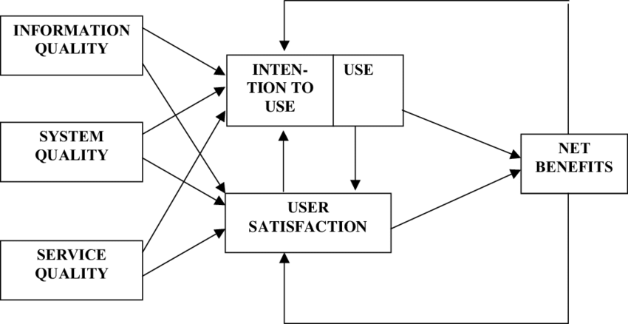
Figure ‎2.1 ISSM Model
(Source: Delone & McLean, 2003)

Unified Theory of Acceptance and Usage of Technology
The Unified Theory of Acceptance and Use of Technology (UTAUT) is a theoretical framework developed in 2003 by Venkatesh, Morris, and Davis to explain how and why individuals adopt and use new technologies. It builds on and integrates key concepts from earlier models of technology adoption, such as the Technology Acceptance Model (TAM) and the Theory of Planned Behaviour (TPB).
- Performance Expectancy: According to (Venkatesh et al, 2003), The degree to which a perosn thinks that utilising the system will enable him or her to advance in their career is known as performance expectancy (Chang, 2012). Job fitm extrinsic incentive, perceived usefulness are the three elements that influence performance expectancym (Chang, 2012). It is defined by these authors as the extent to which people believe that using services will help them more (Jaride & Taqi, 2021). It describes the degree to which people believe a system or technology will improve their performance or accomplish their goals. Since people are more inclined to utilise a technology if they believe it to be useful and effective, this construct is frequently the best indicator of technology adoption.
- Effort Expectancy: Venkatesh defines effort exepectation as the level of simplicity involved in using the system (Chang, 2012). In UTAUT, effort expectancy describes how simple people believe a system or piece of technology to be. It focuses on the simplicity of learning and using technology, which directly influences whether people are willing to adopt it. When a system is designed to be user-friendly, with intuitive features and minimal complexity, users are more likely to engage with it. This element is especially crucial in the early phases of adoption, when usability might determine whether individuals or organizations see value in technology. For instance, in the context of digital marketing, if small businesses find tools like SEO platforms or social media advertising intuitive and straightforward, their likelihood of adoption increases significantly. Effort expectancy is closely linked to other constructs in UTAUT, such as performance expectancy, and is moderated by variables like user experience, where experienced users may rely less on ease of use as a deciding factor.
- Social Influence: Social Influence is the extent to which consumers feel that other important people, including family and friends, think they ought to use a particular technology (Jaride & Taqi, 2021). It is described as the degree to which an individual feels that other people ought to consider that they utilise the new method (Chang, 2012).
The degree to which people believe significant others (e.g., peers, managers, or industry leaders) think they should utilise a certain technology is also referred to as social influence. This construct highlights how social pressure, and the opinions of others can drive adoption decisions, particularly in organizational or collaborative settings. For example, an SME might adopt a digital marketing tool like Google Ads if competitors or influential figures in their industry endorse its effectiveness. Social influence is especially impactful during the early stages of adoption and is moderated by factors like the user's role and the technology’s context.
- Facilitating Conditions: The degree to which an individual believes that organisational and technological infrastructure are in place to make system use easier (Chang, 2012). The UTAUT construct, which is made up of items from perceived behavioural control, describes the connection between potenial users’ intention to use and the organization’s efforts to remove obstacles to use, Similar to effort expectancy, this variable's power forecasts that usage will decline following initial acceptance (Chang, 2012). According to (Jaride & Taqi, 2021), “Consumers’ perception of the resources and support aviale to adopt a behaviour is what is meant by facilitating conditions”. The degree to which users feel that the infrastructure, resources, and assistance they need to use technology efficiently are available is referred to as the "facilitating conditions.". This includes access to technical support, compatibility with existing systems, and the availability of knowledge or training. For instance, an SME might adopt a digital marketing platform like SEO tools if they have reliable internet access, staff training, and customer support to ensure proper implementation. Facilitating conditions become particularly important during the actual usage phase, as they directly impact the ease and continuity of using the technology.
The influence of age and gender on a person’s intention to engage in a specific behaviour can vary significantly depending on the context. Similarly, the relationship between social influence and behavioural intention is shaped by factors such as an individual’s level of experience and whether the use of a system is voluntary or mandatory.
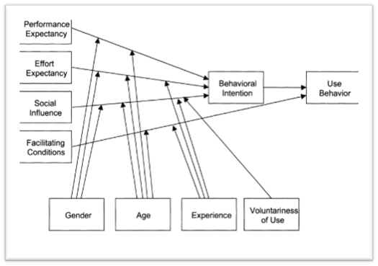
Additionally, both behavioural intention and the presence of supportive conditions play a crucial role in determining how effectively an information system is utilized. These factors collectively highlight the dynamic nature of user adoption and interaction with technology.
Figure ‎2.2 UTAUT Model
(Source: Delone & McLean, 2003)

Integration of ISSM and UTAUT
In exploring the impact of digital marketing strategies on sales performance for Lagos-based e-commerce SMEs, the integration of the ISSM and the UTAUT provides a comprehensive framework. UTAUT is predominantly useful for understanding the factors that impact SMEs’ choices to implement digital marketing tools such as SEO platforms or social media campaigns. By focusing on performance expectancy (the perceived benefits of using a tool) and effort expectancy (the ease of use), UTAUT helps identify the core reasons businesses opt for specific technologies.
On the other hand, ISSM evaluates the effectiveness of these tools post-adoption. It examines key factors such as system quality, information quality, and user satisfaction, all of which directly contribute to the success of the digital marketing strategy. By assessing whether these tools meet the expectations and drive the desired outcomes—such as increased sales and customer engagement, ISSM helps determine the long-term benefits of using digital marketing technologies.
By combining these two models, the research can provide insights into both the adoption and success of digital marketing tools. UTAUT focuses on why a business chooses to adopt a specific tool, while ISSM measures how well that tool performs once implemented. This integration allows for a more holistic understanding of the entire process, from technology adoption to achieving measurable business outcomes.
This dual approach offers SMEs valuable guidance on optimizing their digital marketing strategies. It not only identifies the factors that drive adoption but also helps measure the success of these tools in improving sales performance. Businesses may make well-informed judgements and continuously improve their digital marketing initiatives to get greater outcomes by utilising both methods.

Theoretical Implications
Research has shown a strong link between digital marketing strategies and sales performance in e-commerce SMEs. However, while embracing digital transformation is crucial, the degree to which it’s implemented can sometimes have unintended negative effects, especially when infrastructure and resources are lacking. In Lagos-based e-commerce, where competition is intense, the adoption of tools like SEO, social media ads, and email marketing is essential for growth. Yet, limited resources can slow down digital transformation, which ironically might reduce profitability even though operational processes are becoming more efficient.
Several factors influence the adoption of digital marketing strategies, including user satisfaction, behavioural intentions, service quality, performance expectancy, social influence, and system quality. These factors play a major role in determining how customers engage with digital tools. For this research, I am using the ISSM and UTAUT models to assess the impact of these factors on the effectiveness of digital marketing strategies.

Summary of Findings
Digital marketing plays a vital role in helping businesses enlarge their reach, engage with customers, and remain indispensable in a progressively digital world. Strategies such as SEO, social media marketing, and email campaigns are important for increasing growth and customer retention. In parallel, e-commerce has become vital for businesses to connect with a broader customer base, reduce operational costs, and enhance user experiences. The adoption of e-commerce platforms allows businesses to reach new markets and streamline their processes. To understand how these strategies influence business outcomes, the ISSM and UTAUT models provide valuable frameworks. ISSM evaluates the effectiveness of digital tools by focusing on factors like system quality and user satisfaction, while UTAUT explores factors such as performance expectancy and effort expectancy, which affect technology adoption decisions. Together, these models offer comprehensive insights into how digital marketing and e-commerce impact business performance.

CHAPTER THREE
METHODOLOGY

Preamble
This Chapter shows insight of the methodology directly involved in this research. It examines the conceptual framework that was used in the study, as well as the research approach applies in the investigation, the population size and designs, the type of data gathered, and the process involved in collecting this data. This chapter ends with a conclusion which summarizes the contents of this chapter.

Conceptual Framework
This research used the models UTAUT and ISSM by combining them, to explain why SMEs adopted digital marketing tools and to measure how effective these tools are in driving sales performance. This framework is used to connect the adoption factors (UTAUT) with the success outcomes (ISSM) in order to show how digital marketing influences SMEs’ performances.
The Unified theory of acceptance and use of technology (UTUAT) Model is a framework for technological acceptance created by Venkatesh and a few others that explains why businesses adopt digital marketing tools based on four key factors:
- Performance Expectancy: This is where SMEs adopt digital marketing if they expect sales returns and improvement.
- Effort Expectancy: This is where, if digital marketing such as SEO, Email Marketing etc, are easy to use, SMEs are more likely to adopt them.
- Social Influence: This is where, SMEs may adopt digital marketing if competitors, customers, stakeholders, or industry trends push them to do so.
- Facilitating Conditions: This is the availability of resources such as infrastructure, staff and expertise, that can affect adoption.
The Information System Success Model (ISSM) is a model that will help the SMEs to measure its success, which includes the following factors:
- Information Quality: This focuses on if the digital content the SMEs put out is secure, comprehensive, important, easy to use and personalized to the customers and users and their needs accordingly. Additionally, it should be secure and reliable, ensuring that users trust the business and engage more effectively with its digital marketing efforts.
- System Quality: This focuses on whether the mode or type of digital marketing used in the organization is applicable and beneficial to company’s products and target audience, thereby would either result in less or more customer retention and satisfaction, depending on the outcome of the service used. It examines the effectiveness and efficiency of the digital marketing platforms used by the SME.
- Service Quality: This will evaluate overall performance and reliability of the digital marketing service used by the e-commerce business. Key features include availability (how often the service is accessible), dependability (the consistency of the service in delivering results), flexibility (how well the service adapts to business needs), and usability (ease of navigation and interaction for the business and customers both). A high level of service quality will ensure better customer engagement and a more enlighten digital experience.
- System Use: This measures everything involved in customer interaction and engagement in the digital marketing platforms. This includes metrics such as website visits, time spent on the site, social media engagement (likes, shares, comments), email open rates, and conversion rates. These metrics help businesses understand how effectively customers interact with digital marketing tools.
- User Satisfaction: This is a very important aspect, which gauges the customer reaction and responsiveness to the digital marketing service/ tool in which customers engage with when interacting with an SME’s online presence. Examples are as follows: positive user feedback, high engagement rates, repeat website visits, etc. High user satisfaction usually transforms to customer loyalty and increased sales return.
- Net Benefits: This evaluates the overall effects, both positive and negative effects of the digital marketing tools on the organisation’s performance. Areas include sales growth, brand reputation, customer return rate, return of investment (ROI), economies, and even society at large, this factor cannot be examined with the “system quality” and “information quality” measurements, providing a wholesome view of how digital marketing contributes to business and long-term sustainability.
Using these models, the most important form of assessment would be the overall business performance when it comes to sales return and customer satisfaction and involvement in the SME’s online presence. Therefore, it is suggested that:
H1: Information Quality significantly influences User Satisfaction
Information Quality focuses on if the digital content the SMEs put out is secure, comprehensive, important, easy to use and personalized to the customers and users and their needs accordingly, which leads to increased digital marketing adoption and improved sales performance.
H2: System Quality positively impacts User Satisfaction
System Quality examines the effectiveness and efficiency of the digital marketing platforms used by the SME, as well functioning digital platforms enhance the customer experience and contribute to higher conversion.
H3: Service Quality significantly affects User Satisfaction
Service Quality will evaluate overall performance and reliability of the digital marketing service used by the e-commerce business, as reliable and efficient digital marketing tools improve customer retention and sales returns.
H4: User Satisfaction positively influences Net Benefits
User Satisfaction which gauges the customer reaction and responsiveness to the digital marketing service/ tool in which customers engage with when interacting with an SME’s online presence, meaning that SMEs that are satisfied with digital marketing tools experience higher revenue growth and improved customer retention.
H5: Performance Expectancy positively influences Behavioural Intention

Performance Expectancy is where SMEs implement digital marketing if they expect sales returns and improvement, meaning SMEs are more likely to adopt digital marketing tools if they expect an increase in sales revenue and business growth.
H6: Effort Expectancy has a significant effect on Behavioural Intention
Effort Expectancy is where, if digital marketing such as SEO, Email Marketing etc, are easy to use, navigate and require minimal resources, SMEs are more likely to adopt them.
H7: Behavioural Intention positively influences Actual Use
System Use measures everything involved in customer interaction and engagement in the digital marketing platforms, which lead to the increased utilization of digital marketing tools, which in turn drive Net Benefits, such as higher sales performance, better ROI, and sustained business growth.
H8: User Satisfaction significantly affects Behavioural Intention
User satisfaction is basically how content someone feels with the digital marketing tools they’re using. For SMEs, this satisfaction can strongly influence whether they plan to keep using those tools or even explore more digital strategies in the future.
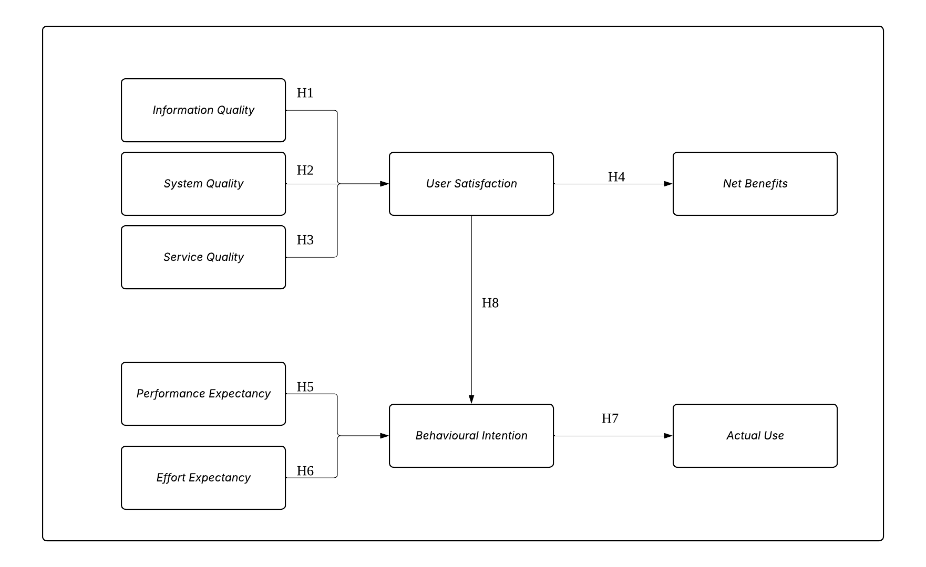
Figure ‎3.1 Conceptual Framework
Table 3.1 shows in detail the indicators, their measurements and what they sought to achieve.

Table ‎3.1 Indicator-Measurement Table
Indicator | Measurement | Purpose (What It Seeks to Achieve)
Information Quality | I receive accurate, relevant, and easy-to-understand information from digital marketing platforms. | The questions on Information Quality seek to evaluate how well digital marketing platforms provide reliable, tailored, and high-quality content to improve engagement and sales.
 | The content I see from digital marketing campaigns is useful and provides clear product details.
 | The marketing messages I receive are personalized and relevant to my interests.
System Quality | The digital marketing platforms I use (e.g., social media ads, SEO, PPC) are efficient and easy to navigate. | The questions on System Quality seek to determine whether digital marketing tools are user-friendly, reliable, and effective for SMEs.
 | The digital tools I use for marketing run smoothly without frequent issues.
 | The features of the digital marketing systems I use meet the needs of my business.
Service Quality | The digital marketing services I use (e.g., Google Ads, Facebook Ads, email marketing) are always available when needed. | The questions on Service Quality seek to assess how reliable and supportive digital marketing service providers are in helping SMEs succeed.
 | The customer support for the marketing tools I use is responsive and helpful.
 | My digital marketing platforms provide dependable performance with minimal downtime.
System Use | I actively use digital marketing tools (SEO, social media ads, email campaigns) to promote my business. | The questions on System Use seek to measure the frequency and depth of SME engagement with digital marketing tools to improve business performance.
 | I regularly check analytics and performance reports for my digital marketing efforts.
 | My business relies on digital marketing to attract and retain customers.
User Satisfaction | I am satisfied with the results of my digital marketing campaigns. | The questions on User Satisfaction seek to understand whether SMEs are happy with digital marketing adoption and its impact on their sales performance.
 | The digital marketing platforms I use meet my expectations in driving sales and engagement.
 | My business has benefited significantly from using digital marketing.
Net Benefits | My digital marketing efforts have led to increased sales and revenue growth. | The questions of Net Benefits seek to evaluate the overall impact of digital marketing on business performance, revenue, and customer loyalty.
 | My customer retention rate has improved since adopting digital marketing strategies.
 | I have experienced a higher return on investment (ROI) from my digital marketing campaigns.
Performance Expectancy | I believe that using digital marketing helps increase sales and brand awareness. | The questions on Performance Expectancy seek to examine whether SMEs expect higher revenue and efficiency from digital marketing adoption.
 | I can attract more customers through online marketing than with traditional methods.
 | Digital marketing reduces my advertising costs while improving results.
Effort Expectancy | Digital marketing tools are easy to learn and implement in my business. | The questions on Effort Expectancy seek to assess whether digital marketing tools are easy to adopt and implement for SMEs.
 | I do not find it difficult to use platforms like Facebook Ads, Google Ads, or SEO tools.
 | I can manage digital marketing without needing expert assistance.
Social Influence | I decided to use digital marketing because my competitors and industry leaders use it. | The questions on Social Influence seek to determine whether external influence (competitors, customers, industry trends) affects SMEs' adoption of digital marketing.
 | I feel that using digital marketing gives my business a more professional and modern image.
 | My business partners, colleagues, or customers encourage me to invest in digital marketing.
Facilitating Conditions | I have access to the necessary tools and resources to use digital marketing effectively. | The questions on Facilitating Conditions seek to analyse whether SMEs have the required infrastructure, support, and resources for successful digital marketing implementation.
 | The technology I currently use is compatible with digital marketing tools.
 | I receive enough technical support and training for my digital marketing efforts.
Behavioural Intention | I plan to continue using digital marketing to grow my business. | The questions on Behavioural Intention seek to predict the long-term commitment of SMEs to digital marketing strategies and future adoption trends.
 | If new digital marketing tools become available, I am likely to adopt them.
 | I would recommend digital marketing to other SMEs looking to increase sales.
Engagement Metrics | I actively monitor click-through rates (CTR), social media interactions, and email open rates. | The questions on Engagement Metrics seek to determine how well customers engage with digital marketing efforts and how SMEs optimize engagement.
 | I measure how customers interact with my ads, website, and digital campaigns.
 | I use customer engagement data to improve my marketing strategies.
Conversion Rate | A significant percentage of visitors from my digital marketing campaigns convert into paying customers. | The questions on Conversion Rate seek to analyse how effectively digital marketing efforts lead to actual sales and revenue generation.
 | My business generates consistent sales from digital marketing efforts.
 | I track conversion rates to optimize my digital marketing performance.
Customer Acquisition Cost (CAC) | I carefully track how much I spend to acquire each new customer through digital marketing. | The questions on Customer Acquisition Cost seek to determine the cost-effectiveness of digital marketing strategies for SMEs.
 | The cost of running digital marketing campaigns is reasonable compared to the revenue it generates.
 | Reducing CAC is a priority in my digital marketing strategy.
Return on Advertising Spend (ROAS) | I measure the revenue generated for every Naira/dollar spent on digital marketing campaigns. | The questions on Return on Advertising Spend seek to measure whether digital marketing campaigns are financially viable and profitable for SMEs.
 | I optimize my advertising spend to maximize business profitability.
 | My digital ads provide a strong return on investment (ROI).
Competitive Advantage | My business stands out from competitors due to its strong digital marketing presence. | The questions on Competitive Advantage seek to assess whether digital marketing helps SMEs gain a competitive edge and expand their customer base.
 | Digital marketing gives me an edge over businesses that rely on traditional marketing.
 | I use digital marketing to expand my market reach and attract new customers.

Research Approach
Research is the systematic process of gathering, examining, and understanding of data to aid problem resolution and increase of knowledge (Toyon, 2023). There are three main research approaches: deductive, inductive, and abductive, this study adopts a deductive approach, which involves developing hypotheses based on existing theories and literature and then designing a research plan to test those hypotheses through data collection and analysis (Saunders et al., 2019).
The deductive research methodology is the method used when conclusions are made after collating and researching of particular topics.
The deductive approach works from the top down; it begins with a theory or hypothesis and then tests it using data. In this method, the researcher builds on existing knowledge or past studies to form a hypothesis, which is then tested by collecting and analysing data. It’s commonly used in quantitative research, especially when the goal is to verify a theory using statistical tools. (Rai & Thapa, 2023)
For this research, the deductive approach methodology is strongly advised to be applied. This research follows the strategy of the deductive methodology by finding a theory or unsolved problem and verifying and confirming its accuracy using hypotheses and diagnoses.

Research Design
The research design is the plan and procedures involved in conducting the research, where the processes, techniques that are used in the data collection and analysis are specified. This research gathered and analysed data using quantitative methods, and the research is also notably deductive, where the research objectives were realized using hypotheses. The quantitative method was chosen for two specific reasons, by the nature of this study.
Firstly, reputable conclusions and recommendations are made based on measures and instruments, which are obvious numerical evidence of data, for researchers interested in or intending to understand and augment the analysed topic. Secondly, it brings about precise and exact results than if the qualitative method was to be used and is swayed or impacted by the researcher’s subjective biases.

Study population and sampling
Population is the number of people that you want to make assumptions about in the chosen area of research (Rai & Thapa, 2023).Sampling is the method used in statistical analysis where a fore ordained number of reviewed data will be taken out of a greater population (Rai & Thapa, 2023). This research make used of the type of sampling called purposive sampling.
Purposive sampling is a form of non-probability sampling where choices about the people to be added to the sample are taken by the researcher, according to the different criterium based on the characteristics of the population of interest, which will enable the best possible answers to the questionnaires of the research (Rai & Thapa, 2023).
There are 100-200 participants in this study, includes employees of the e-commerce businesses: Slot, Jiji, Konga and Jumia. Due to the specific nature of this study, purposive sampling was used to select respondents from active e-commerce SMEs in Lagos. A total of 100 -200 participants were targeted based on their direct involvement in digital marketing activities such as sales, marketing and advertising inside their organizations. This sample size is proper for meaningful statistical analysis and goes in accord with the study's objective of evaluating digital marketing adoption and its impact on sales performance using the structured models ISSM and UTAUT.
The study’s target population is specifically employees of the e-commerce businesses; Slot, Jiji, Konga and Jumia, ranging from sales department, marketing department and the advertising department. Therefore, 110 respondents make up the sample size.

Data Collection
The data used in this research is provided by primary sources or primary data. Primary data are the data directly collected from research respondents, using processes such as questionnaires, interviews and more.
This research used data collected from the employees of the e-commerce businesses such as Slot, Jiji, Konga, and Jumia. Specifically, employees related to sales, marketing and advertising.

Method of collection
A questionnaire is simply a list of printed enquires designed to bring round useful information about a specific matter, which is usually completed by an individual to give his/her opinions (Roopa & Rani, 2017).
This research uses a questionnaire for 2 reasons.
Firstly, the compatibility of quantitative research and questionnaires are in high rates. A questionnaire helps measurable data to be gathered in a level manner so that the data are internally continuous and balanced for analysis (Roopa & Rani, 2017). Secondly, it was adopted for its advantages relating to the measurement of the important variables from the sample in an efficient, cheap, and accurate manner.
In this study, the sample size is 110 respondents, therefore, 110 questionnaires were shared. And out of the 110 questionnaires, 4 went missing, meaning that 106 questionnaires were accounted for and were analysed.

CHAPTER FOUR

RESULTS AND DISCUSSION

Preamble
This chapter includes the procedure, analysis, and explanation of respondents’ participation of this research. A 96.4% respondent rate out of the 110 questionnaires was collated. These questions were created as closed ended questions for participants to send in predefined responses. The sixteen sections of the questions are derived from the models which were discussed before; The ISSM and UTAUT model which the following constructs were derived from. The sections are Information Quality, System Quality, Service Quality, System Use, User Satisfaction, Net Benefits, Performance Expectancy, Effort Expectancy, Social Influence, Facilitating Conditions, Behavioural Intention, Engagement Metrics, Conversion Rate, Customer Acquisition Cost (CAC), Return on Advertising Spend (ROAS), and Competitive Advantage. Also, data collated from the participants were revised and examined using tables and diagrams to measure reliability of whether the research questions had been adequately addressed.

Descriptive Statistics
The data analysis generated the following deductions and interpretations.

Information Quality
The questions on Information Quality looked to know and understand if the information provided by digital marketing platforms are dependable, tailored to the users’ interests, and high-quality, as well as created to improve engagement and sales. From responses in Figure 4.2-1, it is seen that 42.9% of the respondents agree that information provided by digital marketing platforms is easy to understand and accurate, In Figure ‎4.2-2, it shows that 50.5% of the participants agree that the content they receive from digital marketing campaigns is useful and provides clear product details, and 41.0% of the participants from Figure ‎4.2-3 show that the marketing messages that they receive are personalized and relevant to their interests.
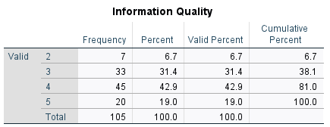
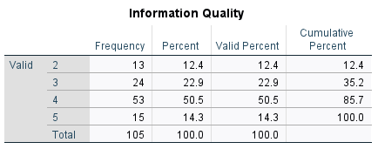
Figure ‎4.1Frequency of Information Quality Question 1
Figure ‎4.2 Frequency of Information Quality Question 2
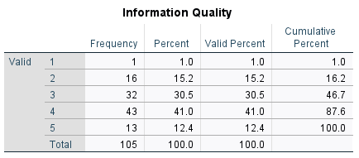
Figure ‎4.3 Frequency of Information Quality Question 3

System Quality
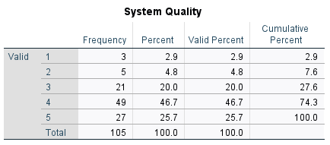
The questions on System Quality sought to understand if the respondents believe that the digital marketing services used are easy to navigate, meet the needs of the SMEs and that the digital tools used for marketing run smoothy. The responses from Figure ‎4.2-4 show that 46.7% of respondents agree that the digital marketing platforms used are efficient and easy to navigate, From the responses of Figure ‎4.2-5, it shows that 50.5% respondents agree that the digital tools I use for marketing run smoothly without frequent issues, And from the responses of Figure ‎4.2-6, it shows that 50.5% respondents agree that the features of the digital marketing systems they use meet the needs of my business.
Figure ‎4.4 Frequency of System Quality Question 1
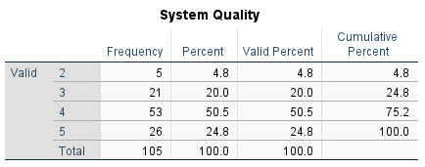
Figure ‎4.5 Frequency of System Quality Question 2

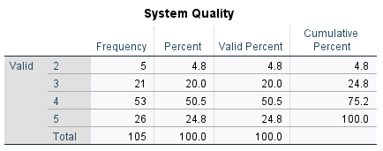
Figure ‎4.6 Frequency of System Quality Question 3

Service Quality
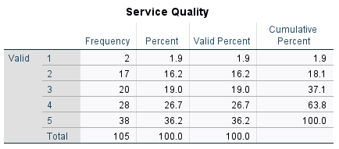
The questions on Service Quality sought to understand that the digital marketing services the respondents use are always available, responsive and provide dependable performance when needed. From the responses gotten from Figure ‎4.2-7, 36.2% of respondents strongly agree that the digital marketing services they use are always available when needed. In the responses from Figure ‎4.2-8, 38.1% of respondents agree that the customer support for the marketing tools used are responsive and helpful. And from the responses of Figure ‎4.2-9, 48.6% of the participants agree that the digital marketing platforms provide dependable performance with minimal downtime.
Figure ‎4.7 Frequency of Service Quality Question 1

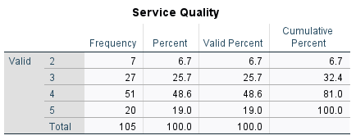
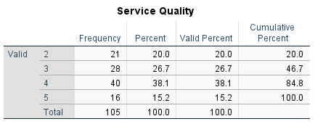
Figure ‎4.8 Frequency of Service Quality Question 2
Figure ‎4.9 Frequency of Service Quality Question 3

User Satisfaction
The questions on User Satisfaction sought to understand if the digital marketing platforms the respondents use meet their expectation in driving sales and engagement and are also satisfied with the results of their digital marketing campaigns. In Figure ‎4.2-10, 41.9% of the respondents agree that they are satisfied with the results of their digital marketing campaigns. In Figure ‎4.2-11, the mean at 3.70 shows that there is an indication of a general agreement that digital marketing helps improve business outcomes. The standard deviation for User Satisfaction was at 0.919, shows a high level of consistency among respondents’ responses.

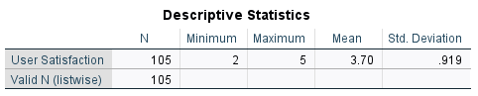
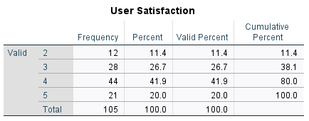
Figure ‎4.10 Frequency of User Satisfaction Question 1
Figure ‎4.11 Standard Deviation of User Satisfaction Question 1

System Use
The questions on System Use sought to understand how actively the respondents use the digital marketing tools to promote the SMEs, how regularly the users check analytics and performance reports for their digital marketing efforts, and how their businesses rely on digital marketing to attract and retain customers. Figure ‎4.2-12 shows that 31.4% of the respondents agree that they actively use digital marketing tools to promote their businesses. In Figure ‎4.2-13, 29.5% of respondents agree that they regularly check analytics and performance reports for their digital marketing efforts, and in the Figure ‎4.2-14, 34.3% of respondents agree that their businesses rely on digital marketing to attract and retain their customers.

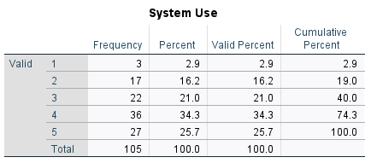
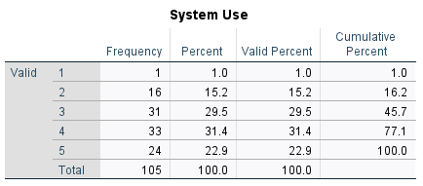
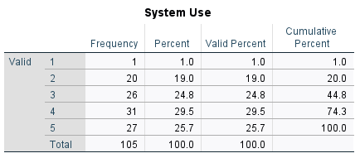
Figure ‎4.12 Frequency of User Satisfaction Question 1
Figure ‎4.13 Frequency of User Satisfaction Question 3
Figure ‎4.14 Frequency of User Satisfaction Question 2

Behavioural Intention
The questions on Behavioural Intention sought to show and understand if the respondents plan to continue to use digital marketing to grow their businesses, would recommend digital marketing to other SMEs looking to increase sales, and if there were new digital marketing tools, the SMEs would adopt them. In Figure ‎4.2-15, 38.1% of the respondents agree that they plan to continue using digital marketing to grow their businesses. From Figure ‎4.2-16, it shows that 38.1% of respondents agree that if new marketing tools become available, they would likely adopt them. And from Figure ‎4.2-17, it shows that 42.9% of respondents strongly agree that they would recommend digital marketing to other SMEs looking to increase sales.
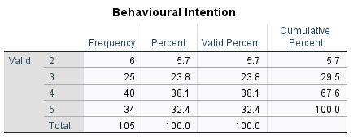
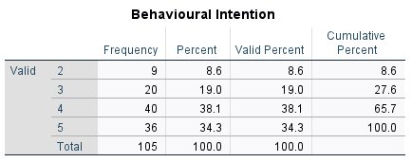
Figure ‎4.15 Frequency of User Satisfaction Question 1
Figure ‎4.16 Frequency of Behavioural Intention Question 1

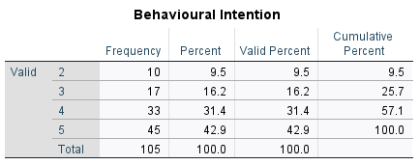
Figure ‎4.17 Frequency of Behavioural Intention Question 3

Net Benefits
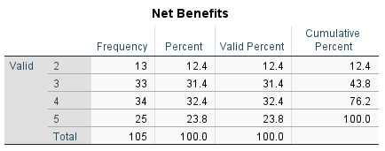
The questions on Net Benefits sought to understand if the respondents believe that their digital marketing efforts have led to increased sales and revenue growth, that their customer retention rate had improved since adopting digital marketing strategies and that they have experienced a higher return on investment (ROI) from their digital marketing campaigns. From Figure ‎4.2-18, it shows 32.4% of respondents agree that their digital marketing efforts have led to increased sales and revenue growth. Figure ‎4.2-19 shows that 43.8% of respondents agree that their customer retention rate has improved since adopting digital marketing strategies. And from Figure ‎4.2-20, 41.0% of respondents have experienced a higher return on investment (ROI) from their digital marketing campaigns.
Figure ‎4.18 Frequency of Net Benefits Question 1
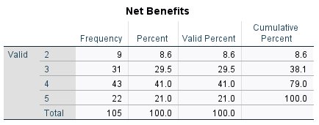
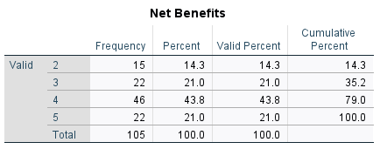
Figure ‎4.19 Frequency of Net Benefits Question 3
Figure ‎4.20 Frequency of Net Benefits Question 2

Performance Expectancy
The questions on Performance Expectancy sought to understand if the respondents believe that using digital marketing helps increase sales and brand awareness, can attract more customers through online marketing than with traditional methods and that digital marketing reduces their advertising costs while improving results. From Figure ‎4.2-21, it shows that 35.2% of respondents agree that using digital marketing helps increase sales and brand awareness. In Figure ‎4.2-22, it is shown that 44.8% of respondents agree that they can attract more customers through online marketing than traditional marketing. And from Figure ‎4.2-23, 45.7% of respondents agree that digital marketing reduces their advertising costs while improving results.
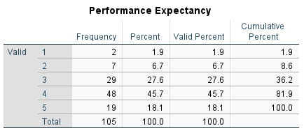
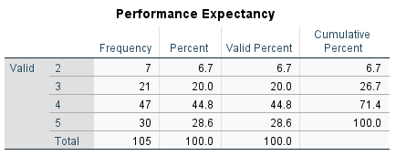
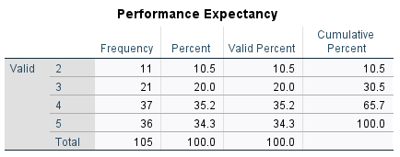
Figure ‎4.21Frequency of Performance Expectancy Question 3
Figure 4.22Frequency of Performance Expectancy Question 2
Figure ‎4.23 Frequency of Performance Expectancy Question 1

Effort Expectancy
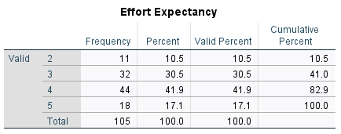
The questions on Effort Expectancy sought to understand whether respondents believe that digital marketing tools are easy to learn and implement in their businesses, whether they do not find it difficult to use platforms like Facebook Ads, Google Ads, or SEO tools, and can manage digital marketing without needing expert assistance. The Figure ‎4.2-24 below shows that 41.9% of respondents agree that digital marketing tools are easy to learn and implement in their businesses. From Figure ‎4.2-25, it shows that 41.9% of respondents agree that they do not find it difficult to use platforms like Facebook Ads, Google Ads, or SEO tools. And Figure ‎4.2-26 shows that 41.9% of respondents also agree that they can manage digital marketing without needing expert assistance.
Figure ‎4.24 Frequency of Effort Expectancy Question 1
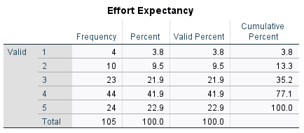
Figure ‎4.25 Frequency of Effort Expectancy Question 2
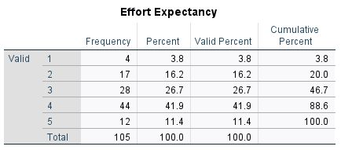
Figure ‎4.26 Frequency of Effort Expectancy Question 3

Social Influence
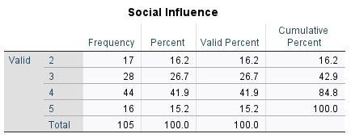
The questions on Social Influence sought to understand whether the respondents agreed that they decided to use digital marketing because my competitors and industry leaders use it, and they feel that using digital marketing gives their business a more professional and modern image, and that business partners, colleagues, or customers encourage them to invest in digital marketing. The Figure ‎4.2-27 below shows that 41.9% of respondents agree that marketing because my competitors and industry leaders use it, the Figure ‎4.2-28 shows that 42.9% of respondents agree that they feel that using digital marketing gives their business a more professional and modern image. And the Figure ‎4.2-29 shows that 45.7% of respondents agree that business partners, colleagues, or customers encourage them to invest in digital marketing.
Figure ‎4.27 Frequency of Social Influence Question 1
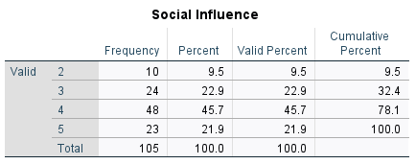
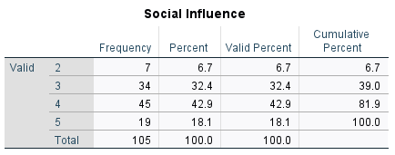
Figure ‎4.28 Frequency of Social Influence Question 3
Figure 4.29 Frequency of Social Influence Question 2

Conversion Rate
The questions on Conversion Rate sought to understand whether the respondents believe that a significant percentage of visitors from their digital marketing campaigns convert into paying customers, also that the respondents believe that their business generates consistent sales from digital marketing efforts and that they track conversion rates to optimize their digital marketing performance. The Figure ‎4.2-30 below shows that 43.8% of respondents agree that a significant percentage of visitors from their digital marketing campaigns convert into paying customers, Figure ‎4.2-31 shows that 35.2% of respondents agree that their business generated consistent sales from digital marketing efforts, and the Figure ‎4.2-32 shows that 41.9% of respondents agree that they tracked conversion rates to optimize their digital marketing performance.
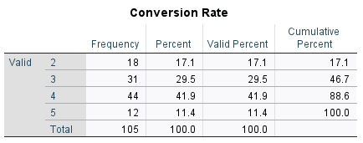
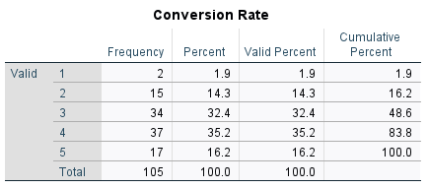
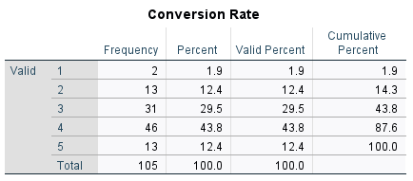
Figure ‎4.30 Frequency of Conversion Rate Question 1
Figure ‎4.31 Frequency of Conversion Rate Question 2
Figure ‎4.32 Frequency of Conversion Rate Question 3

Customer Acquisition Cost
The questions on Customer Acquisition Cost sought to understand whether the respondents carefully track how much they spend to acquire each new customer through digital marketing, whether the cost of running digital marketing campaigns is reasonable compared to the revenue it generates, and whether reducing CAC is a priority in their digital marketing strategy. The Figure ‎4.2-33 below shows that 41.9% of respondents agree that they carefully track how much they spend to acquire each new customer through digital marketing. The Figure ‎4.2 34 shows that 39.0% of respondents are neutral to whether the cost of running digital marketing campaigns is reasonable compared to the revenue it generated, and The Figure ‎4.2-35 shows that 40.0% of respondents agree that reducing CAC is a priority in their digital marketing strategy.
Figure ‎4.33 Frequency of Customer Acquisition Cost Question 1
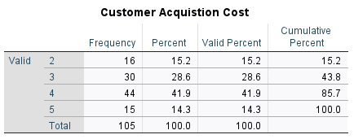
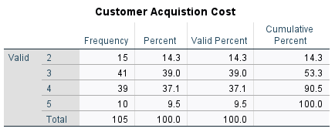
Figure ‎4.34 Frequency of Customer Acquisition Cost Question 2
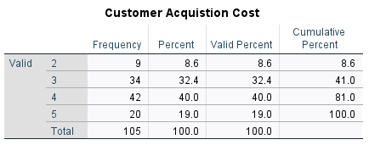
Figure ‎4.35 Frequency of Customer Acquisition Cost Question 3

Competitive Advantage
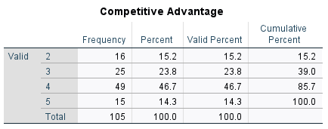
The questions on Competitive Advantage sought to understand whether the respondents believe their business stands out from competitors due to its strong digital marketing presence, whether digital marketing gives them an edge over businesses that rely on traditional marketing, whether they use digital marketing to expand their market reach and attract new customers. The Figure 4.2-36 below shows that 46.7% of respondents agree that their business stands out form competitors due to its strong digital marketing presence. The Figure ‎4.2-37 shows that 34.3% of respondents agree that digital marketing gives them an edge over businesses that rely on traditional marketing, and the Figure ‎4.2-38 shows that 41.9% of respondents strongly agree that they use digital marketing to expand their market reach and attract new customers.
Figure ‎4.36 Frequency of Competitive Advantage Question 1

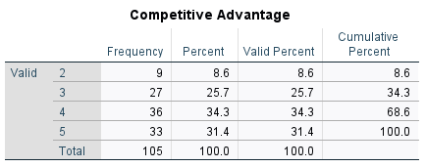
Figure ‎4.37 Frequency of Competitive Advantage Question 2
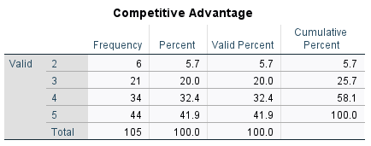
Figure ‎4.38 Frequency of Competitive Advantage Question 3

Return of Advertising Spend
The questions on Return of Advertising Spend sought to understand whether they measure the revenue generated for every Naira/dollar spent on digital marketing campaigns, whether they optimize their advertising spend to maximize business profitability, and whether their digital ads provide a strong return on investment (ROI). The Figure ‎4.2-39 below shows that 32.4% of respondents agree that they measure the revenue generated for every Naira/dollar spent on digital marketing campaigns. The Figure ‎4.2-40 shows that 47.6% of respondents agree that they optimize their advertising spend to maximize business profitability, and the Figure ‎4.2-41 shows that 41.0% of respondents agree that their digital ads provide a strong return on investment (ROI).
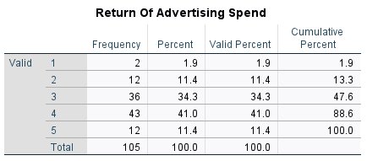
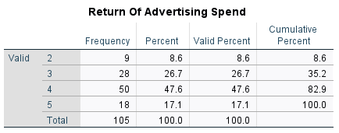
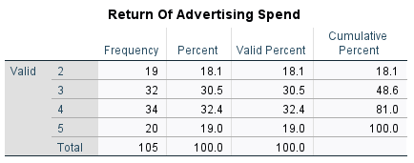
Figure ‎4.39 Frequency of Return of Advertising Spend Question 2
Figure ‎4.40 Frequency of Return of Advertising Spend Question 3
Figure ‎4.41 Frequency of Return of Advertising Spend Question 1

Engagement Metrics
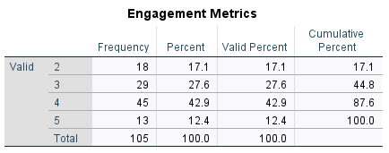
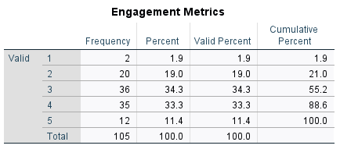
The questions on Engagement Metrics sought to understand whether businesses measure how customers interact with their ads, websites, and digital campaigns, whether they use customer engagement data to improve their marketing strategies, and whether a significant percentage of visitors from digital marketing campaigns convert into paying customers. The Figure ‎4.2-42 below shows that 34.3% of respondents are neutral about whether they measure how customers interact with their ads, websites, and digital campaigns. The Figure 4.2-43 shows that 42.9% of respondents agree that they use customer engagement data to improve their marketing strategies, and the Figure ‎4.2-44 shows that 39.0% of respondents agree that a significant percentage of visitors from their digital campaigns convert into paying customers.
Figure ‎4.42 Frequency of Engagement Metrics Question 2
Figure ‎4.43 Frequency of Engagement Metrics Question 1

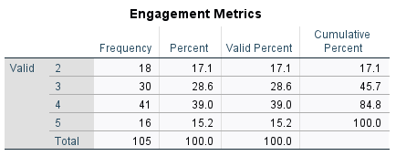
Figure ‎4.44 Frequency of Engagement Metrics Question 3

Facilitating Conditions
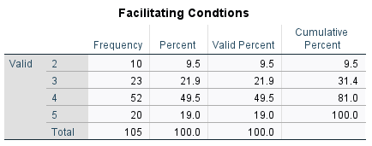
The questions on Facilitating Conditions sought to understand whether businesses have access to the necessary tools and resources to use digital marketing effectively, whether the technology they currently use is compatible with digital marketing tools, and whether they receive enough technical support and training for their digital marketing efforts. The Figure ‎4.2-45 below shows that 49.5% of respondents agree that they have access to the necessary tools and resources to use digital marketing effectively. The Figure ‎4.2-46 shows that 38.1% of respondents agree that the technology they currently use is compatible with digital marketing tools, and the Figure ‎4.2-47 shows that 44.8% of respondents agree that they receive enough technical support and training for their digital marketing efforts.
Figure ‎4.45 Frequency of Facilitating Conditions Question 1

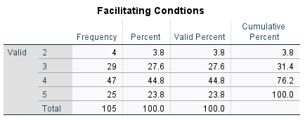
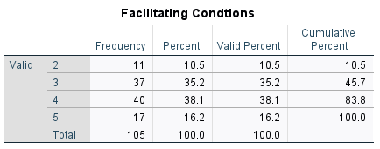
Figure ‎4.46 Frequency of Facilitating Conditions Question 3
Figure ‎4.47 Frequency of Facilitating Conditions Question 2

Measurement Model
This section investigates the relationship between latent variables and their measures.

Outer Loadings
The validity of the measurement model was evaluated using outer loadings. The Table ‎4-1 presents the validity of the items that were retained for further analysis.

Table ‎4.1 Outer Loading Model
 | BI | EE | IQ | NB | PE | SQ | SYQ | SU | US
BI1 | 0.874
BI2 | 0.874
BI3 | 0.888
EE1 |  | 0.855
EE2 |  | 0.788
EE3 |  | 0.846
IQ1 |  |  | 0.772
IQ2 |  |  | 0.827
IQ3 |  |  | 0.822
NB1 |  |  |  | 0.893
NB2 |  |  |  | 0.863
NB3 |  |  |  | 0.896
PE1 |  |  |  |  | 0.876
PE2 |  |  |  |  | 0.880
PE3 |  |  |  |  | 0.706
SQ1 |  |  |  |  |  | 0.882
SQ2 |  |  |  |  |  | 0.730
SQ3 |  |  |  |  |  | 0.890
SYQ1 |  |  |  |  |  |  | 0.751
SYQ2 |  |  |  |  |  |  | 0.793
SYQ3 |  |  |  |  |  |  | 0.856
SU1 |  |  |  |  |  |  |  | 0.824
SU2 |  |  |  |  |  |  |  | 0.842
SU3 |  |  |  |  |  |  |  | 0.818
US1 |  |  |  |  |  |  |  |  | 1.000

Indicator Reliability
Examining the reliability and validity of latent variables is necessary to conclude structural model analyses. The items in the Table ‎4-2 below are those that need to be reported following a reliability and validity PLS-SEM check.
Table ‎4.2 Construct of Reliability and Validity
 | Cronbach's alpha | Composite reliability (rho_a) | Composite reliability (rho_c) | Average variance extracted (AVE)
BI | 0.852 | 0.854 | 0.910 | 0.772
EE | 0.782 | 0.820 | 0.870 | 0.690
IQ | 0.744 | 0.769 | 0.849 | 0.652
NB | 0.861 | 0.869 | 0.915 | 0.782
PE | 0.771 | 0.829 | 0.863 | 0.680
SQ | 0.793 | 0.878 | 0.875 | 0.701
SYQ | 0.722 | 0.745 | 0.843 | 0.642
SU | 0.771 | 0.775 | 0.867 | 0.686
US | 1.000 | 1.000 | 1.000 | 1.000

Given that every item has average variance extracted (AVE) larger than 0.50 and composite reliability (rho_c) greater than the 0.70 criterion, we can conclude that all the constructs have internal reliability and convergent validity.

Discriminant Validity
When evaluating the initial discriminant validity, the criteria developed by (Fornell & Larcker, 1981) was applied. The degree to which the model’s several constructs differ from one another can be explained by discriminant validity.
The discriminant validity explains the correlation between both constructs, and it shows that it is not greater than the square of the AVE.
In the Table ‎4-3 below, no correlation is greater than the square of the AVE. If the Correlation is not greater than the Square of AVE it means that the questions in the constructs are not discriminant, or they are similar.
Table ‎4.3 Discriminant validity using Fornell and Larcker’s Criterion
 | BehavInt | EfftExp | InfoQual | NetBen | PerfExp | ServQual | SysQual | SysUse | UserSat1
BehavInt | 0.878
EfftExp | 0.499 | 0.831
InfoQual | 0.639 | 0.610 | 0.807
NetBen | 0.647 | 0.786 | 0.609 | 0.884
PerfExp | 0.714 | 0.666 | 0.647 | 0.780 | 0.825
ServQual | 0.584 | 0.697 | 0.678 | 0.764 | 0.807 | 0.837
SysQual | 0.588 | 0.770 | 0.706 | 0.804 | 0.684 | 0.686 | 0.801
SysUse | 0.721 | 0.520 | 0.518 | 0.681 | 0.558 | 0.614 | 0.705 | 0.828
UserSat1 | 0.339 | 0.524 | 0.396 | 0.610 | 0.530 | 0.632 | 0.632 | 0.576 | 1.000

Since the AVE values are higher than the squares of the inter-construct correlations, we can infer that the constructs have enough discriminant validity.

Structural Model
The above hypotheses were tested using SEM, which looked at the direct links between Information quality, System quality, Service quality, and User Satisfaction. In addition to this, we looked at the direct connections that exist between Performance expectancy, Effort expectancy, and User satisfaction. We also looked at the Behavioural intention. In the last we looked at the relationship that exists between Behavioural Intention, facilitating conditions and use behaviour. A second-order construct was conducted in this model.
The structural model in Smart PLS was assessed using the bootstrapping technique. The bootstrapping method was used to create 5,000 subsamples. Furthermore, the path coefficient was analysed to indicate the direction and intensity of relationships among the model's constructs. The structural equation model results obtained with Smart-PLS are displayed in Figure ‎4.3-1.
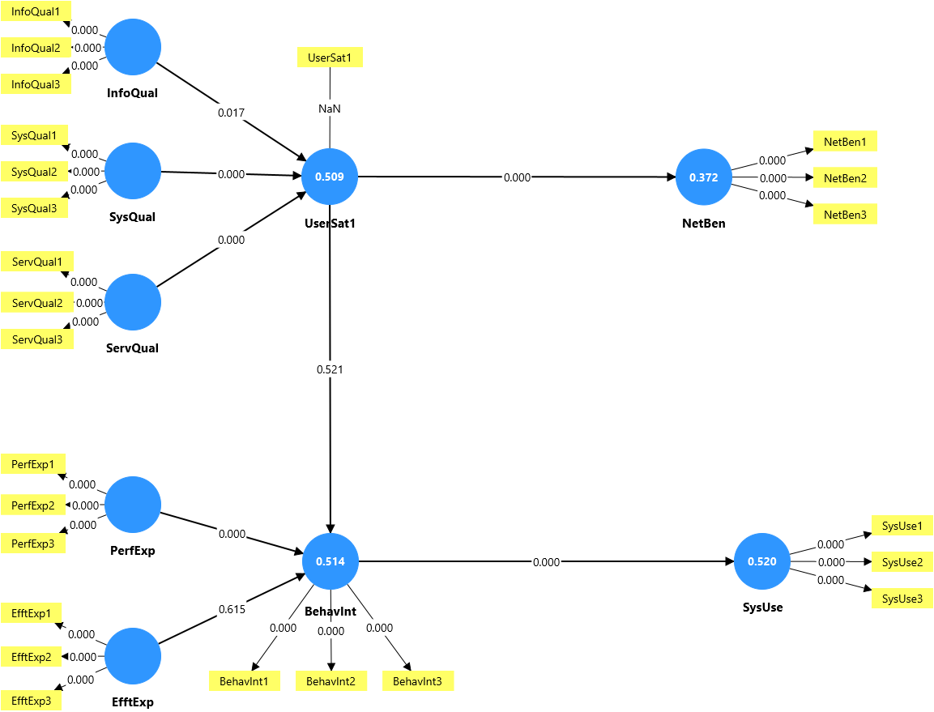
Figure ‎4.48 PLS-SEM Results

Hypothesis Table
Table ‎4.4 Hypothesis Table with bootstrapping
 | Original sample (O) | T statistics(|O/STDEV|) | P values
BehavInt -> SysUse | 0.721 | 13.908 | 0.000
EfftExp -> BehavInt | 0.064 | 0.503 | 0.615
InfoQual -> UserSat1 | -0.285 | 2.379 | 0.017
PerfExp -> BehavInt | 0.709 | 5.739 | 0.000
ServQual -> UserSat1 | 0.479 | 3.735 | 0.000
SysQual -> UserSat1 | 0.505 | 4.252 | 0.000
UserSat1 -> BehavInt | -0.071 | 0.642 | 0.521
UserSat1 -> NetBen | 0.610 | 8.282 | 0.000

In analysing the structural model using SmartPLS, I examined the relationships between the key constructs in my study to test each hypothesis. In the Table 4-4 above, the bootstrapping results provided insights into the strength and significance of these relationships, based on the path coefficients, t-statistics, and p-values.
To start, Behavioural Intention had a strong and significant impact on System Use (β = 0.721, t = 13.908, p < 0.001), which confirms that when users are willing and intentional about adopting digital marketing tools, they are much more likely to use them. This result strongly supports H7 and aligns with the UTAUT framework, showing that intention plays a central role in system usage among SME participants.
However, Effort Expectancy did not significantly influence Behavioural Intention (β = 0.064, t = 0.503, p = 0.615), so H6 was not supported. This result is interesting because it suggests that how easy or difficult a digital tool is to use may not matter much to SME users, possibly because they're already familiar with the platforms, or because they are more focused on the outcomes than on usability.
A surprising finding came from H3, where Information Quality had a significant but negative effect on User Satisfaction (β = -0.285, t = 2.379, p = 0.017). While I expected a positive relationship, this result could mean that too much information, even if accurate, might overwhelm users or lead to higher expectations that aren't met. It raises the point that information needs to be not just correct, but also well-presented and relevant to the users’ needs. This means H1 was supported inversely.
Performance Expectancy had a very strong positive influence on Behavioural Intention (β = 0.709, t = 5.739, p < 0.001), supporting H5. This shows that if users believe digital marketing tools help their business grow or improve productivity, they are more likely to use them. This is one of the most important findings and emphasizes the performance-driven mindset of SMEs.
Looking at satisfaction, both Service Quality (H3) and System Quality (H2) had significant effects on User Satisfaction (β = 0.479 and β = 0.505 respectively, both p < 0.001). This makes sense because good service and well-functioning systems naturally lead to a better user experience. When platforms are reliable and support is available, users tend to be more satisfied.
Interestingly, User Satisfaction did not significantly influence Behavioural Intention (β = -0.071, t = 0.642, p = 0.521), which means H8 wasn’t supported. This shows that even if people are happy with a digital marketing platform, it doesn’t automatically mean they plan to keep using it. Other factors like results, cost, or business pressure might have more influence on their decision-making.
Lastly, User Satisfaction significantly and positively affected Net Benefits (β = 0.610, t = 8.282, p < 0.001), supporting H4. This is an encouraging result, it shows that when users are satisfied, they are more likely to see real business outcomes like increased sales, customer loyalty, or improved ROI. It reinforces the idea that satisfaction is not just emotional but also tied to tangible business success.

Coefficients of Determination
Table ‎4.5 Coefficients of Determination
 | R-square | R-square adjusted
BI | 0.514 | 0.500
NB | 0.372 | 0.365
SYU | 0.520 | 0.516
US | 0.509 | 0.494
In the Table 4-5 above, the R-square values demonstrate that the model explains a substantial portion of variance in key dependent variables. Behavioural Intention (R² = 0.514) and System Use (R² = 0.520) showed strong explanatory power, indicating that their respective predictors effectively accounted for over half of the observed variance. User Satisfaction also showed moderate strength with R² = 0.509. Net Benefits, while lower (R² = 0.372), still indicates a meaningful relationship with its predictors. The adjusted R² values closely mirrored the R² scores, confirming model stability and minimal overfitting.

Discussion
This chapter focused on analysing the data collected from e-commerce SMEs in Lagos, based on the proposed model that integrates the UTAUT and ISSM frameworks. A high response rate was achieved, and responses were carefully analysed using descriptive statistics and structural equation modelling in SmartPLS.
PLS – SEM analysis approaches were used in this study. The software that applies the SEM method with assumptions about data distribution is called Partial Least Squares (PLS). PLS is a SEM method that can also analyse measurements, indicators, and latent variables directly. Currently, industry and multidisciplinary researchers prefer SEM as their quantitative analysis study technique. To demonstrate validity, outer loading must be greater than 0.70 and Average Variance Extracted (AVE) greater than 0.50. To support hypotheses, composite reliability should be greater than 0.70, the t-statistic should be greater than 1.96, and the p-value should be less than 0.05.
The measurement model results showed that all constructs had acceptable reliability and validity. The outer loadings, composite reliability, and AVE values were all within the recommended thresholds, confirming the strength of the indicators used. Discriminant validity was also established, as each construct was distinct and not too closely correlated with others, based on the Fornell-Larcker criterion.
In testing the hypotheses through the structural model, some relationships were strongly supported while others were not. For instance, Behavioural Intention was found to significantly influence System Use, confirming that when SMEs intend to adopt digital marketing tools, they are highly likely to use them in practice. Similarly, Performance Expectancy showed a strong and positive effect on Behavioural Intention, indicating that the perceived usefulness of digital marketing tools strongly shapes usage intentions.
However, Effort Expectancy and User Satisfaction did not significantly influence Behavioural Intention, which was surprising. This could mean that SME users are more focused on actual business outcomes than ease of use or satisfaction alone. Interestingly, Information Quality had a negative but significant effect on User Satisfaction, which suggests that even accurate or high-volume content can lower satisfaction if it’s overwhelming or poorly presented.
On the other hand, System Quality and Service Quality were both strong positive predictors of User Satisfaction, which supports the idea that well-functioning platforms and helpful customer service are essential to how satisfied users feel. Most notably, User Satisfaction significantly influenced Net Benefits, meaning that satisfied users were more likely to experience improved sales performance, customer loyalty, and returns on their digital marketing efforts.
The R-square values further confirmed that the model had strong explanatory power, especially for System Use and Behavioural Intention, which had over 50% of their variance explained by the model. While Net Benefits had a lower R², the relationship was still meaningful and showed that the model could successfully predict sales and marketing outcomes.
Overall, the findings from this chapter reveal that performance-driven factors, system efficiency, and service quality play key roles in determining the success of digital marketing adoption and its impact on SMEs in Lagos. The insights from this research can help businesses understand what influences effective digital marketing use, and where to focus their strategies for better results.

CHAPTER FIVE

SUMMARY, CONCLUSION AND RECOMMENDATIONS

Summary
This study set out to explore how digital marketing strategies influence the sales performance of small and medium-sized e-commerce enterprises (SMEs) in Lagos, Nigeria. Guided by the integrated theoretical frameworks of the Unified Theory of Acceptance and Use of Technology (UTAUT) and the Information Systems Success Model (ISSM), the research examined constructs such as Performance Expectancy, Effort Expectancy, Information Quality, Service Quality, System Quality, User Satisfaction, Behavioural Intention, System Use, and Net Benefits.
The analysis was conducted using SmartPLS to assess both the measurement and structural models. The measurement model confirmed that all constructs had acceptable levels of reliability and validity, with strong outer loadings, composite reliability, and Average Variance Extracted (AVE) scores. Discriminant validity was also established using the Fornell-Larcker criterion.
Sixteen constructs were tested across a well-structured questionnaire distributed to SME participants, and the data was analysed for both reliability and statistical significance. Key findings showed that Performance Expectancy, System Use, System Quality, and Service Quality had significant positive impacts, especially on Behavioural Intention and User Satisfaction, which in turn influenced Net Benefits like increased sales and ROI. Interestingly, Effort Expectancy and User Satisfaction did not significantly influence Behavioural Intention, and Information Quality had an unexpected negative relationship with satisfaction — suggesting that clarity and simplicity in content delivery may be lacking.
The model had strong explanatory power, with R² values indicating that a large percentage of variation in user behaviour and system success could be explained by the constructs studied. Overall, the research concluded that the successful use of digital marketing strategies in SMEs depends not only on adoption but also on how well the systems perform, how useful they are perceived to be, and how satisfied users are with the experience.
This study contributes practical knowledge that SMEs can apply directly to improve how they use digital marketing, and it also opens doors for further research in optimizing content strategies and adoption models in local business contexts.

Conclusion
This study set out to examine how digital marketing strategies influence sales performance among e-commerce SMEs in Lagos, using an integrated framework of UTAUT and ISSM. Through quantitative analysis and structural equation modeling, I was able to uncover the specific factors that contribute to or hinder the adoption and success of digital marketing tools in small business environments.
From the results, it became clear that performance expectancy and system use are major drivers of success, while user satisfaction alone does not automatically lead to behavioral intention. Also, it was interesting to find that information quality had a negative impact on satisfaction, which could mean that how information is presented matters just as much as what is being said. The findings also reinforced the importance of system quality and service delivery, both of which significantly affect how satisfied users are with the tools they adopt.
From the findings of this research, the proper application of these constructs will lead to better performance of sales in the business sector and, more importantly, better ways for the businesses to be satisfied as they use digital marketing.

Recommendations
The following recommendations have been made in light of the research findings and the lessons we learned from the investigation.
- Prioritize Performance-Enhancing Tools: SMEs should invest in digital marketing strategies (like SEO, email marketing, and analytics) that have a clear, measurable impact on sales and customer growth.
- Improve System and Service Quality: Platforms used should be responsive, reliable, and user-friendly, as this contributes significantly to user satisfaction and overall success.
- Simplify and Personalize Content Delivery: Businesses should aim to communicate in clear and engaging ways that speak directly to their audience, avoiding unnecessary or overwhelming information.
- Provide Training and Onboarding Support: Even if ease of use wasn't a strong influence in the study, offering basic training for staff or new users can improve confidence of use and long-term usage.
- Track Key Performance Metrics Regularly: SMEs should actively monitor conversion rates, CAC, and ROAS to evaluate which strategies work and which need improvement.
- Leverage Social Influence and Industry Trends: SMEs can benefit from showcasing case studies, success stories, or peer-led campaigns that demonstrate the real impact of digital marketing.
- Encourage Government and Industry Support: Policymakers and SME-support organizations should provide access to affordable tools, capacity-building programs, and digital infrastructure support.
The model created for this research can also be used to carry out studies relating to sales performance in digital marketing.

REFERENCES
Antre, G., & Dharmadhikari, S. (2024). Effectiveness of Digital Marketing Strategies of Network Marketing Companies on Consumer Psychology. ShodhKosh: Journal of Visual and Performing Arts, 5(6), 112–125. https://dx.doi.org/10.29121/shodhkosh.v5.i6.2024.1653
Arifah, H., Evi, S., Ahamd, J., Dafid, G., Witri, S., & Ardian, A. (2024). View of Marketing Analytics in the Era of Digital-Based Marketing Strategy .pdf.
Bist, A. S., Agarwal, V., Aini, Q., & Khofifah, N. (2022). Managing Digital Transformation in Marketing: ‘Fusion of Traditional Marketing and Digital Marketing’. International Transactions on Aritificial Intelligence, 1(1), 18–27. https://doi.org/10.34306
Caraballo, A., Luna, J., & Carbal, A. (2023). Digital Marketing Adoption in Small and Medium-Sized Enterprises (smes). Panorama Económico, 31(4), 360–374. https://doi.org/10.32997/pe-2023-4774
Chang, A. (2012). Utaut and Utaut 2: A Review and Agenda for Future Research. Journal TheWINNERS, 13(2), 106–114.
Darvidou, K. (2024). Content Marketing Strategy and Development. Technium Business and Management, 10, 55–67.
Delone, W. H., & McLean, E. R. (2003). The DeLone and McLean Model of Information Systems Success: A Ten-Year Update. Journals of Management Information Systems, 19(4), 9–30. https://doi.org/10.1080/07421222.2003.11045748
Dwivedi, Y. K., Wade, M. R., & Schneberger, S. L. (2012). Informations Systems Theory: Vol.2. Springer, 28(May), 461. https://doi.org/10.1007/978-1-4419-6108-2
Fuad, N., Nath, A., Chowdhury, S. A., & Siddique, A.-N. (2024). Impact of Digital Marketing on Small and Medium Enterprises (smes) in Bangladesh. Corporate Sustainable Management Journal, 1–11. https://doi.org/10.26480/csmj.02.2024.59.68
Guru, M. C., & Asifulla, A. (2023). An Investigation on The Impact of Digital Marketing Practices on Performance and the Sustainability of Business. European Economic Letters, 13(5), 1233–1240. https://doi.org/10.52783%2Feel.v13i5.899
Hellstén, S.-M., & Markova, M. (2003). The DeLone and McLean Model of Information Systems Success: A Ten-Year Update. Journal of Management Information Systems, 19(4), 9–30.
Hidayati, A., Susanti, E., Jamalong, A., Ginting, D., Suwanto, W., & Ardian Arifin. (2024). Marketing Analytics in the Era of Digital-Based Marketing Strategy. Jurnal Ilmaih Ilmu Terapan Universitas Jambi, 8(1), 61–75. https://doi.org/10.22437/jiituj.v8i1.31908
Ilesanmi, O. A., & Oyedepo, O. H. (2023). Digital Marketing and Performance of Smes in Nigeria. International Journal of Intellectual Discourse, 6(3), 253–265.
Jaride, C., & Taqi, A. (2021). Mobile Banking Adoption: A Systematic Review and Direction for Further Research. Journal of Theoretical and Applied Information Technology, 99(16), 3946–3959.
Kakkar, T., Nrip, N., & Deshmukh, A. (2024). A Study of Search Engine Optimizations (SEOs). May, 2024. https://doi.org/10.5281/zenodo.11118982
Kusandi. (2024). Digital Marketing Strategy to Increase MSME Sales in the Digital Age. Journal of Computer Science and Digital Business, 2(1), 45–56. https://doi.org/10.61166/interkoneksi.v2i1.17
Kusnadi. (2024). Interkoneksi Strategi Digital Marketing Untuk Meningkatkan Penjualan UMKM Di Era Digital. 2(1), 45–56.
Mailchimp. (2024). Traditional Marketing: Is It Worth Your Budget? Traditional Marketing vs Digital Marketing – Which To Prioritize? | Mailchimp. https://mailchimp.com/resources/traditional-marketing/#:~:text=Traditional
Murali, V., & Sardar, G. (2023). Enhancing Sales Performance and Business Sustainability of MSMEs through Digital Marketing Practices. Journal of Namibian Studies, 4112–4124.
Mustaqeem, K. M., & Sarder, M. A. U. (2024). The Impact of Digital Marketing on Small and Medium Enterprises (SMEs) in Bangladesh. International Journal of Research and Scientific Innovation, XI(IX), 807–817. https://doi.org/10.51244/IJRSI.2024.1109069
Olaolu, E. O., & Shuara, J. (2024). A Guide to Digital Marketing—A Handbook for Students and Practitioners.
Purnomo, Y. J. (2023a). Digital Marketing Strategy to Increase Sales Conversion on E-commerce Platforms. Journal of Contemporary Administration and Management (ADMAN), 1(2), 54–62. https://doi.org/10.61100/adman.v1i2.23
Purnomo, Y. J. (2023b). Digital Marketing Strategy to Increase Sales Conversion on Ecommerce Platforms. Journal of Contemporary Administration and Management, 1(2), 54–62. https://doi.org/10.61100/adman.v1i2.23
Rai, N., & Thapa, B. (2023). A Study on Purposive Sampling Method in Research. 1–12.
Rençber, H. (2020). United theory of acceptance and use of technology. Consumer Behavior Models, 181–192. https://doi.org/10.1007/978-3-030-10576-1_300692
Robinson, W. (2024). What Is Sales Performance Management? Varicent. https://www.varicent.com/blog/what-is-sales-performance-management
Roopa, S., & Rani, M. (2017). Questionnaire Designing for a Survey. The Journal of Indian Orthodontic Society, 273–277. https://doi.org/10.5005%2Fjp-journals-10021-1104
Saunders, M., Lewis, P., & Thronhill, A. (2019). Research Methods for Business Students: Chapter 4;understanding Research Philosophy and Approaches to Theory Development. Pearson Education Limited.
Schneider, G. P. (2017). Electronic Commerce.
Singh, A. K., & Bisaria, C. (2024). Evolving Dynamics: A Comparative Analysis of Digital Marketing and Traditional Marketing Strategies in Reshaping Brand Customer Relationships. International Journal of Advanced Research in Commerce, Management &Social Science, 07(1), 163–169. https://doi.org/10.26480/csmj.02.2024.59.68
Tabiat, A. (2022). The Impact of Digital Marketing on Sales Performance: The Case of Lebanese Pharmaceutical Companies. European Journal of Business and Management Research, 7(4), 349–355. https://doi.org/10.24018%2Fejbmr.2022.7.4.1600
Tetiana, I. (2024). Search Engine Marketing in Creating Website User Impressions. 40–69. https://doi.org/10.31617%2F1.2024(153)03
Toyon, M. A. S. (2023). Introduction to Research: Mastering the Basics. Scholars Journal of Research in Social Science, 3(1), 1–24. https://doi.org/10.5281/zenodo.7724719
Wikipedia. (2025). Information systems success model. https://en.wikipedia.org/wiki/Information_systems_success_model
Yakup, D., & Ibrahim, H. E. (2016). View of Travel from Traditional Marketing to Digital Marketing.pdf.

APPENDIX
THE IMPACT OF DIGITAL MARKETING ON SALES PERFORMANCE IN E-COMMERCE SMES

My name is ALABI FAITH FIYINFOLUWA, a final-year student at Covenant University, studying Management Information Systems. I am currently conducting research on ‘THE IMPACT OF DIGITAL MARKETING ON SALES PERFORMANCE IN E-COMMERCE SMES IN LAGOS, NIGERIA’ as part of my final-year project.
The purpose of this study is to understand how digital marketing tools and strategies influence business growth, customer acquisition, and profitability among small and medium-sized enterprises (SMEs). Your insights and experiences will help provide valuable data to improve digital marketing adoption and effectiveness.
All responses will be kept strictly confidential and used solely for academic purposes. No personally identifiable information will be shared.
Your participation is greatly appreciated, and your feedback will contribute significantly to the success of this research.

SECTION 1: DEMOGRAPHIC INFORMATION
1.What is your business name? (Optional)
___________________________________________________________________________
2.What is your role in the business?
☐ Business Owner
☐ Marketing Manager
☐ Sales Manager
☐ Other (please specify) ______________________
3.How long has your business been operating?
☐ Less than 1 year
☐ 1–3 years
☐ 4–6 years
☐ More than 6 years
4.What is your business size?
☐ Small (1–10 employees)
☐ Medium (11–50 employees)
☐ Large (51+ employees)
5.Which digital marketing channels does your business use? (Select all that apply)
☐ Social Media Ads (Facebook, Instagram, Twitter/X, LinkedIn)
☐ SEO (Search Engine Optimization)
☐ Pay-Per-Click (Google Ads, Bing Ads)
☐ Email Marketing
☐ Content Marketing (Blogging, Video, Influencer Marketing)
☐ Affiliate Marketing
☐ Other (please specify) __________________

SECTION 2: DIGITAL MARKETING EFFECTIVENESS (INFORMATION QUALITY & SYSTEM PERFORMANCE)
On a scale of 1 to 5, please rate the following statements:
(SD = Strongly Disagree, D = Disagree, N = Neutral, A = Agree, SA = Strongly Agree)
S/N |  | SD | D | N | A | SA
1. | I receive accurate, relevant, and easy-to-understand information from digital marketing platforms.
2. | The content I see from digital marketing campaigns is useful and provides clear product details.
3. | The marketing messages I receive are personalized and relevant to my interests.
4. | The digital marketing platforms I use (e.g., social media ads, SEO, PPC) are efficient and easy to navigate.
5. | The digital tools I use for marketing run smoothly without frequent issues.
6. | The features of the digital marketing systems I use meet the needs of my business.

SECTION 3: SYSTEM RELIABILITY AND RESPONSIVENESS
S/N |  | SD | D | N | A | SA
1. | The digital marketing services I use (e.g., Google Ads, Facebook Ads, email marketing) are always available when needed.
2. | The customer support for the marketing tools I use is responsive and helpful.
3. | The marketing messages I receive are personalized and relevant to my interests.
4. | My digital marketing platforms provide dependable performance with minimal downtime.
5. | I am satisfied with the response time of my digital marketing campaigns.

SECTION 4: USAGE AND BEHAVIORAL INTENTION
S/N |  | SD | D | N | A | SA
1. | I actively use digital marketing tools (SEO, social media ads, email campaigns) to promote my business.
2. | I regularly check analytics and performance reports for my digital marketing efforts.
3. | My business relies on digital marketing to attract and retain customers.
4. | I plan to continue using digital marketing to grow my business.
5. | If new digital marketing tools become available, I am likely to adopt them.
6. | I would recommend digital marketing to other SMEs looking to increase sales.

SECTION 5: SALES PERFORMANCE & RETURN ON INVESTMENT (ROI)
S/N |  | SD | D | N | A | SA
1. | My digital marketing efforts have led to increased sales and revenue growth
2. | My customer retention rate has improved since adopting digital marketing strategies.
3. | I have experienced a higher return on investment (ROI) from my digital marketing campaigns.
4. | I believe that using digital marketing helps increase sales and brand awareness.
5. | I can attract more customers through online marketing than with traditional methods.
6. | Digital marketing reduces my advertising costs while improving results.

SECTION 6: EFFORT EXPECTANCY AND EASE OF USE
S/N |  | SD | D | N | A | SA
1. | Digital marketing tools are easy to learn and implement in my business.
2. | I do not find it difficult to use platforms like Facebook Ads, Google Ads, or SEO tools.
3. | I can manage digital marketing without needing expert assistance.

SECTION 7: SOCIAL INFLUENCE & FACILITATING CONDITIONS
S/N |  | SD | D | N | A | SA
1. | I decided to use digital marketing because my competitors and industry leaders use it.
2. | I feel that using digital marketing gives my business a more professional and modern image.
3. | My business partners, colleagues, or customers encourage me to invest in digital marketing.
4. | I have access to the necessary tools and resources to use digital marketing effectively.
5. | The technology I currently use is compatible with digital marketing tools.
6. | I receive enough technical support and training for my digital marketing efforts.

SECTION 8: SALES CONVERSION & CUSTOMER ACQUISITION COST (CAC)
S/N |  | SD | D | N | A | SA
1. | I actively monitor click-through rates (CTR), social media interactions, and email open rates.
2. | I measure how customers interact with my ads, website, and digital campaigns.
3. | I use customer engagement data to improve my marketing strategies.
4. | A significant percentage of visitors from my digital marketing campaigns convert into paying customers.
5. | My business generates consistent sales from digital marketing efforts.
6. | I track conversion rates to optimize my digital marketing performance.
7. | I carefully track how much I spend to acquire each new customer through digital marketing.
8. | The cost of running digital marketing campaigns is reasonable compared to the revenue it generates.
9. | Reducing CAC (Customer Acquisition Cost) is a priority in my digital marketing strategy.

SECTION 9: COMPETITIVE ADVANTAGE & BUSINESS GROWTH
S/N |  | SD | D | N | A | SA
1. | I measure the revenue generated for every Naira/dollar spent on digital marketing campaigns.
2. | I optimize my advertising spend to maximize business profitability.
3. | My digital ads provide a strong return on investment (ROI).
4. | My business stands out from competitors due to its strong digital marketing presence.
5. | Digital marketing gives me an edge over businesses that rely on traditional marketing.
6. | I use digital marketing to expand my market reach and attract new customers.

