Development of a Flowchart Generation Extension for Code Snippets in Integrated Development Environments

By

Badaki, Ireoluwawolede Alayomide
(21CG029834)

A Project Submitted to the Department of Computer and Information Sciences, College of Science and Technology, Covenant University Ota, Ogun State.

In Partial Fulfilment of the Requirements for the Award of the Bachelor of Science (Honours) Degree in Computer Science

June, 2025

Certification
I hereby certify that this project was carried out by Badaki, Ireoluwawolede Alayomide in the department of Computer and Information Sciences, College of Science and Technology, Covenant University, Ota, Ogun State, Nigeria under my supervision.

Miss. Ti-Jesu Tunde-Adeleke _____________________
Supervisor Signature and Date

Prof. Aderonke A. Oni ____________________
Head of Department Signature and Date

Dedication
I thank my Father, God Almighty, for his guidance, protection, grace, strength, courage, wisdom and provision throughout this project. I would also like to thank my family and parents, who have always extended their support and prayers.

Acknowledgements
First and foremost, God is the source of my deep thankfulness for directing me during the completion of this project. I'd also like to thank my family for their unending provision and support. Similarly, I am grateful to my supervisor, Ms. Ti-Jesu Tunde-Adeleke, for her direction and oversight in this research and to the Head of the Department of Computer and Information Science for her assistance.

Table of Contents
CONTENT PAGES
COVER PAGE i
CERTIFICATION ii
DEDICATION iii
ACKNOWLEDGEMENTS iv
TABLE OF CONTENTS v
LIST OF FIGURES viii
LIST OF TABLES x
ABBREVIATIONS xi
ABSTRACT xiii
CHAPTER ONE: INTRODUCTION 1
1.1 Background Information 1
1.2 Statement of the Problem 2
1.3 Aim and Objectives 3
1.4 Methodology 3
1.5 Significance of the Study 5
CHAPTER TWO: LITERATURE REVIEW 7
2.1 Preamble 7
2.2 Review of Relevant Concepts 7
2.2.1 Integrated Development Environments (IDEs) 7
2.2.2 Flowcharts 12
2.2.3 Flowcharts in Software Development 14
2.2.4 Code Visualisation Algorithms 16
2.3 Review of Related Works 18
2.3.1 ConfiGen 19
2.3.2 GoCity 20
2.3.3 Software Engineering Experience In Action (SEEIA) 21
2.4 Review of Existing Systems 22
2.4.1 Understand 22
2.4.2 Diagramming AI 23
2.4.3 IntelliJ IDEA Diagrams Plugin 24
2.5 Review of Related Methods 25
2.5.1 VDM Support in the VS Code Environment 25
2.5.2 Flowgen 27
2.5.3 _toFlowchart 30
CHAPTER THREE: SYSTEM ANALYSIS AND DESIGN 34
3.1 Preamble 34
3.2 Overview of the System 34
3.3 Requirements Analysis 36
3.3.1 Functional Requirements 36
3.3.2 Non-Functional Requirements 37
3.4 Physical Design 37
3.4.1 The Proposed System Architecture 37
3.5 Logical Design 39
3.5.1 Use Case Diagram 40
3.5.2 Activity Diagram 41
3.5.3 Sequence Diagram 42
3.6 Conceptual Design 42
3.6.1 Context Diagram 42
3.6.2 Entity Relationship Diagram 43
CHAPTER FOUR: SYSTEM IMPLEMENTATION AND EVALUATION 44
4.1 Preamble 44
4.2 System Requirements 44
4.2.1 Hardware Requirements 44
4.2.2 Software Requirements 45
4.3 Implementation Tools 45
4.3.1 Visual Studio Code (VSCode) 45
4.3.2 JavaScript 46
4.3.3 HTML5 and CSS3 46
4.3.4 Mermaid.js 46
4.3.5 Netlify 47
4.3.6 Git and GitHub 47
4.4 Development Methodology 47
4.5 Evaluation of The System 48
4.5.1 Evaluation Criteria 49
4.5.2 Evaluation Results 49
4.5.3 Discussion 59
4.6 Program Modules and Interfaces 59
4.6.1 VSToFlow Helper 59
4.6.2 VSToFlow 60
CHAPTER FIVE: SUMMARY, RECOMMENDATION AND CONCLUSION 63
5.1 Summary 63
5.2 Limitations of the Study 63
5.3 Recommendations 64
5.4 Conclusion 65
REFERENCES 66

List of Figures
FIGURES | TITLES OF FIGURES | PAGES
2.1 | VSCode User Interface | 9
2.2 | Visual Studio 2022 User Interface | 11
2.3 | IntelliJ IDEA's User Interface | 12
2.4 | A Flowchart of Ronald Knuth's RUNCIBLE compiler | 15
2.5 | How a struct is visualised in GoCity | 20
2.6 | Understand's User Interface | 22
2.7 | Diagramming AI flowchart generated for the Selection Sort Algorithm | 23
2.8 | IntelliJ IDEA Diagram Plugin | 24
2.9 | Annotated C++ code with nested if-else blocks | 29
2.10 | Resulting Activity Diagram of Code from Figure 2.9 | 29
2.11 | _toFlowchart is depicted as a 3-stage compiler | 31
2.12 | PHP code with a standard while loop | 31
2.13 | Flowchart of code from Figure 2.12 using _toFlowchart | 32
3.1 | A diagram of the Flow of the System's Development | 35
3.2 | System Architecture Diagram | 39
3.3 | Use Case Diagram | 40
3.4 | Activity Diagram | 41
3.5 | Sequence Diagram | 42
3.6 | Context Diagram | 42
3.7 | Entity Relationship Diagram | 43
4.1 | VSToFlowHelper: VSCode Extension Module | 60
4.2 | VSToFlow | 61

List of Tables
TABLES | TITLE OF TABLES | PAGES
1.1 | Objectives-Methodology Mapping Table | 4
2.1 | Standard Flowchart Symbols and Their Meanings | 13
2.2 | Comparison of Related Methods | 33
4.1 | Hardware Requirements | 44
4.2 | Software Requirements | 45
4.3 | Python Test Cases | 50
4.4 | JavaScript Test Cases | 53
4.5 | C++ Test Cases | 56

Abbreviations
AI | Artificial Intelligence
ANSI | American National Standards Institute
AST | Abstract Syntax Tree
CERN | Conseil Européen pour la Recherche Nucléaire
DFD | Data Flow Diagram
DSL | Domain-Specific Language
EBNF | Extended Backus-Naur Form
ERD | Entity Relationship Diagram
HTML | Hyper Text Markup Language
IDE | Integrated Development Environment
IR | Intermediate Representation
ISO | International Organization for Standardization
JAM | JavaScript, APIs and Markup
MDA | Model Driven Architecture
OMG | Object Management Group
OMT | Object Modelling Technique
OOSE | Object Management Group
OMT | Object Modelling Technique
OOSE | Object-Oriented Software Engineering
PAD | Problem Analysis Diagram
RAPTOR | Rapid Algorithmic Prototyping Tool for Ordered Reasoning
SEE | Software Engineering Experience
SEEIA | Software Engineering Experience In Action
SVN | Subversion
UML | Unified Modelling Language
UI | User Interface
VDM | Vienna Development Method
VSCode | Visual Studio Code

Abstract
With the increasing complexity of software development, the need for more visual tools to manage the development process has become paramount. This study presents the development of a Visual Studio Code (VSCode) extension designed to generate flowcharts from selected code snippets. The tool aims to enhance code comprehension, debugging efficiency, and educational utility by offering automated visual representations of programming logic. Addressing the lack of integrated flowchart tools in mainstream IDEs, the system parses code written in Python, JavaScript, and C++ to generate standardized flowcharts using Mermaid.js. It consists of two key components: a lightweight web application for flowchart rendering and a VSCode extension that seamlessly transmits selected code for visualisation. A custom static parser was developed for each supported language, focusing on expression statements, conditional blocks, and loop constructs. The system follows an iterative development methodology and is hosted using modern web technologies (HTML5, JavaScript, CSS, and Netlify). Evaluation across multiple code structures revealed strengths in visual clarity and language flexibility, though limitations remain in handling complex nesting and dynamic constructs. The extension demonstrates potential for improving programming education and team-based software development through intuitive, in-editor visualisation.

With the increase in complexity
Keywords: Flowcharts, Integrated Development Environments (IDEs), Visual Studio Code, Parsing Algorithm, Code Visualisation, Debugging Tools, Educational Technology, Software Development.

Chapter One

Introduction

Background Information
Flowcharts have been used since the 1940s (Priestley, 2020) and are still a common way to visualise program flow (Zhang, Meng, Zou, Zhou & Hwang, 2023), helping programmers design, read and debug their code.
Programming dates back to the early nineteenth century when Ada Lovelace became the first programmer in the 1840s for her work on Charles Babbage's Analytical Engine (Jaeger, 2023). Lovelace’s algorithm to compute Bernoulli numbers is considered the world’s first published computer program (Jaeger, 2023). However, early programming tasks became increasingly complex, increasing the demand for visual User Interface (UI) tools for code design and understanding (Ensmenger, 2016). Flowcharts, which showed the control flow through a program using simple polygons and arrows, evolved as an essential mechanism in this environment. Flowcharts were introduced to computer science as early as 1947 when Herman Goldstine and John von Neumann wrote about their use of flowcharts in their report "Planning and coding of problems for an electronic computing instrument, Part II, Volume 1"(Priestley, 2020).
With the growing complexity of software development, the need for cohesive tools to manage the development process emerged (Segun-Falade, Osundare, Kedi, Okeleke, Ijomah & Abdul-Azeez, 2024). Integrated Development Environments are a collection of development tools — code editors, compilers, debuggers, version control, etc – that aid in developing software products. IDEs were first introduced in the 1970s when Maestro 1 was released (Leimbach, 2008). They have become an essential tool in the current software engineering landscape because they enhance productivity, reduce errors and improve code quality. Further customisation and enhancement of IDEs are implemented through extensions and plugins (Li et al., 2019). These extensions enhance the IDE capabilities by adding functionalities like code analysers, auto-completion tools, project management and collaboration features. These are designed to help streamline and successfully fulfil the developer's needs and make the coding process as efficient as possible (Li et al., 2019). Although significant improvements in IDEs and programming tools have been made, some hurdles still exist in modern software development. Modern software projects can often become mammoth networks of code that are too difficult to comprehend for engineers (Bakhirkin & Lukin, 2021). Working with such large codebases can be time-consuming and cause mistakes in debugging and maintenance (Bakhirkin & Lukin, 2021). Clear communication and visibility of code logic, often absent, are needed for effective collaboration among team members (Baxter, Dacre, Dong & Ceylan, 2023). Additionally, new engineers usually face a steep learning curve as they try to grasp the existing codebases (Shah, Yu, Tong, Raj, 2024).
This project aims to develop an extension for Integrated Development Environments (IDEs) that generates a flowchart visualisation corresponding to highlighted code segments. The extension will be used to overcome the issues mentioned above by helping users gain a better understanding of the code logic and flow, resulting in reduced complexity and increased readability. The tool will also highlight the order of operations and control flow, which will help with debugging and maintenance. The generated flowcharts will also help enhance team-wide communication by providing a shared language between team members.

Statement of the Problem
The absence of tools that smoothly incorporate automated visual representations of the function and intent of written code into mainstream development environments impedes effective participation in development (Krause-Glau, Bader, & Hasselbring, 2022). Despite major advances being made to enhance software development tools and Integrated Development Environments (IDEs), the power of flowcharts to aid understanding and collaboration is yet to be fully realised. Modern software projects are often so large and intricate that finding the right way to piece together a codebase is purely impractical for a single individual reading the codebase (Shah et al., 2024).
Many software developers end up using manual approaches due to automatic flowchart generation not currently being integrated into widely used IDEs and dev tools that work with their development environment (Polkovnikov, 2016). This disconnect creates challenges for navigating and understanding codebases and ultimately results in more debugging time, less maintainable code and stifled team collaboration (Ebert, Castor, Novielli & Serebrenik, 2019). Hence, code readability, debugging, and collaboration continue to be challenges for developers and software development teams.

Aim and Objectives
The aim of the study is to develop a Visual Studio Code (VSCode) extension for generating flowcharts from code snippets using a custom web-based flowchart renderer. The specific objectives outlined to achieve this aim are:
- To identify the requirements for the development of the VSCode extension
- To design and develop a web application that generates a corresponding flowchart from code using a static code parser.
- To design and develop a Visual Studio Code extension that integrates with the system, such that selected code snippets can be sent to the web application for flowchart visualisation
- To test the functionality of the system using various code examples across supported languages in order to verify the correctness and robustness of the algorithm.
- To evaluate the prototype’s effectiveness and usability in aiding the understanding of elementary programming concepts

Methodology
The development of the system will follow the Iterative Development methodology. Based on the Iterative Methodology, the project will be carried out as follows:
Table 1.1 shows the mapping of the objectives of the study to the above methodology.

Table 1.1: Objectives-Methodology Mapping Table
S/N | Objective | Methodology
1. | To identify the requirements for the development of the VSCode extension | Literature Review and Requirements Gathering  - Conduct a literature review on visual programming aids and flowchart tools by exploring scholarly papers and case studies.  - Conduct a competitor analysis to identify features, limitations, and user feedback on existing tools for code visualisation.
2. | To design and develop a web application that generates a corresponding flowchart from code using a static code parser | Development of Parsing Algorithm and IDE Integration  - Design and create a minimal modular parser for the three selected languages that outlines the structure and logical flow of code.  - Design mapping rules for translating code structures into standardised flowchart components.  - Develop a web application that uses the above parser and mapping rules to render the flowchart live in the browser upon user input.
3. | To design and develop a Visual Studio Code extension that integrates with the system, such that selected code snippets can be sent to the web application for flowchart visualisation | Design and Development of Extension  - Use the VSCode Extension Application Programming Interface (API) to build an extension that extracts selected code snippets from the active editor.  - Implement functionality to encode and send code snippets to the web application for flowchart generation.
4. | To test the functionality of the system using various code examples across supported languages in order to verify the correctness and robustness of the algorithm | System Prototype Testing  - Design test cases to test the correctness and robustness of the algorithm compared to competitors.  - Verify that flowcharts visually render the correct control structures, decision paths, and logical sequencing.
5. | To evaluate the prototype’s effectiveness and usability in aiding the understanding of elementary programming concepts | Evaluation  - Conduct informal user walkthroughs to assess how effectively the system communicates logical flow from the source code.  - Identify possible refinements to the prototype based on findings to improve user functionality and usability.

Significance of the Study
The project is significant in multiple ways. To begin, the tool recommends incorporating automated flowchart generation into development environments to assist users in understanding programming logic and flow. This functionality addresses challenges that developers may face while navigating a large codebase and significantly decreases the learning curve. Furthermore, it aims to increase team cooperation by providing a visual representation of the code logic. It is a visual aid that promotes shared knowledge and collaboration among team members in the context of major software projects. When developers have the same vision for a program's direction, they work together more efficiently (Murphy, Kersten, Elves & Bryan, 2019).
On an educational level, this tool is excellent for teaching programming fundamentals. It provides a visual aid to help children learn simple ideas. Seeing the logic flow through the code as a flowchart makes programming less abstract and more comprehensible (Allen, 2023).
The extension streamlines the development workflow by connecting directly to a popular IDE such as Visual Studio Code. It will allow developers to say goodbye to the days of jumping between independent tools and integrated development environments. As intended, the integration improves the flow, allowing the user to focus on writing code and solving problems without being distracted. The tool's findings may also have implications for future breakthroughs in computer science and educational technology, illustrating the benefits of incorporating visual aids directly into coding environments like VSCode.

Chapter Two

Literature Review

Preamble
The evolution of software development tools has been marked by a growing emphasis on enhancing code comprehension, debugging efficiency and collaboration. Among these tools, flowcharts have played a significant role since their inception in the 1940s, providing a visual representation of program logic that simplifies complex algorithms and fosters clear communication (Priestley, 2020). Integrated Development Environments (IDEs), first introduced in the 1970s, have similarly revolutionised the software engineering process by consolidating essential development tools into cohesive platforms (Leimbach, 2008).
In recent years, the integration of advanced features such as artificial intelligence, real-time error detection and visual programming aids has further transformed IDEs, as seen in platforms like Visual Studio Code (Stack Overflow, 2024). However, despite these advancements, the seamless incorporation of automated visual tools like flowchart generators into mainstream IDEs remains underexplored. This gap poses challenges in navigating complex codebases, reducing debugging time and enhancing team collaboration (Shafeek & Karunarathne, 2018; Murphy et al., 2019).

Review of Relevant Concepts
Relevant concepts on flowchart-based extension development for integrated development environments (IDEs) are further discussed in this chapter.

Integrated Development Environments (IDEs)
Integrated Development Environments (IDEs) are software platforms that give developers a set of tools for quickly writing, debugging and managing code from a single interface (Alizadehsani, Gomez, Ghaemi, González, Jordan, Fernández, & Pérez-Lancho, 2022). An IDE's primary components are often a source code editor, build automation tools and a debugger. Advanced IDEs like Visual Studio Code and IntelliJ enhance this functionality with intelligent capabilities such as code autocompletion, syntax highlighting and real-time nine error detection, allowing developers to simplify the software development process. According to Marron (2024), modern IDEs are evolving into intelligent development environments by incorporating artificial intelligence to foresee developer needs, automate repetitive operations, and offer improvements, thus increasing productivity even more.
Advancements in IDE design have made it possible to create more flexible and efficient development environments that can make use of a variety of computer resources to improve the overall programming experience (Antonova and Bartkova, 2020). Modern IDEs now feature a plethora of features aimed at improving the productivity of developers. Advances in IDE design have made it possible to create more flexible and efficient development environments that can make use of a variety of computer resources to improve the overall programming experience (Antonova and Bartkova, 2020). Modern IDEs use Artificial Intelligence (AI) technologies like recommender systems, language modelling, and deep learning to simplify programming and solve challenges in multi-platform software development (Alizadehsani et al., 2022). AI integration in IDEs is revolutionising software development processes, with implications for programmer productivity and code quality (Alizadehsani et al., 2022).
Some popular IDEs include:
- Visual Studio Code: According to the Stack Overflow Developer Survey (2024), Visual Studio Code (VSCode) is used by more than twice as many developers as its nearest alternative. The core features of VSCode are:
  - Code editing: VS Code supports syntax highlighting, intelligent code completion, snippets and code refactoring. It also includes an interactive debugger that allows developers to step through their code, inspect variables and view call stacks.
  - Customisation: Users can customise the editor by changing themes, keyboard shortcuts and preferences. They can also install extensions to add functionality.
  - Built-in Git: VS Code has built-in support for Git, allowing users to manage their source control without leaving the editor.
  - Extensions: The editor supports a wide range of extensions that can enhance its functionality, including support for additional languages, themes, debuggers and commands. The VS Code Extension API enables developers to modify almost every aspect of the editor, from the user interface to the editing experience. Many core features of VS Code, such as the support of various programming languages, are themselves built as extensions, showcasing the power of this API.
  - Open Source: VS Code is built on an open-source foundation, with its core code available on GitHub. Microsoft uses this base code, makes slight modifications and releases it under a proprietary license. This approach allows for a thriving community of external contributors who actively participate in the development process (Plainer, 2021). However, finding suitable issues for new contributors can be challenging due to the large backlog and limited labelling of issues (Plainer, 2021).

Figure 2.1 is an image of VSCode’s User Interface.
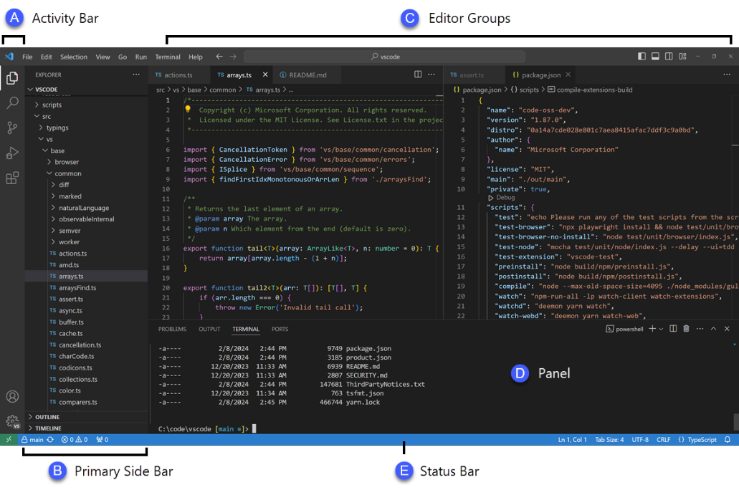
Figure 2.1: VSCode User Interface
Source: https://code.visualstudio.com/docs/getstarted/userinterface
- Visual Studio: According to the Stack Overflow Developer Survey (2024), Visual Studio is the second most used IDE after VSCode. It was also developed by Microsoft by bundling many of its existing programming 11 tools together (Desjardins, 2014). The core features of Visual Studio include:
  - Multiple Language Support: It supports C, C++, Visual Basic, Python, etc. and can be extended to accommodate others through extensions.
  - Debugging Tools: The IDE includes advanced debugging capabilities that help identify and fix code errors quickly. These tools provide both source-level and machine-level debugging options.
  - Version Control Integration: Visual Studio seamlessly integrates with version control systems like Git, enabling collaborative coding and project management.
  - AI-Assisted Development: Features like IntelliCode and GitHub Copilot enhance coding efficiency by providing intelligent code suggestions and completions.
  - Extensions: Visual Studio supports a large ecosystem of extensions that can be used to enhance its functionality and allow developers to customise their environment to better suit their needs. The Extension Manager is the primary tool used for discovering, installing, and managing extensions.

Figure 2.2 is an image of Visual Studio’s user interface.
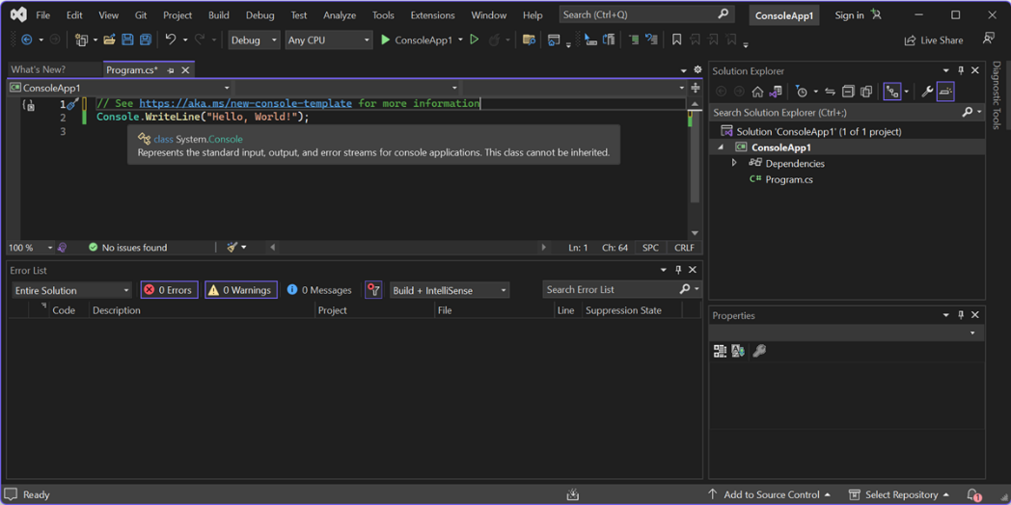
Figure 2.2: Visual Studio 2022 User Interface
Source: https://learn.microsoft.com/en-us/visualstudio/ide/quickstart-ide-orientation
- IntelliJ IDEA: According to the Stack Overflow Developer Survey (2024), IntelliJ IDEA is the third most popular IDE after VSCode and Visual Studio. 12 It is an IDE developed by JetBrains that was primarily designed for Java development but has expanded support to languages such as Kotlin, Groovy and Scala (Hagos, 2022). The core features of IntelliJ IDEA include:
  - Language Support: Aside from Java, the language the IDE was originally designed for, IntelliJ also natively supports Kotlin (JetBrains’ language), Scala and Groovy.
  - Advanced Refactoring and Smart Code completion: IntelliJ IDEA continuously inspects code for potential issues and errors, and suggests quick fixes as developers type code. IntelliJ IDEA offers context-aware code completion to developers as they type and offers refactoring tools that allow for mass renaming of variables, extraction of functions, etc.
  - Version Control Integration: IntelliJ IDEA integrates with version control systems like Git, Subversion (SVN), and Mercurial, enabling easy collaboration and management of code changes directly within the IDE.
  - Testing and Code Coverage Tools: The IDE includes built-in testing frameworks and code coverage tools for Java, Kotlin, Scala and Groovy that help ensure thorough testing of applications.
Figure 2.3 is an image of IntelliJ IDEA’s user interface.
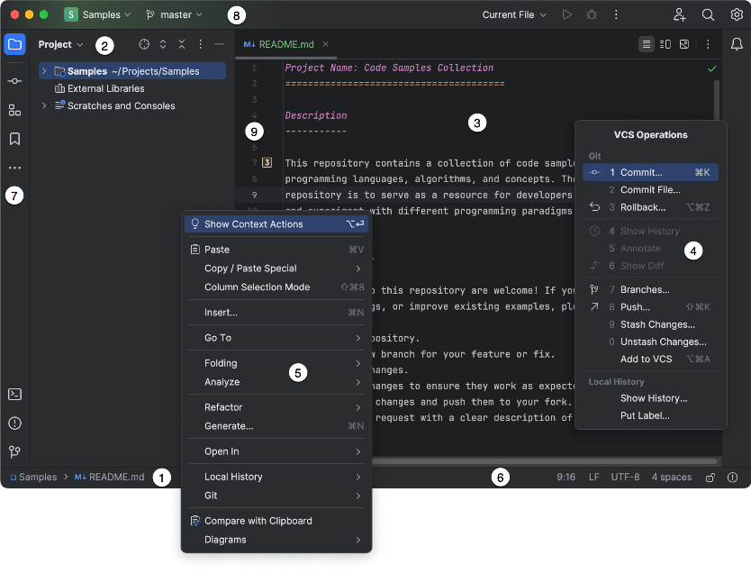
Figure 2.3: IntelliJ IDEA's User Interface
Source: https://www.jetbrains.com/help/idea/guided-tour-around-the-user-interface.html

Flowcharts
Flowcharts are the graphical representation of the definition, analysis, or method of solution of a problem in which symbols are used to represent operations, data, flow, equipment, etc (International Organization for Standardization, 1985). They utilise standardised symbols and arrows to depict the flow of information and decision-making points, making complex processes easier to understand and analyse (Zhang et al., 2023).
The global standard for documenting flowcharts is governed by the International Organisation for Standardization (ISO) and the American National Standards Institution (ANSI). The key standard relevant to flowchart documentation is ISO 5807:1985, which specifies symbols and conventions for data, program and system flowcharts, as well as program network charts and system resources charts (ISO, 1985). Based on the ISO standard, some basic flowchart symbols are described in Table 2.1.

Table 2.1: Standard Flowchart Symbols and Their Meanings
S/N | Symbol | Flowchart Meaning
1. |  | Data in any medium
2. |  | Data stored in a medium suitable for processing
3. |  | A process executing a defined operation or group of operations resulting in a change in information or the direction of flow
4. |  | A predefined process consisting of one or more operations that are specified elsewhere.
5. |  | A decision having a single-entry point and multiple alternatives exists, one and only one of which may be followed after evaluating defined conditions within the symbol.
6. |  | A line representing the flow of data or control, with optional arrowheads added to indicate the direction of flow.
Several other symbols are outlined in ISO 5807:1985 but are only needed when the precise nature or form of the process or data being modelled is known and when it is necessary to depict the specific medium.

Flowcharts in Software Development
Flowcharts have been a cornerstone of software engineering, serving as visual tools for depicting the logical flow of algorithms, processes and systems. Their role in software development spans problem analysis, design, debugging and communication among stakeholders (Zhang et al., 2023). Flowcharts were introduced as tools for visualising algorithms and logical processes in early computer science (Allen, 2023). Their structured representation made complex processes more comprehensible, promoting clarity in the step-by-step flow of logic. The simple, standardised symbols (e.g., rectangles for processes, diamonds for decisions) provide a consistent language for documenting software logic. Early advocates emphasised their role in structured programming, arguing that flowcharts helped eliminate unnecessary use of ‘goto’ statements and facilitated top-down program design.
Ronald Knuth further posited that programming is a literary activity, intended for human readability as much as machine execution (Ensmenger, 2016). Flowcharts align with this philosophy by providing a visual medium that abstracts code into a universally comprehensible format, aiding both developers and non-technical stakeholders in understanding program logic.
In the initial phases of software development, flowcharts serve as a communication bridge between developers and clients (Ensmenger, 2016). They enable the translation of vague user requirements into clear workflows. Entity-relationship diagrams (ERDs) and Data Flow Diagrams (DFDs), extensions of traditional flowcharts, are frequently used to model system interactions and data flow during the design phase (Cahyono, 2020). These visual tools assist developers in identifying potential issues early, reducing costly errors in later stages. Flowcharts are particularly effective for algorithm visualisation, as they break down complex logic into manageable steps. This aspect is critical in educational settings, where they are used to teach programming concepts to beginners (Allen, 2023). Visualising algorithms as flowcharts helps novices understand control structures like loops, conditionals and recursion before implementing them in code.
Flowcharts facilitate debugging by providing a high-level view of program logic, allowing developers to trace errors in the flow of execution. They are equally valuable for software maintenance, where new developers must quickly comprehend legacy code (Bakhirkin & Lukin, 2021). Visual representations of control flow, such as those provided by tools like Microsoft Visio or GraphViz, are often more intuitive for the process of software development than sifting through lines of code.
The rise of distributed teams has amplified the need for tools that enhance cross-developer communication (Murphy et al., 2019). Flowcharts, integrated with version control systems or collaborative platforms, help teams synchronize their understanding of shared codebases.
While flowcharts offer numerous advantages, they are not without limitations. Complex software systems often exceed the capacity of a single flowchart, leading to convoluted and difficult-to-read diagrams. Alternative visual tools like Activity Diagrams or sequence diagrams are sometimes preferred for larger systems. For example, Figure 2.4 is a flowchart designed for Knuth’s 1959 RUNCIBLE compiler and is far too complex to provide any practical use in explaining the functions of the compiler (Ensmenger, 2016).
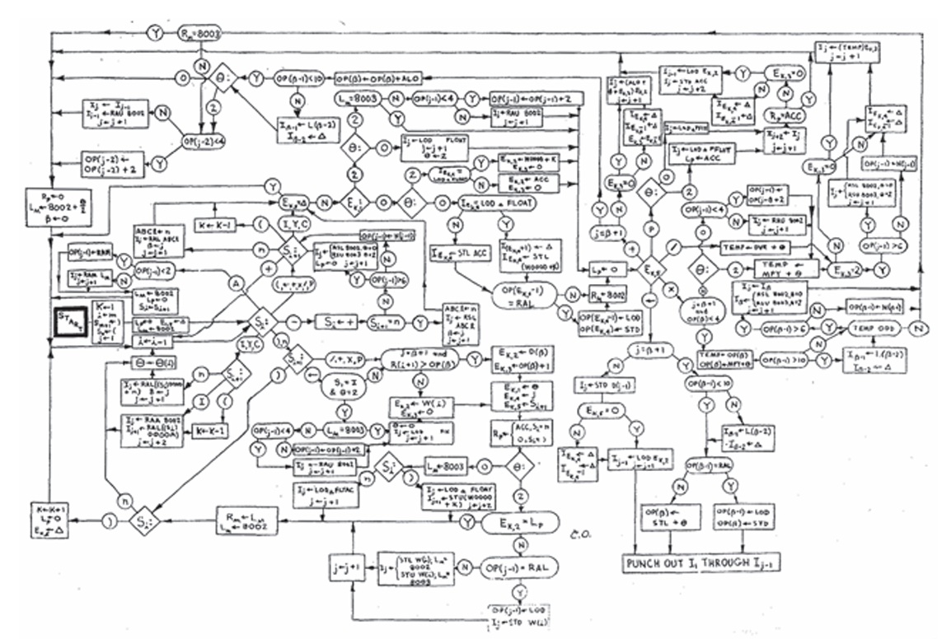
Figure 2.4: A Flowchart of Ronald Knuth's RUNCIBLE compiler (Ensmenger, 2016)
Alternative visual tools like Activity Diagrams or sequence diagrams are sometimes preferred for larger systems.
Flowcharts are also static representations and may not fully depict dynamic or asynchronous behaviour in current applications. For instance, real-time systems and event driven architectures often require specialized notations (Akesson, Nasri, Nelissen, Altmeyer & Davis, 2022) Variations in symbol usage and layout conventions can lead to inconsistent interpretations, particularly across international or interdisciplinary teams.
However, software tools like Lucidchart and Draw.io are evolving to offer interactive, editable flowcharts integrated with software repositories to aid in the application of flowcharts and Unified Modelling Language (UML) diagrams (Lu & Alexandru, 2023). These allow developers to update diagrams as code evolves, bridging the gap between documentation and implementation. Research continues to explore the effectiveness of flowcharts as pedagogical tools, particularly in introducing computational thinking and algorithm design to beginners (Allen, 2023). Emerging AI-powered platforms can automatically generate flowcharts from natural language descriptions or incomplete code, accelerating the transition from concept to implementation.
Flowcharts remain an essential tool in software development, having progressed from their classic purpose in algorithm representation to modern applications in automated visualisation, teaching and distributed development. While their limitations necessitate the employment of additional tools for large-scale or dynamic systems, their simplicity and universality ensure their continuous usefulness. Emerging technologies have the potential to overcome existing difficulties, cementing flowcharts' place in the future of software engineering.

Code Visualisation Algorithms
Numerous studies and projects have focused on developing algorithms to automate the conversion of program code into these visual formats. This review explores the foundational work, methodologies, advancements and limitations in the development of such algorithms, emphasising their impact on software engineering practices.
The idea of generating visualisations from program code dates back to the early days of programming when flowcharts were manually created to represent algorithms (Allen, 2023). With the advent of high-level programming languages, researchers began exploring automated approaches to produce these visual representations. Early systems, such as structured programming tools introduced in the 1970s, laid the groundwork for automated diagram generation (Ensmenger, 2016). These tools focused on eliminating unstructured ‘goto’ statements by visualizing structured control flow and introducing foundational elements for algorithm design.
The creation of UML in the 1990s further influenced this domain, standardising the visual representation of object-oriented systems. UML emerged as a standardized visual modelling language for software systems (O'Regan, 2014). It was developed by Jim Rumbaugh, Grady Booch and Ivar Jacobson, often referred to as the "three amigos," who aimed to unify and improve upon their object-oriented modelling approaches: Object Modelling Technique (OMT), Booch Method and Object-Oriented Software Engineering (OOSE) (Rittgen, 2005; Engels et al., 2005). The first version, UML 0.9, was released in June 1996, followed by versions 1.0 and 1.1 in 1997, with the latter being adopted by the Object Management Group (OMG) (P. Rittgen, 2005). UML offers formal notations for class diagrams, sequence diagrams and use-case diagrams, which could be generated from code or used to guide software development. The standardization of visual models provided by UML has been instrumental in software engineering for modelling and visualizing object-oriented systems (Koç, Erdoğan, Barjakly, & Peke, 2021). They enhance developers' understanding of software systems, aiding in maintenance and evaluation and help bridge the gap between documentation and code (Apostol, Bogdan & Marcu, 2024; Buzaid et al., 2022).
Extended Backus-Naur Form (EBNF) and similar grammar specifications have also been used to define the syntax of programming languages for parsing. Grammar-driven algorithms ensure that the parsing process accommodates language-specific constructs and can map them to corresponding visual elements. Systems like PHPLY (Python Lex-Yacc) have been developed to parse specific programming languages such as PHP. These systems integrate grammar definitions to extract semantic details and translate them into flowcharts or UML diagrams. In the context of Model-Driven Architecture (MDA), researchers have explored transforming program code into intermediate models, such as Problem Analysis Diagrams (PADs), which can subsequently be converted into other formats like UML diagrams (Li et al., 2019).
Pattern recognition techniques are also used to identify programming constructs (e.g., loops, conditionals and methods) and map them to corresponding visual elements. Semantic analysis, often integrated with Abstract Syntax Tree (AST) traversal, enables algorithms to infer relationships and dependencies within the code. Automatic Conversion of Structured Flowcharts into PADs by (Li et al., 2019) demonstrated the use of semantic analysis to translate flowcharts into PADs, which provide a two-dimensional representation of program logic. These algorithms focus on static analysis to identify inheritance, aggregation and other object-oriented principles (Li et al., 2019).
Graph-based algorithms are central to visualizing program logic. Graph theory provides a strong foundation for representing relationships between code components, while visualisation libraries like GraphViz and PlantUML render the final diagrams. Research by Shafeek & Karunarathne (2018) introduced methods for creating directed graphs to represent control flow. These graphs are then used to generate flowcharts and activity diagrams. Modern tools often integrate graph libraries to streamline visualisation.
Algorithms that generate visualisations from code have found significant applications in reverse engineering. For instance, tools like IBM Rational Rose and Microsoft Visio use reverse engineering techniques to generate UML diagrams, facilitating system maintenance and upgrades (Yu & Xiong, 2018). They have also been adopted in educational environments to help students understand programming concepts. Tools like Rapid Algorithmic Prototyping Tool for Ordered Reasoning (RAPTOR) use flowcharts to teach beginners the fundamentals of coding, translating simple programs into step-by-step visual workflows (Coffman, de Freitas, Hill & Weingart, 2023). Modern IDEs incorporate visualisation features powered by these algorithms. For example, JetBrains IntelliJ IDEA and Eclipse can generate class diagrams and sequence diagrams directly from Java projects, streamlining the development process (Krauter, König, Rutle & Lamo, 2022).

Review of Related Works
This section outlines a review of some written publications that have attempted to solve the problem of code visualisation.

ConfiGen
Ahmmed, Cohen & Gazillo (2024) present ConfiGen, an automated approach that provides user-facing documentation and back-end analysis to show definitions and uses of configuration options with traceability to lines of program code. (Ahmmed et al., 2024) highlight the limitations of existing documentation tools like Javadoc, Docstrings, and Doxygen, which are designed for only one language and do not adequately address reconfigurability. ConfiGen aims to make configurability a first-class element in documentation, enhancing the ability to manage configuration changes over time.
Ahmmed et al. (2024) also discuss the motivation and related work in the field of software reconfigurability. They mention the challenges of maintaining documentation for configurable software and the need for tools that can provide traceability between configuration options and code. Ahmmed et al. (2024) argue that existing tools do not provide sufficient support for managing configuration changes over time and propose ConfiGen as a solution to this problem.
ConfiGen is built on top of the Doxygen documentation tool and extends it with static analysis to identify the usage of configuration options in the code. The tool parses Kconfig files to extract configuration symbols and their attributes and then uses Cscope to find the uses of these configurations in the source files. The output is presented in Hypertext Markup Language (HTML) documentation, including the defined locations and traceability of the symbols used in the source code.
The case study results indicate that ConfiGen can provide relevant information about configuration options and their usage, making it a valuable tool for software maintenance tasks such as testing, debugging, and refactoring. The authors conclude that ConfiGen has the potential to make configuration documentation a first-class element in software documentation and plan to further develop the tool to support runtime reconfigurability and evaluate its effectiveness in different use cases (Ahmmed et al., 2024).

GoCity
Brito, Brito, Brito, and Valente (2019) introduce GoCity, a web-based implementation of the CodeCity program visualisation metaphor specifically designed for the Go programming language. GoCity aims to support Go developers in software maintenance tasks by providing a visual representation of source code metrics extracted automatically and visualizing them in the form of a 3D city to help developers further understand the design and architecture of their projects (Brito et al., 2019).
Brito et al. (2019) highlight that despite the growing popularity of Go, a statically typed and compiled language created by Google in 2007 and publicly available since 2009, there is a lack of tools to support Go developers in maintaining and evolving their projects. GoCity aims to address this gap by adapting the CodeCity metaphor, originally implemented for C++, Java, and Smalltalk, to support Go's unique features. GoCity represents Go projects as 3D cities where source code elements are visualised as urban structures. For example, a struct in Go is represented as a building, with the number of methods defining the building's height, and the number of attributes defining the building’s width. The tool provides an on-the-fly visualisation based on metrics from the source code, such as the number of methods, attributes, and lines of code. The colour intensity of the buildings indicates the size of the code elements, with darker buildings representing larger elements. Figure 2.5 presents an overview of GoCity’s proposed visualisation.
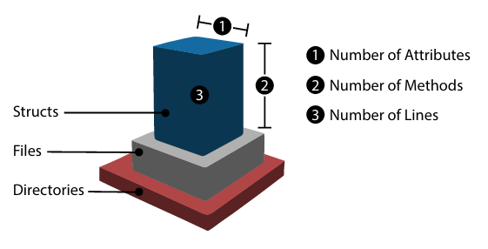
Figure 2.5: How a struct is visualised in GoCityy
The architecture of GoCity consists of two main modules: the processing module and the front-end module. The processing module fetches the project from its repository, extracts metadata, and defines the hierarchy and location of buildings in the city. The front-end module provides a web-based interface for users to interact with the visualisation, implemented using Babylon.js and React.js. The interface allows users to rotate and zoom the image and provides features to retrieve the code from GitHub.

Software Engineering Experience In Action (SEEIA)
Augustinowski, Cheema, and Gawenda (2024) investigate how to improve code-review methods via collaborative software visualisation in the Software Engineering Experience In Action (SEEIA) project. SEEIA is a continuation of the Software Engineering Experience (SEE) project, which depicts software projects as code cities in virtual rooms for dispersed development teams (Augustinowski et al., 2024). The SEE platform provides a virtual workplace in which creators may interact with avatars, use voice and text chat capabilities, a built-in web browser, and tables that illustrate many elements of software projects, such as Implementation, Evolution, Dynamic, and Architecture (Augustinowski et al., 2024). These tables visualise code metrics, project changes over time, runtime interactions, and architectural adherence (Augustinowski et al., 2024).
Augustinowski et al. (2024) employ action research methodologies, which involve iterative cycles of diagnosing, planning action, taking action, and evaluating action. The primary research question is to determine which functions should be added to SEE to enhance the code review process, allowing reviewers to gain a quick and comprehensive overview of the entire project context.
Three major enhancements were introduced to SEE for code reviewing. The Diff City is a new type of code city that visualises the changes between two project versions. The Code Window displays the difference between the source code of each code piece depicted as a node in the city. Test Coverage Visualisation, which adds coverage data from Java projects to the node of a code city, displaying how test coverage changes with code.
The project is presently in its first cycle of action research, with the next stage being to determine whether the reviewer benefits from the deployed changes. Augustinowski et al. (2024) aim to integrate SEE into code reviews and leverage action research to improve software to fit user needs. Future feature ideas include creating code cities directly from version control systems, adding a log function for recording important findings, and annotating code with comments (Augustinowski et al., 2024).

Review of Existing Systems
This section will discuss a review of some automated code visualisation software for Integrated Development Environments that already exist and are in mass circulation.

Understand
The Understand VSCode Extension is a tool developed by SciTools and serves as a valuable tool for enhancing code comprehension through its static analysis and visualisation features, primarily focusing on code metrics and relationships. It offers functionalities such as generating UML diagrams, providing insights into code complexity and maintainability, and visualising dependencies within a codebase. Figure 2.6 is an image of a control flow diagram automatically created from uploaded code documents.
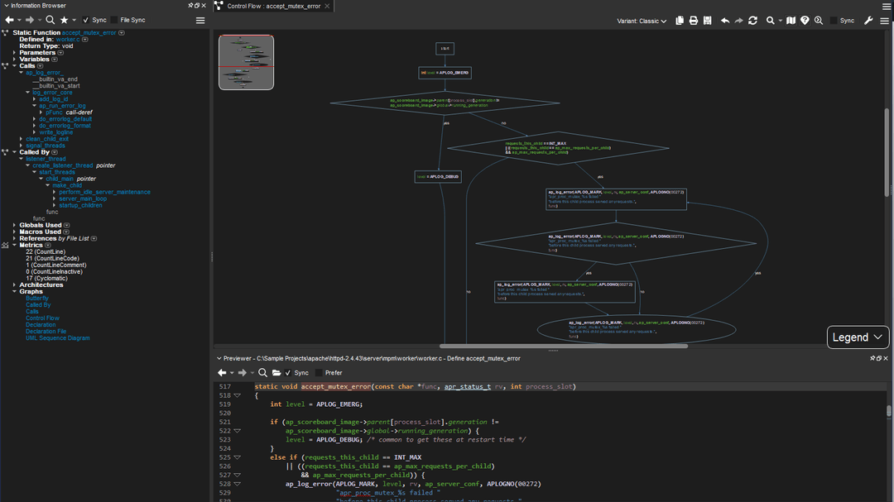
Figure 2.6: Understand's User Interface
Source: https://github.com/stinb/UnderstandForVSCode
Understand currently has a VSCode Extension but it does not integrate the platform’s automatic visualisation capabilities, meaning that users are unable to make use of these visualisations without installing the Understand client. This also means that users constantly have to switch between both applications to view flowcharts.

Diagramming AI
Diagramming AI is a web-based tool that leverages the power of artificial intelligence (AI) to automatically generate diagrams, including flowcharts and UML diagrams. It aims to enhance the efficiency of software development by simplifying the visualisation of complex architectures and relationships within systems.
However, Diagramming AI only supports the translation of descriptions of systems to Flowchart visualisations, with no provisions for directly generating flowcharts from code written in programming languages. This lack of support for direct conversion of program code to flowchart may hinder the usability of the application for users who do not have a deep enough understanding of code to generate a description for the system and makes it an unlikely tool for improving the understanding of programming constructs and complex codebases. It currently has no direct integrations within Integrated Development Environments. Figure 2.7 shows Diagramming AI in use.
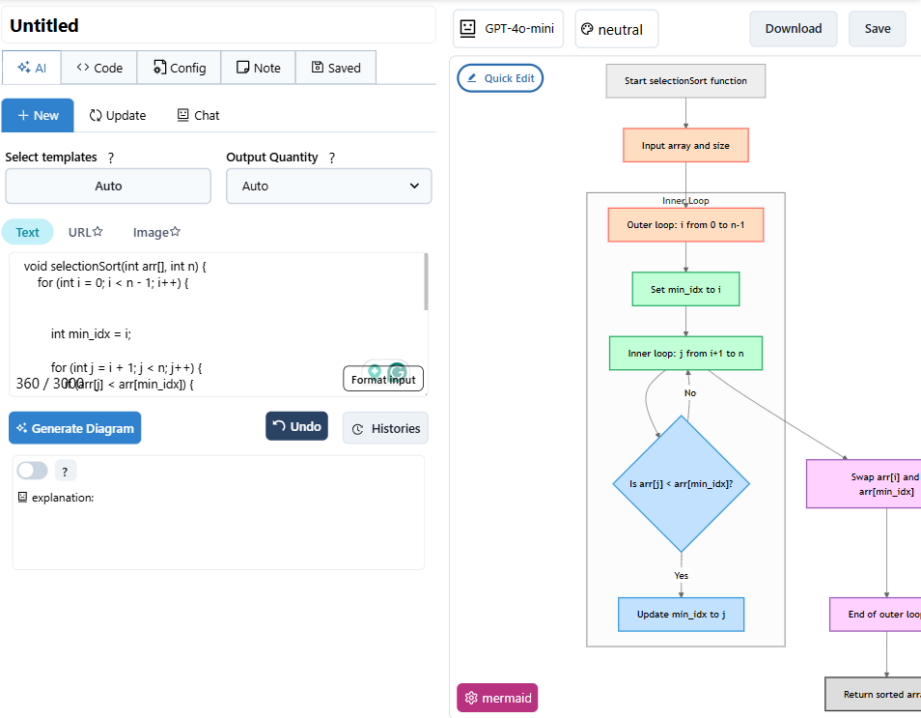
Figure 2.7: Diagramming AI flowchart generated for the Selection Sort Algorithm

IntelliJ IDEA Diagrams Plugin
IntelliJ IDEA's Diagrams Plugin offers a robust method for visualizing code structures through UML class diagrams. This feature allows developers to generate diagrams that reflect the actual classes, methods, and relationships within their applications. Users can create diagrams for specific packages, analyse class hierarchies, and manage dependencies visually. The integration of the Diagrams plugin, which is enabled by default, facilitates easy access to these visualisation tools, allowing users to manipulate the diagrams through context menus and toolbar options. There is also added customisation of the UML class diagrams by using the ‘Structure’ tool to add new members of the class, delete the existing ones, see implementations, check parent classes, add annotations, etc. Figure 2.8 shows a class diagram for a class open in the Diagrams tool.
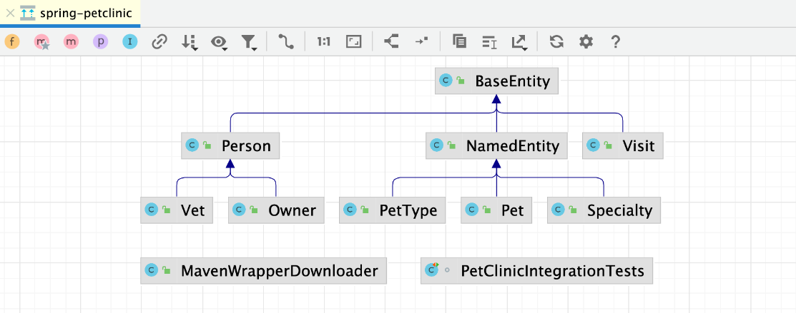
Figure 2.8: IntelliJ IDEA Diagram Plugin
Source: https://www.jetbrains.com/help/idea/class-diagram.html
However, the tool is currently only available for IntelliJ IDEA and can only be used in projects written in Kotlin and Java. The tool's use of UML class diagrams, while suited for the object-oriented nature of Kotlin and Java, may not be suited to other programming languages that support the use of other programming paradigms.

Review of Related Methods
This section will review some existing methods for the generation of flowcharts in particular automatically from source code.

VDM Support in the VS Code Environment
Lund et al. (2022) proposed that UML visualisations of Vienna Development Method (VDM) models can be improved by using a text-based diagram tool called PlantUML. PlantUML is a text-based diagram tool that has been implemented as a VSCode extension. According to Lund et al. (2022), PlantUML offers several advantages over previous tools for UML visualisation:
- Text-based Format: Diagrams are created from simple text descriptions, making them easier to version-control using systems like Git. This approach facilitates collaboration among team members as PlantUML diagrams can be edited and merged like source code.
- Automation: PlantUML generates diagrams with automatic placement of elements, removing the need for manual positioning.
- Usability: It supports various export formats (e.g., XMI, PNG, SVG), improving interoperability with other tools.
- VS Code Integration: PlantUML is available as a VS Code extension, enabling real-time updates to UML diagrams directly within the IDE. The diagrams can be displayed alongside VDM model files, providing a unified and efficient workflow for developers.
The transformation pipeline between VDM++/VDM-RT models and PlantUML diagrams designed by Lun et al. was intended to be bidirectional, involving the traversing of VDM abstract syntax trees (ASTs) to extract relevant elements (classes, attributes, associations, etc.). These elements are then mapped to PlantUML syntax according to predefined rules (e.g., attributes become PlantUML fields, associations become arrows). The text-based PlantUML diagram is parsed and converted back into a VDM AST. This reconstructed AST regenerates the original VDM model, preserving its structure and semantics. The proposed architecture leverages class mapping introduced in VDMJ 4 for AST manipulation.
Each transformation direction has specific steps:
- Each VDM class is mapped to a PlantUML class, represented by ‘class ClassName {...}’. Class members (attributes, operations) are included within the curly braces.
- VDM instance variables are translated into PlantUML attributes, preserving access modifiers (‘+’, ‘-’, ‘’) and static indicators.
- VDM operations and functions are represented as PlantUML methods, with functions distinguished using stereotypes (e.g., ‘<> ‘).
- Associations in VDM are represented by PlantUML arrows with role names and multiplicities. For example, a sequence type in VDM (‘seq of ClassName’) is mapped to an association with a ‘0..n’ multiplicity. (iv) Inheritance relationships in VDM are mapped directly to PlantUML inheritance syntax (e.g., ‘ClassName’).
- Inheritance relationships in VDM are mapped directly to PlantUML inheritance syntax (e.g., ‘ClassName <| SubClassName’)
Qualified associations, unique to VDM, are represented in PlantUML using square brackets to indicate qualifiers. Static and constant attributes are annotated in PlantUML using stereotypes.
The PlantUML text file is then parsed to identify elements like classes, attributes, associations and their metadata (e.g., visibility, multiplicity). Parsed elements are mapped back to corresponding VDM constructs. For example, PlantUML attributes are reconstructed as VDM instance variables with type annotations inferred from the context. Static analysis of the original VDM model is suggested to identify and warn users about cases where certain VDM-specific constructs (e.g., types, optional values) lack direct equivalents in UML. Extensions to PlantUML could also be proposed (e.g., collaborating with PlantUML developers to support VDM-specific syntax).
While PlantUML can host UML visualisations for VDM models due to the fulfilment of all the necessary transformation rules, the task of integrating VDM models into PlantUML and VSCode is not without challenges:
- Qualified Associations: Current PlantUML syntax does not natively support qualified associations. In VDM++, qualified associations are instance variables that map qualifier types or classes to classes. Workarounds using square brackets or collaboration with PlantUML developers may be required.
- VDM-RT Support: While the focus is initially on VDM++, extending the transformation to VDM-RT requires handling additional constructs like real-time constraints.
- Bidirectional Updates: Maintaining consistency between VDM models and PlantUML diagrams during iterative edits remains a challenge.
- Static Analysis for Compatibility: A mechanism to analyse VDM models for constructs that cannot be represented in UML is yet to be implemented. If implemented, it will warn users about potential issues.
This approach modernizes the VDM modelling ecosystem, aligning it with contemporary development practices and toolchains in automating the process of visualizing modelling tools.

Flowgen
Kosower, Lopez-Villrejo & Roubtsov, (2014) present Flowgen, a framework designed to generate high-level UML activity diagrams from annotated C++ source code. Kosowe et al. (2014) addressed the challenge of bridging the understanding gap between high-level algorithm design and low-level code implementation, particularly in complex scientific computing contexts with the development of Flowgen
The primary goal of Flowgen is to enhance the accessibility of complex C++ codes, facilitating collaboration among developers and science specialists with varying expertise. Kosowe et al. (2014) argue that traditional documentation tools, while helpful, often fail to provide a clear, high-level overview of code functionality. Flowgen aims to fill this gap by transforming developer comments and annotations into visual representations that abstract away implementation details.
Flowgen operates by extracting information from C++ source files, focusing on annotations and control structures. Annotations are specific comments written in a distinct syntax developers use to enrich their code and describe the purpose and actions of code segments. These annotations serve as the foundation for generating activity diagrams. Control structures are fundamental concepts in programming, encompassing sequencing, selection and repetition. The framework analyses C++ control structures (like loops (for/while) and conditionals(if/else)) to understand the flow of execution within the code. This analysis is crucial for accurately representing the logical flow in the generated diagrams.
For each annotated function or method, Flowgen generates interconnected UML activity diagrams that visually represent the algorithm's behaviour at a high level. Developers annotate their C++ code using a syntax that distinguishes Flowgen annotations from regular comments.
For example,
//$ action description
allows Flowgen to identify key actions and their associated descriptions.
Flowgen processes each source file sequentially, producing HTML files containing the generated diagrams. Each diagram corresponds to a function or method and is interactive, allowing users to zoom in on details or navigate between related diagrams. The output consists of a set of interconnected HTML files, each containing activity diagrams that represent the flow of actions within the annotated functions. The diagrams include elements such as:
- Actions: Represented as nodes in the diagram
- Flow Paths: Indicated by directional arrows connecting actions.
- Conditional Branches: Illustrated using diamond-shaped elements to depict decision points
Figure 2.9 and Figure 2.10 show an example of some C++ code demonstrating the use of nested if-statements and a generated UML activity diagram from the code, respectively.
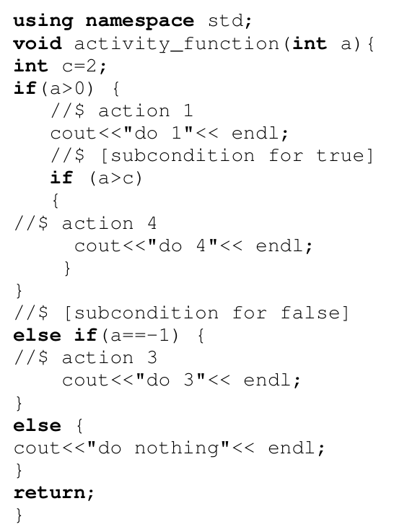
Figure 2.9: Annotated C++ code with nested if-else blocks
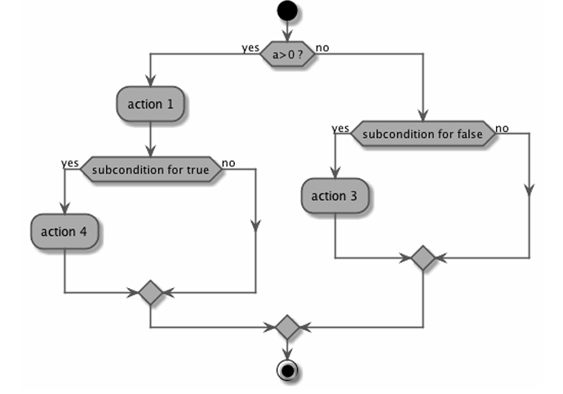
Figure 2.10: Resulting Activity Diagram of Code from Figure 2.9
The generated diagrams are designed for user interaction, allowing users to explore different levels of detail through zooming and browsing capabilities. The methodology is exemplified by its application to the VINCIA plug-in used to simulate events at Conseil Européen pour la Recherche Nucléaire (CERN) Large Hadron Collider. This case study demonstrates how Flowgen can be employed in real-world scenarios to improve code documentation and facilitate collaboration among developers and scientists.
Flowgen is positioned as a complementary tool to Doxygen, which primarily focuses on generating structural documentation. While Doxygen does provide insights into class structures and relationships, Flowgen enhances this by offering behavioural representations through high-level activity diagrams. Kosowe et al. (2014) note that existing tools typically generate low-level diagrams closely tied to code implementation; in contrast, Flowgen emphasises high-level semantics derived from developer annotations.

_toFlowchart
Previous work on compilers and transpilers has established a foundation for translating code between textual representations (Kulkarni, Chavan & Hardiker, 2015). Transpilers, which focus on higher-level source-to-source translation, enable the generation of various outputs from intermediate representations. The _toFlowchart methodology builds on these principles by adapting a standard compiler architecture to the novel task of visualising program logic as flowcharts (Shafeek & Karunarathne, 2018). Unlike traditional compilers, this approach treats flowcharts as the target "language," using an Abstract Syntax Tree (AST) as an intermediate representation.
The AST plays a critical role in bridging the semantic gap between programming constructs and their graphical representation with its ability to preserve the logical structure of source code (Ghica, 2021). _toFlowchart introduces a modular AST framework defined in EBNF, enabling extensibility across multiple programming languages. This abstraction ensures that flowchart generation remains consistent with the semantics of the source code, aligning with recommendations from early compiler research. _toFlowchart aims to convert code to GraphViz visualisations using a 3-stage compiler:
- Tokenising and parsing the source code to generate an AST
- Translating the AST to a Dot language representation and
- Using GraphViz to render flowcharts from the Dot specification
Figure 2.11 is a visual representation of this compiler
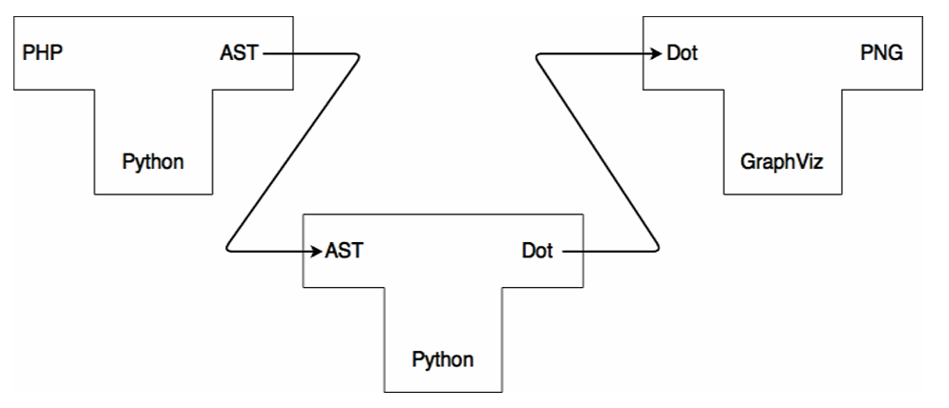
Figure 2.11: _toFlowchart depicted as a 3-stage compiler
GraphViz, a robust graph-based drawing tool, was used for graph visualisation. By abstracting intermediate representations into the Dot language, _toFlowchart achieves greater flexibility in adapting to diverse programming constructs and languages.
The methodology's effectiveness was evaluated through a rigorous comparison of manually designed flowcharts, source code logic and compiler-generated outputs, as is best practice in experimental software engineering, emphasising correctness and semantic fidelity. _toFlowchart testing focused on common constructs, such as if-else conditions, switch-case statements and loops, to validate its translation accuracy. The resulting flowcharts were found to be both valid and correct, reflecting logical flows consistent with the original code. Figure 2.12 shows standard PHP code for a simple while loop, and Figure 2.13 demonstrates a flowchart generated from this code by _toFlowchart.
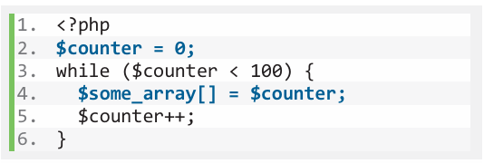
Figure 2.12: PHP code with a standard while loop
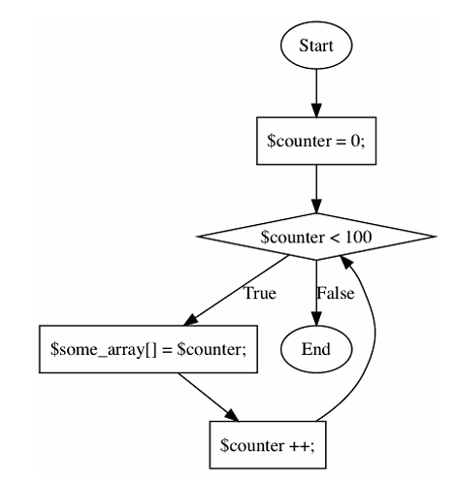
Figure 2.13: Flowchart of code from Figure 2.12 using _toFlowchart
While promising, the approach is currently limited to PHP and a subset of programming constructs. Future enhancements could include expanding grammar definitions, refining flowchart aesthetics and incorporating more complex language paradigms. Additionally, a user-friendly interface could democratize the tool's utility for developers of varying expertise.
Table 2.2 provides a tabular comparison of the features of the three works outlined in this chapter to the developed system

Table 2.2: Comparison of Related Methods
Feature | VDM to PlantUML | Flowgen | _toFlowchart | Developed System
Programming Language Support | None (Makes use of VDM++ and VDM-RT) | C++ | PHP | C++, Python and JavaScript
Output Format | UML diagrams (XML, PNG, SVG, etc.) | UML Activity Diagrams (interactive HTML files) | Flowcharts rendered via GraphViz | Flowcharts rendered via Mermaid.js and Mermaid syntax
Input Requirements | VDM models | Annotated C++ code | PHP source code | Raw source code
IDE Integration | YES | NO | NO | YES
Full Automation | YES | NO | YES | YES

Chapter Three

System Analysis and Design

Preamble
This section outlines the analysis and design of the proposed system. It details the requirements of the system; techniques used in the development of the system, and diagrams modelling the system.

Overview of the System
The suggested system is a code-to-flowchart generation platform that assists learners and developers in visualising the control flow of simple code structures as part of their development workflow. The system consists of two main components: a web application that parses and renders code, and a Visual Studio Code (VSCode) plugin that sends selected code snippets to the application for visualisation. VSCode was chosen due to its vast popularity in the developer market and its flexible extension framework.
At its heart, the design emphasizes simplicity, modularity, and accessibility, drawing on visual learning theory concepts and the cognitive benefits of diagrammatic representation in computer science teaching. A modular design was implemented, with parsing and code generation logic segregated per language, facilitating flexibility and readability for future generations of the iterative model. Each parser converts source code into an intermediate representation (IR), a structured object format for defining control flow transitions. This IR is then ingested by a language-specific Mermaid generation module, which guarantees that all flowcharts start with a rounded "Start" node, conditionals are represented as diamonds with marked Yes/No edges, and loops appropriately reconnect to their condition nodes.
To ensure that the system is compatible with multiple target languages while keeping the parsing logic manageable, the syntax supported is limited to expression statements, if/else conditions, and for loops, key building blocks in introductory programming, and the evaluation criteria for the _toFlowchart program. This limited scope enables the usage of bespoke static parsers written in plain JavaScript for each of the three target languages: Python, JavaScript, and C++.
The VSCode extension is designed to have minimal user interactions to reduce user effort. The front-end web application is implemented as a fully static client-side site hosted on Netlify, removing the need for a backend server. It receives code via a query parameter, making it easily accessible from external tools like the VSCode extension. The rendering process relies on the Mermaid.js API for predictable, DOM-independent flowchart generation, enhancing reliability across browsers and environments. Figure 3.1 presents a diagram for the flow of the development of this system:

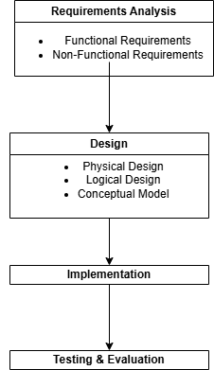
Figure 3.1: A diagram of the Flow of the System's Development

Requirements Analysis
Requirements analysis is the process of determining, gathering, and documenting what a software system must accomplish and how it should function. It guarantees that the completed product satisfies user requirements, commercial objectives, and technical constraints. The Requirements for this system were derived as a result of the literature review and comparative analysis performed in chapter 2.

Functional Requirements
Functional Requirements refer to essential services and functionality that the software must provide for it to be considered complete. They are listed as follows:
- Accept user code from VSCode: The system must be able to capture the user’s selected code snippet and send it to the web application.
- Display and edit code input in Web Application: The system must allow users to review and edit the code received by the web application before proceeding to flowchart generation.
- Allow Language Selection: The system must allow users to select the programming language used to write the input code from one of the supported languages (JavaScript, Python, C++).
- Generate valid Mermaid Flowchart Syntax: The system must be able to generate valid Mermaid.js syntax from the code that reflects the logical flow of the input code.
- Enable Coping of the Mermaid Code: The system must allow users to copy the Mermaid code for use in documentation platforms that have native support for rendering Mermaid syntax.
- Render the Flowchart: The system must be able to visually render the flowchart in the browser to allow for easy review of the generated flowchart.
- Support Manual Code Input: The system must allow users to input code manually independently of the VSCode extension.

Non-Functional Requirements
Non-Functional Requirements are operational qualities and constraints on a system that ensure the system’s usability, reliability, efficiency, etc. They are listed as follows:
- Usability: The user interface for the extension and the web application should be easy to use, especially for inexperienced developers.
- Cross-browser compatibility: The online application should be compatible with all main browsers (Chrome, Edge, and Firefox).
- Security: The system may not store or transfer code to third parties. All code parsing and rendering must occur on the client or a controlled backend.
- Scalability: The architecture should be intended to support additional languages in future iterations with minimum reworking.
- Reliability: The system should constantly generate diagrams with no syntax errors or crashes due to incorrect input.
- Maintainability: The code should be modular, with separate files for parsing, Mermaid conversion, and rendering to facilitate debugging and improvements to the system during iterations.

Physical Design
Physical design is the process of transforming the system's logical design (conceptual architecture, flow, and linkages) into a real, implementable structure. It specifies how the system will be constructed, deployed, and interact with hardware, software, data, and networks.

The Proposed System Architecture
System architecture is the fundamental organization of a system, represented by its components, their interactions to one another and to the environment, and the principles that guide its design and evolution. It is the set of structures required to reason about the system, which includes software parts, their relationships, and the qualities of both.
The system's architecture is modular in nature, consisting of two connected components: a Visual Studio Code extension that runs within the developer's local IDE, and a static web application hosted statically that provides code analysis and visualisation. These components work together to create a lightweight, extensible pipeline for converting code into visual flowcharts that does not require complex backend infrastructure or third-party parsers.
The functions of the components in the architecture are as follows:
- The VSCode Extension: acts as an intermediary between the local coding environment and the online visualisation tool. It allows users to highlight code in the VSCode editor and communicate it to the hosted web application via a Uniform Resource Locator URL) query parameter. This provides smooth integration without the need for laborious copy-pasting.
- The Web Application: is the key coordinating component that accepts code from the extension and user input through the web UI. It coordinates communication between the interface, the static parsing logic, the diagram generating logic, and the Mermaid render engine. It guarantees that data flows properly from code input to visual output.
- The User Interface (UI): is the visual layer that allows users to paste, edit, and preview the code to be parsed. It also has options for selecting a programming language, generating flowcharts, and copying the Mermaid code. It sends user input to the parser modules and then shows the final drawn diagram.
- Static Parsers: are JavaScript modules that examine the structure of input code (Python, JavaScript, and C++). They identify essential control flow elements and return a reduced structure suited for flowchart production. These parsers are incorporated in the web application and are intended to function without any external dependencies.
- Mermaid Plaintext Module: accepts the Mermaid syntax string created by the IR and prepares it for rendering. It handles any further formatting, escaping, or changes required for legal Mermaid code. It may also provide the Mermaid code for preview or copying by the user.
- The Mermaid API: the core Mermaid.js package that renders diagrams. It accepts Mermaid code and generates flowcharts with a client-side rendering engine.
- Mermaid Rendering Module: is in charge of translating the Mermaid plaintext into a real SVG diagram. It converts the syntax into a visual flowchart using the Mermaid JavaScript API included in the frontend, which is then injected into the user interface for display.
The system architecture is depicted in Figure 3.2 below.
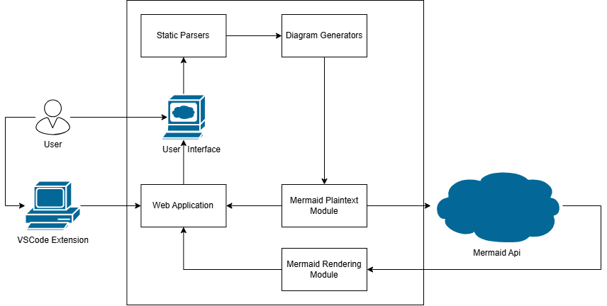
Figure 3.2: System Architecture Diagram

Logical Design
Logical Design is the phase of the development of the system where the system’s functional requirements are translated into a high-level model, including the components of the system, the interactions between these components, the flow of data within components and processes.
Logical Design provides a blueprint for the functioning of a system, guarantees consistency with the user requirements and use cases while acting as a mediator between the requirements analysis and physical design

Use Case Diagram
The use case diagram is a UML diagram that shows the system's functionality from the perspective of external actors (e.g., users, systems) by displaying use cases (functional objectives) and their interactions. In Figure 3.3 below is the Use Case diagram of the system from a user looking to generate a flowchart from code in VSCode.
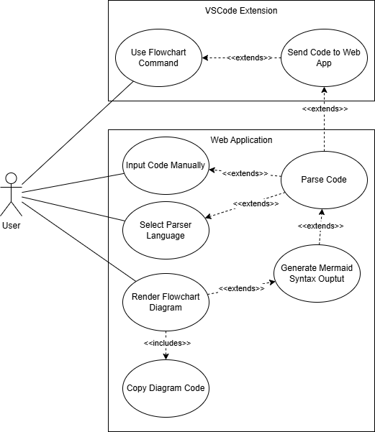
Figure 3.3: Use Case Diagram

Activity Diagram
The activity diagram is a UML diagram that portrays the dynamic behaviour of a system or process by concentrating on the flow of activities, choices, and transitions. Figure 3.4 is the activity diagram of a user seeking to generate a flowchart from code in their editor.
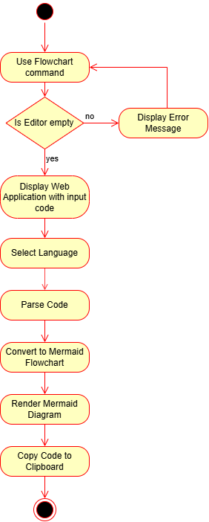
Figure 3.4: Activity Diagram

Sequence Diagram
The sequence diagram is a UML diagram that depicts the interaction between objects or actors over time, showing the sequence of messages or method calls to achieve a specific goal. Figure 3.5 is the sequence diagram of a user interacting with the system to generate a flowchart.
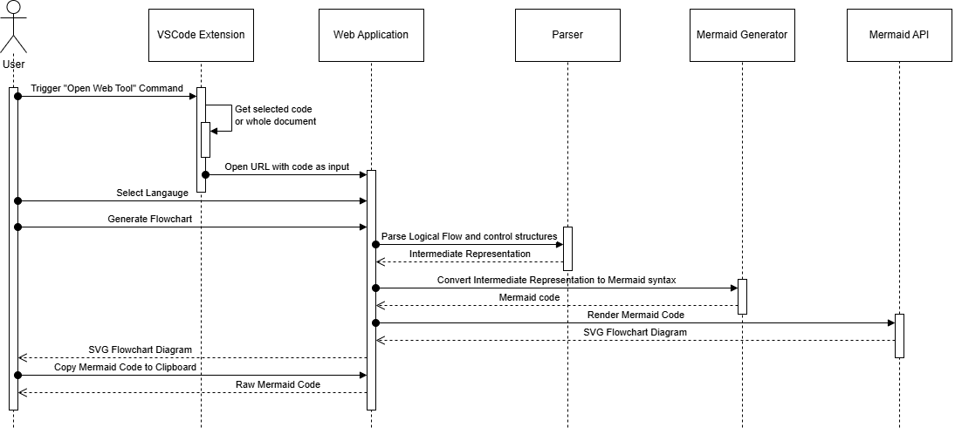
Figure 3.5: Sequence Diagram

Conceptual Design
Conceptual design is a high-level, abstract depiction of a system that defines its major components, linkages, and general structure in order to fulfil user needs. It focuses on what the system should perform but does not specify how it will be implemented.

Context Diagram
The context diagram is a high-level Data Flow Diagram (DFD) (Level 0) that portrays the system as a single operation interacting with other entities. They define system boundaries, showing inputs, outputs and interactions with external entities. Figure 3.6 combines the web application and VSCode extension as the whole system.
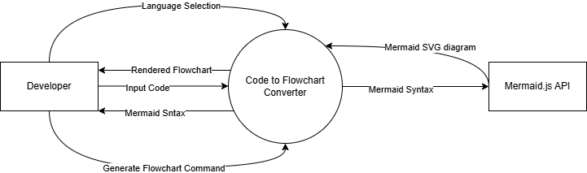
Figure 3.6: Context Diagram

Entity Relationship Diagram
The Entity Relationship Diagram is a diagrammatic representation of the data model that shows entities, properties, and relationships inside a system. Figure 3.7 shows the entity relationship diagram of the system.
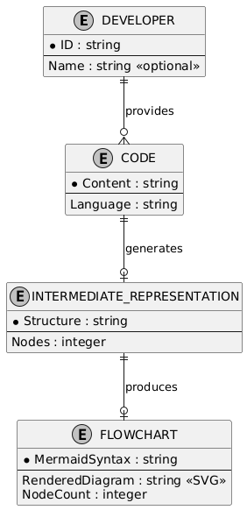
Figure 3.7: Entity Relationship Diagram

Chapter Four

System Implementation and Evaluation

Preamble
This chapter outlines the implementation of the proposed recommendation system. It presents the hardware and software requirements for the system's use, the development methodology, program modules and interfaces, and the evaluation of the system.

System Requirements
System requirements are high-level descriptions of what a system must perform to fulfil user demands. They include hardware and software requirements.

Hardware Requirements
Hardware requirements define the physical resources required to execute the system, including computing power, memory, storage, and peripherals. The hardware requirements for the system are outline in Table 4.1
Table 4.1: Hardware Requirements
S/N | Hardware | Requirement
1. | Processor | 1.6 GHz or faster dual-core processor
2. | RAM | 4 GB
3. | Storage | ~ 500 MB
4. | Display | 1024 x 768 resolution or higher
5. | Internet Connection | Required

Software Requirements
Software requirements describe the software environment, tools, or dependencies required to execute or build the system, such as operating systems, libraries, or frameworks. The software requirements for the system are outlined in Table 4.2
Table 4.2: Software Requirements
S/N | Software | Requirement
1. | Visual Studio Code | 1.101 or higher
2. | Browser | Must support JavaScript and ES6
3. | Clipboard API support | Required

Implementation Tools
These are the tools used to construct the software project. They contributed to the effective development of the recommendation system project.

Visual Studio Code (VSCode)
Visual Studio Code is a free, open-source code editor created by Microsoft. It was utilised for this project's software development because it supports IntelliSense, debugging, Git integration, and extensibility through extensions.
In this project, VSCode served as both the primary development environment and the deployment platform for the custom extension. The addon was created with TypeScript and used VSCode's command APIs to record user-selected code snippets. When activated, the extension encodes the selected code and runs the hosted web application in the user's default browser, passing the code as a URL query parameter. This provides a fluid experience for developers who want immediate visual feedback on the logic flow of the code they're working on from their editor.

JavaScript
JavaScript is a versatile high-level language and one of the core languages of the world wide web. JavaScript was used extensively in the development of the web application frontend. JavaScript handled user input events, Document Object Model (DOM) manipulation, integration with Mermaid.js, clipboard copying, and routing logic for parsing and rendering diagrams. In this project, JavaScript also powered the static code parsing logic, which was manually written to support a subset of three language (JavaScript, Python, and C++) focused only on expression statements, if/else blocks, and for loops. Using pure JavaScript, the application remains lightweight and compatible with modern browsers without requiring build steps or runtime dependencies.

HTML5 and CSS3
HTML (Hypertext Markup Language) was used to define the structure of the frontend interface, including the layout of the input text area, buttons, language selector, and Mermaid output container. All user interaction happens within this structured HTML interface.
CSS (Cascading Style Sheets) was used to style the web interface and provide a visually appealing, responsive layout. A dark mode theme was applied for better readability and user comfort, especially for developers working in low-light environments. This is also in line with the VSCode default light mode theming Custom styles ensured proper spacing, theming, and visibility of the Mermaid diagrams within the browser viewport.

Mermaid.js
Mermaid.js is a JavaScript library that allows the generation of diagrams and visualisations from textual descriptions written in a simple domain-specific language (DSL). It is particularly suited for generating flowcharts, sequence diagrams, class diagrams, and more. In this system, Mermaid.js was used to take the text-based IR generated from user code and render it into an SVG-based flowchart in the browser. It was chosen for its flexibility, ease of integration with client-side JavaScript, and the ability to render dynamic diagrams without server-side processing. The Mermaid rendering API allowed for real-time diagram updates based on user interaction. Mermaid.js is also useful in the sense that Mermaid syntax generated by the system can be used outside of the system for documentation purposes. For example, GitHub has native support of rendering Mermaid diagrams with their syntax typed in a markdown (.md) file.

Netlify
Netlify is a platform for automating the deployment and hosting of modern web projects. It is designed in mind for systems developed using JavaScript, Application Programming Interfaces (APIs) and Markup (HTML, CSS), also known as JAM stack (JavaScript, APIs, and Markup) applications.
For this project, Netlify was used to host the static frontend web application. This included the HTML, CSS, JavaScript files, and the embedded Mermaid renderer. Netlify provided instant global deployment through Git integration and allowed the site to be accessed publicly from a URL. This setup ensured that the VSCode extension could reliably open the hosted web app, passing code as a URL parameter, regardless of the user’s machine or environment.

Git and GitHub
Git is a distributed version control system used to manage changes to the source code over time. GitHub is a cloud-based hosting service for Git repositories. These tools were used throughout the development process to track progress, collaborate on code, and manage branches for modular development (e.g., separating parser logic, UI, and integration). Git enabled backup, branching, and rollback of features, while GitHub served as the central repository for the frontend application and the VSCode extension. GitHub Actions or Netlify’s Git integration could also be used to automate deployments on push events.

Development Methodology
Iterative development methodology was used as software development methodology. The creation of code-to-flowchart generation system was based on iterative methodology of development and it is a process where the system was created and enhanced by the several cycles of refinement. Instead of trying to bring the entire solution all at once, the project was split into small pieces that were designed, constructed, and enhanced gradually through feedback on user experience and results of testing, and according to changing needs.
During the initial development stage, a minimal viable product (MVP) is constructed as a simple HTML-page with a text input and a manually callable diagram generation subsystem. This prototype was able to accept only the static input of the JavaScript and gave back hardcoded Mermaid diagrams. When the functions proved to be valid, each subsequent release provided support of other languages (Python and C++), support of Mermaid.js to render the code in real-time and dynamic parsing of condition and loops.
To preserve control over complexity, further iterations included a bespoke parser that operated without third-party libraries, focussing solely on expressions, if/else statements, and for loops. As the parser improved, the intermediate representation (IR) format became more versatile and better aligned with Mermaid syntax. Each iteration includes testing with different input scenarios, which helped refine the parsing logic, node rendering, and Mermaid code escaping.
After validating the frontend component, the system was expanded to incorporate a Visual Studio Code extension that enables users to highlight code in the editor and submit it directly to the web app. Initially, language selection was done manually, but later revisions enabled smoother integration by inferring context or streamlining user input.
Throughout development, feedback loops guided each cycle by testing inputs, analysing rendering issues, and debugging edge situations like nested loops and special characters in code. This ensured not just functional correctness, but also usability and reliability.

Evaluation of The System
The system was evaluated thoroughly to ensure that the flowcharts created from Python, JavaScript, and C++ source code were accurate and valid. The evaluation process followed a four-phase methodology based on work done in the development of the _toFlowchart system:
- Code implementation of the logic for the following six constructs: simple expression statements, if/else constructs, for loops, nested if/else constructs, if/else within for loops, nested for loops.
- Flowchart generation from the input code.
- Validating the output for correctness.

Evaluation Criteria
The evaluation criteria for assessing the performance of the flowchart generation algorithm include the following metrics that were evaluated qualitatively with a YES/NO rating by the developer.
- Structural accuracy: Do all anticipated nodes and edges exist in the generated flowchart?
- Control flow correctness: Do branching circumstances correspond to the original logic (e.g., "Yes"/"No" labels, loop-back edges at the end of a for loop)?
- Visual clarity and formatting: Are the diagrams legible and consistent?
Discrepancies, when found, were noted and categorised to provide a basis for future evaluation.

Evaluation Results
The results for the testing of the JavaScript, C++ and Python parsers in the following categories are outlined in Table 4.3, Table 4.4 and Table 4.5 below:

Table 4.3: Python Test Cases
Construct | Code Implementation | Generated Flowchart | Structural Accuracy | Control Flow Correctness | Visual Clarity and Formatting
Simple Expression Statement | x = 5 | 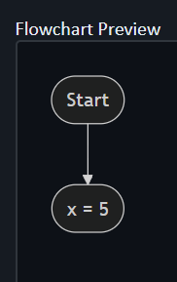 | YES | YES | YES
If/Else Construct | if x > 0:  print("Positive")  else:  print("Non-positive") | 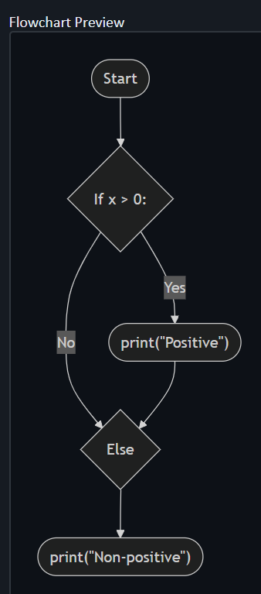 | NO | NO | YES
For Loops | for i in range(3):  print(i) | 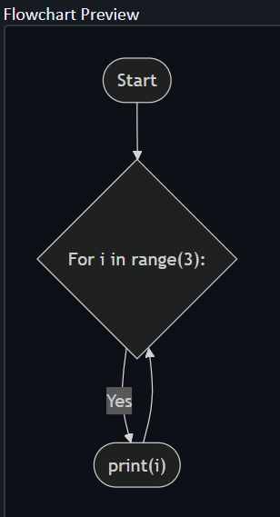 | YES | YES | YES
Nested If/Else Constructs | if x > 0:  if x < 10:  print("Between 1 and 9")  else:  print("10 or more")  else:  print("Zero or negative") | 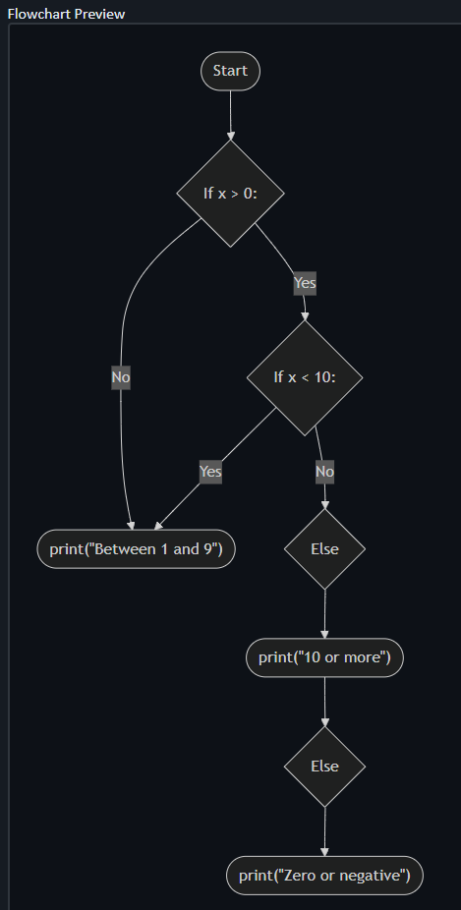 | YES | YES | YES
If/Else within loops | for i in range(3):  if i % 2 == 0:  print("Even")  else:  print("Odd") | 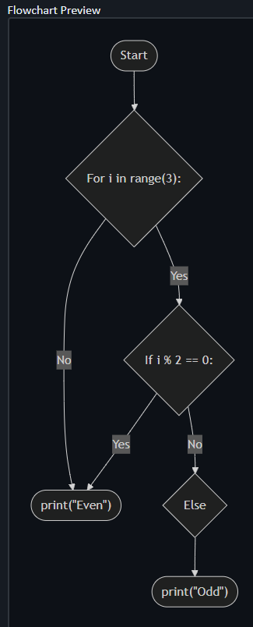 | NO | NO | YES
Nested For Loops | for i in range(2):  for j in range(2):  print(i, j) | 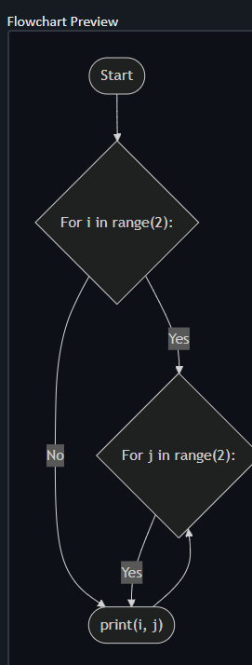 | NO | NO | YES

Table 4.4: JavaScript Test Cases
Construct | Code Implementation | Generated Flowchart | Structural Accuracy | Control Flow Correctness | Visual Clarity and Formatting
Simple Expression Statement | let x = 5; | 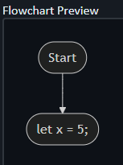 | YES | YES | YES
If/Else Construct | if (x > 0) {  console.log("Positive");  } else {  console.log("Non-positive");  } | 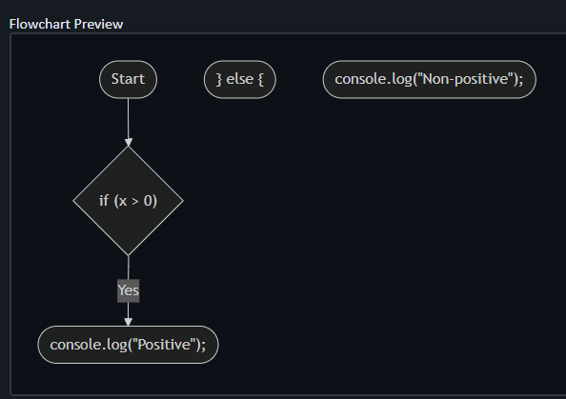 | NO | NO | NO
For Loops | for (let i = 0; i < 3; i++) {  console.log(i);  } | 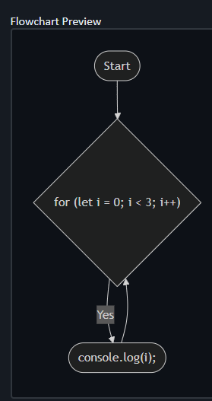 | YES | YES | YES
Nested If/Else Constructs | if (x > 0) {  if (x < 10) {  console.log("Between 1 and 9");  } else {  console.log("10 or more");  }  } else {  console.log("Zero or negative");  } | 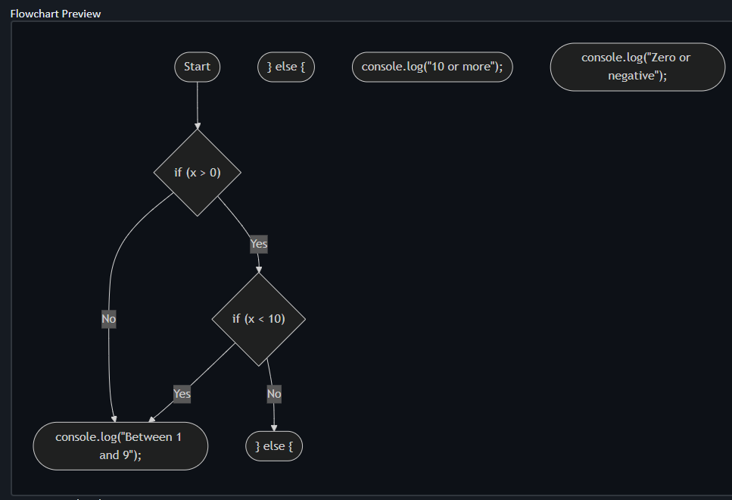 | NO | NO | NO
If/Else within loops | for (let i = 0; i < 3; i++) {  if (i % 2 === 0) {  console.log("Even");  } else {  console.log("Odd");  }  } | 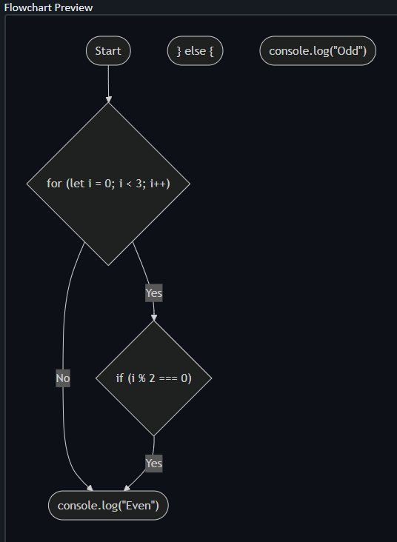 | NO | NO | NO
Nested For Loops | for (let i = 0; i < 2; i++) {  for (let j = 0; j < 2; j++) {  console.log(i, j);  }  } | 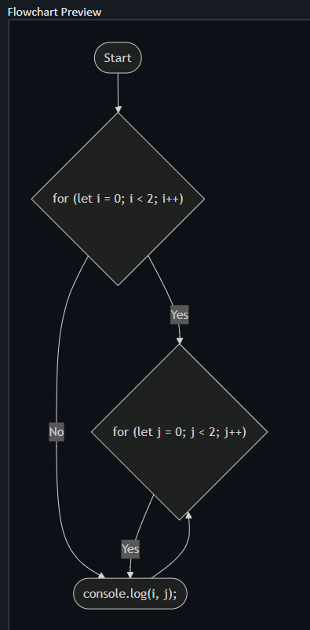 | NO | NO | YES

Table 4.5: C++ Test Cases
Construct | Code Implementation | Generated Flowchart | Structural Accuracy | Control Flow Correctness | Visual Clarity and Formatting
Simple Expression Statement | int x = 5; | 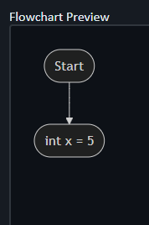 | YES | YES | YES
If/Else Construct | if (x > 0) {  std::cout << "Positive\n";  } else {  std::cout << "Non-positive\n";  } | 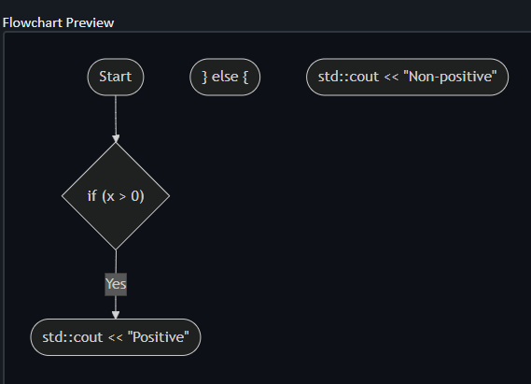 | NO | NO | NO
For Loops | for (int i = 0; i < 3; i++) {  std::cout << i << "\n";  } | 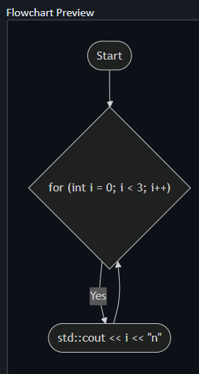 | YES | YES | YES
Nested If/Else Constructs | if (x > 0) {  if (x < 10) {  std::cout << "Between 1 and 9\n";  } else {  std::cout << "10 or more\n";  }  } else {  std::cout << "Zero or negative\n";  } | 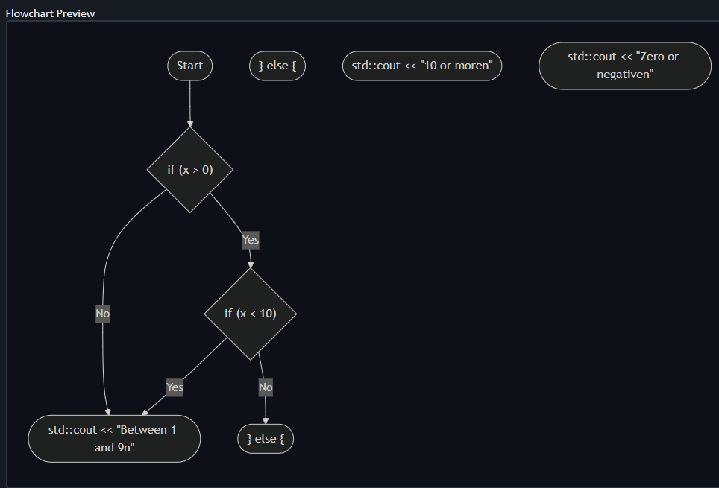 | NO | NO | NO
If/Else within loops | for (let i = 0; i < 3; i++) {  if (i % 2 === 0) {  console.log("Even");  } else {  console.log("Odd");  }  } | 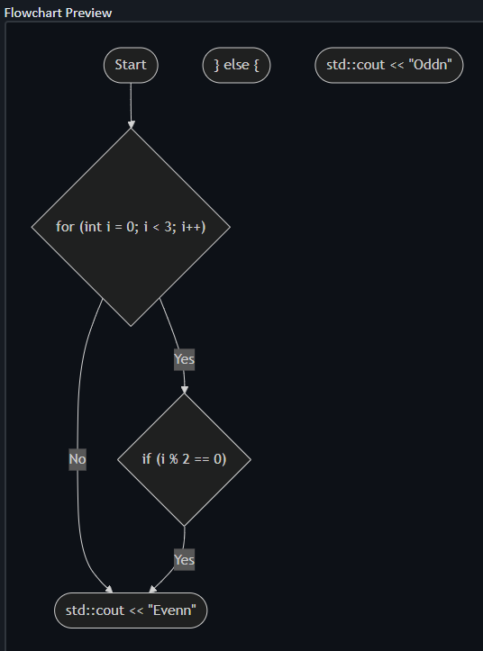 | NO | NO | NO
Nested For Loops | for (int i = 0; i < 2; i++) {  for (int j = 0; j < 2; j++) {  std::cout << i << " " << j << "\n";  }  } | 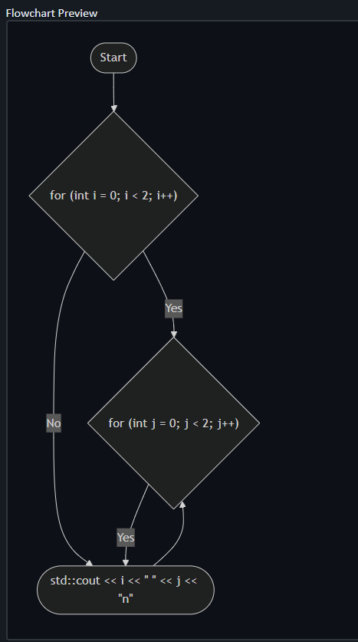 | NO | NO | YES

Discussion
Despite the prototype's success in visualising basic code structures, some significant shortcomings were discovered during evaluation, particularly in the handling of conditional and nested control flow expressions.
One of the most noticeable faults was the system's uneven and frequently inaccurate rendering of if/else expressions in all three supported programming languages (Python, JavaScript, and C++). In numerous test scenarios, while basic if statements were correctly parsed and presented, the corresponding else branches were either omitted, misplaced, or wrongly merged in the resulting flowchart. This issue impairs the correctness of decision logic representation, which is required to explain branching behaviour. The problem appears to be the parser's inability to preserve parent-child relationships between conditions and their related blocks.
In addition, the technology struggled to accurately visualise nested for loops. In such circumstances, inner loops were flattened or visually separated from their surrounding loops. This resulted in flowcharts that did not accurately depict the structural hierarchy or repetitive execution flow expected in nested iterations. It can be implied that the existing parsing logic lacks a reliable stack- or tree-based approach for maintaining contextual depth throughout traversal.
These limitations indicate that, while the system is appropriate for basic linear and shallow control flows, more advanced parsing logic and improved internal representations (IR) are required to accurately support deeper nested and more complex branching patterns.

Program Modules and Interfaces
This section outlines the modules and interfaces present in the developed system, both for the web application and its corresponding VSCode Extension.

VSToFlow Helper
VSToFlow Helper is the name of the VSCode extension. The Visual Studio Code Extension is intended to effortlessly integrate into the developer's workflow. The interface is command-driven and straightforward. Users interact with the extension by highlighting a chunk of code in the editor and running the “Open Web Tool” command (from the command palette, as seen in Figure 4.1). When activated, the extension grabs the selected text, encodes it, and launches the hosted web application in the user's default browser, using the code embedded in the URL as a query parameter. This approach reduces the need for complex settings or visual clutter in the editor, allowing users to go seamlessly from coding to visualising logic.
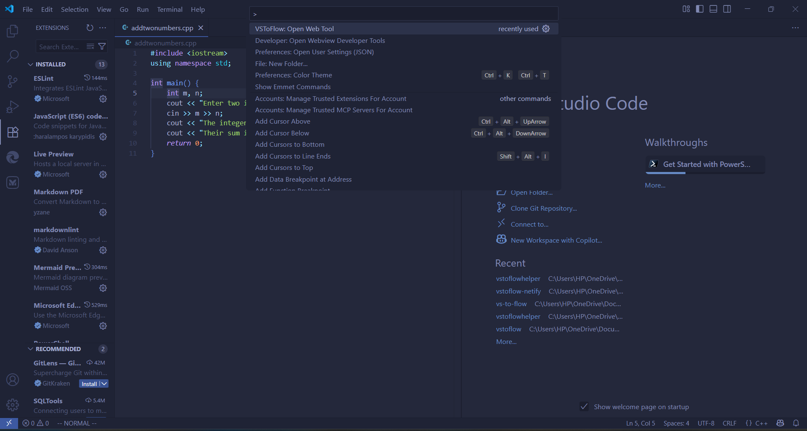
Figure 4.1: VSToFlowHelper: VSCode Extension Module

VSToFlow
VSToFlow is the name of the hosted web application. It is hosted at https://vstoflowhelper.netlify.app via Netlify. it is made up of 3 areas, a code input area, a Flowchart rendering area and a raw Mermaid code display area as seen in Figure 4.2 .
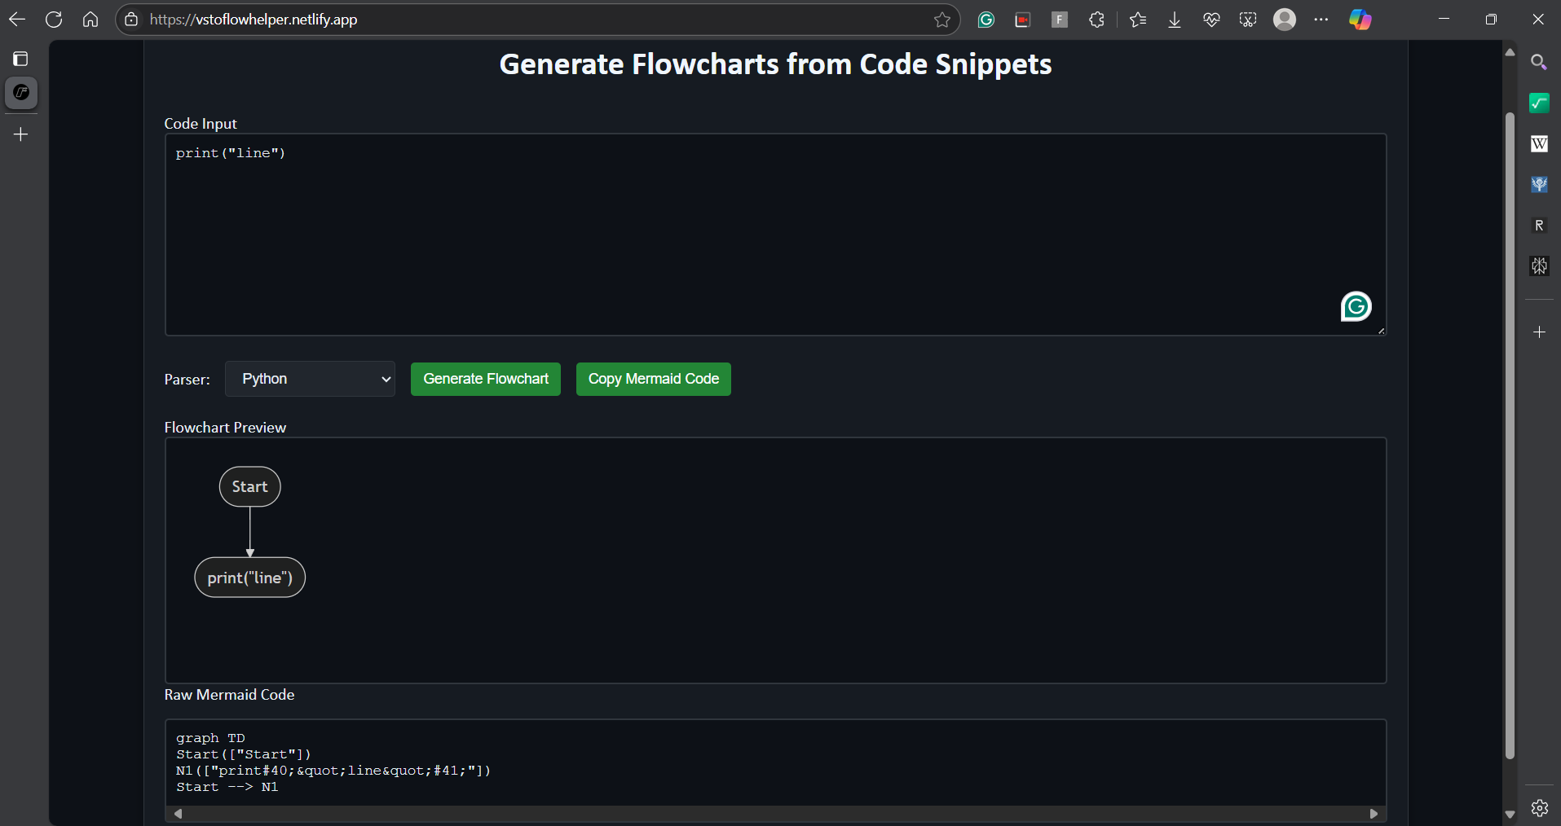
Figure 4.2: VSToFlow
In the Code input area, the user is presented with a code input field, implemented as a scrollable text area element, while landing on the web application (via the extension or directly). This module allows users to inspect the code given by the extension or enter it directly. Below the text area are interactive controls, such as:
- A menu to choose the programming language.
- The "Generate Flowchart" button initiates the parsing and diagram production process.
- The "Copy Mermaid Code" button transfers the underlying Mermaid syntax to the clipboard.
These controls are clearly labelled, allowing both experienced developers and newcomers to engage with the system without any prior training.
The flowchart rendering area is a dedicated element that uses Mermaid.js to render the flowchart dynamically based on the parsed code. It takes up the middle of the page and is tailored to match the dark mode theme. When the user hits "Generate Flowchart," the diagram updates in real time and is produced with SVG to improve clarity and scalability. This module gives visual feedback that corresponds directly to the input code's logical control flow, allowing users to trace conditions, loops, and expressions using clearly labelled nodes and edges. This module also displays error messages that may occur during parsing.
The Raw Mermaid code display area is located below the graphic and enables technically inclined users to investigate the Mermaid syntax used to build the diagram, which is helpful for debugging or embedding the diagram elsewhere. It also adds transparency to the copy to clipboard feature by displaying exactly what was generated from the input code.

Chapter Five

SUMMARY, Conclusion and Recommendations

Summary
The goal of this project was to design and build a lightweight, browser-based system capable of visualising code logic using flowcharts and a static parser. The solution combines a custom Visual Studio Code plugin with a Netlify-hosted responsive web application. These components enable users to highlight code in their VSCode editor, simply send it to the web interface, and view an automatically generated Mermaid.js-based flowchart that replicates the code's underlying control flow. The parsers were created to handle a small but important collection of programming constructs, if/else statements, for loops, and expression statements, in three major languages: Python, JavaScript, and C++.
Throughout the development process, an iterative technique was used, allowing the system to evolve through cycles of prototyping, feedback, and improvement. The emphasis was on modularity, clarity, and user experience. The decision to employ client-side technologies contributed to the system's simplicity and scalability, while Mermaid.js offered a strong and versatile diagram-rendering layer. To improve usability, dark mode UI, code sanitisation, nested structure support, and copy-to-clipboard functions have been introduced. Each module, from the parser to the diagram generator, was created individually and then combined into a cohesive, user-friendly interface suitable for both instructional and practical use.

Limitations of the Study
The addition for creating flowcharts in Integrated Development Environments (IDEs) has some restrictions. One notable limitation is that it focuses on C and C-based programming languages, limiting its usefulness for developers working with other languages. Because of its specialized nature, it may be unable to efficiently handle the syntactical and structural intricacies of non-C-based programming environments (Shah et al., 2024).
Another restriction is the difficulty in creating a parser algorithm capable of accurately translating complex code into conventional flowchart pieces. While it is designed to handle loops, conditionals and functions, unorthodox or improperly formatted code may result in mistakes or missing elements in the output flowcharts (Allen, 2023; Ensmenger, 2016).
The extension may also struggle to appropriately depict program flow in non-structured programming paradigms, such as object-oriented programming, due to the difficulties commonly faced in representing these paradigms in flowcharts (Allen, 2023).
The small testing scope may fail to account for the numerous requirements and obstacles that professional developers confront in real-world circumstances, reducing the findings' generalizability.

Recommendations
As a starting point, the code-to-flowchart system provides a reasonable basis for visualising simple control flow components in many programming languages. Future developers can, however, explore a variety of enhancements to make the tool more comprehensive, scalable, and intelligent, including the following.
Currently, the system supports three languages: Python, JavaScript, and C++, but only for fundamental structures such as if/else, for loops, and expression statements. Future developers could explore improving the parser to include other control structures, such as while, switch/case, do/while, and try/catch blocks. Furthermore, adding function declarations, recursion, and method calls would enable the tool to display more complicated and realistic code examples, improving its instructional and practical usefulness.
While the present system depends on manually developed static parsers to keep the frontend lightweight, future versions may include browser-friendly AST libraries (such as Tree-sitter or Esprima for JavaScript). This would increase accuracy, minimise parser maintenance costs, and enable more efficient nesting, scoping, and syntax checking. A modular backend parsing service might be implemented to outsource more complex processing without sacrificing speed.
Developers can increase user involvement by allowing flowcharts to be modified immediately within the generated diagram (for example, clicking a node to change its label or rearrange it). Libraries such as Mermaid Live Editor and interaction with jsPlumb or GoJS might be used to provide drag-and-drop editing and code creation.

Conclusion
In conclusion, the project successfully demonstrates how lightweight web technologies can be leveraged to support automated visualisation of code control flow, offering developers and learners a clearer understanding of logical program structure. The VSCode extension and web application integration exemplify how modern tooling can bridge the gap between development environments and visualisation aids without requiring backend infrastructure. The system is functional and extensible, laying the groundwork for further enhancements such as expanded grammar support, reverse diagram-to-code translation, collaborative features, and deeper educational integration.
Ultimately, this project proves that static analysis, when applied thoughtfully, can provide valuable insights into code behaviour in a way that is both visual and interactive. It offers a helpful tool for students learning programming concepts and developers seeking to understand or explain complex control structures. By documenting a clean architecture, modular design, and a transparent development process, the system also serves as a strong foundation for future academic or commercial enhancements in code visualisation technologies.

References
Ahmmed, J., Cohen, M. B., & Gazzillo, P. (2024). Towards Automated Configuration Documentation. Proceedings of the 39th IEEE/ACM International Conference on Automated Software Engineering, 2256–2261. https://doi.org/10.1145/3691620.3695311
Akesson, B., Nasri, M., Nelissen, G., Altmeyer, S., & Davis, R. I. (2022). A comprehensive survey of industry practice in real-time systems. Real-Time Systems, 58(3). https://doi.org/10.1007/s11241-021-09376-1
Alizadehsani, Z., Gomez, E. G., Ghaemi, H., González, S. R., Jordan, J., Fernández, A., & Pérez-Lancho, B. (2022). Modern Integrated Development Environment (IDEs). Lecture Notes in Networks and Systems, 253. https://doi.org/10.1007/978-3-030-78901-5_24
Allen, M. (2023). Flowcharting: From Abstractionism to Algorithmics in Art and Architecture. In Flowcharting: From Abstractionism to Algorithmics in Art and Architecture. https://doi.org/10.54872/gta/4616
Antonova, А., & Bartkova, S. (2020). An overview of the advantages of cloud computing and online IDE. Automation of Technological and Business Processes, 12(3). https://doi.org/10.15673/atbp.v12i3.1927
Apostol, D. C., Bogdan, R., & Marcu, M. (2024). UML Diagrams in Teaching Software Engineering Classes. A Case Study in Computer Science Class. 2024 IEEE 22nd World Symposium on Applied Machine Intelligence and Informatics, SAMI 2024 - Proceedings. https://doi.org/10.1109/SAMI60510.2024.10432905
Augustinowski, S., Cheema, A., & Gawenda, L. (n.d.). Transforming Code-Review Practices: An Action Research Study with Collaborative Software Visualisation in SEE. https://github.com/uni-bremen-agst/SEE
Bakhirkin, M. V., & Lukin, V. N. (2021). Modern Realities of Software Project Management. Modelling and Data Analysis, 11(4). https://doi.org/10.17759/mda.2021110406
Baxter, D., Dacre, N., Dong, H., & Ceylan, S. (2023). Institutional challenges in agile adoption: Evidence from a public sector IT project. Government Information Quarterly, 40(4). https://doi.org/10.1016/j.giq.2023.101858
Brito, R., Brito, A., Brito, G., & Valente, M. T. (2019). GoCity: Code City for Go. SANER 2019 - Proceedings of the 2019 IEEE 26th International Conference on Software Analysis, Evolution, and Reengineering. https://doi.org/10.1109/SANER.2019.8668008
Buzaid, F., Albalooshi, F., & Elmedany, W. (2022). The Use of UML Diagrams to Enhance Dynamic Feature Location Techniques. 2022 International Conference on Innovation and Intelligence for Informatics, Computing, and Technologies, 3ICT 2022. https://doi.org/10.1109/3ICT56508.2022.9990768
Cahyono, T., … S. S.-J. T. I., & 2022, undefined. (2020). Implementation Of The Waterfall Method In The Design Of A Website-Based Book Lending System. Jutif.If.Unsoed.Ac.Id, 4(36).
Coffman, J., de Freitas, A. A., Hill, J. M., & Weingart, T. (2023). Visual vs. Textual Programming Languages in CS0.5. https://doi.org/10.1145/3545945.3569722
Desjardins, P. (2014). Introducing Visual Studio. In Visual Studio Condensed (pp. 1–23). Apress. https://doi.org/10.1007/978-1-4302-6823-9_1
Ebert, F., Castor, F., Novielli, N., & Serebrenik, A. (2019). Confusion in Code Reviews: Reasons, Impacts, and Coping Strategies. SANER 2019 - Proceedings of the 2019 IEEE 26th International Conference on Software Analysis, Evolution, and Reengineering. https://doi.org/10.1109/SANER.2019.8668024
Ensmenger, N. (2016). The Multiple Meanings of a Flowchart. Information & Culture, 51(3). https://doi.org/10.7560/ic51302
Ghica, D. R. (2021). Operational semantics with hierarchical abstract syntax graphs. Electronic Proceedings in Theoretical Computer Science, EPTCS, 334. https://doi.org/10.4204/eptcs.334.1
Hagos, T. (2022). Beginning IntelliJ IDEA. Apress. https://doi.org/10.1007/978-1-4842-7446-0
International Organization for Standardization. (1985). ISO 5807:1985 - Information processing — Documentation symbols and conventions for data, program and system flowcharts, program network charts and system resources charts. https://www.iso.org/standard/11955.html
Jaeger, L. (2023). Ada Lovelace (1815–1852): Inventor of Computer Algorithms. In Women of Genius in Science. https://doi.org/10.1007/978-3-031-23926-7_7
Jiang, S., & Coblenz, M. (2024). An Analysis of the Costs and Benefits of Autocomplete in IDEs. Proceedings of the ACM on Software Engineering, 1(FSE), 1284–1306. https://doi.org/10.1145/3660765
Koç, H., Erdoğan, A. M., Barjakly, Y., & Peker, S. (2021). UML Diagrams in Software Engineering Research: A Systematic Literature Review. https://doi.org/10.3390/proceedings2021074013
Kosower, D. A., Lopez-Villarejo, J. J., & Roubtsov, S. (2014). Flowgen: Flowchart-based documentation framework for C++. Proceedings - 2014 14th IEEE International Working Conference on Source Code Analysis and Manipulation, SCAM 2014, 59–64. https://doi.org/10.1109/SCAM.2014.35
Krause-Glau, A., Bader, M., & Hasselbring, W. (2022). Collaborative Software Visualisation for Program Comprehension. Proceedings - 2022 Working Conference on Software Visualisation, VISSOFT 2022. https://doi.org/10.1109/VISSOFT55257.2022.00016
Krauter, T., König, H., Rutle, A., & Lamo, Y. (2022). The Visual Debugger Tool. Proceedings - 2022 IEEE International Conference on Software Maintenance and Evolution, ICSME 2022. https://doi.org/10.1109/ICSME55016.2022.00066
Kulkarni, R., Chavan, A., & Hardikar, A. (2015). Transpiler and it’s Advantages. (IJCSIT) International Journal of Computer Science and Information Technologies, 6(2).
Leimbach, T. (2008). The SAP story: Evolution of SAP within the German software industry. IEEE Annals of the History of Computing, 30(4). https://doi.org/10.1109/MAHC.2008.75
Li, J., Beba, S., & Karlsen, M. M. (2019). Evaluation of open-source IDE plugins for detecting security vulnerabilities. ACM International Conference Proceeding Series. https://doi.org/10.1145/3319008.3319011
Lu, Y., & Alexandru, C. A. (2023). Systematic Review of UML Diagramming Software Tools for Higher Education Software Engineering Courses. ACM International Conference Proceeding Series. https://doi.org/10.1145/3610969.3611123
Lund, J., Jensen, L. B., Macedo, H. D., & Larsen, P. G. (2022). Towards UML and VDM Support in the VS Code Environment. Proceedings - 20th International Overture Workshop, 50–65.
Marron, M. (2024). A New Generation of Intelligent Development Environments. Proceedings - 2024 1st IDE Workshop, IDE 2024, 43–46. https://doi.org/10.1145/3643796.3648452
Murphy, G. C., Kersten, M., Elves, R., & Bryan, N. (2019). Enabling Productive Software Development by Improving Information Flow. In Rethinking Productivity in Software Engineering. https://doi.org/10.1007/978-1-4842-4221-6_24
Segun-Falade O. D. , Osundare, O. S., Kedi W. E., Okeleke P. E., Ijomah T. F., & Abdul-Azeez O. Y.. (2024). Developing crossplatform software applications to enhance compatibility across devices and systems. Computer Science & IT Research Journal, 5(8), 2040–2061. https://doi.org/10.51594/csitrj.v5i8.1491
Polkovnikov, I. (2016). Unified Control and Data Flow Diagrams Applied to Software Engineering and other Systems.
Priestley, M. (2020). Flow diagrams, assertions, and formal methods. Lecture Notes in Computer Science (Including Subseries Lecture Notes in Artificial Intelligence and Lecture Notes in Bioinformatics), 12233 LNCS. https://doi.org/10.1007/978-3-030-54997-8_1
Shafeek, N., & Karunarathne, D. D. (2018). _ToflowChart: A prototype compiler to convert source-code to flowchart. 18th International Conference on Advances in ICT for Emerging Regions, ICTer 2018 - Proceedings. https://doi.org/10.1109/ICTER.8615581
Shah, A., Yu, J., Tong, T., & Raj, A. G. S. (2024). Working with Large Code Bases: A Cognitive Apprenticeship Approach to Teaching Software Engineering. SIGCSE 2024 - Proceedings of the 55th ACM Technical Symposium on Computer Science Education, 1. https://doi.org/10.1145/3626252.3630755
Yu, Z., & Xiong, Z. (2018). Comparative analyses for the performance of Rational Rose and Visio in software engineering teaching. Journal of Physics: Conference Series, 1087(6). https://doi.org/10.1088/1742-6596/1087/6/062041
Zhang, J. H., Meng, B., Zou, L. C., Zhu, Y., & Hwang, G. J. (2023). Progressive flowchart development scaffolding to improve university students’ computational thinking and programming self-efficacy. Interactive Learning Environments, 31(6). https://doi.org/10.1080/10494820.2021.1943687

