#Import Data  
library(readr)  
food_prices_large2 <- read_csv("food_prices/food_prices_large2.csv")

## Rows: 321 Columns: 11  
## ── Column specification ────────────────────────────────────────────────────────  
## Delimiter: ","  
## chr (7): Country, State_Povinces, City_Market, Product, currency_name, Suppl...  
## dbl (4): Id, month, Year, Price  
##   
## ℹ Use `spec()` to retrieve the full column specification for this data.  
## ℹ Specify the column types or set `show_col_types = FALSE` to quiet this message.

View(food_prices_large2)

## 

#load library  
library(tidyverse)

## ── Attaching core tidyverse packages ──────────────────────── tidyverse 2.0.0 ──  
## ✔ dplyr 1.1.1 ✔ purrr 1.0.1  
## ✔ forcats 1.0.0 ✔ stringr 1.5.0  
## ✔ ggplot2 3.4.1 ✔ tibble 3.2.1  
## ✔ lubridate 1.9.2 ✔ tidyr 1.3.0  
## ── Conflicts ────────────────────────────────────────── tidyverse_conflicts() ──  
## ✖ dplyr::filter() masks stats::filter()  
## ✖ dplyr::lag() masks stats::lag()  
## ℹ Use the conflicted package (<http://conflicted.r-lib.org/>) to force all conflicts to become errors

library(dplyr)  
library(formattable)  
library(lessR)

##   
## lessR 4.2.8 feedback: gerbing@pdx.edu   
## --------------------------------------------------------------  
## > d <- Read("") Read text, Excel, SPSS, SAS, or R data file  
## d is default data frame, data= in analysis routines optional  
##   
## Learn about reading, writing, and manipulating data, graphics,  
## testing means and proportions, regression, factor analysis,  
## customization, and descriptive statistics from pivot tables.  
## Enter: browseVignettes("lessR")  
##   
## View changes in this and recent versions of lessR.  
## Enter: news(package="lessR")  
##   
## Interactive data analysis.  
## Enter: interact()  
##   
##   
## Attaching package: 'lessR'  
##   
## The following object is masked from 'package:formattable':  
##   
## style  
##   
## The following objects are masked from 'package:dplyr':  
##   
## recode, rename

library(psych)

##   
## Attaching package: 'psych'  
##   
## The following objects are masked from 'package:lessR':  
##   
## reflect, rescale, scree, skew  
##   
## The following objects are masked from 'package:ggplot2':  
##   
## %+%, alpha

library(plyr)

## ------------------------------------------------------------------------------  
## You have loaded plyr after dplyr - this is likely to cause problems.  
## If you need functions from both plyr and dplyr, please load plyr first, then dplyr:  
## library(plyr); library(dplyr)  
## ------------------------------------------------------------------------------  
##   
## Attaching package: 'plyr'  
##   
## The following objects are masked from 'package:lessR':  
##   
## ., rename  
##   
## The following objects are masked from 'package:dplyr':  
##   
## arrange, count, desc, failwith, id, mutate, rename, summarise,  
## summarize  
##   
## The following object is masked from 'package:purrr':  
##   
## compact

library(ggplot2)

##Filter for all Country  
unique(food_prices_large2$Country)

## [1] "Afghanistan" "Algeria"   
## [3] "Armenia" "Azerbaijan"   
## [5] "Bangladesh" "Benin"   
## [7] "Bhutan" "Bolivia"   
## [9] "Burkina Faso" "Burundi"   
## [11] "Cambodia" "Cameroon"   
## [13] "Central African Republic" "Chad"   
## [15] "Colombia" "Congo"   
## [17] "Costa Rica" "Cote d'Ivoire"   
## [19] "Democratic Republic of the Congo" "El Salvador"   
## [21] "Ethiopia" "Gambia"   
## [23] "Ghana" "Guatemala"   
## [25] "Guinea-Bissau" "Guinea"   
## [27] "Haiti" "Honduras"   
## [29] "India" "Indonesia"   
## [31] "Iraq" "Jordan"   
## [33] "Kenya" "Kyrgyzstan"   
## [35] "Lao People's Democratic Republic" "Lebanon"   
## [37] "Lesotho" "Liberia"   
## [39] "Mauritania" "Mozambique"   
## [41] "Myanmar" "Nigeria"   
## [43] "Pakistan" "Peru"   
## [45] "Philippines" "Rwanda"   
## [47] "Senegal" "Sri Lanka"   
## [49] "Swaziland" "Syrian Arab Republic"   
## [51] "Tajikistan" "Timor-Leste"   
## [53] "Turkey" "Ukraine"   
## [55] "Yemen" "Zambia"   
## [57] "State of Palestine" "Sudan"   
## [59] "Egypt" "South Sudan"

attach(food_prices_large2)  
colnames(food_prices_large2)

## [1] "Id" "Country" "State_Povinces" "City_Market"   
## [5] "Product" "currency_name" "Supply_chain" "month"   
## [9] "Month_name" "Year" "Price"

#count total missing values in each column  
sapply(food_prices_large2, function(x) sum(is.na(x)))

## Id Country State_Povinces City_Market Product   
## 0 0 39 0 0   
## currency_name Supply_chain month Month_name Year   
## 0 0 0 0 0   
## Price   
## 0

#view First six rows of food price  
head(food_prices_large2)

## # A tibble: 6 × 11  
## Id Country State_Povinces City_Market Product currency_name Supply_chain  
## <dbl> <chr> <chr> <chr> <chr> <chr> <chr>   
## 1 1 Afghanist… Badakhshan Fayzabad Bread AFN Retail   
## 2 1 Afghanist… Badakhshan Fayzabad Wheat AFN Retail   
## 3 1 Afghanist… Badakhshan Fayzabad Rice (… AFN Retail   
## 4 1 Afghanist… Badakhshan Fayzabad Wage (… AFN Retail   
## 5 1 Afghanist… Badakhshan Fayzabad Livest… AFN Retail   
## 6 1 Afghanist… Badakhshan Fayzabad Fuel (… AFN Retail   
## # ℹ 4 more variables: month <dbl>, Month_name <chr>, Year <dbl>, Price <dbl>

#display rows and columns  
dim(food_prices_large2)

## [1] 321 11

#Measure of central Tendency  
mean(food_prices_large2$Price)

## [1] 13258.39

#measureofnormality  
hist(Year, xlab = "price over the year",  
 ylab = "frequency",  
 main = "Histogram for food price",  
 col = "green",  
 probability = TRUE)  
  
lines(density(Price))

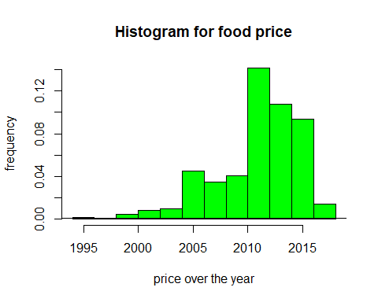

#plot  
boxplot(Price,   
 xlab = "price",  
 ylab = "freq",  
 main = "boxplot for product",  
 col = "blue")

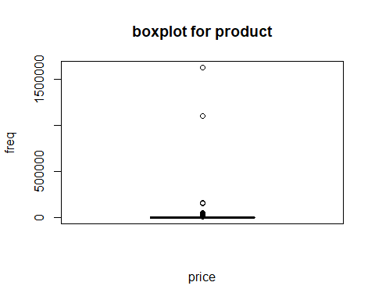

#Create Histogram of values for Price  
ggplot(data = food_prices_large2,aes(x=Price)) +geom_histogram(fill = "steel blue",   
 color = "black") +  
 ggtitle("frequency Of Price")

## `stat_bin()` using `bins = 30`. Pick better value with `binwidth`.

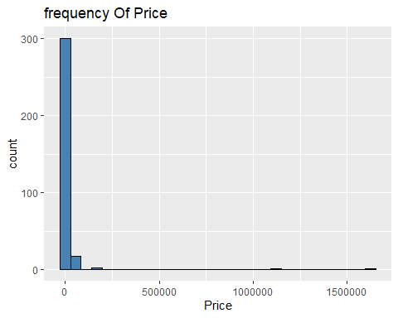

#Define data  
priceoffood <- c(Price)  
productsold <- c(Product)  
Country <- c(Country)  
view(priceoffood)  
view(productsold)  
view (Country)

#sort product  
sort_product <-food_prices_large2 %>% arrange(desc(productsold))

#Sort data by numbers in decending order and select top 10  
Buttom10 <- sort_product %>% tail(10)  
Top10 <- sort_product%>% head(10)  
  
print(Top10)

## # A tibble: 10 × 11  
## Id Country State_Povinces City_Market Product currency_name Supply_chain  
## <dbl> <chr> <chr> <chr> <chr> <chr> <chr>   
## 1 205 Rwanda $West/Ibureng… Birambo Zucchi… RWF Retail   
## 2 238 Syrian A… City-Damascus Sheikh Sa'… Yogurt SYP Retail   
## 3 66 Cote d'I… Vallee Du Ban… Bouake Yam (f… XOF Retail   
## 4 182 Nigeria Oyo Ibadan Yam (A… NGN Wholesale   
## 5 94 Ghana Greater Accra Accra Yam GHS Wholesale   
## 6 195 Peru Lima Lima Wheat … PEN Retail   
## 7 170 Mozambiq… Sofala Beira Wheat … MZN Retail   
## 8 108 Haiti Sud Cayes Wheat … HTG Retail   
## 9 138 Kyrgyzst… Chuy Bishkek Wheat … KGS Retail   
## 10 138 Kyrgyzst… Chuy Bishkek Wheat … KGS Retail   
## # ℹ 4 more variables: month <dbl>, Month_name <chr>, Year <dbl>, Price <dbl>

print(Buttom10)

## # A tibble: 10 × 11  
## Id Country State_Povinces City_Market Product currency_name Supply_chain  
## <dbl> <chr> <chr> <chr> <chr> <chr> <chr>   
## 1 90 Gambia $Kanifing Mun… Banjul Beans … GMD Retail   
## 2 170 Mozambiq… Sofala Beira Beans … MZN Retail   
## 3 170 Mozambiq… Sofala Beira Beans … MZN Retail   
## 4 61 Costa Ri… <NA> National A… Beans … USD Wholesale   
## 5 43 Burundi Bujumbura Mai… Bujumbura Beans BIF Retail   
## 6 999 State of… Jenin Jenin Banana… NIS Retail   
## 7 4 Algeria Alger Algiers Bananas DZD Retail   
## 8 205 Rwanda $West/Ibureng… Birambo Avocad… RWF Retail   
## 9 13 Armenia Yerevan Yerevan Apples… AMD Retail   
## 10 4 Algeria Alger Algiers Apples DZD Retail   
## # ℹ 4 more variables: month <dbl>, Month_name <chr>, Year <dbl>, Price <dbl>