Software Engineering
TEMIRLAN ULUGBEK UULU
ASSIGNMENT 1

Task 2

The company produces Ukuleles according to the orders it gets from the customers. For producing Ukuleles it orders the specific parts of it from suppliers and assembly of the separate parts takes places within the company after the order has arrived. Customer should specify the amount of ukuleles, and characteristics of its parts.

Ukulele will consist of 4 parts: body, headstock, neck, strings. Customer can specify the following characteristics for each of the parts:
- Body: length, width, color, material
- Headstock: color, material
- Neck: length, color, material
- Strings: amount, material.
Company will have sales department, management department, manufacturing department. Sales department gets the orders from customers and passes them to management department. Management department keeps track of the finance, material supply and human resources. Management department rejects or accepts the orders according to the current resources the company has. If it accepts the orders, it contacts and orders the necessary parts for production from suppliers, if the necessary materials are not there in the company stock. After the full supply, it passes the order to manufacturing department. That department assemblies the Ukulele and returns the order to the management department, which in turn returns it to the customer.

Here is the simple UML diagram that specifies what makes up the ready product (i.e. Ukulele). It shows the parts needed for Ukulele.
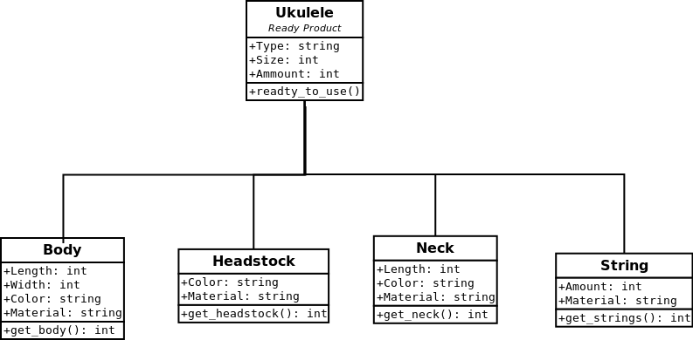
The following UML diagram shows and describes the roles and the dynamics between them:

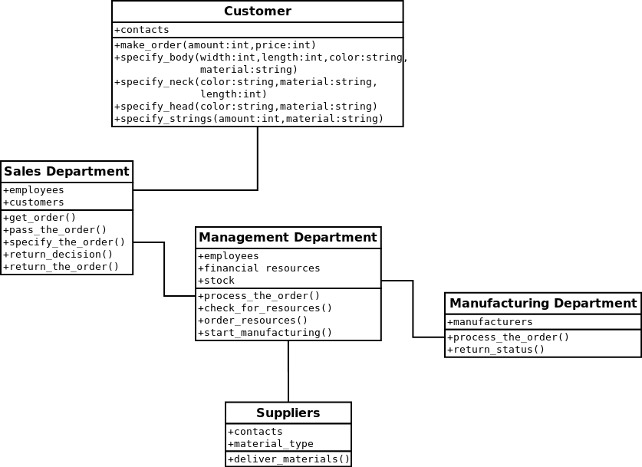
The dynamics between the roles:

