Business Template:
all data types, default values, constraints and foreign keys are shown in part 2.3 in the tables and screenshots. Also, you can see them following the link: https://drawsql.app/teams/temirlan-turabay/diagrams/epam

Social Media platform
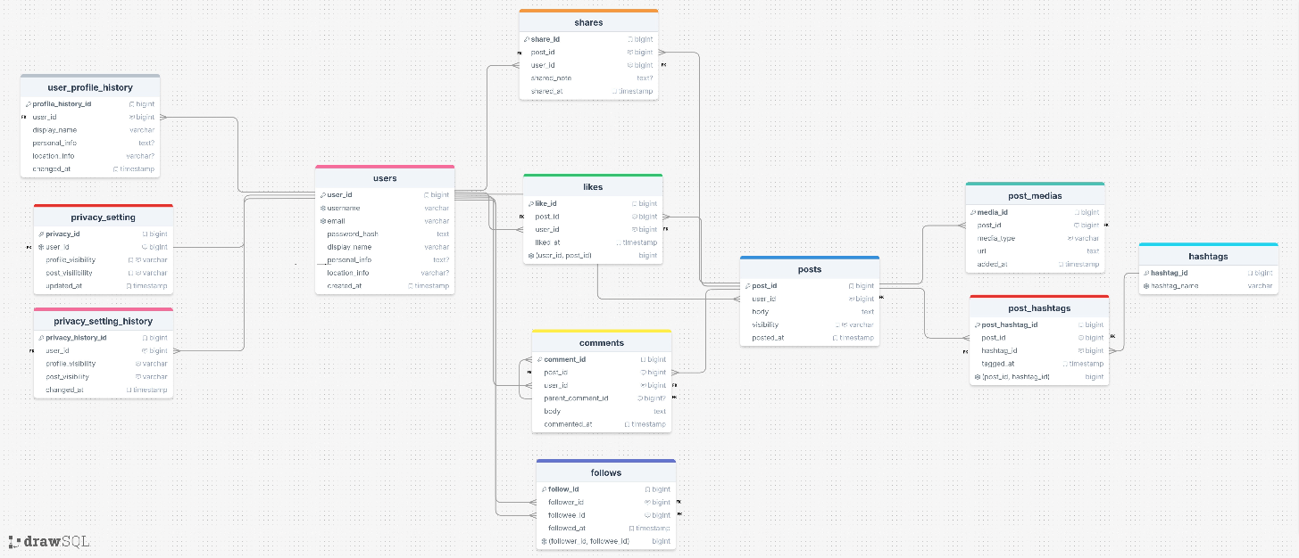
PLEASE CHECK THE LINK (because the default values and constraints are written inside of the tables as comments in drawsql): https://drawsql.app/teams/temirlan-turabay/diagrams/epam

Contents
Business Description 3
1.1 the Benefits of implementing a database. Project Vision 3
2 Model description 3
2.1 Definitions & Acronyms 3
2.2 Logical Scheme 3
2.3 Objects 3

Business Description

the Benefits of implementing a database. Project Vision
To answer these questions, you can rely on the following questions:
- How will the database solve the problems listed in the description?
This database solves the main problems by organizing the social media platform into separate parts such as users, posts, comments, likes, shares, etc. This makes the system clearer and avoids storing the same information many times. For example, hashtags do not need to be written again inside every post, because they are stored separately and linked when needed. Because of this, the database reduces duplication and lowers the chance of mistake.
- How will it ensure data integrity, consistency, and traceability?
I ensure data integrity and consistency by using primary keys, foreign keys, unique constraints, and default values. These rules make sure that every record is connected correctly. For example, a like cannot exist without a valid user and a valid post. I also prevent duplicates, such as duplicate likes or duplicate follow relations. For traceability, I keep not only the current data, but also older versions of important data.
- How does your model store the history of changes?
My model stores the history of changes in separate history tables instead of overwriting old values. For example, the current user information is stored in the main user table, but previous versions are saved in user_profile_history. In the same way, the current privacy settings are stored in privacy_setting, while older versions are saved in privacy_setting_history. This helps me see what the current value is and also what it was before and when it changed.
- How does your structure allow the system to scale without major redesign?
I designed the structure in a way where each main area of the platform is separated. There are separate tables for identity, content and settings. Thus, the system can grow easily. For example, if later I want to add new modules I will be able to do that without changing the whole database structure. This makes the model flexible and scalable.
- Which constraints and checks have you added to keep data correct as volume grows?
I used primary keys for unique identification and foreign keys to keep relationships valid. I also used unique constraints to stop duplicate events, such as the same user liking the same post twice. I also use check constraints for fields with limited values, for example current profile_visibility can only be public, private, or followers_only, and media_type can only be image, video, or gif.

Model description

Definitions & Acronyms
To answer these questions, you can rely on the following questions:
- Which key entities, roles, or processes require formal definitions for correct interpretation of the model?
In my opinion, the most important entities that need clear definitions are user, post, media, hashtag, like, comment, share, and follow. These are the main objects of the system, so if they are not defined properly, the model can be misunderstood.
- Which terms could be misunderstood without clarification?
For example, share may look like a new post, but in my model it is only an interaction with an existing post. The term follow is a directed relationship, where one user follows another user. Media can also be misunderstood, because in my model it is not stored as the actual file, but as a URL and media type. In addition, “history” tables need explanation, because they store previous data only, and does not have any default entry values.
- Which abbreviations or role names appear repeatedly in tables or relationships?
The abbreviations that appear repeatedly in my model are PK (key logo), FK (no logo) and UK (snowflake logo). There are many attributes that are named as …_id which shows that this column is a key column of one of the type mentioned above. Also, the terms …visibility are repeated, which has constraints such as: public, private and followers only. The terms …_at should be understood as time of creation of the particular record in the table, which everywhere has a default value of CURRENT_TIMESTAMP.

Logical Scheme
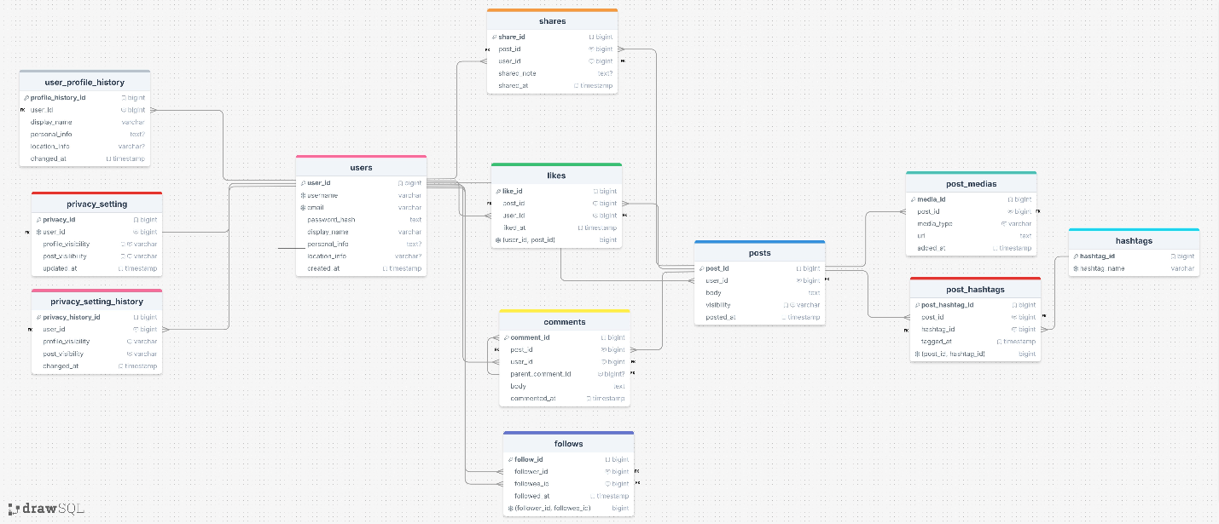
Answer following questions:
- Which modeling decision was the most difficult and why?
The most difficult modeling decision for me were the “history” tables and representing many-to-many relationships. For example, the privacy_setting_history has identical columns as the privacy_setting table, however, coming up with the idea of storing only the previous values and restraining from the default constraints was a chellange itself. Also, for many-to-many releationships, it was hard to understand that one user can like many posts, and one post can be liked by many users, which tells us that the like table should act as a bridge between the two.
- Provide examples of potential data anomalies that your design prevents. Explain which constraints or structure elements prevent them.
My design prevents several data anomalies. For example, it prevents one user from liking the same post more than once by using a unique constraint on (user_id, post_id) in the likes table. It also prevents duplicate follow records with a unique constraint on (follower_id, followee_id) in follows, and the same hashtag cannot be linked twice to the same post because of the unique constraint on (post_id, hashtag_id) in post_hashtags. Foreign keys also prevent orphan records, so a like cannot point to a deleted user or a missing post, and a media record cannot exist without a valid post.
- If you were to add new attributes or participants, would the model remain scalable and why?
Yes, I think the model would remain scalable if I added new attributes or participants. The reason is that I separated the database into clear domains, such as users, posts, privacy, etc. Because of this, new features can be added without changing the whole structure. For example, I the new users could be participants could be stored inside of the users table, and I could also add new attribute such as importance_level to differentiate between default and vip users. Also, I could add mentions in comments table or create a new table and connect it with the comments table. This modular design makes the schema flexible and easier to extend.
- Which part of your model would most likely change if requirements expand?
The part that would most likely change is the interaction and visibility part of the model. For example, likes could become different reaction types, shares could need their own visibility rules and comments could include moderation status or mentions. Privacy settings might also become more detailed than just a few fixed values. I think these areas are the most likely to change because social media platforms often expand their interaction features over time.

Objects
Table Description:
- What real-world concept or event does this table represent?
- Why must this information be stored separately instead of inside another table?
- What is the normalization level of the table (1NF, 2NF, 3NF)? Explain your reasoning.
- Are there partial or transitive dependencies? How did you eliminate them? Which attributes depend only on the key, and which depend on other fields?
- Why did you choose this primary key (PK) for the table? Could a composite key work instead? Which foreign keys (FK) did you add and why?

users:
This table represents the main user account in the platform. In real life, it means one registered
person who can create posts, like, comment, share, follow others, and manage privacy. I store it separately because many other tables depend on it, so it should be the central table instead of repeating user information inside other tables.
This table is in 3NF because all fields describe one user and depend only on the primary key, which is user_id. There are no repeating groups and no partial or transitive dependencies.
I chose user_id as the PK because it is stable and simple for references. A composite key could work with something like username or email, but that would be less practical because those values can change. I did not add foreign keys in this table because it is the parent table for many others.

Table Name | Field name | Field Description | Data Type
users | user_id | Unique identifier of the user account. | BIGINT PRIMARY KEY
 | username | Unique username of the account. | VARCHAR(255) NOT NULL UNIQUE
 | email | Unique email address of the user. | VARCHAR(255) NOT NULL UNIQUE
 | password_hash | Password of the user. | TEXT NOT NULL
 | display_name | Public name shown on the profile. | VARCHAR(255) NOT NULL
 | personal_info | Short biography. | TEXT
 | location_info | User location information. | VARCHAR(255)
 | created_at | Date and time when the account was created. | TIMESTAMP NOT NULL DEFAULT CURRENT_TIMESTAMP

user_id | username | email | password_hash | display_name | personal_info | location_info | created_at
1 | Ali123 | ali@gmail.com | Hash1 | Ali | Student | Astana | NOW()
2 | Temir | temir@gmai.com | Hash2 | Temir | Developer | Almaty | NOW()
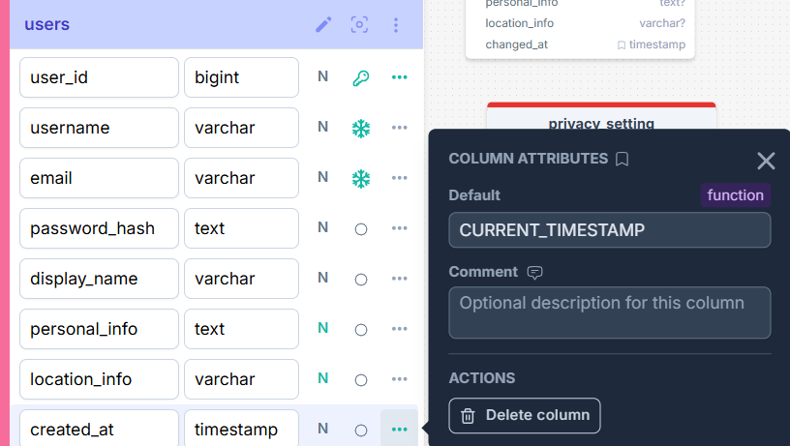

user_profile_history:
This table represents historical snapshots of user profile changes. In real life, it means the old versions of profile data that were valid before the user updated something. I store it separately because the main users table should only keep the current version, while this table keeps past versions for traceability.
This table is in 3NF because all fields describe one user and depend only on the primary key, which is user_id. There are no repeating groups and no partial or transitive dependencies.
I chose profile_history_id as the PK because it uniquely identifies each saved snapshot. A composite key with user_id and changed_at could also work, but I think a surrogate key is simpler. The FK user_id links the history row to the user whose profile changed.

Table Name | Field name | Field Description | Data Type
user_profile_history | profile_history_id | Unique identifier of the profile history record. | BIGINT PRIMARY KEY
 | user_id | Reference to the user whose profile was changed. | BIGINT NOT NULL  FOREIGN KEY (user_id) REFERENCES users(user_id) ON DELETE CASCADE
 | display_name | Previous display name. | VARCHAR(255) NOT NULL
 | personal_info | Previous personal information. | TEXT
 | location_info | Previous location information. | VARCHAR(255)
 | changed_at | Date and time when this profile snapshot was stored. | TIMESTAMP NOT NULL DEFAULT CURRENT_TIMESTAMP

Profile_history_id | User_id | Display_name | Personal_info | Location_info | Changed_at
1 | 1 | Ali | Student | Astana | 17.03.2026 15:38:01
2 | 2 | Temir | Developer | Almaty | 15.03.2026 15:38:01
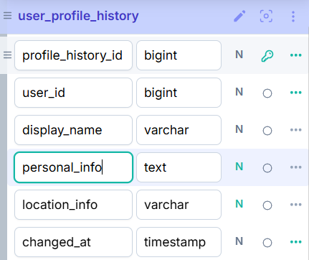
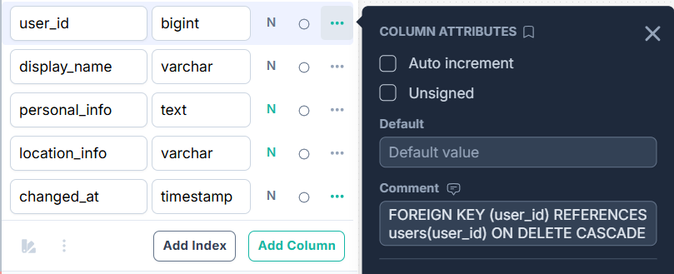
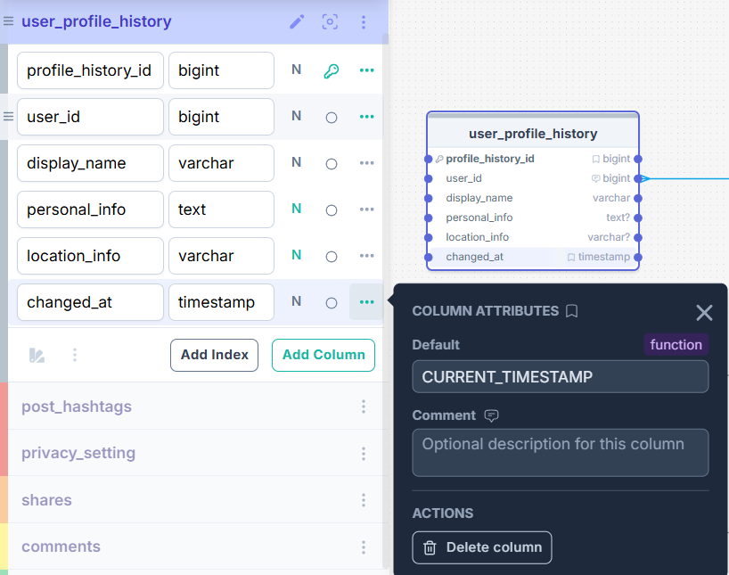

privacy_setting:
This table represents the current privacy settings of a user. In real life, it means the active visibility choices for that account. I store it separately because privacy should not be mixed directly with identity information in users and has it’s own history of changes.
This table is in 3NF because all fields describe one user and depend only on the primary key, which is user_id. There are no repeating groups and no partial or transitive dependencies.
I chose privacy_id as the PK because it gives a simple unique identifier. I added user_id as an FK to connect privacy settings to the correct user, and user_id should also be unique to enforce the one-to-one relationship.

Table Name | Field name | Field Description | Data Type
privacy_setting | privacy_id | Unique identifier of the current privacy record. | BIGINT PRIMARY KEY
 | user_id | Reference to the user who owns these privacy settings. | BIGINT NOT NULL UNIQUE  FOREIGN KEY (user_id) REFERENCES users(user_id) ON DELETE CASCADE
 | profile_visibility | Visibility of the user’s entire profile. | VARCHAR(255) NOT NULL DEFAULT 'public'  CHECK (profile_visibility IN ('public','private','followers_only’'))
 | post_visibility | Visibility of the user’s posts. | VARCHAR(255) NOT NULL DEFAULT 'public'  CHECK (post_visibility IN ('public','private','followers_only'))
 | updated_at | Date and time of the latest privacy update. | TIMESTAMP NOT NULL DEFAULT CURRENT_TIMESTAMP

Privacy_id | User_id | Profile_visibility | Post_visibility | Updated_at
1 | 1 | Public | Public | NOW()
2 | 2 | Private | Private | NOW()
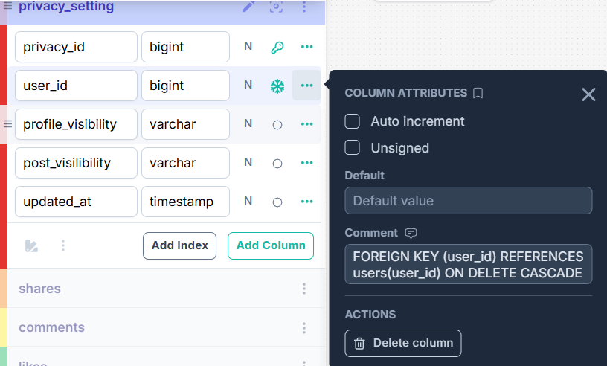
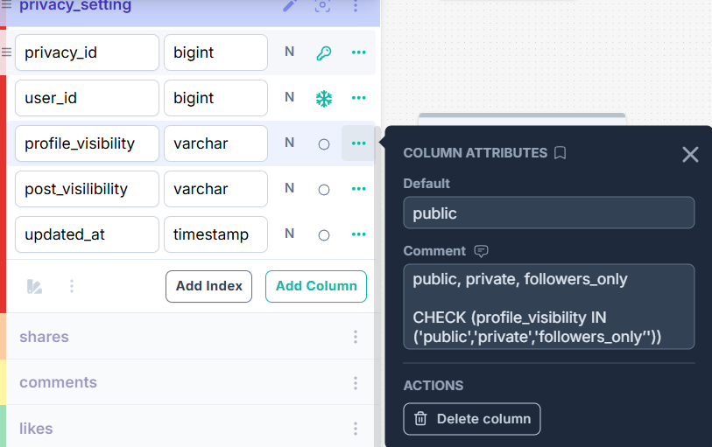
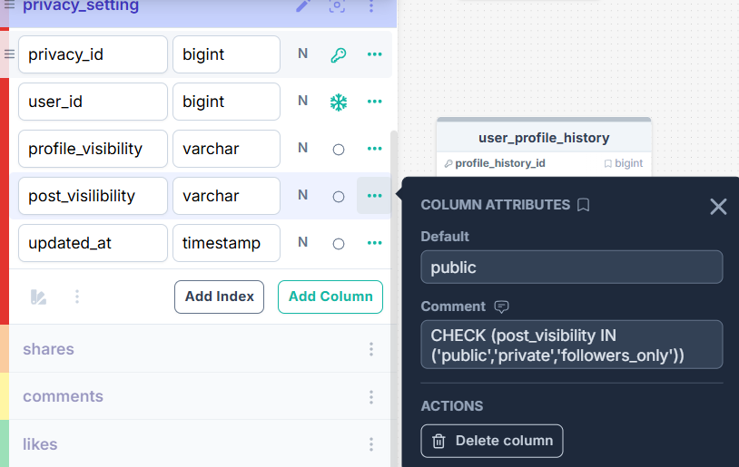
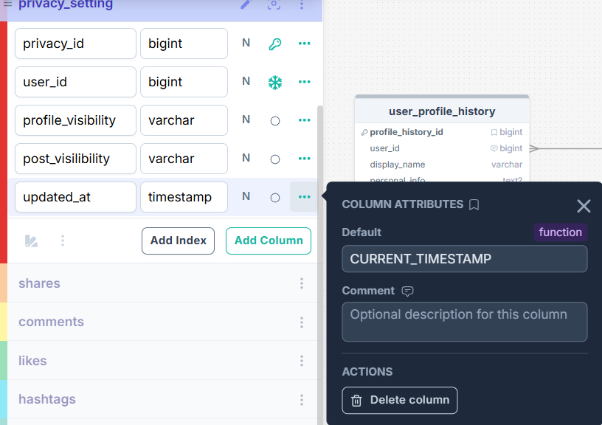

privacy_setting_history:
This table represents the history of privacy changes. In real life, it means all previous privacy values a user had before making updates. I store it separately because the current settings and the historical versions are not the same thing. The current table changes in place, while the history table keeps record of old settings.
This table is in 3NF because all fields describe one user and depend only on the primary key, which is user_id. There are no repeating groups and no partial or transitive dependencies.
I chose privacy_history_id as the PK because it gives each historical record its own identifier. A composite key could be made from privacy_id and timestamp, but I think a surrogate key is easier to use. The FK user_id is added to connect each history row to the correct user.

Table Name | Field name | Field Description | Data Type
privacy_setting_history | privacy_history_id | Unique identifier of the privacy history record. | BIGINT PRIMARY KEY
 | user_id | Reference to the user whose privacy settings changed. | BIGINT NOT NULL  FOREIGN KEY (user_id) REFERENCES users(user_id) ON DELETE CASCADE
 | profile_visibility | Previous profile visibility value. | VARCHAR(255) NOT NULL  CHECK (profile_visibility IN ('public','private','followers_only’'))
 | post_visibility | Previous post visibility value. | VARCHAR(255) NOT NULL  CHECK (post_visibility IN ('public','private','followers_only'))
 | changed_at | Date and time when this privacy snapshot was stored. | TIMESTAMP NOT NULL DEFAULT CURRENT_TIMESTAMP

Privacy_history_id | User_id | Profile_visibility | Post_visibility | Changed_at
1 | 1 | Private | Private | 19.03.2026 15:38:01
2 | 2 | Public | Public | 18.03.2026 15:38:01
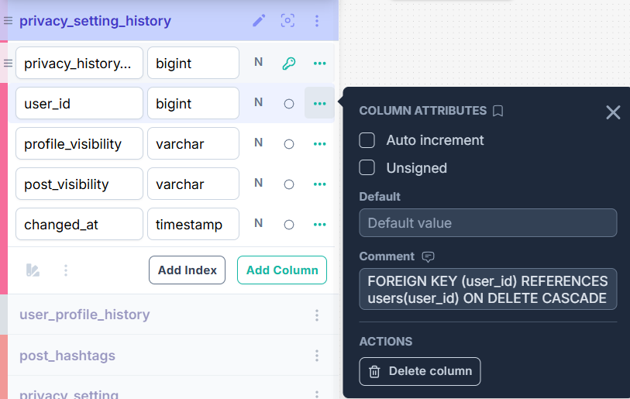
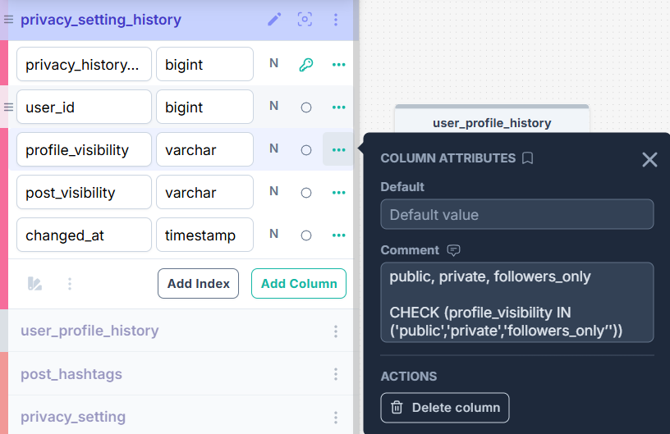
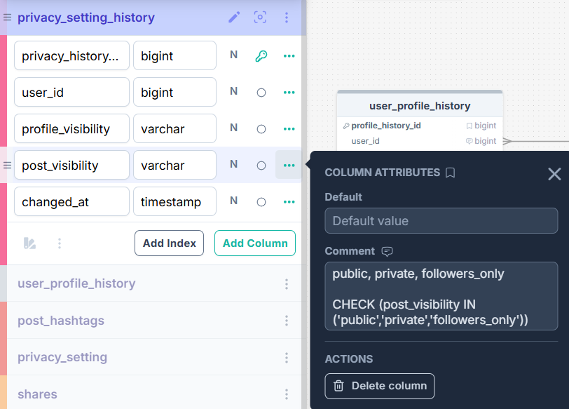
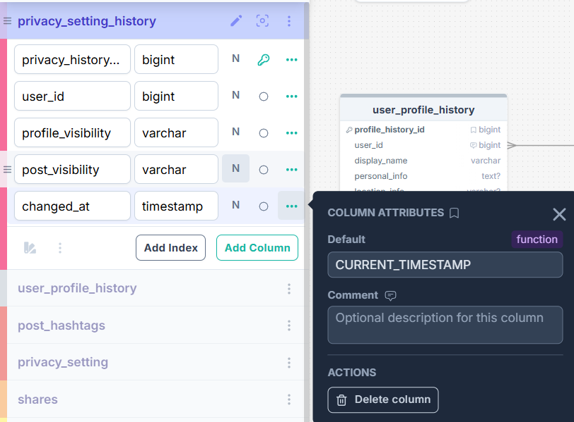
posts:
This table represents original content created by users. In real life, it is one post published on the platform. I keep it separately because posts are the main content object and many other tables such as likes, comments, shares, media and hashtags connect to it.
This table is in 3NF because all fields describe one user and depend only on the primary key, which is user_id. There are no repeating groups and no partial or transitive dependencies.
I chose post_id as the PK because it is a stable identifier for each post. A composite key would not be practical because one user can create too many posts. I added user_id as an FK because every post must belong to its author.

Table Name | Field name | Field Description | Data Type
posts | post_id | Unique identifier of the post. | BIGINT PRIMARY KEY
 | user_id | Reference to the author of the post. | BIGINT NOT NULL  FOREIGN KEY (user_id) REFERENCES users(user_id) ON DELETE CASCADE
 | body | Text content of the post. | TEXT NOT NULL
 | visibility | Visibility level of this exact post to point differentiate from others. | VARCHAR(255) NOT NULL DEFAULT 'public'  CHECK (visibility IN ('public','private','followers_only'))
 | posted_at | Date and time when the post was created. | TIMESTAMP NOT NULL DEFAULT CURRENT_TIMESTAMP

Post_id | User_id | Body | Visibility | Posted_at
1 | 1 | Here is the top… | Public | NOW()
2 | 2 | I want to say that… | Private | NOW()
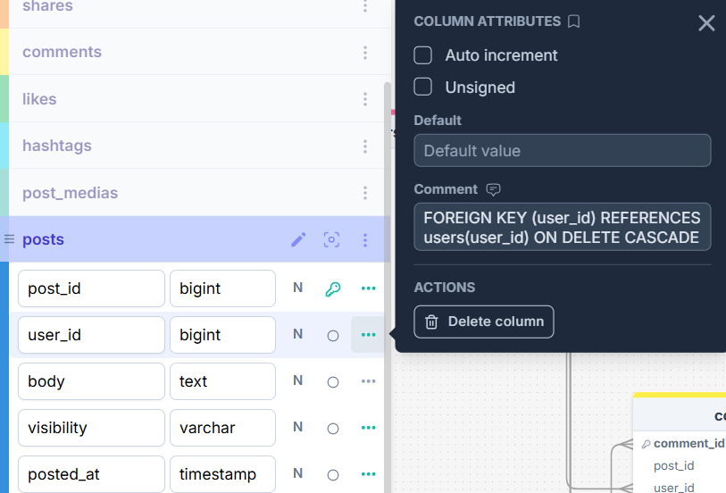
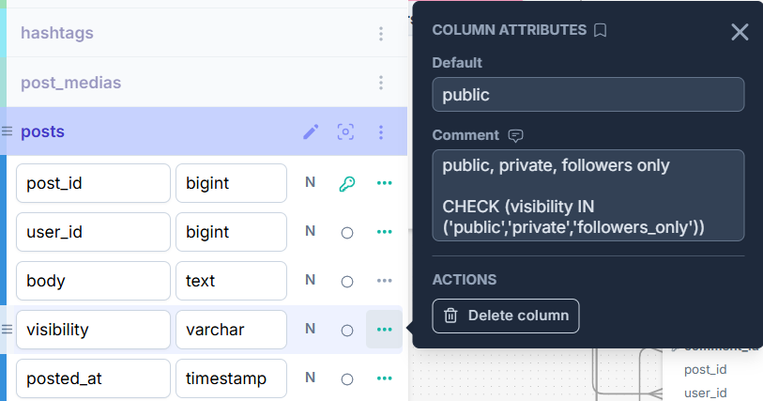
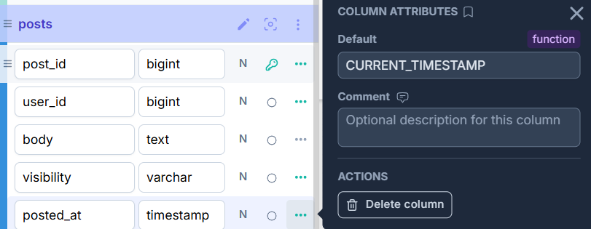

post_medias:
This table represents media attached to posts. In real life, it means one image, video or gif that belongs to a post. I store it separately because one post can have many media files with each having own differences.
This table is in 3NF because all fields describe one user and depend only on the primary key, which is user_id. There are no repeating groups and no partial or transitive dependencies.
I chose media_id as the PK because it gives each attachment its own identifier. A composite key with post_id and media_url could work also. I added post_id as an FK to show which post the media belongs to.

Table Name | Field name | Field Description | Data Type
post_medias | media_id | Unique identifier of the media record. . | BIGINT PRIMARY KEY
 | post_id | Reference to the post that owns the media. | BIGINT NOT NULL  FOREIGN KEY (post_id) REFERENCES posts(post_id) ON DELETE CASCADE
 | media_type | Type of media such as image, video, or gif. | VARCHAR(255) NOT NULL  CHECK (media_type IN ('image','video’,’gif’))
 | url | URL of the attached media file. | TEXT NOT NULL
 | added_at | Date and time when the media was added to the post. | TIMESTAMP NOT NULL DEFAULT CURRENT_TIMESTAMP

Media_id | Post_id | Media_type | Url | Added_at
1 | 1 | image | https://img.freepik.com/free-photo/lavender-field-sunset-near-valensole_268835-3910.jpg?semt=ais_hybrid&w=740&q=80 | NOW()
2 | 2 | image | https://media.istockphoto.com/id/814423752/photo/eye-of-model-with-colorful-art-make-up-close-up.jpg?s=612x612&w=0&k=20&c=l15OdMWjgCKycMMShP8UK94ELVlEGvt7GmB_esHWPYE= | NOW()
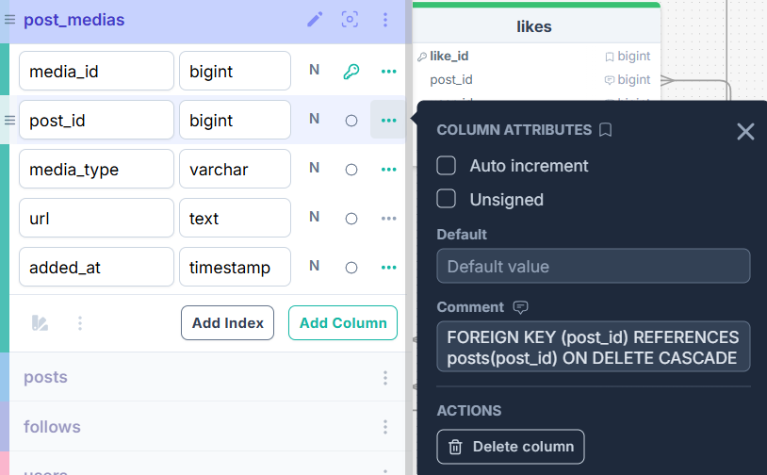
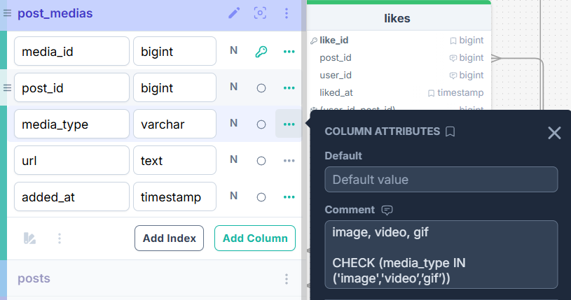
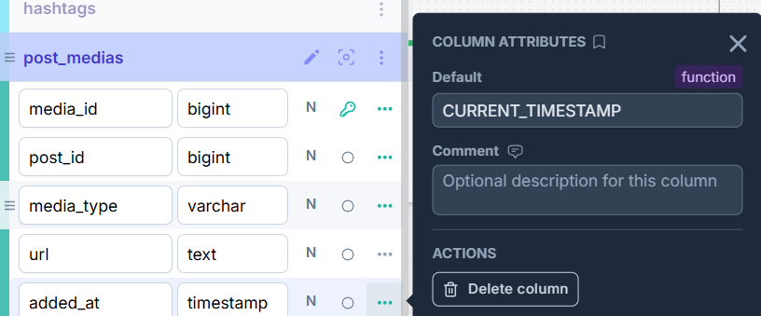
hashtags:
This table represents the hashtag dictionary. In real life, it means one reusable hashtag that can appear in many posts. I store it separately because if hashtag text were stored directly inside posts, it would cause duplication.
This table is in 3NF because all fields describe one user and depend only on the primary key, which is user_id. There are no repeating groups and no partial or transitive dependencies.
I chose hashtag_id as the PK because it is simple and stable. There are no FKs in this table because it is parent table that is referenced by post_hashtags.

Table Name | Field name | Field Description | Data Type
hashtags | hashtag_id | Unique identifier of the hashtag. | BIGINT PRIMARY KEY
 | hashtag_name | Unique text of the hashtag. | VARCHAR(255) NOT NULL UNIQUE

Hashtag_id | Hashtag_name
1 | gym
2 | lifestyle

post_hashtags:
This table represents the relationship between posts and hashtags. I store it separately because this is a many-to-many relationship: one post can have many hashtags and one hashtag can be used in many posts.
This table is in 3NF because all fields describe one user and depend only on the primary key, which is user_id. There are no repeating groups and no partial or transitive dependencies.
I chose post_hashtag_id as the PK because it gives each relation its own identifier. Yes, a composite key of (post_id, hashtag_id) could also work. I added post_id and hashtag_id as FKs to connect the row to both related tables.

Table Name | Field name | Field Description | Data Type
post_hashtags | post_hashtag_id | Unique identifier of the post-hashtag relation. | BIGINT PRIMARY KEY
 | post_id | Reference to the related post. | BIGINT NOT NULL  FOREIGN KEY (post_id) REFERENCES posts(post_id) ON DELETE CASCADE
 | hashtag_id | Reference to the related hashtag. | BIGINT NOT NULL  FOREIGN KEY (hashtag_id) REFERENCES hashtags(hashtag_id) ON DELETE CASCADE
 | tagged_at | Date and time when the hashtag was created (because the hashtags can only be created inside of the post). | TIMESTAMP NOT NULL DEFAULT CURRENT_TIMESTAMP
 | (post_id, hashtag_id) | Unique identifier of the post to hashtag relation. | UNIQUE

Post_hashtag_id | Post_id | Hashtag_id | Tagged_at | (post_id, hashtag_id)
1 | 1 | 1 | NOW() | (1,1)
2 | 2 | 2 | NOW() | (2,2)
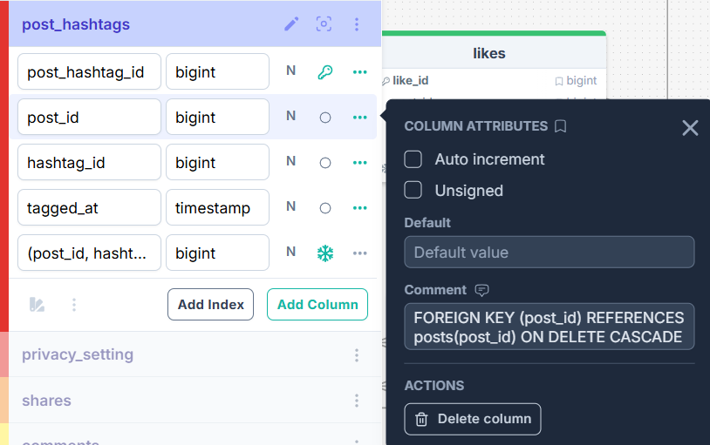
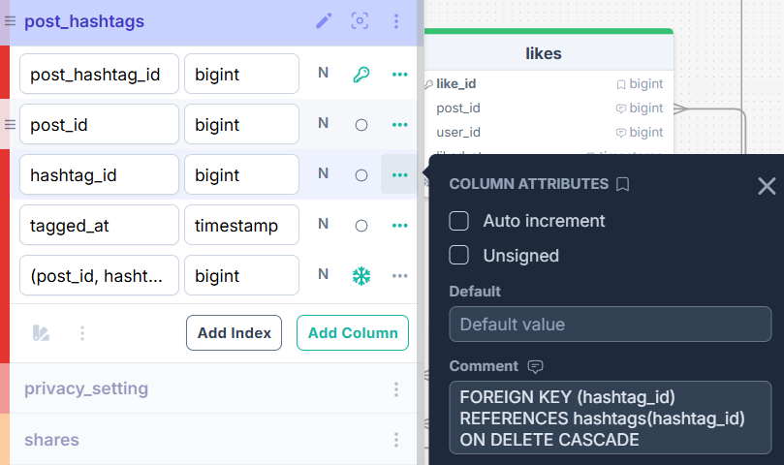
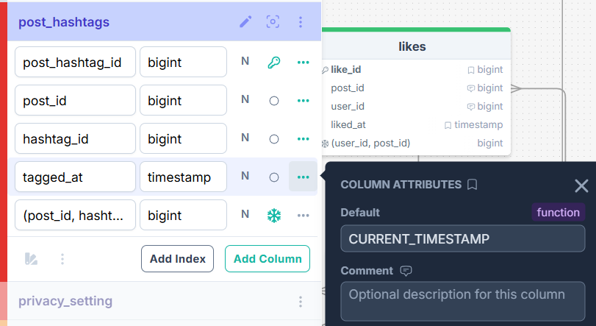
likes:
This table represents a like event. In real life, it means one user liking one post. I keep it separately because a like is an action, not a property of the user or the post itself.
This table is in 3NF because all fields describe one user and depend only on the primary key, which is user_id. There are no repeating groups and no partial or transitive dependencies.
I chose like_id as the PK because it gives each event its own identifier. A composite key of (user_id, post_id) could also work. I added user_id and post_id as FKs because a like must always belong to an existing user and an existing post.

Table Name | Field name | Field Description | Data Type
likes | like_id | Unique identifier of the like event. | BIGINT PRIMARY KEY
 | post_id | Reference to the liked post. | BIGINT NOT NULL  FOREIGN KEY (post_id) REFERENCES posts(post_id) ON DELETE CASCADE
 | user_id | Reference to the user who liked the post. | BIGINT NOT NULL  FOREIGN KEY (user_id) REFERENCES users(user_id) ON DELETE CASCADE
 | liked_at | Date and time when the like was made. | TIMESTAMP NOT NULL DEFAULT CURRENT_TIMESTAMP
 | (user_id, post_id) | Unique identifier of the user liking the post. | UNIQUE

Like_id | Post_id | User_id | Liked_at | (user_id, post_id)
1 | 1 | 1 | NOW() | (1,1)
2 | 2 | 2 | NOW() | (2,2)
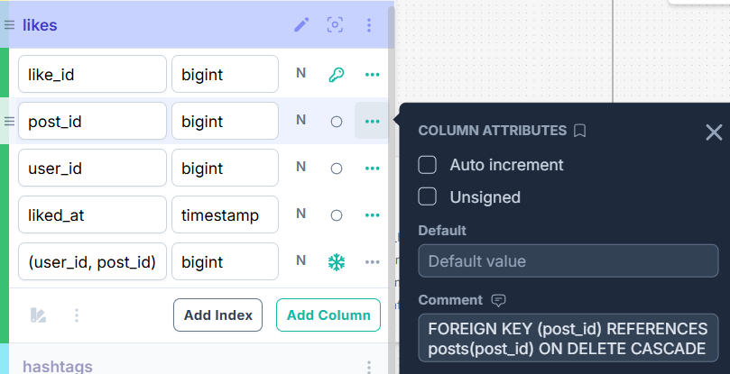
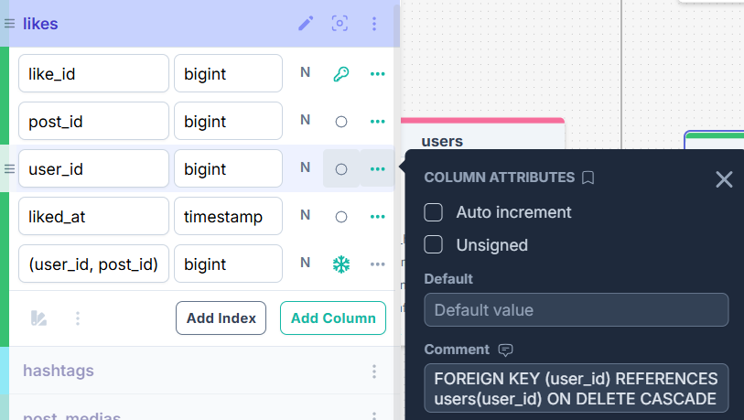
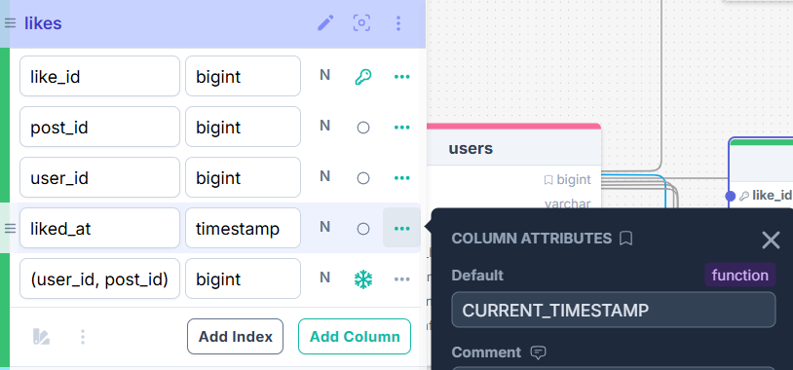

comments:
This table represents comments on posts. In real life, it means one text response written by a user. I store it separately because comments can be many, they have their own author and time, and they can also reply to other comments.
This table is in 3NF because all fields describe one user and depend only on the primary key, which is user_id. There are no repeating groups and no partial or transitive dependencies. The self-reference for replies does not break normalization.
I chose comment_id as the PK because each comment needs its own stable identifier. A composite key would not be practical because comments may reply to other comments and need independent references. I added post_id and user_id as FKs for the related post and author, and parent_comment_id as a self-referencing FK for nested replies.

Table Name | Field name | Field Description | Data Type
comments | comment_id | Unique identifier of the comment. | BIGINT PRIMARY KEY
 | post_id | Reference to the post being commented on. | BIGINT NOT NULL  FOREIGN KEY (post_id) REFERENCES posts(post_id) ON DELETE CASCADE
 | user_id | Reference to the author of the comment. | BIGINT NOT NULL  FOREIGN KEY (user_id) REFERENCES users(user_id) ON DELETE CASCADE
 | parent_comment_id | Reference to the parent comment if this is a reply. | BIGINT  FOREIGN KEY (parent_comment_id) REFERENCES comments(comment_id) ON DELETE CASCADE
 | body | Body content of the comment. | TEXT NOT NULL
 | commented_at | Date and time when the comment was created. | TIMESTAMP NOT NULL DEFAULT CURRENT_TIMESTAMP

comment_id | post_id | user_id | parent_comment_id | body | commented_at
1 | 1 | 1 | NULL | This looks tasty | NOW()
2 | 2 | 2 | NULL | That’s sad | NOW()
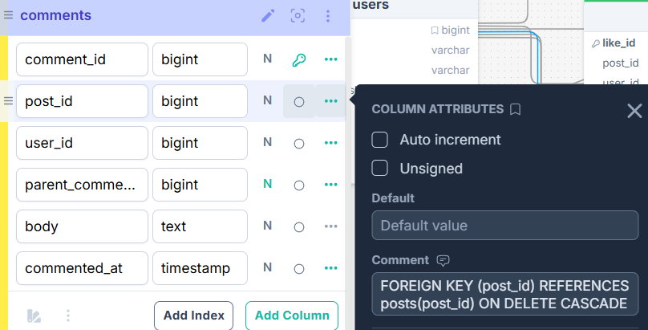
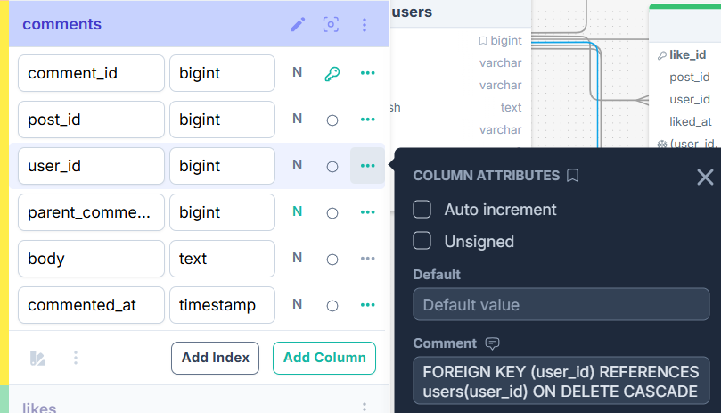
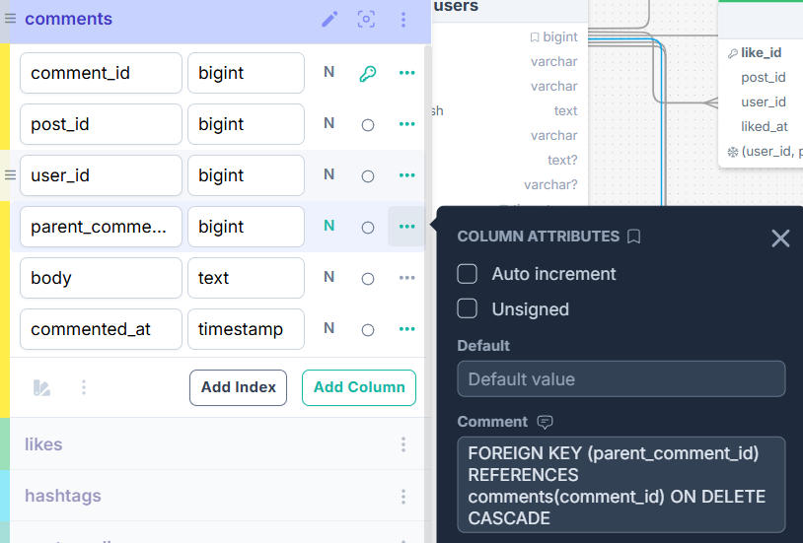
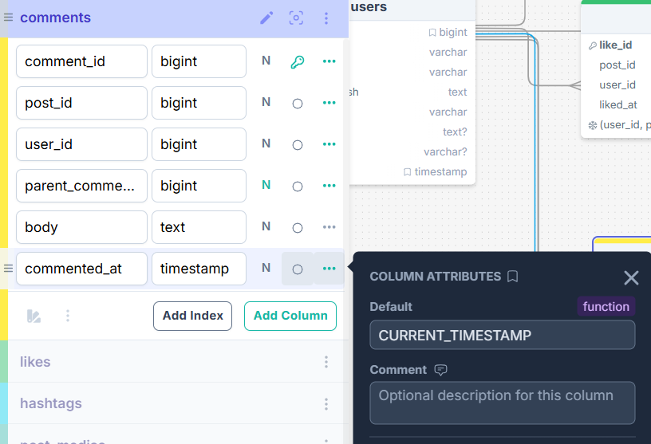

follows:
This table represents the follow relationship between users. In real life, it means one user follows another user. I keep it separately because this is a many-to-many relationship between users and cannot be stored correctly inside the users table.
This table is in 3NF because all fields describe one user and depend only on the primary key, which is user_id. There are no repeating groups and no partial or transitive dependencies.
I chose follow_id as the PK because it is simple and gives each relationship its own identifier. A composite key of (follower_id, followee_id) could also work well here. I added two FKs, follower_id and followee_id but they represent different roles in the same relationship.

Table Name | Field name | Field Description | Data Type
follows | follow_id | Unique identifier of the follow relation. | BIGINT PRIMARY KEY
 | follower_id | Reference to the user who follows. | BIGINT NOT NULL  FOREIGN KEY (follower_id) REFERENCES users(user_id) ON DELETE CASCADE
 | followee_id | Reference to the user being followed. | BIGINT NOT NULL  FOREIGN KEY (followee_id) REFERENCES users(user_id) ON DELETE CASCADE
 | followed_at | Date and time when the follow was created. | TIMESTAMP NOT NULL DEFAULT CURRENT_TIMESTAMP
 | (follower_id, followee_id) | Unique identifier of the follower to followee releationship. | UNIQUE

Follow_id | Follower_id | Followee_id | Followed_at | (follower_id, followee_id)
1 | 1 | 2 | NOW() | (1,2)
2 | 2 | 1 | NOW() | (2,1)
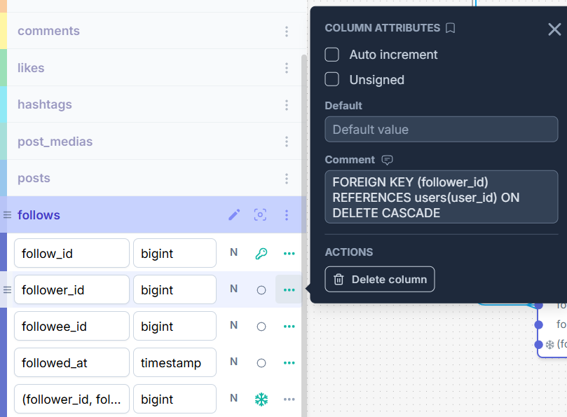
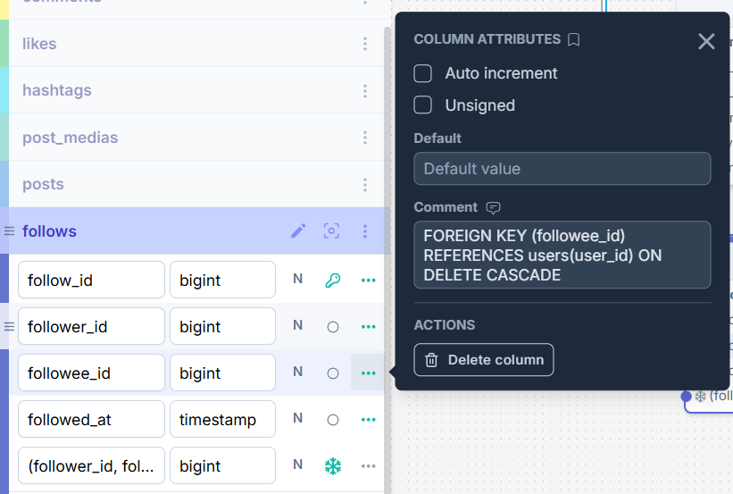
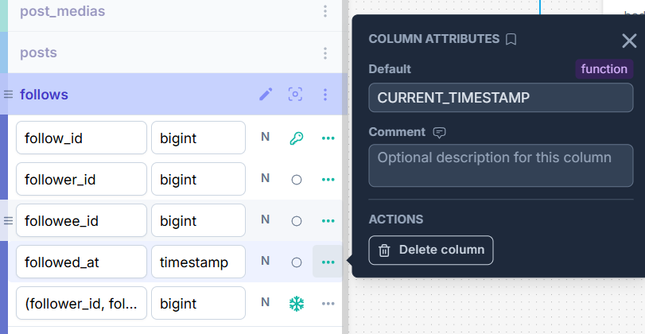

shares:
This table represents a share event. In real life, it means a user shares an existing post, sometimes with an extra note. I store it separately because sharing is not the same as creating a new original post. It is an interaction with existing content.
This table is in 3NF because all fields describe one user and depend only on the primary key, which is user_id. There are no repeating groups and no partial or transitive dependencies.
I chose share_id as the PK because each share should have its own identifier. I added user_id and post_id as FKs because every share must reference the user who shared and the post that was shared.

Table Name | Field name | Field Description | Data Type
shares | share_id | Unique identifier of the share event. | BIGINT PRIMARY KEY
 | post_id | Reference to the shared post. | BIGINT NOT NULL  FOREIGN KEY (post_id) REFERENCES posts(post_id) ON DELETE CASCADE
 | user_id | Reference to the user who shared the post. | BIGINT NOT NULL  FOREIGN KEY (user_id) REFERENCES users(user_id) ON DELETE CASCADE
 | shared_note | Optional note added during sharing. | TEXT
 | shared_at | Date and time when the share happened. | TIMESTAMP NOT NULL DEFAULT CURRENT_TIMESTAMP

Share_id | Post_id | User_id | Shared_note | Shared_at
1 | 1 | 1 | Look at this ahah | NOW()
2 | 2 | 2 | It is you bro | NOW()
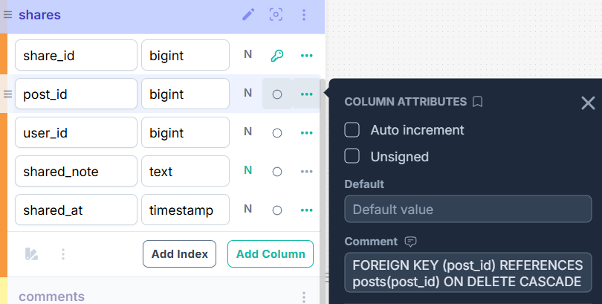
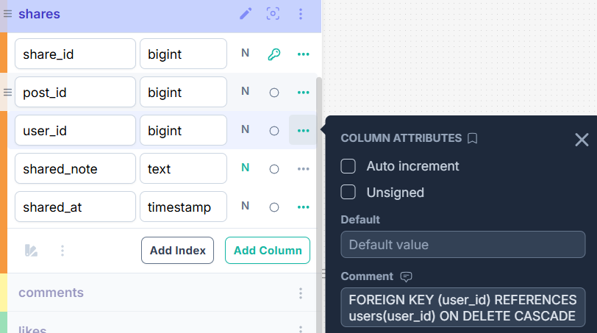
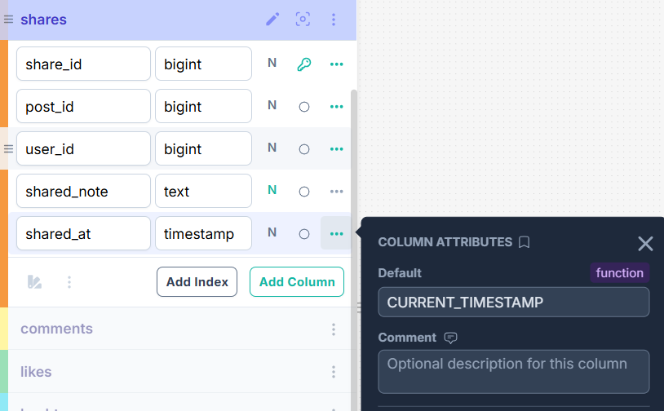

ASSUMPTIONS:
- I assumed that each user has exactly one current row in privacy_setting.
- I assumed that the visibility fields have allowed values public, private, and followers_only.
- I assumed that users store the latest profile values and every meaningful profile change results in an inserted row in user_profile_history.
- I assumed that privacy_setting stores the latest privacy values and every privacy change results in an inserted row in privacy_setting_history.
- I assumed that likes and shares are only for posts, not for comments.
- I assumed that a share points to an existing post and does not create a second full copy of that post in posts.
- I assumed that a post may contain only media and therefore posts.body may be nullable.
- I assumed that media types are restricted to image, video, and gif.
- I assumed that self-follow is forbidden.

