# Work Report

# Introduction

The main task of «Universal S.G» LLP is the retail sale of goods from China via the Internet. The founder of the company is engaged in logistics throughout Kazakhstan. The logistics industry is the circulatory system of the economy, ensuring timely delivery of goods along the entire production chain, from raw materials and equipment to the final buyer. In addition, because of the pandemic, deliveries have become much more, and it has become more difficult to work. Delivery times were tight, and people refused the purchased goods. The money was returned to them, but it was economically unprofitable to send the goods back to China, so they decided to buy and sell it themselves.

They sold goods on kaspi.kz that took a percentage of the revenue and they decided to create their own online store, but the budget was not enough to get services from the masters of website development, and my friend and I were well acquainted with the founder of the company and showed them our projects made while studying at IITU, and we offered to create an online store for a certain percentage of each sale.

Therefore, the purpose of the internship was to develop a full-fledged online store. To achieve the goal, it was necessary to decide on the choice of a method for website development, since we created only simple websites using the Spring Framework, we realized that it would be long and difficult to develop an online store in the shortest possible time in this way, and decided to implement it by the most popular method for creating websites through the WordPress CMS. Wordpress is a constructor with which you can quickly create your website and edit its contents, and installation can be performed on any hosting that supports PHP and MySQL DBMS. Thus, we have set the following tasks for ourselves to achieve the goal:

1. Choose a hosting service, and install Wordpress and a theme for online store on it.
2. Familiarize yourself and professionally master the chosen theme, WordPress and WooCommerce plugin.
3. Develop the necessary functions for the full operation of the online store.

# The main part

## Install WordPress on hosting, and choose a theme for the online store

We chose WordPress due to its great popularity compared to other CMS that allow you to create an online store. The w3techs website provides the following statistics — WordPress is used by 23% of the sites analyzed from the top 10 million sites rated by Amazon Alexa. The share among other CMS in this sample is 60% [1].

We think that such popularity is due to the fact that WordPress is free, open source and has a friendly website management interface, easy installation and use, hence a simple entry threshold compared to other CMS. Since WordPress is open source, there is a lot of ready-made code, templates and tutorials inside it.

First of all, we started comparing different free hosting sites for installing WordPress on them, and the choice fell on hosting beget.com [2].

Because he arranged us for the following reasons:

1. There is a free version for 30 days for testing
2. Fast work speed compared to other hosting sites on which we have installed the theme and Wordpress
3. Free domain for the site
4. Free SSL certificate for each domain
5. Full compatibility and automatic CMS installation.
6. There are all the technologies for comfortable work with the support of popular frameworks

After choosing a hosting and installing WordPress, we started installing the Woodmart theme [3]. Because we needed ready-made design options for an online store to choose from. A WordPress theme is a set of files that is responsible for the appearance of the site.

We chose this theme because it is the most popular WordPress theme for any store or corporate website. The rating of the WoodMart theme is high which means users appreciate available features and design solutions to the full.

## Familiarize yourself and professionally master the chosen theme, WordPress and WooCommerce plugin

To familiarize myself with WordPress, I first took this course:

* 1. <https://fedorvasilev.com/wordpress-uchebnik.html> To learn WooCommerce, I watched the following videos:

1. https://[www.youtube.com/watch?v=Txg-PrWRdzs&t=3s](http://www.youtube.com/watch?v=Txg-PrWRdzs&t=3s)
2. <https://www.youtube.com/watch?v=WDvzs5UrzeI&t=922s>
3. <https://youtube.com/playlist?list=PLrZ36o0cnx9qaC5KaF237tQdx8Ps882V-> To get acquainted with the woodmart theme I watched the following videos:
4. <https://www.youtube.com/watch?v=d8RW5_3-AHE&t=15111s>
5. <https://www.youtube.com/watch?v=kTGcNvT09rU&t=3s>

After familiarizing ourselves with these technologies, we began to redesign the site using the WPBakery plugin, and custom CSS, JS, and started importing goods to the site in order to understand how to edit products on the site. After watching the tutorials on YouTube and reading the WordPress documentation on this topic [4] [5], we realized that it was possible to import products via Excel, this was what suited the manager. However, it was necessary to bring the table to a certain structure, for example:

1. Categories and subcategories are written in one column and separated by the symbol '>'
2. Links to images are written in one column and separated by commas
3. To add product attributes, it is important to specify the name, values, visibility and globality in separate columns.

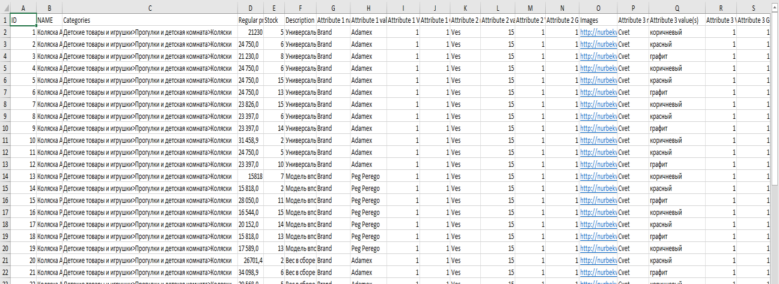

## Develop the necessary functions for the full operation of the online store

* 1. **Adding the possibility of pre-orders for customers, a system for detailed tracking of pre-orders, and their processing by the store manager.**

There were many ways to add pre-orders, from adding plugins to manually writing code. Most plugins with the necessary functionality were paid; we needed to find a good plugin for pre-orders with the following functions:

* + 1. Adding the possibility of pre-orders for all products when they will not be available or specify the date when pre-orders will become possible for some products
    2. When making a pre-order, the information got into a separate table with detailed statistics about each product that has pre-orders.
    3. Specify the exact date when the product will be available, and a discount on the product.

After checking dozens of plugins and methods, we settled on the paid version, which has the functionality we need - WooCommerce Pre-Orders [6].

## Creating a product tracking page and a plugin for assigning track numbers to products through integration with the API from track24, and Kazpost.

I integrated API track24 into our website so that customers could track purchased goods by track code, and added the ability to assign a track code to the product for managers [7].

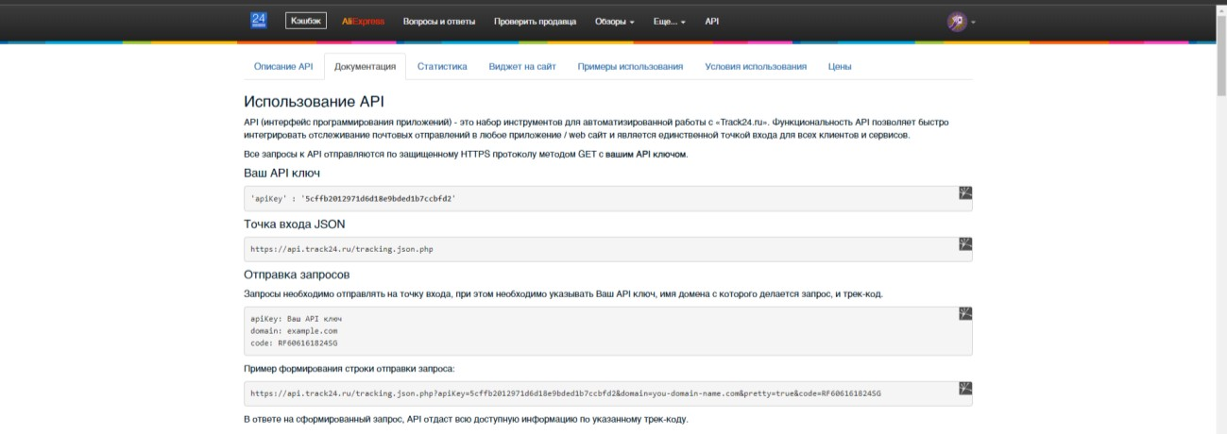

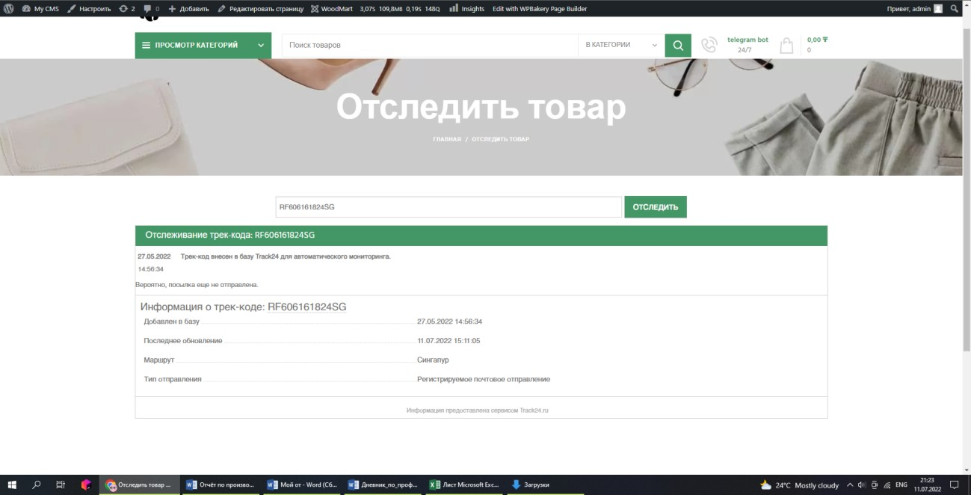

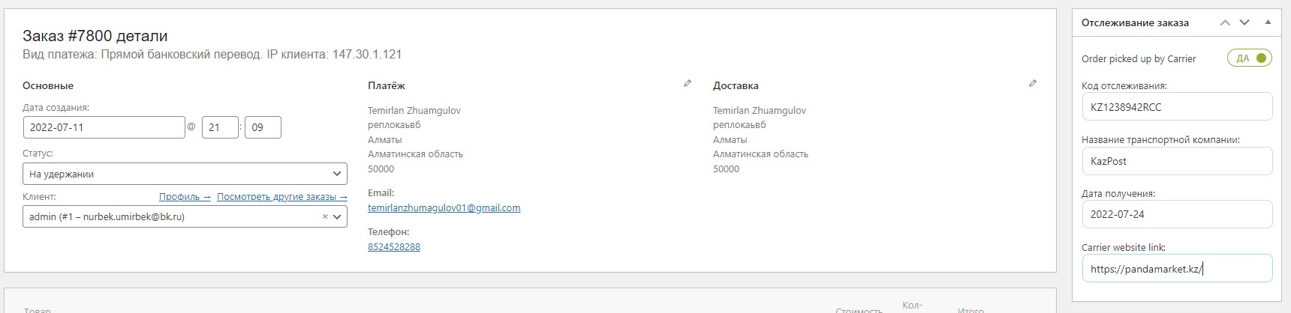

The customer can see information about the track code and when the delivery will arrive in his account in the orders section:

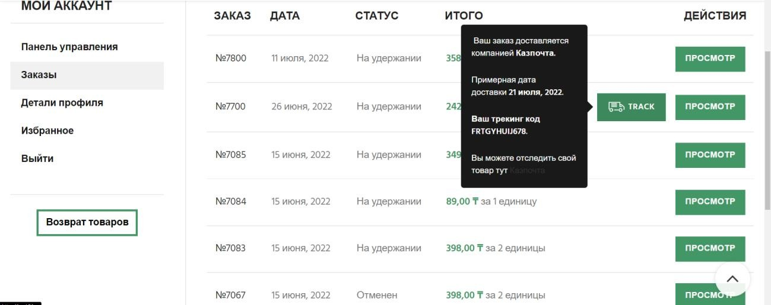

## Creation of Telegram bot for the return of goods and customer support.

To create a telegram bot, I used a leadteh chatbot constructor [8]. I wrote telegram bot scripts on it, where the following three buttons are available in the menu:



When selecting the option to return the product. The bot will ask you in stages:

1. Briefly write the reason for the refund
2. Send the video for unpacking
3. Send a photo of the product
4. Send the article of the product (you can find it on the website in the card of your product)

If you send something else instead of the video, then the validation will not let you go further, exactly as well as with the photo and the article of the product.

If you have passed the validation, you will receive a message: Our manager will contact you if the goods have arrived with damage, and no more than 14 days have passed since the receipt of the goods! Then the manager will receive such a letter:



When choosing the option to lower the price, the bot will ask you:

* 1. Send the article of the product from which you want to reduce the price (The article of the product can be found on the website in the product card)
  2. Send a link to a similar product from another online store with a lower price
  3. Send one screenshot of the product from another online store so that the price and information about the product are visible

Validation also works here and after passing it, the bot will write to you:

Thank you for supporting our store! Our manager will contact you and reduce the price for the goods under the conditions:

1. The product is identical. This means that it has 100% identical characteristics: color, completeness, version, etc.
2. Applies only to products with the status - In stock.

When choosing the third option, the client will go to our page with the refund policy in which the information from the article on consumer protection.

## Creation of a plugin for automatically finding postal codes at the selected address.

Three problems needed to be solved:

We first tried to solve these problems through plugins, but not one plugin did not solve them. Therefore, we decided that we need to write the plugin and code ourselves

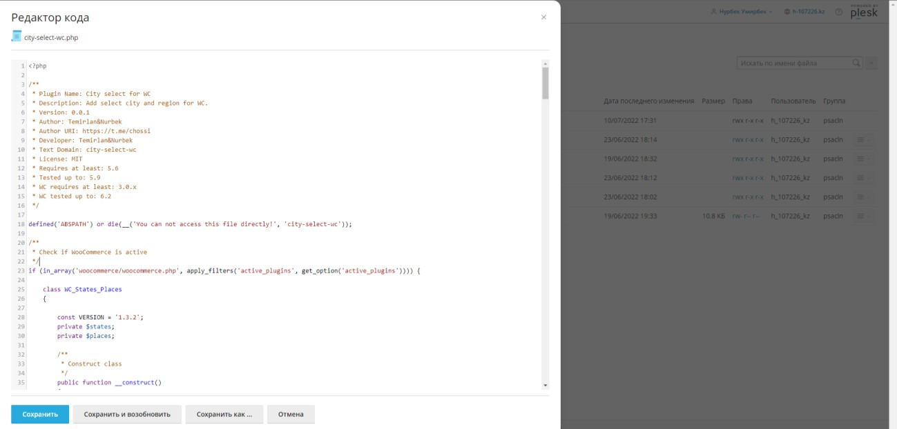

The first problem was that many people do not know the postal address of their Kazpost, so we had to collect the indexes of all cities manually and add them to the JSON array, but we also needed to show the user how many days the delivery will be when choosing a “courier delivery service” or “to the Kazpost branch”, and that's why we added them too. Using this array, we checked the region and city entered by the user for a match with the region and city of the array, if the condition was true, then we filled in the index and delivery field with data from the array, and if the condition is false, then the user enters the index himself, and the delivery is shown by regions (it is already less accurate).

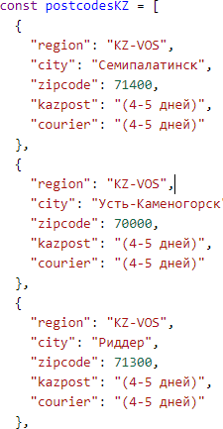

The second problem, which was related to the human factor. People can enter an incorrect address, and then the program will not work. Therefore, we did everything through “select” tags. First, the client selects the country, then the region, then the city, and then the index is automatically assigned.

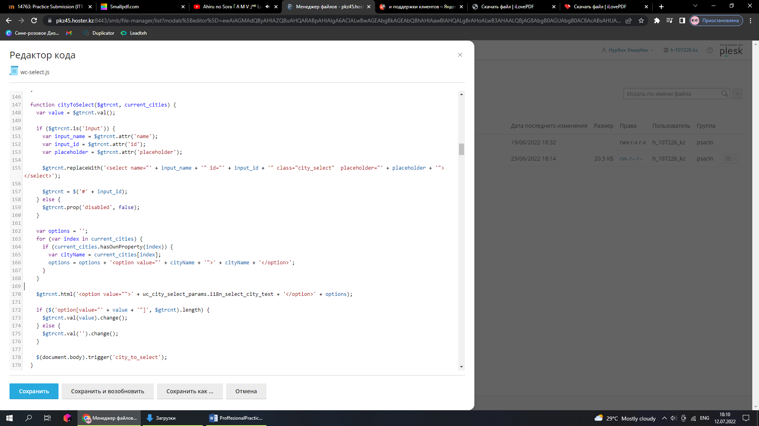

The third problem was that the order could come from a city that we did not add, and for such a case we had to add the opportunity for a person to write the address himself if the selection did not suit him. But then the buyer must enter the index himself.

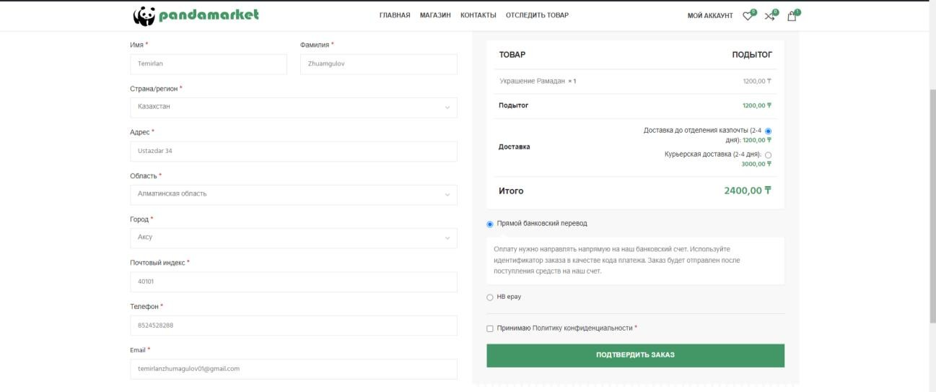Final result:

We have a selection of cities and regions and a search that narrows this selection.

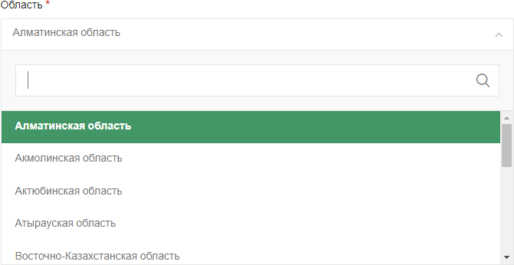

If the city entered in the search bar is not in the selection, then you can select it, but the index field will not be filled in automatically.

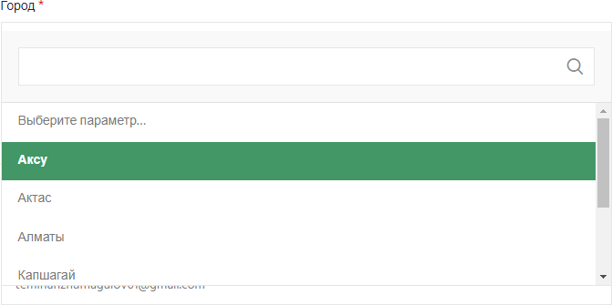

## Transferring a website from one hosting to another

By this time, the manager had decided on the name of the domain, and asked to choose a good paid hosting and move the website there. We offered different hosting services, he wanted to take it from Amazon or Google, but it turned out to be illegal. It turns out that if the site provides services in the territory of Kazakhstan and the domain name ends with .kz that it must be registered in Kazakhstan and with a Kazakhstani hoster.

There was a choice between PS.kz and hoster.kz after looking at the reviews on the Internet and talking with the people who make the site, we came to the conclusion that hoster.kz is better and bought hosting from this hoster. We chose a tariff plan (Eco-4) and paid 2240 tenge for hosting [9].

After that, we had to choose the right SSL certificate and install it on the hosting, because without it there was no way to connect Internet acquiring, authorization, and the site would cause more trust among visitors.

The choice was between certificates — Sectigo, RapidSSL, GeoTrust, Thawte and Symantec. We chose RapidSSL Standard for 6000 tenge because it offers inexpensive entry-level SSL certificates with 256-bit encryption, which will provide reliable protection for internal networks, small sites and other small Internet projects. For us it was a good value for money [10].

By adding the certificate, we added authorization using Google, Facebook, and Vkontakte.

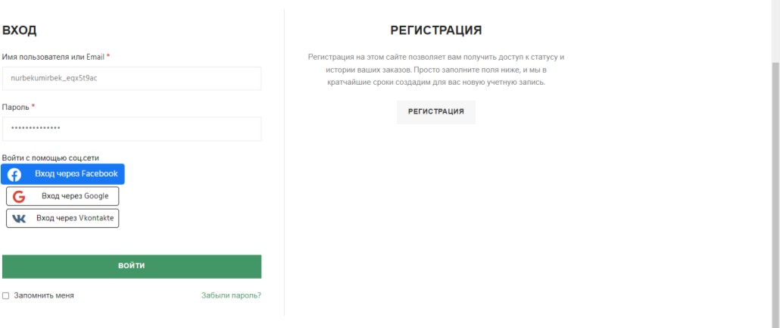

## Epay acquiring connections from Halyk Bank.

Internet acquiring is a technology that is a type of acquiring that allows you to accept bank cards for payment via the Internet. The main difference from trading and mobile acquiring is the absence of a terminal for physically reading card data.

There are several types of online acquiring in Kazakhstan – woopkassa, epayment, post, etc.

Woopkassa is one of the most convenient tools for receiving payment through the site, but the commission is 3.5% and 3%, which seemed huge to our managers and they decided to look at other tools [11].

Epayment – acquiring owned by KazKom Bank, but this bank joined Halyk bank. The commission is significantly less than 3%, and for Halyk bank customers 2.5% [12].

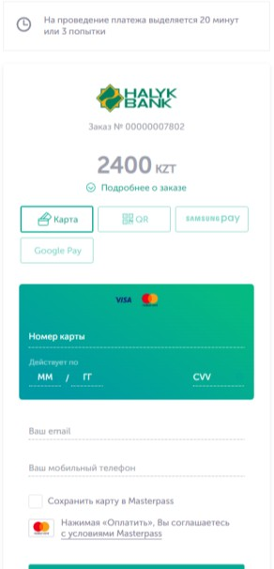They chose it, and we integrated the test version on the site:

## Testing a program that automatically collects information from products from AliExpress into an Excel spreadsheet

The fact was that it was difficult to manually drive in all the data of goods from AliExpress, since their number exceeded 1500. Therefore, the manager hired a programmer for this task, who had to parse the data by links in excel in a certain way. We have compiled all the requirements and tested his program.

Several shortcomings of the parser were revealed during testing:

1. When parsing 50 or more products, AliExpress blocked access to the parser, including my computer ip for unusual activity.
2. The product description parsed only the content inside the tags, so due to the absence of <br>, <h>, <p> the text merged into one hard-to-read paragraph.
3. The color was badly parsed, because this field may be different for the goods. For example, instead of color, there may be light emitted, origin, or brand. And it was displayed as “color: CHINA”

After correcting all these shortcomings, we began to parse the products using the links provided to us by the supervisor's workers and add the resulting Excel to the online store.

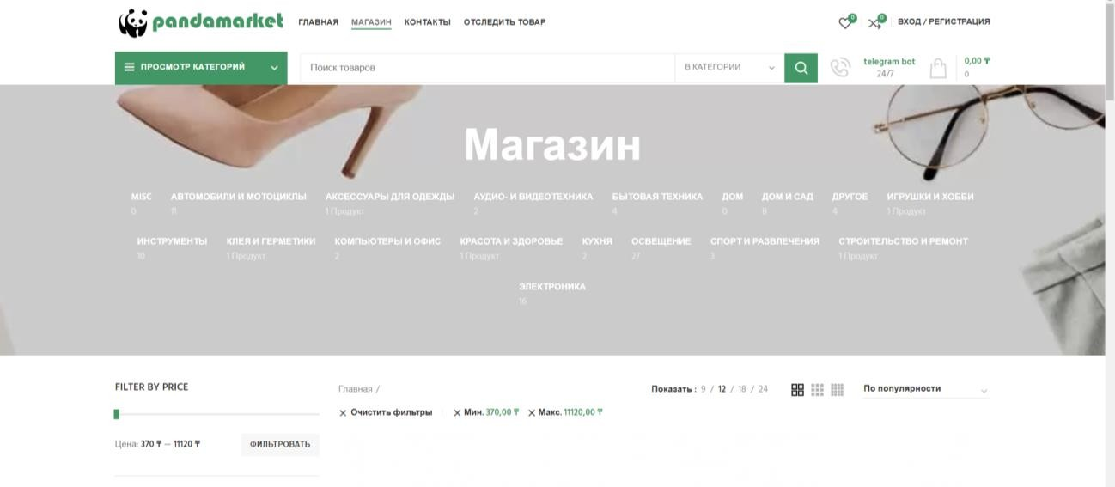

## Website optimization

The main disadvantages of WordPress:

1. A small set of basic features.
2. Slow speed for loading a web resource.
3. Duplicate images and pages.
4. A huge number of poorly made themes and extensions with errors.

Initially, the template and WordPress has a limited set of functions, but they can be extended with plugins. However, an excessive number of them can affect the speed of the web resource. In our case CMS WordPress, namely the mass of add- ons installed to it, significantly load the server where the site is hosted. To avoid such a load, we have reduced the number of additional plugins to the lowest possible minimum, replacing them with our own code.

Another disadvantage of WordPress is the automatic generation of duplicate pages, which negatively affects the promotion of the site. In addition, this engine makes copies of images when loading them, while in different sizes. To prevent this, we installed the «Ultimate media cleaner» plugin [13].

The last thing we used for optimization was the Accelerator plugin. Modern proprietary technologies and optimization algorithms allowed us to achieve very high performance: A fragmented cache, efficient data updating, splitting the loading of scripts and styles into three stages, and lean lazy loading of images and videos [14].

## 9. Familiarization with bitrix24 CRM, and Google Analytics

CRM (Customer Relationship Management) is a system that has access to all channels of communication with customers and can automate sales. One is the only service that combines programs for collecting data about customers and transactions, transaction management, control over managers, analytics and forecasting. It simplifies the routine, allowing you to focus on sales [15].

We have familiarized ourselves with this technology to add similar features to our admin panel. WooCommerce already records all customer and transaction data, and has sales analytics. It remains for us to add the role of the store manager, who will have limited functions, and add detailed reporting on the work of all managers. The rest of the analytics about ads, page traffic, engagement indicators for catalogs and pages were done using the Google Analytics connection.

We did this through the "members" plugin. By adding the manager the ability to process orders and pre-orders, assign track codes to orders, add discounts to products in a certain period of time, create email lists to send customers coupons or updates. Detailed reporting has been built into this plugin, where we can observe how many successful deals each manager has closed.

And we registered our site in Google Analytics and connected the code provided by them to our site. Thus, we have an opportunity for detailed analytics of the store [16] [17].

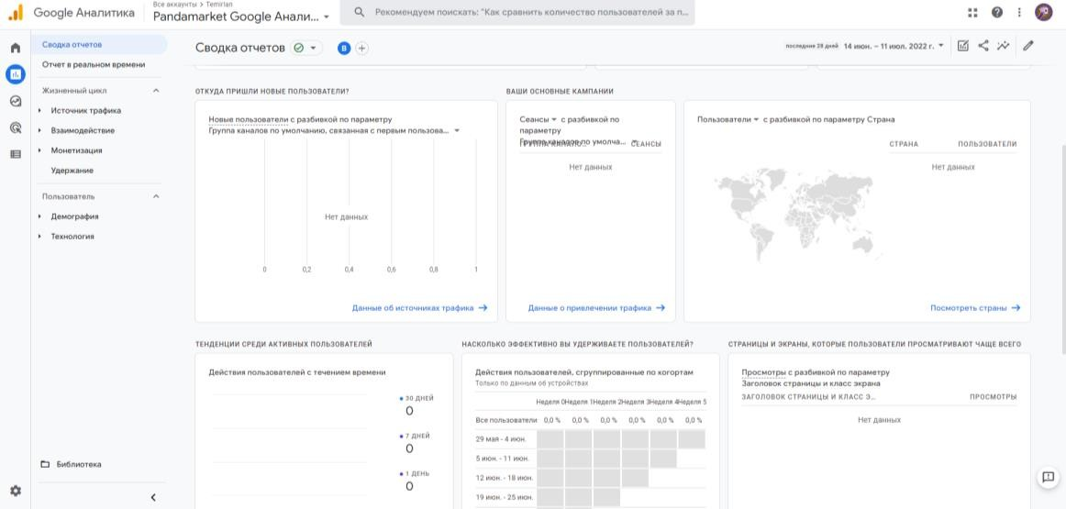

Why have we enabled Google Analytics?

In order to understand how much time people spend on our site, what products they search for in the search engine, which catalogs they pay attention to more often, who these people are, do they perform the actions that we expect from them. To track the traffic sources from where people come to our site.

Which traffic-attracting sources work and which do not? To determine whether to spend money on this advertisement in the future or not.

# Conclusion

During the development of the online store for the "Universal S.G" LLP, I managed to:

* 1. Familiarize yourself and practically master the most popular method for creating websites with simple WordPress content management
  2. Study the WooCommerce plugin and the WoodMart theme for creating an online store in WordPress.
  3. Compare different plugins for pre-orders and choose the best
  4. Integrate the API from track24 for tracking goods and Kazpost for assigning track codes.
  5. Create a telegram bot in the constructor for the return of goods
  6. Develop our plugin in Wordpress for automatic display of the city postal code, and the delivery time to this city, when the client specifies the address.
  7. Add authorization via social networks
  8. Connect acquiring ePay from Halyk bank
  9. Test the Aliexpress web page parser
  10. Speed up the work of the site, and reduce unnecessary plugins
  11. Get acquainted with bitrix24 CRM, and Google analytics
  12. Connect Google analytics to the site

## REFERNCES

1. <https://w3techs.com/technologies/overview/content_management>
2. <https://beget.com/ru>
3. [https://themeforest.net/item/woodmart-woocommerce-wordpress-](https://themeforest.net/item/woodmart-woocommerce-wordpress-theme/20264492) [theme/20264492](https://themeforest.net/item/woodmart-woocommerce-wordpress-theme/20264492)
4. <https://www.youtube.com/watch?v=Djf04pyY4dQ&t=618s>
5. [https://github.com/woocommerce/woocommerce/wiki/Product-CSV-Import-](https://github.com/woocommerce/woocommerce/wiki/Product-CSV-Import-Schema#csv-columns-and-formatting) [Schema#csv-columns-and-formatting](https://github.com/woocommerce/woocommerce/wiki/Product-CSV-Import-Schema#csv-columns-and-formatting)
6. <https://wordpress.org/plugins/pre-orders-for-woocommerce/>
7. [https://track24.ru/?page=api#apiDocumentation](https://track24.ru/?page=api&apiDocumentation)
8. <https://leadteh.ru/>
9. https://hoster.kz/ 10.https://hoster.kz/ssl/about_ssl/ 11.<https://www.woopkassa.kz/> 12.https://halykbank.kz/business/payment/epay

13.<https://wordpress.org/plugins/ultimate-media-cleaner/> 14.<https://www.s-sols.com/ru/products/wordpress/accelerator> 15.<https://www.youtube.com/user/Bitrix24video/playlists> 16.<https://analytics.google.com/> 17.https://[www.youtube.com/watch?v=cN1Jcfxi4qs](http://www.youtube.com/watch?v=cN1Jcfxi4qs)