Insertion Sort
Our pseudocode for insertion sort is presented as a procedure called INSERTION-SORT, which takes as a parameter an array A[1 ‥ n] containing a sequence of length n that is to be sorted. (In the code, the number n of elements in A is denoted by length[A].) The input numbers are sorted in place: the numbers are rearranged within the array A, with at most a constant number of them stored outside the array at any time. The input array A contains the sorted output sequence when INSERTION-SORT is finished.
INSERTION-SORT(A)
1 for j ← 2 to length[A]
2 do key ← A[j]
3 ▹ Insert A[j] into the sorted sequence A[1 ‥ j - 1].
4 i ← j - 1
5 while i > 0 and A[i] > key
6 do A[i + 1] ← A[i]
7 i ← i - 1
8 A[i + 1] ← key
Loop invariants and the correctness of insertion sort
Figure 2.2 shows how this algorithm works for A = 〈5, 2, 4, 6, 1, 3〉. The index j indicates the "current card" being inserted into the hand. At the beginning of each iteration of the "outer" for loop, which is indexed by j, the subarray consisting of elements A[1 ‥ j - 1] constitute the currently sorted hand, and elements A[j + 1 ‥ n] correspond to the pile of cards still on the table. In fact, elements A[1 ‥ j - 1] are the elements originally in positions 1 through j - 1, but now in sorted order. We state these properties of A[1 ‥ j -1] formally as a loop invariant:
- At the start of each iteration of the for loop of lines 1-8, the subarray A[1 ‥ j - 1] consists of the elements originally in A[1 ‥ j - 1] but in sorted order.
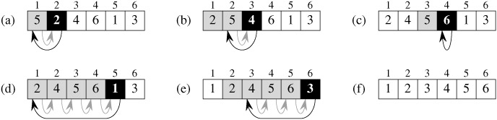
Figure 2.2: The operation of INSERTION-SORT on the array A = 〈5, 2, 4, 6, 1, 3〉. Array indices appear above the rectangles, and values stored in the array positions appear within the rectangles. (a)-(e) The iterations of the for loop of lines 1-8. In each iteration, the black rectangle holds the key taken from A[j], which is compared with the values in shaded rectangles to its left in the test of line 5. Shaded arrows show array values moved one position to the right in line 6, and black arrows indicate where the key is moved to in line 8. (f) The final sorted array.
2.3.1 The divide-and-conquer approach
Many useful algorithms are recursive in structure: to solve a given problem, they call themselves recursively one or more times to deal with closely related subproblems. These algorithms typically follow a divide-and-conquer approach: they break the problem into several subproblems that are similar to the original problem but smaller in size, solve the subproblems recursively, and then combine these solutions to create a solution to the original problem.
The divide-and-conquer paradigm involves three steps at each level of the recursion:
- Divide the problem into a number of subproblems.
- Conquer the subproblems by solving them recursively. If the subproblem sizes are small enough, however, just solve the subproblems in a straightforward manner.
- Combine the solutions to the subproblems into the solution for the original problem.
The merge sort algorithm closely follows the divide-and-conquer paradigm. Intuitively, it operates as follows.
- Divide: Divide the n-element sequence to be sorted into two subsequences of n/2 elements each.
- Conquer: Sort the two subsequences recursively using merge sort.
- Combine: Merge the two sorted subsequences to produce the sorted answer.
The recursion "bottoms out" when the sequence to be sorted has length 1, in which case there is no work to be done, since every sequence of length 1 is already in sorted order.
The key operation of the merge sort algorithm is the merging of two sorted sequences in the "combine" step. To perform the merging, we use an auxiliary procedure MERGE(A, p, q, r), where A is an array and p, q, and r are indices numbering elements of the array such that p ≤ q < r. The procedure assumes that the subarrays A[p ‥ q] and A[q + 1 ‥ r] are in sorted order. It merges them to form a single sorted subarray that replaces the current subarray A[p ‥ r].
Our MERGE procedure takes time Θ(n), where n = r - p + 1 is the number of elements being merged, and it works as follows. Returning to our card-playing motif, suppose we have two piles of cards face up on a table. Each pile is sorted, with the smallest cards on top. We wish to merge the two piles into a single sorted output pile, which is to be face down on the table. Our basic step consists of choosing the smaller of the two cards on top of the face-up piles, removing it from its pile (which exposes a new top card), and placing this card face down onto the output pile. We repeat this step until one input pile is empty, at which time we just take the remaining input pile and place it face down onto the output pile. Computationally, each basic step takes constant time, since we are checking just two top cards. Since we perform at most n basic steps, merging takes Θ(n) time.
The following pseudocode implements the above idea, but with an additional twist that avoids having to check whether either pile is empty in each basic step. The idea is to put on the bottom of each pile a sentinel card, which contains a special value that we use to simplify our code. Here, we use ∞ as the sentinel value, so that whenever a card with ∞ is exposed, it cannot be the smaller card unless both piles have their sentinel cards exposed. But once that happens, all the nonsentinel cards have already been placed onto the output pile. Since we know in advance that exactly r - p + 1 cards will be placed onto the output pile, we can stop once we have performed that many basic steps.
MERGE(A, p, q, r)
1 n₁ ← q - p + 1
2 n₂ ← r - q
3 create arrays L[1 ‥ n₁ + 1] and R[1 ‥ n₂ + 1]
4 for i ← 1 to n₁
5 do L[i] ← A[p + i - 1]
6 for j ← 1 to n₂
7 do R[j] ← A[q + j]
8 L[n₁ + 1] ← ∞
9 R[n₂ + 1] ← ∞
10 i ← 1
11 j ← 1
12 for k ← p to r
13 do if L[i] ≤ R[j]
14 then A[k] ← L[i]
15 i ← i + 1
16 else A[k] ← R[j]
17 j ← j + 1
In detail, the MERGE procedure works as follows. Line 1 computes the length n₁ of the subarray A[p ‥ q], and line 2 computes the length n₂ of the subarray A[q + 1 ‥ r]. We create arrays L and R ("left" and "right"), of lengths n₁ + 1 and n₂ + 1, respectively, in line 3. The for loop of lines 4-5 copies the subarray A[p ‥ q] into L[1 ‥ n₁], and the for loop of lines 6-7 copies the subarray A[q + 1 ‥ r] into R[1 ‥ n₂]. Lines 8-9 put the sentinels at the ends of the arrays L and R. Lines 10-17, illustrated in Figure 2.3, perform the r - p + 1 basic steps by maintaining the following loop invariant:
- At the start of each iteration of the for loop of lines 12-17, the subarray A[p ‥ k - 1] contains the k - p smallest elements of L[1 ‥ n₁ + 1] and R[1 ‥ n₂ + 1], in sorted order. Moreover, L[i] and R[j] are the smallest elements of their arrays that have not been copied back into A.
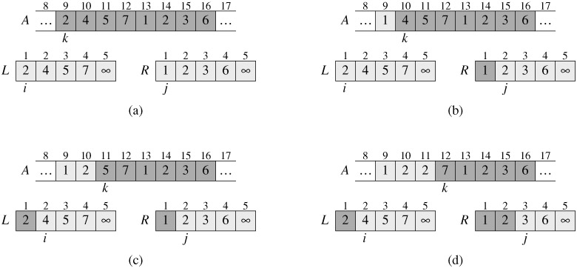
Figure 2.3: The operation of lines 10-17 in the call MERGE(A, 9, 12, 16), when the subarray A[9 ‥ 16] contains the sequence 〈2, 4, 5, 7, 1, 2, 3, 6〉. After copying and inserting sentinels, the array L contains 〈2, 4, 5, 7, ∞〉, and the array R contains 〈1, 2, 3, 6, ∞〉. Lightly shaded positions in A contain their final values, and lightly shaded positions in L and R contain values that have yet to be copied back into A. Taken together, the lightly shaded positions always comprise the values originally in A[9 ‥ 16], along with the two sentinels. Heavily shaded positions in A contain values that will be copied over, and heavily shaded positions in L and R contain values that have already been copied back into A. (a)-(h) The arrays A, L, and R, and their respective indices k, i, and j prior to each iteration of the loop of lines 12-17. (i) The arrays and indices at termination. At this point, the subarray in A[9 ‥ 16] is sorted, and the two sentinels in L and R are the only two elements in these arrays that have not been copied into A.
We must show that this loop invariant holds prior to the first iteration of the for loop of lines 12-17, that each iteration of the loop maintains the invariant, and that the invariant provides a useful property to show correctness when the loop terminates.
- Initialization: Prior to the first iteration of the loop, we have k = p, so that the subarray A[p ‥ k - 1] is empty. This empty subarray contains the k - p = 0 smallest elements of L and R, and since i = j = 1, both L[i] and R[j] are the smallest elements of their arrays that have not been copied back into A.
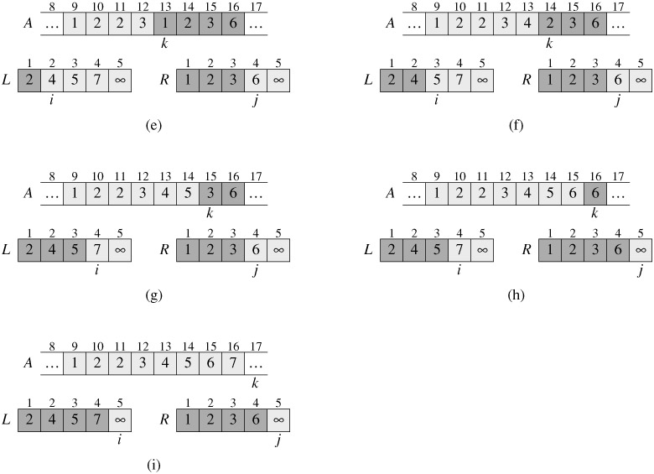
- Maintenance: To see that each iteration maintains the loop invariant, let us first suppose that L[i] ≤ R[j]. Then L[i] is the smallest element not yet copied back into A. Because A[p ‥ k - 1] contains the k - p smallest elements, after line 14 copies L[i] into A[k], the subarray A[p ‥ k] will contain the k - p + 1 smallest elements. Incrementing k (in the for loop update) and i (in line 15) reestablishes the loop invariant for the next iteration. If instead L[i] > R[j], then lines 16-17 perform the appropriate action to maintain the loop invariant.
- Termination: At termination, k = r + 1. By the loop invariant, the subarray A[p ‥ k - 1], which is A[p ‥ r], contains the k - p = r - p + 1 smallest elements of L[1 ‥ n₁ + 1] and R[1 ‥ n₂ + 1], in sorted order. The arrays L and R together contain n₁ + n₂ + 2 = r - p + 3 elements. All but the two largest have been copied back into A, and these two largest elements are the sentinels.
To see that the MERGE procedure runs in Θ(n) time, where n = r - p + 1, observe that each of lines 1-3 and 8-11 takes constant time, the for loops of lines 4-7 take Θ(n₁ + n₂) = Θ(n) time,^{[6]} and there are n iterations of the for loop of lines 12-17, each of which takes constant time.
We can now use the MERGE procedure as a subroutine in the merge sort algorithm. The procedure MERGE-SORT(A, p, r) sorts the elements in the subarray A[p ߩ r]. If p ≥ r, the subarray has at most one element and is therefore already sorted. Otherwise, the divide step simply computes an index q that partitions A[p ‥ r] into two subarrays: A[p ‥ q], containing ⌈n/2⌉ elements, and A[q + 1 ‥ r], containing ⌊n/2⌋ elements.^{[7]}
MERGE-SORT(A, p, r)
1 if p < r
2 then q ← ⌊(p + r)/2⌋
3 MERGE-SORT(A, p, q)
4 MERGE-SORT(A, q + 1, r)
5 MERGE(A, p, q, r)
To sort the entire sequence A = 〈A[1], A[2], . . . , A[n]〉, we make the initial call MERGE-SORT(A, 1, length[A]), where once again length[A] = n. Figure 2.4 illustrates the operation of the procedure bottom-up when n is a power of 2. The algorithm consists of merging pairs of 1-item sequences to form sorted sequences of length 2, merging pairs of sequences of length 2 to form sorted sequences of length 4, and so on, until two sequences of length n/2 are merged to form the final sorted sequence of length n.
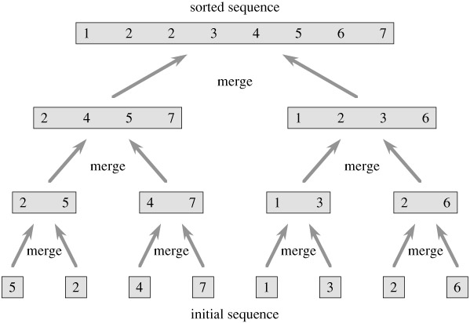
Figure 2.4: The operation of merge sort on the array A = 〈5, 2, 4, 7, 1, 3, 2, 6〉. The lengths of the sorted sequences being merged increase as the algorithm progresses from bottom to top.
Chapter 7: Quicksort
Quicksort is a sorting algorithm whose worst-case running time is Θ(n²) on an input array of n numbers. In spite of this slow worst-case running time, quicksort is often the best practical choice for sorting because it is remarkably efficient on the average: its expected running time is Θ(n lg n), and the constant factors hidden in the Θ(n lg n) notation are quite small. It also has the advantage of sorting in place (see page 16), and it works well even in virtual memory environments.
Section 7.1 describes the algorithm and an important subroutine used by quicksort for partitioning. Because the behavior of quicksort is complex, we start with an intuitive discussion of its performance in Section 7.2 and postpone its precise analysis to the end of the chapter. Section 7.3 presents a version of quicksort that uses random sampling. This algorithm has a good average-case running time, and no particular input elicits its worst-case behavior. The randomized algorithm is analyzed in Section 7.4, where it is shown to run in Θ(n²) time in the worst case and in O(n lg n) time on average.
7.1 Description of quicksort
Quicksort, like merge sort, is based on the divide-and-conquer paradigm introduced in Section 2.3.1. Here is the three-step divide-and-conquer process for sorting a typical subarray A[p ‥ r].
- Divide: Partition (rearrange) the array A[p ‥ r] into two (possibly empty) subarrays A[p ‥ q - 1] and A[q + 1 ‥ r] such that each element of A[p ‥ q - 1] is less than or equal to A[q], which is, in turn, less than or equal to each element of A[q + 1 ‥ r]. Compute the index q as part of this partitioning procedure.
- Conquer: Sort the two subarrays A[p ‥ q -1] and A[q +1 ‥ r] by recursive calls to quicksort.
- Combine: Since the subarrays are sorted in place, no work is needed to combine them: the entire array A[p ‥ r] is now sorted.
The following procedure implements quicksort.
QUICKSORT(A, p, r)
1 if p < r
2 then q ← PARTITION(A, p, r)
3 QUICKSORT(A, p, q - 1)
4 QUICKSORT(A, q + 1, r)
To sort an entire array A, the initial call is QUICKSORT(A, 1, length[A]).
Partitioning the array
The key to the algorithm is the PARTITION procedure, which rearranges the subarray A[p ‥ r] in place.
PARTITION(A, p, r)
1 x ← A[r]
2 i ← p - 1
3 for j ← p to r - 1
4 do if A[j] ≤ x
5 then i ← i + 1
6 exchange A[i] ↔ A[j]
7 exchange A[i + 1] ↔ A[r]
8 return i + 1
Figure 7.1 shows the operation of PARTITION on an 8-element array. PARTITION always selects an element x = A[r] as a pivot element around which to partition the subarray A[p ‥ r]. As the procedure runs, the array is partitioned into four (possibly empty) regions. At the start of each iteration of the for loop in lines 3-6, each region satisfies certain properties, which we can state as a loop invariant:
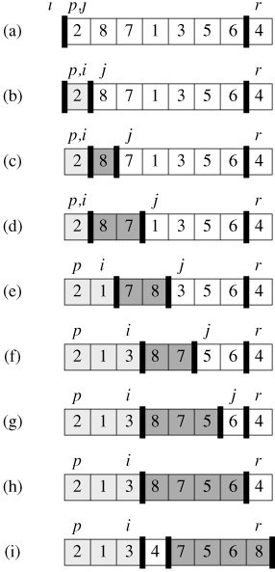
Figure 7.1: The operation of PARTITION on a sample array. Lightly shaded array elements are all in the first partition with values no greater than x. Heavily shaded elements are in the second partition with values greater than x. The unshaded elements have not yet been put in one of the first two partitions, and the final white element is the pivot. (a) The initial array and variable settings. None of the elements have been placed in either of the first two partitions. (b) The value 2 is "swapped with itself" and put in the partition of smaller values. (c)-(d) The values 8 and 7 are added to the partition of larger values. (e) The values 1 and 8 are swapped, and the smaller partition Grows. (f) The values 3 and 8 are swapped, and the smaller partition grows. (g)-(h) The larger partition grows to include 5 and 6 and the loop terminates. (i) In lines 7-8, the pivot element is swapped so that it lies between the two partitions.
- At the beginning of each iteration of the loop of lines 3-6, for any array index k,
  - If p ≤ k ≤ i, then A[k] ≤ x.
  - If i + 1 ≤ k ≤ j - 1, then A[k] > x.
  - If k = r, then A[k] = x.
Figure 7.2 summarizes this structure. The indices between j and r - 1 are not covered by any of the three cases, and the values in these entries have no particular relationship to the pivot x.
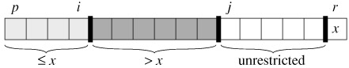
Figure 7.2: The four regions maintained by the procedure PARTITION on a subarray A[p ‥ r]. The values in A[p ‥ i] are all less than or equal to x, the values in A[i + 1 ‥ j - 1] are all greater than x, and A[r] = x. The values in A[j ‥ r - 1] can take on any values.
We need to show that this loop invariant is true prior to the first iteration, that each iteration of the loop maintains the invariant, and that the invariant provides a useful property to show correctness when the loop terminates.
- Initialization: Prior to the first iteration of the loop, i = p - 1, and j = p. There are no values between p and i, and no values between i + 1 and j - 1, so the first two conditions of the loop invariant are trivially satisfied. The assignment in line 1 satisfies the third condition.
- Maintenance: As Figure 7.3 shows, there are two cases to consider, depending on the outcome of the test in line 4. Figure 7.3(a) shows what happens when A[j] > x; the only action in the loop is to increment j. After j is incremented, condition 2 holds for A[j - 1] and all other entries remain unchanged. Figure 7.3(b) shows what happens when A[j] ≤ x; i is incremented, A[i] and A[j] are swapped, and then j is incremented. Because of the swap, we now have that A[i] ≤ x, and condition 1 is satisfied. Similarly, we also have that A[j - 1] > x, since the item that was swapped into A[j - 1] is, by the loop invariant, greater than x.
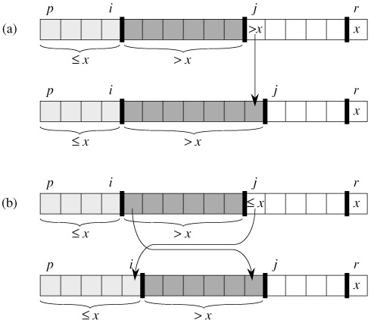
Figure 7.3: The two cases for one iteration of procedure PARTITION. (a) If A[j] > x, the only action is to increment j, which maintains the loop invariant. (b) If A[j] ≤ x, index i is incremented, A[i] and A[j] are swapped, and then j is incremented. Again, the loop invariant is maintained.
- Termination: At termination, j = r. Therefore, every entry in the array is in one of the three sets described by the invariant, and we have partitioned the values in the array into three sets: those less than or equal to x, those greater than x, and a singleton set containing x.
The final two lines of PARTITION move the pivot element into its place in the middle of the array by swapping it with the leftmost element that is greater than x.
The output of PARTITION now satisfies the specifications given for the divide step.
The running time of PARTITION on the subarray A[p ‥ r] is Θ(n), where n = r - p + 1
8.2 Counting sort
Counting sort assumes that each of the n input elements is an integer in the range 0 to k, for some integer k. When k = O(n), the sort runs in Θ(n) time.
The basic idea of counting sort is to determine, for each input element x, the number of elements less than x. This information can be used to place element x directly into its position in the output array. For example, if there are 17 elements less than x, then x belongs in output position 18. This scheme must be modified slightly to handle the situation in which several elements have the same value, since we don't want to put them all in the same position.
In the code for counting sort, we assume that the input is an array A[1 ‥ n], and thus length[A] = n. We require two other arrays: the array B[1 ‥n] holds the sorted output, and the array C[0 ‥ k] provides temporary working storage.
COUNTING-SORT(A, B, k)
1 for i ← 0 to k
2 do C[i] ← 0
3 for j ← 1 to length[A]
4 do C[A[j]] ← C[A[j]] + 1
5 ▹ C[i] now contains the number of elements equal to i.
6 for i ← 1 to k
7 do C[i] ← C[i] + C[i - 1]
8 ▹ C[i] now contains the number of elements less than or equal to i.
9 for j ← length[A] downto 1
10 do B[C[A[j]]] ← A[j]
11 C[A[j]] ← C[A[j]] - 1
Figure 8.2 illustrates counting sort. After the initialization in the for loop of lines 1-2, we inspect each input element in the for loop of lines 3-4. If the value of an input element is i, we increment C[i]. Thus, after line 4, C[i] holds the number of input elements equal to i for each integer i = 0, 1, . . .,k. In lines 6-7, we determine for each i = 0, 1, . . .,k, how many input elements are less than or equal to i by keeping a running sum of the array C.
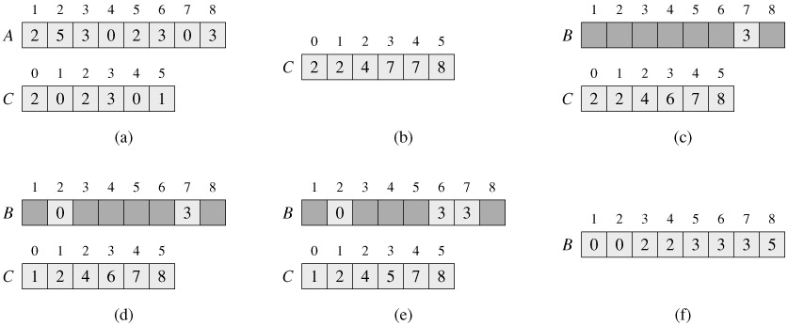
Figure 8.2: The operation of COUNTING-SORT on an input array A[1 ‥ 8], where each element of A is a nonnegative integer no larger than k = 5. (a) The array A and the auxiliary array C after line 4. (b) The array C after line 7. (c)-(e) The output array B and the auxiliary array C after one, two, and three iterations of the loop in lines 9-11, respectively. Only the lightly shaded elements of array B have been filled in. (f) The final sorted output array B.
Finally, in the for loop of lines 9-11, we place each element A[j] in its correct sorted position in the output array B. If all n elements are distinct, then when we first enter line 9, for each A[j], the value C[A[j]] is the correct final position of A[j] in the output array, since there are C[A[j]] elements less than or equal to A[j]. Because the elements might not be distinct, we decrement C[A[j]] each time we place a value A[j] into the B array. Decrementing C[A[j]] causes the next input element with a value equal to A[j], if one exists, to go to the position immediately before A[j] in the output array.
How much time does counting sort require? The for loop of lines 1-2 takes time Θ(k), the for loop of lines 3-4 takes time Θ(n), the for loop of lines 6-7 takes time Θ(k), and the for loop of lines 9-11 takes time Θ(n). Thus, the overall time is Θ(k+n). In practice, we usually use counting sort when we have k = O(n), in which case the running time is Θ(n).

