MIT 8103 Advanced Database Systems
Portfolio Documentation
Name | Temitope Agbaje
Matric number | 301931176
Session | 2026/2027 Academic Session, First Semester (Continuous Assessment)
Case study | Supalogi, a simulated ride-hailing platform
GitHub repository | https://github.com/TemitopeAgbaje/advanced-database-portfolio

1. Case study: Supalogi
Supalogi is a simulated ride-hailing platform operating in Lagos, Abuja and Accra. Riders request trips, nearby available drivers accept them, the rider pays at the end of the trip, and the rider and driver rate each other. Operations staff run reports on trips, earnings and city activity. The same case study is used in all five portfolio activities, so each part builds on the one before.
Tools used: PostgreSQL 15 and pgAdmin 4 (Portfolios 1–3), MongoDB 6.0 and mongosh (Portfolios 4–5), dbdiagram.io for the ER diagram, and Git/GitHub. Each portfolio folder in the repository has its own README with the scripts, how to run them, the screenshots, and a “What I found” section.

2. Portfolio activities

Portfolio 1 — Database design and modelling
I designed a relational schema of seven tables: cities, riders, drivers, vehicles, trips, payments and ratings, normalised to third normal form (normalisation.md). Primary keys identify each row; foreign keys make sure every trip belongs to a registered rider and driver; payments.trip_id is UNIQUE so a trip has only one payment; and CHECK constraints reject bad data such as a rating of 7, a negative payment, or a trip that starts before it was requested. The scripts were run on PostgreSQL 15 and tested with sample data.
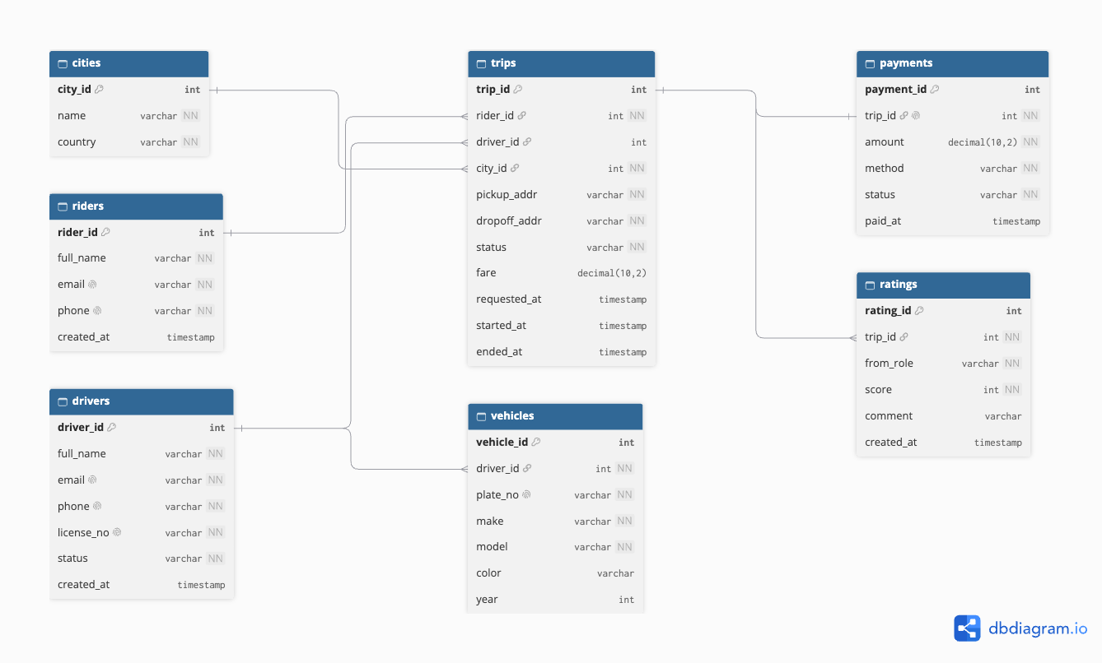
Figure 1. Supalogi ER diagram (portfolio-1-database-design/er-diagram.png)

Portfolio 2 — Query processing and optimisation
I generated 200,000 trips, 20,000 riders and 1,500 drivers, wrote five reporting queries, and compared their execution plans with EXPLAIN ANALYZE before and after optimisation.
Query | Optimisation | Before (ms) | After (ms)
Q1 Rider trip history | Composite index (rider_id, requested_at) | 49.373 | 0.056
Q2 Driver weekly earnings | Composite index (driver_id, requested_at) | 10.162 | 0.083
Q3 Matching queue | Partial index on waiting (requested) trips only | 11.686 | 0.039
Q5 Monthly city report | Materialized view (42 stored rows) | 62.988 | 0.027
Q4 Top 10 drivers | None: the planner keeps a full scan | 42.886 | n/a
Before the indexes PostgreSQL read through the whole trips table (Seq Scan); after, it went straight to the matching rows (Index Scan). Q4 reads a large share of the table, so a full scan was already the best plan and indexes did not help.

Portfolio 3 — Transactions and concurrency
Four demonstrations were run in pgAdmin, using two query tabs as two users at the same time:
- Commit: completing a trip, inserting its payment and freeing the driver were saved together as one transaction.
- Rollback: a manual ROLLBACK undid a trip update, and a payment of −2800 failed the CHECK constraint so the whole transaction was undone.
- Double booking: without a lock, two drivers accepted the same trip and the second overwrote the first (lost update). With SELECT … FOR UPDATE, the second tab waited, and only one driver got the trip.
- Isolation: in READ COMMITTED a transaction saw another tab’s fare change mid-way; in REPEATABLE READ it kept its snapshot and its update failed with “could not serialize access” (40001).
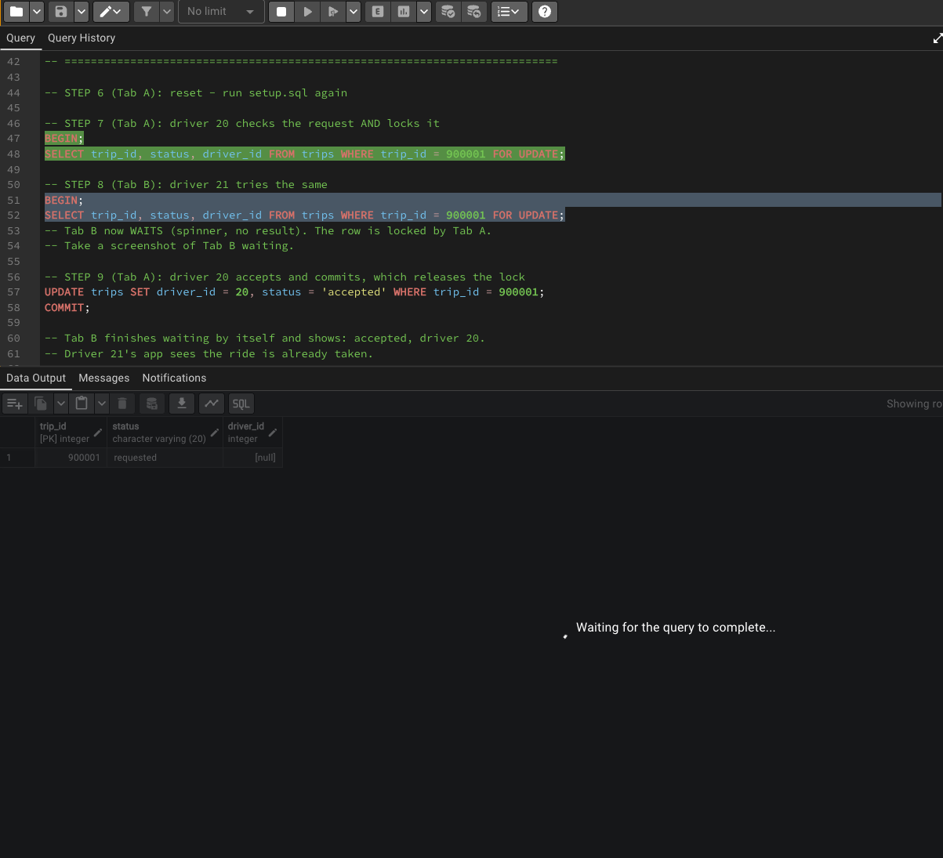  Figure 2. Tab B waits for the row lock | 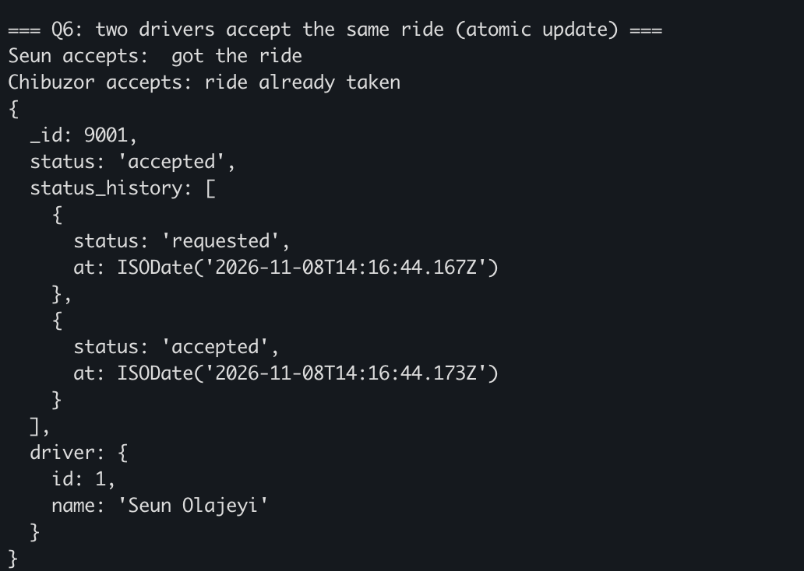  Figure 3. MongoDB: only one driver gets the ride

Portfolio 4 — NoSQL and advanced data models
I modelled Supalogi in MongoDB as documents: three collections (riders, drivers, trips) instead of seven tables. A trip document embeds the rider and driver names, pickup and dropoff (GeoJSON points), the payment, ratings and status history, so one read returns the whole trip with no joins. With 200 riders, 60 drivers and 5,000 trips, the queries showed: nearest available drivers using a 2dsphere index and $geoNear; a compound index that cut the documents examined from 5,000 (COLLSCAN) to 5 (IXSCAN); an aggregation pipeline for revenue per city; a flexible schema (only some trips have stops or a promo code; cancelled trips have no payment field); and an atomic findOneAndUpdate so only one of two drivers can accept a ride (Figure 3). My conclusion was to use both: PostgreSQL for payments and MongoDB for trips and driver matching.

Portfolio 5 — Distributed and cloud database exercise
I ran a three-node MongoDB replica set on my laptop (ports 27021–27023) and broke it on purpose:
- Replication: one primary and two secondaries all held the same 300 trips.
- Failover / availability: when the primary was switched off, the other two nodes elected a new primary within seconds and no trips were lost; a new trip was still saved with one node down.
- Recovery: the stopped node came back as a secondary and caught up on the trip it missed.
- Consistency: with two of three nodes down, the last node refused writes (no majority) but still allowed reads, so two nodes can never both act as primary and save different data.
Sharding and cloud design: shard the trips collection on { city, _id }, with Nigeria and Ghana zones so each country’s data stays in its region; deploy the replica set members across three availability zones on a managed cloud service; keep payments in PostgreSQL with a standby copy; and take daily backups, because replication also copies mistakes.
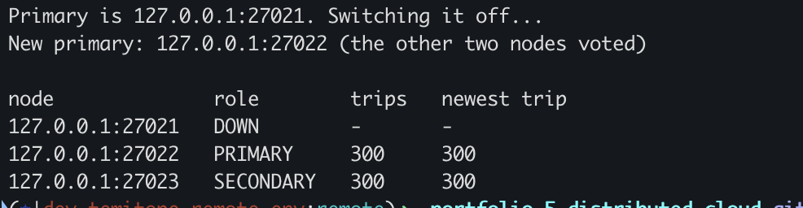
Figure 4. Failover: 27021 is down and 27022 is the new primary

3. Individual reflection
The part I found hardest was transactions and concurrency, because it took me a while to understand. What helped me understand it was running the two tabs myself and watching Tab B wait. The part that clicked most for me was distributed and cloud databases.
Things I learned that I did not know before: an index can make a query go from 49 ms to 0.05 ms; without a lock, two people can book the same driver; and three servers can vote for a new primary when one of them dies.
If Supalogi were a real company, the first thing I would do is add the indexes, so the app stays fast as the number of trips grows.

4. AI-use declaration
I used Claude (an AI assistant) while doing this portfolio. It drafted the first versions of the SQL and MongoDB scripts and the README text, and explained the concepts when I didn’t understand them. I chose the case study, ran every script on my own PostgreSQL and MongoDB, took all the screenshots, checked the results, asked for changes where things were wrong, and wrote the “What I found” sections from my own answers. AI only fixed spelling and grammar there. I can explain every file in the repository.

5. References
- MongoDB, Inc. MongoDB Manual: Replication, Sharding and Geospatial Queries. https://www.mongodb.com/docs/manual/
- Nigeria Data Protection Act 2023; Ghana Data Protection Act 2012 (Act 843).
- PostgreSQL Global Development Group. PostgreSQL 15 Documentation: Using EXPLAIN, Indexes, Transaction Isolation and Explicit Locking. https://www.postgresql.org/docs/15/

