KPMG GreenPath
IT Sustainability Practice
Carbon Footprint Calculator
Database Design Document
Database Design Document (DDD)
Draft v1.0 — for engineering and methodology review
2026-05-20
Classification: Confidential — for engineering and methodology review

Document Control
Field | Detail
Document title | Carbon Footprint Calculator — Database Design Document
Programme | KPMG GreenPath — IT Carbon Assessment
Document type | Database Design Document (DDD)
Version | 1.0 (Draft)
Date | 2026-05-20
Status | For engineering and methodology review
Author | Architecture team
Target platform | PostgreSQL 16 (Azure Database for PostgreSQL)
ORM / migrations | SQLAlchemy 2.x · Alembic
Classification | Confidential

Revision History
Version | Date | Author | Summary of change
0.1 | 2026-05-12 | Architecture team | Core table list extracted from build guide
0.9 | 2026-05-18 | Architecture team | Physical schema, constraints and indexing drafted
1.0 | 2026-05-20 | Architecture team | First reviewable draft with full DDL and diagrams

Table of Contents

1. Introduction

1.1 Purpose
This Database Design Document specifies how the Carbon Footprint Calculator stores, governs, and relates its data. The data model matters more than the frontend: it is what makes results reproducible, traceable, and assurance-ready. This document is the data counterpart to the System Analysis Document.

1.2 Scope
The design covers the nine core relational entities, their attributes, keys, constraints, indexes, and relationships; the governance model for emission factors and assumptions; the audit and traceability mechanism; and the migration and security posture. It targets PostgreSQL 16 accessed through SQLAlchemy 2.x with Alembic migrations.

1.3 Audience
- Backend engineers implementing the schema, ORM models, and migrations.
- Methodology and assurance reviewers validating traceability and reproducibility.
- Factor admins responsible for governed-dataset imports.
- Platform/operations responsible for backup, retention, and tenant isolation.

1.4 Conventions
- Table and column names are lower_snake_case; primary keys are named id.
- Foreign keys are named <referenced_table>_id.
- Monetary-style precision is avoided; emissions are stored as double precision / numeric with explicit units.
- All emission-bearing columns carry an explicit unit defined in the factor metadata (no naked numbers).
- Governed datasets (emission_factor, country_factor, assumption) are versioned and immutable once published.

2. Design Principles & Governance
The data model separates four concerns: (1) user inputs, (2) factors, (3) results, and (4) assumptions and source metadata. Inputs and factors are never colocated — that separation is precisely what makes re-running a historical assessment with a different factor version possible.
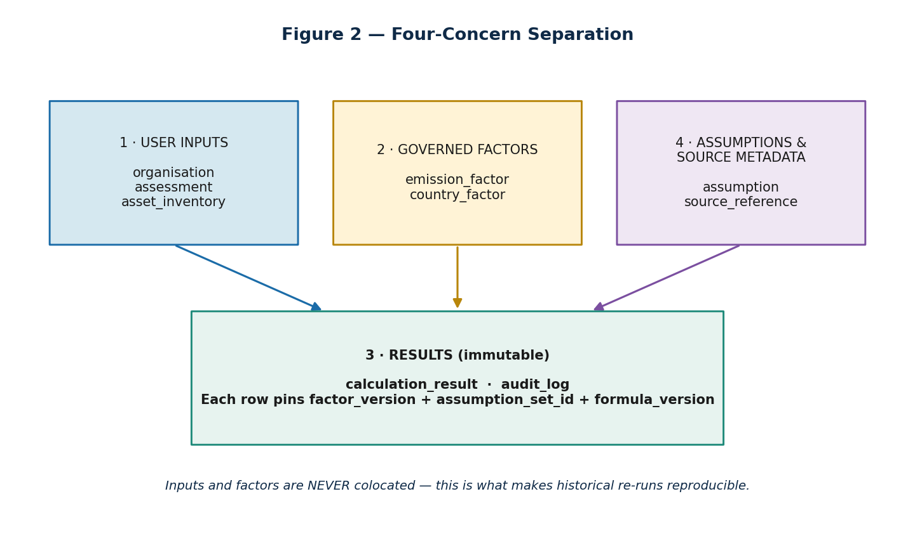
Figure 1 — Four-concern separation across the schema.

2.1 Governance Rules
- Do not hardcode factors. Factors live in country_factor / emission_factor with country, year, source, and source_version metadata.
- Governed datasets are loaded via the admin import pipeline and versioned; end users never edit them.
- Every calculation_result pins the factor_version, assumption_set_id, and formula_version it consumed, so historical assessments remain reproducible after factor refreshes.
- Determinism: the same inputs and the same pinned versions always reproduce the same outputs.
- Every factor carries an explicit unit; the engine refuses to multiply mismatched units.

3. Conceptual Data Model
At the conceptual level, an organisation owns many assessments; an assessment owns many asset-inventory rows and produces many calculation results. Asset rows and results reference governed emission factors; assessments reference an assumption set and a factor set. Source references cite the provenance of factors and results, and an append-only audit log records every change.
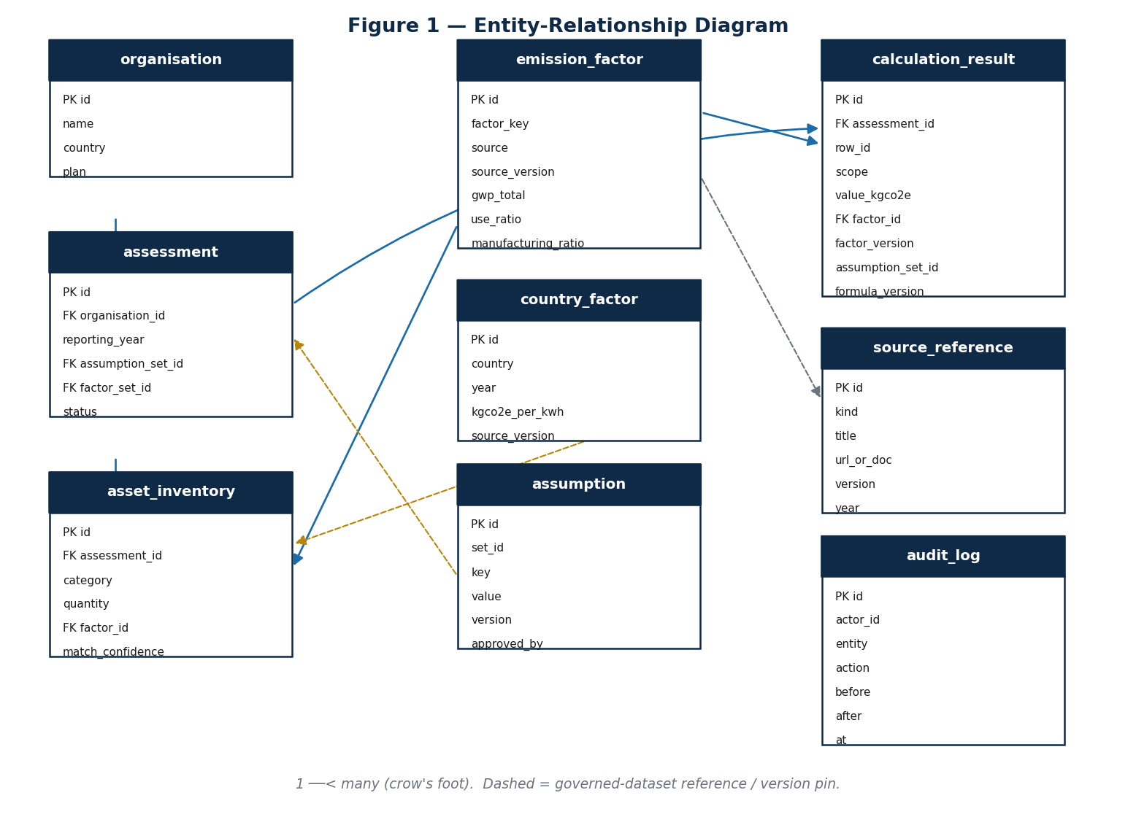
Figure 2 — Entity-relationship diagram (crow's-foot; dashed = governed-dataset reference / version pin).

4. Logical Data Model
The model is normalised to third normal form (3NF). User-input entities are mutable within a draft; governed datasets and results are immutable once published. Source metadata that varies in shape (e.g. citation attributes) is stored in JSONB columns to avoid sparse schemas while keeping structured fields strongly typed.

4.1 Entity Summary
Entity | Concern | Cardinality highlights
organisation | Input (tenant) | 1 org → many assessments
assessment | Input | Belongs to 1 org; → many inventory rows & results
asset_inventory | Input | Belongs to 1 assessment; references 1 emission_factor
emission_factor | Governed factor | Referenced by many inventory rows & results
country_factor | Governed factor | Referenced per assessment country/year
assumption | Governed metadata | Grouped by set_id; pinned per assessment
calculation_result | Result (immutable) | Belongs to 1 assessment; pins factor & assumption versions
source_reference | Metadata | Cited by factors and results
audit_log | Result (append-only) | References any entity by (entity, entity_id)

5. Physical Schema
Each entity is specified below with its column-level design and a PostgreSQL DDL definition. Column type abbreviations: PK = primary key, FK = foreign key, NN = NOT NULL, U = part of a unique constraint.

5.1 organisation
Customer tenant. The top of the ownership hierarchy; every other input row is reachable from an organisation.
Column | Type | Null | Notes
id | uuid | NN | PK
name | text | NN | Display name of the client organisation
country | char(2) | NN | ISO 3166-1 country code (default reporting geography)
plan | text | — | Commercial plan / tier

Constraints
- PRIMARY KEY (id)
- CHECK (char_length(country) = 2)

Indexes
- btree (name) for lookup

DDL
CREATE TABLE organisation (
id uuid PRIMARY KEY DEFAULT gen_random_uuid(),
name text NOT NULL,
country char(2) NOT NULL,
plan text
);

5.2 assessment
A single reporting cycle for one organisation. Holds the version pins (assumption_set_id, factor_set_id) that make the assessment reproducible.
Column | Type | Null | Notes
id | uuid | NN | PK
organisation_id | uuid | NN | FK → organisation(id)
name | text | NN | e.g. “FY2026 IT Carbon Footprint”
reporting_year | int | NN | Reporting year
country | char(2) | NN | ISO 3166-1; drives country_factor selection
employee_count | int | NN | Used for per-employee intensity
status | text | NN | draft | submitted | published
created_by | text | NN | Entra user principal
created_at | timestamptz | NN | Creation timestamp
assumption_set_id | uuid | NN | Pinned assumption set
factor_set_id | uuid | NN | Pinned factor set

Constraints
- PRIMARY KEY (id)
- FOREIGN KEY (organisation_id) REFERENCES organisation(id)
- CHECK (status IN ('draft','submitted','published'))
- CHECK (reporting_year BETWEEN 2000 AND 2100)

Indexes
- btree (organisation_id)
- btree (organisation_id, reporting_year)

DDL
CREATE TABLE assessment (
id uuid PRIMARY KEY DEFAULT gen_random_uuid(),
organisation_id uuid NOT NULL REFERENCES organisation(id),
name text NOT NULL,
reporting_year int NOT NULL CHECK (reporting_year BETWEEN 2000 AND 2100),
country char(2) NOT NULL,
employee_count int NOT NULL CHECK (employee_count >= 0),
status text NOT NULL DEFAULT 'draft'
CHECK (status IN ('draft','submitted','published')),
created_by text NOT NULL,
created_at timestamptz NOT NULL DEFAULT now(),
assumption_set_id uuid NOT NULL,
factor_set_id uuid NOT NULL
);
CREATE INDEX ix_assessment_org_year ON assessment (organisation_id, reporting_year);

5.3 asset_inventory
User-entered IT estate rows. Each row is matched to an emission factor server-side on write, and stores the resulting match confidence.
Column | Type | Null | Notes
id | uuid | NN | PK
assessment_id | uuid | NN | FK → assessment(id)
category | text | NN | laptop | desktop | monitor | phone | tablet | printer | server
model_name | text | — | As entered by the user (free text)
quantity | int | NN | Number of units
lifespan_years | int | — | Overrides factor default_lifetime if set
reconditioning_rate | numeric | NN | 0..1 share of refurbished fleet
factor_id | uuid | — | FK → emission_factor(id) (matched)
match_confidence | text | NN | exact | high | estimated | manual
notes | text | — | Free-text annotation

Constraints
- PRIMARY KEY (id)
- FOREIGN KEY (assessment_id) REFERENCES assessment(id) ON DELETE CASCADE
- FOREIGN KEY (factor_id) REFERENCES emission_factor(id)
- CHECK (quantity >= 0)
- CHECK (reconditioning_rate BETWEEN 0 AND 1)
- CHECK (match_confidence IN ('exact','high','estimated','manual'))

Indexes
- btree (assessment_id)
- btree (factor_id)

DDL
CREATE TABLE asset_inventory (
id uuid PRIMARY KEY DEFAULT gen_random_uuid(),
assessment_id uuid NOT NULL REFERENCES assessment(id) ON DELETE CASCADE,
category text NOT NULL,
model_name text,
quantity int NOT NULL CHECK (quantity >= 0),
lifespan_years int CHECK (lifespan_years > 0),
reconditioning_rate numeric NOT NULL DEFAULT 0
CHECK (reconditioning_rate BETWEEN 0 AND 1),
factor_id uuid REFERENCES emission_factor(id),
match_confidence text NOT NULL
CHECK (match_confidence IN ('exact','high','estimated','manual')),
notes text
);
CREATE INDEX ix_inventory_assessment ON asset_inventory (assessment_id);

5.4 emission_factor
Versioned factor catalogue for device-level emissions. A governed dataset: loaded via the admin pipeline, never edited by end users.
Column | Type | Null | Notes
id | uuid | NN | PK
factor_key | text | NN | Stable key, e.g. boavizta:laptop:dell-latitude-5420
source | text | NN | Boavizta | ADEME | UK Gov | provider
source_version | text | NN | Dataset release, e.g. Boavizta 2024-Q4
year | int | NN | Reporting year the factor is valid for
geography | char(2) | — | ISO 3166-1 region code
unit | text | NN | Explicit unit string (allow-list)
lifecycle_boundary | text | NN | cradle-to-gate | cradle-to-grave | use-phase
gwp_total | numeric | NN | kgCO₂e per unit (cradle-to-grave)
use_ratio | numeric | NN | In-use share (0..1)
manufacturing_ratio | numeric | NN | Embodied share (0..1)
default_lifetime | int | NN | Default lifespan in years
error_ratio | numeric | — | Relative error for the result margin
last_updated_at | timestamptz | NN | Ingestion timestamp

Constraints
- PRIMARY KEY (id)
- UNIQUE (source, source_version, factor_key)
- CHECK (use_ratio + manufacturing_ratio BETWEEN 0.999 AND 1.001)
- CHECK (gwp_total >= 0)
- CHECK (unit IN ('kgCO2e/kWh','kgCO2e/device','kgCO2e/year','tCO2e/year'))

Indexes
- unique (source, source_version, factor_key)
- btree (factor_key)
- btree (source, year)

DDL
CREATE TABLE emission_factor (
id uuid PRIMARY KEY DEFAULT gen_random_uuid(),
factor_key text NOT NULL,
source text NOT NULL,
source_version text NOT NULL,
year int NOT NULL,
geography char(2),
unit text NOT NULL
CHECK (unit IN ('kgCO2e/kWh','kgCO2e/device',
'kgCO2e/year','tCO2e/year')),
lifecycle_boundary text NOT NULL,
gwp_total numeric NOT NULL CHECK (gwp_total >= 0),
use_ratio numeric NOT NULL,
manufacturing_ratio numeric NOT NULL,
default_lifetime int NOT NULL CHECK (default_lifetime > 0),
error_ratio numeric,
last_updated_at timestamptz NOT NULL DEFAULT now(),
CONSTRAINT uq_factor UNIQUE (source, source_version, factor_key),
CONSTRAINT ck_ratio_sum CHECK (use_ratio + manufacturing_ratio
BETWEEN 0.999 AND 1.001)
);
CREATE INDEX ix_factor_key ON emission_factor (factor_key);
CREATE INDEX ix_factor_src_yr ON emission_factor (source, year);

5.5 country_factor
Grid electricity emission factor by country and year. Year-pinned so that annual source updates do not retroactively change historical results.
Column | Type | Null | Notes
id | uuid | NN | PK
country | char(2) | NN | ISO 3166-1 country code
year | int | NN | Reporting year
kgco2e_per_kwh | numeric | NN | Grid factor (kgCO₂e/kWh)
source | text | NN | e.g. UK Gov, ADEME
source_version | text | NN | Dataset release identifier

Constraints
- PRIMARY KEY (id)
- UNIQUE (country, year, source_version)
- CHECK (kgco2e_per_kwh >= 0)

Indexes
- unique (country, year, source_version)
- btree (country, year)

DDL
CREATE TABLE country_factor (
id uuid PRIMARY KEY DEFAULT gen_random_uuid(),
country char(2) NOT NULL,
year int NOT NULL,
kgco2e_per_kwh numeric NOT NULL CHECK (kgco2e_per_kwh >= 0),
source text NOT NULL,
source_version text NOT NULL,
CONSTRAINT uq_country_factor UNIQUE (country, year, source_version)
);
CREATE INDEX ix_country_factor ON country_factor (country, year);

5.6 assumption
Versioned methodology constants grouped into immutable sets. A change to any assumption is a governed methodology change requiring approval.
Column | Type | Null | Notes
id | uuid | NN | PK
set_id | uuid | NN | Groups assumptions into a versioned set
key | text | NN | e.g. reconditioning_benefit_factor, cloud_scope_classification
value | text | NN | Stored as text; typed on read
source | text | — | Provenance of the assumption
version | text | NN | Set version, e.g. assumption_set_2026_v1.0
approved_by | text | — | Approver (methodology lead)

Constraints
- PRIMARY KEY (id)
- UNIQUE (set_id, key)

Indexes
- unique (set_id, key)
- btree (set_id)

DDL
CREATE TABLE assumption (
id uuid PRIMARY KEY DEFAULT gen_random_uuid(),
set_id uuid NOT NULL,
key text NOT NULL,
value text NOT NULL,
source text,
version text NOT NULL,
approved_by text,
CONSTRAINT uq_assumption UNIQUE (set_id, key)
);
CREATE INDEX ix_assumption_set ON assumption (set_id);

5.7 calculation_result
Engine output — immutable. Each row pins the factor version, assumption set, and formula version it consumed, which is the foundation of reproducibility.
Column | Type | Null | Notes
id | uuid | NN | PK
assessment_id | uuid | NN | FK → assessment(id)
row_id | uuid | — | Originating asset_inventory row (nullable for data-centre/cloud)
scope | text | NN | scope2 | scope3
category | text | NN | Device category, data_centre, or cloud
value_kgco2e | numeric | NN | Computed emissions
factor_id | uuid | — | FK → emission_factor(id)
factor_version | text | NN | Pinned factor source_version
assumption_set_id | uuid | NN | Pinned assumption set
formula_version | text | NN | e.g. device_v1
calculated_at | timestamptz | NN | When the engine produced the row

Constraints
- PRIMARY KEY (id)
- FOREIGN KEY (assessment_id) REFERENCES assessment(id) ON DELETE CASCADE
- FOREIGN KEY (factor_id) REFERENCES emission_factor(id)
- CHECK (scope IN ('scope2','scope3'))
- CHECK (value_kgco2e >= 0)

Indexes
- btree (assessment_id)
- btree (assessment_id, scope)
- btree (factor_id)

DDL
CREATE TABLE calculation_result (
id uuid PRIMARY KEY DEFAULT gen_random_uuid(),
assessment_id uuid NOT NULL REFERENCES assessment(id) ON DELETE CASCADE,
row_id uuid,
scope text NOT NULL CHECK (scope IN ('scope2','scope3')),
category text NOT NULL,
value_kgco2e numeric NOT NULL CHECK (value_kgco2e >= 0),
factor_id uuid REFERENCES emission_factor(id),
factor_version text NOT NULL,
assumption_set_id uuid NOT NULL,
formula_version text NOT NULL,
calculated_at timestamptz NOT NULL DEFAULT now()
);
CREATE INDEX ix_result_assessment ON calculation_result (assessment_id, scope);

5.8 source_reference
Citation rows linked from results and factors. Provides the provenance that the report appendix lists for every number.
Column | Type | Null | Notes
id | uuid | NN | PK
kind | text | NN | dataset | report | methodology | manual
title | text | NN | Human-readable citation title
url_or_doc | text | — | URL or document reference
version | text | — | Source version
geography | char(2) | — | ISO 3166-1 where applicable
year | int | — | Source year

Constraints
- PRIMARY KEY (id)

Indexes
- btree (kind)

DDL
CREATE TABLE source_reference (
id uuid PRIMARY KEY DEFAULT gen_random_uuid(),
kind text NOT NULL,
title text NOT NULL,
url_or_doc text,
version text,
geography char(2),
year int
);

5.9 audit_log
Append-only event log. Captures who changed what and when, with before/after JSONB snapshots, enabling the report's audit appendix and reviewer sign-off.
Column | Type | Null | Notes
id | uuid | NN | PK
actor_id | text | NN | Entra user principal
entity | text | NN | Affected table name
entity_id | uuid | NN | Affected row id
action | text | NN | create | update | publish | import
before | jsonb | — | Prior state snapshot
after | jsonb | — | New state snapshot
at | timestamptz | NN | Event timestamp

Constraints
- PRIMARY KEY (id)
- Append-only: no UPDATE or DELETE granted to the application role

Indexes
- btree (entity, entity_id)
- btree (at)

DDL
CREATE TABLE audit_log (
id uuid PRIMARY KEY DEFAULT gen_random_uuid(),
actor_id text NOT NULL,
entity text NOT NULL,
entity_id uuid NOT NULL,
action text NOT NULL,
before jsonb,
after jsonb,
at timestamptz NOT NULL DEFAULT now()
);
CREATE INDEX ix_audit_entity ON audit_log (entity, entity_id);
CREATE INDEX ix_audit_at ON audit_log (at);

6. Data Dictionary (selected fields)
The following consolidated reference defines the units and meaning of the most important measurement fields. The unit allow-list is enforced on factor import.
Field | Unit | Meaning
gwp_total | kgCO₂e/device | Cradle-to-grave global warming potential per device
use_ratio | ratio (0..1) | Share of lifecycle emissions attributable to in-use electricity
manufacturing_ratio | ratio (0..1) | Share attributable to embodied manufacturing
kgco2e_per_kwh | kgCO₂e/kWh | Grid electricity emission factor for a country/year
reconditioning_rate | ratio (0..1) | Share of fleet that is refurbished
value_kgco2e | kgCO₂e | Computed emissions for a result row
error_ratio | ratio | Relative error used to derive a result margin

Unit allow-list
- kgCO₂e/kWh
- kgCO₂e/device
- kgCO₂e/year
- tCO₂e/year

7. Relationships & Referential Integrity
Child | Parent | FK column | On delete
assessment | organisation | organisation_id | RESTRICT
asset_inventory | assessment | assessment_id | CASCADE
asset_inventory | emission_factor | factor_id | RESTRICT
calculation_result | assessment | assessment_id | CASCADE
calculation_result | emission_factor | factor_id | RESTRICT

7.1 Version-Pinning Relationships
In addition to physical foreign keys, three logical pins guarantee reproducibility: assessment.factor_set_id and assessment.assumption_set_id capture the governed datasets in force, while calculation_result.factor_version, assumption_set_id, and formula_version record exactly what each result consumed. Governed-dataset rows are never deleted, so these pins always resolve.

8. Indexing & Query Performance

8.1 Factor Lookup
Factor matching walks a five-level confidence hierarchy. Indexes support exact and fuzzy lookups without full scans.
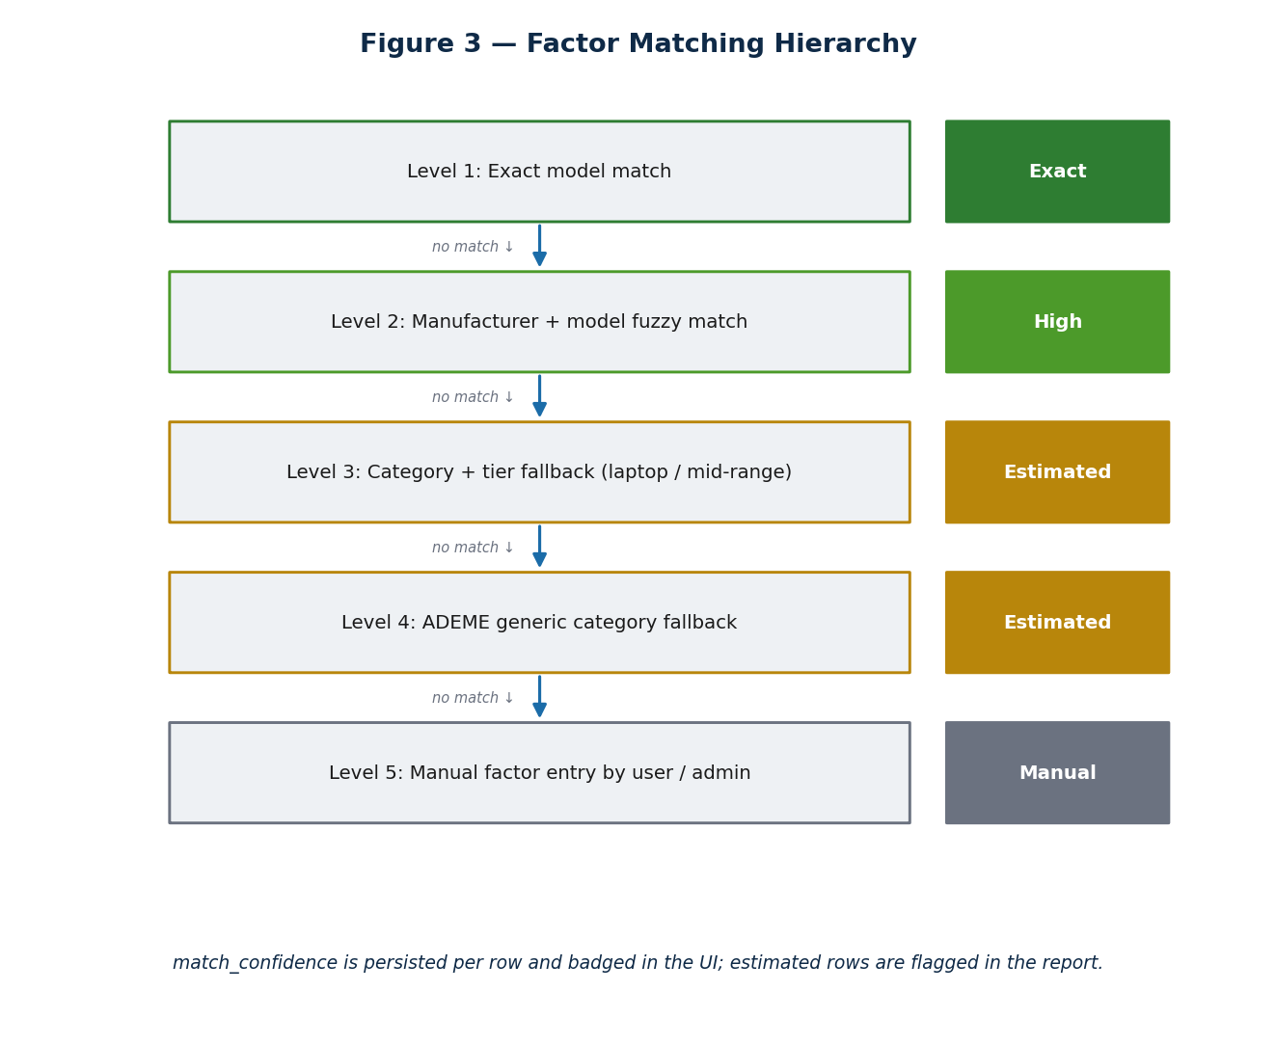
Figure 3 — Factor matching hierarchy and the resulting stored confidence.
Query | Supporting index
Exact model match | ix_factor_key on emission_factor(factor_key)
Source/year browse & filter | ix_factor_src_yr on emission_factor(source, year)
Country grid factor | ix_country_factor on country_factor(country, year)
Results by assessment & scope | ix_result_assessment on calculation_result(assessment_id, scope)
Inventory by assessment | ix_inventory_assessment on asset_inventory(assessment_id)
Audit by entity / time | ix_audit_entity, ix_audit_at on audit_log

8.2 Idempotency Index
The /calculate operation is idempotent on (assessment_id, factor_set_id, assumption_set_id, inputs_hash). An application-maintained inputs_hash (and an optional unique index over the tuple) lets the engine detect that an identical run already exists and return the persisted result rather than recompute.

9. Factor Governance & Versioning
Governed datasets are immutable once published. The admin import pipeline is the only path that writes them.
- Upload a signed CSV/JSON file to Azure Blob.
- Validate: no missing factor names; no duplicate IDs across (source, source_version, factor_key); all units in the allow-list; use_ratio + manufacturing_ratio = 1.0 (± 0.001); no negative factors unless explicitly allowlisted.
- Render a diff versus the existing factor set before commit.
- On commit, publish a new immutable factor_set_id; existing assessments remain pinned to their original set.
Because historical assessments pin their factor set, refreshing factors (e.g. an annual UK Gov update) never regresses previously published results.

10. Audit Trail & Traceability
Every result row must answer the five north-star questions. The schema maps each question to concrete columns, and the append-only audit log records the sixth (when and who).
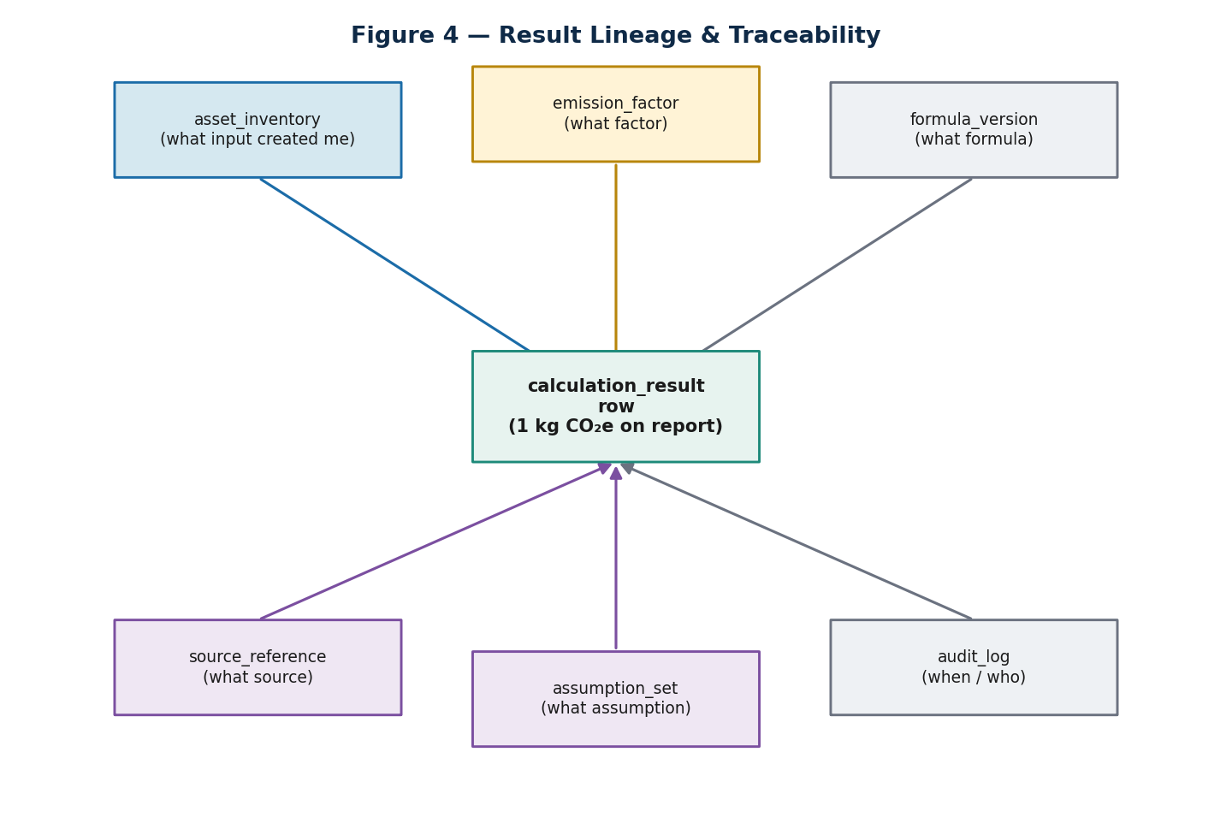
Figure 4 — Result lineage: a single calculation_result row resolves to its full provenance.
Question | Resolved by
What input created me? | calculation_result.row_id → asset_inventory
What factor was used? | calculation_result.factor_id + factor_version → emission_factor
What formula was used? | calculation_result.formula_version
What source did it come from? | emission_factor → source_reference
What assumptions applied? | calculation_result.assumption_set_id → assumption
When / who? | audit_log (actor_id, action, before, after, at)

10.1 Worked Traceability Example
Laptop emissions calculated using:
Model : Dell Latitude 5420
Quantity : 150
Factor source : Boavizta 2024-Q4
gwp_total : 364 kgCO2e/device
Use ratio : 12.2%
Manufacturing : 84.8%
Lifespan : 4 years
Country factor : UK electricity (UK Gov 2025) 0.209 kgCO2e/kWh
Formula version : device_v1
Assumption set : assumption_set_2026_v1.0 (reconditioning_benefit = 0.30)
Calculated at : 2026-05-20T10:14:23Z by user=temi.makinde@...

11. Data Integrity & Constraints
Constraint | Enforced on | Rule
Ratio sum | emission_factor | use_ratio + manufacturing_ratio ∈ [0.999, 1.001]
Non-negative factor | emission_factor, country_factor | gwp_total ≥ 0; kgco2e_per_kwh ≥ 0
Unit allow-list | emission_factor | unit ∈ {kgCO₂e/kWh, kgCO₂e/device, kgCO₂e/year, tCO₂e/year}
Status enum | assessment | status ∈ {draft, submitted, published}
Scope enum | calculation_result | scope ∈ {scope2, scope3}
Match confidence enum | asset_inventory | ∈ {exact, high, estimated, manual}
Reconditioning bounds | asset_inventory | reconditioning_rate ∈ [0, 1]

12. Migration & Versioning Strategy
- Schema changes are managed exclusively through Alembic migrations; no manual DDL in production.
- Each migration is reviewed and applied in CI before deployment; downgrade paths are provided where feasible.
- Governed datasets are seeded and updated only through the admin import pipeline, which publishes new immutable factor sets.
- A factor-set refresh creates new rows and a new factor_set_id; it never mutates rows referenced by published assessments.
- Golden-case input sets are re-run on every formula or factor change; the diff is approved before a new set is published.

13. Security, Retention & Backup
Concern | Approach
Tenant isolation | All input data is reachable only via organisation_id; queries are scoped to the caller's tenant.
Identity | actor_id maps to a Microsoft Entra principal; RBAC governs admin import and publish.
PII surface | Limited to user principals (created_by, actor_id); no client personal data stored in the MVP.
Immutability | calculation_result and audit_log are write-once; the application role lacks UPDATE/DELETE on audit_log.
Retention | Published reports and audit logs retained for the assurance period; drafts prunable per policy.
Backup | Azure Database for PostgreSQL automated backups with point-in-time restore; Blob artefacts versioned.

14. Appendix

14.1 Golden-Case Sample
Reference cases derived from the KPMG Excel workbook anchor regression testing. The engine output must match byte-for-byte.
Data centre electricity = 361 kWh
France factor = 0.055 kgCO2e/kWh
Expected result = 19.855 kgCO2e/year

14.2 Consolidated DDL (order of creation)
Tables are created in dependency order: organisation → emission_factor / country_factor / source_reference / assumption → assessment → asset_inventory → calculation_result → audit_log. Full per-table DDL is given in Section 5.
-- creation order (definitions in §5)
CREATE TABLE organisation ( ... );
CREATE TABLE emission_factor ( ... );
CREATE TABLE country_factor ( ... );
CREATE TABLE source_reference ( ... );
CREATE TABLE assumption ( ... );
CREATE TABLE assessment ( ... ); -- FK organisation
CREATE TABLE asset_inventory ( ... ); -- FK assessment, emission_factor
CREATE TABLE calculation_result ( ... ); -- FK assessment, emission_factor
CREATE TABLE audit_log ( ... );

