KPMG GreenPath
IT Sustainability Practice
Carbon Footprint Calculator
System Analysis Document
System Analysis Document (SAD)
Draft v1.0 — for engineering and methodology review
2026-05-20
Classification: Confidential — for engineering and methodology review

Document Control
Field | Detail
Document title | Carbon Footprint Calculator — System Analysis Document
Programme | KPMG GreenPath — IT Carbon Assessment
Document type | System Analysis Document (SAD)
Version | 1.0 (Draft)
Date | 2026-05-20
Status | For engineering and methodology review
Author | Architecture team
Source baseline | Carbon Footprint Calculator Software Design Document (SDD), v1.0
Classification | Confidential

Revision History
Version | Date | Author | Summary of change
0.1 | 2026-05-12 | Architecture team | Initial skeleton derived from build guide
0.9 | 2026-05-18 | Architecture team | Requirements, NFRs and risk analysis added
1.0 | 2026-05-20 | Architecture team | First reviewable draft synthesised from the SDD

Distribution & Approval
Role | Name | Responsibility
Engineering lead | — | Owns technical delivery and architecture
Methodology lead | — | Owns factor governance and calculation correctness
Assurance reviewer | — | Independent reproducibility sign-off
Product owner | — | Owns scope, roadmap and acceptance

Table of Contents

1. Introduction

1.1 Purpose
This System Analysis Document defines what the Carbon Footprint Calculator must do and why. It captures the business need, stakeholders, functional and non-functional requirements, use cases, architecture analysis, interfaces, constraints, and risks. It is the analysis counterpart to the Database Design Document, which specifies how the data is structured and governed.
The calculator replaces the existing KPMG GreenPath IT carbon footprint Excel workbook with a governed, auditable calculation product. It is deliberately not a spreadsheet wrapper: it is a calculation engine with first-class source data, versioned assumptions, a row-level audit trail, and an explainable report.

1.2 North Star
A user of the report must be able to point at any kilogram of CO₂e on the page and trace it, in one click, back to the user input, the emission factor, the factor source and version, the formula version, and the assumption set that produced it. Every analysis decision in this document serves that single objective.

1.3 Scope

In scope (MVP)
- IT asset inventory: laptops, desktops, monitors, phones, tablets, printers, servers.
- Data-centre electricity consumption (annual kWh) with country grid factors.
- Cloud provider-reported emissions (AWS, Azure, GCP) treated as Scope 3.
- Scope 2 and Scope 3 reporting, per-employee intensity, and category breakdown.
- Source traceability, factor governance, Excel/PDF export, and an append-only audit trail.

Out of scope (MVP)
- Full enterprise Scope 1/2/3 carbon accounting.
- Supplier portals and supplier-side primary data collection.
- Automated AWS/Azure/GCP API integrations and real-time grid intensity.
- Multi-step approval workflows and AI-driven reduction recommendations.

1.4 Intended Audience
- Engineering team — implementing the frontend, backend engine, and data layer.
- Methodology and assurance reviewers — validating calculation correctness and reproducibility.
- Product owner — managing scope, roadmap, and acceptance.
- Platform/operations — provisioning and operating the Azure environment.

1.5 Definitions & Glossary
Term | Definition
Carbon footprint | Greenhouse-gas emissions from an activity, expressed as kgCO₂e or tCO₂e (1 tCO₂e = 1,000 kgCO₂e).
CO₂e (equivalent) | Common measure converting different greenhouse gases into a CO₂-equivalent value.
Activity data | Quantitative measure of an activity, e.g. 100 laptops, 50,000 kWh, 100 cloud VM hours.
Emission factor | kgCO₂e per unit of activity, e.g. 0.209 kgCO₂e/kWh for UK grid electricity.
Scope 1 | Direct emissions from owned/controlled sources (vehicles, boilers, on-site fuel).
Scope 2 | Indirect emissions from purchased electricity, heat, steam, cooling.
Scope 3 | Indirect value-chain emissions (manufacturing, cloud, transport, purchased goods).
gwp_total | Cradle-to-grave global warming potential of a device, in kgCO₂e per unit.
use / manufacturing ratio | Split of a device's lifecycle emissions between in-use electricity and embodied manufacturing.
Country factor | Grid electricity emission factor (kgCO₂e/kWh) for a given country and reporting year.

1.6 References
- GHG Protocol — Corporate Standard (Scope 1/2/3 definitions and accounting concepts).
- Boavizta — ICT/digital environmental impact data and API (primary device-level factors).
- ADEME / Base Empreinte — public emission factor database (generic category fallback).
- UK Government greenhouse gas conversion factors (annual UK electricity, fuels, transport).
- Cloud provider sustainability reports — AWS, Microsoft, Google customer carbon tooling.
- KPMG GreenPath IT Carbon Footprint Calculator workbook (golden test cases and formulas).

2. System Overview & Context
A credible carbon calculator is fundamentally a math engine plus governed source data plus traceable results. The UI is the least interesting component. Every number the system produces must answer five questions: what input created me, what factor did I use, what formula did I use, what source did I come from, and what assumption changed me?
The product is positioned as a planning tool, not a science tool. A KPMG consultant should be able to complete an assessment for a single reporting year and produce a defensible PDF/Excel report — covering devices, data-centre electricity, and cloud emissions, with full factor traceability — in under an hour, without needing to understand carbon accounting internals.

2.1 System Context
The calculator sits between the people who run assessments and the governed datasets that make those assessments defensible. Consultants and admins provide inputs; reviewers and clients consume traceable outputs; external datasets and the Azure platform supply factors, identity, storage, and telemetry.
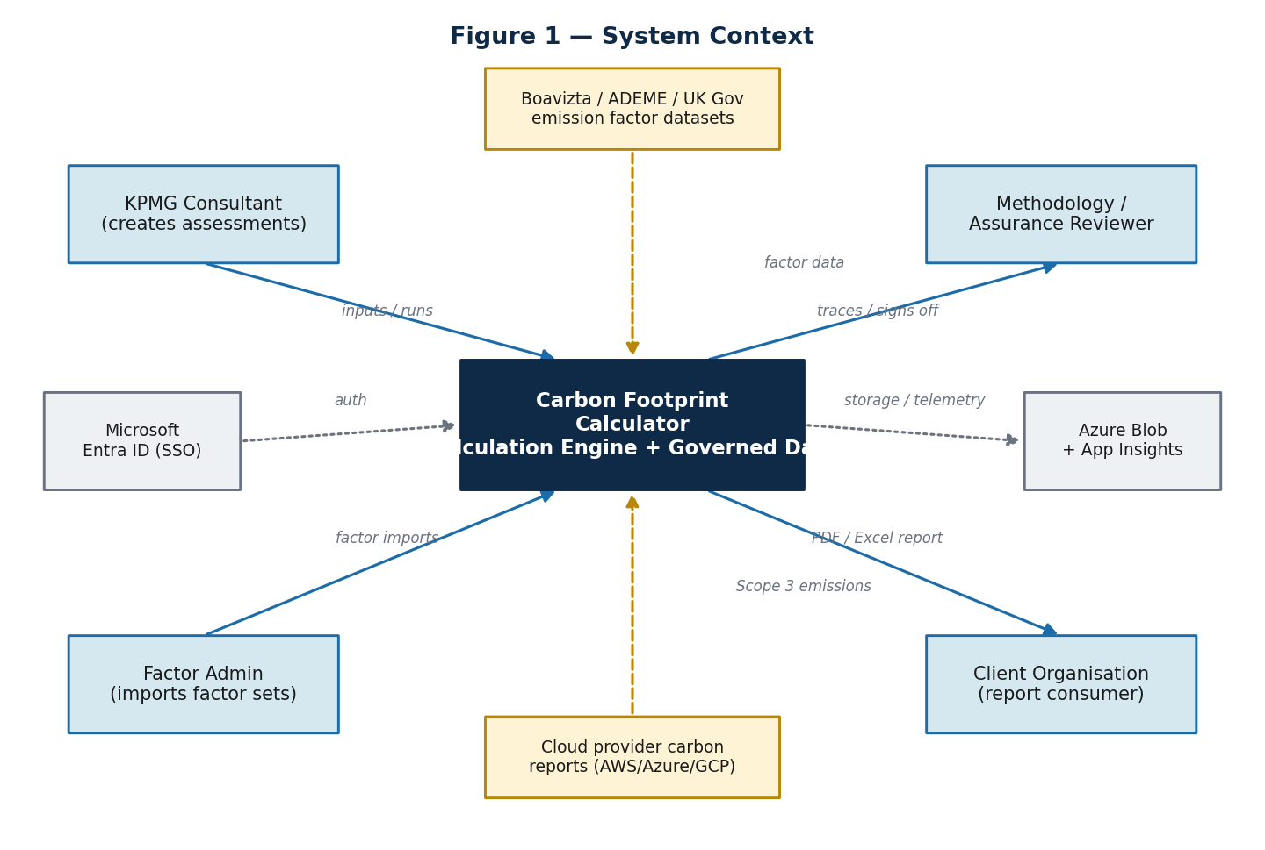
Figure 1 — System context: actors, external data sources, and platform services.

2.2 Guiding Insight
For IT estates, Scope 3 (device manufacturing) typically dominates Scope 2 (electricity in use) — often by an order of magnitude. This is why lifecycle extension, refurbishment, and procurement choices are the largest reduction levers, and why the system must store both the use and manufacturing ratios explicitly and expose assumption levers in the report.

3. Stakeholder Analysis
The system serves five primary stakeholder groups. Their differing needs drive the functional and non-functional requirements that follow.
Stakeholder | Primary need | Key concern
KPMG consultant | Complete an assessment quickly and produce a defensible report | Speed, clarity, confidence in numbers
Client organisation | Understand its IT carbon footprint and reduction levers | Trust, readability, actionable drivers
Methodology / assurance reviewer | Reproduce any line item independently | Determinism, traceability, versioning
Factor admin | Govern and version emission-factor datasets | Validation, immutability, auditability
Platform / operations | Operate the service reliably and securely | Identity, observability, cost, resilience

4. Functional Requirements
Functional requirements are organised by backend module. Each requirement has a stable identifier (FR-x). The calculation engine is the heart of the system and is specified in additional detail.

4.1 Authentication & Tenancy
ID | Requirement
FR-1 | Authenticate users via Microsoft Entra ID (OAuth2/OIDC) with SSO.
FR-2 | Enforce role-based access control and inject a dependency-validated user context per request.
FR-3 | Scope all data access to the user's organisation (tenant).

4.2 Organisations & Assessments
ID | Requirement
FR-4 | Create and manage organisations and their membership.
FR-5 | Create an assessment for one organisation and reporting year (name, country, employee count).
FR-6 | Manage assessment lifecycle: draft → submitted → published.
FR-7 | Pin each assessment to an immutable factor set and assumption set at calculation time.

4.3 Asset Inventory & Factor Matching
ID | Requirement
FR-8 | Capture IT asset rows: category, model, quantity, lifespan, reconditioning rate, notes.
FR-9 | Match each row to an emission factor server-side on write using a confidence-aware hierarchy.
FR-10 | Persist and display the match confidence (exact / high / estimated / manual) on every row.
FR-11 | Show a row-level calculated footprint and a calculation-details drawer per row.

Factor matching hierarchy
Level | Strategy | Stored confidence
1 | Exact model match | Exact
2 | Manufacturer + model fuzzy match | High
3 | Category + tier fallback (e.g. laptop / mid-range) | Estimated
4 | ADEME generic category fallback | Estimated
5 | Manual factor entry by user/admin | Manual

4.4 Calculation Engine
ID | Requirement
FR-12 | Run the engine server-side; the frontend never computes footprints.
FR-13 | Compute per-device use (Scope 2) and manufacturing (Scope 3) emissions, data-centre electricity, and cloud emissions.
FR-14 | Refuse to multiply mismatched units; every factor carries an explicit unit.
FR-15 | Persist each result with the factor version, assumption set, and formula version used.
FR-16 | Be idempotent: hash(inputs + factor_set + assumption_set) ⇒ stable output.

Core formula family
Annual footprint = annual_use_emissions + annual_manufacturing_emissions

Scope 2 / Use = quantity * gwp_total * use_ratio
* country_factor / lifespan
Scope 3 / Manufacturing = quantity * gwp_total * manufacturing_ratio
* (1 - reconditioning_rate
* reconditioning_benefit_factor)
/ lifespan
Data centre = annual_kWh * country_electricity_factor
Cloud = sum(provider_reported_kgCO2e)
Total = sum(device totals) + data_centre + cloud

Worked example — single device line
Ten laptops, gwp_total = 300 kgCO₂e/device, use_ratio = 0.20, manufacturing_ratio = 0.80, UK country factor = 0.209 kgCO₂e/kWh, lifespan = 4 years, reconditioning_rate = 0:
Use = 10 * 300 * 0.20 * 0.209 / 4 = 31.35 kgCO2e/year
Manufacturing = 10 * 300 * 0.80 * 1 / 4 = 600.00 kgCO2e/year
Total = 631.35 kgCO2e/year
Manufacturing dominates by roughly 19×. For IT footprints, procurement, lifespan extension, and refurbishment are the biggest reduction levers — which is exactly what the assumption levers must expose in the report.

4.5 Reporting & Export
ID | Requirement
FR-17 | Generate a PDF report (ReportLab) and an Excel report (openpyxl), stored in Azure Blob.
FR-18 | Include executive summary, totals, scope split, category breakdown, top drivers, and per-employee intensity.
FR-19 | Include methodology, assumptions, source data, limitations, and a full row-level audit appendix.

4.6 Audit & Admin
ID | Requirement
FR-20 | Write an append-only audit log capturing actor, entity, action, and before/after state.
FR-21 | Provide an admin-only factor import pipeline (CSV/JSON) with validation and a pre-commit diff.
FR-22 | Publish each accepted import as a new immutable factor set; existing assessments stay pinned.

5. Use Cases & User Journey

5.1 Recommended Eight-Step Journey
Step | Screen | User action
1 | Create assessment | Name the assessment (e.g. “FY2026 IT Carbon Footprint”)
2 | General inputs | Pick country and reporting year
3 | General inputs | Enter number of employees (per-employee metric)
4 | Asset inventory | Add IT assets (laptops, desktops, monitors, phones, tablets, printers, servers)
5 | Electricity / data centre | Enter annual kWh consumed by the data centre / IT load
6 | Cloud emissions | Paste provider-reported kgCO₂e (AWS, Azure, GCP)
7 | Results dashboard | Review total, scope split, top drivers, per-employee
8 | Export report | Generate PDF / Excel with full traceability appendix
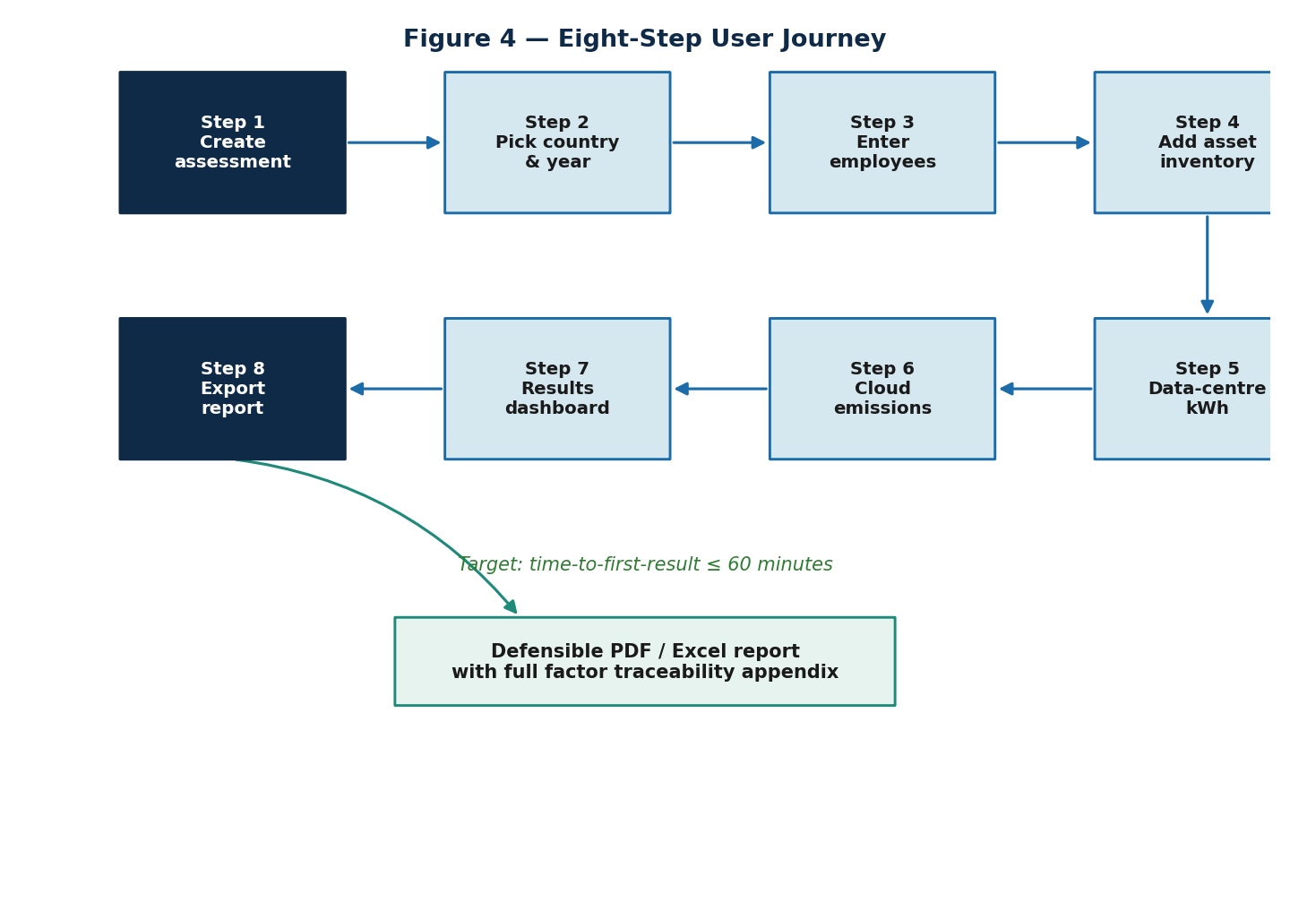
Figure 2 — The eight-step assessment journey; target time-to-first-result ≤ 60 minutes.

5.2 Use Case: Run an Assessment
Field | Detail
Actor | KPMG consultant
Pre-conditions | Authenticated; organisation exists; a published factor set and assumption set are available
Trigger | Consultant creates an assessment and enters inventory, electricity, and cloud data
Main flow | 1) Create assessment → 2) enter general inputs → 3) add inventory (server matches factors) → 4) enter kWh → 5) paste cloud emissions → 6) run /calculate → 7) review dashboard
Post-conditions | calculation_result rows persisted with pinned versions; audit_log written
Alternate flows | Estimated/manual factor matches flagged; draft can be re-run idempotently

5.3 Use Case: Import a Factor Set
Field | Detail
Actor | Factor admin
Pre-conditions | Admin role; signed CSV/JSON factor file prepared
Main flow | 1) Upload file to Blob → 2) pipeline validates → 3) diff vs. existing set rendered → 4) admin commits → 5) new immutable factor set published
Post-conditions | New factor_set_id available; historical assessments remain pinned to prior versions
Exceptions | Validation failure (missing names, duplicate IDs, bad units, ratios ≠ 1.0) blocks commit

5.4 Use Case: Export a Traceable Report
Field | Detail
Actor | Consultant / reviewer
Pre-conditions | An assessment has calculation results
Main flow | 1) Request export → 2) backend renders PDF/Excel → 3) artefact stored in Blob → 4) signed URL returned
Post-conditions | Report includes methodology, assumptions, source data, limitations, and audit appendix

6. Non-Functional Requirements
ID | Category | Requirement & target
NFR-1 | Determinism | Same inputs + factor versions + assumption versions ⇒ byte-identical outputs (regression-testable).
NFR-2 | Traceability | 100% of result rows link to a source_reference and pinned factor/assumption/formula versions.
NFR-3 | Performance | Time-to-first-result ≤ 60 minutes for a new client; engine runs in-request (fast).
NFR-4 | Reproducibility | An external reviewer can independently reproduce any line item.
NFR-5 | Security | Entra ID SSO, RBAC, conditional access; tenant-isolated data.
NFR-6 | Auditability | Append-only audit log with before/after; drafts vs. published; reviewer sign-off to publish.
NFR-7 | Observability | App Insights + OpenTelemetry traces show which factor_version each calculation used.
NFR-8 | Portability | SPA served as static assets via Blob + CDN; report rendered server-side.
NFR-9 | Maintainability | Engine is pure, fully unit-tested Python; factors are data, never code.
NFR-10 | Data quality | Match confidence persisted per row; estimated rows flagged in the report limitations.

7. System Architecture Analysis

7.1 Technology Choices
Layer | Choice | Rationale
Frontend | React 18 + Vite + TypeScript | SPA served as static assets from Azure Blob + CDN; no SSR needed because the report is rendered server-side as PDF/Excel.
Backend | Python 3.12 + FastAPI + Pydantic v2 | Pydantic enforces unit/source/factor metadata at the type level; FastAPI emits OpenAPI; pandas/pyarrow for imports and golden diffs.
Database | PostgreSQL 16 (Azure) | JSONB for source metadata; deterministic SQL factor lookups; strong constraints; SQLAlchemy 2.x + Alembic.
Object storage | Azure Blob Storage | Generated PDF/Excel reports, factor import files, evidence attachments.
Identity | Microsoft Entra ID | Aligns with KPMG tenanting; SSO, RBAC, conditional access out of the box.
Queue (optional) | Azure Service Bus | Async report generation; the engine itself runs in-request.
Observability | App Insights + OpenTelemetry | Distributed traces show which factor_version each calculation used.

7.2 Key Decision
FastAPI is chosen over NestJS for the backend. The hard problems are factor governance, unit-safe schemas, and golden-case validation against the existing Excel workbook — all of which the Python ecosystem (Pydantic v2, pandas, pyarrow, openpyxl) handles directly. The frontend is plain React + Vite rather than Next.js because the report is rendered server-side as PDF/Excel, so there is nothing for SSR to do.

7.3 Backend Modules
Module | Responsibility
app.auth | Entra ID OAuth via Authlib/MSAL, JWT validation, injected user context
app.organisations | Tenant CRUD and membership
app.assessments | Assessment lifecycle (draft → submitted → published)
app.inventory | Asset inventory CRUD; factor match on write
app.factors | Read-only factor catalogue and country grid factors
app.calculations | The deterministic engine; pure Python, fully unit-tested
app.reports | PDF (ReportLab) / Excel (openpyxl) rendering; export to Blob
app.audit | Append-only event log writer/reader
app.admin | Factor imports (pandas), assumption versioning, methodology locking

7.4 Architecture & Deployment View
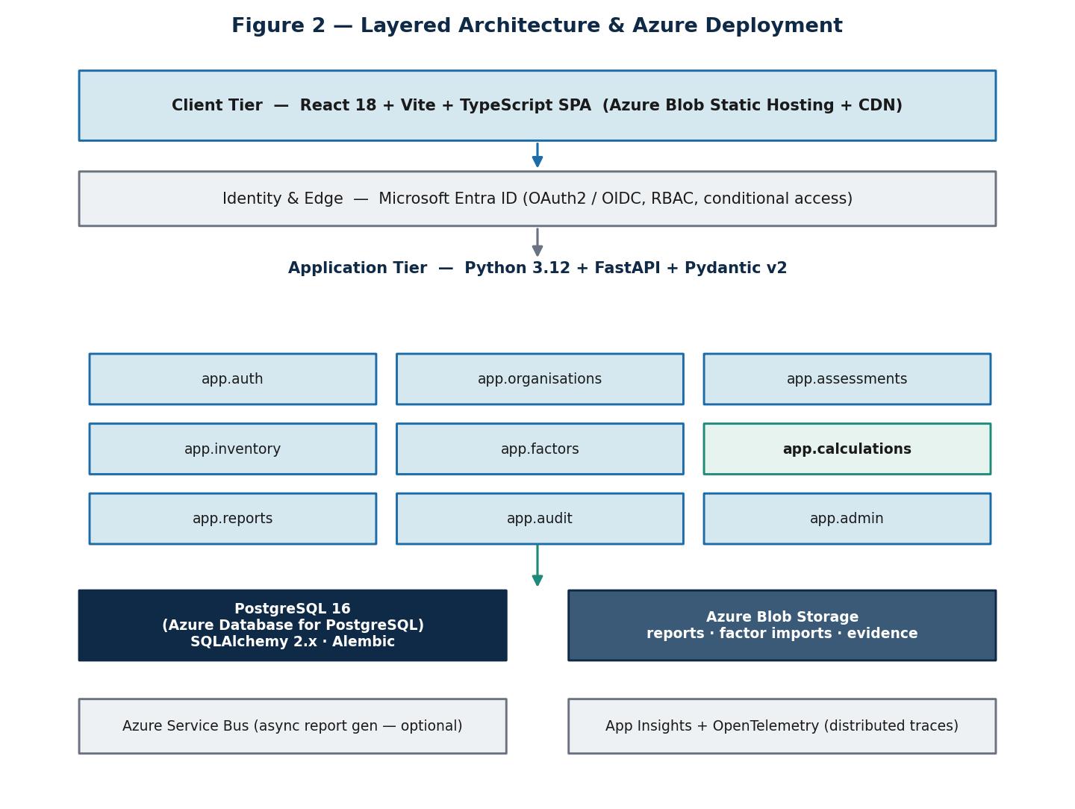
Figure 3 — Layered architecture and Azure deployment topology.

8. Data Flow Analysis
Inputs and factors travel along a deliberately one-directional path: user inputs are matched to governed factors, the engine computes results, results and audit events are persisted immutably, and the report is rendered from persisted results. Crucially, inputs and factors are never colocated, so a historical assessment can be re-run against a different factor version.
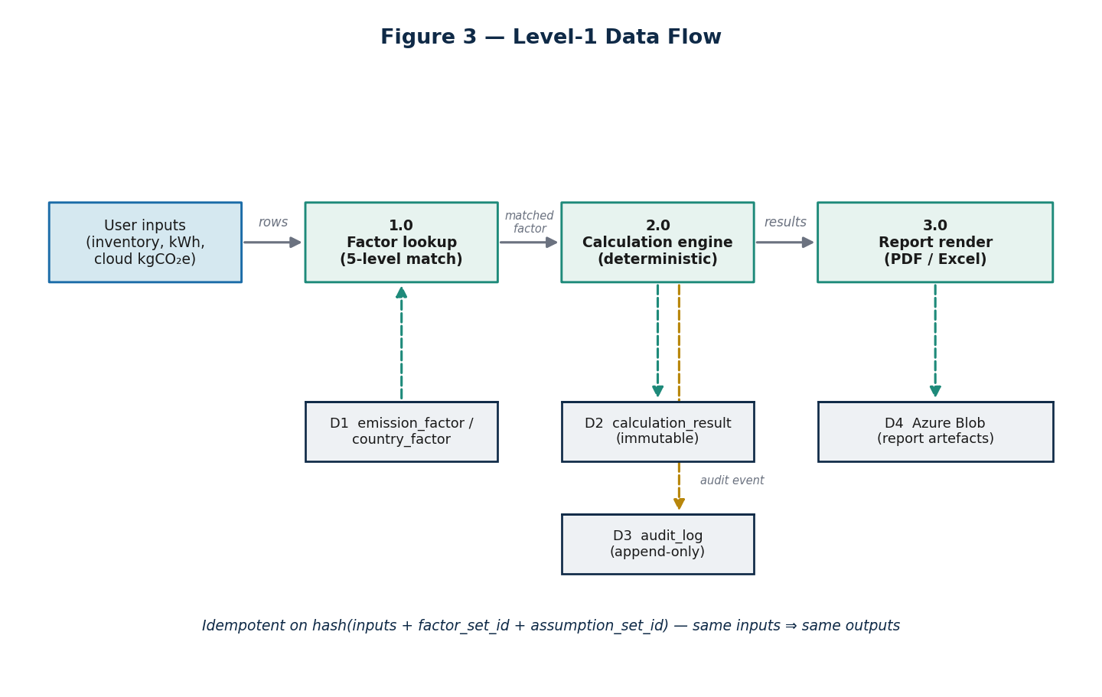
Figure 4 — Level-1 data flow from inputs through the engine to persisted, traceable results.

8.1 Idempotency
The /calculate operation is idempotent on (assessment_id, factor_set_id, assumption_set_id, inputs_hash). The same inputs always yield the same outputs; this property is also the regression-test surface used against the KPMG golden cases.

9. Interface Analysis

9.1 REST API Surface
Method | Path | Purpose
POST | /assessments | Create assessment (org, reporting year, country, employees)
GET | /assessments/:id | Read assessment with pinned factor/assumption versions
POST | /assessments/:id/inventory | Upsert asset inventory rows (server matches factors)
POST | /assessments/:id/calculate | Run engine; persist calculation_result + audit_log
GET | /assessments/:id/results | Read results (totals, scope split, per-employee, drivers)
GET | /assessments/:id/export | Generate PDF/Excel report; return Blob URL
GET | /factors | Browse factor catalogue (read-only; filter by source/year)
POST | /admin/factors/import | Admin-only: ingest a new factor set version

9.2 Admin Factor Import Pipeline
- Upload a signed CSV/JSON file to Azure Blob.
- Validate: no missing factor names, no duplicate IDs, valid units, ratios add to 1.0, no negative factors unless explicitly allowed.
- Render a diff versus the existing factor set before commit.
- On commit, publish a new immutable factor_set_id; existing assessments remain pinned to their original set.

9.3 External Data Interfaces
Source | Used for | Boundary
Boavizta | Digital equipment / IT infrastructure factors | Cradle-to-grave, manufacturer-specific where available
ADEME / Base Empreinte | Fallback when Boavizta has no match | France methodology, generic category fallback
UK Government factors | UK electricity, fuels, transport | Annual publication, country = UK
Cloud provider reports | AWS / Azure / GCP self-reported emissions | Provider-reported, treated as Scope 3

10. Constraints, Assumptions & Dependencies
- The platform is Azure-native and uses Microsoft Entra ID for identity, aligning with KPMG tenanting.
- Emission factors, country factors, and assumptions are governed datasets, loaded via the admin pipeline — never edited by end users.
- Every published report references an immutable assumption set and factor set.
- MVP non-goals (full Scope 1/2/3 accounting, supplier portals, real-time grid intensity, AI advice) are explicitly excluded.
- Cloud providers may under-report Scope 3 in customer-facing reports; a manual override factor is permitted and documented.

11. Risk Analysis & Anti-patterns

11.1 Prohibited Anti-patterns
# | Anti-pattern | What to do instead
1 | Copying the Excel cell-for-cell | Extract the formula family and source data; design a clean engine. The Excel is a reference, not a target.
2 | Hardcoding emission factors in code | Store factors in country_factor / emission_factor tables with full metadata.
3 | Ignoring units | Every factor row stores its unit; the engine refuses to multiply mismatched units.
4 | No source traceability | Every result row has a factor_id and source_reference; the report appendix lists them.
5 | No exact-vs-estimated distinction | Persist match_confidence per row; UI badges it; the report flags estimated rows.

11.2 Other Risks & Mitigations
Risk | Likelihood | Impact | Mitigation
Boavizta dataset/API format changes | Medium | Medium | Versioned admin import pipeline; assessments pin their factor set.
Annual UK Gov / ADEME updates shift results | High | Medium | Year-pinned country_factor rows; report states factor source and year.
Cloud providers under-report Scope 3 | Medium | Medium | Document the limitation; allow a manual override factor.
User mis-enters inventory and republishes | Medium | High | Drafts vs. published; audit_log before/after; reviewer sign-off to publish.
Methodology debate (cloud Scope 2 vs 3) | Medium | Medium | Encode as a versioned assumption; changing it is a governed change with approval.

12. Success & Acceptance Criteria
Criterion | Target
Golden test reproducibility | 100% match against KPMG Excel reference cases
Time-to-first-result for a new client | ≤ 60 minutes (8-step journey)
Factor traceability coverage | 100% of result rows link to a source_reference
Assumption versioning | Every published report references an immutable assumption set
Re-run determinism | Hash(inputs + factor_version + assumption_version) = stable output

12.1 Testing Strategy (summary)
- Unit tests (pytest) on the pure engine, e.g. calculate_electricity(1000, 0.209) ≈ 209.0.
- Golden test cases derived from the KPMG workbook; engine output must match byte-for-byte (e.g. 361 kWh × 0.055 = 19.855 kgCO₂e/year).
- Regression tests re-run the full golden set whenever formulas or factors change; the diff is approved before publishing a new factor set.
- Factor-import tests: no missing names, no duplicate IDs, units in allow-list, ratios sum to 1.0 (±0.001), no negatives unless allowlisted.
- Contract (OpenAPI) and Playwright end-to-end tests covering the full create → export journey.

13. Phased Roadmap
Phase | Theme | Deliverables
1 | Understanding prototype | Basic UI · manual inputs · static factor table · simple results · Excel export
2 | Governed MVP | PostgreSQL factor tables · source metadata · assessment versioning · PDF/Excel · audit trail · admin import
3 | Product-grade calculator | RBAC · multiple orgs · scenario modelling · approval workflow · factor version management · data-quality scoring
4 | Advanced capability | Cloud provider API integrations · procurement imports · asset-management integrations · reduction recommendations · benchmarks
5 | Assurance-ready | Methodology locking · evidence attachments · change history · assumption approval · reviewer sign-off · exportable audit pack

13.1 Four-Week Cheat Sheet (Phase 1 → 2)
Week | Focus | Output
1 | Understand and model | Read the Excel · identify source sheets · document formulas · create data model · sample test cases
2 | Build calculation engine | Factor tables · calculate* functions · unit tests · validate against Excel golden cases
3 | Build UI | Assessment setup · asset inventory · data-centre input · cloud input · results dashboard
4 | Reporting & governance | Export report · source references · assumptions screen · audit trail · admin factor upload

14. Appendix

14.1 Five Questions Every Number Must Answer
- What activity was measured?
- What factor was used?
- What formula was used?
- What source did the factor come from?
- What assumptions were applied?
- When was it calculated, and who changed the input?

14.2 Document Closeout
This System Analysis Document is the baseline for engineering and methodology review. It is paired with the Database Design Document, which details the schema, governance, indexing, and migration strategy that realise the requirements above.

