KPMG GreenPath
Technology Sustainability Intelligence
Carbon, Clearly
A Defensible Loop for IT and AI — Software Design Document v2.0
Software Design Document (SDD) — v2.0
Draft v2.0 — supersedes the MVP SDD v1.0
2026-06-04
Classification: Confidential — for engineering and methodology review

Document Control
Field | Detail
Document title | GreenPath — Carbon, Clearly: A Defensible Loop for IT and AI (SDD v2.0)
Programme | KPMG GreenPath — Technology Sustainability Intelligence
Supersedes | Carbon Footprint Calculator SDD v1.0 (MVP, IT-only)
Positioning | Decision-useful, not formal accounting
Version | 2.0 (Draft)
Date | 2026-06-04
Author | Architecture team
Target platform | React 18 + Vite · Python 3.12 + FastAPI · PostgreSQL 16 (Azure)
Classification | Confidential

What changed since v1.0
v1.0 specified a one-shot, accounting-grade IT footprint calculator — effectively Module 1 (Measure), minus AI and the confidence/hotspot layer. v2.0 reframes the product as a recurring, decision-useful loop for IT and AI across five modules, and closes the eight feature gaps identified.
Area | v1.0 | v2.0
Positioning | Assurance-grade accounting | Decision-useful, confidence-banded
Coverage | IT devices, data centre, cloud | + AI workloads (training / inference)
Modules | Calculate + report (1) | Measure · Assess · Plan-lite · Report · Govern (5)
Cadence | Single annual assessment | Recurring quarterly / annual periods with locking
Outputs | PDF + Excel | PDF + PPTX + Excel, with period-on-period delta
Confidence | Per-row error margin | KPI confidence bands + 0–100 score + engagement dial

Table of Contents

Table of Contents
Document Control 2
What changed since v1.0 2
Table of Contents 3
1. Executive Summary 5
1.1 North Star 5
2. Positioning & Principles 5
3. Goals, Scope & Non-Goals 6
3.1 In scope (v2.0) 6
3.2 Out of scope (v2.0) 6
3.3 Success criteria 6
4. The Recurring Loop 6
5. Domain Model & Glossary 8
6. Module 1 — Measure 8
6.1 Core formula family (IT) 9
6.2 AI workloads (new in v2.0) 9
6.3 Confidence bands & the engagement dial 9
6.4 Hotspots 10
7. Module 2 — Assess 11
7.1 The six domains 11
7.2 Scoring & gap derivation 11
8. Module 3 — Plan-lite 12
8.1 Design rules 12
9. Module 4 — Report 12
9.1 Pack sections 13
10. Module 5 — Governance-lite 13
11. The Period Model 13
12. Data Model 14
12.1 New and changed tables 15
13. System Architecture 16
13.1 Technology choices 16
13.2 Backend modules 16
14. API Surface (v2.0) 17
15. Testing Strategy 17
16. Phased Roadmap & Gap Closure 17
17. Risks & Anti-patterns 18
18. Appendix 18
18.1 The five questions every number must answer 18
18.2 Worked traceability example 18
18.3 References 19
18.4 Document closeout 19

1. Executive Summary
GreenPath turns messy IT and AI inputs into an indicative carbon baseline, a practical action plan, and a quarterly story of progress — with confidence bands and an audit trail by design. It is not a six-month consulting study and it is not a formal greenhouse-gas accounting ledger. It is a decision-useful working tool that answers the three questions every CIO and CSO is now being asked:
- What is our baseline? — an indicative annual footprint for IT and AI, with the assumptions on the table.
- Where are the hotspots? — the handful of components, regions and workloads that drive most of the emissions, ranked rather than buried in a spreadsheet.
- What do we do next, and how do we prove it? — practical actions with owners and impact tags, then a quarterly pack that shows what changed and why.

GreenPath is a recurring loop, not a one-off deliverable: Measure → Assess → Plan-lite → Report → Govern, refreshed each quarter, with each module handing its output to the next. The number compounds in value at every refresh.

1.1 North Star
Every number GreenPath shows traces back to one model. A reader of any chart or pack can see the activity that created it, the factor and formula used, the source and version of that factor, the assumptions applied, the confidence band around it, and who approved it — in one place. Decision-useful does not mean unaccountable; it means honest about uncertainty and fully auditable.

2. Positioning & Principles
GreenPath is deliberately positioned as decision-useful, not formal accounting. This positioning shapes every design choice in this document.
Principle | What it means in the design
Indicative, not audited ledger | Headline KPIs are single annualised numbers with an explicit confidence band, not balance-sheet figures.
Assumptions on the table | Every factor, ratio and assumption is visible, versioned, and overridable with a recorded reason.
Confidence is first-class | Each KPI carries a band and a 0–100 confidence score that tightens as evidence is added.
A loop, not a deliverable | The product compounds value through quarterly refreshes; periods are first-class and lockable.
Audit by design | Governance-lite records every mutation; approving a period locks its headline KPIs.
Decision-useful output | Hotspots, levers and actions — not just totals — so the board and procurement can act.
This is a friendly divergence from the v1.0 framing. The governed, deterministic engine underneath is retained — factors are still data, results still pin their versions — but the headline experience is an indicative, confidence-banded, decision-useful loop.

3. Goals, Scope & Non-Goals

3.1 In scope (v2.0)
- IT estate: laptops, desktops, monitors, phones, tablets, printers, servers, networking.
- Data-centre electricity (annual kWh / MWh) with country grid factors.
- Cloud: provider-reported emissions and cloud SaaS workloads.
- AI workloads: training and inference compute (GPU-hours, region, model class) as a first-class source.
- Confidence bands and a 0–100 confidence score per KPI, driven by an engagement-level dial.
- Hotspot analysis: component × dimension scoring, avoidability, and a lever (recommendation) catalogue.
- Maturity assessment: six domains, 27 questions, levels 1–5, with evidence per question.
- Plan-lite: auto-seeded actions with effort buckets, owners, due dates and impact tags.
- Recurring periods (quarterly / annual) with period locking and period-on-period delta.
- Reporting: PDF, PPTX and Excel from one data shape, with executive narrative.
- Governance-lite: audit log, evidence library, assumption overrides, approval and period locking.

3.2 Out of scope (v2.0)
- Formal enterprise Scope 1/2/3 accounting and statutory disclosure.
- Supplier portals and supplier-side primary data collection.
- Real-time grid carbon intensity and live cloud-provider API integrations (roadmap, not MVP of v2).
- Multi-step, multi-approver workflow engines beyond single period approval.

3.3 Success criteria
Criterion | Target
Time-to-first-baseline | Indicative baseline for IT + AI in ≤ 1 working session
Traceability | 100% of KPIs trace to one model (input → factor → formula → source → assumption)
Confidence transparency | Every headline KPI shows a band and a 0–100 score
Decision-usefulness | Each hotspot pre-matched to at least one lever; each gap seeds an action
Defensibility | Approved periods are immutable; every number has provenance and an approver
Determinism | Same inputs + pinned factor/assumption versions ⇒ same outputs and band

4. The Recurring Loop
GreenPath is five modules wired into one recurring loop. Each module consumes the previous module's output and contributes to the next; Governance-lite wraps all of them.
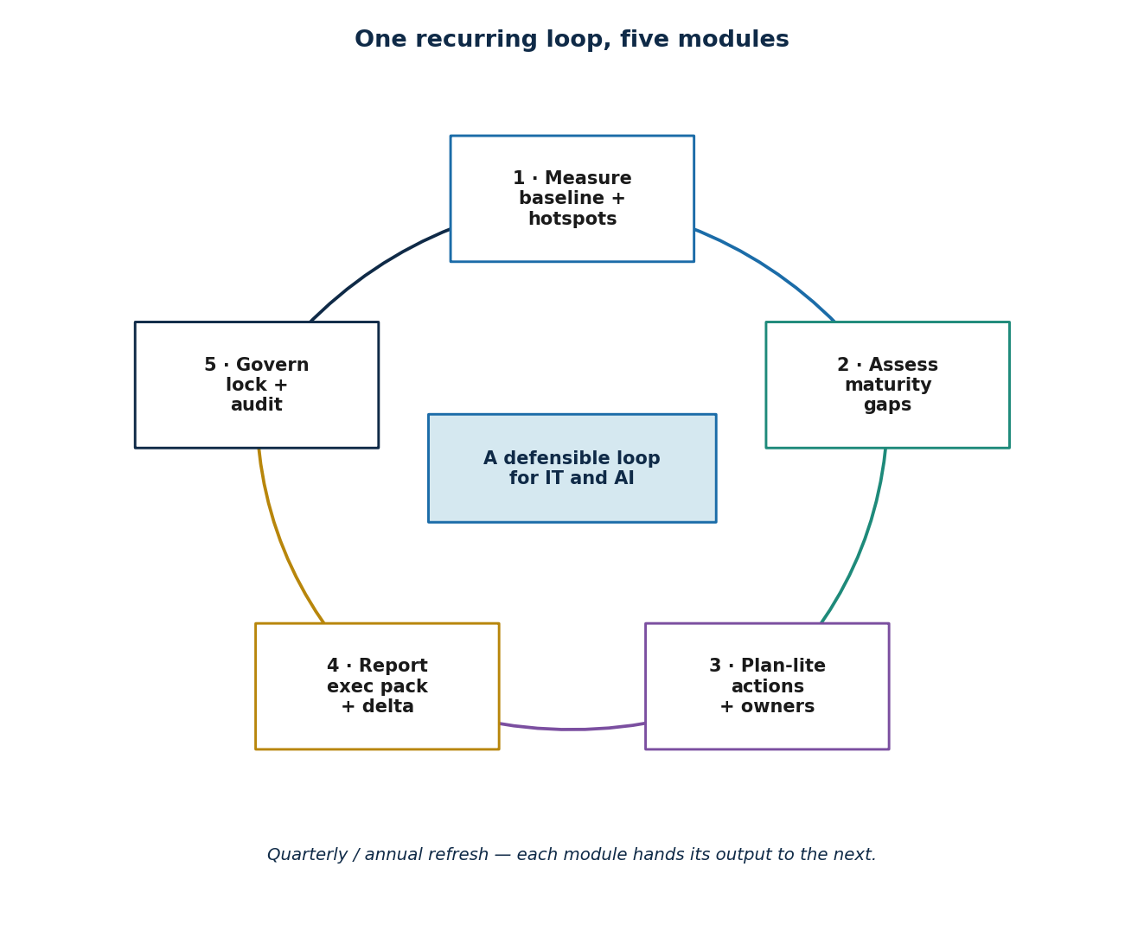
Figure 1 — One recurring loop: Measure → Assess → Plan-lite → Report → Govern.
Module | Consumes | Produces
1 · Measure | Activity data, AI workloads, factors | Footprint + confidence band, hotspots
2 · Assess | Maturity questionnaire responses | Domain scores and maturity gaps
3 · Plan-lite | Hotspots + maturity gaps | Owned, dated, impact-tagged actions
4 · Report | All of the above + prior period | PDF / PPTX / Excel pack with delta narrative
5 · Governance-lite | Every mutation across modules | Audit log, evidence, approvals, period locks
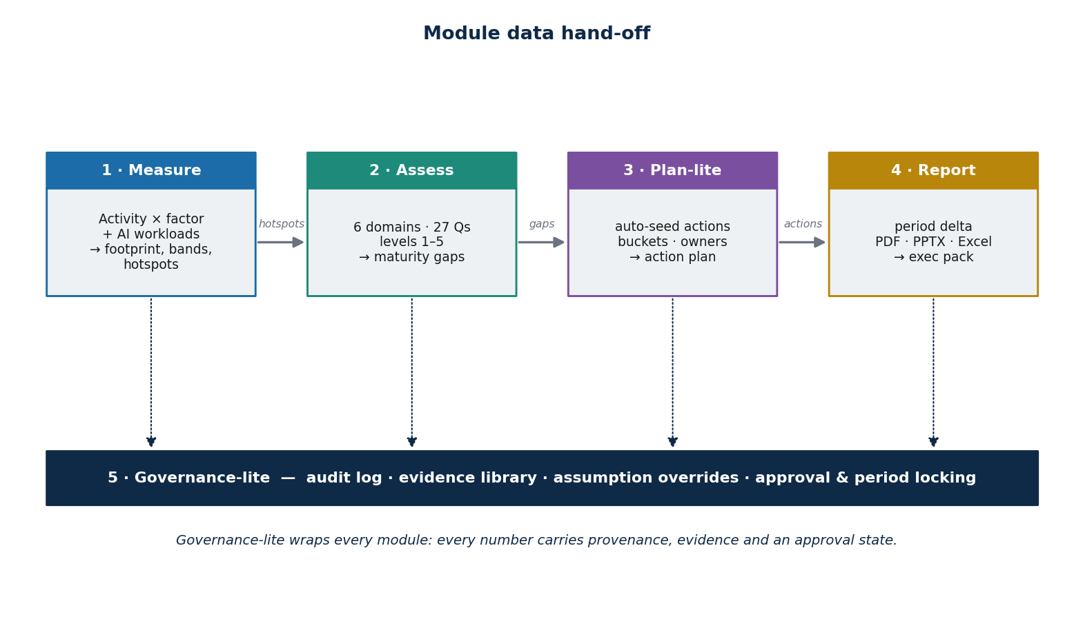
Figure 2 — Module data hand-off; Governance-lite wraps every module.

5. Domain Model & Glossary
v2.0 extends the v1.0 carbon vocabulary with the loop, AI, confidence, hotspot, maturity and planning concepts. The domain language is enforced at the type level (Pydantic v2).
Term | Definition
Engagement | A client relationship under which recurring assessment periods are run.
Period | A reporting cycle (quarter or year) that can be approved and locked.
Confidence band | The plausible range around a KPI (e.g. 1,613–2,553 tCO₂e) given data quality.
Confidence score | A 0–100 score summarising how well-evidenced a KPI is.
Engagement dial | The depth of engagement (Light / Standard / Deep) that narrows the band.
AI workload | A training or inference compute activity with GPU-hours, region and model class.
Hotspot | A component × dimension cell scored for how much it drives the footprint.
Avoidability | How readily a hotspot's emissions can be reduced (a scored dimension).
Lever | A pre-matched recommendation that reduces a hotspot (e.g. shift to low-carbon region).
Maturity gap | The difference between current and target maturity level for a question/domain.
Action | A planned change with effort bucket, owner, due date, impact tag and source link.
Period delta | The change in a KPI versus the prior locked period (e.g. −9.5%).

6. Module 1 — Measure
Measure turns activity data and reference factors into a single annualised tCO₂e number, with a confidence band that shrinks as evidence is added. Hotspots, components and scopes are computed from the same inputs, so every chart traces back to one model.

6.1 Core formula family (IT)
Annual footprint = use_emissions + manufacturing_emissions

Use (Scope 2) = qty * gwp_total * use_ratio
* country_factor / lifespan
Manufacturing (Scope 3) = qty * gwp_total * manufacturing_ratio
* (1 - reconditioning_rate * benefit) / lifespan
Data centre = annual_kWh * country_electricity_factor
Cloud = sum(provider_reported_kgCO2e)

6.2 AI workloads (new in v2.0)
AI is a first-class source, not a footnote — in every demo the top hotspot is an AI training workload. An AI workload is modelled from compute energy and the carbon intensity of the region it runs in, with an optional embodied-hardware share.
AI compute (Scope 2/3) = gpu_hours * avg_power_kw * pue
* region_grid_factor
+ embodied_share (optional)

# Avoidability lever example:
# shift region (high-carbon -> low-carbon) lowers region_grid_factor
# => projected saving feeds straight into Plan-lite
AI input | Meaning
workload_type | training | inference
gpu_hours | Total accelerator hours for the period
avg_power_kw | Average device power draw (kW)
pue | Data-centre power usage effectiveness multiplier
region | Execution region → region grid carbon factor
model_class | Size/family tier used for fallback estimates

6.3 Confidence bands & the engagement dial
Each KPI is reported as value ± band with a 0–100 confidence score. The band is derived from the data quality of its inputs (the match-confidence of each factor and the completeness of activity data) and is then scaled by the engagement-level dial: a Light engagement reports a wide band; adding evidence and deepening the engagement narrows it.
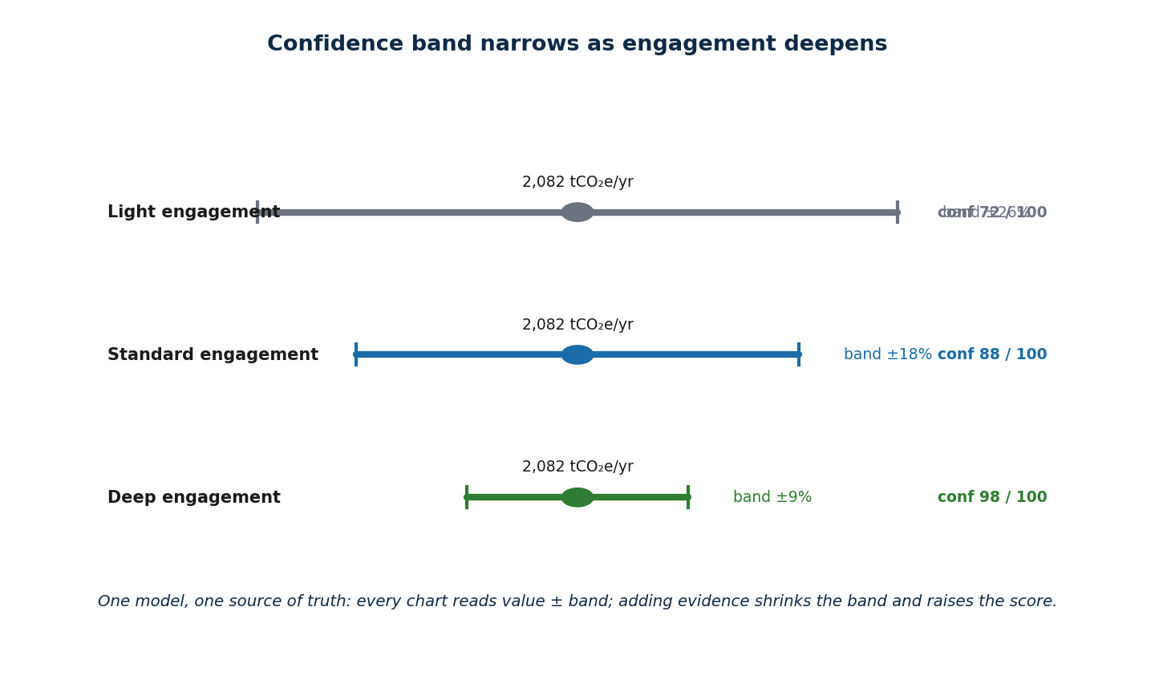
Figure 3 — The same headline KPI under Light, Standard and Deep engagement.
Engagement tier | Typical band | Typical score
Light (guided forms only) | ± ~25% | 70–78 / 100
Standard (forms + CSV evidence) | ± ~18% | 84–90 / 100
Deep (evidence attached per KPI) | ± ~9% | 95–99 / 100

6.4 Hotspots
Not all emissions are equal. The hotspot engine scores every component against five dimensions — energy intensity, carbon intensity, inefficiency, avoidability and maturity gap — and ranks the cells worth acting on first. Each high hotspot is pre-matched to a lever, which feeds straight into Plan-lite.
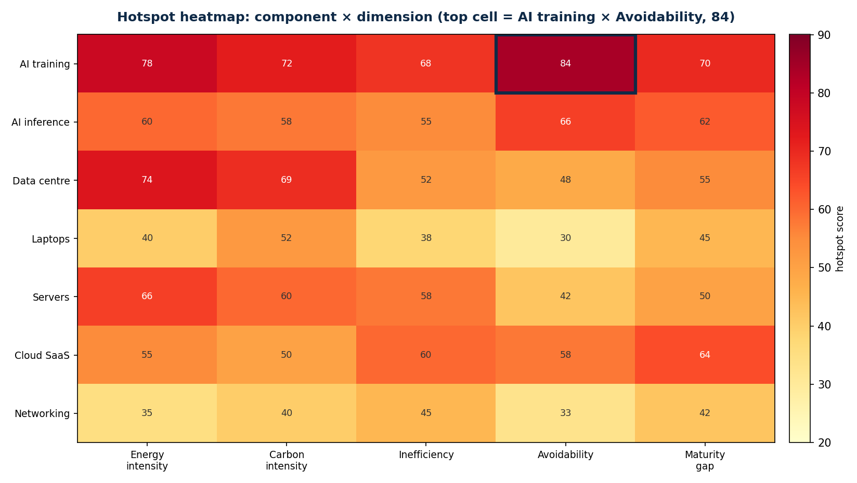
Figure 4 — Hotspot heatmap; the top cell is AI training × Avoidability (score 84).
- Component × dimension matrix with marginal averages.
- Avoidability score isolates fixable emissions from structural ones.
- Pre-matched levers (from the lever catalogue) attach to each ranked hotspot.

7. Module 2 — Assess
Capability matters as much as carbon. Assess scores the organisation against six dossier-aligned domains and 27 questions, levels 1–5, with evidence per question. Every gap is auto-derived and exposed as a candidate action in Plan-lite.

7.1 The six domains
# | Domain | Focus
1 | Strategy | Sustainability ambition, targets and ownership
2 | Governance | Policies, accountability, decision rights
3 | Measurement | Data quality, factor governance, confidence
4 | Architecture | Efficient, low-carbon technology choices
5 | Supplier | Procurement, vendor and cloud sustainability
6 | Culture | Awareness, incentives, skills

7.2 Scoring & gap derivation
- Each of the 27 questions is answered on a 1–5 maturity level, with an evidence reference.
- Domain score = aggregate of its question levels; an organisation profile spans all six domains.
- Gap = target level − current level; each non-zero gap becomes a candidate action, cross-linked to any related hotspot.

8. Module 3 — Plan-lite
Plan-lite turns the outputs of Measure and Assess into a working plan in one click. Hotspots and maturity gaps are auto-seeded into proposed actions, bucketed by effort horizon. Every action carries an estimated impact tag, an owner and a due date, with the source hotspot or gap preserved for audit.
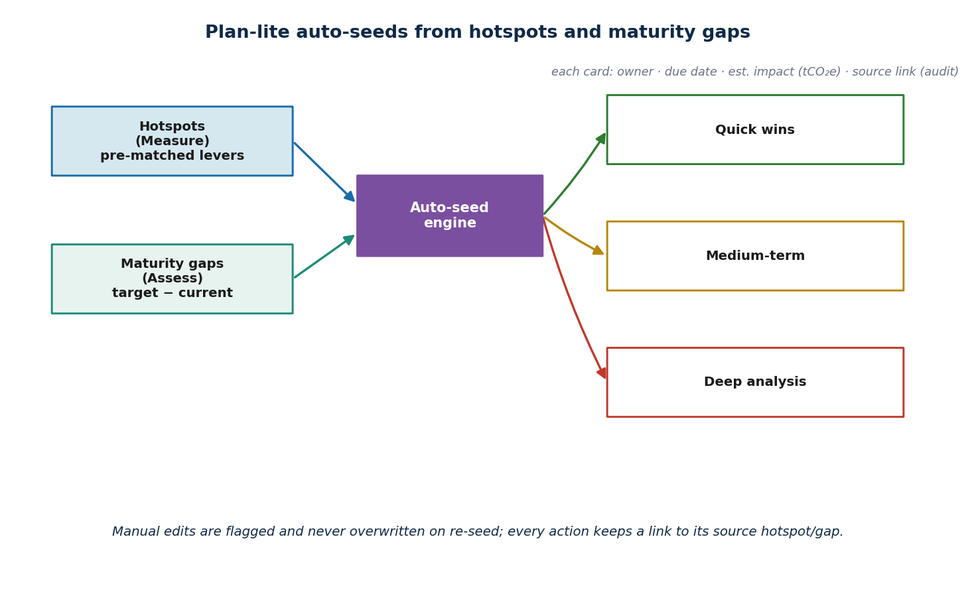
Figure 5 — Plan-lite auto-seeds actions from hotspots and maturity gaps.
Effort bucket | Horizon | Example
Quick win | 0–3 months | Shift an AI training job to a low-carbon region
Medium-term | 3–12 months | Extend laptop refresh cycle / increase refurbishment
Deep analysis | > 12 months | Re-architect a high-inefficiency workload

8.1 Design rules
- Auto-seed from hotspots (with pre-matched levers) and from maturity gaps (target − current).
- Each action: title, effort bucket, owner, due date, estimated impact (tCO₂e), and a source link.
- Manual edits are flagged and never overwritten when the plan is re-seeded in a later period.
- Actions move across a Kanban board; status changes are recorded for the audit trail.

9. Module 4 — Report
Report assembles a quarterly or annual pack with an executive narrative, the period-on-period delta, hotspots and actions — in a single export. Three formats (PDF, PPTX, Excel) are produced from one data shape, so the same numbers appear consistently wherever a stakeholder reads them.
Capability | Detail
Period selector | Choose a period; the pack renders that period and its delta vs. the prior locked period.
Delta narrative | Auto-generated executive text, e.g. “total footprint −9.5% vs Q4 2026; top hotspot AI training (67% share).”
Three formats, one shape | PDF (ReportLab), PPTX (python-pptx) and Excel (openpyxl) from the same result model.
Auto cover / scope / appendix | Branded cover, scope statement, and a traceability appendix generated automatically.

9.1 Pack sections
- Executive summary — headline KPI with band, period delta, key drivers.
- Scope & category breakdown — IT, data centre, cloud, AI; Scope 2 vs Scope 3.
- Hotspots — ranked cells with avoidability and pre-matched levers.
- Action plan — owned, dated, impact-tagged actions by effort bucket.
- Confidence & limitations — band, score, and explicitly flagged estimated inputs.
- Appendix — full traceability (input → factor → formula → source → assumption).

10. Module 5 — Governance-lite
Governance-lite is the trust layer behind every number. It records every input edit, factor pin, assumption override, evidence attachment and approval. Approving a period locks its headline KPIs; subsequent edits open a new period. One surface holds the assumptions log, evidence library, approvals and history.
Capability | Detail
Append-only audit log | Every mutation captured with actor, entity, action and before/after state.
Evidence library | Files in Blob linked to specific KPIs and assumptions; raises the confidence score.
Assumption overrides | Any default factor/assumption can be overridden with a recorded reason and approver.
Approval & period locking | Approving a period snapshots and locks its KPIs; later edits open the next period.
Change history | Full period-looking history — what changed, when, by whom, and why.

11. The Period Model
The recurring loop rests on a first-class period model — the single biggest structural change from v1.0. An engagement owns an ordered series of periods; a period holds the inputs, results, hotspots, maturity responses and actions for one cycle. Approving a period snapshots and locks its headline KPIs, and computes the delta against the prior locked period.
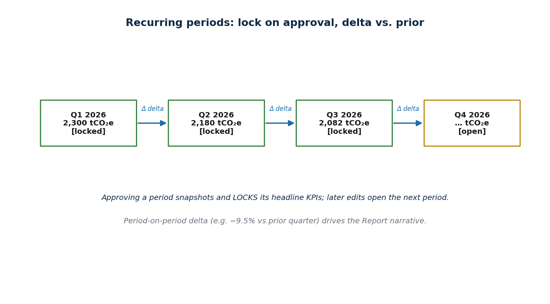
Figure 6 — Recurring periods: lock on approval, delta versus the prior period.
- Engagement → ordered Periods (quarter or year); exactly one period is “open” at a time.
- Locking a period freezes its KPIs, bands and pack so they can be cited without drift.
- Period-on-period delta drives the Report narrative and the progress story.
- Re-seeding Plan-lite in a new period preserves manual edits from the prior period.

12. Data Model
The schema keeps the v1.0 separation of concerns — inputs, factors, results, assumptions/sources — and adds entity groups for AI, hotspots, maturity, planning, periods and governance. The map below groups tables by concern; tables marked (NEW) are added in v2.0.
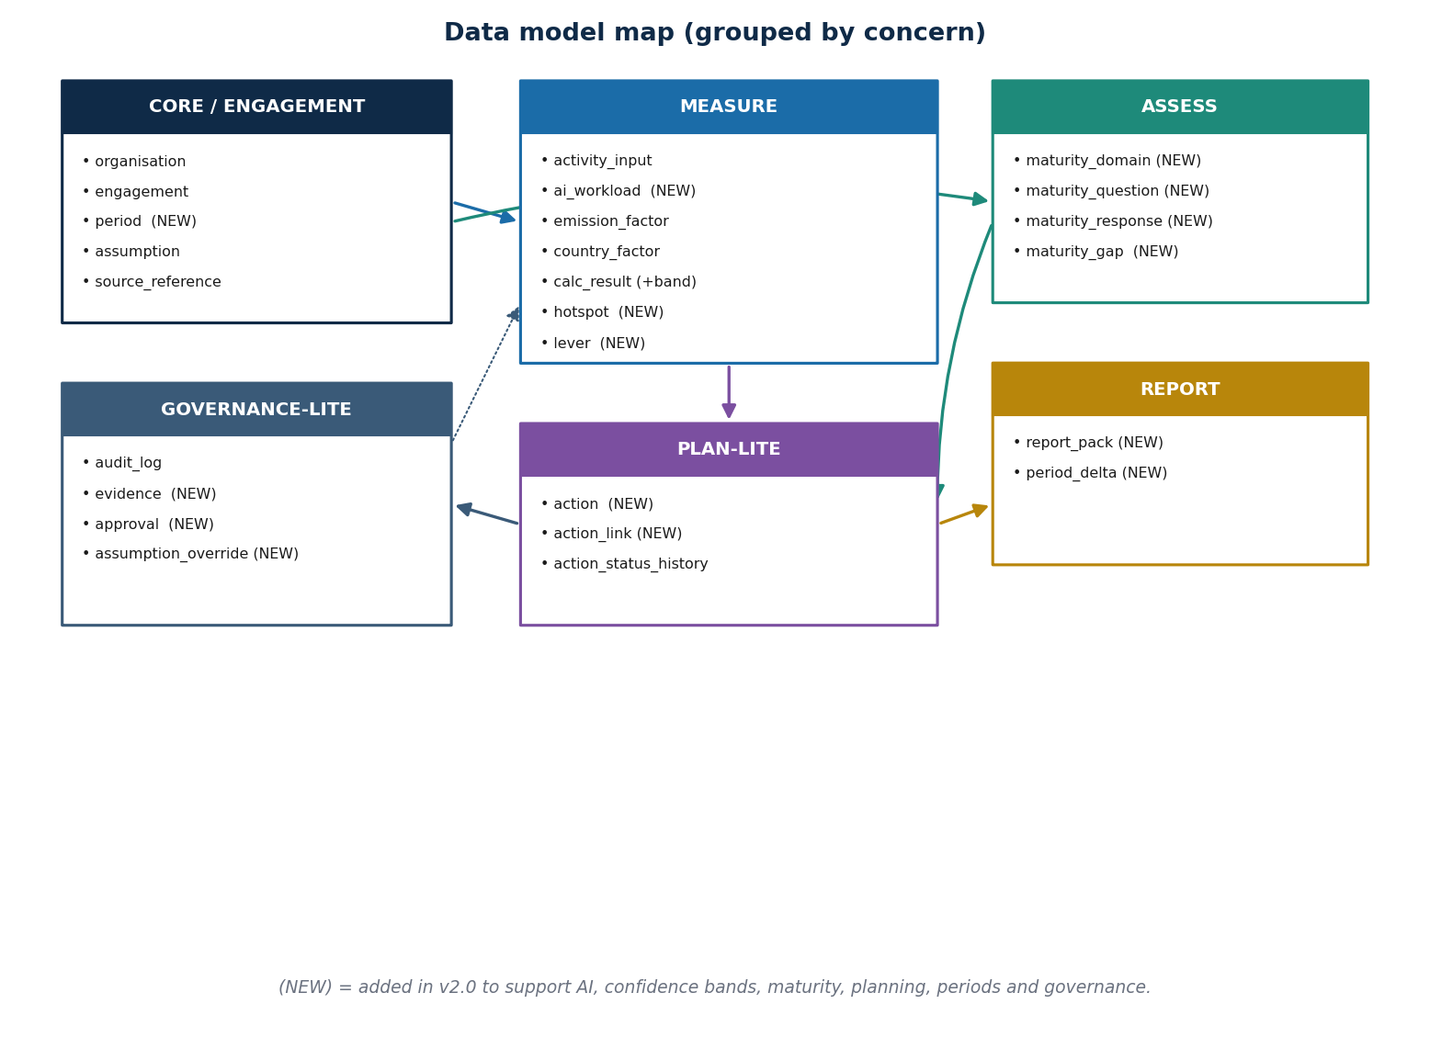
Figure 7 — Data-model map grouped by concern (v2.0 additions marked NEW).

12.1 New and changed tables
Table | Status | Purpose / key fields
engagement | new | Client relationship; owns periods. id, organisation_id, name, status
period | new | Reporting cycle. id, engagement_id, kind (quarter|year), label, state (open|locked), locked_at, prior_period_id
activity_input | changed | Generalised inventory/electricity/cloud input. + period_id
ai_workload | new | AI compute. id, period_id, workload_type, gpu_hours, avg_power_kw, pue, region, model_class
calc_result | changed | + value_low, value_high, confidence_score, period_id
hotspot | new | id, period_id, component, dimension, score, avoidability, lever_id
lever | new | Recommendation catalogue. id, title, applies_to, est_reduction_pct
maturity_domain | new | id, name (6 rows)
maturity_question | new | id, domain_id, text (27 rows), target_level
maturity_response | new | id, period_id, question_id, level (1–5), evidence_id
maturity_gap | new | Derived. id, period_id, question_id, gap, seeded_action_id
action | new | id, period_id, title, bucket, owner, due_date, est_impact_tco2e, is_manual_edit
action_link | new | Lineage. id, action_id, source_kind (hotspot|gap), source_id
report_pack | new | id, period_id, format (pdf|pptx|xlsx), blob_url, generated_at
period_delta | new | id, period_id, kpi, value, prior_value, delta_pct
evidence | new | id, kind, blob_url, linked_entity, linked_id, uploaded_by
approval | new | id, period_id, approver, approved_at, locks_kpis
assumption_override | new | id, period_id, assumption_key, value, reason, approved_by
Retained from v1.0: organisation, emission_factor, country_factor, assumption, source_reference, audit_log. calc_result still pins factor_version, assumption_set_id and formula_version so historical periods remain reproducible.

13. System Architecture

13.1 Technology choices
Layer | Choice | Rationale / change in v2.0
Frontend | React 18 + Vite + TS | SPA via Azure Blob + CDN; adds Kanban (Plan-lite), heatmap (hotspots), dial (confidence).
Backend | Python 3.12 + FastAPI + Pydantic v2 | Type-level units/metadata; OpenAPI; pandas/pyarrow for imports and golden diffs.
Reporting | ReportLab · python-pptx · openpyxl | python-pptx added for PPTX export from the same result model.
Database | PostgreSQL 16 (Azure) | JSONB for evidence/source metadata; new period, AI, hotspot, maturity, plan tables.
Object storage | Azure Blob Storage | Report packs, factor imports, and the evidence library.
Identity | Microsoft Entra ID | SSO, RBAC, conditional access; aligns with KPMG tenanting.
Observability | App Insights + OpenTelemetry | Traces show which factor_version and assumption set each KPI used.

13.2 Backend modules
Package | Responsibility
app.engagements | Engagement and period lifecycle, locking, delta computation (new)
app.measure | Activity + AI inputs, engine, confidence bands
app.hotspots | Component × dimension scoring, avoidability, lever matching (new)
app.assess | Maturity domains/questions/responses, gap derivation (new)
app.plan | Auto-seed actions, buckets, Kanban status (new)
app.reports | PDF / PPTX / Excel pack rendering with delta narrative
app.governance | Audit log, evidence library, overrides, approvals (extends app.audit)
app.factors / app.admin | Read-only factor catalogue; admin factor imports (retained)

14. API Surface (v2.0)
Method | Path | Purpose
POST | /engagements | Create an engagement (client relationship)
POST | /engagements/:id/periods | Open a new reporting period
POST | /periods/:id/measure | Upsert activity + AI inputs; server matches factors
POST | /periods/:id/calculate | Run engine; persist results with bands + hotspots
GET | /periods/:id/hotspots | Ranked hotspots with avoidability and levers
POST | /periods/:id/assess | Submit maturity responses; derive gaps
POST | /periods/:id/plan/seed | Auto-seed actions from hotspots + gaps
PATCH | /actions/:id | Edit/move an action (flags manual edit)
GET | /periods/:id/export | Generate PDF / PPTX / Excel pack; return Blob URL
POST | /periods/:id/approve | Approve and lock the period; compute delta
POST | /evidence | Attach evidence to a KPI or assumption
Determinism is retained: /periods/:id/calculate is idempotent on (period_id, factor_set_id, assumption_set_id, inputs_hash). The same inputs reproduce the same KPI and band.

15. Testing Strategy
- Unit tests (pytest) on the pure engine, incl. AI compute, e.g. calculate_electricity(1000, 0.209) ≈ 209.0.
- Golden cases from the KPMG workbook; byte-for-byte match (e.g. 361 kWh × 0.055 = 19.855 kgCO₂e).
- Band tests: confidence band and score are deterministic for fixed inputs and engagement tier.
- Hotspot tests: ranking and avoidability scores are stable; top cell matches expected fixtures.
- Maturity tests: domain aggregation and gap derivation; each gap seeds exactly one candidate action.
- Plan tests: re-seed preserves manual edits; every action retains a valid source link.
- Period tests: locking is irreversible; delta equals current − prior; reopened edits land in a new period.
- Export tests: PDF, PPTX and Excel render the same KPIs; Playwright covers measure → approve → export.

16. Phased Roadmap & Gap Closure
The eight gaps identified against the brochure map to delivery phases. Status reflects current understanding and should be confirmed against the live staging environment.
Gap | Phase | Status (to confirm)
Period model (backbone) | P1 — Loop foundation | Verify in staging
Confidence bands + score + dial | P1 — Measure uplift | Verify in staging
AI workloads | P1 — Measure uplift | Verify in staging
Hotspot engine + lever catalogue | P2 — Decision layer | Planned / partial
Assess (maturity model) | P2 — Decision layer | Planned
Plan-lite (actions) | P3 — Planning | Planned
Report: PPTX + delta narrative | P3 — Reporting | Planned / partial
Governance-lite: evidence, approval, lock | P4 — Assurance | Planned
Recommendation: design and build the period model first (it underpins Report-delta and Governance-locking), land AI + confidence bands to make Measure credible, then Hotspots and Assess so Plan-lite has something to seed from.

17. Risks & Anti-patterns
Risk / anti-pattern | Mitigation
Presenting indicative bands as audited figures | Always render the band + score; label the pack “decision-useful, not formal accounting.”
AI factors are sparse and volatile | Region grid factors year-pinned; model_class fallback; confidence reflects the estimate.
Hotspot scores look precise but are heuristic | Document the scoring method; expose dimension inputs; let reviewers see the components.
Auto-seeded plans overwrite human judgement | Manual edits flagged and never overwritten on re-seed.
Demo features assumed live | Roadmap marks each module Live / Partial / Planned; confirm against staging before commitments.
Period locking disputes | Locks are explicit, attributed and reversible only by opening a new period (audited).

18. Appendix

18.1 The five questions every number must answer
- What activity (incl. AI workload) created me?
- What factor and formula were used?
- What source and version did the factor come from?
- What assumptions — and which overrides — were applied?
- What is my confidence band, and who approved the period?

18.2 Worked traceability example
AI training emissions (Q3 2026, locked):
Workload : LLM fine-tune, training
GPU-hours : 12,000 avg_power: 0.40 kW PUE: 1.20
Region : UK South grid factor: 0.209 kgCO2e/kWh (UK Gov 2025)
Compute estimate : 12000 * 0.40 * 1.20 * 0.209 = 1,203.8 kgCO2e
Confidence : band ±18%, score 88/100 (Standard engagement)
Top lever : shift to low-carbon region (est. -34%) -> Plan-lite quick win
Assumption set : assumption_set_2026_v1.0
Approved : period Q3 2026 locked 2026-10-05 by methodology lead

18.3 References
- GreenPath product brochure, 2026 edition — five-module loop and feature set.
- Carbon Footprint Calculator SDD v1.0 — engine, factor governance, data model baseline.
- GHG Protocol Corporate Standard — Scope 1/2/3 concepts.
- Boavizta, ADEME / Base Empreinte, UK Government conversion factors — emission factors.
- AWS / Microsoft / Google customer carbon tooling — cloud and AI region intensity references.

18.4 Document closeout
This SDD v2.0 supersedes v1.0 and is the design baseline for the five-module GreenPath loop. Module statuses in Section 16 must be reconciled against the live staging environment before delivery commitments are made.

