DATA STRUCTURE TERM PROJECT

TEMMUZ BURAK YAVUZER 20160808026

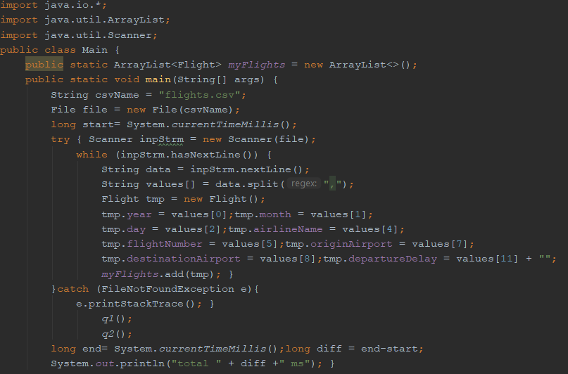

In that part I tried to read csv file. Actually there is a plenty of algorithms to do that.Firstly I need to start with a file name.The way I read from the file is exactly the same way we read from the keyboard that is with the scanner . I make each line of file flight object.I just set the all properties and I add each flight object to array list

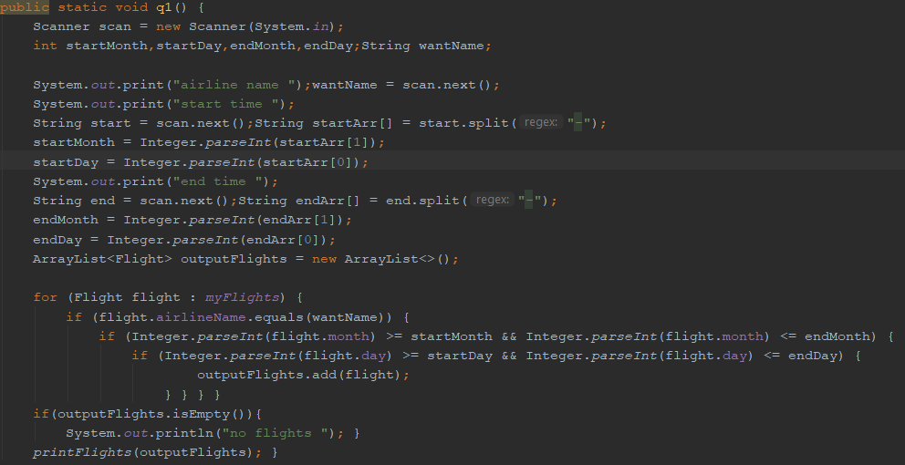

For the first question I created a method to do that .With that method I scan the input from the user for example start and end days,months,years etc..Also I wrote split medhod because I wanted to take all time like 1-1-2015.I wrote several conditions to do which we are supposed to do and I just add that data to outputFlights Arraylist and I print the outputFilghts using printFlight method

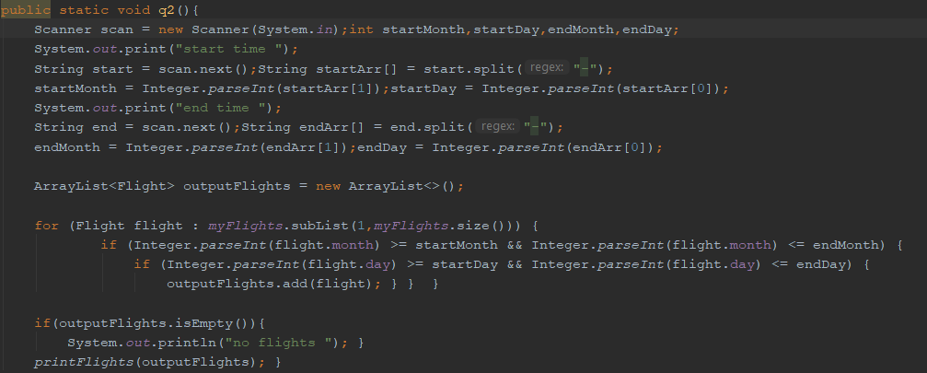

In the second question I scan the input from the user as same way the previous question. And I wrote several conditions and I use the same printFlight medhod to print that actually it is not very diffirent from the first question I just add the total numbers of the entries between these dates

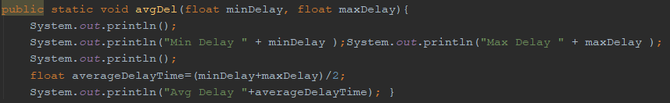

To get average I wrote a method which is not critial and not hard to understand . It is just takes the times average of before and after the question and it prints the average of it.