COMPUTER NETWORK EXPERIMENT 1

Local Networks(LANs) and Ethernet

Temmuz Burak Yavuzer 20160808026

**PURPOSE OF THE PROJECT**

In each computer system,perform the setup procedures according to Table 1.Connect the computers to the related hub or swich.Create a network topologies , discuss the difference between Hubs and Switches by the help of the Packet Tracer.

**NETWORK AND EVENTS WE WILL DISCUSS**

In our experiment we will use the Cisco’s Packet Tracer for that experiment.In the assigment documents topologies are created and filtered as the below figures

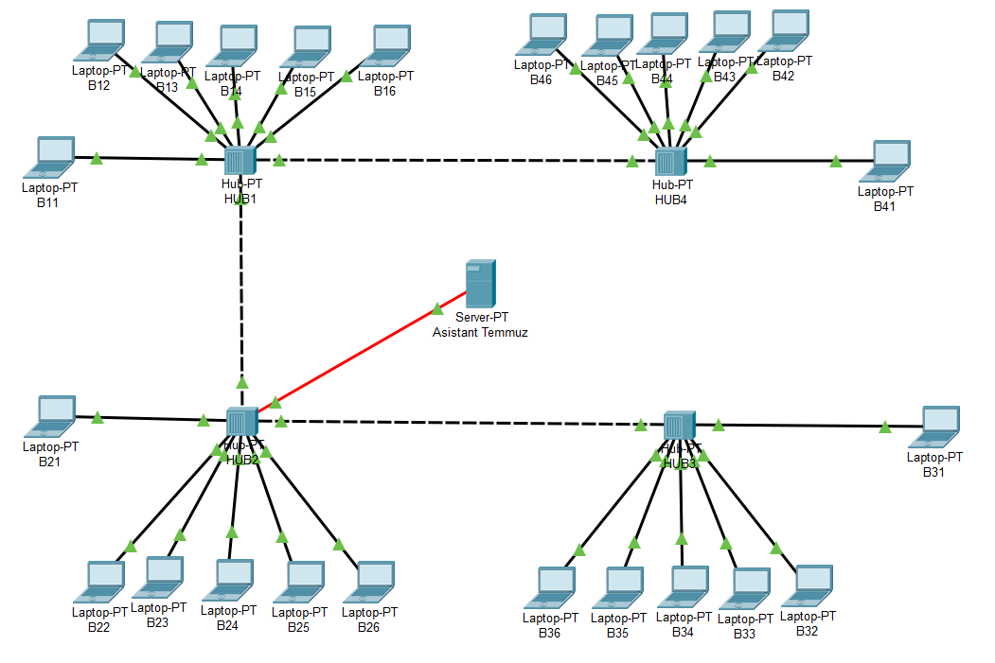

In that figure you see the topologies that I created by the help of the Packet Tracer.In additon to that my student number is 20160808026 so when we look at the assignment we will see B[ 1 I 2 I 3 I 4 ] [studentnumber mod 6 +1].Actually I could do that topology with several computers but I wanted to create that topology with the all computer given in the assignment.Also as you can see I divided my computer which comes from the B[ 1 I 2 I 3 I 4 ] [studentnumber mod 6 +1]. My actual computers are B11,B21,B31,B41.

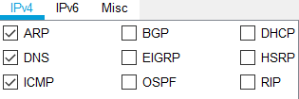

Here is the filters that we need to select for that assingment.My other topology for the switches is given below .As you can see I divided my special computers from the other computer.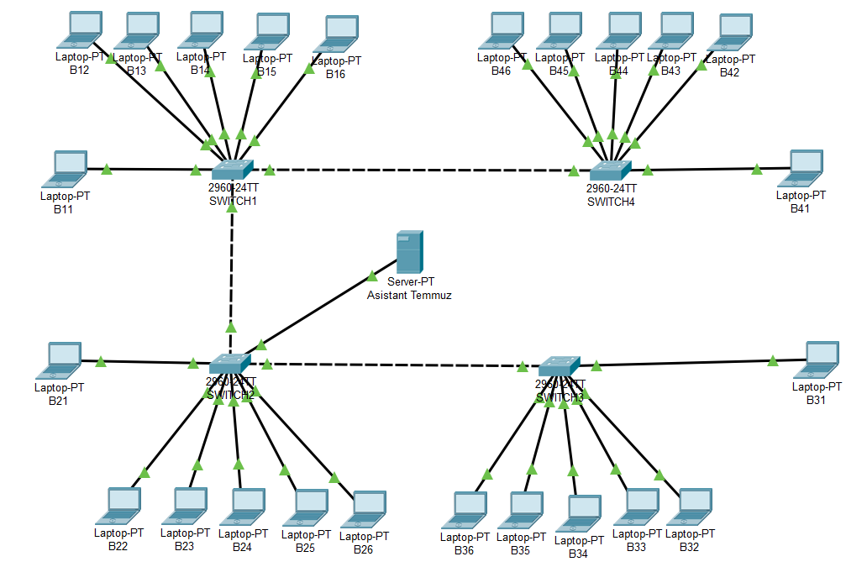

Before starting the details I want to show that Asistant Temmuz server’s IP address and how I prepared the DNS.In addition to that we should have 4 links between between hubs and switches but as you can see I only have 3 link.This is beacuse of the avoid the infinite loops.

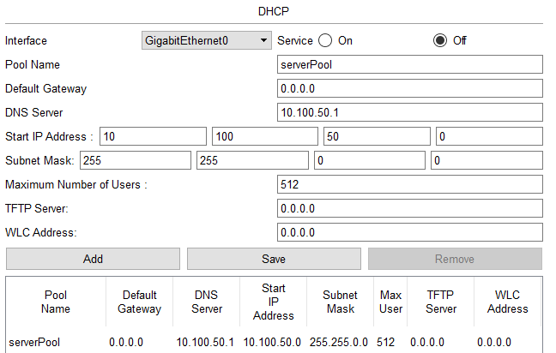

Here is the Web sites that I will use in the assingment.I added several web pages and also the web pages uses same IP.We dont have to give address to the gateway if you dont have router.

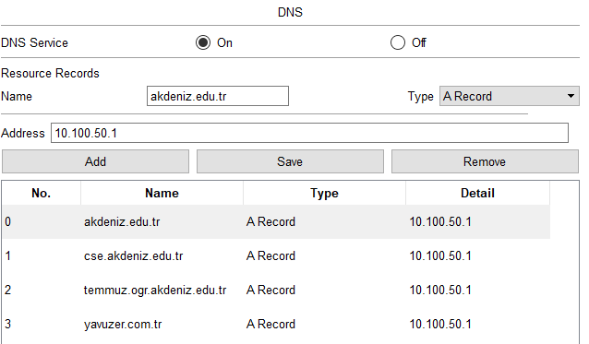

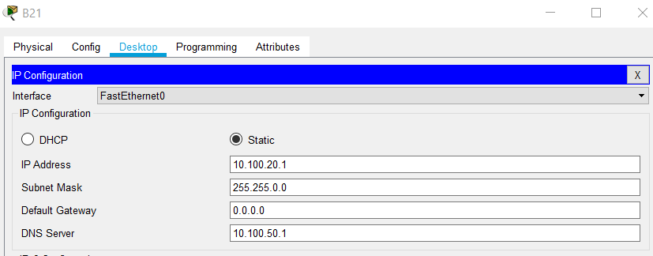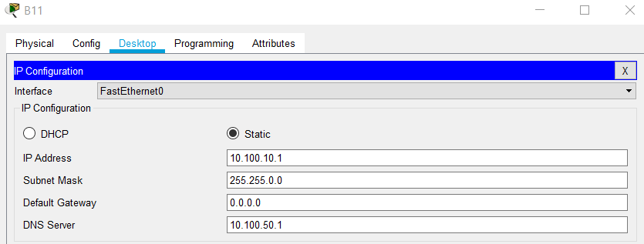In the figures below you will see that special computers IP configurations.While I was giving the IP addreses. I didnt use DHCP but using DHCP would make that configurations very easy.I just wanted to learn step by step how to assing the IP’s.

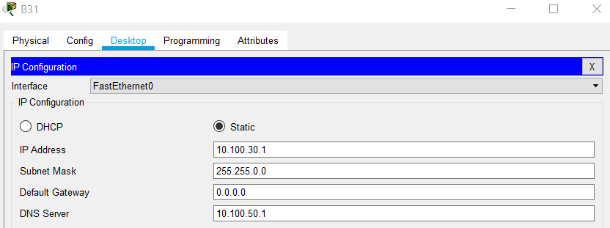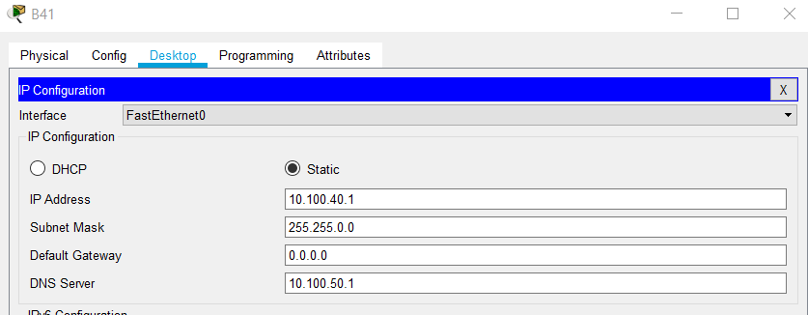

First of all I want to look at the which devices connected to each other by looking at the ARP table using “arp -a” command.As you can see the figure in below that devices is not connected right

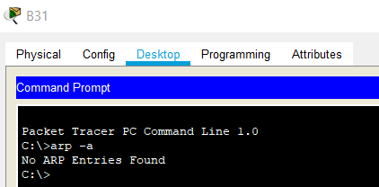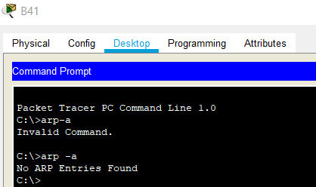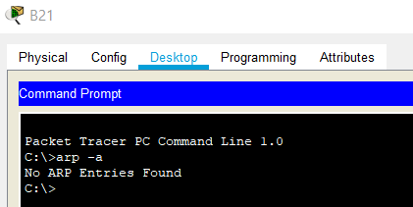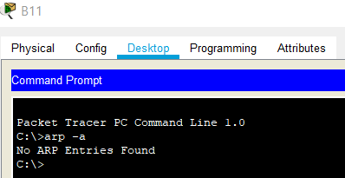

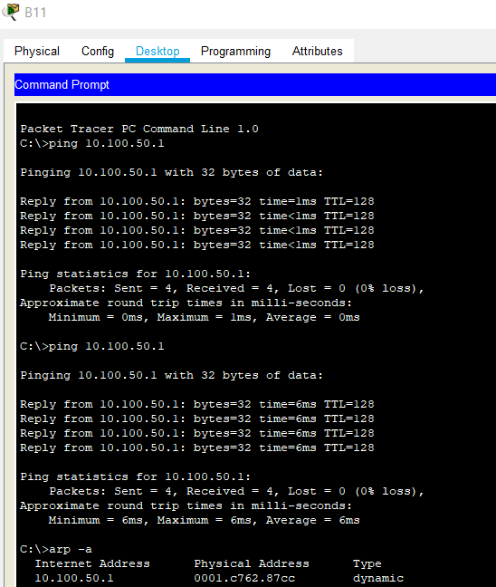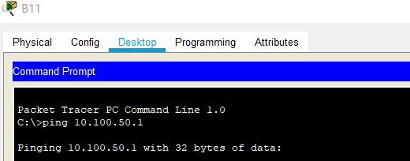We looked at the ARP table.As it shows that devices isnt connected.So we should connect that devices by pinging.To understand what’s going on whe should look at the Simulation Mode.

As we can expect in our ARP table we connected to B11 to Assistant-Temmuz server.

**SENDING PACKET IN HUBS(STEP BY STEP)**

This example for the B11 which pings to the Server Temmuz.At that step we can say that B11 sending a packets to the assistant computer.To do that PC sends ARP to the first Hub.

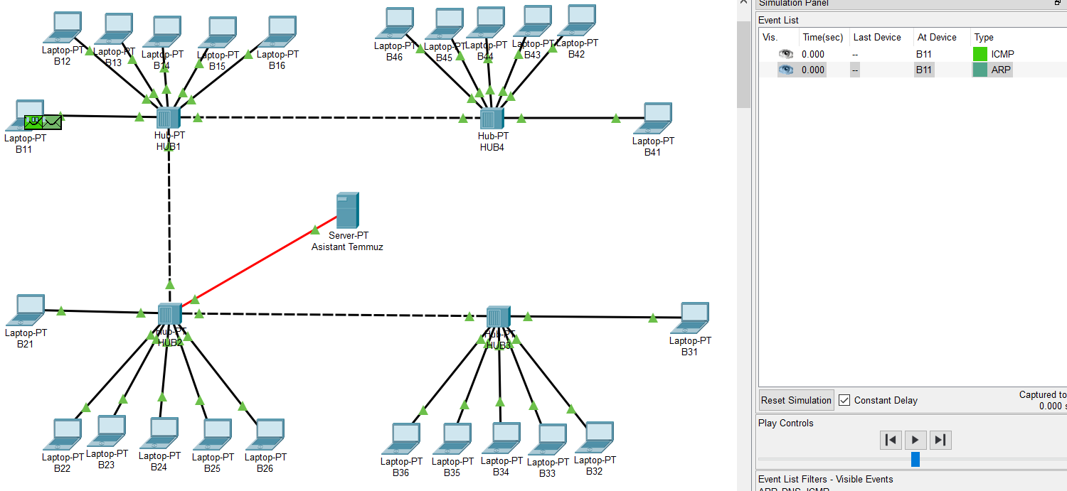

First Hub received that message.

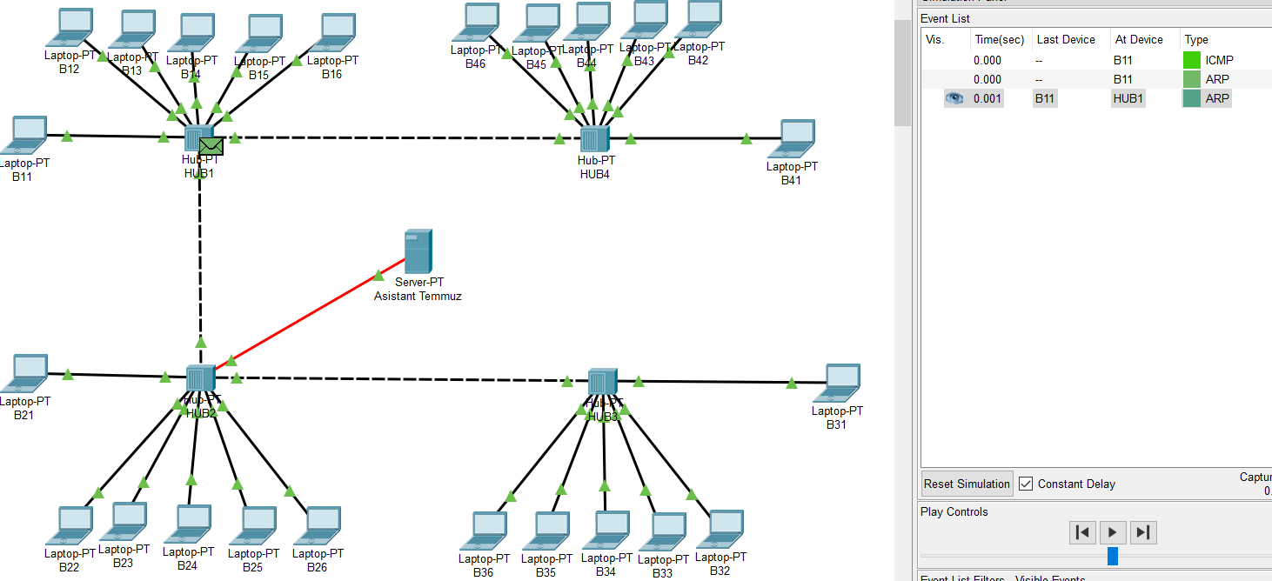

Hubs do not track the path.Hubs are not as intelligent as switches.They are always sending to the links which they are attached to.In that step HUB1 connected to B12,…,B16 and HUB2.As we remember our destination is Asistant Temmuz Server so HUB2 is our new step.

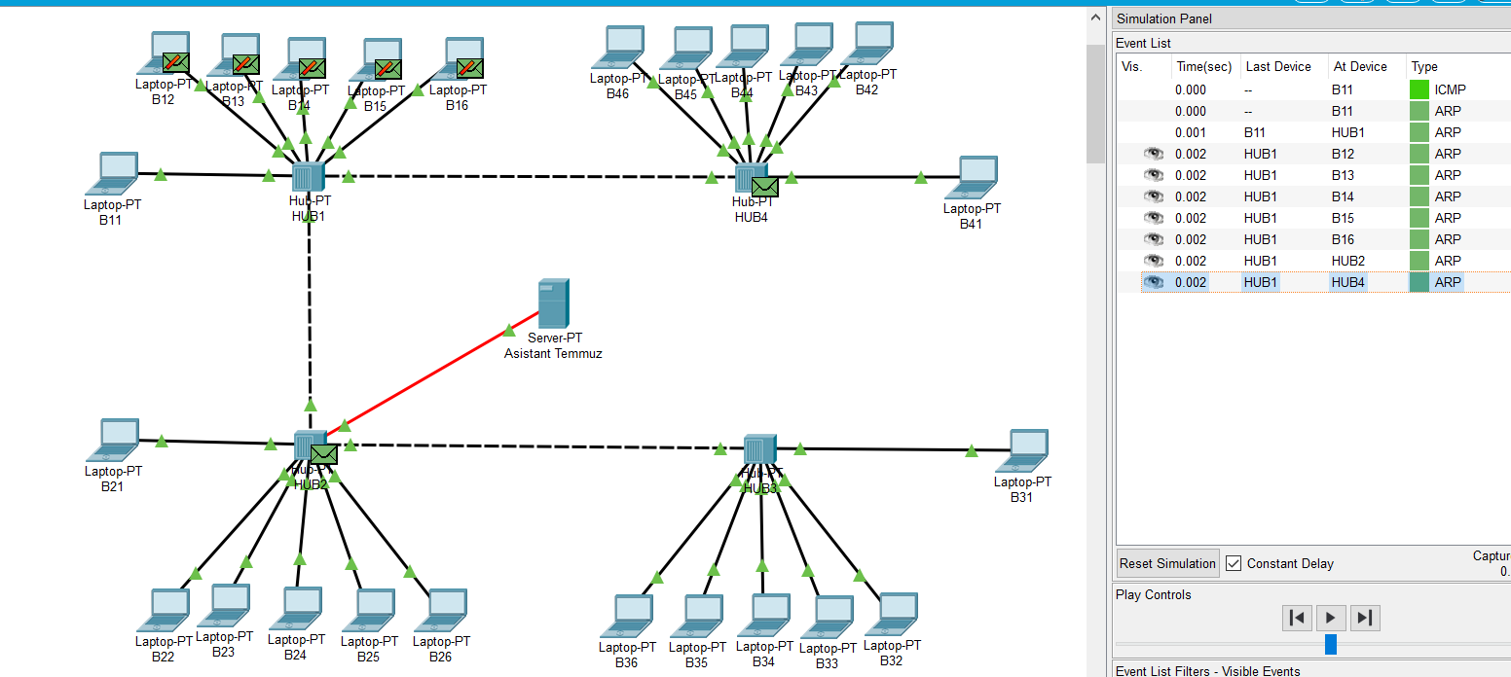

In that step Asistant Temmuz Server recived from the HUB2. Other part of the network recived too, but they are not our destination so they just dropped.Sending to the all links is the HUB’s characteristics.We see that in the below

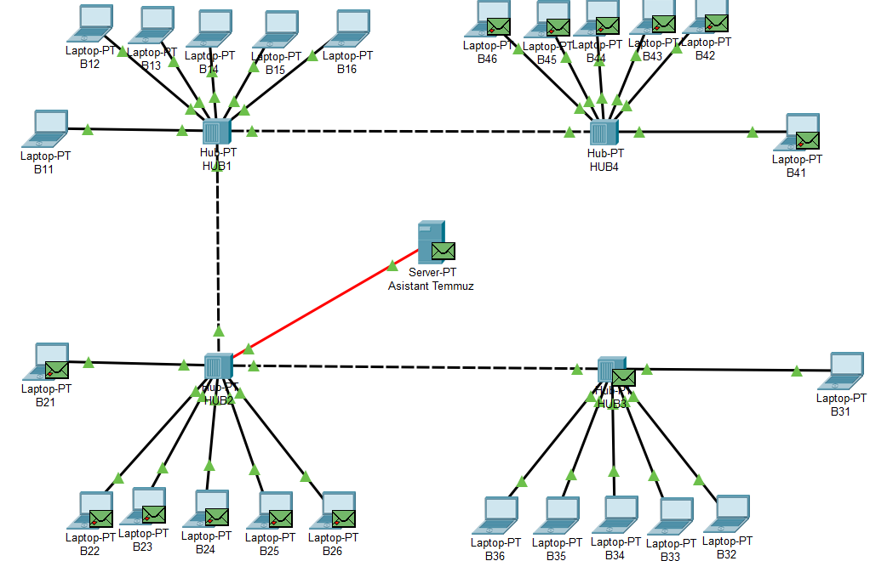

Server recived but it have to respond back. Server Responded back to HUB2.HUB2 Received.

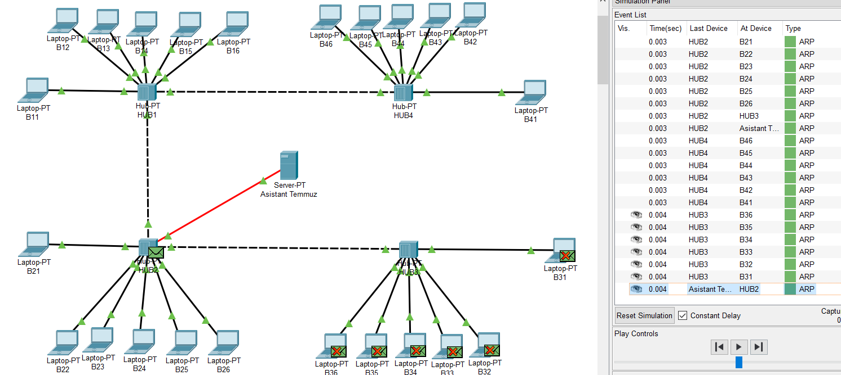

HUB2 Sended back to all of his links.HUB1 just received.

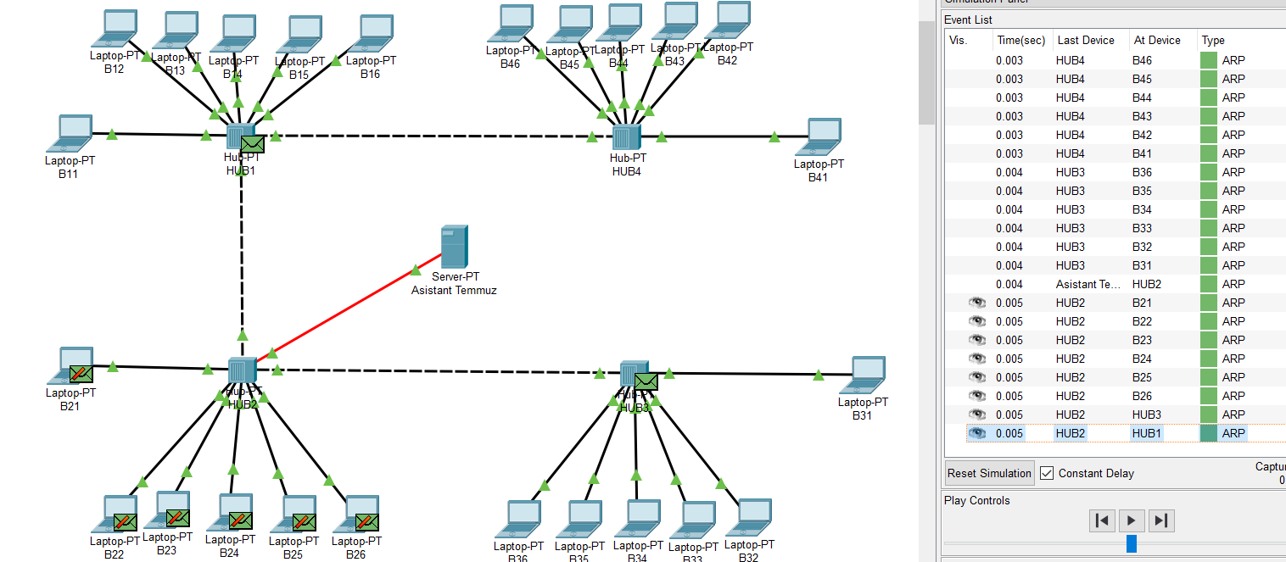

HUB1 Responded back to computer B11.Our cycle is completed.In the result of that B11 Connected to Asistant Temmuz.What I try to mean is that B11s Arp table has Assistant Temmuz’s Adress

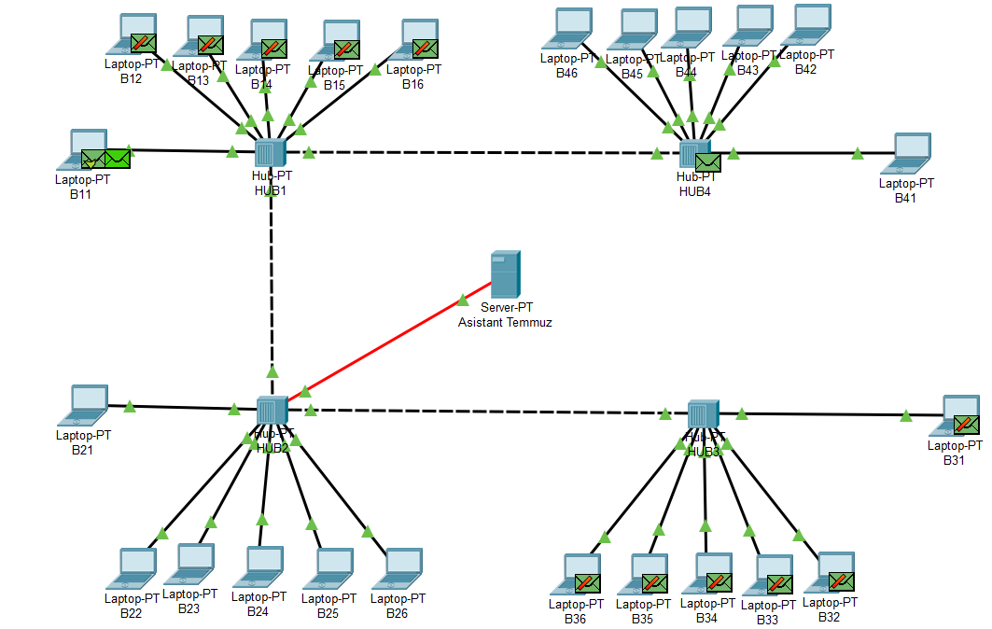

Other connections like B21 to Assistant Temmuz , B31 to Assistant Temmuz,B41 to Asistant Temmuz.Will be same as the B11 to Asistan Temmuz Server.I will just add the result of that connections because it will be hard to do that steps for all computer.

**PROOF’S FOR OTHER PART OF THE NETWORK THAT ARE WORKING**

This for the B21.Start and the result of the connection.This is for the proof that part of network is working

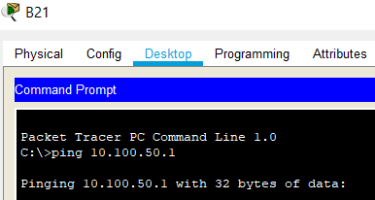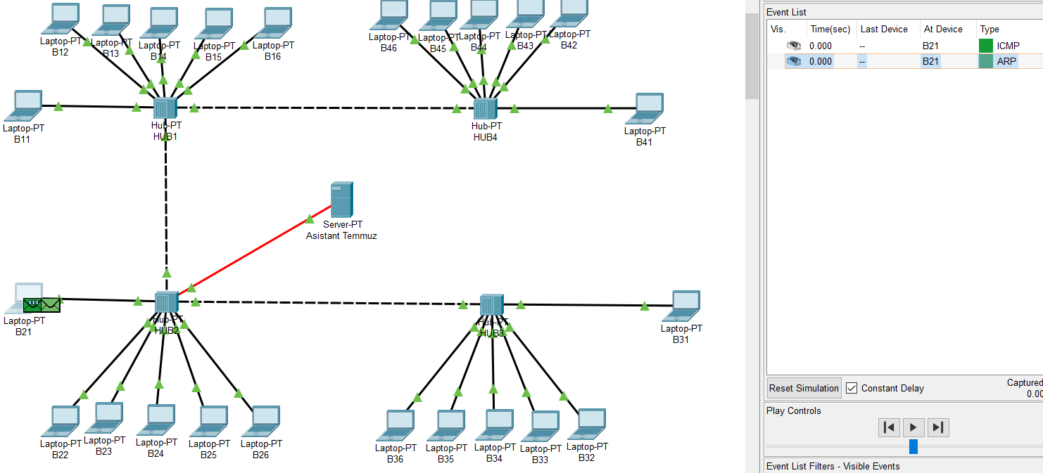

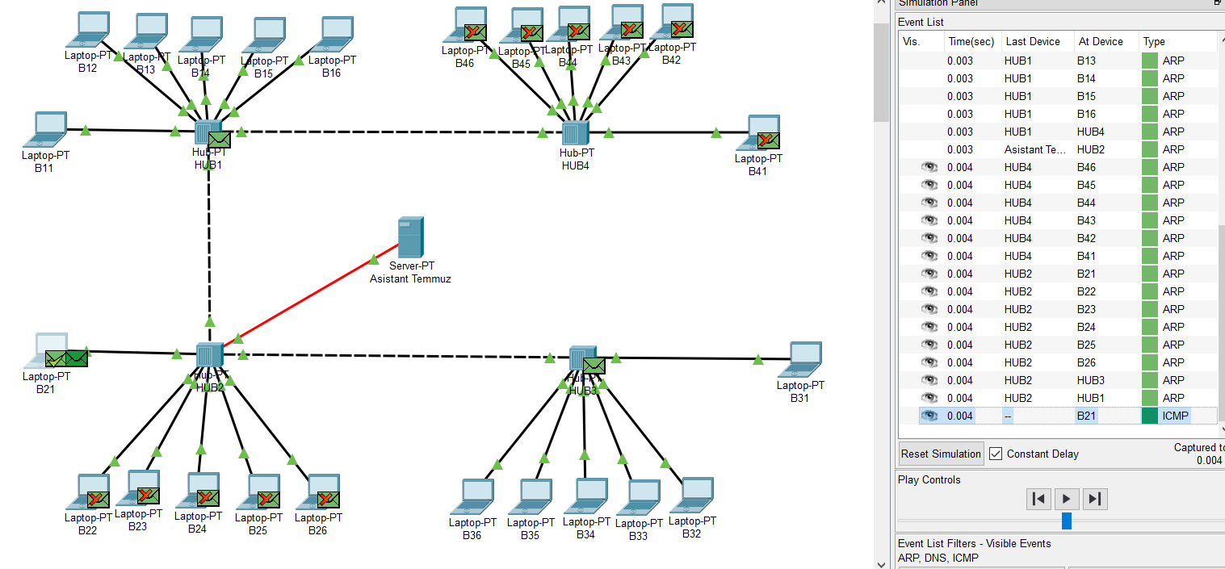

This if for B31.Start and the Result of the connection.This is for the proof that part network is working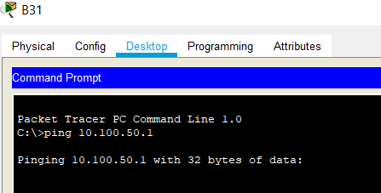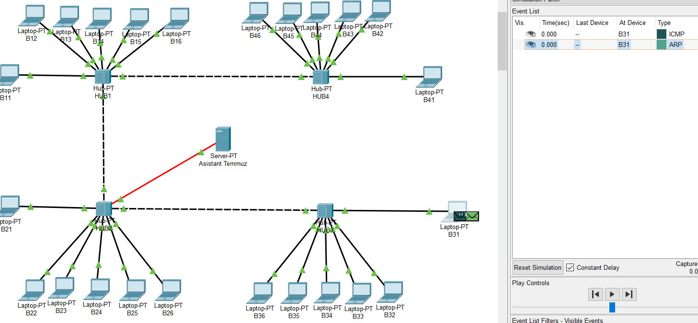

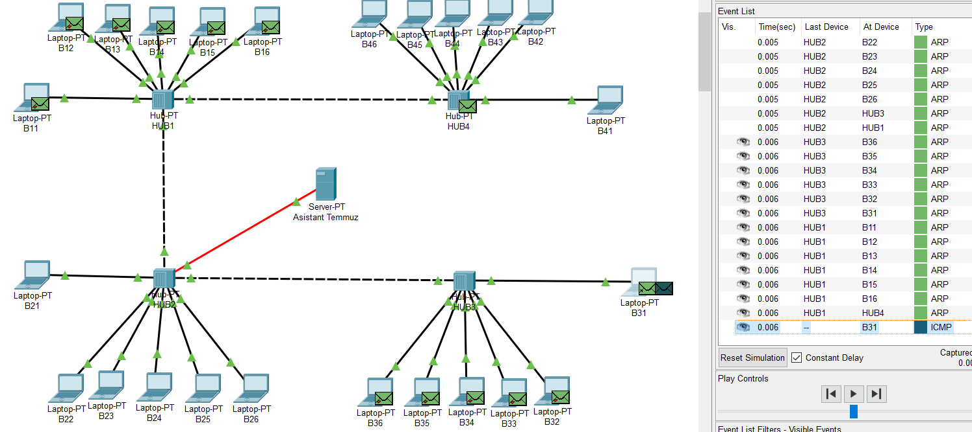

This if for B41.Start and the Result of the connection.This is for the proof that part of network is working

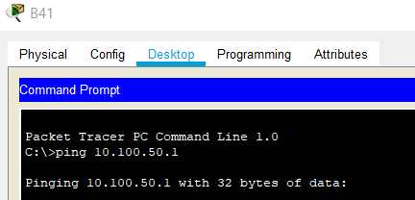

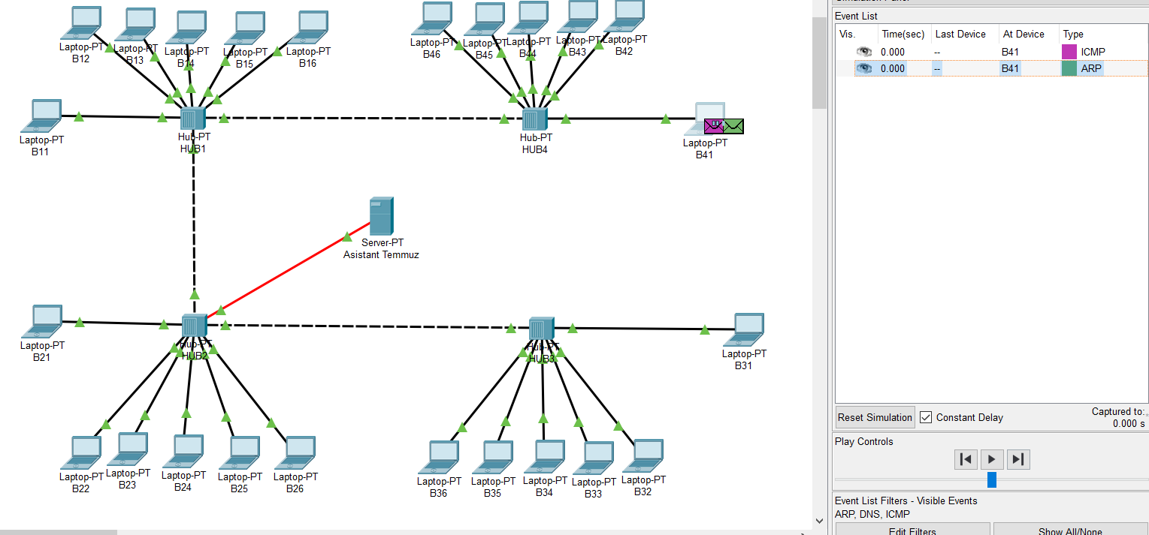



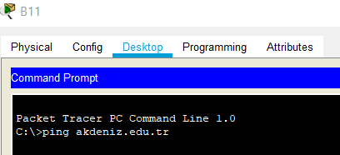**ANOTHER PROOF FOR THE DNS IS WORKING**

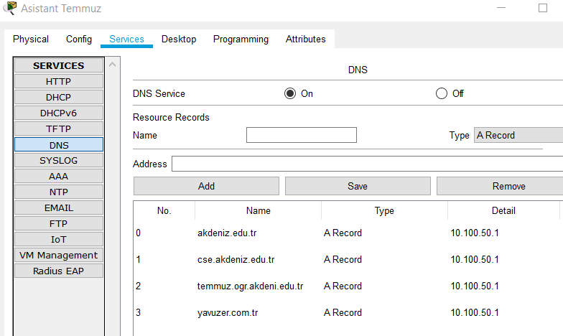

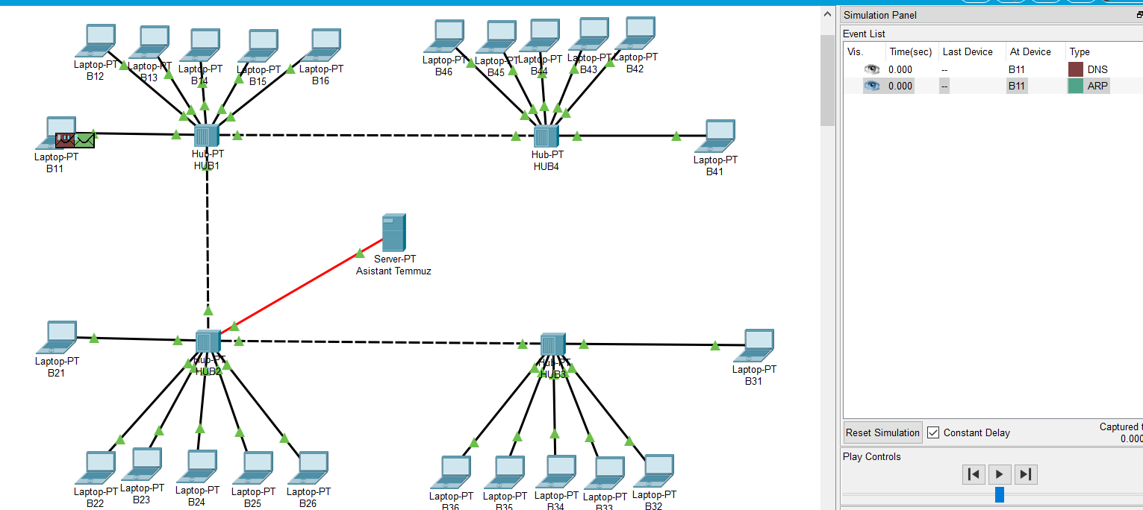

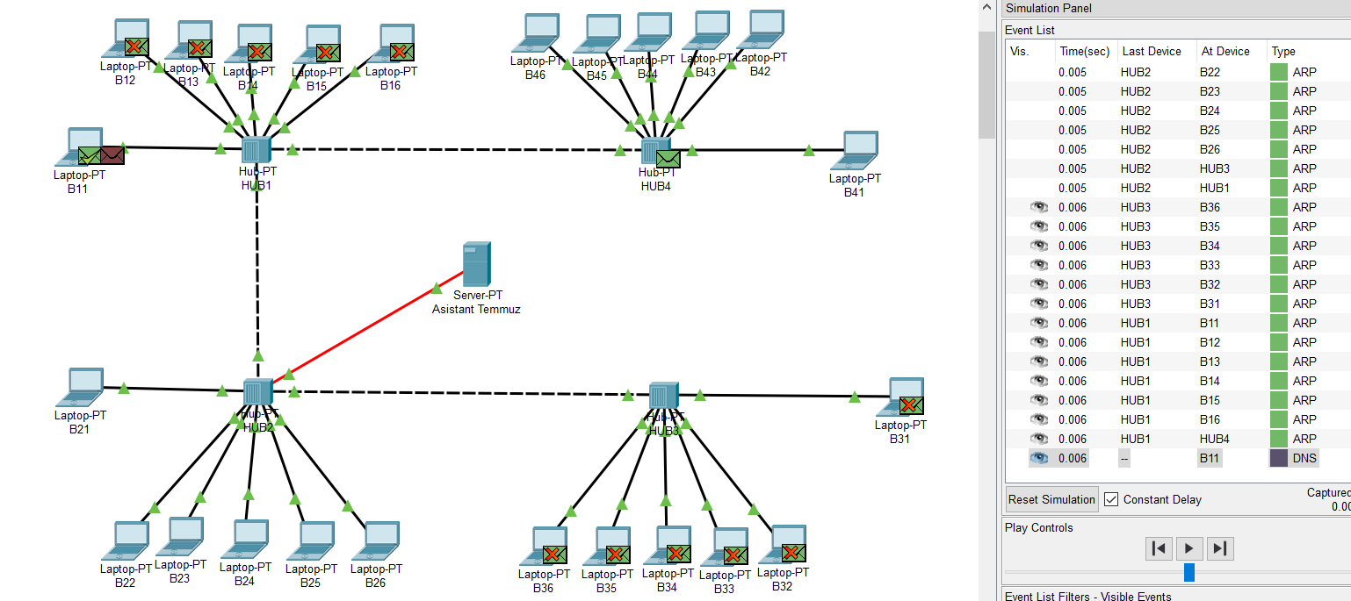

SENDİNG PACKETS IN SWITCH

In this part of the experiment we want to use switchs for that network.All of that experiment’s steps expained in the below with the Secrenshots.In this experiment I used B41 computer to connect Assistan Temmuz Server

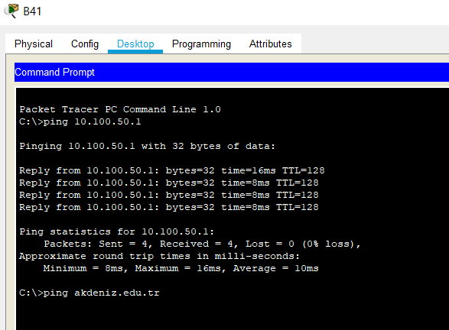

We just sent a ping to Assistan Temmuz server from the B41

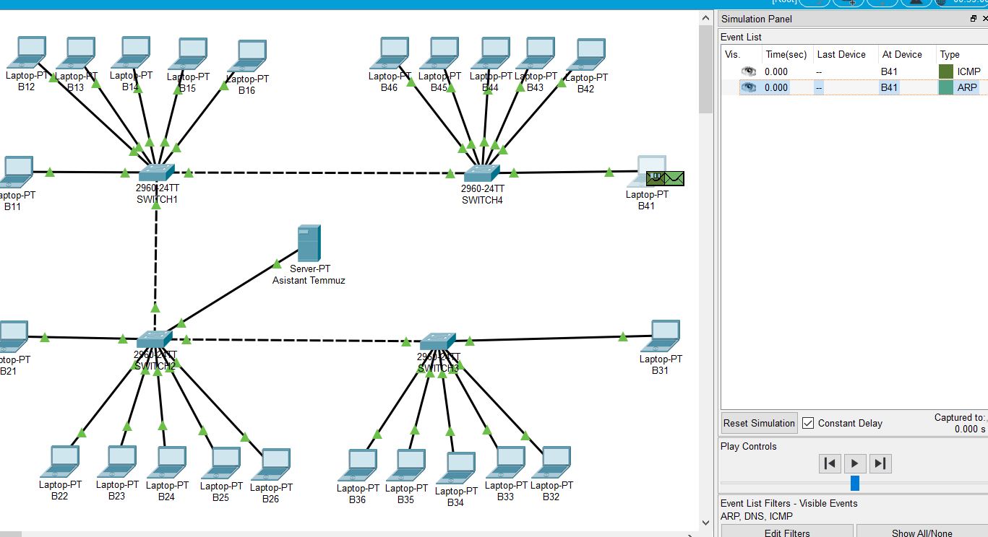

At that step as we can see our connection was the same as the hubs because our switch’s does not know the which links should use.In that step switchs uses the same methods like the Hubs.

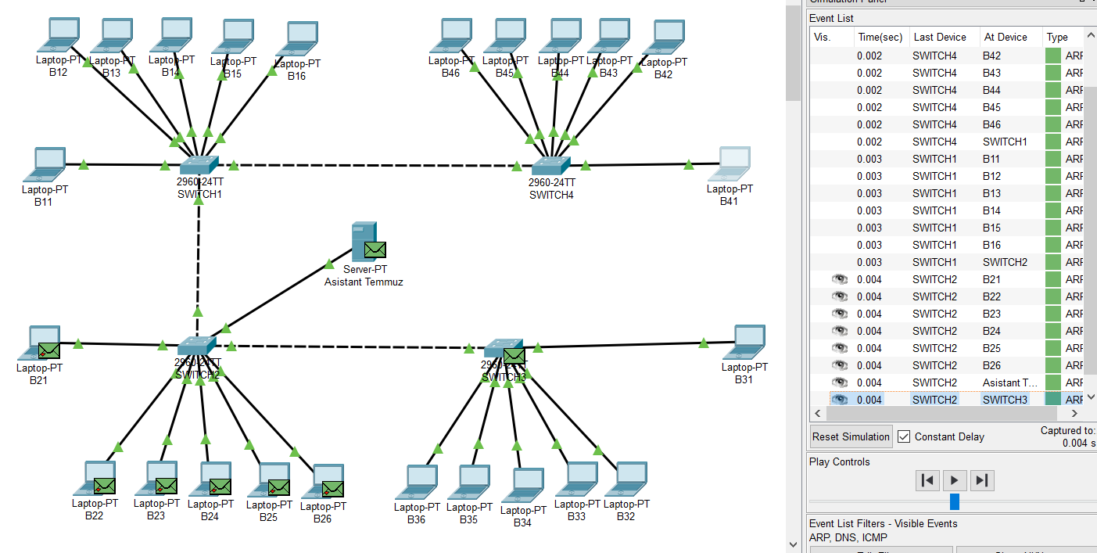

In that step B41 created the connection between the Assistant Temmuz Server.Other way of the say that if B41 wanted to send again , switch knows which the path they should use right now.

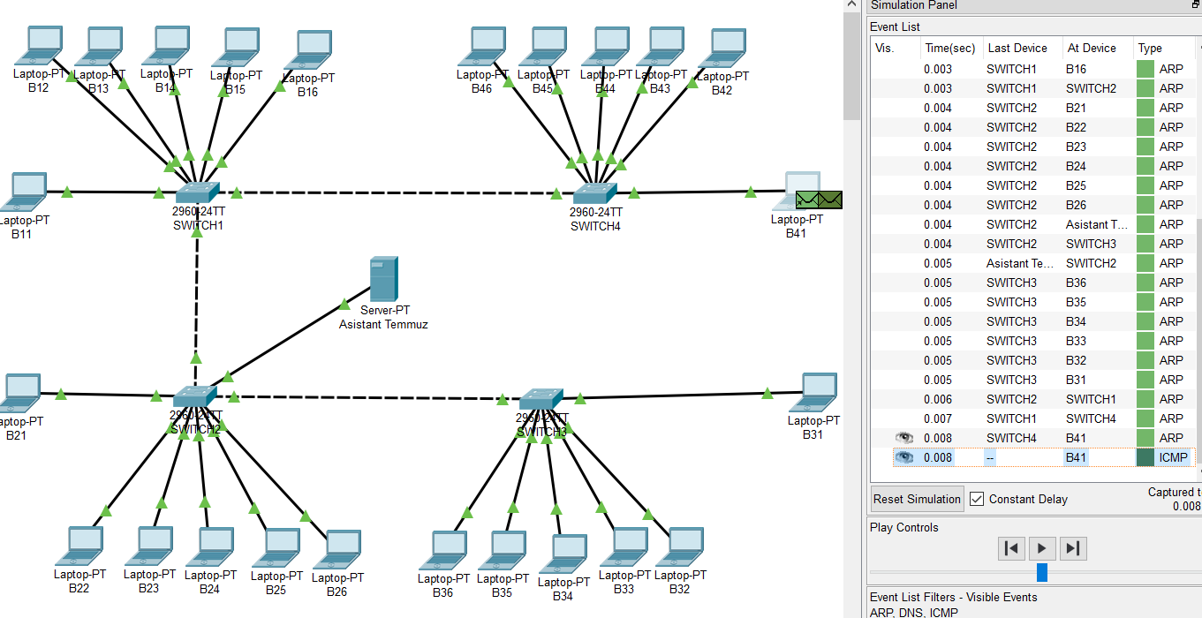

As I expained at the above,B41 send request and the switchs know the which links the should transfer the packets.Asistant Temmuz Server Received.

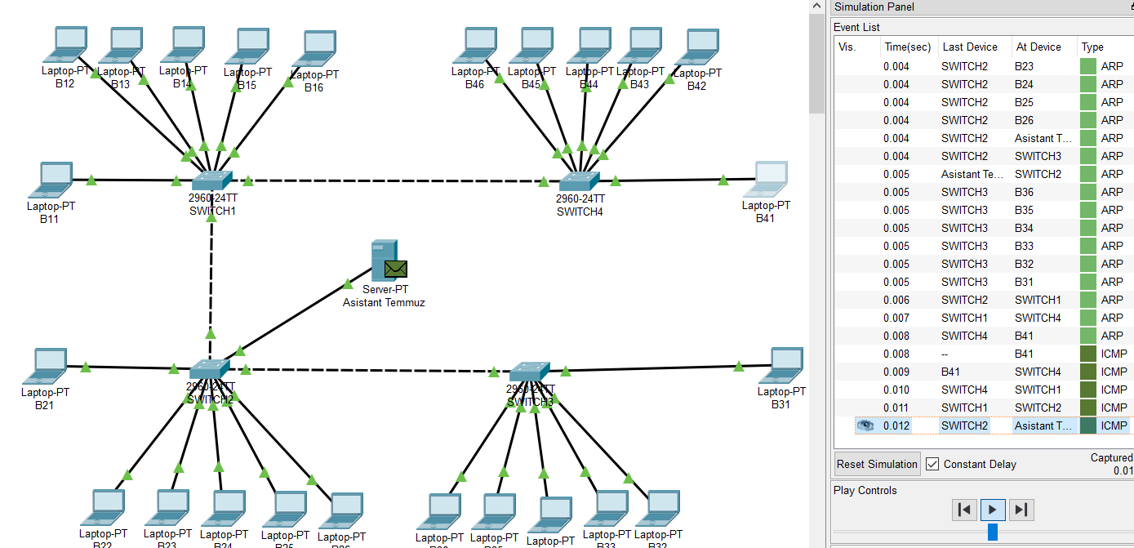

In that part B41 can send ICMP directly without repated broadcast.This is the main difference between hubs and switchs

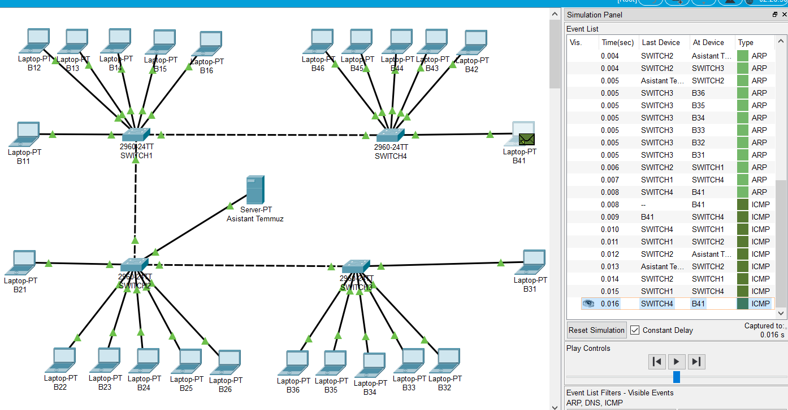

In that part B41 wanted to look at akdeniz.edu.tr.So B41 just send the ping.As you can see our path is know by the devices.Result of that B41 sends the DNS request to the Assistant Temmuz Server

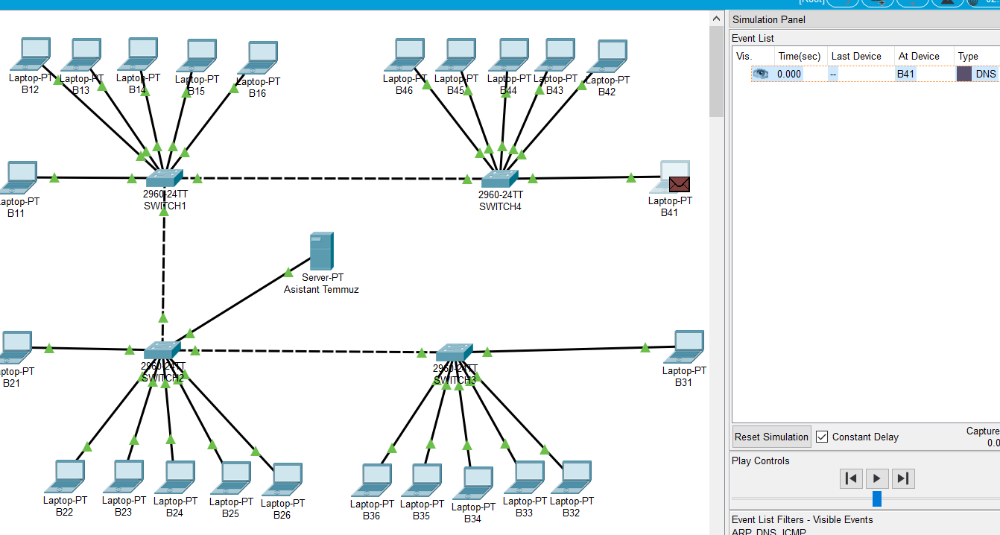

Result of that , B41 got the information which it wanted to get from the akdeniz.edu.tr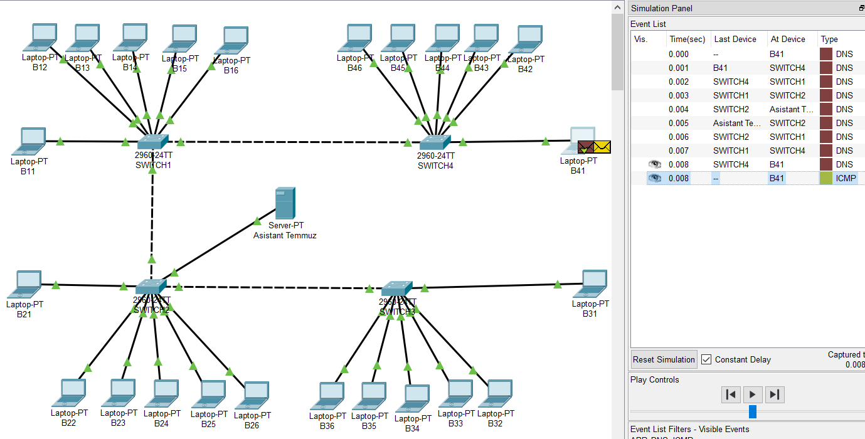

**CONCULUSION**

Depends on your requirement you can choose Hub or Switch.Hub’s are not useful for universties or big companies because Hub do not store the path of the devices.Switch can be used by all kind of networks.Hubs are slow because of their nature when we compare with the Switchs.Hubs dont have MAC tables.Hubs are using broadcasting this makes hubs entry level devices.Switch are more intelligent from the Hubs.Hubs are mostly obsolote devices that you dont want to use in your network this days because it has many disadvantages.

**IP RECORD OF B11 B21 B31 B41**