RE-Assist Assessment
Gaurab Baral

Repository: https://github.com/TempGaurab/Assessment_Gaurab
Project Overview:
This project implements a customized AI-based treatment plan generator using the Gemini API. The agent takes structured inputs on symptoms, physical condition, and location, and returns a medically relevant plan with suggested actions, local care options, and clear justifications. Built using vanilla Python (no no-code tools), this agent simulates a virtual health assistant suitable for triage support or patient-facing tools.
I also built a front-end website using React and it is deployed on the web where you can view it at https://assessment-gaurab.vercel.app/ . I am not that experienced with React, so it is just a base version as of now. I also did the same thing with Lang chain but sticking with regular Gemini as it is faster. For testing the project, I just stick with python for now. It is the same exact code and the same logic in both react-JavaScript and python.
Pipeline Overview:
The pipeline revolves around Google’s ‘Gemini’. I chose Gemini as it has a high token window and is also free. You can see how I thought about the project from the two notebooks that I created and how to tackle those problems. The first one is ‘learning_the_problem& gemini.ipunb’ and the second one is ‘langchain_basics.ipynb’. With these two files into consideration, I finally put everything into a third file called python_File.ipynb where I check it for one last time.
Lastly, I made an OOP design and this it the best version that generated the customized treatment plan which can be viewed in assessment.py. Here is the design of the pipeline:
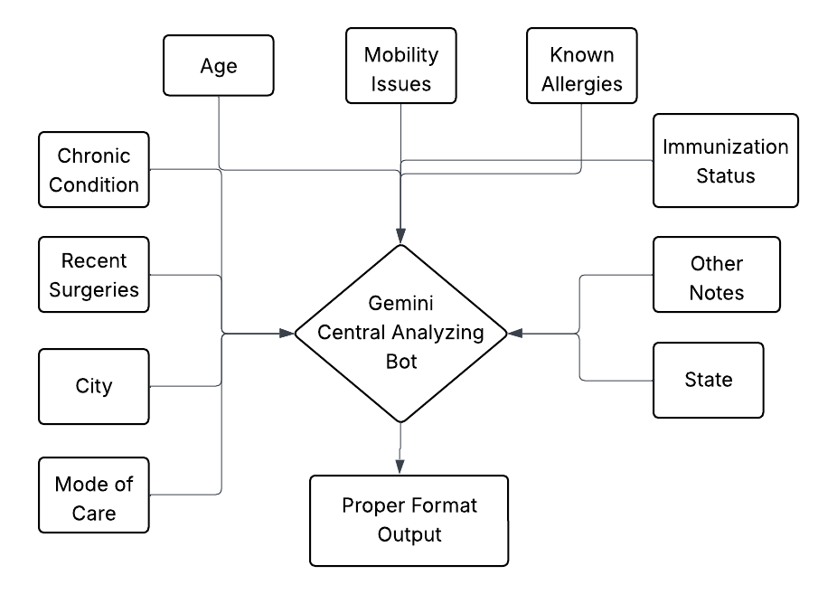
Because of exams and limited timeframe, I weas only able to test with Gemini but where can be multi-agentic approach to do this. User inputs the input and they get the output in a format like this.
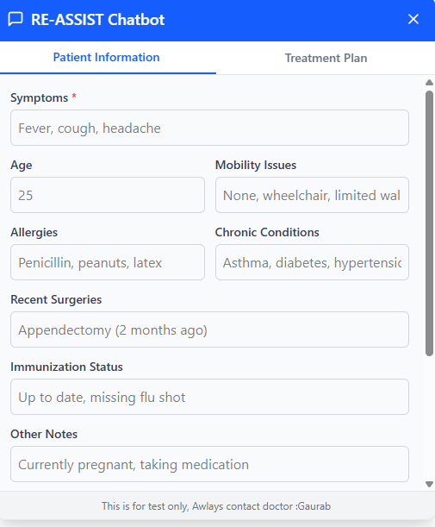

Of course, further work can be done to further improve the output. The input shown on top is of the react web-app which you can access at https://assessment-gaurab.vercel.app/. The python version of the app also calculates distance based on latitude and longitude analysis It automatically converts City + State into (Latitude, Longitude) using OpenStreetMap.

Quantitative Evaluation:
- BLEU Score:
  - BLEU measures the similarity between the generated treatment plan and a reference plan by calculating precision on overlapping n-grams (phrases or words).
  - A score above 0.6 is considered good.
  - It works by comparing the AI-generated plan with a set of reference treatment plans prepared by medical experts.
  - Since I was not provided with the medical expert’s answers, this is not something that I can calculate right now.
- In terms of other similarity metrics, I can use Cosine or Jaccard similarity functions to obtain a similarity score, which serves as an alternative approach to BLEU.

Qualitative Evaluation:
- Human Feedback
  - A real-world evaluation by healthcare professionals to assess the usefulness, clarity, and medical accuracy of the treatment plan.
  - Feedback should be collected on a Likert scale (1-5), with a score of 4 or higher considered acceptable. Key questions can focus on:
    - Is the plan clinically relevant?
    - Are the location-specific suggestions appropriate?
    - Is the language easy to understand for the patient?
For the Qualitative Evaluation, we can select a bunch of response from the chatbot and user interaction and then submit to the professional for them to review. This can be done by storing the data in a database like MongoDB or any postgre SQL databases.

Edge Cases and Failure Conditions:
For the python based code, Most of the functions have error handling thus can handle any runtime errors although high likely, that it wont be the case. For the python based application, a sample output terminal is shown below:
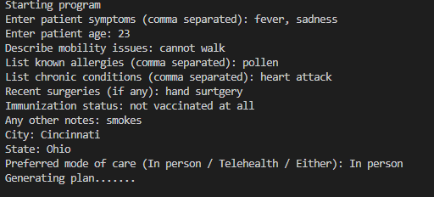
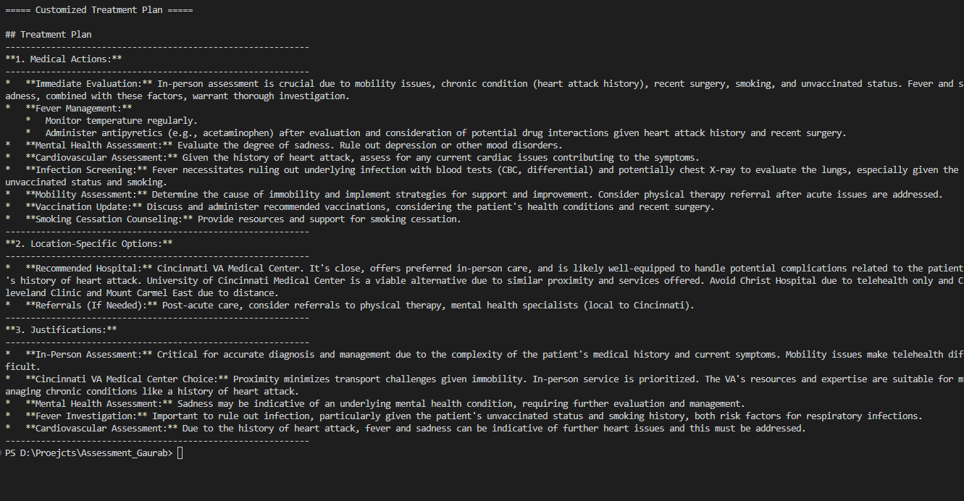

Another python file called TestTreatmentPlanAssistant is created which test each of the functions independently. The next few images would be the test cases of these programs. This tests 5 different user inputs for each of the functions defined.
Lastly, as requested here are 3 sample cases of the code working in the python version. It saves the report to treatment_plans_report.txt which is a text file. I have attached the file with this code.

How to run the program in your environment? ->Refer to Readme.tsxt for this

