Computer Network Chapter 3

Assignment

苏建锐 10195101553

3-1

The output should be A B ESC ESC C ESC ESC ESC FLAC ESC FLAG D .

3-2

1. If the transmitting time is quite long, an open-loop protocol can save a lot of time because the sender doesn't need wait for the feedback.

2. If the chance of error is low, the open-loop protocol is more efficient.

3-3

Calculating process:

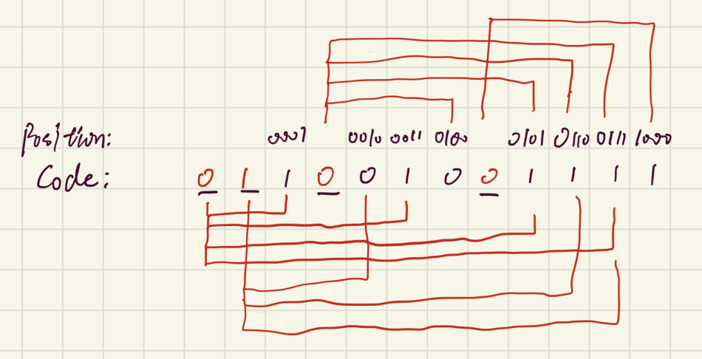

So the value should be 011001001111.

3-4

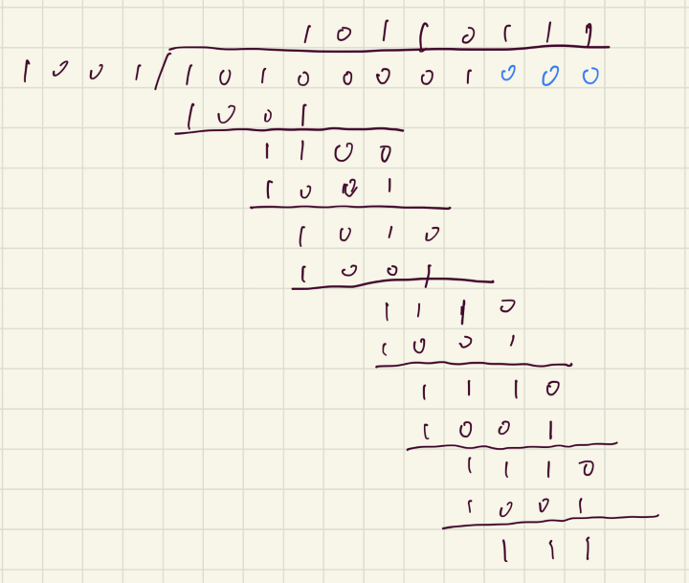

So the reminder is x^2+x+1.

3-5

Adding the 4-bit words yields 1001 + 1100 + 1010 + 0011 = 100010. The carry is added to the LSBs: 0100. The one’s complement value is then 1011, which is the checksum.

And indeed, the check works out as expected. Adding the data and the checksum yields 1001 + 1100 +

1010 + 0011 + 1011 = 101101, which gives 1111 (carry) and thus 0000 (negation).

3-6

Bit rate = 4 kbps One-way propagation delay = 20 ms E!iciency = Transmission time of packet/(Transmission time of packet + 2 \* Propagation delay) To reach the e!iciency of at least 50%, let x be the frame size.

So 0.5 = a /(a + 2 \* 20) a = x / 4000 \* 1000 Therefore, Minimum frame size = x = 160bit.

3-7

Protocol 5 here refers to the Go-Back-N Protocol.

The propagation time = 6 \* 3000 = 18 ms, the transmission speed for T1 Trunk is 1.544Mbps = 1544 bits/ms

Transmission time for a frame is 64byte \* 8 / 1.544 \* 10 ^ 6 \* 1000 + PROPAGATION TIME = 0.3ms + 36ms = 36.2

During the 0.3 ms, frames to be sent: 1544 \* 36.3 / (64 \* 8) = 109. Because 2 ^ 7 = 128 > 109, so 7 bits are needed for the sequence number.

3-8

Protocol 6 here refers to the Selective Repeat Protocol.

Yes, if there isn't an auxiliary timer҅ when a batch of frames arrives and all acknoledgements were lost, the sender will just repeatedly send the first frame again and again because it doesn't know it's already sent and have no time limit, thus there will be a deadlock.

3-9

Protocol 6 here refers to the Selective Repeat Protocol.

Yes. These code were used for placing the incoming acknowledgements. If there's not this, the sender would keep timing out and no further frame will be sent.

3-10

The time needed for trasmitting a frame: 1000 bits / 1Mbps = 1 ms The time needed for the first frame to arrive: 270 ms The time neede for the acknowlegement to send: 1ms The time needed for the feedback acknowlement to arrive: 270ms

During this time cycle, 542 ms is needed in total.

If there were k frames are sent in the 542 ms, the efficiency is k/542.

a) k = 1, efficiency = 1/542; b) Protocol 5 refers to Go-Back-N Protocol, as three-bit sequence number is used, there can be 7 frames be sending, efficiency = 7/542; c) In the Selective Repeat Protocol, the size of window should be no larger than half of the sequence number, so k = 4, efficiency = 4/542.