UCSD CSE140L Spring 2014

**LAB#4 Report**

Demonstration Date : 6 / 2 /14 Student CID________268_________________

Student Name: ________Kieth__________________________________Vo__________________

First M.I. Last

**TED Submission Date & Time :**

(FILLED BY Student BEFORE DEMO) (*** FILLED BY TUTOR/INSTRUCTOR ***)

**Self-test Report** Demo Reviewer

Name : ____________________________

Working Not working **Demo** score **Report** score

**Part1**: _________ ________ _________/3 Procedural Description( )/1

**Part2**: _________ _________ _________/3 Verilog HDL codes ( )/1

**Part3**: _________ _________ __________/3 State Diagram ( )/2

**Part4**: _________ _________ __________/3 Compilation Report ( )/1

(Screen copy)

**Part5**: _________ ________ _________ /3

**Subtotal**  **Subtotal**

________/15 _____________/5

**TOTAL Score:** **________________/20**

* 1. For the first part I made a 4 bit variable and initialized it to 5. Then I had another variable which would be used to hold the value of the XNOR operation. In execute_random I set register_A to be equal to the 4 bit variable and then shifted the variable left by one and set the least significant bit to the value of the XNOR operation. Finally I fetched the next state.
  2. For this part I added the operation for memory_address_register to update to the memory_data_register for execute_addind. Then I just called the fetch state and then the add state in order to get the data and add it to register_A.
  3. For this part I did the same thing as part 2 except this time the memory address register was changed to program_counter + instruction_register[7:0] for execute_addpcr.
  4. I looked through the code and found that SW[7] was a conditional statement for the clock. Then I tested it after loading the board and found that it did indeed freeze the clock.
  5. For this part I looked into the clock module and saw when the clock was reset. I added an input to the module which was SW[8] and then I added an if statement for SW[8]. If it was off then everything stayed the same. If it was on then the clock would reset at the DIV_CONST variable divided by 5 which meant that it was 5 times faster.

// 7-seg display mux

always @ (*)

begin

case (SW[2:0])

3'b000: hexdata <= 16'h0268;

3'b001: hexdata <= register_A ;

3'b010: hexdata <= program_counter ;

3'b011: hexdata <= instruction_register ;

3'b100: hexdata <= memory_data_register_out ;

3'b111: hexdata <= out;

default: hexdata <= 16'h0268 ;

endcase

end

clock_divider clk1Hzfrom50MHz (

CLOCK_50,

KEY[3],

clk_1Hz,

SW[8]

);

// State Encodings

parameter reset_pc = 5'h0,

fetch = 5'h1,

decode = 5'h2,

execute_add = 5'h3,

execute_store = 5'h4,

execute_store2 = 5'h5,

execute_store3 = 5'h6,

execute_load = 5'h7,

execute_jump = 5'h8,

execute_jump_n = 5'h9,

execute_out = 5'ha,

execute_xor = 5'hb,

execute_or = 5'hc,

execute_and = 5'hd,

execute_jpos = 5'he,

execute_jzero = 5'hf,

execute_addi = 5'h10,

execute_shl = 5'h11,

execute_shr = 5'h12,

execute_sub = 5'h13,

execute_random = 5'h14,

execute_addind = 5'h15,

execute_addpcr = 5'h16;

reg [3:0] randomNumber = 4'b0101;

reg [1:0] placeHolder;

// Execute random

execute_random:

begin

register_A <= randomNumber;

placeHolder = randomNumber[3] ~^ randomNumber[2];

randomNumber = randomNumber << 1;

randomNumber[0] = placeHolder;

state <= fetch;

end

// Execute addind

execute_addind:

begin

state <= fetch;

state <= execute_add;

end

// Execute addpcr

execute_addpcr:

begin

state <= fetch;

state <= execute_add;

end

execute_random: memory_address_register <= program_counter;

execute_addind: memory_address_register <= memory_data_register;

execute_addpcr: memory_address_register <= program_counter + instruction_register[7:0];

8'b01000101:

state <= execute_random;

8'b01000110:

state <= execute_addind;

8'b01000111:

state <= execute_addpcr;

module clock_divider (clk, rst_n, clk_o, fast);

parameter DIV_CONST = 10000000;

input clk;

input rst_n;

input fast;

output reg clk_o;

reg [31:0] div;

reg en;

always @ (posedge clk or negedge rst_n)

begin

if (!rst_n)

begin

div <= 0;

en <= 0;

end

else

if (!fast)

begin

begin

if (div == DIV_CONST)

begin

div <= 0;

en <= 1;

end

else

begin

div <= div + 1;

en <= 0;

end

end

end

else if (fast)

begin

begin

if (div == (DIV_CONST / 5))

begin

div <= 0;

en <= 1;

end

else

begin

div <= div + 1;

en <= 0;

end

end

end

end

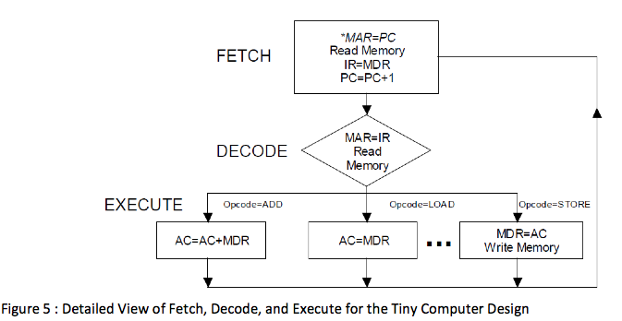

Opcode = RANDOM OPCODE = ADDIND OPCODE = ADDPCR

AC <= 4-bit random number AC <= AC + IMA AC <= AC + PCR

