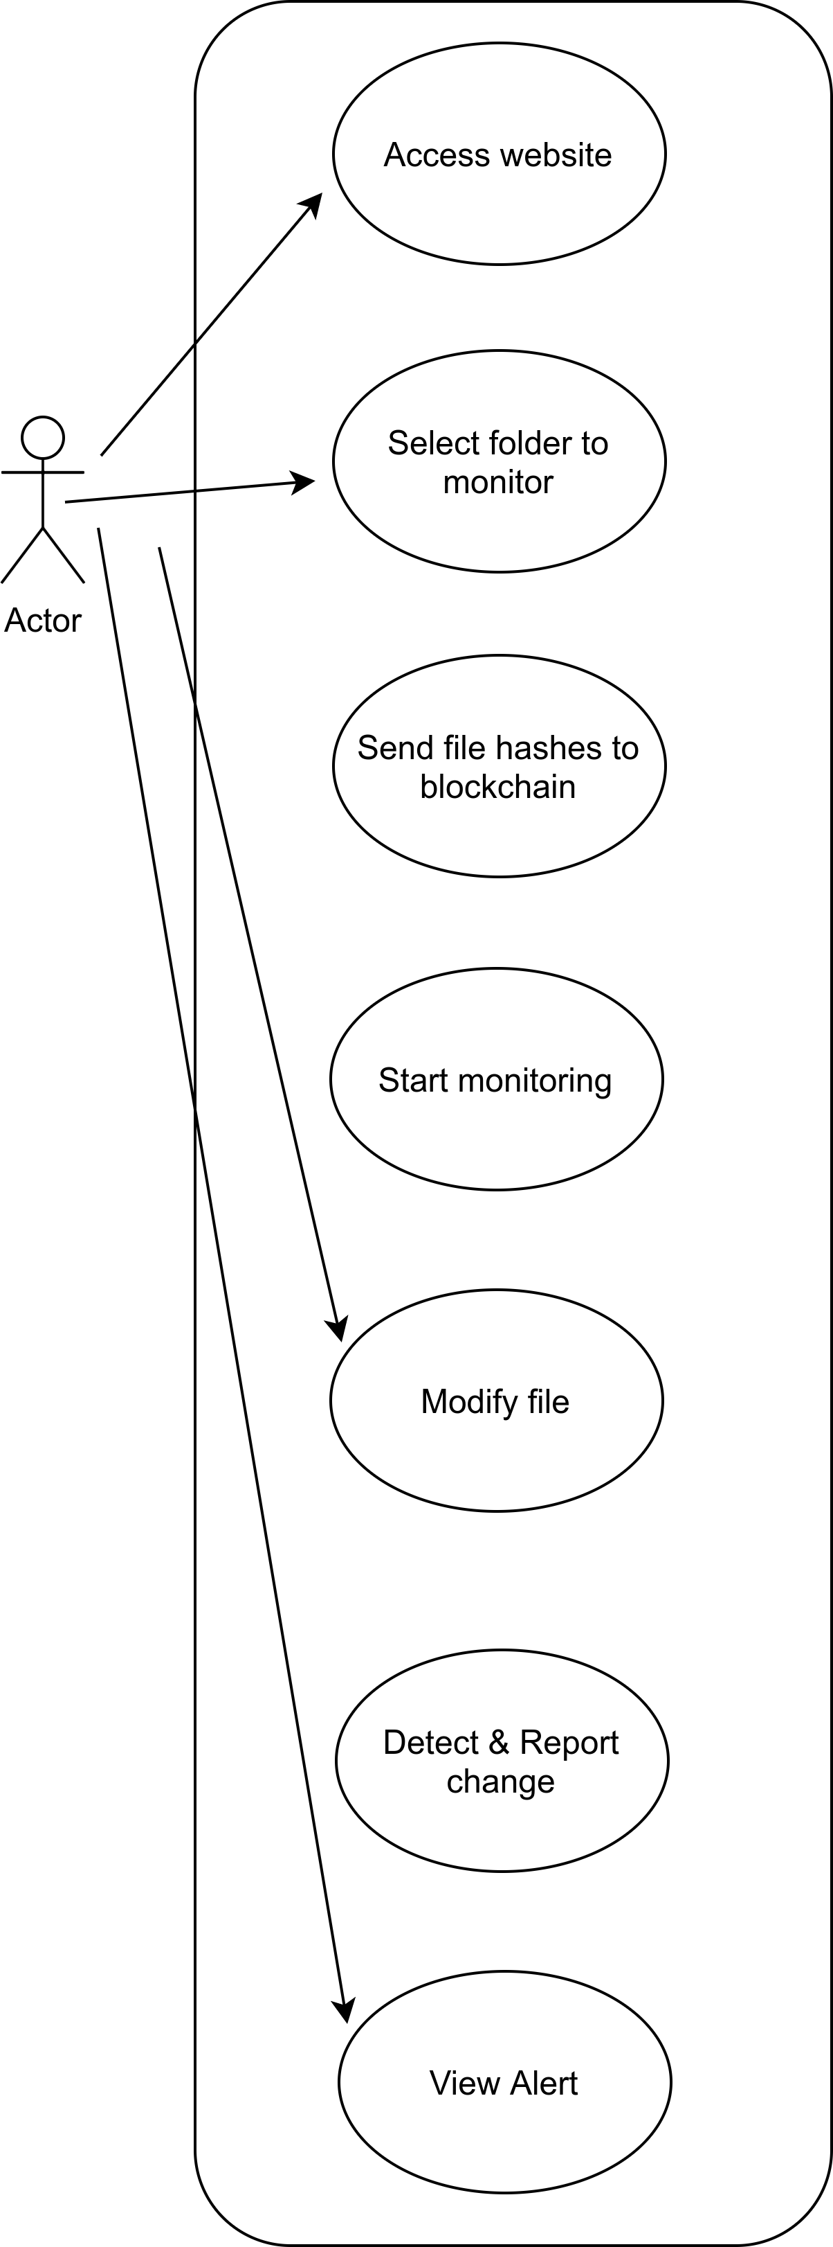
DocEyes - A Tamper-Proof Document Storage System

Use Case

Sequence Diagram

