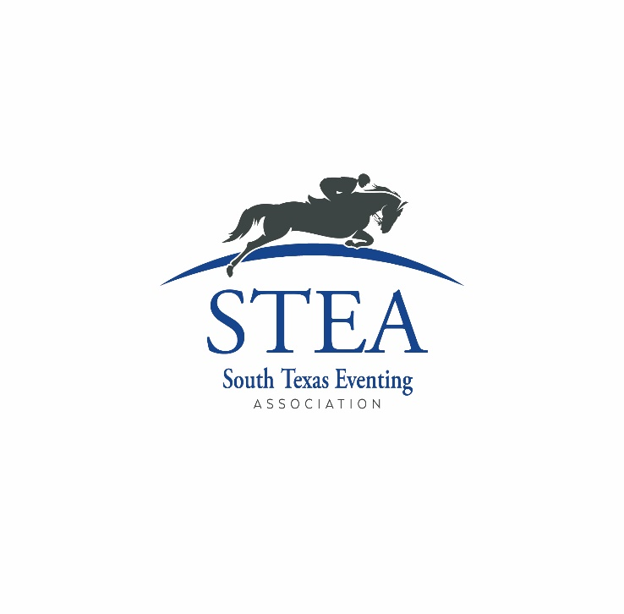

Annual High Point Awards Program

Annual Awards for Schooling Competitions.

Introduction - STEA shall present annual High Point Awards to members for points earned at Member Schooling Events during each Competition Year (December 1 to the next November 30).

Member Schooling Events - In order for an Eventing competition to qualify for STEA points: (a) the organizer of the competition must be a Business, Individual or Life member of STEA, (b) the competition must be a schooling competition (c) the competition must be listed on STEA’s website calendar. Questions about whether or not a competition is or will be eligible for STEA points should be directed to the Secretary. Show organizers are encouraged to work together as soon as possible before the start of each Competition Year to try to coordinate neighboring competitions and to check the STEA show calendar before adding or rescheduling competitions, notify the Secretary in advance of show schedules and changes so that STEA can alert members and place the competition on STEA’s website calendar, post final results on their individual websites within a reasonable time after each Member Schooling Event, use qualified, impartial judges and follow STEA rules in Member Schooling Events, and include STEA member names on their Entry Forms and online results.

Membership to Earn Points - To earn points at a Member Schooling Event, the rider must be a member of STEA on the date the Member Schooling Event begins. The horse is also required to be a STEA member on the date the Member Schooling Event begins.

General Rules

1. STEA will present schooling year-end awards for Champion, Reserve Champion, 3rd, 4th, 5th and 6th places in the following categories:

Junior Rider Age 17 and under

Senior Amateur Rider Age 18 and up

A competitor’s category is determined by his or her age on December 1 of the current membership year. Any person who qualifies as an Amateur under USEF/USEA rules is considered an Amateur for purposes of these rules. In the event of a dispute about whether or not a rider is an Amateur for points, the determination of the STEA board of directors will be final.

1. Points shall accrue for schooling horse trials (HT), combined tests (CT) and Eventing Derby’s (Derby). This includes divisions known as “GAG”, “Starter” and such, so long as the minimum average height of each jumping test is 18 inches. This also includes divisions of USEA horse trials which are not recognized for USEA points.

1. To be eligible for points, a HT must include scores for three tests (dressage, cross country and stadium jumping), a CT must include scores for two tests (dressage and stadium jumping), and a Derby must include scores for both a dressage test and a jumping test with a combination of cross country and stadium obstacles. A horse/rider combination may only earn points for one division/test per show.

1. Year-End High Point Awards are given for the greatest total number of points earned at two or more Member Schooling Events during the show year by a horse/rider combination, according to the Points Table listed below. The following divisions will not be included or considered for any purpose: A division in which the rider either competed hors concours (either voluntarily or at the request of the show organizer), was eliminated, or withdrew from competition; or a division which was cancelled without a final score for both a dressage and at least one jumping test.

1. The horse’s competition name must remain consistent during the show year. Any changes must be made in writing to the Secretary.

1. Points accrue for a particular horse/rider combination. Riders competing additional horses will accrue a separate set of points.

1. If there is a tie for a High Point Award, it shall be awarded to both parties equally.
2. STEA will designate a Secretary for each Competition Year. Secretary can be contacted at stea@steventing.com. The STEA Secretary will maintain a Points Table and post it on the STEA website periodically, but not less than twice per Competition Year. A year-end Points Table will be posted on the STEA website promptly after the last Member Schooling Event of the Competition Year. Members will have 10 business days to comment or dispute the scores, after which points will become final and no longer subject to dispute. It is the rider’s responsibility to check the Points Tables on a regular basis and promptly contact the Points Keeper with any questions or comments.

Points and Points Table - Points for High Point Awards will be awarded according to the following table:

STEA Annual Awards Program - Points Table

|  |  |  |  |  |  |  |  |
| --- | --- | --- | --- | --- | --- | --- | --- |
| Member  Schooling  Event | Number of  Starters in Division |  |  | Placings | |  |  |
| 1st | 2nd | 3rd | 4th | 5th | 6th |
| Combined  Test | 1 – 4 | 3 | 2.5 | 2 | 1.5 | 1 | .5 |
| 5 and above | 6 | 5 | 4 | 3 | 2 | 1 |
| Derby | 1 – 4 | 4.5 | 3.75 | 3 | 2.75 | 1.5 | .75 |
| 5 and above | 9 | 7.5 | 6 | 5.5 | 3 | 1.5 |
| Horse Trials | 1 - 4 | 6 | 5 | 4 | 3 | 2 | 1 |
| 5 and above | 12 | 10 | 8 | 6 | 4 | 2 |