Unity Project Standard Operating Procedures (SOP)

Here is a basic guideline on how to set up you Unity project and use organizing standards.

One of the first thing you should do when you open the project for the first time is creating folders for your assets.
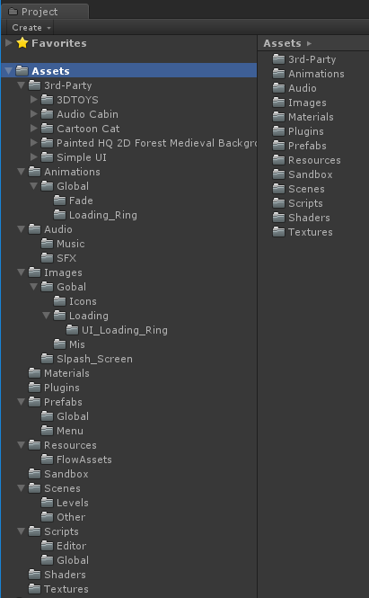
- Directory Structure
- 3rd-Party
- Animations
- Audio
  - Music
  - SFX
- Materials
- Models
- Plugins
- Prefabs
- Resources
- Textures
- Sandbox
- Scenes
  - Levels
  - Other
- Scripts
  - Editor
- Shaders

- Do not store any asset files in the root directory. Use sub-directories whenever possible.
- Do not create any additional directories in the root directory, unless you really need to.
- Be consistent with naming. If you decide to use camel case for directory names and low letters for assets, stick to that convention.
- Don’t try to move context-specific assets to the general directories. For instance, if there are materials generated from the model, don’t move them to Materials directory because later you won’t know where these come from.
- Use 3rd-Party to store assets imported from the Asset Store. They usually have their own structure that shouldn’t be altered.
- Use Sandbox directory for any experiments you’re not entirely sure about. While working on this kind of things, the last thing that you want to care about is a proper organization. Do what you want, then remove it or organize when you’re certain that you want to include it in your project. When you’re working on a project with other people, create your personal Sandbox sub-directory like: Sandbox/JohnyC.\

2. Scene hierarchy structure
Next to the project’s hierarchy there’s also scene hierarchy. As before, I will present you a template. You can adjust it to your needs.
- Management
- GUI
- Cameras
- Lights
- World
  - Terrain
  - Props
- _Dynamic
There are several rules you should follow:
- All empty objects should be located at 0,0,0 with default rotation and scale.
- When you’re instantiating an object in runtime, make sure to put it in _Dynamic – do not pollute the root of your hierarchy or you will find it difficult to navigate through it.
- For empty objects that are only containers for scripts, use “@” as prefix – e.g. @Cheats

3. Use prefabs for everything

Prefabs in Unity are not perfect, but they are the best thing you will find to share pre-configured hierarchies of objects. Generally speaking, try to prefab everything that you put on your scenes. You should be able to create a new level from an empty scene just by adding one or more prefabs to it.

The reason why you should use prefabs is that when a prefab changes, all the instances change too. Have 100 levels and want to add a camera effect on all of them? Not a problem! If your camera is a prefab, just add a camera effect to the camera prefab!

Be aware that you cannot have a prefab in another prefab. Use links instead – have a field that requires a prefab to be assigned and make sure to assign it when instance is created. Consider auto-connecting prefab instances in Awake() or OnEnable() when it makes sense.
