REPUBLIC OF CAMEROON
Peace-Work-Fatherland
REPUBLIQUE DU CAMEROON
Paix-Travail- Patrie




ONE LOVE, ONE MIND, ONE LEGACY!
LinkedIn: shaderl
Tel: 678 358 509 / 692 199 722
Site : www.shaderl.com
Email: info@shaderl.com

AFRICAN INSTITUTE OF COMPUTER SCIENCES -PAUL BIYA TECHNOLOGICAL CENTER OF EXCELLENCE
P.O. Box: 13719 Yaoundé
Tel: +237.242.729.957
Fax : 22729958
E-mail : contact@iaicameroun.com

INTERNSHIP REPORT

CONCEPTION AND REALIZATION OF AN IT PROJECT MANAGEMENT WEB APPLICATION. CASE STUDY OF SHADERL

Internship carried out from the 1st July to 30th September 2025
in view of obtaining a Higher Technician Diploma (HTD) in Computer Sciences.
Option: Software Engineering
Written By:
TEMFACK TAKONDJE ROLEX
Level II student at AICS Cameroon

Supervised By:
Professional Supervisor
Mr. Eric BITOM
Consultant at shaderl
Academic Supervisor
Mr. ASANE Derick
Lecturer at AICS

Academic Year: 2024 - 2025

DEDICATION

This work is dedicated to my Family for their support and encouragements throughout this academic adventure

ACKNOWLEDGEMENT

Drafting this document would not have been possible without the contributions of several individuals who dedicated their time and efforts to ensure its completion. Our heartfelt gratitude goes to the following peoples:
- The Resident Representative of AICS Cameroon, Mr. Armand Claude ABANDA, for his unwavering support, encouraging words, and valuable advice on how to approach various situations.
- The Chief Executive Officer of SHADERL, Mr. ASANE Derick for trusting us with the opportunity to serve as interns their prestigious enterprise. Your support and guidance have been invaluable to our learning experience.
- Our professional supervisor Mr. Eric BITOM, for his advice, professional expertise and commitment he showed during his supervision.
- Our academic supervisor Mr. ASANE Derick for his moral support, advice and invaluable support throughout the academic year.
- Our academic teachers, Mr. MESSIO and Mrs. TCHOUTOUO Isabelle for their guidance and assistance in the realization of this document.
- To all my teachers at AICS Cameroon, for the knowledge they imparted, which has been essential in my journey.
- To my parents, brothers and sister, for their unwavering love and support they gave me through my long academic journey.
- To the countless contributors of the open-source programming community, for their invaluable resources that helped me learn essential skills and troubleshoot issues.
- Finally, to all my classmates, for their collaborative spirit and teamwork throughout the academic year.
Thank you all for your contributions and support!

SUMMARY

DEDICATION i
ACKNOWLEDGEMENT ii
SUMMARY iii
LIST OF FIGURES iv
LIST OF TABLES vi
LIST OF ABREVIATIONS vii
ABSTRACT viii
RESUME ix
GENERAL INTRODUCTION 1
PART I: THE EXISTING SYSTEM 2
PART II: SPECIFICATION BOOK 15
PART IV: ANALYSIS PHASE 32
PART V: DESIGN PHASE 72
PART VI: DEPLOYMENT PHASE 90
PARTVII: TEST OF FUNCTIONALITIES 102
PART VIII: INSTALATION AND USER GUIDE 109
PERSPECTIVE 117
GENERAL CONCLUSION 118
ANNEXES x
BIBLIOGRAPHY xi
WEBOGRAPHY xii
TABLE OF CONTENT xiii

LIST OF FIGURES

Figure 1: Functional organization of SHADERL 9
Figure 2:localization plan of SHADERL 10
Figure 3: Project follow up importance survey 17
Figure 4: project visibility level survey 18
Figure 5:functionality preference survey 19
Figure 6:frequency usage survey 20
Figure 7:integrated payment survey 21
Figure 8: Gantt project planning 35
Figure 9: project planning Gantt chart 35
Figure 10: UML diagrams 48
Figure 11:2TUP diagram 51
Figure 12:formalism of a use case diagram 54
Figure 13:General use case diagram 58
Figure 14: manage collaborator specific use case 59
Figure 15:manage user account specific use case 60
Figure 16: manage roadmap specific use case 61
Figure 17: formalism of a communication diagram 66
Figure 18: Communication diagram of authentication 68
Figure 19:order service communication diagram 69
Figure 20: make payment communication diagram 70
Figure 21: formalism of a sequence diagram 71
Figure 22: Authentication sequence diagram 73
Figure 23: Order service sequence diagram 74
Figure 24: make payment sequence diagram 75
Figure 25: formalism of an activity diagram 76
Figure 26:authentication activity diagram 79
Figure 27: order service activity diagram 80
Figure 28: make payment activity diagram 81
Figure 29: N-tier architecture 86
Figure 30: MVT architecture pattern 87
Figure 31: formalism of a class diagram 88
Figure 32:Application class diagram 91

Figure 33: formalism of a state machine diagram 92
Figure 34: transaction state machine diagram 94
Figure 35: developer invitation state machine 95
Figure 36: formalism of a package diagram 96
Figure 37: application package diagram 99
Figure 38: formalism of a deployment diagram 106
Figure 39: applications deployment diagram 108
Figure 40: formalism of a component diagram 109
Figure 41: Application's component diagram 111
Figure 42:test showcase configurations 117
Figure 43: test showcase results 118
Figure 44: user registration showcase 124
Figure 45: project manager account creation showcase 125
Figure 46: authentication showcase 126

LIST OF TABLES

Table 1:comparative study of Devpilot and existing project management applications. 23
Table 2: Chronogram of activities 34
Table 3:Software resources 36
Table 4: Hardware requirements source (https://www.ubuy.cm) 37
Table 5: Human resources source (https://www.paylab.com/cm/salaryinfo/information-technology) 38
Table 6: global estimation table 39
Table 7: list of participants 41
Table 8: Differences between UML and MERISE 49
Table 9:components of a use case diagram 55
Table 10: textual description of authentication 62
Table 11: Textual description of manage roadmap (delete action) 63
Table 12:Order service textual description 64
Table 13: components of a communication diagram 67
Table 14: components of a sequence diagram 72
Table 15: components of an activity diagram 77
Table 16: components of a class diagram 89
Table 17: components of a state machine diagram 93
Table 18: components of a package diagram 97
Table 19: technology stack 104
Table 20: components of a deployment diagram 107
Table 21: components of a component diagram 110

LIST OF ABREVIATIONS

- 2TUP: 2 Track Unified Process
- AICS: African Institute of Computer Sciences
- API: Application Programming interface
- DBMS: Database Management System
- GUI: Graphical User Interface
- IT: Information Technology
- MERISE : Méthode d’Etude et de Réalisation Informatique pour des Systèmes d’Entreprise
- MVC: Model View Controller.
- MVT: Model View Template
- MS WORD: Microsoft Office WORD
- UML: Unified Modelling Language

ABSTRACT

The study of the theme “CONCEPRION AND REALIZATION OF AN IT PROJECT MANAGEMENT WEB APPLICATION. CASE STUDY: SHADERL” aims at developing a computerized solution to ensure client implication in the development process of the different IT services especially web sites, web applications, mobile applications which may require long development periods and tough organization. In a world shifting more and more towards digitalization, the rise for the need of it services increase and with it the need for adequate management tools to better organize the process of creation of these services. The main issue here is to provide a portal for client participation in the management aspect of a project while keeping the core aspects of project management in order to ensure the client’s needs or requirements are met. Our system enhances transparency and professionalism in project management. By utilizing modern, flexible and secure tools, it facilitates the task of project management. The innovation here is the addition of the client in the development process. Although he doesn’t have any administrative role his presence is essential in order to foster transparency and ensure final delivered product meets exactly the customer’s needs.
Key words
- Project management
- Transparency
- collaboration

RESUME

L'étude du thème "CONCEPTION ET RÉALISATION D'UNE APPLICATION WEB DE GESTION DE PROJETS INFORMATIQUES. CAS PRATIQUE : SHADERL" a pour but de développer une solution informatisée pour garantir l'implication du client dans le processus de développement des différents services informatiques, notamment les sites web, les applications web, les applications mobiles, qui peuvent nécessiter de longues périodes de développement et une organisation rigoureuse.
Dans un monde qui se numérise de plus en plus, le besoin en services informatiques ne cesse de croître, et avec lui, la nécessité d'outils de gestion adéquats pour mieux organiser le processus de création de ces services. Le problème principal ici est de fournir un portail permettant au client de participer à l'aspect gestion d'un projet, tout en conservant les aspects fondamentaux de la gestion de projet, afin de s'assurer que les besoins ou les exigences du client sont respectés.
Notre système renforce la transparence et le professionnalisme dans la gestion de projet. En utilisant des outils modernes, flexibles et sécurisés, il facilite la tâche de gestion de projet. L'innovation réside dans l'ajout du client au processus de développement. Bien qu'il n'ait aucun rôle administratif, sa présence est essentielle pour favoriser la transparence et garantir que le produit final livré corresponde exactement aux besoins du client.
Mots-clés
- Gestion de projet
- Transparence
- Collaboration

GENERAL INTRODUCTION

In today’s rapidly evolving digital landscape, transparency and communication are essential for effective IT service delivery. Many clients struggle to monitor project progress and engage with developers during outsourced development. To solve this, we undertook a three-month internship at SHADERL, a tech startup offering various IT services, as part of my academic program at AICS Cameroon. During this internship, we were assigned the theme “CONCEPTION AND REALIZATION OF AN IT PROJECT MANAGEMENT WEB APPLICATION.” This report addresses key challenges in IT project supervision by detailing the development of Devpilot, a platform that improves client visibility, fosters collaboration, and enhances project delivery with SHADERL as our base case study. To achieve this, extensive research was conducted on existing solutions. This report is structured in the following parts:
- PART I: The Insertion phase
- PART II: Existing System
- PART III: The specification book
- PART IV: Analysis book
- PART V: Design phase
- PART VI: Deployment phase
- PART VII: Test of functionalities
- PART VIII: user guide

PART I: THE EXISTING SYSTEM

Preamble

The existing system is a document that provides a view of how the current system works, how it carries out its different activities, it equally provides a deep understanding of the system associated to the various limitations and the problems that result from it and we propose the solution.

Content

INTRODUCTION
- PRESENTATION OF THE PROJECT THEME
- STUDY OF THE EXISTING SYSTEM
- CRITICISMS OF THE EXISTING SYSTEM
- PROBLEMATICS
- PROPOSED SOLUTION
CONCLUSION

INTRODUCTON
As Engineers our role in the society is problem-solving which is targeted at making life easier for everyone and in order to bring forth a solution, we ought to ask ourselves some questions to know why the problem exist in the first place and how it is being dealt with at a time. The existing system refers to the system put in place to carry out the work done in the field on which our theme is based. Understanding this system is a great step in solving the problems that we might identify. It’s of great importance that we take into consideration this system before proposing a suitable solution that will ameliorate or replace the current one.

PRESENTATION OF THE PROJECT THEME
The African tech ecosystem has grown rapidly in recent years, with increasing demand for digital solutions tailored to local needs. However, many small and medium-sized enterprises (SMEs) still face challenges managing outsourced IT projects due to a lack of platforms that ensure transparency and client involvement. To address this issue, we propose the theme “CONCEPTION AND REALIZATION OF AN IT PROJECT MANAGEMENT WEB APPLICATION. CASE STUDY: SHADERL.” This web application aims to provide a user-friendly solution that enables clients to monitor project progress, communicate directly with the project manager, and improve overall collaboration throughout the development process.

DESCRIPTION OF EXISTING SYSTEM
Based on our study of the current IT project management landscape, we have identified significant challenges that lead to inefficiency and client dissatisfaction. While IT companies and startups offer valuable services, they often struggle with a transparent and scrupulously followed work plan.
The primary issues are:
- Limited Client Engagement: There is little to no real customer involvement throughout the development lifecycle of the project they have ordered. This lack of collaboration can lead to misunderstandings and outcomes that don't fully meet the client's vision.
- Inadequate Workflow Transparency: Customers are often excluded from or have limited participation in the workflow planning process. This creates a disconnect between the client's expectations and the project team's actual progress.
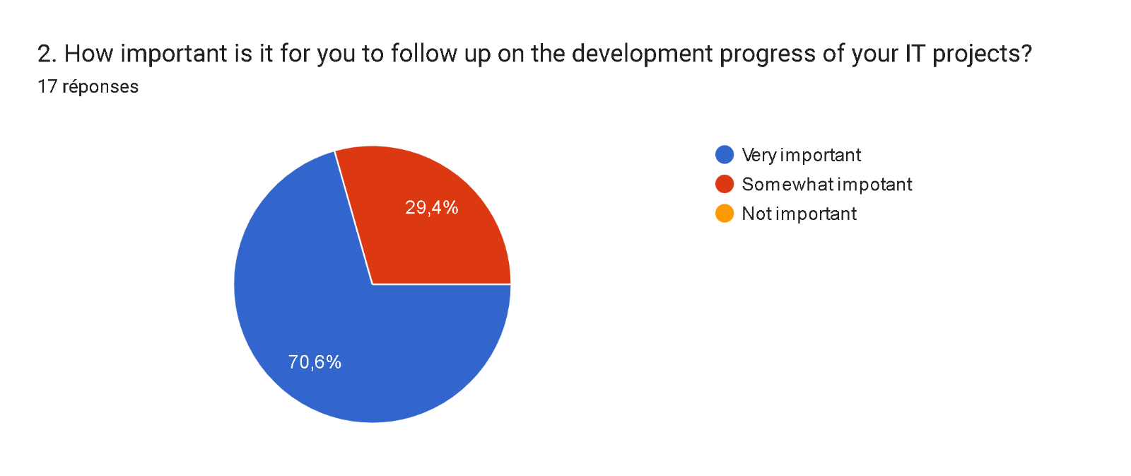
This analysis provides a strong foundation for why a platform like Devpilot is needed to bridge this gap and foster a more collaborative and transparent project environment as it brings the client and the project manager closer for a better hand in hand workflow.

Figure 3: Project follow up importance survey

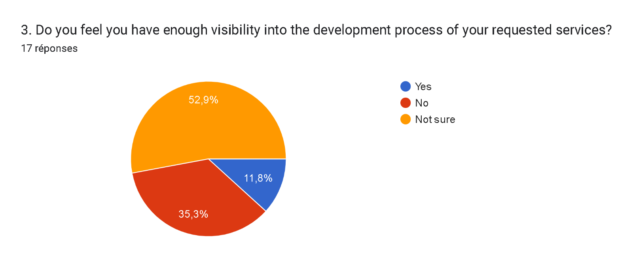

Figure 4: project visibility level survey

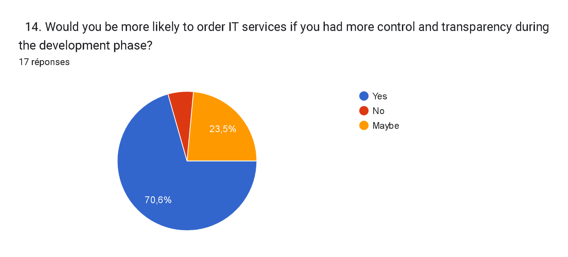
Figure 5:functionality preference survey

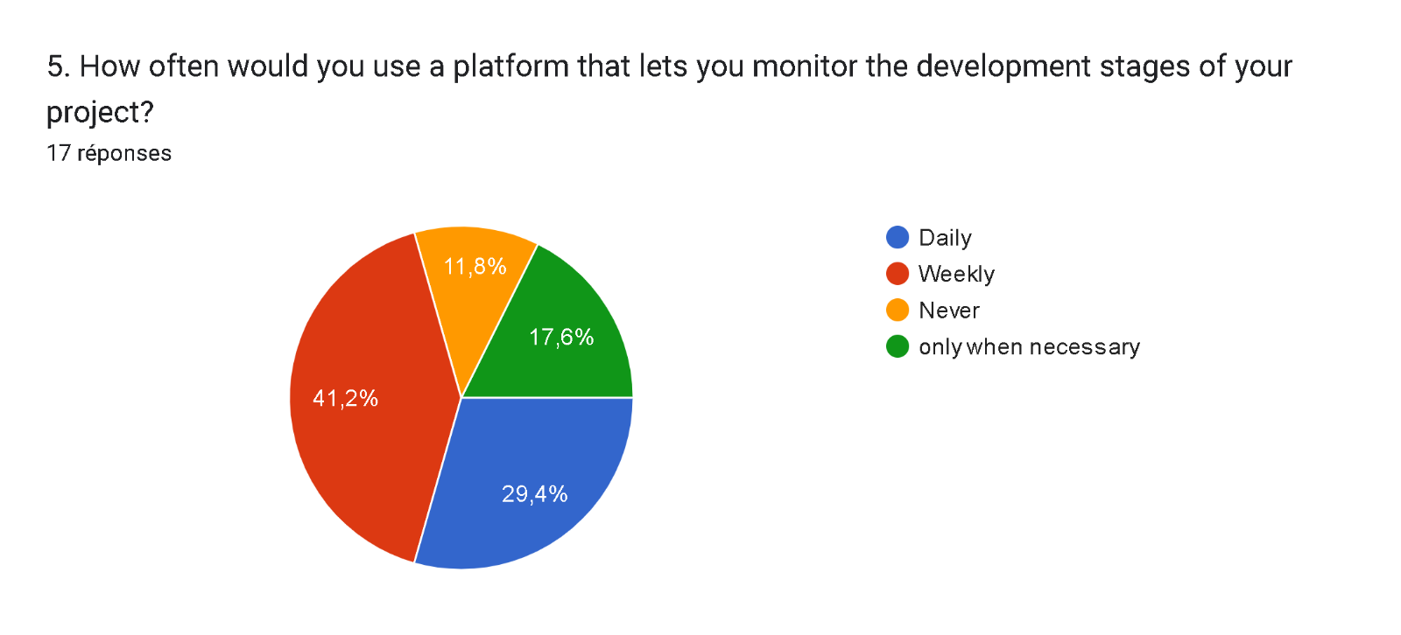
Figure 6:frequency usage survey

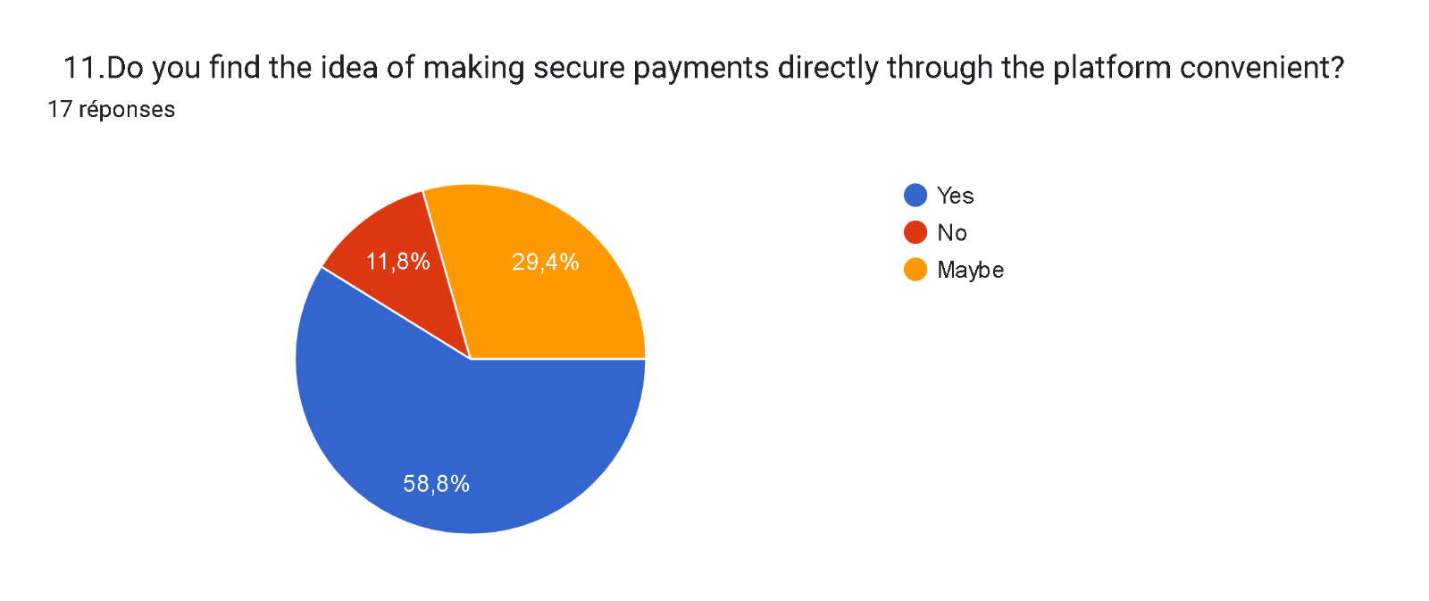
Figure 7:integrated payment survey

From the above charts we can get the following information’s:
The first chart shows data about the importance clients give to the follow up of their projects under development with 70.6% judging it very important and 29.4% not really sure if it really matters.
The second chart shows data about the level of visibility customers or clients usually think they have on the projects they orders, it shows that 52.9% of participants to the survey are not sure they have enough visibility , while 35.3% says they don’t have enough visibility with only 11.8% saying that they have enough visibility.
The third chart shows data concerning the likely hood for clients to order IT services on an application that will permit them to manage the progress of the project and as results we have 70.6% saying yes, 23.5% not sure and only 5.9% saying no.
The fourth chart shows data on how often a client will use an application giving him access to the development process of a service he ordered and we had 41.2%, 29.4%, 17.6% of participants saying they will use the application weekly, daily, only when necessary respectively for only 11.8% saying never.
The fifth chart shows data on how clients will feel convenient in making payments via the application and as response we had 58.8% and 29.4% saying yes and maybe respectively and only 11.8% saying no.
From all these statistics, we clearly see the need of putting in place an application that will give more client control over their IT projects under development while keeping the key aspects of project management.

CRITITCISMS OF THE EXIXTING SYSTEM
After research and study of popular project management platforms such as Monday, Trello and Click Up we were able to come out with the following table which shows the gaps left by Trello and Click Up that our supplication (Devpilot) compensates.
Table 1:comparative study of Devpilot and existing project management applications.
Feature/Goal | Monday/Trello/Click Up | Devpilot
Primary Focus | - Internal team/project/task management | Client-facing IT project tracking
Target audience | - Teams, startups, product managers | Startups, Clients of IT companies and project manager
Client Visibility | - Not designed for it | Core feature
Project manager-Client Communication | - Limited / via plugins | Limited to update plugin messages
Payment Integration | - Limited / external | Integrated for service payments
User Simplicity | - Moderate learning curve | Simple for non-technical clients

PROBLEMATIC
In today’s digital era, many individuals and businesses outsource the development of their digital solutions to IT service providers. However, these clients often face a lack of visibility into the development process, making it difficult to track progress, communicate effectively, or ensure the final result meets their expectations. This situation leads us to ask: “HOW CAN WE HELP CLIENTS GAIN BETTER VISIBILITY AND CONTROL OVER THE DEVELOPMENT OF THEIR IT PROJECTS?”
We will try to offer solutions regarding this problem through our application.

PROPOSED SOLUTION
After analyzing and evaluating the limitations of existing systems, we propose to design a web application that will enable clients in Cameroon and across Africa to:

- Gain real-time visibility into the progress of their ongoing IT projects
- Collaborate more effectively with development teams through integrated updates plugin messages
- Easily manage and monitor project milestones via intuitive and user-friendly dashboards
- Access and select project templates to streamline the project initiation process
- Maintain control over project quality through feedback, approvals, and transparent communication

CONCLUSION
Having reached the end of this part, we studied the existing system by carrying out a survey that enabled us to come out with the limitations of the system that leads to the consequences and we proposed solutions to the various limitations. Finally, we proposed our solution which is “CONCEPTION AND REALIZATION OF AN IT PROJECT MANAGEMENT WEB APPLICATION. CASE STUDY: SHADERL”.

PART II: SPECIFICATION BOOK

Preamble

The Specification book is a document which is been established by the customer needing a particular product and the producer (engineer) who is to create the product, which is to be respected to its fullness during the realization of the product. From this, we obtain the major importance of the specification book.

Content

INTRODUCTION
- CONTEXT AND JUSTIFICATION
- OBJECTIVES OF THE PROJECT
- EXPRESSION OF NEEDS
- PROJECT PLANNING
- ESTIMATED COST OF THE PROJECT
- PROJECT CONSTRAINTS
- DELIVERABLES
CONCLUSION

INTODUCTION
The specification book of our reports helps us provide details about our theme, to improve our understanding of it and increase the likelihood of it succeeding. To delimitate the scope of our project, we will specify the context of our theme. From the context, we will list the problems we have identified in our context and that we have decided to address throughout the project. After presenting our solution, we will talk about the objective we have set for the project. Also, we will explore the needs to which our system will respond both at the functional and non-functional level. We will then look at the estimated financial requirements for our project, and establish a plan we will follow to complete our project on time. From here we will discuss what is expected of us by the end of the project under the project deliverables.

CONTEXT AND JUSTIFICATION

CONTEXT
The digital economy has seen significant growth in recent years, marked by the widespread adoption of technology and increased demand for custom digital solutions. This has led to the rise of IT companies and startups offering development services to businesses and individuals. However, as competition intensifies, one major challenge persists: the lack of transparency and effective communication between clients and service providers during project execution.
To address this gap, the development of a project management platform becomes essential. Such a solution will not only improve visibility for clients over the progress of their projects but also enhance collaboration, ensure better alignment with expectations, and strengthen trust in the services offered by IT companies and startups.

JUSTIFICATIONS
The development of a project management platform focused on transparency is essential due to the growing reliance on IT service providers for custom digital solutions. Many existing tools fail to meet client expectations when it comes to tracking progress, maintaining clear communication, and staying involved throughout the project lifecycle. This lack of visibility often leads to misunderstandings, delays, and dissatisfaction.
Devpilot directly addresses these challenges by offering a dedicated web application that improves how clients interact with their development teams. It allows users to monitor progress in real time, communicate easily with developers, and access key project information through an intuitive and organized interface. By simplifying client involvement and increasing transparency, Devpilot enhances collaboration and contributes to the delivery of higher-quality digital services.

OBJECTIVES OF THE PROJECT

GENERAL OBJECTIVES
The main objective of this project is to develop a user-friendly web application that helps IT companies and startups manage their projects more effectively, while enabling clients to monitor progress and stay actively involved throughout the development process.

SPECIFIC OBJECTVES
- Provide clients with real-time visibility into the progress of their IT projects
- Facilitate direct and continuous communication between clients and development teams
- Simplify project tracking through intuitive dashboards and milestone monitoring
- Enable clients to review, approve, and give feedback on project stages
- Support transparent documentation and sharing of deliverables throughout the development process

EXPRESSION OF NEEDS

FUNCTIONAL NEEDS
Functional needs describe what the users can do on the system. There are listed below as follows:
Company Administrator:
- Manage users accounts
- Manage templates
- Manage services
- Upload completed projects to project gallery
- View application statistics
- Manage his personal profile

Project manager:
- Manage development roadmap for a project
- Provide textual updates via the update hub
- Download user selected template
- Manage his personal profile
- Manage collaborators invited to work on a specific project
- Consult notifications
Developer
- Provide updates via update hub
- Manage his profile
- Consult notifications

Client
- Order a service
- Provide textual updates to project manager via update hub
- Consult notifications
- track project development progress
- select templates
- provide feedback
- Manage his profile
- Make payments

NON FUNCTONALREQUIREMENTS
Non-functional requirements are a set of criteria that define the overall qualities, characteristics, and constraints of a software system, rather than its specific behaviors or functions. These requirements describe how the system should operate, rather than what it should do.
Performance, Reliability and Security
- Performance defines how fast a software system responds to certain user’s action under certain workload. It explains how much a user must wait before the target operation.
- Reliability and Availability: The application should have high uptime and minimal downtime, ensuring users can access the platform consistently.
  - The application should have a friendly user interface (UI) and should be easy to use.
  - The code should be clear to facilitate future development and improvement.
- Security: The application should provide a strong security mechanism to reassure user’s that they can trust it for their sensitive information. Some of the security principles include confidentiality, Integrity and Authentication.

PROJECT PLANNING

Chronogram of activities
Table 2: Chronogram of activities
PHASE | OBJECTIVE | OUTPUT | DURATION | PERIOD
INSERTION | Collecting information’s from enterprises | Insertion book | 2 weeks | 1st July to 14th July 2025
EXISTING SYSTEM | Study of the existing system | Existing System | 1week | 15th July to 21st July 2025
SPECIFICATION BOOK | Specification of the user needs | Specification Book | 5 days | 22nd July to 26th July 2025
ANALYSIS | ANALYSIS | Capture of needs Use case and textual description Modelling | 2 weeks | 27th July to 9th Auguste 2025
CONCEPTION | Hardware and software conception | Conception Book | 2 weeks | 10th August to 23rd August 2025
REALIZATION | Realization of the system | Realization Document | 3 weeks | 24th August to 13th of September 2025
DEPLOYMENT | Deployment of the system | Testing and debugging the software | 1 week | 14th September to 20th September
WRITING USER GUIDE | Instruction on how to use the software and hardware | User Guide | 5 days | 21st September to 25th September

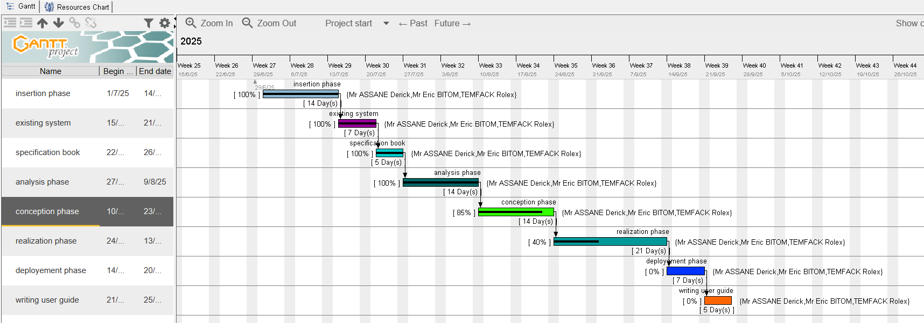
Gantt Project Planning
Figure 8: Gantt project planning

Figure 9: project planning Gantt chart

ESTIMATED COST OF PROJECT

Software resources
Table 3:Software resources
RESOURCES | DESIGNATION | USAGE | QUANTITY | UNIT COST(FCFA)
Formatting | Microsoft office  2019 | Writing Report | 1 | 38,750
Cloud storage | GitHub | Saving report and source code | 1 | Freemium
Web browser | Google chrome | For research and viewing the  application | 1 | Freeware
Code Editor | Visual studio | For writing code of the application | 1 | Freeware
UML analysis | Visual Paradigm | For drawing UML diagrams | 1 | Freemium
Project planning | Gantt Project | For building Gantt chart | 1 | Freemium
Database | SQLite | To store diiferent information’s | 1 | Freemium
TOTAL 1 |  |  |  | 38,750

Hardware resources
Table 4: Hardware requirements source (https://www.ubuy.cm)
Resources | Usage | Quantity | Unit cost (FCFA)
DESKTOP-KUHD5580 | For drafting the report and coding | 1 | 450,000
Printer HP | For printing the report | 1 | 165,000
USB key 64GB | For installation of and sharing of software’s | 1 | 7,000
Star Link | For collaborative network Connectivity | 1 | 200000
TOTAL2 |  |  | 822,000

Human resources
Table 5: Human resources source (https://www.paylab.com/cm/salaryinfo/information-technology)
ROLES | NUMBERS OF DAYS | QUANTITY | COST PER DAY (IN FCFA) | TOTAL PRICE (IN FCFA)
Project Manager | 40 | 1 | 35,000 | 1,400,000
Analyst | 12 | 1 | 25,000 | 300,000
Designer | 04 | 1 | 20,000 | 80,000
Programmer | 18 | 1 | 15,000 | 270,000
Tester | 10 | 2 | 10,000 | 100,000
Unforseen | / | / | / | 650,000
Total 3 |  |  |  | 2,800,000

Global estimations:
Table 6: global estimation table
TOTAL1 (IN FCFA) | TOTAL2 (IN FCFA) | TOTAL3 (IN FCFA) | OVEROLL TOTAL (IN FCFA)
38,750 | 822,000 | 2,800,000 | 3,660,750
THREE MILLION SIX HUNDRED AND SIXTY THOUSAND SEVEN HUNDRED AND FIFTHY

CONSTRAINTS
- Technical constraint: For the development of our system, we have sufficiently robust tools to guarantee a minimum of security, extensibility and excellent scalability. Moreover, the programming phase will have to follow all the technical standards for a better performance in a reduced execution time, this is why the choice of the development technologies is crucial.
- Time constraint: The project will be realized in 13 weeks (3 months) starting from the beginning date, 1st July 2025.
- Cost Constraint: The project will have a minimum cost of seven million which the developer(student) may not afford
- Integration Constraints: Limitations imposed by third-party APIs or services that may have usage restrictions or performance issues.

LIST OF PARTICIPANTS AND DELIVERABLES

List of participants:
Table 7: list of participants
NAME | FUNCTION | ROLE
Mr. ASSANE Derick | Follos student at academic level | Academic supervisor
TEMFACK TAKONDJE ROLEX | AICS student | Student at AICS Cameroon

List of deliverables:
In project management, any component materializing the result of a realization service is called a deliverable. In the case of our project, the deliverables are: A report composed of the following document
  - The application.
  - The user guides.

CONCLUSION
Reaching the end of this part. The list of objectives to be achieved has been enumerated and made clear. The specification book permitted us to present the different actors associated with the project as well as the requirement and the provisional planning needed for the achievement of our project. We will move directly to the next part which is the analysis phase. In the analysis phase, we will model our system with a modelling language and a unified process, do a comparative study of UML and MERISE

.

PART IV: ANALYSIS PHASE

Preamble

The main objective of the analysis phase is to capture the user’s need, the delimitation of the field of study and to have a clear understanding of the system in study. To achieve this, we will use UML with the 2TUP as method applied to UML to analyze the system. We will start by doing a comparison between UML and MERISE, of various unified processes and lastly, we will present the modelling of the solution we propose Devpilot.

Content

INTRODUCTION
I. METHODOLOGY
1. COMPARATIVE STUDY OF UML AND MERISE.
2. COMPARATIVE STUDY OF UNIFIED PROCESSES.
II. CHOICE OF THE ANALYSIS METHOD
3. MODELLING OF THE PROPOSED SOLUTION
CONCLUSION

INTRODUCTION
System development can be thought of as having two major components: System analysis and system design which both help in understanding the details of the existing system or the system to be designed. The analysis and design of information systems has most of the time vocation to allow the creation of databases, which must represent as closely as possible the reality of the field studied thus requiring the use of a design method. This is why our choice will be directed on the UML method as it offers much to developers seeking a user-centered approach and / or a wide scope in design. This part of the report consists of the comparative study of UML and MERISE, unified processes and finally the various diagrams that meet the functional need requirements.

METHODOLOGY
- COMPARATIVE STUDY OF MERISE AND UML

MERISE
MERISE stands for “Méthode d’Etude et de Réalisation Informatique pour des Systèmes d’Entreprise”. Although it is prescriptive to some extent, MERISE permits the participation of end users and senior management as well as data processing professionals in its decision cycle. MERISE is a method for designing, developing and carrying out IT projects. The goal of this method is to achieve the design of an information system. The MERISE method is based on the separation of data and processing to be carried out in several conceptual and physical models. The essentials of the approach lie in its three cycles: the decision cycle, the life cycle and the abstraction cycle, which cover data and process elements equally. The separation of data and processing ensures longevity in model. Indeed, the arrangement of data does not have to be often overhauled, while treatments are more frequently.

UML
UML (Unified Modelling Language) is a standard notation for the modelling of real world objects as a first step in developing an object-oriented design methodology. Its notation is derived from three object-oriented design and analysis methodologies: Grady Booch's methodology for describing a set of objects and their relationships, James Rumbaugh's Object-Modelling Technique (OMT), Ivar Jacobson's approach which includes a use case methodology. Other ideas also contributed to UML, which was the result of a work effort by Booch, Rumbaugh, Jacobson, and others to combine their ideas, working under the sponsorship of Rational Software. UML captures information about the static and dynamic view of a system. UML 2.5 comprises of 14 diagrams which represent the different views of a system. The 14 diagrams can be subdivided into two, Static or structural and Dynamic diagrams. These diagrams include;

STATIC OR STRUCTURAL DIAGRAMS
- Class Diagram;
- Object Diagram;
- Component Diagram;
- Deployment Diagram;
- Composite Structure Diagram;
- Package Diagram;
- Profile Diagram;

DYNAMIC OR BEHAVIORAL DIAGRAMS
- Use Case Diagrams;
- Activity Diagram;
- State Machine Diagram;
- Sequence Diagram;
- Communication Diagram;
- Interaction Diagram;
- Timing Diagram;

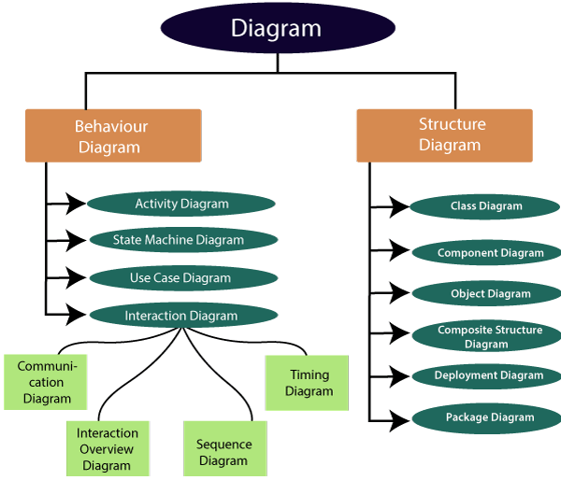

Figure 10: UML diagrams

Table 8: Differences between UML and MERISE

MERISE | UML
It stands for Méthode d'Étude et de  Réalisation Informatique pour les Systèmes d'Entreprises | Unified Modeling Language
MERISE is a systemic method of analysis and design of information systems. That is, it uses a system approach. | UML is however not a method but rather an object modeling language to which it is necessary to associate an approach to make it a method. This is the case with the 2TUP method; RUP and XP.
MERISE proposes to consider the real system from two points of view:  - A static view (data)  - A dynamic view (treatments).  That is, with the MERISE method, we have a separate study of the data and the treatments. | UML offers a different approach from that of MERISE in that it combines data and processing. Because with UML, centralizing the data of a type and the associated processing makes it possible to limit the maintenance points in the code and facilitates access to information in the event of software development.  In addition, UML describes the dynamics of the information system as a set of operations attached to the objects of the system.
Rational | Object

- COMPARATIVE STUDY OF UNIFIED PROCESS

A UNIFIED PROCESS
A Unified Process is a process of development of software constructed on UML; it is iterative, incremental, centered on architecture, driven by use cases and requirements.

Iteration is distinct sequence of activities with a basic plan and evaluation criterion that produces an internal or external output. Either the content of an iteration is improved, or the evolution of the system is evaluated by users.

An increment is the difference between two released products at the end of two iterations. Each iteration that the group is capable of integrating the technical environment in order to develop a final product and give users the possibility of having tangible results.

Centered on architecture the different models derived during the establishment of system must be reliable and coherent.

Driven by use case and requirements enables the clear definition of a users’ needs and priorities respectively thereby minimizing the risk of project failure.

THE TWO TRACK UNIFIED PROCESS
2TUP is a unified process which is built on UML and has as objective to bring solution to constraints of functional and technical changes imposed on information systems by strengthening controls on development capacities. It proposes a Y-sharped development life cycle that separates the functional aspect from the technical aspects, and the merging of these two forms the implementation aspect. 2TUP distinguishes therefore two branches: the functional and technical branches, the combination of the result of these two branches forms the third: the realization branch – where we realize our system. The diagram below illustrates the branches of 2TUP.

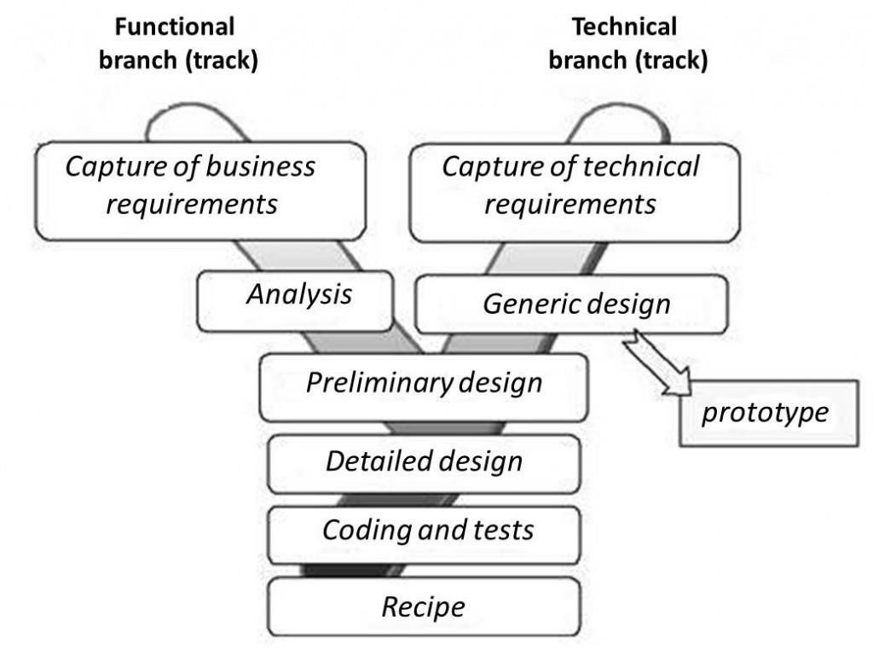

Figure 11:2TUP diagram

- The left branch (FUNCTIONAL BRANCH)
It captures the functional needs of a system. This ensures the production of software that meets the needs/requirements of the user. The analysis here consists of studying precisely the functional specification in order to obtain an idea of what the system is going to realize, and its result does not depend on any technology.
- The right branch (TECHNICAL BRANCH)
The technical branch enumerates the technical needs and proposes a generic design validated by a prototype. The technical needs include constraints and choices related to the conception of the system, the tools
- The middle branch (REALIZATION OR IMPLEMENTATION BRANCH)
In this branch, we study the preliminary conception, detailed conception, and documentation of the system. The realization branch supports the following: Preliminary conception: This is the most sensitive step of 2TUP as it is the confluence of the functional and technical branch. It is completed when the deployment model, the operating model, the logical model, interphases and the software configuration model are defined. We have the following diagrams:
- Component Diagram;
- Deployment Diagram;
- Package Diagram;
- Composite Structure Diagram;
Detailed conception: This is the detailed design of each feature of the system. We have the following diagrams:
- Class;
- Sequence;
- State Machine;
Coding and testing: These are the phase where we program the designed features and test the coded features.
The recipe: Also known as the deliverables is the validation phase of the functions of the developed system.

CHOICE OF ANALYSIS METHOD
The reason why we chose UML modelling language and the software development process 2TUP instead of many others that exist, include:
UML is the current standard for programming in an object-oriented language. For this reason, it is widely understood and well known making it easy for a new programmer to join the project and be productive from the very first day.
UML diagrams allow teams to virtualize how a project is or will be working, and they can be used in any field, not just software engineering. The diagrams will allow teams to virtualize together how a system, or a process will work or did work. It can provide new ideas for how teams have to collaborate to achieve the goal of the workflow process.
2TUP is centered around the creation and maintenance of a model, rather than the production of mountain documents.
2TUP is user oriented as it permits the development of software that responds to the needs of the users through the study of the user needs.
2TUP is iterative and incremental, hence it enables the project team to produce refined amelioration if necessary and easily integrate it in the already existing system.
2TUP by permitting the project team identify and test the key functionalities of the system limits the risk related to building the system.

- MODELING OF THE PROPOSED SOLUTION
- Capture of Functional Needs
The first step of the left (functional) branch of Two Track Unified Process (2TUP) is the capture of the functional needs. At this step, we capture the intended behavior of the system that maybe express as services, tasks or functions the system is required to perform.

USE CASE DIAGRAM

Definition:
Use case diagram shows the functionalities of a system, their interdependencies and how they relate with actors of the system. A use case is a specification of behavior. The main objectives of the use case diagram are:
- Provide a high-level view of the system.
- Identify the functions of the system.
Use case diagrams are completed with a textual description of each use case that is intended to define the use case in greater details.

Formalism:
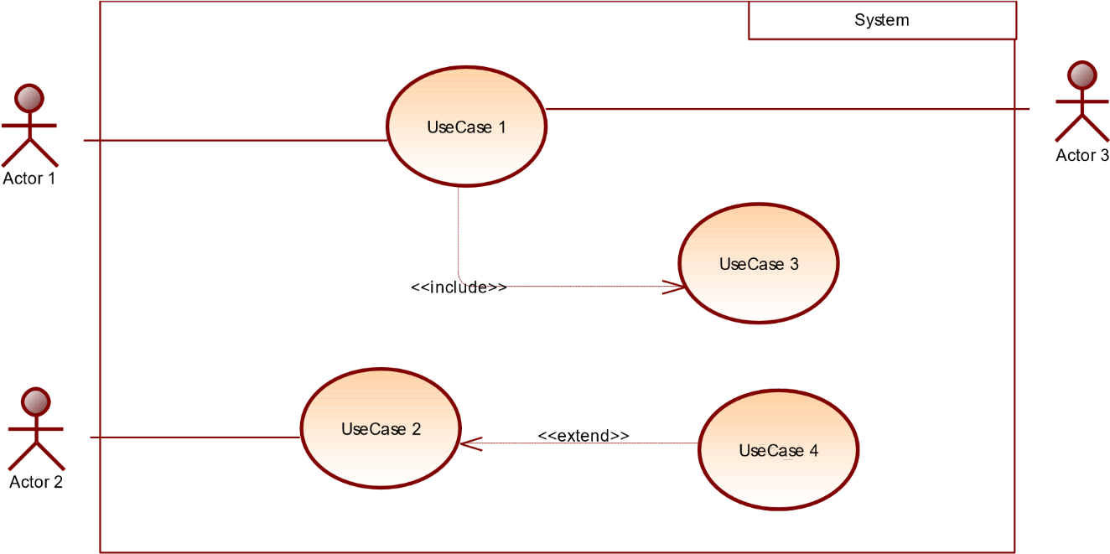

Figure 12:formalism of a use case diagram

Components of a Use Case Diagram

Table 9:components of a use case diagram
Elements | Notation |  | Description
Actors |  | 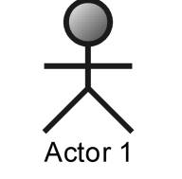 | Represents an entity that directly interacts with the system. The actor is what performs the different possible actions of the system
Use case |  | 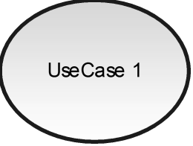 | A use case represents a functionality of the system. It is an action that can be performed by an actor.
Association |  | 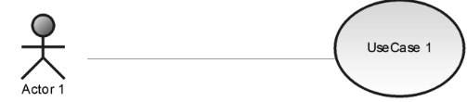 | it indicates that an actor takes part in a use Case.
Include |  | 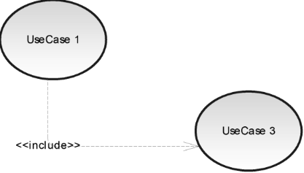 | An inclusion denotes that an included action must be performed before the including action can be performed.
Extend |  | 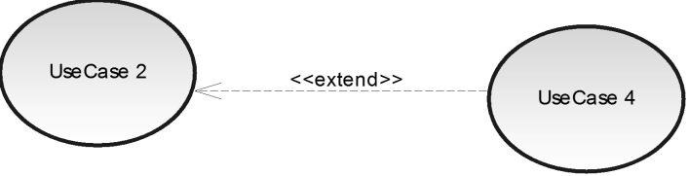 | An extension denotes that an extending action may be performed while an extended action is being performed.

Generalization | 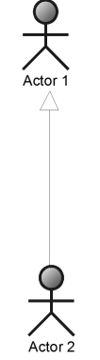  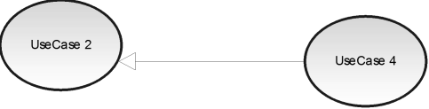 | This shows that an actor or a use case is a kind of another abstract or concrete actors can be defined and later specialized using generalization relationship.
System | 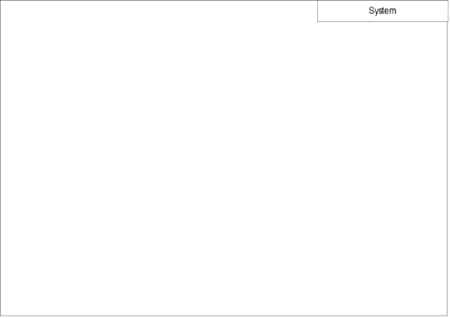 | It is a container of use cases which interact with external actors

The actors of our system
The actors of our system are listed below
- Admin
- Project manager
- Developer
- Client
- SMTP server
- Payment API
- Video call API

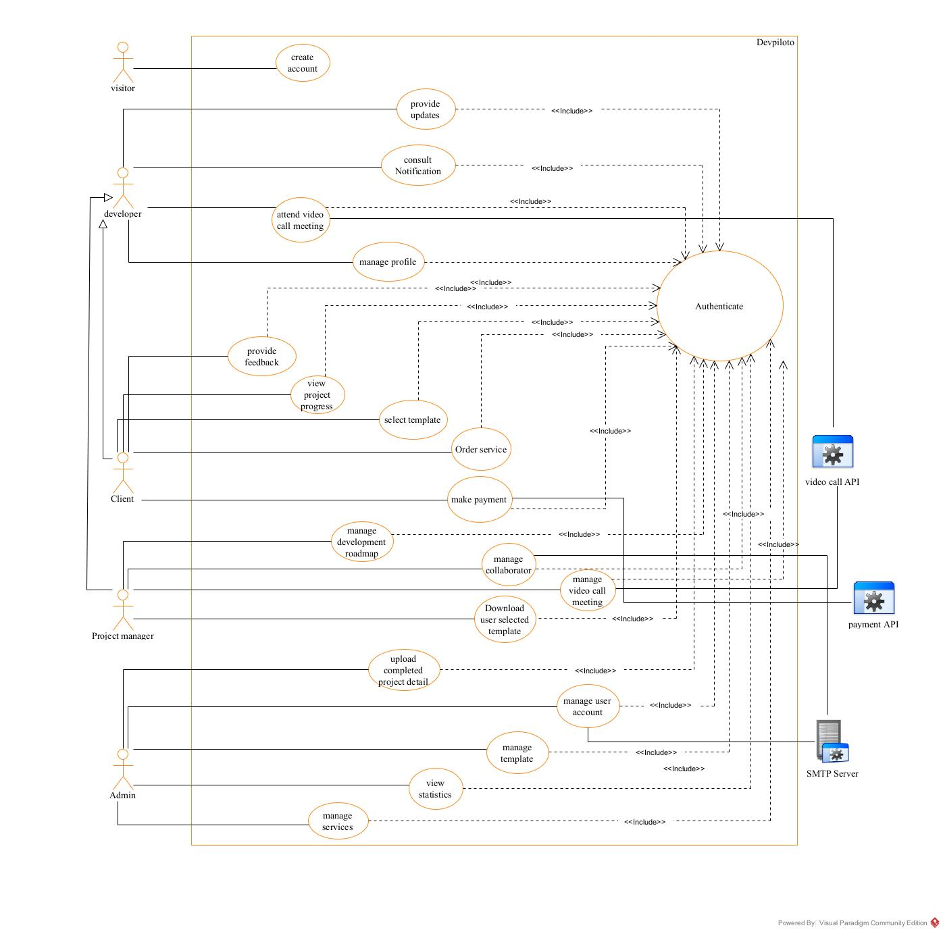
General Use Case diagram
Figure 13:General use case diagram

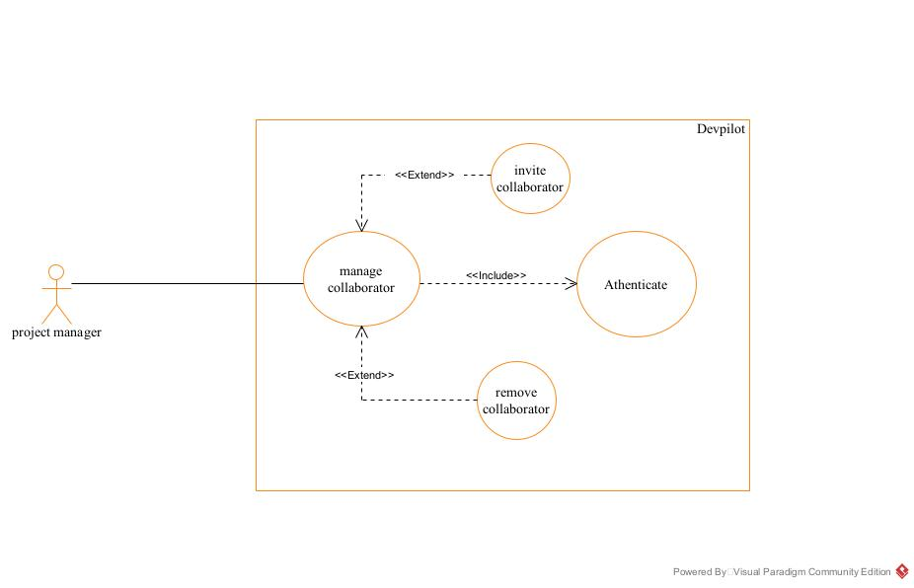
Specific use case of manage collaborators
Figure 14: manage collaborator specific use case

Specific use case diagram of manage user account
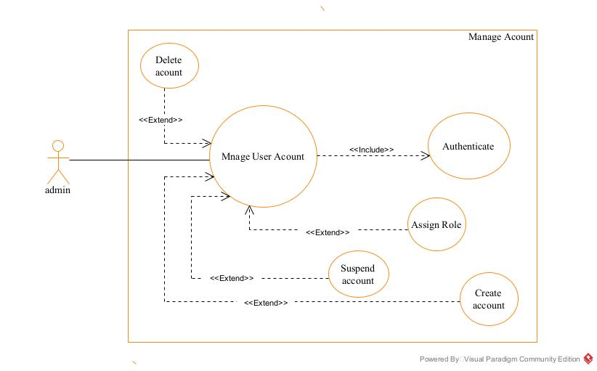
Figure 15:manage user account specific use case

Specific use case of manage roadmap
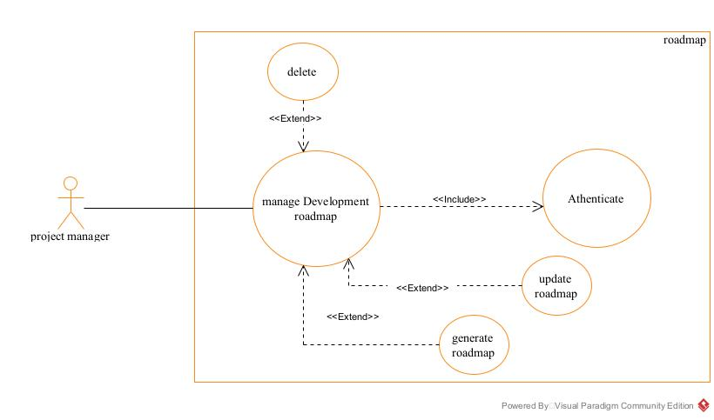
Figure 16: manage roadmap specific use case

Textual description of Authenticate
Table 10: textual description of authentication
Title | Authenticate
Summary | This Use Case
Actors | Admin, Project manager, Client
Date | August 14, 2025
Stakeholders | SHADERL
Version | 1.0
Precondition | - The app is launched  - The actor has an account in the application  - The actors account is neither suspended nor deleted
Trigger | The actor clicks on the Login button.
Nominal scenarios | - The system displays the login form.  - The actor fills and submit the form.  - The system verifies conformity of the forms fields.  - The system sends the data to the dbms.  - The dbms returns the result of the query.  - The system verifies the query results.  - The system displays a success message to the actor
Alternative scenario | - At step 3 of the nominal scenario the user enters wrong credentials or omits a character  - The system displays an error message then returns to step 2 of the nominal scenario.  - At step 6 of the nominal scenario, the dbms result is not valid.  - The system displays an error message then returns to step 2 of the nominal scenario.
Post condition of success | The user has access to his/her dashboard
Poste condition of failure | The user does not have access to the platform
Non-functional requirement | The password should not be visible on screen

Manage roadmap textual description
Table 11: Textual description of manage roadmap (delete action)
Title | Manage roadmap
Summary | The use case describes how a roadmap is managed case study of road map creation
Actor(s) | Project manager
Date | August 14, 2025
Stakeholder | SHADERL
Version | 1.0
Precondition | - The actor must be authenticated  - The actor has necessary permissions  - The actor must be in a workspace/dashboard
Triggers | The user clicks on the “create road map” button
Nominal scenario | - The system displays the roadmap creation from  - The actor fills the form with relevant information’s concerning project development phases and submits it.  - The system verifies all fields has been filled  - The system sends data to the dbms  - The dbms returns result of the query  - The system verifies dbms results  - The system displays a success message to the actor
Alternative scenario | - At step 3 of nominal scenario the actor forgets to fill one field  - The system displays an error message and returns to step 2 of nominal scenario.
Post condition of success | The actor can view the roadmap created
Post condition of failure | No roadmap is created

Order service textual description
Table 12:Order service textual description
Title | Order service
summary | This use case explains how a service is ordered
Actor(s) | Client
Date | August 14, 2025
Stake holder | SHADERL
Version | 1.0
precondition | - The user must be authenticated  - The user must have access to the service page
Trigger(s) | The user clicks on place order
Nominal scenario | - The system displays the order form  - The actor fills and submit the form  - The system checks the form conformity  - The system sends the data to the DBMS  - The DBMS returns the result to the system  - The system verifies DBMS results  - The system displays a success message to the user

Alternative scenario | - At step 3 of the nominal scenario the user forgets to fill o field  - The system displays and error message and returns to step 2 of nominal scenario  - At step 6 of nominal scenario the system gets an error  - The system displays and error message and return to step 2 of nominal scenario
Precondition of success | The user successfully places an order
Precondition of failure | No order is placed

COMMUNICATION DIAGRAM

Definition
Communication Diagrams model the interactions between objects in a sequence. They describe both the static structure and the dynamic behavior of a system. It is a simplified version of a Collaboration Diagram introduced in UML 2.0. A communication diagram is more focused on showing the collaboration of objects rather than the time sequence.

Formalism




Figure 17: formalism of a communication diagram

8.3:
Message_
11
Message_
8.4:
12
8.5:
Message_
13
Objet_1
Obje
t_2
Objet_3
Objet_4

Components of a communication

Table 13: components of a communication diagram
ELEMENT | NOTATION | DESCRIPTION
Message | 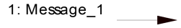 | Designs a particular communication between lifelines.
Connectors |  | It represents the relationships that exist between lifelines
Dependency | 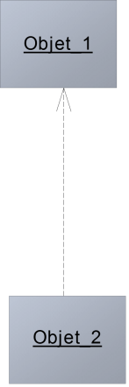 | A dependency is a relationship that signifies a single or a set of model elements for their specification
Lifeline | 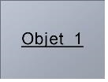 | An object represents an individual participant in the interaction conversation.

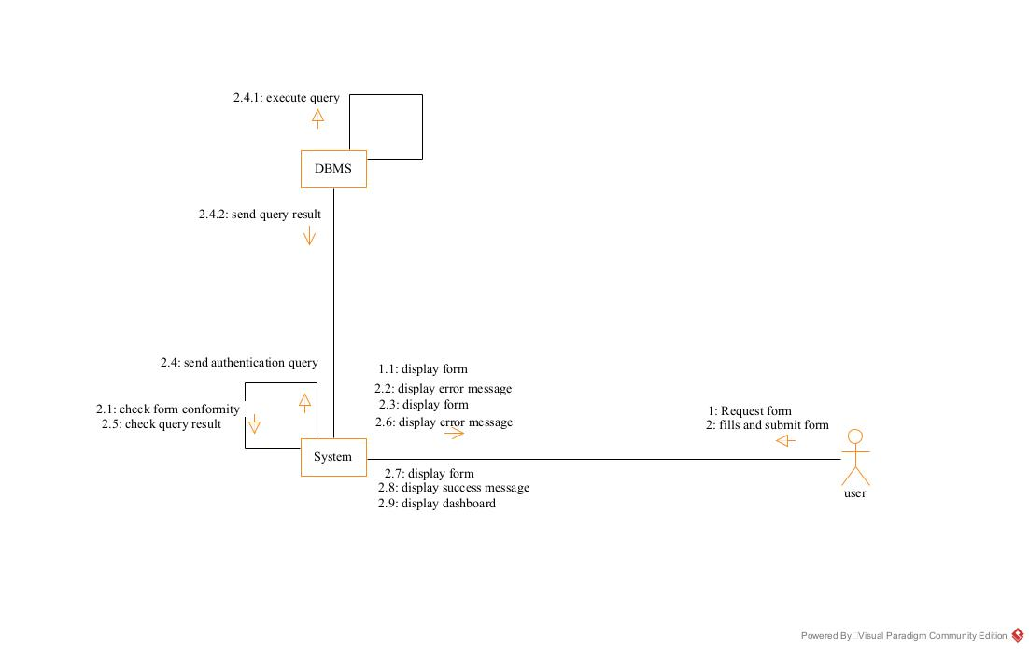
Communication diagram of Authentication
Figure 18: Communication diagram of authentication

Communication diagram of order Service
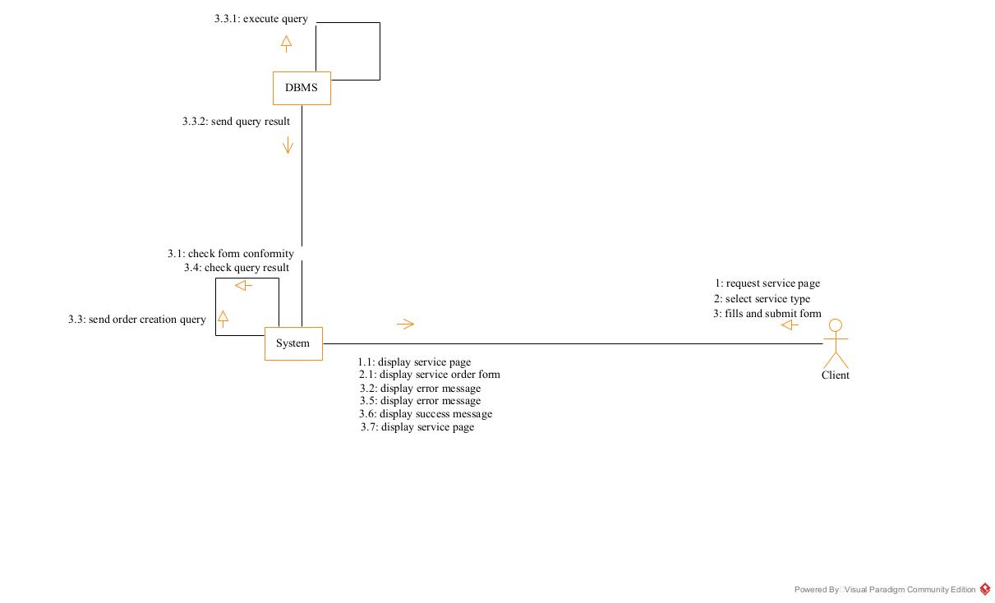
Figure 19:order service communication diagram

Communication diagram of Make payment
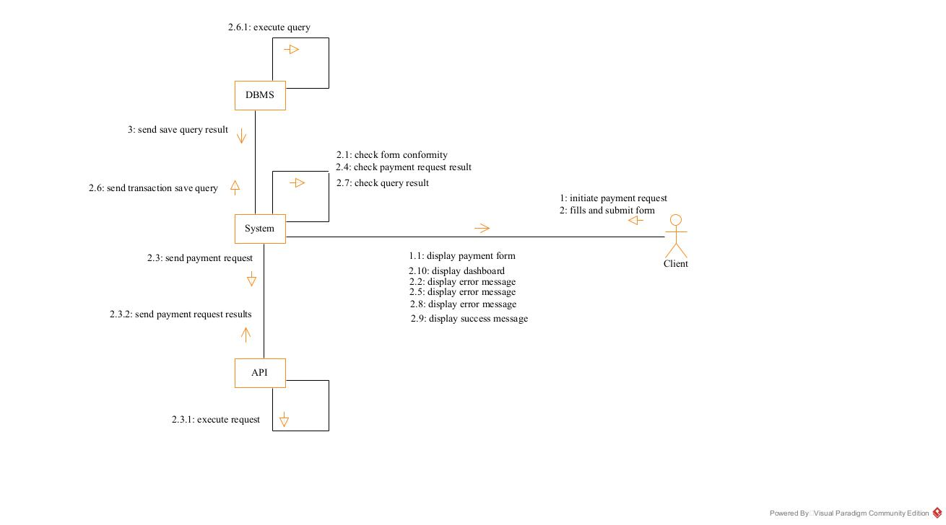
Figure 20: make payment communication diagram

SEQUENCE DIAGRAM

Definition
A Sequence diagram describes interactions among classes in terms of an exchange of messages over time. They are also called event diagrams. A Sequence diagram is a good way to visualize and validate various runtime scenarios. These can help to predict how a system will behave and to discover responsibilities a class may need to have in the process of modelling a new system.

Formalism



Figure 21: formalism of a sequence diagram

sequence diagram formalism
Objet_1
Objet_2
Objet_3
ok
not ok
alt
Message_6
Message_5
Message_4
Message_3
Message_2
Message_1

Components of a sequence diagram
Table 14: components of a sequence diagram
ELEMENT | NOTATION | DESCRIPTION
Life line | 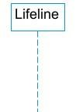 | An individual participant in a sequence diagram, it is position at the top of the diagram
Combined fragment | 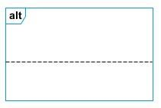 | It represents a choice of behavior in which at most one operand will be chosen.
Messages | 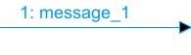  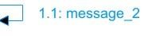  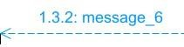 | These are arrows which shows the direction of message flow. We have the synchronous, the asynchronous and the self-messages.
Activation | 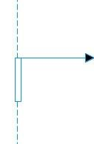 | It describes the time period in which an operation is performed by an element

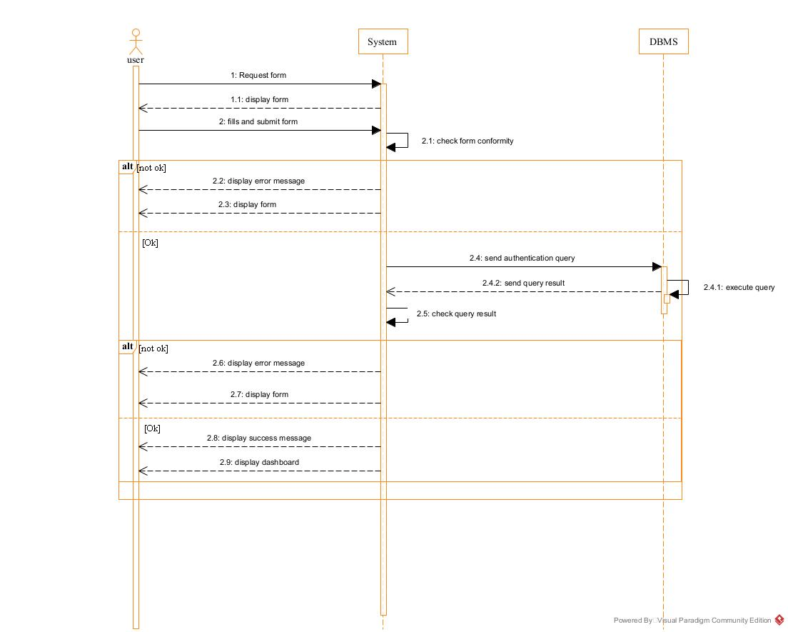
Sequence diagram of Authentication
Figure 22: Authentication sequence diagram

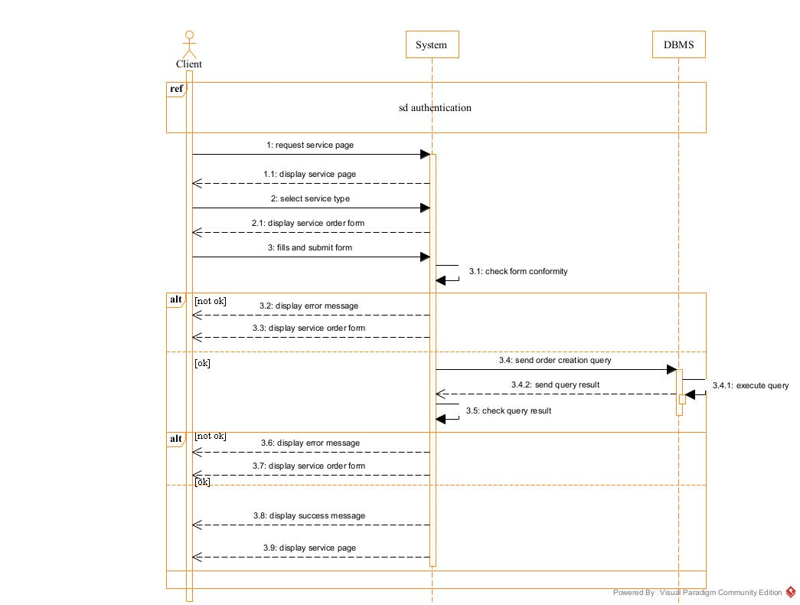
Sequence diagram of Order service
Figure 23: Order service sequence diagram

Sequence diagram of make payment
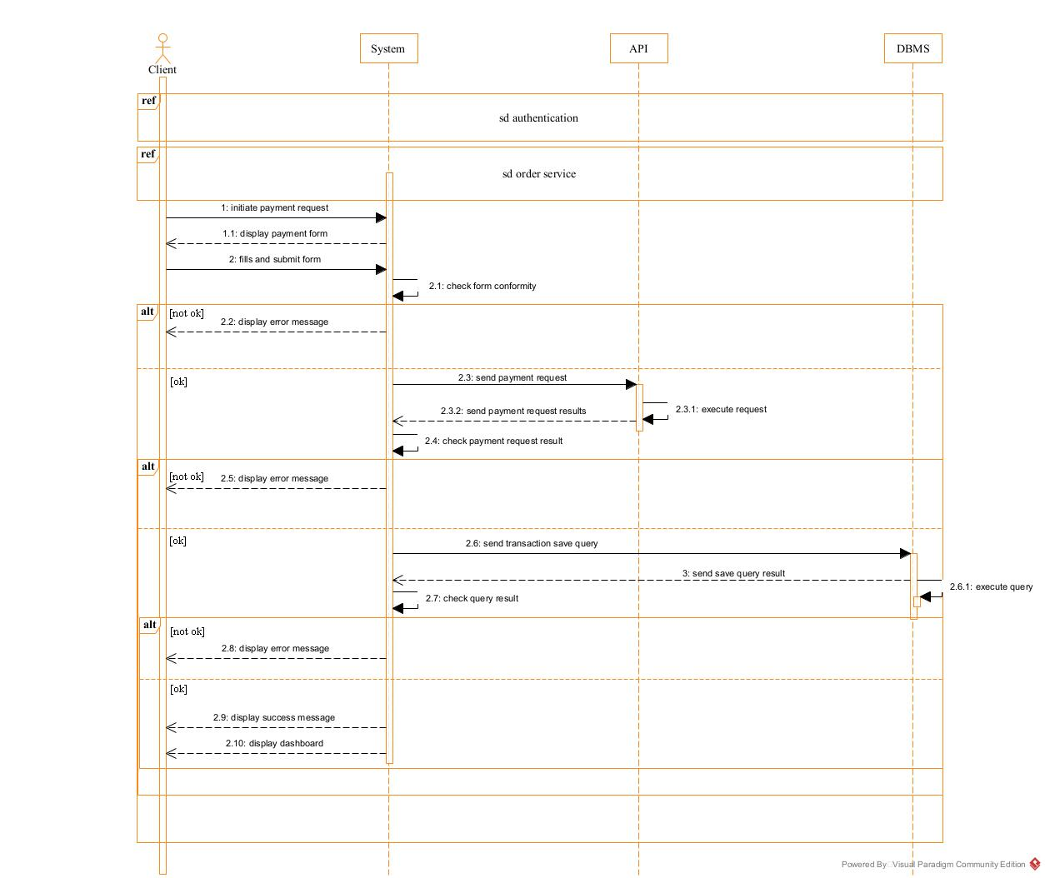
Figure 24: make payment sequence diagram

ACTIVITY DIAGRAM

Definition
An activity diagram is a graphical representation of workflows that show the steps needed in the realization of a process; showing the details from a start point to an end point through all decisions and actions that can possible be performed. Activity diagrams are intended to model both the computational and organizational process. They flow can be sequential, branched or concurrent. Below is an activity diagram formalism.

Formalism














Figure 25: formalism of an activity diagram

Partition 1
Partition 2
Partition 3
action 1
action 3
action 2
action 4
action 5
action 7
action 8
Decision_1
Decision_2
[
ok
]
[
not ok
]
action 6
[
ok
]
[
not ok
]

Components of an activity diagram
Table 15: components of an activity diagram
Element Diagrammatic Representation |  | Description
Activity | 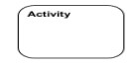 | Used to represent a set of actions.
Action | 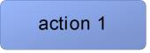 | Represent a task to be performed.
Activity edge |  | A directed connection between two activity nodes through which tokens may flow
Initial node |  | Shows the beginning of an activity or set of actions.
Final node |  | Stops all controls and object flows in an activity.
Object node | 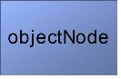 | Represents an object connected to a series of object flows.
Decision node | 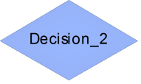 | Represents a test condition that slits an incoming activity edge into opposite outgoing activity edges.
Merge node | 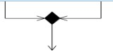 | Reunite different decision paths created using a decision node.

Fork node |  | Slits behavior into parallel or concurrent flows of activities (or actions).
Join node |  | Unites a set of parallel or concurrent flows of activities or actions.
Swimlane and partition | 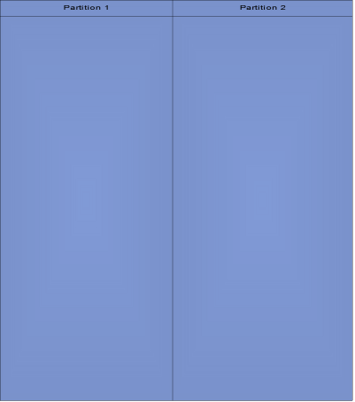 | A way of grouping activities performed by the same actor in an activity diagram or to group actions in the same thread.

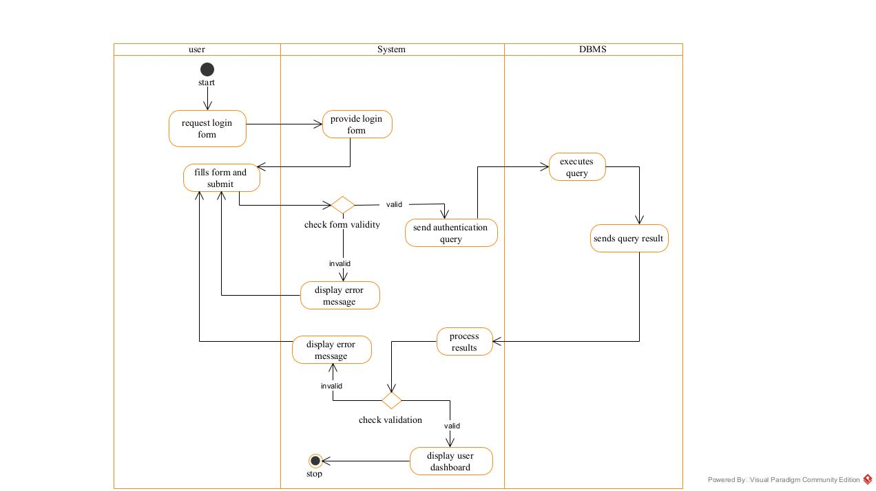
Activity diagram of authentication
Figure 26:authentication activity diagram

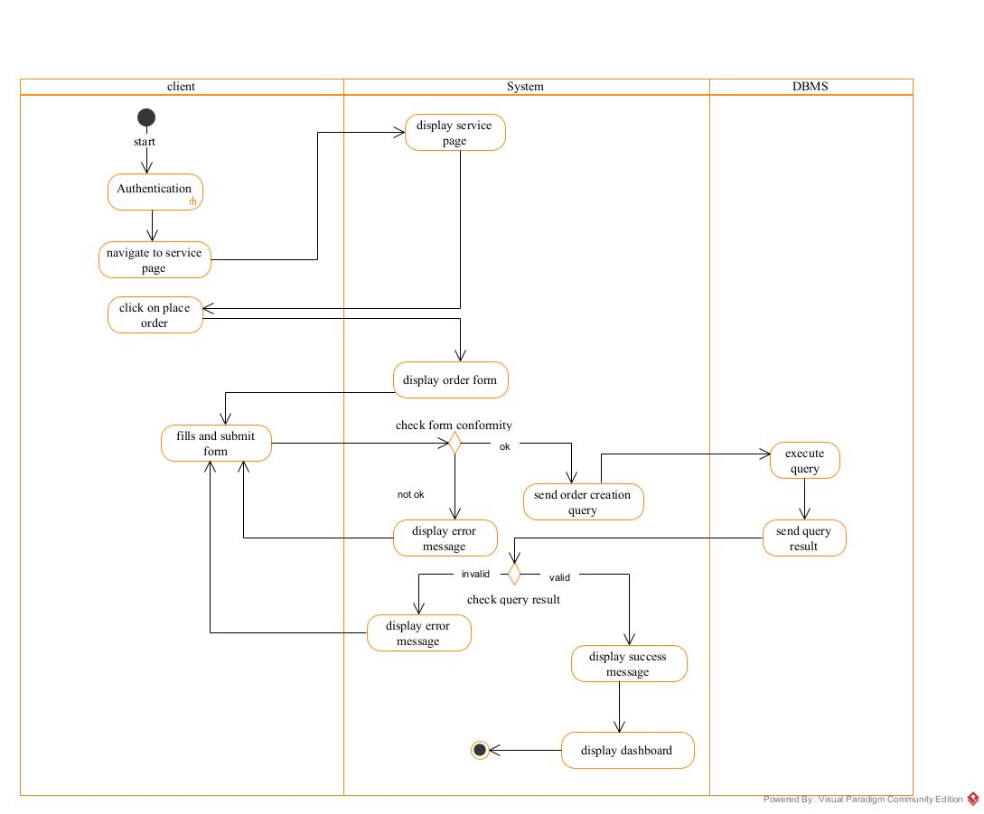
Activity diagram of Order service
Figure 27: order service activity diagram

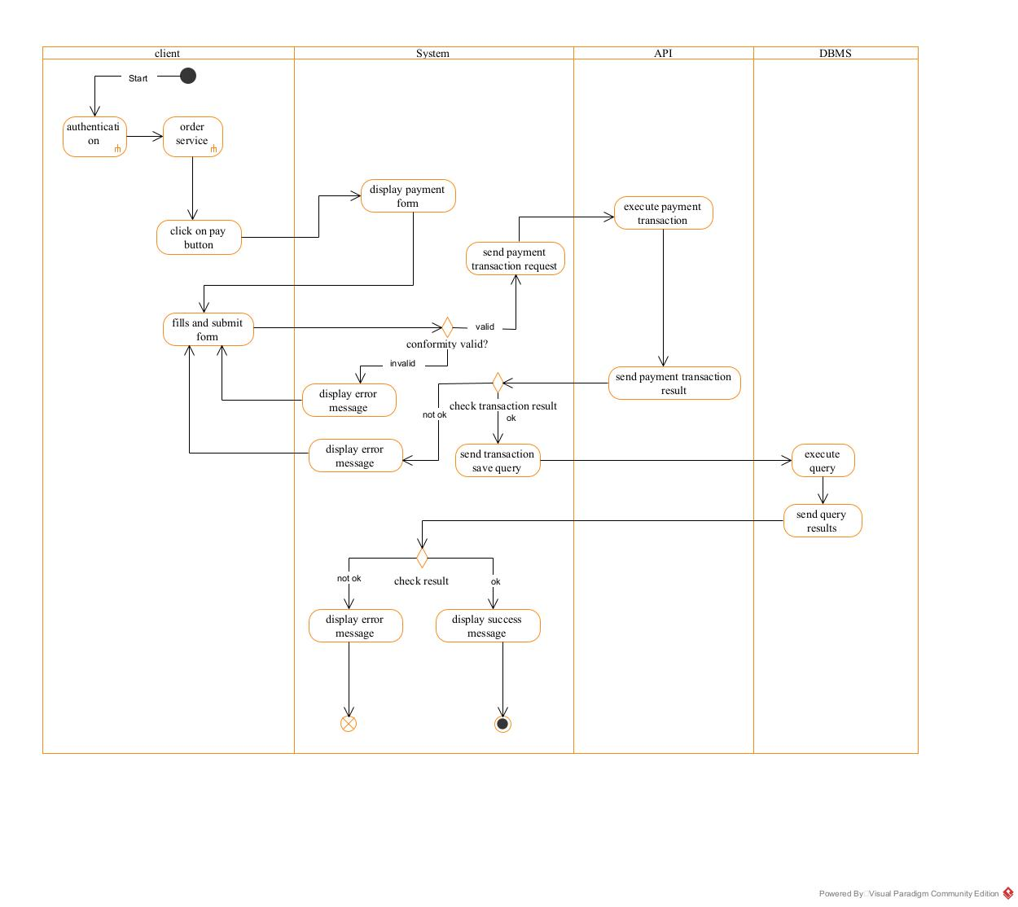
Activity diagram of Make payment
Figure 28: make payment activity diagram

CONCLUSION
In the analysis phase, we selected a software development process and a modeling language, after which we outlined the functional requirements of our system. We examined the use case diagram, which illustrates the relationships between the actors and the use cases (the actions the actors can perform within the system). We also explored the communication diagram, which depicts the system's architecture based on object-oriented programming principles. Additionally, we analyzed the sequence diagram, which outlines the flow of messages between elements in the system. Finally, we reviewed the activity diagram, which illustrates the workflow of our system. We will now transition to the conception phase, where we will present the technical aspects of our system along with the associated diagrams

PART V: DESIGN PHASE

Preamble

The conception phase will permit us to present in an orderly manner the components necessary for the good functioning of our software and also the architecture used for the proposed solution. It bridges the gap between the analysis phase and the realization phase.

Content

INTRODUCTION
I. TECHNICAL BRANCH
A. CAPTURE OF TECHNICAL NEEDS
B. RELATED UML DIAGRAMS
i. STATE MACHINE DIAGRAM
ii. PACKAGE DIAGRAM
CONCLUSION

INTRODUCTION
The conceptual phase will provide a detailed description of the necessary specifications, features, and operations required to meet the functional requirements of the proposed system, as outlined in the analysis phase. This stage aims to identify and consider essential components both hardware and software as well as the system's structure (including network capabilities), processes, and procedures needed to achieve its objectives. We will examine several key diagrams, including the class diagram, state machine diagram, and package diagram, to support our understanding of the system's design and functionality.

TECHNICAL BRANCH
- CAPTURES OF TECHNICAL NEEDS

Physical architecture
The design of the Devpilot system is based on an n-tier architecture, which effectively partitions the entire system into related but separate modules. This modular approach allows for independent modification, alteration, or replacement of each tier as needed.
In our project, we utilize the n-tier architecture to separate the system components based on user interactions and the data managed within the database. Each layer has a well-defined communication interface, enabling independent evolution without impacting other layers. The n-tier architecture of Devpilot consists of the following components:
Client Tier (Presentation Interface): This tier represents the user interface of the application, where users interact with the system. It encompasses the web applications that allow users to upload, search, and manage their Projects.
Application Tier: This tier consists of the web server that hosts the Devpilot application. It handles the business logic, processes user requests, and facilitates communication between the client and data tiers.
Data Tier: This tier represents the DBMS and storage server, where all user data are stored. It manages data access, retrieval, and security, ensuring that users can securely access their information.
Email Tier: This tier contains the mail server of the organization.
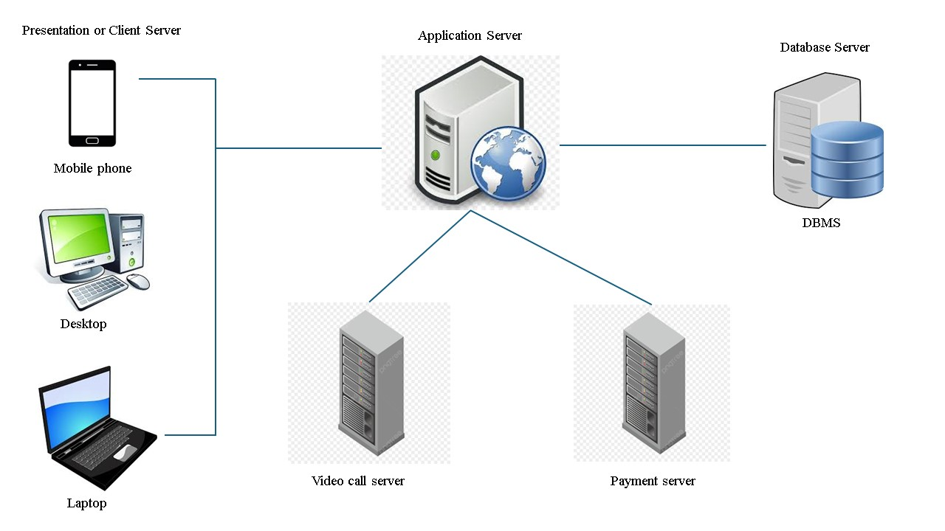

Figure 29: N-tier architecture

Logical architecture
Model View Template (MVT) architecture pattern, which is a variation of the traditional Model View Controller (MVC) design pattern. It is made up of the following:
- Model: it acts as the data layer of the application responsible for structuring your database and handling data related logic it typically represents your database tables and is responsible for querying, inserting, updating and deleting data. Django models are usually backed by relational databases like MySQL, PostgreSQL, SQLite.
- View: it is responsible for handling business logic and user interface rendering. It processes user requests, interact with the models to fetch data, and passes that data to templates for display. In Django views are python functions or classes that returns HTTP responses.
- Template: it is responsible for presenting data to the user. it contains the static parts of the HTML and special template syntax like Django template language to dynamically insert data
The Model View Template (MVT) architectural pattern is, particularly in Django, id popular due to its focus on separation of concerns, which allows developers to work on different parts of an application independently, like the database (Model), business logic (View) and user interface (Template), without interfering with each other.
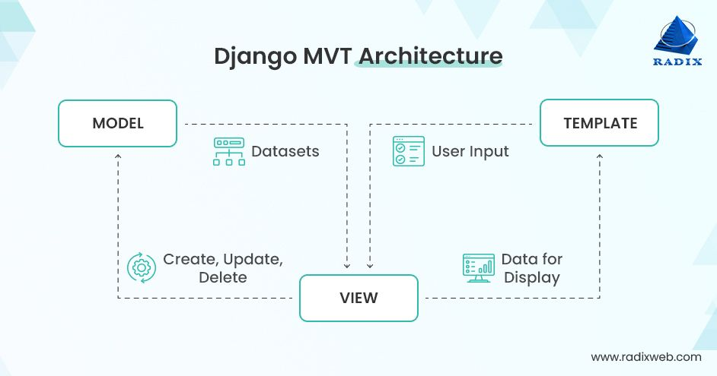

Figure 30: MVT architecture pattern

- RELATED UML DIAGRAMS
- Class Diagram

Definition:
A class diagram is a static diagram. It represents the static view of an application. class diagram is not only used for visualizing, describing and documenting different aspect of the system but also for constructing executable code of the software application. Class diagram describes the attribute and operation of a class and constraints imposed on the system. Its purpose is to model the static view of an application.

Formalism:
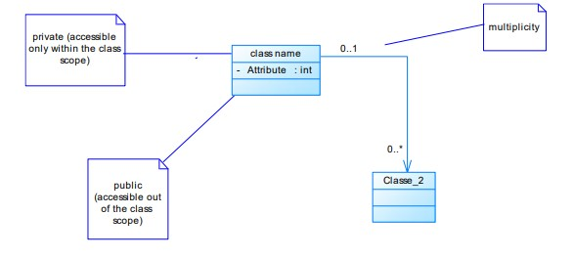
Figure 31: formalism of a class diagram

Elements of a Class Diagram

Table 16: components of a class diagram
Element | Representation | Description
Class | 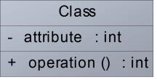 | A class is an element that defines the attributes and behaviors that an object can generate
Composition | 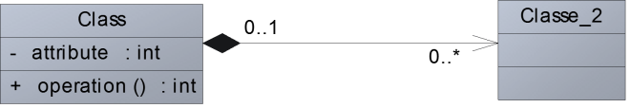 | If a parent of a composite is deleted, usually, all its parts are deleted with it.
Aggregation | 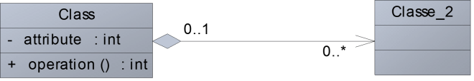 | If the parent of the aggregate is deleted, usually the children are not deleted.
Dependency | 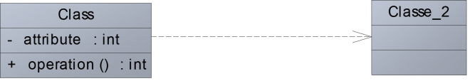 | It existed between two classes, if one changes it may cause the change in the order, but the other way around

Generalization | 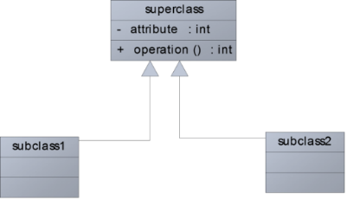 | it a relationship between a whole thing (called superclass) and a more specific thing  (Called subclass)
Association | 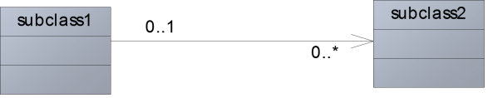 | It is a general type of relationship between elements, it may include cardinality, roles etc.

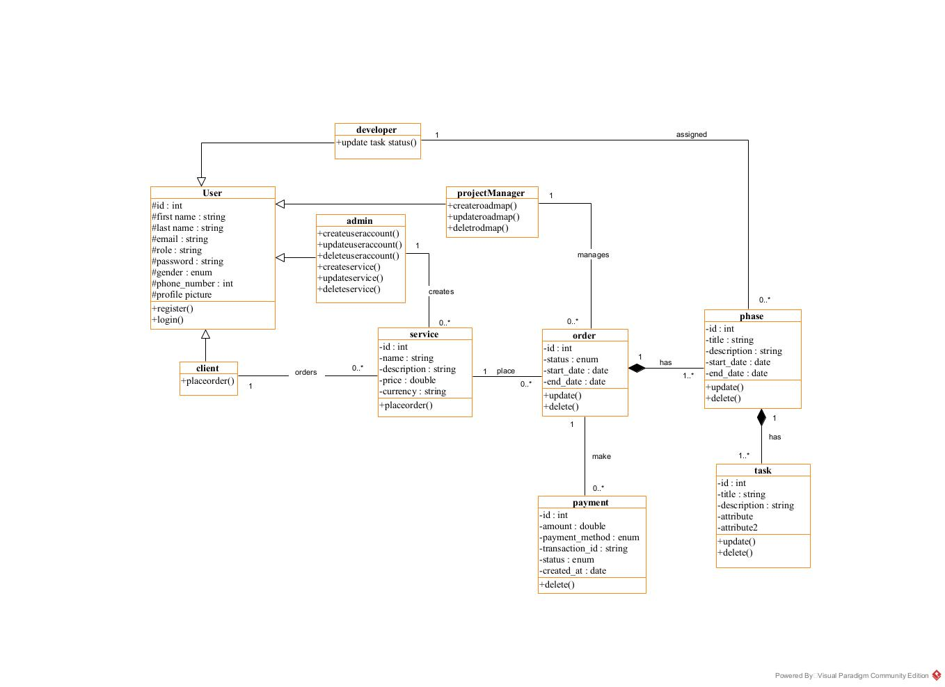
Devpilot’s class Diagram

Figure 32:Application class diagram

- State Machine Diagram

Definition
A state machine diagram describes the behavior of a single object in response to a series of events in a system. Also known as the state machine diagram, it models the dynamic flow of control from the state of a particular object within a system.

Formalism:
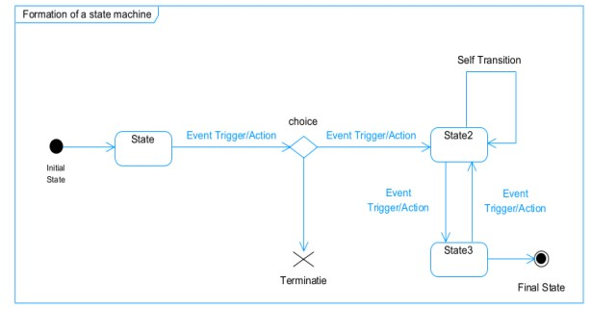
Figure 33: formalism of a state machine diagram

Components of a State Machine Diagram

Table 17: components of a state machine diagram
Element | Representation | Description
State | 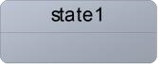 | Models a situation during which a certain invariant condition holds.
First (Initial  State) |  | It represents a default vertex, that is, a source for a single transaction to the default or composite state.
Final State |  | A state specifying that the enclosing region is complete.
Transition | 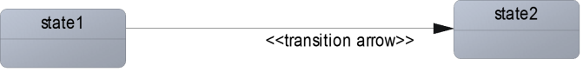 | A direction relation between a source and a target vertex.
Choice pseudo state |  | A diamond symbol that indicates a dynamic condition with branched  potential results
Terminate | 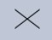 | Implies that the execution of a state by means of it context is terminated.
Diagram overview | 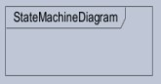 | A placeholder for the linked states in a state machine diagram.

Transaction state machine diagram
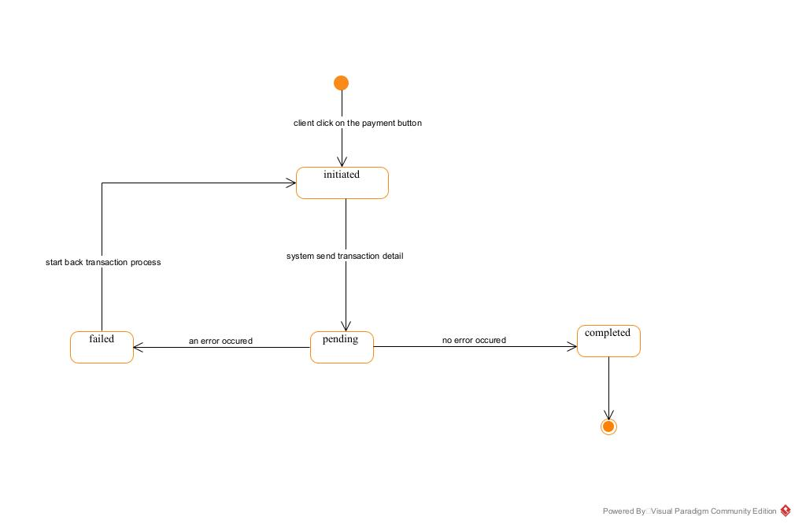
Figure 34: transaction state machine diagram

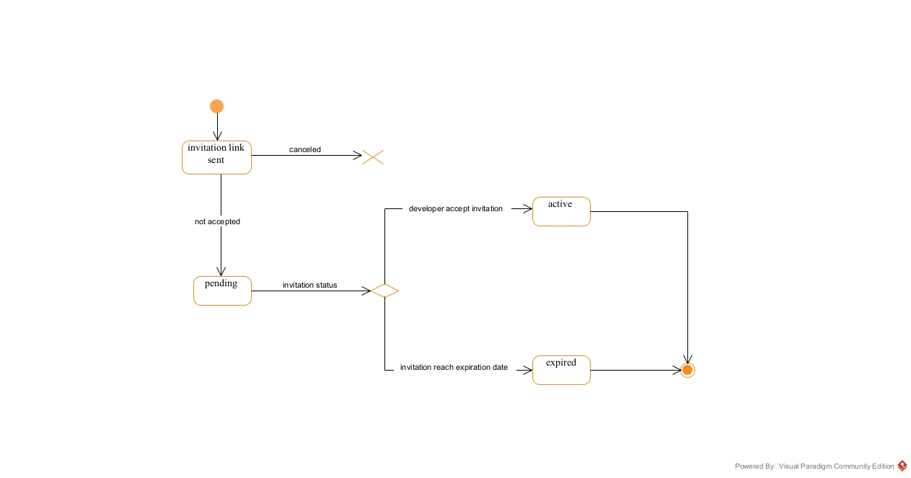
Developer invitation state machine diagram
Figure 35: developer invitation state machine

- Package Diagram:

Definition:
This is a structural diagram used to show the organization and arrangement of various model elements in the form of packages. A package diagram is the grouping of related UML elements such as classes, diagrams or even other packages.

Formalism:
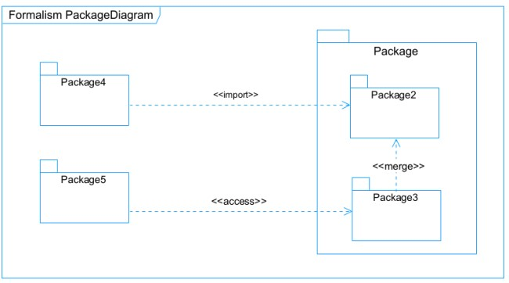
Figure 36: formalism of a package diagram

Components of a package diagram

Table 18: components of a package diagram
Element Representation |  | Description
Package | 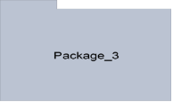 | A package is a namespace use to group related elements; it is a mechanism used to group elements into a better structure in a system.
Package import | 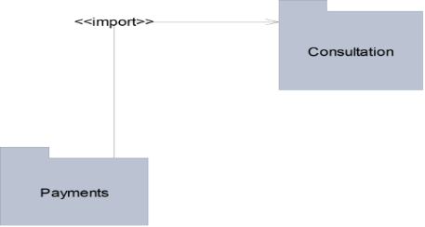 | A relationship Indicate that, functionality has been imported from one package to another.
Package access | 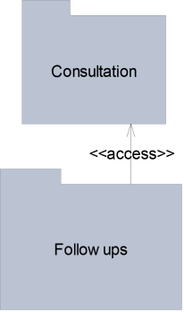 | A relationship  Indicates that one package requires assistance from the function of another package.

Package merge | 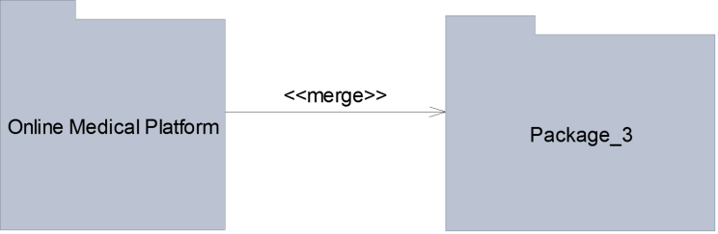 | It is a relationship  which shows that, the functionality of two packages are combines to a single function.

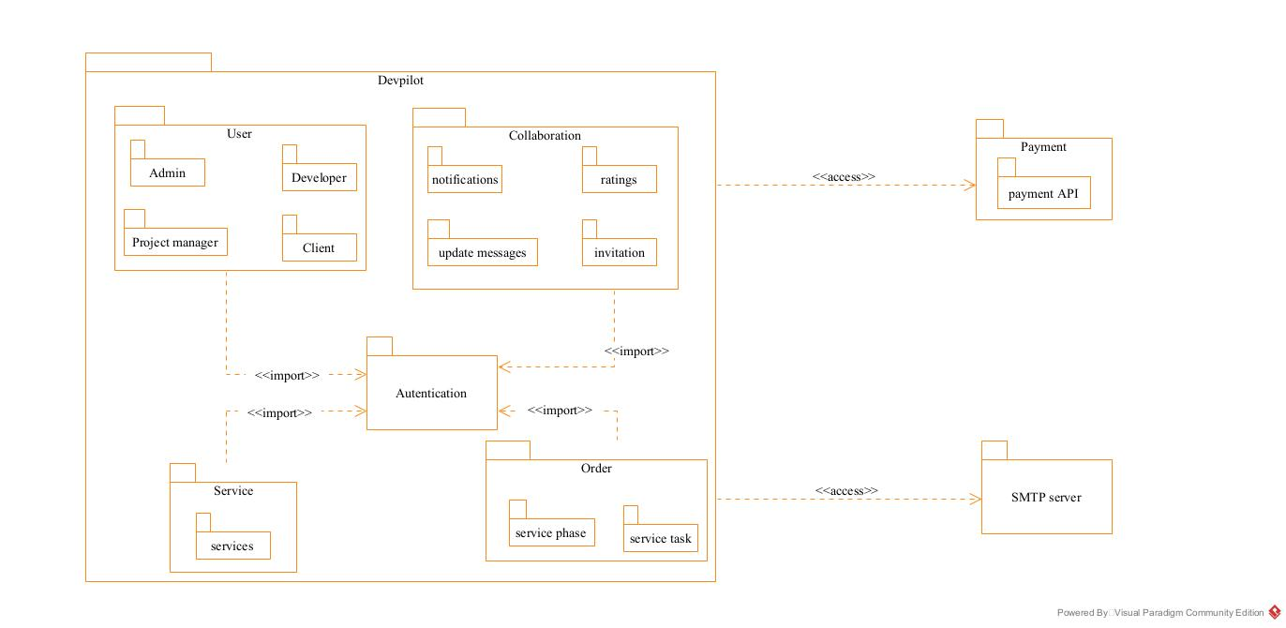
Devpilot’s package diagram
Figure 37: application package diagram

CONCLUSION
In the conception phase, our objective was to plan the various aspects of our system, demonstrating how it will be structured and integrated within existing technical architectures. We began by addressing the technical constraints for our system, followed by identifying the components, their groupings, and the appropriate deployment targets for each. We concluded this phase by examining the interactions between the different elements and actors within our system. The next phase of our report is the realization phase, where we will focus on the implementation aspects of our system.

PART VI: DEPLOYMENT PHASE

Preamble

In this phase we will to straight forward in the implementation of our solution, we will base ourselves on the analysis and conception phases and also present the component and deployment diagrams.

Content

INTRODUCTION
- TECHNOLOGY STACK
- II. RELATED UML DIAGRAMS
A. DEPLOYMENT DIAGRAM
B. COMPONENT DIAGRAM
CONCLUSION

INTRODUCTION
The Deployment phase marks the transition from design to implementation for our digital preservation app, focusing on the selected technology stack and relevant UML diagrams, specifically the deployment and component diagrams. We will outline the technologies chosen for the frontend, backend, database, and cloud services, ensuring scalability and optimal performance. The deployment diagram will illustrate the physical architecture of the application components across servers and services, while the component diagram will detail the internal structure, highlighting key components and their interactions. This comprehensive approach aims to establish a solid foundation for development, facilitating collaboration and alignment with project goals for a successful app launch

TECHNOLOGY STACK
Table 19: technology stack
NAME | LOGO | DESCRIPTION | ADVANTAGE
HTML |  | HTML (Hyper-Text Markup Language) is a Standard markup language for creating web pages. | It helps us to Structures and organizes web content.
Tailwind CSS |  | It is a Utility-first CSS framework used | It is helps us to Styles web pages quickly with predefined classes.
Django |  | Django is a High-level Python web framework used for web application’s development. | It helps us to Builds secure, scalable, and maintainable web applications.
JavaScript |  | JavaScript is a high level dynamic and interpreted programing language. | It is primarily used for web development, client-side scripting and server-side programming.
Google Chrome |  | Google Chrome is a fast, secure, and user-friendly web browser developed by Google. Used to test our application UI | Chrome is optimized for  fast page loading and  efficient resource  management, providing a

SQLite |  | SQL is a popular open-source relational database management system that allows you to store and manage data in a structured and efficient way | It is easy to set up and use even for developers with no extensive knowledge of database, it is light-weight and doesn’t require significant resoureces.
Visual studio code |  | Visual Studio Code (VS Code) is a free, open-source, and cross-platform source code editor developed by Microsoft. | Provides a fast and efficient environment for writing and editing code, with support for syntax highlighting, intelligent code completion (IntelliSense), snippets, and code refactoring.
Chrome |  | Google Chrome is a fast, secure, and user-friendly web browser developed by Google. Used to test our application UI | Chrome is optimized for fast page loading and efficient resource management, providing a smooth browsing experience.

Visual  Paradigm |  | Visual Paradigm is a comprehensive modeling tool that supports software design and system modeling. Used to design our UML diagrams. | Supports multiple modeling languages and methodologies, making it suitable for various project requirements and enabling teams to adapt to different development processes.
Gantt Project |  | Gantt Project is a free, open-source project management tool that allows users to create Gantt charts for planning and scheduling projects | Allows users to assign tasks, set deadlines, and manage resources effectively, facilitating better project coordination and efficiency.

RELATED UML DIAGRAMS
- DEPLOYMENT DIAGRAM

Definition
Deployment diagram is a structural diagram used to visualize the topology of the physical components of a system, where the software is deployed. They consist of nodes and their relationship. It is related to the component diagram because the components are deployed using the deployment diagram. A deployment diagram consists of nodes. Nodes are nothing but physical hardware used to deploy the application.

Formalism
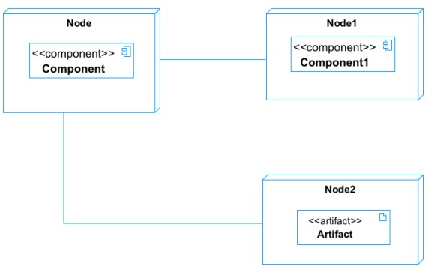
Figure 38: formalism of a deployment diagram

components of a deployment diagram
Table 20: components of a deployment diagram
Element | Representation | Description
Node | 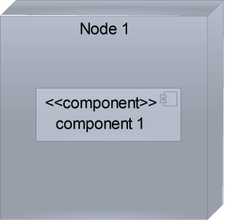 | It is a hardware used to deploy the application
Artifact | 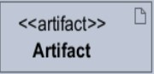 | An artifact is a major product, which is produced or used during the development of a software. E.g diagrams, data models, setup scripts
Component | 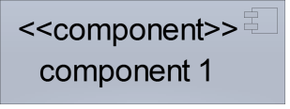 | It represents a modular part of a system that encapsulates its content and whose manifestation is replaceable within it environment.
Association | association | An association helps to connect two nodes together which permits them to communicate together

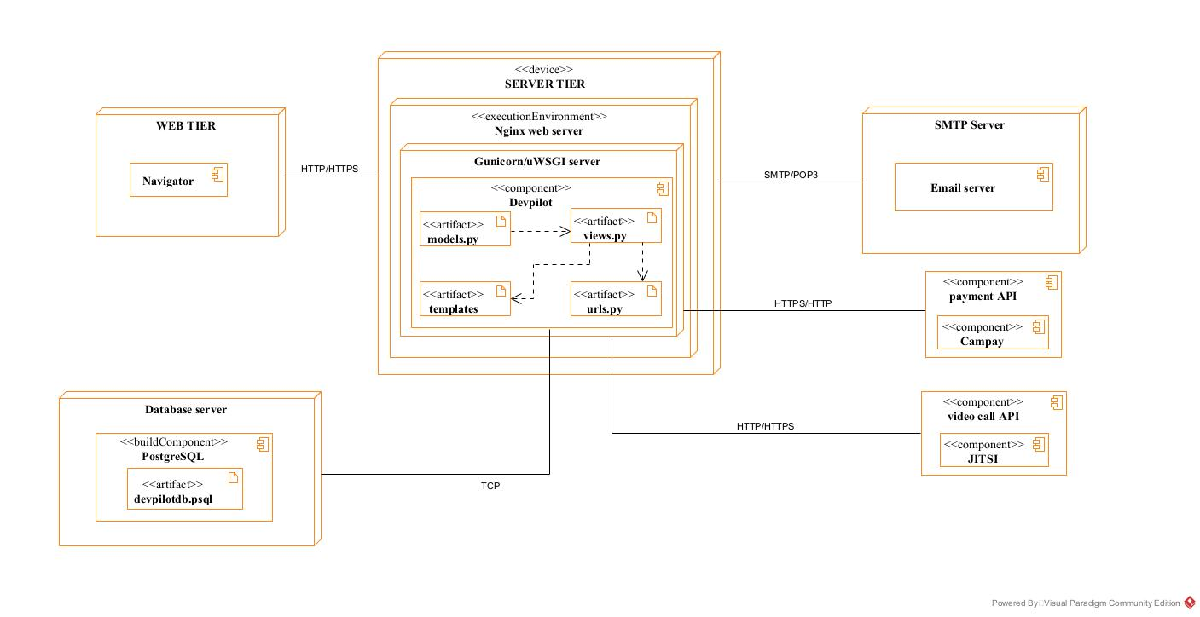
System deployment diagram

Figure 39: applications deployment diagram

- COMPONENT DIAGRAM

Definition
Component diagrams are used to model the physical aspect of a system. Now the question is what are this physical aspect? They are elements such as Executables, libraries, files, document etc. which resides in a node. The component diagram does not describe the functionality of the system, but it describes the components used to make those functionalities.

Formalism
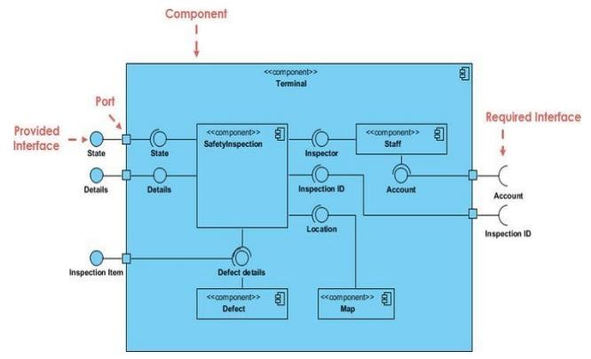
Figure 40: formalism of a component diagram
a.

Elements of a Component Diagram

Table 21: components of a component diagram
Name Representation |  | Description
A Component | 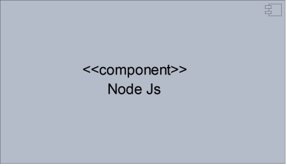 | A component is an abstract logical unit block of a system.it is represented as a rectangle with smaller rectangle in the upper right corner which saves as it icon for recognition.
Dependency | 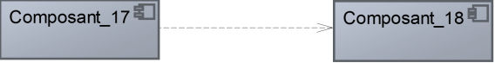 | Dependency is a directed relationship which is used to show that some components are dependent on others for their correct functioning.
Required  Interface | 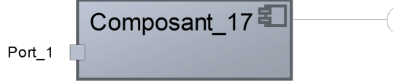 | It is a straight line from the component box with an attached half circle representing interfaces where a component requires information in order to perform its own functions.
Provided Interface | 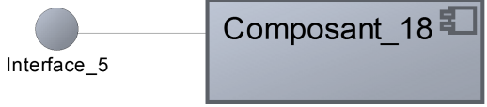 | It is a straight line from the component box with an attached circle representing interfaces where a component produces information used by required interfaces
Port | 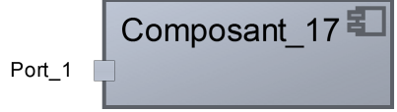 | A port (represented by a small square at the end of a required or provided interface) is used when the components delegate the interfaces to an internal class.

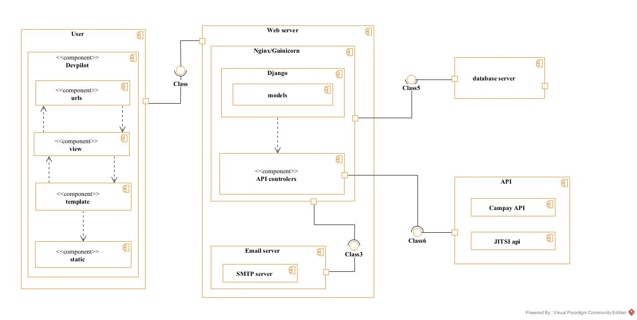
System component diagram
Figure 41: Application's component diagram

CONCLUSION
In conclusion, the deployment phase is a crucial step in the development of our project management app, where we bring our vision to life through the implementation of the selected technology stack and the creation of key UML diagrams. By leveraging technologies such as HTML, Tailwind CSS, Django, we ensure that the application is scalable, efficient, and capable of meeting user needs. The deployment and component diagrams provide valuable insights into the system architecture, facilitating better communication among team members and streamlining the development process. Following this phase, we will transition to functional testing, where we will rigorously evaluate the application to ensure all features work as intended, further enhancing its reliability and user experience before deployment.

PARTVII: TEST OF FUNCTIONALITIES

Preamble

In this phase, we will present the various functionalities of our application.

Content

INTRODUCTION
- APPLICATION FUNCTIONALITIES
- TEST SHOWCASE
CONCLUSION

INTRODUCTION
The testing phase allows us to gain deeper insights into the solution we are developing, for web platforms. This phase highlights the various functionalities or modules within our application and their benefits to users. In this context, we will explore the different functionalities present in Devpilot examining how each module contributes to enhancing user experience and meeting their needs.

APPLICATION FUNCTIONALITIES
- User Authentication: This functionality enables users to access their workspace through accounts created and managed exclusively by an admin. The admin has the ability to suspend, reset, or activate user accounts, ensuring control over user access and security.
- User account creation: this functionality enables non users to create accounts in our application
- Road map creation: this functionality permits project managers to create roadmaps
- Service management: this functionality permits the admin to add services provided by the company in the app
- Collaboration tools: this functionality gives permit developers to be invited to work on a project and gives room to update exchanges via a structured message system.
- User management tools: this functionality permits the admin to
- Log Out Users can securely log out to close their working session, ensuring that their accounts remain protected.
- Task Assignment Managers can assign tasks related to Services to developers. This feature ensures that responsibilities are clearly defined and tracked within the app
- Task Status Management Users can change the status of assigned tasks to "pending," "Completed. This functionality allows for effective task management and ensures everyone is updated on task progress.
- Reporting and Analytics Users receive insights into their application usage updates, transactions and more. This feature helps in understanding user behavior and improving the application.
- User Support and Documentation This functionality provides help resources, including FAQs and user guides, ensuring users have access to assistance when needed.
- Personal information’s modification this functionality allows user to manage their personal information’s, upload assets such as profile pictures.

TEST SHOWCASE
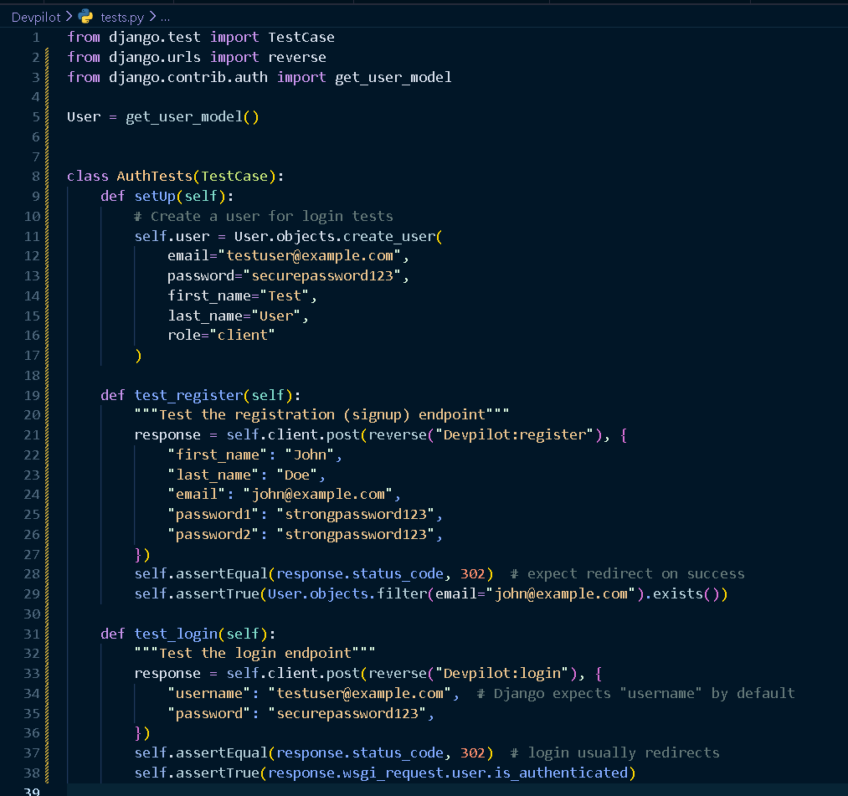
The following tests were carried out using our python built in test.py file using the configurations bellow
Figure 42:test showcase configurations

The above test configuration is executed by typing the command python manage.py test

The results of the test carried out above are as follows
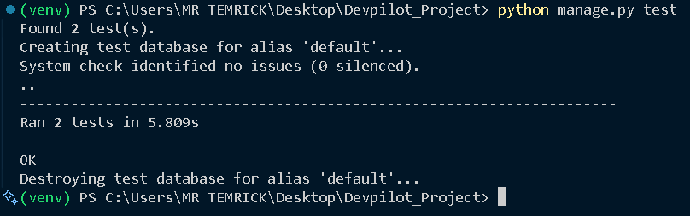
Figure 43: test showcase results

Above are the results of the test of the registration and authentication modules and we receiving a 200 (ok) status code from the backend hence the test was successful

CONCLUSION
In the testing phase, we outlined the different functionalities of our application and their benefits to various users, including SME’s, Organizations, users. This phase is crucial for understanding how the application operates and serves its users effectively. We will now transition to the final phase, which is the installation and user guide. In this section, we will provide detailed instructions on how to install and use Devpilot.

PART VIII: INSTALATION AND USER GUIDE

Preamble

The purpose of the user guide is to provide users of our platform with step-by-step instructions on how to install and use the system.

Content

INTRODUCTION
- INSTALLATION OF THE APPLICATION
- SHOWCASE
CONCLUSION

INTRODUCTION
This is the final phase of our report. In this section, we will outline the requirements for our system, detail the installation process, and explain how to access the system and its features. We will present this information in a step-by-step manner to ensure that first-time users can easily set up the platform. Following this, we will showcase our application by reviewing the different screens, highlighting the user interface and key functionalities.

INSTALLATION OF THE APPLICATION
Here we are going to give some steps in order to have the complete set up to run Devpilot locally that is on your machine.
Step1 get access to the application directory:
The very first step is to get access to the repository containing the application’s source code. After that clone the repository on your computer using the command
git clone <<repository URL>>
after doing this you are good to go to the next step
Step 2 install required dependencies
After getting access to the application source code and cloning in your computer the next step is to install the necessary dependencies to be able to run Devpilot locally, to do as shown below;
Open a terminal and navigate to location where you cloned the repository, for example let’s say you cloned it on the desktop so we will navigate there using the command: cd Desktop
When in the location where you cloned the repository, access the repository containing the source code of our app
Cd Devpilot_project
After that you need to create a virtual environment using the command: python -m venv name_of_environment. Replace name_of_environment with the actual name you want to give to your virtual environment t let’s say we created a virtual with name venv to activate it we type the command venv\Scripts\activate.
After activating the virtual environment install the dependencies using the following command pip install -r requirements.txt
after the installation is completed you can move to the next step
step 3 launching of servers:
after successful installation of the dependencies you need to launch the development servers so as to view the app locally.
Run the command: python manage.py runserver (in a virtual environment) open another terminal activate the virtual environment and run the command python mange.py tailwind start (this command is to run the tailwind local server to get access to tailwind classes)
Pro tip: to facilitate this task you can run the above commands from your virtual studio Code terminal.

SHOWCASE

User Registration
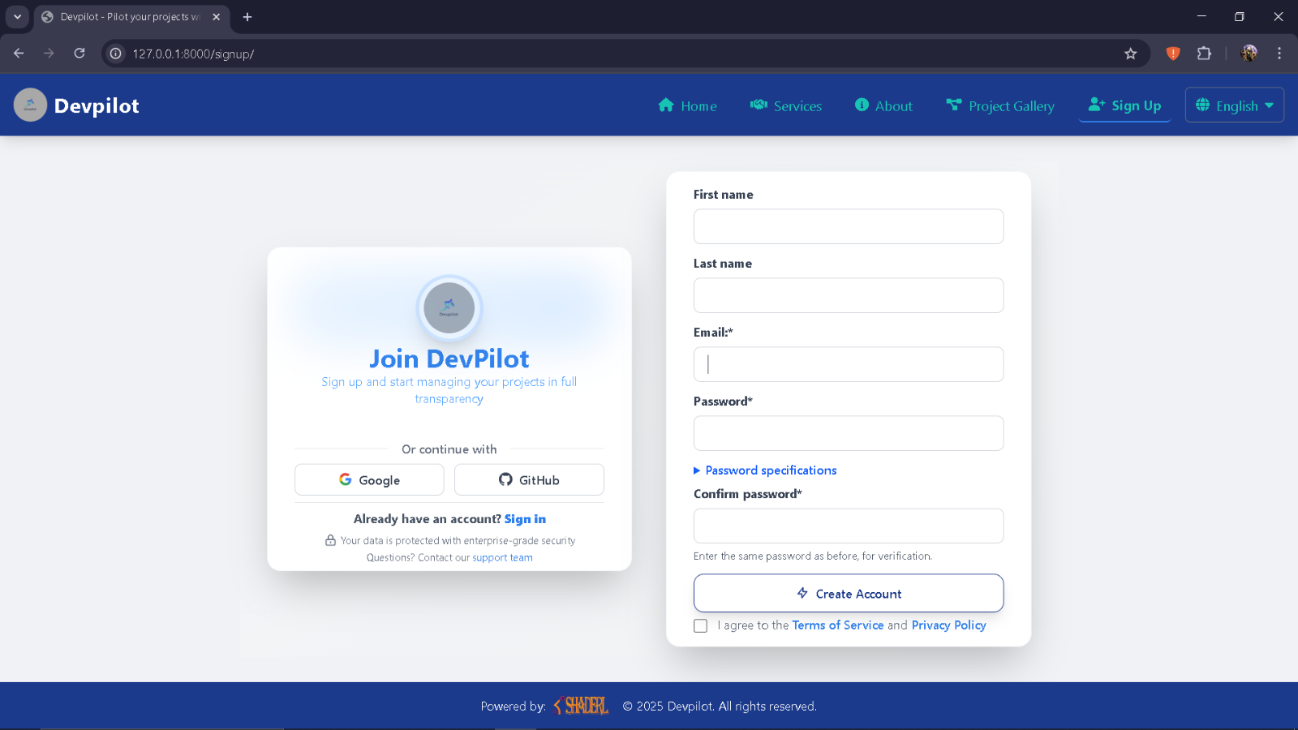
Here the user creates an account using the registration form and is automatically logged in.
Figure 44: user registration showcase

Project manager account creation
Here the Amin creates the project manager account with the password automatically generated and sent to the project manager through Gmail
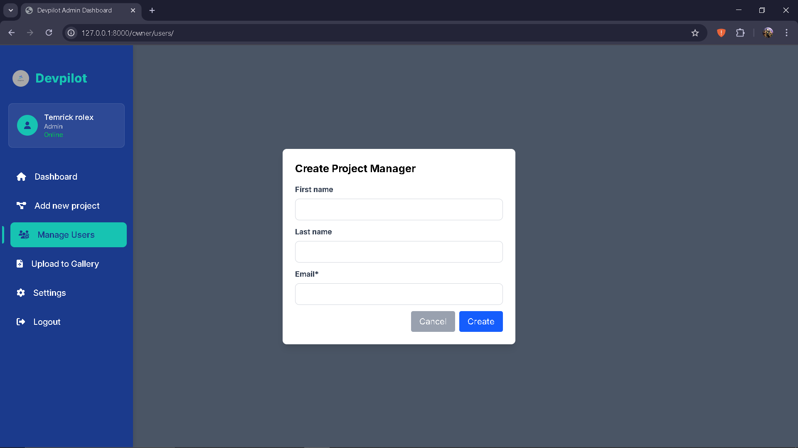
Figure 45: project manager account creation showcase

User authentication
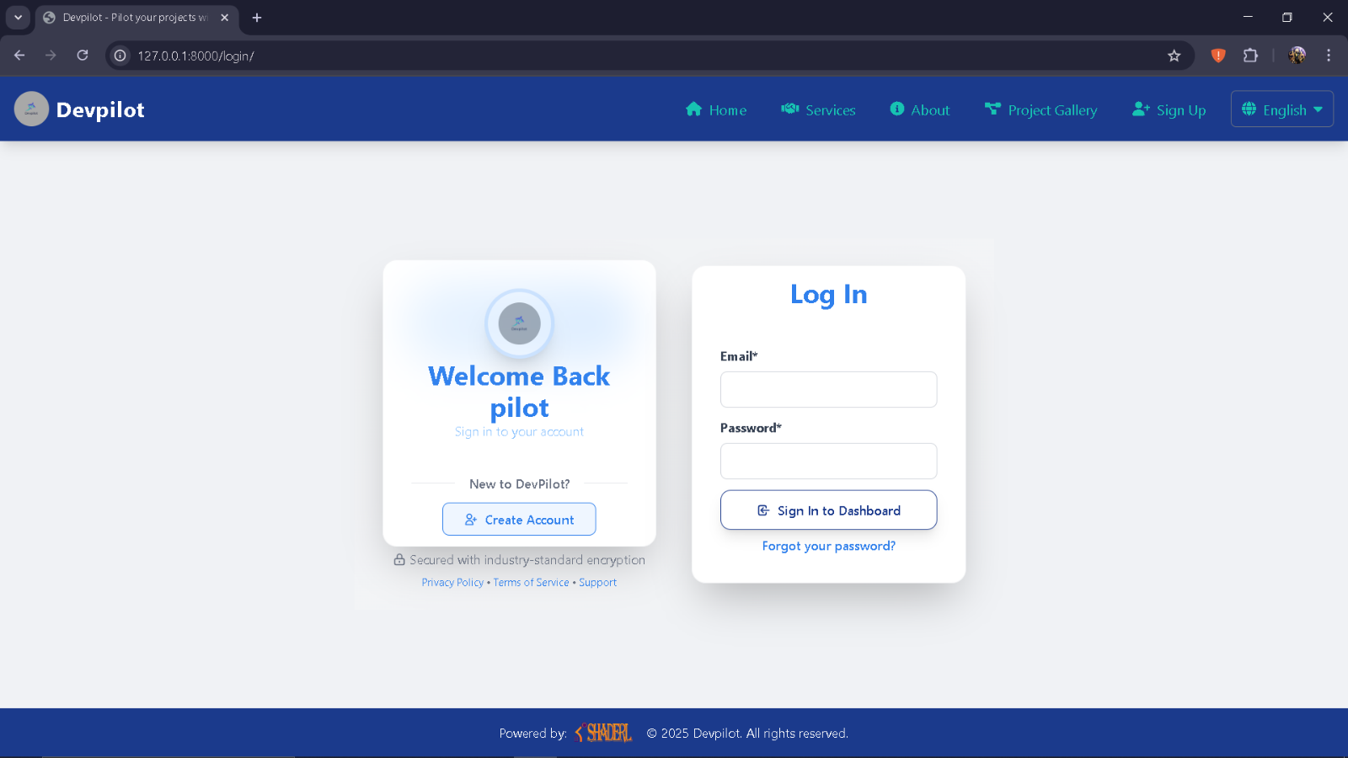
Here the use logs into his account using his email and password and is redirected according to his role
Figure 46: authentication showcase

CONCLUSION
Once the platform is set up, it is essential to provide a manual to assist its various users. Therefore, we have outlined the different tools required for installation and detailed the installation process to ensure the application runs smoothly. Additionally, we will explain how users can effectively navigate and utilize the platform once the environment is fully configured. This manual will serve as a comprehensive guide to maximize the user experience.

PERSPECTIVE

Having reached the end of this document and considering the fact that this project can be improved to a higher extend, as perspectives we can bring some ameliorations such as:
- AI assistance: The implementation of an AI assistant to generate sample roadmaps for clients
- User Onboarding and Tutorials: To ensure a smooth user experience, particularly for new clients, implement interactive tutorials that explain how to use the platform to its full potential.
- Automated Reports: Automate the generation of weekly or monthly project reports. These reports could be sent to the client via email and could include a summary of progress, key achievements, and upcoming tasks.
- Mobile app Development: with majority of the global population mostly used their phones the development of a mobile version of this application will be a great milestone.

GENERAL CONCLUSION

Having reached the conclusion of our project and internship at SHADERL, we have accomplished significant milestones during this period. The experience was both challenging and rewarding, requiring us to navigate through stress, setbacks, and successes. Our time at SHADERL proved invaluable, teaching us how to adapt to a professional environment and work effectively as a team. For our project, we focused on the theme "CONCEPTION AND REALIZATION OF AN IT PROJECT MANAGEMENT WEB APPLICATION. CASE STUDY: SHADERL," with the primary goal of integrating the client to the project development process while keeping the core aspect of project management. We began by assessing existing systems and identifying project constraints and requirements outlined in our specification document. Utilizing the UML-2TUP methodology, we meticulously analyzed our system architecture. We employed various technologies, including HTML, Tailwind CSS and Java Script for the frontend, Django for the backend and SQLite for the database. Our platform will empower users specifically clients to have more visibility in the development process of their various IT services ordered while keeping the project management side intact so as to stay in context. Looking ahead, we recognize that this project can be further improved. We envision enhancements such as the implementation of an AI assistant. to generate sample roadmaps for clients, user onboarding tutorials, Automate the generation of reports and develop a mobile version of our application. These improvements aim to elevate the platform's functionalities and responsiveness, ultimately providing users with an even more powerful tool for managing their various projects. This is just the beginning; we are committed to making updates and enhancements in functionality and security to ensure our application remains reliable and meets the evolving needs of its users.

ANNEXES

BIBLIOGRAPHY

- Mercurial 2025.
- A Guide to the Project Management Body of Knowledge (PMBOK Guide) — Project Management Institute

WEBOGRAPHY

- https://docs.djangoproject.com/en/5.2/ Django documentation June 25, 2025.
- https://www.geeksforgeeks.org/python/django-project-mvt-structure/ Structure of the Model View Template logical architecture., August 15 2025 5:00 PM
- https://www.youtube.com/watch?v=OZmyAJJVu5U how to create an advanced user profile?
- https://www.youtube.com/watch?v=ao1ESgIy2Ws how to draw a UML class Diagram? September 2, 2025
- https://www.youtube.com/watch?v=84N1D6fI-i4 how to draw a UML package diagram? September 2, 2025.
- https://www.youtube.com/watch?v=_iiOOxIDrGA&t=3s how to draw a UML component Diagram? September 2, 2025.
- https://youtu.be/ZfEK3WP73eY how to configure an SMTP server.
- https://www.google.com/url?sa=i&url=https%3A%2F%2Fwww.javatpoint.com%2Fumldiagrams UML diagrams. July 15 2025.
- https://www.mysciencework.com/omniscience/pervasive-mobile-healthcare-system-based-on-cloud-computing immage of the 2TUP. July 15 2025.

TABLE OF CONTENT

DEDICATION i
ACKNOWLEDGEMENT ii
SUMMARY iii
LIST OF FIGURES iv
LIST OF TABLES vi
LIST OF ABREVIATIONS vii
ABSTRACT viii
RESUME ix
GENERAL INTRODUCTION 1
PART I: INSERTION PHASE 2
INTRODUCTION 4
I- WELCOME AND INSERTION 5
II- GENERAL REPRESENTATION OF SHADERL 5
III-ORGANISATION OF SHADERL 7
IV- GEOGRAPHICAL LOCATION 10
V- BRIEF PRESENTATION OF THE PROJECT THEME 11
CONCLUSION 12
PART II: THE EXISTING SYSTEM 13
INTRODUCTON 15
II. PRESENTATION OF THE PROJECT THEME 16
I. DESCRIPTION OF EXISTING SYSTEM 17
II. CRITITCISMS OF THE EXIXTING SYSTEM 23
III. PROBLEMATIC 24
IV. PROPOSED SOLUTION 24
CONCLUSION 25

PART III: SPECIFICATION BOOK 26
INTODUCTION 28
III. CONTEXT AND JUSTIFICATION 29
IV. OBJECTIVES OF THE PROJECT 30
V. EXPRESSION OF NEEDS 31
VI. PROJECT PLANNING 34
VII. ESTIMATED COST OF PROJECT 36
VIII. CONSTRAINTS 40
IX. LIST OF PARTICIPANTS AND DELIVERABLES 41
CONCLUSION 42
PART IV: ANALYSIS PHASE 43
INTRODUCTION 45
I. METHODOLOGY 46
1. COMPARATIVE STUDY OF MERISE AND UML 46
2. COMPARATIVE STUDY OF UNIFIED PROCESS 50
II. CHOICE OF ANALYSIS METHOD 53
3. MODELING OF THE PROPOSED SOLUTION 54
CONCLUSION 82
PART V: DESIGN PHASE 83
INTRODUCTION 85
I. TECHNICAL BRANCH 86
A. CAPTURES OF TECHNICAL NEEDS 86
B. RELATED UML DIAGRAMS 88
I. Class Diagram 88
II. State Machine Diagram 92
III. Package Diagram: 96
CONCLUSION 100

PART VI: DEPLOYMENT PHASE 101
INTRODUCTION 103
I. TECHNOLOGY STACK 104
II. RELATED UML DIAGRAMS 106
A. DEPLOYMENT DIAGRAM 106
A. COMPONENT DIAGRAM 109
CONCLUSION 112
PARTVII: TEST OF FUNCTIONALITIES 113
INTRODUCTION 115
I. APPLICATION FUNCTIONALITIES 116
II. TEST SHOWCASE 117
CONCLUSION 119
PART VIII: INSTALATION AND USER GUIDE 120
INTRODUCTION 122
I. INSTALLATION OF THE APPLICATION 123
II. SHOWCASE 124
CONCLUSION 127
PERSPECTIVE 128
GENERAL CONCLUSION 129
ANNEXES x
BIBLIOGRAPHY xi
WEBOGRAPHY xii
TABLE OF CONTENT xiii

