# Observation 1: Commits by day

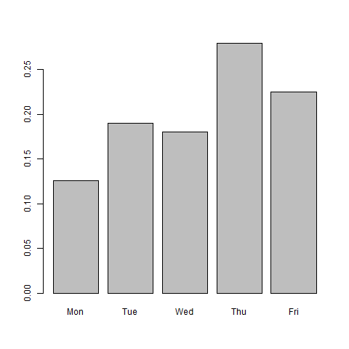

Above is a bar chart of the commits per day. The most obvious observation here is that this office does not work on weekends.

It is clear that Monday has the fewest number of commits, with less than half of the number of commits on Thursday, the busiest day. This is representative of a general trend of more commits occurring as the week goes on but with a slight drop off on Friday.

There could be a number of explanations for this trend. It could be down to productivity. The authors could be sluggish on Monday after the weekend, with productivity rising as the past weekend becomes a distant memory. The drop in Friday could be due to the anticipation of and desperation for the coming weekend.

Alternatively, there could be another factor at play here. It could be based off the nature of the commits they’re working on. Perhaps this trend is representative of the activity of their userbase?

It could also be down to other work. Perhaps Monday is a particularly busy day for another area of work which occupies the authors and prevents them from working on commits.

# Observation 2: Commits by hour

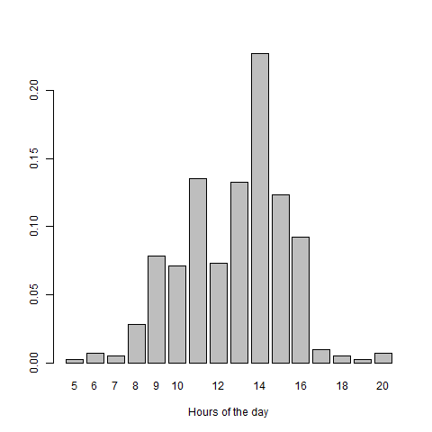

At first, the most interesting thing we see here is that the distribution of commits seems to be normal. The majority of commits occur from 11:00 – 15:00 with the exception of 12:00 (possibly due to lunch time) and a significant peak at 14:00.

The reason for the significant peak at 14:00 is not clear, however, if we assume that the authors have other duties beyond git commits and these duties are scheduled, perhaps 14:00 coincides with the time period that most authors are scheduled to perform commits.

The overall picture of this bar chart is that we can determine the working hours which seem to be from 09:00 to 17:00. There are, however a small number of commits outside these hours, most of them happening between 08:00 and 09:00 which could be explained by some of the authors starting work earlier.

Lastly, it appears that some workers are making commits late into the night and early morning. This could be due to some workers taking their work home with them or perhaps working in different time zones.

# Observation 3: Commits by Author

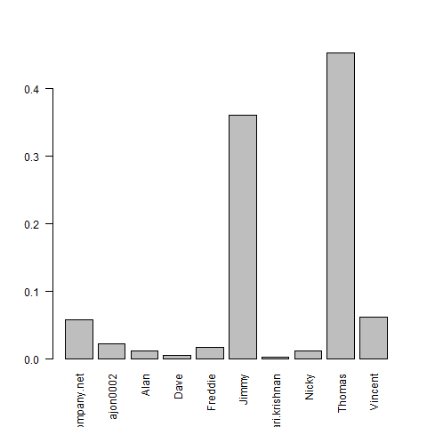

What’s immediately clear here is that over 80% of commits are being performed by Jimmy and Thomas.

This could be because Jimmy and Thomas are the staff members who are typically tasked with performing commits. Other staff may commit on projects that they may be more familiar with than Jimmy or Thomas.

Maybe the other staff members are part timers or volunteers. Additionally, perhaps Jimmy and Thomas are teaching the other staff members how to perform commits and the other staff members’ commits are ones they’ve performed as a sort of practice or homework. Reading the comments for each of these commits would clarify this.