Tab 1 : HOME

* Powerful pictures of their projects (Without descrption or caption). Add a “VOLUNTEER” tab on the pictures
* The title, a picture and a one liner abut each project
* Reach – The number of volunteers, beneficiaries, presence across Chennai/TN/ India
* Testimonials of volunteers, beneficiaries and donors.
* Awards and Media features – if any

EXAMPLE

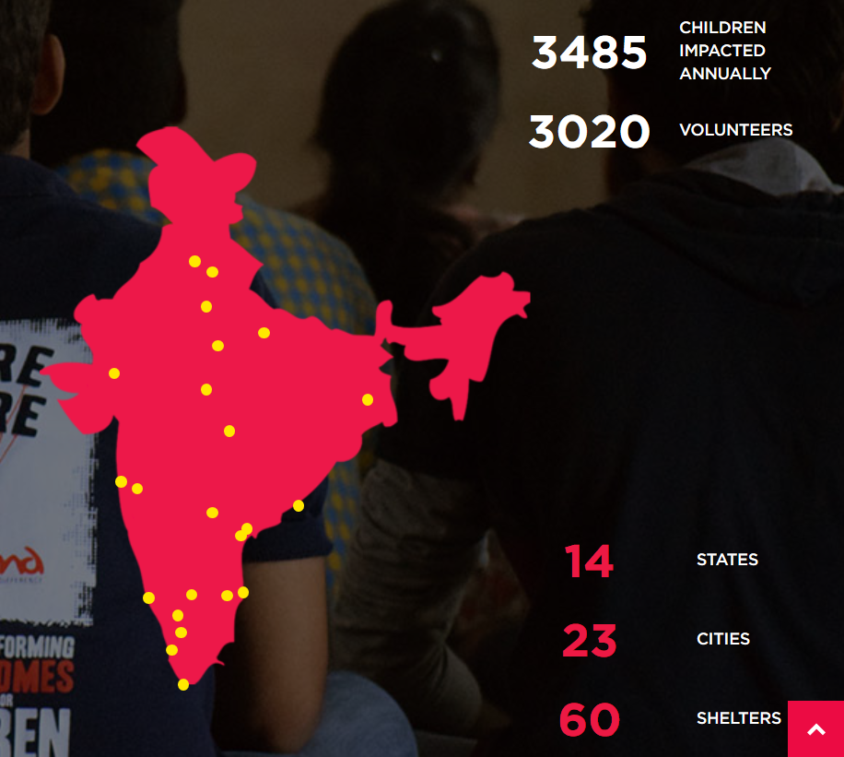

Tab 2: About

* A detailed writeup about RCT.
* Include a timeline of RCT
* Vision and mission

EXAMPLE

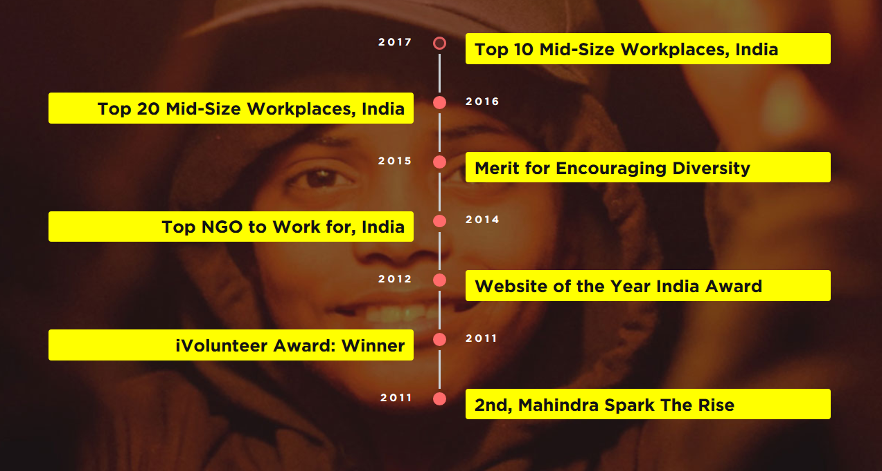

Tab 3: Projects

Every project of rct. Displayed as a picture opening which would lead to the writeup about the project.

FAQ

* I have registered on the website. How do I proceed further?
* Is there any limit for volunteering?
* Will I get a tax exemption for donations made?
* When do the projects happen?
* Will I receive a certificate for volunteering?

**Privacy Policy**  
*Real Charitable Trust* is fully aware of the care to be taken about the information of our supporters, (also includes volunteers and donors). We appreciate your trust & we are committed to act with utmost care. By visiting our website, you are accepting the practices defined in our policy.  
The information collected from our supporters helps us to have personal relationships & improve your online experience. Any information you give us is stored with utmost care & security. This information helps us in serving you better. Needless to say we are bound to co-operate fully when situation requires us to do so, like by law or legal process, we have to provide information about our supporters.  
*RCT* will not share any of your personal details with any third party without prior approval from you.  
However, *RCT* does not have the liberty to share the personal information with our internal team to better serve you and the needs of our organisation.  
Once you register with *RCT* /subscribe for our newsletter, you authorise RCT to contact you via e-mails, text messages, phone calls and other means.  
**Use of cookies:**  
Cookies are small amount of data, mostly alphanumerical identifiers that are transferred to your computer’s hard drive. They are small pieces of information that are stored by your browser. This helps our system to recognize your browser the next time you enter our site and helps us serve you in a better and faster way.  
Our cookies do not contain any personally identifying information. Most web browsers automatically accept cookies. To take advantage of the website’s unique features, we recommend that you allow cookies.  
**Governing law and jurisdiction:**  
This policy is governed by the laws of India. Dispute if any, relating to any matter relating to or arising of out of this policy shall be subject to the exclusive jurisdiction of the appropriate courts at Chennai.

**Terms and Conditions:**

1.       Your use of the site constitutes acceptance of these Terms and Conditions.

2.       You agree to use this site only for lawful purposes, and in a manner which does not infringe the rights of RCT or any third party (including but not limited to any RCT sponsors or supported child).

3.       RCT shall in no event be liable for any damages including, without limitation, direct, indirect or consequential damages, whatsoever arising from or in connection with the use or loss of use of the website, or any content on the website.

4.       RCT can change these Terms and Conditions at any time by posting changes online under this section “Terms and Conditions”. Your continued use of this site after changes have been posted, constitutes your acceptance of the modified terms.

5.       RCT does not guarantee that the website’s facilities and functions will be free from error or interruption, or that the site or the server that makes it available to you are free of viruses or bugs, that defects will be corrected, or that the content on the website is accurate or complete.

6.       Once you have made a donation or any other monetary contribution RCT has the discretion to utilise them in a manner that we seem fit and best suited.

7. RCT takes no responsibility for the content of external Internet sites linked to or cited on this site and any consequence that may arise from visiting such links is the sole responsibility of the user.

8.       As a user of this site, you are prohibited from using any of the content of the site, including but not limited to the photos, the details of the children, volunteer information donor/sponsor details, without prior approval from RCT.

9.   These terms and conditions shall be governed by and construed in accordance with the laws of India. Any disputes shall be subject to the exclusive jurisdiction of the Courts of India, located in Chennai.

10.   RCT reserves the right to publish the details of your Sponsorship of children, donations or any other contribution. Un-authorised Publication or use of such details is considered a violation and may draw legal charges.

12.   If you do not accept these Terms and Conditions in full, you must stop using this site immediately. We reserve the right to prevent you accessing this site, without prejudice to any of our other rights, if we consider that you have contravened any of these Terms and Conditions.

13.   In case of any violation of the above-mentioned Terms and conditions, RCT has the legal right to file charges against the user.

**Utilisation of Donations:**

Once you have made a donation or any other monetary contribution, through but not limited to *** PROJECT NAMES OF RCT**** RCT has the discretion to utilise them in a manner that we seem fit  and best suited for the organisation .

Why volunteer at RCT?

RCT provides each socially responsible citizen with an opportunity to serve the cause they believe in. We work alongside the disadvantaged population across different age groups – children, youth and the elderly. We also work towards creating a better environment for the future generation.