DSS5104 Assignment 2
Deep Learning for Tabular Data
Ten Wei Ze | A0326190J
GitHub repository Containing Code: https://github.com/TenWeiZe/DSS5104-Assignment-2

Introduction
While deep learning has found great success in many areas, when it comes to tabular data, traditional tree-based models still remain the dominant approach due to their strong performance, robustness, and minimal preprocessing requirements. However, recent studies have found that well-tuned deep learning models can be competitive on certain benchmarks.
This report evaluates the performance of two deep learning models, TabNet and FT-Transformer, and two tree-based models, XGBoost and Random Forest. The models are assessed through experiments, with evaluation based on predictive performance, robustness, preprocessing requirements, and inference cost. In addition, feature importance rankings are compared across models to assess whether different models identify similar key predictors. XGBoost and Random Forest were selected to serve as classical baselines due to their widely demonstrated success in tabular data modelling.

2.0 Datasets used for experiment
Three datasets, each with unique characteristics, were selected to ensure feature diversity in the experiments. Two classification datasets (Adult Income and Porto Seguro Safe Driver) and one regression dataset (California Housing) were used. The characteristics of the datasets are tabulated below:
Dataset | Number of rows | Number of numerical features | Number of categorical features | Cardinality of categorical features (average | max) | Missing values | Target Distribution
Adult Income¹ | 48,842 | 5 | 7 | 12.3 | 42⁴ | Moderate (~6%) in some categorical features | 76% / 24%
Porto Seguro Safe Driver | 196,419² | 43³ | 14 | 13.1 | 104⁵ | Heavy (up to ~69%)⁶ in both numeric and categorical features | 96% / 4%
California Housing | 20,640 | 8 | 0 | N/A | None | N/A

Notes:
- For the Adult Income dataset, two features, fnlwgt and education, were removed as they do not provide additional predictive value.
- Porto Seguro Safe Driver dataset is large, so a subsample of 33% was used for the experiment due to computational constraints.
- Binary features were treated as numerical variables.
- Max cardinality of 42 driven by a single feature, remaining features have cardinality 2–15.
- Max cardinality of 104 driven by a single feature, remaining features have cardinality of 2–18.
- Two extremes of 45% and 69%; other features 0-18%.

3.0 Data Split
A consistent 60/20/20 train/validation/test split, using the same random seed, was applied across all experiments to ensure comparability of results between models. The two classification datasets exhibit imbalanced target distributions; therefore, stratified sampling was applied to preserve the original class distribution.

4.0 Preprocessing
Different datasets and models require varying preprocessing steps. However, preprocessing is kept to the minimum required for each model to ensure a fair and consistent comparison. The preprocessing approach for each model is described in the following sections.

4.1 TabNet
For categorical features, TabNet provides native categorical embedding support, where each category is mapped to a learned dense vector representation. Thus, label encoding (assigning a unique integer to each category) is sufficient for categorical. To ensure that categorical features are processed correctly, the indices of categorical columns and their respective cardinalities are explicitly specified via cat_idxs and cat_dims, which enable TabNet to apply embedding transformations instead of treating these features as continuous inputs. Missing values were marked with "?" or "-1" in their respective datasets and were treated as their own category during label encoding, requiring no additional processing.
For numeric features across all three datasets, StandardScaler normalization was applied, with the scaler fit exclusively on the training set and subsequently applied to the validation and test sets to prevent data leakage. Numerical missing values were retained and normalized alongside valid values via StandardScaler, as no imputation strategy was applied.

4.2 FT-Transformer
FT-Transformer is implemented via pytorch-tabular, which accepts pandas DataFrames directly and handles categorical embeddings internally through its DataConfig: categorical columns can be passed as raw values (e.g., strings), and pytorch-tabular internally encodes them into integers before learning embeddings. As a result, no label encoding is required for FT-Transformer, unlike TabNet. The missing values in categorical features were again treated as their own category, requiring no additional processing.
Numeric features and their missing values are handled similarly to those in TabNet, and were normalized using StandardScaler

4.3 XGBoost
For XGBoost, one-hot encoding was required for categorical features to avoid the unintended ordinal relationship introduced by label encoding, since XGBoost does not learn embedding representations for categorical variables and instead treats all inputs as numerical features. Missing categorical values are treated as their own category during one-hot encoding.
Numerical features do not require scaling, so they are left in their original form. Missing numerical values are also retained and used directly by the model.

4.4 Random Forest
Both categorical and numerical features underwent the same preprocessing as in XGBoost.

4.5 Note on Missing Values
The preprocessing of missing values was kept to a minimum and did not incorporate methods such as imputation. While categorical missing values can just be treated as their own category, the Porto Seguro Safe Driver dataset has missing numerical values, indicated by “-1”, which were retained as numerical values and standardised alongside other features. While this does not reflect best practice, it was adopted to maintain a consistent level of preprocessing effort across models and evaluate how different models respond to imperfect or incomplete data.

5.0 Hyperparameter tuning
Optuna was used for hyperparameter optimisation, with a consistent tuning budget allocated to each model across all datasets. The tuning configurations are summarised in the table below.
Model | Parameters tuned | n_trials
TabNet | n_d/n_a, n_steps, learning rate | 20¹ for Porto Seguro Safe Driver dataset, 50 for all other datasets
FT-Transformer | num_attn_blocks, num_heads, learning rate
XGBoost | n_estimators, max_depth, learning rate
Random Forest | n_estimators, max_depth, max_features
- Due to large size of dataset, reduced tuning n_trials to 20 due to computational constraints

6.0 Model Performance
For classification datasets, accuracy and AUC-ROC were used for performance evaluation. For accuracy, prediction threshold was set to 0.5 while AUC-ROC measured the probability that a randomly chosen positive example will be scored higher by the model than a randomly chosen negative example, making it useful for imbalanced datasets.
For the regression dataset, RMSE and MAE were used for performance evaluation. RMSE penalizes larger errors more heavily, while MAE treats all errors equally.
Each experiment was conducted across three fixed random seeds, with results reported as the mean, standard deviation across seeds (SD), and coefficient of variation (CV% = SD/mean × 100) of the evaluation metrics. For classification tasks, higher accuracy and AUC-ROC indicate better performance, whereas for regression tasks, lower RMSE and MAE are preferred.

6.1 Adult Income (Classification)
Model | Accuracy SD | Accuracy CV% | AUC-ROC SD | AUC-ROC CV%
TabNet | 0.0006 | 0.0690 | 0.0029 | 0.3170
FT-Transformer | 0.0017 | 0.1998 | 0.0006 | 0.0703
XGBoost | 0.0003 | 0.0307 | 0.0002 | 0.0193
Random Forest | 0.0002 | 0.0194 | 0.0003 | 0.0308
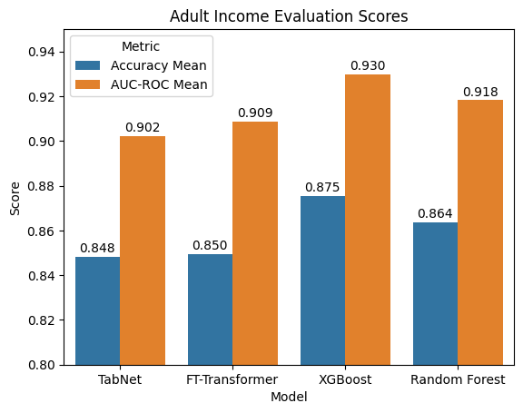

Tree-based models outperform deep learning models in terms of both accuracy and AUC-ROC, with XGBoost achieving the best overall performance, followed by Random Forest. Deep learning models also exhibit greater variability than tree-based models overall, although stability differs across models and metrics, with TabNet being more stable than FT-Transformer in terms of accuracy, while FT-Transformer is more stable in AUC-ROC.
The superior performance of tree-based models could be attributed to the relatively small sample size of ~50k, as deep learning models typically perform better with larger datasets, whereas tree-based models tend to perform better at this scale.

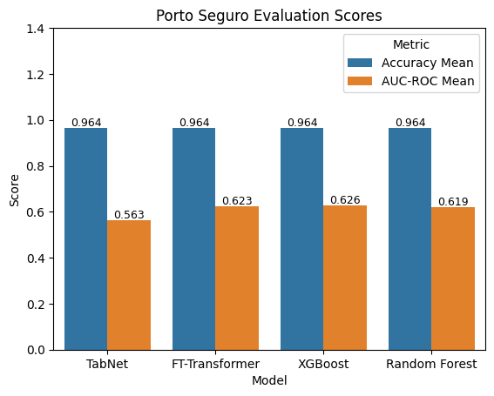
6.2 Porto Seguro Safe Driver (Classification)
Model | Accuracy SD | Accuracy CV% | AUC-ROC SD | AUC-ROC CV%
TabNet | 0 | 0 | 0.0101 | 1.7946
FT-Transformer | 0 | 0 | 0.0014 | 0.2235
XGBoost | 0 | 0 | 0.0008 | 0.1287
Random Forest | 0 | 0 | 0.0015 | 0.2415

For this dataset, class imbalance is very extreme (96% negative vs 4% positive), making accuracy a poor evaluation metric, as reflected by the similar accuracy scores across all models despite differences in AUC-ROC. This indicates that accuracy is dominated by the majority class and does not capture differences in model performance. Thus, AUC-ROC is used as the primary evaluation metric.
In terms of AUC-ROC, XGBoost, FT-Transformer, and Random Forest exhibit comparable performance, while TabNet performs noticeably worse than the other models. In terms of stability, XGBoost, FT-Transformer, and Random Forest demonstrate consistently lower variability, whereas TabNet exhibits noticeably higher variability, indicating lower stability across runs.
The larger sample size (~200k) likely contributed to FT-Transformer achieving predictive performance and stability comparable to tree-based models. TabNet’s weaker performance, on the other hand, may be attributable to its relative sensitivity to extreme class imbalance, high cardinality, and substantial missing values in the dataset.
Notably, all models exhibit slightly higher variability compared to the Adult Income dataset, suggesting that this dataset may be more challenging to model.

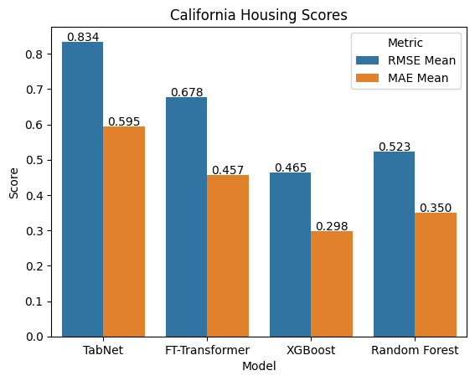
6.3 California Housing (Regression)
Model | RMSE SD | RMSE CV% | MAE SD | MAE CV%
TabNet | 0.0860 | 10.3015 | 0.0661 | 11.1116
FT-Transformer | 0.0186 | 2.7499 | 0.0068 | 1.4817
XGBoost | 0.0008 | 0.1662 | 0.0007 | 0.2445
Random Forest | 0.0015 | 0.2925 | 0.0014 | 0.3868

Tree-based models outperformed deep learning models in terms of both RMSE and MAE, with XGBoost achieving the best overall performance, followed by Random Forest. Among the deep learning models, FT-Transformer performed substantially better than TabNet. A similar pattern was observed in model stability: tree-based models exhibited the lowest variability, and among deep learning models, FT-Transformer demonstrated significantly better stability than TabNet.
Similar to the Adult Income dataset, the relatively small dataset size (~20k samples) is likely a key reason why deep learning models performed worse than tree-based models. The superior performance of FT-Transformer over TabNet in terms of both predictive performance and stability is consistent with findings from the Porto Seguro Safe Driver dataset.

6.4 Overall Findings
In terms of predictive performance and model stability, tree-based models (particularly XGBoost) consistently outperformed deep learning models, with Random Forest ranking second. Even with a substantially larger dataset, deep learning models only managed to match, but not exceed the performance of tree-based models.
These findings are consistent with existing literature (Grinsztajn et al., 2022), which shows that tree-based models generally outperform deep learning models on tabular data. This is partly because deep learning models struggle to learn irregular patterns, are less robust to uninformative features, and do not handle tabular data well, as it lacks the clear structure (unlike images and text). Prior work also suggests that increasing dataset size can reduce the performance gap between deep learning and tree-based models.
Grinsztajn et al. (2022) further show that even well-tuned deep learning models, after extensive hyperparameter tuning (approximately 400 random search iterations), do not close this performance gap. This contrasts with findings from Gorishniy et al. (2021), who report that sufficiently tuned deep learning models can be competitive on certain benchmarks. However, this study was unable to fully evaluate this claim due to computational constraints on the number of tuning iterations.
In this study, FT-Transformer becomes competitive with tree-based models for more complex datasets with a larger sample size, while TabNet still falls short. This may be due to its weaker handling of class imbalance, high cardinality, and a large proportion of missing values.

7.0 Inference Cost
The inference times and model sizes are shown in the charts below.
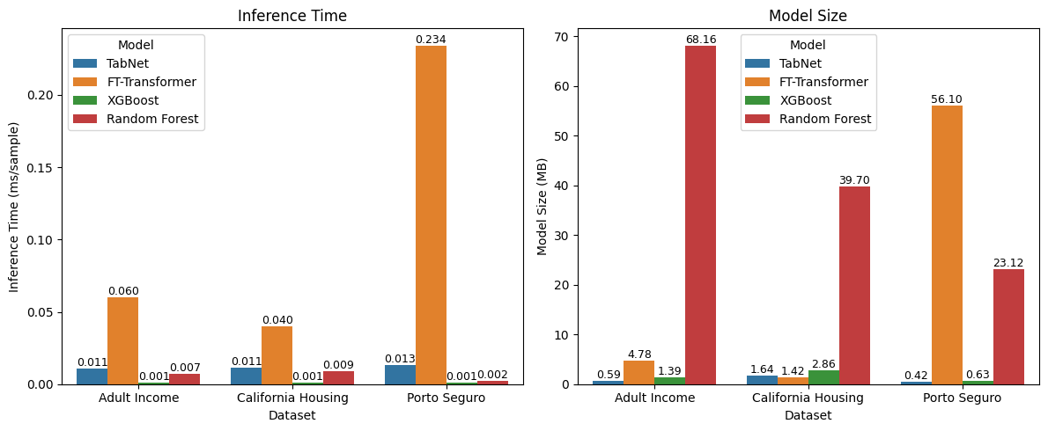
For inference time, across the 3 datasets, FT-Transformer took the longest, followed by TabNet, Random Forest and then XGBoost. Tree-based models generally exhibited faster inference time compared to deep learning models. Notably, FT-Transformer’s inference time increases sharply for Porto Seguro compared to the other datasets, while the increase for tree-based models and TabNet is relatively small. This is likely because FT-Transformer processes all features jointly, making it more sensitive to datasets with many features.
Unlike inference time, model size shows significant variability across datasets. For Adult Income and California Housing, Random Forest models were the largest, while for Porto Seguro Safe Driver, the FT-Transformer model was the largest. The explosion in size of the FT-Transformer model for Porto Seguro Safe Driver could be attributed to the high number of categorical features and the high cardinality of these features, as the model uses embedding layers whose size scales with feature cardinality.
An interesting observation is that for the complex Porto Seguro dataset, while the size of the FT-Transformer expanded significantly, the size of TabNet was substantially smaller. This can be attributed to the different ways the models handle complexity. During the tuning phase, Optuna selected lower n_da and n_a values for the TabNet model, likely to improve generalisation on a dataset with weaker signal, resulting in a significantly more compact model. Another interesting observation that FT-Transformer becomes the smallest model for the California Housing dataset, a fully numerical dataset, further reinforcing that its model size grows drastically with the number and cardinality of categorical features.

8.0 Feature Importance
To study differences in interpretation, the top five most important features for each model are tabulated below. It should be noted that one-hot encoding was used for the tree-based models, resulting in multiple representations of the same feature. As such, feature importance comparisons are conducted at the original feature level (for example, ‘relationship_Husband’ and ‘relationship_Wife’ are grouped together as ‘relationship’). The rank of grouped features is determined by the highest-ranked category, as this reflects the strongest contribution of the feature to the model.
Adult Income (12 features total)
Model | Feature importance (Most to Least)
TabNet | 'education-num', 'relationship', 'age', 'capital-gain', 'marital-status'
FT-Transformer | 'education-num', 'marital-status', 'relationship', 'age', 'capital-gain'
XGBoost | marital-status, 'relationship’, 'capital-gain', 'education-num', 'capital-loss'
Random Forest | 'capital-gain', 'education-num', 'marital-status’, 'age', 'hours-per-week'

The two deep learning models have the same top 5 most important features , with ‘education-num’ at the top for both. While ‘education-num’, ‘capital-gain’ and ‘marital-status’ are top 5 most import features in all 4 models, the tree-based models diverge both in their top-ranked feature and in their remaining top features, with XGBoost uniquely identifying 'capital-loss' and Random Forest uniquely identifying 'hours-per-week'.
Porto Seguro Safe Driver (57 features total)
Model | Feature importance (Most to Least)
TabNet | 'ps_ind_06_bin', 'ps_calc_17_bin', 'ps_car_12', 'ps_calc_01', 'ps_reg_02'
FT-Transformer | 'ps_ind_05_cat', 'ps_ind_15', 'ps_car_15', 'ps_ind_17_bin', 'ps_ind_03',
XGBoost | 'ps_car_07_cat', 'ps_ind_05_cat, 'ps_ind_17_bin', 'ps_ind_07_bin', 'ps_ind_06_bin'
Random Forest | 'ps_car_13', 'ps_reg_03', 'ps_reg_02', 'ps_car_14', 'ps_ind_15'

For this more complex dataset, all four models diverge greatly on feature importance, with no feature appearing in the top 5 of all four models. This is likely due to the dataset's complexity and weak individual feature signals, in contrast to Adult Income where a few informative features such as 'education-num', 'capital-gain', and 'marital-status' consistently appeared across all models.
California Housing (8 features total, all numeric)
Model | Feature importance (Most to Least)
TabNet | 'Latitude', 'MedInc', 'Longitude', 'HouseAge', 'AveOccup
FT-Transformer | 'MedInc', 'Latitude', 'Longitude', 'HouseAge', 'AveOccup'
XGBoost | 'MedInc', 'Longitude', 'AveOccup', 'Latitude', 'AveRooms'
Random Forest | 'MedInc', 'AveOccup', 'Latitude', 'Longitude', 'AveRooms'

For very simple datasets, such as California Housing, all four models show strong agreement on feature importance, with 'MedInc', 'Latitude', 'Longitude', and 'AveOccup' appearing in every model's top 4. In fact, both deep learning models have near identical rankings, with the exception of their top-ranked feature, where TabNet ranks 'Latitude' first while FT-Transformer ranks 'MedInc' first. Overall, both deep learning models diverge from the tree-based models only in their preference for 'HouseAge' over 'AveRooms’.
The results of these analyses suggest that the models tend to agree with one another when the dataset is simple and diverge when datasets get more complicated.

9.0 Practical Verdict
Overall, tree-based models exhibited better predictive performance and stability compared to deep learning models. However, at large enough scale, deep learning models (in this experiment, FT-Transformer) can compete with tree-based models.
Yet, even with comparable performance, deep learning models still lose out to tree-based models on inference time, with XGBoost particularly being many folds faster, making tree-based models the premier choice for deployment in real-time APIs due to its very low latency. However, Random Forest would face issue in terms of deployment cost & scalability due to its extremely large model size. While FT-transformer models can be smaller than the other models for fully numerical datasets, its size grows drastically with number of categorical features and their cardinality, making them unsuitable for deployment in feature-rich categorical datasets. Interestingly, TabNet maintains a compact model size even on complex datasets, making it potentially viable when model size is a key constraint, though its lower predictive performance and higher instability limit its practical appeal.
To conclude, while there are scenarios where deep learning models can be competitive, for most tabular datasets, XGBoost remains the most practical choice overall, offering the best combination of predictive performance, inference speed, stability, and model size across all datasets tested.

References
Grinsztajn, L., Oyallon, E., & Varoquaux, G. (2022). Why do tree-based models still outperform deep learning on typical tabular data?. Advances in neural information processing systems, 35, 507-520.
A.I Use Declaration
Claude sonnet 4.6 and ChatGPT5.3 were used for language improvements and to generate certain segments of code. I am responsible for the content and quality of the submitted work.

