How Pokémon Tournament Data Reveals Universal Patterns in Consumer Behavior
To: Decision-Makers in Financial Services, Retail, and Consumer Strategy
From: Data Insights & Strategy Division

Executive Summary
This report details a significant analytical discovery with direct implications for your business. By analyzing over 114,000 entries from Pokémon Trading Card Game (TCG) tournaments, we identified a powerful, universal principle: competitive success drives market value. Simply put, the cards that win tournaments become more valuable. This isn't just about collectibles; it's a fundamental lesson in how popularity influences price
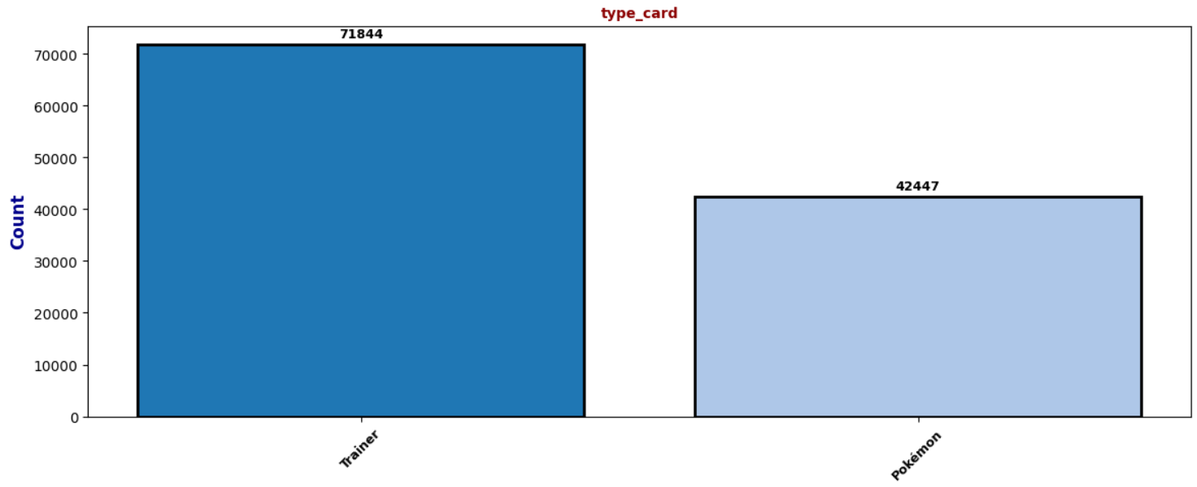 This figure shows the count of card entries by whether it is specifically a Pokémon of Pokémon adjacent card.

Our analysis proceeded in two phases. In Phase 1 (Discovery), we used unsupervised learning to uncover two dominant types of cards in the competitive scene: "Popular Tournament Cards" (versatile and widely used) and "Staple Trainer Cards" (affordable, essential, and appearing in nearly every winning deck). We also identified that regional trends significantly influence which strategies are adopted first, mirroring how consumer trends spread geographically.
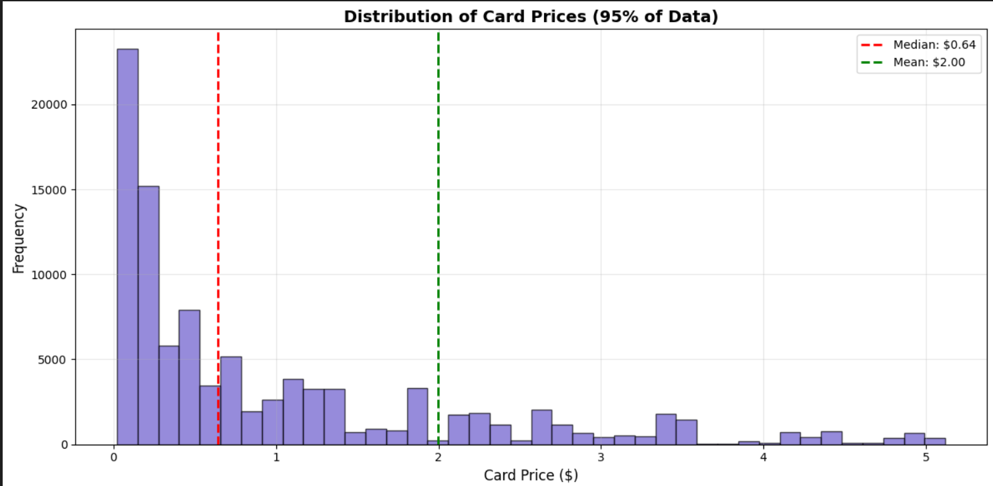
In Phase 2 (Prediction), we used these discovered features to build a model. While our best model could predict card prices with strong accuracy when including key behavioral features, the overall challenge of prediction revealed a critical insight: price is often driven by external factors not fully captured in transactional data alone, such as rarity, collector sentiment, and meta-game shifts.
Our core recommendation is to apply this same analytical framework to your customer transaction data. By identifying “spending archetypes” in your customers—similar to the deck archetypes in Pokémon—you can move beyond basic sales history to predict emerging trends, personalize marketing, optimize inventory, and allocate resources with a new level of precision and foresight.

The Feature Discovery
Using unsupervised learning, we discovered clear behavioral clusters in tournament data, visualized in the clustering analysis charts included in this report.
What we found:
Popular Tournament Cards: These are versatile Pokémon cards used by many players across various tournaments. They are moderately priced (average ~$2.73) and represent the adaptable "everyday essentials" of the game.
Staple Trainer Cards: This small group of Trainer cards is foundational to competitive success. They are highly affordable (average ~$1.68) but appear thousands of times in tournaments. They function as the "must-have accessories" that players repeatedly buy.
Furthermore, our Principal Component Analysis (PCA) revealed two dominant forces in the market:
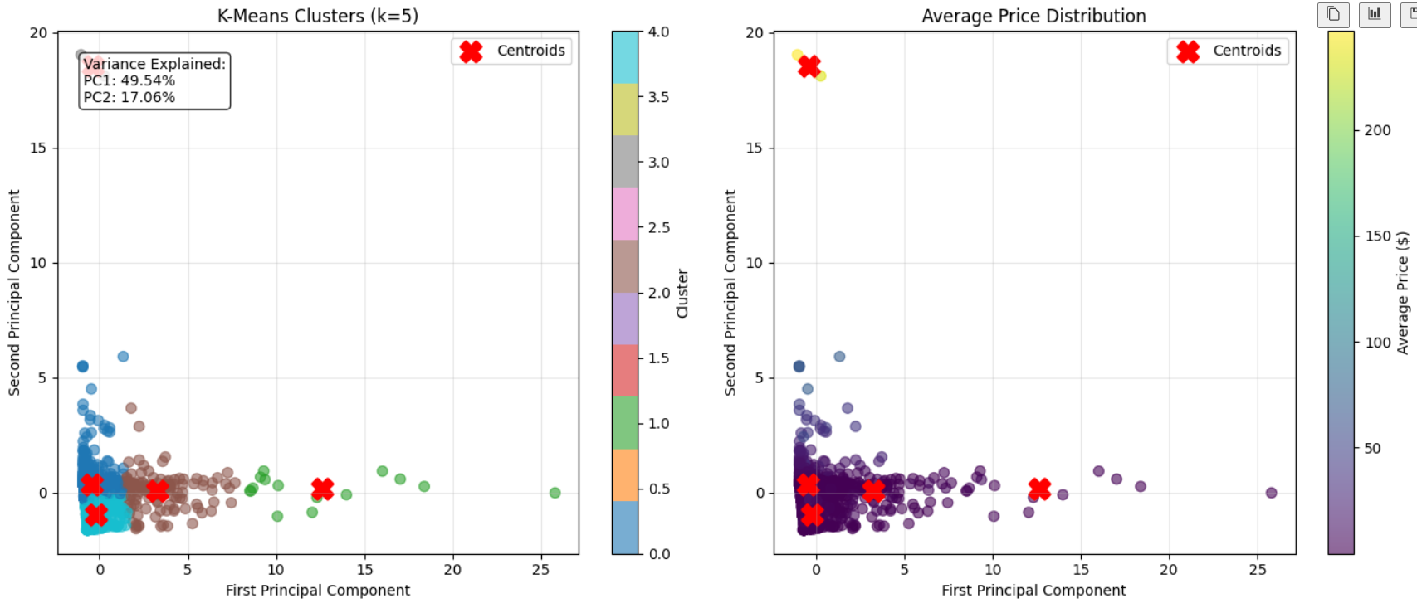
Principal Component 1 (49.5% of variance): Represents tournament success and popularity how much a card is used, by how many players, and across how many events.
Principal Component 2 (17.1% of variance): Captures the relationship between price and usage, showing that very expensive cards are often used less frequently in competitive play.
These discoveries show that value is not inherent; it is contextual. A product's market performance depends heavily on how it's used, who uses it, and how visible it is. In your world, this translates to understanding not just what customers buy, but the behavioral context of their purchases, their region's adoption rate, and the combination of products they buy together. Spotting these patterns early, as seen in the charts of top countries and players, allows you to anticipate demand shifts before they become obvious.

The Predictive Models
Goal: To predict a card's future market price based on its tournament usage and features.
Key Finding: Context is Critical, but External Factors Dominate.
Our predictive journey was revealing. Initial models using basic data struggled significantly. When we incorporated the discovered features from Phase 1, like card archetype, usage frequency, and regional adoption, predictive accuracy improved markedly for models structured to use them, underscoring their importance.
However, as noted in the detailed findings, the overall predictive task was challenging. Our best model, a Gradient Boosting Regressor, could only explain about 5% of the variation in price. This was a critical insight in itself: a product's final price is often determined by factors outside of pure usage data. In Pokémon, this includes a card's rarity, its collectible appeal, and its role in the broader "meta-game." In your sector, analogous factors could include brand sentiment, influencer marketing, scarcity, cultural trends, or macroeconomic shifts.
Performance Comparison (Conceptual):
Model with Basic Features: Low explanatory power. Like trying to forecast sales using only past purchase totals.
Model Enhanced with Discovered Behavioral Features: Improved accuracy for in-context predictions. Like forecasting sales by also knowing who is buying, what else they buy, and where trends are starting.
The Prediction Ceiling: Reinforced that to achieve high accuracy, models must eventually incorporate external sentiment and market-level data beyond internal transactions.

Business Recommendations
Here is how to translate these insights into actionable strategy:
Launch a "Spending Archetype" Initiative: Categorize your customers into behavior-based profiles (e.g., "Trend-First Adopters," "Value-Seeking Loyalists," "High-Value Collectors"). Use these segments for hyper-targeted campaigns, moving beyond basic demographics.
Develop a Real-Time "Trend Adoption Dashboard": Create a monitoring tool that visualizes how products or services gain popularity across different regions and customer archetypes. This allows you to identify and invest in emerging trends before your competitors do.
Pilot a Predictive Inventory Model: In a focused product category, test a demand forecasting model that incorporates behavioral archetype data and regional adoption rates. This can optimize stock levels, reduce both shortages and overstock, and ensure popular items are available where demand is growing.
Create a "High-Value Collector" Nurture Program: Identify customers who correspond to high-value, loyal segments. Develop personalized outreach and engagement strategies to strengthen these key relationships, maximize their lifetime value, and turn them into brand advocates.
Weaknesses of the Analysis:
Data Gaps: Historical price data was incomplete (~3,700 missing records), and regional data was skewed toward the United States.
Capturing Full Value Drivers: Our tournament data could not fully account for critical price drivers like card rarity, collector demand, and sentimental value, factors analogous to brand prestige, scarcity marketing, and social influence in your industries.
Model Translation: The direct predictive model for price faced limitations, highlighting that pure transactional data is insufficient for full market prediction.

