Project 1



By
Amr Ashraf 202101355
Marwan Ahmed 202101214
Amr Ahmed 202100302
Contents
PART A: DSB LC USING MATLAB: 3
1- Modulation (Ka = 0.5): 3
2- Moderate Modulation (Ka = 1): 4
3- Strong Modulation (Ka = 2): 4
PART B: DSB SC USING MATLAB: 5
1- First Message Signal: 5
2- Second Message Signal: 5
3- Demodulated Signals: 6
4- Demodulated Signals (Filtered): 6
PART C: SSB USING MATLAB: 7
1- Shifted Signals: 7
3- Modulated Signals: 7
4- Spectrum of the modulated signals: 8
5- Demodulated Signals: 9
6- Local carrier frequency at the receiver is f1 = fc + 0.1B: 9
7- Local carrier frequency at the receiver is f2 = fc – 0.2B: 10

PART A: DSB LC USING MATLAB:
The modulation index represents the ratio of the amplitude of the modulating signal to the amplitude of the carrier signal. It's calculated as:
$$modulation index= Ka*Am$$
The output signal s(t) represents the modulated signal resulting from the combination of the message signal and the carrier wave. Let's examine the plots of the modulated signals s(t) for both m1(t) and m2(t):

1- Modulation (Ka = 0.5):
For m1(t):
The modulated signal starts with an amplitude = 0 and gradually decreases until around 0.5ms.
Then, it increases sharply and start decreasing again until approximately 1.5ms, maintaining a positive amplitude until 1ms and then a negative amplitude until 1.5ms. After that, it decreases again until 2ms.
modulation index = ka * Am = 0.5 * 1 = 0.5.
For m2(t):
The modulated signal starts with a positive amplitude and remains constant until around 0.5ms.
From 0.5ms to 1ms, it decreases sharply.
Between 1ms and 1.5ms, it decreases sharply to a negative amplitude.
After 1.5ms, it remains negative with a relatively constant amplitude until 2ms.
modulation index = ka * Am = 0.5 * 1 = 0.5.
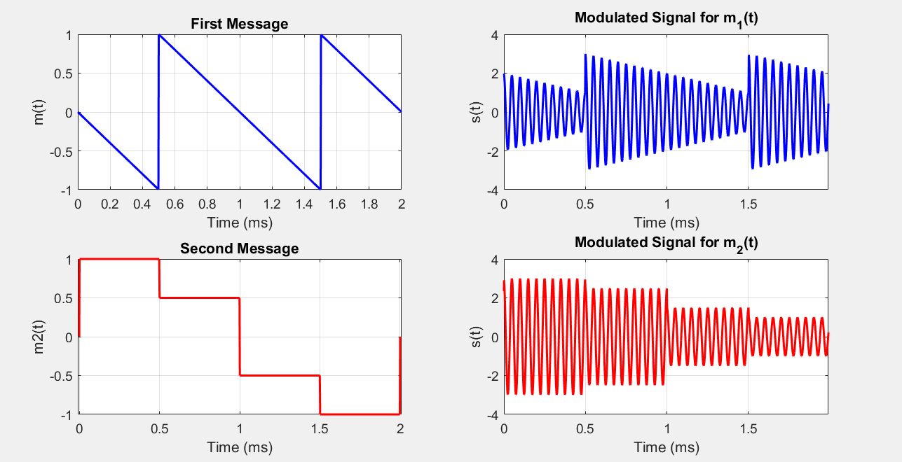

2- Moderate Modulation (Ka = 1):
The modulated signals exhibit a more pronounced variation compared to the message signals.
There is a noticeable increase in the amplitude of the carrier wave during the peaks of the message signal, indicating effective modulation. The signal maintains its fidelity while occupying a broader bandwidth due to the increased modulation index.
modulation index = ka * Am = 1 * 1 = 1.
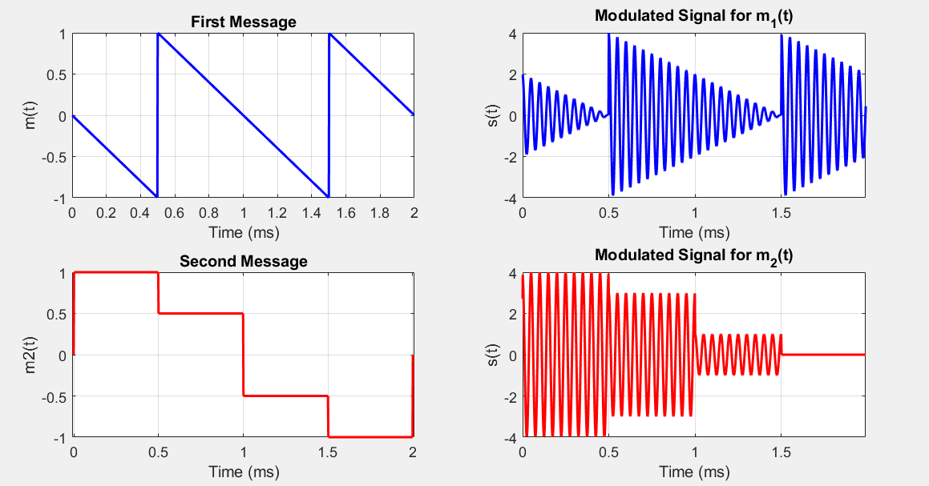

3- Strong Modulation (Ka = 2):
The modulated signals show significant variations in amplitude, with the carrier wave reaching its maximum and minimum amplitudes during the peaks and troughs of the message signals, respectively.
The modulation index of 2 results in overmodulation, leading to distortion in the modulated signal.
Despite the distortion, the modulated signal still carries the information from the message signal, but with a wider bandwidth and potentially reduced signal quality due to non-linear effects.
modulation index = ka * Am = 2 * 1 = 2.
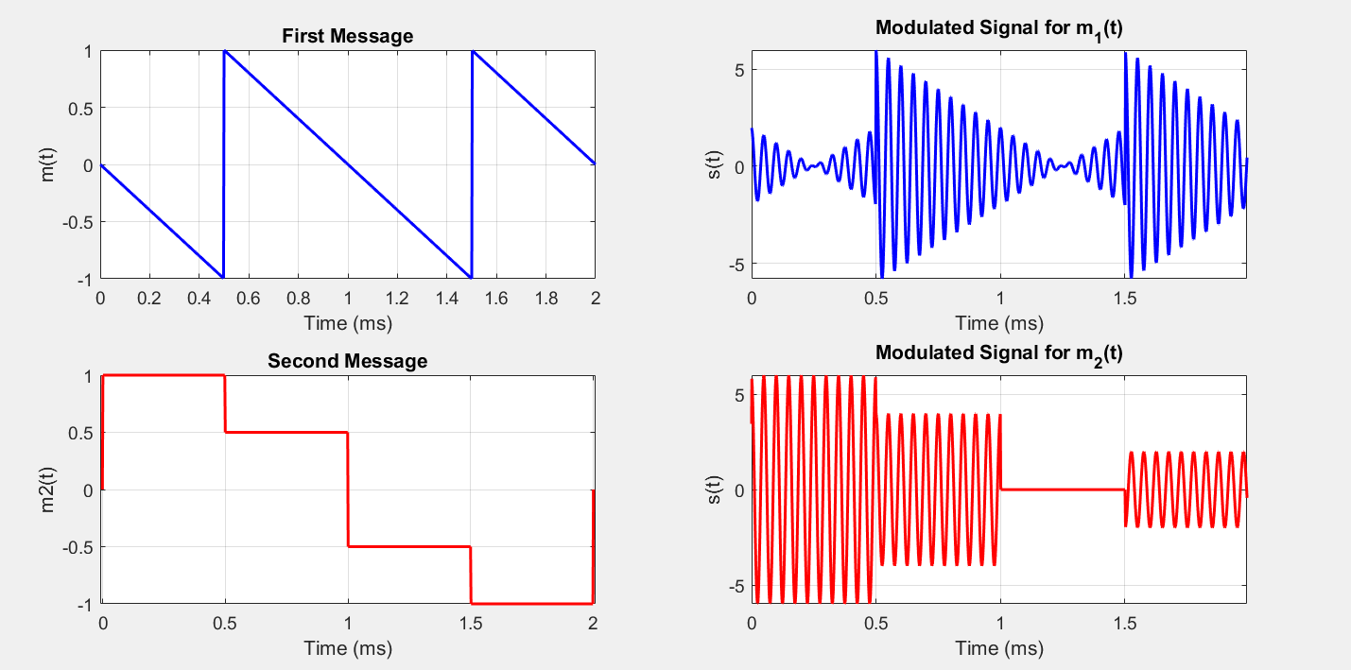

PART B: DSB SC USING MATLAB:

1- First Message Signal:
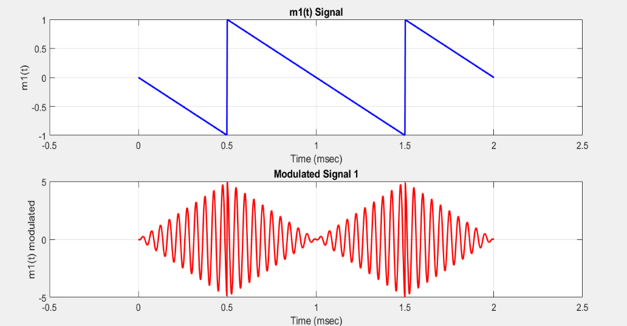
For the first message here after the modulation we can see that the result of the [m1(t) * carrier] gives us modulated signal proportional to the message due to AM Modulation. We can see that the modulated one start with low amplitude as the message signal start from 0 and it increases gradually proportional until t=0.5 msec it arrives the highest amplitude then the message signal start to decreasing in amplitude so we see from t=0.5 msec to t=1 msec the modulated signal change proportionally to it and so on in the second period

2- Second Message Signal:
We can see here in the second message after modulation that the modulated signal is proportional to the amplitude od the message signal (AM Modulation). We can see that modulated signal start with highest amplitude as the message one start at amplitude 1 remains constant until t=0.5 msec then the modulated one decreased sharply to amplitude 0.5 from t=0.5 msec to t=1 msec then change sharply and inverse its direction at same sec with same amplitude until t=1.5 msec then increase in the amplitude proportional to message signal till the end of the period
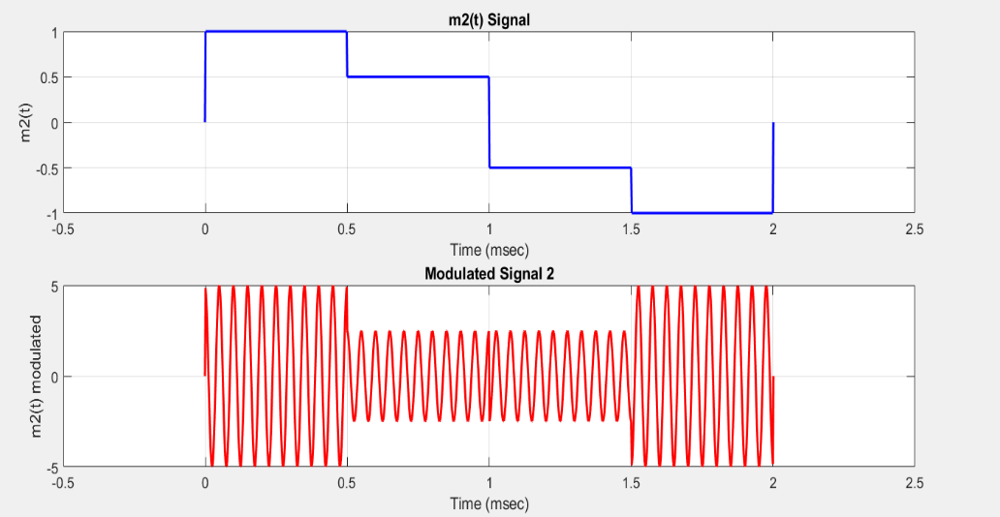

3- Demodulated Signals:
They are not filtered yet
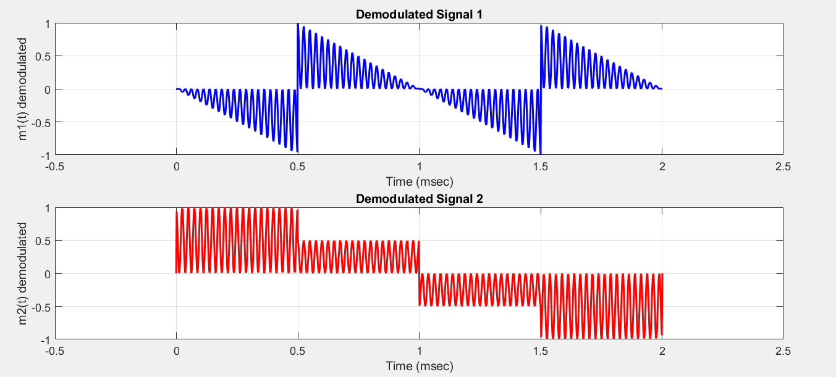

4- Demodulated Signals (Filtered):
we can see after we multiplied the modulated signal by the carrier again in demodulation and using the Low Pass Filter it restores the original message signal again with a kind of distortion due to the characteristics of the LPF and with 1/2m(t) which means half the amplitude of the original signal due to analytically mathematics when we multiplied m(t) times Cos^2(Wc)

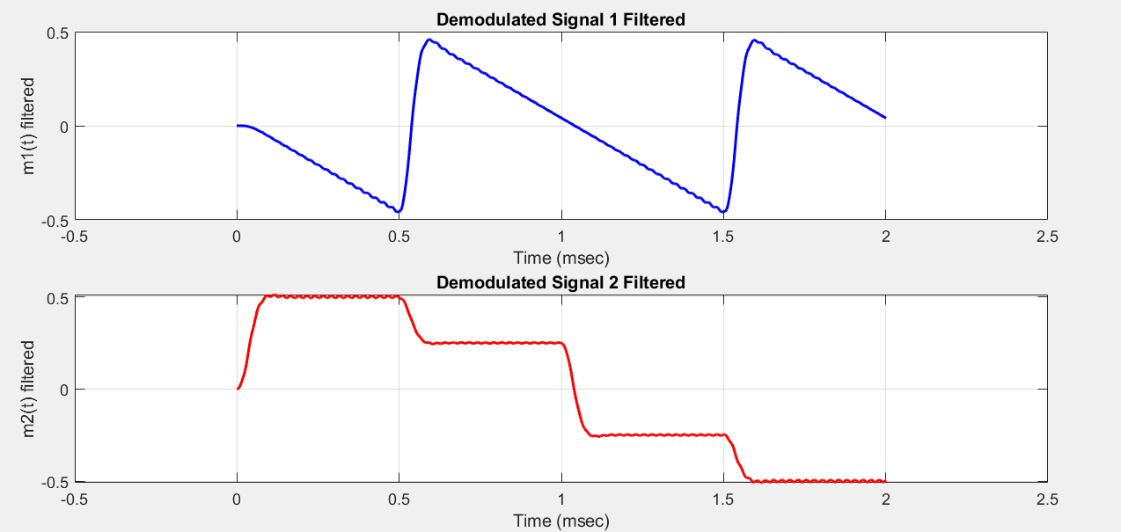

PART C: SSB USING MATLAB:

1- Shifted Signals:
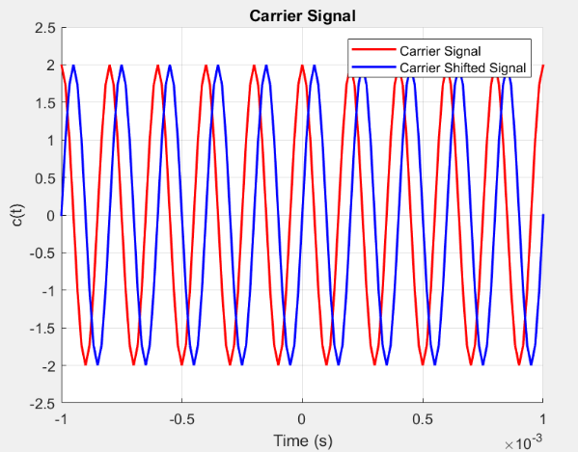
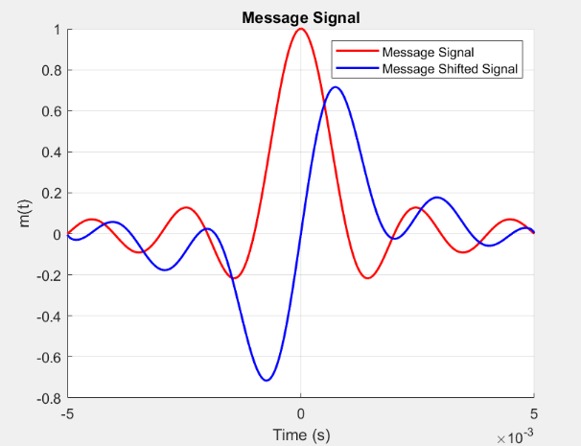
We need to apply a phase shift the message signal and the carrier signal by using Hilbert filter.

3- Modulated Signals:
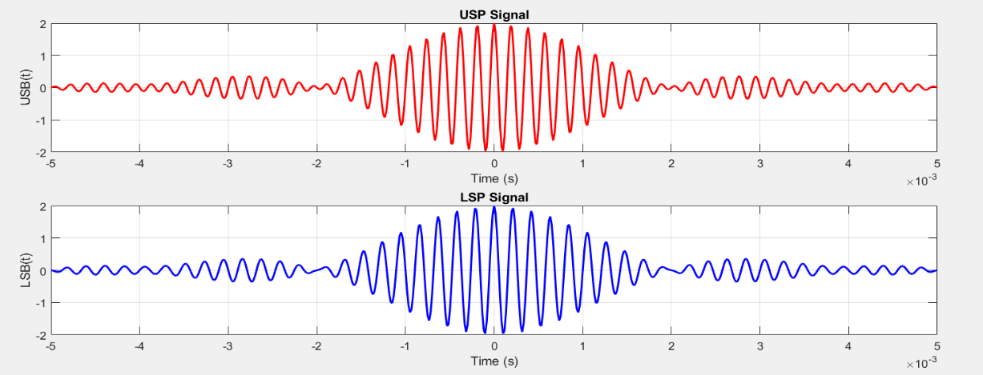
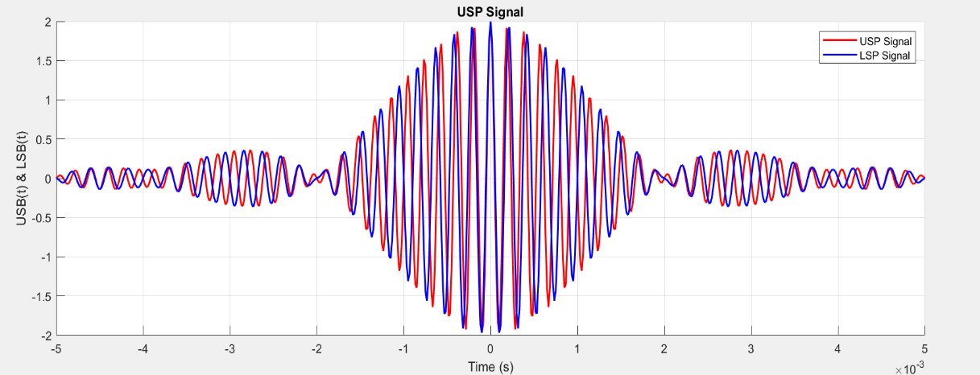
We multiply the two original signal with each other to make x1(t) and then multiply the two shifted signals to make x2(t) the we get the USB = x1(t) – x2(t) and the LSB = x1(t) + x2(t)

4- Spectrum of the modulated signals:

USB is the sideband containing the spectral components that are above the carrier frequency.
LSB is the sideband containing the spectral components that are below the carrier frequency.
While both USB and LSB contain the same information, they are mirror images of each other in the frequency domain. This means that the USB is a mirror reflection of the LSB around the carrier frequency.

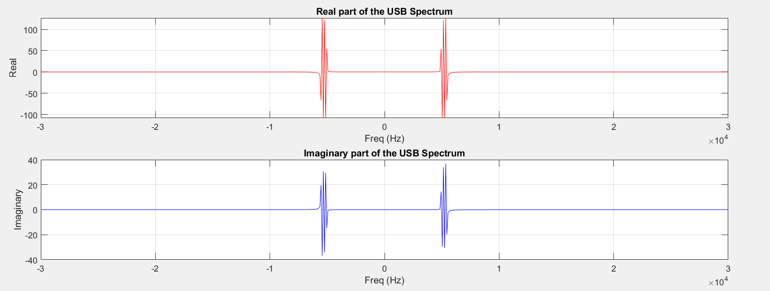

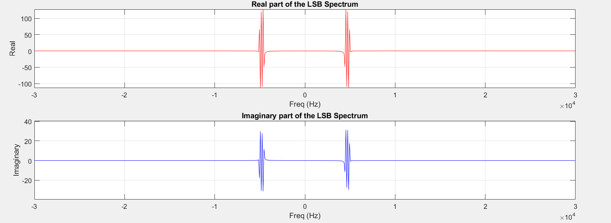

5- Demodulated Signals:
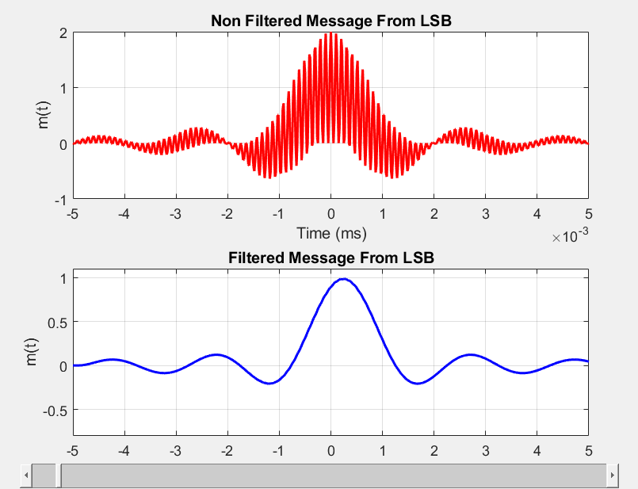
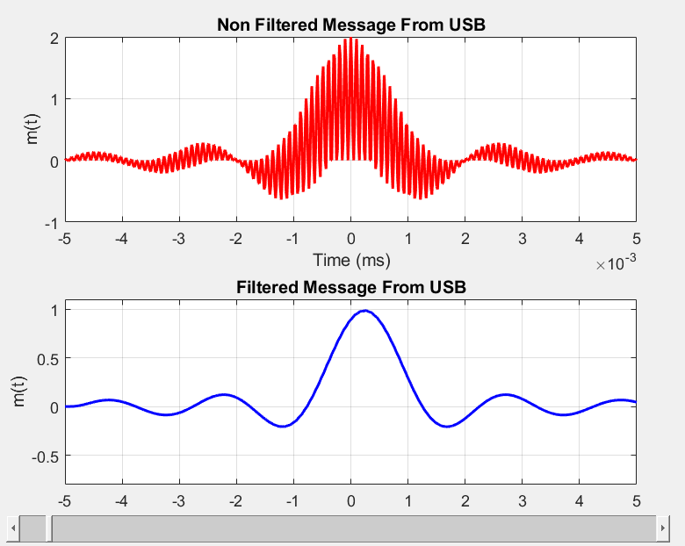
We can use either the USB or the LSB signal in the demodulation my multiply it with the carrier again to obtain the original message then we apply a low pass filter on it to get message signal again.

6- Local carrier frequency at the receiver is f1 = fc + 0.1B:
In this case, the local carrier frequency at the receiver is higher than the carrier frequency of the transmitted signal by 0.1B. This results in a positive frequency offset, causing the received signal to appear with lower frequency than the original signal if we used the USB in demodulation and appear with higher frequencies than the original if we used the LSB in demodulation.
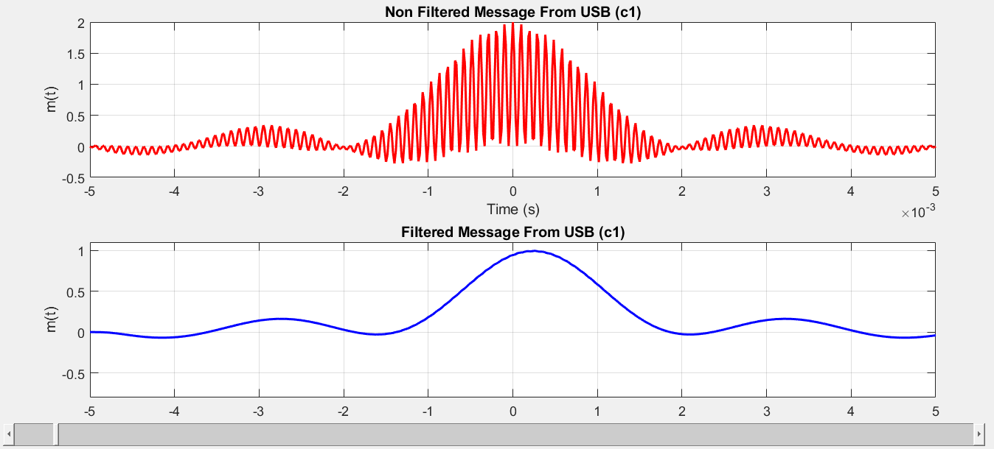

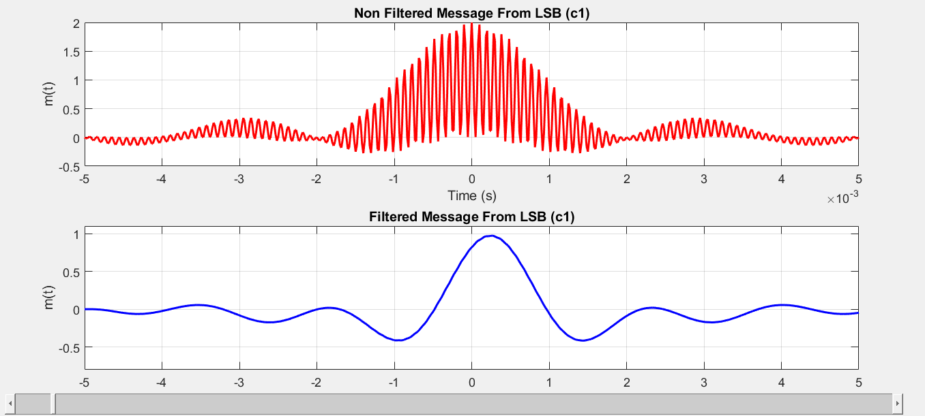

7- Local carrier frequency at the receiver is f2 = fc – 0.2B:
In this case, the local carrier frequency at the receiver is lower than the carrier frequency of the transmitted signal by 0.2B. This results in a negative frequency offset, causing the received signal to appear with higher frequency than the original signal if we used the USB in demodulation and appear with lower frequencies than the original if we used the LSB in demodulation.
