Project 2



By
Amr Ashraf 202101355
Marwan Ahmed 202101214
Amr Ahmed 202100302
Contents
PART A: PAM MODULATION: 3
1- Modulation: 3
2- Demodulation: 4
3- Test Cases: 5
Message 1: with (Ts = 1/8) and (T = 0.25 * Ts) and (t = 0: 0.001: 1) 5
Message 2: with (Ts = 0.4) and (T = 0.1) and (t = 0: 0.01: 8) 5
PART B: FLAT-TOP PAM MODULATION: 6
1- Modulation: 6
2- Demodulation: 7
3- Test Cases: 8
Message 1: with (Ts = 1/8) and (T = 0.25 * Ts) and (t = 0: 0.001: 1) 8
Message 2: with (Ts = 0.4) and (T = 0.4) and (t = 0: 0.01: 8) 8
PART C: PWM MODULATION: 9
1- Modulation: 9
2- Demodulation: 10
3- Test Cases: 11
Message 1: with (Ts = 1/8) and (A = 2) and (t = 0: 0.001: 1) 11
Message 2: with (Ts = 0.4) and (A = 2) and (t = 0: 0.01: 8) 11
PART D: PPM MODULATION: 12
1- Modulation: 12
2- Demodulation: 12
3- Test Cases: 13
Message 1: with (Ts = 1/8) and (T = 0.1*Ts) and (A = 2) and (t = 0: 0.001: 1) 13
Message 2: with (Ts = 0.4) and (T = 0.05) and (A = 2) and (t = 0: 0.01: 8) 13

PART A: PAM MODULATION:
Pulse Amplitude Modulation (PAM) is a form of modulation where the amplitude of a series of pulses is varied in accordance with the amplitude of a modulating signal. In simpler terms, it's a technique where the amplitude of a periodic pulse train is varied based on the amplitude of the signal being transmitted.
PAM is used in various digital communication systems, especially in baseband transmission over short distances, like within a computer or between digital devices. However, due to its sensitivity to noise and distortion, it's often used in combination with other modulation techniques, such as Pulse Code Modulation (PCM) in digital telephony or in digital modulation schemes like Pulse Amplitude Modulation (PAM) for higher data rates.

1- Modulation:
To modulate the message signal, we first need to make the Train of pulses with the specified Ts (pulse period) and T (pulse on time)
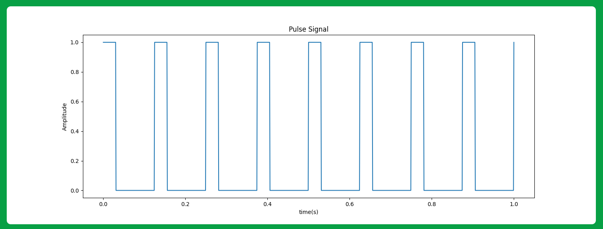
Then: we get our message signal
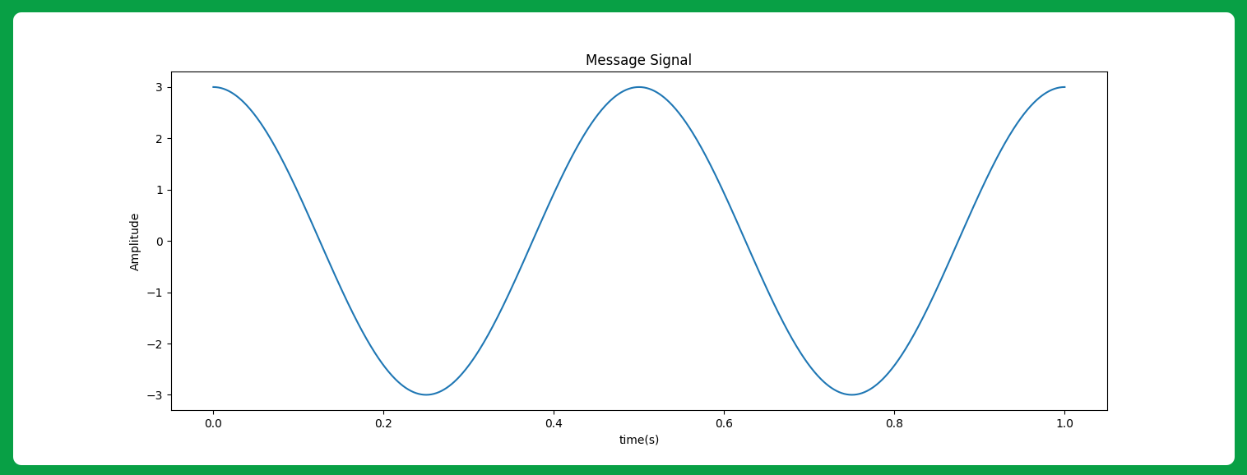
Then: we multiply the pulse signal with the message signal to obtain the modulated signal
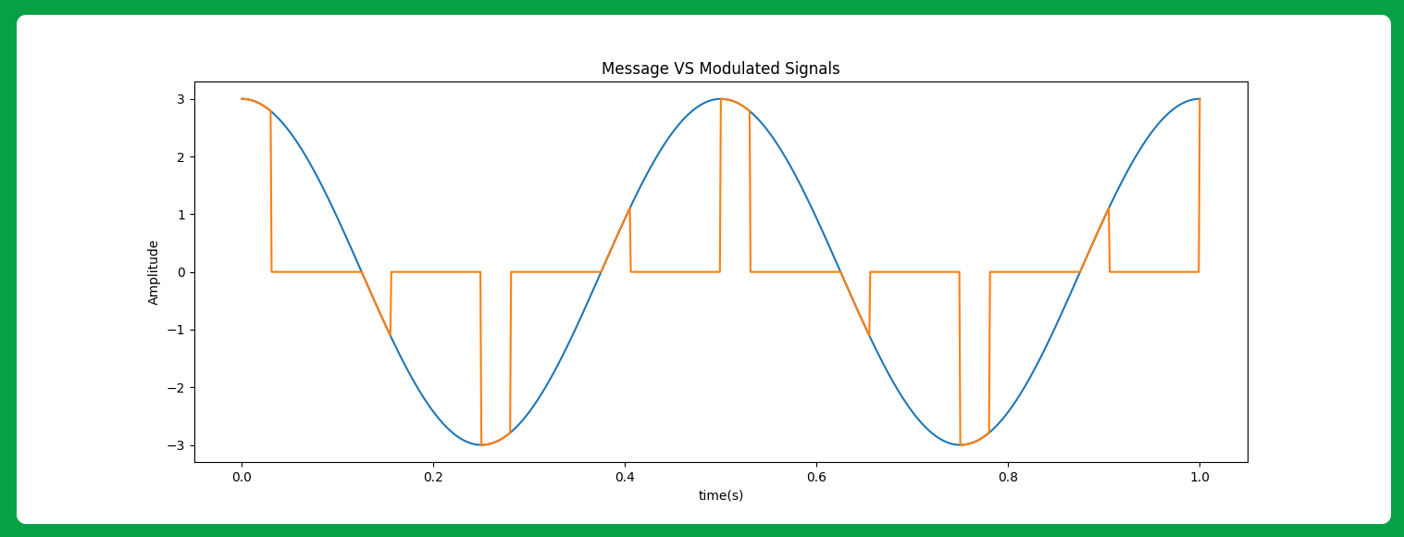
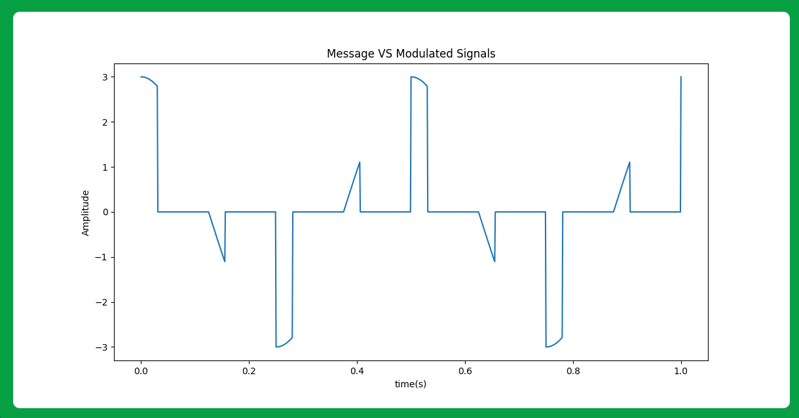

2- Demodulation:
To demodulate the received signal, we pass it to a (lop pass filter) with cutoff frequency more than message bandwidth (B) and less than (Fs – B) and then apply a suitable gain
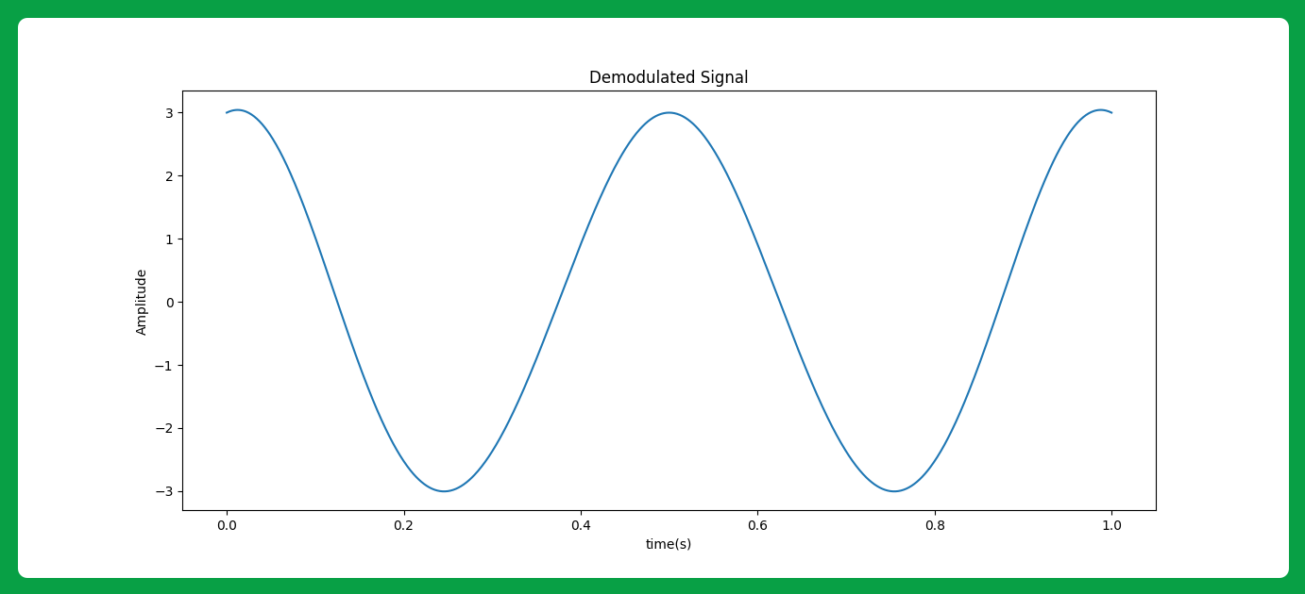

3- Test Cases:

Message 1: with (Ts = 1/8) and (T = 0.25 * Ts) and (t = 0: 0.001: 1)
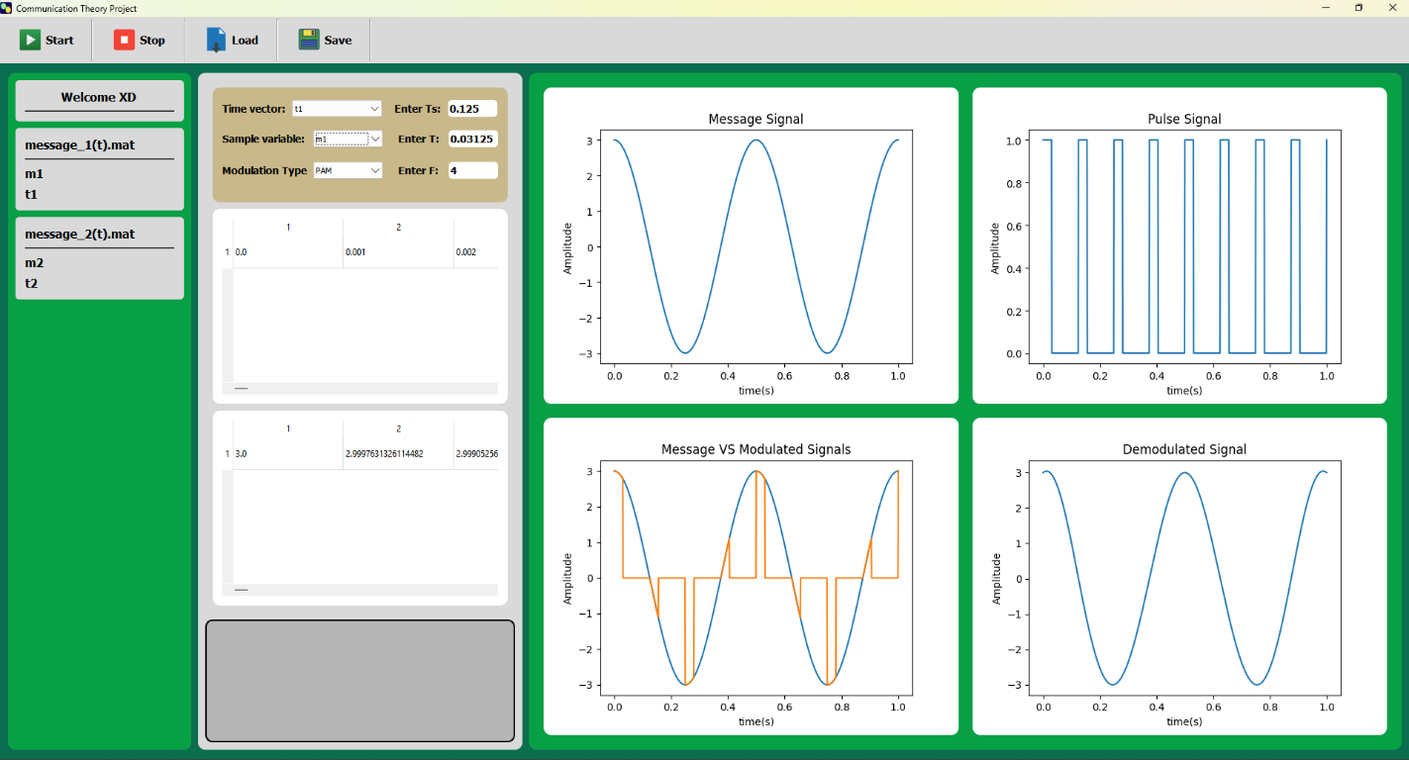

Message 2: with (Ts = 0.4) and (T = 0.1) and (t = 0: 0.01: 8)
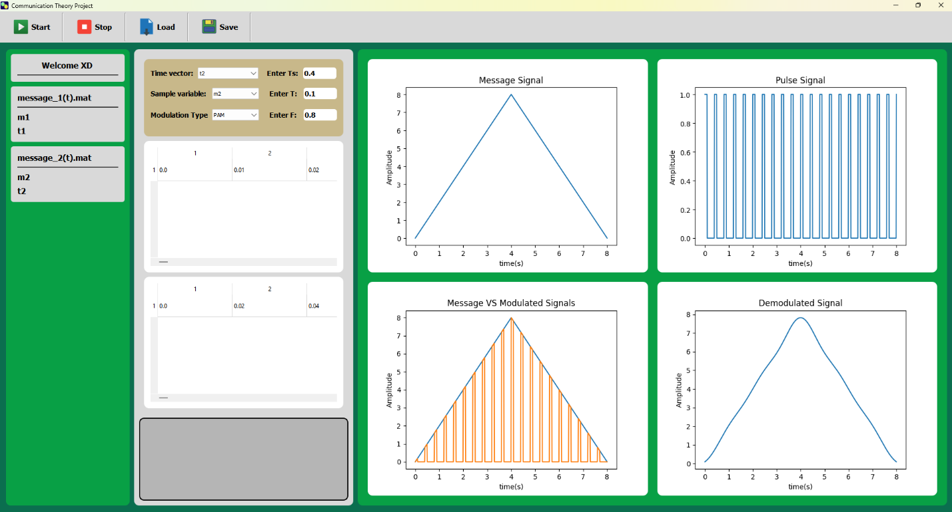

PART B: FLAT-TOP PAM MODULATION:
Flat-top PAM (FT-PAM) is a variation of Pulse Amplitude Modulation (PAM) where the pulses have a flat top, meaning that the pulse shape remains constant at its maximum amplitude for a certain duration before returning to zero. This is in contrast to regular PAM, where the pulse shape might vary more gradually.

1- Modulation:
To modulate the message signal, we get our message signal

Then: we sample it

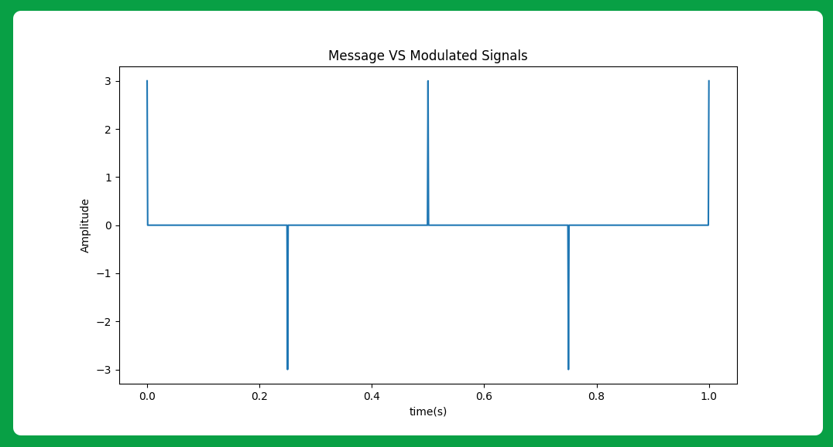
Then: we enter the sampled signal to a pulse generator which output is rectangle at each pulse
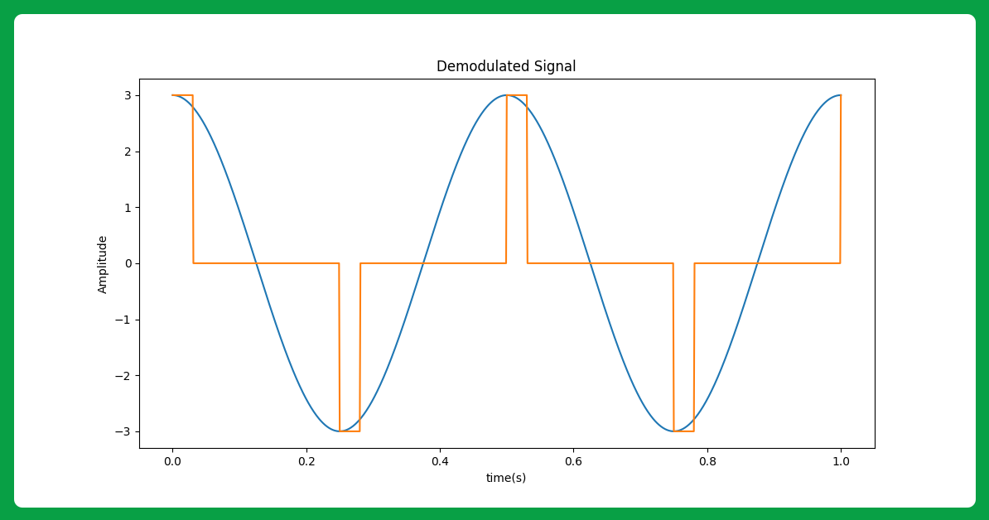
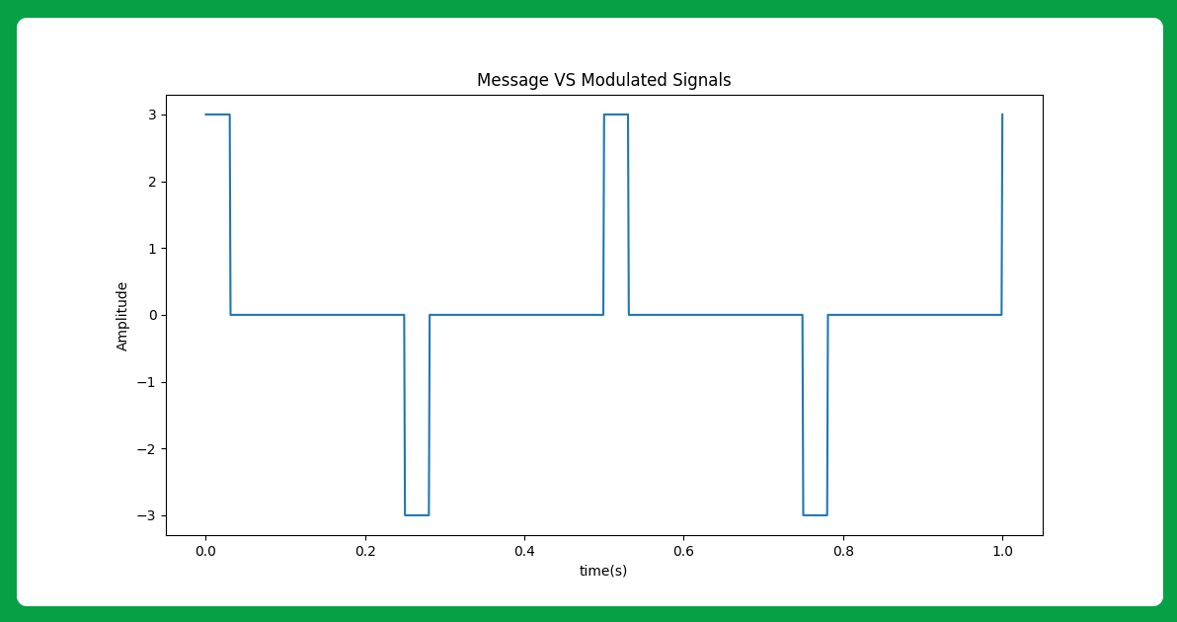

2- Demodulation:
To demodulate the received signal, we pass it to a (lop pass filter) with cutoff frequency more than message bandwidth (B) and less than (Fs – B) and then apply a suitable gain

3- Test Cases:

Message 1: with (Ts = 1/8) and (T = 0.25 * Ts) and (t = 0: 0.001: 1)
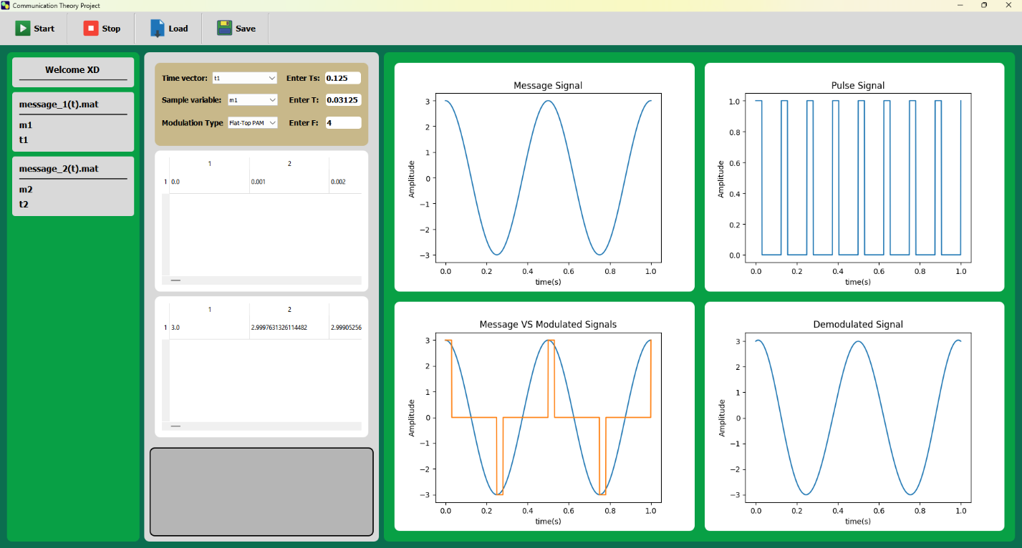

Message 2: with (Ts = 0.4) and (T = 0.4) and (t = 0: 0.01: 8)
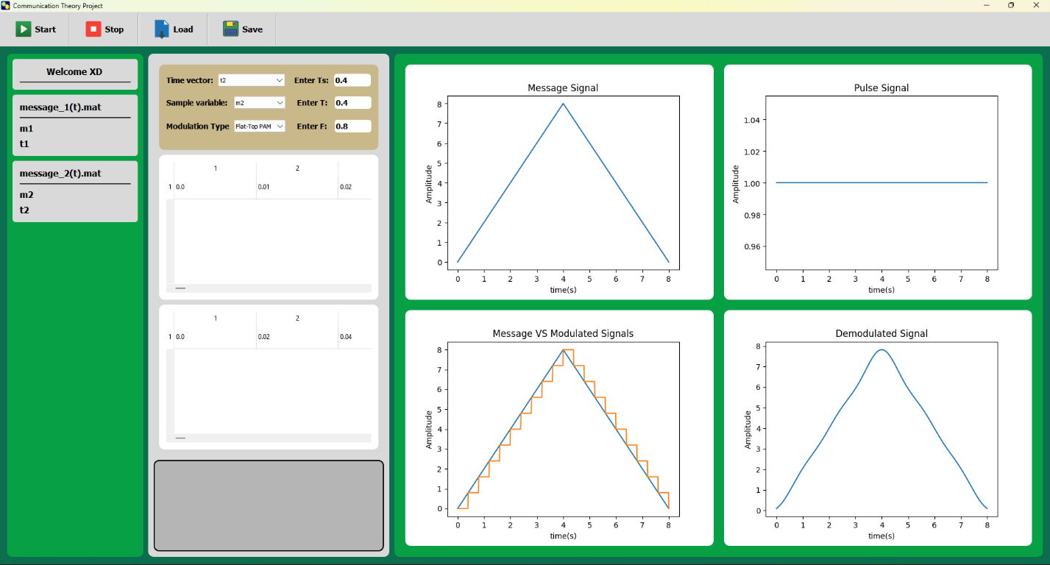

PART C: PWM MODULATION:
Pulse Width Modulation (PWM) is a modulation technique where the width of the pulses in a periodic signal is varied in proportion to a modulating signal. PWM is commonly used to control the power delivered to electrical devices, such as motors, LEDs, and audio signals.

1- Modulation:
We first get our message signal
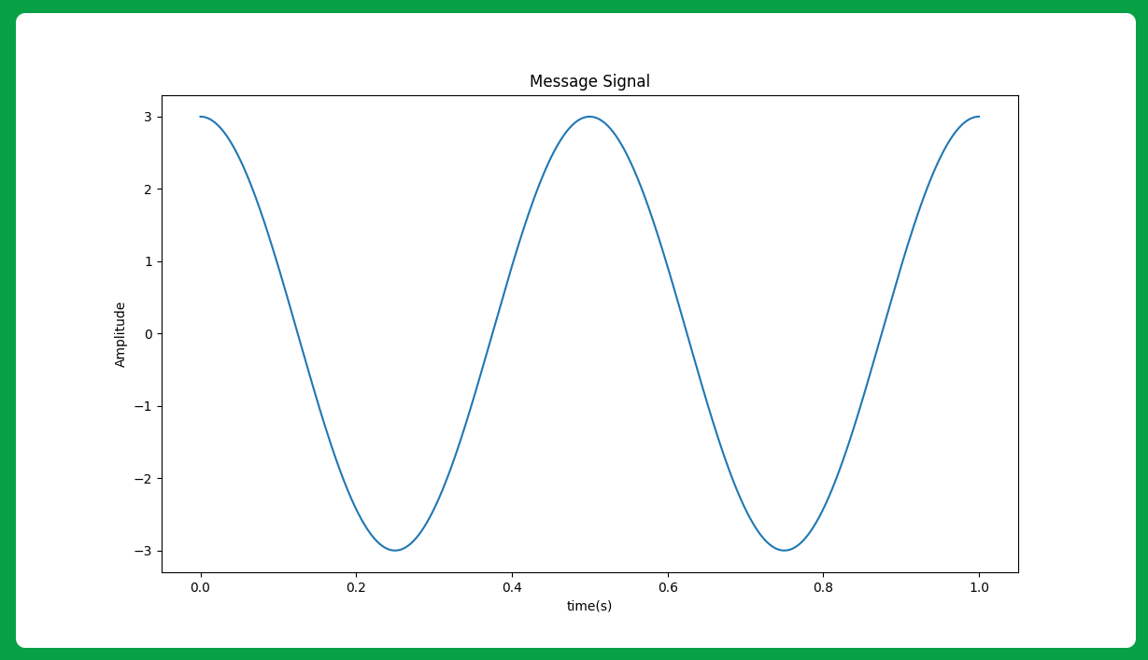
Then: we make a train of triangle pulses
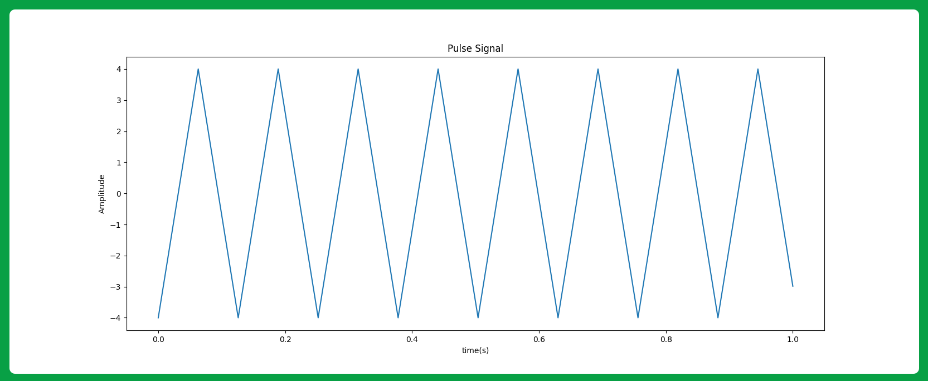
Then: we enter the two signals to a comparator which gives True only when the message signal amplitude is higher the pulse signal amplitude
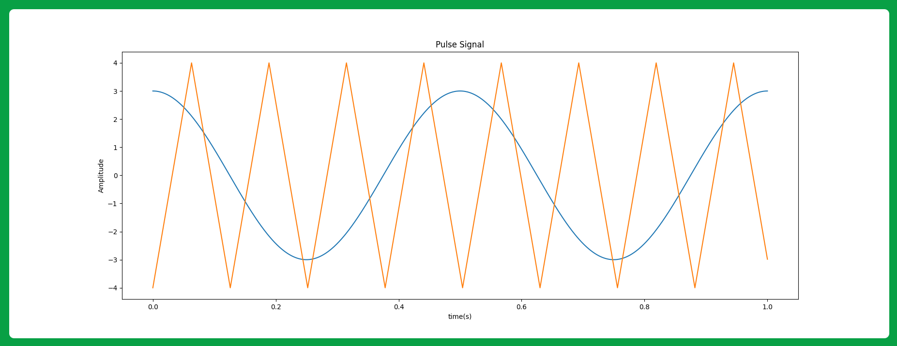
Which gives the modulated signal as the output.
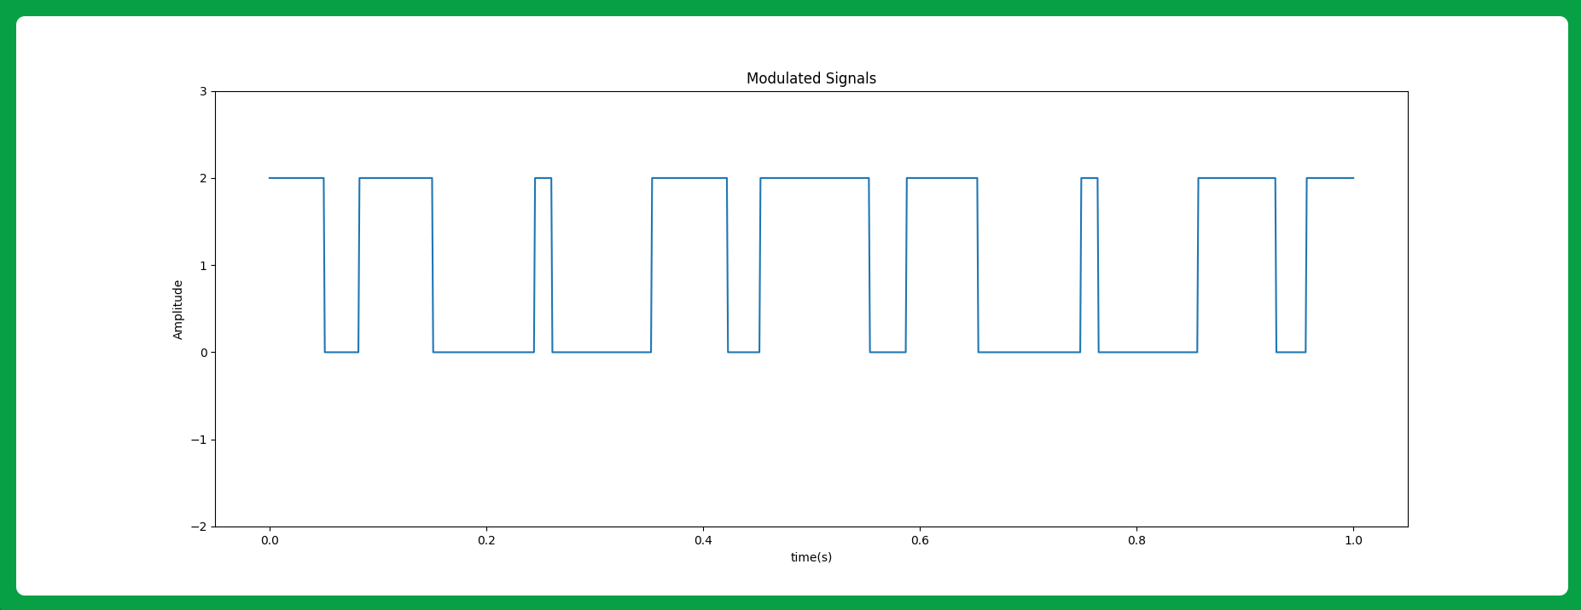

2- Demodulation:
To demodulate the received signal, we need to convert it to a PAM signal then we pass it to a (lop pass filter) with cutoff frequency more than message bandwidth (B) and less than (Fs – B) and then apply a suitable gain, we can do this by enter the signal to a integrate and sample device which give us the PAM version of our signal:
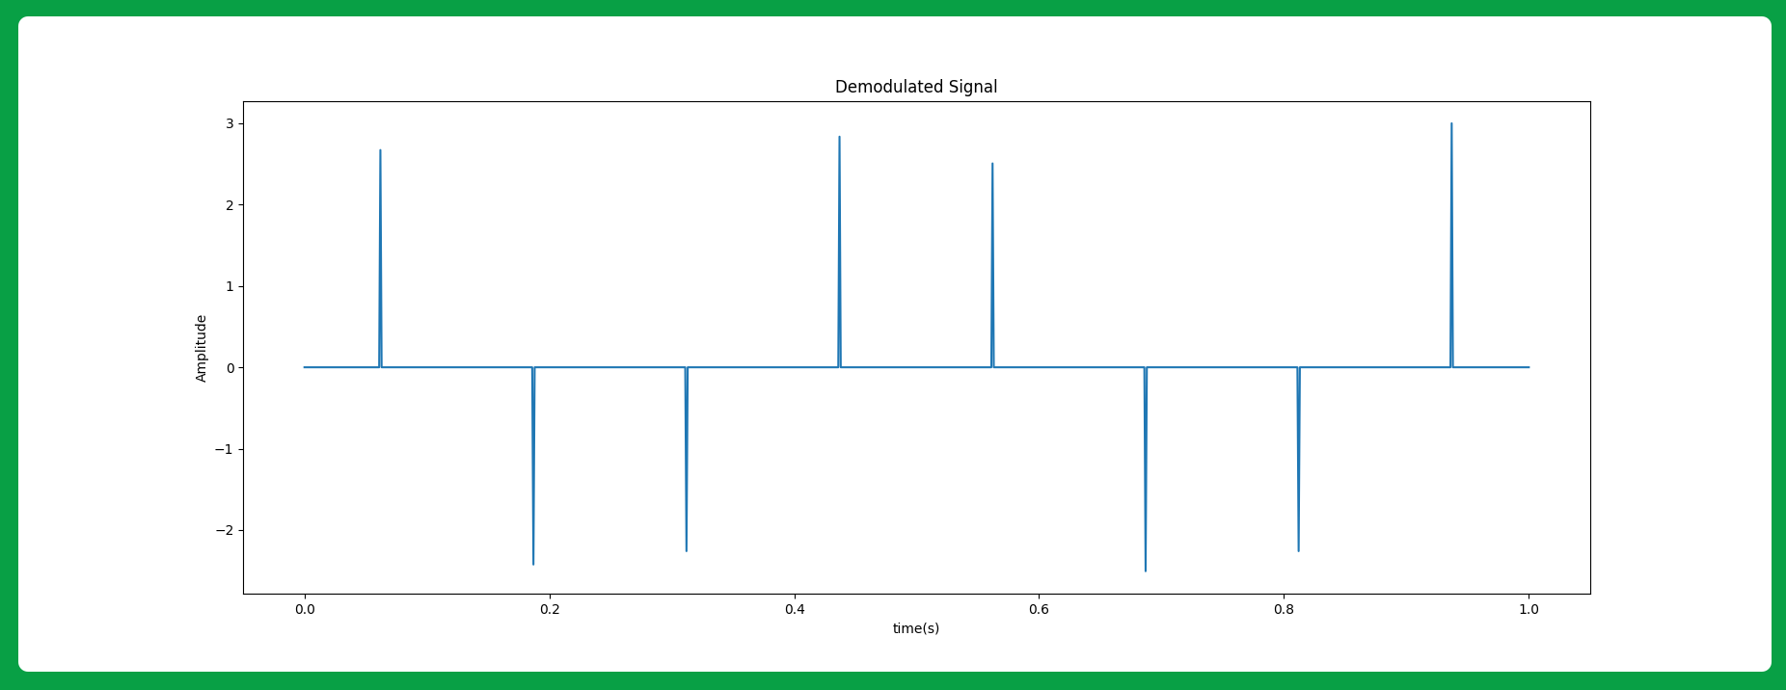
Then: we enter it to a low pass filter to generate the original signal
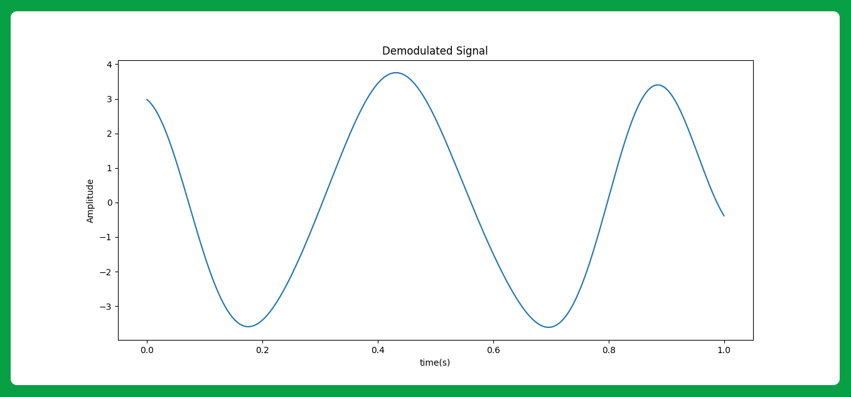

3- Test Cases:

Message 1: with (Ts = 1/8) and (A = 2) and (t = 0: 0.001: 1)
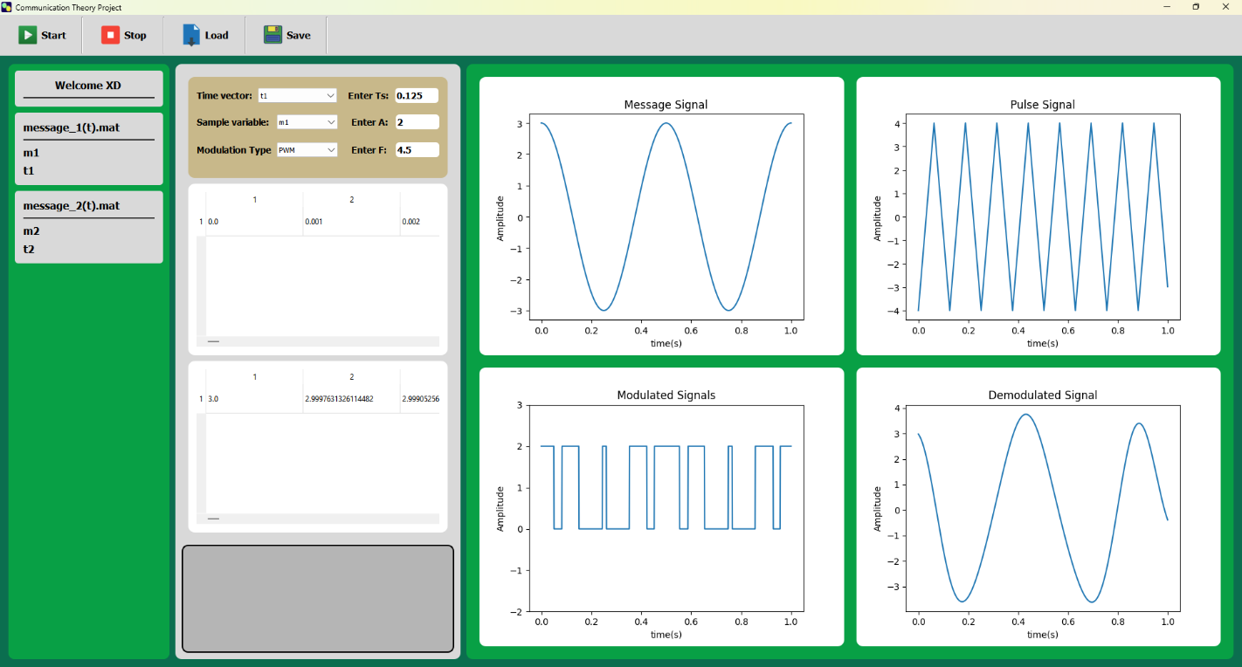

Message 2: with (Ts = 0.4) and (A = 2) and (t = 0: 0.01: 8)
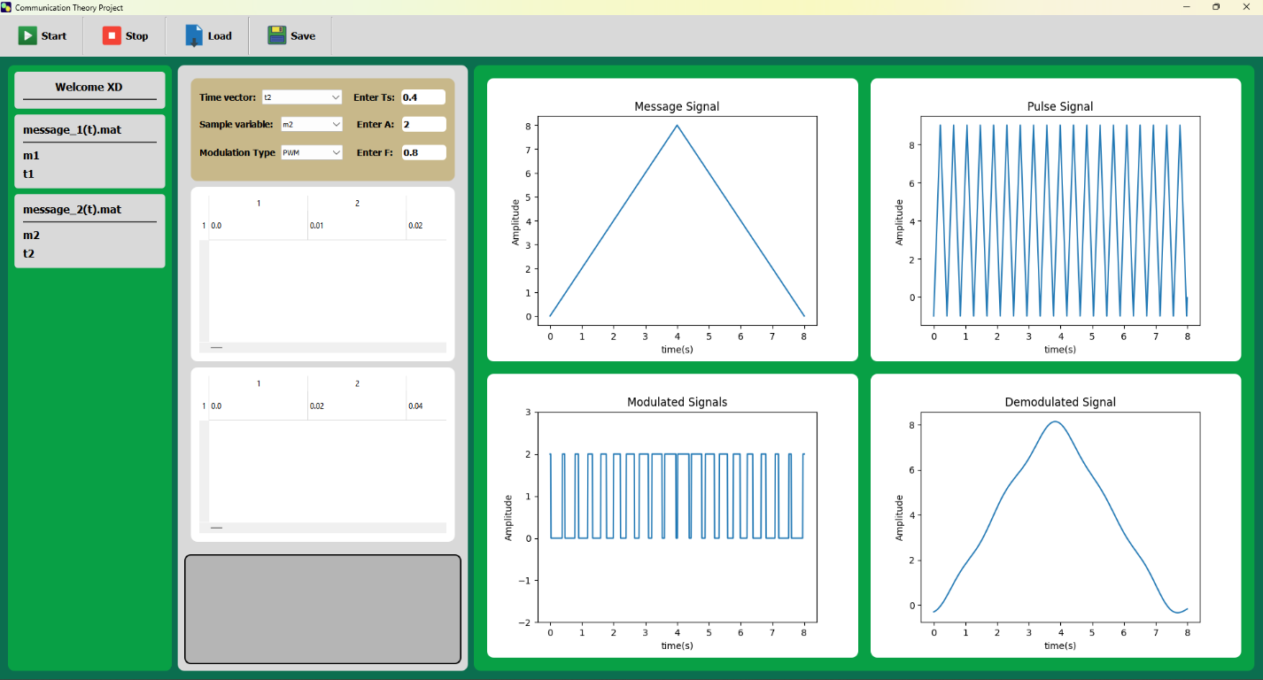

PART D: PPM MODULATION:
Pulse Position Modulation (PPM) is a modulation technique similar to Pulse Width Modulation (PWM), but instead of varying the width of the pulses, it varies the position of the pulses within a constant-width time frame.
In PPM, the timing of the pulses relative to a reference point is varied according to the modulating signal. A higher amplitude of the modulating signal might cause the pulse to be positioned later in the time frame, while a lower amplitude might cause it to be positioned earlier.

1- Modulation:
We do the same steps as PWM but after that we enter the signal to a pulse generator which only generate fixed width pulses at the end of the widths of the PWM
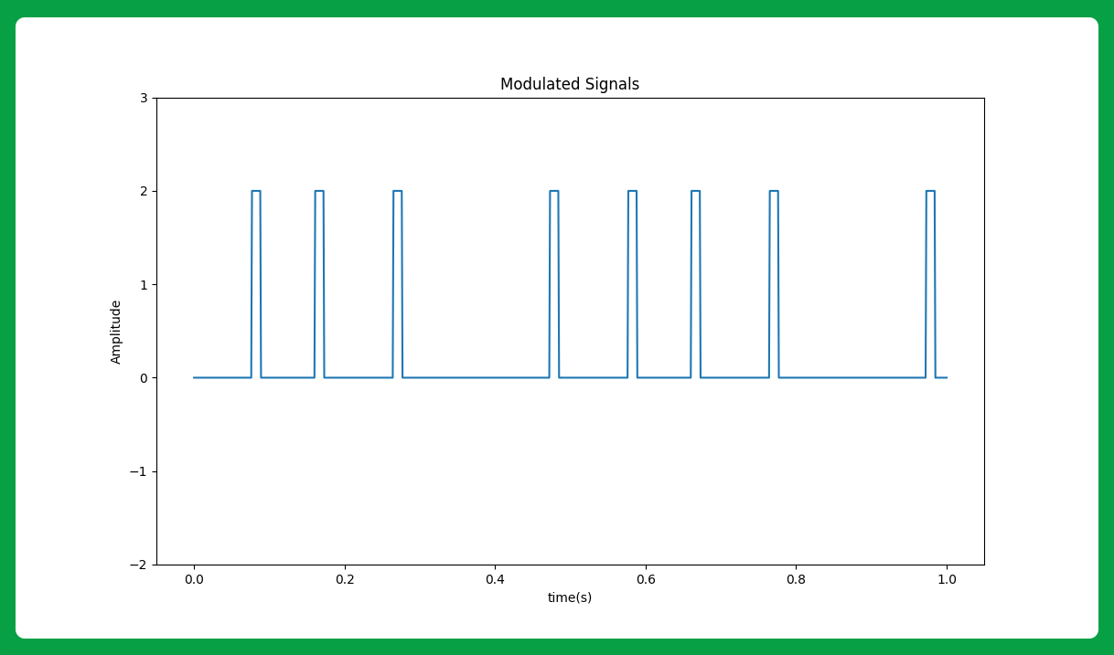

2- Demodulation:
We convert the signal back to the PWM signal using SR flip-flop (we enter Pulse generator signal to the R input, and enter a reference pulse signal to the S input), due to the set and reset signals applied to the flip-flop, we get a PWM signal at its output. The PWM signal can be demodulated using the PWM demodulator as explained above in the report.

3- Test Cases:

Message 1: with (Ts = 1/8) and (T = 0.1*Ts) and (A = 2) and (t = 0: 0.001: 1)
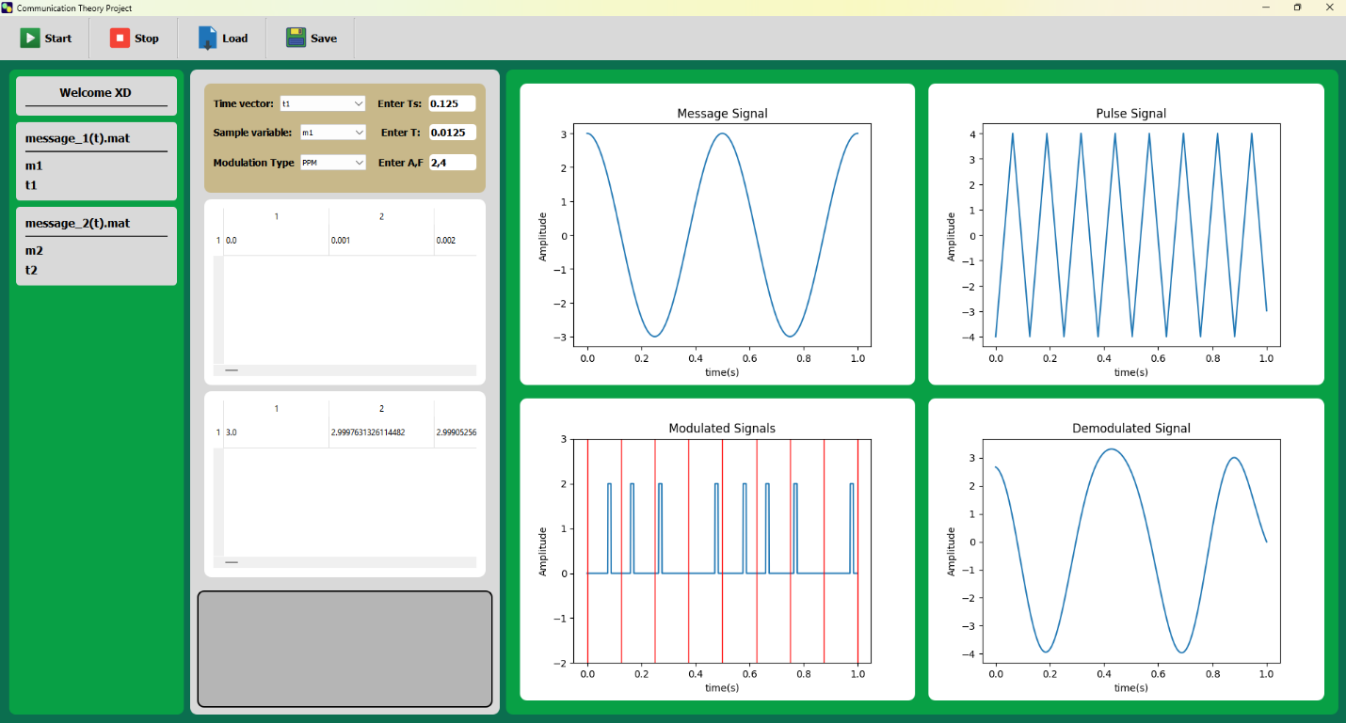

Message 2: with (Ts = 0.4) and (T = 0.05) and (A = 2) and (t = 0: 0.01: 8)
