Probability Project



By
Amr Ashraf
Marwan Ahmed
Amr Ahmed
Contents
Section 1: Random Variables: 3
1-Sample_Variable_2023: 3
2- y follow U (-3,5): 3
3- y follow N (-8,4): 4
1- MGF(t): 4
2- Mean: 4
3- Variance: 4
4- Error in results: 4
Section 2: Random Processes: 5
1-Sample_Process_2023: 5
1-Z(t): 6
1-w(t): 7

Section 1: Random Variables:

1-Sample_Variable_2023:
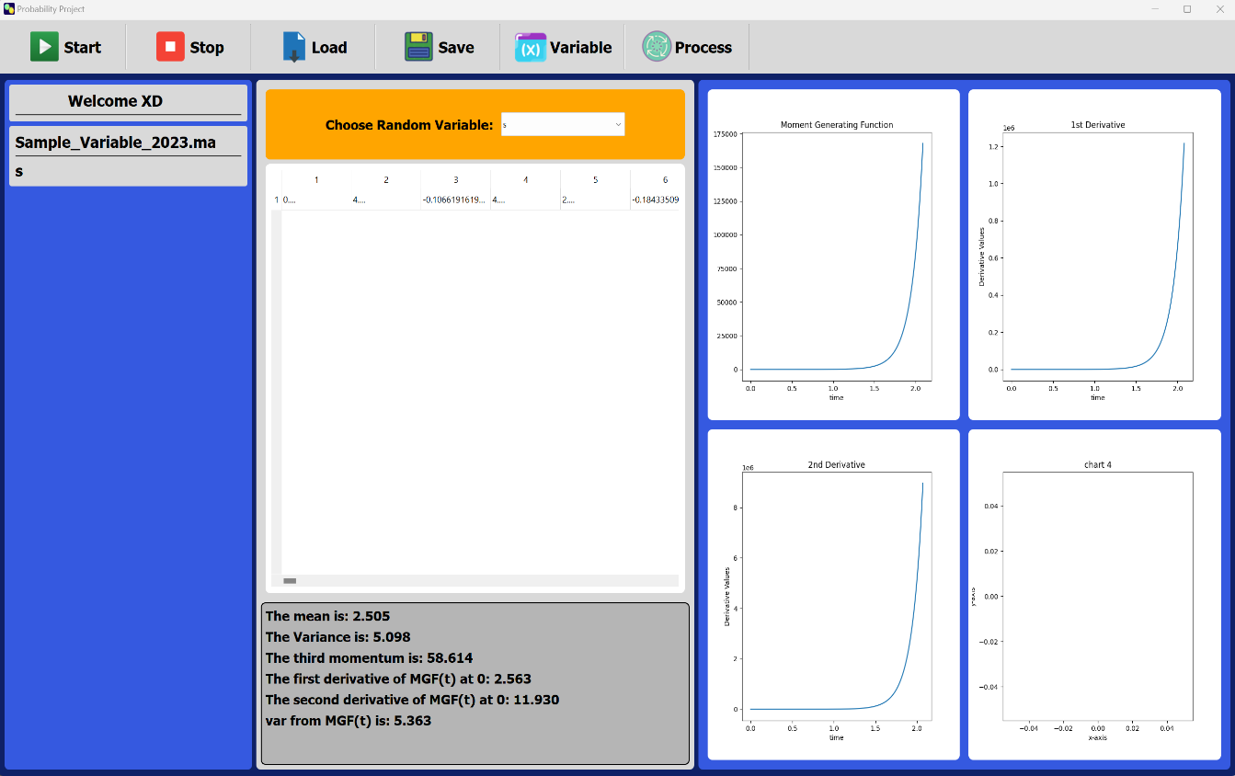

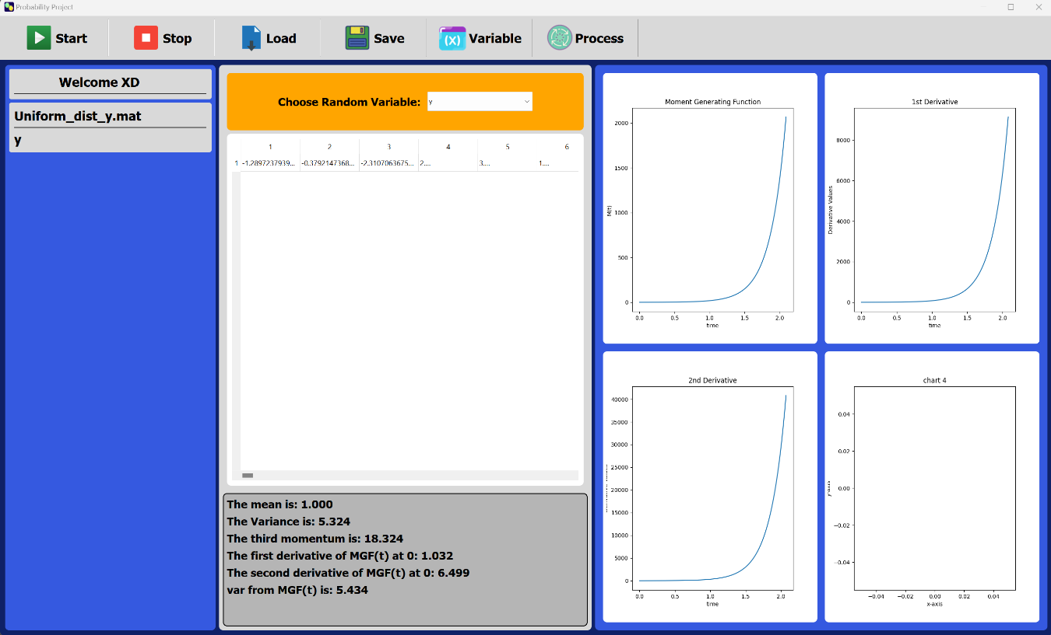
2- y follow U (-3,5):

3- y follow N (-8,4):
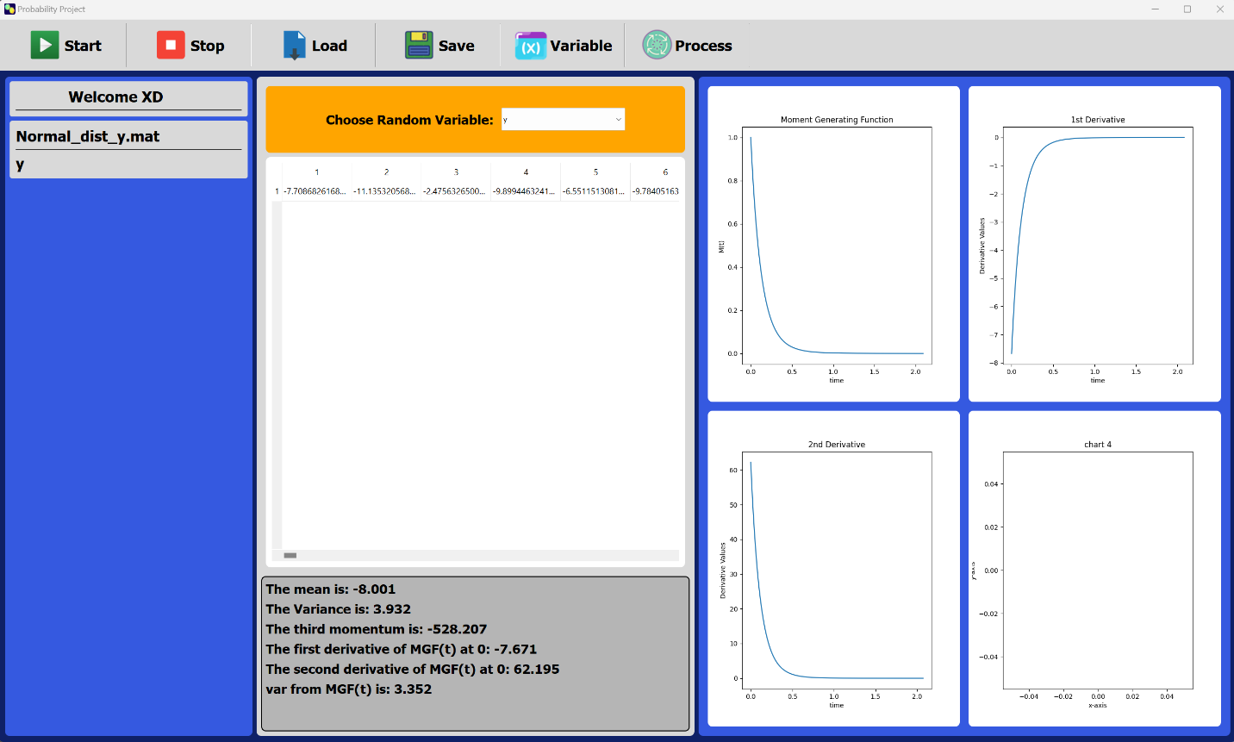

1- MGF(t):
As we see all the MGF(t) starts from value 1 which is good because any valid MGF should start with 1

2- Mean:
the first derivative of MGF(t) at t = 0 is E(x) which is the mean like we calculated before

3- Variance:
the second derivative of MGF(t) at t = 0 is E(x²) so if we calculate the (the second derivative of MGF(t) at t = 0) – (the first derivative of MGF(t) at t = 0)² will give us the variance as we calculated before.

4- Error in results:
the little difference in the results is due to the sampling of the time vector when we differentiate the smaller dt we take the better results we get

Section 2: Random Processes:

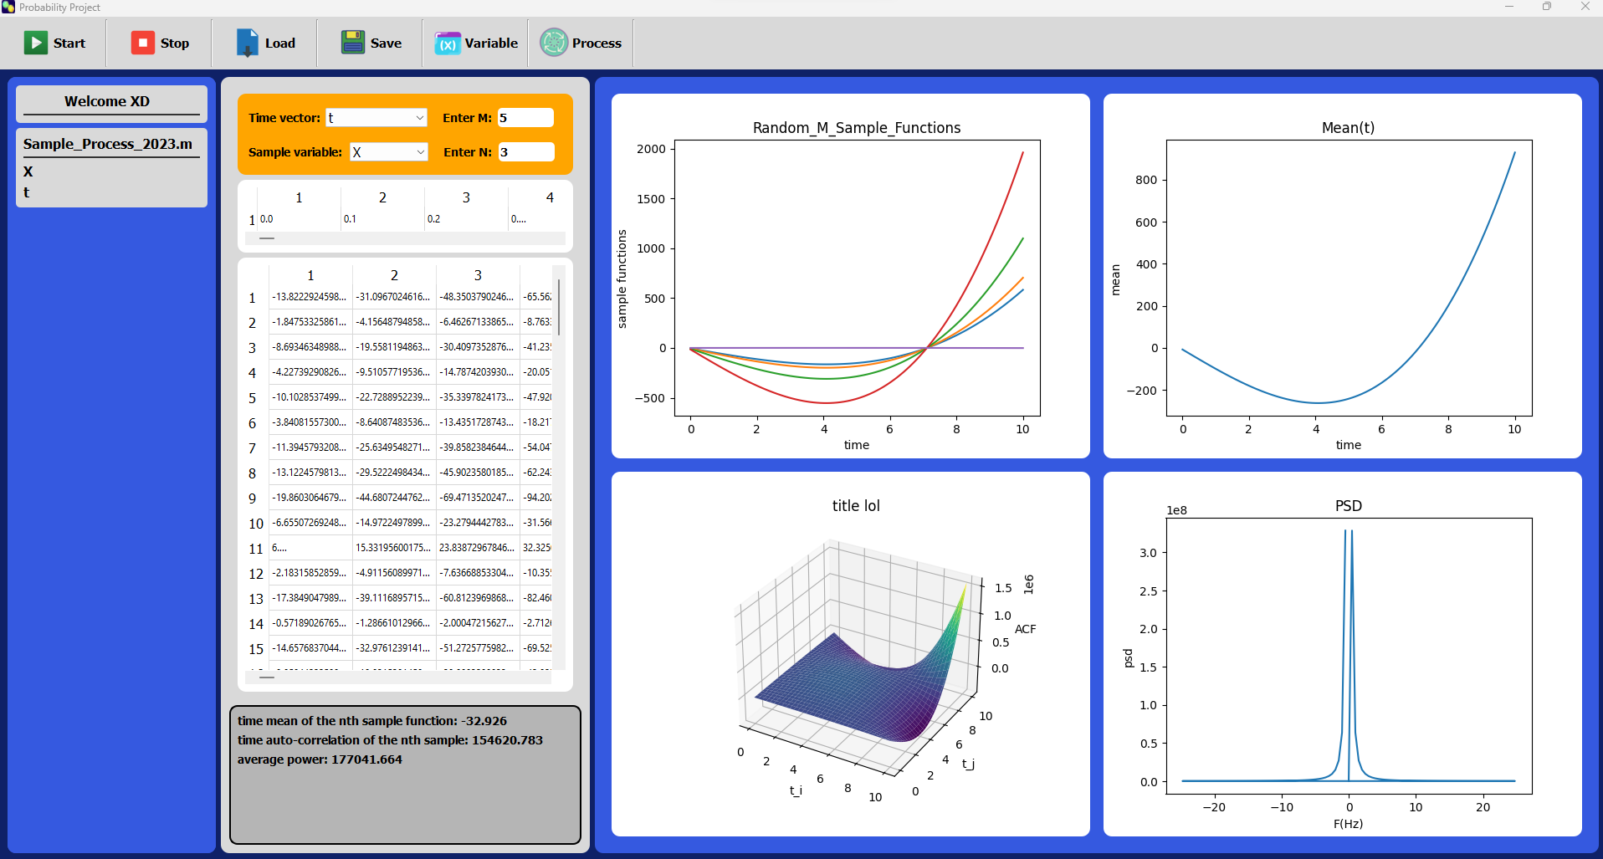
1-Sample_Process_2023:
There are the M sample functions that user entered from the sample file

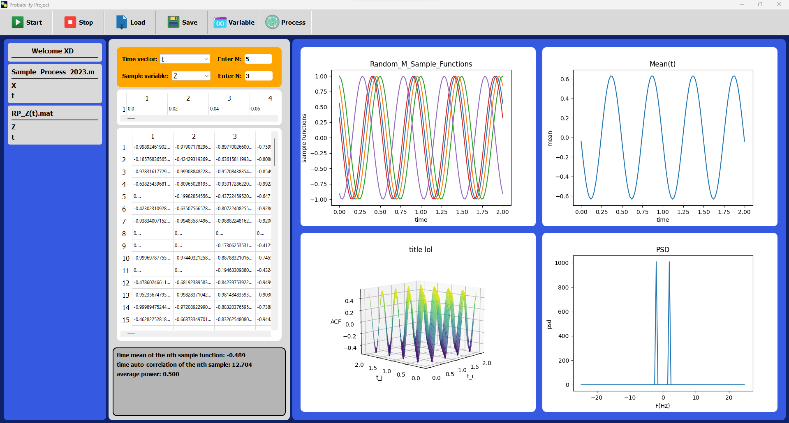
1-Z(t):
There are the M sample functions that user entered from the sample file
This is the M sample function that user entered from the sample file where theta follow uniform distribution, we can show that there are differences between each sample function plotted as (theta) is the RV that follows the uniform distribution but A, omega it still the same

1-w(t):
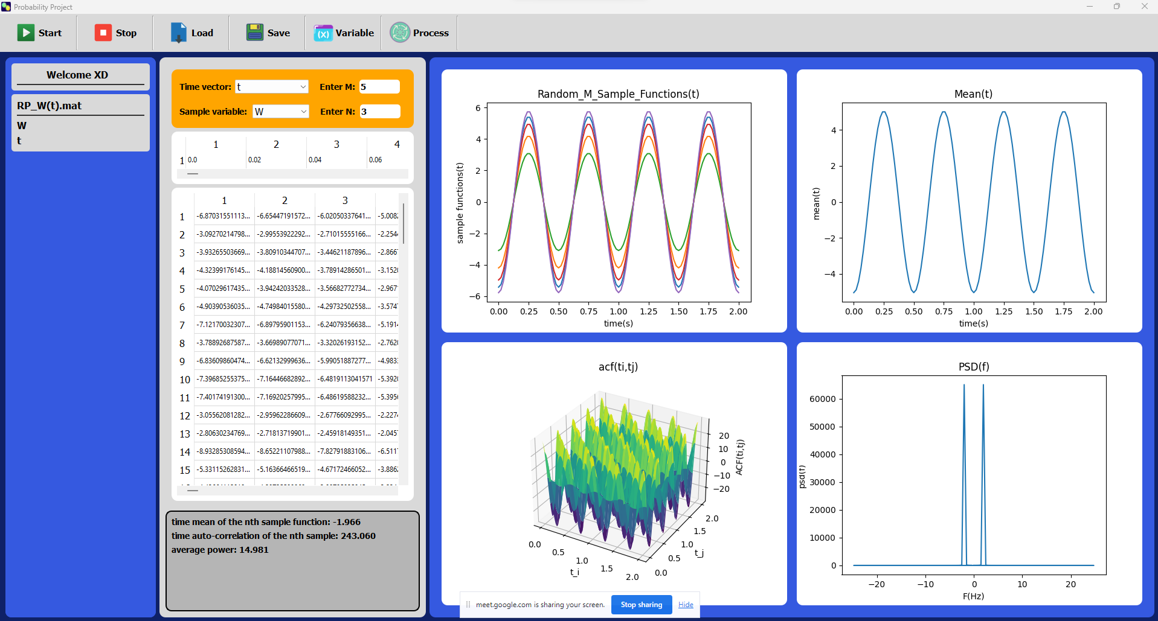
There are the M sample functions that user entered from the sample file
This is the M sample functions that user entered from the sample file that Amplitude follows the normal distribution we can find differences on the Amplitudes between the sample function as it is the RV and the rest of variables are constant
Comment on the mean plot:
we can see that the ensemble mean is varying with time and it is not const
Comment on the 3D plot:
we can show that we put the t_i and t_j on the x-axis and y-axis and the vector of the ACF is on the z-axis so to get that 3D plot for each plane at difference value with ti and tj we plotting the ACF resulting that graph
Is there a relation between the statistical ACF and the time ACF, for the test process?
we can find that the time ACF is const but the statistical ACF is not constant
Is there a relation between the statistical mean and the time mean, for the test process?
we can find that the time mean is const but the statistical mean is not constant resulting to the random process is not Ergodic

