**Rabanes, Matthew Gabriel M.**

**Tenedero, Gerard Emilson G.**

**PROBLEM 1**: Write a program that will implement the function

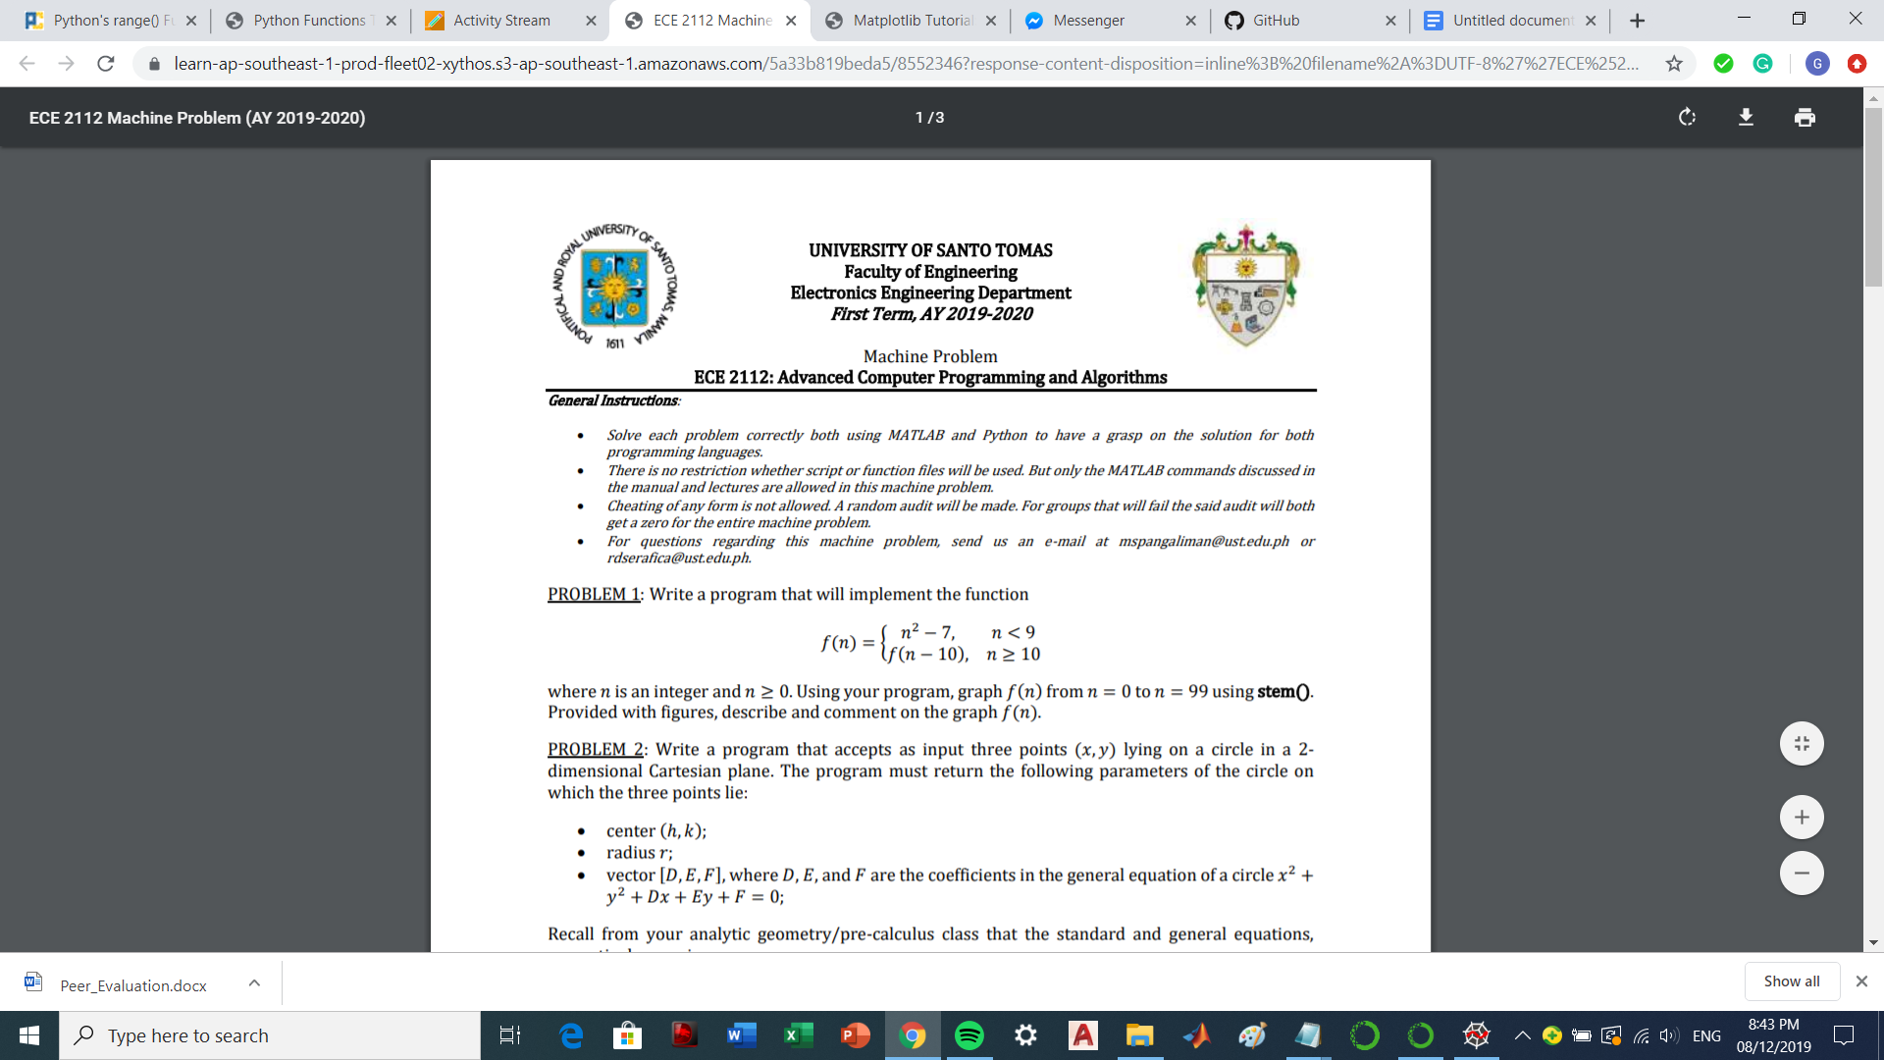

where 𝑛 is an integer and 𝑛 ≥ 0. Using your program, graph 𝑓(𝑛) from 𝑛 = 0 to 𝑛 = 99 using stem(). Provided with figures, describe and comment on the graph 𝑓(𝑛).

**Sample:**

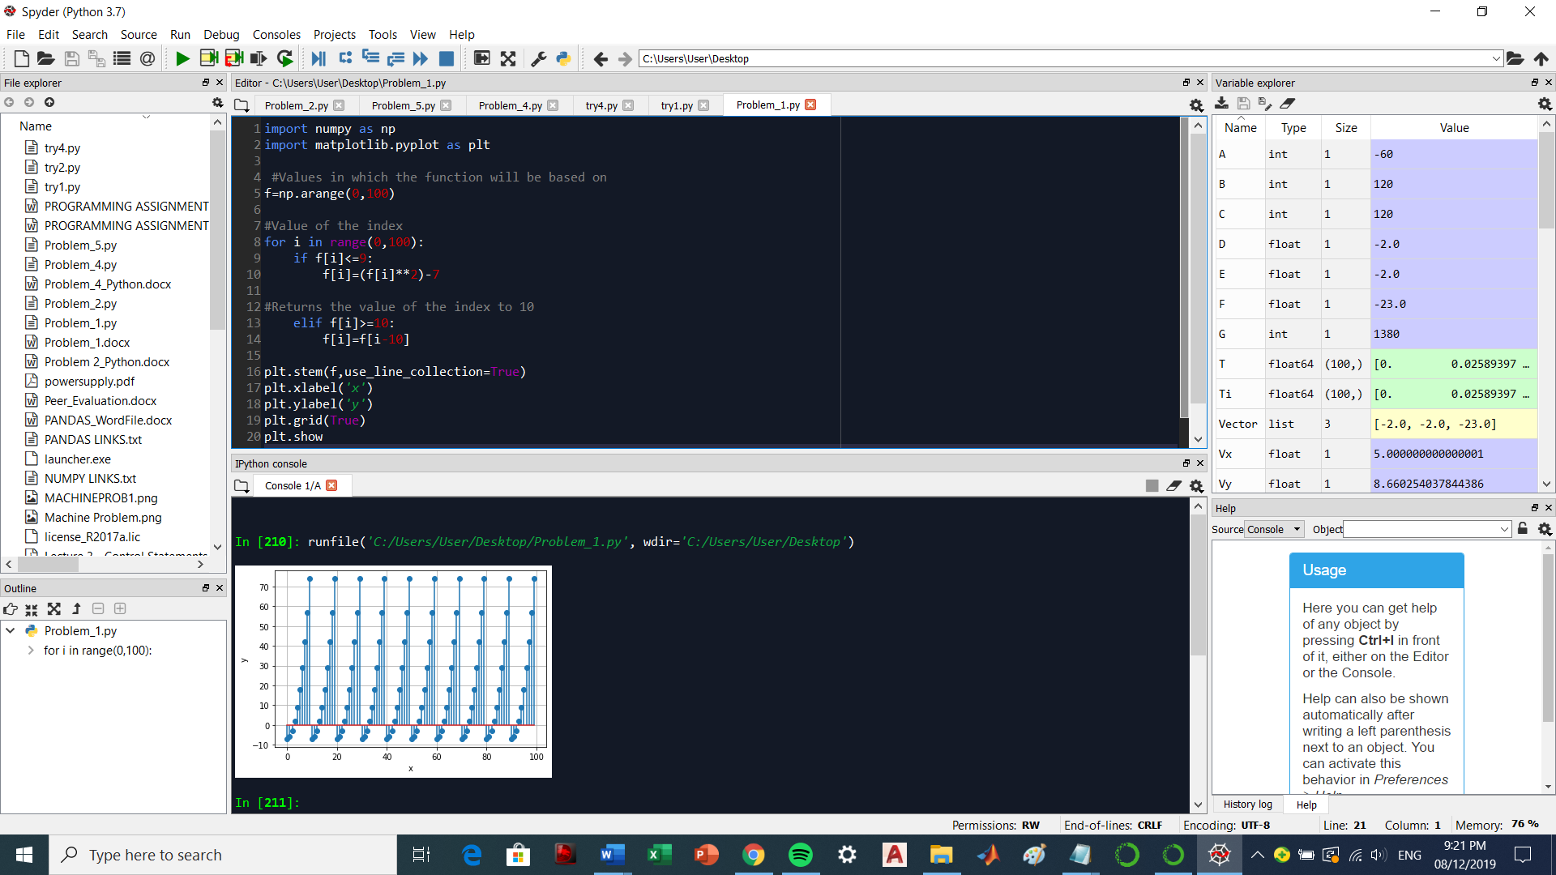

The graph of the given piecewise function will always return to 0 once it reaches the value of 10 because of the second condition in which we subtract 10 to the value of the independent variable. The graph seems to look like a repeating exponential graph, which starts from -7 until it reaches the 10th value in which it will return the value of the dependent variable to 0.