**Rabanes, Matthew Gabriel M.**

**Tenedero, Gerard Emilson G.**

**Problem 3:** Given a certain set of experimental points (𝑥𝑖 , 𝑦𝑖 ), regardless of how many, the program must be able to return the coefficients of the polynomial 𝑓(𝑥) that would best approximate the data according to the least-norm error vector 𝑒(𝑥) in Experiment 4, i.e.

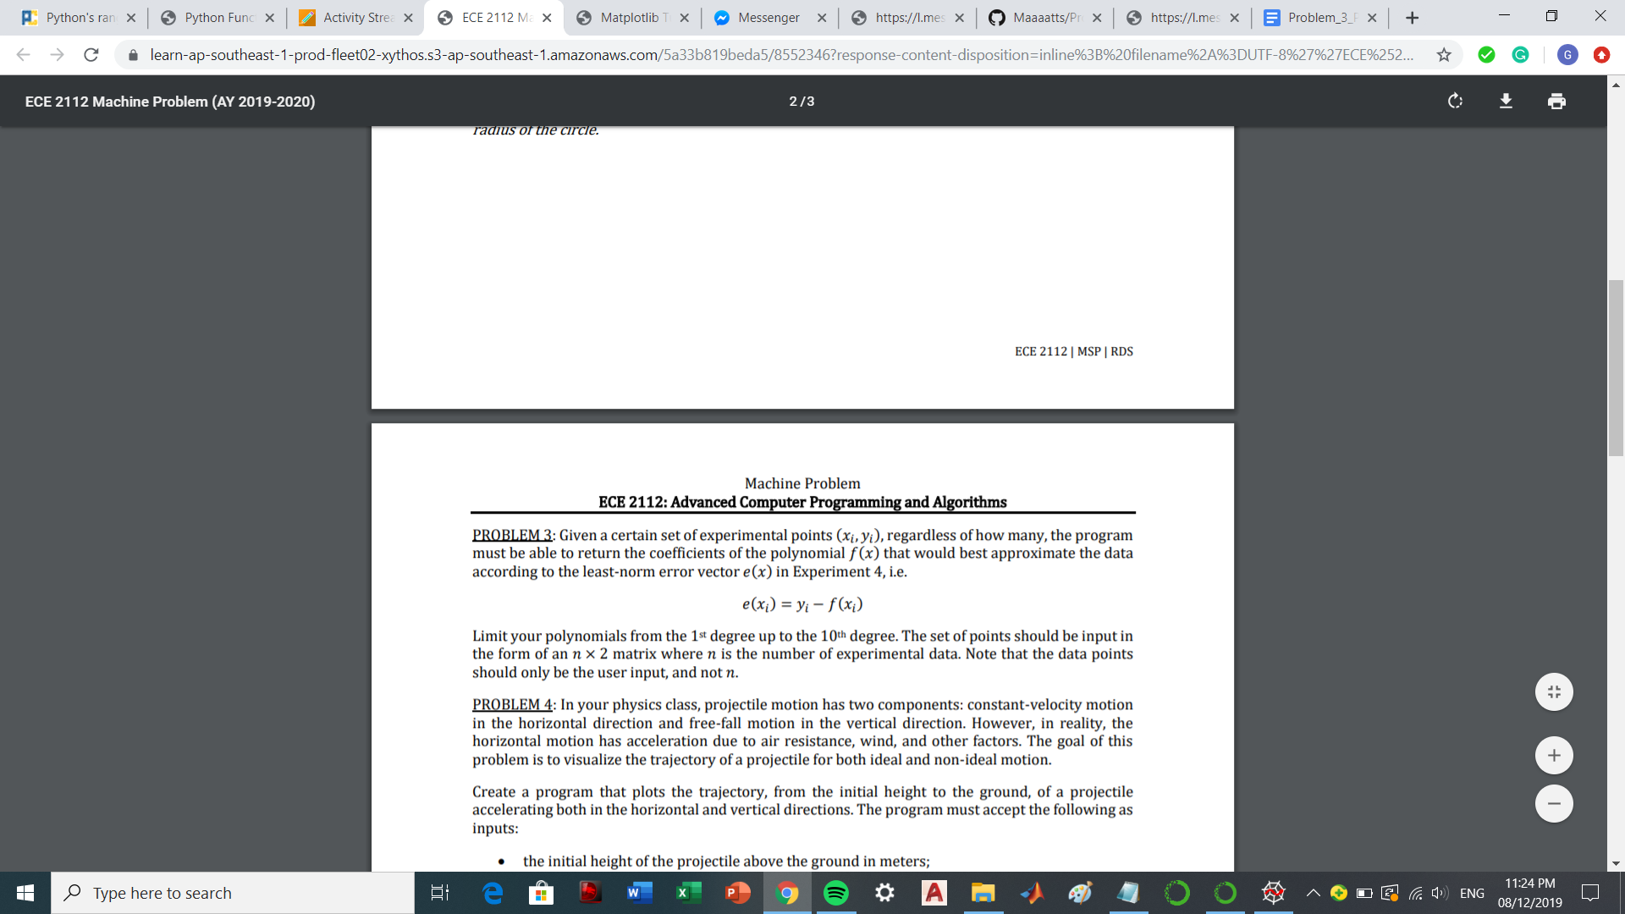

Limit your polynomials from the 1st degree up to the 10th degree. The set of points should be input in the form of a 𝑛 × 2 matrix where 𝑛 is the number of experimental data. Note that the data points should only be the user input and not 𝑛.

**Code Screenshot:**

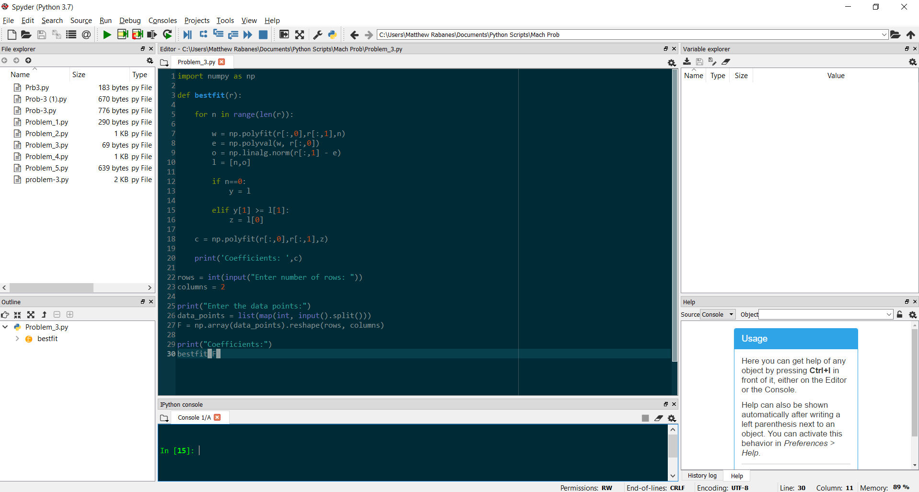

**Sample:**

Testing for data points

[ 2 -4; 3 -6; -3 2; 1 -5; -4 -2; 6 10; -1 -4; 5 2; -2 1; 8 -7 ]

