**Rabanes, Matthew Gabriel M.**

**Tenedero, Gerard Emilson G.**

**Problem 4**: In your physics class, the projectile motion has two components: constant-velocity motion in the horizontal direction and free-fall motion in the vertical direction. However, in reality, the horizontal motion has acceleration due to air resistance, wind, and other factors. The goal of this problem is to visualize the trajectory of a projectile for both ideal and non-ideal motion.

Create a program that plots the trajectory, from the initial height to the ground, of a projectile accelerating both in the horizontal and vertical directions. The program must accept the following as inputs:

* the initial height of the projectile above the ground in meters;
* the magnitude of the velocity in m/s;
* the angle in degrees with respect to the +𝑥-axis at which the projectile is fired;
* the 𝑥-component of the acceleration, considering the sign, in m s 2 ⁄ ;
* the 𝑦-component of the acceleration, considering the sign, in m s 2 ⁄ ;

**Code Screenshots:**

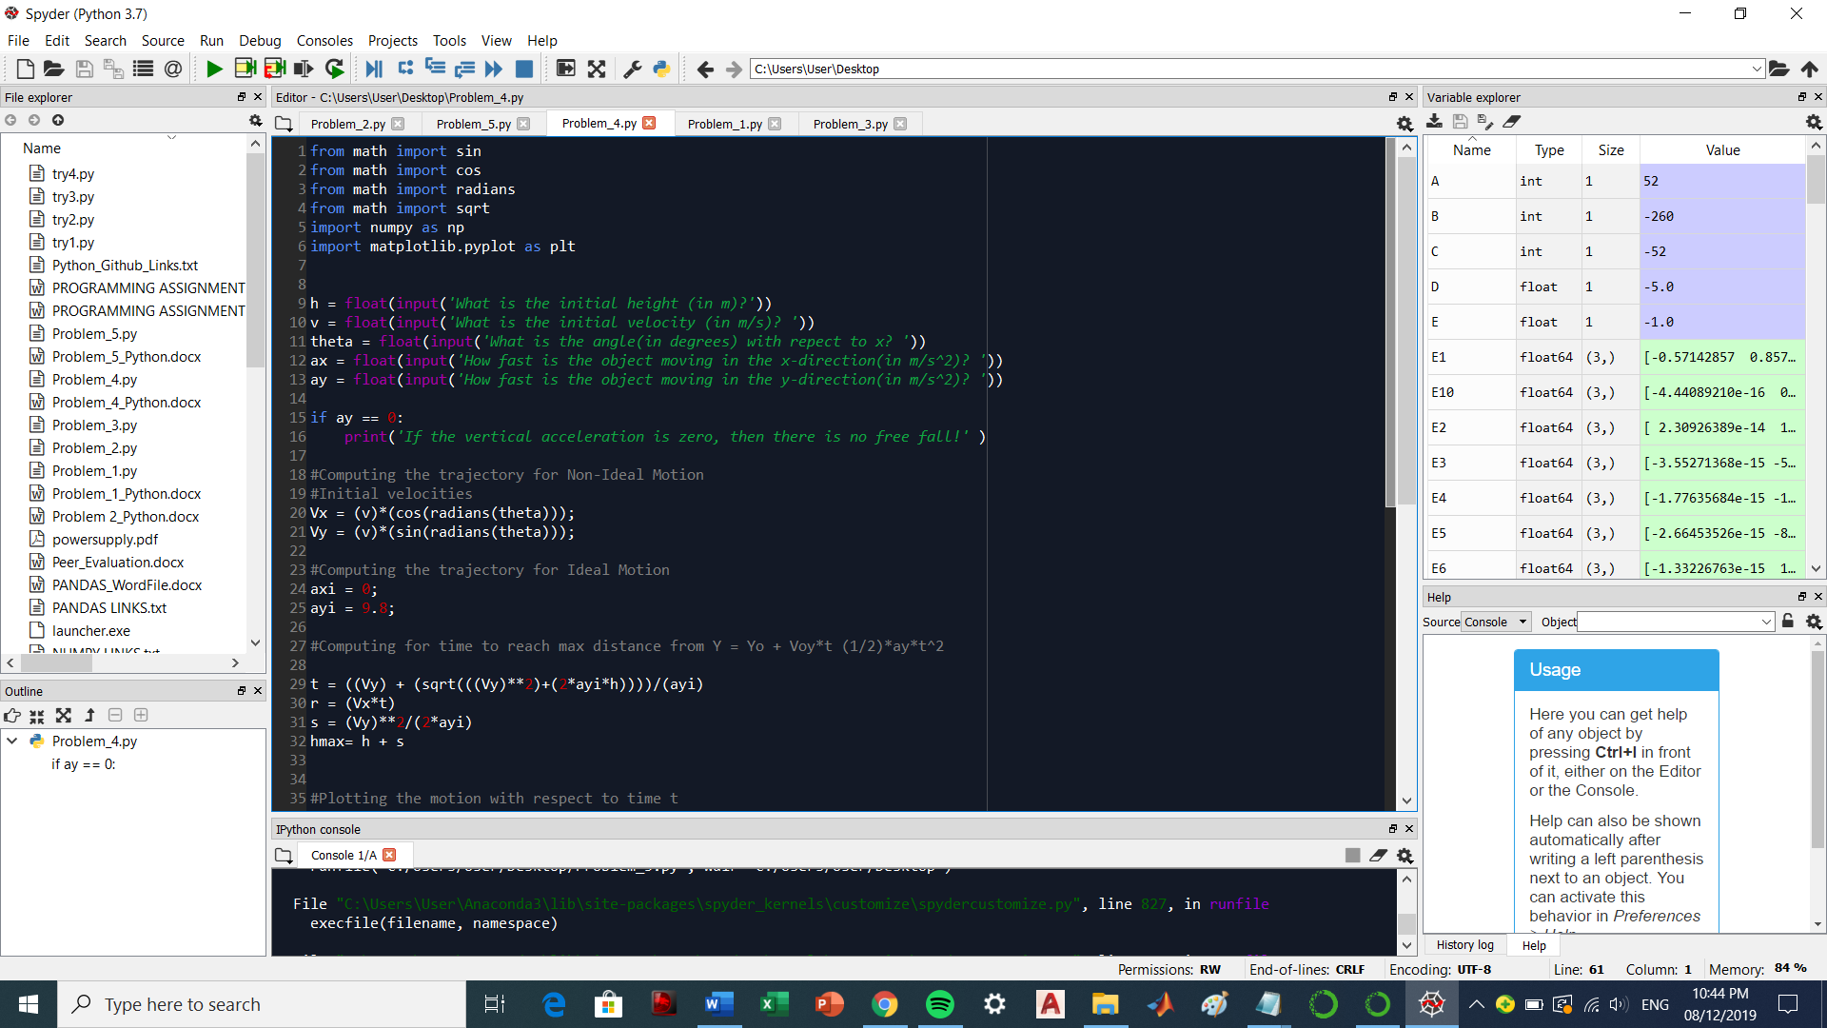

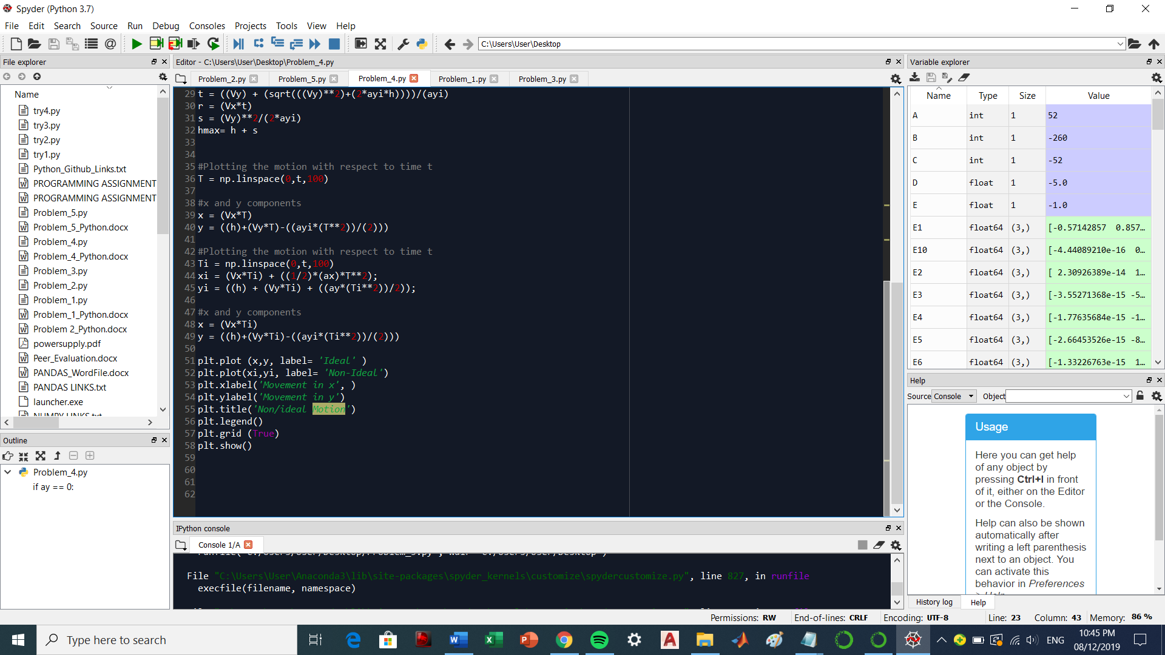

**Sample:**

Values inputted are 10,10,60, 10 , -10

