**Rabanes, Matthew Gabriel M.**

**Tenedero, Gerard Emilson G.**

**Problem 5:** For n = 0:199, given the user-input 𝑥(𝑛), determine 𝑦(𝑛) if

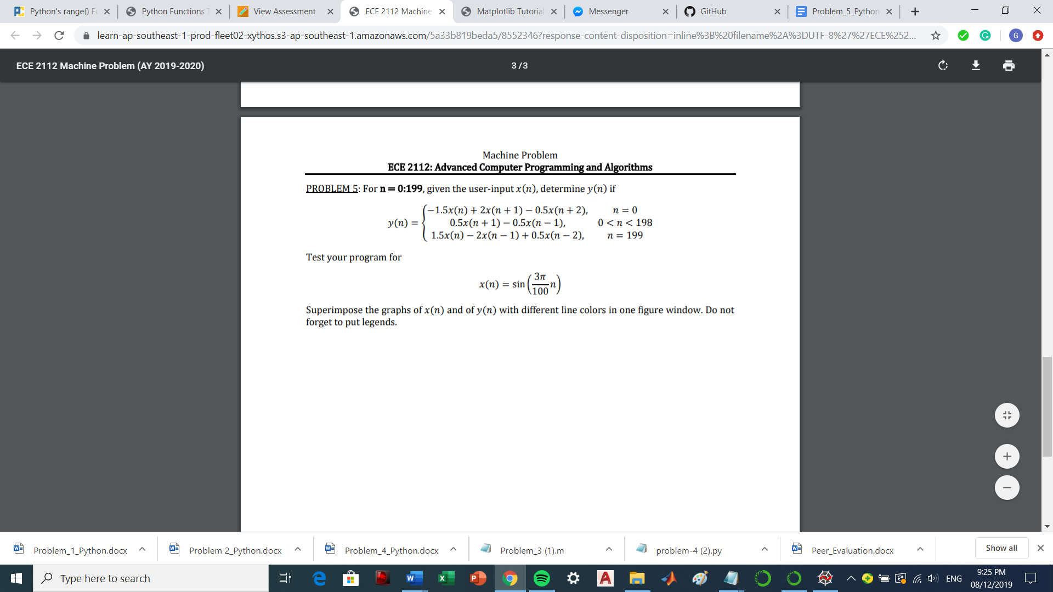

Test your program for

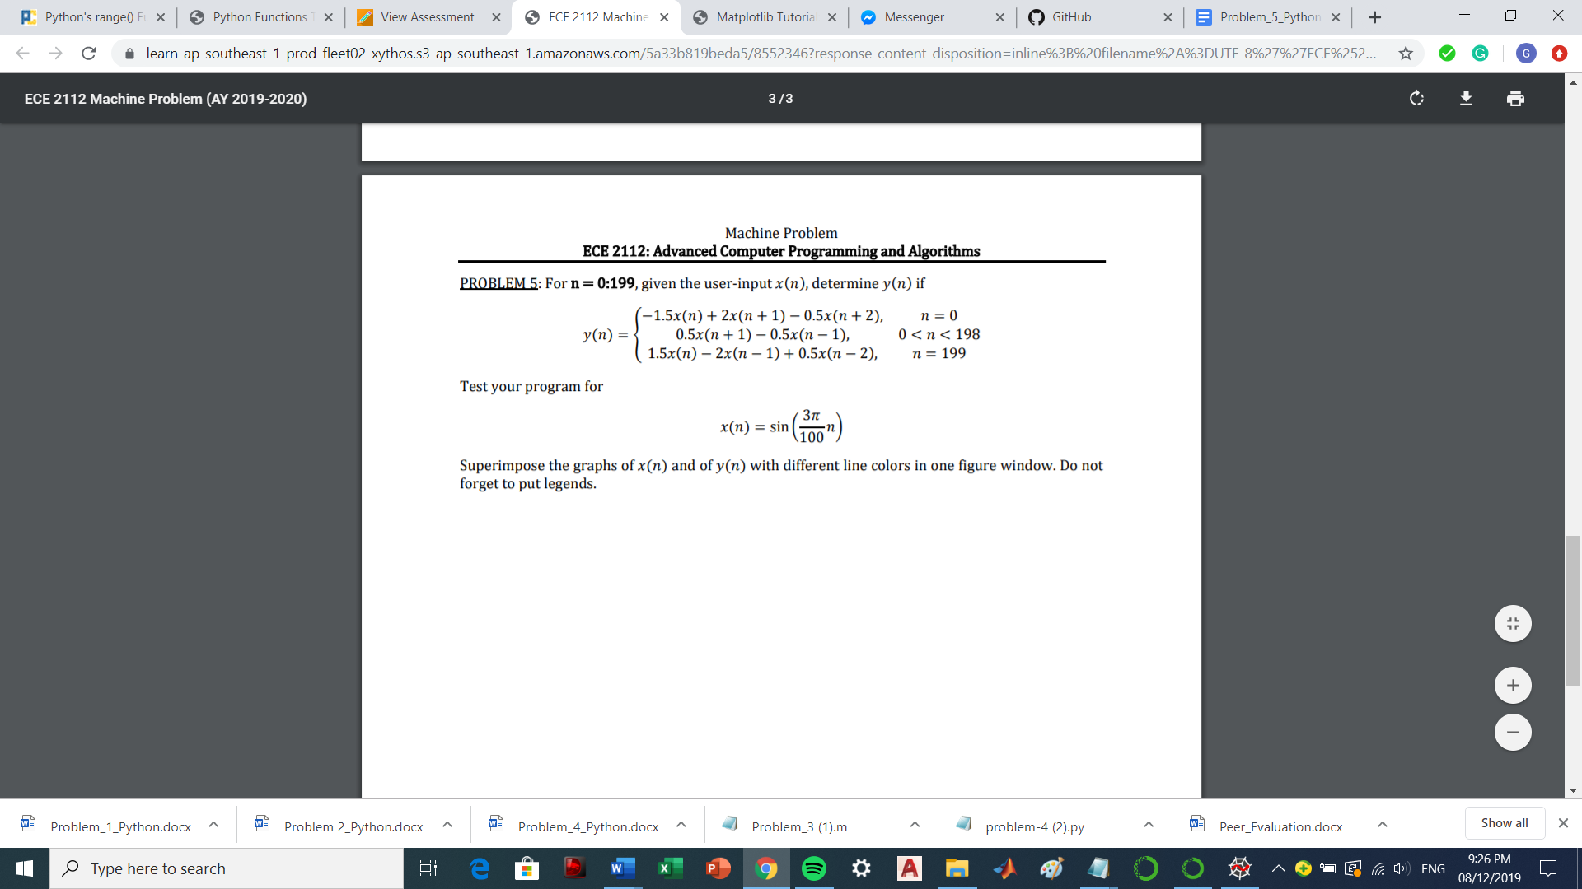

**Code Screenshot:**

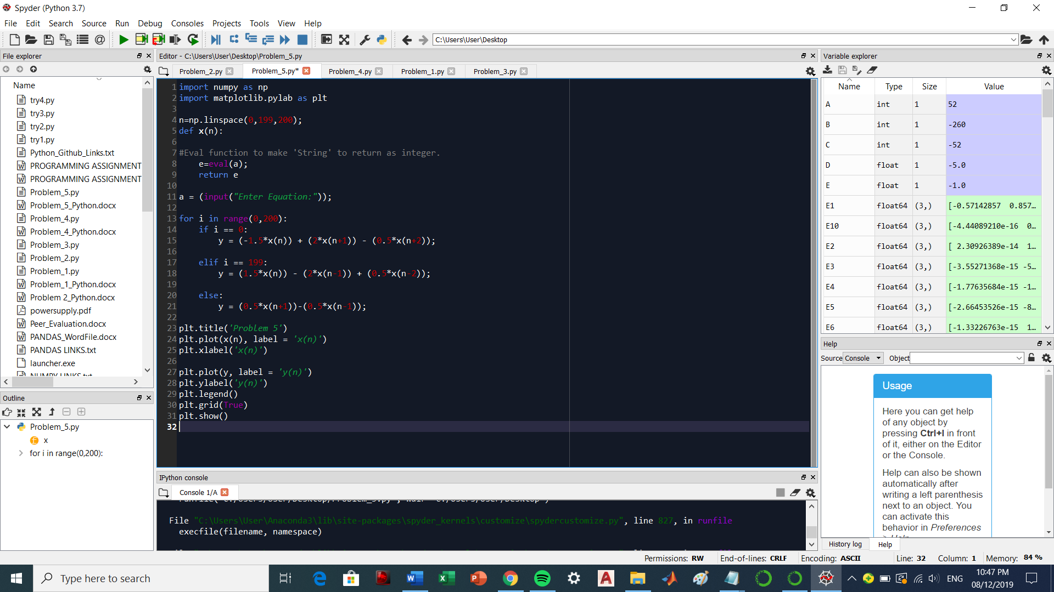

**Sample:**  
To test the program input this code in the console: np.sin(np.pi*3*n/100)

