LCD booster pack is designed to simplify the physical connection in interfacing an LCD to MSP430 Launch. The LCD booster pack is compatible for 16x2 parallel LCD. All power and control pins necessary to connect it to the launchpad are achieved with long wire-wrap headers which extend through the shield. The LCD makes use of 6 IO pins, so we can make use of remaining pins for other purposes.

Pin diagram:

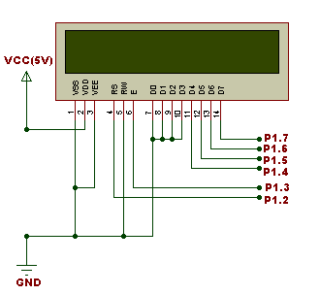

**Demo application:**

**Demo code:**

**Source code:**

**#include** <msp430g2231.h>

**#include** "lcd.h"

**int** main(**void**)

{

WDTCTL = 0x5A80;

**int** o; // Stop the Watchdog timer

**for**(o=0; o<0xEF; o++)

delay(145); // Startup delay

init_lcm();

clr_lcm(); // Clear the disp[32] buffer

putstr("16x2 LCD SHIELD");

lcm_line2();

putstr("BY TENET");

P1DIR |= 0xFF; // Set P1.0 as o/p

**while**(1)

{ // Dodo code that generates LED viewable PWM on P1.0

// ;)

P1OUT &= 0xFE;

**char** j;

**char** i =0;

**for**(i=0; i<0xFF; i++)

{

**for**(j =0; j<=i; j++)

{

P1OUT |= 0x01;

delay(10);

}

**for**(j=i; j<0xFF; j++)

{

P1OUT &= 0xFE;

delay(10);

}

}

}

}

