CS1 Homework 1 (10 pts)

1. (2 pts) Check whether the argument is valid. To do this select atomic propositions, annotate them with letters, write premises and conclusion in logical forms, and use the truth tables.
2. Either sales will go up and the boss will be happy, or expenses will go up and the boss won’t be happy.

Therefore, sales and expenses will not go both up.

S: Sales will go up

E: Expenses will go up

B: The boss will be happy

﹁B: the boss won’t be happy

Premises:

(S∧B)∨(E∧﹁B)

Conclusion:

﹁(S∧E)

Truth Table:

S E B (S∧B) (E∧﹁B) (S∧B)∨(E∧﹁B) ﹁(S∧E)

T T T T F T F

T T F F T T F

T F T T F T T

T F F F F F T

F T T F F F T

F T F F T T T

F F T F F F T

F F F F F F T

Invalid

1. x>0 or y>0

y>0 or z>0

Therefore, x>0 or z>0.

X: x>0

Y: y>0

Z: z>0

Premises:

X∨Y

Y∨Z

Conclusion:

X∨Z

Truth Table:

X Y Z X∨Y Y∨Z X∨Z

T T T T T T

T T F T T T

T F T T T T

T F F T F T

F T T T T T

F T F T T F

F F T F T T

F F F F F F

Invalid

1. (1 pt) Prove the first distributive law for logical statements:

$$P∧\left(Q V R\right)≡\left(P∧Q\right)V(P∧R)$$

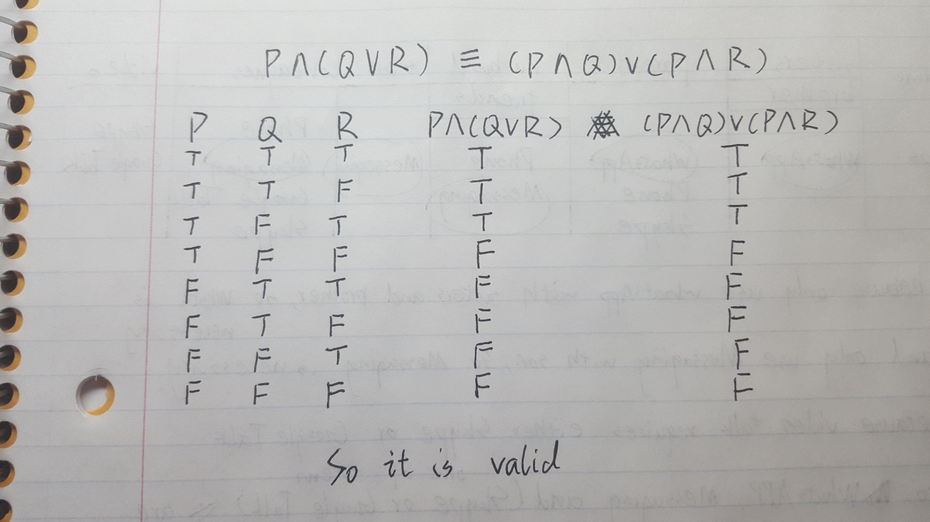

1. (1 pt) Simplify (shorten as much as you can) the logical statement, indicating which equivalency laws are you using.

$¬(¬P∧Q)V(P∧¬R)$

¬(¬P∧Q)V(P∧¬R) ≡ (P V ¬Q) V(P∧¬R) De Morgan’s Laws

(P V ¬Q) V(P∧¬R) ≡ ¬Q V P V (P∧¬R) Associative Laws

¬Q V P V (P∧¬R) ≡ ¬Q V P Absorption Laws

1. (2 pts) Check whether the argument is valid using Euler diagrams.
2. The year is divisible by 100, so it is not a leap year.

(Hint: make circles corresponding to sets: years divisible by 4, years divisible by 100, years divisible by 400. Remember the logical statement (from the lecture) describing a leap year.)

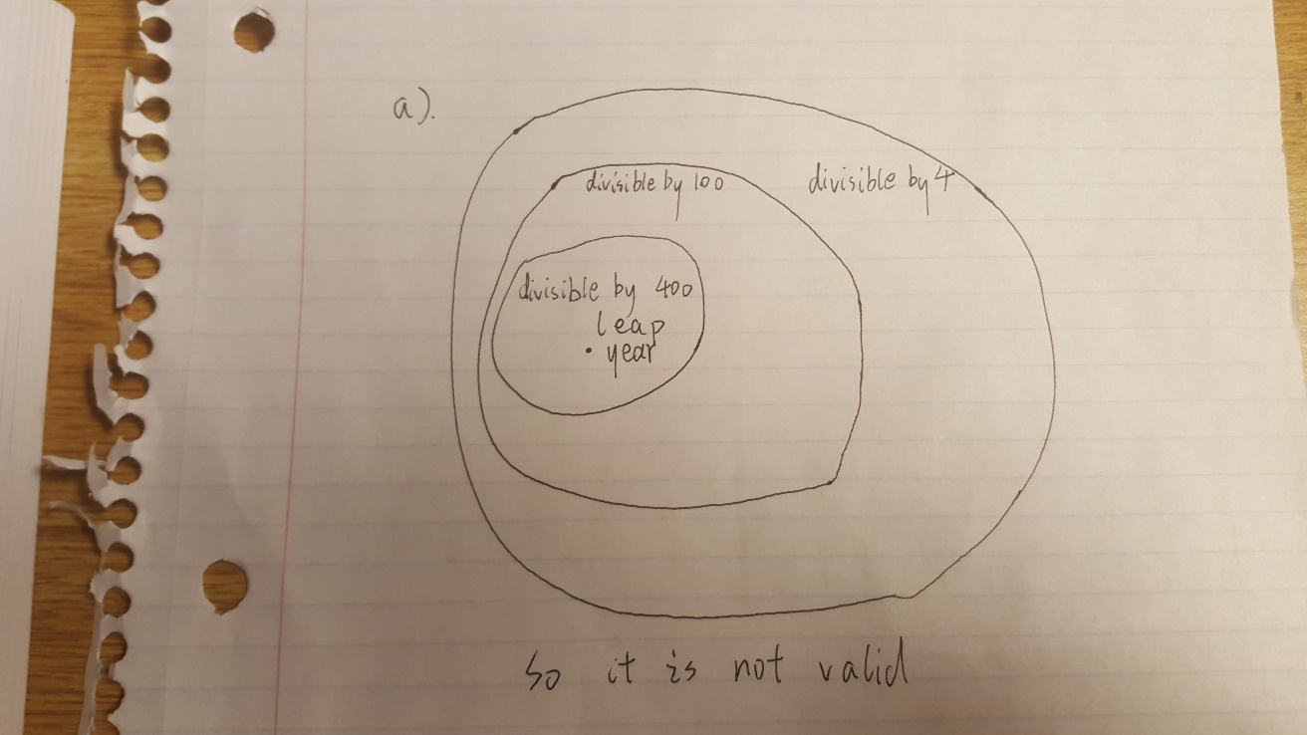

1. Everyone who is good at programming knows mathematics. You know math, so you are good at programming.

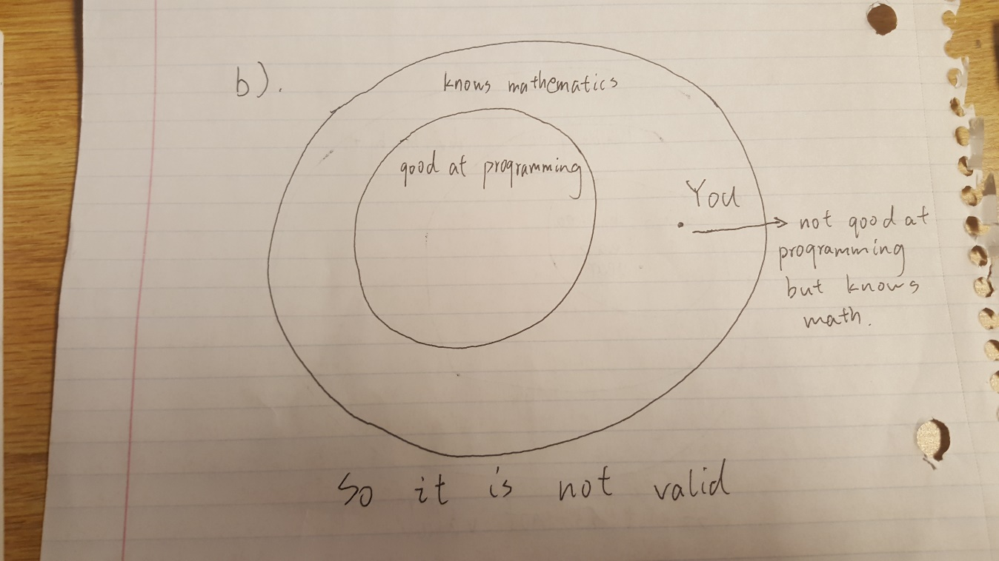

1. (4 pts) Negate the following statements.
2. All students that are good at math are also good at programming.

Exist a student that are good at math but not good at programming.

1. Some people always tell the truth.

Every people not always tell the truth.

$∀C∃x f\left(x\right)>C.$

∃C∀x f(x)<=C.

1. Nobody is perfect.

Somebody is perfect.

1. (3 points) I need help figuring out which apps should I install on my (Android) smartphone. My restrictions are the following: I have only limited amount of space, while I need to communicate with my sisters and brother using just WhatsApp, with my parents using either WhatsApp, Phone, or Skype, with my husband and friends using Phone or Messaging, with my son using just Messaging, and with my colleagues that use either Phone, Messaging, Google Talk, or Skype. Moreover, occasionally I need to do a video talk with colleagues, which is not supported by WhatsApp, Phone, and Messaging, but is supported by Google Talk or Skype. Which apps do I absolutely need to have on my smartphone? Please use set diagrams to answer this question. Which set diagrams do you need to use: Venn or Euler?

