Programming

(a)

1. Optimization Problem
   1. From basic form, we have the Lagrange function Screen Shot 2023-04-09 at 10.47.32 PM,
   2. Stationarity: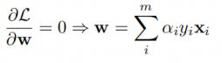 and 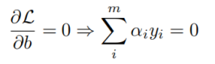
   3. Feasibility:Screen Shot 2023-04-09 at 10.49.57 PM
   4. Complementary slackness:Screen Shot 2023-04-09 at 10.51.09 PM
   5. we get the dual problem and replace all stationary conditions:Screen Shot 2023-04-09 at 10.52.38 PMScreen Shot 2023-04-09 at 10.53.08 PM
   6. calculate w and b using the optimal solutionScreen Shot 2023-04-09 at 10.55.25 PM,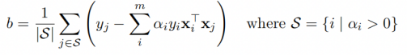
2. result:

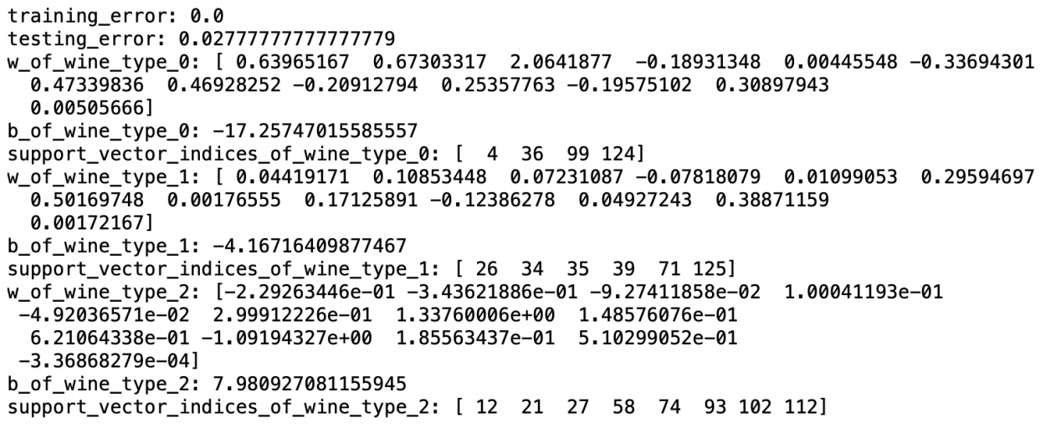

(b)

1. Optimization Problem
   1. 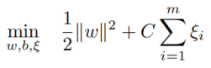 Screen Shot 2023-04-09 at 11.12.55 PMScreen Shot 2023-04-09 at 11.13.15 PM
   2. Lagrange function: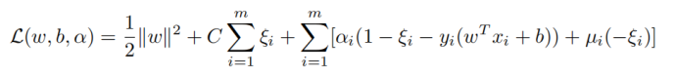whereScreen Shot 2023-04-09 at 11.15.19 PM
   3. stationarity: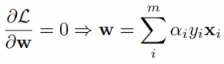,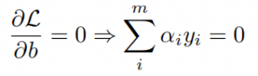,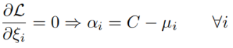
   4. feasibility:Screen Shot 2023-04-09 at 11.17.21 PM
   5. complementary slackness:Screen Shot 2023-04-09 at 11.18.18 PM
   6. by above equations, we get: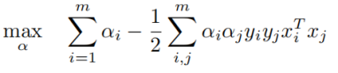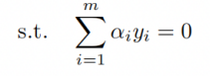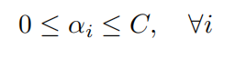
   7. w and b: 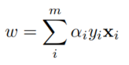,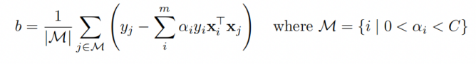
2. result

if C = 0.1

training_error: 0.024193548387096753

testing_error: 0.03703703703703709

w_of_wine_type_0: [ 0.31780258 0.46333307 0.19600666 -0.1289372 -0.00784464 0.09288631

0.11118361 0.01299479 -0.08894368 0.36526926 -0.07445056 0.17801977

0.00512369]

b_of_wine_type_0: -8.702745624377638

support_vector_indices_of_wine_type_0: [ 18 43 68 106 116 117]

number_of_slack_variable_of_wine_type_0: 39

w_of_wine_type_1: [-0.00708274 0.07949818 0.07843626 -0.04683579 0.00351802 0.20616001

0.37579988 -0.01044131 0.12928718 -0.11749999 0.05679649 0.32644161

0.00302703]

b_of_wine_type_1: -3.5746931208668187

support_vector_indices_of_wine_type_1: [ 8 11 13 16 17 21 47 53 72 104 107 114]

number_of_slack_variable_of_wine_type_1: 77

w_of_wine_type_2: [-0.08487372 -0.29295446 -0.10102865 -0.03953776 -0.00253163 0.07631926

0.45465227 -0.03370602 0.12052404 -0.60369919 0.0893062 0.22714005

-0.00146847]

b_of_wine_type_2: 5.1633090824552506

support_vector_indices_of_wine_type_2: [ 3 9 50 56 75 84 94 112]

number_of_slack_variable_of_wine_type_2: 50

if C = 0.2

training_error: 0.016129032258064502

testing_error: 0.03703703703703709

w_of_wine_type_0: [ 0.3119302 0.49548314 0.23396967 -0.132782 -0.00749298 0.12103827

0.15741617 0.03194166 -0.10723996 0.35452434 -0.09896029 0.14769604

0.00517536]

b_of_wine_type_0: -8.775883291890398

support_vector_indices_of_wine_type_0: [ 18 43 68 106 117]

number_of_slack_variable_of_wine_type_0: 35

w_of_wine_type_1: [ 1.68234971e-02 1.18946416e-01 7.91512469e-02 -7.37104833e-02

1.24840480e-02 2.87091806e-01 4.90470774e-01 1.94710974e-04

1.61058517e-01 -7.36290129e-02 5.47327016e-02 3.97290762e-01

1.73546784e-03]

b_of_wine_type_1: -4.301830989772964

support_vector_indices_of_wine_type_1: [ 8 11 16 17 21 47 53 72 107 114]

number_of_slack_variable_of_wine_type_1: 79

w_of_wine_type_2: [-0.12301814 -0.23566756 -0.08240382 -0.04330842 -0.01206244 0.08105994

0.5276736 0.00276846 0.16579102 -0.8305954 0.12611743 0.25133672

-0.00108722]

b_of_wine_type_2: 6.880851721089387

support_vector_indices_of_wine_type_2: [ 2 3 9 40 56 75 94 112]

number_of_slack_variable_of_wine_type_2: 44

if C = 0.3

training_error: 0.016129032258064502

testing_error: 0.01851851851851849

w_of_wine_type_0: [ 0.30804032 0.57205641 0.30013497 -0.14638295 -0.00438617 0.18116906

0.229077 0.04006673 -0.1794601 0.35053322 -0.11042658 0.16872574

0.00494689]

b_of_wine_type_0: -9.128417661087653

support_vector_indices_of_wine_type_0: [ 18 68 106]

number_of_slack_variable_of_wine_type_0: 31

w_of_wine_type_1: [ 1.68391388e-02 1.19689548e-01 7.94370884e-02 -7.65770600e-02

1.23664508e-02 2.89055319e-01 4.94061488e-01 1.10894479e-04

1.62174883e-01 -7.39410261e-02 5.49859618e-02 3.99967081e-01

1.76252096e-03]

b_of_wine_type_1: -4.265220743562575

support_vector_indices_of_wine_type_1: [ 8 11 16 17 21 47 53 107 114]

number_of_slack_variable_of_wine_type_1: 78

w_of_wine_type_2: [-1.53328135e-01 -3.22761792e-01 -9.85858832e-02 1.14183799e-02

-2.61691430e-02 1.66490897e-01 6.08977353e-01 2.34195390e-02

2.55872518e-01 -9.88409084e-01 1.92685568e-01 3.18248826e-01

-5.95473860e-04]

b_of_wine_type_2: 7.691454337946711

support_vector_indices_of_wine_type_2: [ 2 3 9 40 56 75 94 112]

number_of_slack_variable_of_wine_type_2: 39

if C = 0.4

training_error: 0.016129032258064502

testing_error: 0.01851851851851849

w_of_wine_type_0: [ 3.57243162e-01 5.90207037e-01 3.78414022e-01 -1.47537202e-01

2.86183880e-04 1.61204548e-01 2.13493638e-01 7.03854009e-02

-2.16449878e-01 4.27347775e-01 -1.27002291e-01 1.47309516e-01

4.96123975e-03]

b_of_wine_type_0: -10.612331642429297

support_vector_indices_of_wine_type_0: [ 18 68 106]

number_of_slack_variable_of_wine_type_0: 35

w_of_wine_type_1: [ 1.68391388e-02 1.19689548e-01 7.94370884e-02 -7.65770600e-02

1.23664508e-02 2.89055319e-01 4.94061488e-01 1.10894479e-04

1.62174883e-01 -7.39410261e-02 5.49859618e-02 3.99967081e-01

1.76252096e-03]

b_of_wine_type_1: -4.265220743562575

support_vector_indices_of_wine_type_1: [ 8 11 16 17 21 53 107 114]

number_of_slack_variable_of_wine_type_1: 78

w_of_wine_type_2: [-1.83230978e-01 -3.07635191e-01 -9.10515665e-02 3.45624309e-02

-3.02377121e-02 3.15785891e-01 6.89670275e-01 5.38043742e-02

3.43727917e-01 -9.98964129e-01 2.15646182e-01 3.86882362e-01

-4.75519122e-04]

b_of_wine_type_2: 7.360435194794495

support_vector_indices_of_wine_type_2: [ 2 3 9 40 56 75 94 112]

number_of_slack_variable_of_wine_type_2: 31

if C = 0.5

training_error: 0.008064516129032251

testing_error: 0.01851851851851849

w_of_wine_type_0: [ 0.38278408 0.62030645 0.46656202 -0.14868433 0.00225128 0.13063458

0.19177645 0.09856444 -0.23396638 0.4574861 -0.14199567 0.13526616

0.00520143]

b_of_wine_type_0: -11.542658809249613

support_vector_indices_of_wine_type_0: [ 18 41 68 106]

number_of_slack_variable_of_wine_type_0: 35

w_of_wine_type_1: [ 1.68391388e-02 1.19689548e-01 7.94370884e-02 -7.65770600e-02

1.23664508e-02 2.89055319e-01 4.94061488e-01 1.10894479e-04

1.62174883e-01 -7.39410261e-02 5.49859618e-02 3.99967081e-01

1.76252096e-03]

b_of_wine_type_1: -4.265220743562575

support_vector_indices_of_wine_type_1: [ 8 11 16 17 21 53 107 114]

number_of_slack_variable_of_wine_type_1: 78

w_of_wine_type_2: [-1.89339427e-01 -2.96004132e-01 -4.50001086e-02 4.27061808e-02

-3.26511816e-02 3.94737009e-01 7.30508774e-01 8.57030611e-02

4.15286987e-01 -1.00662249e+00 2.38447362e-01 4.29168880e-01

-3.98897992e-04]

b_of_wine_type_2: 7.007567364295701

support_vector_indices_of_wine_type_2: [ 2 3 9 40 56 75 84 94 112]

number_of_slack_variable_of_wine_type_2: 28

if C = 0.6

training_error: 0.008064516129032251

testing_error: 0.01851851851851849

w_of_wine_type_0: [ 0.39261044 0.61265853 0.54233229 -0.15029922 0.00274726 0.11261475

0.20802282 0.1155824 -0.23793632 0.45174522 -0.14372429 0.14178792

0.00509501]

b_of_wine_type_0: -11.751631013385984

support_vector_indices_of_wine_type_0: [ 18 41 68 81 106]

number_of_slack_variable_of_wine_type_0: 36

w_of_wine_type_1: [ 1.68391388e-02 1.19689548e-01 7.94370884e-02 -7.65770600e-02

1.23664508e-02 2.89055319e-01 4.94061488e-01 1.10894479e-04

1.62174883e-01 -7.39410261e-02 5.49859618e-02 3.99967081e-01

1.76252096e-03]

b_of_wine_type_1: -4.265220743562575

support_vector_indices_of_wine_type_1: [ 8 16 17 21 53 107]

number_of_slack_variable_of_wine_type_1: 78

w_of_wine_type_2: [-1.90597104e-01 -3.09128723e-01 -3.38791777e-02 5.02332849e-02

-3.72816006e-02 4.16802014e-01 7.57652325e-01 1.10192991e-01

4.87648647e-01 -1.06020346e+00 2.14084397e-01 4.79767643e-01

-4.30213548e-04]

b_of_wine_type_2: 7.3731075335810425

support_vector_indices_of_wine_type_2: [ 2 3 9 40 56 75 84 94 112]

number_of_slack_variable_of_wine_type_2: 28

if C = 0.7

training_error: 0.008064516129032251

testing_error: 0.01851851851851849

w_of_wine_type_0: [ 0.40203582 0.61221937 0.60831136 -0.1513033 0.00279686 0.09204772

0.23661761 0.1314835 -0.23779759 0.43946813 -0.14178896 0.13278732

0.00506569]

b_of_wine_type_0: -11.93794155147734

support_vector_indices_of_wine_type_0: [ 18 68 81 106]

number_of_slack_variable_of_wine_type_0: 36

w_of_wine_type_1: [ 1.68391388e-02 1.19689548e-01 7.94370884e-02 -7.65770600e-02

1.23664508e-02 2.89055319e-01 4.94061488e-01 1.10894479e-04

1.62174883e-01 -7.39410261e-02 5.49859618e-02 3.99967081e-01

1.76252096e-03]

b_of_wine_type_1: -4.265220743562575

support_vector_indices_of_wine_type_1: [ 8 16 17 21 53 107]

number_of_slack_variable_of_wine_type_1: 78

w_of_wine_type_2: [-2.01333163e-01 -3.15028511e-01 -4.06264965e-02 5.90225555e-02

-3.96948625e-02 3.87101929e-01 8.76827418e-01 1.19242537e-01

5.09756241e-01 -1.06295386e+00 2.06314328e-01 4.98747351e-01

-3.86878377e-04]

b_of_wine_type_2: 7.505439090492528

support_vector_indices_of_wine_type_2: [ 2 3 9 40 56 75 84 94 112]

number_of_slack_variable_of_wine_type_2: 23

if C = 0.8

training_error: 0.008064516129032251

testing_error: 0.01851851851851849

w_of_wine_type_0: [ 0.40621999 0.61428146 0.68260029 -0.15261375 0.00279309 0.06902623

0.25096099 0.14881178 -0.2374554 0.42790529 -0.14315415 0.13559532

0.00507091]

b_of_wine_type_0: -12.090285059492206

support_vector_indices_of_wine_type_0: [ 18 68 81 106]

number_of_slack_variable_of_wine_type_0: 35

w_of_wine_type_1: [ 1.68391388e-02 1.19689548e-01 7.94370884e-02 -7.65770600e-02

1.23664508e-02 2.89055319e-01 4.94061488e-01 1.10894479e-04

1.62174883e-01 -7.39410261e-02 5.49859618e-02 3.99967081e-01

1.76252096e-03]

b_of_wine_type_1: -4.265220743562575

support_vector_indices_of_wine_type_1: [ 8 16 17 21 53 107]

number_of_slack_variable_of_wine_type_1: 78

w_of_wine_type_2: [-2.12281776e-01 -3.20423098e-01 -4.71610010e-02 6.75105337e-02

-4.19412817e-02 3.56576414e-01 9.96353283e-01 1.28281404e-01

5.29876082e-01 -1.06389942e+00 1.98191168e-01 5.16004035e-01

-3.46170365e-04]

b_of_wine_type_2: 7.628838304595769

support_vector_indices_of_wine_type_2: [ 2 3 9 40 56 75 84 94 112]

number_of_slack_variable_of_wine_type_2: 21

if C = 0.9

training_error: 0.008064516129032251

testing_error: 0.01851851851851849

w_of_wine_type_0: [ 0.41034883 0.61641119 0.75687163 -0.15392003 0.0027856 0.0460054

0.26530976 0.16613221 -0.23713964 0.41620586 -0.14450432 0.13838364

0.0050763 ]

b_of_wine_type_0: -12.241209595229506

support_vector_indices_of_wine_type_0: [ 18 68 81 106]

number_of_slack_variable_of_wine_type_0: 35

w_of_wine_type_1: [ 1.68391388e-02 1.19689548e-01 7.94370884e-02 -7.65770600e-02

1.23664508e-02 2.89055319e-01 4.94061488e-01 1.10894479e-04

1.62174883e-01 -7.39410261e-02 5.49859618e-02 3.99967081e-01

1.76252096e-03]

b_of_wine_type_1: -4.265220743562575

support_vector_indices_of_wine_type_1: [ 8 16 17 21 53 107]

number_of_slack_variable_of_wine_type_1: 78

w_of_wine_type_2: [-2.23041106e-01 -3.25886636e-01 -5.38290106e-02 7.60474605e-02

-4.42138178e-02 3.26061261e-01 1.11590454e+00 1.37289411e-01

5.50180761e-01 -1.06509542e+00 1.90107340e-01 5.33021050e-01

-3.05593092e-04]

b_of_wine_type_2: 7.7533370130956145

support_vector_indices_of_wine_type_2: [ 2 3 9 40 56 75 84 94 112]

number_of_slack_variable_of_wine_type_2: 18

if C = 1.0

training_error: 0.008064516129032251

testing_error: 0.01851851851851849

w_of_wine_type_0: [ 0.41447743 0.61854224 0.83114279 -0.15522428 0.00277819 0.02298327

0.2796578 0.18345294 -0.23682282 0.40450718 -0.1458546 0.14117062

0.00508172]

b_of_wine_type_0: -12.392211420443639

support_vector_indices_of_wine_type_0: [ 18 68 81 106]

number_of_slack_variable_of_wine_type_0: 34

w_of_wine_type_1: [ 1.68391388e-02 1.19689548e-01 7.94370884e-02 -7.65770600e-02

1.23664508e-02 2.89055319e-01 4.94061488e-01 1.10894479e-04

1.62174883e-01 -7.39410261e-02 5.49859618e-02 3.99967081e-01

1.76252096e-03]

b_of_wine_type_1: -4.265220743562575

support_vector_indices_of_wine_type_1: [ 8 16 17 21 53 107]

number_of_slack_variable_of_wine_type_1: 78

w_of_wine_type_2: [-2.27262027e-01 -3.35530999e-01 -7.45347814e-02 8.92078289e-02

-4.69926089e-02 3.09840491e-01 1.24112524e+00 1.43924882e-01

5.88702441e-01 -1.07904077e+00 1.87032479e-01 5.22874883e-01

-3.18311321e-04]

b_of_wine_type_2: 7.882122412125398

support_vector_indices_of_wine_type_2: [ 2 3 9 40 56 75 84 94]

number_of_slack_variable_of_wine_type_2: 15

1. impact of parameter settings

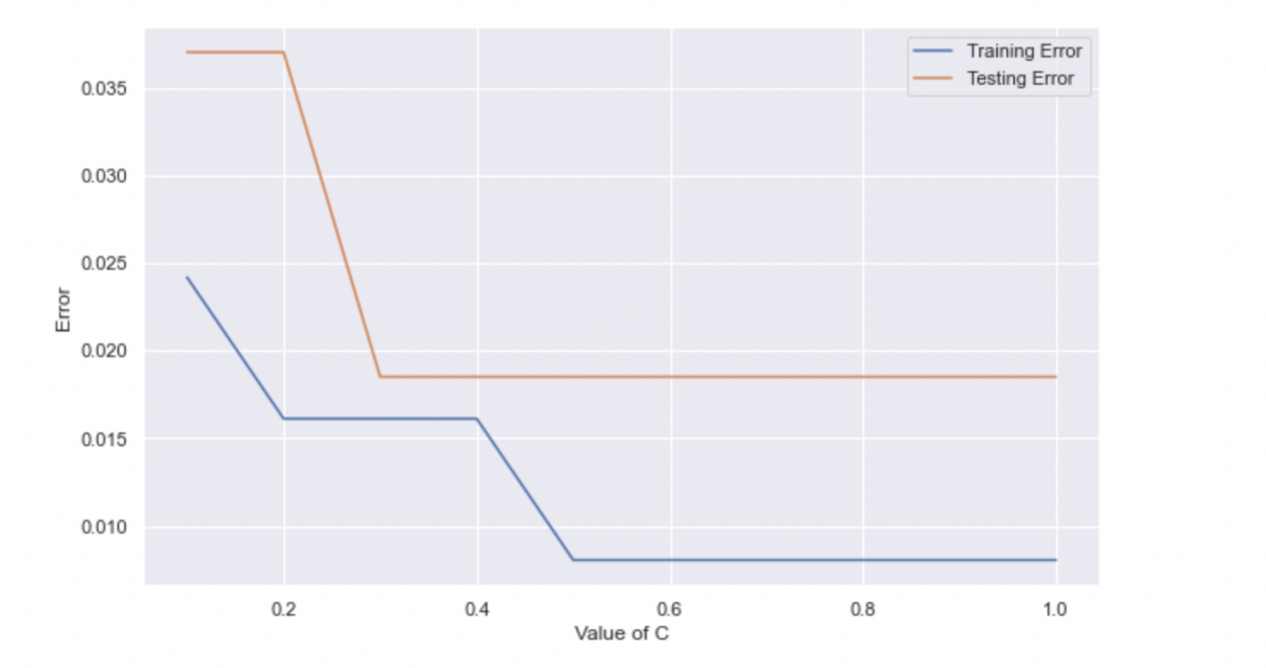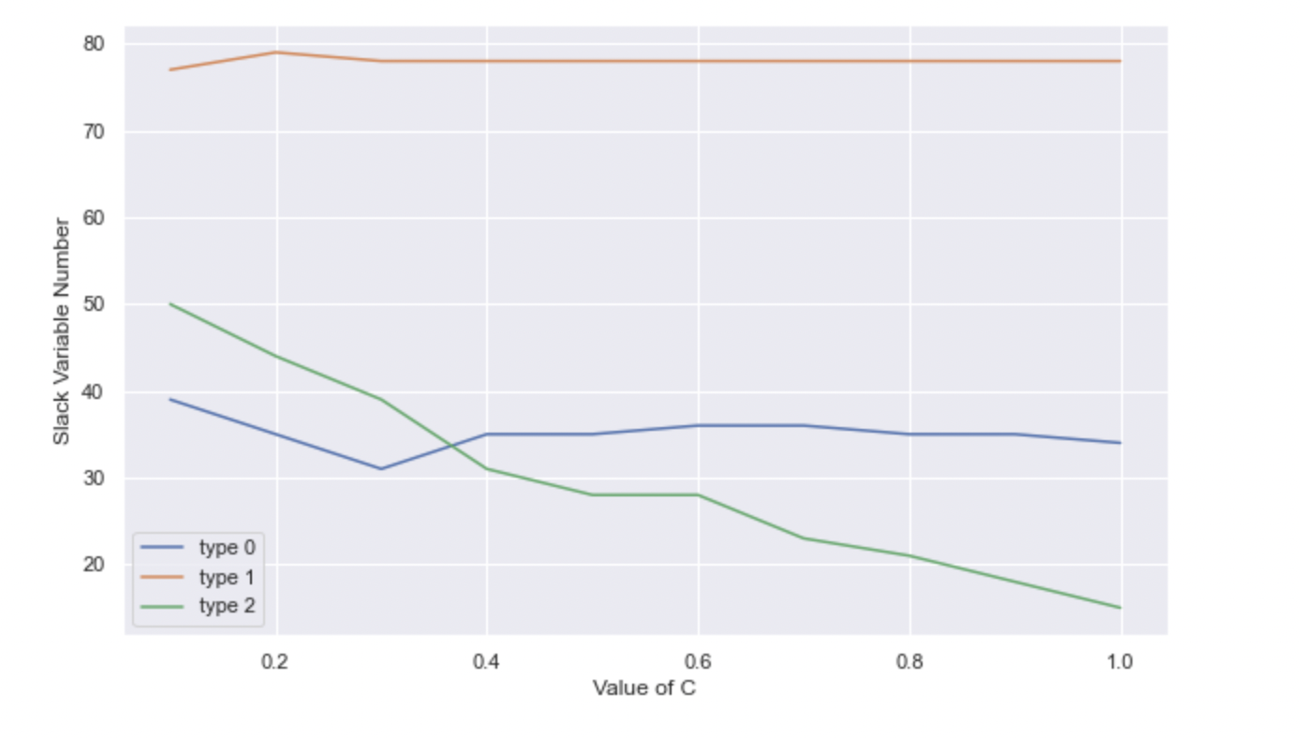

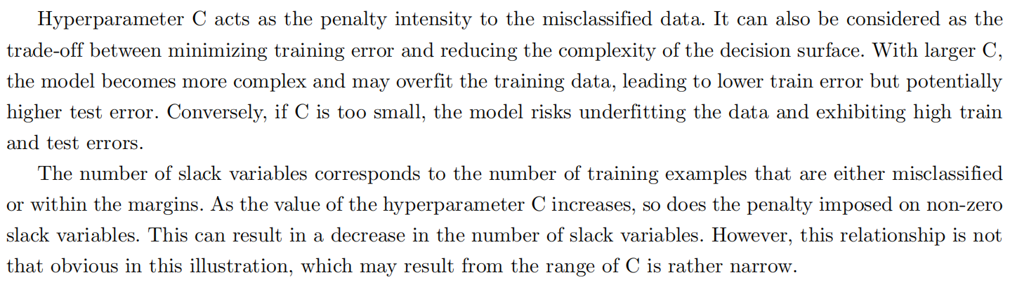

(c)

1. Optimization Problem

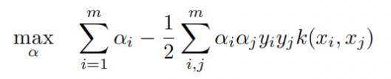

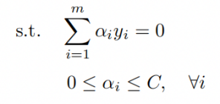

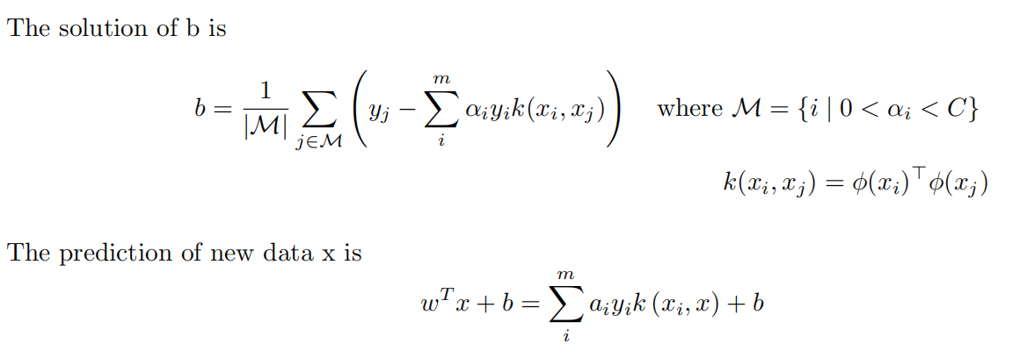

(1.1)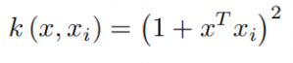

(1.2)result

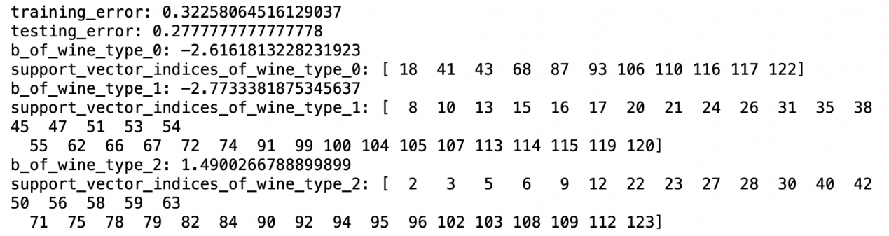

(2.1)

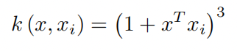

(2.2)result

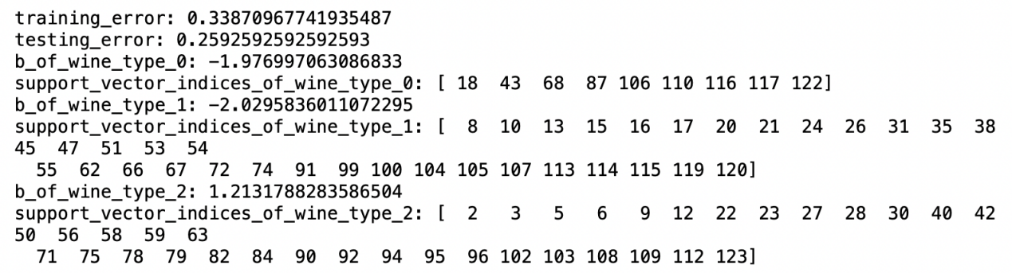

(3.1)Screen Shot 2023-04-09 at 11.40.30 PM

(3.2)result

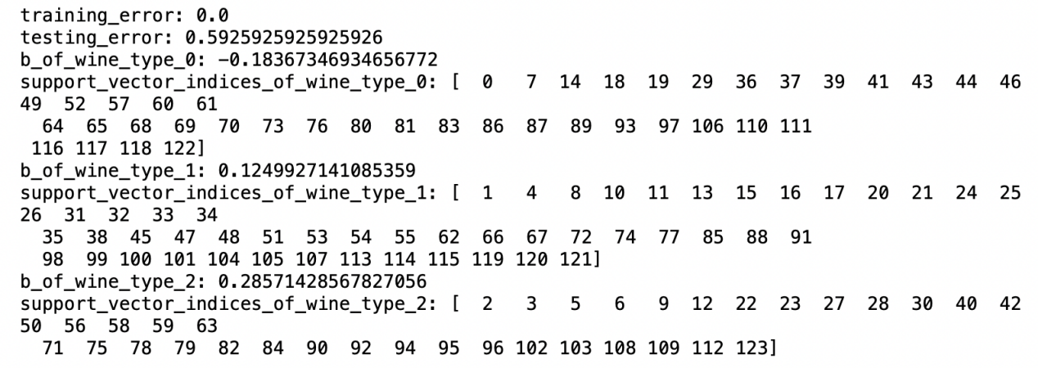

(4.1)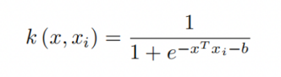

(4.2)result

