JMM：java内存模型

指令重排，内存屏障

<https://www.cnblogs.com/chenyangyao/p/5269622.html>

<http://ifeve.com/jmm-cookbook-reorderings/>

需要明白**jvm内存模型**和java内存模型（jmm）

concurrentHashmap1.7 +内存模型

<https://www.ibm.com/developerworks/cn/java/java-lo-concurrenthashmap/index.html>

Java对象结构

<https://blog.csdn.net/zqz_zqz/article/details/70246212>

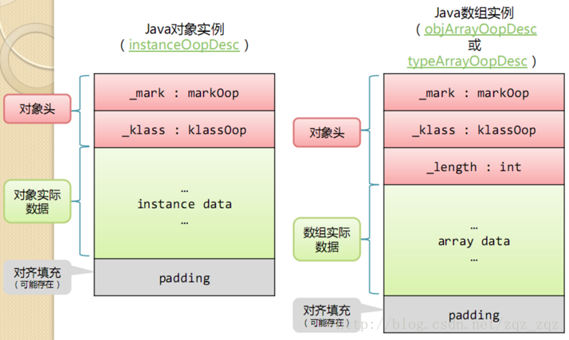

Longadder源代码阅读

<https://blog.csdn.net/zqz_zqz/article/details/70665941>

类的加载机制

<http://www.cnblogs.com/ityouknow/p/5603287.html>

字节码学习：<https://www.cnblogs.com/onlywujun/p/3523991.html>

Java反射机制译文

<http://ifeve.com/java-reflection/>

技术点汇总：<https://blog.csdn.net/Amen_Wu/article/details/79522912>