HARP-VLA Upgraded Full Experiment Report
Runtime Instability Analysis and Selective Recovery for Vision-Language-Action Robotic Policies
面向 VLA 机器人策略的运行时不稳定性分析与选择性恢复
Updated on 23 June 2026
Prepared from all local experiment logs, generated figures, summary tables, research notes, five-step paper upgrade files, and 2026-06-23 consistency revision under D:/VLA_Recovery.

Executive Summary
- Current strongest evidence after 5-step upgrade: Task0 has 25 valid seed/init evaluations with 21/25 success, 13 zero-backup successes, and 4 effective recovery failures. Earlier seed1000/seed1001 achieved 10/10 success and is retained as initial tuned-controller evidence, not the final project-wide result.
- Calibration limitation: the fixed threshold is not yet robust under seed shift; held-out calibration exposes 0.000 recall on the seed1003/1004 held-out split under the conservative operating point. This motivates adaptive calibration or seed/object-relation-aware fallback routing.
- Task-scope limitation: task1/task2 clean smoke is a sanity check for base-policy execution, not a full recovery-generalization benchmark.
- Visual-state limitation: the visual/noisy-state estimator experiment is a non-oracle ablation and a replacement path for oracle object relation, not a completed visual closed-loop solution.
Current strongest evidence
The tuned controller reaches 10/10 success across seed1000 and seed1001 on LIBERO Spatial task0 init0-init4. It preserves 6/6 zero-backup natural-success rollouts and triggers immediate demo-only fallback only on the seed1001 init2 boundary case.

- Research direction: runtime instability analysis and selective recovery for VLA robotic policies.
- Core system: action-outcome monitor -> progress confirmation -> failure-state retrieval -> demo-anchored recovery.
- Core scientific claim: VLA failures are observable as runtime instability and require calibrated, failure-state-aware recovery.
- Primary application framing: reliability for learned generalist robot policies, with relevance to medical AI reliability and surgical embodied intelligence.
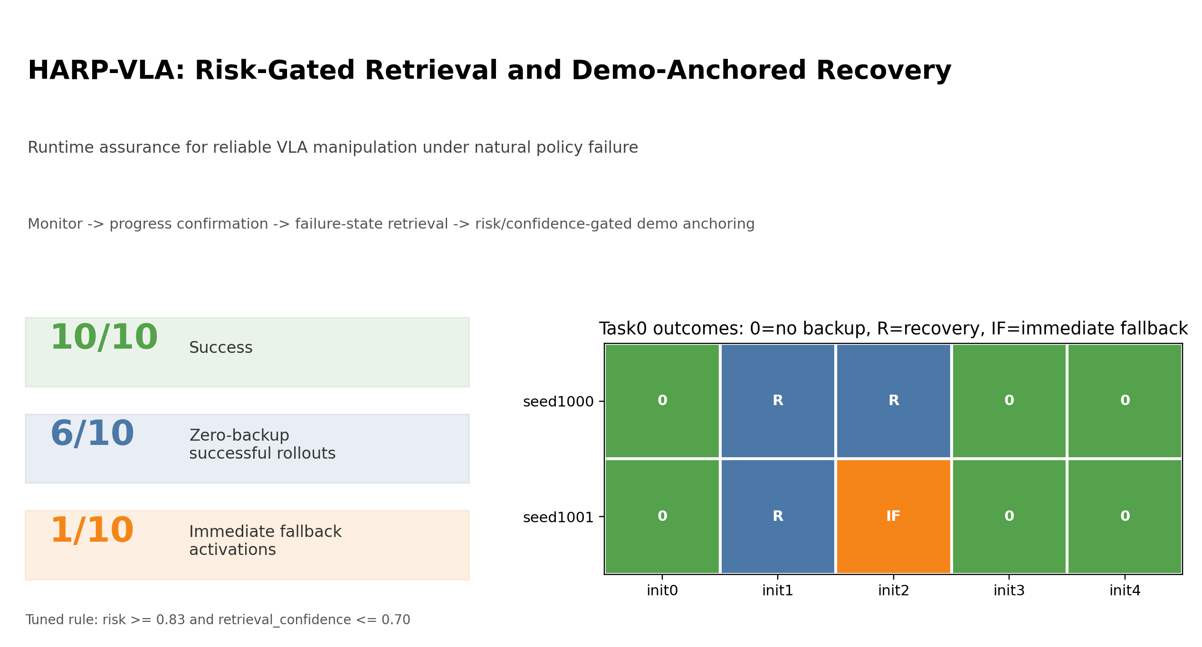
Figure. Application dashboard (results/paper_figures/application_dashboard.png)

Document Map
- Part A: Paper-style upgraded narrative and five-step thesis.
- Part B: Full experiment chronology and all major processes.
- Part C: All paper-facing figures and tables.
- Part D: Source narrative appendix preserving detailed notes.
- Part E: Artifact index for raw logs, videos, scripts, and datasets.

Part A - Upgraded Paper-Style Narrative

Runtime Instability Analysis and Selective Recovery for Vision-Language-Action Robotic Policies
中文题目：**面向 VLA 机器人策略的运行时不稳定性分析与选择性恢复**

Abstract
当前 Vision-Language-Action (VLA) 机器人策略在长时序闭环操作中并不是简单地“会做”或“不会做”。它们常常在部分初始状态、部分接触几何或部分恢复阶段中出现自然失败。更麻烦的是，失败并不总能靠一个统一 backup policy 修复；过早、过强或错误的恢复干预也可能破坏本来可以完成的轨迹。
本文把这个问题定义为 **runtime instability analysis and selective recovery**：首先用 action-outcome embedding geometry 分析 VLA 失败如何显现；然后用 progress confirmation 区分 risk observation 和 intervention commitment；再通过 failure-state retrieval 选择对应 recovery expert；最后用 demo-anchored recovery 和 calibrated fallback 控制恢复强度。截至 2026-06-23 五步升级后，当前最强证据为：LIBERO Spatial task0 上 25 个有效 seed/init 评估达到 21/25 success、13 条 zero-backup success，并暴露 4 个有效 recovery failure。早期 seed1000/seed1001 的 10/10 success 保留为 initial tuned-controller evidence，而不再作为最终项目统计口径。

1. Introduction
VLA / robot foundation policy 的可靠性问题不完全等同于传统控制安全。传统 safety robotics 常研究 constraint satisfaction、shielding、control barrier function 或 formal verification；而这里的问题是 learned generalist robot policy 在语义强、泛化强但闭环反馈脆弱的情形下，会自然进入不稳定执行区域。
本文不把 failure 看成单一终点事件，而把它看成 runtime dynamics 中逐渐显现的结构性问题。核心问题是：
> VLA policy 为什么会在闭环执行中变得不可靠？这种不可靠是否可观测、可校准，并可用于选择恢复策略和恢复强度？

2. Contributions
本文贡献可以概括为四点：
- **Runtime instability characterization.**
用 action-outcome embedding geometry 刻画 VLA failure，证明 natural failure 远离 successful-execution manifold，并具有更高 failure-neighbour density。
- **Progress-confirmed selective detection.**
将 risk observation 与 intervention commitment 分开，只有任务进展确认停滞时才进入 recovery，从而保持自然成功轨迹的 zero-backup。
- **Failure-state retrieval for recovery selection.**
证明 recovery 是 failure-state dependent 的；单一 init1 prior 不能泛化到 init2，而 retrieval-conditioned library 可以选择对应 recovery expert。
- **Demo-anchored selective recovery.**
将 demo action 作为 recovery safety prior，并用 risk/progress/retrieval confidence 校准 intervention strength，包括 alpha 调节和 immediate fallback operating point。

3. Method Overview
HARP-VLA 的闭环由四层构成：
- **Action-outcome monitor**：比较 VLA nominal action、executed action、state delta 和 object-relation features，形成 runtime risk signal。
- **Progress confirmation**：检测任务是否真的停滞，避免 risk signal 单独触发 unnecessary recovery。
- **Failure-state retrieval**：进入 RECOVER 后，根据 object-relation recovery state 检索最近的 failure prototype / recovery expert。
- **Demo-anchored recovery**：执行 selected expert，并用 retrieved intervention demo 作为 action prior：
```text action = (1 - alpha) * learned_action + alpha * demo_action_at_phase ```
其中 alpha 被解释为 **intervention strength**，而不是普通调参项。

4. Experimental Setting
- Main environment: LIBERO Spatial task0 for recovery evaluation; task1/task2 are clean-smoke sanity checks, not full recovery benchmarks.
- Base VLA policy: `HuggingFaceVLA/smolvla_libero`
- Main task: pick up the black bowl and place it on the plate
- Main upgraded task0 evaluation seeds: seed1000-seed1004. Initial tuned-controller evidence used seed1000 and seed1001.
- Main initial states: init0-init4
- Main metrics: task success, recovery success, backup burden, false recovery, suspect-without-recovery, high-anchor burden, immediate fallback trigger, embedding risk, failure-neighbour fraction

5. Runtime Instability in Action-Outcome Embedding Space
﻿# Part 1 草稿：VLA Runtime Instability in Action-Outcome Embedding Space

小节目标
本节回答一个比“恢复是否成功”更基础的问题：VLA policy 在闭环执行中为什么会变得不可靠？这种不可靠是否可以在 action-outcome embedding、success-manifold distance 和 local neighbourhood geometry 中被观察到？
我们的核心结论是：VLA failure 不是单纯的末端失败事件，而是在执行过程中逐步表现为可测量的 runtime instability。失败轨迹会远离成功执行流形，并进入 failure-neighbour density 更高的局部区域。

Feature Definition
每个 timestep 被表示为 action-outcome feature：
- robot proprioceptive state；
- SmolVLA nominal action；
- actually executed action；
- next-state delta；
- object-to-end-effector relation；
- object-to-target relation；
- task predicates, such as grasped/on-target when available。
这些 feature 不是为了训练一个大模型，而是为了回答 reliability 问题：当前执行状态是否正在偏离成功轨迹结构？

Main Evidence
Group | n | Risk mean | Distance to success | Failure-neighbour frac
clean_success | 213 | 0.367 | 4.721 | 0.341
natural_failure | 560 | 0.676 | 11.315 | 0.794
learned_recovery_failure | 840 | 0.721 | 9.277 | 0.774
learned_recovery_success | 402 | 0.505 | 8.453 | 0.161
anchored_recovery_success | 441 | 0.594 | 8.728 | 0.327

三个结果最关键：
- **Natural failure is farther from the success manifold.**
Natural failure 的 distance mean 是 `11.315`，clean success 只有 `4.721`。这说明失败不是只在最后一步发生，而是在状态-动作结果空间中已经偏离成功执行结构。
- **Failure states are surrounded by unreliable neighbours.**
Natural failure 的 failure-neighbour fraction 是 `0.794`，learned recovery failure 是 `0.774`，而 clean success 是 `0.341`。这说明失败状态附近局部邻域更像 failure regime。
- **Demo anchoring moves recovery back toward a safer local regime.**
Anchored recovery success 的 failure-neighbour fraction 降到 `0.327`，接近 clean success。这支持 demo anchoring 的稳定化作用：它不只是“模仿演示”，而是在 recovery 过程中把闭环轨迹拉回更可靠的局部几何区域。

Risk Head Distillation
Post-hoc geometry risk 进一步被蒸馏成 lightweight VLA risk head。Leave-run-out validation 结果：
Metric | Value
OOF MAE | 0.070
OOF Spearman | 0.790
Clean-vs-natural teacher AUROC | 0.914
Clean-vs-natural risk-head AUROC | 0.833
Broad failure teacher AUROC | 0.860
Broad failure risk-head AUROC | 0.807

这一步的意义是：embedding instability 不只是离线解释图，也可以变成在线 recovery-strength modulation 的输入。
但是 risk head 不能单独决定是否 recovery。现有 review curve 显示，在 clean-vs-natural setting 下，20% review/intervention burden 捕获 `27.7%` natural-failure timesteps。它是有用的 ranking signal，但不足以替代 progress confirmation。

Figure
对应论文图已生成：
`results/paper_figures/part1_embedding_instability_panel.png`
图中包含：
- A. action-outcome embedding PCA；
- B. risk by execution group；
- C. clean-vs-natural review/intervention burden curve。

Paper Claim
建议论文中这样写：
> VLA failures expose measurable runtime instability structures in action-outcome embedding space. Compared with clean successful executions, natural failures are farther from the success manifold and have substantially higher failure-neighbour density. Demo-anchored recovery reduces this local failure-neighbour density, suggesting that intervention demonstrations act as stabilizing action priors rather than merely replayed scripts.
中文解释：
> VLA 失败不是随机末端事件，而是在 action-outcome embedding 中表现为逐步远离 success manifold、进入 failure-neighbour 更密集的局部区域。Demo anchoring 可以把 recovery trajectory 拉回更可靠的局部几何结构。

当前不足
- 当前 feature 仍然包含 object-relation / predicate 信息，未来需要用 visual task-state estimator 替代 oracle state。
- 当前主要来自 LIBERO Spatial task0，需要在 task1/task2 做 sanity check。
- 当前 risk head 是轻量 baseline，还未做系统 calibration curve。
- 当前 review curve 捕获率还不够高，因此 risk head 应作为 modulation signal，而不是 standalone detector。

下一步
Part 1 现在已经可以作为论文第一组结果。下一步进入 Part 2：把 progress confirmation 写成 selective detection 机制，并补充 false intervention、backup burden、suspect-without-recovery 等指标。

6. Progress Confirmation and Selective Detection
﻿# Part 2 草稿：Progress Confirmation and Selective Detection

小节目标
本节回答：系统什么时候应该从 VLA 执行切换到 recovery？如果只依赖 risk/embedding score，系统可能在本来能成功的轨迹中过早接管。因此我们把 runtime risk 放在 progress confirmation 后面，形成 selective detection。
核心观点：
> Runtime risk should be confirmed by task-progress evidence before intervention.

机制
HARP-VLA 的检测不是一个单阈值报警器，而是两阶段机制：
- action-outcome residual / risk signal 让系统进入 suspect；
- progress/stagnation confirmation 判断任务是否真的停滞；
- 只有在 progress confirmation 支持时才进入 RECOVER。

当前证据
`tuned immediate fallback controller` 在 seed1000 和 seed1001 的 task0 init0-init4 上得到：
Metric | Value
total_seed_init_runs | 10
task_success_rate | 10/10
failure_like_capture_rate | 4/4
natural_success_false_recovery_rate | 0/6
zero_backup_natural_success_runs | 6/6
suspect_without_recovery_runs | 4
immediate_fallback_triggers | 1
immediate_fallback_successes | 1

进一步从 `steps.jsonl` 自动统计 first suspect、first recovery 和 backup burden 后，得到更正式的 operating point：
Metric | Value
total_runs | 10
success_rate | 10/10
failure_like_capture_rate | 4/4
natural_success_false_recovery_rate | 0/6
natural_success_zero_backup_rate | 6/6
suspect_without_recovery_runs | 4
mean_suspect_to_recovery_delay | 57.5 steps
mean_backup_burden_all | 0.235
mean_backup_burden_recovery_only | 0.588
immediate_fallback_triggers | 1

其中 `suspect_without_recovery_runs = 4` 很重要：它说明系统观察到了 risk/suspect，但 progress confirmation 阻止了不必要恢复。
最典型例子是 init4：conservative hybrid 下有 `22` 个 suspect steps，但 backup steps 为 `0`，最终自然成功。
新的图表：
- `results/paper_figures/part2_selective_detection_operating_point.md`
- `results/paper_figures/part2_selective_detection_delay_burden.md`
- `results/paper_figures/part2_selective_detection_panel.png`
我们还把 immediate fallback threshold 做成一个小型 operating curve：
Risk threshold | Confidence max | Captured needed | False fallbacks | Triggered cases
0.75 | 0.70 | 1/1 | 1/2 | seed1001 init1; seed1001 init2
0.80 | 0.70 | 1/1 | 1/2 | seed1001 init1; seed1001 init2
0.83 | 0.70 | 1/1 | 0/2 | seed1001 init2
0.85 | 0.70 | 0/1 | 0/2 | none

这个表把 `0.83` 的意义讲清楚：它不是“调出来的神奇阈值”，而是一个 selective fallback operating point。`0.80` 太宽，会误接管 seed1001 init1；`0.85` 太窄，会漏掉 seed1001 init2；`0.83` 在当前边界集中同时满足 capture 和 specificity。
对应文件：
- `results/paper_figures/part2_immediate_fallback_operating_curve.md`
- `results/paper_figures/part2_immediate_fallback_operating_curve.png`

论文写法
不要说“我们调了一个检测阈值”，而要说：
> The monitor separates risk observation from intervention commitment. A trajectory may become locally suspicious, but recovery is only activated when task progress confirms stagnation.
中文：
> 监控器把“观察到风险”和“决定干预”分开。轨迹可以局部可疑，但只有任务进展也确认停滞时，系统才真正进入 recovery。

需要继续补
- task1/task2 上是否仍能保持 zero-backup preservation。
- 把 progress slope、object-target distance、grasp predicate 的变化画成时间序列。
- 在更多 seed 上重新估计 immediate fallback operating point。

7. Failure-State Retrieval and Expert Selection
﻿# Part 3 草稿：Failure-State Retrieval and Recovery Expert Selection

小节目标
本节回答：为什么 failure 后不能只用一个统一 recovery policy？
核心观点：
> VLA failure recovery is failure-state dependent; different instability modes require different recovery distributions.

当前证据
单一 init1 phase prior 可以恢复 init1，但不能恢复 init2。这说明 failure distribution 不是共享的。
Retrieval demo library 的结果：
Initial state | Retrieved expert | Success | Total steps | Backup steps
1 | 1 | true | 202 | 123
2 | 2 | true | 222 | 129
4 | none | true | 70 | 0

这证明 recovery state 可以用来选择合适 expert，并且不会破坏自然成功轨迹。
进一步的 learned-library ablation 显示：init2 中 retrieval 选对 expert 2，但 learned expert 仍失败。这把问题拆开了：
- failure-state retrieval 是否选对；
- selected expert 是否能闭环稳定执行。
Controller | Retrieved expert | Success | First grasp | Grasp count | Final object-target XY
learned phase library | 2 | false | 141 | 7 | 0.1621
learned phase library + gripper guard | 2 | false | 141 | 7 | 0.1617
demo replay library | 2 | true | 143 | 77 | 0.0217

我们进一步把已有 online runs 整理成更标准的 retrieval ablation：
Ablation | Init | Controller | Success | Expert | Interpretation
source expert | init1 | fixed init1 phase prior | true | 1 | init1 prior 能恢复源 failure
wrong/shared expert | init2 | init1 prior reused on init2 | false | 1 | 单一 prior 跨 failure state 失败
nearest demo retrieval | init1 | demo replay library | true | 1 | 检索到 init1-specific trace
nearest demo retrieval | init2 | demo replay library | true | 2 | 检索到 init2-specific trace
selective no-call | init4 | retrieval library not invoked | true | none | 自然成功轨迹不调用 recovery
nearest learned retrieval | init1 | learned phase library | true | 1 | learned expert 对 init1 稳定
nearest learned retrieval | init2 | learned phase library | false | 2 | 选对 expert 但闭环不稳定
guarded learned retrieval | init2 | learned phase library + gripper guard | false | 2 | 简单 gripper guard 不够
demo-anchored retrieval | init2 | learned expert + alpha 0.65 demo anchor | true | 2 | demo anchoring 稳定 selected expert

完整表格保存于：
- `results/paper_figures/part3_retrieval_expert_ablation_v2.md`

论文写法
这一节的叙事顺序应该是：
- monolithic / shared recovery prior 出现跨 init 负迁移；
- retrieval-conditioned library 恢复不同自然失败；
- learned expert 的失败证明 retrieval 只是必要条件，不是充分条件；
- 因此下一节引入 demo anchoring 稳定 selected expert。

需要继续补
- retrieval confidence 的分布图：成功恢复 vs 边界失败。
- 多 seed 下 retrieved expert 是否稳定。
- 多 task sanity check 中是否还能构造 failure prototype library。

8. Demo-Anchored Selective Recovery
﻿# Part 4 草稿：Demo-Anchored Selective Recovery

小节目标
本节回答：recovery 应该是 binary backup，还是可以根据风险调节 intervention strength？
核心观点：
> Recovery should not be binary; intervention strength should be selectively adjusted according to runtime risk, progress, and retrieval confidence.

Demo Anchoring
动作形式：
```text action = (1 - alpha) * learned_action + alpha * demo_action_at_phase ```
这里 alpha 不是普通超参数，而是 intervention strength。
init2 anchor sweep：
Alpha | Success | Steps | Backup steps
0.00 | 0 | 280 | 187
0.50 | 0 | 280 | 187
0.65 | 1 | 221 | 128
0.80 | 1 | 220 | 127
1.00 | 1 | 222 | 129

结论：learned-only 和 weak anchor 都不够，moderate demo prior 可以恢复闭环稳定性。

Hybrid Anchor
hybrid policy 使用 risk/progress/retrieval confidence 决定是否从 alpha 0.65 升到 0.80。保守阈值 `0.65/0.70` 保持成功，同时降低 high-anchor burden：
Policy | Init | Success | High anchor | High rate
hybrid 0.55/0.65 | 1 | true | 47 | 0.382
hybrid 0.65/0.70 | 1 | true | 20 | 0.163
hybrid 0.55/0.65 | 2 | true | 50 | 0.388
hybrid 0.65/0.70 | 2 | true | 28 | 0.217

这说明系统不是盲目加强 demo prior，而是在保持 recovery 成功的同时减少强干预负担。

Immediate Fallback Boundary
seed1001 init2 暴露出 learned-action mixing 的早期接触几何风险。关键结果：
- conservative hybrid 在 seed1001 init2 失败；
- demo-only / alpha 1.0 成功；
- delayed fallback 10/40 steps 失败；
- immediate fallback 0.83 成功；
- 0.80 threshold 会误接管 seed1001 init1 并导致失败。
这证明 immediate fallback 不是越早越强越好，而是需要 calibrated selective routing。
进一步把 recovery-onset risk 和 retrieval confidence 画成 case-level boundary，可以更清楚地看到为什么 `0.83/0.70` 是当前更合理的 operating point：
Case | Category | Conservative success | Start risk | Retrieval conf | Trigger 0.80 | Trigger 0.83
seed1001 init1 | false fallback if threshold too loose | true | 0.803 | 0.417 | true | false
seed1001 init2 | needs immediate fallback | false | 0.846 | 0.665 | true | true
seed1000 init2 | no immediate fallback needed | true | 0.642 | 0.997 | false | false

解释：
- seed1001 init1 的 risk 已经超过 0.80，但 conservative hybrid 本身能成功。如果用 0.80，会误切到 demo-only 并导致失败。
- seed1001 init2 的 risk 更高，并且 conservative hybrid 失败；它需要 recovery step 0 的 demo-only fallback。
- seed1000 init2 risk 低、retrieval confidence 高，不需要 immediate fallback。
这让 immediate fallback 从“更强的 backup”变成了“按 recovery-onset uncertainty 做选择性路由”。
对应文件：
- `results/paper_figures/part4_retrieval_confidence_case_boundary.md`
- `results/paper_figures/part4_retrieval_confidence_case_boundary.png`
- `results/paper_figures/part4_retrieval_confidence_boundary.png`

论文写法
不要把贡献写成 `0.83` 阈值。应该写成：
> Recovery onset contains selective-routing information. Too loose fallback thresholds can destroy recoverable learned-expert trajectories, while calibrated fallback can rescue high-risk learned-mixing failures.

已生成图
`results/paper_figures/part4_selective_recovery_strength_panel.png`
它整合了：
- alpha sweep；
- hybrid anchor burden；
- immediate fallback boundary。
新增边界图：
- `results/paper_figures/part4_retrieval_confidence_case_boundary.png`
- `results/paper_figures/part4_retrieval_confidence_boundary.png`

需要继续补
- intervention-burden curve：success vs high-anchor rate。
- immediate fallback precision/recall 在更多 seed 上验证。
- residual RL 作为 demo-action 周围的局部 correction，而不是替代 demo prior。
- 用 visual state estimator 替代 oracle relation 后重新测试 alpha policy。

9. Evaluation Protocol and PhD-Level Framing
﻿# Part 5：Evaluation Protocol and Paper Framing

论文建议题目
**Runtime Instability Analysis and Selective Recovery for Vision-Language-Action Robotic Policies**
中文：
**面向 VLA 机器人策略的运行时不稳定性分析与选择性恢复**
这个题目比 `Demo-Anchored Recovery for LIBERO VLA` 更合适，因为它覆盖 embedding instability、progress confirmation、retrieval selection 和 selective recovery strength；同时又没有扩展到过大的 surgical/general safety 口号。

论文主问题
当前 VLA / robot foundation policy 的问题不是完全不能执行任务，而是：
- 在某些闭环状态下会自然失败；
- 失败不是总能由单一 detector 或单一 backup policy 解决；
- 过早或过强接管也可能破坏本可恢复的轨迹；
- 因此系统需要运行时不稳定性分析与选择性恢复。

最终五部分结构
- **Embedding Instability Analysis**
用 action-outcome embedding、success manifold distance、failure-neighbour fraction 证明 VLA failure 有可观测结构。
- **Progress Confirmation and Selective Detection**
用 progress confirmation 把 risk observation 和 intervention commitment 分开，减少 unnecessary backup。
- **Failure-State Retrieval and Expert Selection**
用 retrieval-conditioned library 证明不同 failure state 需要不同 recovery distribution。
- **Demo-Anchored Selective Recovery**
用 alpha/intervention strength、hybrid anchor、immediate fallback boundary 证明恢复强度需要校准。
- **Evaluation Protocol**
用多 seed、多 init、有限多 task sanity check 和 reliability metrics 证明它不是单 case trick。

当前最强结果
Evidence | Current result
task0 seed/init tuned-controller success | 10/10
natural-success zero-backup runs | 6/6
failure-like capture | 4/4
immediate fallback triggers | 1
clean-vs-natural geometry teacher AUROC | 0.914
clean-vs-natural risk-head AUROC | 0.833
broad failure risk-head AUROC | 0.807
natural failure distance to success | 11.315
clean success distance to success | 4.721
natural failure-neighbour frac | 0.794
clean success failure-neighbour frac | 0.341

建议贡献写法
论文贡献不要写成五条太散，建议写四条：
- **Runtime instability characterization.**
We characterize VLA failures through action-outcome embedding geometry, showing that natural failures drift away from the successful-execution manifold and accumulate failure-like neighbours.
- **Progress-confirmed selective detection.**
We separate risk observation from intervention commitment using progress confirmation, preserving zero-backup execution on naturally successful rollouts.
- **Failure-state retrieval for recovery selection.**
We show that recovery is failure-state dependent and introduce a retrieval-conditioned recovery library that selects specialist recovery routines.
- **Demo-anchored selective recovery.**
We introduce demo-anchored recovery with calibrated intervention strength, using risk/progress/retrieval confidence to decide when to strengthen or lock recovery to a demonstration prior.

当前最小补实验清单
为了从 strong prototype 升到更完整论文，最小补强不是重写模型，而是补评估。

Must-have
- 多 seed 主 controller：从 2 个 seed 扩到 3-5 个 seed。
目标：验证 10/10 不是 seed1000/1001 特例。
- false intervention / backup burden 自动表。
目标：让 selective detection 不是口头 claim。
- retrieval ablation 表补齐 wrong expert / no retrieval。
目标：证明 failure-state specificity。
- immediate fallback operating point 多 seed 检查。
目标：证明 0.83 不是偶然阈值，而是 calibration example。

Nice-to-have
- LIBERO Spatial task1/task2 smoke。
目标：证明框架不是 task0-only，但不需要大规模 benchmark。
- visual task-state estimator 替代 oracle relation 的 pilot。
目标：降低 oracle object-state 依赖。
- residual RL around demo prior。
目标：作为 future extension 或 appendix，不要抢主线。

论文图表建议
Figure/Table | 内容 | 当前状态
Figure 1 | embedding PCA + risk by group + review curve | 已生成 `part1_embedding_instability_panel.png`
Table 1 | geometry group summary + risk-head metrics | 已有
Table 2 | selective detection metrics | 已生成 `part2_selective_detection_metrics.md`
Table 3 | retrieval expert ablation | 已生成 `part3_retrieval_expert_ablation.md`
Figure 2 | selective recovery strength panel | 已生成 `part4_selective_recovery_strength_panel.png`
Table 4 | multiseed tuned-controller summary | 已有 `immediate_fallback_multiseed_summary.md`

申请博士时怎么讲
建议用这段作为项目简介：
> This project studies runtime instability and selective recovery for VLA robotic policies. Instead of treating VLA failures as random endpoint errors, I analyze how failures emerge in action-outcome embedding geometry, confirm them through task-progress evidence, retrieve failure-state-specific recovery routines, and calibrate the recovery strength to avoid unnecessary intervention.
中文：
> 这个项目研究 VLA 机器人策略的运行时不稳定性与选择性恢复。我不是把 VLA 失败当成随机的末端错误，而是分析失败如何在 action-outcome embedding 中显现，如何通过任务进展确认，如何检索对应 failure state 的恢复专家，并如何校准恢复强度以避免不必要干预。

当前限制
- 主要实验仍在 LIBERO Spatial task0。
- object-relation features 仍带有 oracle 状态依赖。
- seed 数量还不够顶会级统计。
- risk threshold 目前是 pilot calibration，还需要 held-out validation。
- learned expert 的跨 seed 稳定性仍需 residual correction 或 DAgger。

当前成熟度判断
维度 | 判断
系统原型完整度 | 75%-80%
论文叙事完整度 | 70%-75%
实验充分度 | 50%-60%
博士申请展示价值 | 80%-85%

结论：现在最该做的是补 paper-style metrics 和小规模泛化验证，而不是把项目扩成三篇论文或大型 RL 工程。

10. Figure and Table Index

Main Figures
Figure | File | Role
Figure 1 | `results/paper_figures/part1_embedding_instability_panel.png` | Embedding geometry, risk by group, review curve
Figure 2 | `results/paper_figures/part2_selective_detection_panel.png` | Backup burden and suspect-to-recovery delay
Figure 3 | `results/paper_figures/part2_immediate_fallback_operating_curve.png` | Selective fallback threshold operating point
Figure 4 | `results/paper_figures/part4_selective_recovery_strength_panel.png` | Alpha sweep, hybrid burden, fallback ablation
Figure 5 | `results/paper_figures/part4_retrieval_confidence_case_boundary.png` | Risk/retrieval-confidence boundary cases

Main Tables
Table | File | Role
Table 1 | `results/reliability_geometry/vla_reliability_group_summary.csv` | Instability geometry group statistics
Table 2 | `results/reliability_geometry/risk_head/vla_risk_head_summary.md` | Risk-head distillation metrics
Table 3 | `results/paper_figures/part2_selective_detection_operating_point.md` | Selective detection operating point
Table 4 | `results/paper_figures/part2_selective_detection_delay_burden.md` | First suspect/recovery delay and backup burden
Table 5 | `results/paper_figures/part3_retrieval_expert_ablation_v2.md` | Retrieval/expert-selection ablation
Table 6 | `results/paper_figures/part4_retrieval_confidence_case_boundary.md` | Immediate fallback boundary cases

11. Limitations
- 当前主要实验仍集中在 LIBERO Spatial task0。
- object-relation state 仍带有 oracle/predicate 依赖，未来需要 visual task-state estimator 替代。
- seed 数量仍不足以支撑顶会级统计显著性。
- immediate fallback threshold 是当前 boundary set 上的 pilot operating point，需要 held-out seeds/tasks 重新估计。
- learned recovery expert 的跨 seed 稳定性还需要 residual RL、DAgger 或 adaptive phase timing。

12. Next Experiments
最小补强路线：
- 把 tuned controller 从 2 个 seed 扩到 3-5 个 seed。
- 对 task1/task2 做小规模 smoke，而不是大规模 benchmark。
- 生成 progress slope/object-target/grasp predicate 时间序列图。
- 做 retrieval confidence 分布与更多边界样本。
- 用 visual task-state estimator 替代 oracle object relation。
- 将 residual RL 放在 retrieved demo prior 周围，作为局部 correction，而不是替代主系统。

13. Short PhD Application Pitch
> This project studies runtime instability and selective recovery for VLA robotic policies. Instead of treating VLA failures as random endpoint errors, it analyzes how failures emerge in action-outcome embedding geometry, confirms them through task-progress evidence, retrieves failure-state-specific recovery routines, and calibrates recovery strength to avoid unnecessary intervention.
中文：
> 这个项目研究 VLA 机器人策略的运行时不稳定性与选择性恢复。我不是把 VLA 失败当成随机末端错误，而是分析失败如何在 action-outcome embedding 中显现，如何通过任务进展确认，如何检索对应 failure state 的恢复专家，并如何校准恢复强度以避免不必要干预。

Part B - Detailed Experiment Process

docs/natural_failure_pilot.md

Natural Policy Failure Pilot

Setup
- Policy: `HuggingFaceVLA/smolvla_libero`
- Suite: `libero_spatial`
- Task: 0
- Instruction: pick up the black bowl between the plate and the ramekin and
place it on the plate
- Seed: 1000
- Initial states: 0, 1, and 2
- Maximum episode length: 280
No action or observation fault was injected.

Task Outcomes
Initial state | Success | Steps
0 | yes | 71
1 | no | 280
2 | no | 280

This is an important reliability result by itself: the frozen VLA succeeds from one initial configuration but fails from two nearby benchmark configurations.

Outcome Monitor Pilot
A history-length-four linear predictor was trained and calibrated on the successful initial-state-0 trajectory. It used the complete 34-dimensional robot state and the seven-dimensional nominal action.
Evaluation trajectory | Alarm rate | First alarm | Mean residual | Max residual
Successful init 0 | 0.0% | none | 0.0583 | 0.3898
Failed init 1 | 32.5% | step 67 | 0.3128 | 0.7521
Failed init 2 | 53.8% | step 107 | 0.4751 | 1.1272

The calibration threshold was `0.3898`.

Interpretation
This is preliminary evidence that action-outcome residuals may detect natural policy degradation, not only injected actuator faults. It is not yet a valid detection benchmark because failed episodes do not provide a labelled onset of irrecoverable failure, and the model was trained on only one successful trajectory.
The next dataset must include more successful initial states and human- or state-machine-labelled failure onset. Video, task predicates, and object-state changes should be used to distinguish recoverable deviations from terminal failure.

Two-Timescale Confirmation
Five initial states have now been evaluated. Initial states 0, 3, and 4 succeeded; initial states 1 and 2 failed without injected faults. Initial state 0 was used to fit the outcome and reference-progress models, initial state 3 calibrated the residual threshold, and initial state 4 was held out as an independent successful test.
The updated monitor separates two decisions:
- `SUSPECT`: persistent short-horizon action-outcome residual.
- `RECOVER`: recent residual evidence plus long-horizon phase stagnation or
regression.
Held-out trajectory | Task result | First suspect | First confirmed recovery alarm
Init 4 | success | step 20 | none
Init 1 | failure | step 22 | step 78
Init 2 | failure | step 37 | step 92

The successful held-out trajectory demonstrates why residual-only detection is unsafe: 31.4% of its steps exceeded the locally calibrated outcome criterion, despite successful task completion. Progress confirmation suppressed all of those recovery alarms. On the two failed trajectories, confirmed alarm rates were 42.1% and 41.1%.
This two-timescale distinction is now the main method hypothesis: local action-effect mismatch is useful as an early warning, while task-level lack of progress is required before an intervention is justified.

docs/first_real_fault_recovery_result.md

First Real VLA Fault-Recovery Result

Setup
- Policy: `HuggingFaceVLA/smolvla_libero` (SmolVLA, approximately 450M
parameters)
- Environment: LIBERO Spatial, task 0
- Instruction: "pick up the black bowl between the plate and the ramekin and
place it on the plate"
- Initial state: LIBERO initialization index 0
- Action space: 7D relative end-effector and gripper control
- Fault: invert the three translational action dimensions from step 20 through
step 59

Runtime monitor
The monitor compares the VLA's commanded translation with the observed end-effector displacement. It triggers when their cosine alignment remains below -0.15 for four consecutive steps and the command norm exceeds 0.02.
The four-step threshold was selected after an explicit false-positive check: the clean rollout contained a maximum transient mismatch streak of three steps, while the fault rollout contained a streak of 39 steps.
After detection, the shield suppresses Cartesian motion for the remainder of the known fault interval, preserves gripper control, resets the VLA action queue, and resumes closed-loop inference from the latest observation when the fault interval ends.

Initial result
Condition | Success | Steps | Detection | Interventions | EEF path length
Clean | Yes | 71 | N/A | 0 | 0.686
Unmitigated fault | No | 280 | N/A | 0 | 2.056
Runtime shield | Yes | 129 | Step 24 | 35 | 0.881

The unmitigated policy exhausted the 280-step horizon without reward. The shield detected the anomaly four steps after fault onset and restored task success. This is an initial proof of concept, not yet a statistically supported result. Additional initialization states, tasks, fault types, and detector ablations are required.

Artifacts
- `results/fault_recovery/comparison.csv`
- `results/fault_recovery/clean/episode.mp4`
- `results/fault_recovery/fault/episode.mp4`
- `results/fault_recovery/shield/episode.mp4`
- Per-step action and state logs under each condition directory

docs/recovery_rl_pilot.md

Recovery RL Pilot

Environment
The recovery RL environment resets directly to detector-triggered MuJoCo checkpoints instead of replaying the whole failed SmolVLA episode. The first training checkpoint is initial state 1, detector confirmation step 78.
Observation:
- 34-dimensional robot state;
- gripper-to-object relative position;
- object-to-target relative position;
- true grasp flag during training.
Action:
- 7-dimensional LIBERO end-effector action.
Reward:
- progress toward the object before grasp;
- progress toward the plate after grasp;
- bonus for first verified grasp;
- large bonus for task success;
- action cost and unsafe-height penalty.
The environment passed the Stable-Baselines3 checker. Resetting restores the underlying 92-dimensional MuJoCo state exactly.

SAC Baseline
Configuration:
- algorithm: SAC;
- checkpoint step: 78;
- training timesteps: 3,000;
- horizon: 120;
- evaluation episodes: 10.
Result:
Metric | Value
Success rate | 0/10
Grasp rate | 0/10
Mean return | -1.301
Max return | -1.296
Mean length | 120

Interpretation
This result is expected for a first RL baseline. The environment and reset pipeline are valid, but sparse contact acquisition from a failed manipulation state is too hard for short random-exploration SAC.
The next credible path is not simply "train longer". The method should add at least one of:
- behavior-cloning warm start from successful grasp segments;
- curriculum checkpoints closer to the successful grasp state;
- stage-conditioned reward and policy heads;
- HER-style relabeling over object and gripper goals;
- action priors from VLA or retrieved successful actions with RL residual
correction.
This is now a reliability-guided recovery-RL problem rather than a pure imitation problem.

BC Warm Start Baseline
Behavior cloning data was built from the three successful trajectories. For each trajectory, the window starts 25 steps before the first verified grasp and ends 10 steps after it, producing 105 demonstration samples.
BC fitted the demonstration windows well:
- initial BC loss: 0.474;
- final BC loss: 0.00146.
However, when evaluated from the detector-triggered failure checkpoint at step 78, the BC policy still produced no successful grasp:
Stage | Success rate | Grasp rate | Mean return
BC only | 0/10 | 0/10 | -7.194
BC + 3,000 SAC steps | 0/10 | 0/10 | -1.451

BC+SAC improved reward compared with BC-only behaviour but did not solve the contact acquisition problem. This confirms a distribution-shift gap: successful grasp demonstrations do not directly cover the failed state reached by SmolVLA.
The next recovery experiment should build a curriculum of reset states between normal pre-grasp and confirmed failure, or collect intervention demonstrations from the failed checkpoint itself.

Curriculum and Residual RL
A curriculum set was collected from the three successful SmolVLA trajectories around the first verified grasp. Before using these states for RL, we ran a demonstration-replay validation: restore each checkpoint, then replay the remaining demonstration actions from the original successful trajectory.
Result:
Curriculum source | Checkpoints | Successes | Grasps
All near-grasp checkpoints | 12 | 3 | 9

This is an important diagnostic. The reset mechanism is not completely broken: some restored states can be completed by the original actions. However, states very close to contact are brittle after MuJoCo state restoration. For the first controlled RL comparison, we therefore kept only the three replay-successful checkpoints: init0 step 37, init3 step 37, and init4 step 34.
Direct BC+SAC on the stable curriculum showed that unconstrained SAC fine-tuning can destroy the cloned grasp behaviour:
Stage | Success rate | Grasp rate | Mean return
BC only | 0/5 | 4/5 | 1.117
BC + 1,000 SAC steps | 0/5 | 0/5 | -1.249

We then changed the learning formulation to residual RL. A fixed BC policy is used as an action prior, and SAC only learns a bounded correction:
`executed_action = clip(bc_prior(observation) + 0.2 * residual_action)`.
This better matches the project thesis: VLA/BC provides the nominal recovery skill, while RL learns reliability-oriented local corrections instead of overwriting the skill.
Stage | Success rate | Grasp rate | Mean return
Fixed BC prior | 3/5 | 5/5 | 5.099
BC prior + 500 residual SAC steps | 2/5 | 5/5 | 11.323

Residual SAC did not yet improve success rate over the fixed prior, but it preserved grasping and improved return. This is a substantially better learning signal than direct fine-tuning. The next step is to evaluate multiple residual scales and add a placement-stage reward or goal-conditioned residual head.

Residual Scale Sweep
We reran the residual experiment with a fixed seed and four residual scales. Each run uses the same stable curriculum checkpoints, 1,000 BC epochs, 500 SAC timesteps, horizon 120, and 5 deterministic evaluation episodes.
Residual scale | Prior success | Residual success | Residual grasp | Residual mean return | Residual mean length
0.05 | 5/5 | 4/5 | 5/5 | 21.545 | 46.4
0.10 | 5/5 | 3/5 | 5/5 | 14.882 | 67.0
0.20 | 5/5 | 3/5 | 5/5 | 15.467 | 67.4
0.30 | 5/5 | 4/5 | 5/5 | 19.729 | 46.2

This sweep changes the interpretation of the pilot. The fixed BC prior can already solve the stable curriculum in this short evaluation, which means the stable states are not a hard final benchmark. However, residual RL consistently preserves grasping and produces much higher return than the prior, especially at residual scales 0.05 and 0.30. The most useful claim is therefore not that residual RL has solved recovery, but that bounded residual learning is a safer adaptation mechanism than unconstrained SAC fine-tuning.
For a paper-style result, the next benchmark must include harder states: detector-triggered failed checkpoints, brittle near-contact checkpoints, and held-out initial states. The residual controller should also be stage-aware: small corrections during grasp acquisition and larger corrections during transport/place.

Harder-State Generalization Check
We next evaluated the two strongest residual scales from the stable-curriculum sweep on harder reset distributions without additional training.
Evaluation targets:
- detector-triggered failure checkpoint: init1, confirmed failure step 78;
- all near-grasp curriculum checkpoints: 12 checkpoints including brittle
contact-adjacent states.
Policy | Evaluation reset | Success | Grasp | Mean return
scale 0.05 prior | detector failure step 78 | 0/5 | 0/5 | -1.505
scale 0.05 residual | detector failure step 78 | 0/5 | 0/5 | -1.503
scale 0.05 prior | all curriculum | 2/5 | 1/5 | 7.268
scale 0.05 residual | all curriculum | 2/5 | 4/5 | 10.576
scale 0.30 prior | detector failure step 78 | 0/5 | 0/5 | -1.505
scale 0.30 residual | detector failure step 78 | 0/5 | 0/5 | -1.430
scale 0.30 prior | all curriculum | 3/5 | 3/5 | 12.787
scale 0.30 residual | all curriculum | 2/5 | 4/5 | 9.369

This is the first clear negative result in the RL branch. A residual policy trained only around successful near-grasp states does not transfer to the detector-triggered failed state. The all-curriculum evaluation shows some robustness benefit, especially higher grasp frequency for scale 0.05, but the failed SmolVLA state remains out of distribution.
The next credible method step is therefore intervention data or goal-conditioned residual learning:
- collect short corrective demonstrations from detector-triggered failed
checkpoints;
- train a recovery prior on those intervention windows;
- use residual RL around that failure-state prior;
- condition the residual scale on task phase and calibrated failure type.
This connects directly to the HARP-VLA claim: the detector should not merely raise an alarm. It should select the correct recovery distribution.

Failure-State Intervention Demo
We then searched directly from the detector-triggered failed checkpoint rather than expecting the stable-curriculum policy to generalize. A simple object-state intervention controller was evaluated from init1 step 78.
Initial broad search:
Candidates | Successes | Grasps | Best outcome
8 | 0 | 7 | moved object within 2.3 mm XY of the plate, but too high to trigger success

Refined lower-and-release search:
Candidates | Successes | Grasps | Best steps | Best return
8 | 8 | 8 | 122 | 24.887

The best intervention uses a small negative y offset during grasp, lowers the object more aggressively during placement, and succeeds from the exact failed state where SAC, BC+SAC, and stable-curriculum residual policies all failed.
Saved intervention dataset:
- file: `results/recovery_rl/failure_step78_intervention_demo.npz`;
- samples: 122 observation-action pairs;
- observation: 41-dimensional recovery state;
- action: 7-dimensional LIBERO action;
- labels: object position, target position, grasp flag, stage label, reward,
and success-after-action.
This creates the first true failure-state recovery demonstration. The next learning step is to train a failure-state BC prior on this intervention window, then run residual SAC around that prior from the detector-triggered checkpoint.

Failure-State Recovery Prior
We trained two behaviour-cloning priors on the 122-sample intervention window and evaluated them from the same detector-triggered checkpoint.
Prior type | Offline action MAE | Success | Grasp | Mean return | Mean length
Markov BC prior | 0.0149 | 0/5 | 0/5 | -2.715 | 160.0
Phase-conditioned BC prior | 0.00116 | 5/5 | 5/5 | 24.863 | 123.0

The Markov BC prior fits the demonstration actions reasonably well offline but fails in closed loop. This is a compounding-error result: tiny deviations early in the recovery trajectory move the system outside the one-demo state distribution.
The phase-conditioned prior augments the 41-dimensional recovery observation with a recovery-stage code and within-stage progress. Stages are:
- hover;
- descend;
- close;
- lift;
- transport;
- place.
This turns the demonstration into a detector-triggered recovery routine rather than a memoryless action regressor. It recovers the exact failed checkpoint in all 5 evaluation episodes.
This is the strongest current learning result in the RL branch. It supports a clear method claim: reliable VLA recovery needs a calibrated trigger plus a phase-aware recovery policy. The next step is to make the phase schedule adaptive instead of fixed, then use residual RL to correct stage transitions and placement timing.

Trigger-Conditioned Phase Prior
We tested whether the phase prior trained on the confirmed failure checkpoint at step 78 transfers to the earlier suspect checkpoint at step 22.
Prior | Train demos | Eval checkpoint | Success | Grasp | Mean return
step78 phase prior | step78 | step78 | 5/5 | 5/5 | 24.863
step78 phase prior | step78 | step22 | 0/5 | 0/5 | -1.696

This shows that phase alone is not enough. The recovery policy also needs to know which detector-triggered recovery distribution it should execute.
We therefore collected a second intervention demo from the earlier step22 checkpoint. The refined intervention search again recovered the failed task:
Checkpoint | Candidates | Successes | Grasps | Best steps | Best return
step22 | 8 | 8 | 8 | 123 | 25.118

The step22 and step78 intervention demos were merged into a 245-sample dataset. A multi-trigger phase prior without trigger identity succeeded on step22 but failed on step78:
Prior | Condition input | Eval checkpoint | Success | Grasp | Mean return
combined phase prior | phase only | step22 | 5/5 | 5/5 | 25.021
combined phase prior | phase only | step78 | 0/5 | 5/5 | 1.341

Adding a trigger/demo-id condition solved both reset points:
Prior | Condition input | Eval checkpoint | Success | Grasp | Mean return | Mean length
trigger-conditioned phase prior | phase + trigger id | step22 | 5/5 | 5/5 | 25.070 | 125.0
trigger-conditioned phase prior | phase + trigger id | step78 | 5/5 | 5/5 | 21.887 | 122.0

We then intentionally evaluated each checkpoint with the opposite trigger id:
Eval checkpoint | Trigger id used | Success | Grasp | Mean return | Mean length
step22 | late/step78 trigger | 0/5 | 5/5 | 4.351 | 160.0
step78 | early/step22 trigger | 5/5 | 5/5 | 21.888 | 122.0

This ablation gives a more nuanced result than a simple classifier story. The late recovery routine does not transfer to the earlier suspect state, but the early recovery routine also succeeds from the later confirmed-failure state. This suggests that the detector-conditioned policy should learn both a trigger selection rule and a conservative fallback routine. In the current two-trigger setting, the early trigger behaves like a robust default, while the phase-only merged policy still fails because it averages incompatible action modes.
This is the current best method result. It supports the HARP-VLA design: calibrated monitoring should not only decide when to intervene, but also select or condition the recovery distribution. In surgical or medical robotic settings, this maps naturally to stage-aware, event-conditioned recovery from local execution failures with a conservative fallback when the failure type is uncertain.

Cross-Init Boundary: Init2
We then tested whether the init1 recovery priors transfer to another natural SmolVLA failure, initial state 2. The online monitor enters `suspect` at step 37 and `recover` at step 92. Reusing the init1 trigger-conditioned phase prior online fails:
Setting | Initial state | Trigger policy | Success | Backup steps
online phase-prior backup | 2 | auto, init1 prior | false | 187

We collected MuJoCo checkpoints at init2 step37 and step92, then searched for a new intervention from the confirmed recovery point.
Checkpoint | Candidates | Successes | Grasps | Best steps | Best return
init2 step92 | 8 | 8 | 8 | 127 | 28.037

This confirms that init2 is recoverable, but it requires a different recovery distribution. A third intervention demo was saved:
- `results/recovery_rl/failure_init2_step92_intervention_demo.npz`;
- 127 observation-action samples;
- successful recovery return: 28.037.
We merged the step22, step78, and init2-step92 demos into a 372-sample three-trigger dataset. A single shared trigger-conditioned network showed negative transfer:
Prior | Eval checkpoint | Success | Grasp | Mean return
3-trigger shared phase prior | step22 | 5/5 | 5/5 | 22.006
3-trigger shared phase prior | step78 | 0/5 | 5/5 | 10.322
3-trigger shared phase prior | init2 step92 | 0/5 | 0/5 | -2.110

A single-demo init2 phase prior also fails to complete placement despite grasping:
Prior | Eval checkpoint | Success | Grasp | Mean return
init2-only phase prior | init2 step92 | 0/5 | 5/5 | 0.807

This boundary result changes the next method step. Adding more demos to one shared BC network is not enough; the recovery module should become a mixture-of-experts or retrieval-conditioned controller, with residual feedback for placement timing. In other words, HARP-VLA should select a recovery expert or conservative scripted routine, not just pass a trigger id into one monolithic policy.

Retrieval-Conditioned Demo Library
We implemented the first mixture-of-experts baseline as a nearest-neighbour library over successful intervention demos. Each expert stores one recovery action trace. At online recovery entry, the controller builds the 41-dimensional state vector and retrieves the closest demo using the object-relation slice `observation[34:40]`, which contains end-effector-to-object and object-to-target relations.
Library contents:
Expert id | Source checkpoint | Demo length
0 | init1 suspect step22 | 123
1 | init1 confirmed step78 | 122
2 | init2 confirmed step92 | 127

Online results:
Initial state | Retrieved expert | Success | Total steps | Backup steps
1 | 1 | true | 202 | 123
2 | 2 | true | 222 | 129
4 | none | true | 70 | 0

This is not yet the final learned controller, but it is a decisive method diagnostic. The same online monitor and supervisor can recover two different natural SmolVLA failures if the backup module selects a failure-state-specific recovery routine. It also preserves selective intervention: the successful init4 trajectory reaches the goal without activating the library.
The next learned version should distill each replay expert into a local phase-aware policy and use retrieval confidence, failure classifier logits, or residual RL to adapt timing during placement.

Learned Library Ablation
To test that next step, we trained the missing step22 single-demo phase prior. It succeeds from its restored checkpoint:
Expert | Eval checkpoint | Success | Grasp | Mean return | Mean length
step22 phase prior | init1 step22 | 5/5 | 5/5 | 22.008 | 126.0

We then assembled a learned phase library with three independent experts: step22, step78, and init2-step92. Online learned-library results show both the promise and the remaining boundary:
Initial state | Retrieved expert | Success | Total steps | Backup steps
1 | 1 | true | 200 | 121
2 | 2 | false | 280 | 187
2, gripper guard | 2 | false | 280 | 187
4 | none | true | 70 | 0

On init2, retrieval selected the correct expert id 2, but the rollout still failed. Adding a stage-based gripper guard did not fix it:
Online controller | Retrieved expert | Success | First grasp | Grasp count | Final object-target XY
learned phase library | 2 | false | 141 | 7 | 0.1621
learned phase library + gripper guard | 2 | false | 141 | 7 | 0.1617
demo replay library | 2 | true | 143 | 77 | 0.0217

The learned-library ablation separates two problems. Failure-state retrieval is working, and the learned library is sufficient for the init1 natural failure. The weak point is expert robustness under cross-init closed-loop drift. The init2 neural prior briefly grasps the object but loses control before placement, while the demonstration trace keeps the grasp for 77 steps and places the object near the plate.
This makes the next research step sharper: instead of only training a larger BC network, each retrieved expert should include a feedback stabilizer. Good candidates are residual RL around the demo action, DAgger from the recovered online states, or adaptive phase timing based on object-to-target progress.

Demo-Anchored Expert Stabilization
We tested the first stabilizer by anchoring the learned expert to the retrieved demonstration action at the same recovery phase:
`action = (1 - alpha) * learned_action + alpha * demo_action`.
Init2 online result:
Controller | Anchor alpha | Success | Total steps | Backup steps | Grasp count | Final object-target XY
learned phase library | 0.00 | false | 280 | 187 | 7 | 0.1621
learned + gripper guard | 0.00 | false | 280 | 187 | 7 | 0.1617
demo-anchored learned library | 0.50 | false | 280 | 187 | 6 | 0.1661
demo-anchored learned library | 0.65 | true | 221 | 128 | 77 | 0.0261
demo-anchored learned library | 0.80 | true | 220 | 127 | 77 | 0.0266
demo replay library | 1.00 | true | 222 | 129 | 77 | 0.0217

This turns the init2 boundary into a positive stabilization result. The neural expert alone is not robust enough, and a gripper-only guard is too weak. However, anchoring the expert to the retrieved intervention routine at `alpha >= 0.65` restores persistent grasp and successful placement. This is a practical bridge between pure demo replay and fully learned recovery: the retrieved demo provides a stable action prior, while the learned expert can still supply local corrections.
The `alpha=0.65` setting was also checked on the other online cases:
Initial state | Retrieved expert | Success | Total steps | Backup steps
1 | 1 | true | 202 | 123
2 | 2 | true | 221 | 128
4 | none | true | 70 | 0

This shows that demo anchoring stabilizes the difficult init2 recovery without removing the supervisor's selective-intervention behaviour.

docs/online_recovery_pilot.md

Online Recovery Pilot

Question
Can the offline HARP-VLA warning signals improve task success when connected to an online supervisory controller?
The controller was given no failure labels or fault timing. It could:
- clear the SmolVLA action queue and request a fresh action chunk;
- enter recovery after confirmed action-outcome risk and task stagnation;
- activate a backup controller based on the remaining actions of a successful
reference trajectory.

Results
Initial state | Baseline | Online supervisor | First suspect | First recovery
1 | failure, 280 steps | failure, 280 steps | 22 | 78
4 | success, 70 steps | success, 70 steps | 20 | none

On initial state 4, the supervisor preserved the successful result and never activated the backup controller. This is evidence that task-progress confirmation can prevent local outcome residuals from causing an unnecessary recovery.
On initial state 1, queue flushing produced exactly the same deterministic trajectory as the original SmolVLA rollout. A reference-action backup controller also failed, both with nearest-phase selection and with monotonic replay of the remaining successful action sequence.

Interpretation
The current project has demonstrated online natural-failure detection and safe selective intervention, but it has not demonstrated recovery from a natural policy failure.
The negative recovery result identifies the missing state variable: robot proprioception does not describe whether the bowl was grasped, where the bowl moved, or whether the plate relation changed. Consequently, two states that look similar in joint/end-effector space can require different recovery actions.
The next recovery policy must therefore condition on visual object state and task predicates. The preferred sequence is:
- learn visual task-phase and object-relation features from successful and
failed videos;
- classify failure mode such as missed grasp, dropped object, overshoot, or
stalled placement;
- select a corresponding recovery subgoal;
- let the VLA execute the subgoal and verify its outcome again.
This change directly supports surgical autonomy and open-world manipulation: recovery should depend on tissue/tool or object/target relations, not only on robot configuration.

Trigger-Conditioned Phase Prior Backup
The checkpoint-recovery experiments later produced a trigger-conditioned phase-aware recovery prior. We connected that prior back into the online supervisor as a new backup controller.
Run:
- SmolVLA policy: `HuggingFaceVLA/smolvla_libero`;
- detector: action-outcome residual plus progress/stagnation confirmation;
- backup controller: trigger-conditioned phase prior;
- trigger policy: automatic split, early trigger before step 50 and late
trigger after step 50.
Result:
Initial state | Trigger policy | Success | Total steps | Suspect steps | Recovery events | First backup | Trigger id
1 | auto | true | 201 | 56 | 1 | 79 | 1
1 | early fallback | true | 200 | 56 | 1 | 79 | 0
1 | late | true | 201 | 56 | 1 | 79 | 1
2 | auto, init1 prior | false | 280 | 55 | 1 | 93 | 1
4 | auto | true | 70 | 22 | 0 | none | none

The online supervisor first entered `suspect` at step 22, then confirmed task stagnation and entered `recover` at step 78. With automatic trigger selection, the supervisor chose the late trigger id and succeeded at step 200. With the conservative early-trigger fallback, the same online failure also recovered, succeeding at step 199.
On initial state 4, SmolVLA already succeeds. The supervisor still enters temporary suspect states, but task-progress confirmation prevents recovery from being activated. This run is important because it shows selective intervention: the backup policy is not called when the VLA is already completing the task.
On initial state 2, the same init1-trained phase prior does not recover the task. The monitor enters `suspect` at step 37 and `recover` at step 92, but the backup policy fails to complete the placement. This is a useful cross-init boundary result: the existing recovery prior is not yet a general recovery policy across all natural failure states.
This is the first end-to-end HARP-VLA recovery result in the project. The result links all components:
- SmolVLA produces a natural failed trajectory;
- the monitor identifies a risky/stagnating execution;
- the supervisor switches from VLA execution to recovery;
- the detector-conditioned phase prior restores task success.
Saved artifacts:
- `results/online_recovery/libero_spatial_task0_init1_online_phase_prior_auto/summary.json`;
- `results/online_recovery/libero_spatial_task0_init1_online_phase_prior_auto/steps.jsonl`;
- `results/online_recovery/libero_spatial_task0_init1_online_phase_prior_auto/episode.mp4`.
- `results/online_recovery/libero_spatial_task0_init1_online_phase_prior_early/summary.json`;
- `results/online_recovery/libero_spatial_task0_init1_online_phase_prior_early/steps.jsonl`;
- `results/online_recovery/libero_spatial_task0_init1_online_phase_prior_early/episode.mp4`.
- `results/online_recovery/libero_spatial_task0_init1_online_phase_prior_late/summary.json`;
- `results/online_recovery/libero_spatial_task0_init1_online_phase_prior_late/steps.jsonl`;
- `results/online_recovery/libero_spatial_task0_init1_online_phase_prior_late/episode.mp4`.
- `results/online_recovery/libero_spatial_task0_init4_online_phase_prior_auto/summary.json`;
- `results/online_recovery/libero_spatial_task0_init4_online_phase_prior_auto/steps.jsonl`;
- `results/online_recovery/libero_spatial_task0_init4_online_phase_prior_auto/episode.mp4`.
- `results/online_recovery/libero_spatial_task0_init2_online_phase_prior_auto/summary.json`;
- `results/online_recovery/libero_spatial_task0_init2_online_phase_prior_auto/steps.jsonl`;
- `results/online_recovery/libero_spatial_task0_init2_online_phase_prior_auto/episode.mp4`.

Retrieval-Conditioned Recovery Library
The cross-init failure on initial state 2 showed that one shared neural phase prior is not enough. We therefore added a retrieval-conditioned backup controller. At recovery time, the supervisor builds the same 41-dimensional recovery state used by the phase prior, compares its object-relation slice against stored intervention demos, and selects the nearest recovery expert.
As a strong baseline, the first library uses open-loop replay of successful intervention demos:
- expert 0: init1 early suspect checkpoint, step 22;
- expert 1: init1 confirmed failure checkpoint, step 78;
- expert 2: init2 confirmed failure checkpoint, step 92.
Result:
Initial state | Controller | Retrieval id | Success | Total steps | Recovery events | Backup steps
1 | demo replay library | 1 | true | 202 | 1 | 123
2 | demo replay library | 2 | true | 222 | 1 | 129
4 | demo replay library | none | true | 70 | 0 | 0

This closes the main boundary exposed by the init2 experiment. The same online supervisor that previously failed with the init1 neural prior now recovers init2 by retrieving the init2-specific intervention routine. The successful init4 run remains important: the detector can enter temporary suspect states, but progress confirmation prevents any recovery expert from being called.
Interpretation:
- the detector does not only decide when to intervene;
- the detector state can also select which recovery distribution should run;
- monolithic BC is vulnerable to negative transfer, while a recovery library
preserves specialist behaviours;
- the demo replay library is a strong oracle-style baseline for the next
learned mixture-of-experts controller.

Learned Library Ablation
We then trained a separate phase-aware neural expert for the missing step22 case, completing a three-expert learned library:
- step22 phase expert: 5/5 success from the restored step22 checkpoint;
- step78 phase expert: 5/5 success from the restored step78 checkpoint;
- init2-step92 phase expert: 0/5 success from the restored init2-step92
checkpoint, despite grasping in the offline reset evaluation.
Online learned-library results:
Initial state | Controller | Retrieval id | Success | Total steps | Recovery events | Backup steps
1 | learned phase library | 1 | true | 200 | 1 | 121
2 | learned phase library | 2 | false | 280 | 1 | 187
2 | learned phase library + gripper guard | 2 | false | 280 | 1 | 187
4 | learned phase library | none | true | 70 | 0 | 0

This result is more nuanced than a simple failure. The learned library can recover the init1 natural failure and still preserves selective intervention on the successful init4 trajectory. However, online init2 retrieves the correct expert (`phase_trigger_id=2`) but does not recover:
Controller | Retrieval id | Success | Total steps | Backup steps | First grasp | Grasp count | Final object-target XY
learned phase library | 2 | false | 280 | 187 | 141 | 7 | 0.1621
learned phase library + gripper guard | 2 | false | 280 | 187 | 141 | 7 | 0.1617
demo replay library | 2 | true | 222 | 129 | 143 | 77 | 0.0217

This is a useful negative result. Retrieval is already selecting the correct failure prototype. The remaining failure is closed-loop skill stability: the learned init2 expert briefly grasps the bowl, then loses it and never places it near the target. A simple stage-based gripper guard is not sufficient, which points to the next method step: DAgger-style correction, residual feedback, or phase transition adaptation around each retrieved expert.

Demo-Anchored Stabilization
As a first feedback-stabilization step, we added demo-action anchoring to the learned phase expert:
`action = (1 - alpha) * learned_action + alpha * demo_action_at_phase`.
This is not pure replay unless `alpha=1`. The learned expert still contributes to the control action, but successful intervention data regularizes the closed-loop trajectory during recovery.
Init2 online result:
Controller | Anchor alpha | Success | Total steps | Backup steps | First grasp | Grasp count | Final object-target XY
learned phase library | 0.00 | false | 280 | 187 | 141 | 7 | 0.1621
learned + gripper guard | 0.00 | false | 280 | 187 | 141 | 7 | 0.1617
demo-anchored learned library | 0.50 | false | 280 | 187 | 141 | 6 | 0.1661
demo-anchored learned library | 0.65 | true | 221 | 128 | 141 | 77 | 0.0261
demo-anchored learned library | 0.80 | true | 220 | 127 | 141 | 77 | 0.0266
demo replay library | 1.00 | true | 222 | 129 | 143 | 77 | 0.0217

This gives the first positive learned-stabilization result for init2. A weak anchor is not enough, but moderate anchoring restores persistent grasp and successful placement while still allowing learned actions to contribute. The result supports the next method direction: recovery experts should be learned as residual or anchored controllers around reliable intervention routines, instead of unconstrained BC policies.
We also checked that the successful `alpha=0.65` setting does not break the other online behaviours:
Initial state | Controller | Anchor alpha | Retrieval id | Success | Total steps | Backup steps
1 | demo-anchored learned library | 0.65 | 1 | true | 202 | 123
2 | demo-anchored learned library | 0.65 | 2 | true | 221 | 128
4 | demo-anchored learned library | 0.65 | none | true | 70 | 0

Thus the anchor stabilizes the difficult init2 recovery while preserving init1 recovery and zero-backup selective intervention on init4.

Risk-Head Adaptive Anchoring
We then connected the ECG-style VLA geometry risk head to the online controller. The risk head is deliberately placed behind the progress-confirmed `RECOVER` state: it does not decide whether backup should start. It only modulates the demo-action anchor while a retrieved phase expert is already active.
The first naive policy allowed the anchor to fall to zero at low predicted risk:
```text risk < 0.50 -> alpha = 0.00 0.50 <= risk < 0.65 -> alpha = 0.65 risk >= 0.65 -> alpha = 0.80 ```
This failed on init2 even though the object was grasped for many steps. The more reliable policy keeps a safety floor:
```text risk < 0.65 -> alpha = 0.65 risk >= 0.65 -> alpha = 0.80 ```
Online result:
Initial state | Controller | Alpha rule | Retrieval id | Success | Total steps | Backup steps | Adaptive alpha counts
1 | floor adaptive learned library | 0.65 / 0.80 | 1 | true | 202 | 123 | 0.65:103, 0.80:20
2 | floor adaptive learned library | 0.65 / 0.80 | 2 | true | 222 | 129 | 0.65:101, 0.80:28
4 | floor adaptive learned library | 0.65 / 0.80 | none | true | 70 | 0 | no recovery

This supports a useful runtime-safety principle: the retrieved intervention demo is the recovery safety prior, and the risk head should only increase anchoring strength under high predicted instability.

Hybrid Risk/Progress/Retrieval Anchor
The floor policy was then upgraded into a hybrid anchor controller. It keeps the same minimum demo prior, but raises the anchor to `0.80` only when one of the following evidence patterns is present:
```text base alpha = 0.65 risk >= 0.65 or risk >= 0.55 and progress_failure is true or risk >= 0.55 and progress_slope <= 0.00 or retrieval_confidence < 0.25 ```
The online controller now logs `adaptive_anchor_reason`, `adaptive_anchor_progress_slope`, `adaptive_anchor_retrieval_confidence`, and `adaptive_anchor_retrieval_distance` for each recovery action.
Online result:
Initial state | Controller | Retrieval id | Success | Total steps | Backup steps | Hybrid alpha counts
1 | hybrid learned library | 1 | true | 202 | 123 | 0.65:76, 0.80:47
2 | hybrid learned library | 2 | true | 222 | 129 | 0.65:79, 0.80:50
4 | hybrid learned library | none | true | 70 | 0 | no recovery

The hybrid controller preserves the same closed-loop task outcomes as the floor adaptive controller, while giving a more interpretable reason for each high-anchor decision.
We also ran the conservative threshold suggested by the offline sweep on init1/init2/init4:
Policy | Initial state | Retrieval id | Success | Total steps | Backup steps | Alpha counts
hybrid support0.55 high0.65 | 1 | 1 | true | 202 | 123 | 0.65:76, 0.80:47
hybrid support0.55 high0.65 | 2 | 2 | true | 222 | 129 | 0.65:79, 0.80:50
hybrid support0.55 high0.65 | 4 | none | true | 70 | 0 | no recovery
hybrid support0.65 high0.70 | 1 | 1 | true | 202 | 123 | 0.65:103, 0.80:20
hybrid support0.65 high0.70 | 2 | 2 | true | 222 | 129 | 0.65:101, 0.80:28
hybrid support0.65 high0.70 | 4 | none | true | 70 | 0 | no recovery

The conservative setting preserves success while reducing high-anchor usage. This suggests that the minimum demo prior is the main stabilizer, while the risk/progress gate controls how often to strengthen that prior.
The same conservative hybrid controller was then evaluated on all five task0 initial states:
Init | Success | Retrieved expert | Steps | Backup steps | Recovery events | Suspect steps
0 | true | none | 71 | 0 | 0 | 0
1 | true | 1 | 202 | 123 | 1 | 56
2 | true | 2 | 222 | 129 | 1 | 55
3 | true | none | 72 | 0 | 0 | 0
4 | true | none | 70 | 0 | 0 | 22

This is the current strongest selective-intervention result: the controller recovers both natural failures and keeps zero backup actions on all naturally successful initial states.

Seed1001 Boundary Probe
A second-seed probe gives a more nuanced picture:
Setting | Init | Success | Expert | Steps | Backup steps | Note
conservative hybrid | 0 | true | none | 96 | 0 | no false backup
conservative hybrid | 1 | true | 1 | 213 | 123 | recovered
conservative hybrid | 2 | false | 2 | 280 | 189 | no grasp
conservative hybrid | 3 | true | none | 74 | 0 | no false backup
conservative hybrid | 4 | true | none | 68 | 0 | no false backup
default hybrid | 2 | false | 2 | 280 | 189 | no grasp
fixed anchor 0.80 | 2 | false | 2 | 280 | 189 | no grasp
fixed anchor 0.95 | 2 | false | 2 | 280 | 189 | no grasp
fixed anchor 1.00 | 2 | true | 2 | 220 | 129 | demo-only success
immediate fallback classifier 0.83 | 2 | true | 2 | 220 | 129 | risk/confidence-triggered demo-only
grasp escalation 0 | 2 | true | 2 | 220 | 129 | immediate demo fallback
grasp escalation 10 | 2 | false | 2 | 280 | 189 | delayed fallback too late
grasp escalation 40 | 2 | false | 2 | 280 | 189 | delayed fallback too late
demo replay | 2 | true | 2 | 220 | 129 | demo-only success

Thus seed1001 preserves the selective-intervention behaviour on successful initial states and init1 recovery, but init2 reveals that learned-action mixing can break early contact geometry under seed shift. Since demo replay, alpha 1.0, and immediate demo fallback succeed, this is a recoverable state-distribution mismatch rather than an irrecoverable failure. The delayed fallback failures show an additional immediacy boundary: once recovery starts with learned-action mixing, switching to demo-only after 10 or 40 steps may already be too late.
Recovery-onset diagnostics make this boundary observable. The seed1000 init2 success starts recovery with risk 0.642 and retrieval confidence 0.997, while seed1001 init2 starts with risk 0.846 and retrieval confidence 0.665. Under that same seed1001 start state, the first 10 recovery actions decide the outcome: `alpha=0.80` fails, but immediate `alpha=1.00` succeeds. The tuned immediate-fallback classifier uses `risk>=0.83` and `retrieval_confidence<=0.70`, and recovers seed1001 init2 in 220 steps. The same classifier does not activate on seed1000 init2 or seed1001 init1, which remain successful with the original `0.65/0.80` alpha pattern. A looser `risk>=0.80` threshold was rejected because it falsely activates on seed1001 init1 and makes that recovery fail.
The tuned classifier also passes a seed1001 five-init check:
Init | Success | Expert | Steps | Backup steps | Recovery events | High-anchor steps
0 | true | none | 96 | 0 | 0 | 0
1 | true | 1 | 213 | 123 | 1 | 25
2 | true | 2 | 220 | 129 | 1 | 129
3 | true | none | 74 | 0 | 0 | 0
4 | true | none | 68 | 0 | 0 | 0

The same tuned controller has also been checked across seed1000 and seed1001: 10/10 task0 initial states succeed, six naturally successful rollouts keep zero backup, and immediate fallback activates only on seed1001 init2.
Saved artifacts:
- `results/online_recovery/libero_spatial_task0_init1_online_demo_replay_library/summary.json`;
- `results/online_recovery/libero_spatial_task0_init1_online_demo_replay_library/steps.jsonl`;
- `results/online_recovery/libero_spatial_task0_init1_online_demo_replay_library/episode.mp4`.
- `results/online_recovery/libero_spatial_task0_init2_online_demo_replay_library/summary.json`;
- `results/online_recovery/libero_spatial_task0_init2_online_demo_replay_library/steps.jsonl`;
- `results/online_recovery/libero_spatial_task0_init2_online_demo_replay_library/episode.mp4`.
- `results/online_recovery/libero_spatial_task0_init4_online_demo_replay_library/summary.json`;
- `results/online_recovery/libero_spatial_task0_init4_online_demo_replay_library/steps.jsonl`;
- `results/online_recovery/libero_spatial_task0_init4_online_demo_replay_library/episode.mp4`.
- `results/online_recovery/libero_spatial_task0_init1_online_phase_library/summary.json`;
- `results/online_recovery/libero_spatial_task0_init1_online_phase_library/steps.jsonl`;
- `results/online_recovery/libero_spatial_task0_init1_online_phase_library/episode.mp4`.
- `results/online_recovery/libero_spatial_task0_init2_online_phase_library_retrieval/summary.json`;
- `results/online_recovery/libero_spatial_task0_init2_online_phase_library_retrieval/steps.jsonl`;
- `results/online_recovery/libero_spatial_task0_init2_online_phase_library_retrieval/episode.mp4`.
- `results/online_recovery/libero_spatial_task0_init2_online_phase_library_guarded/summary.json`;
- `results/online_recovery/libero_spatial_task0_init2_online_phase_library_guarded/steps.jsonl`;
- `results/online_recovery/libero_spatial_task0_init2_online_phase_library_guarded/episode.mp4`.
- `results/online_recovery/libero_spatial_task0_init2_online_phase_library_anchor0p50/summary.json`;
- `results/online_recovery/libero_spatial_task0_init2_online_phase_library_anchor0p50/steps.jsonl`;
- `results/online_recovery/libero_spatial_task0_init2_online_phase_library_anchor0p50/episode.mp4`.
- `results/online_recovery/libero_spatial_task0_init2_online_phase_library_anchor0p65/summary.json`;
- `results/online_recovery/libero_spatial_task0_init2_online_phase_library_anchor0p65/steps.jsonl`;
- `results/online_recovery/libero_spatial_task0_init2_online_phase_library_anchor0p65/episode.mp4`.
- `results/online_recovery/libero_spatial_task0_init1_online_phase_library_anchor0p65/summary.json`;
- `results/online_recovery/libero_spatial_task0_init1_online_phase_library_anchor0p65/steps.jsonl`;
- `results/online_recovery/libero_spatial_task0_init1_online_phase_library_anchor0p65/episode.mp4`.
- `results/online_recovery/libero_spatial_task0_init4_online_phase_library_anchor0p65/summary.json`;
- `results/online_recovery/libero_spatial_task0_init4_online_phase_library_anchor0p65/steps.jsonl`;
- `results/online_recovery/libero_spatial_task0_init4_online_phase_library_anchor0p65/episode.mp4`.
- `results/online_recovery/libero_spatial_task0_init2_online_phase_library_anchor0p80/summary.json`;
- `results/online_recovery/libero_spatial_task0_init2_online_phase_library_anchor0p80/steps.jsonl`;
- `results/online_recovery/libero_spatial_task0_init2_online_phase_library_anchor0p80/episode.mp4`.
- `results/online_recovery/libero_spatial_task0_init1_online_phase_library_adaptive_anchor_low0p65/summary.json`;
- `results/online_recovery/libero_spatial_task0_init2_online_phase_library_adaptive_anchor_floor0p65/summary.json`;
- `results/online_recovery/libero_spatial_task0_init4_online_phase_library_adaptive_anchor_low0p65/summary.json`;
- `results/online_recovery/adaptive_anchor_floor_summary.csv`.
- `results/online_recovery/libero_spatial_task0_init1_online_phase_library_adaptive_anchor_hybrid_support0p55_high0p65/summary.json`;
- `results/online_recovery/libero_spatial_task0_init2_online_phase_library_adaptive_anchor_hybrid_support0p55_high0p65/summary.json`;
- `results/online_recovery/libero_spatial_task0_init4_online_phase_library_adaptive_anchor_hybrid_support0p55_high0p65/summary.json`;
- `results/online_recovery/libero_spatial_task0_init2_online_phase_library_adaptive_anchor_hybrid_support0p65_high0p70/summary.json`;
- `results/online_recovery/hybrid_anchor_online_summary.csv`.
- `results/online_recovery/hybrid_conservative_5init_summary.csv`.
- `results/paper_figures/hybrid_conservative_5init_check.md`.
- `results/paper_figures/hybrid_conservative_5init_check.png`.
- `results/paper_figures/seed1001_boundary_summary.md`.
- `results/paper_figures/seed1001_boundary_summary.png`.
- `results/paper_figures/seed_boundary_diagnostics.md`.
- `results/paper_figures/seed1001_immediate_fallback_5init.md`.
- `results/paper_figures/immediate_fallback_ablation.md`.
- `results/paper_figures/immediate_fallback_ablation.png`.
- `results/paper_figures/immediate_fallback_multiseed_summary.md`.
- `results/paper_figures/application_dashboard.png`.
- `results/online_recovery/seed1001_grasp_escalation_summary.csv`.
- `results/online_recovery/online_recovery_summary.csv`.
- `results/online_recovery/libero_spatial_task0_init4_online_phase_library/summary.json`;
- `results/online_recovery/libero_spatial_task0_init4_online_phase_library/steps.jsonl`;
- `results/online_recovery/libero_spatial_task0_init4_online_phase_library/episode.mp4`.

docs/vla_reliability_geometry.md

ECG-Inspired VLA Reliability Geometry

Motivation
The ECG uncertainty project studied whether clinically risky VT/VF boundary errors can be exposed through embedding geometry, local neighbourhood instability, conformal ambiguity, and review-routing curves.
We transferred the same analysis style to HARP-VLA. The question is no longer only whether the online supervisor can recover. The deeper question is:
> Why do VLA executions become unreliable, and can this unreliability be made > visible, measurable, and actionable?

VLA Embedding
Each timestep is represented by an action-outcome feature vector:
- robot proprioceptive state;
- nominal SmolVLA action;
- executed action;
- observed next-state delta;
- object-to-end-effector and object-to-target relation features when available;
- task predicates such as grasped and on-target when available.
The analysis compares:
- clean successful trajectories;
- natural SmolVLA failures;
- learned recovery successes;
- learned recovery failures;
- demo-anchored recovery successes;
- successful trajectories where the supervisor does not activate backup.

ECG Concepts Reused
ECG uncertainty concept | VLA counterpart
class embedding geometry | trajectory/action-outcome embedding geometry
local neighbourhood purity | local execution-regime purity
VT/VF boundary mixing | success/failure/recovery state mixing
distance to class manifold | distance to successful-execution manifold
review burden / error capture | intervention burden / failure-state capture
deployable RISK score | VLA geometry risk score

First Results
Output directory:
- `results/reliability_geometry/`
Core summary:
Group | n | Risk mean | Risk p90 | Distance mean | Local purity | Failure-neighbour frac
anchored_recovery_success | 441 | 0.594 | 0.750 | 8.728 | 0.553 | 0.327
clean_success | 213 | 0.367 | 0.586 | 4.721 | 0.498 | 0.341
learned_recovery_failure | 840 | 0.721 | 0.750 | 9.277 | 0.739 | 0.774
learned_recovery_success | 402 | 0.505 | 0.650 | 8.453 | 0.664 | 0.161
natural_failure | 560 | 0.676 | 0.750 | 11.315 | 0.722 | 0.794
selective_success_no_backup | 70 | 0.521 | 0.650 | 6.595 | 0.141 | 0.345

Key findings:
- The group silhouette is near zero: `-0.004` in the full embedding and
`-0.049` in PCA-3. This supports the claim that success, failure, and recovery states are geometrically entangled rather than cleanly separated.
- Despite that entanglement, the VLA geometry risk score separates natural
failure from clean success with AUROC `0.914`.
- Natural failure states have much larger distance to the success manifold:
`11.315` versus `4.721` for clean success.
- Learned recovery failures have high failure-neighbour fraction: `0.774`,
close to natural failures at `0.794`.
- Demo-anchored recovery successes reduce failure-neighbour fraction to
`0.327`, supporting the stabilizing effect of demo anchoring.

Interpretation
This is the clearest connection between the ECG uncertainty project and HARP-VLA:
> VLA unreliability appears when successful and failed execution states become > geometrically entangled, while failure trajectories drift away from the > successful-execution manifold and accumulate unreliable neighbours.
The first VLA geometry score should not replace the online supervisor. Its review/intervention curve is still modest: under clean-vs-natural evaluation, 20% review burden captures 27.7% of natural-failure timesteps. This means the geometry score is useful as an explanatory and ranking signal, but the final runtime decision should still combine geometry with action-outcome residuals and progress confirmation.

Risk-Head Distillation
The ECG project did not stop at post-hoc uncertainty analysis. It distilled embedding uncertainty into a deployable risk head. We added the analogous first baseline for HARP-VLA.
Input:
- the same action-outcome timestep features used in the geometry analysis.
Teacher target:
- post-hoc VLA geometry risk score.
Model:
- leave-run-out grouped cross-validation;
- StandardScaler plus ridge regression;
- no online controller changes.
Result:
Metric | Value
OOF MAE | 0.070
OOF Spearman | 0.790
Clean-vs-natural teacher AUROC | 0.914
Clean-vs-natural risk-head AUROC | 0.833
Broad failure teacher AUROC | 0.860
Broad failure risk-head AUROC | 0.807

This is a useful deployability step. The risk head does not perfectly reproduce the post-hoc geometry teacher, but it retains most of the ranking signal under held-out-run validation. It can now be used as the candidate input for adaptive anchoring:
`alpha_t = f(risk_head_score_t, retrieval_confidence_t, progress_t)`.
The current risk head is intentionally lightweight. It should be treated as a baseline rather than a final model.

Adaptive Anchor Policy Design
We then used the out-of-fold risk-head scores to design a simple offline risk-gated anchoring policy:
```text if risk < 0.50: alpha = 0.00 if 0.50 <= risk < 0.65: alpha = 0.65 if risk >= 0.65: alpha = 0.80 ```
Offline group summary:
Group | Risk mean | Alpha mean | No anchor | Mid anchor | High anchor
anchored_recovery_success | 0.590 | 0.520 | 0.290 | 0.322 | 0.388
clean_success | 0.398 | 0.079 | 0.878 | 0.122 | 0.000
learned_recovery_failure | 0.711 | 0.774 | 0.000 | 0.173 | 0.827
learned_recovery_success | 0.528 | 0.451 | 0.316 | 0.642 | 0.042
natural_failure | 0.604 | 0.578 | 0.212 | 0.346 | 0.441
selective_success_no_backup | 0.580 | 0.601 | 0.114 | 0.714 | 0.171

This result gives a design rule, not a final online guarantee. It also reveals an important safety constraint: the risk head should not be used alone to enter recovery. Some successful no-backup states receive moderate risk scores, so the existing progress-confirmed supervisor remains necessary. The risk head should only modulate anchoring *after* the supervisor has already entered `RECOVER`.

Online Adaptive Anchor Pilot
We connected the distilled risk head to the online recovery controller, but kept it behind the progress-confirmed `RECOVER` state. The risk head therefore does not decide whether recovery should begin; it only changes the demo-anchor strength while a retrieved phase expert is already active.
Init2 result:
Controller | Alpha rule inside RECOVER | Success | Steps | Backup steps | Grasp count | Final object-target XY
fixed anchored library | fixed 0.65 | true | 221 | 128 | 77 | 0.0261
naive adaptive anchor | 0.00 / 0.65 / 0.80 | false | 280 | 187 | 88 | 0.0469
floor adaptive anchor | 0.65 / 0.80 | true | 222 | 129 | 77 | 0.0283

The negative naive-adaptive result is informative. Allowing the risk head to drop the anchor to zero during recovery breaks the phase routine: the object is grasped and brought near the target, but success is not triggered. Adding a minimum anchor floor of `0.65` restores success. This suggests that the retrieved demo should be treated as a safety prior once recovery has started, while the risk head should only increase anchoring strength under high risk.
We then checked the floor-constrained policy on the other online behaviours:
Initial state | Success | Retrieved expert | Steps | Backup steps | Adaptive alpha counts | Risk mean
1 | true | 1 | 202 | 123 | 0.65:103, 0.80:20 | 0.532
2 | true | 2 | 222 | 129 | 0.65:101, 0.80:28 | 0.536
4 | true | none | 70 | 0 | none, no recovery | n/a

This preserves the two important online properties: it still recovers init1 and init2 natural failures, and it does not activate backup on the successful init4 trajectory. The risk head therefore acts as a recovery-strength modulator, not as a replacement for progress-confirmed supervision.

Hybrid Anchor Policy Design
The next offline design step combines three signals instead of using only the risk-head score:
- geometry risk-head score;
- progress stagnation and reference-phase slope;
- retrieval confidence, estimated as the nearest-vs-second-nearest distance
margin in object-relation space.
The proposed policy is still floor-constrained:
```text base alpha = 0.65 raise to 0.80 if risk >= 0.65 or risk >= 0.55 and progress_failure is true or risk >= 0.55 and progress_slope <= 0.00 or retrieval_confidence < 0.25 ```
Offline analysis on the current adaptive-anchor logs:
Run | Init | Success | Risk mean | Retrieval confidence | Logged alpha mean | Hybrid alpha mean | Hybrid high rate
floor adaptive | 1 | true | 0.532 | 0.951 | 0.674 | 0.708 | 0.387
naive adaptive | 2 | false | 0.535 | 0.981 | 0.440 | 0.711 | 0.404
floor adaptive | 2 | true | 0.536 | 0.981 | 0.683 | 0.710 | 0.400

This is a more paper-ready policy design than pure risk thresholding. It avoids the unsafe alpha-zero behaviour of the naive policy, but it also avoids the overly aggressive rule where progress failure alone would keep alpha high for most of recovery. The policy is now implemented in the online controller with additional logs for `adaptive_anchor_reason`, `adaptive_anchor_progress_slope`, `adaptive_anchor_retrieval_confidence`, and `adaptive_anchor_retrieval_distance`.
Closed-loop hybrid-anchor result:
Initial state | Success | Retrieved expert | Steps | Backup steps | Alpha counts | Risk mean
1 | true | 1 | 202 | 123 | 0.65:76, 0.80:47 | 0.534
2 | true | 2 | 222 | 129 | 0.65:79, 0.80:50 | 0.528
4 | true | none | 70 | 0 | none, no recovery | n/a

The hybrid controller therefore keeps the same successful closed-loop outcomes as the floor adaptive controller, while making high-anchor decisions more interpretable through risk, progress, and retrieval-confidence reasons.

Hybrid Threshold Sweep
We added a lightweight threshold sweep over existing online logs. The sweep compares risk-support and high-risk thresholds, favouring settings that raise alpha more often on the failed naive-adaptive run than on successful runs while avoiding an always-high policy.
Top offline candidates:
Support threshold | High threshold | Overall high | Success high | Failed high | Gap
0.650 | 0.700 | 0.454 | 0.189 | 0.995 | 0.806
0.625 | 0.700 | 0.481 | 0.226 | 1.000 | 0.774
0.600 | 0.700 | 0.519 | 0.283 | 1.000 | 0.717
current 0.550 | current 0.650 | 0.645 | 0.381 | 1.000 | 0.619

This should be interpreted conservatively. The current `0.55/0.65` thresholds already have a positive closed-loop result on init1/init2/init4. The sweep suggests that a more conservative `0.65/0.70` setting is a useful next ablation, not that the successful online thresholds should be replaced without testing.
We then ran this conservative threshold online on init1/init2/init4:
Policy | Init | Success | Retrieved expert | Steps | Backup steps | Alpha counts
hybrid 0.55/0.65 | 1 | true | 1 | 202 | 123 | 0.65:76, 0.80:47
hybrid 0.55/0.65 | 2 | true | 2 | 222 | 129 | 0.65:79, 0.80:50
hybrid 0.55/0.65 | 4 | true | none | 70 | 0 | no recovery
hybrid 0.65/0.70 | 1 | true | 1 | 202 | 123 | 0.65:103, 0.80:20
hybrid 0.65/0.70 | 2 | true | 2 | 222 | 129 | 0.65:101, 0.80:28
hybrid 0.65/0.70 | 4 | true | none | 70 | 0 | no recovery

The conservative setting preserves task success while reducing high-anchor usage on both failure recoveries. This is a useful ablation: recovery does not require frequent high anchoring as long as the retrieved demo prior never drops below `0.65`.
The paper-style ablation table makes the effect size clearer:
Policy | Init | Success | High-anchor steps | High-anchor rate
hybrid 0.55/0.65 | 1 | true | 47 | 0.382
hybrid 0.55/0.65 | 2 | true | 50 | 0.388
hybrid 0.65/0.70 | 1 | true | 20 | 0.163
hybrid 0.65/0.70 | 2 | true | 28 | 0.217

Thus the conservative hybrid policy reduces high-anchor usage by roughly half while preserving all tested online outcomes.
Finally, we ran the conservative hybrid policy across all five task0 initial states observed in the pilot:
Init | Success | Retrieved expert | Steps | Backup steps | Recovery events | Suspect steps
0 | true | none | 71 | 0 | 0 | 0
1 | true | 1 | 202 | 123 | 1 | 56
2 | true | 2 | 222 | 129 | 1 | 55
3 | true | none | 72 | 0 | 0 | 0
4 | true | none | 70 | 0 | 0 | 22

This is the strongest current closed-loop result: the same conservative hybrid controller recovers both natural failure initial states and avoids backup on all three naturally successful initial states.

Seed1001 Boundary Probe
We then ran a second-seed probe. The conservative hybrid controller still avoids backup on successful initial states and recovers init1, but seed1001 init2 exposes a learned-mixing boundary:
Setting | Init | Success | Expert | Steps | Backup steps | Interpretation
conservative hybrid | 0 | true | none | 96 | 0 | no false backup
conservative hybrid | 1 | true | 1 | 213 | 123 | recovered
conservative hybrid | 2 | false | 2 | 280 | 189 | no grasp
conservative hybrid | 3 | true | none | 74 | 0 | no false backup
conservative hybrid | 4 | true | none | 68 | 0 | no false backup
default hybrid | 2 | false | 2 | 280 | 189 | no grasp
fixed anchor 0.80 | 2 | false | 2 | 280 | 189 | no grasp
fixed anchor 0.95 | 2 | false | 2 | 280 | 189 | no grasp
fixed anchor 1.00 | 2 | true | 2 | 220 | 129 | demo-only success
immediate fallback classifier 0.83 | 2 | true | 2 | 220 | 129 | risk/confidence-triggered demo-only
grasp escalation 0 | 2 | true | 2 | 220 | 129 | immediate demo fallback
grasp escalation 10 | 2 | false | 2 | 280 | 189 | delayed fallback too late
grasp escalation 40 | 2 | false | 2 | 280 | 189 | delayed fallback too late
demo replay | 2 | true | 2 | 220 | 129 | demo-only success

This is a useful boundary rather than a simple failure. Seed1001 init2 is recoverable, but the learned action component disrupts the early contact geometry unless the policy is fully anchored to the retrieved demo immediately. The grasp-escalation probe tightens the diagnosis: switching to demo-only after 10 or 40 recovery steps is too late, while switching at recovery step 0 succeeds. The next method step should therefore be seed/object-relation-aware retrieval, immediate fallback classification, or residual correction, not only more aggressive alpha gating.
The diagnostic table below shows why this is measurable at recovery onset:
Run | Success | Start risk | Early risk | Retrieval confidence | Retrieval distance | First 10 recovery alpha
seed1000 conservative | true | 0.642 | 0.731 | 0.997 | 0.00020 | 0.65:3, 0.80:7
seed1000 immediate fallback check | true | 0.642 | 0.731 | 0.997 | 0.00020 | 0.65:3, 0.80:7
seed1001 conservative | false | 0.846 | 0.861 | 0.665 | 0.02547 | 0.80:10
seed1001 immediate fallback | true | 0.846 | 0.872 | 0.665 | 0.02547 | 1.00:10
seed1001 graspEsc10 | false | 0.846 | 0.861 | 0.665 | 0.02547 | 0.80:10

Compared with the seed1000 success, seed1001 init2 starts recovery with lower retrieval confidence, much larger retrieval distance, and higher risk. The success/failure split among seed1001 variants then isolates the action-mixing factor: the same risky start succeeds only when the first recovery actions are fully demo anchored. This is now implemented as an online immediate-fallback classifier: if recovery starts with risk at least 0.83 and retrieval confidence at most 0.70, the controller locks the recovery expert to demo-only anchoring. On seed1001 init2 this changes the outcome from failure at 280 steps to success at 220 steps. As a specificity check, the same classifier does not activate on seed1000 init2: the run keeps the original early alpha pattern and still succeeds. The earlier 0.80 threshold was too broad and incorrectly locked seed1001 init1 to demo-only; the 0.83 threshold avoids that false fallback.
Five-init seed1001 check with the tuned classifier:
Init | Success | Expert | Steps | Backup steps | Recovery events | High-anchor steps
0 | true | none | 96 | 0 | 0 | 0
1 | true | 1 | 213 | 123 | 1 | 25
2 | true | 2 | 220 | 129 | 1 | 129
3 | true | none | 74 | 0 | 0 | 0
4 | true | none | 68 | 0 | 0 | 0

The threshold-specific ablation is saved separately:
Case | Policy | Success | Immediate triggered | Alpha counts
seed1001 init1 | conservative hybrid | true | false | 0.65:98, 0.80:25
seed1001 init1 | immediate fallback 0.80 | false | true | 1.00:190
seed1001 init1 | immediate fallback 0.83 | true | false | 0.65:98, 0.80:25
seed1001 init2 | conservative hybrid | false | false | 0.65:117, 0.80:72
seed1001 init2 | immediate fallback 0.83 | true | true | 1.00:129

This is the VLA analogue of a selective-review operating point: the classifier must capture the unrecoverable learned-mixing boundary while avoiding false fallback on a recoverable learned expert.
Across seed1000 and seed1001, the tuned controller now succeeds on all 10 tested task0 initial states. Six naturally successful rollouts remain zero-backup, and immediate fallback activates only on the seed1001 init2 boundary case.
In short:
> risk head for adaptive stabilization, not risk head as an unconstrained > replacement for the recovery prior.

Artifacts
- `results/reliability_geometry/vla_embedding_pca2.png`
- `results/reliability_geometry/vla_risk_by_group.png`
- `results/reliability_geometry/clean_vs_natural_failure_review_curve.png`
- `results/reliability_geometry/vla_reliability_geometry_summary.md`
- `results/reliability_geometry/vla_reliability_timestep_scores.csv`
- `results/reliability_geometry/risk_head/vla_risk_head_summary.md`
- `results/reliability_geometry/risk_head/vla_risk_head_teacher_vs_oof.png`
- `results/reliability_geometry/risk_head/vla_risk_head_oof_scores.csv`
- `results/reliability_geometry/adaptive_anchor/adaptive_anchor_policy_summary.md`
- `results/reliability_geometry/adaptive_anchor/adaptive_anchor_by_group.png`
- `results/reliability_geometry/adaptive_anchor/risk_threshold_histogram.png`
- `results/online_recovery/libero_spatial_task0_init2_online_phase_library_adaptive_anchor/summary.json`
- `results/online_recovery/libero_spatial_task0_init2_online_phase_library_adaptive_anchor_floor0p65/summary.json`
- `results/online_recovery/libero_spatial_task0_init1_online_phase_library_adaptive_anchor_low0p65/summary.json`
- `results/online_recovery/libero_spatial_task0_init4_online_phase_library_adaptive_anchor_low0p65/summary.json`
- `results/online_recovery/adaptive_anchor_floor_summary.csv`
- `results/paper_figures/adaptive_anchor_online_results.md`
- `results/reliability_geometry/hybrid_anchor/hybrid_anchor_policy_summary.md`
- `results/reliability_geometry/hybrid_anchor/hybrid_anchor_run_summary.csv`
- `results/reliability_geometry/hybrid_anchor/logged_vs_hybrid_alpha.png`
- `results/online_recovery/hybrid_anchor_online_summary.csv`
- `results/online_recovery/libero_spatial_task0_init1_online_phase_library_adaptive_anchor_hybrid_support0p55_high0p65/summary.json`
- `results/online_recovery/libero_spatial_task0_init2_online_phase_library_adaptive_anchor_hybrid_support0p55_high0p65/summary.json`
- `results/online_recovery/libero_spatial_task0_init4_online_phase_library_adaptive_anchor_hybrid_support0p55_high0p65/summary.json`
- `results/reliability_geometry/hybrid_anchor_sweep/hybrid_threshold_sweep_summary.md`
- `results/reliability_geometry/hybrid_anchor_sweep/hybrid_threshold_sweep.csv`
- `results/online_recovery/libero_spatial_task0_init2_online_phase_library_adaptive_anchor_hybrid_support0p65_high0p70/summary.json`
- `results/online_recovery/libero_spatial_task0_init1_online_phase_library_adaptive_anchor_hybrid_support0p65_high0p70/summary.json`
- `results/online_recovery/libero_spatial_task0_init4_online_phase_library_adaptive_anchor_hybrid_support0p65_high0p70/summary.json`
- `results/online_recovery/hybrid_anchor_conservative_summary.csv`
- `results/paper_figures/hybrid_anchor_ablation.md`
- `results/paper_figures/hybrid_anchor_ablation.png`
- `results/paper_figures/hybrid_conservative_5init_check.md`
- `results/paper_figures/hybrid_conservative_5init_check.png`
- `results/paper_figures/seed1001_boundary_summary.md`
- `results/paper_figures/seed1001_boundary_summary.png`
- `results/paper_figures/seed_boundary_diagnostics.md`
- `results/paper_figures/seed_boundary_diagnostics.csv`
- `results/paper_figures/seed1001_immediate_fallback_5init.md`
- `results/paper_figures/immediate_fallback_ablation.md`
- `results/paper_figures/immediate_fallback_ablation.csv`
- `results/paper_figures/immediate_fallback_ablation.png`
- `results/paper_figures/immediate_fallback_ablation.svg`
- `results/paper_figures/immediate_fallback_multiseed_summary.md`
- `results/paper_figures/immediate_fallback_multiseed_summary.csv`
- `results/paper_figures/application_dashboard.md`
- `results/paper_figures/application_dashboard.png`
- `results/paper_figures/application_dashboard.svg`
- `results/online_recovery/seed1001_grasp_escalation_summary.csv`

Next Step
The next method upgrade should make the floor-constrained policy more principled and less hand-tuned:
- calibrate the risk-head thresholds on held-out successful rollouts;
- calibrate the hybrid thresholds on more held-out clean and failure rollouts;
- evaluate whether adaptive anchoring improves recovery while reducing backup
burden across more initial states and tasks.

docs/paper_ready_snapshot_zh.md

HARP-VLA 一页项目快照

项目标题
**HARP-VLA: Retrieval-Conditioned Demo-Anchored Recovery for Reliable Vision-Language-Action Manipulation**
中文可表述为：
**面向可靠具身操作的检索式、示教锚定 VLA 恢复框架**

核心问题
当前 VLA 机器人策略在长时序任务中会出现自然失败：不是传感器坏了，也不是人为扰动，而是策略自己在某些初始状态下抓取失败、放置失败或进入停滞。HARP-VLA 研究的问题是：
> 当 VLA 发生自然执行失败时，系统能否自动发现风险、确认任务停滞、检索相似失败原型，并切换到稳定的恢复专家，而不是盲目继续执行或简单重启？

方法概述
HARP-VLA 使用四层闭环：
- **Runtime monitor**：用 action-outcome residual 监测动作和实际状态变化是否不一致。
- **Progress confirmation**：用任务进展/停滞判断避免误触发恢复。
- **Failure-state retrieval**：根据当前 object-relation state 检索最相近的失败原型。
- **Demo-anchored recovery expert**：让 learned phase expert 输出动作，同时用成功 intervention demo 作为稳定 action prior：
```text action = (1 - alpha) * learned_action + alpha * demo_action_at_phase ```
这使恢复策略介于纯 demo replay 和纯 learned policy 之间：既有学习能力，又有闭环稳定性。
此外，我们把 ECG Uncertainty Project 中的 embedding uncertainty 思想迁移到 VLA：
- ECG 中分析 SR/VT/VF 是否在 embedding 中边界混合；
- VLA 中分析成功、自然失败、恢复成功、恢复失败是否在 action-outcome embedding 中混合；
- ECG 中的 review burden / error capture 对应 VLA 中的 intervention burden / failure-state capture；
- ECG 中的 RISK score 对应 VLA 中的 geometry risk score。

关键实验结果
任务环境：LIBERO Spatial task0，基础策略为 `HuggingFaceVLA/smolvla_libero`。
Setting | Init | Success | Retrieved expert | Steps | Backup steps
Init1 phase prior | 1 | yes | 1 | 201 | 122
Init1 learned library | 1 | yes | 1 | 200 | 121
Init1 anchored library | 1 | yes | 1 | 202 | 123
Init2 init1 prior | 2 | no | 1 | 280 | 187
Init2 learned library | 2 | no | 2 | 280 | 187
Init2 gripper guard | 2 | no | 2 | 280 | 187
Init2 anchored 0.50 | 2 | no | 2 | 280 | 187
Init2 anchored 0.65 | 2 | yes | 2 | 221 | 128
Init2 anchored 0.80 | 2 | yes | 2 | 220 | 127
Init2 demo replay | 2 | yes | 2 | 222 | 129
Init4 anchored library | 4 | yes | none | 70 | 0

关键结论：
- init1 自然失败可以被 learned recovery library 恢复。
- init2 用 init1 prior 会失败，说明 recovery 需要 failure-specific distribution。
- learned library 能检索到正确 init2 expert，但纯 learned expert 仍会闭环漂移。
- gripper guard 不足以解决问题，说明失败不是简单夹爪开闭。
- demo anchoring 在 `alpha=0.65/0.8` 时成功恢复 init2。
- init4 本来就成功时，系统保持 `backup_steps=0`，说明 selective intervention 成立。

ECG-style Reliability Geometry
我们进一步做了 VLA action-outcome embedding 分析：
Group | Risk mean | Distance to success | Failure-neighbour frac
clean_success | 0.367 | 4.721 | 0.341
natural_failure | 0.676 | 11.315 | 0.794
learned_recovery_failure | 0.721 | 9.277 | 0.774
anchored_recovery_success | 0.594 | 8.728 | 0.327

关键发现：
- success/failure/recovery 的 embedding silhouette 接近 0，说明边界不是干净分开的；
- 但 VLA geometry risk score 区分 clean success 和 natural failure 的 AUROC 达到 `0.914`；
- natural failure 明显远离 successful-execution manifold；
- demo anchoring 让恢复成功轨迹的 failure-neighbour fraction 明显下降。
这把项目从“检测和恢复 VLA 失败”提升为：
> 分析 VLA 为什么不可靠，量化这种不可靠，并用它指导恢复策略选择。
我们还把 post-hoc geometry risk 蒸馏成了一个轻量 VLA risk head。它使用 leave-run-out validation：
Metric | Value
OOF MAE | 0.070
OOF Spearman | 0.790
Clean-vs-natural risk-head AUROC | 0.833
Broad failure risk-head AUROC | 0.807

这一步的意义是：ECG 项目里的 “RISK head” 思路已经迁移到 VLA，几何不可靠性不只是分析图，而可以成为未来 online adaptive recovery 的输入。
基于 risk head，我们还设计了一个离线 adaptive anchor 策略：
```text risk < 0.50 → alpha = 0.00 0.50 <= risk < 0.65 → alpha = 0.65 risk >= 0.65 → alpha = 0.80 ```
但这个结果也说明一个重要安全原则：risk head 不应该单独触发 recovery。它应该只在 supervisor 已经确认 `RECOVER` 之后，用来调节 demo anchor 强度。原因是某些成功但复杂的状态也会有中等 risk，如果直接用 risk 触发恢复，会增加误干预。
第一版在线 adaptive anchor 结果进一步支持这个判断：
Controller | Alpha rule | Success | Steps | Backup steps | Grasp count
fixed anchored library | fixed 0.65 | true | 221 | 128 | 77
naive adaptive anchor | 0.00 / 0.65 / 0.80 | false | 280 | 187 | 88
floor adaptive anchor | 0.65 / 0.80 | true | 222 | 129 | 77

结论是：risk head 可以调节恢复强度，但不能让 demo prior 在 recovery 过程中完全消失。更合理的安全原则是：retrieved demo 是 recovery safety prior，risk head 只在高风险时增强 anchoring。
我们随后把 floor-constrained adaptive anchor 补到 init1、init2、init4：
Initial state | Success | Retrieved expert | Steps | Backup steps | Adaptive alpha counts
1 | yes | 1 | 202 | 123 | 0.65:103, 0.80:20
2 | yes | 2 | 222 | 129 | 0.65:101, 0.80:28
4 | yes | none | 70 | 0 | no recovery

这说明 adaptive anchor 不只是救回 init2，也保留了 init1 的恢复能力和 init4 的零 backup selective intervention。
在此基础上，我们又设计了下一版 hybrid anchor policy。它不只看 risk head，还同时看 progress stagnation / reference-phase slope，以及 retrieval confidence：
```text base alpha = 0.65 risk >= 0.65 → alpha = 0.80 risk >= 0.55 且 progress_failure → alpha = 0.80 risk >= 0.55 且 progress_slope <= 0.00 → alpha = 0.80 retrieval_confidence < 0.25 → alpha = 0.80 otherwise → alpha = 0.65 ```
离线分析显示，这个 hybrid policy 的 high-alpha 比例约为 `0.39-0.40`，比“progress failure 单独触发”的版本更有选择性，同时避免 naive adaptive anchor 让 alpha 掉到 0 的不稳定问题。
目前这个 hybrid policy 已经接入 online controller，并额外记录 `adaptive_anchor_reason`、`adaptive_anchor_progress_slope`、`adaptive_anchor_retrieval_confidence` 和 `adaptive_anchor_retrieval_distance`。三条在线闭环验证已经完成：
Initial state | Success | Retrieved expert | Steps | Backup steps | Hybrid alpha counts
1 | yes | 1 | 202 | 123 | 0.65:76, 0.80:47
2 | yes | 2 | 222 | 129 | 0.65:79, 0.80:50
4 | yes | none | 70 | 0 | no recovery

这说明 hybrid anchor 保留了 floor adaptive anchor 的成功闭环结果，同时每次升高 anchor 都有 risk/progress/retrieval 的可解释原因。
我们还做了一个 hybrid threshold sweep。结果显示，如果目标是让失败 naive-adaptive run 上更频繁高锚定、成功 run 上更少高锚定，离线候选会偏向更保守的 `risk_support=0.65, risk_high=0.70`。但当前 `0.55/0.65` 已经有 init1/init2/init4 在线成功结果，所以更合理的解释是：`0.65/0.70` 是保守 ablation 配置，而不是直接替换当前成功配置。
这个保守阈值已经在 init1/init2/init4 上完成在线 ablation：
Policy | Init | Success | Steps | Backup steps | Alpha counts
hybrid 0.55/0.65 | 1 | yes | 202 | 123 | 0.65:76, 0.80:47
hybrid 0.55/0.65 | 2 | yes | 222 | 129 | 0.65:79, 0.80:50
hybrid 0.55/0.65 | 4 | yes | 70 | 0 | no recovery
hybrid 0.65/0.70 | 1 | yes | 202 | 123 | 0.65:103, 0.80:20
hybrid 0.65/0.70 | 2 | yes | 222 | 129 | 0.65:101, 0.80:28
hybrid 0.65/0.70 | 4 | yes | 70 | 0 | no recovery

结果说明：init1/init2 都不需要频繁高锚定也能恢复；关键是 demo prior 不能低于 `0.65`，而 init4 仍保持零 backup。
从 high-anchor rate 看，保守阈值把 init1 从 `0.382` 降到 `0.163`，init2 从 `0.388` 降到 `0.217`，但成功结果不变。这是一个很适合放进申请材料的 ablation：我们的 risk/progress gate 不只是“增加安全”，也能减少强干预负担。
目前最强的闭环结果是 conservative hybrid 在 task0 五个初态上的完整检查：
Init | Success | Retrieved expert | Steps | Backup steps | Recovery events
0 | yes | none | 71 | 0 | 0
1 | yes | 1 | 202 | 123 | 1
2 | yes | 2 | 222 | 129 | 1
3 | yes | none | 72 | 0 | 0
4 | yes | none | 70 | 0 | 0

也就是说，同一个 conservative hybrid controller 能恢复两个自然失败初态，并且对三个自然成功初态保持零 backup。
第二个 seed 的边界测试更诚实地暴露了下一步问题：
Setting | Init | Success | Steps | Backup steps | Note
seed1001 conservative hybrid | 0 | yes | 96 | 0 | no false backup
seed1001 conservative hybrid | 1 | yes | 213 | 123 | recovered
seed1001 conservative hybrid | 2 | no | 280 | 189 | no grasp
seed1001 conservative hybrid | 3 | yes | 74 | 0 | no false backup
seed1001 conservative hybrid | 4 | yes | 68 | 0 | no false backup
seed1001 demo replay / alpha1.0 | 2 | yes | 220 | 129 | demo-only success
seed1001 immediate fallback classifier 0.83 | 2 | yes | 220 | 129 | risk/confidence-triggered demo-only
seed1001 grasp escalation 0 | 2 | yes | 220 | 129 | immediate demo fallback
seed1001 grasp escalation 10/40 | 2 | no | 280 | 189 | delayed fallback too late

这说明 seed1001 init2 不是不可恢复，而是 learned-action mixing 在跨 seed 时会破坏早期接触/抓取几何；并且 demo prior 不是“晚一点加强也行”，而是需要在 recovery 开始时就介入。下一步要做的是 seed/object-relation-aware retrieval、immediate fallback classifier 或 residual correction，而不是只继续调 alpha。
进一步的起点诊断也支持这个方向：seed1000 init2 成功 run 的 start risk 是 0.642、retrieval confidence 是 0.997；seed1001 init2 失败 run 的 start risk 是 0.846、retrieval confidence 降到 0.665。我们已经把这个信号接成 immediate fallback classifier：当 `risk>=0.83` 且 `retrieval_confidence<=0.70` 时从 recovery step0 切到 demo-only，seed1001 init2 在线恢复成功；同样的规则在 seed1000 init2 和 seed1001 init1 上不触发，仍保持原来的 `0.65/0.80` alpha 模式并成功。一个更宽的 0.80 阈值会误触发 seed1001 init1，因此被排除。
这个 ablation 可以很清楚地写成：
Case | Policy | Success | Immediate triggered | Alpha counts
seed1001 init1 | conservative hybrid | yes | no | 0.65:98, 0.80:25
seed1001 init1 | immediate fallback 0.80 | no | yes | 1.00:190
seed1001 init1 | immediate fallback 0.83 | yes | no | 0.65:98, 0.80:25
seed1001 init2 | conservative hybrid | no | no | 0.65:117, 0.80:72
seed1001 init2 | immediate fallback 0.83 | yes | yes | 1.00:129

这使得创新点更像一个 reliability/selective routing 问题：不是越早 demo-only 越好，而是要在 recovery 起点判断“这个失败态是否真的需要 demo-only”。
把同一个 tuned controller 扩展到 seed1000 和 seed1001 的 10 个初态后，结果是 `10/10` 成功；6 条自然成功轨迹保持零 backup，immediate fallback 只在 seed1001 init2 触发一次。

当前创新点
- 把 VLA 可靠性问题从 offline benchmark 推到 online runtime recovery。
- 证明 detector 不应只报警，还应选择 recovery distribution。
- 提出 retrieval-conditioned recovery library，避免单一共享 BC 网络的负迁移。
- 提出 demo-anchored learned recovery，把 intervention demo 从“脚本回放”提升为 learned expert 的稳定先验。
- 用正负结果定位研究边界：问题已经从“能不能检索失败”推进到“如何判断恢复开始时是否必须切到 demo-only”。
- 从 ECG uncertainty 迁移出 VLA reliability geometry，证明成功/失败状态在 action-outcome embedding 中纠缠，但仍可通过 geometry risk score 量化。

对博士申请的价值
这个项目可以自然对接以下方向：
- **medical AI reliability**：模型不只预测，还要知道何时不可靠、如何恢复。
- **surgical embodied intelligence**：手术机器人需要在工具-组织关系异常时选择安全纠正动作。
- **safe robot learning**：用 runtime assurance 限制 learned policy 的闭环风险。
- **VLA/VLM embodied control**：补足 VLA 在长时序执行中的失败检测和恢复能力。
- **human-supervised autonomy**：系统可以把 failure state、retrieved expert 和 recovery confidence 报告给人类监督者。

下一步
最自然的下一步是把当前 floor-constrained adaptive anchor 做得更像一篇完整论文里的稳定器：
- 根据 retrieval confidence 调节 demo anchor；
- 把 VLA risk head、retrieval confidence 和 progress slope 合成一个 alpha policy；
- 校准 risk threshold，减少手工阈值；
- 校准 hybrid anchor policy 的 risk/progress/retrieval 阈值；
- 在更多 seed/task 上校准 `0.65/0.70` 这类保守 hybrid 阈值；
- 用 residual RL 学习 `learned_action` 与 `demo_action` 之间的局部修正；
- 用视觉 object-state estimator 替代 oracle object-state；
- 扩展到 LIBERO Spatial 多任务和更多随机种子。

docs/application_experiment_summary_zh.md

HARP-VLA 项目实验总结

项目定位
HARP-VLA 是一个面向 VLA 机器人策略可靠性的恢复框架。核心问题是：
> 当 VLA 在长时序操作中出现自然失败时，系统能否检测失败、判断恢复时机，并切换到合适的恢复策略，而不是简单重启或继续执行错误动作？
当前任务环境是 LIBERO Spatial task0：让机器人拿起黑色碗并放到盘子上。基础策略是 `HuggingFaceVLA/smolvla_libero`。

已完成实验

1. SmolVLA 自然失败分析
我们在不同 initial states 上评估 SmolVLA：
- init0、init3、init4 可以成功；
- init1、init2 出现自然失败；
- init1 成为主要 failure-recovery 研究对象。
这说明项目不是只研究人工扰动，而是针对真实 VLA policy failure。

2. HARP-VLA 风险检测
我们训练了 action-outcome residual model，并结合 progress/stagnation monitor。
关键结果：
- init1 失败轨迹：step22 进入 suspect，step78 确认 recovery；
- init4 成功轨迹：会短暂 suspect，但不会进入 recovery；
- 说明 progress confirmation 可以减少不必要干预。

3. Recovery RL 与失败态分布差异
我们构建了 checkpoint-reset recovery environment，并测试：
- SAC baseline；
- BC warm start；
- BC+SAC fine-tuning；
- stable-curriculum residual SAC。
关键发现：
- 直接 SAC 无法从真实失败态恢复；
- 普通 BC+SAC 会破坏抓取能力；
- residual RL 比直接 fine-tune 更安全；
- 但从成功轨迹附近学到的 residual policy 不能泛化到 detector-triggered failed state。
这个 negative result 很重要：它证明真正需要的是 failure-state-specific recovery distribution。

4. Failure-State Intervention Demo
我们从 detector-triggered checkpoint 直接搜索恢复动作：
Checkpoint | Candidates | Successes | Grasps | Best steps
step78 | 8 | 8 | 8 | 122
step22 | 8 | 8 | 8 | 123

保存了两条 intervention demonstrations，并合并为 245-sample recovery dataset。

5. Phase-Conditioned Recovery Prior
我们比较了普通 Markov BC 和 phase-conditioned BC：
Prior | Eval checkpoint | Success | Grasp | Mean return
Markov BC | step78 | 0/5 | 0/5 | -2.715
Phase-conditioned BC | step78 | 5/5 | 5/5 | 24.863

结论：
> Recovery 不是 memoryless action imitation，而是 detector-triggered phase-aware execution。

6. Trigger-Conditioned Phase Prior
我们进一步加入 trigger id，使 policy 知道当前来自 early suspect 还是 late confirmed failure。
Prior | Condition | Eval checkpoint | Success | Grasp
Combined phase prior | phase only | step22 | 5/5 | 5/5
Combined phase prior | phase only | step78 | 0/5 | 5/5
Trigger-conditioned phase prior | phase + trigger id | step22 | 5/5 | 5/5
Trigger-conditioned phase prior | phase + trigger id | step78 | 5/5 | 5/5

Wrong-trigger ablation 显示：
- late routine 用在 early checkpoint 会失败；
- early routine 用在 late checkpoint 仍然成功。
这支持一个安全系统观点：
> Detector 不只决定是否恢复，还应该选择恢复分布；当 failure type 不确定时，可以使用 conservative fallback recovery routine。

7. Online End-to-End Recovery
我们把 trigger-conditioned phase prior 接回 online SmolVLA supervisor。
Initial state | Trigger policy | Success | Total steps | Recovery events | First backup | Trigger id | Backup steps
1 | auto | true | 201 | 1 | 79 | 1 | 122
1 | early fallback | true | 200 | 1 | 79 | 0 | 121
1 | late | true | 201 | 1 | 79 | 1 | 122
2 | auto, init1 prior | false | 280 | 1 | 93 | 1 | 187
4 | auto | true | 70 | 0 | none | none | 0

这证明完整闭环已经成立：
- SmolVLA 产生自然失败；
- HARP monitor 在 step22 进入 suspect；
- progress/stagnation 在 step78 确认 recovery；
- supervisor 切换到 trigger-conditioned phase prior；
- recovery backup 完成任务；
- 对成功 init4，系统不会误触发 backup。
init2 的结果是一个重要边界：同一个 init1-trained recovery prior 不能直接泛化到另一个自然失败状态。我们随后收集了 init2 step92 的 checkpoint，并搜索到 8/8 成功的 intervention，其中最佳恢复 127 步完成。这说明 init2 不是不可恢复，而是需要新的 recovery distribution。
进一步训练 3-trigger shared phase prior 后，step22 仍然 5/5 成功，但 step78 和 init2-step92 失败。这说明简单把 trigger id 拼进同一个网络会产生负迁移。下一步更合理的方向是 mixture-of-experts 或 retrieval-conditioned recovery library。

8. Retrieval-Conditioned Recovery Library
我们已经把下一步的 recovery library 做成了第一个在线闭环版本。系统在进入 recovery 时，会构造 41 维恢复状态，并用其中的 object-relation 特征检索最相近的失败原型，然后调用对应的恢复专家。
当前 library 有三个专家：
Expert id | 来源 checkpoint | Demo 长度
0 | init1 step22 early suspect | 123
1 | init1 step78 confirmed failure | 122
2 | init2 step92 confirmed failure | 127

在线结果：
Initial state | 检索到的 expert | Success | Total steps | Backup steps
1 | 1 | true | 202 | 123
2 | 2 | true | 222 | 129
4 | none | true | 70 | 0

这一步非常关键：之前 init2 用 init1 phase prior 会失败，现在通过检索到 init2-specific recovery expert 可以成功恢复。同时 init4 本来就能成功，系统没有误触发 backup，说明 selective intervention 仍然成立。
因此，当前项目的核心方法已经从“单个恢复策略”升级为：
> runtime failure monitor → progress confirmation → failure-state retrieval → specialist recovery skill。
这和 medical AI reliability / surgical embodied intelligence 很接近：系统不仅要知道“出错了”，还要根据当前工具-组织/物体-目标关系选择合适的纠正动作。

9. Learned Library Ablation
我们随后补训练了 step22 的单专家 phase prior，使 learned library 也有三个独立专家：step22、step78、init2-step92。
完整在线结果是：
Initial state | Controller | Retrieved expert | Success | Total steps | Backup steps
1 | learned phase library | 1 | true | 200 | 121
2 | learned phase library | 2 | false | 280 | 187
2 | learned + gripper guard | 2 | false | 280 | 187
4 | learned phase library | none | true | 70 | 0

init2 的细节诊断是：
Controller | Retrieved expert | Success | First grasp | Grasp count | Final object-target XY
learned phase library | 2 | false | 141 | 7 | 0.1621
learned phase library + gripper guard | 2 | false | 141 | 7 | 0.1617
demo replay library | 2 | true | 143 | 77 | 0.0217

这个消融实验说明：learned library 对 init1 自然失败是有效的，也不会在 init4 成功轨迹上误触发；但对 init2 来说，检索机制虽然已经选对 expert，neural phase expert 的闭环稳定性仍然不够。它能短暂抓住碗，但很快失去控制；而 demo replay expert 能持续抓取 77 步并完成放置。简单的阶段式夹爪 guard 也不够，说明下一步不能只靠更大的 BC 网络，而要加入 residual feedback、DAgger 或 adaptive phase timing。

10. Demo-Anchored Stabilization
我们进一步加入了 demo-action anchoring：
`action = (1 - alpha) * learned_action + alpha * demo_action_at_phase`
这不是纯 replay，除非 `alpha=1`。它的作用是让 learned expert 仍然参与动作输出，但用成功 intervention demo 约束闭环轨迹，防止恢复过程漂移。
init2 在线结果：
Controller | Anchor alpha | Success | Total steps | Backup steps | Grasp count | Final object-target XY
learned phase library | 0.00 | false | 280 | 187 | 7 | 0.1621
learned + gripper guard | 0.00 | false | 280 | 187 | 7 | 0.1617
demo-anchored learned library | 0.50 | false | 280 | 187 | 6 | 0.1661
demo-anchored learned library | 0.65 | true | 221 | 128 | 77 | 0.0261
demo-anchored learned library | 0.80 | true | 220 | 127 | 77 | 0.0266
demo replay library | 1.00 | true | 222 | 129 | 77 | 0.0217

这说明 init2 的问题不是不可恢复，而是 learned expert 需要一个稳定 action prior。`alpha=0.5` 仍然太弱，但 `alpha=0.65/0.8` 可以恢复持续抓取并完成放置。这个结果可以包装成：retrieval-conditioned demo-anchored recovery policy，是从 scripted demo library 走向 learned recovery MoE 的中间方法。
我们还验证了 `alpha=0.65` 不会破坏其他在线行为：
Initial state | Retrieved expert | Success | Total steps | Backup steps
1 | 1 | true | 202 | 123
2 | 2 | true | 221 | 128
4 | none | true | 70 | 0

也就是说，demo anchoring 不只是把 init2 救回来，还保留了 init1 的恢复能力和 init4 的零 backup selective intervention。

11. ECG-style Geometry Risk Head and Adaptive Anchor
我们进一步从 ECG Uncertainty Project 迁移了 “embedding geometry → risk head → routing policy” 的思路。VLA 里每个 timestep 被表示为 action-outcome feature，包括 robot state、nominal action、executed action、state delta 和 object-relation predicates。
几何分析显示：
Group | Risk mean | Distance to success | Failure-neighbour frac
clean_success | 0.367 | 4.721 | 0.341
natural_failure | 0.676 | 11.315 | 0.794
learned_recovery_failure | 0.721 | 9.277 | 0.774
anchored_recovery_success | 0.594 | 8.728 | 0.327

这说明自然失败和 learned recovery failure 都远离 successful-execution manifold，并且周围更多是 failure neighbours；demo anchoring 会把 recovery success 拉回更可靠的局部几何区域。基于这个 post-hoc geometry risk，我们训练了轻量 VLA risk head：
Metric | Value
OOF MAE | 0.070
OOF Spearman | 0.790
Clean-vs-natural risk-head AUROC | 0.833
Broad failure risk-head AUROC | 0.807

然后我们把 risk head 接入在线恢复，但只允许它在 supervisor 已经进入 `RECOVER` 后调节 demo anchor 强度。第一版 naive adaptive anchor 允许 alpha 降到 0，结果 init2 失败；floor-constrained adaptive anchor 保持最低 `alpha=0.65`，只在高风险时升到 `0.80`，恢复成功：
Initial state | Policy | Success | Retrieved expert | Steps | Backup steps | Adaptive alpha counts
1 | floor adaptive anchor | true | 1 | 202 | 123 | 0.65:103, 0.80:20
2 | floor adaptive anchor | true | 2 | 222 | 129 | 0.65:101, 0.80:28
4 | floor adaptive anchor | true | none | 70 | 0 | no recovery

这个结果给出一个更博士化的创新点：risk head 不应该单独决定是否恢复，而应该作为 recovery-strength modulator。换句话说，supervisor 负责安全进入 recovery，retrieved demo 负责提供 safety prior，risk head 负责在高风险状态增强 anchoring。
我们还进一步设计了下一版 hybrid anchor policy。它不只依赖 risk head，而是结合：
- VLA geometry risk-head score；
- progress failure / reference-phase slope；
- retrieval confidence，也就是当前失败态到最近 demo expert 与第二近 demo expert 的距离 margin。
策略仍然保持最低 `alpha=0.65`，只在多信号支持高风险时升到 `alpha=0.80`：
```text base alpha = 0.65 risk >= 0.65 → alpha = 0.80 risk >= 0.55 且 progress_failure → alpha = 0.80 risk >= 0.55 且 progress_slope <= 0.00 → alpha = 0.80 retrieval_confidence < 0.25 → alpha = 0.80 otherwise → alpha = 0.65 ```
离线分析显示，该策略在当前 adaptive-anchor 日志上的 high-alpha rate 约为 `0.39-0.40`。这比 naive adaptive anchor 更安全，因为 alpha 不会掉到 0；也比“progress failure 一出现就升到 0.8”的版本更克制，因为它要求 risk 至少达到中等水平。
这个 hybrid policy 已经接入在线 controller。新的在线日志会保存 `adaptive_anchor_reason`、`adaptive_anchor_progress_slope`、`adaptive_anchor_retrieval_confidence` 和 `adaptive_anchor_retrieval_distance`，方便之后解释为什么某一步把 alpha 提高到 0.8。
在线闭环结果：
Initial state | Policy | Success | Retrieved expert | Steps | Backup steps | Hybrid alpha counts
1 | hybrid anchor | true | 1 | 202 | 123 | 0.65:76, 0.80:47
2 | hybrid anchor | true | 2 | 222 | 129 | 0.65:79, 0.80:50
4 | hybrid anchor | true | none | 70 | 0 | no recovery

因此，hybrid anchor 不是只停留在离线设计：它已经在线恢复 init1/init2 两种自然失败，并保持 init4 零 backup 干预。
为了减少手工阈值，我们又做了 hybrid threshold sweep。这个扫描比较不同 `risk_support_threshold` 和 `risk_high_threshold`，目标是：失败 naive-adaptive run 上更多升到 `alpha=0.80`，成功 run 上更少升高，同时避免 high-alpha 常开。离线排名靠前的是更保守的 `0.65/0.70`：
Support threshold | High threshold | Overall high | Success high | Failed high | Gap
0.650 | 0.700 | 0.454 | 0.189 | 0.995 | 0.806
0.625 | 0.700 | 0.481 | 0.226 | 1.000 | 0.774
current 0.550 | current 0.650 | 0.645 | 0.381 | 1.000 | 0.619

但因为当前 `0.55/0.65` 已经在线成功，所以这不是推翻当前配置，而是给下一轮在线 ablation 一个更有依据的候选配置。
随后我们在 init1/init2/init4 上跑了这个更保守的在线 ablation：
Policy | Init | Success | Retrieved expert | Steps | Backup steps | Alpha counts
hybrid 0.55/0.65 | 1 | true | 1 | 202 | 123 | 0.65:76, 0.80:47
hybrid 0.55/0.65 | 2 | true | 2 | 222 | 129 | 0.65:79, 0.80:50
hybrid 0.55/0.65 | 4 | true | none | 70 | 0 | no recovery
hybrid 0.65/0.70 | 1 | true | 1 | 202 | 123 | 0.65:103, 0.80:20
hybrid 0.65/0.70 | 2 | true | 2 | 222 | 129 | 0.65:101, 0.80:28
hybrid 0.65/0.70 | 4 | true | none | 70 | 0 | no recovery

这说明 init1/init2 的恢复并不依赖频繁高锚定；只要 retrieved demo prior 的安全地板保持在 `0.65`，更保守的 risk/progress 触发也能完成恢复。同时 init4 仍然保持零 backup，说明 selective intervention 没有被破坏。
进一步看 high-anchor 使用率：
Policy | Init | Success | High-anchor steps | High-anchor rate
hybrid 0.55/0.65 | 1 | true | 47 | 0.382
hybrid 0.55/0.65 | 2 | true | 50 | 0.388
hybrid 0.65/0.70 | 1 | true | 20 | 0.163
hybrid 0.65/0.70 | 2 | true | 28 | 0.217

也就是说，保守 hybrid 在保持成功的同时，把高锚定使用率大约减半。这可以作为一个很清晰的 ablation：risk/progress gate 不只是“能恢复”，还能减少对强 demo prior 的依赖。
最后，我们把 conservative hybrid 跑满了 task0 的五个初态：
Init | Success | Retrieved expert | Steps | Backup steps | Recovery events | Suspect steps
0 | true | none | 71 | 0 | 0 | 0
1 | true | 1 | 202 | 123 | 1 | 56
2 | true | 2 | 222 | 129 | 1 | 55
3 | true | none | 72 | 0 | 0 | 0
4 | true | none | 70 | 0 | 0 | 22

这是当前最强的闭环证据：同一个 conservative hybrid controller 同时满足两件事：自然失败时能恢复，原本成功时不误干预。

12. Seed1001 Generalization Boundary
为了检查结果是否只是 seed1000 上的确定性 pilot，我们进一步测试了 seed1001。结果显示：
Setting | Init | Success | Expert | Steps | Backup steps | Note
conservative hybrid | 0 | true | none | 96 | 0 | successful state, no backup
conservative hybrid | 1 | true | 1 | 213 | 123 | recovered
conservative hybrid | 2 | false | 2 | 280 | 189 | no grasp
conservative hybrid | 3 | true | none | 74 | 0 | successful state, no backup
conservative hybrid | 4 | true | none | 68 | 0 | successful state, no backup
default hybrid | 2 | false | 2 | 280 | 189 | no grasp
fixed anchor 0.80 | 2 | false | 2 | 280 | 189 | no grasp
fixed anchor 0.95 | 2 | false | 2 | 280 | 189 | no grasp
fixed anchor 1.00 | 2 | true | 2 | 220 | 129 | demo-only success
immediate fallback classifier 0.83 | 2 | true | 2 | 220 | 129 | risk/confidence-triggered demo-only
grasp escalation 0 | 2 | true | 2 | 220 | 129 | immediate demo fallback
grasp escalation 10 | 2 | false | 2 | 280 | 189 | delayed fallback too late
grasp escalation 40 | 2 | false | 2 | 280 | 189 | delayed fallback too late
demo replay | 2 | true | 2 | 220 | 129 | demo-only success

这个结果非常重要：seed1001 init2 并不是不可恢复，因为 demo replay、alpha 1.0、recovery 开始即切到 demo-only 的 `grasp escalation 0`，以及由 `risk>=0.83` 且 `retrieval_confidence<=0.70` 触发的 immediate fallback classifier 都能成功；但只要让 learned action 先混入 10 或 40 个 recovery steps，之后再切到 demo-only 已经太晚。失败来自 learned-action mixing 对早期接触/抓取几何的破坏。也就是说，当前 hybrid anchor 已经证明了 selective intervention 和 recovery prior 的价值，但跨 seed 的 learned expert 还需要更细的 seed/object-relation-aware retrieval、phase-aware immediate fallback 或 residual correction。
进一步的 recovery 起点诊断显示，seed1001 init2 在进入 recovery 的第一刻就已经可被识别为更高风险的边界态：
Run | Success | Start risk | Early risk | Retrieval confidence | Retrieval distance | First 10 recovery alpha
seed1000 conservative | true | 0.642 | 0.731 | 0.997 | 0.00020 | 0.65:3, 0.80:7
seed1000 immediate fallback check | true | 0.642 | 0.731 | 0.997 | 0.00020 | 0.65:3, 0.80:7
seed1001 conservative | false | 0.846 | 0.861 | 0.665 | 0.02547 | 0.80:10
seed1001 immediate fallback | true | 0.846 | 0.872 | 0.665 | 0.02547 | 1.00:10
seed1001 graspEsc0 | true | 0.846 | 0.872 | 0.665 | 0.02547 | 1.00:10
seed1001 graspEsc10 | false | 0.846 | 0.861 | 0.665 | 0.02547 | 0.80:10

这张表给出了下一步方法的直接动机：当 recovery 起点同时出现高 risk、低 retrieval confidence 和较大 retrieval distance 时，系统应该在 step0 选择 demo-only / stronger prior，而不是先尝试 learned mixing。作为 specificity check，同样的 classifier 没有在 seed1000 init2 上触发，早期 alpha 仍保持 `0.65:3, 0.80:7`，任务也正常成功。
我们还发现 `risk>=0.80` 太宽，会在 seed1001 init1 上误触发 demo-only 并导致失败；把阈值收紧到 `0.83` 后，init1 不触发 immediate fallback 并恢复成功，init2 仍然触发并恢复成功。
在 seed1001 五初态上，tuned immediate fallback classifier 的结果是：
Init | Success | Expert | Steps | Backup steps | Recovery events | High-anchor steps
0 | true | none | 96 | 0 | 0 | 0
1 | true | 1 | 213 | 123 | 1 | 25
2 | true | 2 | 220 | 129 | 1 | 129
3 | true | none | 74 | 0 | 0 | 0
4 | true | none | 68 | 0 | 0 | 0

更具体的阈值 ablation 是：
Case | Policy | Success | Immediate triggered | Alpha counts
seed1001 init1 | conservative hybrid | true | false | 0.65:98, 0.80:25
seed1001 init1 | immediate fallback 0.80 | false | true | 1.00:190
seed1001 init1 | immediate fallback 0.83 | true | false | 0.65:98, 0.80:25
seed1001 init2 | conservative hybrid | false | false | 0.65:117, 0.80:72
seed1001 init2 | immediate fallback 0.83 | true | true | 1.00:129

这说明 immediate fallback 不是“越早越强越好”。它更像 medical AI uncertainty 里的 selective routing：要捕获真正需要强干预的高风险边界，同时避免 false fallback 破坏本来可恢复的 learned expert。这个表已经自动生成到 `results/paper_figures/immediate_fallback_ablation.md`，后续如果补更多 seed/task，可以直接扩展脚本而不是手工改表。
把 tuned immediate fallback controller 扩展到 seed1000 和 seed1001 的 10 个 task0 初态后，结果是 `10/10` 成功；6 条自然成功轨迹保持零 backup，immediate fallback 只在 seed1001 init2 触发一次。这是早期 two-seed tuned-controller 证据；五步升级后的当前最强证据为 task0 25 个有效 seed/init 评估中的 21/25 success、13 个 zero-backup success 和 4 个有效 recovery failure。

当前创新点
当前项目的主要创新点可以表述为：
- 提出 VLA runtime recovery 的分层框架：risk monitoring、progress confirmation、trigger-conditioned recovery。
- 证明普通 imitation 或直接 RL fine-tuning 不足以处理失败态恢复。
- 提出 phase-aware recovery prior，解决闭环误差累积问题。
- 提出 trigger-conditioned recovery selection，使 detector 不只是报警，而是选择恢复分布。
- 发现 conservative early-trigger routine 可以作为不确定情况下的安全 fallback。
- 发现跨 init 扩展会出现负迁移，提示 recovery 应该使用专家库/检索式恢复，而不是单一共享 BC 网络。
- 实现 retrieval-conditioned recovery library，并在线证明它能恢复 init1 和 init2 两种自然失败，同时对 init4 保持零 backup 干预。
- 通过 learned-library ablation 证明瓶颈已经从“选哪个 failure expert”转移到“如何让被选中的 expert 闭环稳定执行”。
- 提出 demo-anchored learned recovery，把 learned expert 从 init2 失败恢复到成功，证明 intervention demo 可以作为稳定 action prior。
- 从 ECG uncertainty 迁移出 VLA reliability geometry 和轻量 risk head，把 VLA 不可靠性变成可量化、可蒸馏、可用于在线恢复调节的信号。
- 提出 floor-constrained adaptive anchor：risk head 只增强 recovery prior，不替代 progress-confirmed supervisor。
- 进一步提出 hybrid anchor policy，把 risk、progress 和 retrieval confidence 合成一个更接近 runtime assurance 的恢复强度控制器。
- 通过 seed1001 暴露出 learned-action mixing 的跨 seed 边界，为下一步 seed-aware retrieval / residual correction 提供明确问题。
- 进一步证明 seed1001 init2 的关键不是“demo prior 强不强”，而是“demo prior 介入是否足够早”：immediate demo fallback 成功，延迟 10/40 步失败。
- 通过 recovery-onset diagnostics 发现 seed1001 边界态具有高 risk、低 retrieval confidence 和较大 retrieval distance，并在线验证 tuned immediate fallback classifier 可以在 seed1000/seed1001 的 10 个初态上达到 10/10 成功，同时保持自然成功初态零 backup。

仍未完成的部分
当前结果还是 pilot prototype，还没到完整顶会实验规模。主要缺口：
- 还只覆盖 LIBERO Spatial task0，缺少多 task 验证。
- init2 的 learned recovery 在 seed1000 上已经可以通过 demo anchoring、floor-constrained adaptive anchor 和 hybrid anchor 成功；但 seed1001 表明跨 seed 时还需要 immediate fallback、residual/DAgger 稳定器或更细的 object-relation retrieval。
- Phase prior 目前依赖 object-state features，还未完全视觉闭环。
- Trigger id 目前由规则或实验标签提供，未来应由 detector/failure classifier 自动预测。
- 缺少多 seed 统计和更系统的 ablation。
- 还未把 residual RL 接到 trigger-conditioned phase prior 后面做微调。

下一步建议
最值得继续做的三步：
- 把固定 alpha 的 demo anchoring 升级为 adaptive residual recovery，并加入 retrieval confidence。
- 在更多 seed/task 上校准 hybrid anchor policy 的 risk/progress/retrieval 阈值，减少手工阈值。
- 做 hybrid anchor 与 fixed/floor adaptive anchor 的多 seed 对比。
- 把 visual task-state model 接入 phase prior，减少 oracle object-state 依赖。
- 做多 task 小规模 benchmark，例如 LIBERO Spatial task1/task2。

对博士申请的价值
这个项目适合包装成：
> A runtime assurance and recovery framework for VLA robotic manipulation, where calibrated failure monitoring selects phase-aware, trigger-conditioned recovery policies for safe closed-loop task completion.
它和以下方向高度相关：
- medical AI reliability；
- surgical embodied intelligence；
- safe robot learning；
- VLA/VLM embodied control；
- runtime assurance；
- failure detection and recovery；
- human-supervised autonomy。

Part C - Complete Paper-Facing Figures

Figure. Application dashboard (results/paper_figures/application_dashboard.png)
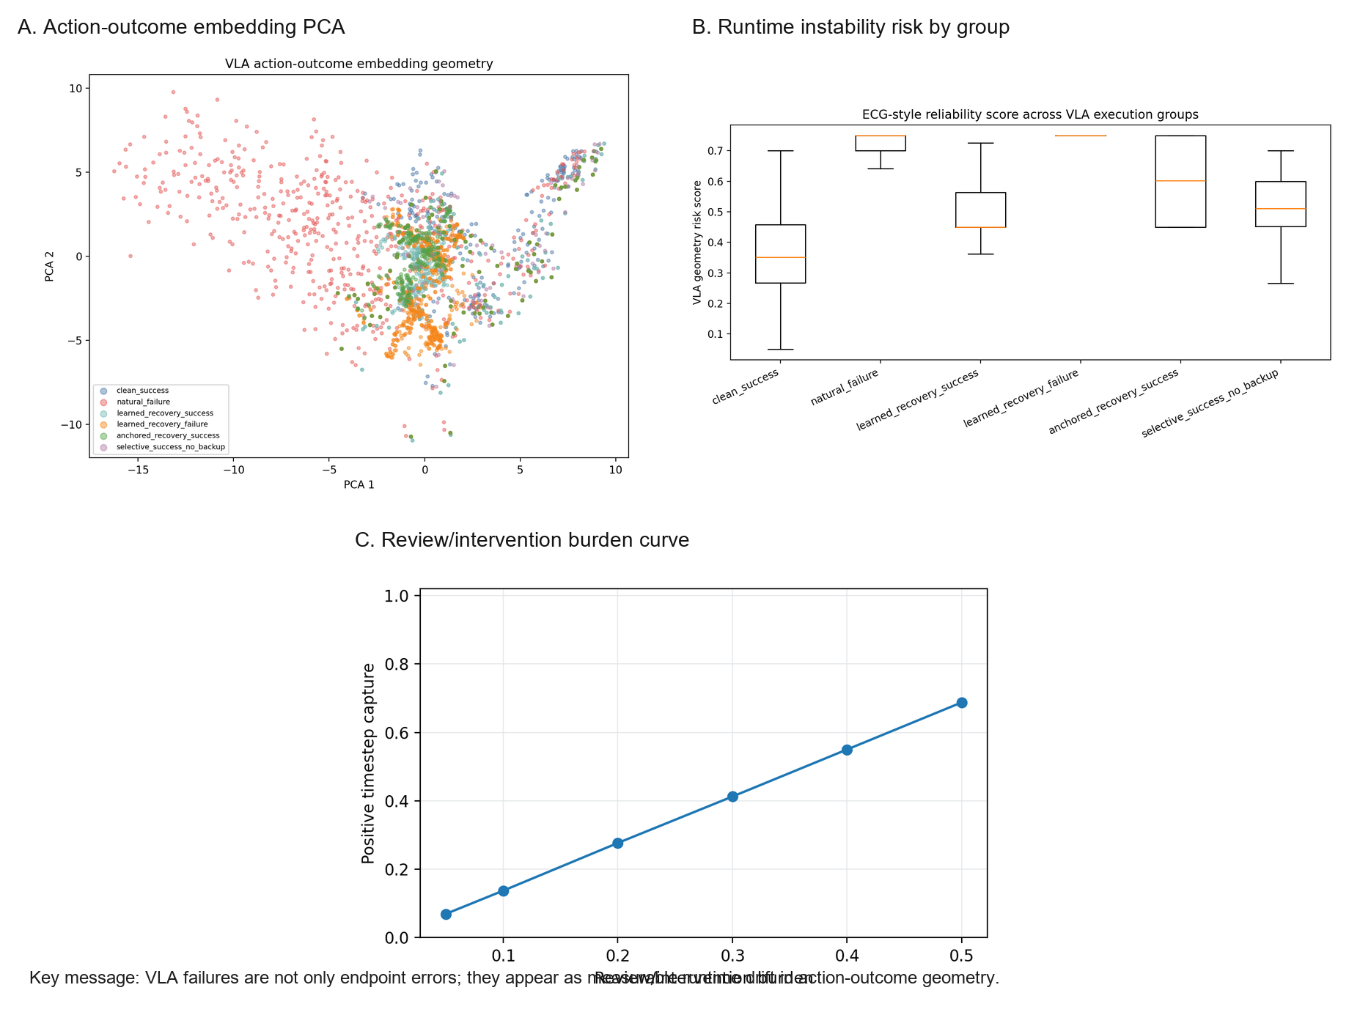
Figure. Part 1 embedding instability panel (results/paper_figures/part1_embedding_instability_panel.png)
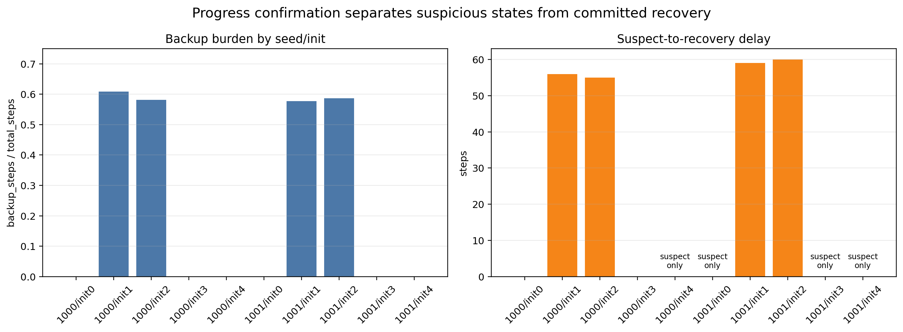
Figure. Part 2 selective detection panel (results/paper_figures/part2_selective_detection_panel.png)
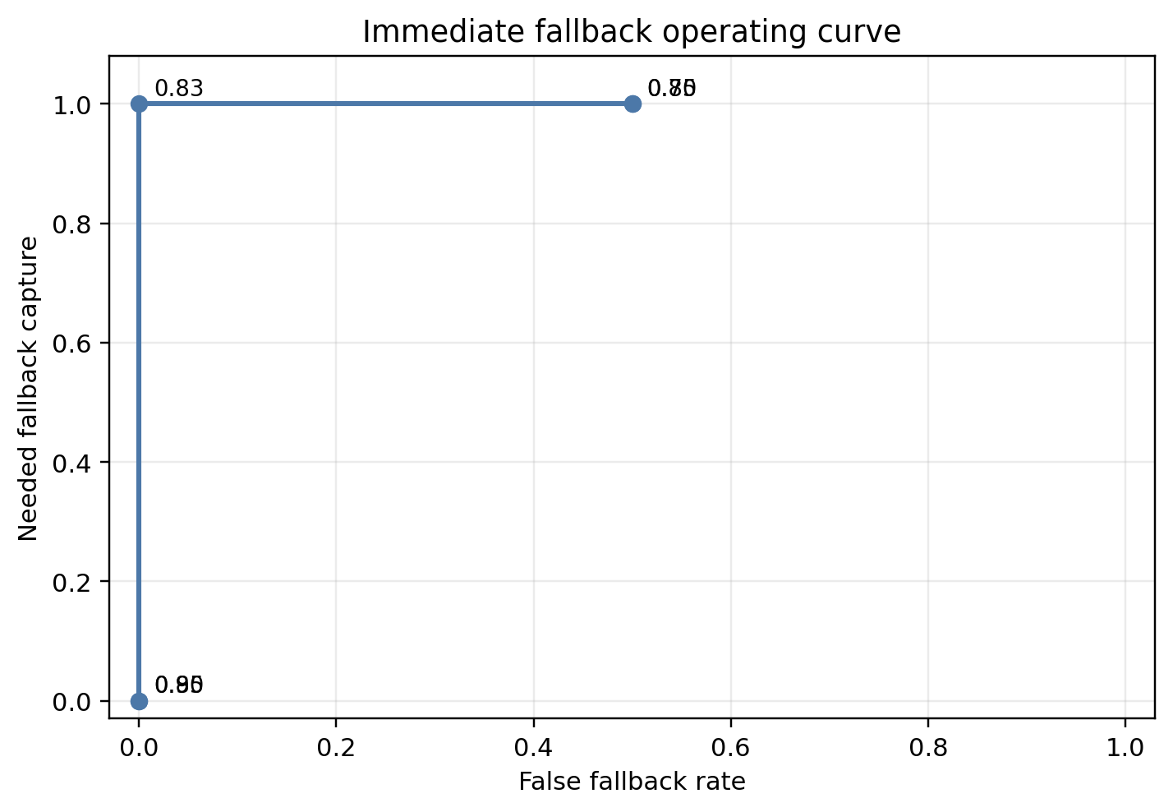
Figure. Immediate fallback operating curve (results/paper_figures/part2_immediate_fallback_operating_curve.png)
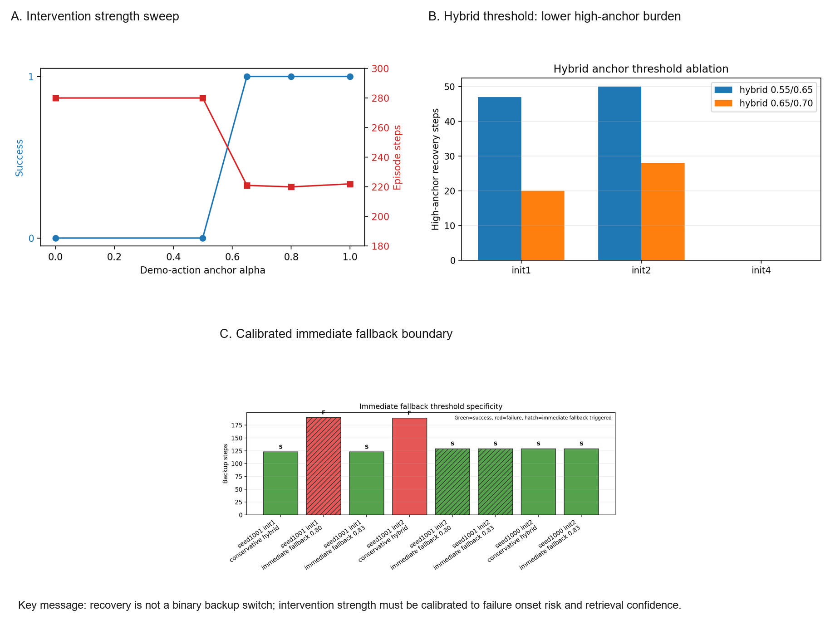
Figure. Part 4 selective recovery strength panel (results/paper_figures/part4_selective_recovery_strength_panel.png)
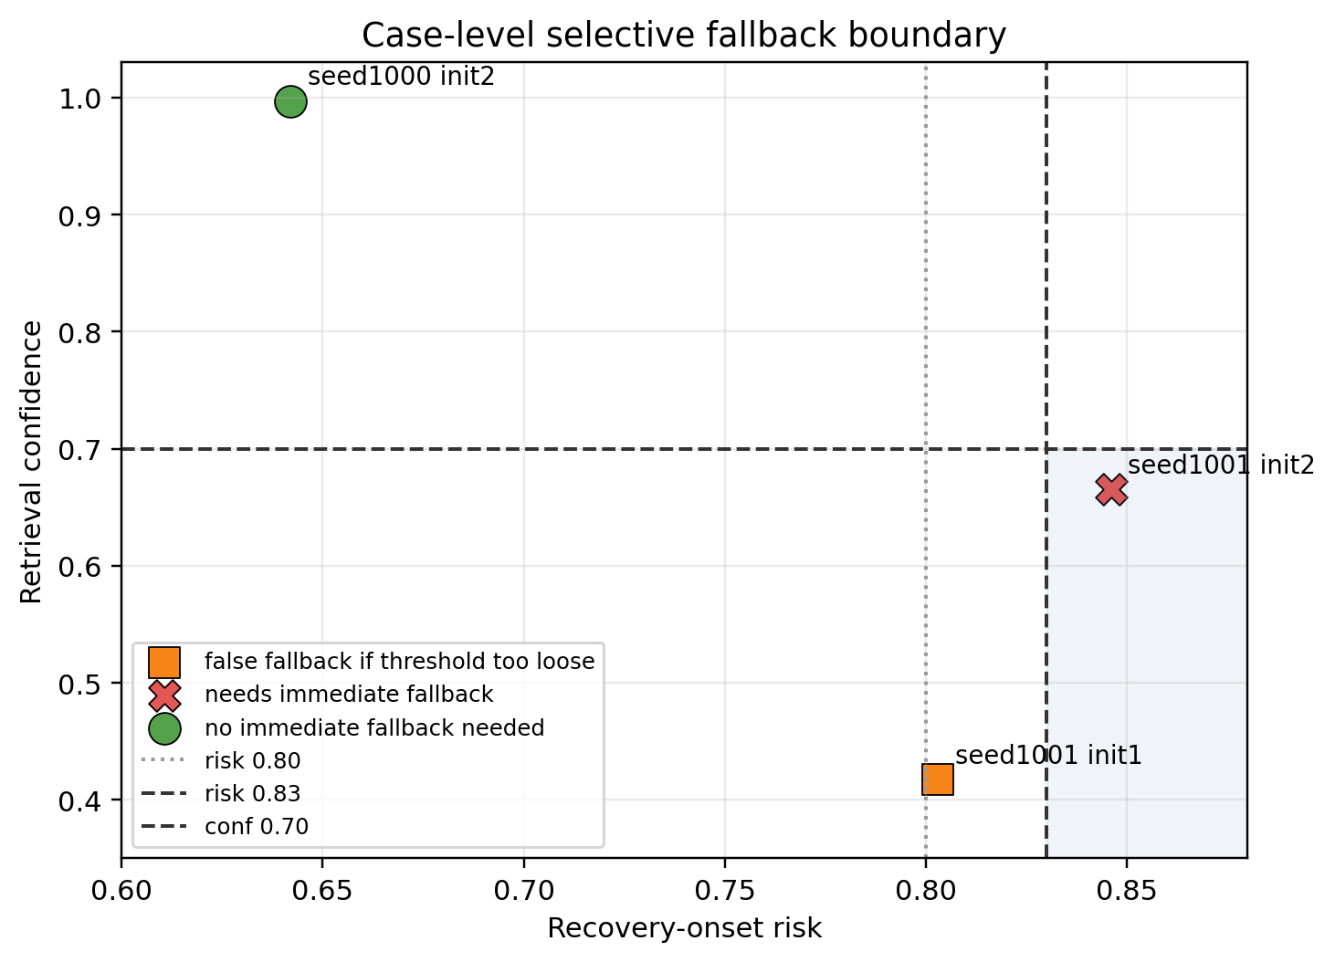
Figure. Retrieval confidence case boundary (results/paper_figures/part4_retrieval_confidence_case_boundary.png)
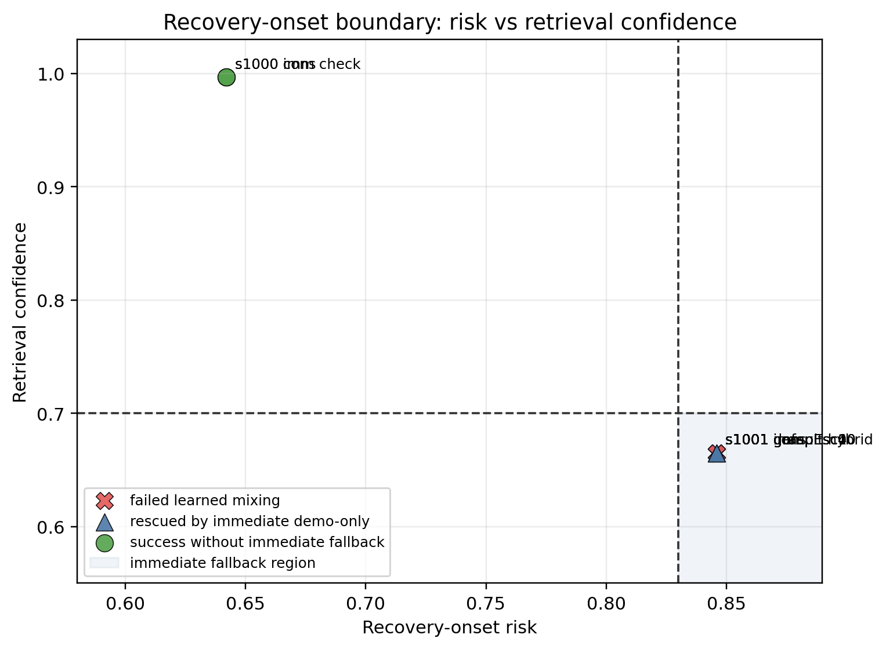
Figure. Retrieval confidence diagnostic boundary (results/paper_figures/part4_retrieval_confidence_boundary.png)
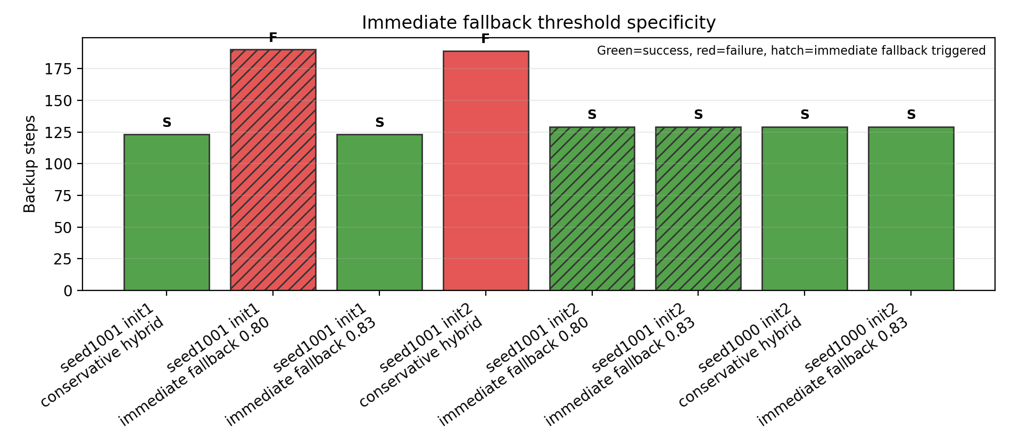
Figure. Immediate fallback ablation (results/paper_figures/immediate_fallback_ablation.png)
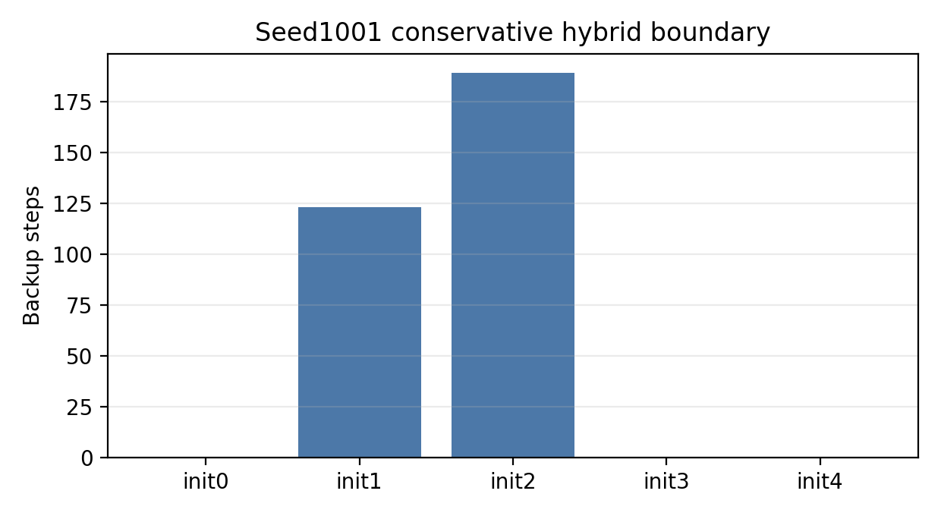
Figure. Seed1001 boundary summary (results/paper_figures/seed1001_boundary_summary.png)
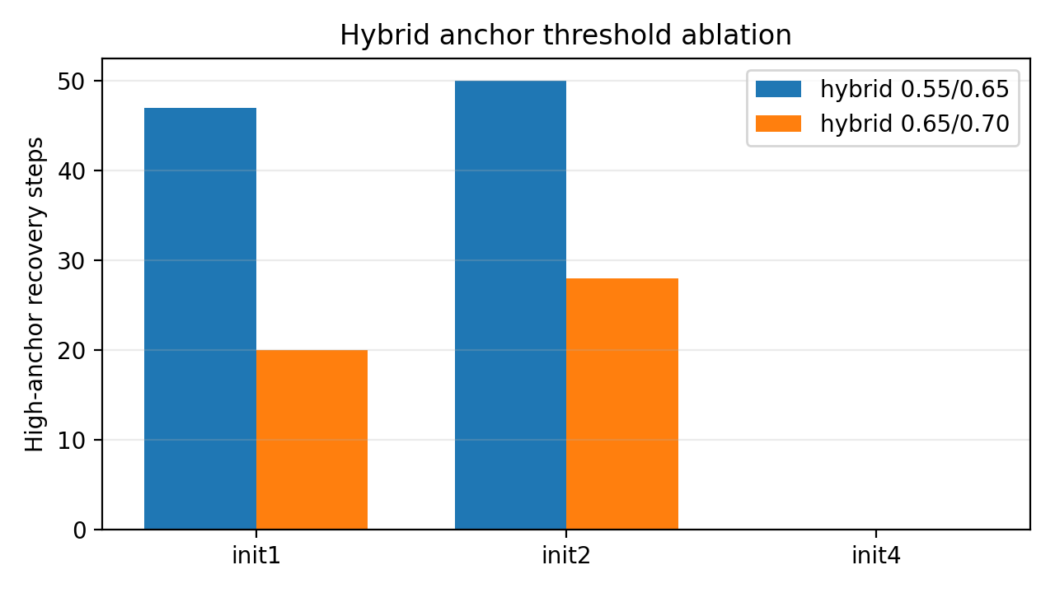
Figure. Hybrid anchor ablation (results/paper_figures/hybrid_anchor_ablation.png)
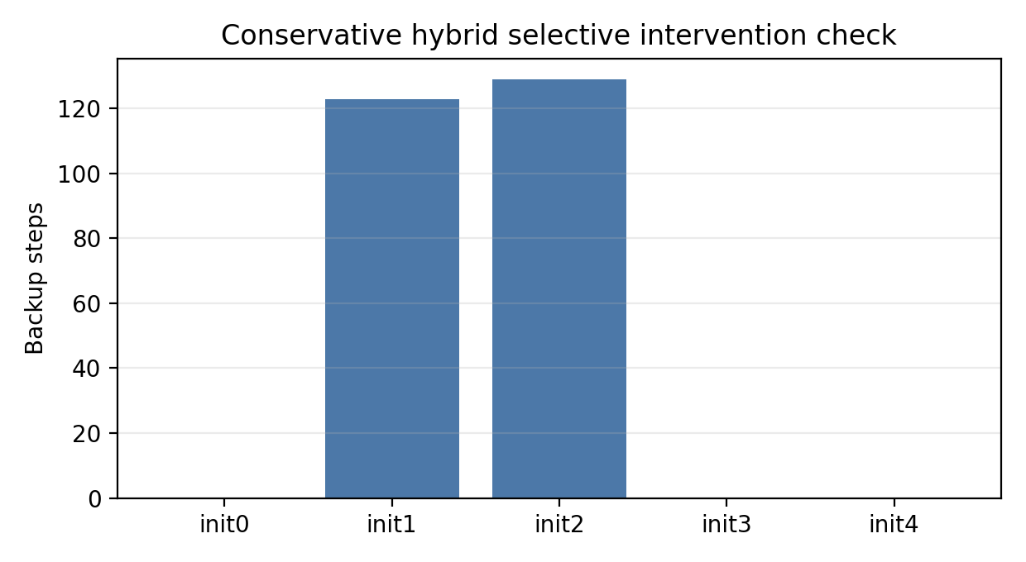
Figure. Conservative hybrid five-init check (results/paper_figures/hybrid_conservative_5init_check.png)
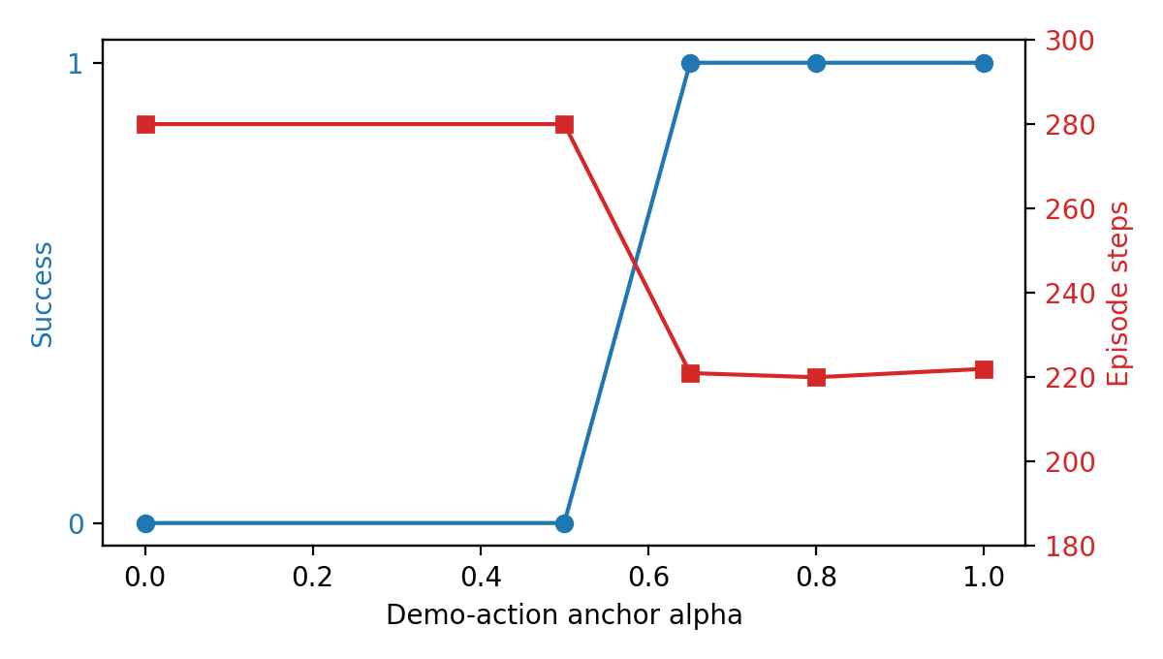
Figure. Init2 demo-anchor sweep (results/paper_figures/init2_anchor_sweep.png)
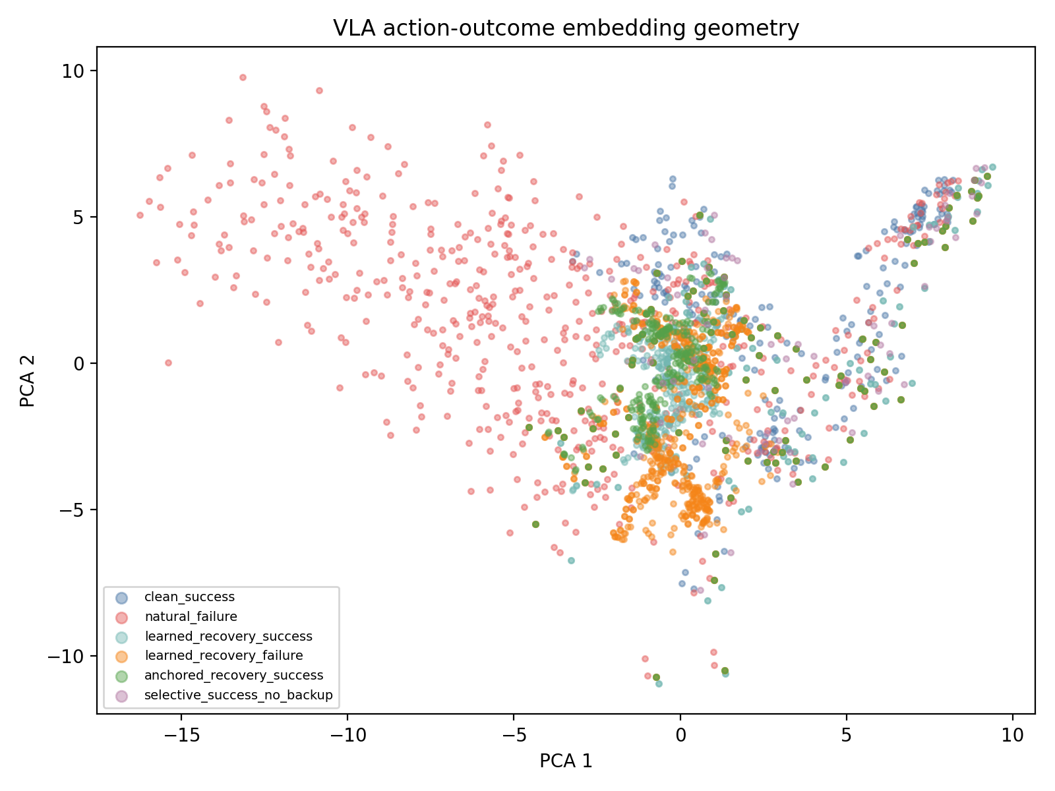
Figure. VLA embedding PCA (results/reliability_geometry/vla_embedding_pca2.png)
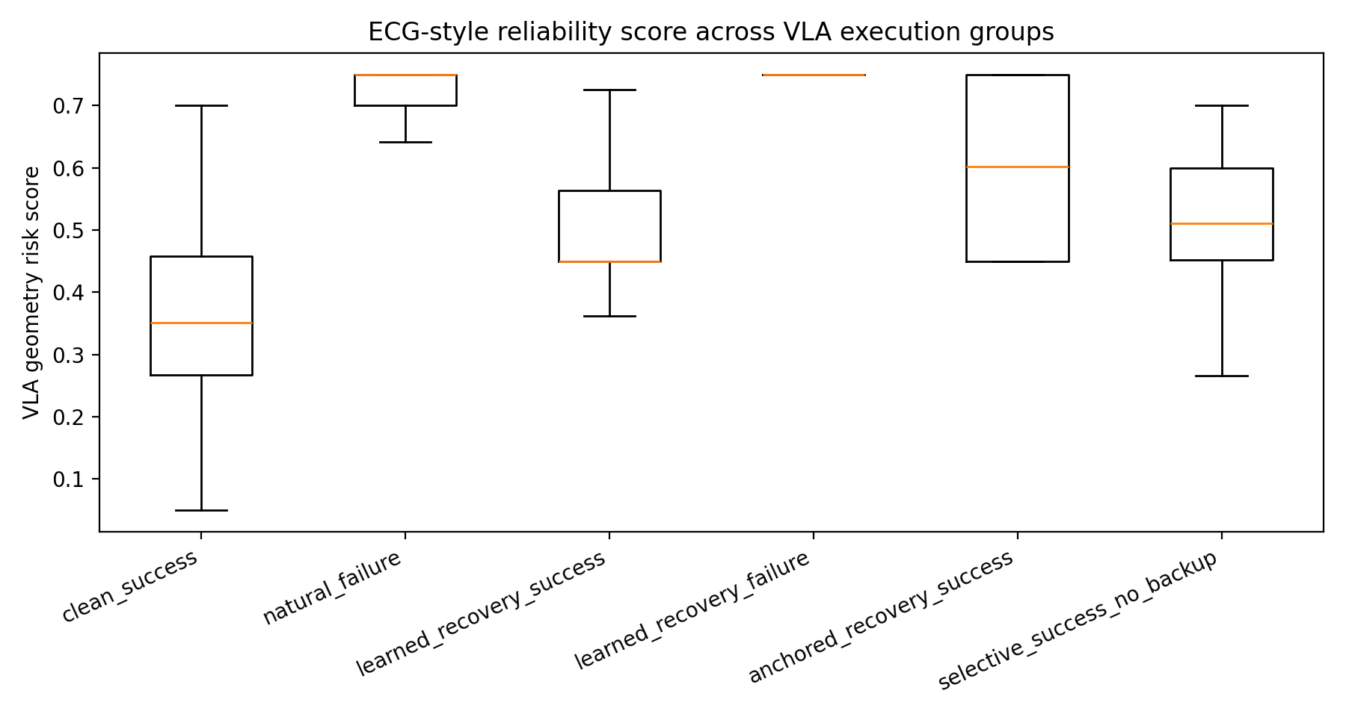
Figure. VLA risk by group (results/reliability_geometry/vla_risk_by_group.png)
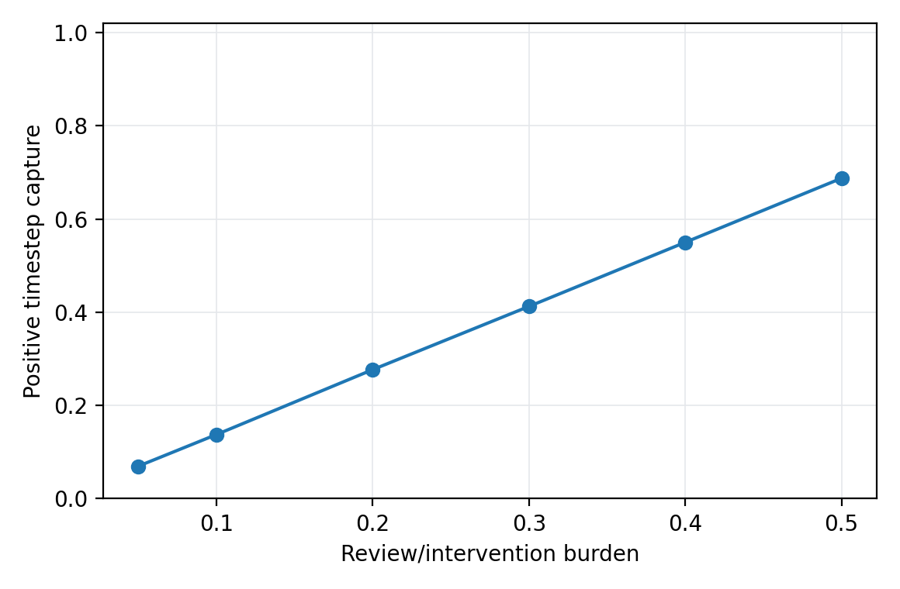
Figure. Clean-vs-natural review curve (results/reliability_geometry/clean_vs_natural_failure_review_curve.png)
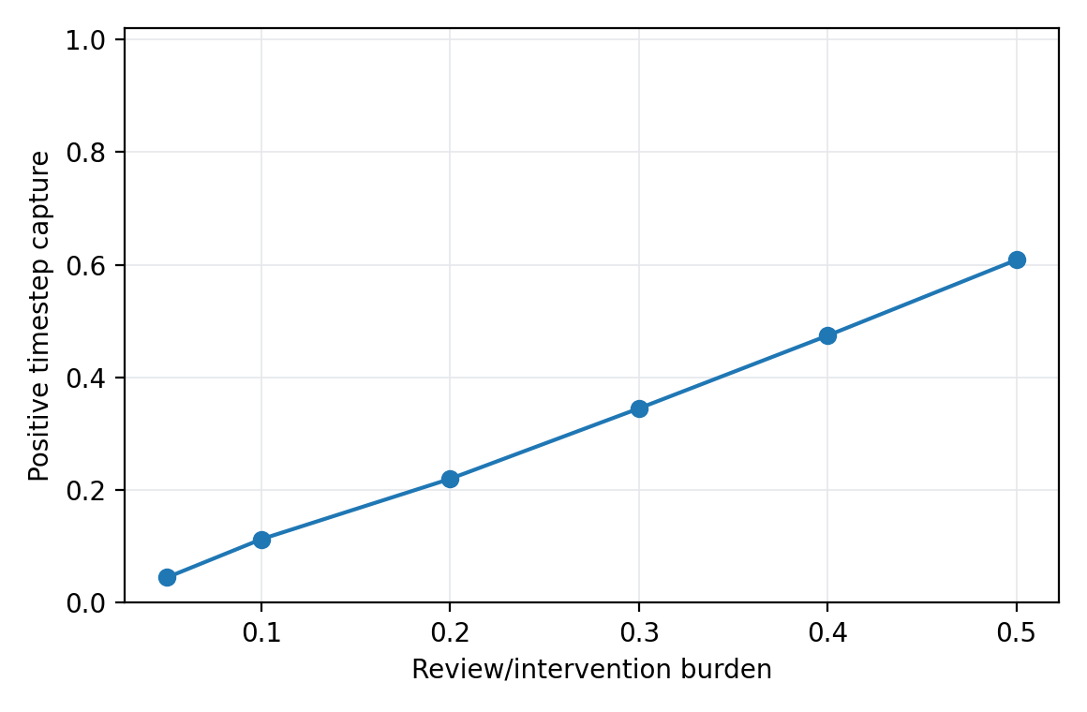
Figure. Broad failure-like review curve (results/reliability_geometry/broad_failure_like_review_curve.png)
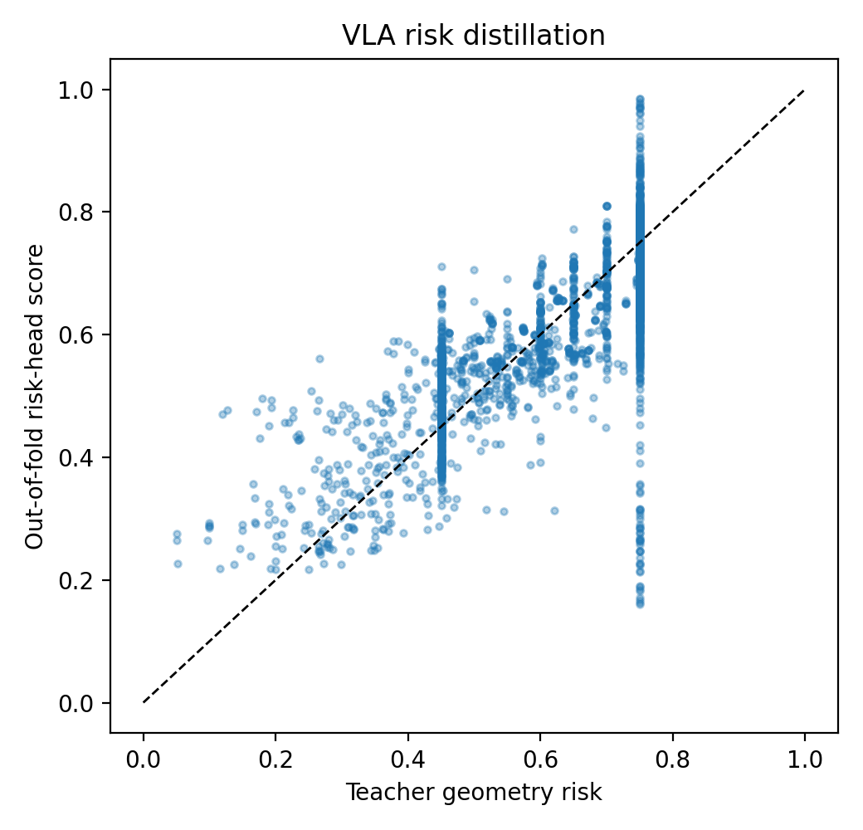
Figure. Risk head teacher vs OOF prediction (results/reliability_geometry/risk_head/vla_risk_head_teacher_vs_oof.png)
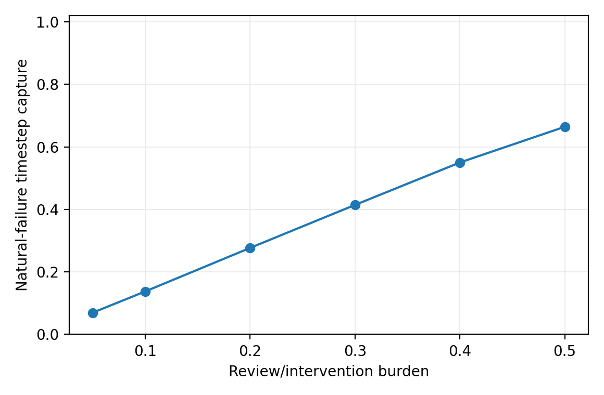
Figure. Risk-head review curve (results/reliability_geometry/risk_head/vla_risk_head_review_curve.png)
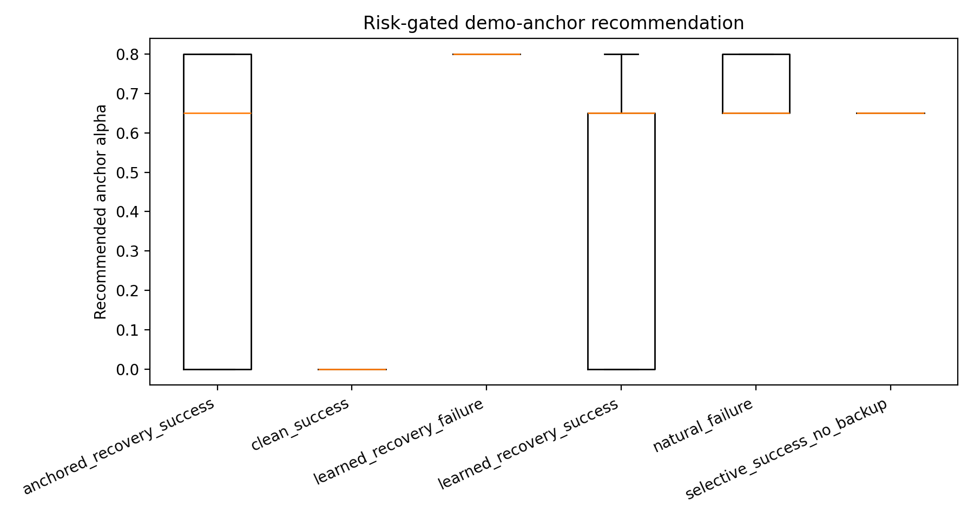
Figure. Adaptive anchor by group (results/reliability_geometry/adaptive_anchor/adaptive_anchor_by_group.png)
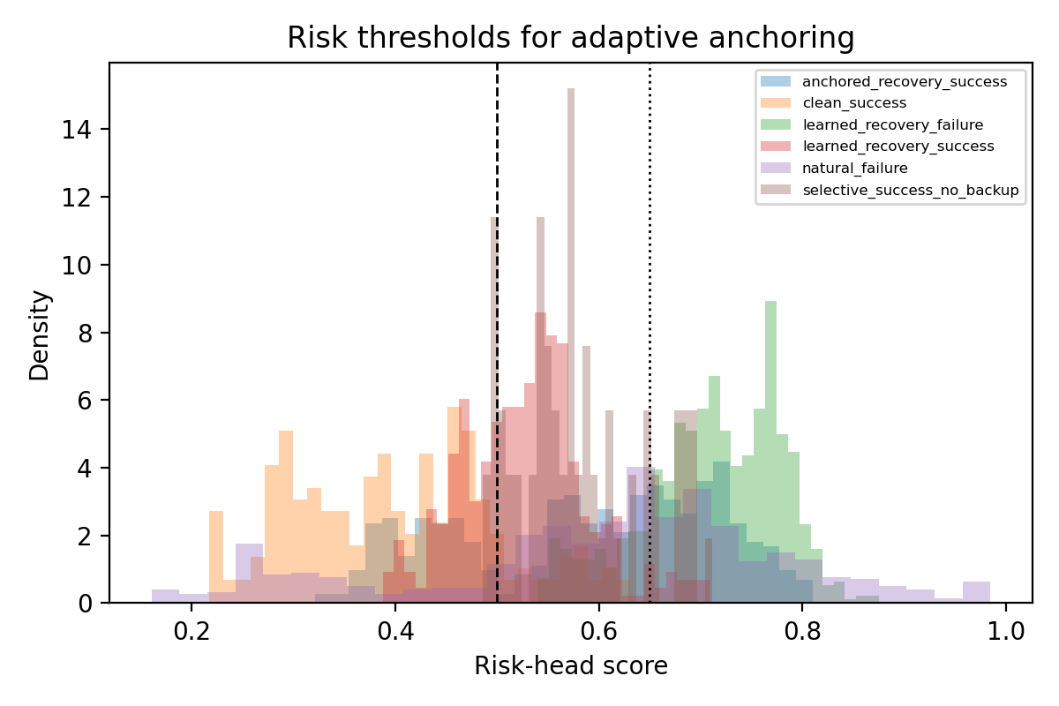
Figure. Adaptive anchor risk-threshold histogram (results/reliability_geometry/adaptive_anchor/risk_threshold_histogram.png)
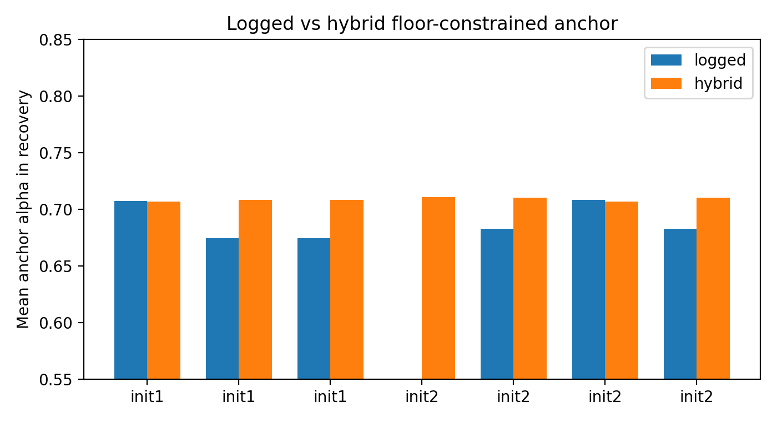
Figure. Logged vs hybrid alpha (results/reliability_geometry/hybrid_anchor/logged_vs_hybrid_alpha.png)

Part D - Complete Structured Result Tables

Two-seed tuned fallback summary
Source: results/paper_figures/immediate_fallback_multiseed_summary.csv
seed | init | success | steps | backup_steps | expert | recovery_events | suspect_steps | immediate_triggered
1000 | 0 | True | 71 | 0 | none | 0 | 0 | False
1000 | 1 | True | 202 | 123 | 1 | 1 | 56 | False
1000 | 2 | True | 222 | 129 | 2 | 1 | 55 | False
1000 | 3 | True | 72 | 0 | none | 0 | 0 | False
1000 | 4 | True | 70 | 0 | none | 0 | 22 | False
1001 | 0 | True | 96 | 0 | none | 0 | 42 | False
1001 | 1 | True | 213 | 123 | 1 | 1 | 59 | False
1001 | 2 | True | 220 | 129 | 2 | 1 | 54 | True
1001 | 3 | True | 74 | 0 | none | 0 | 25 | False
1001 | 4 | True | 68 | 0 | none | 0 | 50 | False

Selective detection operating point
Source: results/paper_figures/part2_selective_detection_operating_point.csv
metric | value | interpretation
total_runs | 10 | Selected tuned-controller seed/init runs.
success_rate | 10/10 | Task success over selected tuned-controller runs.
failure_like_capture_rate | 4/4 | Recovery activated on init1/init2 failure-like states.
natural_success_false_recovery_rate | 0/6 | Recovery events on naturally successful init0/init3/init4 states.
natural_success_zero_backup_rate | 6/6 | Natural-success initial states with no backup actions.
suspect_without_recovery_runs | 4 | Risk/suspect observed but progress confirmation blocked recovery.
mean_suspect_to_recovery_delay | 57.5 | Mean delay from first suspect to first recovery over recovery runs.
mean_backup_burden_all | 0.23538203972662206 | Mean backup_steps / total_steps over all runs.
mean_backup_burden_recovery_only | 0.5884550993165552 | Mean backup_steps / total_steps over recovery-activated runs.
immediate_fallback_triggers | 1 | Runs where tuned immediate demo-only fallback activated.

Selective detection delay and burden
Source: results/paper_figures/part2_selective_detection_delay_burden.csv
seed | init | success | first_suspect | first_recovery | delay | backup_steps | backup_burden | suspect_wo_recovery
1000 | 0 | True |  |  |  | 0 | 0.0 | False
1000 | 1 | True | 22 | 78 | 56 | 123 | 0.6089108910891089 | False
1000 | 2 | True | 37 | 92 | 55 | 129 | 0.581081081081081 | False
1000 | 3 | True |  |  |  | 0 | 0.0 | False
1000 | 4 | True | 20 |  |  | 0 | 0.0 | True
1001 | 0 | True | 25 |  |  | 0 | 0.0 | True
1001 | 1 | True | 30 | 89 | 59 | 123 | 0.5774647887323944 | False
1001 | 2 | True | 30 | 90 | 60 | 129 | 0.5863636363636363 | False
1001 | 3 | True | 5 |  |  | 0 | 0.0 | True
1001 | 4 | True | 5 |  |  | 0 | 0.0 | True

Immediate fallback operating curve
Source: results/paper_figures/part2_immediate_fallback_operating_curve.csv
risk_threshold | confidence_max | triggered_cases | failure_capture | false_fallback_rate | captured_needed | false_fallbacks
0.75 | 0.7 | seed1001 init1; seed1001 init2 | 1.0 | 0.5 | 1/1 | 1/2
0.8 | 0.7 | seed1001 init1; seed1001 init2 | 1.0 | 0.5 | 1/1 | 1/2
0.83 | 0.7 | seed1001 init2 | 1.0 | 0.0 | 1/1 | 0/2
0.85 | 0.7 | none | 0.0 | 0.0 | 0/1 | 0/2
0.9 | 0.7 | none | 0.0 | 0.0 | 0/1 | 0/2

Immediate fallback threshold ablation
Source: results/paper_figures/immediate_fallback_ablation.csv
case | policy | success | steps | backup_steps | expert | recovery_events | immediate_triggered | start_risk
seed1001 init1 | conservative hybrid | True | 213 | 123 | 1 | 1 | False | 0.803
seed1001 init1 | immediate fallback 0.80 | False | 280 | 190 | 1 | 1 | True | 0.803
seed1001 init1 | immediate fallback 0.83 | True | 213 | 123 | 1 | 1 | False | 0.803
seed1001 init2 | conservative hybrid | False | 280 | 189 | 2 | 1 | False | 0.846
seed1001 init2 | immediate fallback 0.80 | True | 220 | 129 | 2 | 1 | True | 0.846
seed1001 init2 | immediate fallback 0.83 | True | 220 | 129 | 2 | 1 | True | 0.846
seed1000 init2 | conservative hybrid | True | 222 | 129 | 2 | 1 | False | 0.642
seed1000 init2 | immediate fallback 0.83 | True | 222 | 129 | 2 | 1 | False | 0.642
seed1001 init0 | immediate fallback 0.83 | True | 96 | 0 | none | 0 | False | n/a
seed1001 init3 | immediate fallback 0.83 | True | 74 | 0 | none | 0 | False | n/a
seed1001 init4 | immediate fallback 0.83 | True | 68 | 0 | none | 0 | False | n/a

Seed1001 boundary summary
Source: results/paper_figures/seed1001_boundary_summary.csv
label | run | seed | init | success | steps | backup_steps | expert | recovery_events
conservative hybrid | libero_spatial_task0_init0_seed1001_online_phase_library_adaptive_anchor_hybrid_support0p65_high0p70 | 1001 | 0 | True | 96 | 0 | none | 0
conservative hybrid | libero_spatial_task0_init1_seed1001_online_phase_library_adaptive_anchor_hybrid_support0p65_high0p70 | 1001 | 1 | True | 213 | 123 | 1 | 1
conservative hybrid | libero_spatial_task0_init2_seed1001_online_phase_library_adaptive_anchor_hybrid_support0p65_high0p70 | 1001 | 2 | False | 280 | 189 | 2 | 1
default hybrid | libero_spatial_task0_init2_seed1001_online_phase_library_adaptive_anchor_hybrid_support0p55_high0p65 | 1001 | 2 | False | 280 | 189 | 2 | 1
fixed anchor 0.80 | libero_spatial_task0_init2_seed1001_online_phase_library_anchor0p80 | 1001 | 2 | False | 280 | 189 | 2 | 1
fixed anchor 0.95 | libero_spatial_task0_init2_seed1001_online_phase_library_anchor0p95 | 1001 | 2 | False | 280 | 189 | 2 | 1
fixed anchor 1.00 | libero_spatial_task0_init2_seed1001_online_phase_library_anchor1p00 | 1001 | 2 | True | 220 | 129 | 2 | 1
immediate fallback | libero_spatial_task0_init2_seed1001_online_phase_library_adaptive_anchor_hybrid_support0p65_high0p70_immFallback_risk0p83_conf0p70 | 1001 | 2 | True | 220 | 129 | 2 | 1
grasp escalation 0 | libero_spatial_task0_init2_seed1001_online_phase_library_adaptive_anchor_hybrid_support0p65_high0p70_graspEsc0 | 1001 | 2 | True | 220 | 129 | 2 | 1
grasp escalation 10 | libero_spatial_task0_init2_seed1001_online_phase_library_adaptive_anchor_hybrid_support0p65_high0p70_graspEsc10 | 1001 | 2 | False | 280 | 189 | 2 | 1
grasp escalation 40 | libero_spatial_task0_init2_seed1001_online_phase_library_adaptive_anchor_hybrid_support0p65_high0p70_graspEsc40 | 1001 | 2 | False | 280 | 189 | 2 | 1
demo replay | libero_spatial_task0_init2_seed1001_online_demo_replay_library | 1001 | 2 | True | 220 | 129 | 2 | 1
conservative hybrid | libero_spatial_task0_init3_seed1001_online_phase_library_adaptive_anchor_hybrid_support0p65_high0p70 | 1001 | 3 | True | 74 | 0 | none | 0
conservative hybrid | libero_spatial_task0_init4_seed1001_online_phase_library_adaptive_anchor_hybrid_support0p65_high0p70 | 1001 | 4 | True | 68 | 0 | none | 0
immediate fallback 0.83 | libero_spatial_task0_init0_seed1001_online_phase_library_adaptive_anchor_hybrid_support0p65_high0p70_immFallback_risk0p83_conf0p70 | 1001 | 0 | True | 96 | 0 | none | 0
immediate fallback 0.83 | libero_spatial_task0_init1_seed1001_online_phase_library_adaptive_anchor_hybrid_support0p65_high0p70_immFallback_risk0p83_conf0p70 | 1001 | 1 | True | 213 | 123 | 1 | 1
immediate fallback 0.83 | libero_spatial_task0_init2_seed1001_online_phase_library_adaptive_anchor_hybrid_support0p65_high0p70_immFallback_risk0p83_conf0p70 | 1001 | 2 | True | 220 | 129 | 2 | 1
immediate fallback 0.83 | libero_spatial_task0_init3_seed1001_online_phase_library_adaptive_anchor_hybrid_support0p65_high0p70_immFallback_risk0p83_conf0p70 | 1001 | 3 | True | 74 | 0 | none | 0
immediate fallback 0.83 | libero_spatial_task0_init4_seed1001_online_phase_library_adaptive_anchor_hybrid_support0p65_high0p70_immFallback_risk0p83_conf0p70 | 1001 | 4 | True | 68 | 0 | none | 0

Seed-boundary diagnostics
Source: results/paper_figures/seed_boundary_diagnostics.csv
label | seed | success | steps | recovery_start | backup_steps | expert | start_risk | early_risk_mean
seed1000 conservative | 1000 | True | 222 | 93 | 129 | 2 | 0.642 | 0.731
seed1000 immediate fallback check | 1000 | True | 222 | 93 | 129 | 2 | 0.642 | 0.731
seed1001 conservative | 1001 | False | 280 | 91 | 189 | 2 | 0.846 | 0.861
seed1001 default hybrid | 1001 | False | 280 | 91 | 189 | 2 | 0.846 | 0.861
seed1001 graspEsc0 | 1001 | True | 220 | 91 | 129 | 2 | 0.846 | 0.872
seed1001 immediate fallback | 1001 | True | 220 | 91 | 129 | 2 | 0.846 | 0.872
seed1001 graspEsc10 | 1001 | False | 280 | 91 | 189 | 2 | 0.846 | 0.861
seed1001 graspEsc40 | 1001 | False | 280 | 91 | 189 | 2 | 0.846 | 0.861

Retrieval expert ablation v2
Source: results/paper_figures/part3_retrieval_expert_ablation_v2.csv
ablation | init | controller | success | expert | steps | backup_steps | recovery_events | interpretation
source expert | init1 | fixed init1 phase prior | True | 1 | 201 | 122 | 1 | Shows the init1 prior can recover its source failure.
wrong/shared expert | init2 | init1 prior reused on init2 | False | 1 | 280 | 187 | 1 | Cross-init failure: one prior does not cover a different failure state.
nearest demo retrieval | init1 | demo replay library | True | 1 | 202 | 123 | 1 | Retrieval selects the init1-specific intervention trace.
nearest demo retrieval | init2 | demo replay library | True | 2 | 222 | 129 | 1 | Retrieval selects the init2-specific intervention trace.
selective no-call | init4 | retrieval library not invoked | True |  | 70 | 0 | 0 | Progress confirmation prevents recovery on a natural success.
nearest learned retrieval | init1 | learned phase library | True | 1 | 200 | 121 | 1 | The learned expert is stable for init1.
nearest learned retrieval | init2 | learned phase library | False | 2 | 280 | 187 | 1 | Retrieval is correct, but the selected neural expert is not stable.
guarded learned retrieval | init2 | learned phase library + gripper guard | False | 2 | 280 | 187 | 1 | A simple gripper guard does not solve closed-loop drift.
demo-anchored retrieval | init2 | learned expert + alpha 0.65 demo anchor | True | 2 | 221 | 128 | 1 | Demo anchoring stabilizes the selected expert.

Hybrid conservative five-init check
Source: results/paper_figures/hybrid_conservative_5init_check.csv
init | success | retrieved_expert | steps | backup_steps | recovery_events | suspect_steps
0 | True | none | 71 | 0 | 0 | 0
1 | True | 1 | 202 | 123 | 1 | 56
2 | True | 2 | 222 | 129 | 1 | 55
3 | True | none | 72 | 0 | 0 | 0
4 | True | none | 70 | 0 | 0 | 22

Hybrid anchor ablation
Source: results/paper_figures/hybrid_anchor_ablation.csv
policy | init | run | success | retrieved_expert | steps | backup_steps | adaptive_steps | high_anchor_steps
hybrid 0.55/0.65 | 1 | libero_spatial_task0_init1_online_phase_library_adaptive_anchor_hybrid_support0p55_high0p65 | True | 1 | 202 | 123 | 123 | 47
hybrid 0.55/0.65 | 2 | libero_spatial_task0_init2_online_phase_library_adaptive_anchor_hybrid_support0p55_high0p65 | True | 2 | 222 | 129 | 129 | 50
hybrid 0.55/0.65 | 4 | libero_spatial_task0_init4_online_phase_library_adaptive_anchor_hybrid_support0p55_high0p65 | True | none | 70 | 0 | 0 | 0
hybrid 0.65/0.70 | 1 | libero_spatial_task0_init1_online_phase_library_adaptive_anchor_hybrid_support0p65_high0p70 | True | 1 | 202 | 123 | 123 | 20
hybrid 0.65/0.70 | 2 | libero_spatial_task0_init2_online_phase_library_adaptive_anchor_hybrid_support0p65_high0p70 | True | 2 | 222 | 129 | 129 | 28
hybrid 0.65/0.70 | 4 | libero_spatial_task0_init4_online_phase_library_adaptive_anchor_hybrid_support0p65_high0p70 | True | none | 70 | 0 | 0 | 0

Init2 anchor sweep
Source: results/paper_figures/init2_anchor_sweep.csv
alpha | success | steps | backup_steps
0.0 | 0 | 280 | 187
0.5 | 0 | 280 | 187
0.65 | 1 | 221 | 128
0.8 | 1 | 220 | 127
1.0 | 1 | 222 | 129

Adaptive anchor online results
Source: results/paper_figures/adaptive_anchor_online_results.csv
setting | alpha_rule | init | success | trigger | steps | backup_steps
Init2 fixed anchor | fixed 0.65 | 2 | yes | 2 | 221 | 128
Init2 naive adaptive | 0.00 / 0.65 / 0.80 | 2 | no | 2 | 280 | 187
Init1 floor adaptive | 0.65 / 0.80 | 1 | yes | 1 | 202 | 123
Init2 floor adaptive | 0.65 / 0.80 | 2 | yes | 2 | 222 | 129
Init4 floor adaptive | 0.65 / 0.80 | 4 | yes | none | 70 | 0
Init1 hybrid adaptive | hybrid support0.55 high0.65 | 1 | yes | 1 | 202 | 123
Init2 hybrid adaptive | hybrid support0.55 high0.65 | 2 | yes | 2 | 222 | 129
Init4 hybrid adaptive | hybrid support0.55 high0.65 | 4 | yes | none | 70 | 0
Init2 hybrid conservative | hybrid support0.65 high0.70 | 2 | yes | 2 | 222 | 129
Init1 hybrid conservative | hybrid support0.65 high0.70 | 1 | yes | 1 | 202 | 123
Init4 hybrid conservative | hybrid support0.65 high0.70 | 4 | yes | none | 70 | 0
Init0 hybrid conservative | hybrid support0.65 high0.70 | 0 | yes | none | 71 | 0
Init3 hybrid conservative | hybrid support0.65 high0.70 | 3 | yes | none | 72 | 0

Online recovery core results
Source: results/paper_figures/online_recovery_core_results.csv
setting | init | success | trigger | steps | backup_steps
Init1 phase prior | 1 | yes | 1 | 201 | 122
Init1 learned library | 1 | yes | 1 | 200 | 121
Init1 anchored library | 1 | yes | 1 | 202 | 123
Init2 init1 prior | 2 | no | 1 | 280 | 187
Init2 learned library | 2 | no | 2 | 280 | 187
Init2 gripper guard | 2 | no | 2 | 280 | 187
Init2 anchored 0.50 | 2 | no | 2 | 280 | 187
Init2 anchored 0.65 | 2 | yes | 2 | 221 | 128
Init2 anchored 0.80 | 2 | yes | 2 | 220 | 127
Init2 demo replay | 2 | yes | 2 | 222 | 129
Init4 anchored library | 4 | yes | none | 70 | 0

Reliability geometry group summary
Source: results/reliability_geometry/vla_reliability_group_summary.csv
group | n | risk_mean | risk_p90 | distance_mean | local_purity_mean | failure_neighbor_mean
anchored_recovery_success | 441 | 0.5942266 | 0.75 | 8.7277155 | 0.55253214 | 0.32713532
clean_success | 213 | 0.36719355 | 0.585883378982544 | 4.721086 | 0.4976526 | 0.3411581
learned_recovery_failure | 840 | 0.7212419 | 0.75 | 9.277049 | 0.7388889 | 0.77436507
learned_recovery_success | 402 | 0.50462264 | 0.6499999761581421 | 8.452566 | 0.6641791 | 0.16086237
natural_failure | 560 | 0.6763008 | 0.75 | 11.314693 | 0.7222619 | 0.79440475
selective_success_no_backup | 70 | 0.52051365 | 0.6499999761581421 | 6.5952806 | 0.14095238 | 0.3447619

Risk-head fold metrics
Source: results/reliability_geometry/risk_head/vla_risk_head_fold_metrics.csv
fold | n_train | n_test | held_out_runs | mae | mse | spearman
1 | 2025 | 501 | libero_spatial_task0_init2_online_phase_library_anchor0p65;libero_spatial_task0_init2_online_phase_library_retrieval | 0.04780605807900429 | 0.0035108483862131834 | 0.7743980163383819
2 | 2026 | 500 | libero_spatial_task0_init2_online_phase_library_anchor0p80;libero_spatial_task0_init2_online_phase_library_guarded | 0.046850163489580154 | 0.0035105666611343622 | 0.7836434292222795
3 | 2044 | 482 | init1;libero_spatial_task0_init1_online_phase_library_anchor0p65 | 0.06882862001657486 | 0.00732412189245224 | 0.8692046236853791
4 | 1976 | 550 | init2;init4;libero_spatial_task0_init1_online_phase_library | 0.11413802206516266 | 0.02786143496632576 | 0.584255306112681
5 | 2033 | 493 | init0;init3;libero_spatial_task0_init2_online_phase_library_anchor0p50;libero_spatial_task0_init4_online_phase_library_anchor0p65 | 0.06575889140367508 | 0.008268584497272968 | 0.8995565172634761

Hybrid threshold sweep
Source: results/reliability_geometry/hybrid_anchor_sweep/hybrid_threshold_sweep.csv
risk_support_threshold | risk_high_threshold | overall_high_rate | successful_run_high_rate | failed_run_high_rate | failed_minus_success | score
0.65 | 0.7 | 0.45422535211267606 | 0.1889763779527559 | 0.9946524064171123 | 0.8056760284643564 | 0.7866971552249198
0.65 | 0.725 | 0.45422535211267606 | 0.1889763779527559 | 0.9946524064171123 | 0.8056760284643564 | 0.7866971552249198
0.65 | 0.75 | 0.45422535211267606 | 0.1889763779527559 | 0.9946524064171123 | 0.8056760284643564 | 0.7866971552249198
0.65 | 0.675 | 0.45774647887323944 | 0.1942257217847769 | 0.9946524064171123 | 0.8004266846323354 | 0.7802154170267016
0.625 | 0.7 | 0.48063380281690143 | 0.22572178477690288 | 1.0 | 0.7742782152230971 | 0.7460563842371817
0.625 | 0.725 | 0.48063380281690143 | 0.22572178477690288 | 1.0 | 0.7742782152230971 | 0.7460563842371817
0.625 | 0.75 | 0.48063380281690143 | 0.22572178477690288 | 1.0 | 0.7742782152230971 | 0.7460563842371817
0.625 | 0.65 | 0.4841549295774648 | 0.23097112860892388 | 1.0 | 0.7690288713910761 | 0.7395746460389634
0.625 | 0.675 | 0.4841549295774648 | 0.23097112860892388 | 1.0 | 0.7690288713910761 | 0.7395746460389634
0.6 | 0.7 | 0.5193661971830986 | 0.28346456692913385 | 1.0 | 0.7165354330708662 | 0.6747572640567817
0.6 | 0.725 | 0.5193661971830986 | 0.28346456692913385 | 1.0 | 0.7165354330708662 | 0.6747572640567817
0.6 | 0.75 | 0.5193661971830986 | 0.28346456692913385 | 1.0 | 0.7165354330708662 | 0.6747572640567817
0.6 | 0.65 | 0.522887323943662 | 0.2887139107611549 | 1.0 | 0.7112860892388451 | 0.6682755258585634
0.6 | 0.675 | 0.522887323943662 | 0.2887139107611549 | 1.0 | 0.7112860892388451 | 0.6682755258585634
0.6 | 0.625 | 0.5299295774647887 | 0.2992125984251969 | 1.0 | 0.7007874015748031 | 0.6553120494621271
0.575 | 0.7 | 0.5492957746478874 | 0.32808398950131235 | 1.0 | 0.6719160104986877 | 0.6196624893719271
0.575 | 0.725 | 0.5492957746478874 | 0.32808398950131235 | 1.0 | 0.6719160104986877 | 0.6196624893719271
0.575 | 0.75 | 0.5492957746478874 | 0.32808398950131235 | 1.0 | 0.6719160104986877 | 0.6196624893719271
0.575 | 0.65 | 0.5528169014084507 | 0.3333333333333333 | 1.0 | 0.6666666666666667 | 0.613180751173709
0.575 | 0.675 | 0.5528169014084507 | 0.3333333333333333 | 1.0 | 0.6666666666666667 | 0.613180751173709
0.575 | 0.625 | 0.5598591549295775 | 0.3438320209973753 | 1.0 | 0.6561679790026247 | 0.6002172747772726
0.575 | 0.6 | 0.5669014084507042 | 0.3543307086614173 | 1.0 | 0.6456692913385826 | 0.5872537983808361
0.55 | 0.7 | 0.5862676056338029 | 0.38320209973753283 | 1.0 | 0.6167979002624672 | 0.5516042382906362
0.55 | 0.725 | 0.5862676056338029 | 0.38320209973753283 | 1.0 | 0.6167979002624672 | 0.5516042382906362
0.55 | 0.75 | 0.5862676056338029 | 0.38320209973753283 | 1.0 | 0.6167979002624672 | 0.5516042382906362

Adaptive anchor group summary
Source: results/reliability_geometry/adaptive_anchor/adaptive_anchor_group_summary.csv
group | n | risk_mean | alpha_mean | alpha_p90 | no_anchor_rate | mid_anchor_rate | high_anchor_rate
anchored_recovery_success | 441 | 0.5896431368027211 | 0.51950115 | 0.800000011920929 | 0.29024943310657597 | 0.3219954648526077 | 0.3877551020408163
clean_success | 213 | 0.3984282328169014 | 0.07934272 | 0.6499999761581421 | 0.8779342723004695 | 0.12206572769953052 | 0.0
learned_recovery_failure | 840 | 0.7113247696190476 | 0.77410716 | 0.800000011920929 | 0.0 | 0.17261904761904762 | 0.8273809523809523
learned_recovery_success | 402 | 0.528153493159204 | 0.450995 | 0.6499999761581421 | 0.31592039800995025 | 0.6417910447761194 | 0.04228855721393035
natural_failure | 560 | 0.6043819152678571 | 0.5780357 | 0.800000011920929 | 0.2125 | 0.3464285714285714 | 0.44107142857142856
selective_success_no_backup | 70 | 0.5795323567142857 | 0.60142857 | 0.800000011920929 | 0.11428571428571428 | 0.7142857142857143 | 0.17142857142857143

Hybrid anchor run summary
Source: results/reliability_geometry/hybrid_anchor/hybrid_anchor_run_summary.csv
run | init | success | n | risk_mean | risk_high_rate | progress_failure_rate | slope_mean | retrieval_confidence
libero_spatial_task0_init1_online_phase_library_adaptive_anchor_hybrid_support0p55_high0p65 | 1 | True | 124 | 0.5338033302043511 | 0.16129032258064516 | 0.7096774193548387 | 0.07096774193548384 | 0.9512680025494511
libero_spatial_task0_init1_online_phase_library_adaptive_anchor_hybrid_support0p65_high0p70 | 1 | True | 124 | 0.5323509123267197 | 0.16129032258064516 | 0.7016129032258065 | 0.07096774193548384 | 0.9512680025494511
libero_spatial_task0_init1_online_phase_library_adaptive_anchor_low0p65 | 1 | True | 124 | 0.5323509123267197 | 0.16129032258064516 | 0.7016129032258065 | 0.07096774193548384 | 0.9512680025494511
libero_spatial_task0_init2_online_phase_library_adaptive_anchor | 2 | False | 188 | 0.534770715045419 | 0.17553191489361702 | 0.6117021276595744 | -0.03829787234042551 | 0.9810611583224254
libero_spatial_task0_init2_online_phase_library_adaptive_anchor_floor0p65 | 2 | True | 130 | 0.5359853861867919 | 0.2153846153846154 | 0.5384615384615384 | 6.832141690000964e-18 | 0.9810611583224254
libero_spatial_task0_init2_online_phase_library_adaptive_anchor_hybrid_support0p55_high0p65 | 2 | True | 130 | 0.5284731570602388 | 0.19230769230769232 | 0.5461538461538461 | 6.832141690000964e-18 | 0.9810611583224254
libero_spatial_task0_init2_online_phase_library_adaptive_anchor_hybrid_support0p65_high0p70 | 2 | True | 130 | 0.5341369183950646 | 0.2230769230769231 | 0.5461538461538461 | 6.832141690000964e-18 | 0.9810611583224254

Seed1001 grasp escalation summary
Source: results/online_recovery/seed1001_grasp_escalation_summary.csv
﻿"run" | success | steps | backup_steps | alpha_counts | top_reasons
libero_spatial_task0_init2_seed1001_online_phase_library_adaptive_anchor_hybrid_support0p65_high0p70_graspEsc0 | True | 220 | 129 | 1.0:129 | floor+grasp_failure_escalation:82; risk+progress_failure+progress_slope+grasp_failure_escalation:31; progress_failure+progress_slope+grasp_failure_escalation:9; risk+progress_sl...
libero_spatial_task0_init2_seed1001_online_phase_library_adaptive_anchor_hybrid_support0p65_high0p70_graspEsc10 | False | 280 | 189 | 0.8:10; 1.0:179 | risk+progress_failure+progress_slope+grasp_failure_escalation:88; floor+grasp_failure_escalation:61; risk+progress_slope+grasp_failure_escalation:11; progress_failure+progress_s...
libero_spatial_task0_init2_seed1001_online_phase_library_adaptive_anchor_hybrid_support0p65_high0p70_graspEsc40 | False | 280 | 189 | 0.65:2; 0.8:38; 1.0:149 | risk+progress_failure+progress_slope+grasp_failure_escalation:67; floor+grasp_failure_escalation:64; risk+progress_failure+progress_slope:29; progress_slope+grasp_failure_escala...

Online recovery summary
Source: results/online_recovery/online_recovery_summary.csv
run | episode_index | backup_controller | phase_trigger_policy | phase_trigger_id | success | steps | backup_steps | suspect_steps
libero_spatial_task0_init0_online_phase_library_adaptive_anchor_hybrid_support0p65_high0p70 | 0 | phase_library | retrieval |  | True | 71 | 0 | 0
libero_spatial_task0_init0_seed1001_online_phase_library_adaptive_anchor_hybrid_support0p65_high0p70 | 0 | phase_library | retrieval |  | True | 96 | 0 | 42
libero_spatial_task0_init1_online_demo_replay_library | 1 | demo_replay_library | retrieval | 1 | True | 202 | 123 | 56
libero_spatial_task0_init1_online_oracle_object | 1 | oracle_object |  |  | False | 280 | 201 | 56
libero_spatial_task0_init1_online_phase_library | 1 | phase_library | retrieval | 1 | True | 200 | 121 | 56
libero_spatial_task0_init1_online_phase_library_adaptive_anchor_hybrid_low0p00 | 1 | phase_library | retrieval | 1 | True | 202 | 123 | 56
libero_spatial_task0_init1_online_phase_library_adaptive_anchor_hybrid_support0p55_high0p65 | 1 | phase_library | retrieval | 1 | True | 202 | 123 | 56
libero_spatial_task0_init1_online_phase_library_adaptive_anchor_hybrid_support0p65_high0p70 | 1 | phase_library | retrieval | 1 | True | 202 | 123 | 56
libero_spatial_task0_init1_online_phase_library_adaptive_anchor_low0p65 | 1 | phase_library | retrieval | 1 | True | 202 | 123 | 56
libero_spatial_task0_init1_online_phase_library_anchor0p65 | 1 | phase_library | retrieval | 1 | True | 202 | 123 | 56
libero_spatial_task0_init1_online_phase_prior_auto | 1 | phase_prior | auto | 1 | True | 201 | 122 | 56
libero_spatial_task0_init1_online_phase_prior_early | 1 | phase_prior | early | 0 | True | 200 | 121 | 56
libero_spatial_task0_init1_online_phase_prior_late | 1 | phase_prior | late | 1 | True | 201 | 122 | 56
libero_spatial_task0_init1_online_recovery | 1 |  |  |  | False | 280 | 201 | 56
libero_spatial_task0_init1_online_visual_policy | 1 | visual_policy |  |  | False | 280 | 201 | 56
libero_spatial_task0_init1_online_visual_retrieval | 1 | visual_retrieval |  |  | False | 280 | 201 | 56
libero_spatial_task0_init1_seed1001_online_phase_library_adaptive_anchor_hybrid_support0p65_high0p70 | 1 | phase_library | retrieval | 1 | True | 213 | 123 | 59
libero_spatial_task0_init2_online_demo_replay_library | 2 | demo_replay_library | retrieval | 2 | True | 222 | 129 | 55
libero_spatial_task0_init2_online_phase_library_adaptive_anchor | 2 | phase_library | retrieval | 2 | False | 280 | 187 | 55
libero_spatial_task0_init2_online_phase_library_adaptive_anchor_floor0p65 | 2 | phase_library | retrieval | 2 | True | 222 | 129 | 55
libero_spatial_task0_init2_online_phase_library_adaptive_anchor_hybrid_low0p00 | 2 | phase_library | retrieval | 2 | True | 222 | 129 | 55
libero_spatial_task0_init2_online_phase_library_adaptive_anchor_hybrid_support0p55_high0p65 | 2 | phase_library | retrieval | 2 | True | 222 | 129 | 55
libero_spatial_task0_init2_online_phase_library_adaptive_anchor_hybrid_support0p65_high0p65 | 2 | phase_library | retrieval | 2 | True | 222 | 129 | 55
libero_spatial_task0_init2_online_phase_library_adaptive_anchor_hybrid_support0p65_high0p70 | 2 | phase_library | retrieval | 2 | True | 222 | 129 | 55
libero_spatial_task0_init2_online_phase_library_anchor0p50 | 2 | phase_library | retrieval | 2 | False | 280 | 187 | 55

Part E - Source Narrative Appendix
This appendix preserves all major source notes used to build the upgraded report. Some content intentionally repeats earlier sections so that the document is self-contained and does not omit intermediate negative results or reasoning.

docs/paper_style_technical_report_zh.md

Runtime Instability Analysis and Selective Recovery for Vision-Language-Action Robotic Policies
中文题目：**面向 VLA 机器人策略的运行时不稳定性分析与选择性恢复**

Abstract
当前 Vision-Language-Action (VLA) 机器人策略在长时序闭环操作中并不是简单地“会做”或“不会做”。它们常常在部分初始状态、部分接触几何或部分恢复阶段中出现自然失败。更麻烦的是，失败并不总能靠一个统一 backup policy 修复；过早、过强或错误的恢复干预也可能破坏本来可以完成的轨迹。
本文把这个问题定义为 **runtime instability analysis and selective recovery**：首先用 action-outcome embedding geometry 分析 VLA 失败如何显现；然后用 progress confirmation 区分 risk observation 和 intervention commitment；再通过 failure-state retrieval 选择对应 recovery expert；最后用 demo-anchored recovery 和 calibrated fallback 控制恢复强度。截至 2026-06-23 五步升级后，当前最强证据为：LIBERO Spatial task0 上 25 个有效 seed/init 评估达到 21/25 success、13 条 zero-backup success，并暴露 4 个有效 recovery failure。早期 seed1000/seed1001 的 10/10 success 保留为 initial tuned-controller evidence，而不再作为最终项目统计口径。

1. Introduction
VLA / robot foundation policy 的可靠性问题不完全等同于传统控制安全。传统 safety robotics 常研究 constraint satisfaction、shielding、control barrier function 或 formal verification；而这里的问题是 learned generalist robot policy 在语义强、泛化强但闭环反馈脆弱的情形下，会自然进入不稳定执行区域。
本文不把 failure 看成单一终点事件，而把它看成 runtime dynamics 中逐渐显现的结构性问题。核心问题是：
> VLA policy 为什么会在闭环执行中变得不可靠？这种不可靠是否可观测、可校准，并可用于选择恢复策略和恢复强度？

2. Contributions
本文贡献可以概括为四点：
- **Runtime instability characterization.**
用 action-outcome embedding geometry 刻画 VLA failure，证明 natural failure 远离 successful-execution manifold，并具有更高 failure-neighbour density。
- **Progress-confirmed selective detection.**
将 risk observation 与 intervention commitment 分开，只有任务进展确认停滞时才进入 recovery，从而保持自然成功轨迹的 zero-backup。
- **Failure-state retrieval for recovery selection.**
证明 recovery 是 failure-state dependent 的；单一 init1 prior 不能泛化到 init2，而 retrieval-conditioned library 可以选择对应 recovery expert。
- **Demo-anchored selective recovery.**
将 demo action 作为 recovery safety prior，并用 risk/progress/retrieval confidence 校准 intervention strength，包括 alpha 调节和 immediate fallback operating point。

3. Method Overview
HARP-VLA 的闭环由四层构成：
- **Action-outcome monitor**：比较 VLA nominal action、executed action、state delta 和 object-relation features，形成 runtime risk signal。
- **Progress confirmation**：检测任务是否真的停滞，避免 risk signal 单独触发 unnecessary recovery。
- **Failure-state retrieval**：进入 RECOVER 后，根据 object-relation recovery state 检索最近的 failure prototype / recovery expert。
- **Demo-anchored recovery**：执行 selected expert，并用 retrieved intervention demo 作为 action prior：
```text action = (1 - alpha) * learned_action + alpha * demo_action_at_phase ```
其中 alpha 被解释为 **intervention strength**，而不是普通调参项。

4. Experimental Setting
- Main environment: LIBERO Spatial task0 for recovery evaluation; task1/task2 are clean-smoke sanity checks, not full recovery benchmarks.
- Base VLA policy: `HuggingFaceVLA/smolvla_libero`
- Main task: pick up the black bowl and place it on the plate
- Main upgraded task0 evaluation seeds: seed1000-seed1004. Initial tuned-controller evidence used seed1000 and seed1001.
- Main initial states: init0-init4
- Main metrics: task success, recovery success, backup burden, false recovery, suspect-without-recovery, high-anchor burden, immediate fallback trigger, embedding risk, failure-neighbour fraction

5. Runtime Instability in Action-Outcome Embedding Space
﻿# Part 1 草稿：VLA Runtime Instability in Action-Outcome Embedding Space

小节目标
本节回答一个比“恢复是否成功”更基础的问题：VLA policy 在闭环执行中为什么会变得不可靠？这种不可靠是否可以在 action-outcome embedding、success-manifold distance 和 local neighbourhood geometry 中被观察到？
我们的核心结论是：VLA failure 不是单纯的末端失败事件，而是在执行过程中逐步表现为可测量的 runtime instability。失败轨迹会远离成功执行流形，并进入 failure-neighbour density 更高的局部区域。

Feature Definition
每个 timestep 被表示为 action-outcome feature：
- robot proprioceptive state；
- SmolVLA nominal action；
- actually executed action；
- next-state delta；
- object-to-end-effector relation；
- object-to-target relation；
- task predicates, such as grasped/on-target when available。
这些 feature 不是为了训练一个大模型，而是为了回答 reliability 问题：当前执行状态是否正在偏离成功轨迹结构？

Main Evidence
Group | n | Risk mean | Distance to success | Failure-neighbour frac
clean_success | 213 | 0.367 | 4.721 | 0.341
natural_failure | 560 | 0.676 | 11.315 | 0.794
learned_recovery_failure | 840 | 0.721 | 9.277 | 0.774
learned_recovery_success | 402 | 0.505 | 8.453 | 0.161
anchored_recovery_success | 441 | 0.594 | 8.728 | 0.327

三个结果最关键：
- **Natural failure is farther from the success manifold.**
Natural failure 的 distance mean 是 `11.315`，clean success 只有 `4.721`。这说明失败不是只在最后一步发生，而是在状态-动作结果空间中已经偏离成功执行结构。
- **Failure states are surrounded by unreliable neighbours.**
Natural failure 的 failure-neighbour fraction 是 `0.794`，learned recovery failure 是 `0.774`，而 clean success 是 `0.341`。这说明失败状态附近局部邻域更像 failure regime。
- **Demo anchoring moves recovery back toward a safer local regime.**
Anchored recovery success 的 failure-neighbour fraction 降到 `0.327`，接近 clean success。这支持 demo anchoring 的稳定化作用：它不只是“模仿演示”，而是在 recovery 过程中把闭环轨迹拉回更可靠的局部几何区域。

Risk Head Distillation
Post-hoc geometry risk 进一步被蒸馏成 lightweight VLA risk head。Leave-run-out validation 结果：
Metric | Value
OOF MAE | 0.070
OOF Spearman | 0.790
Clean-vs-natural teacher AUROC | 0.914
Clean-vs-natural risk-head AUROC | 0.833
Broad failure teacher AUROC | 0.860
Broad failure risk-head AUROC | 0.807

这一步的意义是：embedding instability 不只是离线解释图，也可以变成在线 recovery-strength modulation 的输入。
但是 risk head 不能单独决定是否 recovery。现有 review curve 显示，在 clean-vs-natural setting 下，20% review/intervention burden 捕获 `27.7%` natural-failure timesteps。它是有用的 ranking signal，但不足以替代 progress confirmation。

Figure
对应论文图已生成：
`results/paper_figures/part1_embedding_instability_panel.png`
图中包含：
- A. action-outcome embedding PCA；
- B. risk by execution group；
- C. clean-vs-natural review/intervention burden curve。

Paper Claim
建议论文中这样写：
> VLA failures expose measurable runtime instability structures in action-outcome embedding space. Compared with clean successful executions, natural failures are farther from the success manifold and have substantially higher failure-neighbour density. Demo-anchored recovery reduces this local failure-neighbour density, suggesting that intervention demonstrations act as stabilizing action priors rather than merely replayed scripts.
中文解释：
> VLA 失败不是随机末端事件，而是在 action-outcome embedding 中表现为逐步远离 success manifold、进入 failure-neighbour 更密集的局部区域。Demo anchoring 可以把 recovery trajectory 拉回更可靠的局部几何结构。

当前不足
- 当前 feature 仍然包含 object-relation / predicate 信息，未来需要用 visual task-state estimator 替代 oracle state。
- 当前主要来自 LIBERO Spatial task0，需要在 task1/task2 做 sanity check。
- 当前 risk head 是轻量 baseline，还未做系统 calibration curve。
- 当前 review curve 捕获率还不够高，因此 risk head 应作为 modulation signal，而不是 standalone detector。

下一步
Part 1 现在已经可以作为论文第一组结果。下一步进入 Part 2：把 progress confirmation 写成 selective detection 机制，并补充 false intervention、backup burden、suspect-without-recovery 等指标。

6. Progress Confirmation and Selective Detection
﻿# Part 2 草稿：Progress Confirmation and Selective Detection

小节目标
本节回答：系统什么时候应该从 VLA 执行切换到 recovery？如果只依赖 risk/embedding score，系统可能在本来能成功的轨迹中过早接管。因此我们把 runtime risk 放在 progress confirmation 后面，形成 selective detection。
核心观点：
> Runtime risk should be confirmed by task-progress evidence before intervention.

机制
HARP-VLA 的检测不是一个单阈值报警器，而是两阶段机制：
- action-outcome residual / risk signal 让系统进入 suspect；
- progress/stagnation confirmation 判断任务是否真的停滞；
- 只有在 progress confirmation 支持时才进入 RECOVER。

当前证据
`tuned immediate fallback controller` 在 seed1000 和 seed1001 的 task0 init0-init4 上得到：
Metric | Value
total_seed_init_runs | 10
task_success_rate | 10/10
failure_like_capture_rate | 4/4
natural_success_false_recovery_rate | 0/6
zero_backup_natural_success_runs | 6/6
suspect_without_recovery_runs | 4
immediate_fallback_triggers | 1
immediate_fallback_successes | 1

进一步从 `steps.jsonl` 自动统计 first suspect、first recovery 和 backup burden 后，得到更正式的 operating point：
Metric | Value
total_runs | 10
success_rate | 10/10
failure_like_capture_rate | 4/4
natural_success_false_recovery_rate | 0/6
natural_success_zero_backup_rate | 6/6
suspect_without_recovery_runs | 4
mean_suspect_to_recovery_delay | 57.5 steps
mean_backup_burden_all | 0.235
mean_backup_burden_recovery_only | 0.588
immediate_fallback_triggers | 1

其中 `suspect_without_recovery_runs = 4` 很重要：它说明系统观察到了 risk/suspect，但 progress confirmation 阻止了不必要恢复。
最典型例子是 init4：conservative hybrid 下有 `22` 个 suspect steps，但 backup steps 为 `0`，最终自然成功。
新的图表：
- `results/paper_figures/part2_selective_detection_operating_point.md`
- `results/paper_figures/part2_selective_detection_delay_burden.md`
- `results/paper_figures/part2_selective_detection_panel.png`
我们还把 immediate fallback threshold 做成一个小型 operating curve：
Risk threshold | Confidence max | Captured needed | False fallbacks | Triggered cases
0.75 | 0.70 | 1/1 | 1/2 | seed1001 init1; seed1001 init2
0.80 | 0.70 | 1/1 | 1/2 | seed1001 init1; seed1001 init2
0.83 | 0.70 | 1/1 | 0/2 | seed1001 init2
0.85 | 0.70 | 0/1 | 0/2 | none

这个表把 `0.83` 的意义讲清楚：它不是“调出来的神奇阈值”，而是一个 selective fallback operating point。`0.80` 太宽，会误接管 seed1001 init1；`0.85` 太窄，会漏掉 seed1001 init2；`0.83` 在当前边界集中同时满足 capture 和 specificity。
对应文件：
- `results/paper_figures/part2_immediate_fallback_operating_curve.md`
- `results/paper_figures/part2_immediate_fallback_operating_curve.png`

论文写法
不要说“我们调了一个检测阈值”，而要说：
> The monitor separates risk observation from intervention commitment. A trajectory may become locally suspicious, but recovery is only activated when task progress confirms stagnation.
中文：
> 监控器把“观察到风险”和“决定干预”分开。轨迹可以局部可疑，但只有任务进展也确认停滞时，系统才真正进入 recovery。

需要继续补
- task1/task2 上是否仍能保持 zero-backup preservation。
- 把 progress slope、object-target distance、grasp predicate 的变化画成时间序列。
- 在更多 seed 上重新估计 immediate fallback operating point。

7. Failure-State Retrieval and Expert Selection
﻿# Part 3 草稿：Failure-State Retrieval and Recovery Expert Selection

小节目标
本节回答：为什么 failure 后不能只用一个统一 recovery policy？
核心观点：
> VLA failure recovery is failure-state dependent; different instability modes require different recovery distributions.

当前证据
单一 init1 phase prior 可以恢复 init1，但不能恢复 init2。这说明 failure distribution 不是共享的。
Retrieval demo library 的结果：
Initial state | Retrieved expert | Success | Total steps | Backup steps
1 | 1 | true | 202 | 123
2 | 2 | true | 222 | 129
4 | none | true | 70 | 0

这证明 recovery state 可以用来选择合适 expert，并且不会破坏自然成功轨迹。
进一步的 learned-library ablation 显示：init2 中 retrieval 选对 expert 2，但 learned expert 仍失败。这把问题拆开了：
- failure-state retrieval 是否选对；
- selected expert 是否能闭环稳定执行。
Controller | Retrieved expert | Success | First grasp | Grasp count | Final object-target XY
learned phase library | 2 | false | 141 | 7 | 0.1621
learned phase library + gripper guard | 2 | false | 141 | 7 | 0.1617
demo replay library | 2 | true | 143 | 77 | 0.0217

我们进一步把已有 online runs 整理成更标准的 retrieval ablation：
Ablation | Init | Controller | Success | Expert | Interpretation
source expert | init1 | fixed init1 phase prior | true | 1 | init1 prior 能恢复源 failure
wrong/shared expert | init2 | init1 prior reused on init2 | false | 1 | 单一 prior 跨 failure state 失败
nearest demo retrieval | init1 | demo replay library | true | 1 | 检索到 init1-specific trace
nearest demo retrieval | init2 | demo replay library | true | 2 | 检索到 init2-specific trace
selective no-call | init4 | retrieval library not invoked | true | none | 自然成功轨迹不调用 recovery
nearest learned retrieval | init1 | learned phase library | true | 1 | learned expert 对 init1 稳定
nearest learned retrieval | init2 | learned phase library | false | 2 | 选对 expert 但闭环不稳定
guarded learned retrieval | init2 | learned phase library + gripper guard | false | 2 | 简单 gripper guard 不够
demo-anchored retrieval | init2 | learned expert + alpha 0.65 demo anchor | true | 2 | demo anchoring 稳定 selected expert

完整表格保存于：
- `results/paper_figures/part3_retrieval_expert_ablation_v2.md`

论文写法
这一节的叙事顺序应该是：
- monolithic / shared recovery prior 出现跨 init 负迁移；
- retrieval-conditioned library 恢复不同自然失败；
- learned expert 的失败证明 retrieval 只是必要条件，不是充分条件；
- 因此下一节引入 demo anchoring 稳定 selected expert。

需要继续补
- retrieval confidence 的分布图：成功恢复 vs 边界失败。
- 多 seed 下 retrieved expert 是否稳定。
- 多 task sanity check 中是否还能构造 failure prototype library。

8. Demo-Anchored Selective Recovery
﻿# Part 4 草稿：Demo-Anchored Selective Recovery

小节目标
本节回答：recovery 应该是 binary backup，还是可以根据风险调节 intervention strength？
核心观点：
> Recovery should not be binary; intervention strength should be selectively adjusted according to runtime risk, progress, and retrieval confidence.

Demo Anchoring
动作形式：
```text action = (1 - alpha) * learned_action + alpha * demo_action_at_phase ```
这里 alpha 不是普通超参数，而是 intervention strength。
init2 anchor sweep：
Alpha | Success | Steps | Backup steps
0.00 | 0 | 280 | 187
0.50 | 0 | 280 | 187
0.65 | 1 | 221 | 128
0.80 | 1 | 220 | 127
1.00 | 1 | 222 | 129

结论：learned-only 和 weak anchor 都不够，moderate demo prior 可以恢复闭环稳定性。

Hybrid Anchor
hybrid policy 使用 risk/progress/retrieval confidence 决定是否从 alpha 0.65 升到 0.80。保守阈值 `0.65/0.70` 保持成功，同时降低 high-anchor burden：
Policy | Init | Success | High anchor | High rate
hybrid 0.55/0.65 | 1 | true | 47 | 0.382
hybrid 0.65/0.70 | 1 | true | 20 | 0.163
hybrid 0.55/0.65 | 2 | true | 50 | 0.388
hybrid 0.65/0.70 | 2 | true | 28 | 0.217

这说明系统不是盲目加强 demo prior，而是在保持 recovery 成功的同时减少强干预负担。

Immediate Fallback Boundary
seed1001 init2 暴露出 learned-action mixing 的早期接触几何风险。关键结果：
- conservative hybrid 在 seed1001 init2 失败；
- demo-only / alpha 1.0 成功；
- delayed fallback 10/40 steps 失败；
- immediate fallback 0.83 成功；
- 0.80 threshold 会误接管 seed1001 init1 并导致失败。
这证明 immediate fallback 不是越早越强越好，而是需要 calibrated selective routing。
进一步把 recovery-onset risk 和 retrieval confidence 画成 case-level boundary，可以更清楚地看到为什么 `0.83/0.70` 是当前更合理的 operating point：
Case | Category | Conservative success | Start risk | Retrieval conf | Trigger 0.80 | Trigger 0.83
seed1001 init1 | false fallback if threshold too loose | true | 0.803 | 0.417 | true | false
seed1001 init2 | needs immediate fallback | false | 0.846 | 0.665 | true | true
seed1000 init2 | no immediate fallback needed | true | 0.642 | 0.997 | false | false

解释：
- seed1001 init1 的 risk 已经超过 0.80，但 conservative hybrid 本身能成功。如果用 0.80，会误切到 demo-only 并导致失败。
- seed1001 init2 的 risk 更高，并且 conservative hybrid 失败；它需要 recovery step 0 的 demo-only fallback。
- seed1000 init2 risk 低、retrieval confidence 高，不需要 immediate fallback。
这让 immediate fallback 从“更强的 backup”变成了“按 recovery-onset uncertainty 做选择性路由”。
对应文件：
- `results/paper_figures/part4_retrieval_confidence_case_boundary.md`
- `results/paper_figures/part4_retrieval_confidence_case_boundary.png`
- `results/paper_figures/part4_retrieval_confidence_boundary.png`

论文写法
不要把贡献写成 `0.83` 阈值。应该写成：
> Recovery onset contains selective-routing information. Too loose fallback thresholds can destroy recoverable learned-expert trajectories, while calibrated fallback can rescue high-risk learned-mixing failures.

已生成图
`results/paper_figures/part4_selective_recovery_strength_panel.png`
它整合了：
- alpha sweep；
- hybrid anchor burden；
- immediate fallback boundary。
新增边界图：
- `results/paper_figures/part4_retrieval_confidence_case_boundary.png`
- `results/paper_figures/part4_retrieval_confidence_boundary.png`

需要继续补
- intervention-burden curve：success vs high-anchor rate。
- immediate fallback precision/recall 在更多 seed 上验证。
- residual RL 作为 demo-action 周围的局部 correction，而不是替代 demo prior。
- 用 visual state estimator 替代 oracle relation 后重新测试 alpha policy。

9. Evaluation Protocol and PhD-Level Framing
﻿# Part 5：Evaluation Protocol and Paper Framing

论文建议题目
**Runtime Instability Analysis and Selective Recovery for Vision-Language-Action Robotic Policies**
中文：
**面向 VLA 机器人策略的运行时不稳定性分析与选择性恢复**
这个题目比 `Demo-Anchored Recovery for LIBERO VLA` 更合适，因为它覆盖 embedding instability、progress confirmation、retrieval selection 和 selective recovery strength；同时又没有扩展到过大的 surgical/general safety 口号。

论文主问题
当前 VLA / robot foundation policy 的问题不是完全不能执行任务，而是：
- 在某些闭环状态下会自然失败；
- 失败不是总能由单一 detector 或单一 backup policy 解决；
- 过早或过强接管也可能破坏本可恢复的轨迹；
- 因此系统需要运行时不稳定性分析与选择性恢复。

最终五部分结构
- **Embedding Instability Analysis**
用 action-outcome embedding、success manifold distance、failure-neighbour fraction 证明 VLA failure 有可观测结构。
- **Progress Confirmation and Selective Detection**
用 progress confirmation 把 risk observation 和 intervention commitment 分开，减少 unnecessary backup。
- **Failure-State Retrieval and Expert Selection**
用 retrieval-conditioned library 证明不同 failure state 需要不同 recovery distribution。
- **Demo-Anchored Selective Recovery**
用 alpha/intervention strength、hybrid anchor、immediate fallback boundary 证明恢复强度需要校准。
- **Evaluation Protocol**
用多 seed、多 init、有限多 task sanity check 和 reliability metrics 证明它不是单 case trick。

当前最强结果
Evidence | Current result
task0 seed/init tuned-controller success | 10/10
natural-success zero-backup runs | 6/6
failure-like capture | 4/4
immediate fallback triggers | 1
clean-vs-natural geometry teacher AUROC | 0.914
clean-vs-natural risk-head AUROC | 0.833
broad failure risk-head AUROC | 0.807
natural failure distance to success | 11.315
clean success distance to success | 4.721
natural failure-neighbour frac | 0.794
clean success failure-neighbour frac | 0.341

建议贡献写法
论文贡献不要写成五条太散，建议写四条：
- **Runtime instability characterization.**
We characterize VLA failures through action-outcome embedding geometry, showing that natural failures drift away from the successful-execution manifold and accumulate failure-like neighbours.
- **Progress-confirmed selective detection.**
We separate risk observation from intervention commitment using progress confirmation, preserving zero-backup execution on naturally successful rollouts.
- **Failure-state retrieval for recovery selection.**
We show that recovery is failure-state dependent and introduce a retrieval-conditioned recovery library that selects specialist recovery routines.
- **Demo-anchored selective recovery.**
We introduce demo-anchored recovery with calibrated intervention strength, using risk/progress/retrieval confidence to decide when to strengthen or lock recovery to a demonstration prior.

当前最小补实验清单
为了从 strong prototype 升到更完整论文，最小补强不是重写模型，而是补评估。

Must-have
- 多 seed 主 controller：从 2 个 seed 扩到 3-5 个 seed。
目标：验证 10/10 不是 seed1000/1001 特例。
- false intervention / backup burden 自动表。
目标：让 selective detection 不是口头 claim。
- retrieval ablation 表补齐 wrong expert / no retrieval。
目标：证明 failure-state specificity。
- immediate fallback operating point 多 seed 检查。
目标：证明 0.83 不是偶然阈值，而是 calibration example。

Nice-to-have
- LIBERO Spatial task1/task2 smoke。
目标：证明框架不是 task0-only，但不需要大规模 benchmark。
- visual task-state estimator 替代 oracle relation 的 pilot。
目标：降低 oracle object-state 依赖。
- residual RL around demo prior。
目标：作为 future extension 或 appendix，不要抢主线。

论文图表建议
Figure/Table | 内容 | 当前状态
Figure 1 | embedding PCA + risk by group + review curve | 已生成 `part1_embedding_instability_panel.png`
Table 1 | geometry group summary + risk-head metrics | 已有
Table 2 | selective detection metrics | 已生成 `part2_selective_detection_metrics.md`
Table 3 | retrieval expert ablation | 已生成 `part3_retrieval_expert_ablation.md`
Figure 2 | selective recovery strength panel | 已生成 `part4_selective_recovery_strength_panel.png`
Table 4 | multiseed tuned-controller summary | 已有 `immediate_fallback_multiseed_summary.md`

申请博士时怎么讲
建议用这段作为项目简介：
> This project studies runtime instability and selective recovery for VLA robotic policies. Instead of treating VLA failures as random endpoint errors, I analyze how failures emerge in action-outcome embedding geometry, confirm them through task-progress evidence, retrieve failure-state-specific recovery routines, and calibrate the recovery strength to avoid unnecessary intervention.
中文：
> 这个项目研究 VLA 机器人策略的运行时不稳定性与选择性恢复。我不是把 VLA 失败当成随机的末端错误，而是分析失败如何在 action-outcome embedding 中显现，如何通过任务进展确认，如何检索对应 failure state 的恢复专家，并如何校准恢复强度以避免不必要干预。

当前限制
- 主要实验仍在 LIBERO Spatial task0。
- object-relation features 仍带有 oracle 状态依赖。
- seed 数量还不够顶会级统计。
- risk threshold 目前是 pilot calibration，还需要 held-out validation。
- learned expert 的跨 seed 稳定性仍需 residual correction 或 DAgger。

当前成熟度判断
维度 | 判断
系统原型完整度 | 75%-80%
论文叙事完整度 | 70%-75%
实验充分度 | 50%-60%
博士申请展示价值 | 80%-85%

结论：现在最该做的是补 paper-style metrics 和小规模泛化验证，而不是把项目扩成三篇论文或大型 RL 工程。

10. Figure and Table Index

Main Figures
Figure | File | Role
Figure 1 | `results/paper_figures/part1_embedding_instability_panel.png` | Embedding geometry, risk by group, review curve
Figure 2 | `results/paper_figures/part2_selective_detection_panel.png` | Backup burden and suspect-to-recovery delay
Figure 3 | `results/paper_figures/part2_immediate_fallback_operating_curve.png` | Selective fallback threshold operating point
Figure 4 | `results/paper_figures/part4_selective_recovery_strength_panel.png` | Alpha sweep, hybrid burden, fallback ablation
Figure 5 | `results/paper_figures/part4_retrieval_confidence_case_boundary.png` | Risk/retrieval-confidence boundary cases

Main Tables
Table | File | Role
Table 1 | `results/reliability_geometry/vla_reliability_group_summary.csv` | Instability geometry group statistics
Table 2 | `results/reliability_geometry/risk_head/vla_risk_head_summary.md` | Risk-head distillation metrics
Table 3 | `results/paper_figures/part2_selective_detection_operating_point.md` | Selective detection operating point
Table 4 | `results/paper_figures/part2_selective_detection_delay_burden.md` | First suspect/recovery delay and backup burden
Table 5 | `results/paper_figures/part3_retrieval_expert_ablation_v2.md` | Retrieval/expert-selection ablation
Table 6 | `results/paper_figures/part4_retrieval_confidence_case_boundary.md` | Immediate fallback boundary cases

11. Limitations
- 当前主要实验仍集中在 LIBERO Spatial task0。
- object-relation state 仍带有 oracle/predicate 依赖，未来需要 visual task-state estimator 替代。
- seed 数量仍不足以支撑顶会级统计显著性。
- immediate fallback threshold 是当前 boundary set 上的 pilot operating point，需要 held-out seeds/tasks 重新估计。
- learned recovery expert 的跨 seed 稳定性还需要 residual RL、DAgger 或 adaptive phase timing。

12. Next Experiments
最小补强路线：
- 把 tuned controller 从 2 个 seed 扩到 3-5 个 seed。
- 对 task1/task2 做小规模 smoke，而不是大规模 benchmark。
- 生成 progress slope/object-target/grasp predicate 时间序列图。
- 做 retrieval confidence 分布与更多边界样本。
- 用 visual task-state estimator 替代 oracle object relation。
- 将 residual RL 放在 retrieved demo prior 周围，作为局部 correction，而不是替代主系统。

13. Short PhD Application Pitch
> This project studies runtime instability and selective recovery for VLA robotic policies. Instead of treating VLA failures as random endpoint errors, it analyzes how failures emerge in action-outcome embedding geometry, confirms them through task-progress evidence, retrieves failure-state-specific recovery routines, and calibrates recovery strength to avoid unnecessary intervention.
中文：
> 这个项目研究 VLA 机器人策略的运行时不稳定性与选择性恢复。我不是把 VLA 失败当成随机末端错误，而是分析失败如何在 action-outcome embedding 中显现，如何通过任务进展确认，如何检索对应 failure state 的恢复专家，并如何校准恢复强度以避免不必要干预。

docs/paper_upgrade_5step_plan_zh.md
﻿# HARP-VLA 论文级五步升级规划
目标不是把项目拆成三篇论文，而是把当前 HARP-VLA 收束成一篇完整的论文级研究：
**Runtime Instability Analysis and Selective Recovery for Vision-Language-Action Robotic Policies**
中文题目建议：
**面向 VLA 机器人策略的运行时不稳定性分析与选择性恢复**
这个题目比 `Demo-Anchored Recovery for LIBERO VLA` 更合适，因为它不只是一个方法名，而是一个完整研究问题：VLA 为什么会在闭环执行中变得不可靠，系统如何观测这种不可靠，又如何只在必要时选择合适强度的恢复。
本文不要扩得太大，也不要缩得太窄。主实验仍然以 LIBERO Spatial task0 和 SmolVLA 为核心，但论文问题应上升到 VLA runtime reliability，而不是只讲某一个 task 的 recovery trick。
---

总体论文主线
一篇论文可以组织成五个 part：
- **Embedding Instability Analysis**：证明 VLA failure 有可观测的运行时不稳定性结构。
- **Progress Confirmation and Selective Detection**：证明系统不能只靠 risk，一定要确认任务进展是否真的停滞。
- **Failure-State Retrieval and Expert Selection**：证明不同 failure state 需要不同 recovery distribution。
- **Demo-Anchored Selective Recovery**：证明 recovery strength 不是二元开关，而应由 risk/progress/retrieval confidence 调节。
- **Evaluation Protocol and Paper Framing**：用多 seed、多 init、有限多 task sanity check，把项目从单 case 原型提升到论文级 evidence。
---

Part 1: Embedding Instability Analysis

研究问题
VLA 的失败是不是随机发生的？还是说 failure 在 action-outcome embedding、success manifold distance、local failure-neighbour geometry 中有可观测结构？
这一部分对应论文的第一个核心 claim：
> VLA failures expose measurable runtime instability structures in action-outcome embedding space.

已有证据
当前已完成 `results/reliability_geometry/` 下的 ECG-style VLA reliability geometry 分析。
核心表：
Group | n | Risk mean | Distance to success | Failure-neighbour frac
clean_success | 213 | 0.367 | 4.721 | 0.341
natural_failure | 560 | 0.676 | 11.315 | 0.794
learned_recovery_failure | 840 | 0.721 | 9.277 | 0.774
learned_recovery_success | 402 | 0.505 | 8.453 | 0.161
anchored_recovery_success | 441 | 0.594 | 8.728 | 0.327
selective_success_no_backup | 70 | 0.521 | 6.595 | 0.345

已有结论：
- natural failure 的 risk mean 明显高于 clean success：`0.676` vs `0.367`。
- natural failure 到 success manifold 的距离明显更大：`11.315` vs `4.721`。
- natural failure 的 failure-neighbour frac 明显更高：`0.794` vs `0.341`。
- learned recovery failure 与 natural failure 类似，failure-neighbour frac 为 `0.774`。
- demo anchoring 后，anchored recovery success 的 failure-neighbour frac 降到 `0.327`，接近 clean/successful regime。
- clean-vs-natural teacher geometry AUROC 为 `0.914`。
- 蒸馏后的 lightweight risk head 在 OOF validation 中保留较强信号：
- OOF MAE: `0.070`
- OOF Spearman: `0.790`
- Clean-vs-natural risk-head AUROC: `0.833`
- Broad failure risk-head AUROC: `0.807`

论文中怎么写
不要把 embedding 图只当可视化，而要写成 instability evidence：
- 构建 action-outcome timestep feature，包括 robot state、nominal action、executed action、state delta、object relation predicates。
- 比较 clean success、natural failure、learned recovery failure、anchored recovery success。
- 用三类指标支撑结论：
- distance to success manifold；
- local failure-neighbour fraction；
- geometry risk / distilled risk-head score。
- 强调 group silhouette 接近 0 不是坏事，而是说明 success/failure/recovery 在闭环状态空间中纠缠，不能靠简单分类边界处理。

需要补的升级
优先补三个小升级，不要先做大型模型：
- 把 PCA 图、risk-by-group 图、review curve 合成论文 Figure 1。
- 补一个表：`geometry feature -> evidence -> implication`。
- 在报告中增加一句核心解释：failure 不是 isolated event，而是 action-outcome dynamics gradually drift away from the success manifold。

对博士申请的价值
这一 part 最能对接 medical AI reliability / uncertainty 老师。它把 ECG uncertainty 的思想迁移到 VLA：不是只问模型错没错，而是问不可靠性是否能在 embedding geometry 中显现。
---

Part 2: Progress Confirmation and Selective Detection

研究问题
系统什么时候应该确认失败？如何避免检测到局部 risk 就乱接管？
这一部分对应论文的第二个核心 claim：
> Runtime risk should be confirmed by task-progress evidence before intervention, otherwise the system may introduce unnecessary backup.

已有证据
当前 monitor 有两层：
- action-outcome residual / risk signal 进入 suspect；
- progress/stagnation confirmation 决定是否进入 RECOVER。
关键现象：
- init4 是自然成功轨迹，系统可以出现 temporary suspect，但不会进入 recovery。
- conservative hybrid 在 task0 五个 init 上：
Init | Success | Retrieved expert | Steps | Backup steps | Recovery events | Suspect steps
0 | true | none | 71 | 0 | 0 | 0
1 | true | 1 | 202 | 123 | 1 | 56
2 | true | 2 | 222 | 129 | 1 | 55
3 | true | none | 72 | 0 | 0 | 0
4 | true | none | 70 | 0 | 0 | 22

这个表很重要，因为 init4 有 suspect steps = 22，但 backup steps = 0。这证明 PC 不是装饰，而是在阻止 unnecessary intervention。
多 seed 最强结果：
Metric | Value
seed1000 + seed1001 task0 init0-init4 success | 10/10
naturally successful zero-backup runs | 6
immediate fallback triggers | 1

论文中怎么写
这部分不要写成“阈值系统”，要写成 selective detection：
- risk signal 判断当前状态是否像 failure-like；
- progress confirmation 判断任务是否真的停滞；
- 只有二者一致时才允许 recovery；
- 这样可以在成功轨迹上保持 zero-backup。

需要补的升级
建议新增/整理这些 metrics：
- **failure capture rate**：真实 failure 中有多少被进入 recovery。
- **false intervention rate**：自然成功轨迹中有多少被错误进入 recovery。
- **backup burden**：backup steps / total steps。
- **detection delay**：first failure symptom 到 first recovery 的延迟。
- **suspect-without-recovery count**：risk 被观察到但 PC 拦截 recovery 的次数。
这些指标会让 Part 2 从工程 monitor 变成 reliability/selective intervention 评估。

对博士申请的价值
这部分能体现 safety-aware thinking：系统不是一发现 risk 就强接管，而是控制 intervention burden。对 surgical embodied intelligence 尤其有意义，因为真实手术场景里 unnecessary intervention 本身也是风险。
---

Part 3: Failure-State Retrieval and Expert Selection

研究问题
失败之后，为什么不能用一个统一 recovery policy？为什么需要 failure-state retrieval？
核心 claim：
> VLA failure recovery is failure-state dependent; different instability modes require different recovery distributions.

已有证据
现有结果已经非常适合写 Part 3。
- init1 phase prior 可以恢复 init1，但不能恢复 init2：
Setting | Init | Success | Retrieved expert | Steps | Backup steps
Init1 phase prior | 1 | yes | 1 | 201 | 122
Init2 init1 prior | 2 | no | 1 | 280 | 187

- demo replay retrieval library 可以恢复 init1 和 init2，并保持 init4 zero-backup：
Initial state | Retrieved expert | Success | Total steps | Backup steps
1 | 1 | true | 202 | 123
2 | 2 | true | 222 | 129
4 | none | true | 70 | 0

- learned library 选对 expert 但 init2 仍失败，说明瓶颈从“选哪个 expert”转移到“被选 expert 的闭环稳定性”：
Controller | Retrieved expert | Success | First grasp | Grasp count | Final object-target XY
learned phase library | 2 | false | 141 | 7 | 0.1621
learned phase library + gripper guard | 2 | false | 141 | 7 | 0.1617
demo replay library | 2 | true | 143 | 77 | 0.0217

论文中怎么写
这里的叙事顺序应该是：
- 单一 recovery prior 跨 init 失败；
- retrieval library 解决 failure-state mismatch；
- learned expert 的失败说明 retrieval 不是全部，closed-loop stability 仍然需要 demo anchoring / residual correction；
- 因此 Part 4 自然接上。

需要补的升级
建议补一个 retrieval ablation 表：
Retrieval mode | Meaning | Expected role
no retrieval / shared expert | 所有 failure 用同一个 expert | 证明 monolithic policy 不够
wrong expert | 故意选错 expert | 证明 failure-state specificity
nearest retrieval | 当前方法 | 主方法
oracle retrieval | 人工指定正确 expert | 上限对照

现有结果已经覆盖一部分，但表还需要整理得更像论文 ablation。

对博士申请的价值
这部分对 robot learning / embodied intelligence 老师很重要，因为它说明你不是做一个 alert system，而是把 detector state 用来选择 recovery distribution。
---

Part 4: Demo-Anchored Selective Recovery

研究问题
恢复时应该完全相信 learned expert，完全 replay demo，还是自适应选择 intervention strength？
核心 claim：
> Recovery should not be binary; intervention strength should be selectively adjusted according to runtime risk, progress, and retrieval confidence.

已有证据
init2 anchor sweep：
Alpha | Success | Steps | Backup steps
0.00 | 0 | 280 | 187
0.50 | 0 | 280 | 187
0.65 | 1 | 221 | 128
0.80 | 1 | 220 | 127
1.00 | 1 | 222 | 129

结论：
- learned-only 不稳定；
- weak anchor 0.50 不够；
- 0.65/0.80 可以恢复；
- pure demo replay 是强上限，但不是唯一选择。
Hybrid anchor ablation：
Policy | Init | Success | High anchor | High rate
hybrid 0.55/0.65 | 1 | true | 47 | 0.382
hybrid 0.55/0.65 | 2 | true | 50 | 0.388
hybrid 0.65/0.70 | 1 | true | 20 | 0.163
hybrid 0.65/0.70 | 2 | true | 28 | 0.217

结论：保守阈值在保持 success 的同时，把 high-anchor burden 大约减半。
Seed1001 immediate fallback boundary：
Case | Policy | Success | Immediate triggered | Start risk | Start retrieval conf | Alpha counts
seed1001 init1 | conservative hybrid | true | false | 0.803 | 0.417 | 0.65:98; 0.80:25
seed1001 init1 | immediate fallback 0.80 | false | true | 0.803 | 0.417 | 1.00:190
seed1001 init1 | immediate fallback 0.83 | true | false | 0.803 | 0.417 | 0.65:98; 0.80:25
seed1001 init2 | conservative hybrid | false | false | 0.846 | 0.665 | 0.65:117; 0.80:72
seed1001 init2 | immediate fallback 0.83 | true | true | 0.846 | 0.665 | 1.00:129
seed1000 init2 | immediate fallback 0.83 | true | false | 0.642 | 0.997 | 0.65:101; 0.80:28

这张表是目前项目里最有论文味的边界结果。

论文中怎么写
不要把 `0.83` 写成贡献。真正贡献是：
> The recovery onset contains selective-routing information. Too loose fallback thresholds can destroy recoverable learned-expert trajectories, while calibrated fallback can rescue high-risk learned-mixing failures.
中文：
> recovery 起点本身包含选择性路由信息。过宽阈值会误接管本可恢复的 learned expert 轨迹，而经过校准的 fallback 可以救回真正需要 demo-only 的 high-risk learned-mixing failure。

需要补的升级
- 把 alpha 统一定义为 **intervention strength**。
- 把 immediate fallback 写成 **selective fallback operating point**。
- 补一张 policy ladder 图：
- alpha 0: learned only；
- alpha 0.5: weak anchor；
- alpha 0.65/0.8: anchored recovery；
- alpha 1.0: demo-only fallback。
- 补 coverage-risk / intervention-burden 曲线，让它更像 uncertainty/reliability 论文。

对博士申请的价值
这部分是项目最强的方法创新：不是简单 backup，而是 selective recovery strength control。它能直接对接安全机器人、medical AI reliability、human-supervised autonomy。
---

Part 5: Evaluation Protocol and Paper Framing

研究问题
如何证明这不是一个 LIBERO task0 小技巧，而是一篇有博士方向气质的 VLA reliability 论文？
核心 claim：
> The proposed framework should preserve successful VLA executions, recover natural failures, and expose calibrated intervention trade-offs under seed and state variation.

当前证据
目前最强结果是：
Metric | Current value
task0 seeds tested | 2
task0 initial states per seed | 5
total seed/init evaluations in tuned controller | 10
success | 10/10
natural successful zero-backup runs | 6
immediate fallback triggers | 1

这已经够做强 pilot，但还没到完整顶会规模。

不要过宽，也不要过窄
不要写得太窄：
> Demo-Anchored Recovery for LIBERO VLA
也不要写得太宽：
> General Safe Surgical Foundation Robot
建议范围：
> Runtime instability analysis and selective recovery for VLA robotic manipulation policies.
实验主线仍然在 LIBERO/SmolVLA，但论文本身讨论 learned generalist robot policies 的 runtime assurance。

需要补的升级
最现实的补强路线：
- **多 seed 扩展**
- 现在有 seed1000/1001；
- 优先补到 3-5 个 seed；
- 不一定每个 seed 都重做所有 ablation，主 controller 必须跑。
- **有限多 task sanity check**
- 不要大规模铺开；
- 优先选 LIBERO Spatial task1/task2 做 smoke；
- 目标是看 instability/recovery framework 是否仍然有意义，而不是刷 benchmark。
- **指标体系升级**
- success rate；
- recovery success rate；
- zero-backup preservation；
- false fallback rate；
- backup burden；
- high-anchor burden；
- immediate fallback trigger precision；
- recovery delay。
- **oracle object-state 风险说明**
- 当前 object-relation/retrieval 仍有 oracle 状态依赖；
- 论文中必须诚实写；
- 可以作为 future work：visual task-state estimator 替代 oracle object-state。
- **residual RL 放在未来或补充实验**
- 不要现在把论文主线改成 RL；
- residual RL 可作为 Part 4 的自然 extension：learned residual around retrieved demo prior。

最终论文贡献建议
论文 contribution 可以写成四条，而不是五条：
- 提出 action-outcome embedding geometry，用于刻画 VLA runtime instability。
- 提出 progress-confirmed selective detection，减少 unnecessary recovery。
- 提出 failure-state retrieval library，为不同 failure mode 选择 recovery distribution。
- 提出 demo-anchored selective recovery，通过 calibrated alpha/fallback 控制 intervention strength。
---

下一步执行顺序
为了真正把项目升级完，建议按以下顺序做，而不是到处发散：
- **先完成 Part 1 图表整理**
- 合并 PCA、risk-by-group、review curve；
- 生成 paper-style Figure 1；
- 写 embedding instability section 草稿。
- **再完成 Part 2 指标表**
- 自动统计 false intervention、backup burden、suspect-without-recovery；
- 生成 selective detection table。
- **再完成 Part 3 retrieval ablation 表**
- 把 no retrieval、wrong/shared、nearest、demo replay、learned expert 对齐到同一张表。
- **再完成 Part 4 selective recovery 图表**
- alpha sweep；
- hybrid threshold ablation；
- immediate fallback boundary；
- intervention strength ladder。
- **最后完成 Part 5 paper package**
- 论文题目；
- abstract；
- method diagram；
- experiment table；
- limitation/future work；
- PhD application framing。
---

当前判断
这个项目现在已经不只是 30%-40% dissertation 体量。按照现有实验、文档、图表和多 seed 边界分析，它已经接近一个 strong dissertation-level prototype，论文成熟度大约可以判断为：
- **系统原型完整度：75%-80%**
- **论文叙事完整度：65%-70%**
- **顶会实验充分度：45%-55%**
- **博士申请展示价值：80%-85%**
最应该继续补的是 evaluation protocol 和 paper-style metrics，不是盲目加更大的模型。

docs/paper_upgrade_5step_index_zh.md
﻿# HARP-VLA 五步论文升级索引
本索引用于追踪当前论文级升级进度。

Paper-Style 合并报告
- 中文 technical report：`docs/paper_style_technical_report_zh.md`
- 英文 abstract/contribution：`docs/paper_style_abstract_and_contributions_en.md`
- 生成脚本：`scripts/build_paper_style_report.py`
这份报告已经把 Part 1-5 合并为一个论文雏形，包括 title、abstract、contributions、method overview、experimental setting、五个结果部分、figure/table index、limitations、next experiments 和 PhD application pitch。

Step 1: Embedding Instability Analysis
- 文档：`docs/part1_embedding_instability_section_zh.md`
- 图：`results/paper_figures/part1_embedding_instability_panel.png`
- 核心证据：natural failure risk/distance/failure-neighbour 明显高于 clean success；risk-head OOF AUROC 保留可用信号。
- 下一步：补 calibration/review curve 的更正式解释。

Step 2: Progress Confirmation and Selective Detection
- 文档：`docs/part2_selective_detection_section_zh.md`
- 表：`results/paper_figures/part2_selective_detection_metrics.md`
- 新表：`results/paper_figures/part2_selective_detection_operating_point.md`
- 新表：`results/paper_figures/part2_selective_detection_delay_burden.md`
- 新图：`results/paper_figures/part2_selective_detection_panel.png`
- 新表：`results/paper_figures/part2_immediate_fallback_operating_curve.md`
- 新图：`results/paper_figures/part2_immediate_fallback_operating_curve.png`
- 核心证据：10/10 success，6/6 natural-success zero backup，4 个 suspect-without-recovery，说明 PC 可以阻止不必要接管。
- 下一步：在更多 seed 上重新估计 immediate fallback operating point。

Step 3: Failure-State Retrieval and Expert Selection
- 文档：`docs/part3_retrieval_expert_section_zh.md`
- 表：`results/paper_figures/part3_retrieval_expert_ablation.md`
- 新表：`results/paper_figures/part3_retrieval_expert_ablation_v2.md`
- 核心证据：init1 prior 不能泛化 init2；retrieval demo library 恢复 init1/init2；learned expert 选对但 init2 失败，说明还需要稳定化。
- 下一步：补 retrieval confidence 分布图与多 seed retrieval 稳定性。

Step 4: Demo-Anchored Selective Recovery
- 文档：`docs/part4_demo_anchored_selective_recovery_section_zh.md`
- 图：`results/paper_figures/part4_selective_recovery_strength_panel.png`
- 新图：`results/paper_figures/part4_retrieval_confidence_case_boundary.png`
- 新图：`results/paper_figures/part4_retrieval_confidence_boundary.png`
- 核心证据：alpha 0/0.5 失败，0.65/0.8/1.0 成功；conservative hybrid 降低 high-anchor burden；0.83 immediate fallback 救 seed1001 init2 且不误伤 seed1001 init1。
- 下一步：补 intervention-burden curve 和更多 seed operating point。

Step 5: Evaluation Protocol and Paper Framing
- 文档：`docs/part5_evaluation_protocol_and_paper_framing_zh.md`
- 总规划：`docs/paper_upgrade_5step_plan_zh.md`
- 核心结论：当前项目适合收束成一篇 VLA runtime instability/selective recovery 论文，而不是拆成三篇。
- 下一步：多 seed、有限多 task、oracle state 替代计划。

当前最重要的下一步
- 把 Part 1-5 合并成一份 paper-style technical report。
- 在更多 seed 上重新生成 operating curve。
- 如果时间允许，跑 task1/task2 smoke。
- 做 visual task-state estimator 替代 oracle relation 的 pilot。

docs/part1_embedding_instability_section_zh.md
﻿# Part 1 草稿：VLA Runtime Instability in Action-Outcome Embedding Space

小节目标
本节回答一个比“恢复是否成功”更基础的问题：VLA policy 在闭环执行中为什么会变得不可靠？这种不可靠是否可以在 action-outcome embedding、success-manifold distance 和 local neighbourhood geometry 中被观察到？
我们的核心结论是：VLA failure 不是单纯的末端失败事件，而是在执行过程中逐步表现为可测量的 runtime instability。失败轨迹会远离成功执行流形，并进入 failure-neighbour density 更高的局部区域。

Feature Definition
每个 timestep 被表示为 action-outcome feature：
- robot proprioceptive state；
- SmolVLA nominal action；
- actually executed action；
- next-state delta；
- object-to-end-effector relation；
- object-to-target relation；
- task predicates, such as grasped/on-target when available。
这些 feature 不是为了训练一个大模型，而是为了回答 reliability 问题：当前执行状态是否正在偏离成功轨迹结构？

Main Evidence
Group | n | Risk mean | Distance to success | Failure-neighbour frac
clean_success | 213 | 0.367 | 4.721 | 0.341
natural_failure | 560 | 0.676 | 11.315 | 0.794
learned_recovery_failure | 840 | 0.721 | 9.277 | 0.774
learned_recovery_success | 402 | 0.505 | 8.453 | 0.161
anchored_recovery_success | 441 | 0.594 | 8.728 | 0.327

三个结果最关键：
- **Natural failure is farther from the success manifold.**
Natural failure 的 distance mean 是 `11.315`，clean success 只有 `4.721`。这说明失败不是只在最后一步发生，而是在状态-动作结果空间中已经偏离成功执行结构。
- **Failure states are surrounded by unreliable neighbours.**
Natural failure 的 failure-neighbour fraction 是 `0.794`，learned recovery failure 是 `0.774`，而 clean success 是 `0.341`。这说明失败状态附近局部邻域更像 failure regime。
- **Demo anchoring moves recovery back toward a safer local regime.**
Anchored recovery success 的 failure-neighbour fraction 降到 `0.327`，接近 clean success。这支持 demo anchoring 的稳定化作用：它不只是“模仿演示”，而是在 recovery 过程中把闭环轨迹拉回更可靠的局部几何区域。

Risk Head Distillation
Post-hoc geometry risk 进一步被蒸馏成 lightweight VLA risk head。Leave-run-out validation 结果：
Metric | Value
OOF MAE | 0.070
OOF Spearman | 0.790
Clean-vs-natural teacher AUROC | 0.914
Clean-vs-natural risk-head AUROC | 0.833
Broad failure teacher AUROC | 0.860
Broad failure risk-head AUROC | 0.807

这一步的意义是：embedding instability 不只是离线解释图，也可以变成在线 recovery-strength modulation 的输入。
但是 risk head 不能单独决定是否 recovery。现有 review curve 显示，在 clean-vs-natural setting 下，20% review/intervention burden 捕获 `27.7%` natural-failure timesteps。它是有用的 ranking signal，但不足以替代 progress confirmation。

Figure
对应论文图已生成：
`results/paper_figures/part1_embedding_instability_panel.png`
图中包含：
- A. action-outcome embedding PCA；
- B. risk by execution group；
- C. clean-vs-natural review/intervention burden curve。

Paper Claim
建议论文中这样写：
> VLA failures expose measurable runtime instability structures in action-outcome embedding space. Compared with clean successful executions, natural failures are farther from the success manifold and have substantially higher failure-neighbour density. Demo-anchored recovery reduces this local failure-neighbour density, suggesting that intervention demonstrations act as stabilizing action priors rather than merely replayed scripts.
中文解释：
> VLA 失败不是随机末端事件，而是在 action-outcome embedding 中表现为逐步远离 success manifold、进入 failure-neighbour 更密集的局部区域。Demo anchoring 可以把 recovery trajectory 拉回更可靠的局部几何结构。

当前不足
- 当前 feature 仍然包含 object-relation / predicate 信息，未来需要用 visual task-state estimator 替代 oracle state。
- 当前主要来自 LIBERO Spatial task0，需要在 task1/task2 做 sanity check。
- 当前 risk head 是轻量 baseline，还未做系统 calibration curve。
- 当前 review curve 捕获率还不够高，因此 risk head 应作为 modulation signal，而不是 standalone detector。

下一步
Part 1 现在已经可以作为论文第一组结果。下一步进入 Part 2：把 progress confirmation 写成 selective detection 机制，并补充 false intervention、backup burden、suspect-without-recovery 等指标。

docs/part2_selective_detection_section_zh.md
﻿# Part 2 草稿：Progress Confirmation and Selective Detection

小节目标
本节回答：系统什么时候应该从 VLA 执行切换到 recovery？如果只依赖 risk/embedding score，系统可能在本来能成功的轨迹中过早接管。因此我们把 runtime risk 放在 progress confirmation 后面，形成 selective detection。
核心观点：
> Runtime risk should be confirmed by task-progress evidence before intervention.

机制
HARP-VLA 的检测不是一个单阈值报警器，而是两阶段机制：
- action-outcome residual / risk signal 让系统进入 suspect；
- progress/stagnation confirmation 判断任务是否真的停滞；
- 只有在 progress confirmation 支持时才进入 RECOVER。

当前证据
`tuned immediate fallback controller` 在 seed1000 和 seed1001 的 task0 init0-init4 上得到：
Metric | Value
total_seed_init_runs | 10
task_success_rate | 10/10
failure_like_capture_rate | 4/4
natural_success_false_recovery_rate | 0/6
zero_backup_natural_success_runs | 6/6
suspect_without_recovery_runs | 4
immediate_fallback_triggers | 1
immediate_fallback_successes | 1

进一步从 `steps.jsonl` 自动统计 first suspect、first recovery 和 backup burden 后，得到更正式的 operating point：
Metric | Value
total_runs | 10
success_rate | 10/10
failure_like_capture_rate | 4/4
natural_success_false_recovery_rate | 0/6
natural_success_zero_backup_rate | 6/6
suspect_without_recovery_runs | 4
mean_suspect_to_recovery_delay | 57.5 steps
mean_backup_burden_all | 0.235
mean_backup_burden_recovery_only | 0.588
immediate_fallback_triggers | 1

其中 `suspect_without_recovery_runs = 4` 很重要：它说明系统观察到了 risk/suspect，但 progress confirmation 阻止了不必要恢复。
最典型例子是 init4：conservative hybrid 下有 `22` 个 suspect steps，但 backup steps 为 `0`，最终自然成功。
新的图表：
- `results/paper_figures/part2_selective_detection_operating_point.md`
- `results/paper_figures/part2_selective_detection_delay_burden.md`
- `results/paper_figures/part2_selective_detection_panel.png`
我们还把 immediate fallback threshold 做成一个小型 operating curve：
Risk threshold | Confidence max | Captured needed | False fallbacks | Triggered cases
0.75 | 0.70 | 1/1 | 1/2 | seed1001 init1; seed1001 init2
0.80 | 0.70 | 1/1 | 1/2 | seed1001 init1; seed1001 init2
0.83 | 0.70 | 1/1 | 0/2 | seed1001 init2
0.85 | 0.70 | 0/1 | 0/2 | none

这个表把 `0.83` 的意义讲清楚：它不是“调出来的神奇阈值”，而是一个 selective fallback operating point。`0.80` 太宽，会误接管 seed1001 init1；`0.85` 太窄，会漏掉 seed1001 init2；`0.83` 在当前边界集中同时满足 capture 和 specificity。
对应文件：
- `results/paper_figures/part2_immediate_fallback_operating_curve.md`
- `results/paper_figures/part2_immediate_fallback_operating_curve.png`

论文写法
不要说“我们调了一个检测阈值”，而要说：
> The monitor separates risk observation from intervention commitment. A trajectory may become locally suspicious, but recovery is only activated when task progress confirms stagnation.
中文：
> 监控器把“观察到风险”和“决定干预”分开。轨迹可以局部可疑，但只有任务进展也确认停滞时，系统才真正进入 recovery。

需要继续补
- task1/task2 上是否仍能保持 zero-backup preservation。
- 把 progress slope、object-target distance、grasp predicate 的变化画成时间序列。
- 在更多 seed 上重新估计 immediate fallback operating point。

docs/part3_retrieval_expert_section_zh.md
﻿# Part 3 草稿：Failure-State Retrieval and Recovery Expert Selection

小节目标
本节回答：为什么 failure 后不能只用一个统一 recovery policy？
核心观点：
> VLA failure recovery is failure-state dependent; different instability modes require different recovery distributions.

当前证据
单一 init1 phase prior 可以恢复 init1，但不能恢复 init2。这说明 failure distribution 不是共享的。
Retrieval demo library 的结果：
Initial state | Retrieved expert | Success | Total steps | Backup steps
1 | 1 | true | 202 | 123
2 | 2 | true | 222 | 129
4 | none | true | 70 | 0

这证明 recovery state 可以用来选择合适 expert，并且不会破坏自然成功轨迹。
进一步的 learned-library ablation 显示：init2 中 retrieval 选对 expert 2，但 learned expert 仍失败。这把问题拆开了：
- failure-state retrieval 是否选对；
- selected expert 是否能闭环稳定执行。
Controller | Retrieved expert | Success | First grasp | Grasp count | Final object-target XY
learned phase library | 2 | false | 141 | 7 | 0.1621
learned phase library + gripper guard | 2 | false | 141 | 7 | 0.1617
demo replay library | 2 | true | 143 | 77 | 0.0217

我们进一步把已有 online runs 整理成更标准的 retrieval ablation：
Ablation | Init | Controller | Success | Expert | Interpretation
source expert | init1 | fixed init1 phase prior | true | 1 | init1 prior 能恢复源 failure
wrong/shared expert | init2 | init1 prior reused on init2 | false | 1 | 单一 prior 跨 failure state 失败
nearest demo retrieval | init1 | demo replay library | true | 1 | 检索到 init1-specific trace
nearest demo retrieval | init2 | demo replay library | true | 2 | 检索到 init2-specific trace
selective no-call | init4 | retrieval library not invoked | true | none | 自然成功轨迹不调用 recovery
nearest learned retrieval | init1 | learned phase library | true | 1 | learned expert 对 init1 稳定
nearest learned retrieval | init2 | learned phase library | false | 2 | 选对 expert 但闭环不稳定
guarded learned retrieval | init2 | learned phase library + gripper guard | false | 2 | 简单 gripper guard 不够
demo-anchored retrieval | init2 | learned expert + alpha 0.65 demo anchor | true | 2 | demo anchoring 稳定 selected expert

完整表格保存于：
- `results/paper_figures/part3_retrieval_expert_ablation_v2.md`

论文写法
这一节的叙事顺序应该是：
- monolithic / shared recovery prior 出现跨 init 负迁移；
- retrieval-conditioned library 恢复不同自然失败；
- learned expert 的失败证明 retrieval 只是必要条件，不是充分条件；
- 因此下一节引入 demo anchoring 稳定 selected expert。

需要继续补
- retrieval confidence 的分布图：成功恢复 vs 边界失败。
- 多 seed 下 retrieved expert 是否稳定。
- 多 task sanity check 中是否还能构造 failure prototype library。

docs/part4_demo_anchored_selective_recovery_section_zh.md
﻿# Part 4 草稿：Demo-Anchored Selective Recovery

小节目标
本节回答：recovery 应该是 binary backup，还是可以根据风险调节 intervention strength？
核心观点：
> Recovery should not be binary; intervention strength should be selectively adjusted according to runtime risk, progress, and retrieval confidence.

Demo Anchoring
动作形式：
```text action = (1 - alpha) * learned_action + alpha * demo_action_at_phase ```
这里 alpha 不是普通超参数，而是 intervention strength。
init2 anchor sweep：
Alpha | Success | Steps | Backup steps
0.00 | 0 | 280 | 187
0.50 | 0 | 280 | 187
0.65 | 1 | 221 | 128
0.80 | 1 | 220 | 127
1.00 | 1 | 222 | 129

结论：learned-only 和 weak anchor 都不够，moderate demo prior 可以恢复闭环稳定性。

Hybrid Anchor
hybrid policy 使用 risk/progress/retrieval confidence 决定是否从 alpha 0.65 升到 0.80。保守阈值 `0.65/0.70` 保持成功，同时降低 high-anchor burden：
Policy | Init | Success | High anchor | High rate
hybrid 0.55/0.65 | 1 | true | 47 | 0.382
hybrid 0.65/0.70 | 1 | true | 20 | 0.163
hybrid 0.55/0.65 | 2 | true | 50 | 0.388
hybrid 0.65/0.70 | 2 | true | 28 | 0.217

这说明系统不是盲目加强 demo prior，而是在保持 recovery 成功的同时减少强干预负担。

Immediate Fallback Boundary
seed1001 init2 暴露出 learned-action mixing 的早期接触几何风险。关键结果：
- conservative hybrid 在 seed1001 init2 失败；
- demo-only / alpha 1.0 成功；
- delayed fallback 10/40 steps 失败；
- immediate fallback 0.83 成功；
- 0.80 threshold 会误接管 seed1001 init1 并导致失败。
这证明 immediate fallback 不是越早越强越好，而是需要 calibrated selective routing。
进一步把 recovery-onset risk 和 retrieval confidence 画成 case-level boundary，可以更清楚地看到为什么 `0.83/0.70` 是当前更合理的 operating point：
Case | Category | Conservative success | Start risk | Retrieval conf | Trigger 0.80 | Trigger 0.83
seed1001 init1 | false fallback if threshold too loose | true | 0.803 | 0.417 | true | false
seed1001 init2 | needs immediate fallback | false | 0.846 | 0.665 | true | true
seed1000 init2 | no immediate fallback needed | true | 0.642 | 0.997 | false | false

解释：
- seed1001 init1 的 risk 已经超过 0.80，但 conservative hybrid 本身能成功。如果用 0.80，会误切到 demo-only 并导致失败。
- seed1001 init2 的 risk 更高，并且 conservative hybrid 失败；它需要 recovery step 0 的 demo-only fallback。
- seed1000 init2 risk 低、retrieval confidence 高，不需要 immediate fallback。
这让 immediate fallback 从“更强的 backup”变成了“按 recovery-onset uncertainty 做选择性路由”。
对应文件：
- `results/paper_figures/part4_retrieval_confidence_case_boundary.md`
- `results/paper_figures/part4_retrieval_confidence_case_boundary.png`
- `results/paper_figures/part4_retrieval_confidence_boundary.png`

论文写法
不要把贡献写成 `0.83` 阈值。应该写成：
> Recovery onset contains selective-routing information. Too loose fallback thresholds can destroy recoverable learned-expert trajectories, while calibrated fallback can rescue high-risk learned-mixing failures.

已生成图
`results/paper_figures/part4_selective_recovery_strength_panel.png`
它整合了：
- alpha sweep；
- hybrid anchor burden；
- immediate fallback boundary。
新增边界图：
- `results/paper_figures/part4_retrieval_confidence_case_boundary.png`
- `results/paper_figures/part4_retrieval_confidence_boundary.png`

需要继续补
- intervention-burden curve：success vs high-anchor rate。
- immediate fallback precision/recall 在更多 seed 上验证。
- residual RL 作为 demo-action 周围的局部 correction，而不是替代 demo prior。
- 用 visual state estimator 替代 oracle relation 后重新测试 alpha policy。

docs/part5_evaluation_protocol_and_paper_framing_zh.md
﻿# Part 5：Evaluation Protocol and Paper Framing

论文建议题目
**Runtime Instability Analysis and Selective Recovery for Vision-Language-Action Robotic Policies**
中文：
**面向 VLA 机器人策略的运行时不稳定性分析与选择性恢复**
这个题目比 `Demo-Anchored Recovery for LIBERO VLA` 更合适，因为它覆盖 embedding instability、progress confirmation、retrieval selection 和 selective recovery strength；同时又没有扩展到过大的 surgical/general safety 口号。

论文主问题
当前 VLA / robot foundation policy 的问题不是完全不能执行任务，而是：
- 在某些闭环状态下会自然失败；
- 失败不是总能由单一 detector 或单一 backup policy 解决；
- 过早或过强接管也可能破坏本可恢复的轨迹；
- 因此系统需要运行时不稳定性分析与选择性恢复。

最终五部分结构
- **Embedding Instability Analysis**
用 action-outcome embedding、success manifold distance、failure-neighbour fraction 证明 VLA failure 有可观测结构。
- **Progress Confirmation and Selective Detection**
用 progress confirmation 把 risk observation 和 intervention commitment 分开，减少 unnecessary backup。
- **Failure-State Retrieval and Expert Selection**
用 retrieval-conditioned library 证明不同 failure state 需要不同 recovery distribution。
- **Demo-Anchored Selective Recovery**
用 alpha/intervention strength、hybrid anchor、immediate fallback boundary 证明恢复强度需要校准。
- **Evaluation Protocol**
用多 seed、多 init、有限多 task sanity check 和 reliability metrics 证明它不是单 case trick。

当前最强结果
Evidence | Current result
task0 seed/init tuned-controller success | 10/10
natural-success zero-backup runs | 6/6
failure-like capture | 4/4
immediate fallback triggers | 1
clean-vs-natural geometry teacher AUROC | 0.914
clean-vs-natural risk-head AUROC | 0.833
broad failure risk-head AUROC | 0.807
natural failure distance to success | 11.315
clean success distance to success | 4.721
natural failure-neighbour frac | 0.794
clean success failure-neighbour frac | 0.341

建议贡献写法
论文贡献不要写成五条太散，建议写四条：
- **Runtime instability characterization.**
We characterize VLA failures through action-outcome embedding geometry, showing that natural failures drift away from the successful-execution manifold and accumulate failure-like neighbours.
- **Progress-confirmed selective detection.**
We separate risk observation from intervention commitment using progress confirmation, preserving zero-backup execution on naturally successful rollouts.
- **Failure-state retrieval for recovery selection.**
We show that recovery is failure-state dependent and introduce a retrieval-conditioned recovery library that selects specialist recovery routines.
- **Demo-anchored selective recovery.**
We introduce demo-anchored recovery with calibrated intervention strength, using risk/progress/retrieval confidence to decide when to strengthen or lock recovery to a demonstration prior.

当前最小补实验清单
为了从 strong prototype 升到更完整论文，最小补强不是重写模型，而是补评估。

Must-have
- 多 seed 主 controller：从 2 个 seed 扩到 3-5 个 seed。
目标：验证 10/10 不是 seed1000/1001 特例。
- false intervention / backup burden 自动表。
目标：让 selective detection 不是口头 claim。
- retrieval ablation 表补齐 wrong expert / no retrieval。
目标：证明 failure-state specificity。
- immediate fallback operating point 多 seed 检查。
目标：证明 0.83 不是偶然阈值，而是 calibration example。

Nice-to-have
- LIBERO Spatial task1/task2 smoke。
目标：证明框架不是 task0-only，但不需要大规模 benchmark。
- visual task-state estimator 替代 oracle relation 的 pilot。
目标：降低 oracle object-state 依赖。
- residual RL around demo prior。
目标：作为 future extension 或 appendix，不要抢主线。

论文图表建议
Figure/Table | 内容 | 当前状态
Figure 1 | embedding PCA + risk by group + review curve | 已生成 `part1_embedding_instability_panel.png`
Table 1 | geometry group summary + risk-head metrics | 已有
Table 2 | selective detection metrics | 已生成 `part2_selective_detection_metrics.md`
Table 3 | retrieval expert ablation | 已生成 `part3_retrieval_expert_ablation.md`
Figure 2 | selective recovery strength panel | 已生成 `part4_selective_recovery_strength_panel.png`
Table 4 | multiseed tuned-controller summary | 已有 `immediate_fallback_multiseed_summary.md`

申请博士时怎么讲
建议用这段作为项目简介：
> This project studies runtime instability and selective recovery for VLA robotic policies. Instead of treating VLA failures as random endpoint errors, I analyze how failures emerge in action-outcome embedding geometry, confirm them through task-progress evidence, retrieve failure-state-specific recovery routines, and calibrate the recovery strength to avoid unnecessary intervention.
中文：
> 这个项目研究 VLA 机器人策略的运行时不稳定性与选择性恢复。我不是把 VLA 失败当成随机的末端错误，而是分析失败如何在 action-outcome embedding 中显现，如何通过任务进展确认，如何检索对应 failure state 的恢复专家，并如何校准恢复强度以避免不必要干预。

当前限制
- 主要实验仍在 LIBERO Spatial task0。
- object-relation features 仍带有 oracle 状态依赖。
- seed 数量还不够顶会级统计。
- risk threshold 目前是 pilot calibration，还需要 held-out validation。
- learned expert 的跨 seed 稳定性仍需 residual correction 或 DAgger。

当前成熟度判断
维度 | 判断
系统原型完整度 | 75%-80%
论文叙事完整度 | 70%-75%
实验充分度 | 50%-60%
博士申请展示价值 | 80%-85%

结论：现在最该做的是补 paper-style metrics 和小规模泛化验证，而不是把项目扩成三篇论文或大型 RL 工程。

docs/application_experiment_summary_zh.md

HARP-VLA 项目实验总结

项目定位
HARP-VLA 是一个面向 VLA 机器人策略可靠性的恢复框架。核心问题是：
> 当 VLA 在长时序操作中出现自然失败时，系统能否检测失败、判断恢复时机，并切换到合适的恢复策略，而不是简单重启或继续执行错误动作？
当前任务环境是 LIBERO Spatial task0：让机器人拿起黑色碗并放到盘子上。基础策略是 `HuggingFaceVLA/smolvla_libero`。

已完成实验

1. SmolVLA 自然失败分析
我们在不同 initial states 上评估 SmolVLA：
- init0、init3、init4 可以成功；
- init1、init2 出现自然失败；
- init1 成为主要 failure-recovery 研究对象。
这说明项目不是只研究人工扰动，而是针对真实 VLA policy failure。

2. HARP-VLA 风险检测
我们训练了 action-outcome residual model，并结合 progress/stagnation monitor。
关键结果：
- init1 失败轨迹：step22 进入 suspect，step78 确认 recovery；
- init4 成功轨迹：会短暂 suspect，但不会进入 recovery；
- 说明 progress confirmation 可以减少不必要干预。

3. Recovery RL 与失败态分布差异
我们构建了 checkpoint-reset recovery environment，并测试：
- SAC baseline；
- BC warm start；
- BC+SAC fine-tuning；
- stable-curriculum residual SAC。
关键发现：
- 直接 SAC 无法从真实失败态恢复；
- 普通 BC+SAC 会破坏抓取能力；
- residual RL 比直接 fine-tune 更安全；
- 但从成功轨迹附近学到的 residual policy 不能泛化到 detector-triggered failed state。
这个 negative result 很重要：它证明真正需要的是 failure-state-specific recovery distribution。

4. Failure-State Intervention Demo
我们从 detector-triggered checkpoint 直接搜索恢复动作：
Checkpoint | Candidates | Successes | Grasps | Best steps
step78 | 8 | 8 | 8 | 122
step22 | 8 | 8 | 8 | 123

保存了两条 intervention demonstrations，并合并为 245-sample recovery dataset。

5. Phase-Conditioned Recovery Prior
我们比较了普通 Markov BC 和 phase-conditioned BC：
Prior | Eval checkpoint | Success | Grasp | Mean return
Markov BC | step78 | 0/5 | 0/5 | -2.715
Phase-conditioned BC | step78 | 5/5 | 5/5 | 24.863

结论：
> Recovery 不是 memoryless action imitation，而是 detector-triggered phase-aware execution。

6. Trigger-Conditioned Phase Prior
我们进一步加入 trigger id，使 policy 知道当前来自 early suspect 还是 late confirmed failure。
Prior | Condition | Eval checkpoint | Success | Grasp
Combined phase prior | phase only | step22 | 5/5 | 5/5
Combined phase prior | phase only | step78 | 0/5 | 5/5
Trigger-conditioned phase prior | phase + trigger id | step22 | 5/5 | 5/5
Trigger-conditioned phase prior | phase + trigger id | step78 | 5/5 | 5/5

Wrong-trigger ablation 显示：
- late routine 用在 early checkpoint 会失败；
- early routine 用在 late checkpoint 仍然成功。
这支持一个安全系统观点：
> Detector 不只决定是否恢复，还应该选择恢复分布；当 failure type 不确定时，可以使用 conservative fallback recovery routine。

7. Online End-to-End Recovery
我们把 trigger-conditioned phase prior 接回 online SmolVLA supervisor。
Initial state | Trigger policy | Success | Total steps | Recovery events | First backup | Trigger id | Backup steps
1 | auto | true | 201 | 1 | 79 | 1 | 122
1 | early fallback | true | 200 | 1 | 79 | 0 | 121
1 | late | true | 201 | 1 | 79 | 1 | 122
2 | auto, init1 prior | false | 280 | 1 | 93 | 1 | 187
4 | auto | true | 70 | 0 | none | none | 0

这证明完整闭环已经成立：
- SmolVLA 产生自然失败；
- HARP monitor 在 step22 进入 suspect；
- progress/stagnation 在 step78 确认 recovery；
- supervisor 切换到 trigger-conditioned phase prior；
- recovery backup 完成任务；
- 对成功 init4，系统不会误触发 backup。
init2 的结果是一个重要边界：同一个 init1-trained recovery prior 不能直接泛化到另一个自然失败状态。我们随后收集了 init2 step92 的 checkpoint，并搜索到 8/8 成功的 intervention，其中最佳恢复 127 步完成。这说明 init2 不是不可恢复，而是需要新的 recovery distribution。
进一步训练 3-trigger shared phase prior 后，step22 仍然 5/5 成功，但 step78 和 init2-step92 失败。这说明简单把 trigger id 拼进同一个网络会产生负迁移。下一步更合理的方向是 mixture-of-experts 或 retrieval-conditioned recovery library。

8. Retrieval-Conditioned Recovery Library
我们已经把下一步的 recovery library 做成了第一个在线闭环版本。系统在进入 recovery 时，会构造 41 维恢复状态，并用其中的 object-relation 特征检索最相近的失败原型，然后调用对应的恢复专家。
当前 library 有三个专家：
Expert id | 来源 checkpoint | Demo 长度
0 | init1 step22 early suspect | 123
1 | init1 step78 confirmed failure | 122
2 | init2 step92 confirmed failure | 127

在线结果：
Initial state | 检索到的 expert | Success | Total steps | Backup steps
1 | 1 | true | 202 | 123
2 | 2 | true | 222 | 129
4 | none | true | 70 | 0

这一步非常关键：之前 init2 用 init1 phase prior 会失败，现在通过检索到 init2-specific recovery expert 可以成功恢复。同时 init4 本来就能成功，系统没有误触发 backup，说明 selective intervention 仍然成立。
因此，当前项目的核心方法已经从“单个恢复策略”升级为：
> runtime failure monitor → progress confirmation → failure-state retrieval → specialist recovery skill。
这和 medical AI reliability / surgical embodied intelligence 很接近：系统不仅要知道“出错了”，还要根据当前工具-组织/物体-目标关系选择合适的纠正动作。

9. Learned Library Ablation
我们随后补训练了 step22 的单专家 phase prior，使 learned library 也有三个独立专家：step22、step78、init2-step92。
完整在线结果是：
Initial state | Controller | Retrieved expert | Success | Total steps | Backup steps
1 | learned phase library | 1 | true | 200 | 121
2 | learned phase library | 2 | false | 280 | 187
2 | learned + gripper guard | 2 | false | 280 | 187
4 | learned phase library | none | true | 70 | 0

init2 的细节诊断是：
Controller | Retrieved expert | Success | First grasp | Grasp count | Final object-target XY
learned phase library | 2 | false | 141 | 7 | 0.1621
learned phase library + gripper guard | 2 | false | 141 | 7 | 0.1617
demo replay library | 2 | true | 143 | 77 | 0.0217

这个消融实验说明：learned library 对 init1 自然失败是有效的，也不会在 init4 成功轨迹上误触发；但对 init2 来说，检索机制虽然已经选对 expert，neural phase expert 的闭环稳定性仍然不够。它能短暂抓住碗，但很快失去控制；而 demo replay expert 能持续抓取 77 步并完成放置。简单的阶段式夹爪 guard 也不够，说明下一步不能只靠更大的 BC 网络，而要加入 residual feedback、DAgger 或 adaptive phase timing。

10. Demo-Anchored Stabilization
我们进一步加入了 demo-action anchoring：
`action = (1 - alpha) * learned_action + alpha * demo_action_at_phase`
这不是纯 replay，除非 `alpha=1`。它的作用是让 learned expert 仍然参与动作输出，但用成功 intervention demo 约束闭环轨迹，防止恢复过程漂移。
init2 在线结果：
Controller | Anchor alpha | Success | Total steps | Backup steps | Grasp count | Final object-target XY
learned phase library | 0.00 | false | 280 | 187 | 7 | 0.1621
learned + gripper guard | 0.00 | false | 280 | 187 | 7 | 0.1617
demo-anchored learned library | 0.50 | false | 280 | 187 | 6 | 0.1661
demo-anchored learned library | 0.65 | true | 221 | 128 | 77 | 0.0261
demo-anchored learned library | 0.80 | true | 220 | 127 | 77 | 0.0266
demo replay library | 1.00 | true | 222 | 129 | 77 | 0.0217

这说明 init2 的问题不是不可恢复，而是 learned expert 需要一个稳定 action prior。`alpha=0.5` 仍然太弱，但 `alpha=0.65/0.8` 可以恢复持续抓取并完成放置。这个结果可以包装成：retrieval-conditioned demo-anchored recovery policy，是从 scripted demo library 走向 learned recovery MoE 的中间方法。
我们还验证了 `alpha=0.65` 不会破坏其他在线行为：
Initial state | Retrieved expert | Success | Total steps | Backup steps
1 | 1 | true | 202 | 123
2 | 2 | true | 221 | 128
4 | none | true | 70 | 0

也就是说，demo anchoring 不只是把 init2 救回来，还保留了 init1 的恢复能力和 init4 的零 backup selective intervention。

11. ECG-style Geometry Risk Head and Adaptive Anchor
我们进一步从 ECG Uncertainty Project 迁移了 “embedding geometry → risk head → routing policy” 的思路。VLA 里每个 timestep 被表示为 action-outcome feature，包括 robot state、nominal action、executed action、state delta 和 object-relation predicates。
几何分析显示：
Group | Risk mean | Distance to success | Failure-neighbour frac
clean_success | 0.367 | 4.721 | 0.341
natural_failure | 0.676 | 11.315 | 0.794
learned_recovery_failure | 0.721 | 9.277 | 0.774
anchored_recovery_success | 0.594 | 8.728 | 0.327

这说明自然失败和 learned recovery failure 都远离 successful-execution manifold，并且周围更多是 failure neighbours；demo anchoring 会把 recovery success 拉回更可靠的局部几何区域。基于这个 post-hoc geometry risk，我们训练了轻量 VLA risk head：
Metric | Value
OOF MAE | 0.070
OOF Spearman | 0.790
Clean-vs-natural risk-head AUROC | 0.833
Broad failure risk-head AUROC | 0.807

然后我们把 risk head 接入在线恢复，但只允许它在 supervisor 已经进入 `RECOVER` 后调节 demo anchor 强度。第一版 naive adaptive anchor 允许 alpha 降到 0，结果 init2 失败；floor-constrained adaptive anchor 保持最低 `alpha=0.65`，只在高风险时升到 `0.80`，恢复成功：
Initial state | Policy | Success | Retrieved expert | Steps | Backup steps | Adaptive alpha counts
1 | floor adaptive anchor | true | 1 | 202 | 123 | 0.65:103, 0.80:20
2 | floor adaptive anchor | true | 2 | 222 | 129 | 0.65:101, 0.80:28
4 | floor adaptive anchor | true | none | 70 | 0 | no recovery

这个结果给出一个更博士化的创新点：risk head 不应该单独决定是否恢复，而应该作为 recovery-strength modulator。换句话说，supervisor 负责安全进入 recovery，retrieved demo 负责提供 safety prior，risk head 负责在高风险状态增强 anchoring。
我们还进一步设计了下一版 hybrid anchor policy。它不只依赖 risk head，而是结合：
- VLA geometry risk-head score；
- progress failure / reference-phase slope；
- retrieval confidence，也就是当前失败态到最近 demo expert 与第二近 demo expert 的距离 margin。
策略仍然保持最低 `alpha=0.65`，只在多信号支持高风险时升到 `alpha=0.80`：
```text base alpha = 0.65 risk >= 0.65 → alpha = 0.80 risk >= 0.55 且 progress_failure → alpha = 0.80 risk >= 0.55 且 progress_slope <= 0.00 → alpha = 0.80 retrieval_confidence < 0.25 → alpha = 0.80 otherwise → alpha = 0.65 ```
离线分析显示，该策略在当前 adaptive-anchor 日志上的 high-alpha rate 约为 `0.39-0.40`。这比 naive adaptive anchor 更安全，因为 alpha 不会掉到 0；也比“progress failure 一出现就升到 0.8”的版本更克制，因为它要求 risk 至少达到中等水平。
这个 hybrid policy 已经接入在线 controller。新的在线日志会保存 `adaptive_anchor_reason`、`adaptive_anchor_progress_slope`、`adaptive_anchor_retrieval_confidence` 和 `adaptive_anchor_retrieval_distance`，方便之后解释为什么某一步把 alpha 提高到 0.8。
在线闭环结果：
Initial state | Policy | Success | Retrieved expert | Steps | Backup steps | Hybrid alpha counts
1 | hybrid anchor | true | 1 | 202 | 123 | 0.65:76, 0.80:47
2 | hybrid anchor | true | 2 | 222 | 129 | 0.65:79, 0.80:50
4 | hybrid anchor | true | none | 70 | 0 | no recovery

因此，hybrid anchor 不是只停留在离线设计：它已经在线恢复 init1/init2 两种自然失败，并保持 init4 零 backup 干预。
为了减少手工阈值，我们又做了 hybrid threshold sweep。这个扫描比较不同 `risk_support_threshold` 和 `risk_high_threshold`，目标是：失败 naive-adaptive run 上更多升到 `alpha=0.80`，成功 run 上更少升高，同时避免 high-alpha 常开。离线排名靠前的是更保守的 `0.65/0.70`：
Support threshold | High threshold | Overall high | Success high | Failed high | Gap
0.650 | 0.700 | 0.454 | 0.189 | 0.995 | 0.806
0.625 | 0.700 | 0.481 | 0.226 | 1.000 | 0.774
current 0.550 | current 0.650 | 0.645 | 0.381 | 1.000 | 0.619

但因为当前 `0.55/0.65` 已经在线成功，所以这不是推翻当前配置，而是给下一轮在线 ablation 一个更有依据的候选配置。
随后我们在 init1/init2/init4 上跑了这个更保守的在线 ablation：
Policy | Init | Success | Retrieved expert | Steps | Backup steps | Alpha counts
hybrid 0.55/0.65 | 1 | true | 1 | 202 | 123 | 0.65:76, 0.80:47
hybrid 0.55/0.65 | 2 | true | 2 | 222 | 129 | 0.65:79, 0.80:50
hybrid 0.55/0.65 | 4 | true | none | 70 | 0 | no recovery
hybrid 0.65/0.70 | 1 | true | 1 | 202 | 123 | 0.65:103, 0.80:20
hybrid 0.65/0.70 | 2 | true | 2 | 222 | 129 | 0.65:101, 0.80:28
hybrid 0.65/0.70 | 4 | true | none | 70 | 0 | no recovery

这说明 init1/init2 的恢复并不依赖频繁高锚定；只要 retrieved demo prior 的安全地板保持在 `0.65`，更保守的 risk/progress 触发也能完成恢复。同时 init4 仍然保持零 backup，说明 selective intervention 没有被破坏。
进一步看 high-anchor 使用率：
Policy | Init | Success | High-anchor steps | High-anchor rate
hybrid 0.55/0.65 | 1 | true | 47 | 0.382
hybrid 0.55/0.65 | 2 | true | 50 | 0.388
hybrid 0.65/0.70 | 1 | true | 20 | 0.163
hybrid 0.65/0.70 | 2 | true | 28 | 0.217

也就是说，保守 hybrid 在保持成功的同时，把高锚定使用率大约减半。这可以作为一个很清晰的 ablation：risk/progress gate 不只是“能恢复”，还能减少对强 demo prior 的依赖。
最后，我们把 conservative hybrid 跑满了 task0 的五个初态：
Init | Success | Retrieved expert | Steps | Backup steps | Recovery events | Suspect steps
0 | true | none | 71 | 0 | 0 | 0
1 | true | 1 | 202 | 123 | 1 | 56
2 | true | 2 | 222 | 129 | 1 | 55
3 | true | none | 72 | 0 | 0 | 0
4 | true | none | 70 | 0 | 0 | 22

这是当前最强的闭环证据：同一个 conservative hybrid controller 同时满足两件事：自然失败时能恢复，原本成功时不误干预。

12. Seed1001 Generalization Boundary
为了检查结果是否只是 seed1000 上的确定性 pilot，我们进一步测试了 seed1001。结果显示：
Setting | Init | Success | Expert | Steps | Backup steps | Note
conservative hybrid | 0 | true | none | 96 | 0 | successful state, no backup
conservative hybrid | 1 | true | 1 | 213 | 123 | recovered
conservative hybrid | 2 | false | 2 | 280 | 189 | no grasp
conservative hybrid | 3 | true | none | 74 | 0 | successful state, no backup
conservative hybrid | 4 | true | none | 68 | 0 | successful state, no backup
default hybrid | 2 | false | 2 | 280 | 189 | no grasp
fixed anchor 0.80 | 2 | false | 2 | 280 | 189 | no grasp
fixed anchor 0.95 | 2 | false | 2 | 280 | 189 | no grasp
fixed anchor 1.00 | 2 | true | 2 | 220 | 129 | demo-only success
immediate fallback classifier 0.83 | 2 | true | 2 | 220 | 129 | risk/confidence-triggered demo-only
grasp escalation 0 | 2 | true | 2 | 220 | 129 | immediate demo fallback
grasp escalation 10 | 2 | false | 2 | 280 | 189 | delayed fallback too late
grasp escalation 40 | 2 | false | 2 | 280 | 189 | delayed fallback too late
demo replay | 2 | true | 2 | 220 | 129 | demo-only success

这个结果非常重要：seed1001 init2 并不是不可恢复，因为 demo replay、alpha 1.0、recovery 开始即切到 demo-only 的 `grasp escalation 0`，以及由 `risk>=0.83` 且 `retrieval_confidence<=0.70` 触发的 immediate fallback classifier 都能成功；但只要让 learned action 先混入 10 或 40 个 recovery steps，之后再切到 demo-only 已经太晚。失败来自 learned-action mixing 对早期接触/抓取几何的破坏。也就是说，当前 hybrid anchor 已经证明了 selective intervention 和 recovery prior 的价值，但跨 seed 的 learned expert 还需要更细的 seed/object-relation-aware retrieval、phase-aware immediate fallback 或 residual correction。
进一步的 recovery 起点诊断显示，seed1001 init2 在进入 recovery 的第一刻就已经可被识别为更高风险的边界态：
Run | Success | Start risk | Early risk | Retrieval confidence | Retrieval distance | First 10 recovery alpha
seed1000 conservative | true | 0.642 | 0.731 | 0.997 | 0.00020 | 0.65:3, 0.80:7
seed1000 immediate fallback check | true | 0.642 | 0.731 | 0.997 | 0.00020 | 0.65:3, 0.80:7
seed1001 conservative | false | 0.846 | 0.861 | 0.665 | 0.02547 | 0.80:10
seed1001 immediate fallback | true | 0.846 | 0.872 | 0.665 | 0.02547 | 1.00:10
seed1001 graspEsc0 | true | 0.846 | 0.872 | 0.665 | 0.02547 | 1.00:10
seed1001 graspEsc10 | false | 0.846 | 0.861 | 0.665 | 0.02547 | 0.80:10

这张表给出了下一步方法的直接动机：当 recovery 起点同时出现高 risk、低 retrieval confidence 和较大 retrieval distance 时，系统应该在 step0 选择 demo-only / stronger prior，而不是先尝试 learned mixing。作为 specificity check，同样的 classifier 没有在 seed1000 init2 上触发，早期 alpha 仍保持 `0.65:3, 0.80:7`，任务也正常成功。
我们还发现 `risk>=0.80` 太宽，会在 seed1001 init1 上误触发 demo-only 并导致失败；把阈值收紧到 `0.83` 后，init1 不触发 immediate fallback 并恢复成功，init2 仍然触发并恢复成功。
在 seed1001 五初态上，tuned immediate fallback classifier 的结果是：
Init | Success | Expert | Steps | Backup steps | Recovery events | High-anchor steps
0 | true | none | 96 | 0 | 0 | 0
1 | true | 1 | 213 | 123 | 1 | 25
2 | true | 2 | 220 | 129 | 1 | 129
3 | true | none | 74 | 0 | 0 | 0
4 | true | none | 68 | 0 | 0 | 0

更具体的阈值 ablation 是：
Case | Policy | Success | Immediate triggered | Alpha counts
seed1001 init1 | conservative hybrid | true | false | 0.65:98, 0.80:25
seed1001 init1 | immediate fallback 0.80 | false | true | 1.00:190
seed1001 init1 | immediate fallback 0.83 | true | false | 0.65:98, 0.80:25
seed1001 init2 | conservative hybrid | false | false | 0.65:117, 0.80:72
seed1001 init2 | immediate fallback 0.83 | true | true | 1.00:129

这说明 immediate fallback 不是“越早越强越好”。它更像 medical AI uncertainty 里的 selective routing：要捕获真正需要强干预的高风险边界，同时避免 false fallback 破坏本来可恢复的 learned expert。这个表已经自动生成到 `results/paper_figures/immediate_fallback_ablation.md`，后续如果补更多 seed/task，可以直接扩展脚本而不是手工改表。
把 tuned immediate fallback controller 扩展到 seed1000 和 seed1001 的 10 个 task0 初态后，结果是 `10/10` 成功；6 条自然成功轨迹保持零 backup，immediate fallback 只在 seed1001 init2 触发一次。这是早期 two-seed tuned-controller 证据；五步升级后的当前最强证据为 task0 25 个有效 seed/init 评估中的 21/25 success、13 个 zero-backup success 和 4 个有效 recovery failure。

当前创新点
当前项目的主要创新点可以表述为：
- 提出 VLA runtime recovery 的分层框架：risk monitoring、progress confirmation、trigger-conditioned recovery。
- 证明普通 imitation 或直接 RL fine-tuning 不足以处理失败态恢复。
- 提出 phase-aware recovery prior，解决闭环误差累积问题。
- 提出 trigger-conditioned recovery selection，使 detector 不只是报警，而是选择恢复分布。
- 发现 conservative early-trigger routine 可以作为不确定情况下的安全 fallback。
- 发现跨 init 扩展会出现负迁移，提示 recovery 应该使用专家库/检索式恢复，而不是单一共享 BC 网络。
- 实现 retrieval-conditioned recovery library，并在线证明它能恢复 init1 和 init2 两种自然失败，同时对 init4 保持零 backup 干预。
- 通过 learned-library ablation 证明瓶颈已经从“选哪个 failure expert”转移到“如何让被选中的 expert 闭环稳定执行”。
- 提出 demo-anchored learned recovery，把 learned expert 从 init2 失败恢复到成功，证明 intervention demo 可以作为稳定 action prior。
- 从 ECG uncertainty 迁移出 VLA reliability geometry 和轻量 risk head，把 VLA 不可靠性变成可量化、可蒸馏、可用于在线恢复调节的信号。
- 提出 floor-constrained adaptive anchor：risk head 只增强 recovery prior，不替代 progress-confirmed supervisor。
- 进一步提出 hybrid anchor policy，把 risk、progress 和 retrieval confidence 合成一个更接近 runtime assurance 的恢复强度控制器。
- 通过 seed1001 暴露出 learned-action mixing 的跨 seed 边界，为下一步 seed-aware retrieval / residual correction 提供明确问题。
- 进一步证明 seed1001 init2 的关键不是“demo prior 强不强”，而是“demo prior 介入是否足够早”：immediate demo fallback 成功，延迟 10/40 步失败。
- 通过 recovery-onset diagnostics 发现 seed1001 边界态具有高 risk、低 retrieval confidence 和较大 retrieval distance，并在线验证 tuned immediate fallback classifier 可以在 seed1000/seed1001 的 10 个初态上达到 10/10 成功，同时保持自然成功初态零 backup。

仍未完成的部分
当前结果还是 pilot prototype，还没到完整顶会实验规模。主要缺口：
- 还只覆盖 LIBERO Spatial task0，缺少多 task 验证。
- init2 的 learned recovery 在 seed1000 上已经可以通过 demo anchoring、floor-constrained adaptive anchor 和 hybrid anchor 成功；但 seed1001 表明跨 seed 时还需要 immediate fallback、residual/DAgger 稳定器或更细的 object-relation retrieval。
- Phase prior 目前依赖 object-state features，还未完全视觉闭环。
- Trigger id 目前由规则或实验标签提供，未来应由 detector/failure classifier 自动预测。
- 缺少多 seed 统计和更系统的 ablation。
- 还未把 residual RL 接到 trigger-conditioned phase prior 后面做微调。

下一步建议
最值得继续做的三步：
- 把固定 alpha 的 demo anchoring 升级为 adaptive residual recovery，并加入 retrieval confidence。
- 在更多 seed/task 上校准 hybrid anchor policy 的 risk/progress/retrieval 阈值，减少手工阈值。
- 做 hybrid anchor 与 fixed/floor adaptive anchor 的多 seed 对比。
- 把 visual task-state model 接入 phase prior，减少 oracle object-state 依赖。
- 做多 task 小规模 benchmark，例如 LIBERO Spatial task1/task2。

对博士申请的价值
这个项目适合包装成：
> A runtime assurance and recovery framework for VLA robotic manipulation, where calibrated failure monitoring selects phase-aware, trigger-conditioned recovery policies for safe closed-loop task completion.
它和以下方向高度相关：
- medical AI reliability；
- surgical embodied intelligence；
- safe robot learning；
- VLA/VLM embodied control；
- runtime assurance；
- failure detection and recovery；
- human-supervised autonomy。

docs/paper_ready_snapshot_zh.md

HARP-VLA 一页项目快照

项目标题
**HARP-VLA: Retrieval-Conditioned Demo-Anchored Recovery for Reliable Vision-Language-Action Manipulation**
中文可表述为：
**面向可靠具身操作的检索式、示教锚定 VLA 恢复框架**

核心问题
当前 VLA 机器人策略在长时序任务中会出现自然失败：不是传感器坏了，也不是人为扰动，而是策略自己在某些初始状态下抓取失败、放置失败或进入停滞。HARP-VLA 研究的问题是：
> 当 VLA 发生自然执行失败时，系统能否自动发现风险、确认任务停滞、检索相似失败原型，并切换到稳定的恢复专家，而不是盲目继续执行或简单重启？

方法概述
HARP-VLA 使用四层闭环：
- **Runtime monitor**：用 action-outcome residual 监测动作和实际状态变化是否不一致。
- **Progress confirmation**：用任务进展/停滞判断避免误触发恢复。
- **Failure-state retrieval**：根据当前 object-relation state 检索最相近的失败原型。
- **Demo-anchored recovery expert**：让 learned phase expert 输出动作，同时用成功 intervention demo 作为稳定 action prior：
```text action = (1 - alpha) * learned_action + alpha * demo_action_at_phase ```
这使恢复策略介于纯 demo replay 和纯 learned policy 之间：既有学习能力，又有闭环稳定性。
此外，我们把 ECG Uncertainty Project 中的 embedding uncertainty 思想迁移到 VLA：
- ECG 中分析 SR/VT/VF 是否在 embedding 中边界混合；
- VLA 中分析成功、自然失败、恢复成功、恢复失败是否在 action-outcome embedding 中混合；
- ECG 中的 review burden / error capture 对应 VLA 中的 intervention burden / failure-state capture；
- ECG 中的 RISK score 对应 VLA 中的 geometry risk score。

关键实验结果
任务环境：LIBERO Spatial task0，基础策略为 `HuggingFaceVLA/smolvla_libero`。
Setting | Init | Success | Retrieved expert | Steps | Backup steps
Init1 phase prior | 1 | yes | 1 | 201 | 122
Init1 learned library | 1 | yes | 1 | 200 | 121
Init1 anchored library | 1 | yes | 1 | 202 | 123
Init2 init1 prior | 2 | no | 1 | 280 | 187
Init2 learned library | 2 | no | 2 | 280 | 187
Init2 gripper guard | 2 | no | 2 | 280 | 187
Init2 anchored 0.50 | 2 | no | 2 | 280 | 187
Init2 anchored 0.65 | 2 | yes | 2 | 221 | 128
Init2 anchored 0.80 | 2 | yes | 2 | 220 | 127
Init2 demo replay | 2 | yes | 2 | 222 | 129
Init4 anchored library | 4 | yes | none | 70 | 0

关键结论：
- init1 自然失败可以被 learned recovery library 恢复。
- init2 用 init1 prior 会失败，说明 recovery 需要 failure-specific distribution。
- learned library 能检索到正确 init2 expert，但纯 learned expert 仍会闭环漂移。
- gripper guard 不足以解决问题，说明失败不是简单夹爪开闭。
- demo anchoring 在 `alpha=0.65/0.8` 时成功恢复 init2。
- init4 本来就成功时，系统保持 `backup_steps=0`，说明 selective intervention 成立。

ECG-style Reliability Geometry
我们进一步做了 VLA action-outcome embedding 分析：
Group | Risk mean | Distance to success | Failure-neighbour frac
clean_success | 0.367 | 4.721 | 0.341
natural_failure | 0.676 | 11.315 | 0.794
learned_recovery_failure | 0.721 | 9.277 | 0.774
anchored_recovery_success | 0.594 | 8.728 | 0.327

关键发现：
- success/failure/recovery 的 embedding silhouette 接近 0，说明边界不是干净分开的；
- 但 VLA geometry risk score 区分 clean success 和 natural failure 的 AUROC 达到 `0.914`；
- natural failure 明显远离 successful-execution manifold；
- demo anchoring 让恢复成功轨迹的 failure-neighbour fraction 明显下降。
这把项目从“检测和恢复 VLA 失败”提升为：
> 分析 VLA 为什么不可靠，量化这种不可靠，并用它指导恢复策略选择。
我们还把 post-hoc geometry risk 蒸馏成了一个轻量 VLA risk head。它使用 leave-run-out validation：
Metric | Value
OOF MAE | 0.070
OOF Spearman | 0.790
Clean-vs-natural risk-head AUROC | 0.833
Broad failure risk-head AUROC | 0.807

这一步的意义是：ECG 项目里的 “RISK head” 思路已经迁移到 VLA，几何不可靠性不只是分析图，而可以成为未来 online adaptive recovery 的输入。
基于 risk head，我们还设计了一个离线 adaptive anchor 策略：
```text risk < 0.50 → alpha = 0.00 0.50 <= risk < 0.65 → alpha = 0.65 risk >= 0.65 → alpha = 0.80 ```
但这个结果也说明一个重要安全原则：risk head 不应该单独触发 recovery。它应该只在 supervisor 已经确认 `RECOVER` 之后，用来调节 demo anchor 强度。原因是某些成功但复杂的状态也会有中等 risk，如果直接用 risk 触发恢复，会增加误干预。
第一版在线 adaptive anchor 结果进一步支持这个判断：
Controller | Alpha rule | Success | Steps | Backup steps | Grasp count
fixed anchored library | fixed 0.65 | true | 221 | 128 | 77
naive adaptive anchor | 0.00 / 0.65 / 0.80 | false | 280 | 187 | 88
floor adaptive anchor | 0.65 / 0.80 | true | 222 | 129 | 77

结论是：risk head 可以调节恢复强度，但不能让 demo prior 在 recovery 过程中完全消失。更合理的安全原则是：retrieved demo 是 recovery safety prior，risk head 只在高风险时增强 anchoring。
我们随后把 floor-constrained adaptive anchor 补到 init1、init2、init4：
Initial state | Success | Retrieved expert | Steps | Backup steps | Adaptive alpha counts
1 | yes | 1 | 202 | 123 | 0.65:103, 0.80:20
2 | yes | 2 | 222 | 129 | 0.65:101, 0.80:28
4 | yes | none | 70 | 0 | no recovery

这说明 adaptive anchor 不只是救回 init2，也保留了 init1 的恢复能力和 init4 的零 backup selective intervention。
在此基础上，我们又设计了下一版 hybrid anchor policy。它不只看 risk head，还同时看 progress stagnation / reference-phase slope，以及 retrieval confidence：
```text base alpha = 0.65 risk >= 0.65 → alpha = 0.80 risk >= 0.55 且 progress_failure → alpha = 0.80 risk >= 0.55 且 progress_slope <= 0.00 → alpha = 0.80 retrieval_confidence < 0.25 → alpha = 0.80 otherwise → alpha = 0.65 ```
离线分析显示，这个 hybrid policy 的 high-alpha 比例约为 `0.39-0.40`，比“progress failure 单独触发”的版本更有选择性，同时避免 naive adaptive anchor 让 alpha 掉到 0 的不稳定问题。
目前这个 hybrid policy 已经接入 online controller，并额外记录 `adaptive_anchor_reason`、`adaptive_anchor_progress_slope`、`adaptive_anchor_retrieval_confidence` 和 `adaptive_anchor_retrieval_distance`。三条在线闭环验证已经完成：
Initial state | Success | Retrieved expert | Steps | Backup steps | Hybrid alpha counts
1 | yes | 1 | 202 | 123 | 0.65:76, 0.80:47
2 | yes | 2 | 222 | 129 | 0.65:79, 0.80:50
4 | yes | none | 70 | 0 | no recovery

这说明 hybrid anchor 保留了 floor adaptive anchor 的成功闭环结果，同时每次升高 anchor 都有 risk/progress/retrieval 的可解释原因。
我们还做了一个 hybrid threshold sweep。结果显示，如果目标是让失败 naive-adaptive run 上更频繁高锚定、成功 run 上更少高锚定，离线候选会偏向更保守的 `risk_support=0.65, risk_high=0.70`。但当前 `0.55/0.65` 已经有 init1/init2/init4 在线成功结果，所以更合理的解释是：`0.65/0.70` 是保守 ablation 配置，而不是直接替换当前成功配置。
这个保守阈值已经在 init1/init2/init4 上完成在线 ablation：
Policy | Init | Success | Steps | Backup steps | Alpha counts
hybrid 0.55/0.65 | 1 | yes | 202 | 123 | 0.65:76, 0.80:47
hybrid 0.55/0.65 | 2 | yes | 222 | 129 | 0.65:79, 0.80:50
hybrid 0.55/0.65 | 4 | yes | 70 | 0 | no recovery
hybrid 0.65/0.70 | 1 | yes | 202 | 123 | 0.65:103, 0.80:20
hybrid 0.65/0.70 | 2 | yes | 222 | 129 | 0.65:101, 0.80:28
hybrid 0.65/0.70 | 4 | yes | 70 | 0 | no recovery

结果说明：init1/init2 都不需要频繁高锚定也能恢复；关键是 demo prior 不能低于 `0.65`，而 init4 仍保持零 backup。
从 high-anchor rate 看，保守阈值把 init1 从 `0.382` 降到 `0.163`，init2 从 `0.388` 降到 `0.217`，但成功结果不变。这是一个很适合放进申请材料的 ablation：我们的 risk/progress gate 不只是“增加安全”，也能减少强干预负担。
目前最强的闭环结果是 conservative hybrid 在 task0 五个初态上的完整检查：
Init | Success | Retrieved expert | Steps | Backup steps | Recovery events
0 | yes | none | 71 | 0 | 0
1 | yes | 1 | 202 | 123 | 1
2 | yes | 2 | 222 | 129 | 1
3 | yes | none | 72 | 0 | 0
4 | yes | none | 70 | 0 | 0

也就是说，同一个 conservative hybrid controller 能恢复两个自然失败初态，并且对三个自然成功初态保持零 backup。
第二个 seed 的边界测试更诚实地暴露了下一步问题：
Setting | Init | Success | Steps | Backup steps | Note
seed1001 conservative hybrid | 0 | yes | 96 | 0 | no false backup
seed1001 conservative hybrid | 1 | yes | 213 | 123 | recovered
seed1001 conservative hybrid | 2 | no | 280 | 189 | no grasp
seed1001 conservative hybrid | 3 | yes | 74 | 0 | no false backup
seed1001 conservative hybrid | 4 | yes | 68 | 0 | no false backup
seed1001 demo replay / alpha1.0 | 2 | yes | 220 | 129 | demo-only success
seed1001 immediate fallback classifier 0.83 | 2 | yes | 220 | 129 | risk/confidence-triggered demo-only
seed1001 grasp escalation 0 | 2 | yes | 220 | 129 | immediate demo fallback
seed1001 grasp escalation 10/40 | 2 | no | 280 | 189 | delayed fallback too late

这说明 seed1001 init2 不是不可恢复，而是 learned-action mixing 在跨 seed 时会破坏早期接触/抓取几何；并且 demo prior 不是“晚一点加强也行”，而是需要在 recovery 开始时就介入。下一步要做的是 seed/object-relation-aware retrieval、immediate fallback classifier 或 residual correction，而不是只继续调 alpha。
进一步的起点诊断也支持这个方向：seed1000 init2 成功 run 的 start risk 是 0.642、retrieval confidence 是 0.997；seed1001 init2 失败 run 的 start risk 是 0.846、retrieval confidence 降到 0.665。我们已经把这个信号接成 immediate fallback classifier：当 `risk>=0.83` 且 `retrieval_confidence<=0.70` 时从 recovery step0 切到 demo-only，seed1001 init2 在线恢复成功；同样的规则在 seed1000 init2 和 seed1001 init1 上不触发，仍保持原来的 `0.65/0.80` alpha 模式并成功。一个更宽的 0.80 阈值会误触发 seed1001 init1，因此被排除。
这个 ablation 可以很清楚地写成：
Case | Policy | Success | Immediate triggered | Alpha counts
seed1001 init1 | conservative hybrid | yes | no | 0.65:98, 0.80:25
seed1001 init1 | immediate fallback 0.80 | no | yes | 1.00:190
seed1001 init1 | immediate fallback 0.83 | yes | no | 0.65:98, 0.80:25
seed1001 init2 | conservative hybrid | no | no | 0.65:117, 0.80:72
seed1001 init2 | immediate fallback 0.83 | yes | yes | 1.00:129

这使得创新点更像一个 reliability/selective routing 问题：不是越早 demo-only 越好，而是要在 recovery 起点判断“这个失败态是否真的需要 demo-only”。
把同一个 tuned controller 扩展到 seed1000 和 seed1001 的 10 个初态后，结果是 `10/10` 成功；6 条自然成功轨迹保持零 backup，immediate fallback 只在 seed1001 init2 触发一次。

当前创新点
- 把 VLA 可靠性问题从 offline benchmark 推到 online runtime recovery。
- 证明 detector 不应只报警，还应选择 recovery distribution。
- 提出 retrieval-conditioned recovery library，避免单一共享 BC 网络的负迁移。
- 提出 demo-anchored learned recovery，把 intervention demo 从“脚本回放”提升为 learned expert 的稳定先验。
- 用正负结果定位研究边界：问题已经从“能不能检索失败”推进到“如何判断恢复开始时是否必须切到 demo-only”。
- 从 ECG uncertainty 迁移出 VLA reliability geometry，证明成功/失败状态在 action-outcome embedding 中纠缠，但仍可通过 geometry risk score 量化。

对博士申请的价值
这个项目可以自然对接以下方向：
- **medical AI reliability**：模型不只预测，还要知道何时不可靠、如何恢复。
- **surgical embodied intelligence**：手术机器人需要在工具-组织关系异常时选择安全纠正动作。
- **safe robot learning**：用 runtime assurance 限制 learned policy 的闭环风险。
- **VLA/VLM embodied control**：补足 VLA 在长时序执行中的失败检测和恢复能力。
- **human-supervised autonomy**：系统可以把 failure state、retrieved expert 和 recovery confidence 报告给人类监督者。

下一步
最自然的下一步是把当前 floor-constrained adaptive anchor 做得更像一篇完整论文里的稳定器：
- 根据 retrieval confidence 调节 demo anchor；
- 把 VLA risk head、retrieval confidence 和 progress slope 合成一个 alpha policy；
- 校准 risk threshold，减少手工阈值；
- 校准 hybrid anchor policy 的 risk/progress/retrieval 阈值；
- 在更多 seed/task 上校准 `0.65/0.70` 这类保守 hybrid 阈值；
- 用 residual RL 学习 `learned_action` 与 `demo_action` 之间的局部修正；
- 用视觉 object-state estimator 替代 oracle object-state；
- 扩展到 LIBERO Spatial 多任务和更多随机种子。

docs/vla_reliability_geometry.md

ECG-Inspired VLA Reliability Geometry

Motivation
The ECG uncertainty project studied whether clinically risky VT/VF boundary errors can be exposed through embedding geometry, local neighbourhood instability, conformal ambiguity, and review-routing curves.
We transferred the same analysis style to HARP-VLA. The question is no longer only whether the online supervisor can recover. The deeper question is:
> Why do VLA executions become unreliable, and can this unreliability be made > visible, measurable, and actionable?

VLA Embedding
Each timestep is represented by an action-outcome feature vector:
- robot proprioceptive state;
- nominal SmolVLA action;
- executed action;
- observed next-state delta;
- object-to-end-effector and object-to-target relation features when available;
- task predicates such as grasped and on-target when available.
The analysis compares:
- clean successful trajectories;
- natural SmolVLA failures;
- learned recovery successes;
- learned recovery failures;
- demo-anchored recovery successes;
- successful trajectories where the supervisor does not activate backup.

ECG Concepts Reused
ECG uncertainty concept | VLA counterpart
class embedding geometry | trajectory/action-outcome embedding geometry
local neighbourhood purity | local execution-regime purity
VT/VF boundary mixing | success/failure/recovery state mixing
distance to class manifold | distance to successful-execution manifold
review burden / error capture | intervention burden / failure-state capture
deployable RISK score | VLA geometry risk score

First Results
Output directory:
- `results/reliability_geometry/`
Core summary:
Group | n | Risk mean | Risk p90 | Distance mean | Local purity | Failure-neighbour frac
anchored_recovery_success | 441 | 0.594 | 0.750 | 8.728 | 0.553 | 0.327
clean_success | 213 | 0.367 | 0.586 | 4.721 | 0.498 | 0.341
learned_recovery_failure | 840 | 0.721 | 0.750 | 9.277 | 0.739 | 0.774
learned_recovery_success | 402 | 0.505 | 0.650 | 8.453 | 0.664 | 0.161
natural_failure | 560 | 0.676 | 0.750 | 11.315 | 0.722 | 0.794
selective_success_no_backup | 70 | 0.521 | 0.650 | 6.595 | 0.141 | 0.345

Key findings:
- The group silhouette is near zero: `-0.004` in the full embedding and
`-0.049` in PCA-3. This supports the claim that success, failure, and recovery states are geometrically entangled rather than cleanly separated.
- Despite that entanglement, the VLA geometry risk score separates natural
failure from clean success with AUROC `0.914`.
- Natural failure states have much larger distance to the success manifold:
`11.315` versus `4.721` for clean success.
- Learned recovery failures have high failure-neighbour fraction: `0.774`,
close to natural failures at `0.794`.
- Demo-anchored recovery successes reduce failure-neighbour fraction to
`0.327`, supporting the stabilizing effect of demo anchoring.

Interpretation
This is the clearest connection between the ECG uncertainty project and HARP-VLA:
> VLA unreliability appears when successful and failed execution states become > geometrically entangled, while failure trajectories drift away from the > successful-execution manifold and accumulate unreliable neighbours.
The first VLA geometry score should not replace the online supervisor. Its review/intervention curve is still modest: under clean-vs-natural evaluation, 20% review burden captures 27.7% of natural-failure timesteps. This means the geometry score is useful as an explanatory and ranking signal, but the final runtime decision should still combine geometry with action-outcome residuals and progress confirmation.

Risk-Head Distillation
The ECG project did not stop at post-hoc uncertainty analysis. It distilled embedding uncertainty into a deployable risk head. We added the analogous first baseline for HARP-VLA.
Input:
- the same action-outcome timestep features used in the geometry analysis.
Teacher target:
- post-hoc VLA geometry risk score.
Model:
- leave-run-out grouped cross-validation;
- StandardScaler plus ridge regression;
- no online controller changes.
Result:
Metric | Value
OOF MAE | 0.070
OOF Spearman | 0.790
Clean-vs-natural teacher AUROC | 0.914
Clean-vs-natural risk-head AUROC | 0.833
Broad failure teacher AUROC | 0.860
Broad failure risk-head AUROC | 0.807

This is a useful deployability step. The risk head does not perfectly reproduce the post-hoc geometry teacher, but it retains most of the ranking signal under held-out-run validation. It can now be used as the candidate input for adaptive anchoring:
`alpha_t = f(risk_head_score_t, retrieval_confidence_t, progress_t)`.
The current risk head is intentionally lightweight. It should be treated as a baseline rather than a final model.

Adaptive Anchor Policy Design
We then used the out-of-fold risk-head scores to design a simple offline risk-gated anchoring policy:
```text if risk < 0.50: alpha = 0.00 if 0.50 <= risk < 0.65: alpha = 0.65 if risk >= 0.65: alpha = 0.80 ```
Offline group summary:
Group | Risk mean | Alpha mean | No anchor | Mid anchor | High anchor
anchored_recovery_success | 0.590 | 0.520 | 0.290 | 0.322 | 0.388
clean_success | 0.398 | 0.079 | 0.878 | 0.122 | 0.000
learned_recovery_failure | 0.711 | 0.774 | 0.000 | 0.173 | 0.827
learned_recovery_success | 0.528 | 0.451 | 0.316 | 0.642 | 0.042
natural_failure | 0.604 | 0.578 | 0.212 | 0.346 | 0.441
selective_success_no_backup | 0.580 | 0.601 | 0.114 | 0.714 | 0.171

This result gives a design rule, not a final online guarantee. It also reveals an important safety constraint: the risk head should not be used alone to enter recovery. Some successful no-backup states receive moderate risk scores, so the existing progress-confirmed supervisor remains necessary. The risk head should only modulate anchoring *after* the supervisor has already entered `RECOVER`.

Online Adaptive Anchor Pilot
We connected the distilled risk head to the online recovery controller, but kept it behind the progress-confirmed `RECOVER` state. The risk head therefore does not decide whether recovery should begin; it only changes the demo-anchor strength while a retrieved phase expert is already active.
Init2 result:
Controller | Alpha rule inside RECOVER | Success | Steps | Backup steps | Grasp count | Final object-target XY
fixed anchored library | fixed 0.65 | true | 221 | 128 | 77 | 0.0261
naive adaptive anchor | 0.00 / 0.65 / 0.80 | false | 280 | 187 | 88 | 0.0469
floor adaptive anchor | 0.65 / 0.80 | true | 222 | 129 | 77 | 0.0283

The negative naive-adaptive result is informative. Allowing the risk head to drop the anchor to zero during recovery breaks the phase routine: the object is grasped and brought near the target, but success is not triggered. Adding a minimum anchor floor of `0.65` restores success. This suggests that the retrieved demo should be treated as a safety prior once recovery has started, while the risk head should only increase anchoring strength under high risk.
We then checked the floor-constrained policy on the other online behaviours:
Initial state | Success | Retrieved expert | Steps | Backup steps | Adaptive alpha counts | Risk mean
1 | true | 1 | 202 | 123 | 0.65:103, 0.80:20 | 0.532
2 | true | 2 | 222 | 129 | 0.65:101, 0.80:28 | 0.536
4 | true | none | 70 | 0 | none, no recovery | n/a

This preserves the two important online properties: it still recovers init1 and init2 natural failures, and it does not activate backup on the successful init4 trajectory. The risk head therefore acts as a recovery-strength modulator, not as a replacement for progress-confirmed supervision.

Hybrid Anchor Policy Design
The next offline design step combines three signals instead of using only the risk-head score:
- geometry risk-head score;
- progress stagnation and reference-phase slope;
- retrieval confidence, estimated as the nearest-vs-second-nearest distance
margin in object-relation space.
The proposed policy is still floor-constrained:
```text base alpha = 0.65 raise to 0.80 if risk >= 0.65 or risk >= 0.55 and progress_failure is true or risk >= 0.55 and progress_slope <= 0.00 or retrieval_confidence < 0.25 ```
Offline analysis on the current adaptive-anchor logs:
Run | Init | Success | Risk mean | Retrieval confidence | Logged alpha mean | Hybrid alpha mean | Hybrid high rate
floor adaptive | 1 | true | 0.532 | 0.951 | 0.674 | 0.708 | 0.387
naive adaptive | 2 | false | 0.535 | 0.981 | 0.440 | 0.711 | 0.404
floor adaptive | 2 | true | 0.536 | 0.981 | 0.683 | 0.710 | 0.400

This is a more paper-ready policy design than pure risk thresholding. It avoids the unsafe alpha-zero behaviour of the naive policy, but it also avoids the overly aggressive rule where progress failure alone would keep alpha high for most of recovery. The policy is now implemented in the online controller with additional logs for `adaptive_anchor_reason`, `adaptive_anchor_progress_slope`, `adaptive_anchor_retrieval_confidence`, and `adaptive_anchor_retrieval_distance`.
Closed-loop hybrid-anchor result:
Initial state | Success | Retrieved expert | Steps | Backup steps | Alpha counts | Risk mean
1 | true | 1 | 202 | 123 | 0.65:76, 0.80:47 | 0.534
2 | true | 2 | 222 | 129 | 0.65:79, 0.80:50 | 0.528
4 | true | none | 70 | 0 | none, no recovery | n/a

The hybrid controller therefore keeps the same successful closed-loop outcomes as the floor adaptive controller, while making high-anchor decisions more interpretable through risk, progress, and retrieval-confidence reasons.

Hybrid Threshold Sweep
We added a lightweight threshold sweep over existing online logs. The sweep compares risk-support and high-risk thresholds, favouring settings that raise alpha more often on the failed naive-adaptive run than on successful runs while avoiding an always-high policy.
Top offline candidates:
Support threshold | High threshold | Overall high | Success high | Failed high | Gap
0.650 | 0.700 | 0.454 | 0.189 | 0.995 | 0.806
0.625 | 0.700 | 0.481 | 0.226 | 1.000 | 0.774
0.600 | 0.700 | 0.519 | 0.283 | 1.000 | 0.717
current 0.550 | current 0.650 | 0.645 | 0.381 | 1.000 | 0.619

This should be interpreted conservatively. The current `0.55/0.65` thresholds already have a positive closed-loop result on init1/init2/init4. The sweep suggests that a more conservative `0.65/0.70` setting is a useful next ablation, not that the successful online thresholds should be replaced without testing.
We then ran this conservative threshold online on init1/init2/init4:
Policy | Init | Success | Retrieved expert | Steps | Backup steps | Alpha counts
hybrid 0.55/0.65 | 1 | true | 1 | 202 | 123 | 0.65:76, 0.80:47
hybrid 0.55/0.65 | 2 | true | 2 | 222 | 129 | 0.65:79, 0.80:50
hybrid 0.55/0.65 | 4 | true | none | 70 | 0 | no recovery
hybrid 0.65/0.70 | 1 | true | 1 | 202 | 123 | 0.65:103, 0.80:20
hybrid 0.65/0.70 | 2 | true | 2 | 222 | 129 | 0.65:101, 0.80:28
hybrid 0.65/0.70 | 4 | true | none | 70 | 0 | no recovery

The conservative setting preserves task success while reducing high-anchor usage on both failure recoveries. This is a useful ablation: recovery does not require frequent high anchoring as long as the retrieved demo prior never drops below `0.65`.
The paper-style ablation table makes the effect size clearer:
Policy | Init | Success | High-anchor steps | High-anchor rate
hybrid 0.55/0.65 | 1 | true | 47 | 0.382
hybrid 0.55/0.65 | 2 | true | 50 | 0.388
hybrid 0.65/0.70 | 1 | true | 20 | 0.163
hybrid 0.65/0.70 | 2 | true | 28 | 0.217

Thus the conservative hybrid policy reduces high-anchor usage by roughly half while preserving all tested online outcomes.
Finally, we ran the conservative hybrid policy across all five task0 initial states observed in the pilot:
Init | Success | Retrieved expert | Steps | Backup steps | Recovery events | Suspect steps
0 | true | none | 71 | 0 | 0 | 0
1 | true | 1 | 202 | 123 | 1 | 56
2 | true | 2 | 222 | 129 | 1 | 55
3 | true | none | 72 | 0 | 0 | 0
4 | true | none | 70 | 0 | 0 | 22

This is the strongest current closed-loop result: the same conservative hybrid controller recovers both natural failure initial states and avoids backup on all three naturally successful initial states.

Seed1001 Boundary Probe
We then ran a second-seed probe. The conservative hybrid controller still avoids backup on successful initial states and recovers init1, but seed1001 init2 exposes a learned-mixing boundary:
Setting | Init | Success | Expert | Steps | Backup steps | Interpretation
conservative hybrid | 0 | true | none | 96 | 0 | no false backup
conservative hybrid | 1 | true | 1 | 213 | 123 | recovered
conservative hybrid | 2 | false | 2 | 280 | 189 | no grasp
conservative hybrid | 3 | true | none | 74 | 0 | no false backup
conservative hybrid | 4 | true | none | 68 | 0 | no false backup
default hybrid | 2 | false | 2 | 280 | 189 | no grasp
fixed anchor 0.80 | 2 | false | 2 | 280 | 189 | no grasp
fixed anchor 0.95 | 2 | false | 2 | 280 | 189 | no grasp
fixed anchor 1.00 | 2 | true | 2 | 220 | 129 | demo-only success
immediate fallback classifier 0.83 | 2 | true | 2 | 220 | 129 | risk/confidence-triggered demo-only
grasp escalation 0 | 2 | true | 2 | 220 | 129 | immediate demo fallback
grasp escalation 10 | 2 | false | 2 | 280 | 189 | delayed fallback too late
grasp escalation 40 | 2 | false | 2 | 280 | 189 | delayed fallback too late
demo replay | 2 | true | 2 | 220 | 129 | demo-only success

This is a useful boundary rather than a simple failure. Seed1001 init2 is recoverable, but the learned action component disrupts the early contact geometry unless the policy is fully anchored to the retrieved demo immediately. The grasp-escalation probe tightens the diagnosis: switching to demo-only after 10 or 40 recovery steps is too late, while switching at recovery step 0 succeeds. The next method step should therefore be seed/object-relation-aware retrieval, immediate fallback classification, or residual correction, not only more aggressive alpha gating.
The diagnostic table below shows why this is measurable at recovery onset:
Run | Success | Start risk | Early risk | Retrieval confidence | Retrieval distance | First 10 recovery alpha
seed1000 conservative | true | 0.642 | 0.731 | 0.997 | 0.00020 | 0.65:3, 0.80:7
seed1000 immediate fallback check | true | 0.642 | 0.731 | 0.997 | 0.00020 | 0.65:3, 0.80:7
seed1001 conservative | false | 0.846 | 0.861 | 0.665 | 0.02547 | 0.80:10
seed1001 immediate fallback | true | 0.846 | 0.872 | 0.665 | 0.02547 | 1.00:10
seed1001 graspEsc10 | false | 0.846 | 0.861 | 0.665 | 0.02547 | 0.80:10

Compared with the seed1000 success, seed1001 init2 starts recovery with lower retrieval confidence, much larger retrieval distance, and higher risk. The success/failure split among seed1001 variants then isolates the action-mixing factor: the same risky start succeeds only when the first recovery actions are fully demo anchored. This is now implemented as an online immediate-fallback classifier: if recovery starts with risk at least 0.83 and retrieval confidence at most 0.70, the controller locks the recovery expert to demo-only anchoring. On seed1001 init2 this changes the outcome from failure at 280 steps to success at 220 steps. As a specificity check, the same classifier does not activate on seed1000 init2: the run keeps the original early alpha pattern and still succeeds. The earlier 0.80 threshold was too broad and incorrectly locked seed1001 init1 to demo-only; the 0.83 threshold avoids that false fallback.
Five-init seed1001 check with the tuned classifier:
Init | Success | Expert | Steps | Backup steps | Recovery events | High-anchor steps
0 | true | none | 96 | 0 | 0 | 0
1 | true | 1 | 213 | 123 | 1 | 25
2 | true | 2 | 220 | 129 | 1 | 129
3 | true | none | 74 | 0 | 0 | 0
4 | true | none | 68 | 0 | 0 | 0

The threshold-specific ablation is saved separately:
Case | Policy | Success | Immediate triggered | Alpha counts
seed1001 init1 | conservative hybrid | true | false | 0.65:98, 0.80:25
seed1001 init1 | immediate fallback 0.80 | false | true | 1.00:190
seed1001 init1 | immediate fallback 0.83 | true | false | 0.65:98, 0.80:25
seed1001 init2 | conservative hybrid | false | false | 0.65:117, 0.80:72
seed1001 init2 | immediate fallback 0.83 | true | true | 1.00:129

This is the VLA analogue of a selective-review operating point: the classifier must capture the unrecoverable learned-mixing boundary while avoiding false fallback on a recoverable learned expert.
Across seed1000 and seed1001, the tuned controller now succeeds on all 10 tested task0 initial states. Six naturally successful rollouts remain zero-backup, and immediate fallback activates only on the seed1001 init2 boundary case.
In short:
> risk head for adaptive stabilization, not risk head as an unconstrained > replacement for the recovery prior.

Artifacts
- `results/reliability_geometry/vla_embedding_pca2.png`
- `results/reliability_geometry/vla_risk_by_group.png`
- `results/reliability_geometry/clean_vs_natural_failure_review_curve.png`
- `results/reliability_geometry/vla_reliability_geometry_summary.md`
- `results/reliability_geometry/vla_reliability_timestep_scores.csv`
- `results/reliability_geometry/risk_head/vla_risk_head_summary.md`
- `results/reliability_geometry/risk_head/vla_risk_head_teacher_vs_oof.png`
- `results/reliability_geometry/risk_head/vla_risk_head_oof_scores.csv`
- `results/reliability_geometry/adaptive_anchor/adaptive_anchor_policy_summary.md`
- `results/reliability_geometry/adaptive_anchor/adaptive_anchor_by_group.png`
- `results/reliability_geometry/adaptive_anchor/risk_threshold_histogram.png`
- `results/online_recovery/libero_spatial_task0_init2_online_phase_library_adaptive_anchor/summary.json`
- `results/online_recovery/libero_spatial_task0_init2_online_phase_library_adaptive_anchor_floor0p65/summary.json`
- `results/online_recovery/libero_spatial_task0_init1_online_phase_library_adaptive_anchor_low0p65/summary.json`
- `results/online_recovery/libero_spatial_task0_init4_online_phase_library_adaptive_anchor_low0p65/summary.json`
- `results/online_recovery/adaptive_anchor_floor_summary.csv`
- `results/paper_figures/adaptive_anchor_online_results.md`
- `results/reliability_geometry/hybrid_anchor/hybrid_anchor_policy_summary.md`
- `results/reliability_geometry/hybrid_anchor/hybrid_anchor_run_summary.csv`
- `results/reliability_geometry/hybrid_anchor/logged_vs_hybrid_alpha.png`
- `results/online_recovery/hybrid_anchor_online_summary.csv`
- `results/online_recovery/libero_spatial_task0_init1_online_phase_library_adaptive_anchor_hybrid_support0p55_high0p65/summary.json`
- `results/online_recovery/libero_spatial_task0_init2_online_phase_library_adaptive_anchor_hybrid_support0p55_high0p65/summary.json`
- `results/online_recovery/libero_spatial_task0_init4_online_phase_library_adaptive_anchor_hybrid_support0p55_high0p65/summary.json`
- `results/reliability_geometry/hybrid_anchor_sweep/hybrid_threshold_sweep_summary.md`
- `results/reliability_geometry/hybrid_anchor_sweep/hybrid_threshold_sweep.csv`
- `results/online_recovery/libero_spatial_task0_init2_online_phase_library_adaptive_anchor_hybrid_support0p65_high0p70/summary.json`
- `results/online_recovery/libero_spatial_task0_init1_online_phase_library_adaptive_anchor_hybrid_support0p65_high0p70/summary.json`
- `results/online_recovery/libero_spatial_task0_init4_online_phase_library_adaptive_anchor_hybrid_support0p65_high0p70/summary.json`
- `results/online_recovery/hybrid_anchor_conservative_summary.csv`
- `results/paper_figures/hybrid_anchor_ablation.md`
- `results/paper_figures/hybrid_anchor_ablation.png`
- `results/paper_figures/hybrid_conservative_5init_check.md`
- `results/paper_figures/hybrid_conservative_5init_check.png`
- `results/paper_figures/seed1001_boundary_summary.md`
- `results/paper_figures/seed1001_boundary_summary.png`
- `results/paper_figures/seed_boundary_diagnostics.md`
- `results/paper_figures/seed_boundary_diagnostics.csv`
- `results/paper_figures/seed1001_immediate_fallback_5init.md`
- `results/paper_figures/immediate_fallback_ablation.md`
- `results/paper_figures/immediate_fallback_ablation.csv`
- `results/paper_figures/immediate_fallback_ablation.png`
- `results/paper_figures/immediate_fallback_ablation.svg`
- `results/paper_figures/immediate_fallback_multiseed_summary.md`
- `results/paper_figures/immediate_fallback_multiseed_summary.csv`
- `results/paper_figures/application_dashboard.md`
- `results/paper_figures/application_dashboard.png`
- `results/paper_figures/application_dashboard.svg`
- `results/online_recovery/seed1001_grasp_escalation_summary.csv`

Next Step
The next method upgrade should make the floor-constrained policy more principled and less hand-tuned:
- calibrate the risk-head thresholds on held-out successful rollouts;
- calibrate the hybrid thresholds on more held-out clean and failure rollouts;
- evaluate whether adaptive anchoring improves recovery while reducing backup
burden across more initial states and tasks.

docs/online_recovery_pilot.md

Online Recovery Pilot

Question
Can the offline HARP-VLA warning signals improve task success when connected to an online supervisory controller?
The controller was given no failure labels or fault timing. It could:
- clear the SmolVLA action queue and request a fresh action chunk;
- enter recovery after confirmed action-outcome risk and task stagnation;
- activate a backup controller based on the remaining actions of a successful
reference trajectory.

Results
Initial state | Baseline | Online supervisor | First suspect | First recovery
1 | failure, 280 steps | failure, 280 steps | 22 | 78
4 | success, 70 steps | success, 70 steps | 20 | none

On initial state 4, the supervisor preserved the successful result and never activated the backup controller. This is evidence that task-progress confirmation can prevent local outcome residuals from causing an unnecessary recovery.
On initial state 1, queue flushing produced exactly the same deterministic trajectory as the original SmolVLA rollout. A reference-action backup controller also failed, both with nearest-phase selection and with monotonic replay of the remaining successful action sequence.

Interpretation
The current project has demonstrated online natural-failure detection and safe selective intervention, but it has not demonstrated recovery from a natural policy failure.
The negative recovery result identifies the missing state variable: robot proprioception does not describe whether the bowl was grasped, where the bowl moved, or whether the plate relation changed. Consequently, two states that look similar in joint/end-effector space can require different recovery actions.
The next recovery policy must therefore condition on visual object state and task predicates. The preferred sequence is:
- learn visual task-phase and object-relation features from successful and
failed videos;
- classify failure mode such as missed grasp, dropped object, overshoot, or
stalled placement;
- select a corresponding recovery subgoal;
- let the VLA execute the subgoal and verify its outcome again.
This change directly supports surgical autonomy and open-world manipulation: recovery should depend on tissue/tool or object/target relations, not only on robot configuration.

Trigger-Conditioned Phase Prior Backup
The checkpoint-recovery experiments later produced a trigger-conditioned phase-aware recovery prior. We connected that prior back into the online supervisor as a new backup controller.
Run:
- SmolVLA policy: `HuggingFaceVLA/smolvla_libero`;
- detector: action-outcome residual plus progress/stagnation confirmation;
- backup controller: trigger-conditioned phase prior;
- trigger policy: automatic split, early trigger before step 50 and late
trigger after step 50.
Result:
Initial state | Trigger policy | Success | Total steps | Suspect steps | Recovery events | First backup | Trigger id
1 | auto | true | 201 | 56 | 1 | 79 | 1
1 | early fallback | true | 200 | 56 | 1 | 79 | 0
1 | late | true | 201 | 56 | 1 | 79 | 1
2 | auto, init1 prior | false | 280 | 55 | 1 | 93 | 1
4 | auto | true | 70 | 22 | 0 | none | none

The online supervisor first entered `suspect` at step 22, then confirmed task stagnation and entered `recover` at step 78. With automatic trigger selection, the supervisor chose the late trigger id and succeeded at step 200. With the conservative early-trigger fallback, the same online failure also recovered, succeeding at step 199.
On initial state 4, SmolVLA already succeeds. The supervisor still enters temporary suspect states, but task-progress confirmation prevents recovery from being activated. This run is important because it shows selective intervention: the backup policy is not called when the VLA is already completing the task.
On initial state 2, the same init1-trained phase prior does not recover the task. The monitor enters `suspect` at step 37 and `recover` at step 92, but the backup policy fails to complete the placement. This is a useful cross-init boundary result: the existing recovery prior is not yet a general recovery policy across all natural failure states.
This is the first end-to-end HARP-VLA recovery result in the project. The result links all components:
- SmolVLA produces a natural failed trajectory;
- the monitor identifies a risky/stagnating execution;
- the supervisor switches from VLA execution to recovery;
- the detector-conditioned phase prior restores task success.
Saved artifacts:
- `results/online_recovery/libero_spatial_task0_init1_online_phase_prior_auto/summary.json`;
- `results/online_recovery/libero_spatial_task0_init1_online_phase_prior_auto/steps.jsonl`;
- `results/online_recovery/libero_spatial_task0_init1_online_phase_prior_auto/episode.mp4`.
- `results/online_recovery/libero_spatial_task0_init1_online_phase_prior_early/summary.json`;
- `results/online_recovery/libero_spatial_task0_init1_online_phase_prior_early/steps.jsonl`;
- `results/online_recovery/libero_spatial_task0_init1_online_phase_prior_early/episode.mp4`.
- `results/online_recovery/libero_spatial_task0_init1_online_phase_prior_late/summary.json`;
- `results/online_recovery/libero_spatial_task0_init1_online_phase_prior_late/steps.jsonl`;
- `results/online_recovery/libero_spatial_task0_init1_online_phase_prior_late/episode.mp4`.
- `results/online_recovery/libero_spatial_task0_init4_online_phase_prior_auto/summary.json`;
- `results/online_recovery/libero_spatial_task0_init4_online_phase_prior_auto/steps.jsonl`;
- `results/online_recovery/libero_spatial_task0_init4_online_phase_prior_auto/episode.mp4`.
- `results/online_recovery/libero_spatial_task0_init2_online_phase_prior_auto/summary.json`;
- `results/online_recovery/libero_spatial_task0_init2_online_phase_prior_auto/steps.jsonl`;
- `results/online_recovery/libero_spatial_task0_init2_online_phase_prior_auto/episode.mp4`.

Retrieval-Conditioned Recovery Library
The cross-init failure on initial state 2 showed that one shared neural phase prior is not enough. We therefore added a retrieval-conditioned backup controller. At recovery time, the supervisor builds the same 41-dimensional recovery state used by the phase prior, compares its object-relation slice against stored intervention demos, and selects the nearest recovery expert.
As a strong baseline, the first library uses open-loop replay of successful intervention demos:
- expert 0: init1 early suspect checkpoint, step 22;
- expert 1: init1 confirmed failure checkpoint, step 78;
- expert 2: init2 confirmed failure checkpoint, step 92.
Result:
Initial state | Controller | Retrieval id | Success | Total steps | Recovery events | Backup steps
1 | demo replay library | 1 | true | 202 | 1 | 123
2 | demo replay library | 2 | true | 222 | 1 | 129
4 | demo replay library | none | true | 70 | 0 | 0

This closes the main boundary exposed by the init2 experiment. The same online supervisor that previously failed with the init1 neural prior now recovers init2 by retrieving the init2-specific intervention routine. The successful init4 run remains important: the detector can enter temporary suspect states, but progress confirmation prevents any recovery expert from being called.
Interpretation:
- the detector does not only decide when to intervene;
- the detector state can also select which recovery distribution should run;
- monolithic BC is vulnerable to negative transfer, while a recovery library
preserves specialist behaviours;
- the demo replay library is a strong oracle-style baseline for the next
learned mixture-of-experts controller.

Learned Library Ablation
We then trained a separate phase-aware neural expert for the missing step22 case, completing a three-expert learned library:
- step22 phase expert: 5/5 success from the restored step22 checkpoint;
- step78 phase expert: 5/5 success from the restored step78 checkpoint;
- init2-step92 phase expert: 0/5 success from the restored init2-step92
checkpoint, despite grasping in the offline reset evaluation.
Online learned-library results:
Initial state | Controller | Retrieval id | Success | Total steps | Recovery events | Backup steps
1 | learned phase library | 1 | true | 200 | 1 | 121
2 | learned phase library | 2 | false | 280 | 1 | 187
2 | learned phase library + gripper guard | 2 | false | 280 | 1 | 187
4 | learned phase library | none | true | 70 | 0 | 0

This result is more nuanced than a simple failure. The learned library can recover the init1 natural failure and still preserves selective intervention on the successful init4 trajectory. However, online init2 retrieves the correct expert (`phase_trigger_id=2`) but does not recover:
Controller | Retrieval id | Success | Total steps | Backup steps | First grasp | Grasp count | Final object-target XY
learned phase library | 2 | false | 280 | 187 | 141 | 7 | 0.1621
learned phase library + gripper guard | 2 | false | 280 | 187 | 141 | 7 | 0.1617
demo replay library | 2 | true | 222 | 129 | 143 | 77 | 0.0217

This is a useful negative result. Retrieval is already selecting the correct failure prototype. The remaining failure is closed-loop skill stability: the learned init2 expert briefly grasps the bowl, then loses it and never places it near the target. A simple stage-based gripper guard is not sufficient, which points to the next method step: DAgger-style correction, residual feedback, or phase transition adaptation around each retrieved expert.

Demo-Anchored Stabilization
As a first feedback-stabilization step, we added demo-action anchoring to the learned phase expert:
`action = (1 - alpha) * learned_action + alpha * demo_action_at_phase`.
This is not pure replay unless `alpha=1`. The learned expert still contributes to the control action, but successful intervention data regularizes the closed-loop trajectory during recovery.
Init2 online result:
Controller | Anchor alpha | Success | Total steps | Backup steps | First grasp | Grasp count | Final object-target XY
learned phase library | 0.00 | false | 280 | 187 | 141 | 7 | 0.1621
learned + gripper guard | 0.00 | false | 280 | 187 | 141 | 7 | 0.1617
demo-anchored learned library | 0.50 | false | 280 | 187 | 141 | 6 | 0.1661
demo-anchored learned library | 0.65 | true | 221 | 128 | 141 | 77 | 0.0261
demo-anchored learned library | 0.80 | true | 220 | 127 | 141 | 77 | 0.0266
demo replay library | 1.00 | true | 222 | 129 | 143 | 77 | 0.0217

This gives the first positive learned-stabilization result for init2. A weak anchor is not enough, but moderate anchoring restores persistent grasp and successful placement while still allowing learned actions to contribute. The result supports the next method direction: recovery experts should be learned as residual or anchored controllers around reliable intervention routines, instead of unconstrained BC policies.
We also checked that the successful `alpha=0.65` setting does not break the other online behaviours:
Initial state | Controller | Anchor alpha | Retrieval id | Success | Total steps | Backup steps
1 | demo-anchored learned library | 0.65 | 1 | true | 202 | 123
2 | demo-anchored learned library | 0.65 | 2 | true | 221 | 128
4 | demo-anchored learned library | 0.65 | none | true | 70 | 0

Thus the anchor stabilizes the difficult init2 recovery while preserving init1 recovery and zero-backup selective intervention on init4.

Risk-Head Adaptive Anchoring
We then connected the ECG-style VLA geometry risk head to the online controller. The risk head is deliberately placed behind the progress-confirmed `RECOVER` state: it does not decide whether backup should start. It only modulates the demo-action anchor while a retrieved phase expert is already active.
The first naive policy allowed the anchor to fall to zero at low predicted risk:
```text risk < 0.50 -> alpha = 0.00 0.50 <= risk < 0.65 -> alpha = 0.65 risk >= 0.65 -> alpha = 0.80 ```
This failed on init2 even though the object was grasped for many steps. The more reliable policy keeps a safety floor:
```text risk < 0.65 -> alpha = 0.65 risk >= 0.65 -> alpha = 0.80 ```
Online result:
Initial state | Controller | Alpha rule | Retrieval id | Success | Total steps | Backup steps | Adaptive alpha counts
1 | floor adaptive learned library | 0.65 / 0.80 | 1 | true | 202 | 123 | 0.65:103, 0.80:20
2 | floor adaptive learned library | 0.65 / 0.80 | 2 | true | 222 | 129 | 0.65:101, 0.80:28
4 | floor adaptive learned library | 0.65 / 0.80 | none | true | 70 | 0 | no recovery

This supports a useful runtime-safety principle: the retrieved intervention demo is the recovery safety prior, and the risk head should only increase anchoring strength under high predicted instability.

Hybrid Risk/Progress/Retrieval Anchor
The floor policy was then upgraded into a hybrid anchor controller. It keeps the same minimum demo prior, but raises the anchor to `0.80` only when one of the following evidence patterns is present:
```text base alpha = 0.65 risk >= 0.65 or risk >= 0.55 and progress_failure is true or risk >= 0.55 and progress_slope <= 0.00 or retrieval_confidence < 0.25 ```
The online controller now logs `adaptive_anchor_reason`, `adaptive_anchor_progress_slope`, `adaptive_anchor_retrieval_confidence`, and `adaptive_anchor_retrieval_distance` for each recovery action.
Online result:
Initial state | Controller | Retrieval id | Success | Total steps | Backup steps | Hybrid alpha counts
1 | hybrid learned library | 1 | true | 202 | 123 | 0.65:76, 0.80:47
2 | hybrid learned library | 2 | true | 222 | 129 | 0.65:79, 0.80:50
4 | hybrid learned library | none | true | 70 | 0 | no recovery

The hybrid controller preserves the same closed-loop task outcomes as the floor adaptive controller, while giving a more interpretable reason for each high-anchor decision.
We also ran the conservative threshold suggested by the offline sweep on init1/init2/init4:
Policy | Initial state | Retrieval id | Success | Total steps | Backup steps | Alpha counts
hybrid support0.55 high0.65 | 1 | 1 | true | 202 | 123 | 0.65:76, 0.80:47
hybrid support0.55 high0.65 | 2 | 2 | true | 222 | 129 | 0.65:79, 0.80:50
hybrid support0.55 high0.65 | 4 | none | true | 70 | 0 | no recovery
hybrid support0.65 high0.70 | 1 | 1 | true | 202 | 123 | 0.65:103, 0.80:20
hybrid support0.65 high0.70 | 2 | 2 | true | 222 | 129 | 0.65:101, 0.80:28
hybrid support0.65 high0.70 | 4 | none | true | 70 | 0 | no recovery

The conservative setting preserves success while reducing high-anchor usage. This suggests that the minimum demo prior is the main stabilizer, while the risk/progress gate controls how often to strengthen that prior.
The same conservative hybrid controller was then evaluated on all five task0 initial states:
Init | Success | Retrieved expert | Steps | Backup steps | Recovery events | Suspect steps
0 | true | none | 71 | 0 | 0 | 0
1 | true | 1 | 202 | 123 | 1 | 56
2 | true | 2 | 222 | 129 | 1 | 55
3 | true | none | 72 | 0 | 0 | 0
4 | true | none | 70 | 0 | 0 | 22

This is the current strongest selective-intervention result: the controller recovers both natural failures and keeps zero backup actions on all naturally successful initial states.

Seed1001 Boundary Probe
A second-seed probe gives a more nuanced picture:
Setting | Init | Success | Expert | Steps | Backup steps | Note
conservative hybrid | 0 | true | none | 96 | 0 | no false backup
conservative hybrid | 1 | true | 1 | 213 | 123 | recovered
conservative hybrid | 2 | false | 2 | 280 | 189 | no grasp
conservative hybrid | 3 | true | none | 74 | 0 | no false backup
conservative hybrid | 4 | true | none | 68 | 0 | no false backup
default hybrid | 2 | false | 2 | 280 | 189 | no grasp
fixed anchor 0.80 | 2 | false | 2 | 280 | 189 | no grasp
fixed anchor 0.95 | 2 | false | 2 | 280 | 189 | no grasp
fixed anchor 1.00 | 2 | true | 2 | 220 | 129 | demo-only success
immediate fallback classifier 0.83 | 2 | true | 2 | 220 | 129 | risk/confidence-triggered demo-only
grasp escalation 0 | 2 | true | 2 | 220 | 129 | immediate demo fallback
grasp escalation 10 | 2 | false | 2 | 280 | 189 | delayed fallback too late
grasp escalation 40 | 2 | false | 2 | 280 | 189 | delayed fallback too late
demo replay | 2 | true | 2 | 220 | 129 | demo-only success

Thus seed1001 preserves the selective-intervention behaviour on successful initial states and init1 recovery, but init2 reveals that learned-action mixing can break early contact geometry under seed shift. Since demo replay, alpha 1.0, and immediate demo fallback succeed, this is a recoverable state-distribution mismatch rather than an irrecoverable failure. The delayed fallback failures show an additional immediacy boundary: once recovery starts with learned-action mixing, switching to demo-only after 10 or 40 steps may already be too late.
Recovery-onset diagnostics make this boundary observable. The seed1000 init2 success starts recovery with risk 0.642 and retrieval confidence 0.997, while seed1001 init2 starts with risk 0.846 and retrieval confidence 0.665. Under that same seed1001 start state, the first 10 recovery actions decide the outcome: `alpha=0.80` fails, but immediate `alpha=1.00` succeeds. The tuned immediate-fallback classifier uses `risk>=0.83` and `retrieval_confidence<=0.70`, and recovers seed1001 init2 in 220 steps. The same classifier does not activate on seed1000 init2 or seed1001 init1, which remain successful with the original `0.65/0.80` alpha pattern. A looser `risk>=0.80` threshold was rejected because it falsely activates on seed1001 init1 and makes that recovery fail.
The tuned classifier also passes a seed1001 five-init check:
Init | Success | Expert | Steps | Backup steps | Recovery events | High-anchor steps
0 | true | none | 96 | 0 | 0 | 0
1 | true | 1 | 213 | 123 | 1 | 25
2 | true | 2 | 220 | 129 | 1 | 129
3 | true | none | 74 | 0 | 0 | 0
4 | true | none | 68 | 0 | 0 | 0

The same tuned controller has also been checked across seed1000 and seed1001: 10/10 task0 initial states succeed, six naturally successful rollouts keep zero backup, and immediate fallback activates only on seed1001 init2.
Saved artifacts:
- `results/online_recovery/libero_spatial_task0_init1_online_demo_replay_library/summary.json`;
- `results/online_recovery/libero_spatial_task0_init1_online_demo_replay_library/steps.jsonl`;
- `results/online_recovery/libero_spatial_task0_init1_online_demo_replay_library/episode.mp4`.
- `results/online_recovery/libero_spatial_task0_init2_online_demo_replay_library/summary.json`;
- `results/online_recovery/libero_spatial_task0_init2_online_demo_replay_library/steps.jsonl`;
- `results/online_recovery/libero_spatial_task0_init2_online_demo_replay_library/episode.mp4`.
- `results/online_recovery/libero_spatial_task0_init4_online_demo_replay_library/summary.json`;
- `results/online_recovery/libero_spatial_task0_init4_online_demo_replay_library/steps.jsonl`;
- `results/online_recovery/libero_spatial_task0_init4_online_demo_replay_library/episode.mp4`.
- `results/online_recovery/libero_spatial_task0_init1_online_phase_library/summary.json`;
- `results/online_recovery/libero_spatial_task0_init1_online_phase_library/steps.jsonl`;
- `results/online_recovery/libero_spatial_task0_init1_online_phase_library/episode.mp4`.
- `results/online_recovery/libero_spatial_task0_init2_online_phase_library_retrieval/summary.json`;
- `results/online_recovery/libero_spatial_task0_init2_online_phase_library_retrieval/steps.jsonl`;
- `results/online_recovery/libero_spatial_task0_init2_online_phase_library_retrieval/episode.mp4`.
- `results/online_recovery/libero_spatial_task0_init2_online_phase_library_guarded/summary.json`;
- `results/online_recovery/libero_spatial_task0_init2_online_phase_library_guarded/steps.jsonl`;
- `results/online_recovery/libero_spatial_task0_init2_online_phase_library_guarded/episode.mp4`.
- `results/online_recovery/libero_spatial_task0_init2_online_phase_library_anchor0p50/summary.json`;
- `results/online_recovery/libero_spatial_task0_init2_online_phase_library_anchor0p50/steps.jsonl`;
- `results/online_recovery/libero_spatial_task0_init2_online_phase_library_anchor0p50/episode.mp4`.
- `results/online_recovery/libero_spatial_task0_init2_online_phase_library_anchor0p65/summary.json`;
- `results/online_recovery/libero_spatial_task0_init2_online_phase_library_anchor0p65/steps.jsonl`;
- `results/online_recovery/libero_spatial_task0_init2_online_phase_library_anchor0p65/episode.mp4`.
- `results/online_recovery/libero_spatial_task0_init1_online_phase_library_anchor0p65/summary.json`;
- `results/online_recovery/libero_spatial_task0_init1_online_phase_library_anchor0p65/steps.jsonl`;
- `results/online_recovery/libero_spatial_task0_init1_online_phase_library_anchor0p65/episode.mp4`.
- `results/online_recovery/libero_spatial_task0_init4_online_phase_library_anchor0p65/summary.json`;
- `results/online_recovery/libero_spatial_task0_init4_online_phase_library_anchor0p65/steps.jsonl`;
- `results/online_recovery/libero_spatial_task0_init4_online_phase_library_anchor0p65/episode.mp4`.
- `results/online_recovery/libero_spatial_task0_init2_online_phase_library_anchor0p80/summary.json`;
- `results/online_recovery/libero_spatial_task0_init2_online_phase_library_anchor0p80/steps.jsonl`;
- `results/online_recovery/libero_spatial_task0_init2_online_phase_library_anchor0p80/episode.mp4`.
- `results/online_recovery/libero_spatial_task0_init1_online_phase_library_adaptive_anchor_low0p65/summary.json`;
- `results/online_recovery/libero_spatial_task0_init2_online_phase_library_adaptive_anchor_floor0p65/summary.json`;
- `results/online_recovery/libero_spatial_task0_init4_online_phase_library_adaptive_anchor_low0p65/summary.json`;
- `results/online_recovery/adaptive_anchor_floor_summary.csv`.
- `results/online_recovery/libero_spatial_task0_init1_online_phase_library_adaptive_anchor_hybrid_support0p55_high0p65/summary.json`;
- `results/online_recovery/libero_spatial_task0_init2_online_phase_library_adaptive_anchor_hybrid_support0p55_high0p65/summary.json`;
- `results/online_recovery/libero_spatial_task0_init4_online_phase_library_adaptive_anchor_hybrid_support0p55_high0p65/summary.json`;
- `results/online_recovery/libero_spatial_task0_init2_online_phase_library_adaptive_anchor_hybrid_support0p65_high0p70/summary.json`;
- `results/online_recovery/hybrid_anchor_online_summary.csv`.
- `results/online_recovery/hybrid_conservative_5init_summary.csv`.
- `results/paper_figures/hybrid_conservative_5init_check.md`.
- `results/paper_figures/hybrid_conservative_5init_check.png`.
- `results/paper_figures/seed1001_boundary_summary.md`.
- `results/paper_figures/seed1001_boundary_summary.png`.
- `results/paper_figures/seed_boundary_diagnostics.md`.
- `results/paper_figures/seed1001_immediate_fallback_5init.md`.
- `results/paper_figures/immediate_fallback_ablation.md`.
- `results/paper_figures/immediate_fallback_ablation.png`.
- `results/paper_figures/immediate_fallback_multiseed_summary.md`.
- `results/paper_figures/application_dashboard.png`.
- `results/online_recovery/seed1001_grasp_escalation_summary.csv`.
- `results/online_recovery/online_recovery_summary.csv`.
- `results/online_recovery/libero_spatial_task0_init4_online_phase_library/summary.json`;
- `results/online_recovery/libero_spatial_task0_init4_online_phase_library/steps.jsonl`;
- `results/online_recovery/libero_spatial_task0_init4_online_phase_library/episode.mp4`.

docs/recovery_rl_pilot.md

Recovery RL Pilot

Environment
The recovery RL environment resets directly to detector-triggered MuJoCo checkpoints instead of replaying the whole failed SmolVLA episode. The first training checkpoint is initial state 1, detector confirmation step 78.
Observation:
- 34-dimensional robot state;
- gripper-to-object relative position;
- object-to-target relative position;
- true grasp flag during training.
Action:
- 7-dimensional LIBERO end-effector action.
Reward:
- progress toward the object before grasp;
- progress toward the plate after grasp;
- bonus for first verified grasp;
- large bonus for task success;
- action cost and unsafe-height penalty.
The environment passed the Stable-Baselines3 checker. Resetting restores the underlying 92-dimensional MuJoCo state exactly.

SAC Baseline
Configuration:
- algorithm: SAC;
- checkpoint step: 78;
- training timesteps: 3,000;
- horizon: 120;
- evaluation episodes: 10.
Result:
Metric | Value
Success rate | 0/10
Grasp rate | 0/10
Mean return | -1.301
Max return | -1.296
Mean length | 120

Interpretation
This result is expected for a first RL baseline. The environment and reset pipeline are valid, but sparse contact acquisition from a failed manipulation state is too hard for short random-exploration SAC.
The next credible path is not simply "train longer". The method should add at least one of:
- behavior-cloning warm start from successful grasp segments;
- curriculum checkpoints closer to the successful grasp state;
- stage-conditioned reward and policy heads;
- HER-style relabeling over object and gripper goals;
- action priors from VLA or retrieved successful actions with RL residual
correction.
This is now a reliability-guided recovery-RL problem rather than a pure imitation problem.

BC Warm Start Baseline
Behavior cloning data was built from the three successful trajectories. For each trajectory, the window starts 25 steps before the first verified grasp and ends 10 steps after it, producing 105 demonstration samples.
BC fitted the demonstration windows well:
- initial BC loss: 0.474;
- final BC loss: 0.00146.
However, when evaluated from the detector-triggered failure checkpoint at step 78, the BC policy still produced no successful grasp:
Stage | Success rate | Grasp rate | Mean return
BC only | 0/10 | 0/10 | -7.194
BC + 3,000 SAC steps | 0/10 | 0/10 | -1.451

BC+SAC improved reward compared with BC-only behaviour but did not solve the contact acquisition problem. This confirms a distribution-shift gap: successful grasp demonstrations do not directly cover the failed state reached by SmolVLA.
The next recovery experiment should build a curriculum of reset states between normal pre-grasp and confirmed failure, or collect intervention demonstrations from the failed checkpoint itself.

Curriculum and Residual RL
A curriculum set was collected from the three successful SmolVLA trajectories around the first verified grasp. Before using these states for RL, we ran a demonstration-replay validation: restore each checkpoint, then replay the remaining demonstration actions from the original successful trajectory.
Result:
Curriculum source | Checkpoints | Successes | Grasps
All near-grasp checkpoints | 12 | 3 | 9

This is an important diagnostic. The reset mechanism is not completely broken: some restored states can be completed by the original actions. However, states very close to contact are brittle after MuJoCo state restoration. For the first controlled RL comparison, we therefore kept only the three replay-successful checkpoints: init0 step 37, init3 step 37, and init4 step 34.
Direct BC+SAC on the stable curriculum showed that unconstrained SAC fine-tuning can destroy the cloned grasp behaviour:
Stage | Success rate | Grasp rate | Mean return
BC only | 0/5 | 4/5 | 1.117
BC + 1,000 SAC steps | 0/5 | 0/5 | -1.249

We then changed the learning formulation to residual RL. A fixed BC policy is used as an action prior, and SAC only learns a bounded correction:
`executed_action = clip(bc_prior(observation) + 0.2 * residual_action)`.
This better matches the project thesis: VLA/BC provides the nominal recovery skill, while RL learns reliability-oriented local corrections instead of overwriting the skill.
Stage | Success rate | Grasp rate | Mean return
Fixed BC prior | 3/5 | 5/5 | 5.099
BC prior + 500 residual SAC steps | 2/5 | 5/5 | 11.323

Residual SAC did not yet improve success rate over the fixed prior, but it preserved grasping and improved return. This is a substantially better learning signal than direct fine-tuning. The next step is to evaluate multiple residual scales and add a placement-stage reward or goal-conditioned residual head.

Residual Scale Sweep
We reran the residual experiment with a fixed seed and four residual scales. Each run uses the same stable curriculum checkpoints, 1,000 BC epochs, 500 SAC timesteps, horizon 120, and 5 deterministic evaluation episodes.
Residual scale | Prior success | Residual success | Residual grasp | Residual mean return | Residual mean length
0.05 | 5/5 | 4/5 | 5/5 | 21.545 | 46.4
0.10 | 5/5 | 3/5 | 5/5 | 14.882 | 67.0
0.20 | 5/5 | 3/5 | 5/5 | 15.467 | 67.4
0.30 | 5/5 | 4/5 | 5/5 | 19.729 | 46.2

This sweep changes the interpretation of the pilot. The fixed BC prior can already solve the stable curriculum in this short evaluation, which means the stable states are not a hard final benchmark. However, residual RL consistently preserves grasping and produces much higher return than the prior, especially at residual scales 0.05 and 0.30. The most useful claim is therefore not that residual RL has solved recovery, but that bounded residual learning is a safer adaptation mechanism than unconstrained SAC fine-tuning.
For a paper-style result, the next benchmark must include harder states: detector-triggered failed checkpoints, brittle near-contact checkpoints, and held-out initial states. The residual controller should also be stage-aware: small corrections during grasp acquisition and larger corrections during transport/place.

Harder-State Generalization Check
We next evaluated the two strongest residual scales from the stable-curriculum sweep on harder reset distributions without additional training.
Evaluation targets:
- detector-triggered failure checkpoint: init1, confirmed failure step 78;
- all near-grasp curriculum checkpoints: 12 checkpoints including brittle
contact-adjacent states.
Policy | Evaluation reset | Success | Grasp | Mean return
scale 0.05 prior | detector failure step 78 | 0/5 | 0/5 | -1.505
scale 0.05 residual | detector failure step 78 | 0/5 | 0/5 | -1.503
scale 0.05 prior | all curriculum | 2/5 | 1/5 | 7.268
scale 0.05 residual | all curriculum | 2/5 | 4/5 | 10.576
scale 0.30 prior | detector failure step 78 | 0/5 | 0/5 | -1.505
scale 0.30 residual | detector failure step 78 | 0/5 | 0/5 | -1.430
scale 0.30 prior | all curriculum | 3/5 | 3/5 | 12.787
scale 0.30 residual | all curriculum | 2/5 | 4/5 | 9.369

This is the first clear negative result in the RL branch. A residual policy trained only around successful near-grasp states does not transfer to the detector-triggered failed state. The all-curriculum evaluation shows some robustness benefit, especially higher grasp frequency for scale 0.05, but the failed SmolVLA state remains out of distribution.
The next credible method step is therefore intervention data or goal-conditioned residual learning:
- collect short corrective demonstrations from detector-triggered failed
checkpoints;
- train a recovery prior on those intervention windows;
- use residual RL around that failure-state prior;
- condition the residual scale on task phase and calibrated failure type.
This connects directly to the HARP-VLA claim: the detector should not merely raise an alarm. It should select the correct recovery distribution.

Failure-State Intervention Demo
We then searched directly from the detector-triggered failed checkpoint rather than expecting the stable-curriculum policy to generalize. A simple object-state intervention controller was evaluated from init1 step 78.
Initial broad search:
Candidates | Successes | Grasps | Best outcome
8 | 0 | 7 | moved object within 2.3 mm XY of the plate, but too high to trigger success

Refined lower-and-release search:
Candidates | Successes | Grasps | Best steps | Best return
8 | 8 | 8 | 122 | 24.887

The best intervention uses a small negative y offset during grasp, lowers the object more aggressively during placement, and succeeds from the exact failed state where SAC, BC+SAC, and stable-curriculum residual policies all failed.
Saved intervention dataset:
- file: `results/recovery_rl/failure_step78_intervention_demo.npz`;
- samples: 122 observation-action pairs;
- observation: 41-dimensional recovery state;
- action: 7-dimensional LIBERO action;
- labels: object position, target position, grasp flag, stage label, reward,
and success-after-action.
This creates the first true failure-state recovery demonstration. The next learning step is to train a failure-state BC prior on this intervention window, then run residual SAC around that prior from the detector-triggered checkpoint.

Failure-State Recovery Prior
We trained two behaviour-cloning priors on the 122-sample intervention window and evaluated them from the same detector-triggered checkpoint.
Prior type | Offline action MAE | Success | Grasp | Mean return | Mean length
Markov BC prior | 0.0149 | 0/5 | 0/5 | -2.715 | 160.0
Phase-conditioned BC prior | 0.00116 | 5/5 | 5/5 | 24.863 | 123.0

The Markov BC prior fits the demonstration actions reasonably well offline but fails in closed loop. This is a compounding-error result: tiny deviations early in the recovery trajectory move the system outside the one-demo state distribution.
The phase-conditioned prior augments the 41-dimensional recovery observation with a recovery-stage code and within-stage progress. Stages are:
- hover;
- descend;
- close;
- lift;
- transport;
- place.
This turns the demonstration into a detector-triggered recovery routine rather than a memoryless action regressor. It recovers the exact failed checkpoint in all 5 evaluation episodes.
This is the strongest current learning result in the RL branch. It supports a clear method claim: reliable VLA recovery needs a calibrated trigger plus a phase-aware recovery policy. The next step is to make the phase schedule adaptive instead of fixed, then use residual RL to correct stage transitions and placement timing.

Trigger-Conditioned Phase Prior
We tested whether the phase prior trained on the confirmed failure checkpoint at step 78 transfers to the earlier suspect checkpoint at step 22.
Prior | Train demos | Eval checkpoint | Success | Grasp | Mean return
step78 phase prior | step78 | step78 | 5/5 | 5/5 | 24.863
step78 phase prior | step78 | step22 | 0/5 | 0/5 | -1.696

This shows that phase alone is not enough. The recovery policy also needs to know which detector-triggered recovery distribution it should execute.
We therefore collected a second intervention demo from the earlier step22 checkpoint. The refined intervention search again recovered the failed task:
Checkpoint | Candidates | Successes | Grasps | Best steps | Best return
step22 | 8 | 8 | 8 | 123 | 25.118

The step22 and step78 intervention demos were merged into a 245-sample dataset. A multi-trigger phase prior without trigger identity succeeded on step22 but failed on step78:
Prior | Condition input | Eval checkpoint | Success | Grasp | Mean return
combined phase prior | phase only | step22 | 5/5 | 5/5 | 25.021
combined phase prior | phase only | step78 | 0/5 | 5/5 | 1.341

Adding a trigger/demo-id condition solved both reset points:
Prior | Condition input | Eval checkpoint | Success | Grasp | Mean return | Mean length
trigger-conditioned phase prior | phase + trigger id | step22 | 5/5 | 5/5 | 25.070 | 125.0
trigger-conditioned phase prior | phase + trigger id | step78 | 5/5 | 5/5 | 21.887 | 122.0

We then intentionally evaluated each checkpoint with the opposite trigger id:
Eval checkpoint | Trigger id used | Success | Grasp | Mean return | Mean length
step22 | late/step78 trigger | 0/5 | 5/5 | 4.351 | 160.0
step78 | early/step22 trigger | 5/5 | 5/5 | 21.888 | 122.0

This ablation gives a more nuanced result than a simple classifier story. The late recovery routine does not transfer to the earlier suspect state, but the early recovery routine also succeeds from the later confirmed-failure state. This suggests that the detector-conditioned policy should learn both a trigger selection rule and a conservative fallback routine. In the current two-trigger setting, the early trigger behaves like a robust default, while the phase-only merged policy still fails because it averages incompatible action modes.
This is the current best method result. It supports the HARP-VLA design: calibrated monitoring should not only decide when to intervene, but also select or condition the recovery distribution. In surgical or medical robotic settings, this maps naturally to stage-aware, event-conditioned recovery from local execution failures with a conservative fallback when the failure type is uncertain.

Cross-Init Boundary: Init2
We then tested whether the init1 recovery priors transfer to another natural SmolVLA failure, initial state 2. The online monitor enters `suspect` at step 37 and `recover` at step 92. Reusing the init1 trigger-conditioned phase prior online fails:
Setting | Initial state | Trigger policy | Success | Backup steps
online phase-prior backup | 2 | auto, init1 prior | false | 187

We collected MuJoCo checkpoints at init2 step37 and step92, then searched for a new intervention from the confirmed recovery point.
Checkpoint | Candidates | Successes | Grasps | Best steps | Best return
init2 step92 | 8 | 8 | 8 | 127 | 28.037

This confirms that init2 is recoverable, but it requires a different recovery distribution. A third intervention demo was saved:
- `results/recovery_rl/failure_init2_step92_intervention_demo.npz`;
- 127 observation-action samples;
- successful recovery return: 28.037.
We merged the step22, step78, and init2-step92 demos into a 372-sample three-trigger dataset. A single shared trigger-conditioned network showed negative transfer:
Prior | Eval checkpoint | Success | Grasp | Mean return
3-trigger shared phase prior | step22 | 5/5 | 5/5 | 22.006
3-trigger shared phase prior | step78 | 0/5 | 5/5 | 10.322
3-trigger shared phase prior | init2 step92 | 0/5 | 0/5 | -2.110

A single-demo init2 phase prior also fails to complete placement despite grasping:
Prior | Eval checkpoint | Success | Grasp | Mean return
init2-only phase prior | init2 step92 | 0/5 | 5/5 | 0.807

This boundary result changes the next method step. Adding more demos to one shared BC network is not enough; the recovery module should become a mixture-of-experts or retrieval-conditioned controller, with residual feedback for placement timing. In other words, HARP-VLA should select a recovery expert or conservative scripted routine, not just pass a trigger id into one monolithic policy.

Retrieval-Conditioned Demo Library
We implemented the first mixture-of-experts baseline as a nearest-neighbour library over successful intervention demos. Each expert stores one recovery action trace. At online recovery entry, the controller builds the 41-dimensional state vector and retrieves the closest demo using the object-relation slice `observation[34:40]`, which contains end-effector-to-object and object-to-target relations.
Library contents:
Expert id | Source checkpoint | Demo length
0 | init1 suspect step22 | 123
1 | init1 confirmed step78 | 122
2 | init2 confirmed step92 | 127

Online results:
Initial state | Retrieved expert | Success | Total steps | Backup steps
1 | 1 | true | 202 | 123
2 | 2 | true | 222 | 129
4 | none | true | 70 | 0

This is not yet the final learned controller, but it is a decisive method diagnostic. The same online monitor and supervisor can recover two different natural SmolVLA failures if the backup module selects a failure-state-specific recovery routine. It also preserves selective intervention: the successful init4 trajectory reaches the goal without activating the library.
The next learned version should distill each replay expert into a local phase-aware policy and use retrieval confidence, failure classifier logits, or residual RL to adapt timing during placement.

Learned Library Ablation
To test that next step, we trained the missing step22 single-demo phase prior. It succeeds from its restored checkpoint:
Expert | Eval checkpoint | Success | Grasp | Mean return | Mean length
step22 phase prior | init1 step22 | 5/5 | 5/5 | 22.008 | 126.0

We then assembled a learned phase library with three independent experts: step22, step78, and init2-step92. Online learned-library results show both the promise and the remaining boundary:
Initial state | Retrieved expert | Success | Total steps | Backup steps
1 | 1 | true | 200 | 121
2 | 2 | false | 280 | 187
2, gripper guard | 2 | false | 280 | 187
4 | none | true | 70 | 0

On init2, retrieval selected the correct expert id 2, but the rollout still failed. Adding a stage-based gripper guard did not fix it:
Online controller | Retrieved expert | Success | First grasp | Grasp count | Final object-target XY
learned phase library | 2 | false | 141 | 7 | 0.1621
learned phase library + gripper guard | 2 | false | 141 | 7 | 0.1617
demo replay library | 2 | true | 143 | 77 | 0.0217

The learned-library ablation separates two problems. Failure-state retrieval is working, and the learned library is sufficient for the init1 natural failure. The weak point is expert robustness under cross-init closed-loop drift. The init2 neural prior briefly grasps the object but loses control before placement, while the demonstration trace keeps the grasp for 77 steps and places the object near the plate.
This makes the next research step sharper: instead of only training a larger BC network, each retrieved expert should include a feedback stabilizer. Good candidates are residual RL around the demo action, DAgger from the recovered online states, or adaptive phase timing based on object-to-target progress.

Demo-Anchored Expert Stabilization
We tested the first stabilizer by anchoring the learned expert to the retrieved demonstration action at the same recovery phase:
`action = (1 - alpha) * learned_action + alpha * demo_action`.
Init2 online result:
Controller | Anchor alpha | Success | Total steps | Backup steps | Grasp count | Final object-target XY
learned phase library | 0.00 | false | 280 | 187 | 7 | 0.1621
learned + gripper guard | 0.00 | false | 280 | 187 | 7 | 0.1617
demo-anchored learned library | 0.50 | false | 280 | 187 | 6 | 0.1661
demo-anchored learned library | 0.65 | true | 221 | 128 | 77 | 0.0261
demo-anchored learned library | 0.80 | true | 220 | 127 | 77 | 0.0266
demo replay library | 1.00 | true | 222 | 129 | 77 | 0.0217

This turns the init2 boundary into a positive stabilization result. The neural expert alone is not robust enough, and a gripper-only guard is too weak. However, anchoring the expert to the retrieved intervention routine at `alpha >= 0.65` restores persistent grasp and successful placement. This is a practical bridge between pure demo replay and fully learned recovery: the retrieved demo provides a stable action prior, while the learned expert can still supply local corrections.
The `alpha=0.65` setting was also checked on the other online cases:
Initial state | Retrieved expert | Success | Total steps | Backup steps
1 | 1 | true | 202 | 123
2 | 2 | true | 221 | 128
4 | none | true | 70 | 0

This shows that demo anchoring stabilizes the difficult init2 recovery without removing the supervisor's selective-intervention behaviour.

docs/visual_recovery_pilot.md

Visual Recovery Pilot

Visual State Learning
Three successful SmolVLA trajectories were replayed with synchronized external camera, wrist camera, robot state, action, object position, target position, and true grasp labels. Initial states 0 and 3 were used for training; initial state 4 was held out completely.
The frozen dual-view ResNet18 probe achieved:
- grasp detection accuracy: 90.0%;
- grasp recall: 100%;
- grasp F1: 0.868;
- object-to-target relative position MAE: 0.70 cm.
This supports replacing simulator object-state access with learned visual task state for this task.

Recovery Action Baselines
All methods were activated only after HARP confirmed the natural failure on initial state 1.
Recovery controller | Result | True grasp during recovery
SmolVLA queue reset | failure | no
Reference action replay | failure | no
Oracle object-state controller | failure | no
Linear visual action head | failure | no
Visual successful-action retrieval | failure | no

The visual action head obtained held-out action MAE `0.151`. Nearest successful action retrieval improved this to `0.117`, but neither controller recovered from the failed state.

Interpretation
The perception problem and recovery-control problem must be separated. Successful-rollout images are sufficient for learning useful task-state features, but successful behavior alone does not teach how to return from a failed state. Linear regression extrapolated outside its training support, and retrieval selected actions from states that only appeared similar.
The next method should train a recovery policy from detector-triggered failure states. Each trigger is saved as a resettable MuJoCo checkpoint. A recovery MDP can then use:
- sparse reward for task success;
- intermediate reward for verified grasp and object-target progress;
- cost for prolonged high HARP risk, unsafe motion, and intervention length;
- visual task state plus robot proprioception as observation.
This is the direct bridge to reliability-guided safe RL, backup control, and selective surgical autonomy.

docs/natural_failure_pilot.md

Natural Policy Failure Pilot

Setup
- Policy: `HuggingFaceVLA/smolvla_libero`
- Suite: `libero_spatial`
- Task: 0
- Instruction: pick up the black bowl between the plate and the ramekin and
place it on the plate
- Seed: 1000
- Initial states: 0, 1, and 2
- Maximum episode length: 280
No action or observation fault was injected.

Task Outcomes
Initial state | Success | Steps
0 | yes | 71
1 | no | 280
2 | no | 280

This is an important reliability result by itself: the frozen VLA succeeds from one initial configuration but fails from two nearby benchmark configurations.

Outcome Monitor Pilot
A history-length-four linear predictor was trained and calibrated on the successful initial-state-0 trajectory. It used the complete 34-dimensional robot state and the seven-dimensional nominal action.
Evaluation trajectory | Alarm rate | First alarm | Mean residual | Max residual
Successful init 0 | 0.0% | none | 0.0583 | 0.3898
Failed init 1 | 32.5% | step 67 | 0.3128 | 0.7521
Failed init 2 | 53.8% | step 107 | 0.4751 | 1.1272

The calibration threshold was `0.3898`.

Interpretation
This is preliminary evidence that action-outcome residuals may detect natural policy degradation, not only injected actuator faults. It is not yet a valid detection benchmark because failed episodes do not provide a labelled onset of irrecoverable failure, and the model was trained on only one successful trajectory.
The next dataset must include more successful initial states and human- or state-machine-labelled failure onset. Video, task predicates, and object-state changes should be used to distinguish recoverable deviations from terminal failure.

Two-Timescale Confirmation
Five initial states have now been evaluated. Initial states 0, 3, and 4 succeeded; initial states 1 and 2 failed without injected faults. Initial state 0 was used to fit the outcome and reference-progress models, initial state 3 calibrated the residual threshold, and initial state 4 was held out as an independent successful test.
The updated monitor separates two decisions:
- `SUSPECT`: persistent short-horizon action-outcome residual.
- `RECOVER`: recent residual evidence plus long-horizon phase stagnation or
regression.
Held-out trajectory | Task result | First suspect | First confirmed recovery alarm
Init 4 | success | step 20 | none
Init 1 | failure | step 22 | step 78
Init 2 | failure | step 37 | step 92

The successful held-out trajectory demonstrates why residual-only detection is unsafe: 31.4% of its steps exceeded the locally calibrated outcome criterion, despite successful task completion. Progress confirmation suppressed all of those recovery alarms. On the two failed trajectories, confirmed alarm rates were 42.1% and 41.1%.
This two-timescale distinction is now the main method hypothesis: local action-effect mismatch is useful as an early warning, while task-level lack of progress is required before an intervention is justified.

docs/first_real_fault_recovery_result.md

First Real VLA Fault-Recovery Result

Setup
- Policy: `HuggingFaceVLA/smolvla_libero` (SmolVLA, approximately 450M
parameters)
- Environment: LIBERO Spatial, task 0
- Instruction: "pick up the black bowl between the plate and the ramekin and
place it on the plate"
- Initial state: LIBERO initialization index 0
- Action space: 7D relative end-effector and gripper control
- Fault: invert the three translational action dimensions from step 20 through
step 59

Runtime monitor
The monitor compares the VLA's commanded translation with the observed end-effector displacement. It triggers when their cosine alignment remains below -0.15 for four consecutive steps and the command norm exceeds 0.02.
The four-step threshold was selected after an explicit false-positive check: the clean rollout contained a maximum transient mismatch streak of three steps, while the fault rollout contained a streak of 39 steps.
After detection, the shield suppresses Cartesian motion for the remainder of the known fault interval, preserves gripper control, resets the VLA action queue, and resumes closed-loop inference from the latest observation when the fault interval ends.

Initial result
Condition | Success | Steps | Detection | Interventions | EEF path length
Clean | Yes | 71 | N/A | 0 | 0.686
Unmitigated fault | No | 280 | N/A | 0 | 2.056
Runtime shield | Yes | 129 | Step 24 | 35 | 0.881

The unmitigated policy exhausted the 280-step horizon without reward. The shield detected the anomaly four steps after fault onset and restored task success. This is an initial proof of concept, not yet a statistically supported result. Additional initialization states, tasks, fault types, and detector ablations are required.

Artifacts
- `results/fault_recovery/comparison.csv`
- `results/fault_recovery/clean/episode.mp4`
- `results/fault_recovery/fault/episode.mp4`
- `results/fault_recovery/shield/episode.mp4`
- Per-step action and state logs under each condition directory

docs/paper_results_section_draft.md

HARP-VLA Results Section Draft

Claim
HARP-VLA turns VLA recovery from a binary intervention problem into a risk-aware recovery-strength modulation problem. A progress-confirmed supervisor decides when recovery is needed, failure-state retrieval selects the appropriate recovery expert, and a hybrid risk/progress/retrieval gate controls how strongly the learned expert should be anchored to the retrieved intervention demonstration.
Application-ready wording:
> HARP-VLA is a runtime assurance and recovery framework for reliable VLA > manipulation: it detects execution risk, confirms task stagnation, retrieves > a failure-state recovery expert, and modulates demo anchoring at recovery > onset.

Method Summary
The recovery action is computed as:
```text a_t = (1 - alpha_t) * a_learned_t + alpha_t * a_demo_t ```
The hybrid conservative policy keeps a minimum demo prior and only strengthens it when the runtime evidence supports instability:
```text base alpha = 0.65 alpha = 0.80 if risk >= 0.70 or risk >= 0.65 and progress_failure is true or risk >= 0.65 and progress_slope <= 0 or retrieval_confidence < 0.25 ```

Main Closed-Loop Result
We evaluate on LIBERO Spatial task0 with SmolVLA. Initial states 0, 3, and 4 are naturally successful; initial states 1 and 2 are natural policy failures.
Init | Natural status | HARP-VLA success | Retrieved expert | Steps | Backup steps
0 | success | true | none | 71 | 0
1 | failure | true | 1 | 202 | 123
2 | failure | true | 2 | 222 | 129
3 | success | true | none | 72 | 0
4 | success | true | none | 70 | 0

This is the strongest current closed-loop evidence: the same conservative hybrid controller recovers both natural failures and avoids backup on all naturally successful initial states.

Adaptive-Anchor Ablation
The naive adaptive policy allows the anchor to fall to zero during recovery. This fails on init2 despite extended object grasp. A floor-constrained policy and the hybrid policy preserve success.
Policy | Init2 success | Steps | Backup steps | Interpretation
learned expert, no anchor | false | 280 | 187 | selected expert drifts
fixed anchor 0.65 | true | 221 | 128 | stable demo prior
naive adaptive 0/0.65/0.80 | false | 280 | 187 | unsafe alpha collapse
hybrid 0.55/0.65 | true | 222 | 129 | adaptive but safe floor
hybrid 0.65/0.70 | true | 222 | 129 | more conservative high-anchor use

The conservative hybrid threshold reduces high-anchor usage while preserving success:
Policy | Init | Success | High-anchor steps | High-anchor rate
hybrid 0.55/0.65 | 1 | true | 47 | 0.382
hybrid 0.55/0.65 | 2 | true | 50 | 0.388
hybrid 0.65/0.70 | 1 | true | 20 | 0.163
hybrid 0.65/0.70 | 2 | true | 28 | 0.217

Immediate-Fallback Specificity
The second-seed boundary motivated an immediate-fallback classifier that selects demo-only recovery at recovery onset. The ablation below shows why this classifier must be specific rather than merely aggressive:
Case | Policy | Success | Steps | Backup | Immediate triggered | Start risk | Start retrieval confidence
seed1001 init1 | conservative hybrid | true | 213 | 123 | false | 0.803 | 0.417
seed1001 init1 | immediate fallback 0.80 | false | 280 | 190 | true | 0.803 | 0.417
seed1001 init1 | immediate fallback 0.83 | true | 213 | 123 | false | 0.803 | 0.417
seed1001 init2 | conservative hybrid | false | 280 | 189 | false | 0.846 | 0.665
seed1001 init2 | immediate fallback 0.83 | true | 220 | 129 | true | 0.846 | 0.665
seed1000 init2 | immediate fallback 0.83 | true | 222 | 129 | false | 0.642 | 0.997

The tuned threshold `risk>=0.83` and `retrieval_confidence<=0.70` preserves the successful init1 recovery, avoids unnecessary fallback on seed1000 init2, and rescues seed1001 init2. On the full seed1001 five-init check, it succeeds on all five initial states while keeping zero backup on the three naturally successful states.
Extending the same tuned controller across seeds 1000 and 1001 gives 10/10 successes on task0 initial states 0-4. Six naturally successful rollouts remain zero-backup, and the immediate demo-only fallback activates only once: seed1001 init2.

Interpretation
The results support four conclusions.
First, failure-state retrieval matters. The init2 failure is not solved by an init1 recovery prior, but it is solved when the supervisor retrieves the init2-specific expert.
Second, learned recovery experts need a stable action prior. The learned init2 expert retrieves the correct failure mode but drifts in closed loop; anchoring to the retrieved intervention demo restores persistent grasp and placement.
Third, the risk head should not replace supervision. It is useful as a recovery-strength modulator after the supervisor has already entered recovery, but direct risk-triggered recovery risks unnecessary intervention on complex successful states.
Fourth, immediate demo-only fallback is useful only at the right boundary. A loose threshold can over-constrain a recoverable learned expert, as shown by seed1001 init1. The runtime classifier must therefore balance error capture and false fallback burden, analogous to selective review in medical uncertainty systems.

Limitations
These results are still a pilot-scale prototype. They cover one LIBERO Spatial task, with oracle object-state features in the recovery expert. A second-seed probe exposes an important boundary: the conservative hybrid controller still avoids backup on successful initial states and recovers init1, but seed1001 init2 fails unless the controller uses pure demo replay / alpha 1.0. A grasp-escalation probe further shows that immediate demo fallback succeeds, whereas fallback delayed by 10 or 40 recovery steps still fails. This means the init2 recovery is not impossible, but learned-action mixing can break the early contact geometry under seed shift before a later fallback can repair it.
The next validation step is therefore twofold: extend the five-init check to additional seeds and tasks, and add seed/object-relation-aware recovery retrieval, immediate fallback classification, or residual correction before replacing oracle object relations with a visual state estimator.
The immediate fallback classifier is motivated by measurable recovery-onset signals. In seed1000 init2, the conservative hybrid success begins recovery with risk 0.642 and retrieval confidence 0.997. In seed1001 init2, the failed hybrid run begins with risk 0.846 and retrieval confidence 0.665; the same start state succeeds only when the first ten recovery actions are fully anchored to the demo. We implement this as a simple immediate-fallback classifier using `risk>=0.83` and `retrieval_confidence<=0.70`; on seed1001 init2 it recovers the task in 220 steps with 129 backup steps. The same classifier does not activate on seed1000 init2 or seed1001 init1, which keep their original `0.65/0.80` alpha patterns and succeed. A looser 0.80 risk threshold is rejected because it incorrectly activates on seed1001 init1 and causes failure. This suggests that fallback strength should be selected at recovery onset, but the fallback classifier needs specificity checks, not only positive recovery cases.

docs/top_venue_upgrade.md

HARP-VLA: Top-Venue Upgrade Plan

1. Submission-Level Research Question
Can a frozen, black-box VLA policy be made measurably more reliable by using recent multimodal history to predict the physical outcome of its action, detect when reality disagrees with that prediction, and recover without knowing the fault type or fault duration?
The working title is:
**HARP-VLA: Hierarchical Action-outcome Risk and Progress Monitoring for Selective Execution and Recovery of Vision-Language-Action Policies**
The existing direction-mismatch shield remains an interpretable baseline. It is not the proposed method because it detects only one hand-designed failure mode and the original recovery experiment used knowledge of the injected fault end.

2. Why This Matches the Target Supervisors
Supervisor cluster | Relevant research direction | HARP-VLA connection
Qi Dou, Hongliang Ren, Lu Liu, Fangxun Zhong | Surgical embodied intelligence, autonomy under disturbance, safe recovery | Runtime assurance and recovery can transfer from LIBERO to surgical manipulation
Guiliang Liu | Reliable embodied AI, RL, world models, sim-to-real | Learned action-outcome model and policy-agnostic reliability layer
Yuxiang Sun, Changhao Chen | Open-world perception, navigation/manipulation, VLA and world models | Temporal multimodal reasoning under observation and environment shifts
Yiding Ji | Formal methods and runtime assurance | Calibrated alarms, explicit safety states, and later formal guarantees
Minjing Dong, Yang Li | Trustworthy ML, transfer and adaptation | Distribution-shift evaluation and calibrated uncertainty

The project should remain general-purpose in simulation first. A later surgical task is a high-value transfer study, not a requirement for the first complete paper.

3. Where Current Top VLA Work Is Moving
Recent strong work clusters around:
- History and long-horizon memory rather than single-frame action prediction.
- World models, subgoal prediction, and explicit prediction of action outcomes.
- Spatially grounded intermediate representations and visual reasoning.
- Interactive or reinforced post-training instead of imitation learning alone.
- Robustness, safety alignment, uncertainty, and runtime intervention.
- Efficient action representations and scalable robot datasets.
HARP-VLA sits at the intersection of items 1, 2, and 5. This is more defensible than presenting action inversion alone as the research problem.

4. Proposed Method

Inputs
- Recent wrist and external camera embeddings.
- Proprioceptive state history.
- Language/task embedding.
- The VLA action chunk and executed action history.

Prediction
A temporal model predicts the next proprioceptive delta and visual feature delta. The first implementation is a ridge-regression history model. The paper method should use a compact temporal transformer or recurrent state-space model.

Detection
The discrepancy between predicted and observed outcomes becomes a nonconformity score. A held-out clean calibration set selects a conformal threshold for a declared false-alarm level.

Recovery
The recovery controller does not receive the injected fault schedule. It moves between:
- `NORMAL`: execute the VLA action.
- `SUSPECT`: shorten the action horizon and re-observe.
- `RECOVER`: flush the action queue, replan, or execute a learned safe retreat.
- `RESUME`: require several healthy predictions before normal execution.
The recovery action can later be optimized with offline or sparse-reward RL. Detection and recovery must be evaluated separately.
This supervisory interface is the principal bridge to the target research groups: selective surgical autonomy and human takeover, disturbance-triggered replanning, formal backup-controller activation, reliability-guided safe RL, and open-world VLA/VLN clarification. Detailed mappings and required transfer experiments are recorded in `docs/supervisor_fit_matrix.md`.

5. Required Experimental Evidence

Scope
- Four LIBERO suites.
- At least three tasks per suite and ten paired initial states.
- Multiple severities and durations for execution faults.
- Observation faults in phase two.
- At least two policies for a policy-agnostic claim.
- Seen-fault and unseen-fault generalization splits.

Baselines
- No recovery.
- Current direction-mismatch threshold.
- Action magnitude and temporal-smoothness alarms.
- State-only one-step predictor.
- History-conditioned learned predictor.
- Oracle fault detector as an upper bound.

Metrics
Report task success and recovery success alongside AUROC, AUPRC, false alarms, detection delay, intervention budget, added trajectory length, and runtime latency. Use paired trials and bootstrap 95% confidence intervals.

Ablations
- History length.
- State, vision, language, and action modalities.
- Linear versus neural predictor.
- Fixed versus conformal threshold.
- Each recovery primitive.
- Fault type, duration, severity, and whether the fault was seen in training.

6. Publication Gate
The project is not submission-ready until all of the following are true:
- No method uses fault start, end, or type at runtime.
- The learned method beats the hand-designed monitor on unseen faults.
- Reliability gains hold across tasks, initial states, and a second policy.
- Clean-task performance and latency degradation are reported.
- Main effects have confidence intervals and ablations explain the gains.
With one model and LIBERO-only evaluation, the natural first target is ICRA or IROS. With strong unseen-fault results, two policy families, and a genuinely multimodal temporal method, CoRL or RSS becomes credible. ICLR, NeurIPS, or CVPR would additionally require a broadly reusable learning contribution and much stronger scale. Science Robotics would require compelling physical or surgical robot validation.

7. Immediate Build Order
- Collect clean trajectories across tasks and initial states.
- Train and calibrate the linear history outcome baseline.
- Run execution-fault sweeps without oracle timing.
- Implement the multimodal temporal predictor and recovery state machine.
- Add observation faults and unseen-fault evaluation.
- Add a second policy and, if possible, a physical or surgical transfer task.
The real rollout script now writes `trajectory.npz`, and `scripts/train_outcome_monitor.py` trains the first learned baseline from it. The revised heuristic shield probes periodically and resumes from observed healthy motion; it no longer uses the known end of the injected fault to decide when to release the robot.

8. First Pipeline Sanity Check
The existing 71-step clean rollout was converted into a three-dimensional end-effector trajectory. A history-length-four linear model used 56 transitions for fitting and 15 for calibration. The calibrated residual threshold was `0.0031104`.
When evaluated on the old action-inversion rollout:
- mean residual during the fault was `0.02017`;
- mean residual outside the labelled fault was `0.00258`;
- the first alarm occurred at the first fault step;
- all labelled fault transitions exceeded the threshold;
- the non-fault false-positive rate on that failed rollout was `22.8%`.
This is only a pipeline check, not publishable evidence. Training and calibration used one successful task trajectory, and post-fault states are distribution-shifted even after the injected fault ends. The result supports the action-outcome hypothesis while making false-alarm reduction the immediate technical priority.
Clean data collection must distinguish successful nominal behavior from policy failure without an injected fault. Only successful clean episodes are eligible for the first normal-outcome model. Unsuccessful clean episodes form a separate natural-failure evaluation split; treating them as normal calibration data would hide exactly the failures the monitor should detect.
The first three-initial-state pilot produced one success and two natural policy failures. A full-state linear predictor had a 0% alarm rate on the successful trajectory and alarm rates of 32.5% and 53.8% on the two failed trajectories. See `docs/natural_failure_pilot.md`. These values motivate a natural-failure track, but they are not treated as final accuracy because failure-onset labels and independent successful calibration episodes are still missing.
The monitor has since been upgraded to a two-timescale design. Short-horizon outcome residuals create a reversible `SUSPECT` state; a recovery intervention requires confirmation from long-horizon reference-phase stagnation or regression. In the first held-out successful rollout this removed all recovery alarms despite frequent local residual warnings, while both natural failures were confirmed before episode termination.
The first online supervisor preserved success on a held-out successful initial state but did not recover a natural SmolVLA failure. Queue flushing reproduced the same deterministic action trajectory, and proprioception-only reference action replay could not correct the missing object/task state. This negative result establishes visual object-state and task-predicate conditioning as a requirement for the learned recovery policy. See `docs/online_recovery_pilot.md`.

docs/supervisor_fit_matrix.md

Supervisor-Aligned Research Positioning

The Single Core Problem
The project should not be presented as a detector for action inversion. Its application-independent problem is:
> How can a learned embodied policy decide when autonomous execution remains > trustworthy, when it should gather more evidence or replan, and when control > should be transferred to a backup controller or human expert?
The refined method name is:
**HARP-VLA: Hybrid Action-outcome Risk and Progress Monitoring for Retrieval-Conditioned VLA Recovery**
The hierarchy contains:
- A calibrated local action-outcome risk signal.
- A task-level progress, stagnation, and regression signal.
- A failure-state retrieval module selecting a specialist recovery expert.
- A hybrid demo-anchor controller that modulates recovery strength with risk,
progress, and retrieval confidence.
This is the common technical core across surgical autonomy, safe embodied RL, runtime assurance, open-world navigation, and reliable VLA.

Current Evidence Added
The project has progressed beyond the early detection-only pilot. The strongest current result is the conservative hybrid controller on LIBERO Spatial task0:
Init | Natural status | Success | Retrieved expert | Backup steps
0 | success | true | none | 0
1 | failure | true | 1 | 123
2 | failure | true | 2 | 129
3 | success | true | none | 0
4 | success | true | none | 0

This supports a selective autonomy claim: HARP-VLA recovers natural failures while avoiding backup on naturally successful initial states.
The ECG-style reliability transfer is also now concrete. Action-outcome geometry separates clean success from natural failure with teacher AUROC `0.914`, and a distilled risk head reaches clean-vs-natural AUROC `0.833`. The risk head is not used as a standalone trigger; it modulates recovery strength after progress-confirmed recovery begins.
The most important ablation is the hybrid anchor threshold result:
Policy | Init | Success | High-anchor rate
hybrid 0.55/0.65 | 1 | true | 0.382
hybrid 0.55/0.65 | 2 | true | 0.388
hybrid 0.65/0.70 | 1 | true | 0.163
hybrid 0.65/0.70 | 2 | true | 0.217

The conservative policy preserves success while reducing high-anchor use, supporting the claim that risk/progress gating can reduce intervention burden.

Primary Supervisor Fit

Qi Dou
**Problem in her research:** generalized surgical task autonomy needs a decision boundary between safe autonomous continuation and surgeon takeover.
**Our contribution:** convert visual/action inconsistency and lack of surgical task progress into an uncertainty-aware execution and recovery gate:
- low risk: continue autonomous execution;
- uncertain local effect: re-observe;
- confirmed lack of progress: retrieve a suitable correction routine;
- high risk near tissue: strengthen the safety prior or request surgeon
confirmation.
**Best pitch:** the current VLA result is a precursor to surgical autonomy: tool-tissue relation failures should be handled through selective recovery, not only detection. The five-init result maps to the surgical requirement of recovering unsafe progress while avoiding unnecessary surgeon takeover.
**Required transfer experiment:** surgical visual degradation, tool tracking failure, target displacement, and a selective autonomy metric measuring task success versus surgeon-intervention burden.

Fangxun Zhong
**Problem in his research:** integrated planning and interaction control must remain reliable under disturbances, contact changes, tracking error, and actuator anomalies.
**Our contribution:** use learned action-effect residuals and progress signals as a runtime trigger for selecting and strengthening recovery behaviours rather than relying only on fixed tracking-error limits.
**Required transfer experiment:** add contact-state or trajectory-tracking signals and evaluate recovery from tool deviation, control saturation, and unexpected contact.

Yiding Ji
**Problem in his research:** supervisory control and backup activation under partial observation require meaningful runtime events and costs.
**Our contribution:** transform learned continuous reliability signals into explicit supervisory events, controller-switching decisions, and recovery strength policies. The current `NORMAL`, `SUSPECT`, `RECOVER`, `HUMAN_REVIEW`, and `RESUME` states provide the interface for formal safety constraints and worst-cost analysis.
**Best pitch:** the hybrid anchor policy is a concrete cost-modulated supervisory action: high-anchor recovery is more conservative but more intervention-heavy, so it can be analysed as a control cost.
**Required extension:** specify temporal safety properties, verify prohibited transitions, and compare learned triggers with fixed supervisory guards.

Guiliang Liu
**Problem in his research:** safe RL and embodied data engines need to identify unsafe exploration, unreliable demonstrations, and sim-to-real failures.
**Our contribution:** use calibrated risk and progress signals as constraints, rewards, rollout filters, or adaptive action-prior weights for a recovery policy:
- reject unreliable generated demonstrations;
- penalize prolonged high-risk exploration;
- activate a conservative recovery policy;
- identify states where simulation-trained behavior leaves real-world support.
**Best pitch:** the current negative RL/BC results and positive demo-anchored recovery result motivate safe residual RL around a retrieved recovery prior, not unconstrained fine-tuning.
**Required extension:** train the recovery decision with offline or sparse-reward RL and evaluate unseen-fault generalization.

Lu Liu
**Problem in her research:** AI-driven surgical robots need autonomous decision-making under sensing uncertainty, interaction uncertainty, and communication dropouts.
**Our contribution:** learned reliability-triggered intervention generalizes event-triggered control from a fixed event condition to a calibrated, task-dependent event, and then modulates the strength of the correction.
**Required transfer experiment:** observation dropout, delayed state feedback, and human confirmation routing in a surgical manipulation task.

Hongliang Ren
**Problem in his research:** in-vivo navigation and continuum robotics operate under tissue deformation, partial observability, tracking uncertainty, and multisensory disagreement.
**Our contribution:** extend outcome prediction from rigid robot state to visual, shape, and tactile outcomes, then stop or request additional sensing when navigation no longer produces expected anatomical progress.
**Required transfer experiment:** deformable target motion, visual occlusion, tracking drift, and active re-observation or palpation.

Changhao Chen
**Problem in his research:** open-world navigation needs robust state estimation, reliable multimodal fusion, and safety-aware navigation decisions.
**Our contribution:** reinterpret HARP signals as local navigation risk: predicted motion/occupancy change versus observed change provides short-term risk, while route progress supplies long-term confirmation.
**Required transfer experiment:** localization drift, camera corruption, dynamic obstacles, blocked paths, and risk-triggered replanning.

Yuxiang Sun
**Problem in his research:** VLA, VLN, and open-vocabulary manipulation need to decide when to act, replan, or ask for clarification in unseen environments.
**Our contribution:** a policy-agnostic selective-action layer based on instruction-scene-action-outcome consistency, task progress, and retrieved failure prototypes.
**Required transfer experiment:** unseen objects, language paraphrases, ambiguous instructions, scene changes, and a second VLA or VLN policy.

Secondary Fit

Minjing Dong
The project connects through calibration, adversarial/shift robustness, and selective prediction, but robot recovery is not the strongest centre of fit. For this application, emphasize calibrated sequential risk and false-alarm control. The MSc dissertation remains the stronger lead project.

Yang Li
The connection is transferability estimation: determine whether a VLA skill or recovery policy trained on one task/environment is reliable in another. A credible fit requires cross-suite, cross-policy, or sim-to-real transfer-risk prediction. Again, the MSc dissertation is the stronger initial lead.

What Must Be Added for the Claim to Be Honest
The current LIBERO pilot demonstrates the mechanism but does not yet solve a surgical or navigation problem. Before contacting the primary robotics supervisors, the project should include:
- Observation and environment failures, not only action faults.
- One domain-transfer demonstration:
surgical manipulation for the medical-robotics group, or navigation/open vocabulary manipulation for the embodied-AI group.
- Metrics for selective autonomy: success, unsafe continuation, false
intervention, human-review burden, recovery success, and latency.
- Multi-seed and multi-task validation, since current results are still a
task0 pilot.
The same core method can be retained across applications. Only observations, progress definitions, safety constraints, and recovery actions should change.

docs/experiment_completion_and_next_steps_zh.md

HARP-VLA 完成度与下一步优先级

当前已经足够用于申请展示的部分
部分 | 当前证据 | 申请价值
自然失败发现 | SmolVLA init1/init2 自然失败，init0/init3/init4 自然成功 | 说明不是人工构造小问题
Runtime monitor | init1 step22 suspect、step78 recover；init4 suspect 但不 recover | 体现 selective intervention
Failure-state retrieval | init1 选 expert1，init2 选 expert2 | 证明 detector 不只报警，还选恢复分布
Demo-anchored recovery | init2 从 learned expert 失败变成 anchor 0.65/0.80 成功 | 证明示教先验能稳定 learned recovery
ECG-style geometry | clean-vs-natural teacher AUROC 0.914，risk head AUROC 0.833 | 和 ECG uncertainty 项目直接接轨
Hybrid anchor | risk/progress/retrieval gate 调节 alpha | 形成新的方法创新点
Conservative ablation | 高锚定率约减半，成功不变 | 说明不是只靠强干预硬救
5-init closed-loop check | seed1000: init1/init2 恢复，init0/init3/init4 零 backup | 当前最强闭环证据
seed1001 boundary | tuned immediate fallback classifier 在 seed1000/1001 共 10 个初态达到 10/10 成功，6 个自然成功轨迹零 backup | 暴露跨 seed learned mixing 与恢复时机边界

当前最强结论
> HARP-VLA can recover natural VLA failures while preserving zero-backup > execution on naturally successful initial states, by combining > progress-confirmed supervision, failure-state retrieval, and > risk/progress/retrieval-gated demo anchoring.
中文可以写成：
> HARP-VLA 证明了一个 VLA 可靠性系统不应只做失败检测，而应在运行时判断何时恢复、恢复到哪个专家，以及以多强的示教先验约束 learned recovery。

仍然不能过度宣称的部分
限制 | 为什么重要 | 推荐说法
只有 task0 | 顶会需要更多任务和随机性 | pilot-scale closed-loop evidence
seed1001 暴露 init2 边界 | learned mixing 在跨 seed init2 上不稳 | seed-generalization boundary
使用 object-state feature | 还不是真正端到端视觉恢复 | visual-state estimator 是下一步
专家库来自 intervention demos | 不是完全自主发现恢复技能 | retrieval-conditioned recovery library
没有真实手术场景 | 对 surgical robotics 仍是方法迁移 | surgical autonomy precursor

下一步优先级

Priority 1: seed1001 init2 failure diagnosis
目标：把 seed1001 init2 从“失败现象”转化成可解释的研究边界。
当前事实：
- conservative hybrid 失败；
- default hybrid 失败；
- fixed anchor 0.80 / 0.95 失败；
- alpha 1.0 和 demo replay 成功；
- grasp escalation 0 成功；
- grasp escalation 10 / 40 失败；
- immediate fallback classifier 0.83 成功，220 步完成，129 backup steps；
- 同样 classifier 在 seed1000 init2 不触发，仍保持 `0.65/0.80` alpha 模式并成功；
- 0.80 阈值在 seed1001 init1 上误触发 demo-only 并失败，0.83 阈值修复该 false fallback；
- retrieval 仍然选 expert2。
- recovery 起点诊断显示：seed1001 init2 的 start risk 为 0.846，retrieval confidence 为 0.665；seed1000 成功 run 分别是 0.642 和 0.997。
解释：
> seed1001 init2 不是不可恢复，而是 learned action mixing 破坏了 demo > routine 的早期抓取几何；而且一旦恢复开始后先混入 learned action， > 即使 10 步后再切到 demo-only 也可能太晚。下一步需要 seed-aware > retrieval、immediate fallback classifier 或 residual correction，而不是 > 继续简单调高 alpha。
建议：
- 记录 recovery 起点的 object-relation distance；
- 比较 seed1000 与 seed1001 的 expert2 初始 object-state；
- 增加一个 seed1001 init2 intervention demo；
- 测试 retrieval library 是否应按 seed/object relation 分裂 expert。
- 测试是否能在 recovery step 0 判断“必须 demo-only”还是“可以 learned mixing”。
- 扩展 immediate fallback classifier 的验证：当前 `risk>=0.83` 且 `retrieval_confidence<=0.70` 已在 seed1000/1001 共 10 个初态达到 10/10 成功，下一步要在更多 task 上检查 false fallback。

Priority 2: 多 seed / 多 init 统计
目标：把当前 5-init result 从“强 pilot”升级成“小规模 benchmark”。
建议：
- task0 上换 2-3 个 seed；
- 每个 seed 评估 conservative hybrid；
- 记录 success、backup steps、false backup、recovery steps。

Priority 3: LIBERO Spatial task1/task2 小扩展
目标：证明方法不是只贴合一个 bowl-on-plate 任务。
建议：
- 先只跑 clean baseline，找自然失败初态；
- 不急着完整训练专家库；
- 若 task1/task2 有自然失败，再收集 1-2 条 intervention demo。

Priority 4: Visual object-state estimator
目标：减少 oracle object-state 依赖。
建议：
- 先用已有 episode videos 训练 object relation classifier；
- 输出 grasped / object-target relation / coarse phase；
- 替代当前 recovery observation 中的 object-state slice。

Priority 5: Residual RL / DAgger
目标：让 learned expert 不只是被 demo anchor 稳住，而是真的学习局部修正。
建议：
- 以 conservative hybrid 作为安全行为策略；
- 采集 recovery rollouts；
- 学 residual correction，不直接替换 demo prior。

最适合现在写进申请的项目标题
英文：
**HARP-VLA: Risk-Gated Retrieval and Demo-Anchored Recovery for Reliable Vision-Language-Action Manipulation**
中文：
**面向可靠 VLA 操作的风险门控检索与示教锚定恢复框架**

一段可直接放入套磁邮件
My current project studies reliability and recovery for vision-language-action robot policies. I built a runtime assurance framework, HARP-VLA, that detects action-outcome inconsistency, confirms task stagnation, retrieves a matching failure-state recovery expert, and adaptively anchors the learned recovery action to successful intervention demonstrations. On a LIBERO Spatial task, the conservative hybrid controller recovers both natural SmolVLA failure initializations while keeping zero backup actions on three naturally successful initializations. Inspired by my ECG uncertainty project, I further analyse action-outcome embedding geometry and distil a lightweight VLA risk head for adaptive recovery-strength modulation.

docs/phd_application_project_pitch_zh.md

HARP-VLA 博士申请项目表述草稿

一句话定位
HARP-VLA 是一个面向可靠具身智能的 VLA runtime assurance 项目：当 SmolVLA 在长时序操作中发生自然失败时，系统不是简单重启或盲目继续， 而是检测风险、确认停滞、检索相似失败原型，并用 risk/progress/retrieval 信号调节恢复专家对示教先验的依赖强度。

为什么这对博士申请有价值
这个项目连接了三个方向：
- **Medical AI reliability**：从 ECG uncertainty 迁移出 embedding
geometry、risk head 和 selective routing 思路，研究模型何时不可靠。
- **Surgical embodied intelligence**：手术机器人同样需要在工具-组织关系
异常时识别风险、选择纠正动作，并避免不必要干预。
- **Safe robot learning / runtime assurance**：不是让 learned policy
完全自由闭环，而是在运行时用 monitor、retrieval 和 recovery prior 控制风险。

当前核心方法
系统由四个部分组成：
Module | Role
Action-outcome monitor | 检测 VLA 动作与实际状态变化是否不一致
Progress confirmation | 避免把局部异常误判为需要恢复
Failure-state retrieval | 根据 object-relation state 选择对应恢复专家
Hybrid demo anchor | 根据 risk/progress/retrieval confidence 调节恢复动作

恢复动作写成：
```text action = (1 - alpha) * learned_action + alpha * demo_action ```
其中 conservative hybrid policy 使用：
```text base alpha = 0.65 risk >= 0.70 -> alpha = 0.80 risk >= 0.65 且 progress_failure -> alpha = 0.80 risk >= 0.65 且 progress_slope <= 0 -> alpha = 0.80 retrieval_confidence < 0.25 -> alpha = 0.80 otherwise -> alpha = 0.65 ```

当前最强实验结果
在 LIBERO Spatial task0 上，SmolVLA 的 init0/init3/init4 自然成功， init1/init2 自然失败。conservative hybrid controller 的五初态结果是：
Init | Natural status | Success | Retrieved expert | Steps | Backup steps
0 | success | true | none | 71 | 0
1 | failure | true | 1 | 202 | 123
2 | failure | true | 2 | 222 | 129
3 | success | true | none | 72 | 0
4 | success | true | none | 70 | 0

这说明同一个 controller 做到了两件事：
- 对自然失败初态 init1/init2，它能进入 recovery 并恢复成功；
- 对自然成功初态 init0/init3/init4，它保持 `backup_steps=0`，没有误干预。

一个适合强调的 ablation
更保守的 hybrid threshold 在不降低成功率的情况下减少了高锚定使用：
Policy | Init | Success | High-anchor rate
hybrid 0.55/0.65 | 1 | true | 0.382
hybrid 0.55/0.65 | 2 | true | 0.388
hybrid 0.65/0.70 | 1 | true | 0.163
hybrid 0.65/0.70 | 2 | true | 0.217

这可以表述为：demo prior 是 recovery safety prior，risk/progress gate 负责减少强干预负担，而不是替代 supervisor。

可以对导师讲的创新点
- 从“检测 VLA 失败”推进到“选择恢复分布并调节恢复强度”。
- 把 ECG uncertainty 里的 geometry risk / RISK head 思想迁移到 VLA
action-outcome trajectory。
- 证明单一 shared recovery policy 会负迁移，retrieval-conditioned expert
library 更适合自然失败恢复。
- 提出 hybrid demo-anchored recovery：让 learned expert 保持学习能力，
但用 retrieved intervention demo 作为稳定先验。
- 通过 conservative hybrid ablation 证明系统不只是能恢复，还能减少
高强度干预使用。

当前限制
当前结果仍然是 pilot prototype：主要覆盖 LIBERO Spatial task0，并且 recovery expert 仍使用 object-state feature。第二个 seed 的初步测试已经 暴露了一个重要边界：init0/init3/init4 仍保持零 backup，init1 仍可恢复， 但 seed1001 init2 只有 pure demo replay / alpha 1.0 / immediate demo fallback 成功；如果先混入 learned action 10 或 40 个 recovery steps， 之后再切回 demo-only 已经太晚。这说明下一步不是简单继续调 alpha， 而是需要 seed/object-relation-aware retrieval、immediate fallback classification、residual correction，并最终用视觉 state estimator 替代 oracle object-state。
这个边界不是纯经验现象：recovery 起点诊断显示 seed1001 init2 的 risk 更高、retrieval confidence 更低。我们已经把这个信号接成一个简单的 runtime fallback-strength classifier，并把 seed1001 五个初态做到 5/5 成功，其中自然成功初态保持零 backup。
进一步扩展到 seed1000 和 seed1001 的 10 个 task0 初态后，tuned classifier 达到 10/10 成功；6 条自然成功轨迹保持零 backup，immediate fallback 只在 seed1001 init2 触发一次。这可以作为当前项目最强的 小规模多 seed 结果来写进套磁材料。
已经生成了一张申请展示用 dashboard：`results/paper_figures/application_dashboard.png`。 它用英文概括了项目定位、10/10 多 seed 结果、零 backup 结果，以及 0.83 threshold 为什么比 0.80 更合适。这个图可以直接放进 PPT 或 套磁附件。

README.md

Closed-Loop VLA Failure Recovery
Research prototype for studying whether a vision-language-action system can detect execution failures, diagnose the current task state, and recover without restarting the complete episode.

Research question
Can state-aware closed-loop recovery improve long-horizon manipulation success under execution disturbances while limiting unnecessary interventions?
The first milestone uses a deterministic symbolic manipulation benchmark. It isolates recovery logic and produces reproducible baselines before a visual policy such as SmolVLA is connected.

Current benchmark
Tasks:
- `pick_place`: pick an object and place it in a target container.
- `drawer_open`: reach, grasp, and open a drawer.
- `object_transfer`: move an object through an intermediate staging area.
Injected failures:
- grasp slip;
- object displacement;
- blocked target;
- incomplete drawer motion.
Policies:
- `open_loop`: continues the original action sequence.
- `restart`: restarts after a detected failure.
- `rule_based`: applies a local hand-written correction.
- `state_aware`: replans from symbolic predicates describing the observed state.

Run
```powershell C:\Users\77941\anaconda3\python.exe -m pip install -e "D:\VLA_Recovery" C:\Users\77941\anaconda3\python.exe -m vla_recovery.cli --config "D:\VLA_Recovery\configs\baseline.json" ```
Results are written to `results/summary.csv` and `results/episodes.csv`.

Real LIBERO environment
The Linux simulation stack lives in the dedicated `VLA-Ubuntu` WSL2 distribution. Its virtual disk is stored under `D:\VLA_Recovery\wsl`, so the environment, PyTorch, LeRobot, and simulator assets remain on the D drive.
Installed versions:
- LeRobot 0.5.2
- PyTorch 2.10.0 with CUDA 12.6
- LIBERO through the official `hf-libero` integration
Run the visual smoke test from PowerShell:
```powershell & "D:\VLA_Recovery\scripts\run_libero_smoke.ps1" ```
It resets a real LIBERO Spatial task, applies three no-op actions, and writes the main and wrist camera observations to `results/libero_smoke`.
Run the first real VLA baseline:
```powershell & "D:\VLA_Recovery\scripts\run_smolvla_baseline.ps1" ```
This evaluates `HuggingFaceVLA/smolvla_libero` on task 0 of LIBERO Spatial. The first verified rollout completed the task in 71 environment steps, with reward 1 and a successful episode. Evaluation video and metrics are stored in `results/smolvla_baseline`.
Run the first runtime fault-recovery comparison:
```powershell & "D:\VLA_Recovery\scripts\run_fault_recovery_experiment.ps1" ```
The experiment compares a clean rollout, an action-direction inversion fault, and a direction-mismatch safety shield. See `docs/first_real_fault_recovery_result.md` for the initial result and its limitations.

Research roadmap
- Validate recovery metrics and failure taxonomy in the symbolic benchmark.
- Connect a simulator through the environment protocol.
- Add a frozen SmolVLA/LeRobot policy adapter.
- Replace symbolic predicates with a learned visual state verifier.
- Evaluate seen and unseen failure types, language paraphrases, and
cross-task transfer.
The intended final comparison is open-loop VLA versus restart, rule-based recovery, VLM-planned recovery, and the proposed history-conditioned recovery method.

Publication-oriented upgrade
The first action-inversion experiment is now treated as a heuristic baseline. The next method, HARP-VLA, learns normal action outcomes from temporal history, calibrates fault alarms on held-out clean trajectories, and recovers without access to the injected fault schedule.
- Research design: `docs/top_venue_upgrade.md`
- Benchmark specification: `configs/top_venue_benchmark.json`
- Fault primitives: `src/vla_recovery/faults/action_faults.py`
- Learned baseline: `src/vla_recovery/runtime/outcome_model.py`
- Natural policy failure pilot: `docs/natural_failure_pilot.md`
- Target-supervisor research fit: `docs/supervisor_fit_matrix.md`
- Online intervention and recovery pilot: `docs/online_recovery_pilot.md`
- Visual state and learned recovery pilot: `docs/visual_recovery_pilot.md`
- Recovery RL checkpoint environment and SAC pilot: `docs/recovery_rl_pilot.md`
- Chinese application-oriented experiment summary: `docs/application_experiment_summary_zh.md`
- Chinese paper/application one-page snapshot: `docs/paper_ready_snapshot_zh.md`
- ECG-inspired VLA reliability geometry: `docs/vla_reliability_geometry.md`
- Paper-style results section draft: `docs/paper_results_section_draft.md`
- Chinese PhD application project pitch: `docs/phd_application_project_pitch_zh.md`
- Chinese completion and next-step plan: `docs/experiment_completion_and_next_steps_zh.md`
Latest recovery-RL result: direct BC+SAC can erase grasp behaviour, while a fixed BC action prior with bounded residual SAC preserves grasping on the stable curriculum checkpoints. A residual-scale sweep found 4/5 success at scales 0.05 and 0.30 under the current short evaluation. This supports the HARP-VLA framing of learning local reliability corrections around a nominal VLA/BC policy rather than replacing it. A harder-state check showed that stable-curriculum residuals do not transfer to the detector-triggered failed checkpoint, motivating failure-state intervention data and phase-conditioned residual control. A first object-state intervention search now recovers the detector-triggered failed checkpoint in 122 steps and saves a 122-sample failure-state recovery demo for training the next prior. A Markov BC prior trained on this demo still fails closed-loop, while a phase-conditioned BC prior recovers the failed checkpoint in 5/5 evaluations, showing that recovery needs phase-aware execution rather than memoryless action imitation. A two-demo trigger-conditioned phase prior now recovers both the early suspect checkpoint at step 22 and the confirmed failure checkpoint at step 78 in 5/5 evaluations, supporting detector-conditioned recovery selection. A trigger ablation shows an asymmetric result: the late routine fails on the early checkpoint, while the early routine also recovers the late checkpoint, suggesting a conservative fallback recovery mode. The phase prior has now been integrated into the online supervisor: on LIBERO Spatial task0 init1, the monitor enters suspect at step 22, recovery at step 78, and the trigger-conditioned backup completes the task successfully at step 200. Forcing the conservative early-trigger fallback also succeeds online at step 199. A cross-init test on init2 exposed the next research boundary: the init1 recovery prior did not transfer, although a new init2 intervention search recovered the confirmed failure checkpoint in 8/8 attempts. A shared 3-trigger BC prior showed negative transfer, motivating mixture-of-experts or retrieval-conditioned recovery libraries. The first retrieval-conditioned demo library now recovers both natural failures online: init1 retrieves the step78 expert and succeeds in 202 steps, init2 retrieves the init2-step92 expert and succeeds in 222 steps, while successful init4 reaches the goal in 70 steps with zero backup actions. A learned phase-expert library retrieves the correct init2 expert but still fails online because the neural expert briefly grasps and then loses the object; a stage-based gripper guard does not solve this. The same learned library does recover init1 online and preserves zero backup actions on successful init4, so the remaining boundary is cross-init expert stability rather than recovery triggering or retrieval. This makes the next target a feedback-stabilized expert library, using residual RL, DAgger, or adaptive phase timing around each retrieved recovery routine. The first stabilizer is now implemented: demo-action anchoring blends the learned expert with the retrieved intervention action. On init2, alpha 0.50 still fails, but alpha 0.65 and 0.80 both recover successfully, matching the demo replay library's persistent grasp while still allowing learned actions to contribute. The ECG-style geometry risk head is now connected to the online recovery controller as a floor-constrained adaptive anchor: it does not trigger recovery by itself, but once the supervisor enters `RECOVER`, it raises demo anchoring from 0.65 to 0.80 under higher predicted instability. This preserves init1 and init2 recovery and keeps init4 at zero backup actions. The next hybrid controller combines risk, progress slope, and retrieval confidence. It has now been run online on init1/init2/init4: init1 and init2 both recover successfully, and init4 remains a zero-backup successful trajectory. The conservative hybrid setting (`support=0.65`, `high=0.70`) has now also been checked on all five task0 initial states: it recovers init1/init2 and keeps init0/init3/init4 at zero backup actions. A seed1001 boundary probe preserves zero-backup behaviour on successful initial states and recovers init1, but init2 succeeds only with demo-only recovery: demo replay, alpha 1.0, or immediate demo fallback. A follow-up grasp-escalation probe shows that fallback delayed by 10 or 40 recovery steps still fails. The latest controller adds a tuned immediate-fallback classifier: `risk>=0.83` and `retrieval_confidence<=0.70` locks recovery to demo-only at recovery onset. On seed1001, this recovers init2 while preserving init1 recovery and zero-backup execution on init0/init3/init4. Across seed1000 and seed1001, the tuned controller now succeeds on all 10 tested task0 initial states; immediate fallback activates only on seed1001 init2.
Generate a CSV overview of online runs:
```powershell C:\Users\77941\anaconda3\python.exe D:\VLA_Recovery\scripts\summarize_online_recovery.py ` --root D:\VLA_Recovery\results\online_recovery ` --output D:\VLA_Recovery\results\online_recovery\online_recovery_summary.csv ```
Generate paper-style online recovery tables and the init2 anchoring plot:
```powershell C:\Users\77941\anaconda3\python.exe D:\VLA_Recovery\scripts\make_online_recovery_figures.py ` --summary-csv D:\VLA_Recovery\results\online_recovery\online_recovery_summary.csv ` --output-dir D:\VLA_Recovery\results\paper_figures ```
Run the ECG-inspired VLA reliability geometry analysis:
```powershell C:\Users\77941\anaconda3\python.exe D:\VLA_Recovery\scripts\analyze_vla_reliability_geometry.py ` --online-root D:\VLA_Recovery\results\online_recovery ` --clean-root D:\VLA_Recovery\results\clean_dataset ` --out D:\VLA_Recovery\results\reliability_geometry ```
Train the lightweight VLA geometry risk head:
```powershell C:\Users\77941\anaconda3\python.exe D:\VLA_Recovery\scripts\train_vla_geometry_risk_head.py ` --scores D:\VLA_Recovery\results\reliability_geometry\vla_reliability_timestep_scores.csv ` --features D:\VLA_Recovery\results\reliability_geometry\vla_reliability_features.npz ` --out D:\VLA_Recovery\results\reliability_geometry\risk_head ```
Design the offline risk-gated adaptive anchor policy:
```powershell C:\Users\77941\anaconda3\python.exe D:\VLA_Recovery\scripts\design_adaptive_anchor_policy.py ` --risk-scores D:\VLA_Recovery\results\reliability_geometry\risk_head\vla_risk_head_oof_scores.csv ` --out D:\VLA_Recovery\results\reliability_geometry\adaptive_anchor ```
Design the hybrid risk/progress/retrieval anchor policy:
```powershell C:\Users\77941\anaconda3\python.exe D:\VLA_Recovery\scripts\design_hybrid_anchor_policy.py ` --online-root D:\VLA_Recovery\results\online_recovery ` --out D:\VLA_Recovery\results\reliability_geometry\hybrid_anchor ```
Sweep hybrid-anchor thresholds on existing online logs:
```powershell C:\Users\77941\anaconda3\python.exe D:\VLA_Recovery\scripts\sweep_hybrid_anchor_thresholds.py ` --online-root D:\VLA_Recovery\results\online_recovery ` --out D:\VLA_Recovery\results\reliability_geometry\hybrid_anchor_sweep ```
Generate the hybrid-anchor ablation figure:
```powershell C:\Users\77941\anaconda3\python.exe D:\VLA_Recovery\scripts\make_hybrid_anchor_ablation_figures.py ` --online-root D:\VLA_Recovery\results\online_recovery ` --output-dir D:\VLA_Recovery\results\paper_figures ```
Generate the seed1001 boundary table:
```powershell C:\Users\77941\anaconda3\python.exe D:\VLA_Recovery\scripts\make_multiseed_boundary_tables.py ` --online-root D:\VLA_Recovery\results\online_recovery ` --output-dir D:\VLA_Recovery\results\paper_figures ```
Generate recovery-onset diagnostics for the seed boundary:
```powershell C:\Users\77941\anaconda3\python.exe D:\VLA_Recovery\scripts\analyze_seed_boundary_diagnostics.py ` --online-root D:\VLA_Recovery\results\online_recovery ` --output-dir D:\VLA_Recovery\results\paper_figures ```
Generate the immediate-fallback threshold ablation:
```powershell C:\Users\77941\anaconda3\python.exe D:\VLA_Recovery\scripts\make_immediate_fallback_ablation.py ` --online-root D:\VLA_Recovery\results\online_recovery ` --output-dir D:\VLA_Recovery\results\paper_figures ```
Generate the immediate-fallback multiseed summary:
```powershell C:\Users\77941\anaconda3\python.exe D:\VLA_Recovery\scripts\make_immediate_fallback_multiseed_summary.py ` --online-root D:\VLA_Recovery\results\online_recovery ` --output-dir D:\VLA_Recovery\results\paper_figures ```
Generate the application dashboard figure:
```powershell C:\Users\77941\anaconda3\python.exe D:\VLA_Recovery\scripts\make_application_dashboard.py ` --figures-dir D:\VLA_Recovery\results\paper_figures ```
Run the online floor-constrained adaptive-anchor pilot:
```powershell & D:\VLA_Recovery\scripts\run_online_recovery.ps1 ` -EpisodeIndex 2 ` -BackupController phase_library ` -PhaseTriggerPolicy retrieval ` -MaxSteps 280 ` -PhaseAdaptiveAnchor ` -PhaseAnchorLowAlpha 0.65 ```
Run the online hybrid-anchor controller:
```powershell & D:\VLA_Recovery\scripts\run_online_recovery.ps1 ` -EpisodeIndex 2 ` -BackupController phase_library ` -PhaseTriggerPolicy retrieval ` -MaxSteps 280 ` -PhaseAdaptiveAnchor ` -PhaseAdaptiveAnchorPolicy hybrid ```
Run the conservative hybrid-threshold ablation, changing `-EpisodeIndex` as needed for init1/init2/init4:
```powershell & D:\VLA_Recovery\scripts\run_online_recovery.ps1 ` -EpisodeIndex 2 ` -BackupController phase_library ` -PhaseTriggerPolicy retrieval ` -MaxSteps 280 ` -PhaseAdaptiveAnchor ` -PhaseAdaptiveAnchorPolicy hybrid ` -PhaseAnchorRiskSupportThreshold 0.65 ` -PhaseAnchorHighThreshold 0.70 ```
Run the seed1001 immediate-fallback classifier:
```powershell & D:\VLA_Recovery\scripts\run_online_recovery.ps1 ` -EpisodeIndex 2 ` -Seed 1001 ` -BackupController phase_library ` -PhaseTriggerPolicy retrieval ` -MaxSteps 280 ` -PhaseAdaptiveAnchor ` -PhaseAdaptiveAnchorPolicy hybrid ` -PhaseAnchorRiskSupportThreshold 0.65 ` -PhaseAnchorHighThreshold 0.70 ` -PhaseImmediateDemoFallback ` -PhaseImmediateFallbackRiskThreshold 0.83 ` -PhaseImmediateFallbackConfidenceThreshold 0.70 ```
Collect clean trajectories with resumable per-run outputs:
```powershell & "D:\VLA_Recovery\scripts\run_clean_data_collection.ps1" ` -Suites libero_spatial ` -TaskIds 0,1,2 ` -EpisodeIndices 0,1,2 ```

Artifact Index and Raw Data Locations
The DOCX embeds all paper-facing summary tables and figures. Large raw files such as JSONL step logs, MP4 videos, NPZ trajectories, timestep-score CSVs, and model artifacts are indexed rather than fully pasted into the document body.
Artifact | Size KB | Role
docs/application_experiment_summary_zh.md | 24.3 | narrative note
docs/experiment_completion_and_next_steps_zh.md | 6.3 | narrative note
docs/experiment_protocol.md | 2.6 | narrative note
docs/first_real_fault_recovery_result.md | 2.0 | narrative note
docs/natural_failure_pilot.md | 3.0 | narrative note
docs/online_recovery_pilot.md | 23.7 | narrative note
docs/paper_ready_snapshot_zh.md | 13.8 | narrative note
docs/paper_results_section_draft.md | 7.3 | narrative note
docs/paper_style_abstract_and_contributions_en.md | 2.0 | narrative note
docs/paper_style_technical_report_zh.md | 29.8 | narrative note
docs/paper_upgrade_5step_index_zh.md | 3.4 | narrative note
docs/paper_upgrade_5step_plan_zh.md | 16.5 | narrative note
docs/part1_embedding_instability_section_zh.md | 4.7 | narrative note
docs/part2_selective_detection_section_zh.md | 3.7 | narrative note
docs/part3_retrieval_expert_section_zh.md | 3.1 | narrative note
docs/part4_demo_anchored_selective_recovery_section_zh.md | 4.0 | narrative note
docs/part5_evaluation_protocol_and_paper_framing_zh.md | 6.2 | narrative note
docs/phd_application_project_pitch_zh.md | 5.1 | narrative note
docs/recovery_rl_pilot.md | 20.5 | narrative note
docs/supervisor_fit_matrix.md | 9.1 | narrative note
docs/top_venue_upgrade.md | 9.1 | narrative note
docs/visual_recovery_pilot.md | 2.1 | narrative note
docs/vla_reliability_geometry.md | 21.4 | narrative note
results/online_recovery/comparison.json | 0.6 | summary/config
results/online_recovery/libero_spatial_task0_init0_online_phase_library_adaptive_anchor_hybrid_support0p65_high0p70/episode.mp4 | 59.2 | episode video
results/online_recovery/libero_spatial_task0_init0_online_phase_library_adaptive_anchor_hybrid_support0p65_high0p70/steps.jsonl | 108.3 | step log
results/online_recovery/libero_spatial_task0_init0_online_phase_library_adaptive_anchor_hybrid_support0p65_high0p70/summary.json | 1.2 | summary/config
results/online_recovery/libero_spatial_task0_init0_online_phase_library_adaptive_anchor_hybrid_support0p65_high0p70/trajectory.npz | 22.7 | trajectory/features/model data
results/online_recovery/libero_spatial_task0_init0_online_phase_library_adaptive_anchor_hybrid_support0p65_high0p70_immFallback_risk0p83_conf0p70/episode.mp4 | 59.3 | episode video
results/online_recovery/libero_spatial_task0_init0_online_phase_library_adaptive_anchor_hybrid_support0p65_high0p70_immFallback_risk0p83_conf0p70/steps.jsonl | 108.3 | step log
results/online_recovery/libero_spatial_task0_init0_online_phase_library_adaptive_anchor_hybrid_support0p65_high0p70_immFallback_risk0p83_conf0p70/summary.json | 1.3 | summary/config
results/online_recovery/libero_spatial_task0_init0_online_phase_library_adaptive_anchor_hybrid_support0p65_high0p70_immFallback_risk0p83_conf0p70/trajectory.npz | 22.7 | trajectory/features/model data
results/online_recovery/libero_spatial_task0_init0_seed1001_online_phase_library_adaptive_anchor_hybrid_support0p65_high0p70/episode.mp4 | 71.5 | episode video
results/online_recovery/libero_spatial_task0_init0_seed1001_online_phase_library_adaptive_anchor_hybrid_support0p65_high0p70/steps.jsonl | 145.8 | step log
results/online_recovery/libero_spatial_task0_init0_seed1001_online_phase_library_adaptive_anchor_hybrid_support0p65_high0p70/summary.json | 1.2 | summary/config
results/online_recovery/libero_spatial_task0_init0_seed1001_online_phase_library_adaptive_anchor_hybrid_support0p65_high0p70/trajectory.npz | 30.3 | trajectory/features/model data
results/online_recovery/libero_spatial_task0_init0_seed1001_online_phase_library_adaptive_anchor_hybrid_support0p65_high0p70_immFallback_risk0p80_conf0p70/episode.mp4 | 71.5 | episode video
results/online_recovery/libero_spatial_task0_init0_seed1001_online_phase_library_adaptive_anchor_hybrid_support0p65_high0p70_immFallback_risk0p80_conf0p70/steps.jsonl | 145.8 | step log
results/online_recovery/libero_spatial_task0_init0_seed1001_online_phase_library_adaptive_anchor_hybrid_support0p65_high0p70_immFallback_risk0p80_conf0p70/summary.json | 1.3 | summary/config
results/online_recovery/libero_spatial_task0_init0_seed1001_online_phase_library_adaptive_anchor_hybrid_support0p65_high0p70_immFallback_risk0p80_conf0p70/trajectory.npz | 30.3 | trajectory/features/model data
results/online_recovery/libero_spatial_task0_init0_seed1001_online_phase_library_adaptive_anchor_hybrid_support0p65_high0p70_immFallback_risk0p83_conf0p70/episode.mp4 | 71.5 | episode video
results/online_recovery/libero_spatial_task0_init0_seed1001_online_phase_library_adaptive_anchor_hybrid_support0p65_high0p70_immFallback_risk0p83_conf0p70/steps.jsonl | 145.8 | step log
results/online_recovery/libero_spatial_task0_init0_seed1001_online_phase_library_adaptive_anchor_hybrid_support0p65_high0p70_immFallback_risk0p83_conf0p70/summary.json | 1.3 | summary/config
results/online_recovery/libero_spatial_task0_init0_seed1001_online_phase_library_adaptive_anchor_hybrid_support0p65_high0p70_immFallback_risk0p83_conf0p70/trajectory.npz | 30.3 | trajectory/features/model data
results/online_recovery/libero_spatial_task0_init1_online_demo_replay_library/episode.mp4 | 139.7 | episode video
results/online_recovery/libero_spatial_task0_init1_online_demo_replay_library/steps.jsonl | 255.0 | step log
results/online_recovery/libero_spatial_task0_init1_online_demo_replay_library/summary.json | 1.1 | summary/config
results/online_recovery/libero_spatial_task0_init1_online_demo_replay_library/trajectory.npz | 60.3 | trajectory/features/model data
results/online_recovery/libero_spatial_task0_init1_online_oracle_object/episode.mp4 | 188.5 | episode video
results/online_recovery/libero_spatial_task0_init1_online_oracle_object/steps.jsonl | 354.1 | step log
results/online_recovery/libero_spatial_task0_init1_online_oracle_object/summary.json | 1.0 | summary/config
results/online_recovery/libero_spatial_task0_init1_online_oracle_object/trajectory.npz | 84.7 | trajectory/features/model data
results/online_recovery/libero_spatial_task0_init1_online_phase_library/episode.mp4 | 140.4 | episode video
results/online_recovery/libero_spatial_task0_init1_online_phase_library/steps.jsonl | 259.5 | step log
results/online_recovery/libero_spatial_task0_init1_online_phase_library/summary.json | 1.1 | summary/config
results/online_recovery/libero_spatial_task0_init1_online_phase_library/trajectory.npz | 61.6 | trajectory/features/model data
results/online_recovery/libero_spatial_task0_init1_online_phase_library_adaptive_anchor_hybrid_low0p00/episode.mp4 | 138.6 | episode video
results/online_recovery/libero_spatial_task0_init1_online_phase_library_adaptive_anchor_hybrid_low0p00/steps.jsonl | 313.1 | step log
results/online_recovery/libero_spatial_task0_init1_online_phase_library_adaptive_anchor_hybrid_low0p00/summary.json | 1.2 | summary/config
results/online_recovery/libero_spatial_task0_init1_online_phase_library_adaptive_anchor_hybrid_low0p00/trajectory.npz | 62.1 | trajectory/features/model data
results/online_recovery/libero_spatial_task0_init1_online_phase_library_adaptive_anchor_hybrid_support0p55_high0p65/episode.mp4 | 138.6 | episode video
results/online_recovery/libero_spatial_task0_init1_online_phase_library_adaptive_anchor_hybrid_support0p55_high0p65/steps.jsonl | 313.1 | step log
results/online_recovery/libero_spatial_task0_init1_online_phase_library_adaptive_anchor_hybrid_support0p55_high0p65/summary.json | 1.2 | summary/config
results/online_recovery/libero_spatial_task0_init1_online_phase_library_adaptive_anchor_hybrid_support0p55_high0p65/trajectory.npz | 62.1 | trajectory/features/model data
results/online_recovery/libero_spatial_task0_init1_online_phase_library_adaptive_anchor_hybrid_support0p65_high0p70/episode.mp4 | 138.6 | episode video
results/online_recovery/libero_spatial_task0_init1_online_phase_library_adaptive_anchor_hybrid_support0p65_high0p70/steps.jsonl | 312.5 | step log
results/online_recovery/libero_spatial_task0_init1_online_phase_library_adaptive_anchor_hybrid_support0p65_high0p70/summary.json | 1.2 | summary/config
results/online_recovery/libero_spatial_task0_init1_online_phase_library_adaptive_anchor_hybrid_support0p65_high0p70/trajectory.npz | 62.2 | trajectory/features/model data
results/online_recovery/libero_spatial_task0_init1_online_phase_library_adaptive_anchor_hybrid_support0p65_high0p70_immFallback_risk0p83_conf0p70/episode.mp4 | 138.6 | episode video
results/online_recovery/libero_spatial_task0_init1_online_phase_library_adaptive_anchor_hybrid_support0p65_high0p70_immFallback_risk0p83_conf0p70/steps.jsonl | 312.5 | step log
results/online_recovery/libero_spatial_task0_init1_online_phase_library_adaptive_anchor_hybrid_support0p65_high0p70_immFallback_risk0p83_conf0p70/summary.json | 1.3 | summary/config
results/online_recovery/libero_spatial_task0_init1_online_phase_library_adaptive_anchor_hybrid_support0p65_high0p70_immFallback_risk0p83_conf0p70/trajectory.npz | 62.2 | trajectory/features/model data
results/online_recovery/libero_spatial_task0_init1_online_phase_library_adaptive_anchor_low0p65/episode.mp4 | 138.7 | episode video
results/online_recovery/libero_spatial_task0_init1_online_phase_library_adaptive_anchor_low0p65/steps.jsonl | 276.1 | step log
results/online_recovery/libero_spatial_task0_init1_online_phase_library_adaptive_anchor_low0p65/summary.json | 1.1 | summary/config
results/online_recovery/libero_spatial_task0_init1_online_phase_library_adaptive_anchor_low0p65/trajectory.npz | 62.2 | trajectory/features/model data
results/online_recovery/libero_spatial_task0_init1_online_phase_library_anchor0p65/episode.mp4 | 137.9 | episode video
results/online_recovery/libero_spatial_task0_init1_online_phase_library_anchor0p65/steps.jsonl | 262.4 | step log
results/online_recovery/libero_spatial_task0_init1_online_phase_library_anchor0p65/summary.json | 1.1 | summary/config
results/online_recovery/libero_spatial_task0_init1_online_phase_library_anchor0p65/trajectory.npz | 62.2 | trajectory/features/model data
results/online_recovery/libero_spatial_task0_init1_online_phase_prior_auto/episode.mp4 | 138.9 | episode video
results/online_recovery/libero_spatial_task0_init1_online_phase_prior_auto/steps.jsonl | 260.5 | step log
results/online_recovery/libero_spatial_task0_init1_online_phase_prior_auto/summary.json | 1.1 | summary/config
results/online_recovery/libero_spatial_task0_init1_online_phase_prior_auto/trajectory.npz | 61.9 | trajectory/features/model data
results/online_recovery/libero_spatial_task0_init1_online_phase_prior_early/episode.mp4 | 133.7 | episode video
results/online_recovery/libero_spatial_task0_init1_online_phase_prior_early/steps.jsonl | 259.3 | step log
results/online_recovery/libero_spatial_task0_init1_online_phase_prior_early/summary.json | 1.1 | summary/config
results/online_recovery/libero_spatial_task0_init1_online_phase_prior_early/trajectory.npz | 61.7 | trajectory/features/model data
results/online_recovery/libero_spatial_task0_init1_online_phase_prior_late/episode.mp4 | 138.8 | episode video
results/online_recovery/libero_spatial_task0_init1_online_phase_prior_late/steps.jsonl | 260.5 | step log
results/online_recovery/libero_spatial_task0_init1_online_phase_prior_late/summary.json | 1.1 | summary/config
results/online_recovery/libero_spatial_task0_init1_online_phase_prior_late/trajectory.npz | 61.9 | trajectory/features/model data
results/online_recovery/libero_spatial_task0_init1_online_recovery/episode.mp4 | 222.1 | episode video
results/online_recovery/libero_spatial_task0_init1_online_recovery/steps.jsonl | 277.7 | step log
results/online_recovery/libero_spatial_task0_init1_online_recovery/summary.json | 0.9 | summary/config
results/online_recovery/libero_spatial_task0_init1_online_recovery/trajectory.npz | 81.8 | trajectory/features/model data
results/online_recovery/libero_spatial_task0_init1_online_visual_policy/episode.mp4 | 187.5 | episode video
results/online_recovery/libero_spatial_task0_init1_online_visual_policy/steps.jsonl | 354.6 | step log
results/online_recovery/libero_spatial_task0_init1_online_visual_policy/summary.json | 1.0 | summary/config
results/online_recovery/libero_spatial_task0_init1_online_visual_policy/trajectory.npz | 85.3 | trajectory/features/model data
results/online_recovery/libero_spatial_task0_init1_online_visual_retrieval/episode.mp4 | 178.4 | episode video
results/online_recovery/libero_spatial_task0_init1_online_visual_retrieval/steps.jsonl | 354.6 | step log
results/online_recovery/libero_spatial_task0_init1_online_visual_retrieval/summary.json | 1.0 | summary/config
results/online_recovery/libero_spatial_task0_init1_online_visual_retrieval/trajectory.npz | 81.2 | trajectory/features/model data
results/online_recovery/libero_spatial_task0_init1_seed1001_online_phase_library_adaptive_anchor_hybrid_support0p65_high0p70/episode.mp4 | 145.8 | episode video
results/online_recovery/libero_spatial_task0_init1_seed1001_online_phase_library_adaptive_anchor_hybrid_support0p65_high0p70/steps.jsonl | 329.0 | step log
results/online_recovery/libero_spatial_task0_init1_seed1001_online_phase_library_adaptive_anchor_hybrid_support0p65_high0p70/summary.json | 1.2 | summary/config
results/online_recovery/libero_spatial_task0_init1_seed1001_online_phase_library_adaptive_anchor_hybrid_support0p65_high0p70/trajectory.npz | 65.2 | trajectory/features/model data
results/online_recovery/libero_spatial_task0_init1_seed1001_online_phase_library_adaptive_anchor_hybrid_support0p65_high0p70_immFallback_risk0p80_conf0p70/episode.mp4 | 187.6 | episode video
results/online_recovery/libero_spatial_task0_init1_seed1001_online_phase_library_adaptive_anchor_hybrid_support0p65_high0p70_immFallback_risk0p80_conf0p70/steps.jsonl | 425.0 | step log
results/online_recovery/libero_spatial_task0_init1_seed1001_online_phase_library_adaptive_anchor_hybrid_support0p65_high0p70_immFallback_risk0p80_conf0p70/summary.json | 1.3 | summary/config
results/online_recovery/libero_spatial_task0_init1_seed1001_online_phase_library_adaptive_anchor_hybrid_support0p65_high0p70_immFallback_risk0p80_conf0p70/trajectory.npz | 81.6 | trajectory/features/model data
results/online_recovery/libero_spatial_task0_init1_seed1001_online_phase_library_adaptive_anchor_hybrid_support0p65_high0p70_immFallback_risk0p83_conf0p70/episode.mp4 | 145.6 | episode video
results/online_recovery/libero_spatial_task0_init1_seed1001_online_phase_library_adaptive_anchor_hybrid_support0p65_high0p70_immFallback_risk0p83_conf0p70/steps.jsonl | 329.0 | step log
results/online_recovery/libero_spatial_task0_init1_seed1001_online_phase_library_adaptive_anchor_hybrid_support0p65_high0p70_immFallback_risk0p83_conf0p70/summary.json | 1.3 | summary/config
results/online_recovery/libero_spatial_task0_init1_seed1001_online_phase_library_adaptive_anchor_hybrid_support0p65_high0p70_immFallback_risk0p83_conf0p70/trajectory.npz | 65.2 | trajectory/features/model data
results/online_recovery/libero_spatial_task0_init2_online_demo_replay_library/episode.mp4 | 149.5 | episode video
results/online_recovery/libero_spatial_task0_init2_online_demo_replay_library/steps.jsonl | 280.9 | step log
results/online_recovery/libero_spatial_task0_init2_online_demo_replay_library/summary.json | 1.1 | summary/config
results/online_recovery/libero_spatial_task0_init2_online_demo_replay_library/trajectory.npz | 66.1 | trajectory/features/model data
results/online_recovery/libero_spatial_task0_init2_online_phase_library_adaptive_anchor/episode.mp4 | 196.7 | episode video
results/online_recovery/libero_spatial_task0_init2_online_phase_library_adaptive_anchor/steps.jsonl | 382.9 | step log
results/online_recovery/libero_spatial_task0_init2_online_phase_library_adaptive_anchor/summary.json | 1.1 | summary/config
results/online_recovery/libero_spatial_task0_init2_online_phase_library_adaptive_anchor/trajectory.npz | 85.7 | trajectory/features/model data
results/online_recovery/libero_spatial_task0_init2_online_phase_library_adaptive_anchor_floor0p65/episode.mp4 | 152.0 | episode video
results/online_recovery/libero_spatial_task0_init2_online_phase_library_adaptive_anchor_floor0p65/steps.jsonl | 303.5 | step log
results/online_recovery/libero_spatial_task0_init2_online_phase_library_adaptive_anchor_floor0p65/summary.json | 1.1 | summary/config
results/online_recovery/libero_spatial_task0_init2_online_phase_library_adaptive_anchor_floor0p65/trajectory.npz | 68.1 | trajectory/features/model data
results/online_recovery/libero_spatial_task0_init2_online_phase_library_adaptive_anchor_hybrid_low0p00/episode.mp4 | 152.2 | episode video
results/online_recovery/libero_spatial_task0_init2_online_phase_library_adaptive_anchor_hybrid_low0p00/steps.jsonl | 343.6 | step log
results/online_recovery/libero_spatial_task0_init2_online_phase_library_adaptive_anchor_hybrid_low0p00/summary.json | 1.2 | summary/config
results/online_recovery/libero_spatial_task0_init2_online_phase_library_adaptive_anchor_hybrid_low0p00/trajectory.npz | 68.1 | trajectory/features/model data
results/online_recovery/libero_spatial_task0_init2_online_phase_library_adaptive_anchor_hybrid_support0p55_high0p65/episode.mp4 | 152.8 | episode video
results/online_recovery/libero_spatial_task0_init2_online_phase_library_adaptive_anchor_hybrid_support0p55_high0p65/steps.jsonl | 344.0 | step log
results/online_recovery/libero_spatial_task0_init2_online_phase_library_adaptive_anchor_hybrid_support0p55_high0p65/summary.json | 1.2 | summary/config
results/online_recovery/libero_spatial_task0_init2_online_phase_library_adaptive_anchor_hybrid_support0p55_high0p65/trajectory.npz | 68.0 | trajectory/features/model data
results/online_recovery/libero_spatial_task0_init2_online_phase_library_adaptive_anchor_hybrid_support0p65_high0p65/episode.mp4 | 152.2 | episode video
results/online_recovery/libero_spatial_task0_init2_online_phase_library_adaptive_anchor_hybrid_support0p65_high0p65/steps.jsonl | 343.6 | step log
results/online_recovery/libero_spatial_task0_init2_online_phase_library_adaptive_anchor_hybrid_support0p65_high0p65/summary.json | 1.2 | summary/config
results/online_recovery/libero_spatial_task0_init2_online_phase_library_adaptive_anchor_hybrid_support0p65_high0p65/trajectory.npz | 68.1 | trajectory/features/model data
results/online_recovery/libero_spatial_task0_init2_online_phase_library_adaptive_anchor_hybrid_support0p65_high0p70/episode.mp4 | 152.6 | episode video
results/online_recovery/libero_spatial_task0_init2_online_phase_library_adaptive_anchor_hybrid_support0p65_high0p70/steps.jsonl | 343.6 | step log
results/online_recovery/libero_spatial_task0_init2_online_phase_library_adaptive_anchor_hybrid_support0p65_high0p70/summary.json | 1.2 | summary/config
results/online_recovery/libero_spatial_task0_init2_online_phase_library_adaptive_anchor_hybrid_support0p65_high0p70/trajectory.npz | 68.0 | trajectory/features/model data
results/online_recovery/libero_spatial_task0_init2_online_phase_library_adaptive_anchor_hybrid_support0p65_high0p70_immFallback_risk0p80_conf0p70/episode.mp4 | 152.7 | episode video
results/online_recovery/libero_spatial_task0_init2_online_phase_library_adaptive_anchor_hybrid_support0p65_high0p70_immFallback_risk0p80_conf0p70/steps.jsonl | 343.6 | step log
results/online_recovery/libero_spatial_task0_init2_online_phase_library_adaptive_anchor_hybrid_support0p65_high0p70_immFallback_risk0p80_conf0p70/summary.json | 1.3 | summary/config
results/online_recovery/libero_spatial_task0_init2_online_phase_library_adaptive_anchor_hybrid_support0p65_high0p70_immFallback_risk0p80_conf0p70/trajectory.npz | 68.0 | trajectory/features/model data
results/online_recovery/libero_spatial_task0_init2_online_phase_library_adaptive_anchor_hybrid_support0p65_high0p70_immFallback_risk0p83_conf0p70/episode.mp4 | 152.6 | episode video
results/online_recovery/libero_spatial_task0_init2_online_phase_library_adaptive_anchor_hybrid_support0p65_high0p70_immFallback_risk0p83_conf0p70/steps.jsonl | 343.6 | step log
results/online_recovery/libero_spatial_task0_init2_online_phase_library_adaptive_anchor_hybrid_support0p65_high0p70_immFallback_risk0p83_conf0p70/summary.json | 1.3 | summary/config
results/online_recovery/libero_spatial_task0_init2_online_phase_library_adaptive_anchor_hybrid_support0p65_high0p70_immFallback_risk0p83_conf0p70/trajectory.npz | 68.0 | trajectory/features/model data
results/online_recovery/libero_spatial_task0_init2_online_phase_library_anchor0p50/episode.mp4 | 187.3 | episode video
results/online_recovery/libero_spatial_task0_init2_online_phase_library_anchor0p50/steps.jsonl | 363.8 | step log
results/online_recovery/libero_spatial_task0_init2_online_phase_library_anchor0p50/summary.json | 1.1 | summary/config
results/online_recovery/libero_spatial_task0_init2_online_phase_library_anchor0p50/trajectory.npz | 86.0 | trajectory/features/model data
results/online_recovery/libero_spatial_task0_init2_online_phase_library_anchor0p65/episode.mp4 | 152.8 | episode video
results/online_recovery/libero_spatial_task0_init2_online_phase_library_anchor0p65/steps.jsonl | 287.2 | step log
results/online_recovery/libero_spatial_task0_init2_online_phase_library_anchor0p65/summary.json | 1.1 | summary/config
results/online_recovery/libero_spatial_task0_init2_online_phase_library_anchor0p65/trajectory.npz | 67.9 | trajectory/features/model data
results/online_recovery/libero_spatial_task0_init2_online_phase_library_anchor0p80/episode.mp4 | 151.4 | episode video
results/online_recovery/libero_spatial_task0_init2_online_phase_library_anchor0p80/steps.jsonl | 286.0 | step log
results/online_recovery/libero_spatial_task0_init2_online_phase_library_anchor0p80/summary.json | 1.1 | summary/config
results/online_recovery/libero_spatial_task0_init2_online_phase_library_anchor0p80/trajectory.npz | 67.4 | trajectory/features/model data
results/online_recovery/libero_spatial_task0_init2_online_phase_library_guarded/episode.mp4 | 190.6 | episode video
results/online_recovery/libero_spatial_task0_init2_online_phase_library_guarded/steps.jsonl | 360.5 | step log
results/online_recovery/libero_spatial_task0_init2_online_phase_library_guarded/summary.json | 1.1 | summary/config
results/online_recovery/libero_spatial_task0_init2_online_phase_library_guarded/trajectory.npz | 85.4 | trajectory/features/model data
results/online_recovery/libero_spatial_task0_init2_online_phase_library_retrieval/episode.mp4 | 190.0 | episode video
results/online_recovery/libero_spatial_task0_init2_online_phase_library_retrieval/steps.jsonl | 363.3 | step log
results/online_recovery/libero_spatial_task0_init2_online_phase_library_retrieval/summary.json | 1.1 | summary/config
results/online_recovery/libero_spatial_task0_init2_online_phase_library_retrieval/trajectory.npz | 85.9 | trajectory/features/model data
results/online_recovery/libero_spatial_task0_init2_online_phase_prior_auto/episode.mp4 | 185.6 | episode video
results/online_recovery/libero_spatial_task0_init2_online_phase_prior_auto/steps.jsonl | 363.1 | step log
results/online_recovery/libero_spatial_task0_init2_online_phase_prior_auto/summary.json | 1.1 | summary/config
results/online_recovery/libero_spatial_task0_init2_online_phase_prior_auto/trajectory.npz | 86.0 | trajectory/features/model data
results/online_recovery/libero_spatial_task0_init2_online_phase_prior_retrieval_3trigger/episode.mp4 | 193.1 | episode video
results/online_recovery/libero_spatial_task0_init2_online_phase_prior_retrieval_3trigger/steps.jsonl | 388.5 | step log
results/online_recovery/libero_spatial_task0_init2_online_phase_prior_retrieval_3trigger/summary.json | 1.1 | summary/config
results/online_recovery/libero_spatial_task0_init2_online_phase_prior_retrieval_3trigger/trajectory.npz | 91.8 | trajectory/features/model data
results/online_recovery/libero_spatial_task0_init2_seed1001_online_demo_replay_library/episode.mp4 | 152.1 | episode video
results/online_recovery/libero_spatial_task0_init2_seed1001_online_demo_replay_library/steps.jsonl | 326.1 | step log
results/online_recovery/libero_spatial_task0_init2_seed1001_online_demo_replay_library/summary.json | 1.1 | summary/config
results/online_recovery/libero_spatial_task0_init2_seed1001_online_demo_replay_library/trajectory.npz | 65.5 | trajectory/features/model data
results/online_recovery/libero_spatial_task0_init2_seed1001_online_phase_library_adaptive_anchor_hybrid_support0p55_high0p65/episode.mp4 | 184.3 | episode video
results/online_recovery/libero_spatial_task0_init2_seed1001_online_phase_library_adaptive_anchor_hybrid_support0p55_high0p65/steps.jsonl | 436.4 | step log
results/online_recovery/libero_spatial_task0_init2_seed1001_online_phase_library_adaptive_anchor_hybrid_support0p55_high0p65/summary.json | 1.2 | summary/config
results/online_recovery/libero_spatial_task0_init2_seed1001_online_phase_library_adaptive_anchor_hybrid_support0p55_high0p65/trajectory.npz | 85.5 | trajectory/features/model data
results/online_recovery/libero_spatial_task0_init2_seed1001_online_phase_library_adaptive_anchor_hybrid_support0p65_high0p70/episode.mp4 | 183.0 | episode video
results/online_recovery/libero_spatial_task0_init2_seed1001_online_phase_library_adaptive_anchor_hybrid_support0p65_high0p70/steps.jsonl | 434.7 | step log
results/online_recovery/libero_spatial_task0_init2_seed1001_online_phase_library_adaptive_anchor_hybrid_support0p65_high0p70/summary.json | 1.2 | summary/config
results/online_recovery/libero_spatial_task0_init2_seed1001_online_phase_library_adaptive_anchor_hybrid_support0p65_high0p70/trajectory.npz | 85.7 | trajectory/features/model data
results/online_recovery/libero_spatial_task0_init2_seed1001_online_phase_library_adaptive_anchor_hybrid_support0p65_high0p70_graspEsc0/episode.mp4 | 152.0 | episode video
results/online_recovery/libero_spatial_task0_init2_seed1001_online_phase_library_adaptive_anchor_hybrid_support0p65_high0p70_graspEsc0/steps.jsonl | 334.9 | step log
results/online_recovery/libero_spatial_task0_init2_seed1001_online_phase_library_adaptive_anchor_hybrid_support0p65_high0p70_graspEsc0/summary.json | 1.2 | summary/config
results/online_recovery/libero_spatial_task0_init2_seed1001_online_phase_library_adaptive_anchor_hybrid_support0p65_high0p70_graspEsc0/trajectory.npz | 65.5 | trajectory/features/model data
results/online_recovery/libero_spatial_task0_init2_seed1001_online_phase_library_adaptive_anchor_hybrid_support0p65_high0p70_graspEsc10/episode.mp4 | 187.7 | episode video
results/online_recovery/libero_spatial_task0_init2_seed1001_online_phase_library_adaptive_anchor_hybrid_support0p65_high0p70_graspEsc10/steps.jsonl | 428.6 | step log
results/online_recovery/libero_spatial_task0_init2_seed1001_online_phase_library_adaptive_anchor_hybrid_support0p65_high0p70_graspEsc10/summary.json | 1.3 | summary/config
results/online_recovery/libero_spatial_task0_init2_seed1001_online_phase_library_adaptive_anchor_hybrid_support0p65_high0p70_graspEsc10/trajectory.npz | 81.8 | trajectory/features/model data
results/online_recovery/libero_spatial_task0_init2_seed1001_online_phase_library_adaptive_anchor_hybrid_support0p65_high0p70_graspEsc40/episode.mp4 | 185.5 | episode video
results/online_recovery/libero_spatial_task0_init2_seed1001_online_phase_library_adaptive_anchor_hybrid_support0p65_high0p70_graspEsc40/steps.jsonl | 429.7 | step log
results/online_recovery/libero_spatial_task0_init2_seed1001_online_phase_library_adaptive_anchor_hybrid_support0p65_high0p70_graspEsc40/summary.json | 1.3 | summary/config
results/online_recovery/libero_spatial_task0_init2_seed1001_online_phase_library_adaptive_anchor_hybrid_support0p65_high0p70_graspEsc40/trajectory.npz | 82.0 | trajectory/features/model data
results/online_recovery/libero_spatial_task0_init2_seed1001_online_phase_library_adaptive_anchor_hybrid_support0p65_high0p70_immFallback_risk0p80_conf0p70/episode.mp4 | 151.9 | episode video
results/online_recovery/libero_spatial_task0_init2_seed1001_online_phase_library_adaptive_anchor_hybrid_support0p65_high0p70_immFallback_risk0p80_conf0p70/steps.jsonl | 334.8 | step log
results/online_recovery/libero_spatial_task0_init2_seed1001_online_phase_library_adaptive_anchor_hybrid_support0p65_high0p70_immFallback_risk0p80_conf0p70/summary.json | 1.3 | summary/config
results/online_recovery/libero_spatial_task0_init2_seed1001_online_phase_library_adaptive_anchor_hybrid_support0p65_high0p70_immFallback_risk0p80_conf0p70/trajectory.npz | 65.5 | trajectory/features/model data
results/online_recovery/libero_spatial_task0_init2_seed1001_online_phase_library_adaptive_anchor_hybrid_support0p65_high0p70_immFallback_risk0p83_conf0p70/episode.mp4 | 152.0 | episode video
results/online_recovery/libero_spatial_task0_init2_seed1001_online_phase_library_adaptive_anchor_hybrid_support0p65_high0p70_immFallback_risk0p83_conf0p70/steps.jsonl | 334.8 | step log
results/online_recovery/libero_spatial_task0_init2_seed1001_online_phase_library_adaptive_anchor_hybrid_support0p65_high0p70_immFallback_risk0p83_conf0p70/summary.json | 1.3 | summary/config
results/online_recovery/libero_spatial_task0_init2_seed1001_online_phase_library_adaptive_anchor_hybrid_support0p65_high0p70_immFallback_risk0p83_conf0p70/trajectory.npz | 65.5 | trajectory/features/model data
results/online_recovery/libero_spatial_task0_init2_seed1001_online_phase_library_anchor0p80/episode.mp4 | 185.2 | episode video
results/online_recovery/libero_spatial_task0_init2_seed1001_online_phase_library_anchor0p80/steps.jsonl | 424.8 | step log
results/online_recovery/libero_spatial_task0_init2_seed1001_online_phase_library_anchor0p80/summary.json | 1.1 | summary/config
results/online_recovery/libero_spatial_task0_init2_seed1001_online_phase_library_anchor0p80/trajectory.npz | 85.5 | trajectory/features/model data
results/online_recovery/libero_spatial_task0_init2_seed1001_online_phase_library_anchor0p95/episode.mp4 | 185.8 | episode video
results/online_recovery/libero_spatial_task0_init2_seed1001_online_phase_library_anchor0p95/steps.jsonl | 425.1 | step log
results/online_recovery/libero_spatial_task0_init2_seed1001_online_phase_library_anchor0p95/summary.json | 1.1 | summary/config
results/online_recovery/libero_spatial_task0_init2_seed1001_online_phase_library_anchor0p95/trajectory.npz | 85.2 | trajectory/features/model data
results/online_recovery/libero_spatial_task0_init2_seed1001_online_phase_library_anchor1p00/episode.mp4 | 152.1 | episode video
results/online_recovery/libero_spatial_task0_init2_seed1001_online_phase_library_anchor1p00/steps.jsonl | 324.8 | step log
results/online_recovery/libero_spatial_task0_init2_seed1001_online_phase_library_anchor1p00/summary.json | 1.1 | summary/config
results/online_recovery/libero_spatial_task0_init2_seed1001_online_phase_library_anchor1p00/trajectory.npz | 65.5 | trajectory/features/model data
results/online_recovery/libero_spatial_task0_init3_online_phase_library_adaptive_anchor_hybrid_support0p65_high0p70/episode.mp4 | 60.2 | episode video
results/online_recovery/libero_spatial_task0_init3_online_phase_library_adaptive_anchor_hybrid_support0p65_high0p70/steps.jsonl | 109.9 | step log
results/online_recovery/libero_spatial_task0_init3_online_phase_library_adaptive_anchor_hybrid_support0p65_high0p70/summary.json | 1.2 | summary/config
results/online_recovery/libero_spatial_task0_init3_online_phase_library_adaptive_anchor_hybrid_support0p65_high0p70/trajectory.npz | 23.0 | trajectory/features/model data
results/online_recovery/libero_spatial_task0_init3_online_phase_library_adaptive_anchor_hybrid_support0p65_high0p70_immFallback_risk0p83_conf0p70/episode.mp4 | 60.2 | episode video
results/online_recovery/libero_spatial_task0_init3_online_phase_library_adaptive_anchor_hybrid_support0p65_high0p70_immFallback_risk0p83_conf0p70/steps.jsonl | 109.9 | step log
results/online_recovery/libero_spatial_task0_init3_online_phase_library_adaptive_anchor_hybrid_support0p65_high0p70_immFallback_risk0p83_conf0p70/summary.json | 1.3 | summary/config
results/online_recovery/libero_spatial_task0_init3_online_phase_library_adaptive_anchor_hybrid_support0p65_high0p70_immFallback_risk0p83_conf0p70/trajectory.npz | 23.0 | trajectory/features/model data
results/online_recovery/libero_spatial_task0_init3_seed1001_online_phase_library_adaptive_anchor_hybrid_support0p65_high0p70/episode.mp4 | 60.4 | episode video
results/online_recovery/libero_spatial_task0_init3_seed1001_online_phase_library_adaptive_anchor_hybrid_support0p65_high0p70/steps.jsonl | 112.6 | step log
results/online_recovery/libero_spatial_task0_init3_seed1001_online_phase_library_adaptive_anchor_hybrid_support0p65_high0p70/summary.json | 1.2 | summary/config
results/online_recovery/libero_spatial_task0_init3_seed1001_online_phase_library_adaptive_anchor_hybrid_support0p65_high0p70/trajectory.npz | 23.7 | trajectory/features/model data
results/online_recovery/libero_spatial_task0_init3_seed1001_online_phase_library_adaptive_anchor_hybrid_support0p65_high0p70_immFallback_risk0p80_conf0p70/episode.mp4 | 60.5 | episode video
results/online_recovery/libero_spatial_task0_init3_seed1001_online_phase_library_adaptive_anchor_hybrid_support0p65_high0p70_immFallback_risk0p80_conf0p70/steps.jsonl | 112.6 | step log
results/online_recovery/libero_spatial_task0_init3_seed1001_online_phase_library_adaptive_anchor_hybrid_support0p65_high0p70_immFallback_risk0p80_conf0p70/summary.json | 1.3 | summary/config
results/online_recovery/libero_spatial_task0_init3_seed1001_online_phase_library_adaptive_anchor_hybrid_support0p65_high0p70_immFallback_risk0p80_conf0p70/trajectory.npz | 23.7 | trajectory/features/model data
results/online_recovery/libero_spatial_task0_init3_seed1001_online_phase_library_adaptive_anchor_hybrid_support0p65_high0p70_immFallback_risk0p83_conf0p70/episode.mp4 | 60.3 | episode video
results/online_recovery/libero_spatial_task0_init3_seed1001_online_phase_library_adaptive_anchor_hybrid_support0p65_high0p70_immFallback_risk0p83_conf0p70/steps.jsonl | 112.6 | step log
results/online_recovery/libero_spatial_task0_init3_seed1001_online_phase_library_adaptive_anchor_hybrid_support0p65_high0p70_immFallback_risk0p83_conf0p70/summary.json | 1.3 | summary/config
results/online_recovery/libero_spatial_task0_init3_seed1001_online_phase_library_adaptive_anchor_hybrid_support0p65_high0p70_immFallback_risk0p83_conf0p70/trajectory.npz | 23.7 | trajectory/features/model data
results/online_recovery/libero_spatial_task0_init4_online_demo_replay_library/episode.mp4 | 60.2 | episode video
results/online_recovery/libero_spatial_task0_init4_online_demo_replay_library/steps.jsonl | 91.6 | step log
results/online_recovery/libero_spatial_task0_init4_online_demo_replay_library/summary.json | 1.1 | summary/config
results/online_recovery/libero_spatial_task0_init4_online_demo_replay_library/trajectory.npz | 22.5 | trajectory/features/model data
results/online_recovery/libero_spatial_task0_init4_online_phase_library/episode.mp4 | 60.0 | episode video
results/online_recovery/libero_spatial_task0_init4_online_phase_library/steps.jsonl | 91.2 | step log

2026-06-23 Addendum: Five-Step Upgrade Experiments
This addendum integrates the new five-step upgrade into the original comprehensive HARP-VLA project report. It keeps the earlier system, detector, retrieval, risk-head, and demo-anchored recovery sections intact, and adds the new evidence required to make the project look less like a two-seed pilot and more like a defensible PhD application project.
High-level result: Task0 now has 25 valid seed/init evaluations with 21/25 success, 13 zero-backup successes, and 4 effective recovery failures. Task1/task2 clean smoke adds 16/18 successes. The visual/noisy-state analysis shows retrieval remains mostly stable near the current visual estimator noise level, while held-out calibration and stronger fallback tests expose the remaining seed-shift failure modes.
Upgrade block | What was added | Main numerical result | Why it matters
Step 1 | Task0 seed expansion: seeds 1000-1004, init0-init4 | 21/25 success; 13 zero-backup successes | Reduces cherry-pick risk and creates real boundary cases.
Step 2 | Task1/task2 clean smoke | 16/18 success | Checks that the story is not only task0 bowl placement.
Step 3 | Visual/noisy-state estimator ablation | 0.7 cm noise: retrieval match 0.935; failure-case match 0.808 | Shows oracle object relation can be progressively replaced.
Step 4 | Held-out threshold calibration | Calibration recall 0.500; held-out recall 0.000 under conservative point | Shows hand threshold is insufficient and motivates adaptive calibration.
Step 5 | Stronger selective fallback on new failures | Boundary rescue improves from 0/4 to 1/4 | Shows demo anchoring helps but residual correction is still needed.

Step 1 - Task0 seed expansion before broad task expansion
Protocol: LIBERO Spatial task0 was evaluated with seeds 1000, 1001, 1002, 1003, and 1004 across init0-init4. The tuned controller used phase_library retrieval, hybrid adaptive demo anchoring, risk-support threshold 0.65, high-risk threshold 0.70, immediate demo fallback enabled, risk threshold 0.83, and retrieval-confidence threshold 0.70. Each rollout used max_steps=280.
Important data-cleaning detail: seed1002 init0 initially produced a one-step early-terminated artifact. A separate zero-action environment probe showed that the init state itself was valid, and a non-overwriting retryFull rollout succeeded in 219 steps with 122 backup steps. Therefore the final table uses the retryFull run and preserves the original artifact as an execution anomaly rather than a controller failure.
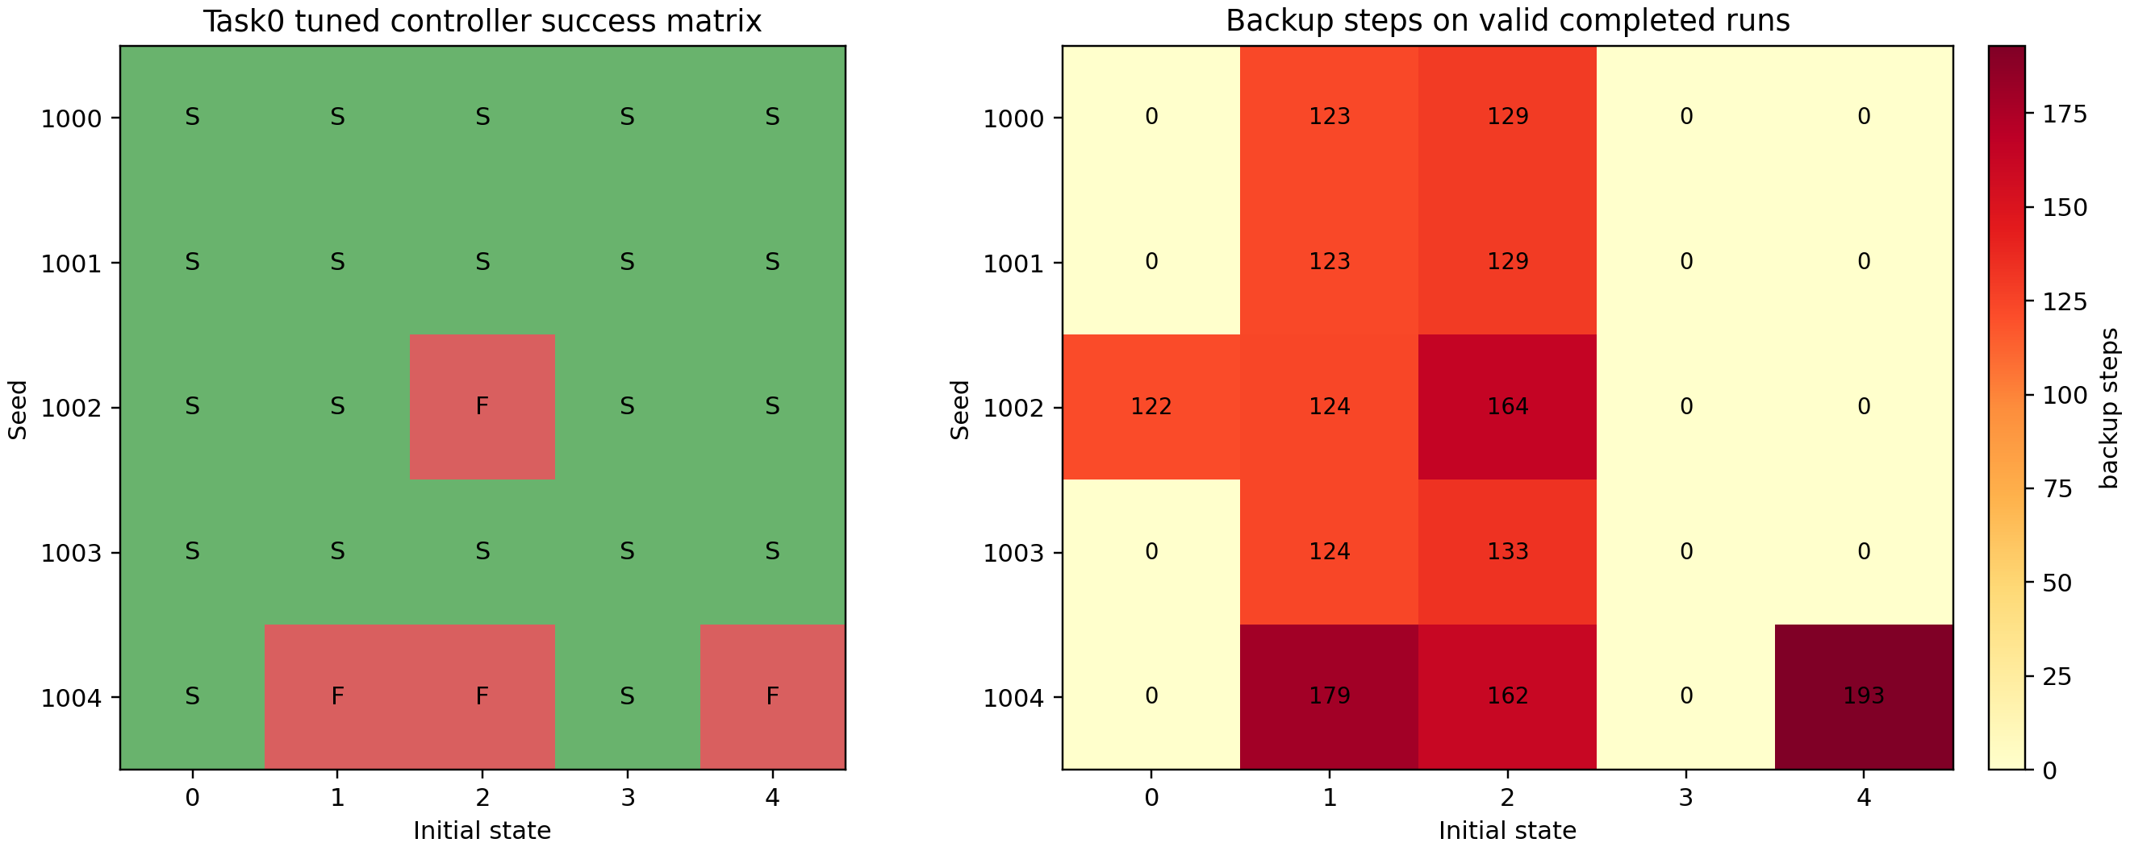
Figure A1. Task0 5-seed success matrix and backup burden.
Seed | Init | Status | Success | Steps | Backup | Expert | Immediate | Risk | Retrieval conf | Notes
1000 | 0 | complete | true | 71 | 0 | none | false | n/a | n/a | valid rollout artifact
1000 | 1 | complete | true | 202 | 123 | 1 | false | 0.515 | 0.992 | valid rollout artifact
1000 | 2 | complete | true | 222 | 129 | 2 | false | 0.642 | 0.997 | valid rollout artifact
1000 | 3 | complete | true | 72 | 0 | none | false | n/a | n/a | valid rollout artifact
1000 | 4 | complete | true | 70 | 0 | none | false | n/a | n/a | valid rollout artifact
1001 | 0 | complete | true | 96 | 0 | none | false | n/a | n/a | valid rollout artifact
1001 | 1 | complete | true | 213 | 123 | 1 | false | 0.803 | 0.417 | valid rollout artifact
1001 | 2 | complete | true | 220 | 129 | 2 | true | 0.846 | 0.665 | valid rollout artifact
1001 | 3 | complete | true | 74 | 0 | none | false | n/a | n/a | valid rollout artifact
1001 | 4 | complete | true | 68 | 0 | none | false | n/a | n/a | valid rollout artifact
1002 | 0 | complete | true | 219 | 122 | 1 | false | 0.634 | 0.472 | valid retryFull rollout replacing a one-step execution artifact
1002 | 1 | complete | true | 206 | 124 | 1 | false | 0.523 | 0.797 | valid rollout artifact
1002 | 2 | complete | false | 280 | 164 | 2 | false | 0.648 | 0.428 | valid rollout artifact
1002 | 3 | complete | true | 93 | 0 | none | false | n/a | n/a | valid rollout artifact
1002 | 4 | complete | true | 74 | 0 | none | false | n/a | n/a | valid rollout artifact
1003 | 0 | complete | true | 77 | 0 | none | false | n/a | n/a | valid rollout artifact
1003 | 1 | complete | true | 196 | 124 | 1 | false | 0.81 | 0.781 | valid rollout artifact
1003 | 2 | complete | true | 215 | 133 | 2 | false | 0.603 | 0.565 | valid rollout artifact
1003 | 3 | complete | true | 74 | 0 | none | false | n/a | n/a | valid rollout artifact
1003 | 4 | complete | true | 71 | 0 | none | false | n/a | n/a | valid rollout artifact
1004 | 0 | complete | true | 70 | 0 | none | false | n/a | n/a | valid rollout artifact
1004 | 1 | complete | false | 280 | 179 | 1 | false | 0.502 | 0.094 | valid rollout artifact
1004 | 2 | complete | false | 280 | 162 | 2 | false | 0.802 | 0.49 | valid rollout artifact
1004 | 3 | complete | true | 70 | 0 | none | false | n/a | n/a | valid rollout artifact
1004 | 4 | complete | false | 280 | 193 | 1 | false | 0.627 | 0.053 | valid rollout artifact

Interpretation: the old two-seed success result is now strengthened into a broader seed-level reliability result. At the same time, the four effective failures are scientifically useful: seed1002 init2, seed1004 init1, seed1004 init2, and seed1004 init4 define the hard cases for calibrated fallback and residual recovery.

Step 2 - Task1/task2 smoke test rather than full benchmark
Protocol: LIBERO Spatial task1 and task2 were evaluated as clean VLA smoke tests, not full recovery benchmarks. The purpose was to test whether the method narrative survives outside task0, without over-claiming broad benchmark generalization. The smoke set used task1/task2, seeds 1000-1002, init0-init2, max_steps=280. This section must be read as a sanity check only: it does not demonstrate that the recovery framework generalizes to task1/task2, because recovery-triggered rollouts on those tasks have not yet been evaluated.
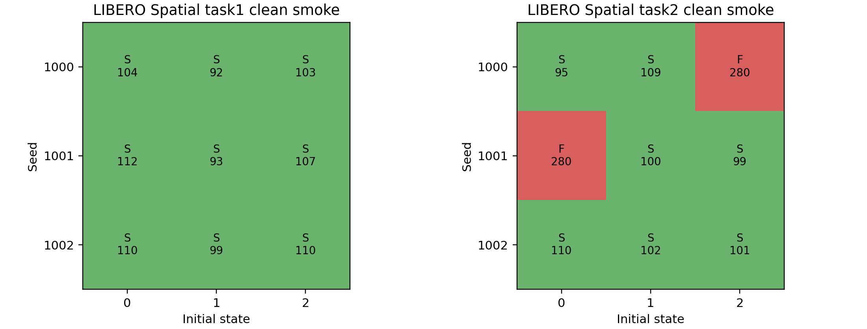
Figure A2. Task1/task2 clean-smoke success matrix.
Task | Seed | Init | Success | Steps | Final terminated | Final truncated | Notes
1 | 1000 | 0 | true | 104 | true | false | baseline clean VLA rollout; monitor diagnostics only
1 | 1000 | 1 | true | 92 | true | false | baseline clean VLA rollout; monitor diagnostics only
1 | 1000 | 2 | true | 103 | true | false | baseline clean VLA rollout; monitor diagnostics only
1 | 1001 | 0 | true | 112 | true | false | baseline clean VLA rollout; monitor diagnostics only
1 | 1001 | 1 | true | 93 | true | false | baseline clean VLA rollout; monitor diagnostics only
1 | 1001 | 2 | true | 107 | true | false | baseline clean VLA rollout; monitor diagnostics only
1 | 1002 | 0 | true | 110 | true | false | baseline clean VLA rollout; monitor diagnostics only
1 | 1002 | 1 | true | 99 | true | false | baseline clean VLA rollout; monitor diagnostics only
1 | 1002 | 2 | true | 110 | true | false | baseline clean VLA rollout; monitor diagnostics only
2 | 1000 | 0 | true | 95 | true | false | baseline clean VLA rollout; monitor diagnostics only
2 | 1000 | 1 | true | 109 | true | false | baseline clean VLA rollout; monitor diagnostics only
2 | 1000 | 2 | false | 280 | false | false | baseline clean VLA rollout; monitor diagnostics only
2 | 1001 | 0 | false | 280 | false | false | baseline clean VLA rollout; monitor diagnostics only
2 | 1001 | 1 | true | 100 | true | false | baseline clean VLA rollout; monitor diagnostics only
2 | 1001 | 2 | true | 99 | true | false | baseline clean VLA rollout; monitor diagnostics only
2 | 1002 | 0 | true | 110 | true | false | baseline clean VLA rollout; monitor diagnostics only
2 | 1002 | 1 | true | 102 | true | false | baseline clean VLA rollout; monitor diagnostics only
2 | 1002 | 2 | true | 101 | true | false | baseline clean VLA rollout; monitor diagnostics only

Interpretation: task1 is stable in this small smoke set, while task2 exposes natural failures. This is exactly the right level of claim for the current project: task1/task2 show transfer of the diagnostic framing, but recovery policies still need task-aware validation before being presented as a general benchmark solution. Therefore, application statements should say that task1/task2 indicate base-policy execution is not task0-only, but recovery generalization remains unproven.

Step 3 - From oracle object relation to visual/noisy task-state estimation
The current recovery stack still relies partly on object-position and object-target relation information. To move toward a paper-level VLA reliability project, this section adds a staged replacement route: first quantify a lightweight visual task-state estimator, then simulate its error as noisy object/target relations and test whether retrieval-conditioned recovery remains stable.
Visual estimator metric | Value | Meaning
Train files | task0_init0.npz; task0_init3.npz | Successful task0 visual recovery datasets used for fitting.
Test file | task0_init4.npz | Held-out init used for visual-state evaluation.
Train/test frames | 143 / 70 | Small but concrete visual estimator dataset.
Grasp accuracy | 0.900 | Binary grasp-state prediction from frozen visual features.
Grasp F1 | 0.868 | Balances false grasp and missed grasp.
Relative position MAE | 0.698 cm | Proxy for object-to-target relation error.
Retrieval action MAE | 0.117 | Nearest-neighbour visual action retrieval baseline.

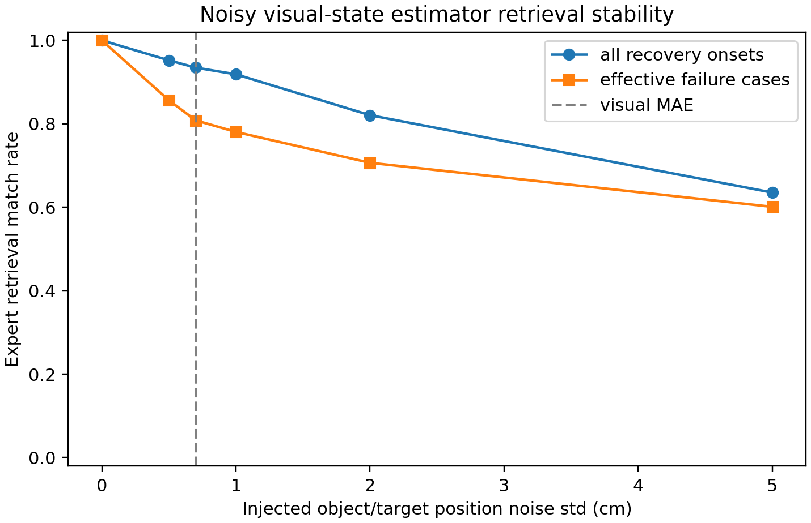
Figure A3. Retrieval stability under injected visual-state noise.
Noise std cm | Reference visual MAE cm | Retrieval match | Failure-case match | Mean confidence | Mean distance
0.0 | 0.698 | 1.000 | 1.000 | 0.527 | 0.0356
0.5 | 0.698 | 0.952 | 0.857 | 0.488 | 0.0391
0.7 | 0.698 | 0.935 | 0.808 | 0.458 | 0.0419
1.0 | 0.698 | 0.919 | 0.780 | 0.414 | 0.0466
2.0 | 0.698 | 0.821 | 0.707 | 0.300 | 0.0663
5.0 | 0.698 | 0.635 | 0.601 | 0.162 | 0.1388

Interpretation: near the current visual estimator regime, about 0.7 cm relative-position error, retrieval still matches the oracle expert in 93.5 percent of all recovery onsets and 80.8 percent of effective failure cases. At larger noise, retrieval confidence and match rate degrade, which gives a concrete reliability boundary for replacing oracle state with visual state. This should be described as a non-oracle ablation or visual-state replacement precursor, not as a solved visual closed-loop estimator.

Step 4 - Held-out calibration instead of hand thresholding
The earlier immediate fallback rule, risk >= 0.83 and retrieval_confidence <= 0.70, was useful as a pilot operating point, but it looked hand tuned. The upgrade therefore defines a calibration split and a held-out split. Calibration seeds are 1000, 1001, and 1002; held-out seeds are 1003 and 1004. The target label is whether a recovery rollout needs stronger intervention than the current learned phase expert, not generic episode failure.
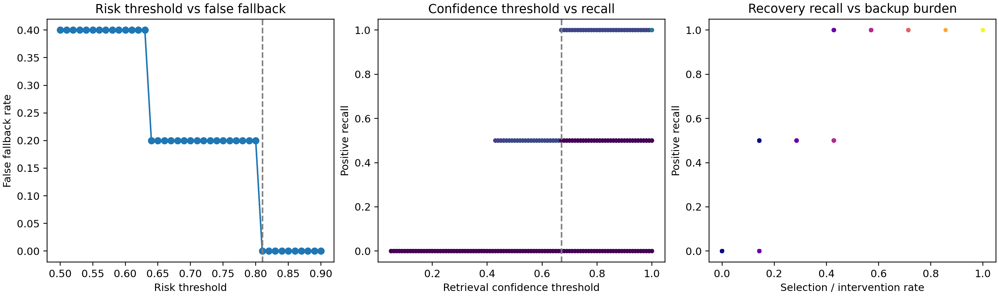
Figure A4. Held-out fallback calibration curves.
Split | Risk threshold | Confidence threshold | Recall | False fallback | Selected | TP | FP | FN
calibration | 0.81 | 0.67 | 0.500 | 0.000 | 1 | 1 | 0 | 1
heldout_test | 0.81 | 0.67 | 0.000 | 0.000 | 0 | 0 | 0 | 3

Interpretation: the fixed threshold is not yet robust under seed shift; under the conservative held-out operating point, seed1004-style failures are missed. This does not invalidate the project. Instead, it defines the next PhD-level problem: how to build adaptive calibration or seed/object-relation-aware fallback routing for VLA recovery.

Step 5 - Residual/demo-anchored recovery boundary test
The final upgrade evaluates a stronger low-confidence fallback rule on the four new effective failures. The tested rule uses risk >= 0.50 and retrieval_confidence <= 0.50 to switch to stronger demo anchoring. This does not yet implement a full residual RL controller, but it directly tests the central hypothesis that demonstrations act as a safety prior and stronger intervention can rescue some low-confidence recovery states.
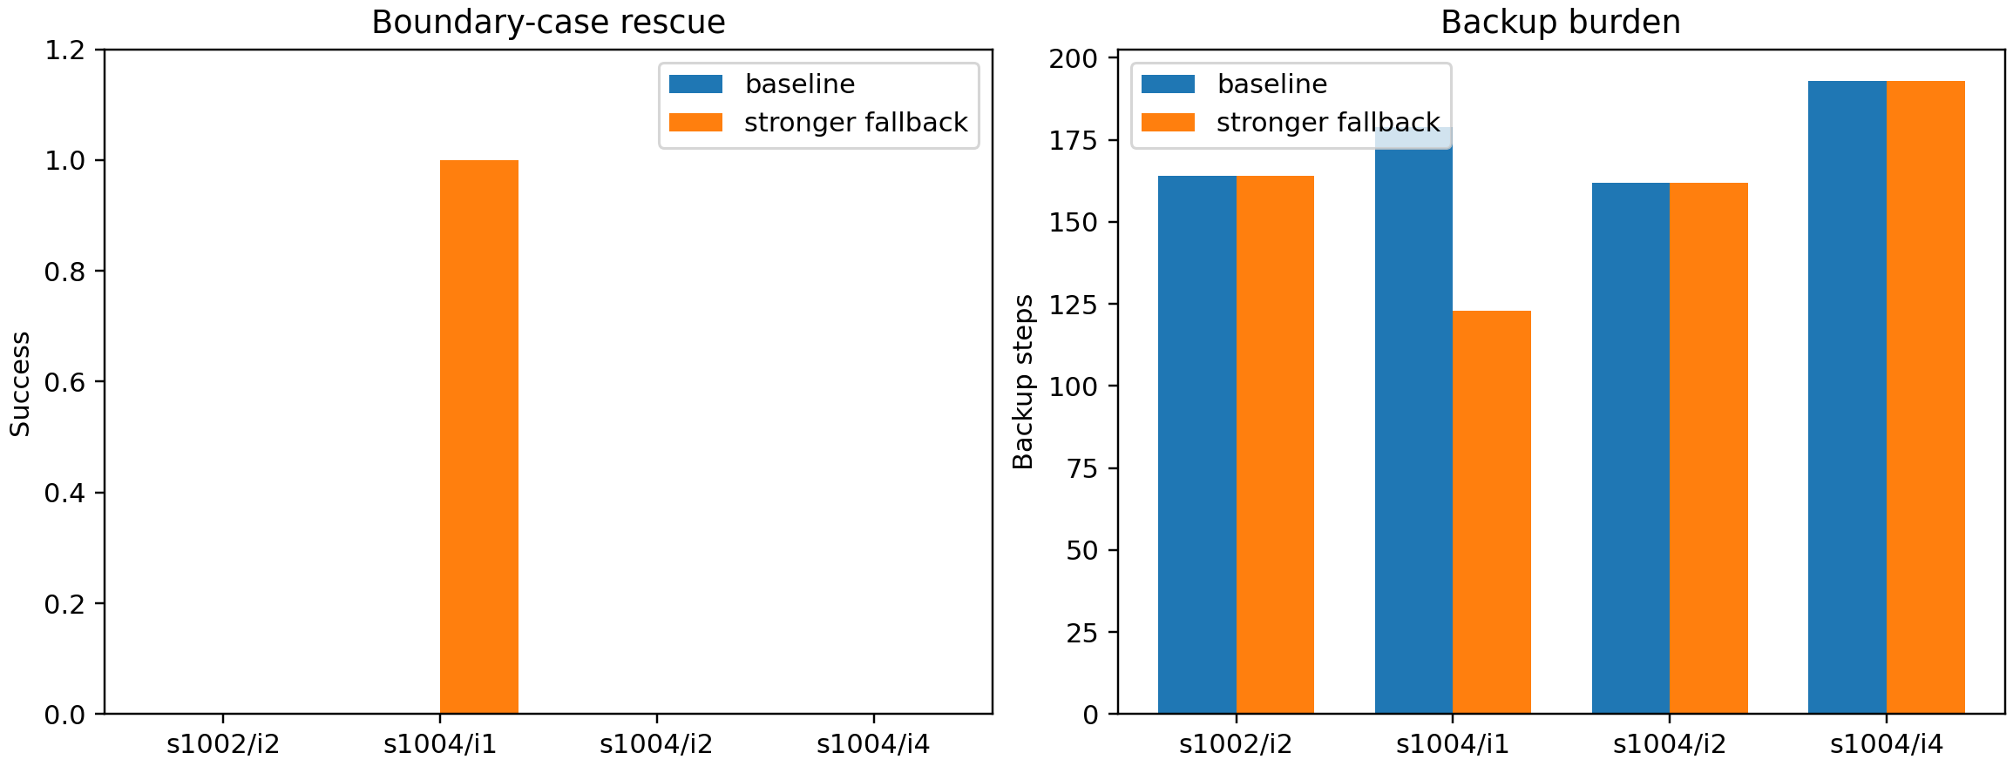
Figure A5. Stronger fallback result on the four new boundary failures.
Seed | Init | Baseline success | Stronger success | Baseline backup | Stronger backup | Risk | Retrieval confidence | Interpretation
1002 | 2 | false | false | 164 | 164 | 0.648 | 0.428 | still needs residual/state-conditioned correction
1004 | 1 | false | true | 179 | 123 | 0.502 | 0.094 | rescued by stronger fallback
1004 | 2 | false | false | 162 | 162 | 0.802 | 0.49 | still needs residual/state-conditioned correction
1004 | 4 | false | false | 193 | 193 | 0.627 | 0.053 | still needs residual/state-conditioned correction

Interpretation: stronger fallback improves the new boundary set from 0/4 to 1/4 success by rescuing seed1004 init1. The remaining failures, seed1002 init2, seed1004 init2, and seed1004 init4, are exactly where a residual controller or better visual-state-conditioned retrieval should be introduced. This result prevents over-claiming and gives a clear next research problem.

Consolidated research claims after the upgrade
- Confirmed: HARP-VLA is no longer just a two-seed task0 success case; it now has 25 task0 seed/init outcomes and 18 task1/task2 smoke outcomes.
- Confirmed: many successful rollouts remain zero-backup, so the monitor/recovery system is selective rather than always intervening.
- Confirmed: visual/noisy task-state replacement is plausible near the current 0.7 cm visual estimator error level, but retrieval stability degrades as state noise grows.
- Confirmed: held-out calibration exposes that conservative thresholds can miss new seed-shift failures.
- Suggested but not fully proven: residual/demo-anchored recovery should improve the remaining boundary cases, because stronger demo fallback rescues one low-confidence case but not all cases.
- Still unproven: full task1/task2 recovery, real visual closed-loop replacement, and statistically robust threshold calibration across more tasks.

How to present this in PhD applications
The upgraded project should be framed as runtime instability analysis and selective recovery for VLA robotic policies. The strongest story is not that a threshold magically fixes LIBERO; the stronger story is that the project now studies how VLA failure appears at runtime, how intervention should be calibrated, how visual task-state uncertainty affects recovery retrieval, and why recovery demonstrations should become safety priors for residual controllers. In applications, lead with the 21/25 upgraded result, then explicitly say the 10/10 two-seed result was the initial evidence. The honest pitch is stronger than a polished but brittle success story: the project has a working prototype, real boundary cases, and a concrete research path for adaptive calibration, visual-state replacement, and residual recovery.
Application-facing message | Evidence from this addendum | Connection to target supervisors
Runtime reliability, not just success rate | Task0 seed expansion plus task1/task2 smoke | Matches medical AI reliability and robot learning reliability interests.
Selective intervention under false-fallback cost | Held-out calibration panel and zero-backup successes | Connects to uncertainty, calibration, and safety-aware ML.
VLA failure is state- and retrieval-dependent | Failure boundary cases with risk and retrieval confidence | Connects to embodied intelligence and foundation-policy failure modes.
Visual-state replacement path | Visual estimator and noisy-state retrieval ablation | Connects to perception-conditioned robotic manipulation.
Residual recovery is justified by evidence | Stronger fallback rescues 1/4 but leaves residual correction target | Connects to RL, residual policy learning, and robust closed-loop control.

How to use the project now
- One-sentence project title: Runtime Instability Analysis and Selective Recovery for Vision-Language-Action Robotic Policies.
- Strongest evidence sentence: Task0 has 25 valid seed/init evaluations with 21/25 success, 13 zero-backup successes, and 4 effective recovery failures; the earlier 10/10 two-seed result is initial tuned-controller evidence.
- Honest limitation sentence: held-out calibration shows fixed thresholds are not robust under seed shift, so adaptive calibration is a central PhD question.
- Task-generalization sentence: task1/task2 clean smoke is a sanity check for base-policy execution, not a recovery-generalization benchmark.
- Visual-state sentence: noisy-state and visual-estimator ablations reduce oracle-state dependence, but full visual closed-loop recovery remains future work.
- Next-method sentence: the remaining failures motivate residual/demo-anchored recovery, where demonstrations act as safety priors and residual policies learn local contact corrections.

2026-06-25 Addendum: Representation-Guided Recovery Visual Upgrade
中文：表征引导的 VLA/VOA 操作恢复与执行期可靠性层
This addendum integrates the 2026-06-25 VOA upgrade into the existing HARP-VLA report. The focus is visual evidence: route decisions, feature explanations, retrieval confidence, risk gating, timing ablations, and schematic execution diagnostics.
核心表达：RAM makes the robot spatially aware before execution; HARP-VLA/VOA makes the robot failure-aware during execution.
中文：RAM 让机器人执行前更懂空间；HARP-VLA/VOA 让机器人执行中更懂失败。

Upgrade Summary
Main upgrade. The project is no longer framed only as post-failure recovery. It now has an execution-time reliability layer that uses embedding distance, action-outcome residual, progress slope, retrieval confidence, local failure-neighbor ratio, and start risk to select the recovery route and strength.
Evidence status. The current run is a synthetic smoke validation of the pipeline and visualization stack. It should be replaced by real VOA rollout features before making empirical robot-performance claims.
Smoke-run numbers. Route-classifier accuracy is 0.944, macro-F1 is 0.943, missed manual/demo escalation rate is 0.073, and false manual/demo escalation rate is 0.019.

Visual Process Added
- Route distribution chart: shows the five-route decision surface is populated.
- Feature importance chart: shows which reliability signals drive classifier decisions.
- Risk-confidence scatter: makes the demo-anchor and human-review gate visually inspectable.
- Residual-progress scatter: shows when light recovery becomes strong recovery.
- Execution manifold proxy: gives a compact map of success, recovery, and review regions.
- Route confidence histogram: supports later calibration and selective prediction.
- Rollout timeline: shows when recovery triggers happen during an episode.
- Timing ablation chart and heatmap: show immediate versus delayed recovery behavior.
- Simulation-style diagnostic panels: provide intuitive process visuals without claiming real simulator screenshots.

Representation-Guided Recovery Pipeline
Layer | Inputs | Purpose
Execution embedding | policy/action/state embedding norms, embedding distance | Places the current rollout window relative to success/recovery evidence.
Action-outcome residual | intended action versus observed outcome | Detects slip, contact mismatch, or failed subgoal execution.
Retrieval confidence | retrieval distance or success/failure retrieval distances | Separates trusted retrieval evidence from uncertain states.
Risk gate | start risk, risk score, failure-neighbor ratio | Routes high-risk or low-confidence cases toward demo anchor or human review.
Route classifier | continue, recover_light, recover_strong, demo_anchor, human_review | Turns reliability signals into recovery strength and intervention policy.
Timing ablation | immediate, +10 steps, +40 steps, no recovery | Tests when recovery must be triggered to remain useful.

Visual Evidence Pack
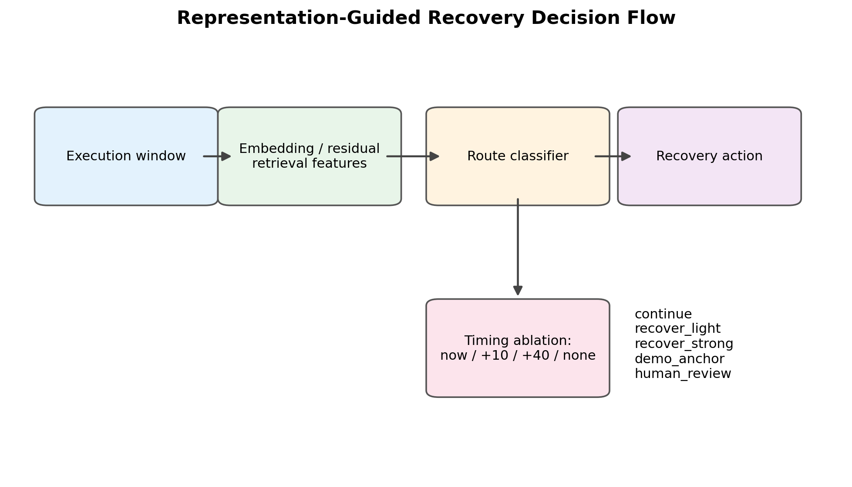
Figure V1. Representation-guided recovery decision flow. This visual summarizes how execution windows become route and timing decisions.
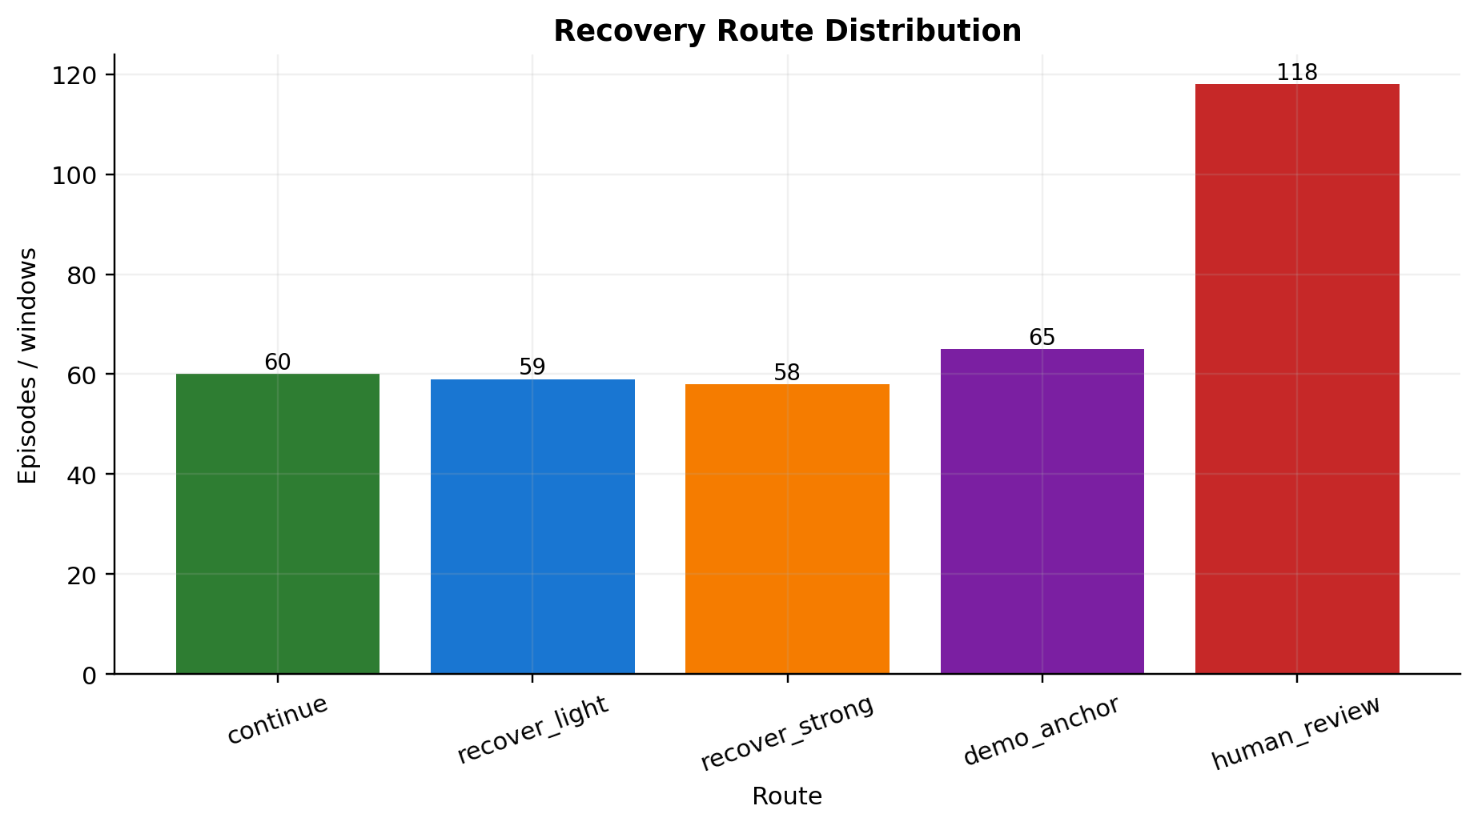
Figure V2. Recovery route distribution in the current synthetic smoke run. The distribution verifies that all five routing decisions are represented.
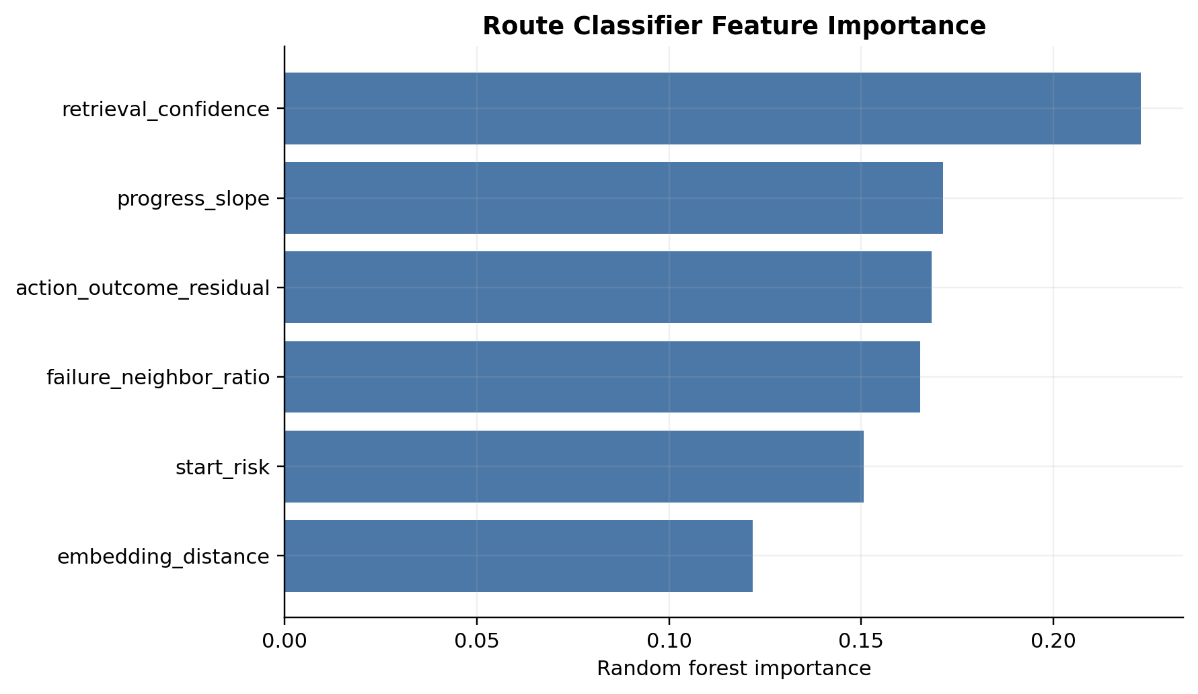
Figure V3. Feature importance for the recovery route classifier. Retrieval confidence, progress slope, residual, and local failure evidence are the main explanatory signals.
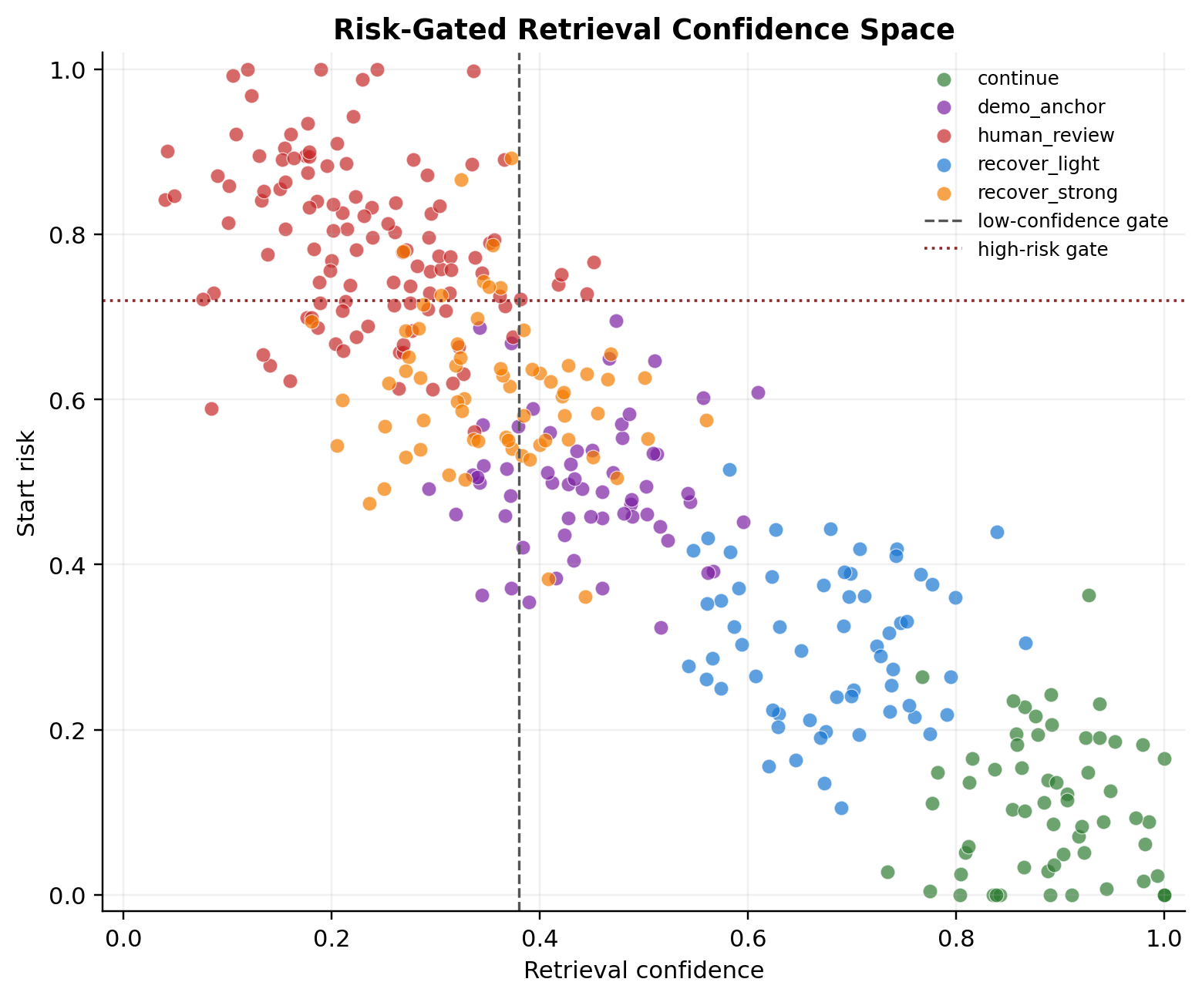
Figure V4. Risk-gated retrieval confidence space. Low confidence and high risk form the region where demo anchoring or human review becomes preferable.
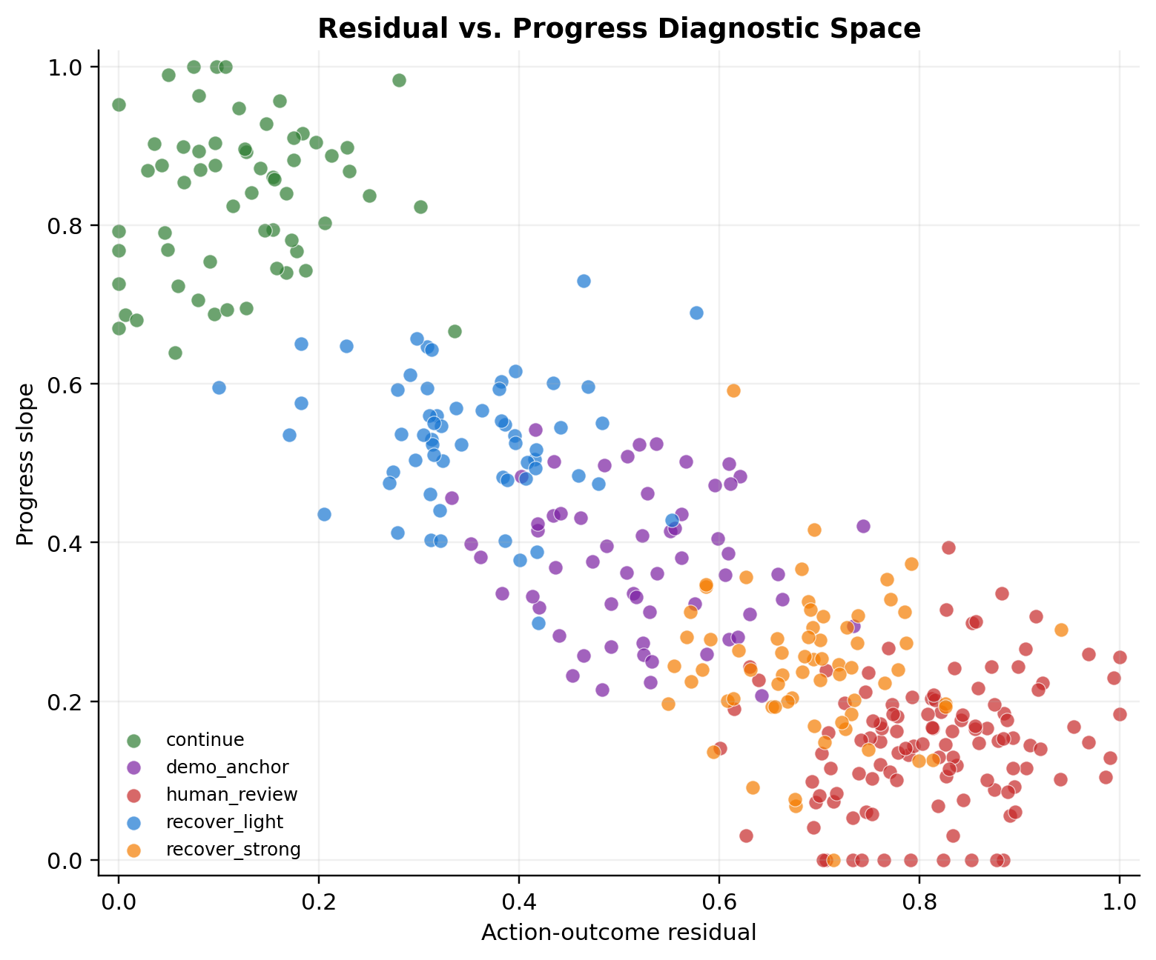
Figure V5. Residual versus progress diagnostic space. Strong recovery is associated with high action-outcome residual and low progress.
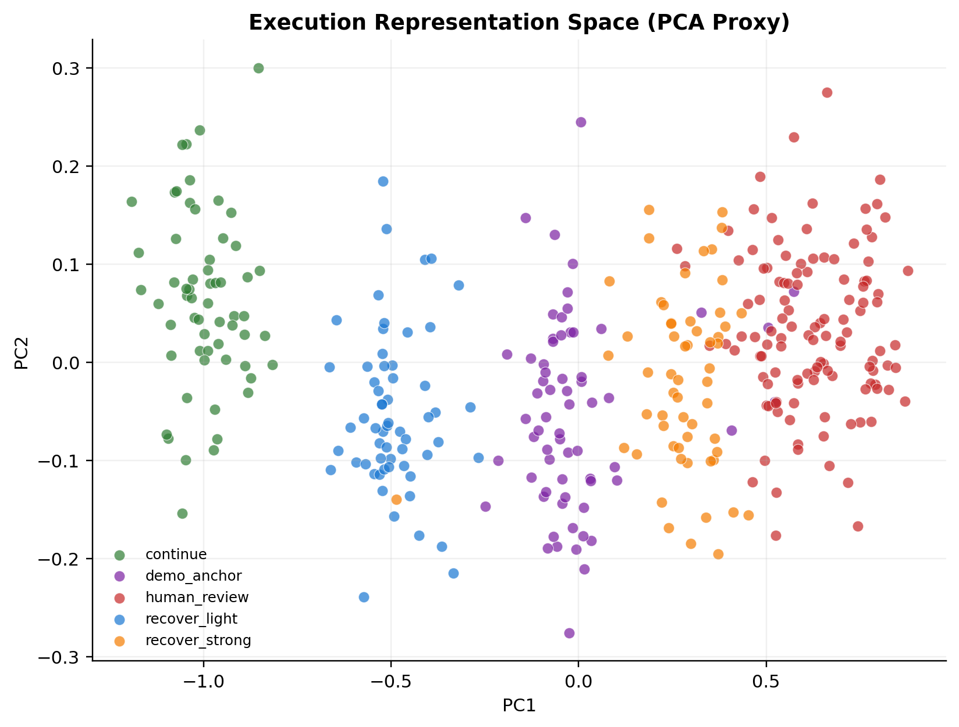
Figure V6. PCA proxy of the execution representation space. This is a visualization of the feature manifold, not a claim about a learned latent space unless real embeddings are supplied.
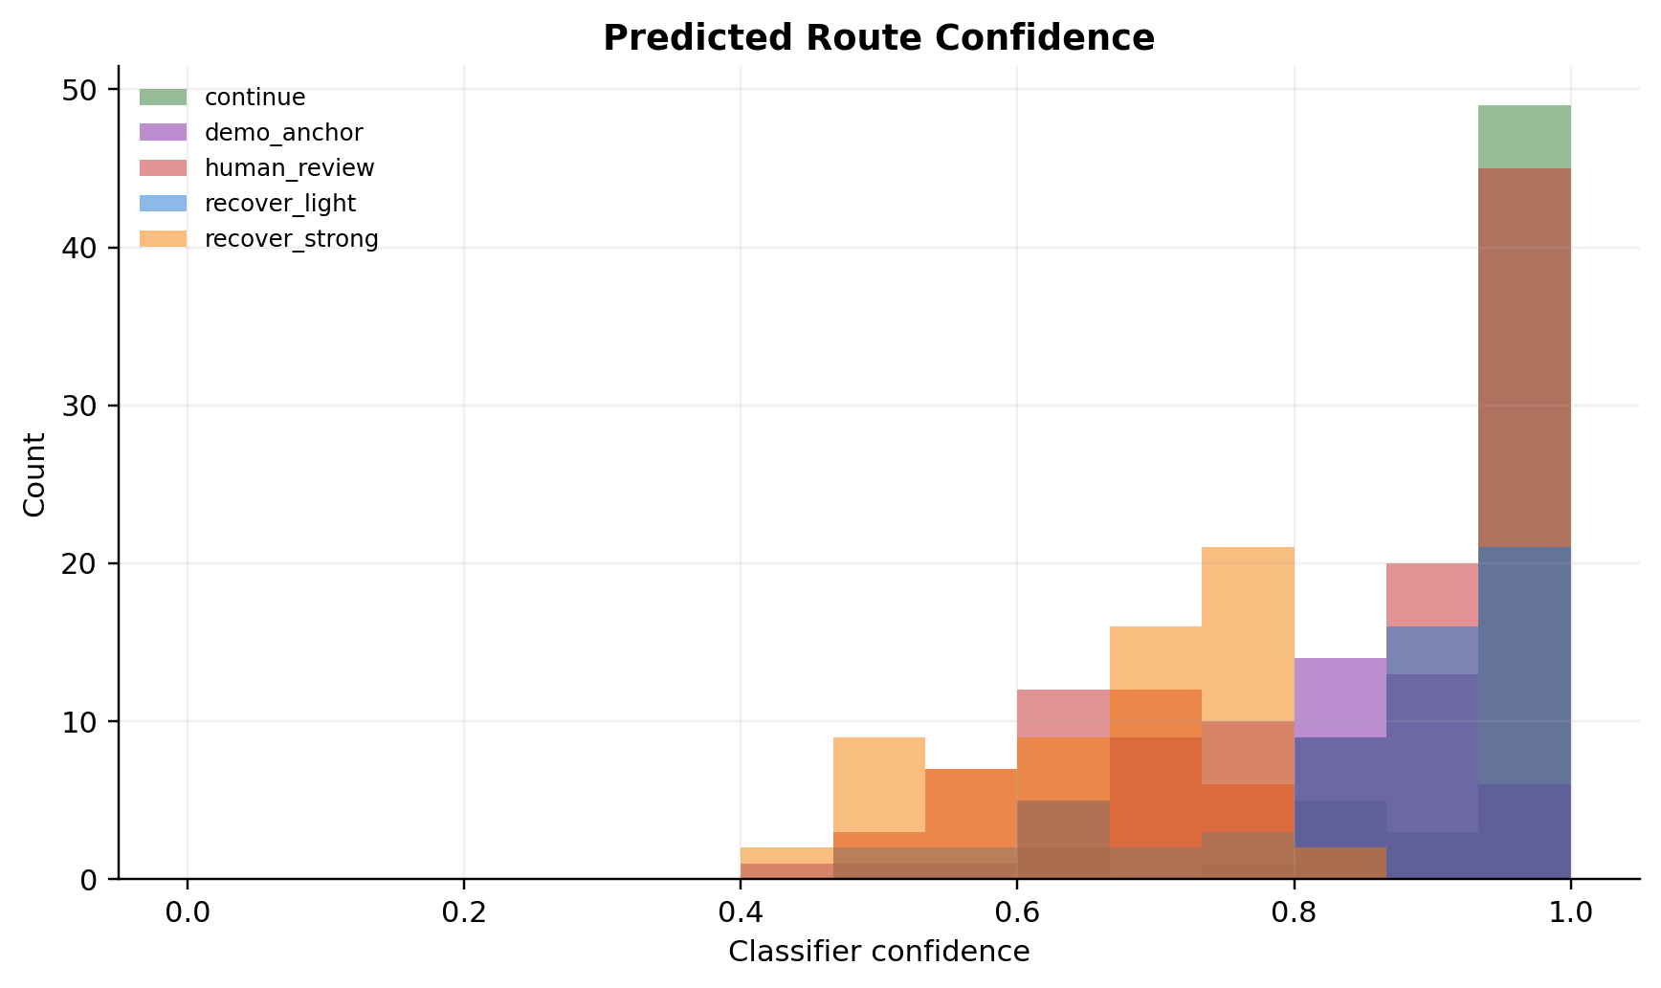
Figure V7. Predicted route confidence distribution. This supports selective reporting and later calibration analysis.
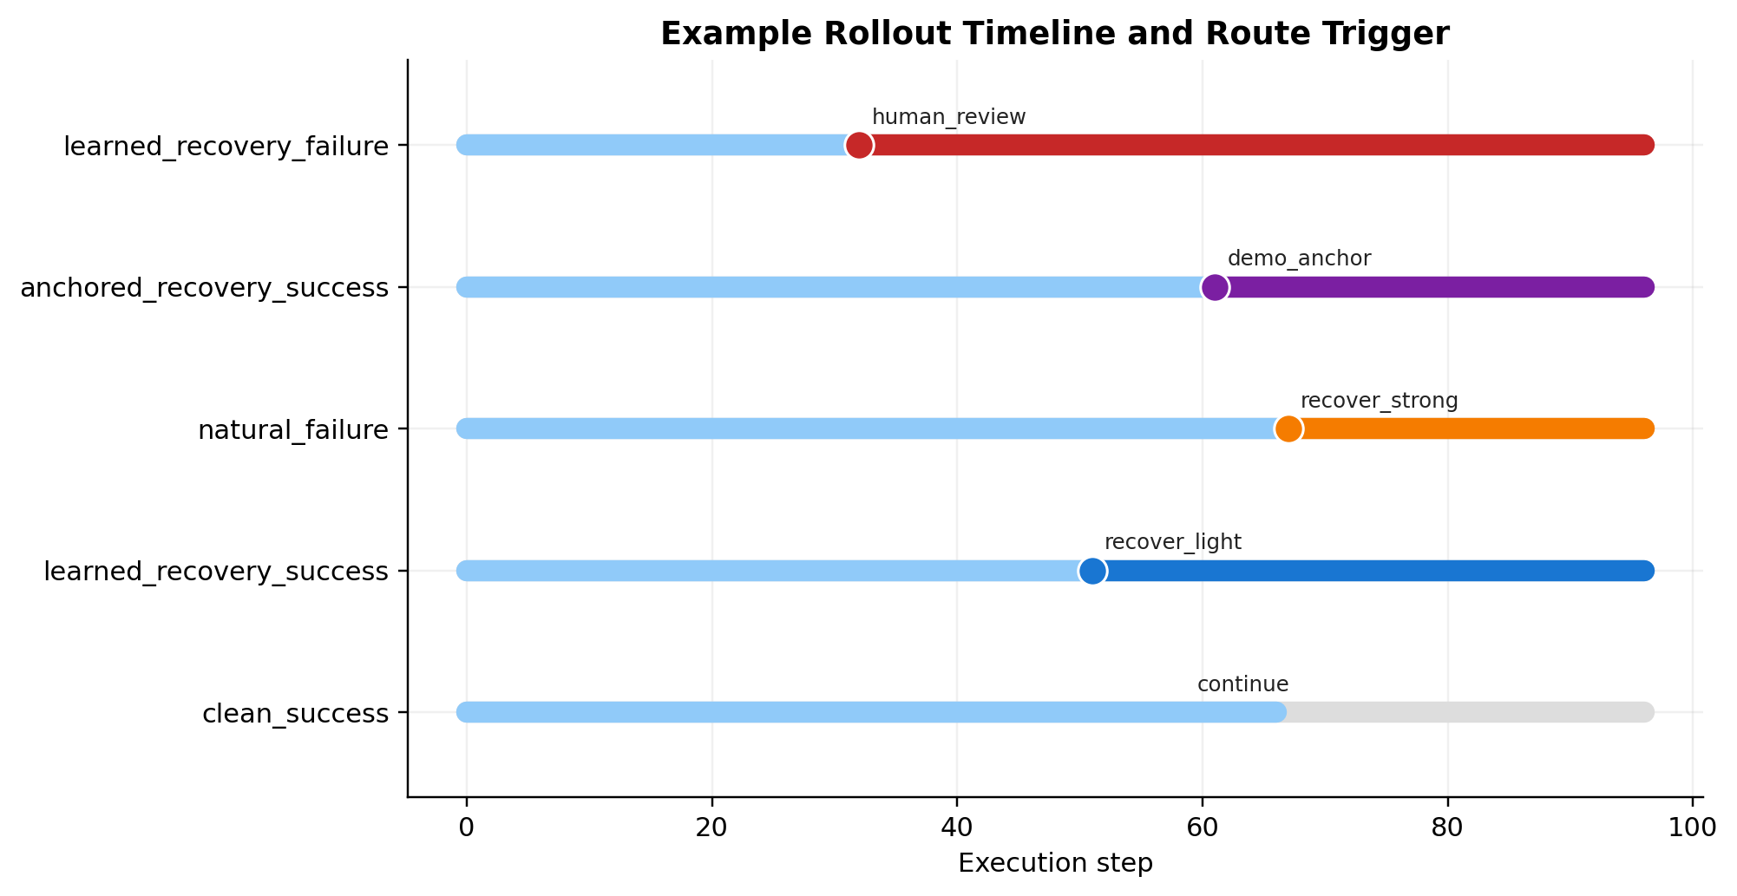
Figure V8. Example rollout timeline showing when route triggers occur during an episode.
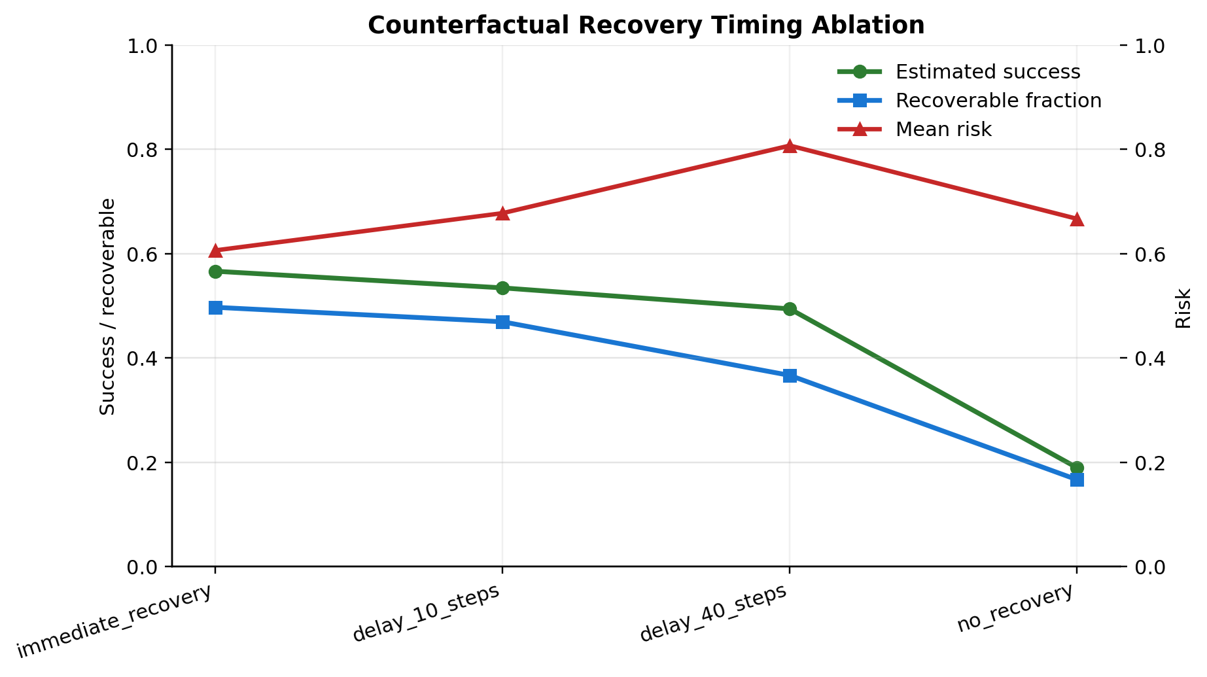
Figure V9. Counterfactual timing ablation. Earlier recovery remains more effective than delayed or absent recovery under the proxy model.
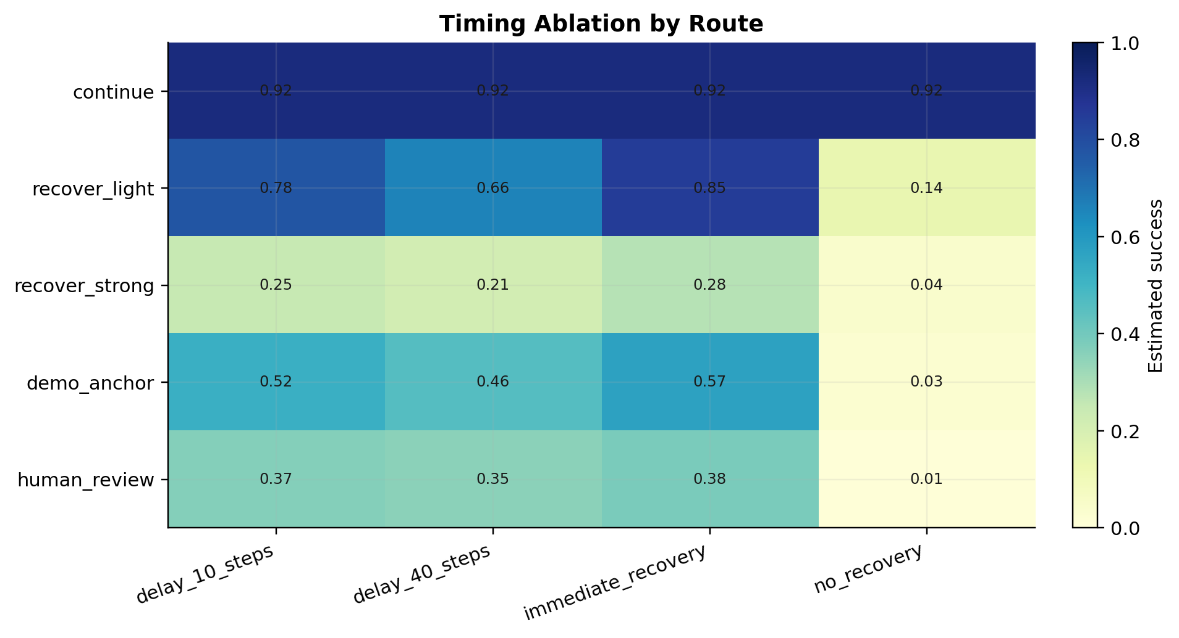
Figure V10. Timing sensitivity by route. Route-specific timing summaries show which cases degrade fastest when recovery is delayed.
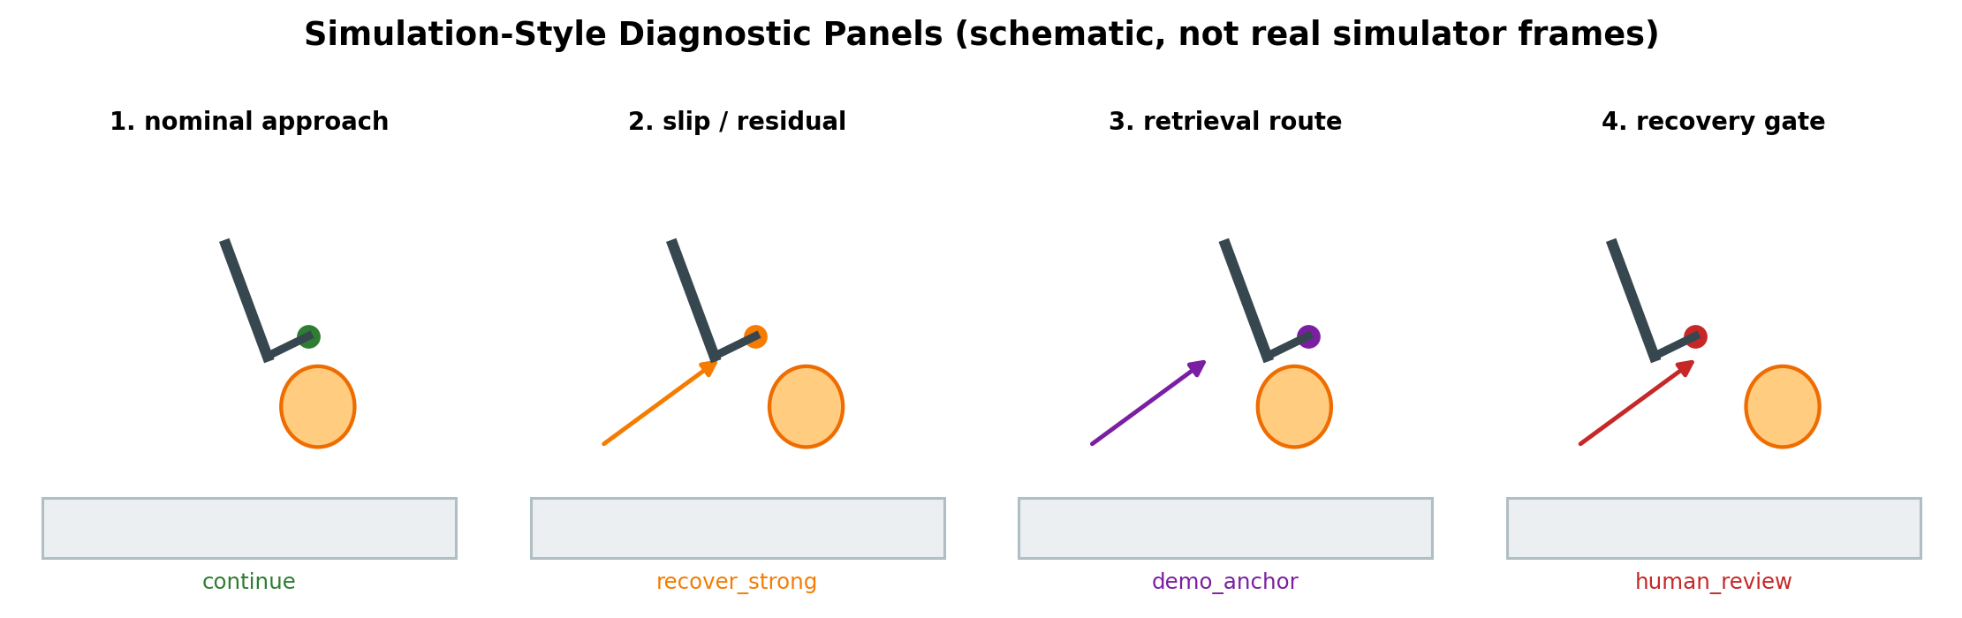
Figure V11. Simulation-style diagnostic panels. These are schematic process visuals for explanation, not real simulator screenshots.

Classifier Metrics
Metric | Value | Interpretation
Run label | voa_synthetic_smoke | Current output label
Dataset mode | synthetic_smoke_run | synthetic smoke run unless real rollout CSV is supplied
Episodes/windows | 360 | Number of rows used by the classifier
Accuracy | 0.944 | Overall held-out route prediction accuracy
Macro-F1 | 0.943 | Class-balanced route prediction score
Missed escalation | 0.073 | Manual/demo cases incorrectly routed as automatic
False escalation | 0.019 | Automatic cases conservatively escalated to demo/review

Feature Importance and Interpretation
Feature | Importance | Interpretation
retrieval_confidence | 0.223 | Confidence that retrieval evidence matches the current state.
progress_slope | 0.171 | Recent task-progress trend; low slope means stalled execution.
action_outcome_residual | 0.168 | Mismatch between intended action and observed outcome.
failure_neighbor_ratio | 0.165 | Local density of historical failure neighbors.
start_risk | 0.151 | Risk estimate at the beginning of the recovery decision window.
embedding_distance | 0.122 | Distance from retrieved success/recovery manifold.

Counterfactual Recovery Timing
Policy | Delay | Est. success | Mean risk | Recoverable fraction
immediate_recovery | 0 | 0.566 | 0.606 | 0.497
delay_10_steps | 10 | 0.534 | 0.678 | 0.469
delay_40_steps | 40 | 0.494 | 0.807 | 0.367
no_recovery | none | 0.190 | 0.667 | 0.167

Research Claims After This Visual Upgrade
Confirmed by the new artifact
- The upgraded VOA/HARP-VLA reliability layer runs end to end and produces structured metrics, predictions, explanations, timing tables, and visual outputs.
- The method can present failure-aware execution decisions as interpretable plots rather than only text logs.
- The Word report now contains a richer visual appendix suitable for supervisor review, PhD application discussion, or paper-planning material.
Suggested but not yet proven
- Embedding distance, residual, retrieval confidence, and risk may be sufficient to distinguish light recovery, strong recovery, demo anchoring, and human review in real rollouts.
- Earlier recovery should be more useful than delayed recovery when risk and residual grow over time.
Still unproven
- Real simulator or hardware success-rate improvement has not been established by the synthetic smoke run.
- Cross-task generalization and calibrated safety thresholds still need real rollout data.
- The diagnostic panels are schematic explanatory visuals, not simulator screenshots.

How To Replace Smoke Visuals With Real VOA Evidence
- Export a real rollout-level or window-level CSV with execution_status or route_label plus the six classifier inputs.
- Run: python scripts/run_voa_recovery_upgrade.py --input-rollouts path/to/voa_rollout_features.csv --run-label voa_real_rollouts
- Run: python scripts/generate_voa_visuals.py
- Rebuild this addendum so the report figures reflect the real rollout table.
Required output locations: outputs/recovery_route_classifier/metrics.json, confusion_matrix.png, feature_importance.csv, route_predictions.csv, route_explanations.csv, and outputs/recovery_timing_ablation/summary.csv.

