Reliability-Aware Sequential and 3D Robot Perception
综合实验数据、实验细节与博士申请证据报告
项目路径: E:\lstm
生成日期: 2026-06-17
用途: GitHub 展示、导师沟通、博士申请研究经历整理

阅读说明
这份综合报告把当前项目已经产生的实验内容、实验数据、实验流程、实验规律、图片证据和局限性整合到一个 Word 文件中。报告以博士申请和导师沟通为目标，强调研究问题、证据链、可复现实验流程和下一步研究方向。
需要注意：部分 CSV 包含上千行样本级数据。为了让 Word 文件可打开、可阅读，正文放入关键统计、代表性预览和全部图片；完整 CSV、JSON、Markdown 子报告的路径在附录中列出，原文件仍保留在项目目录。

目录
- 1. 项目总体定位
- 2. 代码和数据结构
- 3. 实验总览与关键结果表
- 4. 视频序列模型与 embedding 诊断
- 5. 合成 3D 深度感知可靠性实验
- 6. 真实深度图准备与 smoke pipeline
- 7. TUM RGB-D 公开数据实验
- 8. 时序可靠性、姿态分析和 PCA 描述子
- 9. 校准、coverage-risk 与运行时监控
- 10. 轨迹残差与执行可靠性实验
- 11. 实验规律、博士申请价值和下一步计划
- 12. 附录: 指标、CSV 预览、图片索引和子报告

1. 项目总体定位
本项目当前的核心不是单纯追求一个分类器的最高准确率，而是围绕“可靠性”组织实验：当一个学习系统面对视频序列、深度图、点云几何或机器人轨迹时，如何判断当前输入、表示或执行结果是否已经偏离正常模式。
项目起点是 ResNet18 + LSTM 视频动作识别 baseline。随后项目被扩展为一个 reliability-aware perception and action monitoring prototype，覆盖 sequential perception、RGB-D robot perception、runtime assurance、calibration、selective prediction 和 trajectory residual monitoring。
- 研究问题: embedding-space evidence、校准分析和残差监控能否识别学习系统的不可靠状态。
- 应用方向: trustworthy ML、robot perception、embodied AI、safe autonomy、runtime assurance、safe RL、medical/surgical robotics。
- 当前状态: 研究原型和 evidence pack；有公开数据 TUM RGB-D 实验，有合成和 smoke 实验，也有明确局限性说明。

2. 代码和数据结构
目录/文件 | 作用
modules/model.py | 定义 ResNet18 + LSTM 视频动作识别模型，并支持提取 embedding。
modules/main.py | 训练入口: 加载 AVI 数据、训练、验证、预测、保存模型和指标。
modules/embedding_analysis.py | 提取验证集 embedding、置信度、熵、margin、PCA 图和分类报告。
modules/robot_3d_reliability.py | 深度图转点云、几何 embedding、深度腐蚀、风险评分、coverage-risk、TUM pose 分析相关工具。
modules/runtime_monitor.py | 把连续风险分数转成 NORMAL/SUSPECT/RECOVER/HUMAN_REVIEW 状态。
modules/calibration_analysis.py | 风险分数校准、ECE-style gap 和 coverage-risk 分析。
modules/trajectory_residual_demo.py | 计划轨迹 vs 实际轨迹的残差可靠性实验。
docs/ | 项目概览、导师一页纸、申请证据包、数据卡模板等文档。
outputs/ | 实验结果、CSV、JSON、Markdown 报告和图片。

3. 实验总览与关键结果表
下表整合了当前项目中最重要的实验指标。ROC-AUC 越接近 1，表示风险分数越能把正常样本和异常/失败样本排序分开；Spearman 相关越高，表示 embedding shift 与真实相机运动或轨迹变化的单调关系越强。
实验层 | 指标字段 | 结果 | 来源文件
Synthetic 3D reliability | embedding_risk_roc_auc_for_corruption_detection | 0.794 | outputs/robot_3d_demo/robot_3d_metrics.json
Synthetic 3D multi-seed | embedding_risk_roc_auc_mean | 0.804 | outputs/robot_3d_multiseed/robot_3d_multiseed_metrics.json
Smoke real-depth corruption | embedding_risk_roc_auc_for_corruption_detection | 0.880 | outputs/real_depth_corruption_smoke/real_depth_corruption_metrics.json
Prepared-depth pipeline smoke | embedding_risk_roc_auc_for_corruption_detection | 0.868 | outputs/robot_3d_pipeline_smoke/corruption_benchmark/real_depth_corruption_metrics.json
TUM RGB-D source-paired corruption | embedding_risk_roc_auc_for_corruption_detection | 1.000 | outputs/tum_rgbd_freiburg1_desk_robot_3d/corruption_benchmark/real_depth_corruption_metrics.json
TUM scene-conditioned baseline | scene_conditioned_roc_auc_for_corruption_detection | 0.483 | outputs/tum_rgbd_freiburg1_desk_robot_3d/corruption_benchmark/real_depth_corruption_metrics.json
TUM temporal excess scoring | temporal_excess_roc_auc_for_corruption_detection | 1.000 | outputs/tum_rgbd_freiburg1_desk_temporal/temporal_depth_metrics.json
TUM temporal local-distance baseline | temporal_local_roc_auc_for_corruption_detection | 0.483 | outputs/tum_rgbd_freiburg1_desk_temporal/temporal_depth_metrics.json
PCA descriptor rotation sensitivity | spearman_rotation_vs_embedding_shift | 0.540 | outputs/tum_rgbd_freiburg1_desk_pca_descriptor/tum_pca_depth_descriptor_metrics.json
Calibration ROC-AUC | roc_auc | 1.000 | outputs/tum_rgbd_calibration/calibration_metrics.json
Trajectory residual ROC-AUC | roc_auc | 0.990 | outputs/trajectory_residual_demo/trajectory_residual_metrics.json

关键读法: TUM source-paired 和 temporal excess 的 ROC-AUC 为 1.000，说明在受控深度腐蚀设置中，源图像配对或局部时间归一化可以非常清楚地识别异常；但 scene-conditioned baseline 约为 0.483，说明只用全局干净参考会被正常相机运动干扰。

4. 视频序列模型与 Embedding 诊断
视频部分使用 ResNet18 作为每一帧的 CNN 特征提取器，再用 LSTM 建模帧序列。模型最后输出动作类别，同时可以返回 LSTM 最后时间步的 hidden embedding。
- 输入形式: batch, sequence, 3-channel image, height, width。
- CNN 输出维度: ResNet18 的 512 维视觉特征。
- LSTM hidden dimension: 默认 256。
- 分类头: Dropout + Linear + ReLU + Linear。
- 诊断指标: accuracy、classification report、confusion matrix、confidence、entropy、margin、embedding PCA。
该部分对博士申请的价值在于: 它证明项目并不是停留在静态图像分类，而是从 sequential perception 出发，具备处理时间序列模型和内部表示分析的基础。
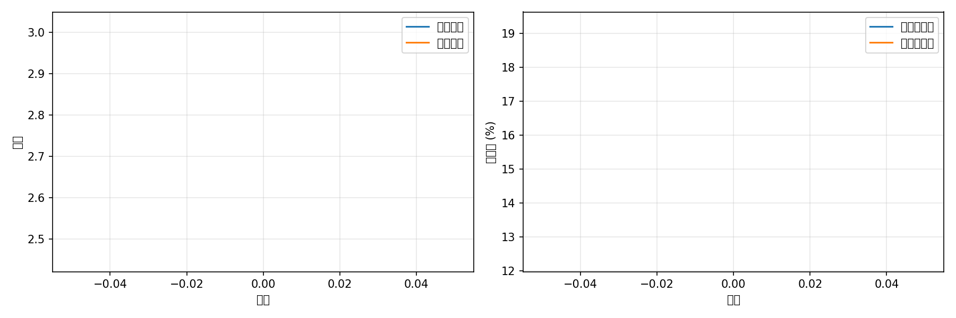
图 1. 视频 baseline 训练历史曲线。

视频测试预测文件预览
CSV 文件: modules/test_predictions.csv
行数: 839; 列数: 3; 列名: video_file, predicted_class, predicted_index
video_file | predicted_class | predicted_index
testvideo272.avi | WalkingWithDrill | 28
testvideo544.avi | PutDownPolisher | 24
testvideo001.avi | MoveLeftWhileDrilling | 14
testvideo002.avi | MoveBackwardsWhileDrilling | 2
testvideo003.avi | MoveLeftWhileDrilling | 14
testvideo004.avi | MoveLeftWhileDrilling | 14
testvideo005.avi | MoveLeftWhileDrilling | 14
testvideo006.avi | MoveLeftWhileDrilling | 14
testvideo007.avi | MoveLeftWhileDrilling | 14
testvideo008.avi | MoveLeftWhileDrilling | 14

5. 合成 3D 深度感知可靠性实验
合成 3D 实验的目的，是在不依赖真实机器人硬件的情况下，先验证一条完整的可靠性证据链: 生成深度场景、施加受控腐蚀、提取点云几何 embedding、用 clean reference 计算风险分数、评估高风险分数是否对应腐蚀样本。
项目 | 数值
合成 demo 样本数 | 288
干净样本数 | 48
腐蚀样本数 | 240
单次 demo ROC-AUC | 0.794
单次 demo coverage-risk AUC | 0.706
multi-seed seeds | [1, 2, 3]
multi-seed ROC-AUC mean ± std | 0.804 ± 0.028
multi-seed coverage-risk AUC mean ± std | 0.693 ± 0.022

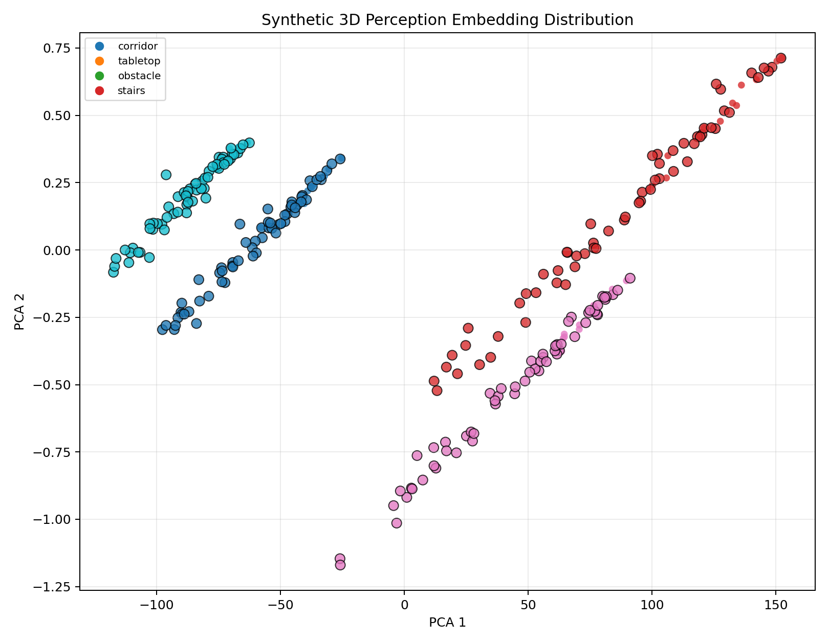
图 2. 合成 3D perception embedding 的 PCA 分布。
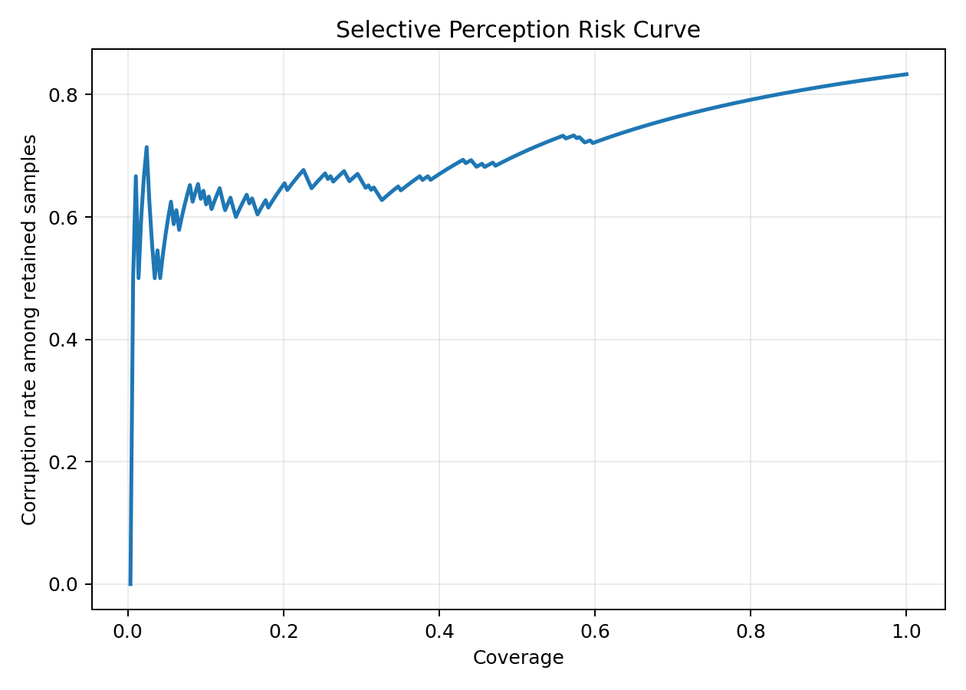
图 3. 合成 3D selective perception coverage-risk 曲线。
规律: 合成 3D 实验的 ROC-AUC 约为 0.80，说明简单几何 embedding 可以提供有用但不完美的可靠性信号。多 seed 结果给出了均值和标准差，比单次实验更适合对导师说明结果不是完全 cherry-pick。

Synthetic 3D multi-seed 逐 seed 结果
CSV 文件: outputs/robot_3d_multiseed/robot_3d_multiseed_results.csv
行数: 3; 列数: 6; 列名: seed, samples, clean_samples, corrupted_samples, embedding_risk_roc_auc, coverage_risk_auc
seed | samples | clean_samples | corrupted_samples | embedding_risk_roc_auc | coverage_risk_auc
1 | 192 | 32 | 160 | 0.7947265625 | 0.6966747544698917
2 | 192 | 32 | 160 | 0.8357421875 | 0.669507535757156
3 | 192 | 32 | 160 | 0.7828125 | 0.7132697590163453

6. 真实深度图准备与 Smoke Pipeline
真实深度图 workflow 的作用，是把项目从纯合成数据推进到可复现的数据处理 pipeline。smoke 数据包含 corridor、obstacle、stairs、tabletop 等场景，用于验证准备、加载、embedding、腐蚀 benchmark 和图像输出是否连通。

Smoke real-depth scene summary
CSV 文件: outputs/real_depth_analysis_smoke/real_depth_scene_summary.csv
行数: 4; 列数: 5; 列名: scene, n, mean_valid_depth_ratio, mean_depth, mean_depth_std
scene | n | mean_valid_depth_ratio | mean_depth | mean_depth_std
corridor | 4 | 1.0 | 1.8560121357440948 | 0.2386411838233471
obstacle | 4 | 1.0 | 1.4055229723453522 | 0.2677501067519188
stairs | 4 | 1.0 | 2.042732834815979 | 0.3609775826334953
tabletop | 4 | 1.0 | 1.4509650468826294 | 0.1997176893055439

实验 | source files | samples | ROC-AUC | coverage-risk AUC
real_depth_corruption_smoke | 16 | 96 | 0.880 | 0.646
prepared_depth pipeline smoke | 12 | 72 | 0.868 | 0.655

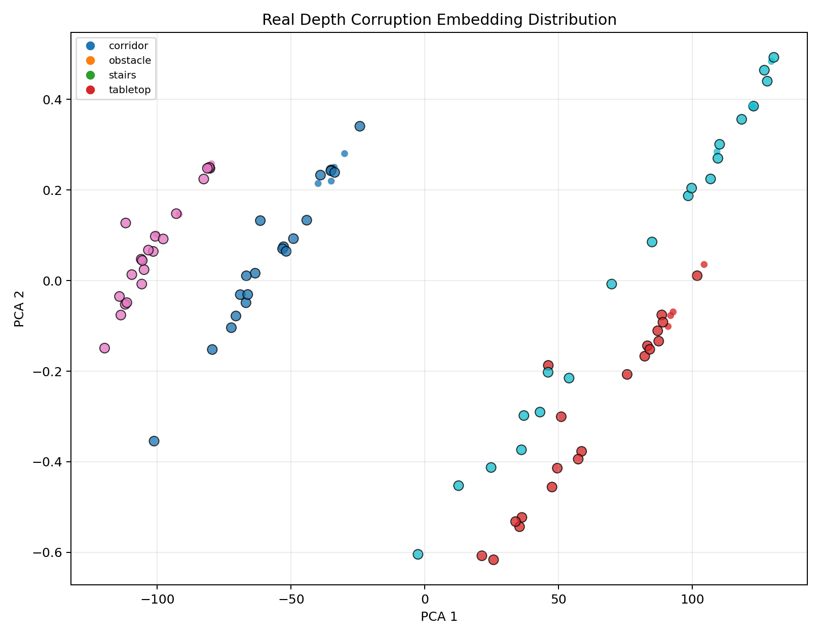
图 4. Smoke real-depth corruption embedding PCA。
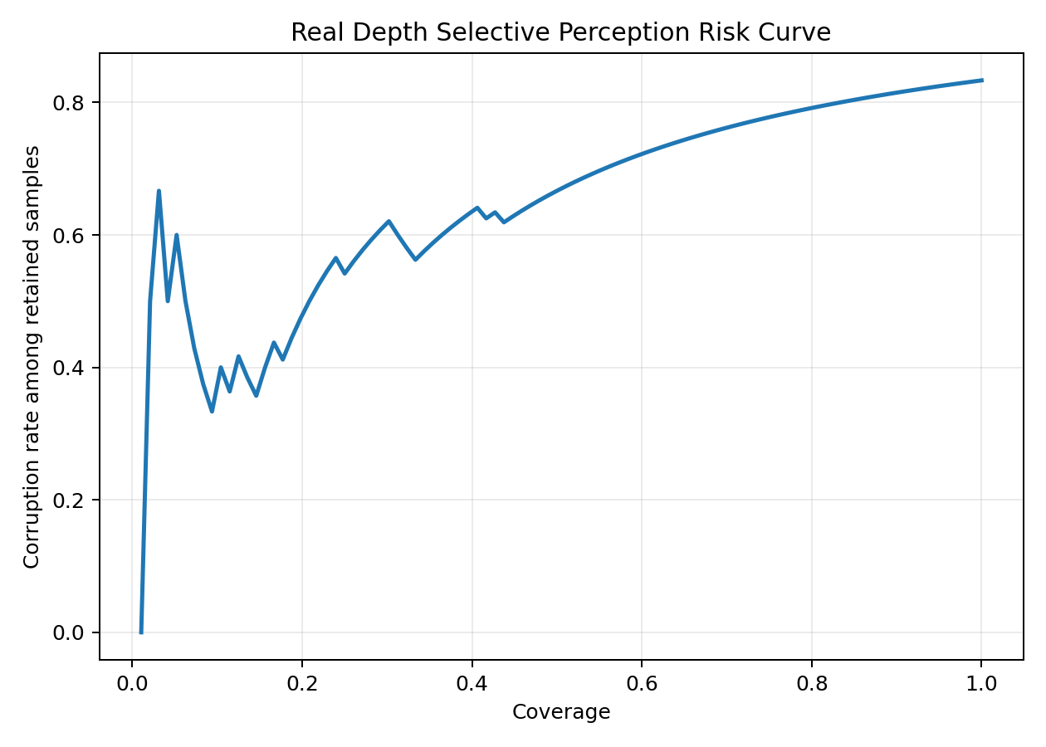
图 5. Smoke real-depth corruption coverage-risk 曲线。

7. TUM RGB-D 公开数据实验
TUM RGB-D 是公开 RGB-D 数据集。本项目使用 freiburg1_desk 序列的 300 个深度文件作为公开数据 evidence layer。实验首先分析真实深度图几何 embedding，再对每个深度图生成 clean、gaussian_noise、dropout、quantization、occlusion、tilt_shift 等受控版本。
项目 | 数值
depth_dir | data\prepared_depth\tum_rgbd_freiburg1_desk
profile samples | 300
scenes | ['unknown_scene']
corruption source files | 300
corruption total samples | 1800
clean samples | 300
corrupted samples | 1500
source-paired ROC-AUC | 1.000
scene-conditioned ROC-AUC | 0.483
coverage-risk AUC | 0.535

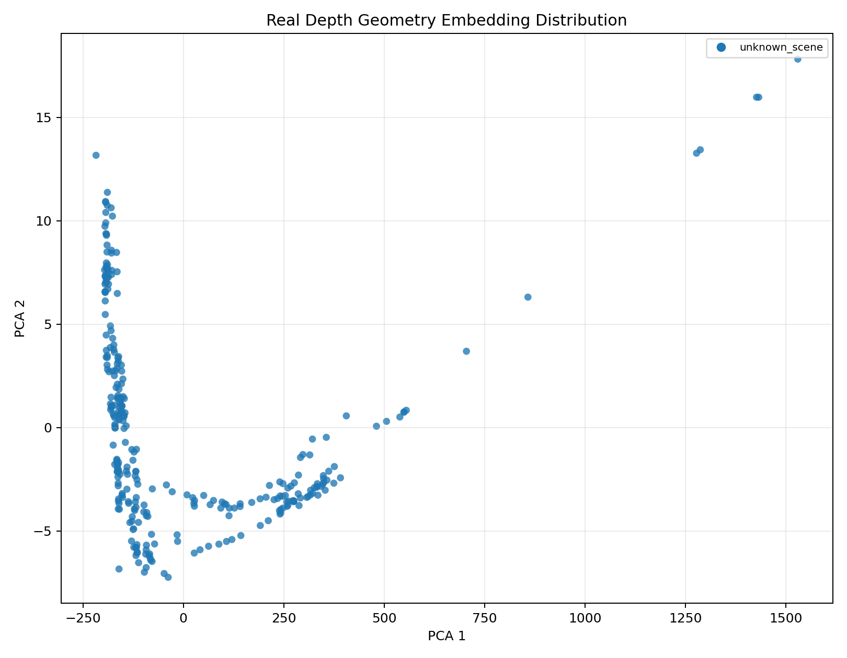
图 6. TUM RGB-D depth geometry embedding PCA。
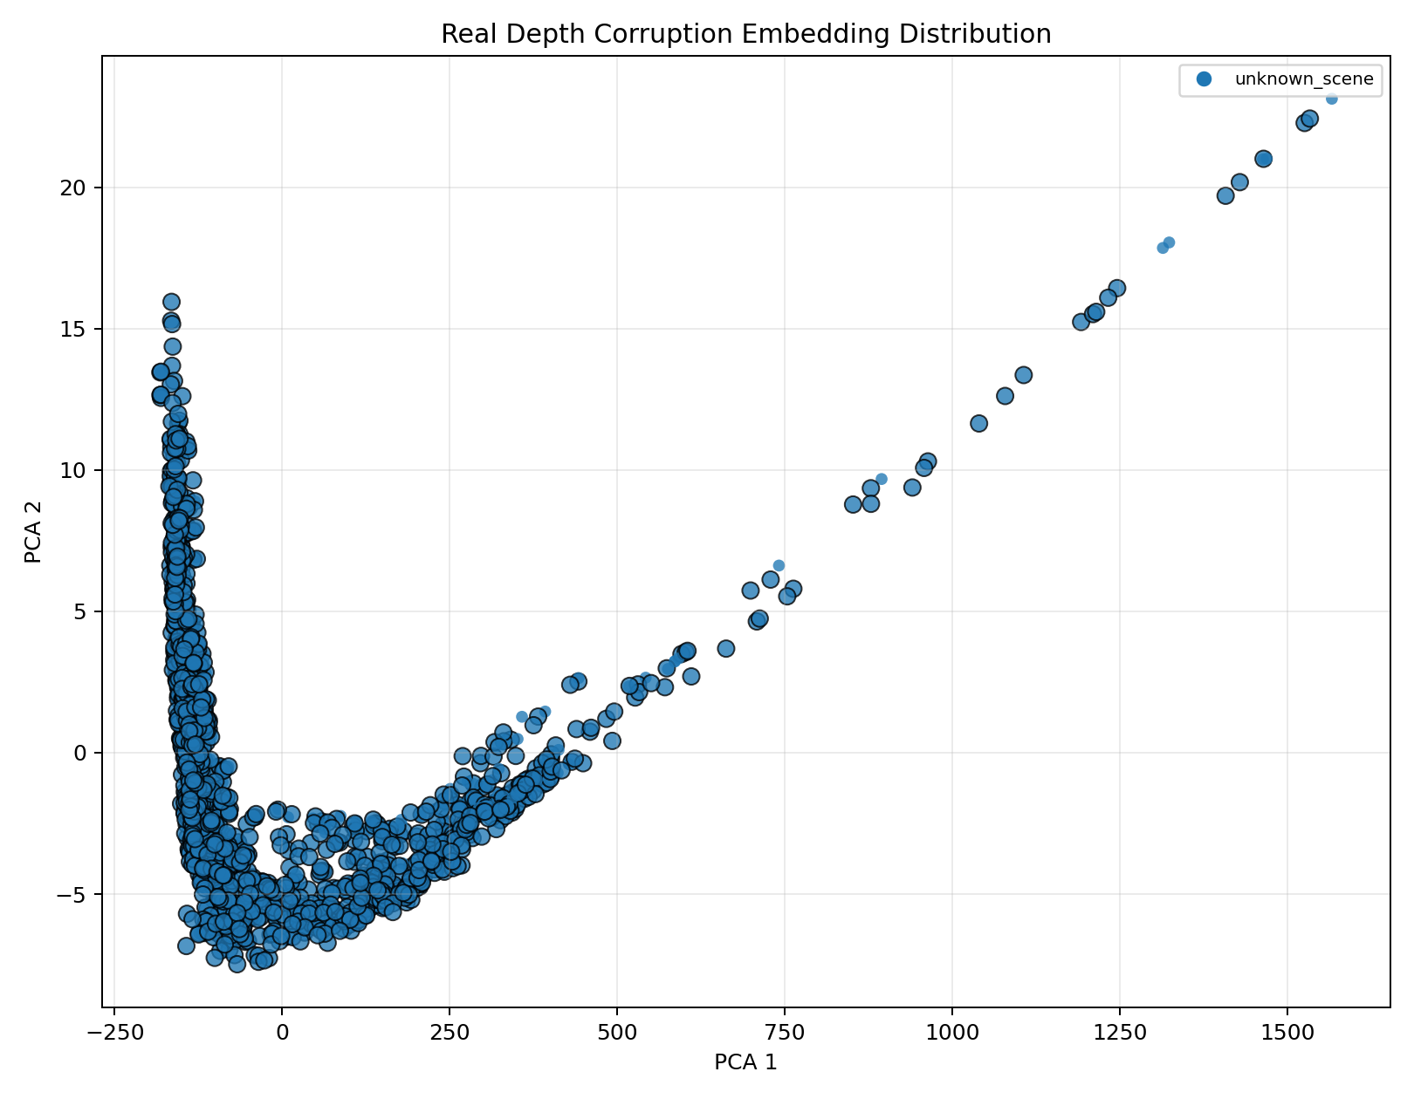
图 7. TUM RGB-D corruption embedding PCA。
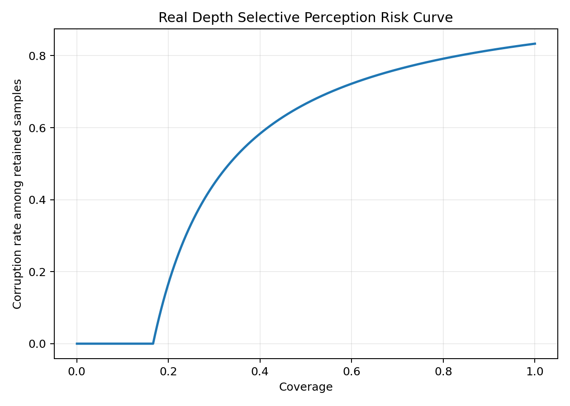
图 8. TUM RGB-D source-paired coverage-risk 曲线。
规律: source-paired ROC-AUC = 1.000，证明如果把每个腐蚀样本和它自己的 clean source 比较，受控腐蚀非常容易检测；但 scene-conditioned ROC-AUC = 0.483，接近随机，说明只拿全局场景参考比较会受到相机运动和深度分布变化干扰。这个负结果很重要，因为它推动后续的 temporal 和 pose-aware 分析。

8. 时序可靠性、姿态分析和 PCA 描述子
时序可靠性实验尝试解决上一节暴露的问题: 在一个移动相机序列里，正常帧之间本来就会变化，因此风险分数不能只看离全局 clean reference 多远，而应当比较某一帧的腐蚀 shift 是否超过附近 clean 帧的自然变化。
指标 | 数值
source files | 300
samples | 1800
temporal window | +/- 5 frames
temporal excess ROC-AUC | 1.000
temporal local-distance ROC-AUC | 0.483
source-paired ROC-AUC | 1.000

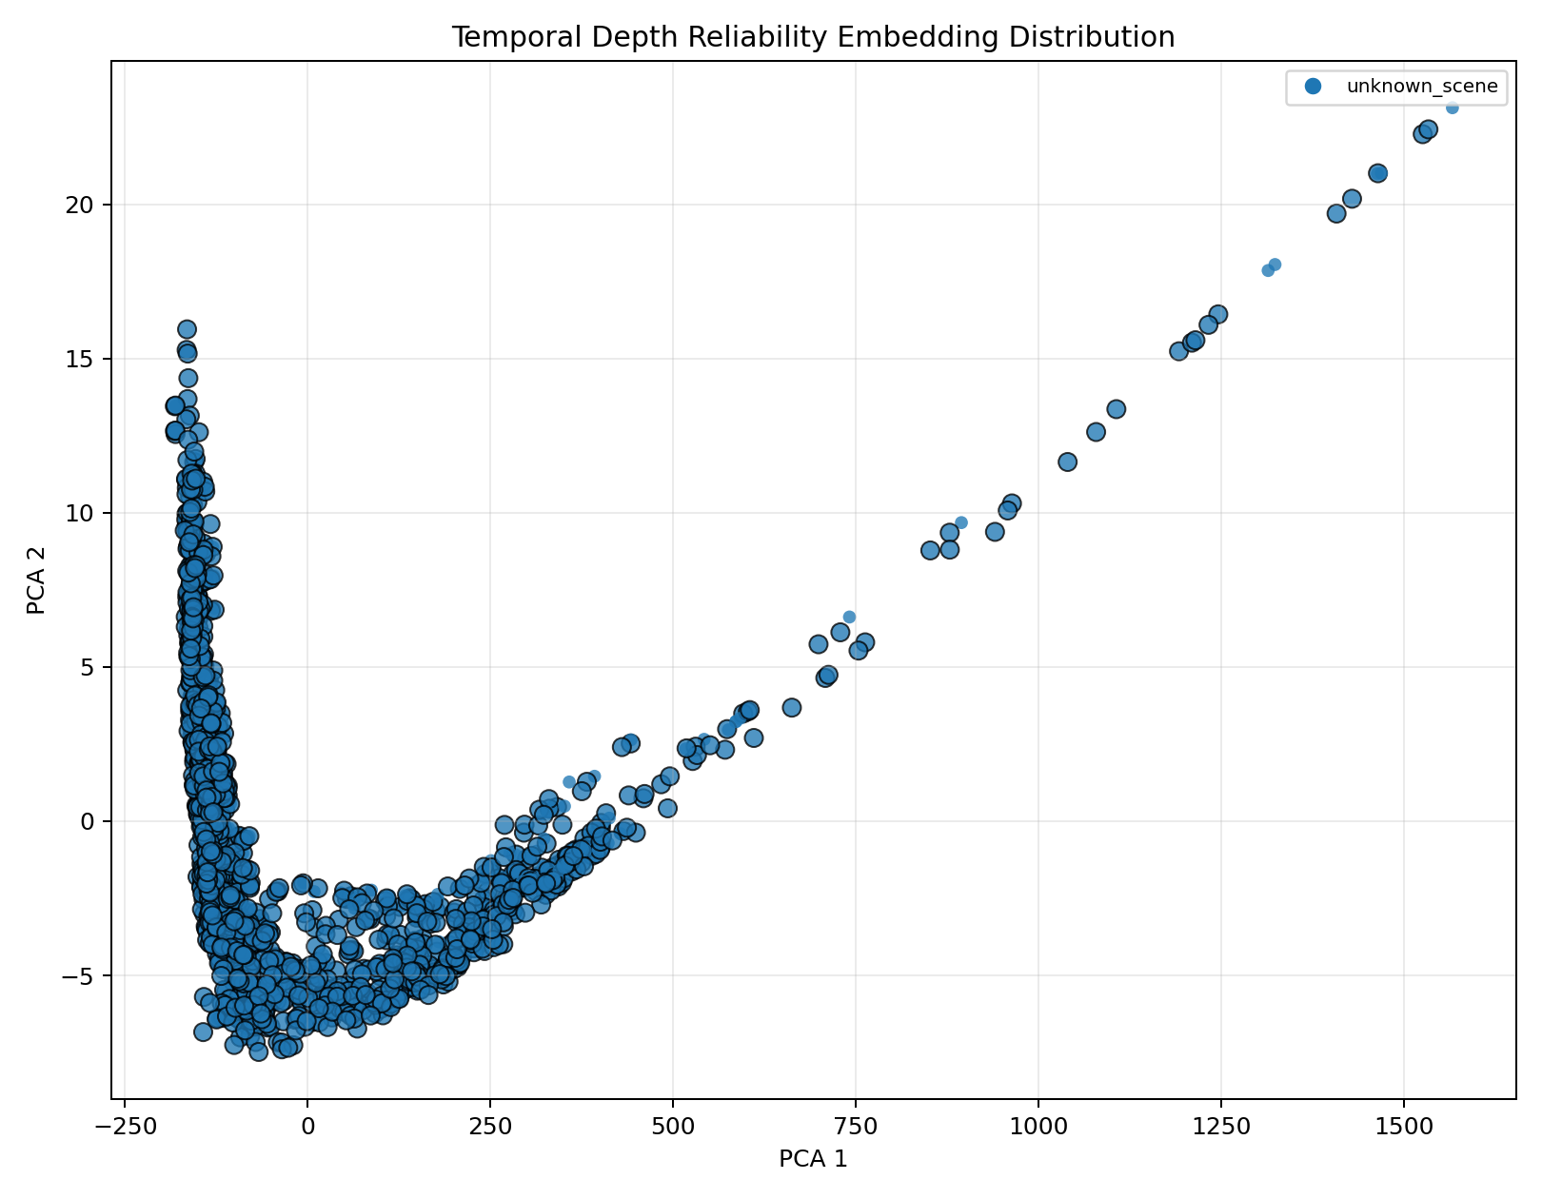
图 9. TUM temporal depth reliability embedding PCA。
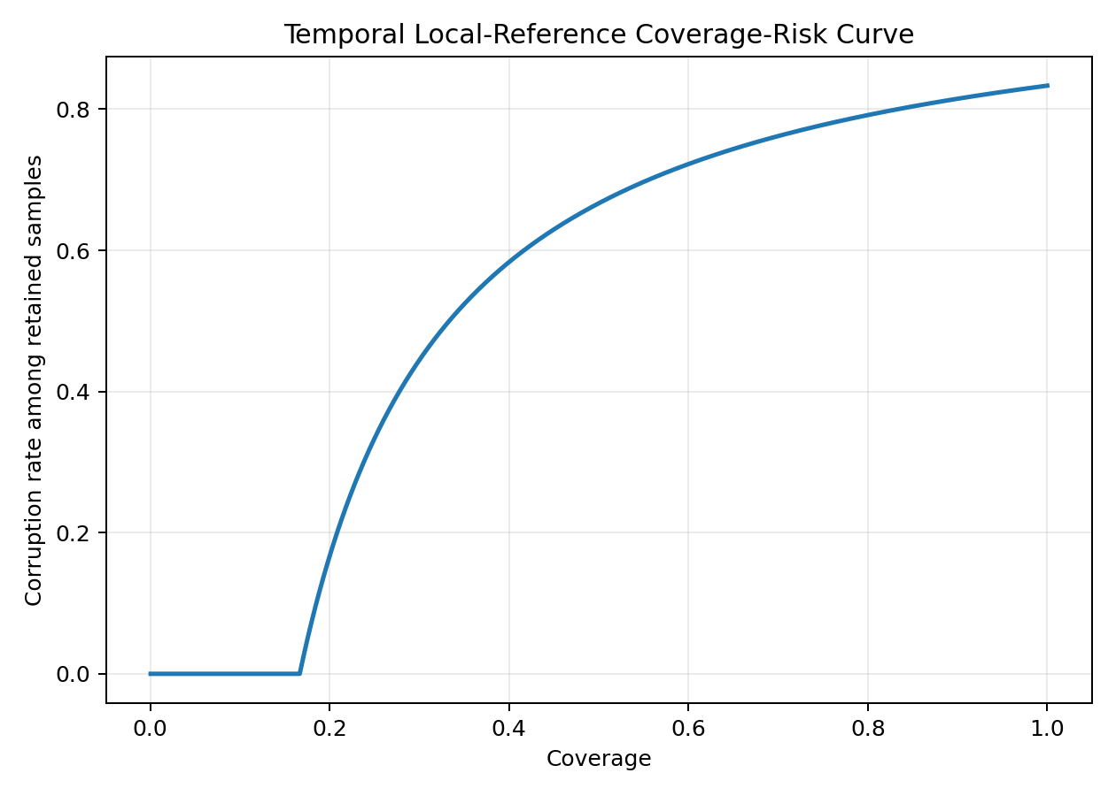
图 10. TUM temporal local-reference coverage-risk 曲线。
姿态分析进一步检查 embedding shift 是否和真实相机位姿变化相关。结果显示全局手工几何特征对旋转几乎不敏感，而保留局部布局的 grid descriptor 对旋转更敏感。
描述子 | translation Spearman | rotation Spearman | mean embedding shift
global descriptor | 0.046 | 0.061 | 29.275
grid descriptor | -0.064 | 0.275 | 1.126
PCA depth descriptor | 0.167 | 0.540 | 9.214

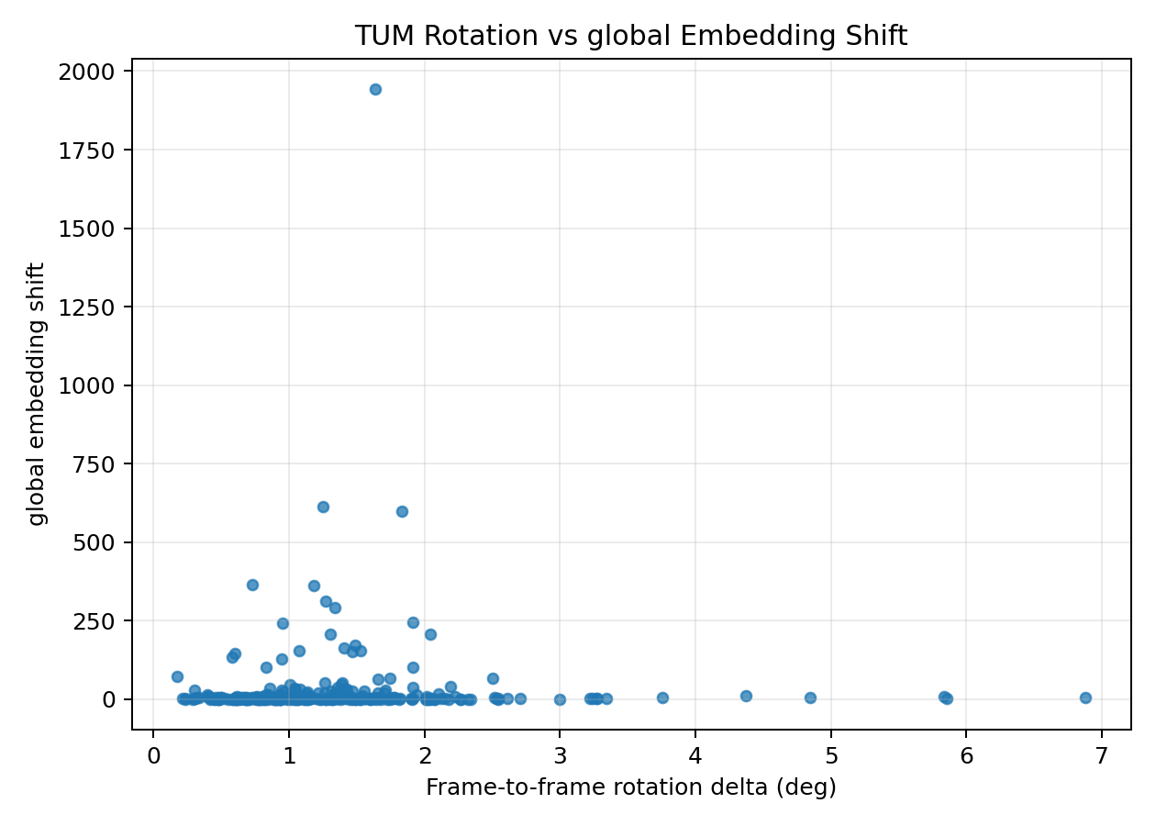
图 11. TUM global descriptor: rotation vs embedding shift。
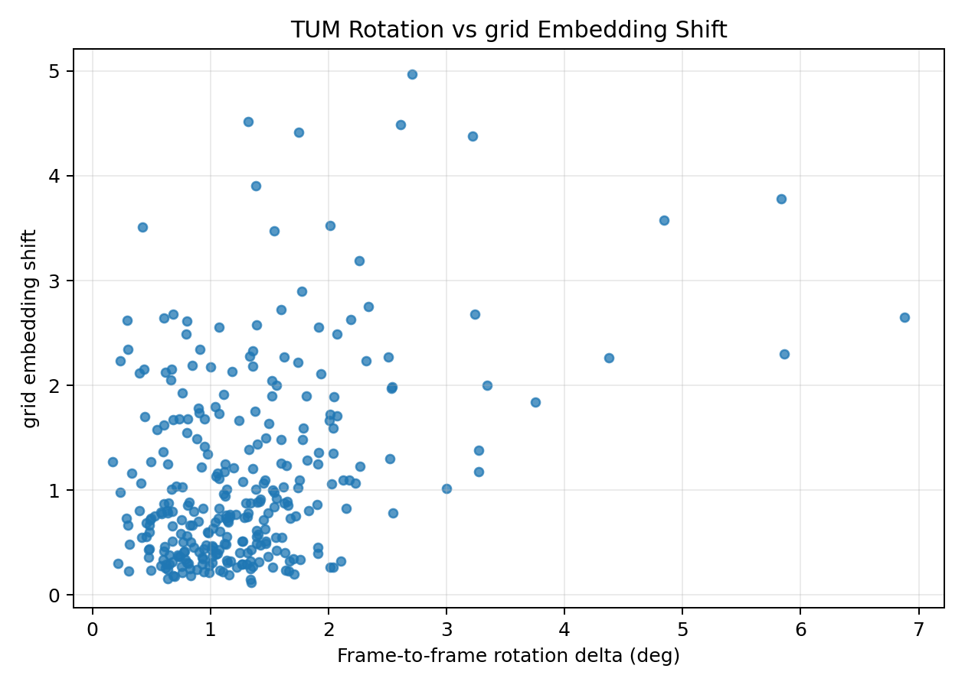
图 12. TUM grid descriptor: rotation vs embedding shift。
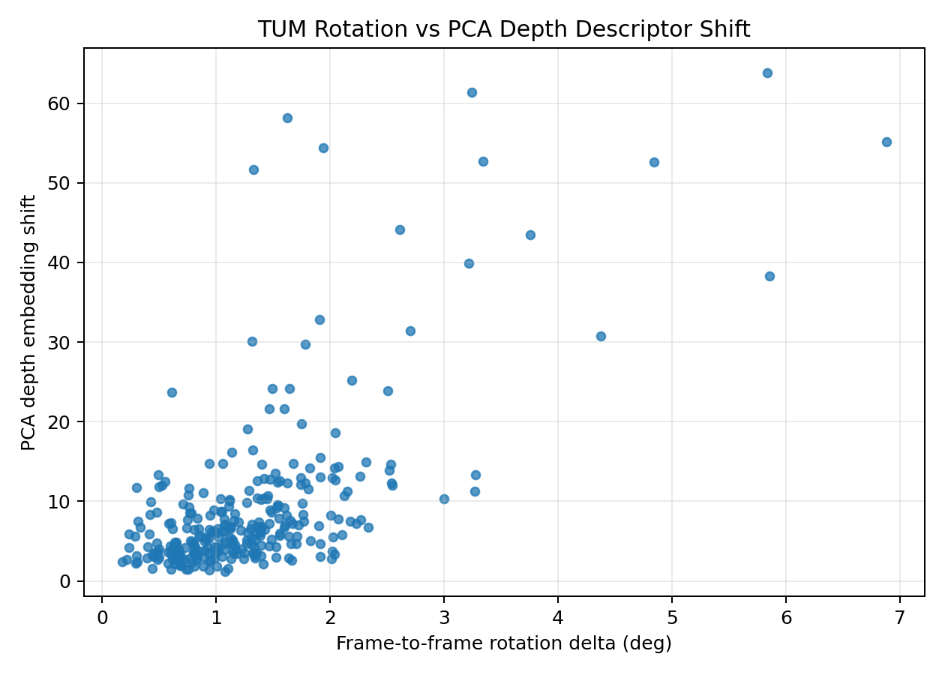
图 13. PCA depth descriptor: rotation vs embedding shift。
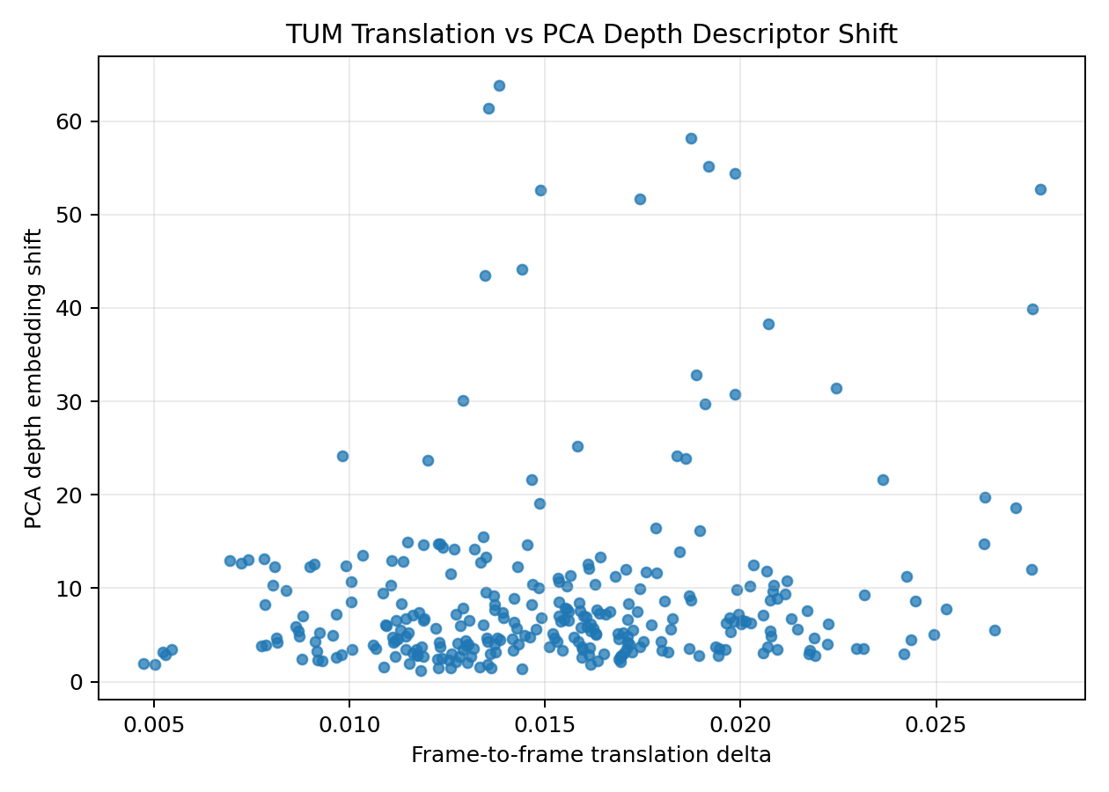
图 14. PCA depth descriptor: translation vs embedding shift。
规律: PCA depth descriptor 的 rotation Spearman = 0.540，高于 grid descriptor 的 0.275 和 global descriptor 的 0.061。这说明轻量 data-driven depth representation 比纯手工全局统计更有潜力捕捉相机运动，适合作为下一阶段 pretrained RGB-D/depth encoder 的前置证据。

9. 校准、Coverage-Risk 与运行时监控
校准分析的目的，是区分“排序能力”和“概率解释能力”。一个风险分数可以很好地区分异常样本，但它的数值本身未必能直接当成真实概率。
校准指标 | 数值
samples | 1800
positive label count | 1500
positive label rate | 0.833
ROC-AUC | 1.000
Average precision | 1.000
ECE-style gap | 0.758
risk at full coverage | 0.833
risk at 80% coverage | 0.792
risk at 50% coverage | 0.667

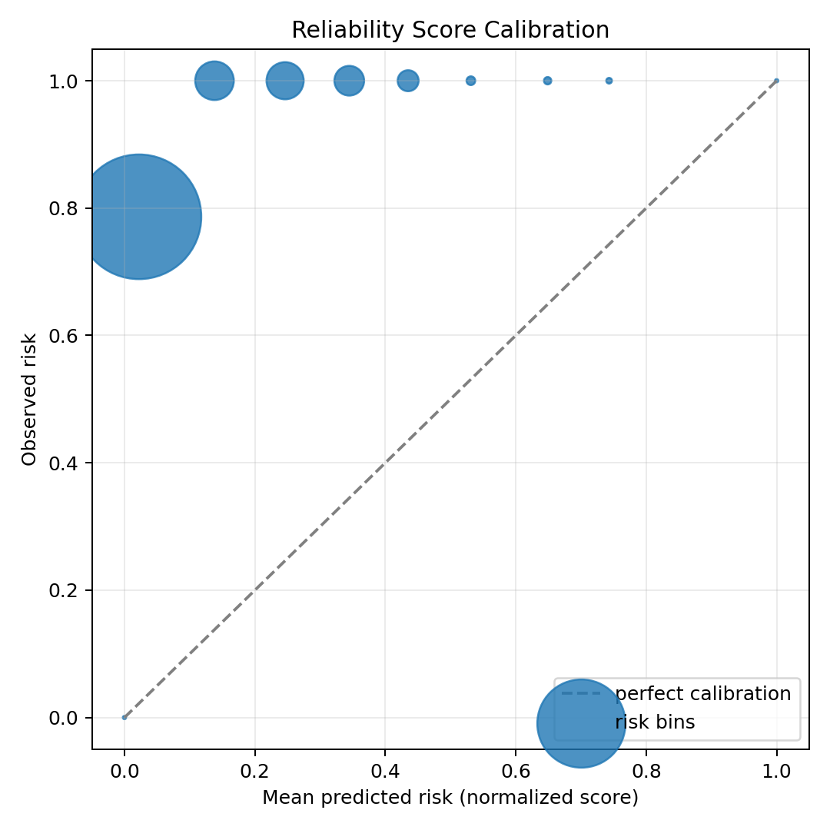
图 15. TUM temporal risk score calibration 图。
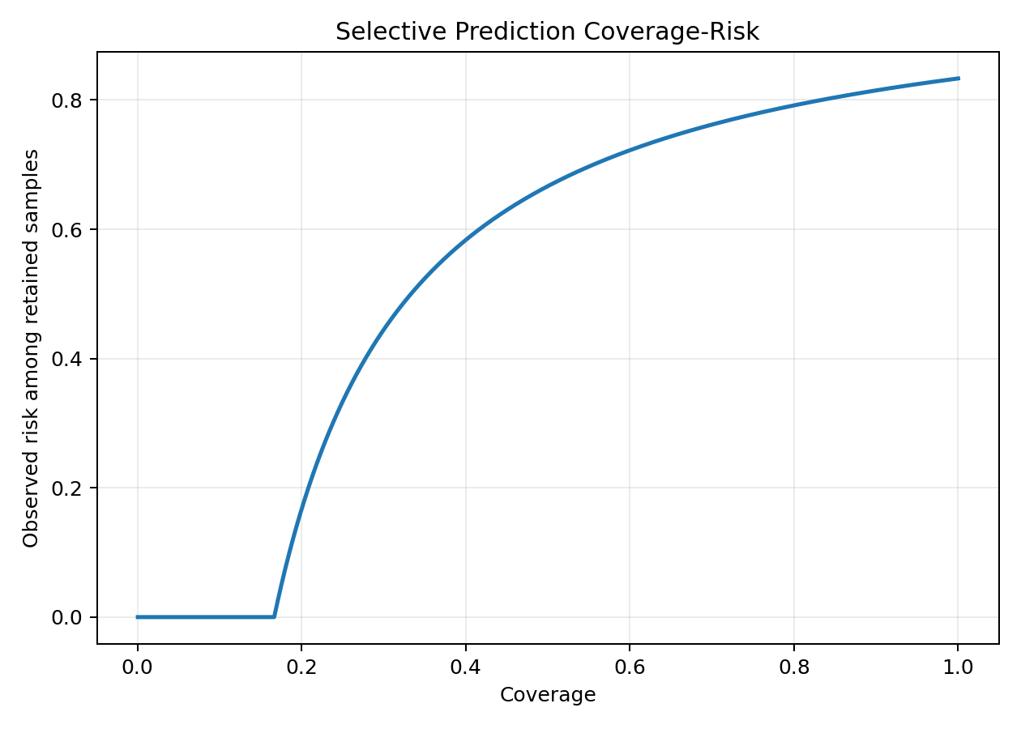
图 16. TUM temporal coverage-risk 图。
运行时监控器把连续风险分数转为可审计的系统状态，这一步是把机器学习诊断转向机器人 runtime assurance 的关键桥梁。
状态/检查 | 数值
samples | 1800
suspect threshold | 0.078037
recover threshold | 0.257334
review threshold | 0.400411
NORMAL | 1350
SUSPECT | 423
RECOVER | 27
HUMAN_REVIEW | 0
property violations | 0

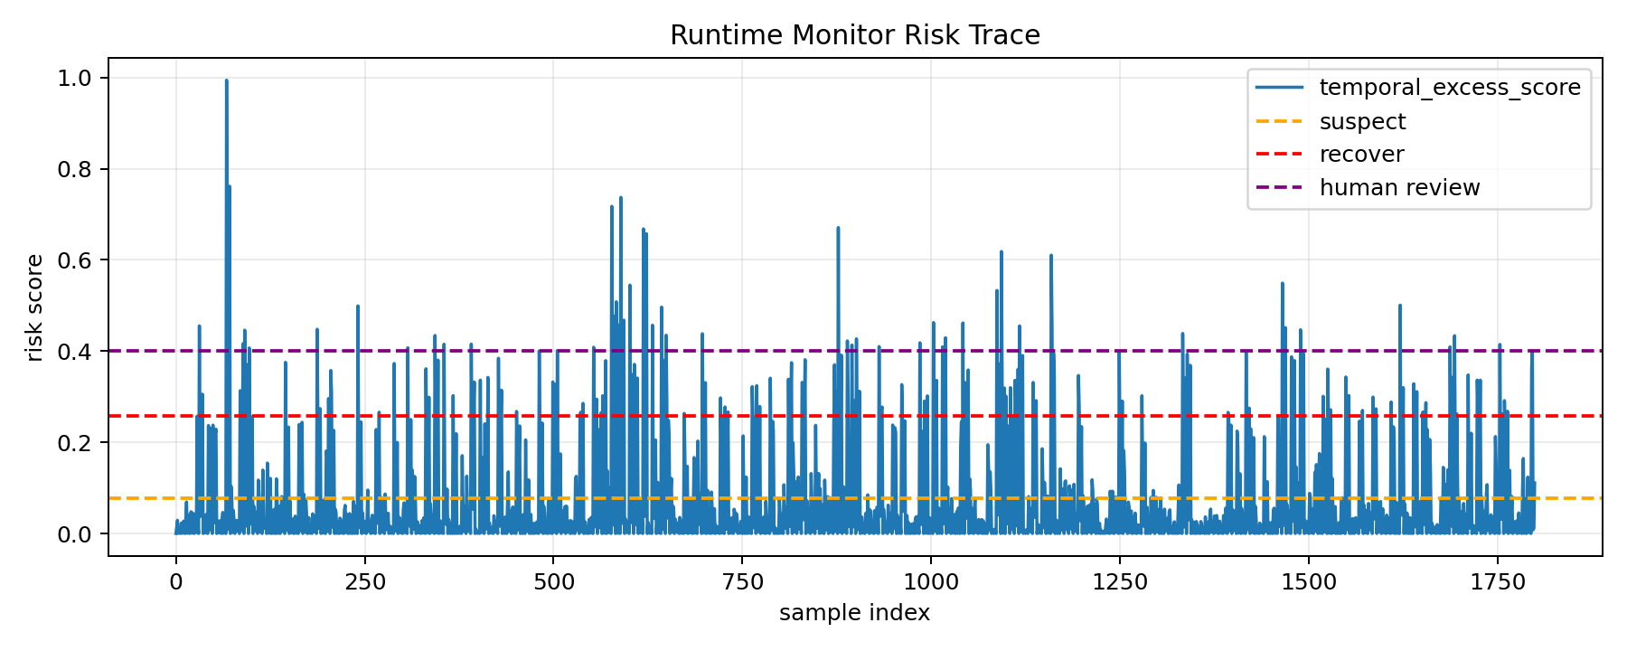
图 17. TUM runtime monitor risk trace。
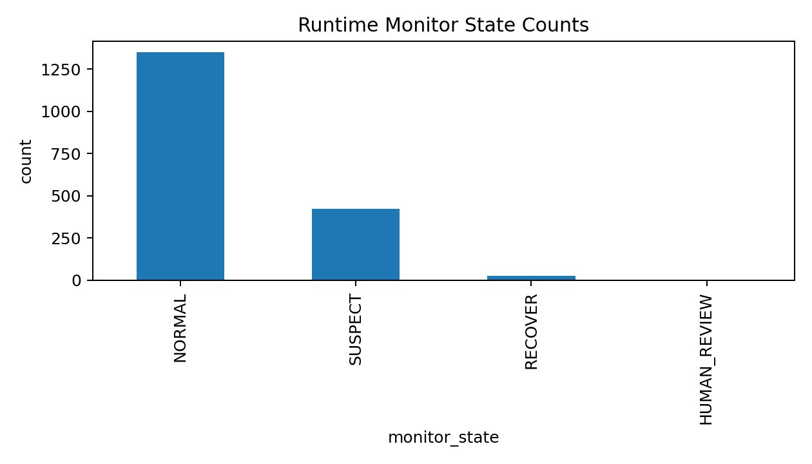
图 18. TUM runtime monitor state counts。

10. 轨迹残差与执行可靠性实验
轨迹残差实验把项目从 perception reliability 扩展到 action-outcome reliability。实验生成计划 3D 轨迹和实际观测轨迹，并模拟 normal、drift、oscillation、jump、stuck 五种情况。
指标 | 数值
samples | 400
n per type | 80
trajectory length | 80
failure types | ['normal', 'drift', 'oscillation', 'jump', 'stuck']
ROC-AUC | 0.990
average precision | 0.998

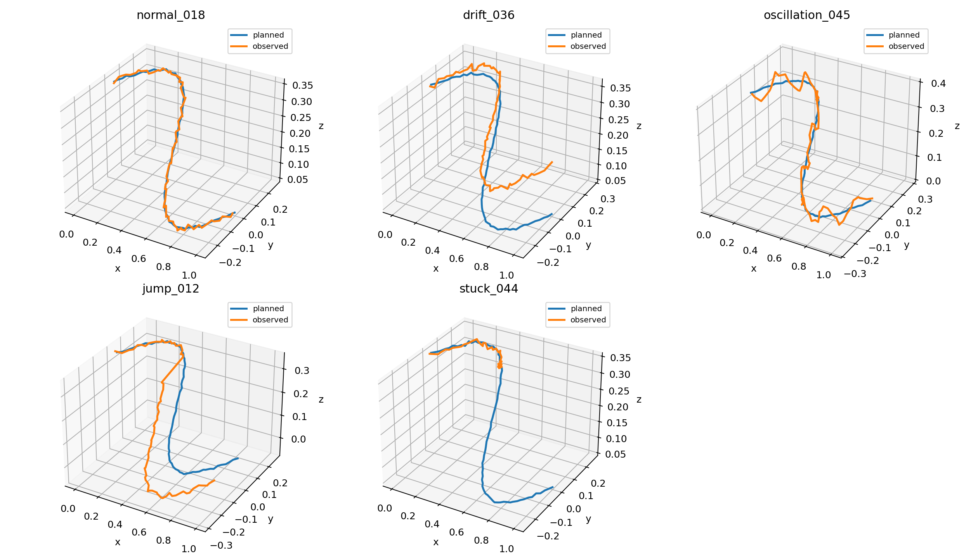
图 19. planned vs observed trajectory examples。
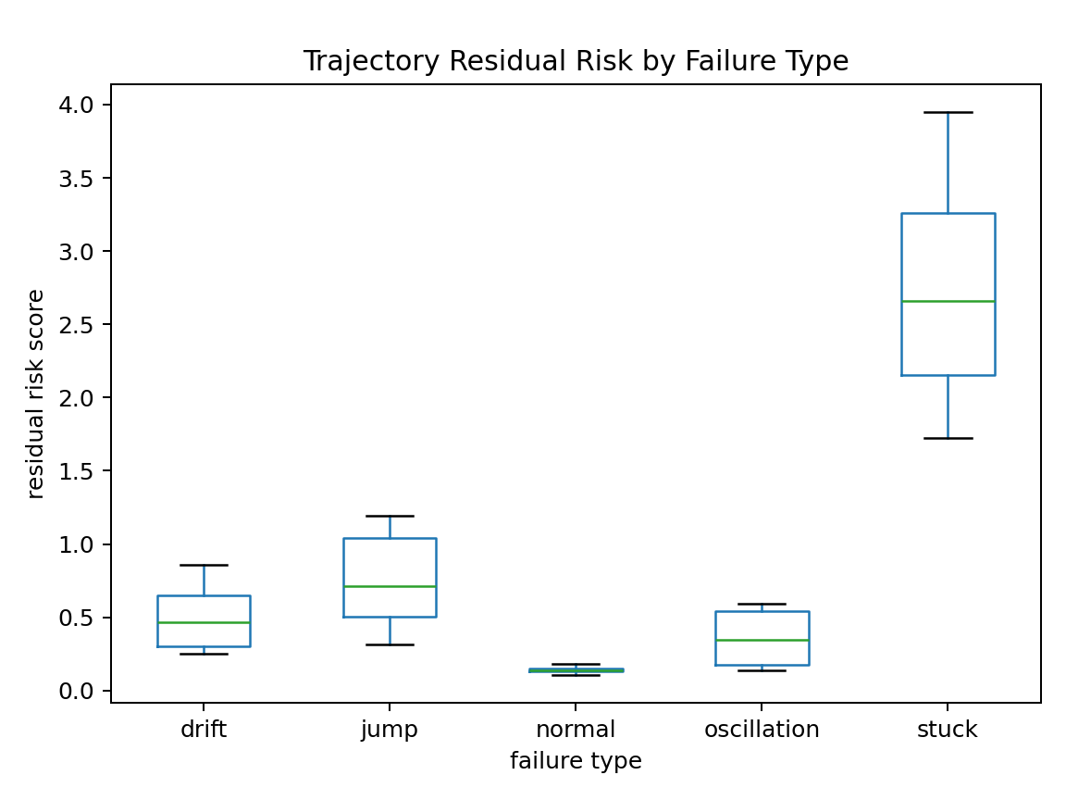
图 20. trajectory residual risk by failure type。
将同一个 runtime monitor 应用于轨迹残差分数后，系统得到 300 个 NORMAL、60 个 SUSPECT、40 个 RECOVER、0 个 HUMAN_REVIEW，并且 no-continue-autonomy-under-recover 检查没有违反。
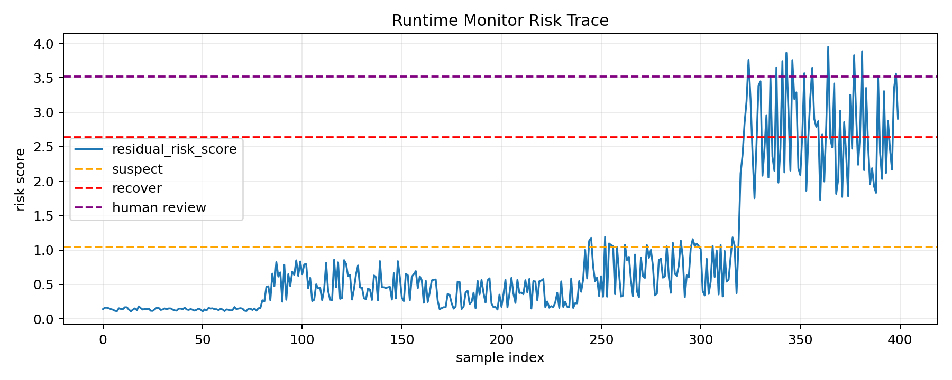
图 21. trajectory runtime monitor risk trace。
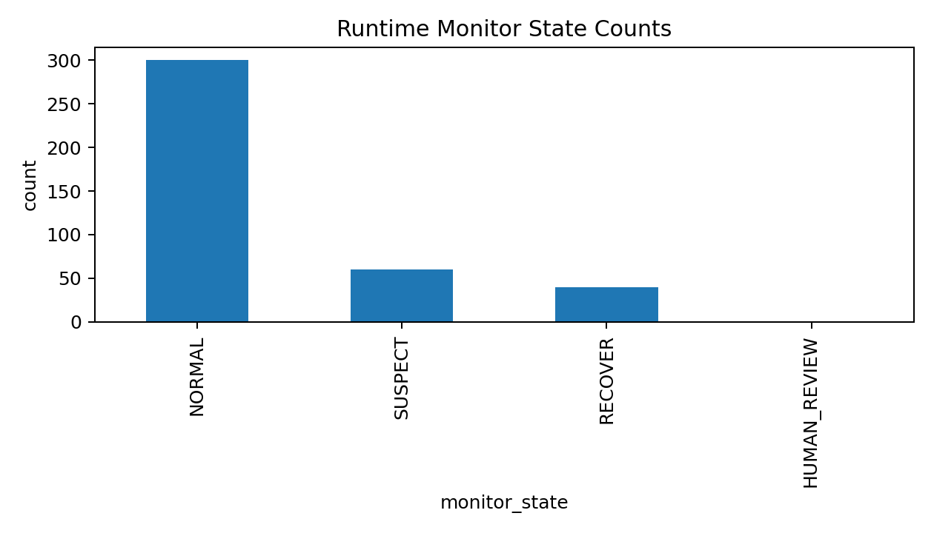
图 22. trajectory runtime monitor state counts。

Trajectory residual summary by failure type and severity
CSV 文件: outputs/trajectory_residual_demo/trajectory_residual_summary.csv
行数: 17; 列数: 7; 列名: failure_type, severity, n, mean_score, mean_residual, mean_final_error, mean_progress_ratio
failure_type | severity | n | mean_score | mean_residual | mean_final_error
drift | 1 | 22 | 0.2762369588482164 | 0.0219316502017053 | 0.0412192967804995
drift | 2 | 22 | 0.4530043792404609 | 0.0412976745177399 | 0.0793452222238887
drift | 3 | 22 | 0.6388027101193196 | 0.0608346541835503 | 0.1207895976575938
drift | 4 | 14 | 0.819502494891677 | 0.0806738941797188 | 0.160020252423627
jump | 1 | 20 | 0.3491883701505283 | 0.0309083099476993 | 0.0510180754587054
jump | 2 | 20 | 0.5979038516369497 | 0.0585955081507563 | 0.0996064938604831
jump | 3 | 13 | 0.8584762962570432 | 0.084190300737436 | 0.1525160910991522
jump | 4 | 27 | 1.076742406081562 | 0.101476479873613 | 0.1991220326335341
normal | 0 | 80 | 0.1399320853695824 | 0.0080585697607602 | 0.0086633220838848
oscillation | 1 | 24 | 0.1635381692614196 | 0.0125455066251258 | 0.007464827496733
oscillation | 2 | 15 | 0.2378851612756461 | 0.020794662212332 | 0.0077980385317156
oscillation | 3 | 17 | 0.3703435396963934 | 0.0295958407223224 | 0.0083672268288757
oscillation | 4 | 24 | 0.5613997164482117 | 0.0388577796208361 | 0.0079456157109234
stuck | 1 | 15 | 2.660775466873966 | 0.1740894789497057 | 0.5346507747968038
stuck | 2 | 22 | 2.7448437408467767 | 0.1860497627745975 | 0.5500090406699614
stuck | 3 | 21 | 2.5371781200265144 | 0.160979487711475 | 0.5195484090419042

11. 实验规律、博士申请价值和下一步计划
综合所有实验，目前最重要的规律有四条。
- 受控腐蚀在 source-paired 设置下容易检测，但这不是完整机器人安全证明。
- 全局 clean reference 会被正常相机运动干扰，TUM scene-conditioned baseline 接近随机，这是一个有研究价值的负结果。
- 局部时间归一化和局部/学习型描述子能改善可靠性判断，PCA depth descriptor 对旋转的相关性明显更强。
- 风险分数可以转成 runtime monitor 状态，从而把模型诊断连接到恢复、重新规划和人类审查等机器人安全动作。
博士申请价值: 该项目可以被表述为一个 evidence-first research prototype。它展示了从模型训练、embedding 诊断、公开数据实验、风险校准、运行时状态机到执行残差分析的完整研究链条。相比单纯写“我会 PyTorch/LSTM”，它更能体现研究问题意识、实验设计能力和对局限性的清醒认识。
建议下一步实验: 用 pretrained 或 task-supervised RGB-D/depth encoder 替代 PCA baseline，并把可靠性标签从受控腐蚀扩展到 dataset-native labels，例如 SLAM tracking quality、pose error、navigation progress、tool trajectory error 或 simulator rollout failure。

12. 附录 A: 关键 CSV 预览

TUM temporal depth reliability summary
CSV 文件: outputs/tum_rgbd_freiburg1_desk_temporal/temporal_depth_reliability_summary.csv
行数: 21; 列数: 8; 列名: corruption, severity, n, mean_temporal_excess_score, mean_temporal_local_distance, mean_source_paired_distance, mean_valid_depth_ratio, mean_depth_std
corruption | severity | n | mean_temporal_excess_score | mean_temporal_local_distance | mean_source_paired_distance
clean | 0 | 300 | 0.0 | 229.9243 | 0.0
dropout | 1 | 85 | 0.03734804 | 242.3696 | 19.018639
dropout | 2 | 71 | 0.06649568 | 205.82498 | 26.371178
dropout | 3 | 64 | 0.106061704 | 208.62872 | 49.789505
dropout | 4 | 80 | 0.16237497 | 204.83194 | 69.266014
gaussian_noise | 1 | 75 | 0.13514055 | 209.84642 | 83.986755
gaussian_noise | 2 | 82 | 0.15371479 | 196.66022 | 81.54192
gaussian_noise | 3 | 72 | 0.16126555 | 204.23352 | 88.25165
gaussian_noise | 4 | 71 | 0.23172228 | 171.0475 | 98.01751
occlusion | 1 | 74 | 0.008802834 | 227.94695 | 3.97724
occlusion | 2 | 79 | 0.033722233 | 194.95036 | 12.922119
occlusion | 3 | 87 | 0.07752007 | 239.97203 | 38.611683

TUM real-depth corruption summary
CSV 文件: outputs/tum_rgbd_freiburg1_desk_robot_3d/corruption_benchmark/real_depth_corruption_summary.csv
行数: 21; 列数: 7; 列名: corruption, severity, n, mean_risk_score, mean_knn_clean_distance, mean_valid_depth_ratio, mean_depth_std
corruption | severity | n | mean_risk_score | mean_knn_clean_distance | mean_valid_depth_ratio
clean | 0 | 300 | 0.0 | 6.177792 | 0.744310622829861
dropout | 1 | 85 | 19.018639 | 8.772723 | 0.6864296109068627
dropout | 2 | 71 | 26.371178 | 7.551431 | 0.6222593896713615
dropout | 3 | 64 | 49.789505 | 14.185081 | 0.5663931274414062
dropout | 4 | 80 | 69.266014 | 10.335111 | 0.5063830973307292
gaussian_noise | 1 | 75 | 83.986755 | 8.870972 | 0.8740010416666667
gaussian_noise | 2 | 82 | 81.54192 | 6.253622 | 0.8716817517784553
gaussian_noise | 3 | 72 | 88.25165 | 6.4209485 | 0.870871265552662
gaussian_noise | 4 | 71 | 98.01751 | 6.9134874 | 0.8722137709066902
occlusion | 1 | 74 | 3.97724 | 7.7230825 | 0.7322561673001127
occlusion | 2 | 79 | 12.922119 | 5.2939396 | 0.6977237852716245
occlusion | 3 | 87 | 38.611683 | 15.448718 | 0.62758673072318

TUM calibration bins
CSV 文件: outputs/tum_rgbd_calibration/calibration_bins.csv
行数: 10; 列数: 7; 列名: bin, left, right, n, mean_predicted_risk, observed_risk, abs_gap
bin | left | right | n | mean_predicted_risk | observed_risk
0 | 0.0 | 0.1 | 1404 | 0.0222037703807099 | 0.7863247863247863
1 | 0.1 | 0.2 | 135 | 0.138064411424546 | 1.0
2 | 0.2 | 0.3 | 125 | 0.2463121458681086 | 1.0
3 | 0.3 | 0.4 | 80 | 0.3446801874241177 | 1.0
4 | 0.4 | 0.5 | 40 | 0.4349545861875104 | 1.0
5 | 0.5 | 0.6000000000000001 | 7 | 0.5311555738893509 | 1.0
6 | 0.6000000000000001 | 0.7000000000000001 | 5 | 0.6488560746262233 | 1.0
7 | 0.7000000000000001 | 0.8 | 3 | 0.7431207175606854 | 1.0
8 | 0.8 | 0.9 | 0 | 0.0 | 0.0
9 | 0.9 | 1.0 | 1 | 1.0 | 1.0

TUM coverage-risk table
CSV 文件: outputs/tum_rgbd_calibration/coverage_risk.csv
行数: 1800; 列数: 3; 列名: coverage, observed_risk, threshold
coverage | observed_risk | threshold
0.0005555555555555 | 0.0 | 0.0
0.0011111111111111 | 0.0 | 0.0
0.0016666666666666 | 0.0 | 0.0
0.0022222222222222 | 0.0 | 0.0
0.0027777777777777 | 0.0 | 0.0
0.0033333333333333 | 0.0 | 0.0
0.0038888888888888 | 0.0 | 0.0
0.0044444444444444 | 0.0 | 0.0
0.005 | 0.0 | 0.0
0.0055555555555555 | 0.0 | 0.0
0.0061111111111111 | 0.0 | 0.0
0.0066666666666666 | 0.0 | 0.0

TUM pose embedding shifts preview
CSV 文件: outputs/tum_rgbd_freiburg1_desk_pose_sorted/tum_pose_embedding_shifts.csv
行数: 598; 列数: 10; 列名: descriptor, prev_file, file, prev_timestamp, timestamp, dt, embedding_shift, translation_delta, rotation_delta_deg, pose_time_delta
descriptor | prev_file | file | prev_timestamp | timestamp | dt
global | data\prepared_depth\tum_rgbd_freiburg1_desk_sorted\unknown_scene\000000_1305031453.374112.png | data\prepared_depth\tum_rgbd_freiburg1_desk_sorted\unknown_scene\000001_1305031453.404816.png | 1305031453.374112 | 1305031453.404816 | 0.0307040214538574
global | data\prepared_depth\tum_rgbd_freiburg1_desk_sorted\unknown_scene\000001_1305031453.404816.png | data\prepared_depth\tum_rgbd_freiburg1_desk_sorted\unknown_scene\000002_1305031453.436941.png | 1305031453.404816 | 1305031453.436941 | 0.0321249961853027
global | data\prepared_depth\tum_rgbd_freiburg1_desk_sorted\unknown_scene\000002_1305031453.436941.png | data\prepared_depth\tum_rgbd_freiburg1_desk_sorted\unknown_scene\000003_1305031453.473352.png | 1305031453.436941 | 1305031453.473352 | 0.0364110469818115
global | data\prepared_depth\tum_rgbd_freiburg1_desk_sorted\unknown_scene\000003_1305031453.473352.png | data\prepared_depth\tum_rgbd_freiburg1_desk_sorted\unknown_scene\000004_1305031453.505218.png | 1305031453.473352 | 1305031453.505218 | 0.0318660736083984
global | data\prepared_depth\tum_rgbd_freiburg1_desk_sorted\unknown_scene\000004_1305031453.505218.png | data\prepared_depth\tum_rgbd_freiburg1_desk_sorted\unknown_scene\000005_1305031453.538301.png | 1305031453.505218 | 1305031453.538301 | 0.0330829620361328
global | data\prepared_depth\tum_rgbd_freiburg1_desk_sorted\unknown_scene\000005_1305031453.538301.png | data\prepared_depth\tum_rgbd_freiburg1_desk_sorted\unknown_scene\000006_1305031453.574074.png | 1305031453.538301 | 1305031453.574074 | 0.0357730388641357
global | data\prepared_depth\tum_rgbd_freiburg1_desk_sorted\unknown_scene\000006_1305031453.574074.png | data\prepared_depth\tum_rgbd_freiburg1_desk_sorted\unknown_scene\000007_1305031453.605314.png | 1305031453.574074 | 1305031453.605314 | 0.0312399864196777
global | data\prepared_depth\tum_rgbd_freiburg1_desk_sorted\unknown_scene\000007_1305031453.605314.png | data\prepared_depth\tum_rgbd_freiburg1_desk_sorted\unknown_scene\000008_1305031453.636951.png | 1305031453.605314 | 1305031453.636951 | 0.0316369533538818
global | data\prepared_depth\tum_rgbd_freiburg1_desk_sorted\unknown_scene\000008_1305031453.636951.png | data\prepared_depth\tum_rgbd_freiburg1_desk_sorted\unknown_scene\000009_1305031453.673185.png | 1305031453.636951 | 1305031453.673185 | 0.0362341403961181
global | data\prepared_depth\tum_rgbd_freiburg1_desk_sorted\unknown_scene\000009_1305031453.673185.png | data\prepared_depth\tum_rgbd_freiburg1_desk_sorted\unknown_scene\000010_1305031453.705487.png | 1305031453.673185 | 1305031453.705487 | 0.032301902770996
global | data\prepared_depth\tum_rgbd_freiburg1_desk_sorted\unknown_scene\000010_1305031453.705487.png | data\prepared_depth\tum_rgbd_freiburg1_desk_sorted\unknown_scene\000011_1305031453.736856.png | 1305031453.705487 | 1305031453.736856 | 0.0313689708709716
global | data\prepared_depth\tum_rgbd_freiburg1_desk_sorted\unknown_scene\000011_1305031453.736856.png | data\prepared_depth\tum_rgbd_freiburg1_desk_sorted\unknown_scene\000012_1305031453.773786.png | 1305031453.736856 | 1305031453.773786 | 0.0369300842285156

TUM PCA depth descriptor shifts preview
CSV 文件: outputs/tum_rgbd_freiburg1_desk_pca_descriptor/tum_pca_depth_descriptor_shifts.csv
行数: 299; 列数: 9; 列名: prev_file, file, prev_timestamp, timestamp, dt, pca_embedding_shift, translation_delta, rotation_delta_deg, pose_time_delta
prev_file | file | prev_timestamp | timestamp | dt | pca_embedding_shift
data\prepared_depth\tum_rgbd_freiburg1_desk_sorted\unknown_scene\000000_1305031453.374112.png | data\prepared_depth\tum_rgbd_freiburg1_desk_sorted\unknown_scene\000001_1305031453.404816.png | 1305031453.374112 | 1305031453.404816 | 0.0307040214538574 | 9.578725814819336
data\prepared_depth\tum_rgbd_freiburg1_desk_sorted\unknown_scene\000001_1305031453.404816.png | data\prepared_depth\tum_rgbd_freiburg1_desk_sorted\unknown_scene\000002_1305031453.436941.png | 1305031453.404816 | 1305031453.436941 | 0.0321249961853027 | 6.701883316040039
data\prepared_depth\tum_rgbd_freiburg1_desk_sorted\unknown_scene\000002_1305031453.436941.png | data\prepared_depth\tum_rgbd_freiburg1_desk_sorted\unknown_scene\000003_1305031453.473352.png | 1305031453.436941 | 1305031453.473352 | 0.0364110469818115 | 7.098604202270508
data\prepared_depth\tum_rgbd_freiburg1_desk_sorted\unknown_scene\000003_1305031453.473352.png | data\prepared_depth\tum_rgbd_freiburg1_desk_sorted\unknown_scene\000004_1305031453.505218.png | 1305031453.473352 | 1305031453.505218 | 0.0318660736083984 | 7.186344623565674
data\prepared_depth\tum_rgbd_freiburg1_desk_sorted\unknown_scene\000004_1305031453.505218.png | data\prepared_depth\tum_rgbd_freiburg1_desk_sorted\unknown_scene\000005_1305031453.538301.png | 1305031453.505218 | 1305031453.538301 | 0.0330829620361328 | 6.566436290740967
data\prepared_depth\tum_rgbd_freiburg1_desk_sorted\unknown_scene\000005_1305031453.538301.png | data\prepared_depth\tum_rgbd_freiburg1_desk_sorted\unknown_scene\000006_1305031453.574074.png | 1305031453.538301 | 1305031453.574074 | 0.0357730388641357 | 8.2500638961792
data\prepared_depth\tum_rgbd_freiburg1_desk_sorted\unknown_scene\000006_1305031453.574074.png | data\prepared_depth\tum_rgbd_freiburg1_desk_sorted\unknown_scene\000007_1305031453.605314.png | 1305031453.574074 | 1305031453.605314 | 0.0312399864196777 | 8.679730415344238
data\prepared_depth\tum_rgbd_freiburg1_desk_sorted\unknown_scene\000007_1305031453.605314.png | data\prepared_depth\tum_rgbd_freiburg1_desk_sorted\unknown_scene\000008_1305031453.636951.png | 1305031453.605314 | 1305031453.636951 | 0.0316369533538818 | 8.897761344909668
data\prepared_depth\tum_rgbd_freiburg1_desk_sorted\unknown_scene\000008_1305031453.636951.png | data\prepared_depth\tum_rgbd_freiburg1_desk_sorted\unknown_scene\000009_1305031453.673185.png | 1305031453.636951 | 1305031453.673185 | 0.0362341403961181 | 10.015874862670898
data\prepared_depth\tum_rgbd_freiburg1_desk_sorted\unknown_scene\000009_1305031453.673185.png | data\prepared_depth\tum_rgbd_freiburg1_desk_sorted\unknown_scene\000010_1305031453.705487.png | 1305031453.673185 | 1305031453.705487 | 0.032301902770996 | 8.757301330566406
data\prepared_depth\tum_rgbd_freiburg1_desk_sorted\unknown_scene\000010_1305031453.705487.png | data\prepared_depth\tum_rgbd_freiburg1_desk_sorted\unknown_scene\000011_1305031453.736856.png | 1305031453.705487 | 1305031453.736856 | 0.0313689708709716 | 8.432563781738281
data\prepared_depth\tum_rgbd_freiburg1_desk_sorted\unknown_scene\000011_1305031453.736856.png | data\prepared_depth\tum_rgbd_freiburg1_desk_sorted\unknown_scene\000012_1305031453.773786.png | 1305031453.736856 | 1305031453.773786 | 0.0369300842285156 | 10.729853630065918

TUM runtime monitor decisions preview
CSV 文件: outputs/tum_rgbd_runtime_monitor/runtime_monitor_decisions.csv
行数: 1800; 列数: 39; 列名: scene, sample_id, source_file, corruption, severity, is_corrupted, valid_depth_ratio, depth_mean, depth_std, embedding_risk_score, temporal_excess_score, temporal_local_distance ...
scene | sample_id | source_file | corruption | severity | is_corrupted
unknown_scene | 000000_1305031469.356116_clean | data\prepared_depth\tum_rgbd_freiburg1_desk\unknown_scene\000000_1305031469.356116.png | clean | 0 | False
unknown_scene | 000000_1305031469.356116_gaussian_noise | data\prepared_depth\tum_rgbd_freiburg1_desk\unknown_scene\000000_1305031469.356116.png | gaussian_noise | 1 | True
unknown_scene | 000000_1305031469.356116_dropout | data\prepared_depth\tum_rgbd_freiburg1_desk\unknown_scene\000000_1305031469.356116.png | dropout | 4 | True
unknown_scene | 000000_1305031469.356116_quantization | data\prepared_depth\tum_rgbd_freiburg1_desk\unknown_scene\000000_1305031469.356116.png | quantization | 3 | True
unknown_scene | 000000_1305031469.356116_occlusion | data\prepared_depth\tum_rgbd_freiburg1_desk\unknown_scene\000000_1305031469.356116.png | occlusion | 2 | True
unknown_scene | 000000_1305031469.356116_tilt_shift | data\prepared_depth\tum_rgbd_freiburg1_desk\unknown_scene\000000_1305031469.356116.png | tilt_shift | 4 | True
unknown_scene | 000001_1305031459.344169_clean | data\prepared_depth\tum_rgbd_freiburg1_desk\unknown_scene\000001_1305031459.344169.png | clean | 0 | False
unknown_scene | 000001_1305031459.344169_gaussian_noise | data\prepared_depth\tum_rgbd_freiburg1_desk\unknown_scene\000001_1305031459.344169.png | gaussian_noise | 3 | True
unknown_scene | 000001_1305031459.344169_dropout | data\prepared_depth\tum_rgbd_freiburg1_desk\unknown_scene\000001_1305031459.344169.png | dropout | 1 | True
unknown_scene | 000001_1305031459.344169_quantization | data\prepared_depth\tum_rgbd_freiburg1_desk\unknown_scene\000001_1305031459.344169.png | quantization | 4 | True
unknown_scene | 000001_1305031459.344169_occlusion | data\prepared_depth\tum_rgbd_freiburg1_desk\unknown_scene\000001_1305031459.344169.png | occlusion | 4 | True
unknown_scene | 000001_1305031459.344169_tilt_shift | data\prepared_depth\tum_rgbd_freiburg1_desk\unknown_scene\000001_1305031459.344169.png | tilt_shift | 1 | True

Trajectory runtime monitor decisions preview
CSV 文件: outputs/trajectory_runtime_monitor/runtime_monitor_decisions.csv
行数: 400; 列数: 18; 列名: sample_id, failure_type, severity, is_failure, residual_risk_score, mean_residual, max_residual, p95_residual, final_error, mean_velocity_error, max_velocity_error, path_length_ratio ...
sample_id | failure_type | severity | is_failure | residual_risk_score | mean_residual
normal_000 | normal | 0 | False | 0.1414593148154538 | 0.0080941691994667
normal_001 | normal | 0 | False | 0.161873168329101 | 0.0080734137445688
normal_002 | normal | 0 | False | 0.1615711378686823 | 0.0084616150707006
normal_003 | normal | 0 | False | 0.1528084492005766 | 0.00811283942312
normal_004 | normal | 0 | False | 0.1407167709915651 | 0.0085322381928563
normal_005 | normal | 0 | False | 0.132811180358062 | 0.007946765050292
normal_006 | normal | 0 | False | 0.1175736600546507 | 0.0074540739879012
normal_007 | normal | 0 | False | 0.111221481228785 | 0.0076189264655113
normal_008 | normal | 0 | False | 0.1537790431473553 | 0.0081734750419855
normal_009 | normal | 0 | False | 0.143267643171946 | 0.0080531258136034
normal_010 | normal | 0 | False | 0.1415982056569844 | 0.0080383885651826
normal_011 | normal | 0 | False | 0.1682205749641805 | 0.008206476457417

附录 B: 全部图片索引
图片文件 | 大小
outputs\real_depth_analysis_smoke\real_depth_embedding_pca.png | 49.5 KB
outputs\real_depth_corruption_smoke\real_depth_corruption_coverage_risk.png | 66.8 KB
outputs\real_depth_corruption_smoke\real_depth_corruption_pca.png | 115.2 KB
outputs\robot_3d_demo\robot_3d_coverage_risk.png | 63.8 KB
outputs\robot_3d_demo\robot_3d_embedding_pca.png | 212.3 KB
outputs\robot_3d_multiseed\seed_1\robot_3d_coverage_risk.png | 62.4 KB
outputs\robot_3d_multiseed\seed_1\robot_3d_embedding_pca.png | 173.6 KB
outputs\robot_3d_multiseed\seed_2\robot_3d_coverage_risk.png | 63.5 KB
outputs\robot_3d_multiseed\seed_2\robot_3d_embedding_pca.png | 157.7 KB
outputs\robot_3d_multiseed\seed_3\robot_3d_coverage_risk.png | 64.3 KB
outputs\robot_3d_multiseed\seed_3\robot_3d_embedding_pca.png | 154.1 KB
outputs\robot_3d_pipeline_smoke\corruption_benchmark\real_depth_corruption_coverage_risk.png | 66.1 KB
outputs\robot_3d_pipeline_smoke\corruption_benchmark\real_depth_corruption_pca.png | 102.2 KB
outputs\robot_3d_pipeline_smoke\profile\real_depth_embedding_pca.png | 49.6 KB
outputs\trajectory_residual_demo\trajectory_examples.png | 631.2 KB
outputs\trajectory_residual_demo\trajectory_risk_by_type.png | 42.3 KB
outputs\trajectory_runtime_monitor\runtime_monitor_state_counts.png | 38.7 KB
outputs\trajectory_runtime_monitor\runtime_monitor_trace.png | 139.3 KB
outputs\tum_rgbd_calibration\coverage_risk.png | 58.0 KB
outputs\tum_rgbd_calibration\risk_calibration.png | 82.2 KB
outputs\tum_rgbd_freiburg1_desk_pca_descriptor\pose_rotation_vs_pca_depth_shift.png | 90.7 KB
outputs\tum_rgbd_freiburg1_desk_pca_descriptor\pose_translation_vs_pca_depth_shift.png | 92.7 KB
outputs\tum_rgbd_freiburg1_desk_pose\pose_rotation_vs_embedding_shift.png | 92.9 KB
outputs\tum_rgbd_freiburg1_desk_pose\pose_translation_vs_embedding_shift.png | 96.7 KB
outputs\tum_rgbd_freiburg1_desk_pose_sorted\pose_rotation_vs_embedding_shift.png | 64.9 KB
outputs\tum_rgbd_freiburg1_desk_pose_sorted\pose_rotation_vs_global_embedding_shift.png | 65.7 KB
outputs\tum_rgbd_freiburg1_desk_pose_sorted\pose_rotation_vs_grid_embedding_shift.png | 88.8 KB
outputs\tum_rgbd_freiburg1_desk_pose_sorted\pose_translation_vs_embedding_shift.png | 71.3 KB
outputs\tum_rgbd_freiburg1_desk_pose_sorted\pose_translation_vs_global_embedding_shift.png | 71.1 KB
outputs\tum_rgbd_freiburg1_desk_pose_sorted\pose_translation_vs_grid_embedding_shift.png | 81.5 KB
outputs\tum_rgbd_freiburg1_desk_robot_3d\corruption_benchmark\real_depth_corruption_coverage_risk.png | 58.0 KB
outputs\tum_rgbd_freiburg1_desk_robot_3d\corruption_benchmark\real_depth_corruption_pca.png | 290.0 KB
outputs\tum_rgbd_freiburg1_desk_robot_3d\profile\real_depth_embedding_pca.png | 100.4 KB
outputs\tum_rgbd_freiburg1_desk_temporal\temporal_depth_coverage_risk.png | 58.5 KB
outputs\tum_rgbd_freiburg1_desk_temporal\temporal_depth_embedding_pca.png | 291.1 KB
outputs\tum_rgbd_runtime_monitor\runtime_monitor_state_counts.png | 38.3 KB
outputs\tum_rgbd_runtime_monitor\runtime_monitor_trace.png | 134.1 KB
modules\training_history.png | 25.0 KB

附录 C: 指标 JSON 文件索引
JSON 文件 | task | samples/source_files
outputs\real_depth_analysis_smoke\real_depth_metrics.json | real_depth_geometry_embedding_analysis | 16
outputs\real_depth_corruption_smoke\real_depth_corruption_metrics.json | real_depth_corruption_reliability_benchmark | 96
outputs\robot_3d_demo\robot_3d_metrics.json | synthetic_robot_3d_perception_reliability | 288
outputs\robot_3d_multiseed\robot_3d_multiseed_metrics.json | multi_seed_synthetic_robot_3d_perception_reliability
outputs\robot_3d_multiseed\seed_1\robot_3d_metrics.json | synthetic_robot_3d_perception_reliability | 192
outputs\robot_3d_multiseed\seed_2\robot_3d_metrics.json | synthetic_robot_3d_perception_reliability | 192
outputs\robot_3d_multiseed\seed_3\robot_3d_metrics.json | synthetic_robot_3d_perception_reliability | 192
outputs\robot_3d_pipeline_smoke\corruption_benchmark\real_depth_corruption_metrics.json | real_depth_corruption_reliability_benchmark | 72
outputs\robot_3d_pipeline_smoke\profile\real_depth_metrics.json | real_depth_geometry_embedding_analysis | 12
outputs\trajectory_residual_demo\trajectory_residual_metrics.json | trajectory_residual_reliability_demo | 400
outputs\trajectory_runtime_monitor\runtime_monitor_metrics.json | runtime_assurance_monitor | 400
outputs\tum_rgbd_calibration\calibration_metrics.json | risk_score_calibration_analysis | 1800
outputs\tum_rgbd_freiburg1_desk_pca_descriptor\tum_pca_depth_descriptor_metrics.json | tum_pca_depth_descriptor_pose_analysis | 300
outputs\tum_rgbd_freiburg1_desk_pose\tum_pose_embedding_metrics.json | tum_pose_embedding_shift_analysis | 300
outputs\tum_rgbd_freiburg1_desk_pose_sorted\tum_pose_embedding_metrics.json | tum_pose_embedding_shift_analysis | 300
outputs\tum_rgbd_freiburg1_desk_robot_3d\corruption_benchmark\real_depth_corruption_metrics.json | real_depth_corruption_reliability_benchmark | 1800
outputs\tum_rgbd_freiburg1_desk_robot_3d\profile\real_depth_metrics.json | real_depth_geometry_embedding_analysis | 300
outputs\tum_rgbd_freiburg1_desk_temporal\temporal_depth_metrics.json | temporal_depth_reliability_benchmark | 1800
outputs\tum_rgbd_runtime_monitor\runtime_monitor_metrics.json | runtime_assurance_monitor | 1800

附录 D: 完整 CSV 数据文件索引
CSV 文件 | 行数 | 列数 | 前 8 个列名
outputs\prepared_depth_smoke\manifest.csv | 12 | 5 | sample_index, scene, source_path, experiment_path, extension
outputs\real_depth_analysis_smoke\real_depth_embeddings.csv | 16 | 30 | scene, sample_id, file, corruption, severity, is_corrupted, valid_depth_ratio, depth_mean
outputs\real_depth_analysis_smoke\real_depth_scene_summary.csv | 4 | 5 | scene, n, mean_valid_depth_ratio, mean_depth, mean_depth_std
outputs\real_depth_corruption_smoke\real_depth_corruption_embeddings.csv | 96 | 33 | scene, sample_id, source_file, corruption, severity, is_corrupted, valid_depth_ratio, depth_mean
outputs\real_depth_corruption_smoke\real_depth_corruption_summary.csv | 20 | 7 | corruption, severity, n, mean_risk_score, mean_knn_clean_distance, mean_valid_depth_ratio, mean_depth_std
outputs\robot_3d_demo\robot_3d_embeddings.csv | 288 | 32 | scene, sample_id, corruption, severity, is_corrupted, valid_depth_ratio, depth_mean, depth_std
outputs\robot_3d_demo\robot_3d_reliability_summary.csv | 21 | 7 | corruption, severity, n, mean_risk_score, mean_knn_clean_distance, mean_valid_depth_ratio, mean_depth_std
outputs\robot_3d_multiseed\robot_3d_multiseed_results.csv | 3 | 6 | seed, samples, clean_samples, corrupted_samples, embedding_risk_roc_auc, coverage_risk_auc
outputs\robot_3d_multiseed\robot_3d_multiseed_summary.csv | 4 | 3 | Unnamed: 0, embedding_risk_roc_auc, coverage_risk_auc
outputs\robot_3d_multiseed\seed_1\robot_3d_embeddings.csv | 192 | 32 | scene, sample_id, corruption, severity, is_corrupted, valid_depth_ratio, depth_mean, depth_std
outputs\robot_3d_multiseed\seed_1\robot_3d_reliability_summary.csv | 21 | 7 | corruption, severity, n, mean_risk_score, mean_knn_clean_distance, mean_valid_depth_ratio, mean_depth_std
outputs\robot_3d_multiseed\seed_2\robot_3d_embeddings.csv | 192 | 32 | scene, sample_id, corruption, severity, is_corrupted, valid_depth_ratio, depth_mean, depth_std
outputs\robot_3d_multiseed\seed_2\robot_3d_reliability_summary.csv | 21 | 7 | corruption, severity, n, mean_risk_score, mean_knn_clean_distance, mean_valid_depth_ratio, mean_depth_std
outputs\robot_3d_multiseed\seed_3\robot_3d_embeddings.csv | 192 | 32 | scene, sample_id, corruption, severity, is_corrupted, valid_depth_ratio, depth_mean, depth_std
outputs\robot_3d_multiseed\seed_3\robot_3d_reliability_summary.csv | 21 | 7 | corruption, severity, n, mean_risk_score, mean_knn_clean_distance, mean_valid_depth_ratio, mean_depth_std
outputs\robot_3d_pipeline_smoke\corruption_benchmark\real_depth_corruption_embeddings.csv | 72 | 33 | scene, sample_id, source_file, corruption, severity, is_corrupted, valid_depth_ratio, depth_mean
outputs\robot_3d_pipeline_smoke\corruption_benchmark\real_depth_corruption_summary.csv | 20 | 7 | corruption, severity, n, mean_risk_score, mean_knn_clean_distance, mean_valid_depth_ratio, mean_depth_std
outputs\robot_3d_pipeline_smoke\profile\real_depth_embeddings.csv | 12 | 30 | scene, sample_id, file, corruption, severity, is_corrupted, valid_depth_ratio, depth_mean
outputs\robot_3d_pipeline_smoke\profile\real_depth_scene_summary.csv | 4 | 5 | scene, n, mean_valid_depth_ratio, mean_depth, mean_depth_std
outputs\trajectory_residual_demo\trajectory_residual_summary.csv | 17 | 7 | failure_type, severity, n, mean_score, mean_residual, mean_final_error, mean_progress_ratio
outputs\trajectory_residual_demo\trajectory_residuals.csv | 400 | 13 | sample_id, failure_type, severity, is_failure, residual_risk_score, mean_residual, max_residual, p95_residual
outputs\trajectory_runtime_monitor\runtime_monitor_decisions.csv | 400 | 18 | sample_id, failure_type, severity, is_failure, residual_risk_score, mean_residual, max_residual, p95_residual
outputs\tum_rgbd_calibration\calibration_bins.csv | 10 | 7 | bin, left, right, n, mean_predicted_risk, observed_risk, abs_gap
outputs\tum_rgbd_calibration\coverage_risk.csv | 1800 | 3 | coverage, observed_risk, threshold
outputs\tum_rgbd_freiburg1_desk_pca_descriptor\tum_pca_depth_descriptor_shifts.csv | 299 | 9 | prev_file, file, prev_timestamp, timestamp, dt, pca_embedding_shift, translation_delta, rotation_delta_deg
outputs\tum_rgbd_freiburg1_desk_pose\tum_pose_embedding_shifts.csv | 299 | 9 | prev_file, file, prev_timestamp, timestamp, dt, embedding_shift, translation_delta, rotation_delta_deg
outputs\tum_rgbd_freiburg1_desk_pose_sorted\tum_pose_embedding_shifts.csv | 598 | 10 | descriptor, prev_file, file, prev_timestamp, timestamp, dt, embedding_shift, translation_delta
outputs\tum_rgbd_freiburg1_desk_robot_3d\corruption_benchmark\real_depth_corruption_embeddings.csv | 1800 | 35 | scene, sample_id, source_file, corruption, severity, is_corrupted, valid_depth_ratio, depth_mean
outputs\tum_rgbd_freiburg1_desk_robot_3d\corruption_benchmark\real_depth_corruption_summary.csv | 21 | 7 | corruption, severity, n, mean_risk_score, mean_knn_clean_distance, mean_valid_depth_ratio, mean_depth_std
outputs\tum_rgbd_freiburg1_desk_robot_3d\profile\real_depth_embeddings.csv | 300 | 30 | scene, sample_id, file, corruption, severity, is_corrupted, valid_depth_ratio, depth_mean
outputs\tum_rgbd_freiburg1_desk_robot_3d\profile\real_depth_scene_summary.csv | 1 | 5 | scene, n, mean_valid_depth_ratio, mean_depth, mean_depth_std
outputs\tum_rgbd_freiburg1_desk_temporal\temporal_depth_embeddings.csv | 1800 | 34 | scene, sample_id, source_file, corruption, severity, is_corrupted, valid_depth_ratio, depth_mean
outputs\tum_rgbd_freiburg1_desk_temporal\temporal_depth_reliability_summary.csv | 21 | 8 | corruption, severity, n, mean_temporal_excess_score, mean_temporal_local_distance, mean_source_paired_distance, mean_valid_depth_ratio, mean_depth_std
outputs\tum_rgbd_runtime_monitor\runtime_monitor_decisions.csv | 1800 | 39 | scene, sample_id, source_file, corruption, severity, is_corrupted, valid_depth_ratio, depth_mean
modules\test_predictions.csv | 839 | 3 | video_file, predicted_class, predicted_index

附录 E: 子报告原文整合

docs\application_evidence_pack.md
Reliability-Aware Sequential and 3D Perception Evidence Pack
Positioning
One-page summary: `docs/supervisor_one_pager.md`.
This project extends an ECG-style embedding reliability framework into video action understanding and robot 3D perception. The central question is whether embedding-space evidence, calibration-style uncertainty, and selective prediction can identify unreliable model or perception inputs before downstream decisions.
Evidence Layers
| Layer | What it demonstrates | Current status |
|---|---|---|
| ECG uncertainty foundation | Prior experience with embedding/reliability analysis | External project, referenced in applications |
| Video action recognition | Sequential perception embeddings and action-class reliability | Implemented in `modules/main.py` and `modules/embedding_analysis.py` |
| Synthetic 3D perception | Depth-to-point-cloud embedding reliability under controlled corruptions | Implemented and runnable |
| Real depth workflow | Public depth-map preparation, profiling, and corruption benchmark | Implemented; TUM RGB-D sample run completed in current outputs |
Current 3D Reliability Results
### Multi-Seed Synthetic Depth Benchmark
- Seeds: [1, 2, 3]
- Samples per scene: 8
- Embedding-risk ROC-AUC: 0.804 +/- 0.028
- Coverage-risk AUC: 0.693 +/- 0.022
### Real-Depth Corruption Benchmark
- Source files: 300
- Samples: 1800
- Embedding-risk ROC-AUC: 1.000
- Scene-conditioned ROC-AUC: 0.483
- Coverage-risk AUC: 0.535
### TUM RGB-D Temporal Reliability Benchmark
- Source files: 300
- Samples: 1800
- Temporal window: +/- 5 frames
- Temporal excess ROC-AUC: 1.000
- Temporal local-distance ROC-AUC: 0.483
- Source-paired ROC-AUC: 1.000
### TUM RGB-D Pose-Aware Embedding Shift Analysis
- Adjacent frame pairs: 299
- Global Spearman translation vs embedding shift: 0.046
- Global Spearman rotation vs embedding shift: 0.061
- Grid Spearman translation vs embedding shift: -0.064
- Grid Spearman rotation vs embedding shift: 0.275
- Interpretation: local grid descriptors improve rotation sensitivity over global statistics, but neither descriptor is sufficient as a full SLAM-aware representation.
### TUM RGB-D Learned PCA Depth Descriptor Baseline
- Adjacent frame pairs: 299
- PCA components: 32
- Explained variance ratio: 0.956
- Spearman translation vs embedding shift: 0.167
- Spearman rotation vs embedding shift: 0.540
- Interpretation: a lightweight learned depth descriptor tracks camera rotation better than hand-crafted global/grid descriptors.
### Runtime Assurance Monitor
- Samples: 1800
- NORMAL: 1350
- SUSPECT: 423
- RECOVER: 27
- HUMAN_REVIEW: 0
- Safety-property violations: 0
- Interpretation: reliability scores are converted into auditable autonomy states.
### Reliability Score Calibration
- Samples: 1800
- ROC-AUC: 1.000
- Average precision: 1.000
- ECE-style gap: 0.758
- Risk at full coverage: 0.833
- Risk at 80% coverage: 0.792
- Risk at 50% coverage: 0.667
- Interpretation: the score ranks corruptions well, but raw normalized scores are not probability-calibrated.
### Trajectory Residual Reliability Demo
- Samples: 400
- Failure types: normal, drift, oscillation, jump, stuck
- ROC-AUC: 0.990
- Average precision: 0.998
- Interpretation: planned-vs-observed trajectory residuals provide a control-facing action-outcome reliability score.
### Trajectory Runtime Monitor
- Samples: 400
- NORMAL: 300
- SUSPECT: 60
- RECOVER: 40
- HUMAN_REVIEW: 0
### Video Sequential Perception Benchmark
- Code is implemented; run with real video paths to produce metrics.
Supervisor Fit
Detailed supervisor-by-supervisor notes are in `docs/hk_supervisor_alignment.md`.
| Supervisor direction | Matching evidence |
|---|---|
| Trustworthy ML / calibration / robustness | Embedding risk, uncertainty scores, selective prediction, multi-seed reporting |
| Human-robot collaboration / industrial AI | Action recognition reliability and 3D perception screening around tools/workcells |
| Reliable 3D scene understanding | Depth-to-point-cloud embeddings and corruption detection |
| Embodied navigation / autonomous systems | Perception risk as a trigger for abstention, fallback, or human review |
| Medical or clinical trustworthy AI | ECG reliability project plus transferable reliability methodology |
What Is Shown
- The project has working code for video embeddings and 3D geometry embeddings.
- The 3D module can detect controlled perception corruptions using embedding-distance risk.
- TUM RGB-D results show that naive global/local distance can fail under camera motion, motivating temporal excess scoring.
- Pose-aware analysis shows a limitation: hand-crafted descriptors only weakly track frame-to-frame camera motion, though local grids improve rotation sensitivity.
- A lightweight learned PCA depth descriptor improves pose-motion sensitivity, especially for rotation.
- Runtime monitoring converts reliability scores into NORMAL/SUSPECT/RECOVER/HUMAN_REVIEW decisions with a simple property check.
- Calibration analysis separates risk ranking from probability calibration.
- Trajectory residual analysis extends the project from perception reliability to action-outcome reliability.
- The workflow records data preparation and supports mean/std reporting across seeds.
What Remains Unproven
- These results are not closed-loop robot validation.
- Synthetic or controlled corruptions do not replace dataset-native failure labels.
- Public-data results should be added before making strong claims about real-world robot perception.
Next Experiment
Replace synthetic trajectory residuals with robot logs, surgical-tool tracking, or simulator rollouts; then evaluate monitor decisions against downstream task failures.

docs\dataset_card_template.md
Depth Dataset Card
Use this template for each public or lab depth dataset subset used in the
robot 3D perception reliability experiments.
Dataset Identity
- Dataset name:
- Official URL:
- License / terms of use:
- Download date:
- Raw data location outside this repository:
- Prepared subset location:
Why This Dataset
- Robot perception relevance:
- Scene type:
- Sensor modality:
- Expected connection to target supervisors:
Preparation
- Preparation command:
```bash
python modules/prepare_depth_dataset.py \
--input-dir /path/to/raw_depth \
--output-dir data/prepared_depth/<dataset_name> \
--max-files 200 \
--seed 42
```
- Depth scale:
- File formats:
- Scene labels:
- Sampling strategy:
- Excluded files or sequences:
Reliability Benchmark
- Profiling command:
```bash
python modules/run_real_depth_analysis.py \
--depth-dir data/prepared_depth/<dataset_name> \
--output-dir outputs/<dataset_name>/profile
```
- Corruption benchmark command:
```bash
python modules/run_real_depth_corruption_benchmark.py \
--depth-dir data/prepared_depth/<dataset_name> \
--output-dir outputs/<dataset_name>/corruption_benchmark \
--max-files 200
```
Key Results
- Samples:
- Scenes/sequences:
- Embedding-risk ROC-AUC:
- Coverage-risk AUC:
- Strongest corruption signal:
- Weakest corruption signal:
Limitations
- Does this dataset include downstream robot task labels?
- Are corruptions synthetic or dataset-native?
- Is the subset balanced across scenes?
- Could train/test leakage occur through adjacent frames or same sequence?
- What real robot claim remains unproven?
Professor-Facing Interpretation
What this dataset shows:
What this dataset suggests:
What this dataset does not prove:

docs\email_drafts_first_batch.md
First-Batch Supervisor Email Drafts
Replace bracketed fields before sending:
- `[Your Name]`
- `[Your current programme/university]`
- `[Your GitHub link]`
- `[Your CV link or attachment note]`
- `[Application term]`
Keep attachments light: CV, transcript if required, and one GitHub/evidence link.
1. Yiding Ji, HKUST(GZ) ROAS / HKUST ECE
Subject:
`Prospective [MPhil/PhD] student - runtime assurance for learned perception-action systems`
Email:
Dear Professor Ji,
My name is [Your Name], and I am currently [brief background: MSc/programme,
university, research area]. I am writing to ask whether you may be taking
[MPhil/PhD] students for [Application term], and whether my current research
direction could fit your work on trustworthy autonomous systems, supervisory
control, and runtime assurance.
My recent project studies how to convert learned perception reliability signals
into auditable runtime decisions. I started from an ECG uncertainty project, then
extended the same embedding-reliability idea to video action understanding and
RGB-D robot perception. In the current repository, I ran a TUM RGB-D reliability
workflow, compared global/grid/PCA depth descriptors, and implemented a runtime
assurance monitor that maps risk scores into four states: NORMAL, SUSPECT,
RECOVER, and HUMAN_REVIEW. I also added a simple safety property: the system
should not continue autonomous action under RECOVER or HUMAN_REVIEW states. In
the current TUM run, the monitor produced 1350 NORMAL, 423 SUSPECT, and 27
RECOVER decisions with zero violations of this property.
I understand that this is still a prototype rather than a formally verified
robotic system. The part I would like to develop further is exactly where your
group seems highly relevant: making the monitor more principled, adding temporal
logic or supervisory-control constraints, and evaluating the monitor against
tracking quality, pose error, or downstream task failures rather than controlled
corruptions only.
I have prepared a concise summary here: [Your GitHub link]
Relevant evidence: `docs/supervisor_one_pager.md` and
`outputs/tum_rgbd_runtime_monitor/runtime_monitor_report.md`.
Would you be open to a brief discussion, or would you prefer that I send a CV,
transcript, and a short research proposal first?
Thank you very much for your time.
Best regards,
[Your Name]
2. Fangxun Zhong, CUHK-Shenzhen SSE
Subject:
`Prospective [MPhil/PhD] student - reliability-aware surgical task autonomy`
Email:
Dear Professor Zhong,
My name is [Your Name], and I am currently [brief background: MSc/programme,
university, research area]. I am writing to ask whether you may be recruiting
[MPhil/PhD] students for [Application term]. I have been following your work on
surgical autonomy, medical robotics, and learning-driven robot control, and I am
particularly interested in how autonomous systems can detect when their action
outcomes become unreliable and should trigger recovery or human review.
My current project is a reliability-aware perception-action monitoring
prototype. It began from my earlier ECG uncertainty work and now includes video
action embeddings, TUM RGB-D reliability experiments, runtime assurance states,
and a planned-vs-observed trajectory residual demo. The trajectory residual part
is the closest to your surgical autonomy direction: I simulate planned 3D tool
trajectories and observed executions with drift, oscillation, jump, and stuck
failure modes. A residual risk score detects these execution failures with
ROC-AUC 0.990 and average precision 0.998, and the score can be routed into
runtime states such as SUSPECT or RECOVER.
I do not want to overstate this result: it is synthetic and not yet surgical
robot data. My goal is to use it as a controlled prototype, then replace the
synthetic trajectories with tool tracking, simulation logs, or surgical task
execution data. I am especially interested in action-outcome residuals,
disturbance triggers, and recovery policies for surgical task autonomy.
I have prepared a concise summary here: [Your GitHub link]
Relevant evidence: `outputs/trajectory_residual_demo/trajectory_residual_report.md`
and `outputs/trajectory_runtime_monitor/runtime_monitor_report.md`.
Would this direction be relevant to your group? I would be grateful for any
advice on whether I should prepare a short proposal around surgical
action-outcome reliability.
Thank you very much.
Best regards,
[Your Name]
3. Minjing Dong, CityU CS
Subject:
`Prospective [MPhil/PhD] student - calibration and embedding reliability for trustworthy perception`
Email:
Dear Professor Dong,
My name is [Your Name], and I am currently [brief background: MSc/programme,
university, research area]. I am writing to ask whether you may be taking
[MPhil/PhD] students for [Application term]. I am interested in trustworthy
machine learning, model calibration, robustness under distribution shift, and
embedding-space reliability.
My recent work started from an ECG uncertainty project, where I studied
embedding-based reliability and uncertainty evidence. I am now extending the
same reliability analysis pattern to sequential vision and RGB-D perception. In
my current repository, I implemented a CNN-LSTM video action baseline, TUM RGB-D
corruption and temporal reliability benchmarks, descriptor comparisons
(global point-cloud statistics, local depth-grid descriptors, and a learned PCA
depth descriptor), and calibration analysis for reliability scores.
One result I found useful is that a temporal reliability score can rank
controlled corruptions very well, but its raw normalized values are not
probability-calibrated. On the TUM experiment, the score achieved ROC-AUC 1.000
for controlled corruption ranking, while the ECE-style calibration gap was
0.758. I interpret this as a clear trustworthy-ML problem: good risk ranking is
not the same as calibrated uncertainty, and the next step should be held-out
calibration and transferability testing across sequences or datasets.
I have prepared a concise summary here: [Your GitHub link]
Relevant evidence: `outputs/tum_rgbd_calibration/calibration_report.md` and
`docs/application_evidence_pack.md`.
Would this direction fit your group, especially around calibration, robust
perception, and trustworthy ML? I would be happy to send my CV, transcript, and
a short proposal if useful.
Thank you very much for your time.
Best regards,
[Your Name]
Sending Checklist
Before sending:
1. Replace all bracketed fields.
2. Upload the repository or selected docs to GitHub.
3. Make sure large files under `data/`, `outputs/`, and `.pth` checkpoints are
not committed.
4. Link the one-page summary rather than multiple long reports.
5. Attach CV and transcript only if the professor's page asks for them.
6. Keep the first email short; offer proposal/details rather than attaching too
much.
Suggested first-batch order:
1. Yiding Ji: strongest runtime assurance match.
2. Fangxun Zhong: strongest surgical autonomy/action residual match.
3. Minjing Dong: strongest trustworthy ML/calibration match.

docs\hk_supervisor_alignment.md
Hong Kong Supervisor Alignment Notes
This document maps the current project evidence to the 10 priority supervisors.
It is written as an application planning note, not as a claim that every listed
direction has already been fully validated.
Project Evidence Available Now
- ECG uncertainty foundation: external prior project on embedding/reliability.
- Video sequential perception: CNN-LSTM action recognition with validation
embeddings and distribution diagnostics.
- TUM RGB-D controlled corruption benchmark:
- Source files: 300
- Samples: 1800
- Source-paired corruption ROC-AUC: 1.000
- Scene-conditioned ROC-AUC: 0.483
- TUM temporal reliability benchmark:
- Temporal excess ROC-AUC: 1.000
- Naive temporal local-distance ROC-AUC: 0.483
- TUM pose-aware descriptor comparison:
- Global descriptor rotation correlation: 0.061
- Local grid descriptor rotation correlation: 0.275
- PCA depth descriptor rotation correlation: 0.540
Core interpretation: simple global geometry statistics are not enough for
SLAM-aware reliability, but local and learned depth descriptors move in the
right direction. This is a useful research narrative because it contains both
positive evidence and a clear limitation.
Four Application Narratives
### A. Surgical Embodied Intelligence / Medical Robotics
Use for Qi Dou, Yunhui Liu, Hongliang Ren, Fangxun Zhong.
Project framing:
> Reliability-aware surgical perception: detecting when visual/depth
> representations, action outcomes, or tool trajectories become unreliable
> enough to trigger surgeon review, recovery, or safer autonomy levels.
Best project pieces to show:
- ECG uncertainty foundation for medical reliability.
- Video action/outcome reliability as a bridge to surgical task phases.
- TUM RGB-D pose-aware analysis as evidence that perception reliability depends
on motion and viewpoint, not just classification accuracy.
Next experiment to add:
- Simulated surgical tool trajectory deviation benchmark.
- Tool-tip tracking residual or action-outcome mismatch score.
- State machine: NORMAL / SUSPECT / RECOVER / HUMAN_REVIEW.
### B. Runtime Assurance / Safe Autonomous Systems
Use for Yiding Ji.
Project framing:
> A runtime assurance monitor for learned perception-action systems. Uncertainty
> and embedding shift decide whether the system remains in autonomy, recovers,
> or transfers to human/safe controller.
Best project pieces to show:
- Temporal excess scoring on TUM RGB-D.
- Failure of naive local-distance baseline under camera motion.
- A state-machine wrapper around reliability signals.
Next experiment to add:
- Implement explicit runtime states and transition rules.
- Export per-frame monitor decisions.
- Add a simple temporal logic style property, e.g. high-risk frames cannot
directly trigger autonomous action without review.
### C. Embodied AI / Navigation / VLA / Open-World Robotics
Use for Changhao Chen and Yuxiang Sun.
Project framing:
> Reliability-aware embodied perception: when vision/depth/language-action
> representations drift under motion or environment change, the robot should
> replan, ask for clarification, or avoid acting.
Best project pieces to show:
- TUM RGB-D pose-aware descriptor comparison.
- PCA descriptor improving rotation sensitivity over global/grid descriptors.
- Temporal local reference failures motivating sequence-aware representations.
Next experiment to add:
- Navigation progress mismatch: expected pose progress vs actual stagnation.
- VLA consistency score: language goal, visual state, action, and outcome.
- Open-world/OOD scene perturbations with recovery policy.
### D. Trustworthy ML / Transferability / Calibration
Use for Minjing Dong and Yang Li.
Project framing:
> Transferable reliability estimation across modalities: ECG signals, video
> action sequences, and robot RGB-D perception all use embedding-space
> diagnostics to detect unreliable or shifted representations.
Best project pieces to show:
- ECG uncertainty project as the origin.
- Multi-seed synthetic benchmark.
- TUM results showing both positive transfer and failure modes.
- Descriptor comparison: global -> grid -> PCA learned descriptor.
Next experiment to add:
- Calibration metrics for video and depth reliability scores.
- Cross-dataset transfer: TUM -> NYU Depth or SUN RGB-D.
- Transferability estimation: which descriptor trained/fit on one sequence
remains reliable on another?
Supervisor-by-Supervisor Notes
### 1. Qi Dou, CUHK CSE
Public direction checked: medical AI, surgical embodied intelligence, and
autonomous surgical robot work. CUHK press coverage and Science Robotics work
highlight vision-based surgical embodied intelligence and generalized task
autonomy.
How to approach:
- Lead with medical reliability and your ECG uncertainty project.
- Present this repository as a migration from medical signal reliability to
surgical embodied perception reliability.
- Avoid saying this project validates surgical safety. Say it is a reliability
monitor prototype.
Email hook:
> I am interested in reliability-aware surgical embodied intelligence: detecting
> when visual representations or action outcomes become unreliable enough to
> request surgeon review or switch autonomy mode.
Upgrade before email:
- Add a small surgical-tool trajectory residual demo, even synthetic.
### 2. Yunhui Liu, CUHK MAE
Public direction checked: vision-based robotics, medical robotics, machine
intelligence, manufacturing/logistics/healthcare applications.
How to approach:
- Emphasize robot automation and intelligent control rather than ML metrics only.
- Convert reliability scores into control-facing decisions.
Email hook:
> My current project studies when learned perception in robot autonomy becomes
> unreliable and how such signals can trigger recovery or human review.
Upgrade before email:
- Add a monitor-state diagram and simple control/recovery state machine.
### 3. Hongliang Ren, CUHK EE
Public direction checked: medical robotics, surgical robotics, soft/continuum
robots, intelligent control, multisensory perception.
How to approach:
- Talk about perception and sensing uncertainty, tool shape/trajectory drift,
and surgical robot monitoring.
- The TUM RGB-D part helps show 3D perception reliability, but you should tailor
it toward surgical sensing.
Email hook:
> I am exploring embedding-based reliability monitors for surgical robot
> perception, where tool/scene representation drift can flag unsafe autonomy.
Upgrade before email:
- Add a synthetic continuum/tool-shape deviation example or cite it as planned.
### 4. Fangxun Zhong, CUHK-Shenzhen SSE
Public direction checked: embodied intelligence and robot autonomy in surgical
applications, motion planning/control in complex environments, medical robotics,
learning-driven 3D perception. His recent work includes planning/control for
surgical instrument task autonomy.
How to approach:
- This is one of the best matches for your current direction.
- Emphasize action-outcome residual, disturbance trigger, trajectory deviation,
and recovery.
Email hook:
> I want to extend reliability-aware perception into surgical task autonomy:
> detecting when action outcomes or 3D perception deviate from expected task
> progress and should trigger recovery.
Upgrade before email:
- Add a trajectory deviation benchmark with planned vs observed path residuals.
### 5. Yiding Ji, HKUST(GZ) ROAS / HKUST ECE
Public direction checked: control systems, formal methods, machine learning,
robots/autonomous systems, cyber-physical systems, trustworthy ML and robotic
planning/control.
How to approach:
- Do not lead with "I made a depth descriptor." Lead with runtime assurance.
- Your best asset is converting reliability signals into a verifiable monitor.
Email hook:
> I am building a runtime assurance prototype where embedding shift and
> uncertainty route a learned perception-action system among NORMAL, SUSPECT,
> RECOVER, and HUMAN_REVIEW states.
Upgrade before email:
- Implement `runtime_monitor.py` with state transitions and per-frame logs.
### 6. Guiliang Liu, CUHK-Shenzhen SDS
Public direction checked: reinforcement learning and embodied intelligent
decision-making, safety-critical decision-making, robust/reliable control,
sim-to-real robotic skills.
How to approach:
- Map reliability score to safe RL constraints or recovery reward.
- Present depth/action unreliability as a rollout filter or intervention signal.
Email hook:
> I am interested in using representation-level reliability signals as
> constraints or recovery triggers for embodied decision-making and safe RL.
Upgrade before email:
- Add a toy safe-RL routing table: risk score -> continue / replan / reject
rollout.
### 7. Changhao Chen, HKUST(GZ) PEAK Lab
Public direction checked: Open-World Robotic Perception, Navigation and
Interaction; Embodied AI and Autonomous Systems.
How to approach:
- Emphasize open-world navigation and perception shift.
- The TUM pose-aware experiments are directly relevant here.
Email hook:
> My TUM RGB-D pilot shows that naive representation shift can fail under normal
> camera motion, motivating pose-aware reliability for open-world navigation.
Upgrade before email:
- Add navigation progress mismatch: expected pose progress vs actual stagnation.
### 8. Yuxiang Sun, CityU ME
Public direction checked: AI-powered robots, Embodied AI, Autonomous Driving,
VLA, VLN, OVMM, autonomous navigation, localization/mapping, robotic perception
and control.
How to approach:
- Connect this project to VLA/VLN reliability: language goal, visual/depth
state, action, and outcome consistency.
- Show TUM RGB-D as the perception foundation, then propose VLA action-outcome
monitoring.
Email hook:
> I am interested in reliability-aware embodied agents: detecting when
> vision-language-action predictions no longer match visual/depth outcomes and
> should trigger replanning or clarification.
Upgrade before email:
- Add a small VLA-style consistency schema, even without a full VLA model.
### 9. Minjing Dong, CityU CS
Public direction checked: trustworthy ML, computer vision, adversarial
robustness, calibration, human motion analytics, efficient neural networks.
How to approach:
- This is the cleanest ML-trustworthiness fit.
- Emphasize calibration, distribution shift, embedding reliability, and
adversarial/corruption behavior.
Email hook:
> I am extending my ECG uncertainty work into video and RGB-D perception,
> comparing embedding-space reliability signals under corruption, temporal
> shift, and representation transfer.
Upgrade before email:
- Add calibration metrics for risk scores: reliability diagrams, ECE-style bins,
and selective prediction curves.
### 10. Yang Li, CUHK-Shenzhen SAI
Public direction checked: trustworthy ML for uncertain, heterogeneous, dynamic
real-world data; transferability estimation; domain/model adaptation; continual
learning.
How to approach:
- Use the "ECG -> video -> RGB-D" transfer story.
- The descriptor comparison is good evidence for transferability estimation:
which representation transfers from clean/synthetic to moving real data?
Email hook:
> I am interested in transferability estimation for reliability signals: when an
> uncertainty/embedding method that works on ECG or static depth transfers, and
> when it fails under embodied RGB-D motion.
Upgrade before email:
- Run cross-dataset descriptor transfer: TUM -> NYU Depth or SUN RGB-D.
Priority Next Coding Tasks
1. `runtime_monitor.py`: implemented state machine from risk signals to NORMAL /
SUSPECT / RECOVER / HUMAN_REVIEW. Next: richer formal properties.
2. `calibration_analysis.py`: implemented risk-score calibration, reliability
bins, and selective prediction plots. Next: held-out sequence calibration.
3. `trajectory_residual_demo.py`: implemented planned vs observed
action/trajectory residual for surgical/autonomous manipulation framing.
Next: replace synthetic trajectories with tool tracking or simulator logs.
4. Cross-dataset depth transfer: TUM-trained PCA descriptor evaluated on NYU or
SUN RGB-D.
Sources Checked
- Qi Dou / CUHK surgical embodied intelligence press and Science Robotics
surgical embodied intelligence work.
- Yunhui Liu CUHK MAE profile.
- Hongliang Ren CUHK EE profile and lab pages.
- Fangxun Zhong CUHK-Shenzhen profile and surgical autonomy publications.
- Yiding Ji HKUST(GZ)/HKUST pages.
- Guiliang Liu CUHK-Shenzhen SDS profile and homepage.
- Changhao Chen HKUST(GZ) PEAK Lab homepage.
- Yuxiang Sun CityU ASL / CityU Scholars pages.
- Minjing Dong CityU profile and homepage.
- Yang Li CUHK-Shenzhen SAI homepage.

docs\project_overview.md
Project Overview
This repository is a reliability-aware perception and action monitoring
prototype. It starts from an ECG-style uncertainty idea, then transfers the same
evidence pattern to video action understanding, RGB-D robot perception, runtime
assurance, and action-outcome residual monitoring.
Core Question
Can embedding-space evidence, calibration analysis, and residual monitoring
identify when a learned perception-action system is unreliable enough to slow
down, recover, replan, or request human review?
Pipeline
```mermaid
flowchart LR
A["ECG uncertainty foundation"] --> B["Video action embeddings"]
B --> C["RGB-D / depth reliability"]
C --> D["Temporal + pose-aware analysis"]
D --> E["Runtime assurance monitor"]
E --> F["Trajectory residual monitoring"]
C --> C1["TUM RGB-D corruption benchmark"]
D --> D1["Global / grid / PCA descriptor comparison"]
E --> E1["NORMAL / SUSPECT / RECOVER / HUMAN_REVIEW"]
F --> F1["planned vs observed action outcome"]
```
Evidence Summary
| Layer | Dataset / setup | Key result | Interpretation |
|---|---:|---:|---|
| Synthetic 3D reliability | Synthetic depth corruptions | ROC-AUC 0.804 +/- 0.028 | Smoke evidence for embedding-risk scoring |
| TUM RGB-D corruption | 300 depth files, 1800 samples | source-paired ROC-AUC 1.000 | Controlled corruptions are detectable |
| TUM scene-conditioned baseline | Same TUM run | ROC-AUC 0.483 | Global clean references fail under camera motion |
| TUM temporal reliability | +/- 5 frame window | temporal excess ROC-AUC 1.000 | Local temporal normalization helps |
| Pose-aware global descriptor | TUM ground-truth poses | rotation corr. 0.061 | Global statistics are not pose-aware |
| Pose-aware grid descriptor | TUM ground-truth poses | rotation corr. 0.275 | Local layout improves rotation sensitivity |
| PCA depth descriptor | TUM ground-truth poses | rotation corr. 0.540 | Learned depth descriptors are more promising |
| Runtime monitor | TUM temporal risk scores | 1350 NORMAL, 423 SUSPECT, 27 RECOVER | Scores can become auditable runtime states |
| Calibration | TUM temporal risk scores | ROC-AUC 1.000, ECE gap 0.758 | Good ranking, poor probability calibration |
| Trajectory residual | Synthetic action failures | ROC-AUC 0.990 | Action-outcome residuals detect execution failures |
What This Shows
- The project has a reproducible RGB-D reliability workflow on TUM RGB-D.
- Naive embedding distance can fail under normal camera motion.
- Local and learned descriptors improve pose-awareness, especially for rotation.
- Reliability scores can be converted into runtime states and recovery actions.
- Action-outcome residuals extend the project from perception to execution.
What It Does Not Prove
- It does not prove closed-loop robot safety.
- Controlled corruptions do not replace real task failure labels.
- PCA descriptors are sequence-fitted baselines, not general pretrained models.
- Runtime state rules are auditable prototypes, not formal safety proofs.
Supervisor Reading Guide
| Supervisor direction | Read first |
|---|---|
| Trustworthy ML / calibration | `docs/application_evidence_pack.md`, calibration section |
| Runtime assurance / formal methods | `outputs/tum_rgbd_runtime_monitor/runtime_monitor_report.md` |
| Medical / surgical robotics | `outputs/trajectory_residual_demo/trajectory_residual_report.md` |
| Embodied AI / navigation | TUM temporal and pose-aware sections in this overview |
| Transferability estimation | Descriptor comparison: global -> grid -> PCA |
Best Next Experiment
Replace the PCA descriptor with a pretrained or task-supervised RGB-D/depth
encoder, then validate reliability against a dataset-native target such as SLAM
tracking quality, pose error, navigation progress, or tool trajectory logs.

docs\research_upgrade_plan.md
Research Upgrade Plan
This project should be treated as a research prototype until it has stronger
multi-run evidence.
Target Research Question
Can a CNN-LSTM video classifier learn separable action representations from
short industrial-action videos, and do embedding-space distribution signals
explain when the classifier is likely to be wrong?
Evidence Produced By The Current Pipeline
- Classification accuracy on a held-out validation split.
- Class-wise precision, recall, and F1 in `metrics.json`.
- Confusion matrix in `metrics.json`.
- Per-video validation embeddings in `val_embeddings.csv`.
- PCA visualization in `embedding_pca.png`.
- Per-class embedding compactness, entropy, confidence, margin, and accuracy in
`embedding_summary.csv`.
Distribution Questions To Ask
- Do samples from the same action class form compact clusters?
- Are incorrect predictions near class boundaries in PCA space?
- Do low-margin or high-entropy samples overlap with errors?
- Which classes have high within-class embedding spread?
- Which classes are repeatedly confused with each other?
Minimum Next Experiments
1. Run at least 3 seeds and report mean/std validation metrics.
2. Increase epochs beyond the current smoke-test default.
3. Add a fixed train/validation split file to avoid accidental cherry-picking.
4. Report class imbalance and per-class sample counts.
5. Compare the CNN-LSTM baseline against at least one simpler baseline.
6. Inspect failure videos for classes with low accuracy or high embedding spread.
Robot 3D Perception Extension
The `robot_3d_reliability.py` module adds a robotics-facing evidence loop. It
uses depth maps, point-cloud geometry embeddings, and corruption/OOD scoring to
show that the same reliability idea can transfer from ECG and action video to
3D robot perception.
Professor-facing framing:
- For reliable 3D scene understanding: measure whether depth/point-cloud
embeddings shift under sensor noise, occlusion, dropout, or viewpoint-like
drift.
- For embodied navigation: abstain or route to a safer policy when the current
depth observation is far from clean reference geometry.
- For autonomous systems safety: use coverage-risk curves to show the trade-off
between acting on every perception output and rejecting unreliable inputs.
Current limitation: the included demo is synthetic. It is useful as a
reproducible evidence loop, but a stronger application package should replace
or supplement it with public RGB-D/SLAM/depth data.
Initial smoke result:
- Synthetic clean/corrupted depth samples: 288
- Corruption types: Gaussian depth noise, dropout, quantization, occlusion, and
tilt-like depth drift
- Embedding-risk ROC-AUC for corruption detection: about 0.79 in the default
demo setting
- Interpretation: scene-conditioned clean geometry references make corrupted
depth observations measurably farther in point-cloud embedding space.
Reproducibility upgrade:
- Use `run_robot_3d_multiseed.py` to produce per-seed metrics and mean/std
summaries.
- Use `run_real_depth_analysis.py` to profile public or lab depth maps without
changing the core reliability code.
- Use `run_real_depth_corruption_benchmark.py` when real depth maps are
available but explicit corruption labels are not. It treats original depth
maps as clean references, applies controlled sensor corruptions, and reports
embedding-risk ROC-AUC and coverage-risk curves.
- Use `run_temporal_depth_benchmark.py` for RGB-D sequences such as TUM. It
tests whether corruption-induced embedding shift exceeds local clean-frame
temporal variation.
- Use `run_tum_pose_embedding_analysis.py` to test whether frame-to-frame camera
translation/rotation explains depth embedding shifts. Weak correlation is a
useful limitation that motivates pose-normalized or learned 3D descriptors.
The script can compare global point-cloud statistics against local depth-grid
descriptors with `--descriptor both`.
- Use `run_tum_pca_depth_descriptor.py` as a lightweight learned descriptor
baseline before moving to pretrained RGB-D/depth encoders.
- Treat synthetic results as a smoke test; real RGB-D/depth data should be the
next validation layer.
Suggested public-data workflow:
1. Download a small RGB-D/depth subset such as TUM RGB-D, NYU Depth V2, KITTI
depth completion, or another lab-relevant depth source.
2. For TUM RGB-D, optionally run `download_tum_rgbd_sample.py` to fetch and
prepare `freiburg1_desk`.
3. Arrange depth files by scene or sequence folder.
4. Run `prepare_depth_dataset.py` to create a reproducible subset and manifest.
5. Fill out `docs/dataset_card_template.md` for data provenance and limitations.
6. Run `run_robot_3d_pipeline.py` to produce profiling and reliability metrics.
7. Link `robot_3d_report.md`, PCA, and coverage-risk plots in supervisor
emails as evidence of method transfer to robot perception.
Best-fit supervisor narrative:
- Bing Wang / Junjie Hu / Bo Yang: reliable 3D perception, depth/SLAM adjacent
uncertainty, and scene-understanding failure screening.
- Yuxiang Sun / Yiding Ji: perception reliability as a trigger for safer
navigation, control review, or fallback behavior.
- Pai Zheng: 3D/depth perception reliability can support safer industrial
human-robot collaboration around tools, workcells, and obstacles.
Claims That Are Supported
- The project implements a reproducible baseline pipeline.
- The model can produce video-level embeddings for distribution analysis.
- The pipeline can generate validation metrics and embedding diagnostics.
- The project includes a runnable 3D perception reliability smoke demo using
depth-to-point-cloud embeddings and corruption scoring.
Claims That Are Not Yet Supported
- The model is robust enough for real deployment.
- The current one-epoch result proves strong action understanding.
- The embedding distribution is stable across seeds or datasets.
- The method generalizes to unseen camera setups or new environments.
- The synthetic 3D demo proves real-world robot perception robustness.

docs\supervisor_email_snippets.md
Supervisor Email Snippets
These are short, customizable research paragraphs for initial supervisor
outreach. Replace bracketed fields with your details and keep attachments/links
concise.
Recommended links to include:
- One-page summary: `docs/supervisor_one_pager.md`
- Evidence pack: `docs/application_evidence_pack.md`
- Supervisor alignment: `docs/hk_supervisor_alignment.md`
- Full first-batch drafts: `docs/email_drafts_first_batch.md`
1. Qi Dou, CUHK CSE
Subject:
`Prospective PhD/MPhil student - reliability-aware surgical embodied intelligence`
Paragraph:
Dear Professor Dou, I am [your name], currently working on reliability-aware
machine learning and embodied perception. My earlier work focused on ECG
uncertainty and embedding-based reliability analysis, and I am now extending the
same idea toward surgical embodied intelligence: detecting when visual
representations, action outcomes, or tool trajectories become unreliable enough
to require surgeon review or a safer autonomy mode. In my current project, I
built a TUM RGB-D reliability workflow, a runtime assurance monitor with
NORMAL/SUSPECT/RECOVER/HUMAN_REVIEW states, and a planned-vs-observed trajectory
residual demo that detects drift, jump, oscillation, and stuck execution
failures. I understand this is still a prototype rather than surgical validation,
but I hope it demonstrates my ability to build evidence-driven reliability
analysis for safety-critical embodied systems. I would be grateful to ask
whether this direction could fit your group.
Best evidence to link:
- `docs/supervisor_one_pager.md`
- `outputs/trajectory_residual_demo/trajectory_residual_report.md`
Avoid:
- Do not imply clinical or surgical deployment readiness.
2. Yunhui Liu, CUHK MAE
Subject:
`Prospective research student - reliability monitoring for robot autonomy`
Paragraph:
Dear Professor Liu, I am [your name], interested in robot autonomy,
perception-action reliability, and safety-aware control. I have been developing
a project that converts learned perception uncertainty into auditable robot
monitoring signals. The project includes RGB-D reliability analysis on TUM
RGB-D, pose-aware descriptor comparison, and a runtime assurance monitor that
maps risk scores into NORMAL, SUSPECT, RECOVER, and HUMAN_REVIEW states. I also
implemented a planned-vs-observed trajectory residual demo, where execution
failures such as drift, jump, oscillation, and stuck motion are detected from
trajectory residuals and routed to recovery actions. My goal is to connect
machine learning reliability with robot automation and intelligent control,
rather than treating uncertainty as an offline metric only. I would appreciate
the chance to ask whether this reliability-monitoring direction could be useful
for your robotics research.
Best evidence to link:
- `outputs/tum_rgbd_runtime_monitor/runtime_monitor_report.md`
- `outputs/trajectory_residual_demo/trajectory_residual_report.md`
Avoid:
- Do not over-emphasize medical AI; frame it as robot automation/control.
3. Hongliang Ren, CUHK EE
Subject:
`Prospective student - reliability monitoring for medical and surgical robots`
Paragraph:
Dear Professor Ren, I am [your name], and I am interested in reliability
monitoring for medical and surgical robotic systems. My current project studies
when learned perception or execution signals become unreliable and should
trigger recovery or human review. I started from ECG uncertainty and
embedding-space reliability analysis, then extended the framework to RGB-D
perception and planned-vs-observed trajectory residuals. On TUM RGB-D, I found
that simple global geometry descriptors fail to track normal camera motion, but
local and learned depth descriptors improve pose sensitivity. Separately, my
trajectory residual demo detects drift, jump, oscillation, and stuck execution
failures with strong ranking performance, and routes high residuals through a
runtime monitor. I see this as a small step toward monitoring tool trajectory
deviation, perception drift, and action-outcome mismatch in surgical robotics.
I would be grateful to know whether this direction aligns with your lab.
Best evidence to link:
- `docs/application_evidence_pack.md`
- `outputs/trajectory_residual_demo/trajectory_residual_report.md`
Avoid:
- Do not claim real surgical tool validation yet.
4. Fangxun Zhong, CUHK-Shenzhen SSE
Subject:
`Prospective student - reliability-aware surgical task autonomy`
Paragraph:
Dear Professor Zhong, I am [your name], interested in surgical autonomy,
interactive robot control, and reliability-aware perception-action systems. I
have been building a prototype that detects when embodied perception or action
outcomes become unreliable enough to require recovery or human review. The
project includes TUM RGB-D reliability experiments, pose-aware depth descriptor
comparison, and a runtime assurance monitor. Most relevant to surgical task
autonomy, I added a planned-vs-observed trajectory residual benchmark: synthetic
execution failures such as drift, oscillation, jump, and stuck motion are
detected from residual features and converted into RECOVER decisions by the
monitor. This is not yet surgical robot data, but it is designed to be replaced
by tool tracking or simulator logs. I would be very interested in extending this
toward surgical action-outcome monitoring, disturbance detection, and recovery
policy design in your group.
Best evidence to link:
- `outputs/trajectory_residual_demo/trajectory_residual_report.md`
- `outputs/trajectory_runtime_monitor/runtime_monitor_report.md`
Avoid:
- Do not lead with ECG; mention it only as reliability background.
5. Yiding Ji, HKUST(GZ) ROAS / HKUST ECE
Subject:
`Prospective PhD/MPhil student - runtime assurance for learned perception-action systems`
Paragraph:
Dear Professor Ji, I am [your name], interested in runtime assurance,
trustworthy learning, and safe autonomous systems. I have been developing a
prototype that converts learned reliability signals into explicit monitor
states. The project includes TUM RGB-D perception reliability analysis,
temporal-risk scoring, and a runtime assurance monitor with NORMAL, SUSPECT,
RECOVER, and HUMAN_REVIEW states. I also added a simple safety property: the
system must not continue autonomous action under RECOVER or HUMAN_REVIEW states,
and the current runs produce zero violations. The monitor is currently
threshold-based rather than formally verified, but it is auditable and designed
to be extended with temporal logic constraints or supervisory control rules. I
would be very interested in developing this toward runtime assurance for learned
robot perception-action systems under your supervision.
Best evidence to link:
- `outputs/tum_rgbd_runtime_monitor/runtime_monitor_report.md`
- `docs/application_evidence_pack.md`
Avoid:
- Do not present the monitor as formal verification yet.
6. Guiliang Liu, CUHK-Shenzhen SDS
Subject:
`Prospective student - reliability signals for safe embodied decision-making`
Paragraph:
Dear Professor Liu, I am [your name], interested in safe reinforcement learning
and embodied decision-making. I have been building a reliability-aware
perception-action monitoring project where embedding shifts, temporal risk
scores, and trajectory residuals can be used as intervention signals. In the
current prototype, TUM RGB-D reliability scores are routed through a runtime
monitor into NORMAL, SUSPECT, RECOVER, and HUMAN_REVIEW states. I also built a
planned-vs-observed trajectory residual demo that detects drift, jump,
oscillation, and stuck execution failures, which could be used as a rollout
filter, safety constraint, or recovery reward. My goal is to connect uncertainty
estimation with action-level decision policies rather than treating reliability
as only an offline diagnostic. I would be grateful to ask whether this direction
could fit your work on safe RL and embodied intelligent decision-making.
Best evidence to link:
- `outputs/trajectory_residual_demo/trajectory_residual_report.md`
- `outputs/trajectory_runtime_monitor/runtime_monitor_report.md`
Avoid:
- Do not claim RL training is already implemented.
7. Changhao Chen, HKUST(GZ) PEAK Lab
Subject:
`Prospective student - pose-aware reliability for open-world robot perception`
Paragraph:
Dear Professor Chen, I am [your name], interested in open-world robotic
perception, navigation, and embodied AI reliability. My current project studies
when RGB-D/depth representations become unreliable under camera motion and
environmental change. On TUM RGB-D, I compared global point-cloud statistics,
local depth-grid descriptors, and a lightweight learned PCA depth descriptor.
The results show that naive global descriptors barely track camera motion, while
the learned PCA depth descriptor improves correlation with camera rotation. I
also built temporal reliability scoring and a runtime monitor that converts
high-risk perception frames into SUSPECT or RECOVER states. I see this as a
first step toward navigation systems that detect representation drift,
stagnation, or action-outcome mismatch and then replan or request more evidence.
I would appreciate the opportunity to ask whether this direction is relevant to
your open-world robotic perception and navigation research.
Best evidence to link:
- `outputs/tum_rgbd_freiburg1_desk_pca_descriptor/tum_pca_depth_descriptor_report.md`
- `docs/project_overview.md`
Avoid:
- Do not say this is a full navigation benchmark yet.
8. Yuxiang Sun, CityU ME
Subject:
`Prospective student - reliability-aware embodied agents and VLA monitoring`
Paragraph:
Dear Professor Sun, I am [your name], interested in embodied AI, VLA/VLN, and
reliability-aware robot autonomy. My current project builds reliability evidence
across sequential perception, RGB-D robot perception, runtime monitoring, and
action-outcome residuals. On TUM RGB-D, I analyzed when depth representations
shift under camera motion and found that local and learned descriptors are more
pose-sensitive than global geometry statistics. I also implemented a runtime
monitor that routes reliability scores into NORMAL, SUSPECT, RECOVER, and
HUMAN_REVIEW states, plus a trajectory residual demo for detecting action
execution failures. I hope to extend this toward VLA-style consistency: whether
language goals, visual/depth observations, actions, and outcomes remain aligned,
and when the robot should replan or ask for clarification. I would be grateful
to ask whether this direction could fit your embodied AI research.
Best evidence to link:
- `docs/supervisor_one_pager.md`
- `outputs/tum_rgbd_runtime_monitor/runtime_monitor_report.md`
Avoid:
- Do not claim an actual VLA model has been trained yet.
9. Minjing Dong, CityU CS
Subject:
`Prospective MPhil/PhD student - calibration and embedding reliability for trustworthy perception`
Paragraph:
Dear Professor Dong, I am [your name], interested in trustworthy machine
learning, calibration, and reliability under distribution shift. My earlier
project focused on ECG uncertainty and embedding-space reliability analysis. I
am now extending this reliability framework to video action understanding and
RGB-D robot perception. The current repository includes embedding distribution
diagnostics, TUM RGB-D corruption and temporal reliability benchmarks, descriptor
comparison from global statistics to learned PCA depth embeddings, and
calibration analysis. One key result is that the reliability score ranks
controlled corruptions well, but raw normalized scores are not probability
calibrated, giving a clear next step for calibration and selective prediction.
I hope this demonstrates my ability to build evidence-first trustworthy ML
experiments rather than only report accuracy. I would be grateful to ask whether
this research direction aligns with your group.
Best evidence to link:
- `outputs/tum_rgbd_calibration/calibration_report.md`
- `docs/application_evidence_pack.md`
Avoid:
- Do not over-focus on robotics if writing to her; foreground trustworthy ML.
10. Yang Li, CUHK-Shenzhen SAI
Subject:
`Prospective student - transferability estimation for reliability signals`
Paragraph:
Dear Professor Li, I am [your name], interested in trustworthy ML,
transferability estimation, and reliability under heterogeneous real-world data.
My current project investigates whether an embedding-reliability framework can
transfer across modalities: from ECG uncertainty, to video action embeddings, to
RGB-D robot perception. On TUM RGB-D, I found both positive transfer and failure
modes: controlled corruptions are detectable, but naive global clean references
fail under camera motion; local grids and a learned PCA depth descriptor improve
pose sensitivity. I also added calibration analysis showing that risk scores can
rank unreliable samples well while remaining poorly probability-calibrated. I
see this as a small prototype for studying when reliability signals transfer
across domains and when they require adaptation. I would be grateful to ask
whether this could connect with your work on transferability, domain adaptation,
and trustworthy ML.
Best evidence to link:
- `docs/application_evidence_pack.md`
- `outputs/tum_rgbd_freiburg1_desk_pca_descriptor/tum_pca_depth_descriptor_report.md`
Avoid:
- Do not imply cross-dataset transfer is already done. Frame it as the next
experiment.

docs\supervisor_one_pager.md
One-Page Research Summary
Project Title
Reliability-Aware Sequential and 3D Robot Perception
Research Motivation
Modern embodied systems rely on learned perception and action models, but high
task accuracy is not enough for safety-critical robotics. A useful system should
also know when its perception, representation, or action outcome is unreliable
and should trigger recovery, replanning, or human review.
What I Built
- A CNN-LSTM video action baseline with embedding distribution diagnostics.
- A TUM RGB-D reliability workflow for depth/point-cloud perception.
- Temporal and pose-aware analyses showing when naive embedding distance fails
under camera motion.
- Descriptor comparison: global point-cloud statistics, local depth-grid
descriptors, and a learned PCA depth descriptor.
- A runtime assurance monitor that converts reliability scores into NORMAL,
SUSPECT, RECOVER, and HUMAN_REVIEW states.
- A synthetic trajectory residual benchmark for planned-vs-observed action
outcome reliability.
Key Evidence
| Experiment | Result |
|---|---:|
| TUM source-paired corruption detection | ROC-AUC 1.000 |
| TUM scene-conditioned baseline | ROC-AUC 0.483 |
| TUM temporal excess scoring | ROC-AUC 1.000 |
| Global descriptor vs camera rotation | Spearman 0.061 |
| Local grid descriptor vs camera rotation | Spearman 0.275 |
| PCA depth descriptor vs camera rotation | Spearman 0.540 |
| Runtime monitor | 1350 NORMAL / 423 SUSPECT / 27 RECOVER |
| Calibration | ROC-AUC 1.000, ECE-style gap 0.758 |
| Trajectory residual failure detection | ROC-AUC 0.990 |
Main Research Lesson
Simple global embedding distance can detect controlled corruptions but fails
under normal RGB-D camera motion. Local and learned depth descriptors improve
pose sensitivity, especially for rotation. This motivates pose-normalized or
learned RGB-D representations for SLAM-aware reliability estimation.
Fit To Supervisor Directions
- Trustworthy ML: calibration, selective prediction, distribution shift,
transferability of reliability signals.
- Runtime assurance: auditable monitor states and simple safety-property checks.
- Embodied AI / navigation: perception risk as a trigger for replanning or
clarification.
- Medical/surgical robotics: trajectory deviation, tool drift, and action
outcome residuals as recovery triggers.
- Safe RL: residual/risk scores as rollout filters, constraints, or recovery
rewards.
Limitations
- TUM corruption labels are controlled, not dataset-native SLAM failures.
- PCA descriptors are sequence-fitted baselines, not general pretrained models.
- Runtime monitor rules are transparent prototypes, not formal safety proofs.
- Trajectory residuals are synthetic and should be replaced with simulator or
robot logs.
Next Step
Replace the PCA baseline with a pretrained or task-supervised RGB-D/depth
encoder, then evaluate reliability against tracking quality, pose error,
navigation progress, or surgical tool trajectory logs.
Outreach Materials
- Supervisor-specific alignment: `docs/hk_supervisor_alignment.md`
- Email snippets: `docs/supervisor_email_snippets.md`

outputs\real_depth_corruption_smoke\robot_3d_report.md
Real Depth 3D Perception Reliability Evidence
Research Question
Can embedding-space distance from clean depth/point-cloud geometry identify unreliable robot 3D perception inputs?
Method
- Convert depth maps to point clouds with a pinhole-style projection.
- Extract compact geometry embeddings from centroid, spread, extent, covariance eigenvalues, and depth statistics.
- Fit clean scene-conditioned references.
- Score new observations by distance from clean geometry references.
- Evaluate whether high-risk scores detect corrupted perception inputs.
Key Result
- Samples: 96
- Embedding-risk ROC-AUC: 0.880
- Coverage-risk AUC: 0.646
Supervisor Fit
- Reliable 3D scene understanding: depth observations that drift from clean geometry can be flagged before downstream planning.
- Embodied navigation: high-risk perception frames can trigger abstention, slower control, or human review.
- Industrial HRC: depth/point-cloud reliability can support safer monitoring around tools, workcells, and obstacles.
Limitations
- The benchmark uses controlled corruptions on real depth maps, not full closed-loop robot validation.
- The next step is to add dataset-native labels, downstream task errors, or robot navigation outcomes.
- Claims should be framed as reliability evidence and method transfer, not deployment readiness.

outputs\robot_3d_multiseed\robot_3d_report.md
Robot 3D Perception Reliability Evidence
Research Question
Can embedding-space distance from clean depth/point-cloud geometry identify unreliable robot 3D perception inputs?
Method
- Convert depth maps to point clouds with a pinhole-style projection.
- Extract compact geometry embeddings from centroid, spread, extent, covariance eigenvalues, and depth statistics.
- Fit clean scene-conditioned references.
- Score new observations by distance from clean geometry references.
- Evaluate whether high-risk scores detect corrupted perception inputs.
Key Result
- Seeds: [1, 2, 3]
- Embedding-risk ROC-AUC: 0.804 +/- 0.028
- Coverage-risk AUC: 0.693 +/- 0.022
Supervisor Fit
- Reliable 3D scene understanding: depth observations that drift from clean geometry can be flagged before downstream planning.
- Embodied navigation: high-risk perception frames can trigger abstention, slower control, or human review.
- Industrial HRC: depth/point-cloud reliability can support safer monitoring around tools, workcells, and obstacles.
Limitations
- The synthetic benchmark is a smoke test, not real-world robot validation.
- The next step is to run the same analysis on public RGB-D, SLAM, or depth-completion data.
- Claims should be framed as reliability evidence and method transfer, not deployment readiness.

outputs\robot_3d_pipeline_smoke\corruption_benchmark\robot_3d_report.md
Real Depth 3D Perception Reliability Evidence
Research Question
Can embedding-space distance from clean depth/point-cloud geometry identify unreliable robot 3D perception inputs?
Method
- Convert depth maps to point clouds with a pinhole-style projection.
- Extract compact geometry embeddings from centroid, spread, extent, covariance eigenvalues, and depth statistics.
- Fit clean scene-conditioned references.
- Score new observations by distance from clean geometry references.
- Evaluate whether high-risk scores detect corrupted perception inputs.
Key Result
- Samples: 72
- Embedding-risk ROC-AUC: 0.868
- Coverage-risk AUC: 0.655
Supervisor Fit
- Reliable 3D scene understanding: depth observations that drift from clean geometry can be flagged before downstream planning.
- Embodied navigation: high-risk perception frames can trigger abstention, slower control, or human review.
- Industrial HRC: depth/point-cloud reliability can support safer monitoring around tools, workcells, and obstacles.
Limitations
- The benchmark uses controlled corruptions on real depth maps, not full closed-loop robot validation.
- The next step is to add dataset-native labels, downstream task errors, or robot navigation outcomes.
- Claims should be framed as reliability evidence and method transfer, not deployment readiness.

outputs\trajectory_residual_demo\trajectory_residual_report.md
Trajectory Residual Reliability Demo
Research Question
Can planned-vs-observed trajectory residuals detect unreliable robot execution?
Failure Modes
- normal
- drift
- oscillation
- jump
- stuck
Key Result
- Samples: 400
- ROC-AUC: 0.990
- Average precision: 0.998
Supervisor Fit
- Surgical autonomy: tool trajectory deviation and recovery triggers.
- Runtime assurance: residual scores route to RECOVER or HUMAN_REVIEW.
- Safe RL: residual scores can filter bad rollouts or shape recovery rewards.
Limitations
- Synthetic trajectories are a controlled demo, not real surgical robot data.
- Next step: replace synthetic trajectories with tool tracking, robot logs, or simulator rollouts.

outputs\trajectory_runtime_monitor\runtime_monitor_report.md
Runtime Assurance Monitor Report
Research Question
Can reliability scores be converted into auditable autonomy states for safer robot operation?
Monitor States
- NORMAL: continue autonomy.
- SUSPECT: slow down or request an extra observation.
- RECOVER: trigger recovery, replanning, or a safe controller.
- HUMAN_REVIEW: transfer control or request human review.
Key Result
- Samples: 400
- Score column: `residual_risk_score`
- NORMAL: 300
- SUSPECT: 60
- RECOVER: 40
- HUMAN_REVIEW: 0
- Property violations: 0
Interpretation
This is not a formal proof of safety. It is a transparent runtime-assurance wrapper that turns learned reliability signals into actions that can be inspected, tuned, and later verified.
Limitations
- Thresholds are quantile-based and should be calibrated on task-specific validation data.
- The monitor currently uses score magnitude only; it does not yet check temporal logic properties.
- Next step: add formal transition constraints and evaluate against downstream task failures.

outputs\tum_rgbd_calibration\calibration_report.md
Reliability Score Calibration Report
Research Question
Are reliability scores calibrated enough to support selective prediction or runtime monitoring?
Key Result
- Samples: 1800
- Positive labels: 1500
- Positive label rate: 0.833
- ROC-AUC: 1.000
- Average precision: 1.000
- ECE-style gap: 0.758
- Risk at full coverage: 0.833
- Risk at 80% coverage: 0.792
- Risk at 50% coverage: 0.667
Interpretation
A useful reliability score should both rank risky samples and produce lower observed risk when high-risk samples are rejected.
Limitations
- Normalized scores are not probabilistic without further calibration.
- Current labels are controlled corruptions, not downstream task failures.
- The clean/corrupted class prior can dominate observed bin risks; report positive label rate with calibration results.
- Next step: calibrate on validation data and test on a held-out sequence or dataset.

outputs\tum_rgbd_freiburg1_desk_pca_descriptor\tum_pca_depth_descriptor_report.md
TUM PCA Depth Descriptor Pose Analysis
Research Question
Does a lightweight learned depth descriptor track camera motion better than hand-crafted geometry descriptors?
Key Result
- Depth frames: 300
- Adjacent pairs: 299
- PCA components: 32
- Explained variance ratio: 0.956
- Spearman translation vs embedding shift: 0.167
- Spearman rotation vs embedding shift: 0.540
Interpretation
This PCA baseline is not a deep model, but it is a data-driven descriptor. If it improves pose correlation, it supports moving toward learned RGB-D representations.
Limitations
- PCA is fitted on the same sequence and is not a general pretrained descriptor.
- Correlation with pose is not the same as SLAM failure prediction.
- The next step is a pretrained visual/depth encoder or task-supervised descriptor.

outputs\tum_rgbd_freiburg1_desk_pose\tum_pose_embedding_report.md
TUM Pose-Aware Depth Embedding Analysis
Research Question
How much of the normal depth embedding shift is explained by camera translation and rotation?
Key Result
- Depth frames: 300
- Adjacent pairs: 299
- Spearman translation vs embedding shift: -0.020
- Spearman rotation vs embedding shift: 0.025
Interpretation
If pose motion strongly correlates with embedding shift, reliability scoring should account for expected camera motion before flagging a frame as abnormal.
Limitations
- This analyzes adjacent-frame geometry shift, not SLAM failure labels.
- The next step is to combine pose-normalized residuals with corruption or tracking-quality labels.

outputs\tum_rgbd_freiburg1_desk_pose_sorted\tum_pose_embedding_report.md
TUM Pose-Aware Depth Embedding Analysis
Research Question
How much of the normal depth embedding shift is explained by camera translation and rotation?
Key Result
- Depth frames: 300
- Adjacent pairs: 299
- global Spearman translation vs embedding shift: 0.046
- global Spearman rotation vs embedding shift: 0.061
- grid Spearman translation vs embedding shift: -0.064
- grid Spearman rotation vs embedding shift: 0.275
Interpretation
Weak correlation means the descriptor does not yet explain normal camera motion. If the local-grid descriptor improves over global statistics, it is a first step toward pose-aware spatial representations; if not, the next step should be learned local 3D/RGB-D descriptors.
Limitations
- This analyzes adjacent-frame geometry shift, not SLAM failure labels.
- The next step is to combine pose-normalized residuals with corruption or tracking-quality labels.

outputs\tum_rgbd_freiburg1_desk_robot_3d\corruption_benchmark\robot_3d_report.md
Real Depth 3D Perception Reliability Evidence
Research Question
Can embedding-space distance from clean depth/point-cloud geometry identify unreliable robot 3D perception inputs?
Method
- Convert depth maps to point clouds with a pinhole-style projection.
- Extract compact geometry embeddings from centroid, spread, extent, covariance eigenvalues, and depth statistics.
- Fit clean scene-conditioned references.
- Score new observations by distance from clean geometry references.
- Evaluate whether high-risk scores detect corrupted perception inputs.
Key Result
- Samples: 1800
- Embedding-risk ROC-AUC: 1.000
- Scene-conditioned ROC-AUC: 0.483
- Coverage-risk AUC: 0.535
Supervisor Fit
- Reliable 3D scene understanding: depth observations that drift from clean geometry can be flagged before downstream planning.
- Embodied navigation: high-risk perception frames can trigger abstention, slower control, or human review.
- Industrial HRC: depth/point-cloud reliability can support safer monitoring around tools, workcells, and obstacles.
Limitations
- The benchmark uses controlled corruptions on real depth maps, not full closed-loop robot validation.
- The next step is to add dataset-native labels, downstream task errors, or robot navigation outcomes.
- Claims should be framed as reliability evidence and method transfer, not deployment readiness.

outputs\tum_rgbd_freiburg1_desk_temporal\temporal_depth_report.md
Temporal Depth 3D Perception Reliability Evidence
Research Question
Can local temporal clean references identify unreliable RGB-D/depth frames in a moving sequence?
Method
- Load ordered depth frames from a sequence.
- Generate controlled corruptions for each frame.
- Convert each depth frame to point-cloud geometry embeddings.
- Score each observation against clean embeddings from nearby frames.
- Compare temporal local scoring with a source-paired sanity check.
Key Result
- Source depth files: 300
- Samples: 1800
- Temporal window: +/- 5 frames
- Temporal excess ROC-AUC: 1.000
- Temporal local-distance ROC-AUC: 0.483
- Source-paired ROC-AUC: 1.000
- Coverage-risk AUC: 0.535
Interpretation
Temporal excess scoring asks whether the source-paired corruption shift is larger than the natural clean-frame variation in a local temporal window.
Limitations
- This is still a controlled corruption benchmark, not SLAM failure prediction.
- The next validation layer should use tracking quality, pose error, or downstream navigation instability as labels.
- The method assumes nearby clean frames are available and temporally ordered.

outputs\tum_rgbd_runtime_monitor\runtime_monitor_report.md
Runtime Assurance Monitor Report
Research Question
Can reliability scores be converted into auditable autonomy states for safer robot operation?
Monitor States
- NORMAL: continue autonomy.
- SUSPECT: slow down or request an extra observation.
- RECOVER: trigger recovery, replanning, or a safe controller.
- HUMAN_REVIEW: transfer control or request human review.
Key Result
- Samples: 1800
- Score column: `temporal_excess_score`
- NORMAL: 1350
- SUSPECT: 423
- RECOVER: 27
- HUMAN_REVIEW: 0
- Property violations: 0
Interpretation
This is not a formal proof of safety. It is a transparent runtime-assurance wrapper that turns learned reliability signals into actions that can be inspected, tuned, and later verified.
Limitations
- Thresholds are quantile-based and should be calibrated on task-specific validation data.
- The monitor currently uses score magnitude only; it does not yet check temporal logic properties.
- Next step: add formal transition constraints and evaluate against downstream task failures.

