ECG ??????
??????????????????????????
?????
???????????????????????? ECG ??????? SR?VT?VF ?????????????????????? VT/VF ?????????????

?????? | ?????
?? | ??????? SR / VT / VF?
??? | ?????????????????????????
VT/VF ?? | ??????????? VT ? VF ?????
???? | ??????? 10%-30% ???????????
???? | RISK ?????????????????????

???????????????????????????????????????????????????????

1. ?????????????
????????
????
????????? ECG ??????????? accuracy?????? ECG ??? SR?VT ?? VF?????????????????? VT ? VF ????????????????????????????????????????????????

????????????????????? accuracy ? macro-F1????????????????????????????????????????embedding ???corruption?review routing?PRO?RISK???????????????????
?????README.md?docs/METHOD_OVERVIEW.md?docs/FINAL_REPORT.md

2. ????? ECG ?????????
??????? RHYTHMS.mat???? SR?VT?VF ???? ECG ???????????SR ? 488 ????VT ? 46 ??VF ? 60 ???????????????????????????? 5 ????????? 100 Hz???????? 500 ???
??????????? split??????? ECG ????????????? train ? test????????????????????? record-level split????? duplicate-family split??????????????????
?????? split ???
????????????????????????????????????record-level ? duplicate-family split ????????????

split | SR ?? | VT ?? | VF ?? | ??
train | 11364 | 541 | 733 | ????
val | 3811 | 373 | 390 | ????? RISK ??
test | 4159 | 506 | 165 | ????

?????src/data.py?src/inspect_data.py?results_public/tables/dataset_split_statistics.csv

3. ??????????????????
????? src/train.py??????????? split???????????????? embedding???????????????logits?softmax ???embedding?test_predictions.csv ? metrics.json?
???? CNN?TCN?ResNet1D?InceptionTime?BiGRU???? ECG regularity ?????? RegularityFusion / ReliabilityGatedFusion?????????????????????????? backbone ???????????
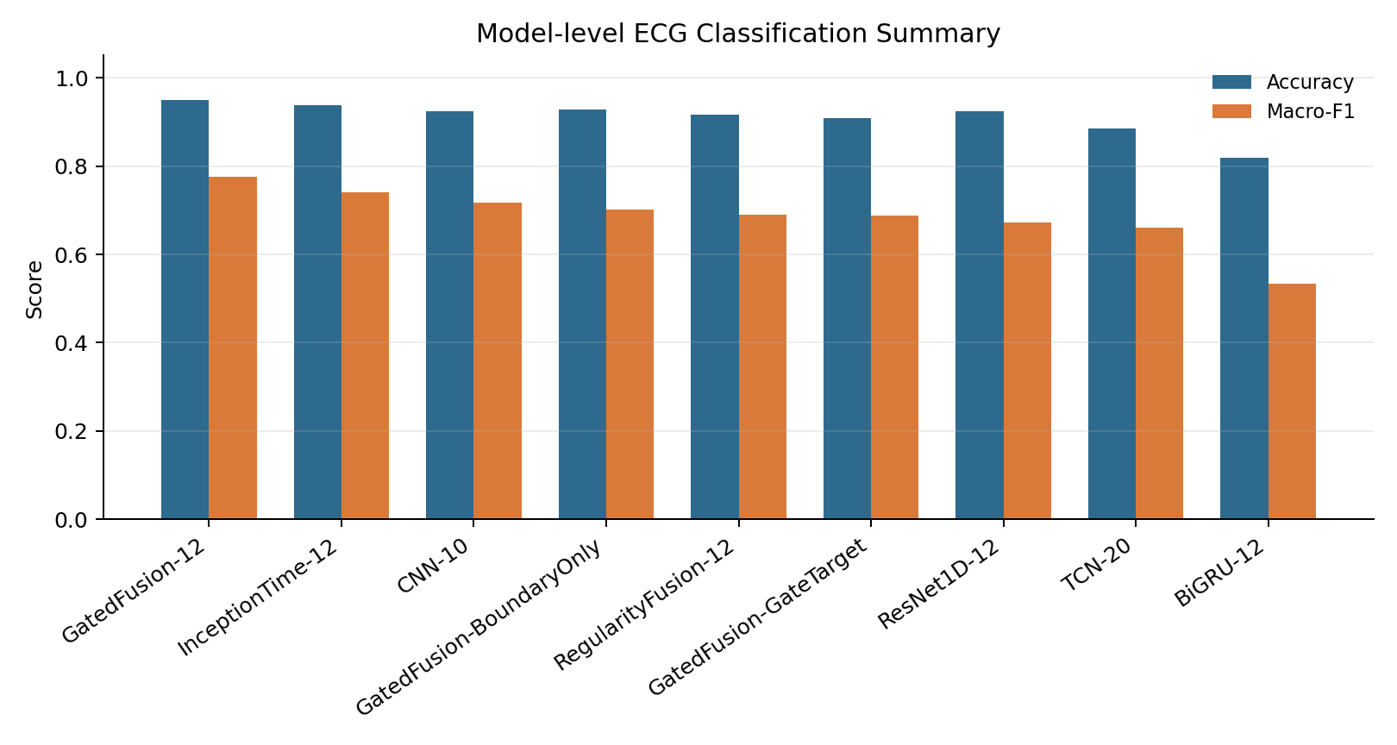
? 1?????????????????????????????????????
??????
?? accuracy ? macro-F1??????????????????????????????????????? VT/VF ????????

?????src/train.py?src/models.py?src/metrics.py?results_public/figures/00_summary/model_performance_summary.png

4. Embedding ? PCA??????????
Embedding ?????????? ECG ????????PCA ?????? embedding ????????? SR?VT?VF ???????????????????PCA ????????????????????
????????????? VT/VF ??????????? SR-VT ? SR-VF??????SR ????????????? VT ? VF ???????????
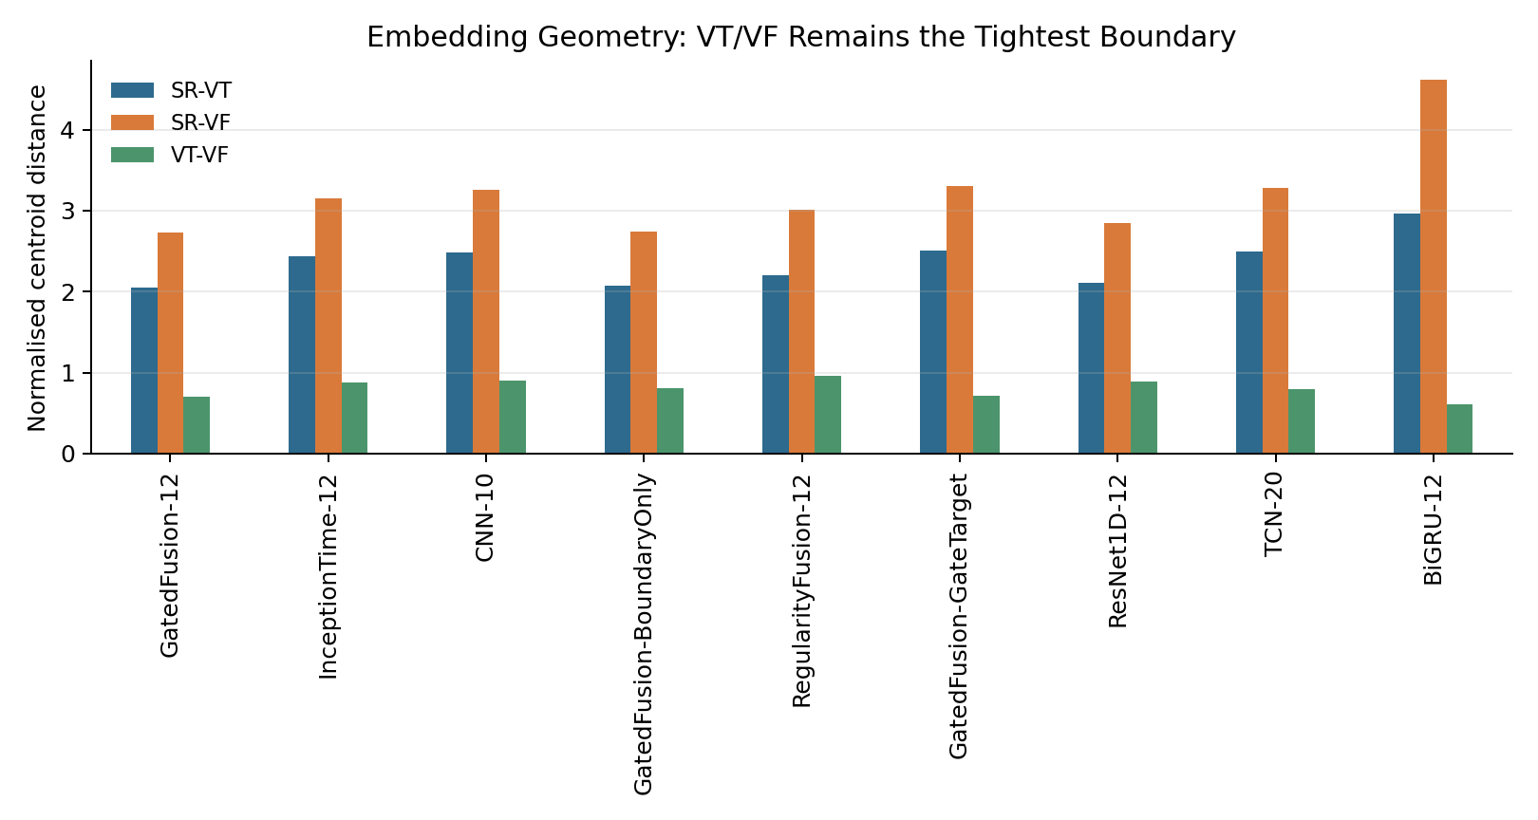
? 2?embedding ????????VT/VF ?????????????
???????
?? VT/VF ????????????????????? overall error???? VT->VF ? VF->VT ? cross-error ????????

?????src/embedding_geometry_analysis.py?src/ambiguity_analysis.py?results_public/figures/01_embedding_pca/contact_sheet.png

5. ??????????????????
????????????????????????????????????? softmax ???? embedding ????softmax ??? MSP?entropy?temperature scaling?energy?embedding ??? prototype distance?Mahalanobis distance?kNN distance?
????????????????????? entropy ? MSP ????????????? energy ???????????????????????????????????????????????? uncertainty score?
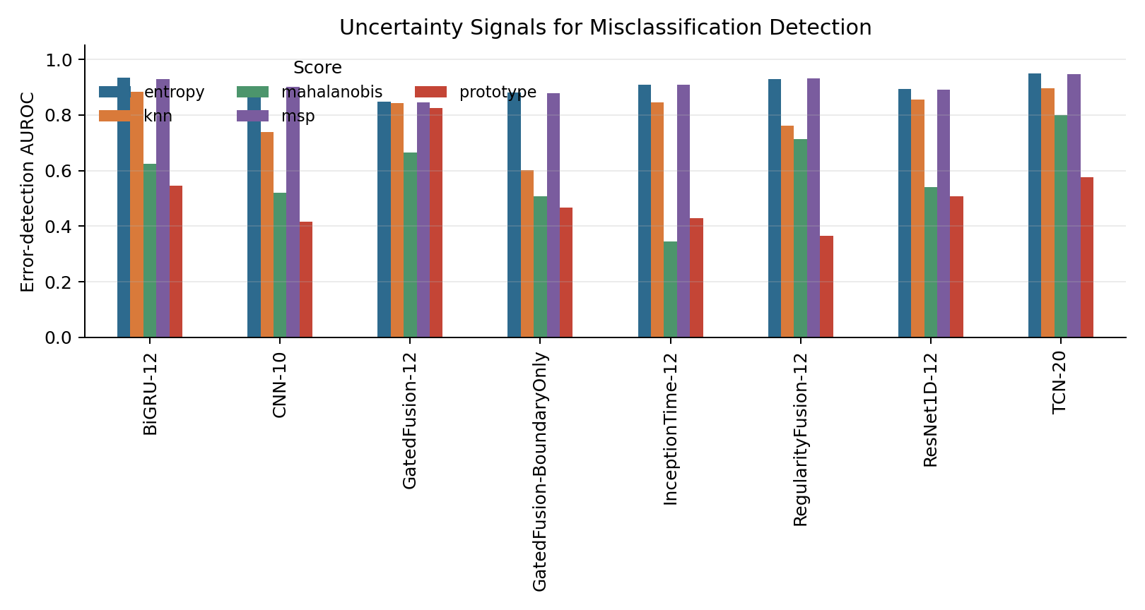
? 3?????????????? AUROC??????????????
?????src/uncertainty.py?src/evaluate_uncertainty.py?results_public/tables/uncertainty_error_detection.csv

6. VT/VF ????????????????
????????????????????? VT/VF ambiguity?????????? VT/VF ??????????softmax ? VT ? VF ??????????????????? VT/VF ????????? ventricular ambiguity index?
?????????????????????????????? VT/VF ??????????????????????
????
?? VT/VF cross-error ??????????????????? SR ??????????? review routing ?????????????????????

?????src/ambiguity_analysis.py?results_public/figures/02_uncertainty_calibration/contact_sheet.png

7. Review routing??????????
???????????????????? AUROC ??????????????????????????????? ECG ??????????
???????????????????????????????????????????? 10%?20%?30% review burden ???????? all errors ??? VT/VF boundary errors?
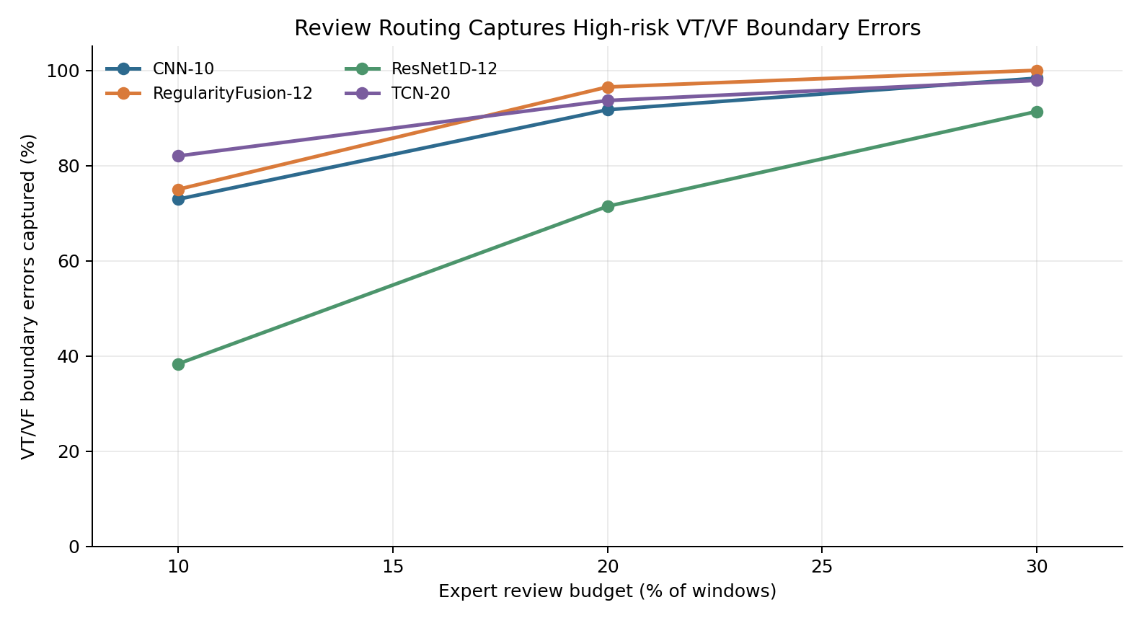
? 4???????? VT/VF ?????????????????????
?? | 10% ?? | 20% ?? | 30% ?? | ??
CNN-10 | 72.9% | 91.7% | 98.3% | baseline ???????????
TCN-20 | 82.0% | 93.7% | 97.9% | ??????
ResNet1D-12 | 38.3% | 71.4% | 91.4% | ???????????
RegularityFusion-12 | 75.0% | 96.5% | 100.0% | regularity ????????

?????src/review_efficiency_analysis.py?src/reliability_map.py?results_public/tables/review_routing_boundary_lrii.csv

8. PRO?????????????
PRO ????? prototype separation / boundary-structure intervention?????? embedding ???? VT/VF ???????? V4/V5 ??? PRO ??????????????? automatic-route VT/VF errors?
??? V6 duplicate-family ??????PRO ??????????????????? seed ???? error migration?????????????????????????
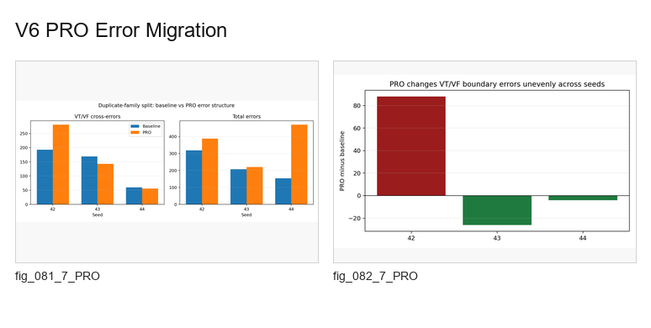
? 5?V6 PRO error migration????????? PRO ??????????
??? PRO ?????
????PRO ???? deployable solution????????????????????????????????????? error migration ???

?????src/pro_geometry_comparison.py?src/run_core_intervention_pipeline.py?results_public/figures/10_v6_pro_error_migration/

9. RISK???????????
RISK ???????? entropy?kNN?local instability?VT/VF mixing?softmax VT/VF ambiguity ???????????????????? risk score??? score ???????? accuracy ???????????????
?? V6 duplicate-family ????validation-selected RISK ? 10% review burden ???? 82.8% ? VT/VF cross-errors?? 20% review burden ??? 100%???????????????????????????????????????????
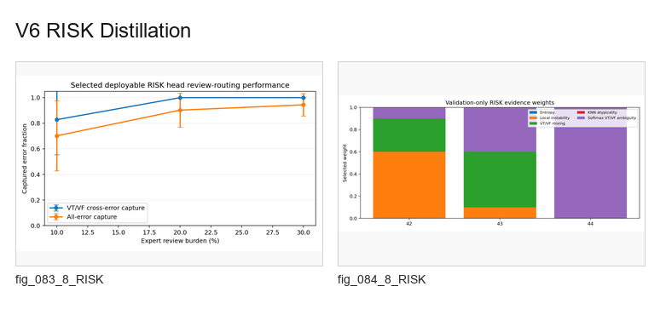
? 6?V6 RISK distillation????????????? validation-only ?????
???? | all-error ?? | VT/VF cross-error ?? | ???????
5% | 37.6% | 52.1% | 3.84%
10% | 70.2% | 82.8% | 2.15%
20% | 90.2% | 100.0% | 0.86%
30% | 94.4% | 100.0% | 0.59%

?????src/generate_risk_targets.py?src/select_deployable_risk_weights.py?src/train_embedding_risk_head.py?results_public/tables/duplicate_family_selected_risk_review_aggregate.csv

10. ???????
??????????? 84 ???????????????????????????????????????? contact sheet ? individual figure?
?? | ????? | ???????
00_summary | ?? | ????????embedding?uncertainty?review routing ????
01_embedding_pca | ??????? SR/VT/VF | ? VT/VF ?????????
02_uncertainty_calibration | ??????? | ? confidence?entropy?risk-coverage?review curve?
03_regularity_interpretability | ECG regularity ?? | ???/????????????
04_ood_corruption | ??????? | ??? corruption severity ????????
05_risk_supervisor_ablation | risk head ? supervisor | ????????ablation ? stability-aware risk?
06_pro_geometry | PRO ????? | ? PRO ???? embedding?????????
07_pro_severity_robustness | PRO ? severity ?? | ? boundary intervention ????????
08_risk_corruption_robustness | RISK ? corruption ???? | ? risk score ??????????
09_pro_boundary_mitigation | V5 PRO ?? | ?????PRO ? boundary-structure mitigation?
10_v6_pro_error_migration | ??? PRO ?? | ? duplicate-family ?? error migration?
11_v6_risk_distillation | ?? RISK ?? | ??????? deployable review-priority score?

?????docs/FIGURE_ATLAS.md?results_public/figures/README.md

11. ???????
??????????????????????????????????????????RISK?????????????????????
??
src/data.py ???? MAT?? 5 ????????record/duplicate-family split?src/inspect_data.py ???????

??
src/models.py ?? backbone?src/train.py ????? logits?probabilities?embeddings?metrics?

????
src/uncertainty.py ?? MSP?entropy?energy?Mahalanobis?kNN?src/evaluate_uncertainty.py ????????

VT/VF ??
src/embedding_geometry_analysis.py ??????src/ambiguity_analysis.py ?? ventricular ambiguity index?

????
src/review_efficiency_analysis.py ?? review burden ???????src/reliability_map.py ?????????

RISK
src/generate_risk_targets.py ???????src/select_deployable_risk_weights.py ????????src/train_embedding_risk_head.py ?? risk head?

????
src/run_multiseed_experiments.py ?? seed?src/aggregate_* ? src/seedwise_statistical_summary.py ?? mean/std?paired differences?

12. ?????????
?????? accuracy?
???? accuracy ??? VT/VF ?????????????????????????????????????????????

PCA ???????
PCA ????????????????? embedding ??? SR?VT?VF ????????? VT/VF ?????

RISK ??? uncertainty ??????
?? uncertainty ??? post-hoc ???RISK ??????????????????????????

PRO ??????
????????????????????????????? error migration?????????/?????

????????
??????????????? corruption?????????????????????

13. ??????????
?????
?????????????????????????????????????????? ECG ???????????embedding?regularity?corruption?review routing ??????????????? RISK ???????????? VT/VF ???????????? RISK ?????????? expert-review priority score???????????? seeds ????????

?????????????????????????????????????????????

?????????
???????????????????????
?? | ??
?????? | docs/COMPLETE_EXPERIMENT_COMPENDIUM.md
???? | docs/FIGURE_ATLAS.md?results_public/figures/README.md
????? | results_public/tables/
????? | results_public/figures/
???? | src/data.py?src/inspect_data.py
???? | src/train.py?src/models.py
?? RISK ? | results_public/tables/duplicate_family_selected_risk_review_aggregate.csv

