MARCH 2017 – AUGUST 2017 ELECTRONICS WEEKLY OJT TIME TABLE
 | MARCH (COMMUNICATION) | APRIL (NAVAIDS) | MAY (SURVEILLANCE) | JUNE (COMMUNICATION) | JULY (NAVAIDS) | AUGUST (SURVEILLANCE)
WEEK 1  Instructor: | VCCS SYSTEM:  - Overview  - System Architecture  - System Operations & Maintenance  Joseph Obodai,  Francis Anyetei | General Introduction and Overview of Navigational Aids Systems for Civil Aviation Use  Isaac Boakye | General Introduction and Overview of Surveillance Systems for Civil Aviation Use  Frank Apeagyei | AMHS / AFTN SYSTEMS:  - AMHS CADAS  - AMHS AIDA  - Practical’s on AMHS  Francis Anyetei  Frank Apeagyei | ILS – LOCALIZER:  - Overview  - System Architecture  - System Operations & Maintenance  - Antenna Systems  Daniel Kusitor | ADS-C SYSTEM:  - Overview  - System Architecture  - System Operations & Maintenance  Joyce Asante
WEEK 2  Instructor: | MICROWAVE / ANTENNA LINKS:  - Overview  - VHF Antennas  - HF Antennas  - Links  - System Operations & Maintenance  Joseph Obodai  Francis Anyetei | VOR (DVOR) SYSTEMS:  - Overview  - Principles  - System Architecture  - System Operations & Maintenance  Frederick Opoku | PSR SYSTEM:  - Overview  - System Architecture  - System Operations & Maintenance  - Antenna Assembly  Joyce Asante | PABX SYSTEM:  - Overview  - System Architecture  - System Operations & Maintenance  Christopher Aguadze | ILS – GLIDE PATH:  - Overview  - System Architecture  - System Operations & Maintenance  - Antenna Systems  Daniel Kusitor | CPDLC SYSTEM:  - Overview  - System Architecture  - System Operations & Maintenance  Isaiah Tefutor
WEEK 3  Instructor: | HF COMMUNICATIONS:  - Overview  - System Architecture  - System Operations & Maintenance  Joseph Obodai | DME (EDME/TDME) SYSTEM:  - Overview  - Principles  - System Architecture  - System Operations & Maintenance  Isaac Boakye | MSSR SYSTEM:  - Overview  - System Architecture  - System Operations & Maintenance  - Antenna Assembly  Anani Adjanoh-Adanlete | VOICE RECORDER SYSTEM:  - Overview  - System Architecture  - System Operations & Maintenance  Solomon Hansen  Jonathan Arthur | NDB SYSTEMS:  - Overview  - System Architecture  - System Operations & Maintenance  - Antenna Systems  Frederick Opoku | RECORDERS:  - ADS-C  - CPDLC  - RADAR  Joyce Asante  Isaiah Tefutor
WEEK 4  Instructor: | VHF COMMUNICATIONS:  - Overview  - System Architecture  - System Operations & Maintenance  Joseph Obodai  Isaiah Tefutor | ILS, NBD & ATIS SYSTEMS:  - Overview  - Principles  - System Architecture  - System Operations & Maintenance  - Other Ancillary Systems  Daniel Kusitor | DATA PROCESSING SYSTEMS:  - RHP  - RDP  - RFE  - FDP  Joyce Asante  Anani Adjanoh-Adanlete | IBS SYSTEMS & VSAT SYSTEMS:  - Overview  - System Architecture  - System Operations & Maintenance  Francis Anyetei  Mahama Asunga | ATIS & ONBOARD SYSTEMS:  - Overview  - System Architecture  - System Operation  Frederick Opoku  Isaac Boakye | PLAYBACK SYSTEMS:  - ADS-C  - CPDLC  - RADAR  Joyce Asante  Isaiah Tefutor
WEEK 5  Instructor: | AMHS/AFTN SYSTEMS:  - Overview  - AFTN System Architecture  - AMHS System Architecture  - System Operations & Maintenance  Francis Anyetei  Isaiah Tefutor |  | DATA PROCESSING SYSTEMS:  - RHP  - RDP  - RFE  - FDP  - Linkages  - CWP’s  Joyce Asante  Anani Adjanoh-Adanlete |  |  | - Group Discussions  - Assessments  DG  DDGT  DATSE  DDATSE  All Managers
FACILITATORS: Ing. FRANK KOFI APPEAGYEI and Ing. ISAAC KWEKU BOAKYE
Time Schedule

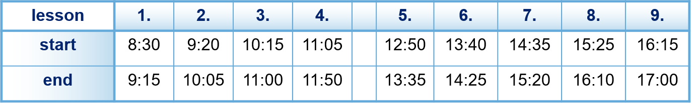

Breaks within blocks
can be adjusted individually.
Course start: 09:00
Course end: 16:10 (17:00)

Please be in the classroom in time!

