Tenniel Takenaka-Fuller

CPE301 – SPRING 2018

Design Assignment 1

**DO NOT REMOVE THIS PAGE DURING SUBMISSION:**

The student understands that all required components should be submitted in complete for grading of this assignment.

|  |  |  |  |
| --- | --- | --- | --- |
| **NO** | **SUBMISSION ITEM** | **COMPLETED (Y/N)** | **MARKS**  **(/MAX)** |
| 1 | COMPONENTS LIST AND CONNECTION BLOCK DIAGRAM w/ PINS |  |  |
| 2. | INITIAL CODE OF TASK 1/A |  |  |
| 3. | INCREMENTAL / DIFFERENTIAL CODE OF TASK 2/B |  |  |
| 3. | INCREMENTAL / DIFFERENTIAL CODE OF TASK 3/C |  |  |
| 3. | INCREMENTAL / DIFFERENTIAL CODE OF TASK 4/D |  |  |
| 3. | INCREMENTAL / DIFFERENTIAL CODE OF TASK 5/E |  |  |
| 4. | SCHEMATICS |  |  |
| 5. | SCREENSHOTS OF EACH TASK OUTPUT |  |  |
| 5. | SCREENSHOT OF EACH DEMO |  |  |
| 6. | VIDEO LINKS OF EACH DEMO |  |  |
| 7. | GOOGLECODE LINK OF THE DA |  |  |
|  |  |  |  |
|  |  |  |  |

1. **COMPONENTS LIST AND CONNECTION BLOCK DIAGRAM w/ PINS**

Atmel Studio 7

1. **INITIAL/DEVELOPED CODE OF TASK 1/A**

A screenshot of a cell phone

Description generated with very high confidence

A close up of a logo

Description generated with high confidence

1. **CODE OF TASK 1/B AND 1/C COMBINED INTO ONE SECTION**

Start program is the continuation of the population process.

A screenshot of a social media post

Description generated with very high confidence

A screenshot of a cell phone

Description generated with very high confidence

1. **CODE OF TASK 1/D**

**A screenshot of a cell phone screen with text

Description generated with very high confidence**

**A screenshot of a cell phone

Description generated with very high confidence**

1. **SCREENSHOTS OF EACH TASK OUTPUT (ATMEL STUDIO OUTPUT)**

## A screenshot of a computer Description generated with very high confidenceTask 1: Before Debugging

## Task 1: After Debugging

Values in register R21, R22, R23, and R25 have changed and loaded values from 0’s.

A screenshot of a computer

Description generated with very high confidence

## A screenshot of a cell phone Description generated with very high confidenceTask 1B and 1C: Before Debugging

A close up of a door

Description generated with high confidence

A screenshot of a cell phone

Description generated with very high confidence

A close up of a logo

Description generated with high confidenceRegister values before debugging

## A close up of a piece of paper Description generated with high confidenceA screenshot of a cell phone Description generated with very high confidenceTask 1B and 1C: After Debugging

Figure X-Pointer Array (300 numbers)

A close up of a white wall

Description generated with high confidence

Figure Y-Pointer Array (Divisible Numbers)

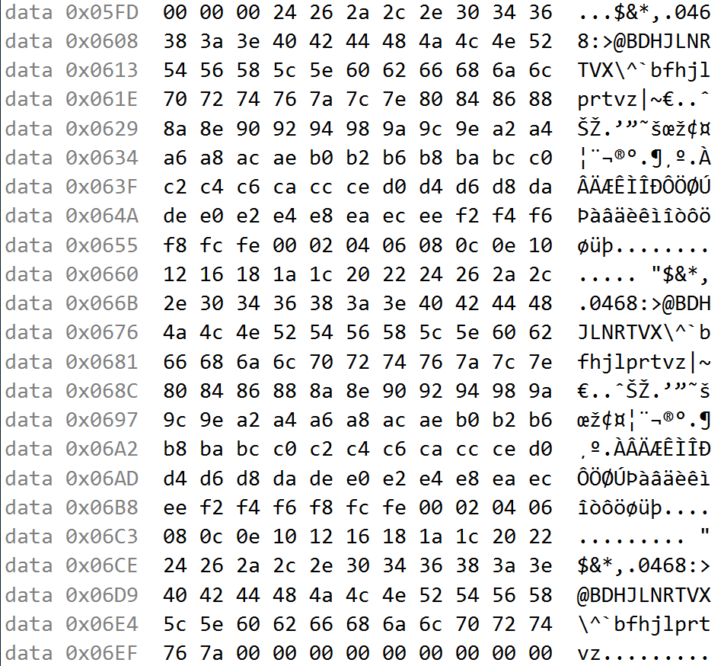

Figure Z-Pointer Array (Non-Divisible #s)

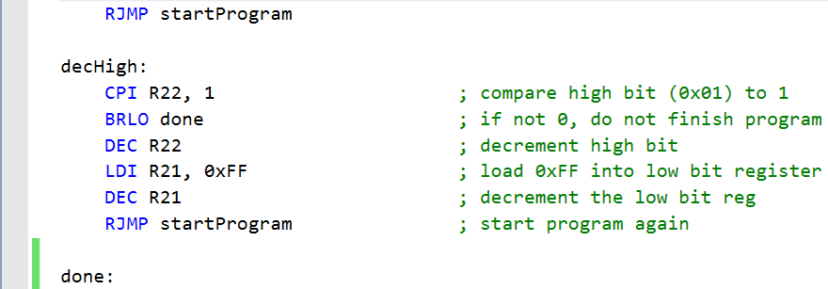

A close up of a logo

Description generated with very high confidence

A close up of a logo

Description generated with very high confidence

The registers R22:R21 registers are zero-d out since I placed 300 in these 2 registers and decremented both for the checkThreeHundred loop. The divisible sum is stored in R17:R16 as 0x1C34 (7,220 in decimal). The non-divisible sum is stored in R19:R18 as 0x7060 (28,768 in decimal). The arrays that x, y, and z are pointing to are shown in the Memory windows above.

## A close up of a keyboard Description generated with very high confidenceTask 1D: After Debugging

1. **SCREENSHOT OF 1E**

**A screenshot of a cell phone

Description generated with very high confidence**

Figure At 16MHz, execution done in 4,014.19 microseconds

1. **GITHUB LINK OF THIS DA**

**Student Academic Misconduct Policy**

<http://studentconduct.unlv.edu/misconduct/policy.html>

“This assignment submission is my own, original work”.

Tenniel Takenaka-Fuller