Tenniel Takenaka-Fuller

CPE301 – SPRING 2018

Design Assignment 3

**DO NOT REMOVE THIS PAGE DURING SUBMISSION:**

The student understands that all required components should be submitted in complete for grading of this assignment.

|  |  |  |  |
| --- | --- | --- | --- |
| **NO** | **SUBMISSION ITEM** | **COMPLETED (Y/N)** | **MARKS**  **(/MAX)** |
| 1 | COMPONENTS LIST AND CONNECTION BLOCK DIAGRAM w/ PINS |  |  |
| 2. | INITIAL CODE OF TASK 1/A |  |  |
| 3. | INCREMENTAL / DIFFERENTIAL CODE OF TASK 2/B |  |  |
| 3. | INCREMENTAL / DIFFERENTIAL CODE OF TASK 3/C |  |  |
| 3. | INCREMENTAL / DIFFERENTIAL CODE OF TASK 4/D |  |  |
| 3. | INCREMENTAL / DIFFERENTIAL CODE OF TASK 5/E |  |  |
| 4. | SCHEMATICS |  |  |
| 5. | SCREENSHOTS OF EACH TASK OUTPUT |  |  |
| 5. | SCREENSHOT OF EACH DEMO |  |  |
| 6. | VIDEO LINKS OF EACH DEMO |  |  |
| 7. | GOOGLECODE LINK OF THE DA |  |  |
|  |  |  |  |
|  |  |  |  |

1. **COMPONENTS LIST AND CONNECTION BLOCK DIAGRAM w/ PINS**

ATMEGA 328P, 20 stripped wires, an FTDI chip, Evil Mad Scientist target board, and the LM35 temperature reader

1. A screenshot of a cell phone

   Description generated with high confidence**COMPLETELY DEVELOPED CODE OF TASK 1**

A screenshot of a social media post

Description generated with very high confidence

A screenshot of a cell phone

Description generated with high confidence

1. **SCHEMATICS**

A close up of text on a white surface

Description generated with high confidence

Schematic of the circuit board.

1. **SCREENSHOTS OF EACH TASK OUTPUT (ATMEL STUDIO OUTPUT)**

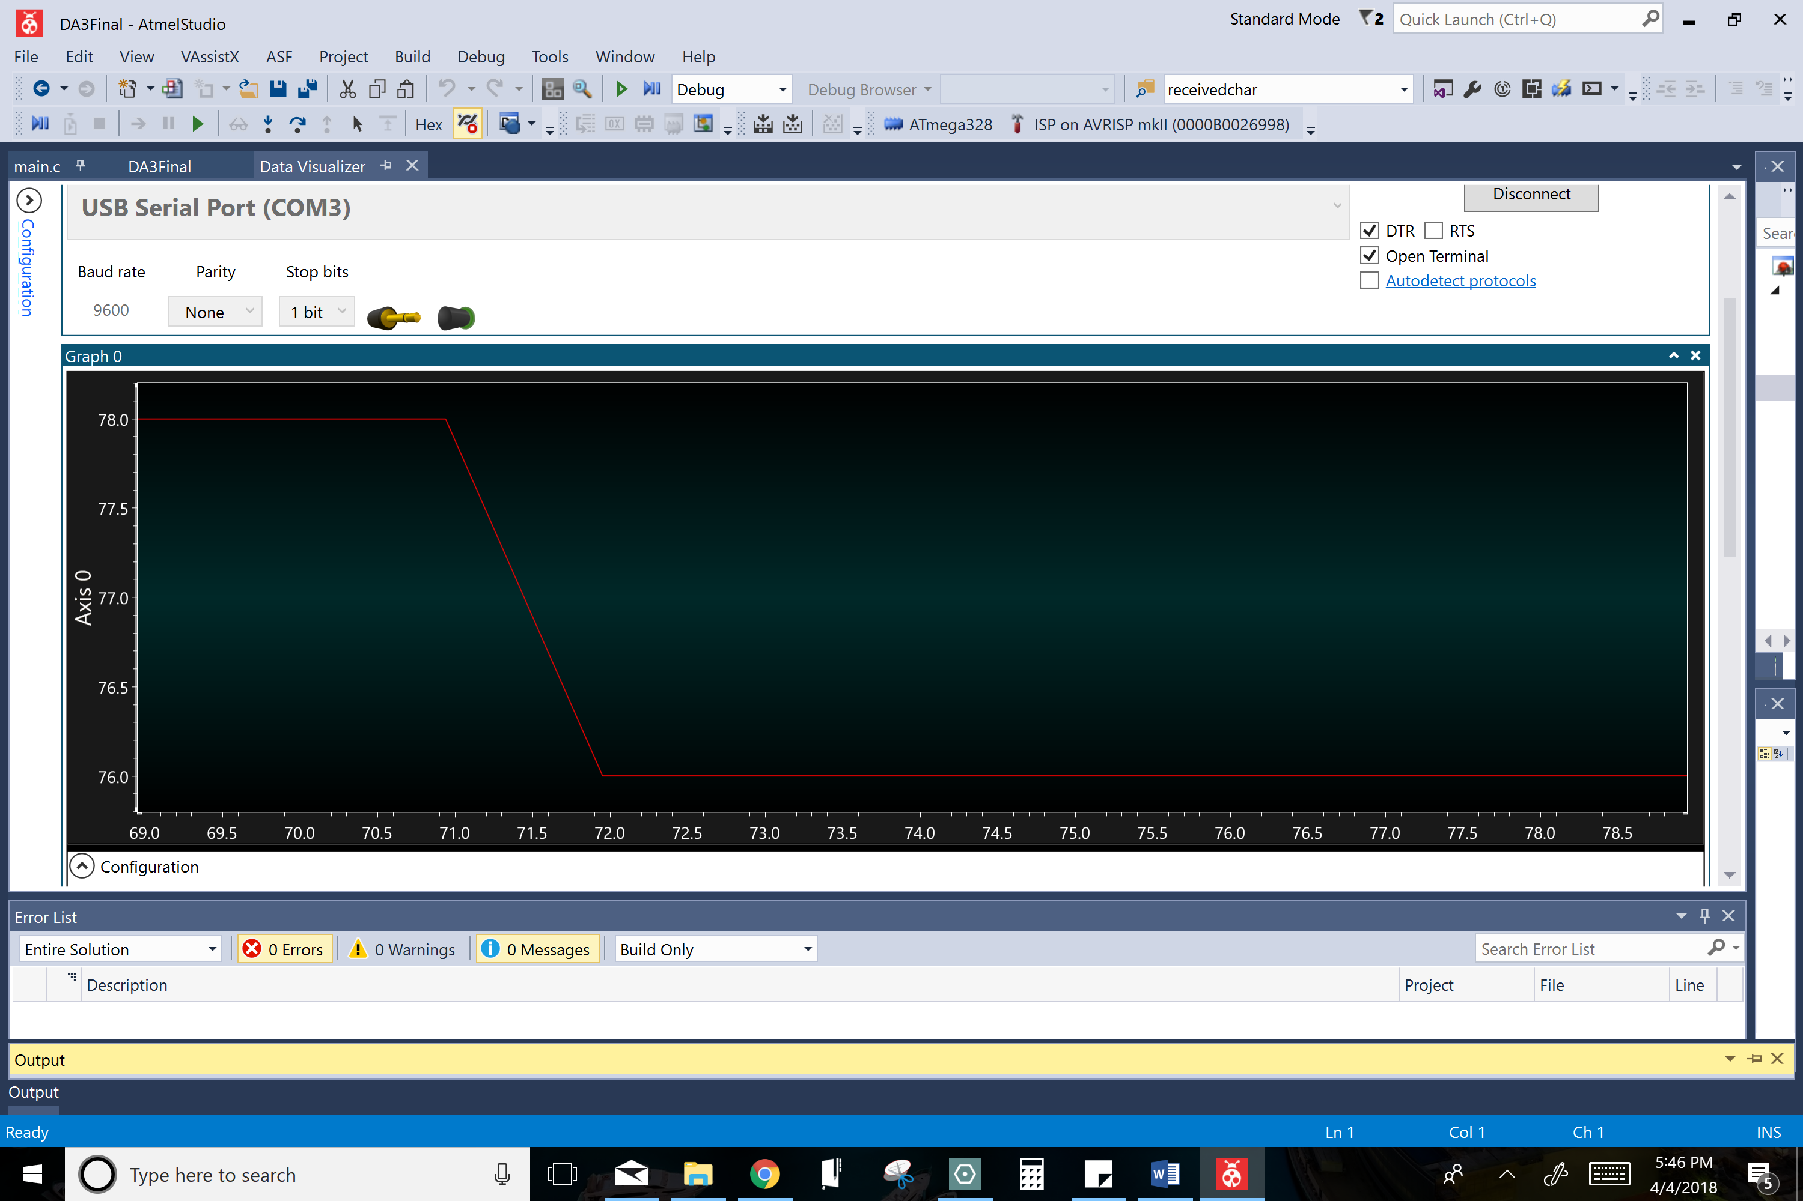

76 degrees is the room temperature the LM35 would read or fall back to unless something very cold or hot would go near it. Pictured here is the LM35 dropping back down to normal room temperature after encountering a hotter temperature.

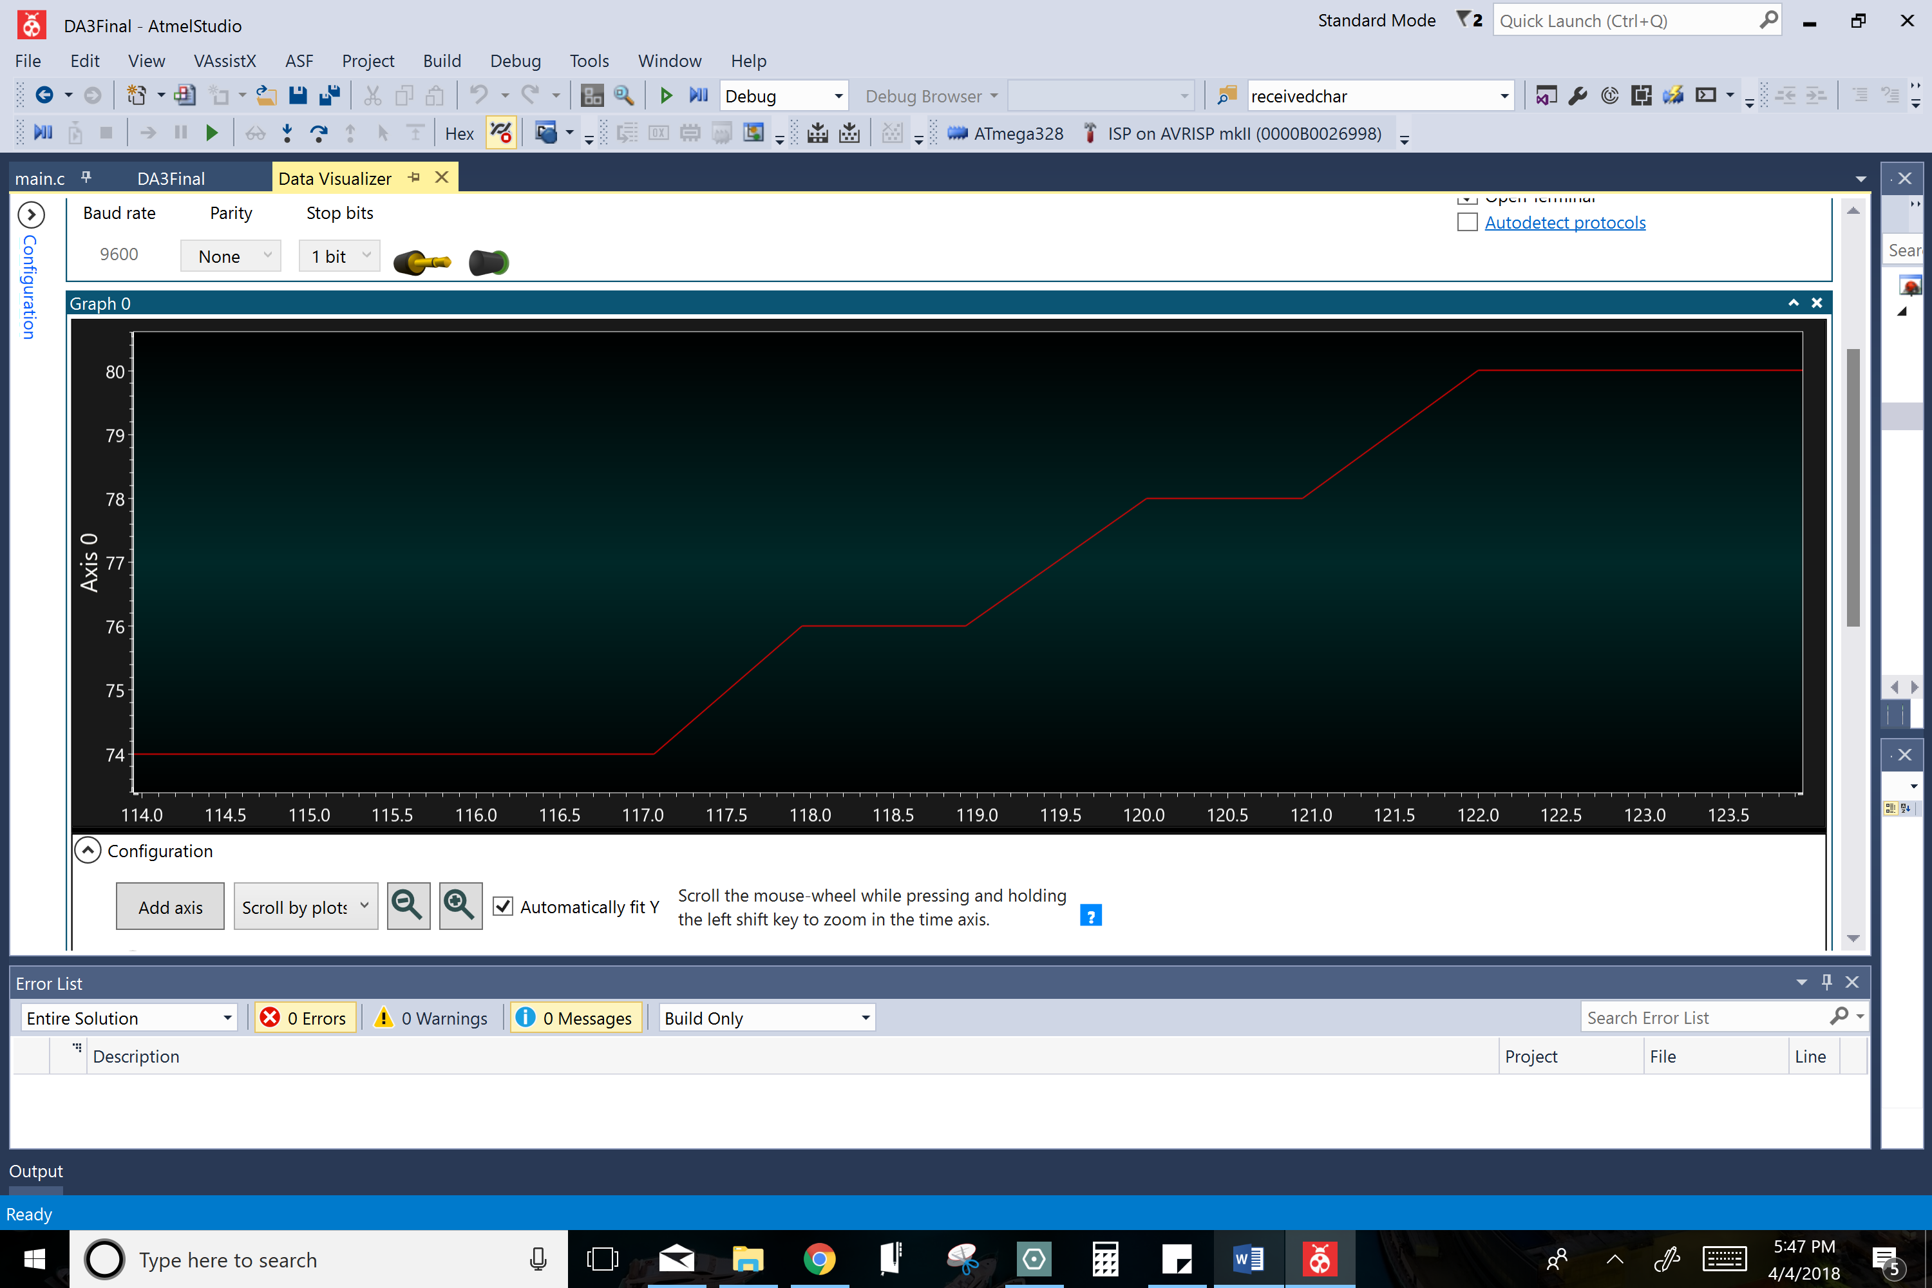

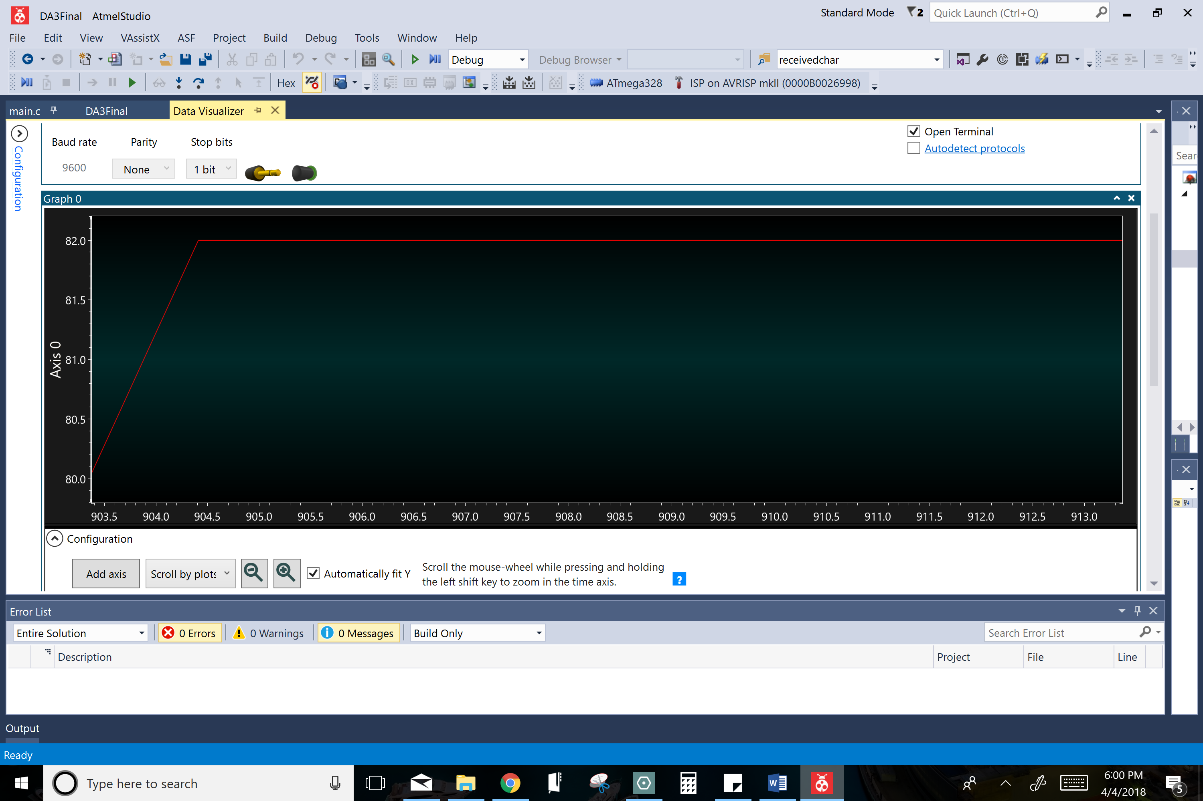

The LM35 is steadily reading a temperature that is hotter than the room temperature.

Pictured above is the LM35 is reading a temperature that is hotter than the room temperature. For demonstration purposes, I held the LM35 with my fingers to increase the temperature it read through my finger’s body heat.

1. **SCREENSHOT OF EACH DEMO (BOARD SETUP)**

A close up of a device

Description generated with high confidence

**A close up of a sign

Description generated with very high confidence**

**A circuit board

Description generated with very high confidence**

1. **FLOW CHART OF PROGRAM**

Pictured above

1. **GITHUB LINK OF THIS DA**

https://github.com/TennielTakenaka/DA3

**Student Academic Misconduct Policy**

<http://studentconduct.unlv.edu/misconduct/policy.html>

“This assignment submission is my own, original work”.

Tenniel Takenaka-Fuller