SHOP SMART RETAIL LIMITED BUSINESS REPORT
OVERVIEW OF DATASET
The Shop Smart retail limited provided Analystlab africa with 9 datasets with 1 dictionary file for better understanding and clarity into what the datasets are about. Each datasets carries records of the different components making up the retail store from customers to sales and the components of the datasets will be explained including the primary key and the foreign keys embedded in them if there’s any below:
- ALA_shopsmart_customers contains records of the customers including details of what you need to know about each customer. It has the customer ID as its primary key with no foreign key in it
- Shopsmart_products contains the records of the products available/ sold in the store including their various categories, prices and important details about them. This dataset contains Product ID as its primary key with no foreign key embedded in it.
- Shopsmart_orders contains the records of the various orders of products placed in different stores. It acts as the fact table for shopsmart retail stores. Its primary key is Order ID and it has different foreign keys including: customer ID, store ID and product ID
- Shopsmart_stores contains the records of the different branches of the shopsmart retail store, their various locations across Nigeria and dates of opening. It has the Store ID as its primary key with no foreign key in it.
- Shopsmart_Returns contains records and details of orders that were returned with the different reasons for their return and date of return. It has the Return ID as its primary key and the Order ID as its foreign key
- Shopsmart_Employee contains records of the employees of the shopsmart across the different stores, their roles, salary, date of employment and other details. It has the Employee ID as its primary key and the Store ID as its foreign key.
- Shopsmart_Suppliers contains records of the various companies and people supplying shopsmart with the various products they sell. It contains necessary details like their email, location, phone and name. Its primary key is Supplier ID and it has no foreign key.
- Shopsmart_Inventory contains records of the different stock of products bought, when they were bought, in which store they were taken to and their arrangement in each store. Its primary key is Inventory ID and the Store ID and Product ID are its foreign key.
- Shopsmart_Order_Items contains the individual line-item details for each transaction/order. Its primary key is Order Item ID and its foreign key is Order ID.

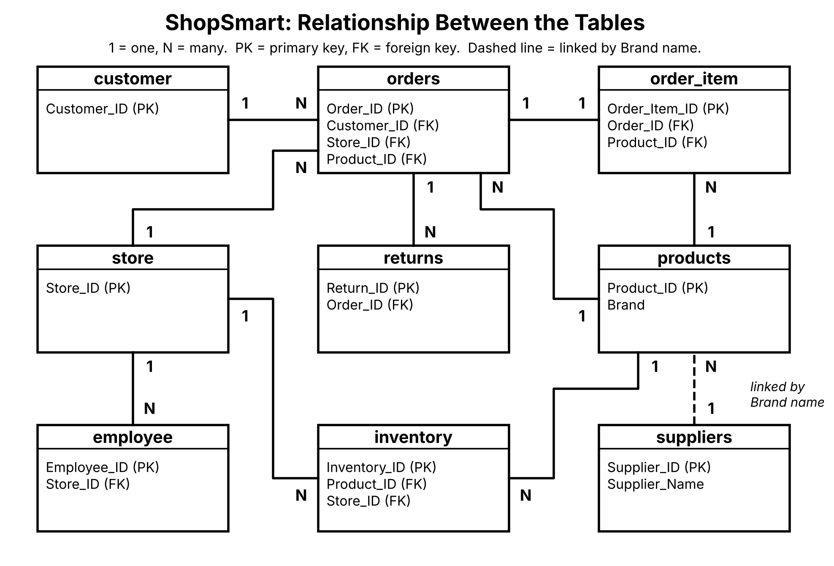

BUSINESS QUESTIONS
ShopSmart earned 7.58B from 50,000 orders in 2025. The answers come from the pivot tables and the metrics sheet. Amounts have no currency symbol because the data does not state one.
 | Question | Answer
1 | Which product generated the highest revenue? | Home Item 400, with 21.6M (Top_10_Products pivot). No product makes even 0.5% of revenue, so sales do not depend on one product.
2 | Which store performed best? | ShopSmart Lagos, with 1.23B (16.3% of revenue), followed by Ibadan (1.23B) and Abuja (1.22B).
3 | Which category sells the most? | Beauty, with 1.76B (23.3% of revenue), followed by Groceries (1.58B) and Electronics (1.53B).
4 | Which month generated the highest revenue? | December, with 660.6M. February was the lowest at 566.6M.
5 | Which customers spend the most? | Joseph Smith (12.0M), Nicole Smith (7.5M) and Mark Smith (6.9M).
6 | Which products are frequently returned? | No product stands out. Home Item 263 has the most returns (11), and several others have 10 each. By category, Home and Beauty have the highest return rates (5.1% each).
7 | Which supplier supplies the highest number of products? | No single supplier leads. Out of 500 products, 11 suppliers supply 2 products each (Williams Group, Thomas Ltd, Martinez Ltd, Myers and Sons, Dyer LLC, Smith LLC, Jones Group, Garcia PLC, Matthews and Sons, Rosales PLC and Smith PLC), and every other supplier supplies 1.
8 | Which stores have low inventory? | Enugu (3,349 units), Kano (4,708 units) and Awka (7,853 units) hold the least stock.
9 | Which region performs best? | South, with 2.42B (32.0% of revenue), followed by East (2.12B), North (1.83B) and West (1.20B).
10 | Which product category should management invest in? | Beauty. It has the highest revenue (23.3%), but its return rate (5.1%) is among the highest, so quality should be watched.

BUSINESS RECOMMENDATIONS
ShopSmart earned 7.58B from 50,000 orders in 2025, an average of 151,505 per order. Sales are steady across the year and spread across many products and customers.

Three key findings
- Sales are steady. Monthly revenue stays between 567M (February) and 661M (December), with no single product making more than 0.3% of revenue.
- Beauty and the South lead. Beauty is the top category at 23.3% of revenue, and the South is the top region at 32.0%. Lagos, Ibadan and Abuja are the top three stores, together making 48.5% of revenue.
- Returns are about 5% of orders. Home and Beauty have the highest category return rates (5.1% each), and no single product is returned often (the most is 11 returns).

Three recommendations
- Invest in Beauty. It is the best-selling category, so widen its range and promote it. Check product quality as it grows, since its return rate is among the highest.
- Reduce returns in Home and Beauty. Review product quality, descriptions and delivery for these two categories, and track their return rate every month.
- Review stock at Enugu, Kano and Awka. They hold the least stock (3,349, 4,708 and 7,853 units) and also have the lowest sales, so confirm they are stocked well enough to sell.

One risk
Sales depend on three stores. Lagos, Ibadan and Abuja make 48.5% of revenue. A disruption at any of them, such as stock shortages or a closure, would hit total sales hard.

One opportunity
Grow the weaker stores and the West region. Enugu, Kano and Awka each make about 0.3B (about 4% of revenue), against about 1.2B for each of the top three stores, and the West is the weakest region at 15.9%. Better stock, local promotions and marketing could close part of this gap.

