Computer Science Department – Master Degree in Software Engineering and IT Management

ArchiVehicle

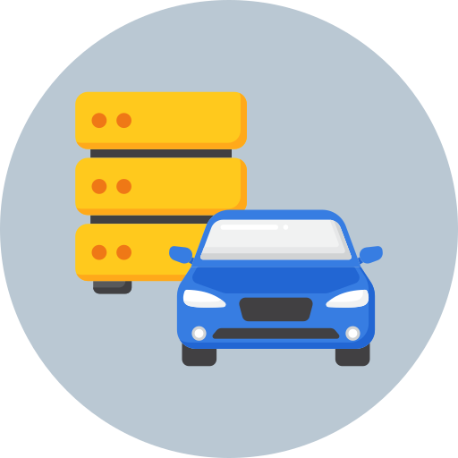



Database II Class

Project Documentation

Superivsors:  Prof.ssa Genoveffa Tortora  Prof. Luigi Di Biasi |  | Author:  Daniele Fabiano  0522501738

Anno accademico 2023/2024
Table of Contents
Introduzione 3
Descrizione del Sistema 3
Dataset 4
Informazioni iniziali sul dataset di partenza 4
Generazione del dataset dei produttori di veicoli 5
Data Cleaning 8
Database 9
Scelta del Database 9
Schema dei dati 9
Struttura di un documento della collezione dei produttori 9
Struttura di un documento della collezione dei veicoli 10
Import dei dataset 11
Applicazione Web 13
Scelta delle tecnologie 13
Pymongo 13
Flask 13
Bootstrap 13
Descrizione delle pagine 14
Pagina Home 14
Pagina Vehicles 14
Pagina Insert Vehicle 15
Pagina Show Single Vehicle 16
Pagina Manufacturers 17
Pagina Stats 18
Installazione di ArchiVehicle 18

Introduction
This documentation describes the project realized for the Database II Class. In this document you can find more details about:
- Requirements of the project;
- Dataset choice;
- Dataset analysis and cleaning;
- DBMS choice;
- Data Scheme creation;
- Uploading data to the database;
- Technologies choice for the webapp;
- Description of the page realized and the possible actions;
- Webapp installation.

Description of the system
ArchiVehicle has the goal to simplify and digitalize the the information management about a vehicle park of a car dealer. This software is intended for the userd of a business that have to retrieve the information about the vehicles and memorize them into the system, thanks to a graphical user interface served by a client/server web application. ArchiVehicle offers the following functionalities:
- Insert, update, delete the information about a vehicle;
- Insert, update, delete the information about a manufacturer of vehicles;
- Searching for a vehicle by applying some filters;
- Quick view of the number of vehicles by each manufacturer, based on various characteristics by vehicle.

Dataset

Information about the initial dataset
Not having available information about vehicles, in order to simulate the use of this application, a public dataset from Kaggle has been picked. The choosed dataset is Vehicle Dataset 2024. For each column it has been defined a description about the showed information e the data type to be memorized. If necessary, it has been specified the possible insertable value of the picked column:
Column name | Description | Data type
name | Full name of the vehicle | String
description | A brief description of the vehicle | String
make | The vehicle’s manufacturer name | String
model | The model name of the vehicle | String
type | The vehicle type | String: {“New”, “Used”}
year | The year of production of the vehicle | Intero
price | The vehicle price | Decimal
engine | Info about the vehicle engine | String
cylinders | The number of cylinders in the vehicle engine | Decimal
fuel | The type of fuel used by the vehicle | String
mileage | The number of miles driven by the vehicle | Decimal
transmission | The type of vehicle transmission | String
trim | The level of vehicle accessories | String
body | The body style of the vehicle | String:  {“Convertible”,  “Hatchback”,  “Pickup Truck”,  “SUV”,  “Sedan”,  “Cargo Van”,  “Passegner Van”,  “Minivan”}
doors | The number of vehicle doors | Decimal
exterior_color | The exterior color of the vehicle | String
interior_color | The interior color of the vehicle | String
drivetrain | The type of vehicle traction | String:  {“All-wheel Drive”,  “Four-wheel Drive”,  “Front-wheel Drive”,  “Rear-wheel Drive”}

Generation of vehicle manufacturer dataset
Now having all the information about the vehicles, but still missing the ones about the manufacturers, it has been decided to use ChatGPT to request the generation of a dataset about the manufacturers. After extracting the name of all the manufacturers, with the techniques showed in the Data Cleaning section, the dataset has been generated and downloaded in a csv format. The conversation is showed next:
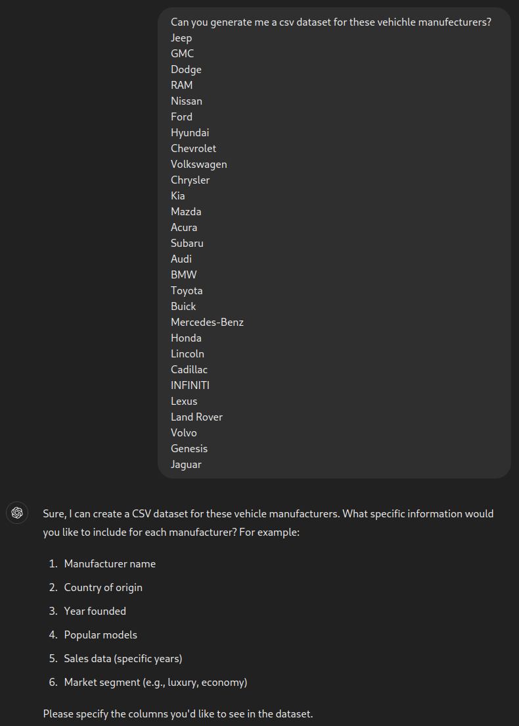Figure 1: Generation of vehicle manufacturer dataset - Part 1

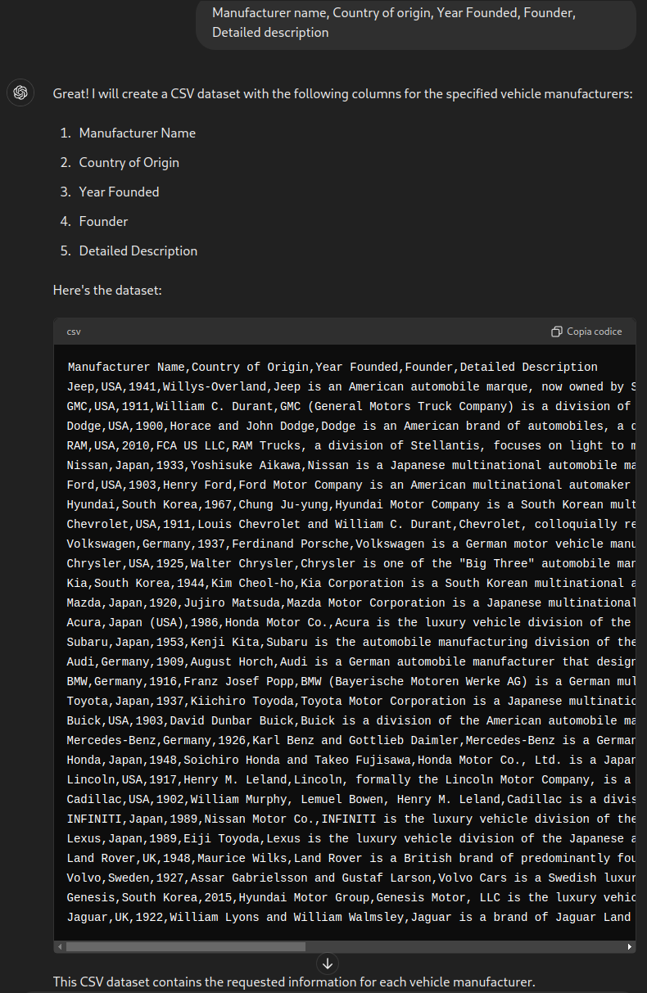Figure 2: Generation of vehicle manufacturer dataset - Part 2

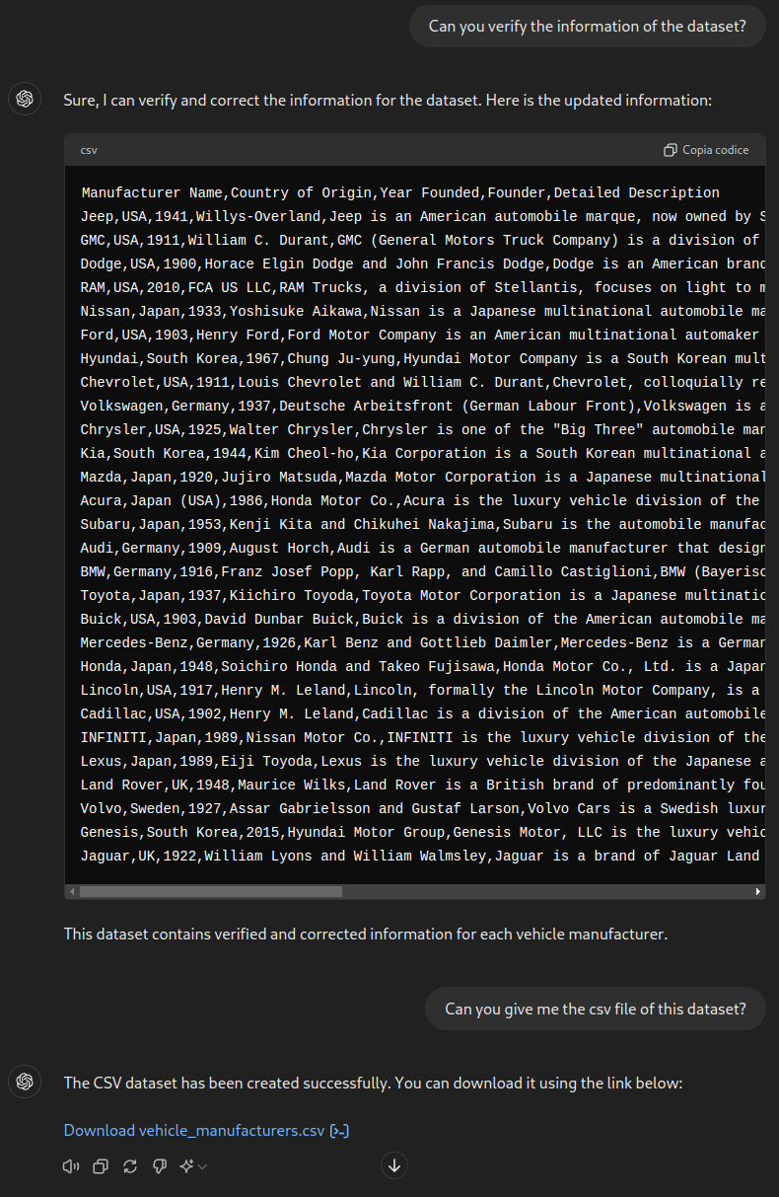Figure 3: Generation of vehicle manufacturer dataset - Part 3
The result dataset has the following columnns:
Nome colonna | Descrizione | Tipo di dato
name | The manufacturer name | String
country | The country where the production company was founded | String
year | The year the production company was founded | Integer
founder | The name of the founder of the production company | String
description | A brief description of the production company | String

Data Cleaning
After obtaining all the dataset, before is possibile to load them on the db, some data cleaning operations have been necessary. For this reason, two notebooks has been realized, using also the pandas library. The main operation are showed next:
- vehicles_dataset_manufacturer_extract.ipynb:
- Extract the make column that contains the manufacturers name;
- Remove the duplicates from the extracted column;
- Save the column on a csv file.
- vehicles_dataset_cleaning.ipynb:
  - Remove the production year from the elements of the name column;
  - Remove the rows whit null/empty values;
  - Remove extra newline/spacing characters from the element of description column;
  - Change the type of cylinders and doors column from float to int;
  - Retrieve the indexes of the rows with meaningless numerical values (0 or 0.0) and the remove these rows;
  - Retrieve the indexes of the rows where the description is under 100 characters lenght and remove these rows;
  - Remove the duplicated rows by the name column;
  - Change the name of body column to chassis;
  - Simplify all the chassis Van types, grouping them up;
  - Create a new column image wiht default value "img";
  - Change the make column name to manufacturer_id and change the manufacturers name with the respective id in the database;
  - Change the name of some columns e move them, in order to correctly import the dataset into the database;
  - Save the cleaned dataset on a csv file.

Database

Database Choose
In order to manage the persistent data of this application, it has been decided to use MongoDB and there are several reason:
- Data structure: thanks to the “flexibility” of a NoSQL databse, is possibile to save the partial info of an entity in a less rigid way. In this case, the car dealer, could have received only the essential vehicles information from the manufacturers and still starts to save them, so they can be later integrated with the missing ones.
- Scalability: a NoSQL database offers an increased expandability, so it’s easier to distribute the data on different nodes on the network. In this case, the car dealer could have multiple shops in the country, having the necessity to use the application on more machines and to define a distribute solution for the database.

Data Scheme
Even if the database been used is a NoSQL, for each collection has been defined a document structure in order to define the data scheme.

Data structure of the manufacturers collection
For each document of the manufacturers collection, since there are a few attributes the srtucture is on a single level, as showed in the next example:
{
“_id”: {
"$oid": "6687ea0b2d6d295df5c1f188"
},
“name”: “Jeep”,
“country”: “USA”,
“year”: 1941,
“founder”: “Willyes-Overland”,
“description”: “Jeep is an American automobile marque, now owned by Stellantis. It is known for its rugged off-road vehicles and military origins.”
}

Data structure of the vehicles collection
For each document of the vehicles collection, since there are a lot of attributes, the structure is on multiple levels with subdocuments. Considering the choices took in the Database Choose section, an example of a document is showed next:
{
“id”: {
“$oid”: “66957f0b62d99ecd714e267b”
},
“name”: “Jeep Grand Cherokee 4xe Trailhawk”,
“description”: “Diamond Black Crystal Pearlcoat 2023 Jeep Grand Cherokee Trailhawk 4xe 4WD 8- Speed Automatic 2.0L I4 DOHC 2.0L I4 DOHC, 4WD. Clement Chrysler Dodge Jeep Ram of Columbia is pleased to offer this 2023 Jeep Grand Cherokee Trailhawk 4xe in Diamond Black Crystal Pearlcoat with Global Black Leather. This Grand Chero...”
“model”: “Grand Cherokee 4xe”,
“chassis”: “SUV”,
“year”: 2023,
“price”: 59547 (in dollari),
“image”: “../static/img/vehicle_sample_suv.png”,
“manufacturer_id”: {
“$oid”: “6687ea0b2d6d295df5c1f188”
},
“mechanical_details”: {
“engine”: “16V GDI DOHC Turbo Hybrid”,
“cylinders”: 4,
“fuel”: “Hybrid”,
“mileage”: 185,
“transmission”: “8-Speed Automatic”,
“drivetrain”: “Four-wheel Drive”,
},
“body_details”: {
“trim”: “Trailhawk”,
“doors”: 4,
“exterior_color”: “Diamond Black”,
“interior_color”: “Global Black”
}
}

Datasets import
After completing all the operation about generating, transforming, cleaning the datasets and defined the structure of the documents, the datasets have been imported into the database, thankns to the DBMS GUI, Compass. In order to correctly create the documents, it has been first imported the manufacturers dataset, so in this way is possible to define the reference between the vehicle document and the respective manufacturer document. In the next figures, this process is showed:
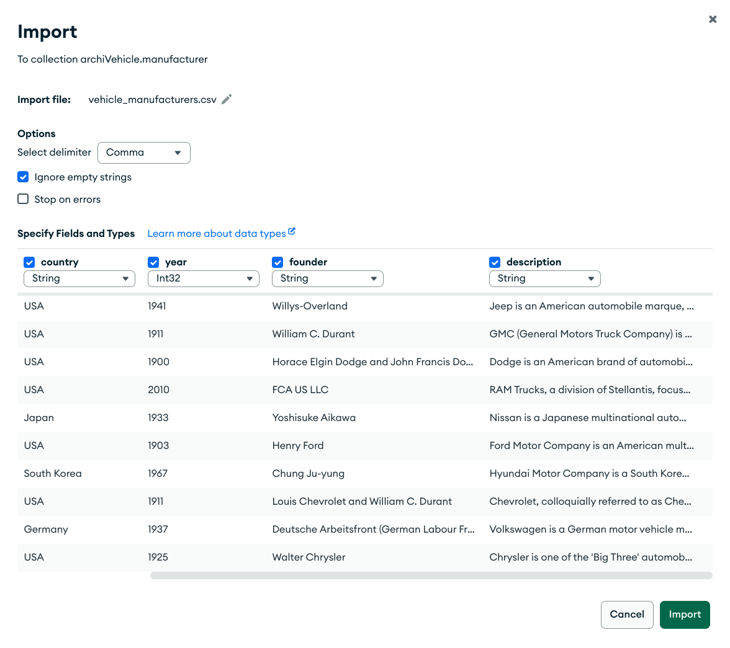Figure 4: Manufacturers dataset import

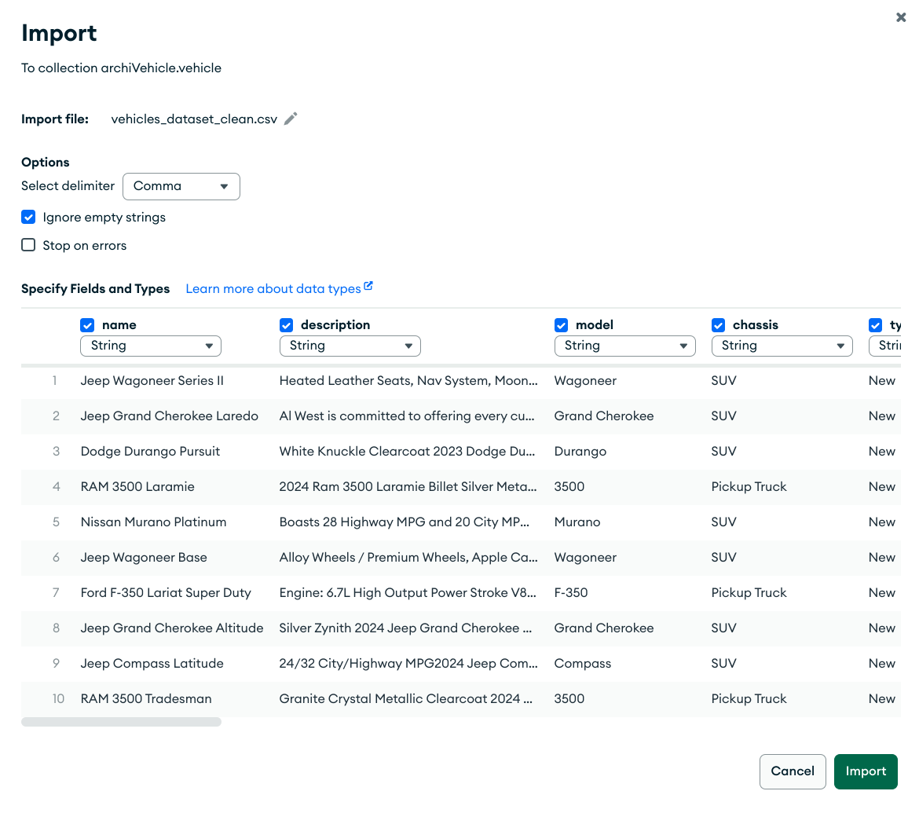Figure 5: Vehicles dataset import

Web Application

Technologies choose
Having short times to realize this application, it has been decided to use technologies with a low learning curve and writing not too much code, using also already defined components where is possible to do it. For these reasons, the picked technologies are:
- Database Driver: PyMongo
- Application logic / back-end: Flask
- Presentation logic / front-end: Bootsrap

PyMongo
PyMongo is the reccomended driver by the MongoDB developers, in order to exploit the potential of their database within a web application. PyMongo offers the main operations to interact with the database. Once the package has been installed, the first step is to import the package and start the connection with the database:
from pymongo import MongoClient
client = MongoClient('localhost', 27017)

Flask
Flask is a micro-framework created for developing web-application in a fast and easy way. Being a micro-framework, there are few functionalities out of the box, such as the server, the debugger, the router, the component for processing requests and responses. Once the package has been installed, the first step is to create a new module named app.py and define the first route for the index page, that will only initially gave a response with a classic “Hello World!” message:
from flask import Flask
@app.route("/")
def index():
return "Hello, World!"

Bootstrap
Bootstrap is a framework created for realizing responsive web pages, offering templates for each necessary component. Thanks to the import html component functionality offered by Flask, is possible to reuse the different components on the web application pages. In order to start use Bootstrap, it’s necessary to include the repsective tags inside the page header.

Descrizione delle pagine

Home Page
In the Home Page, is possible to do a search of the vehicles and apply filters related to the property of the vehicles.

Vehicles Page
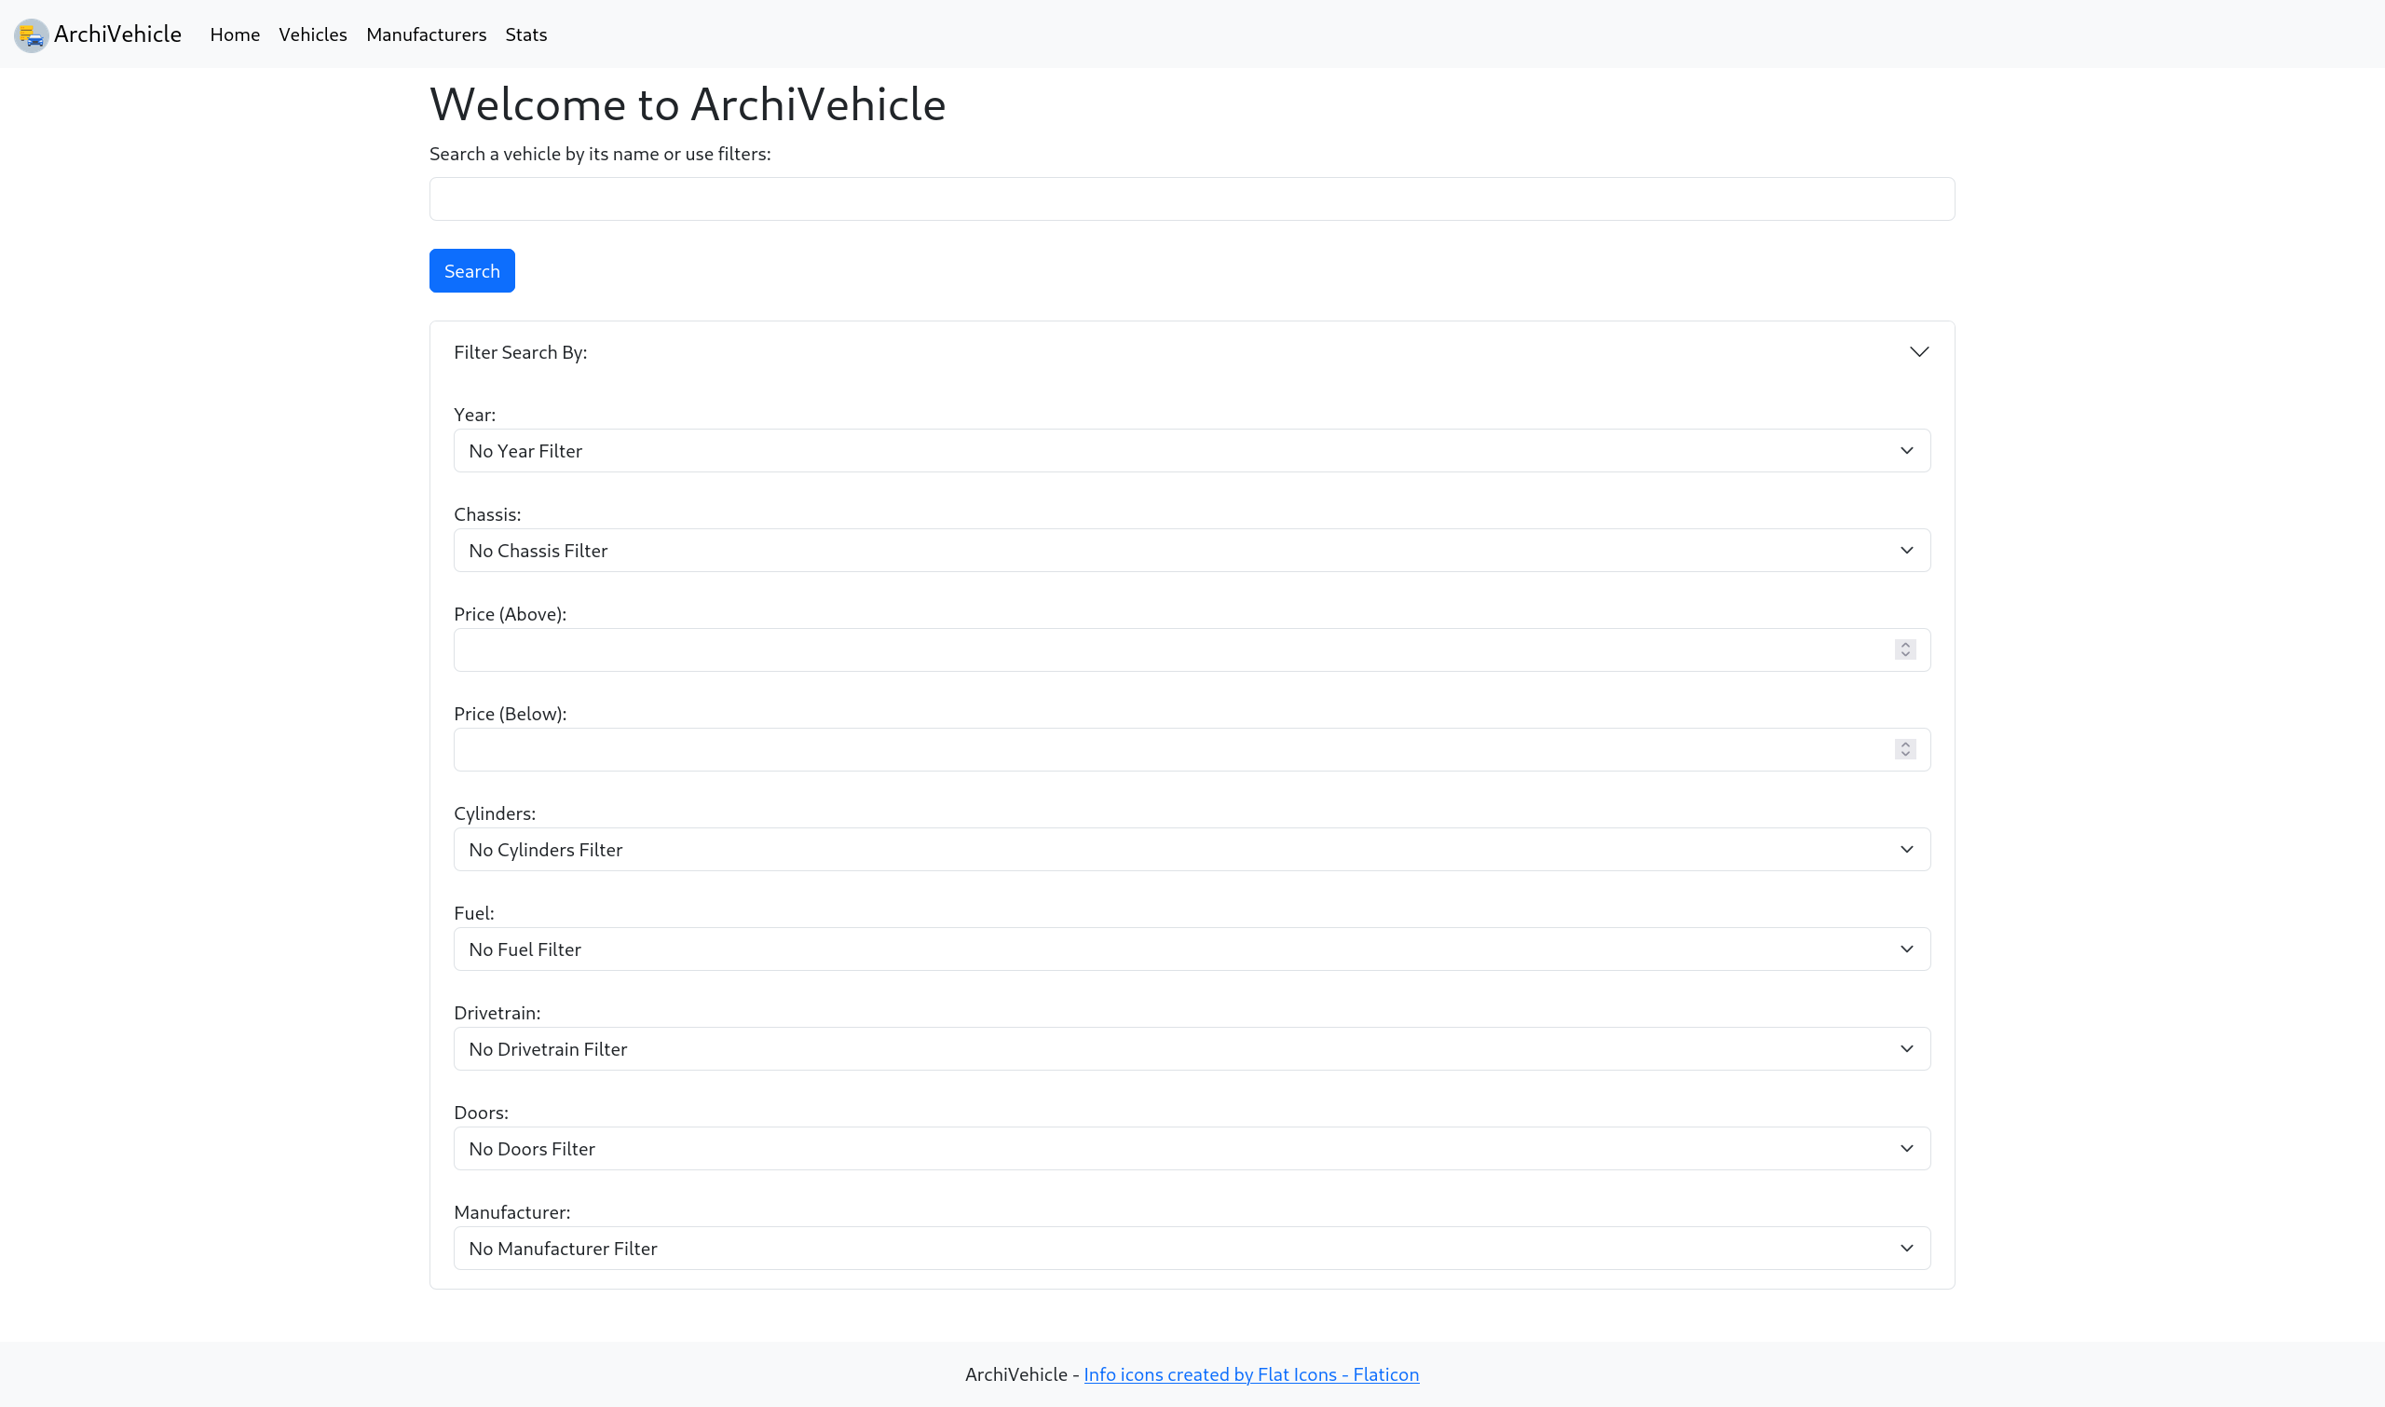Figure 6: Home Page
In the Vehicles Page, is possible to display all the various vehicles and pick one in order to go to the dedicated vehicle page where more details are showed. It is also possible to insert a new vehicle.
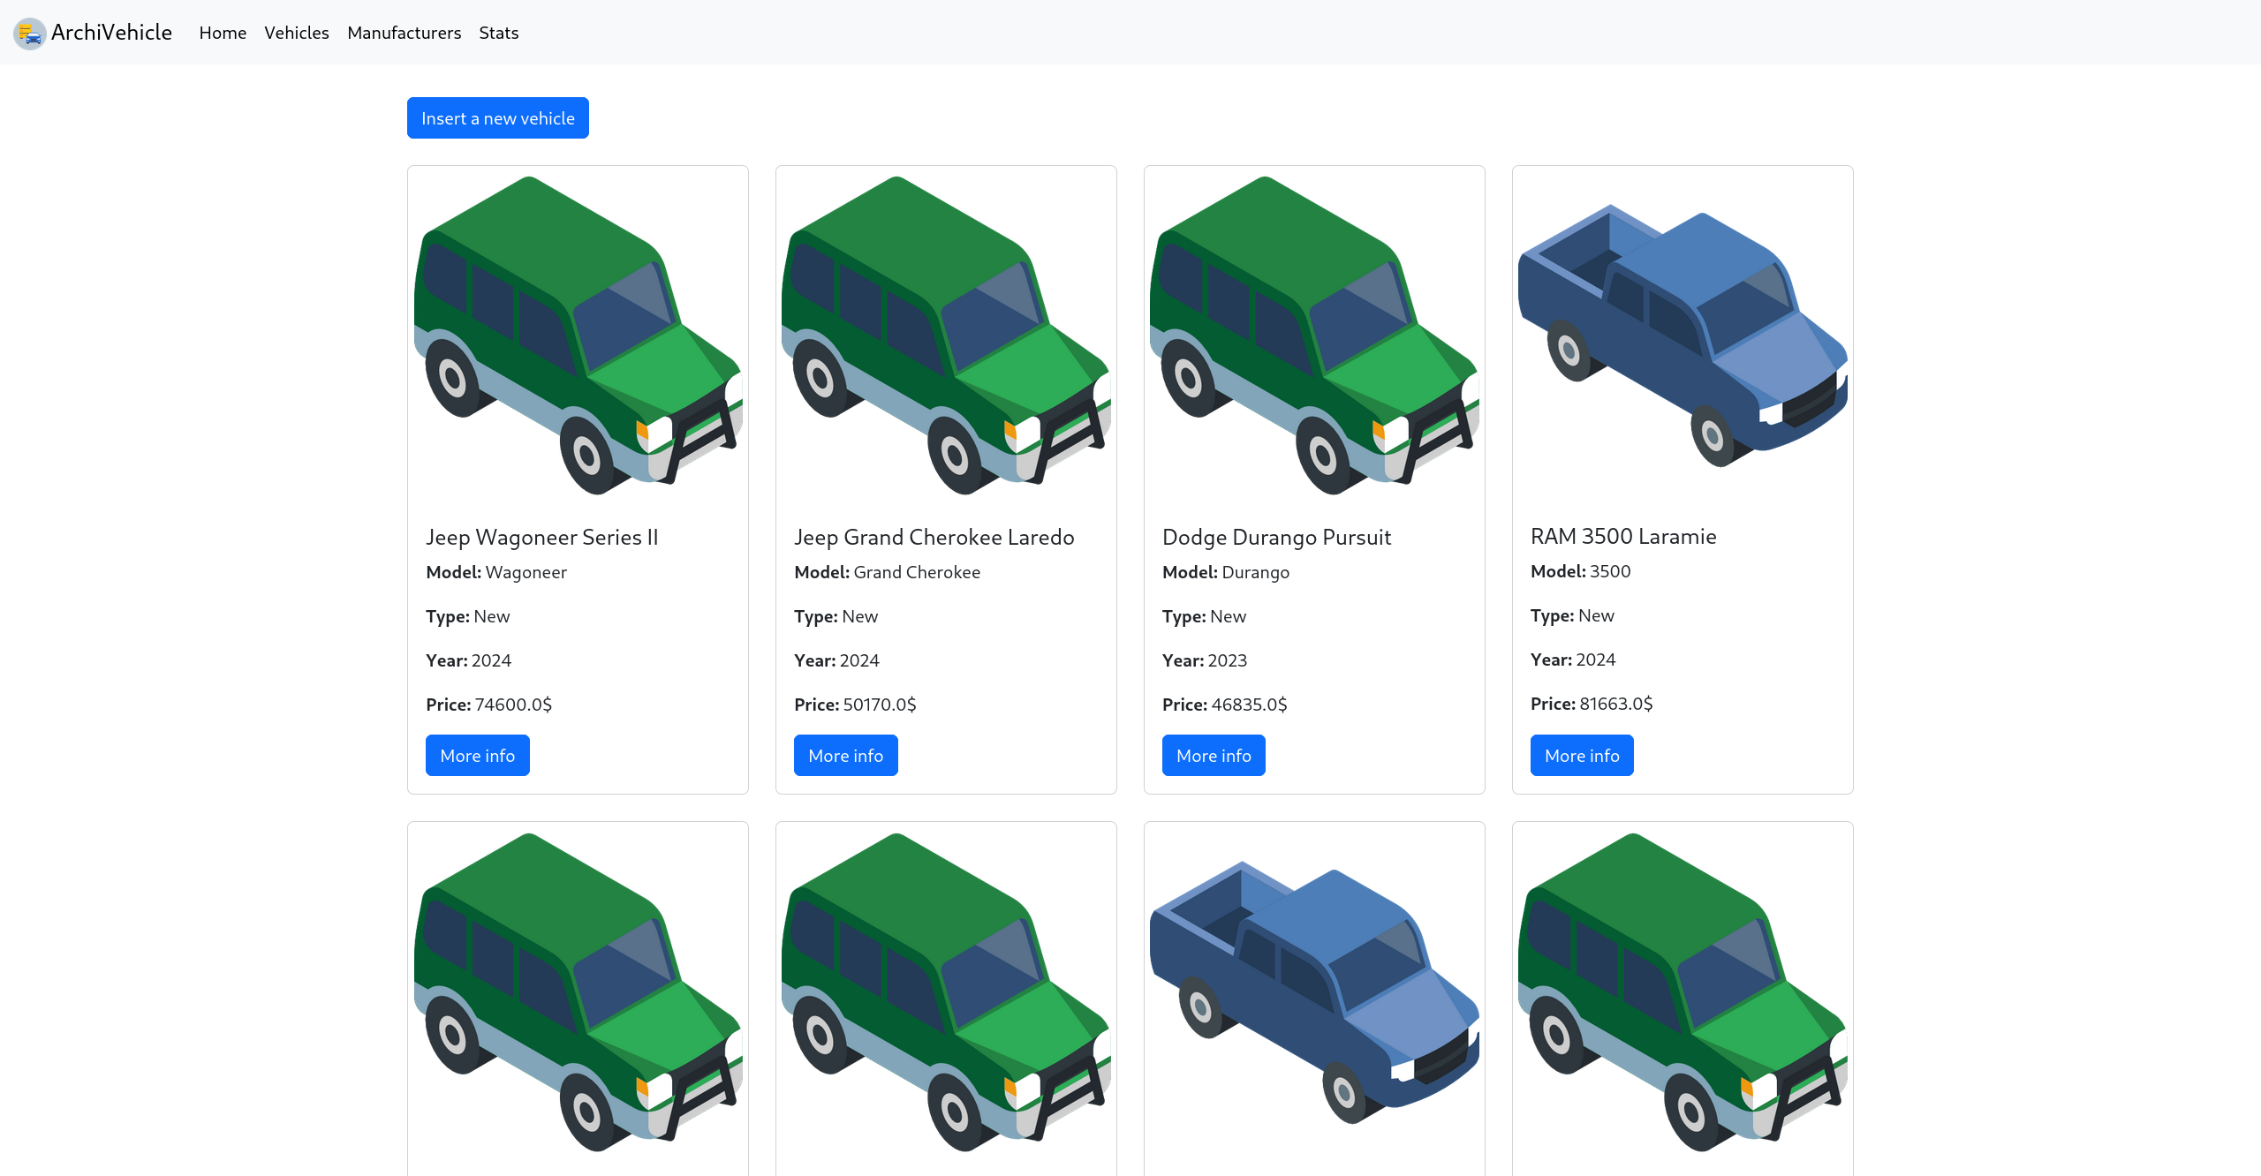Figure 7: Vehicles Page

Insert Vehicle Page
In the Insert Vehicle Page, is possile to insert the info about a new vehicle. The fields marked with a red asterisk are mandatory because they define the main info about the vehicle. Through the two dropdown lists is possible to insert the info related to the details of the vehicle, following the document structure and the data scheme for the vehicle.
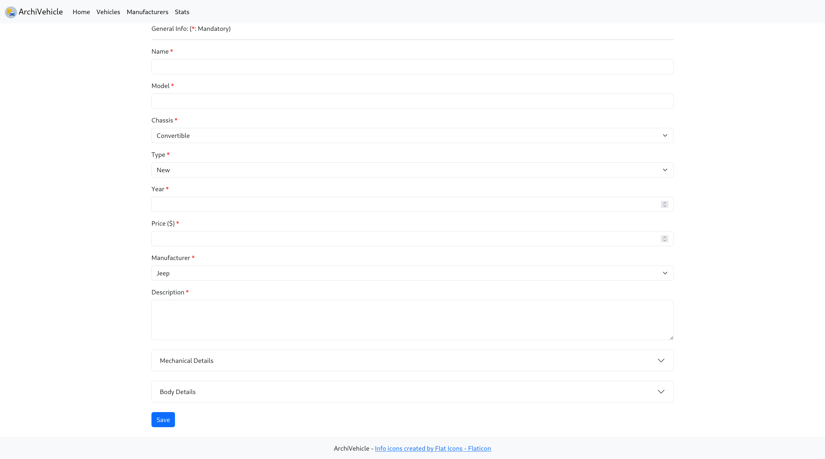Figure 8: Insert Vehicle Page
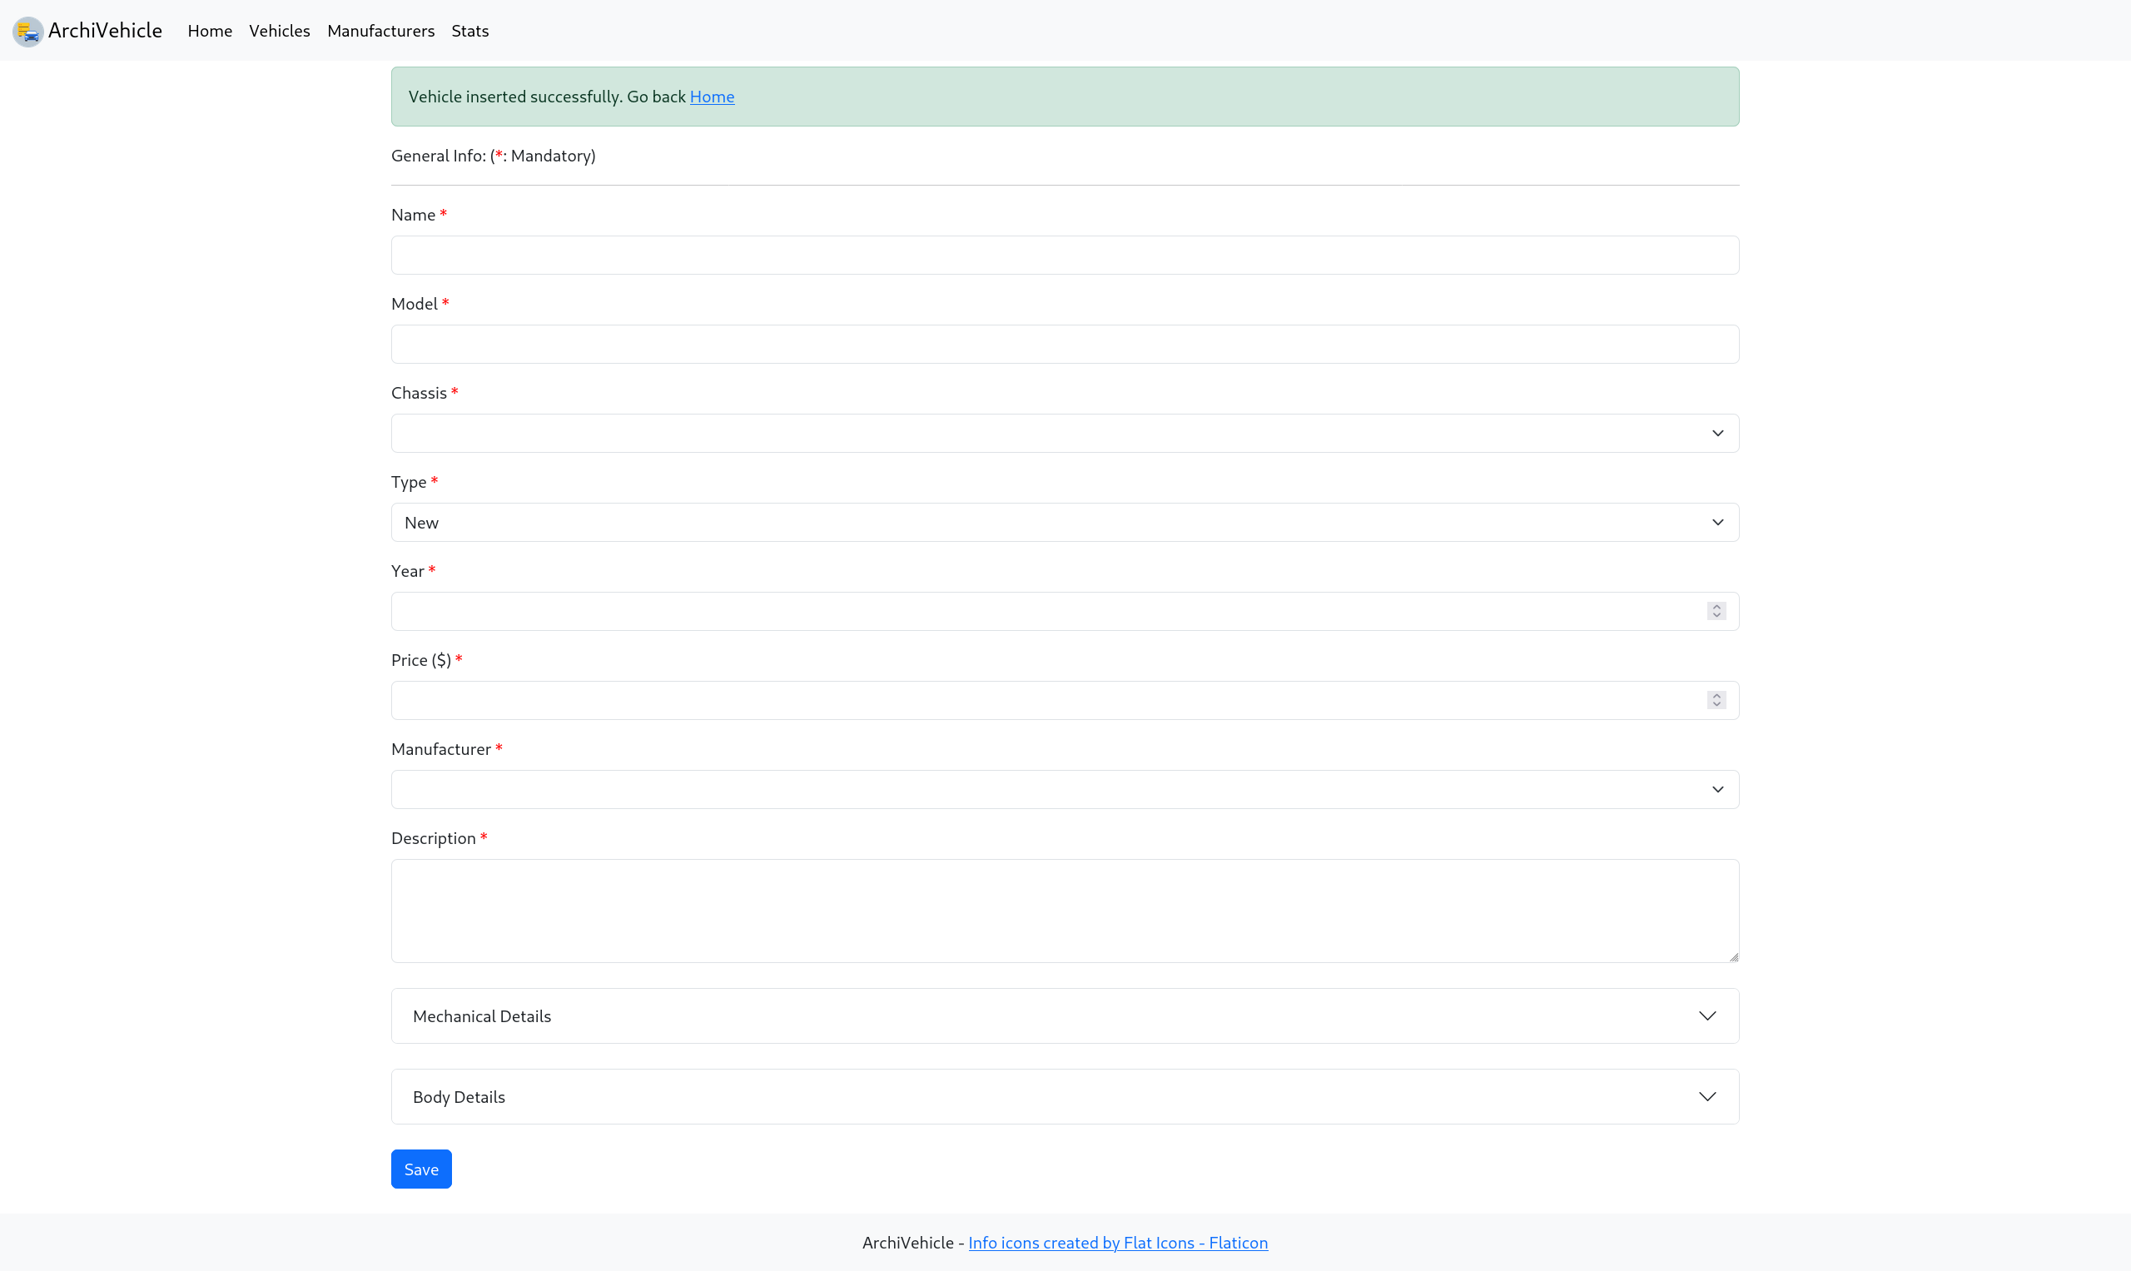Figure 9: Insert Vehicle Page - Success Message

Show Single Vehicle Page
In the Show Single Vehicle Page, is possible to display all the information about the vehicle. Also, is possible to go to the Update Vehicle Page for updating the info about the vehicle and to delete the info about the vehicle after conferming the alert message.
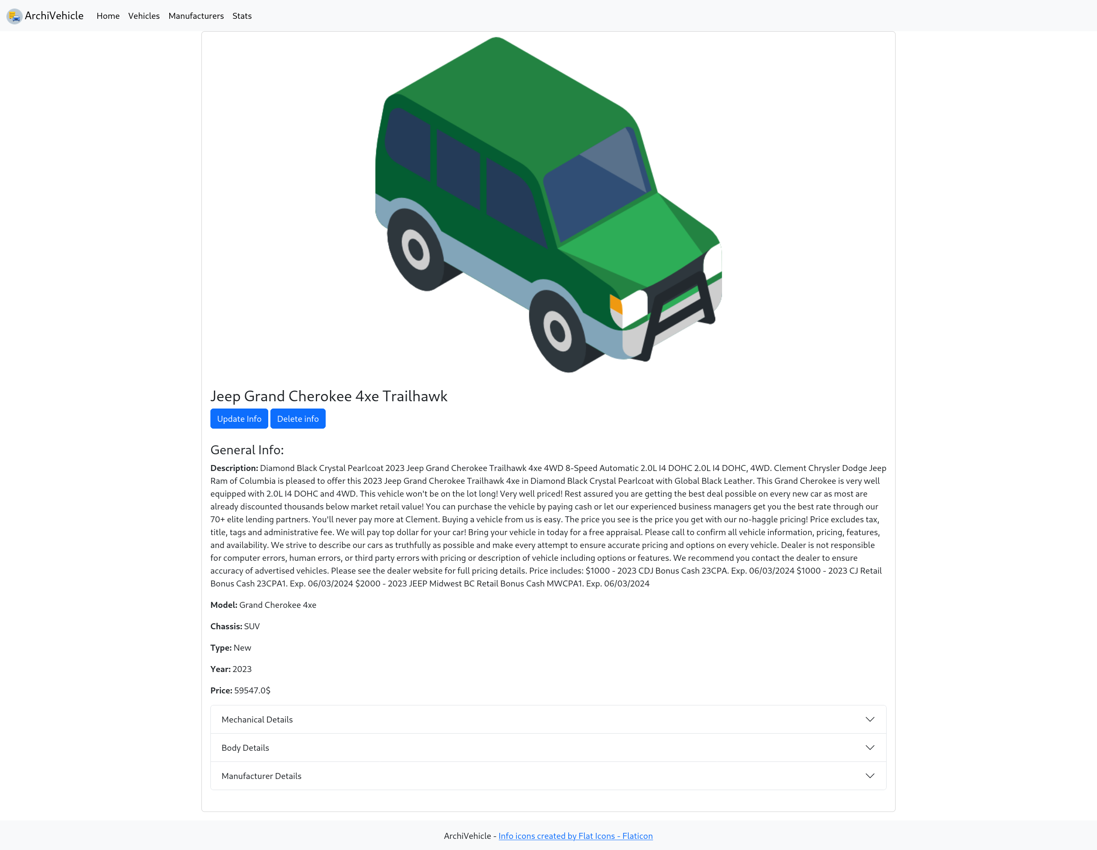Figure 10: Show Single Vehicle Page
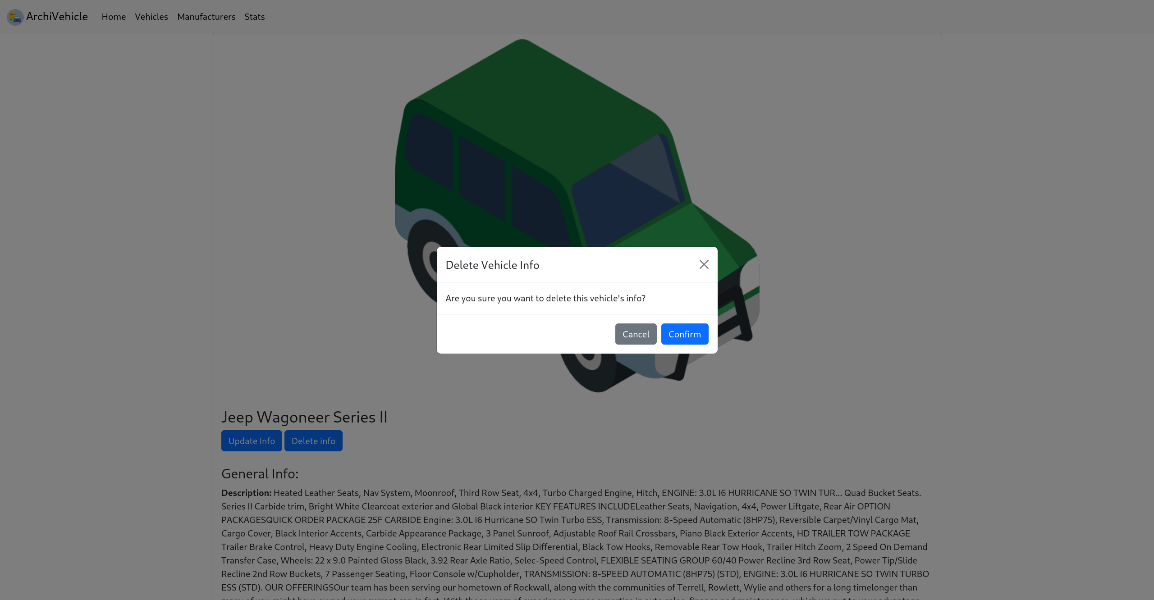Figure 11: Show Single Vehicle Page - Confirm Message

Manufacturers Page
In the Manufacturers Page, is possile to display the info about all the loaded manufacturers. Also, is possible to insert a new manufacturer, update the info of an already existent manufacturer or delete an existing one.

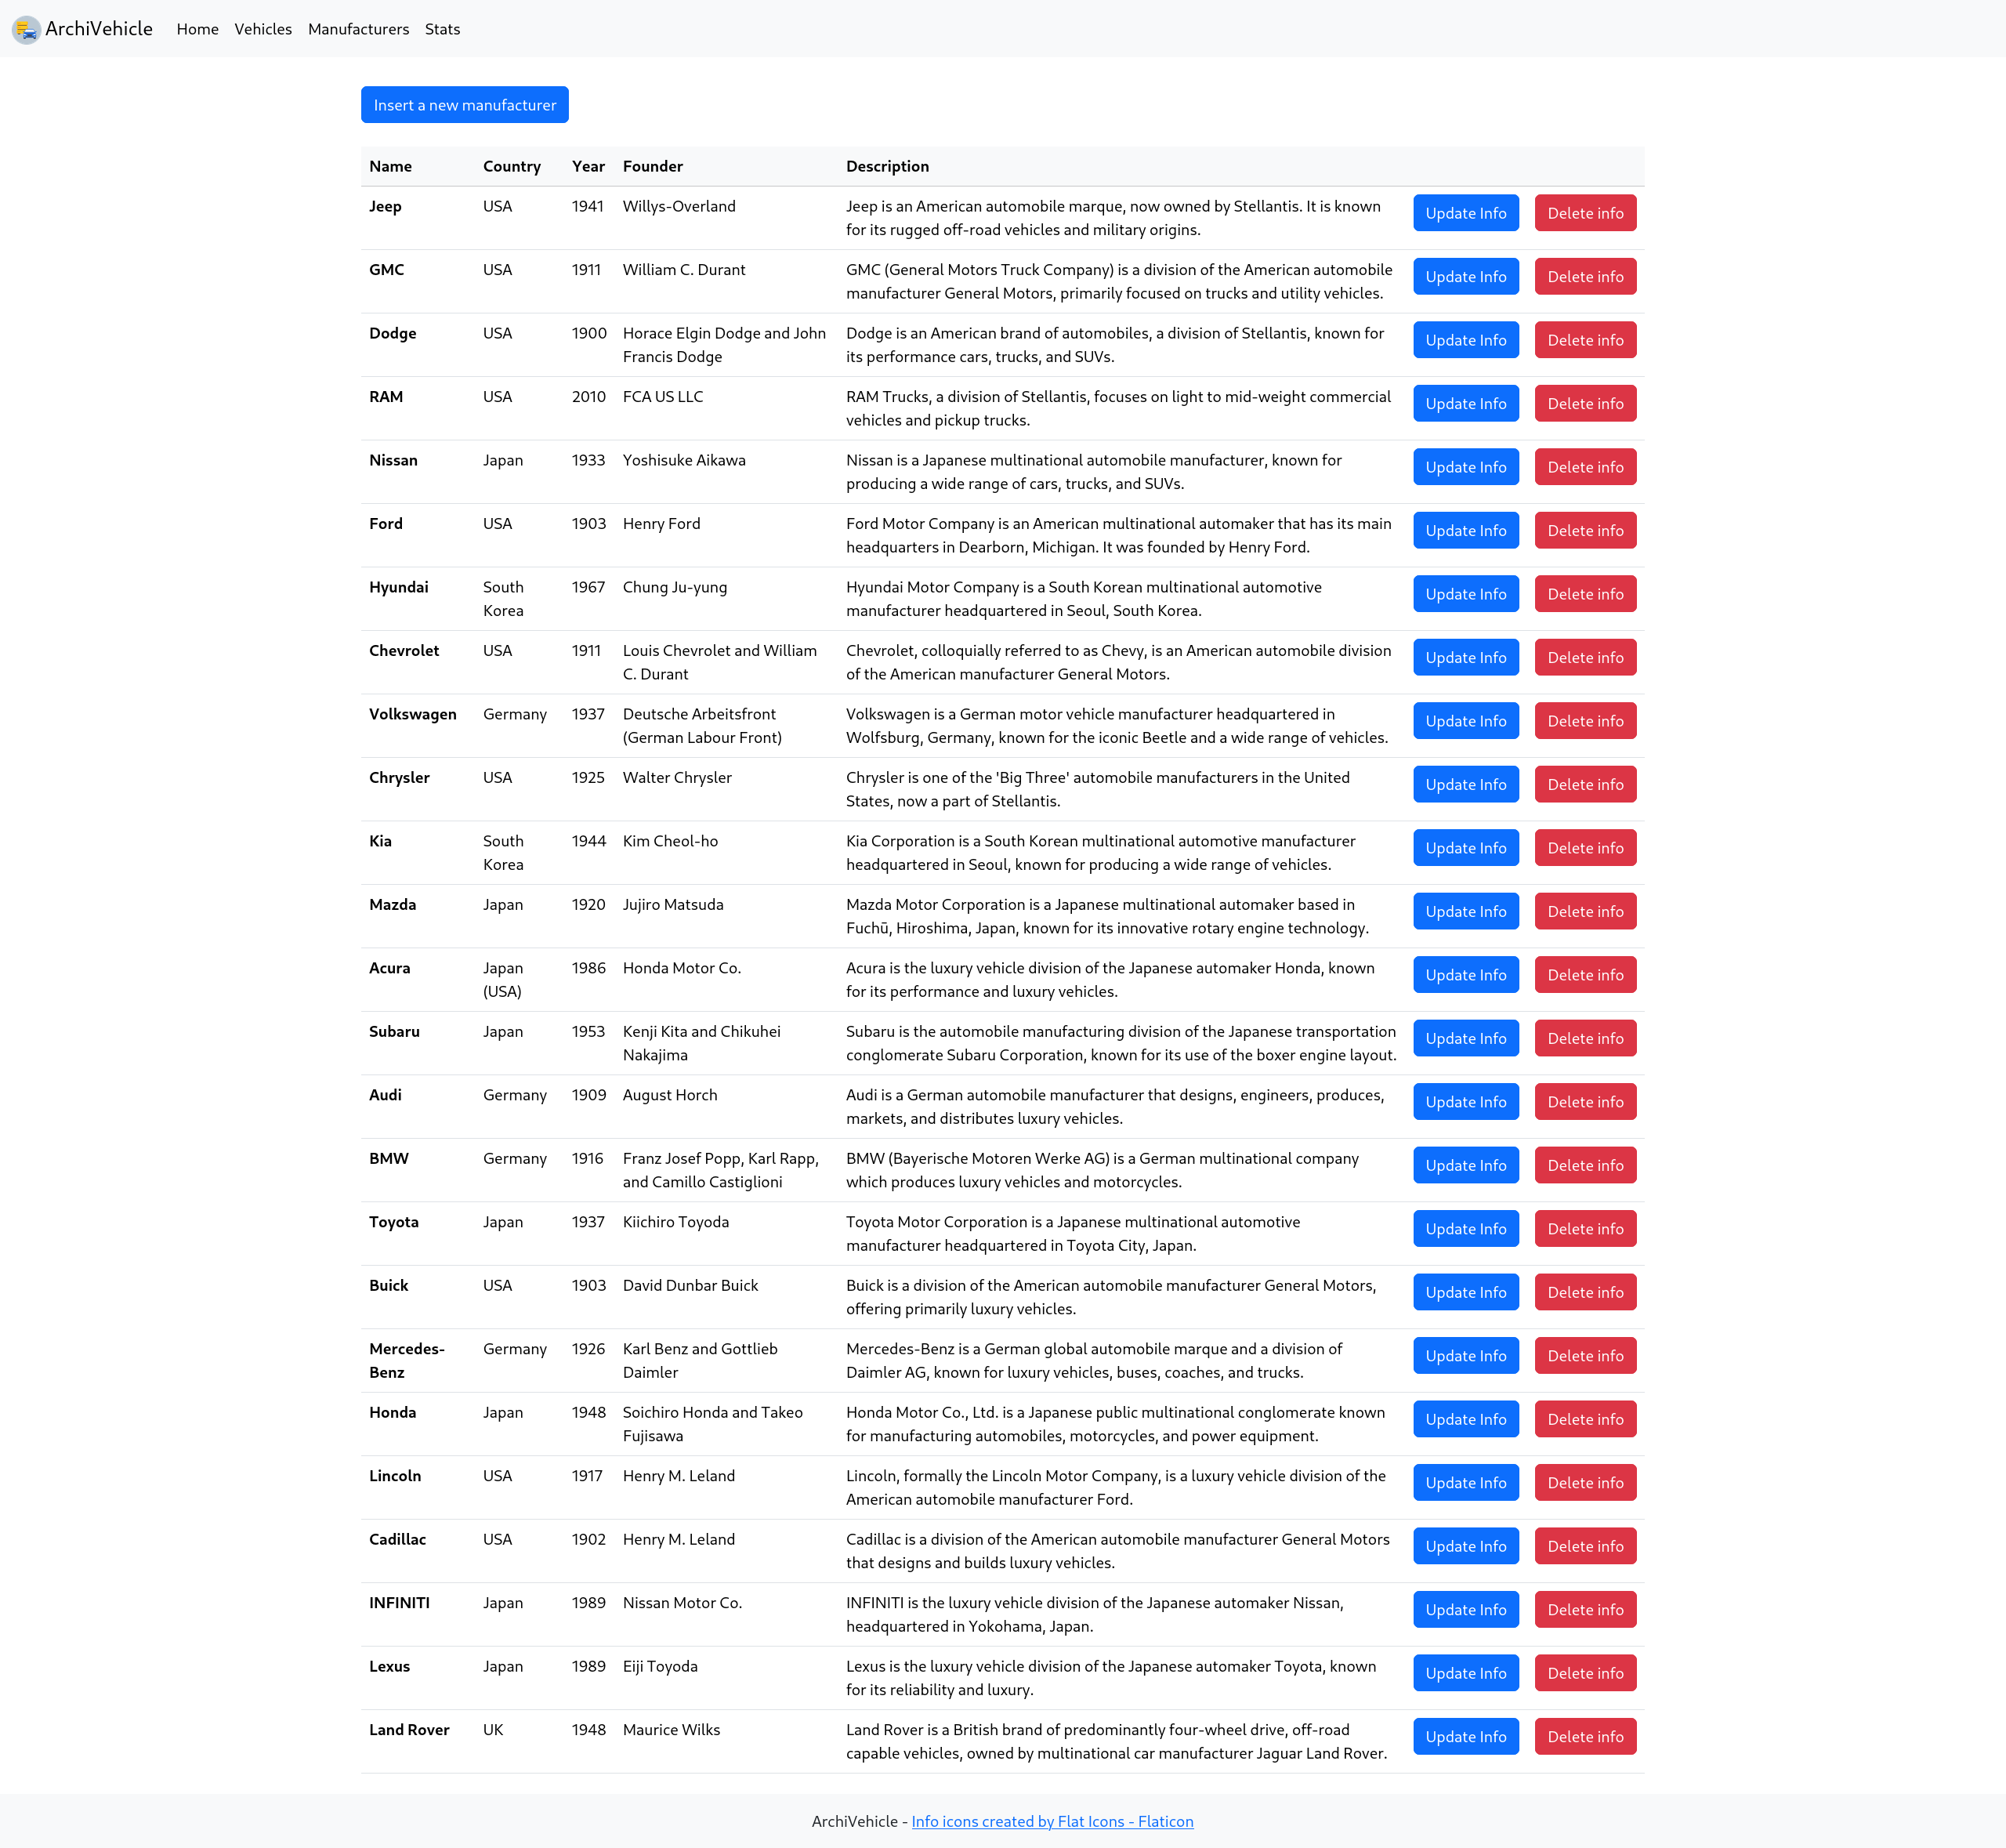Figure 12: Manufacturers Page

Stats Page
In the Stats Page, is possible to display the number of all the vehicles for the respective manufacturer, counting the vehicles given the different features.

ArchiVehicle Installation
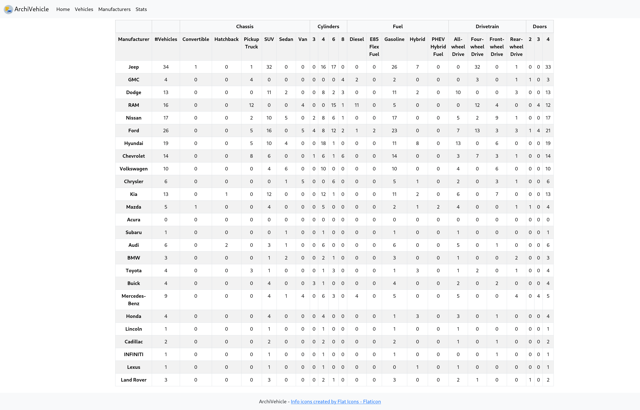Figure 13: Stats Page
In order to install and use ArchiVehicle you need to follow the steps:
1. Import through MongoDB Compass these collections of documents:
- archiVehicle.manufacturer.json
- archiVehicle.vehicle.json
2. Change the current directory to the root of the project;
3. Create a virtual environment with the command:
- python -m venv .venv
4. Activate the virtual environment;
5. Install the needed dependencies with the command:
- pip install flask pymongo
6. Execute the flask server with the command:
- flask run

