How much water does a data center cooling tower really use?
A multi-method, physics-based evaporation and blowdown framework for EnergyPlus
Liang Zhang, Department of Civil and Architectural Engineering and Mechanics, University of Arizona, Tucson, AZ, USA [TBD: confirm affiliation]
Abstract
Water use is becoming a siting and permitting constraint for data centers, yet building energy simulation estimates cooling tower water with simplified relations: a fixed loss per kelvin of range, or Merkel’s assumption that exit air is saturated, combined with a fixed number of cycles of concentration. We present an open framework, implemented as an EnergyPlus Python plugin, that evaluates eight evaporation methods—from bounding and empirical relations to the effectiveness model of Braun et al. and the full Poppe heat and mass transfer model with supersaturated air—at the same simulated operating point every timestep, together with a blowdown model driven by makeup-water chemistry (constituent limits, Langelier saturation index, silica solubility). The Poppe implementation is verified against an independent boundary-value solution of the conservation equations to $<{10}^{−4}$ %. For a fixed counterflow tower at full load, empirical methods deviate from Poppe by $−$39 to +117 % across ambient conditions, and saturated-exit methods, including the EnergyPlus default, by $−$18 to +11 %: they overpredict in hot–dry air and underpredict in cold–humid air, where Poppe predicts fogging exit air. Applied to a 1 MW water-cooled data center in 14 climates (ASHRAE zones 0A–6A), the EnergyPlus default underestimates annual evaporation by 3.7–9.3 %, most in cold climates; the EnergyPlus loss-factor method, used as documented, overestimates it by 4–64 %. Evaporation per unit heat rejected ranges from 1.05 to 1.65 L/kWh$​_{th}$ across climates, and makeup-water chemistry changes total makeup by $−$13 to +22 %, as much as the choice of evaporation physics. The framework also models hybrid adiabatic dry coolers by imposing pad-cooled air on EnergyPlus fluid coolers through EMS actuators. With wetting above 28 °C, the hybrid plant keeps its chillers within their rated range at every site and uses 14–100 % less water than the evaporative tower, but always-wet operation in the hottest, driest climate uses more water than the tower; water spent per kWh of electricity saved is 100–240 L/kWh. We also document five defects in EnergyPlus heat-rejection models, one of which inflates loss-factor evaporation 100-fold and another fluid-cooler air flow about 1000-fold.
Keywords: Data center; Hybrid dry cooler; Cooling tower; Water consumption; Poppe method; Merkel method; EnergyPlus; Blowdown; Water usage effectiveness

Introduction
Data centers convert almost all of their electricity into heat, and most large facilities reject it through evaporative cooling towers. Their direct water use is therefore a function of heat load, climate, makeup-water quality and plant control (Mytton, 2021; Shehabi et al., 2016). As new campuses concentrate in water-stressed regions, operators, utilities and permitting agencies increasingly need credible hourly and annual water estimates at the design stage, and metrics such as water usage effectiveness (WUE) (The Green Grid, 2011) are reported publicly.
Building energy simulation is the natural tool for such estimates, because it already resolves the hourly heat rejected by the plant. EnergyPlus, the most widely used open engine, computes tower evaporation either with a constant loss factor or by assuming saturated exit air (Merkel’s assumption), and blowdown with a fixed concentration ratio (U.S. Department of Energy, 2022). These simplifications are well known in the cooling tower literature: Merkel’s method neglects the Lewis factor, the water lost by evaporation and the real exit-air state (Kloppers and Kröger, 2005a; Merkel, 1925). Kloppers and Kröger (2005a, 2005b) showed that Merkel and e-NTU methods predict heat rejection close to the Poppe method (Poppe and Rögener, 1991) but differ from it in predicted water evaporation, with the difference depending on ambient conditions [TBD: check exact claim and magnitude in K&K 2005 before submission]. These findings have not been carried into building energy simulation, where water estimates feed design decisions, nor have they been combined with water chemistry, which sets blowdown—often a quarter or more of makeup.
This paper makes four contributions:
- An open, multi-method framework that evaluates eight evaporation models on the same EnergyPlus operating point every timestep, so differences isolate evaporation physics (Section 2).
- A blowdown model driven by makeup-water chemistry, including constituent limits, the Langelier saturation index and temperature-dependent silica solubility (Section 2.4).
- Verification of every model, including an independent boundary-value solution of the Poppe equations (Section 3), and a climate-general map of where each simplification fails (Section 4).
- A multi-climate case study of a representative water-cooled data center and an analysis of water-accounting defects in EnergyPlus heat-rejection models (Sections 5–6).
- A hybrid adiabatic dry cooler model coupled to EnergyPlus, and the water–energy trade-off of its wet/dry control across climates (Section 7).

Methods

Accounting mode: one operating point, many evaporation models
At the end of each system timestep, the plugin reads, for every tower, the water inlet and outlet temperatures, water mass flow, heat rejected, air-flow ratio, operating cells and fan part-load ratio, plus the outdoor dry-bulb, wet-bulb, humidity ratio and pressure. The air mass flow is reconstructed from the design air flow and the fan regime (Section 2.3). Every evaporation method is then evaluated at this operating point. EnergyPlus’ thermal solution is not changed. A rating mode, available in the standalone library, instead predicts the cold-water temperature from a fill Merkel number for each method; it is used for the climate map and for future validation against manufacturer data.

Evaporation models
Table 1 lists the eight methods; full equations are given in the supplementary technical reference (docs/METHODS.md).
Evaporation methods evaluated at each timestep.
ID | Model | Key assumption
LAT | $E=\dot{Q}/i_{fg}$ | all heat rejected as latent heat
ROT | $E=0.00153 {\dot{m}}_{w} ΔT$ | rule of thumb, 1 % per 10 °F range
LF | $E=k {\dot{m}}_{w} ΔT$, $k=0.2$ %/K | EnergyPlus LossFactor
EPSAT | EnergyPlus SaturatedExit (replica) | saturated exit air, moist-air basis
MSAT | Merkel energy balance | saturated exit air, dry-air basis
BRAUN | Braun et al. (1989) | e-NTU, $Le_{f}=1$, unsaturated exit humidity
POPPE | Poppe and Rögener (1991), Kloppers and Kröger (2005a) | full model, Bošnjaković $Le_{f}$, supersaturation
POPPE1 | Poppe with $Le_{f}=1$ | isolates the Lewis-factor effect

Poppe model
With water temperature as the independent variable, the humidity ratio, air enthalpy and Merkel number obey (Kloppers and Kröger, 2005a)
$$\frac{dω}{dT_{w}}=\frac{c_{pw} ({\dot{m}}_{w}/{\dot{m}}_{a})(ω_{sw}−ω)}{D}, \frac{di_{ma}}{dT_{w}}=\frac{{\dot{m}}_{w}c_{pw}}{{\dot{m}}_{a}}\left[1+\frac{c_{pw}T_{w}(ω_{sw}−ω)}{D}\right], \frac{dMe_{P}}{dT_{w}}=\frac{c_{pw}}{D},$$
$$D=(i_{masw}−i_{ma})+(Le_{f}−1)\left[i_{masw}−i_{ma}−(ω_{sw}−ω)i_{v}\right]−(ω_{sw}−ω)c_{pw}T_{w},$$
with a corresponding form for supersaturated air, and the Lewis factor of Bošnjaković (1965). Because both water temperatures are known in accounting mode, the equations are integrated from the bottom to the top of the fill (RK4, ten steps) and the Merkel number is an output; no fill correlation is required. The unknown exit humidity enters the local water flow and is found by fixed-point iteration.

Braun e-NTU model
The air-side effectiveness of the operating point gives the number of transfer units in closed form, and the exit humidity follows the effective-saturation relation of Braun et al. (1989). This model is thermodynamically consistent with the EnergyPlus CoolingTower:VariableSpeed:Merkel object.

Air flow reconstruction
Physical evaporation models need the actual air mass flow. For CoolingTower:VariableSpeed:Merkel it is the reported fan-speed ratio times the design air flow and the fraction of cells operating; in free convection, where EnergyPlus reports zero air flow while rejecting heat, the sized free-convection air flow is used. For the regression-based CoolingTower:VariableSpeed models, EnergyPlus reports the free-convection capacity fraction as an air-flow ratio when the fan is off or cycling; the plugin replaces it with the time average of the minimum-speed and free-convection air flows weighted by the fan part-load ratio. Because the Merkel model ties air flow to a $UA$ relation, it is used in the case study.

Operating points beyond the thermodynamic limit
EnergyPlus’ Merkel tower linearises the saturation enthalpy (Braun’s $c_{s}$) and selects the lowest fan speed that meets the condenser setpoint. With an oversized tower at part load this places the exit air within a fraction of a percent of the saturated enthalpy at the hot-water temperature. Poppe, which accounts for $Le_{f}<1$ and the enthalpy of the evaporated water, can then find no positive driving force near the top of the fill. In that case the plugin re-solves the point with the smallest air-flow increase (from 1 % to 50 %) that makes it feasible and records the factor. Near the pinch, evaporation is insensitive to air flow: for a representative point, +2 % air changes Poppe evaporation by $<0.1$ % and +20 % by 1.4 %.

Blowdown from makeup-water chemistry
Blowdown follows from the dissolved-solids balance, $B=E/(N−1)−D$, where $N$ is the cycles of concentration. Instead of a fixed $N$, the plugin sets $N$ to the most restrictive of: constituent limits (silica, calcium hardness, chloride, TDS), product limits, a calcium carbonate limit $LSI≤LSI_{max}$ evaluated at the hot-water temperature (Langelier, 1936), for which $N_{LSI}={10}^{(LSI_{max}−pH+pH_{s}(1))/1.9}$ in closed form, and amorphous-silica solubility at the cold-water temperature (Fournier, 1977). Three modes are available: fixed (EnergyPlus), constituent (constant), and dynamic (re-evaluated every timestep).

Verification
Table 2 summarizes the code verification. Psychrometric functions agree with PsychroLib (Meyer and Thevenard, 2019) within 0.2 %. The Poppe implementation was compared with an independent formulation: the height-wise conservation equations with a prescribed transfer coefficient, solved as a boundary-value problem by shooting with an adaptive stiff integrator (relative tolerance ${10}^{−10}$). Over five cases from hot–dry to hot–humid air, evaporation and Merkel number agree within ${10}^{−4}$ %. The EnergyPlus SaturatedExit replica reproduces EnergyPlus’ reported evaporation within 0.4 % at every loaded timestep, confirming that the plugin reads the same operating point.
Code verification.
Check | Max. deviation
Psychrometrics vs PsychroLib ($p_{ws}$, $ω_{s}$, $i$, $T_{wb}$) | 0.2 % / 0.02 K
Latent heat vs IAPWS-95 (Wagner and Pruß, 2002) | 0.3 %
Poppe energy balance closure | $<0.1$ %
Poppe vs independent BVP (5 cases) | $<{10}^{−4}$ %
Poppe RK4, 10 vs 80 steps | $<0.01$ %
Rating mode, same fill: Merkel / Poppe / e-NTU $T_{w,o}$ | $<0.5$ K
EPSAT replica vs EnergyPlus output | 0.4 %

Where do simplified methods fail? A climate-general map
A counterflow tower was sized with the Poppe model for a 3.9 K approach and 5.6 K range at 35 °C/25.6 °C design conditions and $L/G=1.2$ ($Me_{P}=1.27$). With fill, $L/G$ and range fixed, the cold-water temperature was solved with Poppe over a grid of dry-bulb ($−5$ to 46 °C) and relative humidity (5–100 %), and all methods were evaluated at each point (Fig. 1).
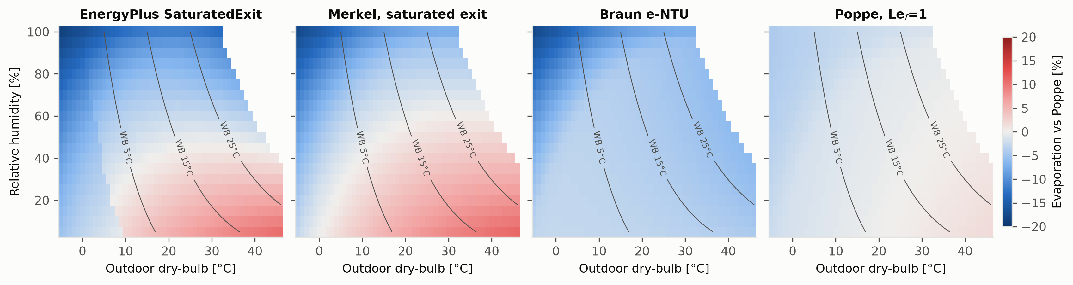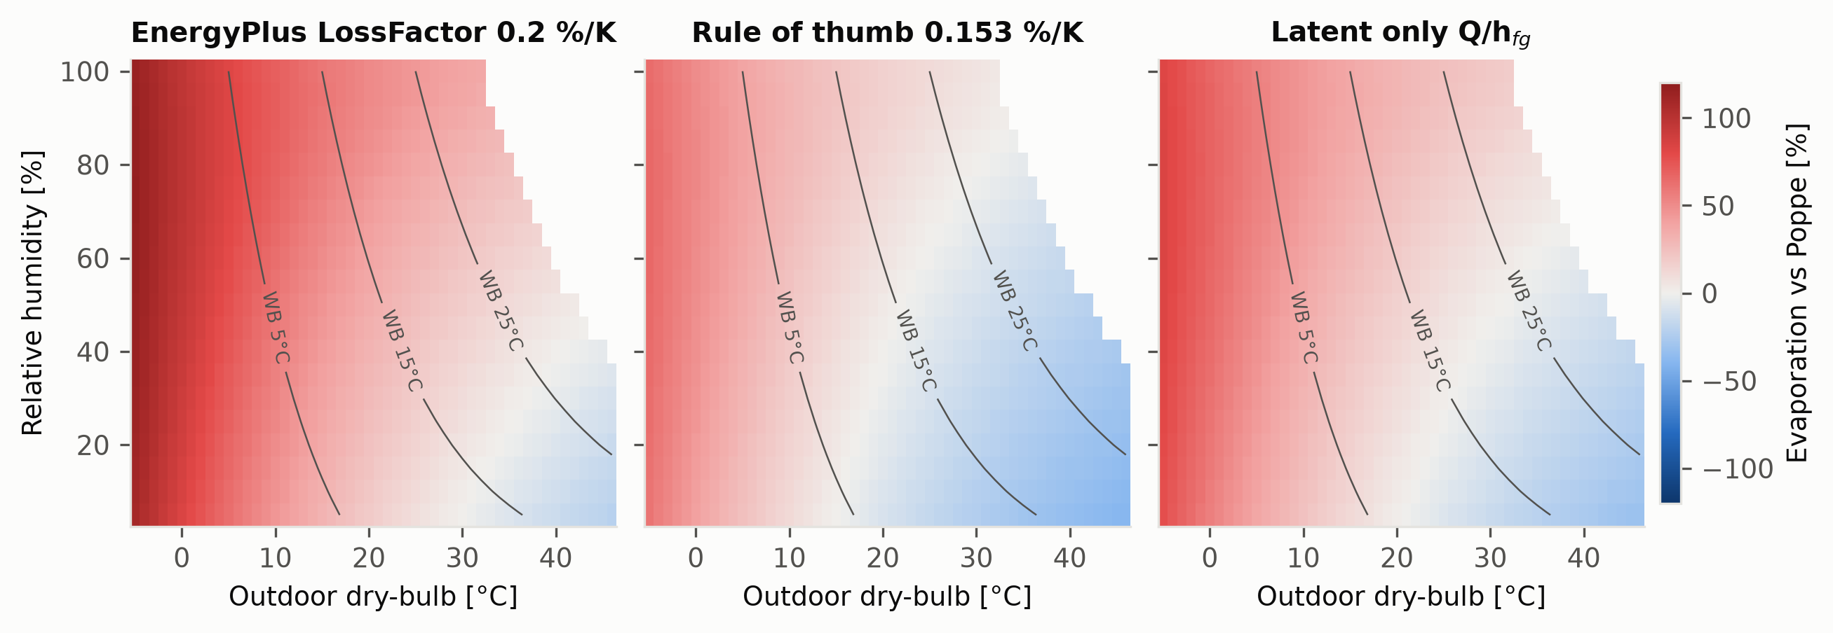
Evaporation of each method relative to Poppe for a fixed tower at full load. Top: physics-based methods ($±$20 % scale). Bottom: empirical methods ($±$120 % scale). Lines: outdoor wet-bulb.
Three patterns emerge. (i) Saturated-exit methods, including the EnergyPlus default, overpredict by up to 11 % in hot–dry air, where real exit air is unsaturated, and underpredict by up to 18 % in cold–humid air, where Poppe predicts supersaturated exit air carrying liquid mist. (ii) The Braun e-NTU model underpredicts everywhere by 3–18 %. (iii) The Lewis factor alone changes evaporation by only $−$4.2 to +1.8 %. Empirical methods are unusable outside the conditions they implicitly assume: the EnergyPlus loss factor of 0.2 %/K overpredicts by up to 117 % in cold weather, and the latent-only bound underpredicts by up to 32 % in hot–dry weather, where sensible heat flows from the air into the water.

Case study: a water-cooled data center
The host model (Table 3) is a single-storey facility with two 500 m$​^{2}$ data halls and 1.0 MW of air-cooled IT equipment (ElectricEquipment:ITE:AirCooled) operating at 70–90 % CPU utilisation (mean IT power 861 kW, 7,540 MWh/yr). Each hall is served by a recirculating CRAH-type air handler with a chilled-water coil and variable-speed fan, supplying 20 °C air (ASHRAE class A1). Three water-cooled variable-speed centrifugal chillers (Carrier 19XR curve set from the EnergyPlus dataset), each sized at 50 % of the design load (N+1), supply 10 °C chilled water. Heat is rejected by a three-cell CoolingTower:VariableSpeed:Merkel sized for a 3.9 K approach and 5.6 K range at the site’s 0.4 % evaporation design wet-bulb; condenser water follows outdoor wet-bulb plus 3.9 K between 18 and 29.4 °C. For every site, design days, site data, tower design air state and condenser design temperature are replaced with that site’s ASHRAE values, so the plant is sized for its climate. Weather is TMYx 2011–2025 for 14 sites spanning ASHRAE climate zones 0A to 6A. Drift is 0.001 % of circulating flow. Annual PUE is 1.24–1.28 across sites, with zero unmet zone hours. Parameter sources and assumptions are listed in the supplementary model documentation.
Data center model (key parameters).
IT load | 1.0 MW design, 0.70–0.90 utilisation, UPS 95 %
Air side | 2 CRAH loops, chilled-water coils, VAV fans, 20 °C supply, no economizer
Chillers | 3 $×$ 50 % water-cooled VSD centrifugal, 10 °C CHW, 6 K design $ΔT$
Tower | Merkel VS, 3 cells (MaximalCell), approach 3.9 K, range 5.6 K at 0.4 % WB
Condenser control | $T_{wb}$ + 3.9 K, limits 18–29.4 °C
Water | drift 0.001 %; EnergyPlus 4 cycles; plugin chemistry (Section 2.4)
Weather | TMYx 2011–2025, 14 sites, climate-specific design days

Results

Evaporation by method and climate
Table 4 and Fig. 2 summarise the annual results. The EnergyPlus SaturatedExit replica reproduces EnergyPlus’ own evaporation within 0.2 % at every site. Against Poppe, the EnergyPlus default underestimates annual evaporation at all 14 sites, by 3.7 % (Phoenix) to 9.3 % (Montreal). The other saturated-exit and e-NTU formulations behave similarly ($−$2.2 to $−$7.3 %), and the Lewis factor alone accounts for 0.1–2.1 %. The deviation is largest in cold climates and smallest in hot–dry ones; at the timestep level it reaches $−$29 % at outdoor temperatures below $−$20 °C (Fig. 4), where the Poppe exit air is supersaturated. Exit air carrying more than 0.1 g/kg of liquid occurs in 400 h (Mumbai) to 7,200 h (Dublin) per year.
Unlike the full-load map of Section 4, saturated-exit methods do not overpredict in hot–dry climates here. The data-center tower is oversized (N+1) and runs at part load near its thermodynamic limit, so its exit air is close to saturation at the hot-water temperature even in dry weather. Whether a simplified method over- or underpredicts thus depends on how close the tower operates to the pinch, not only on climate.
Empirical methods do not follow the climate signal at all (Fig. 3). The loss factor of 0.2 %/K, as documented, is nearly constant through the year and overestimates annual evaporation by 4 % (Riyadh) to 64 % (Dublin); the rule of thumb ranges from $−$20 to +26 % and the latent-only estimate from $−$11 to +40 %. They are closest to Poppe in hot–dry climates, where sensible heat flows from the air into the water.
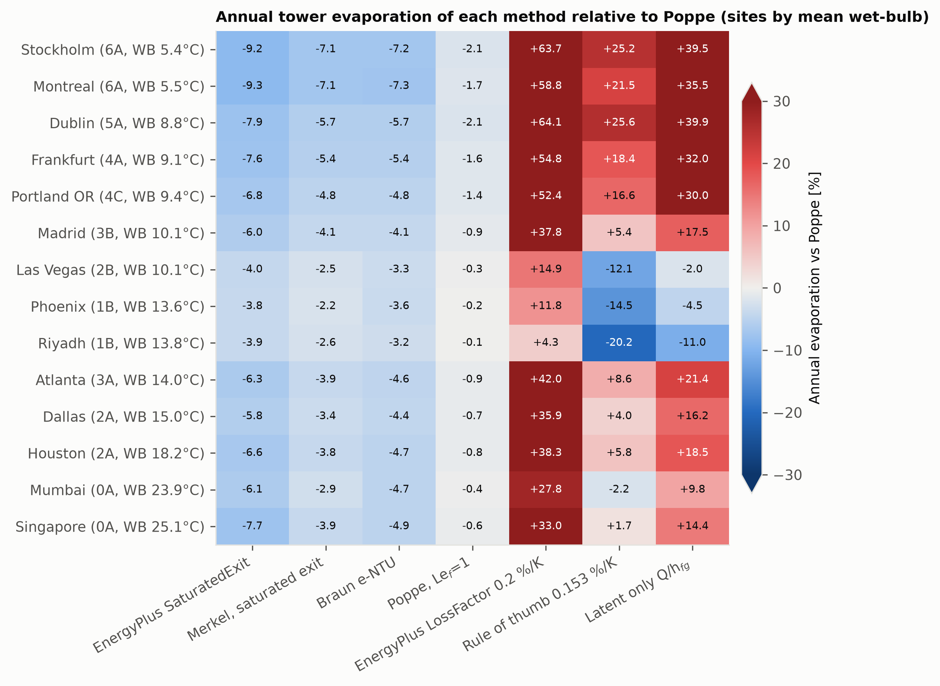
Annual tower evaporation of each method relative to Poppe for the data center in 14 climates.
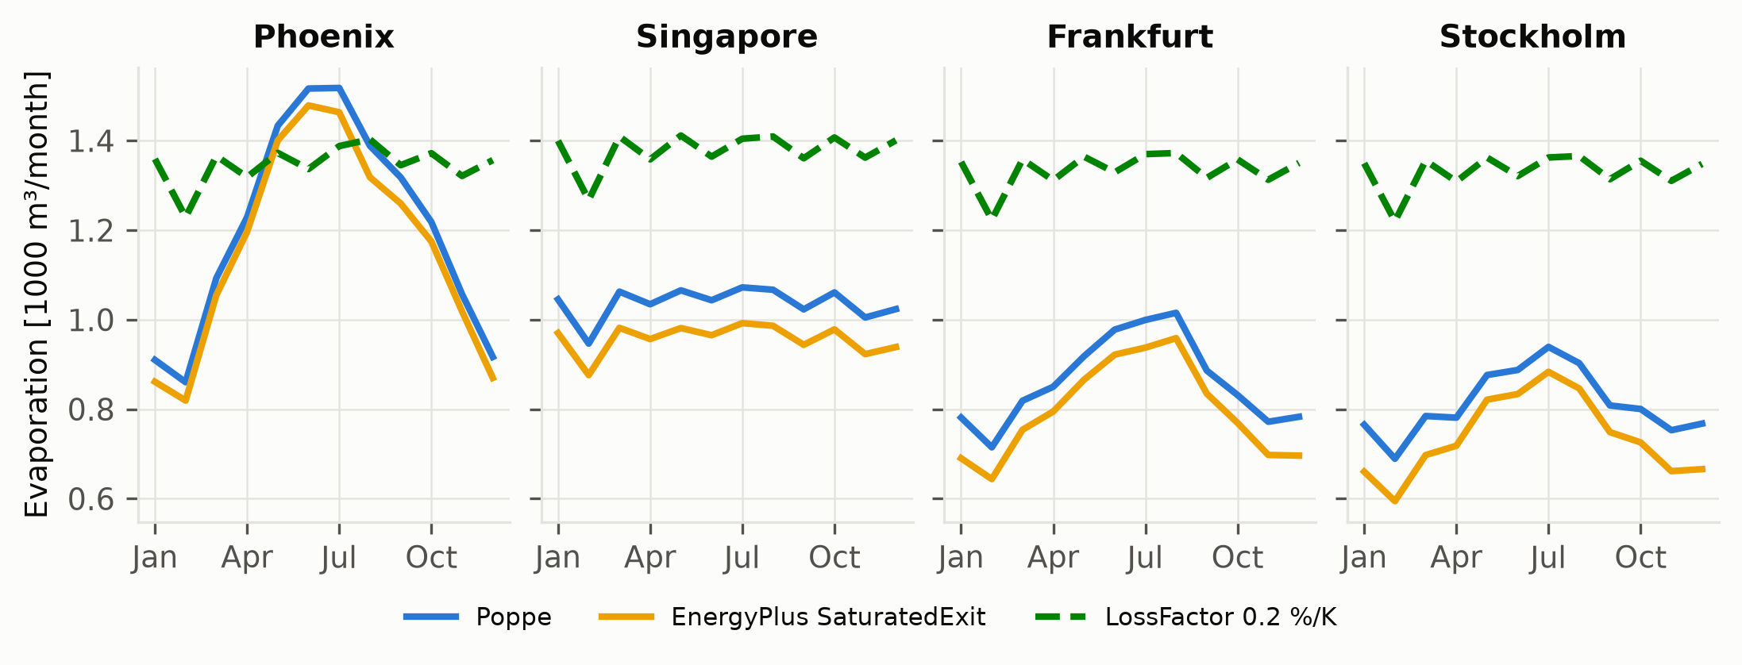
Monthly evaporation, Poppe vs EnergyPlus SaturatedExit and LossFactor (0.2 %/K as documented).
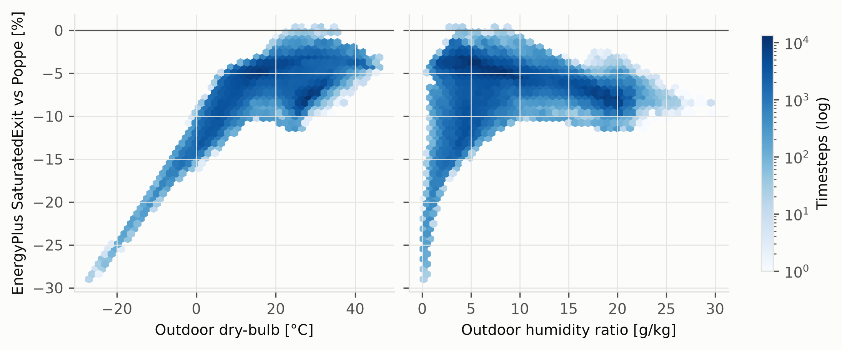
Timestep deviation of EnergyPlus SaturatedExit from Poppe against outdoor dry-bulb and humidity ratio, all 14 sites.
Annual results by site (sorted by mean wet-bulb). $Q$: heat rejected; deviations relative to Poppe; WUE: site makeup per IT energy, EnergyPlus default (SaturatedExit, 4 cycles) and Poppe with constituent-limited cycles for the hard-groundwater example source.
Site | CZ | ${\overset{‾}{T}}_{wb}$ | PUE | $Q$ [MWh] | $E_{Poppe}$ [m$​^{3}$] | L/kWh$​_{th}$ | EP SatExit [%] | LossFactor [%] | WUE$​_{EP}$ | WUE$​_{Poppe}$
Stockholm | 6A | 5.4 | 1.243 | 9254 | 9755 | 1.05 | -9.3 | +63.7 | 1.56 | 1.66
Montreal | 6A | 5.5 | 1.247 | 9282 | 10086 | 1.09 | -9.3 | +58.8 | 1.62 | 1.72
Dublin | 5A | 8.8 | 1.243 | 9264 | 9741 | 1.05 | -7.9 | +64.1 | 1.59 | 1.66
Frankfurt | 4A | 9.1 | 1.245 | 9281 | 10348 | 1.11 | -7.6 | +54.8 | 1.69 | 1.76
Portland OR | 4C | 9.4 | 1.245 | 9277 | 10502 | 1.13 | -6.8 | +52.4 | 1.73 | 1.79
Madrid | 3B | 10.1 | 1.248 | 9314 | 11661 | 1.25 | -6.0 | +37.8 | 1.94 | 1.98
Las Vegas | 2B | 10.1 | 1.251 | 9344 | 14039 | 1.50 | -4.0 | +14.9 | 2.38 | 2.39
Phoenix | 1B | 13.6 | 1.255 | 9368 | 14456 | 1.54 | -3.7 | +11.8 | 2.46 | 2.46
Riyadh | 1B | 13.8 | 1.253 | 9363 | 15485 | 1.65 | -3.9 | +4.3 | 2.63 | 2.63
Atlanta | 3A | 14.0 | 1.258 | 9374 | 11394 | 1.22 | -6.3 | +42.0 | 1.89 | 1.94
Dallas | 2A | 15.0 | 1.259 | 9388 | 11922 | 1.27 | -5.8 | +35.9 | 1.99 | 2.03
Houston | 2A | 18.2 | 1.266 | 9438 | 11775 | 1.25 | -6.7 | +38.3 | 1.94 | 2.00
Mumbai | 0A | 23.9 | 1.282 | 9559 | 12904 | 1.35 | -6.3 | +27.8 | 2.14 | 2.19
Singapore | 0A | 25.1 | 1.284 | 9592 | 12448 | 1.30 | -7.9 | +33.0 | 2.03 | 2.12

Blowdown, makeup and WUE
Evaporation per unit heat rejected ranges from 1.05 L/kWh$​_{th}$ (Dublin) to 1.65 L/kWh$​_{th}$ (Riyadh). With blowdown, WUE ranges from 1.66 to 2.63 L/kWh (Fig. 5). Replacing EnergyPlus’ fixed four cycles by constituent-limited cycles and Poppe evaporation raises WUE by up to 6 %. Across the three illustrative makeup sources and the constituent and dynamic (LSI and silica solubility) chemistry modes, makeup at a given site varies from $−$13 % to +22 % around that estimate. Makeup-water quality is therefore as important as evaporation physics for annual water use, and needs measured utility data in any site assessment.
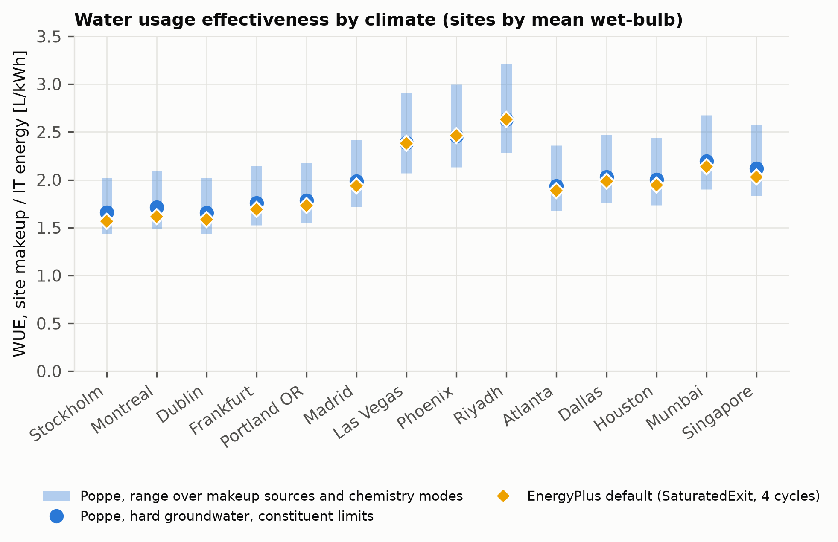
WUE by climate. Bars: range over makeup sources and chemistry modes with Poppe evaporation.

Water-accounting defects in EnergyPlus
Analysis of EnergyPlus v22.2 (unchanged on the development branch in October 2026) identified five defects, documented with reproductions in the supplementary material: (1) towers that are not running still book evaporation, drift and blowdown computed from a stale air-flow ratio (8.65 m$​^{3}$/yr in a stock example with zero heat rejected); (2) the Merkel tower books no evaporation in free convection; (3) regression-based variable-speed towers use a capacity fraction as an air-flow ratio in the fan-off regime; and (4) the LossFactor input, documented in percent per kelvin, is applied as a fraction, so the documented default evaporates 100 times the intended amount (20 %/K; up to 24 % of circulating flow in a stock example); and (5) fluid-cooler air flow is autosized as nominal capacity in watts divided by the design temperature difference times 4, read as m$​^{3}$/s, about 1000 times a physical value (14,061 m$​^{3}$/s for a 58.6 kW stock example). Defects (1)–(3) did not occur in the data-center case study, whose tower never idles or enters free convection; they matter for multi-tower plants and lightly loaded towers.

Hybrid adiabatic dry coolers

Model
Hybrid (adiabatic) dry coolers are the main water-saving alternative to towers in new data centers. EnergyPlus has dry fluid coolers but no water-side hybrid cooler, so the plugin builds one: a bank of FluidCooler:TwoSpeed objects shares one outdoor-air node, and in wet mode the plugin overrides that node’s dry-bulb with the pad-leaving temperature, keeping the wet-bulb, through EMS actuators at the start of each timestep. EnergyPlus then simulates the coils with pre-cooled air, and a condenser setpoint manager that follows the node lowers the condenser water temperature, so the chillers see the benefit. Pad cooling follows adiabatic saturation,
$$T_{pre}=T_{db}−ε (T_{db}−T_{wb}), i(T_{db},ω_{i})+(ω_{pre}−ω_{i})c_{pw}T_{wb}=i(T_{pre},ω_{pre}),$$
with pad effectiveness $ε=0.85$ (assumption, typical of rigid media). Evaporation is E=k​fkma,k(ωpre−ωi) over the fan states of the timestep, recovered exactly from the coolers’ reported fan power, and bleed follows the chemistry model of Section 2.4. Unlike the tower analysis, this plugin changes the EnergyPlus solution.

Case study and control strategies
The data-center model of Section 5 was given a hybrid heat-rejection plant: three 50 % fluid coolers (N+1) sized for wet operation at the 0.4 % dry-bulb design condition (5.6 K approach and range, 8 K design air temperature rise, hard-sized air flows), a condenser setpoint of pad-leaving air plus 5.6 K (23–40 °C), and three 50 % inlet-vane centrifugal chillers (Trane CVHE curve set, rated COP 5.38). No chiller curve set in the EnergyPlus dataset is valid above 41.1 °C leaving condenser water; hours beyond that limit, where EnergyPlus clamps the curves and underestimates chiller energy, are reported for every case. Seven control strategies were run at all 14 sites on identical hardware: dry only, always wet (above 5 °C), and wet when the outdoor dry-bulb exceeds $T_{on}=$ 16, 20, 24, 28 or 32 °C (2 K hysteresis). Because the tower and hybrid plants use different chiller curve sets, energy is compared only among hybrid strategies, and the tower enters as a water reference.

Results
Table 5 and Figs. 6–7 summarise the results. Three findings stand out.
Wet operation is primarily a capacity measure. Dry-only, the chillers run beyond their rated condenser range for up to 3,285 h/yr (Riyadh), 2,800 h (Phoenix) and 1,170–1,880 h in Dallas, Houston, Mumbai and Singapore. Wetting above 28 °C reduces this to at most 5 h/yr at every site.
Saving electricity with pad water is expensive. Relative to dry operation, wetting above 28 °C saves 0–1.7 % of facility electricity at a marginal cost of 100–122 L of water per kWh saved, and always-wet operation 107–241 L/kWh. These figures overstate the cost somewhat, because the dry baseline’s chiller energy is underestimated where curves clamp.
Control decides whether a hybrid saves water. With wetting above 28 °C, site water is 14 % (Riyadh), 31 % (Phoenix) and 41 % (Las Vegas) lower than the evaporative tower, 60–85 % lower in hot–humid climates, and 93–100 % lower in cool climates. Always-wet operation in Riyadh uses 9 % more water than the tower, because the pads cool all the air the dry coil moves, which is more air than a wet tower needs for the same heat.
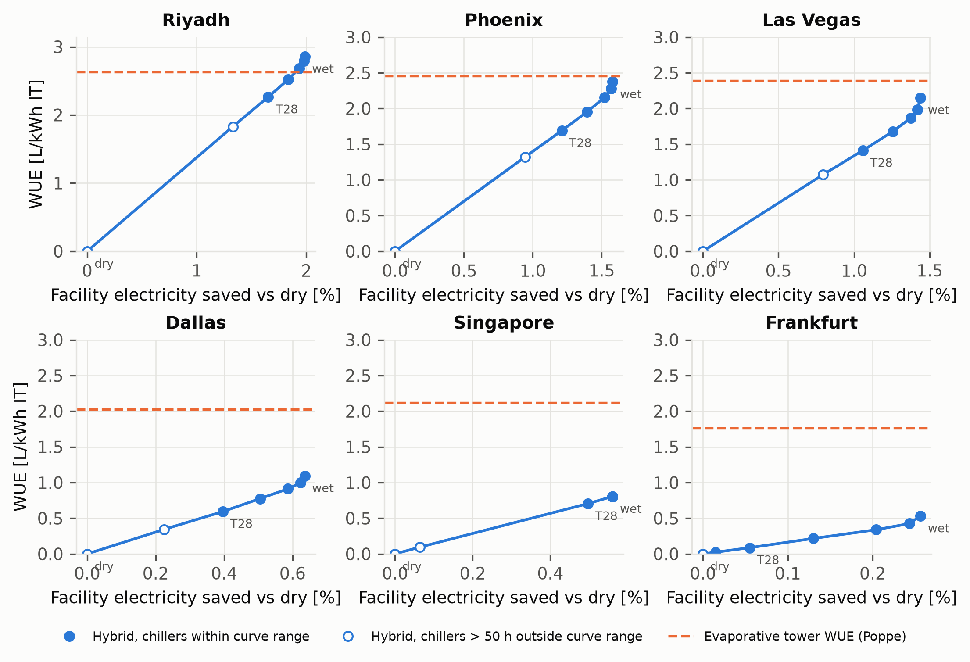
Water–energy trade-off of hybrid dry-cooler control (dry, wet above 32 to 16 °C, always wet) at six sites; dashed: evaporative tower WUE at the same site. Open markers: chillers more than 50 h/yr outside their rated curve range.
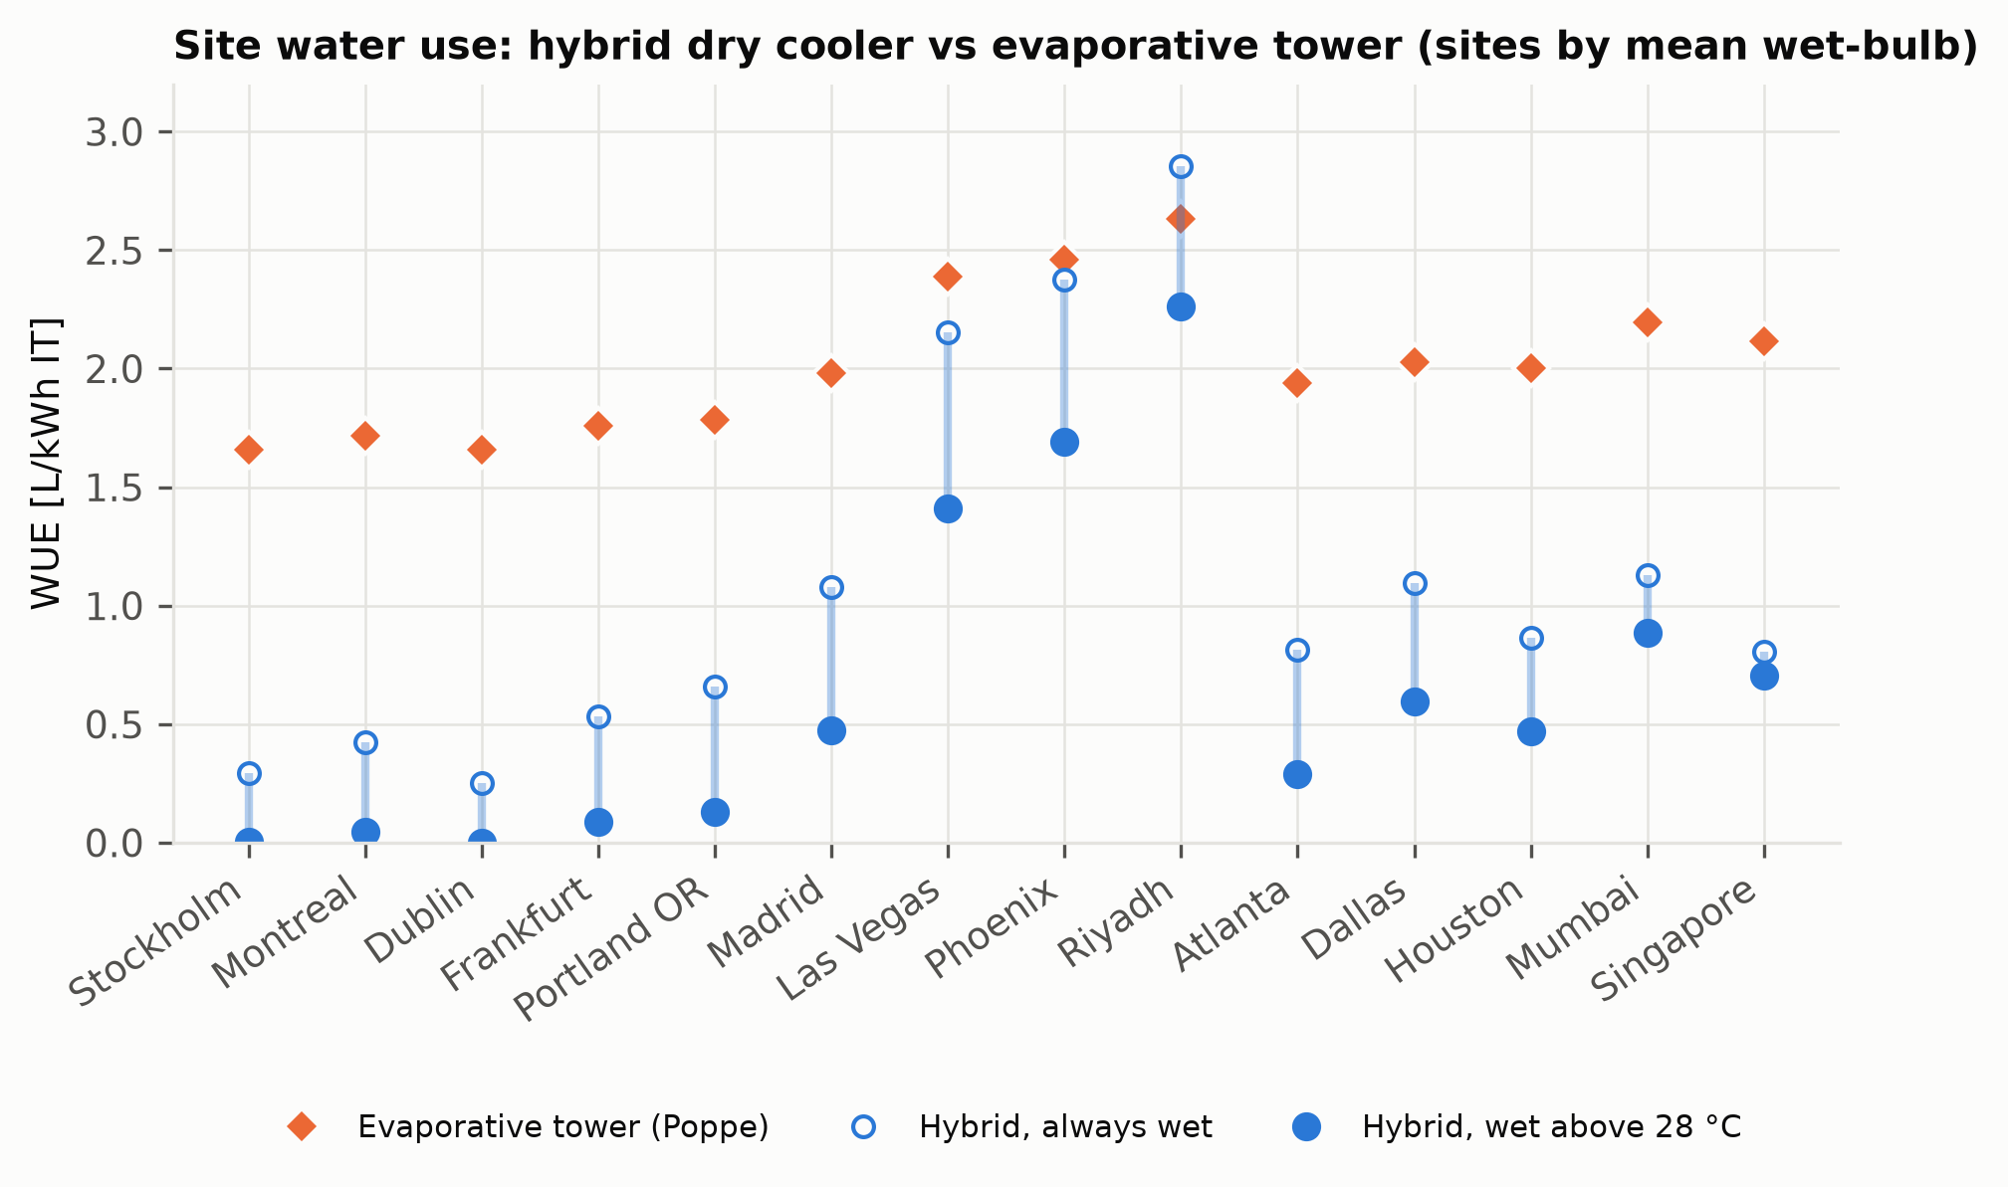
Site water use of the hybrid dry cooler (wet above 28 °C and always wet) and the evaporative tower.
Hybrid dry cooler results by site (sorted by mean wet-bulb). WUE in L/kWh IT; $Δ$WUE$​_{T28}$ relative to the tower; h$​_{out}$: chiller hours outside rated curve range; $ΔE_{T28}$: facility electricity saved vs dry; L/kWh$​_{saved}$: water per kWh saved (T28).
Site | CZ | WUE$​_{tower}$ | WUE$​_{T28}$ | WUE$​_{wet}$ | $Δ$WUE$​_{T28}$ [%] | h$​_{out}$ dry | h$​_{out}$ T28 | $ΔE_{T28}$ [%] | L/kWh$​_{saved}$
Stockholm | 6A | 1.66 | 0.00 | 0.29 | -100 | 0 | 0 | 0.00 | –
Montreal | 6A | 1.72 | 0.05 | 0.42 | -97 | 35 | 0 | 0.03 | 114
Dublin | 5A | 1.66 | 0.00 | 0.25 | -100 | 0 | 0 | 0.00 | –
Frankfurt | 4A | 1.76 | 0.09 | 0.53 | -95 | 78 | 0 | 0.05 | 120
Portland OR | 4C | 1.79 | 0.13 | 0.66 | -93 | 115 | 0 | 0.08 | 122
Madrid | 3B | 1.98 | 0.48 | 1.08 | -76 | 648 | 0 | 0.33 | 109
Las Vegas | 2B | 2.39 | 1.41 | 2.15 | -41 | 2185 | 0 | 1.06 | 100
Phoenix | 1B | 2.46 | 1.69 | 2.37 | -31 | 2803 | 3 | 1.21 | 104
Riyadh | 1B | 2.63 | 2.26 | 2.86 | -14 | 3284 | 0 | 1.65 | 102
Atlanta | 3A | 1.94 | 0.29 | 0.81 | -85 | 457 | 0 | 0.20 | 109
Dallas | 2A | 2.03 | 0.59 | 1.09 | -71 | 1226 | 1 | 0.40 | 113
Houston | 2A | 2.00 | 0.47 | 0.86 | -77 | 1172 | 5 | 0.30 | 116
Mumbai | 0A | 2.19 | 0.89 | 1.13 | -60 | 1875 | 4 | 0.59 | 112
Singapore | 0A | 2.12 | 0.70 | 0.81 | -67 | 1208 | 4 | 0.50 | 105

Discussion

Which method to use
For annual totals in building simulation, saturated-exit and e-NTU methods are within about 10 % of Poppe, biased low in cold climates and at part load near the pinch. Loss-factor and rule-of-thumb estimates should not be used for siting or permitting: their error changes sign with climate and exceeds 60 % in cool, humid climates. Where hourly water matters (peak demand on a utility, drought curtailment, plume abatement), Poppe is preferable because its error relative to saturated exit is concentrated in cold, humid hours.

Limitations
(i) Accounting mode: the thermal solution and air flow are EnergyPlus’, so any bias in its tower model propagates; near the pinch the plugin adjusts air flow by up to 3 % on average to keep the Poppe solution physical. (ii) Water chemistry inputs are illustrative placeholders; treatment limits and the empirical LSI form need site data and vendor limits. (iii) No measured validation yet: manufacturer performance tables and metered makeup and blowdown are needed. (iv) One plant configuration was studied, without water-side economizer, and with drift from a single eliminator assumption.

Hybrid coolers
The hybrid results argue for controls that wet only to keep chillers within their rated condenser range, not to save electricity: below the capacity limit, each kWh saved costs on the order of 100 L of water. The hybrid analysis assumes a constant pad effectiveness, no pad pressure drop, perfect knowledge of the current dry-bulb, placeholder water chemistry, and uses a chiller curve set whose rated range ends at 41.1 °C; a high-lift chiller characterisation and manufacturer pad data are needed before the energy side is used quantitatively.

Outlook
The verified Poppe and e-NTU rating functions allow a full physics-based tower as an EnergyPlus user-defined plant component; demand-based wet/dry control (wetting only when the condenser setpoint cannot be held) and spray and wetted-coil hybrids are natural extensions of the hybrid model.

Conclusions
- A multi-method EnergyPlus plugin evaluates eight evaporation models on the same operating point every timestep, with chemistry-driven blowdown; the Poppe implementation agrees with an independent boundary-value solution to $<{10}^{−4}$ %.
- For a full-load tower, saturated-exit methods deviate from Poppe by $−$18 to +11 % depending on ambient conditions; empirical methods by $−$39 to +117 %.
- In a 1 MW data center across 14 climates, the EnergyPlus default underestimates annual evaporation by 3.7–9.3 %, most in cold climates; the documented loss-factor method overestimates it by 4–64 %.
- Makeup-water chemistry changes annual makeup by $−$13 to +22 %, comparable to the choice of evaporation physics.
- A hybrid adiabatic dry cooler with wetting above 28 °C keeps chillers within their rated range at all sites and uses 14–100 % less water than the tower; always-wet operation can use more water than a tower, and saving electricity with pad water costs about 100–240 L/kWh.
- Five defects were identified in EnergyPlus heat-rejection models; one inflates loss-factor evaporation 100-fold and another autosizes fluid-cooler air flow about 1000-fold.

Data and code availability
The plugin, models, weather metadata and scripts that reproduce every figure are available at [TBD: repository URL].
Bošnjaković, F., 1965. Technical thermodynamics. Holt, Rinehart; Winston, New York.
Braun, J.E., Klein, S.A., Mitchell, J.W., 1989. Effectiveness models for cooling towers and cooling coils. ASHRAE Transactions 95, 164–174.
Fournier, R.O., 1977. Chemical geothermometers and mixing models for geothermal systems. Geothermics 5, 41–50. https://doi.org/10.1016/0375-6505(77)90007-4
Kloppers, J.C., Kröger, D.G., 2005a. A critical investigation into the heat and mass transfer analysis of counterflow wet-cooling towers. International Journal of Heat and Mass Transfer 48, 765–777. https://doi.org/10.1016/j.ijheatmasstransfer.2004.09.004
Kloppers, J.C., Kröger, D.G., 2005b. Cooling tower performance evaluation: Merkel, Poppe, and e-NTU methods of analysis. Journal of Engineering for Gas Turbines and Power 127, 1–7. https://doi.org/10.1115/1.1787504
Langelier, W.F., 1936. The analytical control of anti-corrosion water treatment. Journal AWWA 28, 1500–1521. https://doi.org/10.1002/j.1551-8833.1936.tb13785.x
Merkel, F., 1925. Verdunstungskühlung, VDI-forschungsarbeiten. VDI-Verlag, Berlin.
Meyer, D., Thevenard, D., 2019. PsychroLib: A library of psychrometric functions to calculate thermodynamic properties of air. Journal of Open Source Software 4, 1137. https://doi.org/10.21105/joss.01137
Mytton, D., 2021. Data centre water consumption. npj Clean Water 4, 11. https://doi.org/10.1038/s41545-021-00101-w
Poppe, M., Rögener, H., 1991. Berechnung von rückkühlwerken, in: VDI-wärmeatlas. VDI-Verlag, Düsseldorf, pp. Mi 1–Mi 15.
Shehabi, A., Smith, S.J., Sartor, D.A., Brown, R.E., Herrlin, M., Koomey, J.G., Masanet, E.R., Horner, N., Azevedo, I.L., Lintner, W., 2016. United states data center energy usage report (No. LBNL-1005775). Lawrence Berkeley National Laboratory, Berkeley, CA. https://doi.org/10.2172/1372902
The Green Grid, 2011. Water usage effectiveness (WUE): A green grid data center sustainability metric (White Paper No. 35). The Green Grid.
U.S. Department of Energy, 2022. EnergyPlus engineering reference, version 22.2.0. U.S. Department of Energy.
Wagner, W., Pruß, A., 2002. The IAPWS formulation 1995 for the thermodynamic properties of ordinary water substance for general and scientific use. Journal of Physical and Chemical Reference Data 31, 387–535. https://doi.org/10.1063/1.1461829

