When does a hybrid adiabatic dry cooler save water? Coupled EnergyPlus simulation of wet/dry control for data centers in 14 climates (DRAFT, companion paper)
Liang Zhang, Department of Civil and Architectural Engineering and Mechanics, University of Arizona, Tucson, AZ, USA [TBD: confirm affiliation]
Abstract
[TBD: Draft. Split from the tower-evaporation manuscript after review round 1 (M1). Before submission, address the open items listed in Section [sec:todo].]

Status of this draft
This section was split from the multi-method tower paper (review round 1, comment M1). The referee’s hybrid-specific concerns (M7) must be resolved before the results are used quantitatively:
- The dry baseline cannot hold the condenser setpoint in hot climates, and chiller curves are clamped up to 12.8 K beyond their rated range (no EnergyPlus dataset chiller is valid above 41.1 °C leaving condenser water). A high-lift chiller characterisation (manufacturer data or a physics-based compressor model) is needed.
- The tower and hybrid plants use different chillers; for energy comparisons both plants need the same chiller model.
- Pad pressure drop is zero in the reported runs; pad effectiveness (0.85) and the design air rise (8 K) are untested assumptions. Add a sensitivity analysis and manufacturer pad data.
- Equipment data now in hand (docs/EQUIPMENT_SPECS.md, data/equipment/evap_pad_performance.csv) suggest: pad effectiveness 0.75–0.80 for the base case (EVAPCO pad tests reach at most 78 % at 2 m/s; a 150 mm Munters pad is about 83 %); wet-pad pressure drop 20–85 Pa; pad bleed of about 25 % of evaporation; manufacturer default switch-over to wet only when fans are at 100 % and the setpoint is unmet, with a 21–26 °C threshold, a lockout below 4 °C and at most one wet start per day. The 0.02 W/W fan power is reasonable (about Eurovent class C).
- “L/kWh saved” ratios are unreliable where savings are small (0.03–0.08 %); report them only where savings exceed a threshold, and express uncertainty.
- Literature (verified, in references.bib): hybrid cooling towers (Asvapoositkul and Kuansathan, 2014), pad cooling efficiency and pressure drop (He et al., 2014), spray pre-cooling (Alkhedhair et al., 2013; Yang et al., 2020), measured water use of pad pre-cooled condensers for data centres (Ndukaife and Nnanna, 2019); energy–water trade-offs in hot–arid data centres (Karimi et al., 2025, 2022).
- Control uses perfect knowledge of the current dry-bulb; add dwell time, demand-based control, pad flushing/start-up water and freeze protection.

Hybrid adiabatic dry coolers

Model
Hybrid (adiabatic) dry coolers are the main water-saving alternative to towers in new data centers. EnergyPlus has dry fluid coolers but no water-side hybrid cooler, so the plugin builds one: a bank of FluidCooler:TwoSpeed objects shares one outdoor-air node, and in wet mode the plugin overrides that node’s dry-bulb with the pad-leaving temperature, keeping the wet-bulb, through EMS actuators at the start of each timestep. EnergyPlus then simulates the coils with pre-cooled air, and a condenser setpoint manager that follows the node lowers the condenser water temperature, so the chillers see the benefit. Pad cooling follows adiabatic saturation,
$$T_{pre}=T_{db}−ε (T_{db}−T_{wb}), i(T_{db},ω_{i})+(ω_{pre}−ω_{i})c_{pw}T_{wb}=i(T_{pre},ω_{pre}),$$
with pad effectiveness $ε=0.85$ (assumption, typical of rigid media). Evaporation is E=k​fkma,k(ωpre−ωi) over the fan states of the timestep, recovered exactly from the coolers’ reported fan power, and bleed follows the chemistry model of the companion paper. Unlike the tower analysis, this plugin changes the EnergyPlus solution.

Case study and control strategies
The data-center model of the companion paper was given a hybrid heat-rejection plant: three 50 % fluid coolers (N+1) sized for wet operation at the 0.4 % dry-bulb design condition (5.6 K approach and range, 8 K design air temperature rise, hard-sized air flows), a condenser setpoint of pad-leaving air plus 5.6 K (23–40 °C), and three 50 % inlet-vane centrifugal chillers (Trane CVHE curve set, rated COP 5.38). No chiller curve set in the EnergyPlus dataset is valid above 41.1 °C leaving condenser water; hours beyond that limit, where EnergyPlus clamps the curves and underestimates chiller energy, are reported for every case. Seven control strategies were run at all 14 sites on identical hardware: dry only, always wet (above 5 °C), and wet when the outdoor dry-bulb exceeds $T_{on}=$ 16, 20, 24, 28 or 32 °C (2 K hysteresis). Because the tower and hybrid plants use different chiller curve sets, energy is compared only among hybrid strategies, and the tower enters as a water reference.

Results
Table 1 and Figs. 1–2 summarise the results. Three findings stand out.
Wet operation is primarily a capacity measure. Dry-only, the chillers run beyond their rated condenser range for up to 3,285 h/yr (Riyadh), 2,800 h (Phoenix) and 1,170–1,880 h in Dallas, Houston, Mumbai and Singapore. Wetting above 28 °C reduces this to at most 5 h/yr at every site.
Saving electricity with pad water is expensive. Relative to dry operation, wetting above 28 °C saves 0–1.7 % of facility electricity at a marginal cost of 100–122 L of water per kWh saved, and always-wet operation 107–241 L/kWh. These figures overstate the cost somewhat, because the dry baseline’s chiller energy is underestimated where curves clamp.
Control decides whether a hybrid saves water. With wetting above 28 °C, site water is 14 % (Riyadh), 31 % (Phoenix) and 41 % (Las Vegas) lower than the evaporative tower, 60–85 % lower in hot–humid climates, and 93–100 % lower in cool climates. Always-wet operation in Riyadh uses 9 % more water than the tower, because the pads cool all the air the dry coil moves, which is more air than a wet tower needs for the same heat.
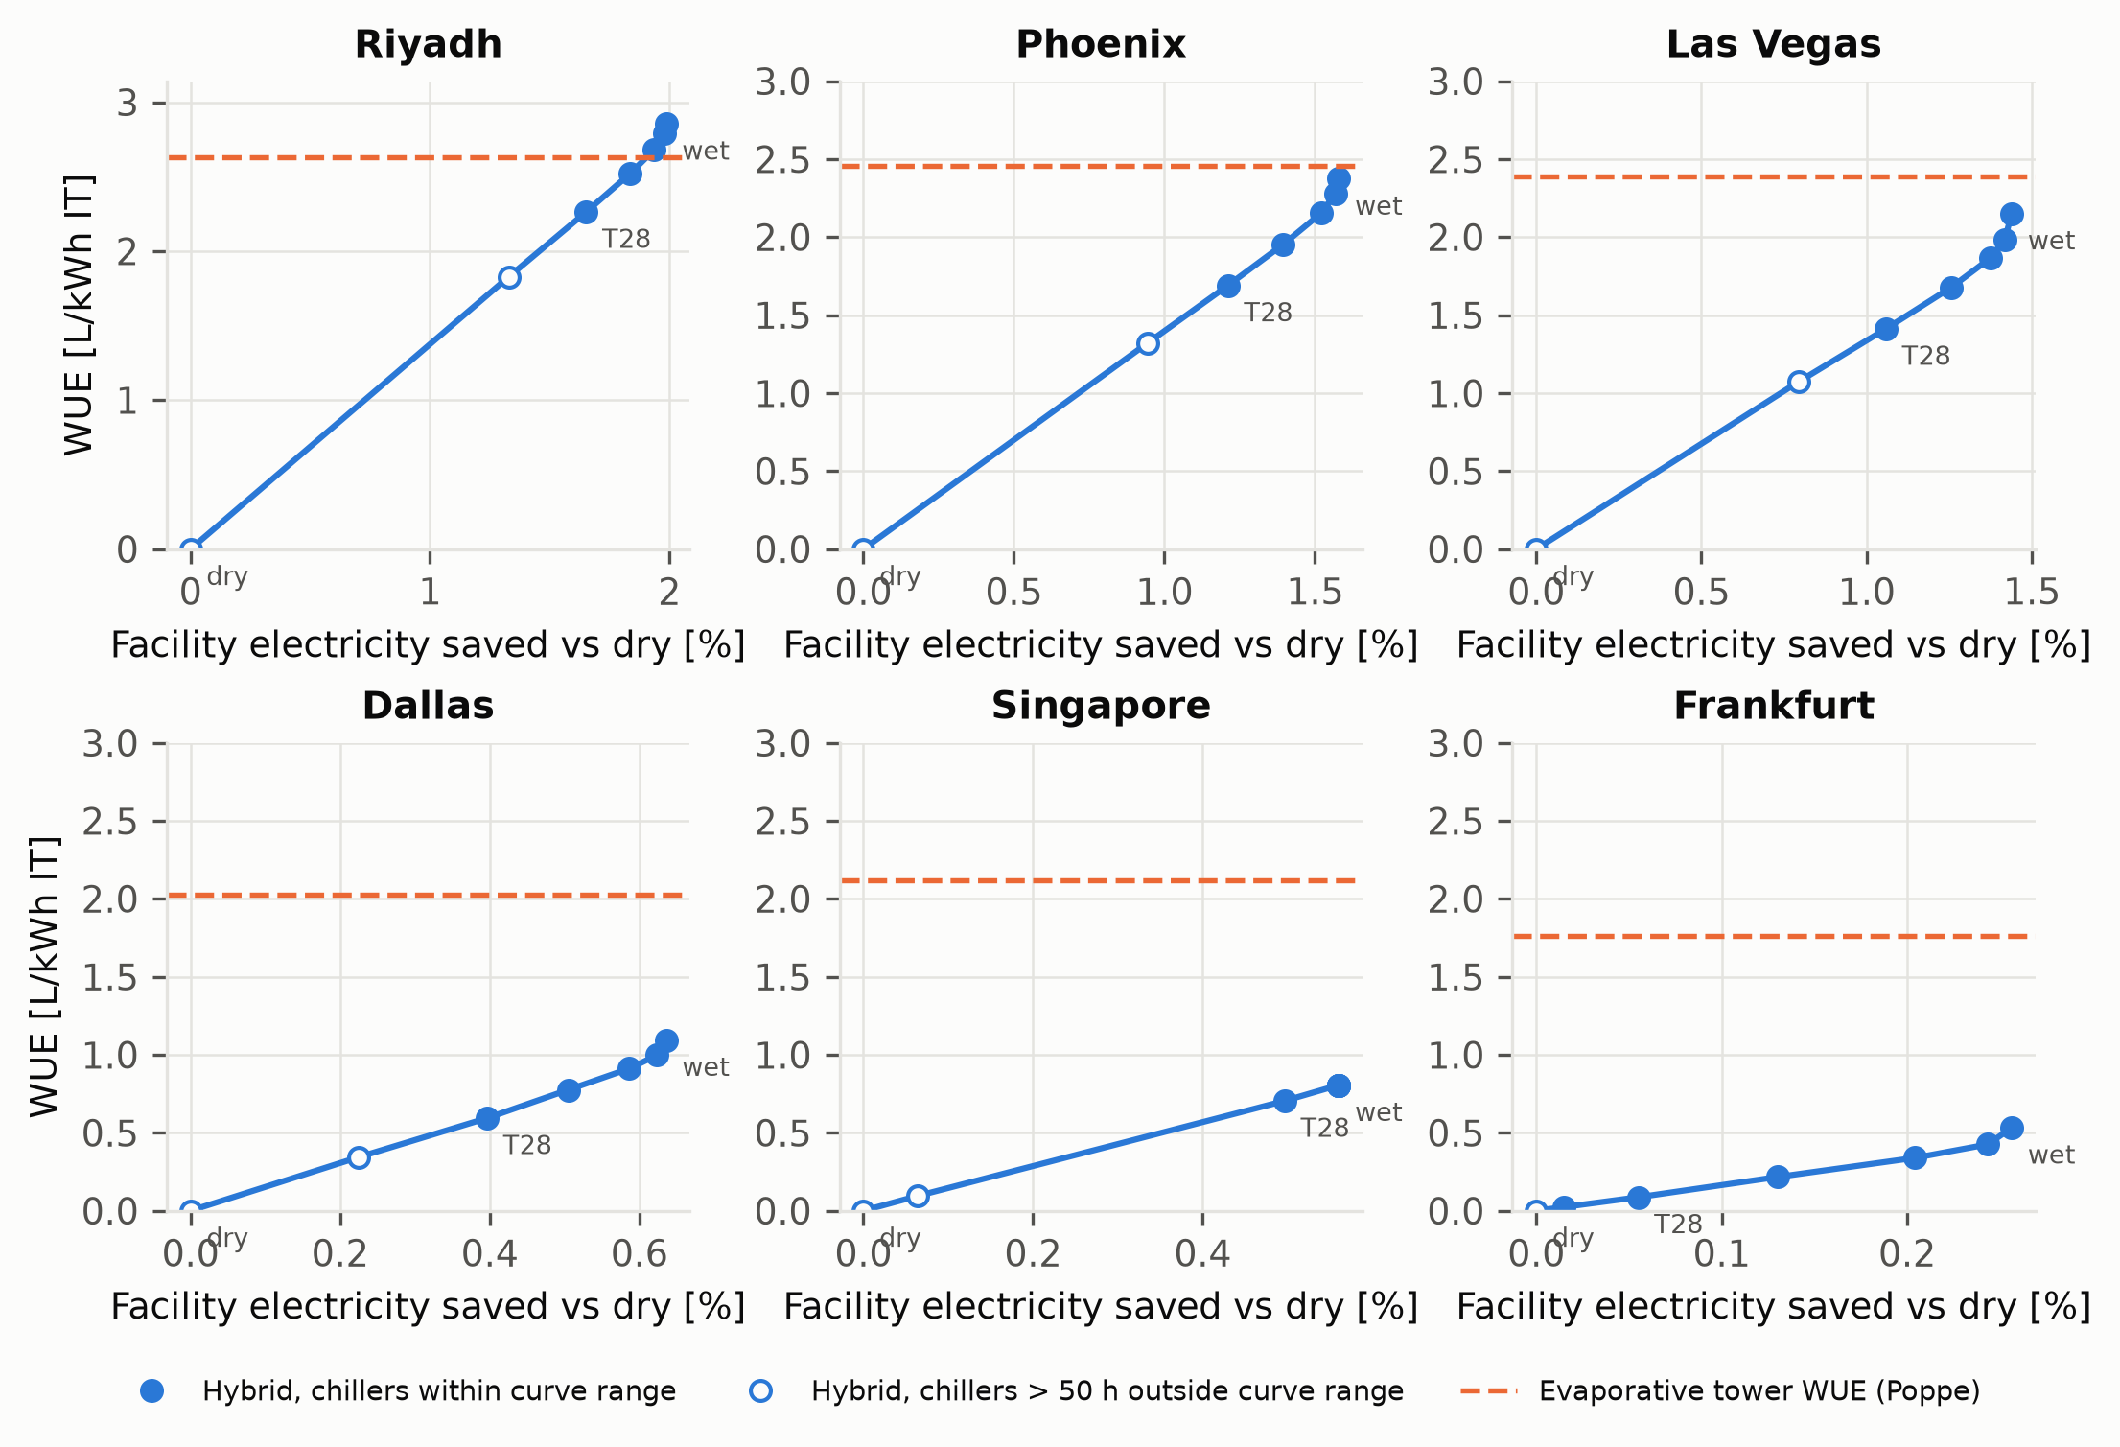
Water–energy trade-off of hybrid dry-cooler control (dry, wet above 32 to 16 °C, always wet) at six sites; dashed: evaporative tower WUE at the same site. Open markers: chillers more than 50 h/yr outside their rated curve range.
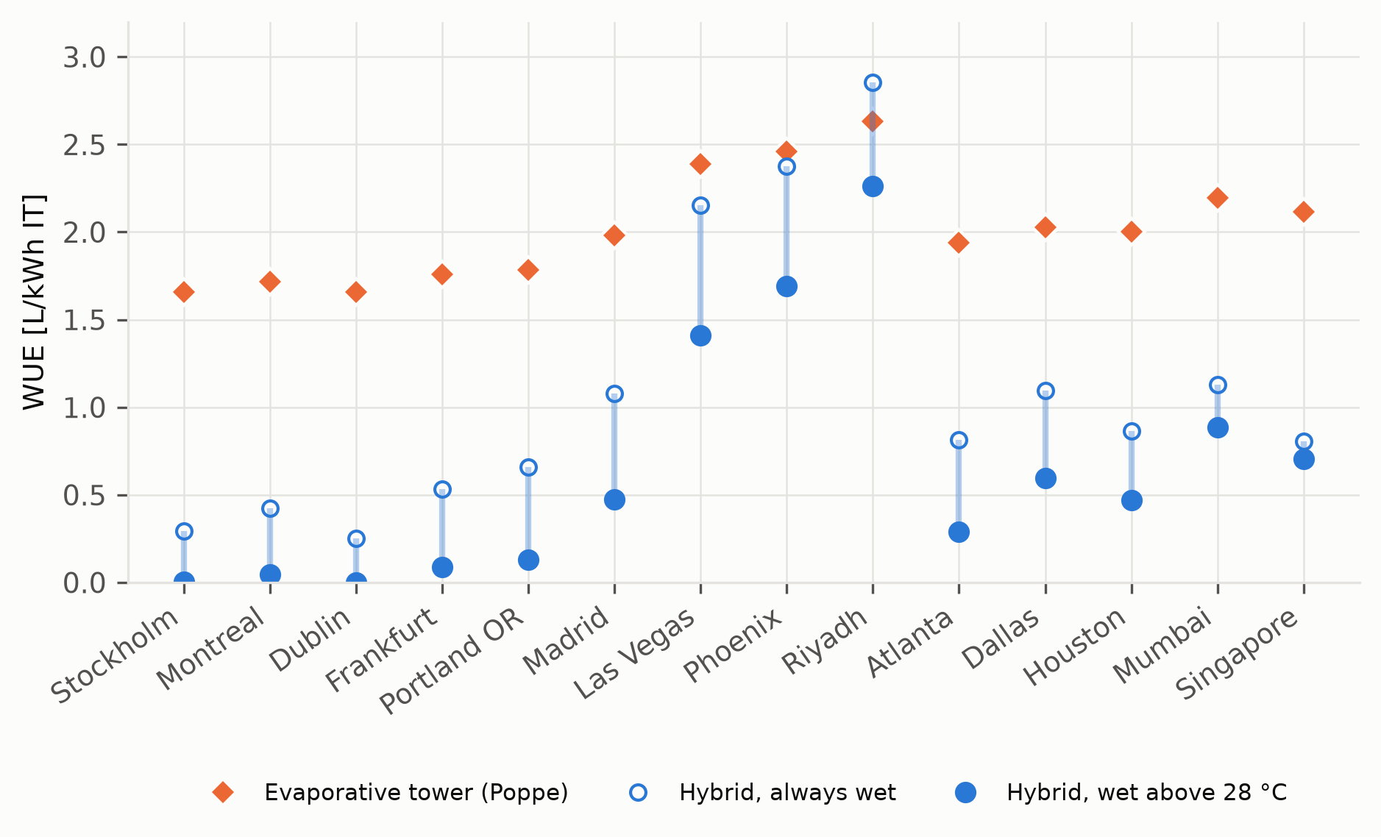
Site water use of the hybrid dry cooler (wet above 28 °C and always wet) and the evaporative tower.
Hybrid dry cooler results by site (sorted by mean wet-bulb). WUE in L/kWh IT; $Δ$WUE$​_{T28}$ relative to the tower; h$​_{out}$: chiller hours outside rated curve range; $ΔE_{T28}$: facility electricity saved vs dry; L/kWh$​_{saved}$: water per kWh saved (T28).
Site | CZ | WUE$​_{tower}$ | WUE$​_{T28}$ | WUE$​_{wet}$ | $Δ$WUE$​_{T28}$ [%] | h$​_{out}$ dry | h$​_{out}$ T28 | $ΔE_{T28}$ [%] | L/kWh$​_{saved}$
Stockholm | 6A | 1.66 | 0.00 | 0.29 | -100 | 0 | 0 | 0.00 | –
Montreal | 6A | 1.72 | 0.05 | 0.42 | -97 | 35 | 0 | 0.03 | 114
Dublin | 5A | 1.66 | 0.00 | 0.25 | -100 | 0 | 0 | 0.00 | –
Frankfurt | 4A | 1.76 | 0.09 | 0.53 | -95 | 78 | 0 | 0.05 | 120
Portland OR | 4C | 1.79 | 0.13 | 0.66 | -93 | 115 | 0 | 0.08 | 122
Madrid | 3B | 1.98 | 0.48 | 1.08 | -76 | 648 | 0 | 0.33 | 109
Las Vegas | 2B | 2.39 | 1.41 | 2.15 | -41 | 2185 | 0 | 1.06 | 100
Phoenix | 1B | 2.46 | 1.69 | 2.37 | -31 | 2803 | 3 | 1.21 | 104
Riyadh | 1B | 2.63 | 2.26 | 2.86 | -14 | 3284 | 0 | 1.65 | 102
Atlanta | 3A | 1.94 | 0.29 | 0.81 | -85 | 457 | 0 | 0.20 | 109
Dallas | 2A | 2.03 | 0.59 | 1.09 | -71 | 1226 | 1 | 0.40 | 113
Houston | 2A | 2.00 | 0.47 | 0.86 | -77 | 1172 | 5 | 0.30 | 116
Mumbai | 0A | 2.19 | 0.89 | 1.13 | -60 | 1875 | 4 | 0.59 | 112
Singapore | 0A | 2.12 | 0.70 | 0.81 | -67 | 1208 | 4 | 0.50 | 105

Data and code availability
The hybrid-cooler plugin, models and scripts are available at https://github.com/TensorBuildLab/EnergyPlus-HeatRejection-Water under the MIT licence.
Alkhedhair, A., Gurgenci, H., Jahn, I., Guan, Z., He, S., 2013. Numerical simulation of water spray for pre-cooling of inlet air in natural draft dry cooling towers. Applied Thermal Engineering 61, 416–424. https://doi.org/10.1016/j.applthermaleng.2013.08.012
Asvapoositkul, W., Kuansathan, M., 2014. Comparative evaluation of hybrid (dry/wet) cooling tower performance. Applied Thermal Engineering 71, 83–93. https://doi.org/10.1016/j.applthermaleng.2014.06.023
He, S., Guan, Z., Gurgenci, H., Hooman, K., Lu, Y., Alkhedhair, A.M., 2014. Experimental study of film media used for evaporative pre-cooling of air. Energy Conversion and Management 87, 874–884. https://doi.org/10.1016/j.enconman.2014.07.084
Karimi, L., Shinh, R., Laisure-Pool, C., Green, M., Yacuel, L., Ashby, J., Hickenbottom, K.L., 2025. Energy and water dynamics in data center cooling: Insights from a modeling study in hot-arid climates. Applied Thermal Engineering 276, 126802. https://doi.org/10.1016/j.applthermaleng.2025.126802
Karimi, L., Yacuel, L., Degraft-Johnson, J., Ashby, J., Green, M., Renner, M., Bergman, A., Norwood, R., Hickenbottom, K.L., 2022. Water-energy tradeoffs in data centers: A case study in hot-arid climates. Resources, Conservation and Recycling 181, 106194. https://doi.org/10.1016/j.resconrec.2022.106194
Ndukaife, T.A., Nnanna, A.G.A., 2019. Optimization of water consumption in hybrid evaporative cooling air conditioning systems for data center cooling applications. Heat Transfer Engineering 40, 559–573. https://doi.org/10.1080/01457632.2018.1436418
Yang, H., Rong, L., Liu, X., Liu, L., Fan, M., Pei, N., 2020. Experimental research on spray evaporative cooling system applied to air-cooled chiller condenser. Energy Reports 6, 906–913. https://doi.org/10.1016/j.egyr.2020.04.001

