Evaluating cooling tower evaporation models for data center water use in building energy simulation
Liang Zhang^{a,b*}
ª University of Arizona, Tucson, AZ, USA
^{b} National Laboratory of the Rockies, Golden, CO, USA
*Corresponding author: liangzhang1@arizona.edu

Abstract
Cooling towers dominate the direct water use of data centers, yet building energy simulation estimates their evaporation with simplified relations of unknown error. This study compares eight evaporation models, from rules of thumb and saturated-exit energy balances to the Poppe model, which resolves the Lewis factor, the evaporated mass and supersaturated exhaust air. All models are evaluated at the same simulated operating point in every timestep, with fan-cycling towers resolved into their fan-on and free-convection states, so that differences isolate evaporation physics. The models are implemented as an open-source EnergyPlus plugin, verified against an independent solution and 126 measured fill tests, and applied in 14 climates to the U.S. Department of Energy large data center prototype, a data center with a variable-speed tower and the large office prototype. The error of simplified models follows the state of the exhaust air: saturated-exit models overpredict where hot, dry air leaves unsaturated and underpredict where cold air leaves supersaturated, and the tower’s air-to-water ratio decides which regime dominates. The EnergyPlus default differs from Poppe by -9 to +38 % in annual evaporation; for the data center prototype, up to 22 percentage points come from averaging fan cycling over the timestep. Empirical rules deviate by up to 65 %, and local makeup-water chemistry changes makeup by -16 to +44 %. Data center water estimates for design, siting and the choice between air-cooled and evaporative heat rejection should use a model that resolves the exhaust-air state and part-load operation, and should state the cycles of concentration assumed.

Highlights
- Eight cooling tower evaporation models compared inside EnergyPlus simulations
- Errors of simple models follow the state of the air leaving the tower
- Simple models overpredict in hot, dry air and underpredict in cold air
- Default EnergyPlus method differs from Poppe by up to 38 % for a data center
- Open-source EnergyPlus plugin makes the physics-based models available to all

Keywords
Cooling tower; Evaporation; Data center; Water use; Poppe method; Building energy simulation; EnergyPlus

Nomenclature
$B$, $D_{r}$ | blowdown, drift [kg/s]
$c_{pa},c_{pv},c_{pw}$ | specific heat of dry air, vapour, liquid water [J/(kg K)]
$D$ | denominator of the Poppe equations, Eq. (2) [J/kg]
$E$ | evaporation rate [kg/s] (annual totals in m$​^{3}$)
$f$ | fan-on fraction of a timestep (fan-cycling tower) [–]
$i_{ma}$, $i_{masw}$ | enthalpy of moist air; of saturated air at $T_{w}$ [J/kg dry air]
$i_{fg}$, $i_{v}$ | latent heat; vapour enthalpy at $T_{w}$ [J/kg]
$K$ | mass transfer coefficient times area [kg/s]
$L/G$ | water-to-dry-air mass flow ratio [–]
$Le_{f}$ | Lewis factor [–]
$Me_{P}$ | Poppe Merkel number [–]
${\dot{m}}_{a}$, ${\dot{m}}_{w}$ | dry-air and water mass flow [kg/s]
$N_{c}$, $N_{c,eff}$ | cycles of concentration; effective annual value $E/(B+D_{r})+1$ [–]
$NTU$ | number of transfer units (Braun model) [–]
$\dot{Q}$ | heat rejected, ${\dot{m}}_{w}c_{pw}(T_{w,i}−T_{w,o})$ [W]
$T_{db}$, $T_{wb}$, $T_{w}$ | dry-bulb, wet-bulb, water temperature [°C]
$ΔT$ | cooling range, $T_{w,i}−T_{w,o}$ [K]
$ω$, $ω_{sw}$ | humidity ratio; saturated at $T_{w}$ [kg/kg dry air]
$ω_{se}$ | humidity ratio of saturated air at the effective saturation enthalpy (Braun model) [kg/kg dry air]
Subscripts $i$, $o$ | inlet, outlet
L/kWh$​_{th}$ | litres of evaporation per kWh of heat rejected

1 Introduction
Evaporative cooling towers reject the condenser heat of most large chilled-water plants. In commercial and institutional buildings they are often the largest single water use, 20–50 % of a facility’s total [1], and in data centers, which convert almost all of their electricity into heat and reject it throughout the year, they dominate direct water use [2,3]. National assessments estimate the water use of data centers and its growth [4], locate it in water-stressed basins [5], and show that their water usage effectiveness (WUE), the site water use per unit of information technology (IT) energy [6], varies widely with climate and cooling technology [7]; the water footprint of computing, including artificial intelligence workloads, has become a public concern [8,9]. Design-stage studies compare the energy and water use of cooling options [10,11], and water use is increasingly part of building siting, permitting and reporting. Such estimates need hourly evaporation that is consistent with the simulated plant.
Where water is scarce, these estimates become a design question. In Arizona, the Colorado River entered its first declared shortage in 2022, which cut Arizona’s allocation by about 18 %, and a deeper shortage level followed in 2023 [12,13]. The state’s 100-year groundwater model for the Phoenix Active Management Area projects 4.86 million acre-feet of unmet demand, so that new developments in parts of the region can no longer demonstrate an assured groundwater supply [14,15]. Cooling towers and chillers have median service lives of about 20 years [16], and the facilities they serve are planned for longer. A heat rejection system chosen on the water supply and prices of today may therefore operate for decades under tighter allocations, and a design based on short-term water availability can turn out to be wrong. Air-cooled heat rejection consumes almost no water on site but uses more energy, especially in hot weather, whereas evaporative towers save energy at the cost of water [10,11,17]; in a hot, arid climate, an air-cooled data center had a 13 % higher power usage effectiveness but a 66 % lower source WUE than a water-cooled one [10]. Choosing between air-cooled, hybrid and water-cooled systems, and sizing them for the life of the facility, requires water consumption estimates that are accurate over the whole range of climates and operating conditions the plant will see.
Building energy simulation resolves the hourly heat rejected by the plant and is therefore the natural tool for these estimates. The evaporation that accompanies this heat, however, is computed with simplified relations. EnergyPlus [18], a widely used open engine, offers a constant loss factor per kelvin of cooling range, or an energy balance that assumes the exhaust air leaves saturated [19]; blowdown follows from a fixed concentration ratio. Powers [20] noted that evaporation models in whole-building simulation are either too simple or too slow for water estimates. In the cooling-tower literature the physics behind these simplifications is well understood. Merkel’s method [21] sets the Lewis factor to one, neglects the mass of water evaporated in the energy balance and assumes saturated exhaust air; the Poppe method [22] retains all three effects and can represent supersaturated (fogging) exhaust [23]. Kloppers and Kröger [24], Kloppers and Kröger [25] compared the Merkel, effectiveness–number of transfer units (e-NTU) [26] and Poppe methods [27]: they agree closely in heat rejection but differ in water evaporated, by an amount that depends on the ambient conditions. Kloppers and Kröger [28] and Khan and Zubair [29] examined the Lewis factor, Navarro et al. [30] recommended Poppe for a new tower design, Qureshi and Zubair [31] studied evaporation-loss prediction, and Lucas et al. [32] measured tower performance with different drift eliminators.
What has not been quantified is how large these model differences are for the annual water use of real buildings, whose towers run at part load, in varying weather and under the control of a chiller plant. Two features of building operation make this question different from the full-load comparisons in the literature. First, when a tower operates depends on the building: a comfort-cooling plant runs mostly in summer, whereas a data center rejects heat in every hour of the year, including freezing and humid hours in which the exhaust air is supersaturated. Second, how a tower meets part load depends on its fan control: a variable-speed fan reduces the air flow, whereas a single-speed fan cycles between full air flow and free convection. Both change the air-to-water ratio and the state of the exhaust air, which, as shown below, decide whether simplified models over- or underpredict.
This paper therefore treats evaporation physics as the subject and the building simulation as the test platform. It asks: (i) where in the space of ambient conditions and air-to-water ratios do simplified evaporation models depart from the Poppe model, and why; (ii) how do the tower’s part-load control and the building’s load pattern change the annual result; and (iii) how does the evaporation-model effect compare with the effect of makeup-water chemistry on total water use? No measured tower evaporation or makeup data are used, so the case-study comparisons are model-to-model: Poppe serves as the most complete model, not as ground truth, and is checked against measured fill tests where these allow. The data center is the primary case because water use matters most there and its towers operate in all seasons; an office building shows how far the conclusions carry to comfort cooling. The contributions are:
- a physical explanation, with a climate-general map, of where and why simplified models depart from Poppe (Sections 2 and 6.2);
- a method that evaluates all models on the same simulated operating point, including the two states of a fan-cycling tower, so that differences isolate evaporation physics (Section 3);
- verification against an independent solution and 126 measured fill tests (Section 4);
- annual results for prototype data center and office buildings and a variable-speed tower in 14 climates (Sections 6.3–6.8);
- the effect of each site’s own makeup water on cycles of concentration and total water use (Section 6.9);
- an open-source EnergyPlus plugin that makes all models available to other users (Section 6.1 and Appendix A), with a tutorial, at https://github.com/TensorBuildLab/EnergyPlus-HeatRejection-Water;
- recommendations on which model to use for data center water estimates (Section 7.3).
All models, building models, data and scripts referred to below as supplementary files are in this repository.

2 Evaporation physics and models

2.1 Heat and mass transfer in a wet cooling tower
In the fill of a counterflow tower, warm water flows down against rising air. Heat leaves the water by evaporation (latent heat) and by convection to the air (sensible heat), and the water mass lost by evaporation is the quantity of interest. Three properties of this process determine how much water evaporates for a given heat rejected. (i) The sensible share of the heat transfer: in cold air a large part of the heat leaves as sensible heat, so less water evaporates per unit heat; in hot, dry air the air can be cooled by the water, so its sensible heat is added to the evaporation and more water evaporates than the heat rejected alone would require. (ii) The Lewis factor $Le_{f}$, the ratio of the heat and mass transfer coefficients, which sets that sensible share at a given driving force. (iii) The state of the exhaust air: it may leave unsaturated (typical of hot, dry air or a high air flow), saturated, or supersaturated, carrying liquid mist (typical of cold, humid air or a low air flow). A model that fixes the exhaust state, for example at saturation, cannot represent the first and last cases and will over- or underpredict accordingly.
The Poppe model [22,24] keeps all three effects. With the water temperature as independent variable,
$\frac{dω}{dT_{w}}=\frac{c_{pw} ({\dot{m}}_{w}/{\dot{m}}_{a})(ω_{sw}−ω)}{D}, \frac{di_{ma}}{dT_{w}}=\frac{{\dot{m}}_{w}c_{pw}}{{\dot{m}}_{a}}\left[1+\frac{c_{pw}T_{w}(ω_{sw}−ω)}{D}\right], \frac{dMe_{P}}{dT_{w}}=\frac{c_{pw}}{D},$ (1)
$D=(i_{masw}−i_{ma})+(Le_{f}−1)\left[i_{masw}−i_{ma}−(ω_{sw}−ω)i_{v}\right]−(ω_{sw}−ω)c_{pw}T_{w},$ (2)
with the corresponding supersaturated form, in which the air is saturated and the excess water is liquid mist, and the Lewis factor of Bošnjaković [33], as used by Kloppers and Kröger [28]. The local water flow decreases by the water evaporated. When both water temperatures and both flows are known, the equations are integrated from the bottom to the top of the fill (fourth-order Runge–Kutta, ten steps) and the Merkel number $Me_{P}$ is an output, so no fill correlation is needed. The unknown exhaust humidity enters the local water flow and is found by fixed-point iteration, converged when it changes by less than ${10}^{−8}$ kg/kg (at most six passes; 0.4 % of the case-study timesteps reach this limit, with an evaporation error below ${10}^{−5}$). In supersaturated air the humidity ratio $ω$ includes the liquid mist; Section 6.5 reports vapour and mist separately.

2.2 Models compared
Table 1 lists the eight models, from the simplest to the most complete. Three are empirical and need only the heat rejected or the water flow and range. The latent-heat bound (LAT) assumes that all heat rejected leaves as latent heat, $E=\dot{Q}/i_{fg}$. The rule of thumb (ROT) evaporates 0.153 % of the circulating water per kelvin of cooling range [34]. The loss factor (LF) of 0.2 %/K is the default of EnergyPlus’ loss-factor mode and the setting of the data center prototype used below.
Two models assume that the exhaust air leaves saturated. Merkel’s energy balance (MSAT) raises the enthalpy of the inlet air by the heat rejected per unit of dry air and takes the exhaust humidity as that of saturated air at this enthalpy, so that evaporation follows from the heat rejected and the exhaust state alone. The EnergyPlus formulation (EPSAT) [19] makes the same assumption with three differences: the inlet enthalpy is that of saturated air at the outdoor wet-bulb temperature, the humidity change is computed on a moist-air basis, and the air flow and the treatment of fan cycling are those of EnergyPlus (Section 3.2). EPSAT is reproduced line by line from the program source, so that it reproduces EnergyPlus’ own evaporation (Section 4).
The e-NTU model of Braun et al. [35] (BRAUN) assumes $Le_{f}=1$ and obtains an unsaturated exhaust humidity from an effective-saturation relation. Its number of transfer units is calculated back from the operating point, so it differs from the saturated-exit models only through this exhaust humidity. Where its exhaust would be supersaturated, which it cannot represent, the result is limited to saturated exit air (25 % of the points of the map in Section 6.2). The Poppe model (POPPE, Section 2.1) is the reference of this study. POPPE1 is the same model with $Le_{f}=1$ and isolates the effect of the Lewis factor. Properties follow the ASHRAE Handbook [36] with the Hyland–Wexler saturation pressure [37], the latent heat of Henderson-Sellers [38] and the water density of Kell [39].
Table 1. Evaporation models compared. $E$: evaporation; ${\dot{m}}_{a}$: dry-air flow; subscripts $i$, $o$: inlet and exhaust air.
ID | Model name | Evaporation | Key assumptions
LAT | Latent-heat bound | $E=\dot{Q}/i_{fg}$ | all heat rejected leaves as latent heat
ROT | Rule of thumb [34] | $E=0.00153 {\dot{m}}_{w}ΔT$ | 0.153 % of the water flow per kelvin of range
LF | Loss factor | $E=0.002 {\dot{m}}_{w}ΔT$ | 0.2 %/K, EnergyPlus default value
EPSAT | EnergyPlus saturated exit [19] | $i_{o}=i_{i}+\dot{Q}/{\dot{m}}_{a}$, $E={\dot{m}}_{a}\left(\frac{ω_{o}}{1+ω_{o}}−\frac{ω_{i}}{1+ω_{i}}\right)$ | saturated exhaust; inlet enthalpy at wet-bulb saturation; EnergyPlus air flow and fan-cycling convention
MSAT | Merkel saturated exit [21] | $i_{o}=i_{i}+\dot{Q}/{\dot{m}}_{a}$, $E={\dot{m}}_{a}\left[ω_{sw}(i_{o})−ω_{i}\right]$ | saturated exhaust; dry-air basis
BRAUN | Braun e-NTU [35] | $E={\dot{m}}_{a}(ω_{o}−ω_{i})$, $ω_{o}=ω_{se}+(ω_{i}−ω_{se}) e^{−NTU}$ | $Le_{f}=1$; unsaturated exhaust; no supersaturation
POPPE | Poppe [22,24] | $E={\dot{m}}_{a}(ω_{o}−ω_{i})$ from Eqs. (1)–(2) | Bošnjaković $Le_{f}$; mass of evaporated water; supersaturated exhaust
POPPE1 | Poppe, $Le_{f}=1$ | as POPPE | isolates the Lewis-factor effect

2.3 Water balance and makeup chemistry
Makeup water replaces evaporation, drift and blowdown. Blowdown follows from the dissolved-solids balance, $B=E/(N_{c}−1)−D_{r}$, with drift $D_{r}$ of 0.001 % of the circulating flow (an assumption for modern eliminators). To keep the comparison of evaporation models free of other effects, the annual results use four cycles of concentration. In practice the cycles are limited by scaling, corrosion and the treatment program [40–42], and they can instead be computed from the makeup chemistry: constituent limits; a calcium carbonate limit on the Langelier saturation index (LSI) at the hot-water temperature [43], which gives $N_{LSI}={10}^{(LSI_{max}−pH+pH_{s}(1))/1.9}$ because calcium and alkalinity both scale with $N_{c}$ (lowering the saturation pH $pH_{s}$ by $2logN_{c}$) while the dissolved-solids term raises it by $0.1logN_{c}$; and amorphous-silica solubility at the cold-water temperature [44]. $N_{c}$ is bounded to 1.5–10, and a constituent missing from the water data imposes no limit. Where limits are evaluated every timestep, $N_{c}$ is assumed to follow the water temperatures instantly, and the effective annual value $N_{c,eff}=E/(B+D_{r})+1$, which reproduces the annual makeup, is reported. Each case-study site is paired with its own municipal supply, compiled from the utilities’ latest water-quality reports or, where these give no mineral data, from U.S. Geological Survey source-water records (calcium, alkalinity, silica, chloride, sulfate and total dissolved solids; sources, conversions and a confidence rating per site in the supplementary file https://github.com/TensorBuildLab/EnergyPlus-HeatRejection-Water/blob/main/docs/WATER_QUALITY_SOURCES.md). Five sourced limit sets span practice: a conventional inhibitor program and a stainless-steel program from a tower manufacturer’s guidelines [45], a second manufacturer’s galvanized-steel guidelines [46], a modern-stabiliser program with $LSI_{max}=2.8$ [47] and an acid-fed program at an assumed pH of 7.5 with the silica limit raised to 200 mg/L [48]. $LSI_{max}=2.0$ for the conventional programs and a recirculating pH of 8.5 without acid are assumptions; in the acid-fed set the alkalinity destroyed by the acid is neglected, which makes its LSI limit conservative. WUE is site makeup per IT energy (L/kWh$​_{IT}$).

3 Evaluating the models in a building simulation

3.1 The same operating point for every model
A building simulation solves the thermal problem of the tower (heat rejected, leaving-water temperature, air flow) with its own tower model, and computes evaporation afterwards; in EnergyPlus evaporation does not feed back to the thermal solution. The comparison exploits this. In every timestep, every evaporation model is evaluated at the operating point the simulation produced: water inlet and outlet temperatures, water flow, heat rejected, air flow and the outdoor dry-bulb, wet-bulb, humidity and pressure. All models therefore see the same tower doing the same thermal work, and their differences isolate evaporation physics. The price is that the operating point comes from the simulation’s own tower model, not from Poppe. Section 6.7 tests how much this matters by replacing the tower by one with an ordinary fill whose air flow is solved with Poppe.

3.2 Part-load operation: variable-speed and fan-cycling towers
How a tower meets part load determines the air flow at which the physics is evaluated. A variable-speed tower (EnergyPlus CoolingTower:VariableSpeed:Merkel) runs at the lowest fan speed that meets the condenser setpoint; its air flow is the fan-speed ratio times the design air flow and the fraction of cells operating, and in free convection, where EnergyPlus reports zero air flow while rejecting heat, the sized free-convection air flow is used.
A single-speed tower (CoolingTower:SingleSpeed, the tower of the U.S. Department of Energy prototype buildings) cycles its fan instead. Within a timestep it runs for a fraction $f$ with the fan on, at design air flow, and for $1−f$ in free convection, with about a tenth of the air flow. The simulation reports only the timestep average, $T_{w,o}=f T_{on}+(1−f) T_{off}$. Because evaporation per unit heat depends on the air-to-water ratio, evaluating the physics once at an average state is not equivalent to evaluating the two states the tower actually passes through. The evaluation therefore reconstructs both: $T_{off}$ is recomputed with EnergyPlus’ own free-convection tower model (a line-by-line replica of its effectiveness model), $T_{on}$ follows from the reported average, so the heat rejected in the timestep is reproduced exactly, and each physical model is evaluated at both states and time-weighted. EnergyPlus itself applies the timestep-average heat to the full design air flow whenever the fan ran; EPSAT reproduces this convention, so its difference from Poppe contains both the saturated-exit physics and the averaging. With fluid-bypass control the fan runs at full speed and the bypassed water is removed from the fill flow.

3.3 Operating points at the thermodynamic limit
EnergyPlus’ variable-speed tower linearises the saturation enthalpy and runs at the lowest fan speed that meets the setpoint. For an oversized tower at part load this can put the exhaust air within a fraction of a percent of the saturated enthalpy at the hot-water temperature, i.e. at the pinch. Poppe, which keeps $Le_{f}<1$ and the enthalpy of the evaporated water, may then find no positive driving force near the top of the fill. In that case the point is re-solved with the smallest air-flow increase (1–50 %) that is feasible, and MSAT, BRAUN and POPPE1 are evaluated at the same adjusted air flow, so that all physical models see one operating point; EPSAT keeps EnergyPlus’ air flow because it must reproduce EnergyPlus. Section 6.7 reports how often this happens.

3.4 Implementation
The models are implemented in Python and coupled to EnergyPlus through its Python plugin interface (PythonPlugin objects, [49]). A plugin is a user-written Python class that EnergyPlus calls at defined points of every timestep; it can read any output variable and write its own. Here the plugin is called at the end of each system timestep, evaluates the models and writes their results as ordinary output variables; it does not change the thermal solution. The source code, a tutorial and all case-study models are openly available at https://github.com/TensorBuildLab/EnergyPlus-HeatRejection-Water; Section 6.1 describes the tool and its use, and Appendix A shows the plugin class and the input objects that connect it to EnergyPlus.

4 Verification
Table 2 summarises the code verification. The Poppe implementation was compared with an independent formulation: the height-wise conservation equations with a prescribed transfer coefficient $K$, including the supersaturated state, solved as a boundary-value problem by shooting with an adaptive stiff integrator (relative tolerance ${10}^{−10}$). Seven cases cover temperate, hot–dry and hot–humid air, high and low $L/G$, and two near-pinch cases with supersaturated exhaust. Evaporation agrees within 0.008 %, and $Me_{P}$ within 0.003 % with 40 steps. Both formulations share the property functions, which are verified separately against PsychroLib [50] and IAPWS-95 [51]. The replicas of EnergyPlus reproduce its own annual evaporation within 0.5 % at every site and tower type, and the free-convection replica reproduces EnergyPlus’ leaving-water temperature within 0.17 K in the timesteps in which the fan stays off.
Table 2. Code verification.
Check | Max. deviation
Psychrometrics vs PsychroLib (saturation pressure, humidity, enthalpy, wet-bulb) | 0.2 % / 0.02 K
Latent heat vs IAPWS-95 | 0.3 %
Poppe vs independent boundary-value solution, 7 cases: evaporation | 0.008 %
$Me_{P}$ (40 steps) | 0.003 %
Poppe energy closure, unsaturated and supersaturated | $<0.1$ %
Rating mode, same fill: Merkel / Poppe / e-NTU outlet temperature | $<0.5$ K
EPSAT replica vs EnergyPlus output, annual, 3 buildings $×$ 14 sites | 0.5 %
Free-convection replica vs EnergyPlus leaving-water temperature (fan off) | 0.17 K
Poppe fixed-point iteration, timesteps at the iteration limit: evaporation | $<{10}^{−3}$ %
Measured fill tests. Kloppers [52] reports 126 counterflow fill tests (trickle fill at three heights, splash fill, and film fill at three heights; 18 tests each) with measured inlet air, water temperatures and flows and outlet-air temperature, together with his own Poppe and Merkel analyses of each test. Solving each test with the Poppe model of this work (ten steps; twenty steps change evaporation by at most 0.006 %) gives Merkel numbers 1.0 % above Kloppers’ Poppe values on average (median absolute difference 0.8 %, 95th percentile 2.0 %, one test 8.8 %) and outlet-air temperatures within 0.3 K of his (Table 3, Fig. 1). Both analyses solve the same equations, so this is an implementation check. Against the measurements, the Poppe outlet-air temperature has a bias of -0.20 K and an rms error of 0.84 K (Kloppers’ analysis: 0.85 K). Saturated-exit analyses of the same tests are less accurate and colder (Table 4): -0.75 K bias and 1.10 K rms for Merkel, 1.07 K for Braun and 1.16 K for Kloppers’ own Merkel analysis. They predict 7 % less evaporation than Poppe on average (3–11 %) and the EnergyPlus formulation 11 % less. This favours Poppe, but only weakly: a 0.26 K difference in rms error corresponds to a 7 % difference in evaporation, and evaporation itself was not measured. All tests also lie in one regime, with inlet air at 11.8–24.2 °C dry-bulb and 9.9–20.6 °C wet-bulb, hot water at 33–53 °C, $L/G$ of 0.65–5.8 and supersaturated exhaust in every test; hot–dry air, freezing air and the 20–35 °C water of building condenser loops are not covered. A fill characteristic $Me_{P}=c (L/G)^{−n}$ fitted to each fill gives $n=0.51$–0.60. With $n=0.6$ anchored at one test, the leaving-water temperature is predicted within 0.17–0.83 K rms over a 3–8-fold range of $L/G$, which changes the predicted evaporation by $±$4.4 % on average (maximum 11.5 %, film fill). Our Merkel numbers are 2.5–4.3 % above Kloppers’ tabulated Merkel values; the cause is not the quadrature, the air-flow basis or the definition of the inlet enthalpy (all tested) and remains unexplained. It does not affect MSAT, whose evaporation follows from the energy balance and the saturated exhaust state alone.
Table 3. Poppe model against the 126 fill tests of Kloppers [52]. $Me_{P}$ vs K.: mean (maximum absolute) difference from Kloppers’ Poppe analysis. $T_{a,o}$: predicted minus measured outlet-air temperature. $n$: fitted fill exponent. Last three columns: rating-mode prediction of the leaving-water temperature $T_{w,o}$ with a single-point $n=0.6$ law or a fitted $Me_{P}=a G_{w}^{b}G_{a}^{c}$ law, and the change in predicted Poppe evaporation caused by the $T_{w,o}$ error of the $n=0.6$ law (not an error against measured evaporation, which is not available).
Fill | $L_{fi}$ [m] | $Me_{P}$ vs K. [%] | $T_{a,o}$ vs meas. bias / rms [K] | $n$ | $T_{w,o}$ rms, $n$=0.6 [K] | $T_{w,o}$ rms, $G_{w},G_{a}$ fit [K] | $ΔE$ from $T_{w,o}$ error, $n$=0.6 [%]
trickle | 1.08 | +0.8 (max 1.7) | +0.55 / 0.86 | 0.55 | 0.38 | 0.13 | +1.0 (max 4.7)
trickle | 1.53 | +0.9 (max 2.2) | -0.88 / 1.18 | 0.59 | 0.18 | 0.13 | -0.5 (max 2.7)
trickle | 1.98 | +1.6 (max 8.8) | -0.58 / 1.12 | 0.59 | 0.17 | 0.19 | +0.0 (max 2.0)
splash 0.1m | 2.50 | +0.9 (max 2.0) | +0.23 / 0.56 | 0.51 | 0.46 | 0.12 | +1.0 (max 6.6)
film | 0.60 | +0.9 (max 1.8) | -0.34 / 0.68 | 0.60 | 0.83 | 0.21 | +4.3 (max 11.5)
film | 0.90 | +1.0 (max 2.6) | -0.25 / 0.63 | 0.57 | 0.68 | 0.14 | -4.4 (max 10.2)
film | 1.20 | +1.0 (max 3.4) | -0.16 / 0.64 | 0.59 | 0.47 | 0.13 | -3.0 (max 7.7)
Table 4. Evaporation models on the 126 fill tests of Kloppers [52]: outlet-air temperature against the measured value, and evaporation relative to Poppe at the measured operating point. EnergyPlus’ formulation gives no outlet-air temperature.
Model | $T_{a,o}$ bias [K] | $T_{a,o}$ rms [K] | $E$ vs Poppe, mean (range) [%]
Poppe (this work) | -0.20 | 0.84 | –
Merkel, saturated exit | -0.75 | 1.10 | -7.2 (-10.9 to -3.1)
Braun e-NTU | -0.71 | 1.07 | -7.3 (-10.9 to -4.4)
EnergyPlus SaturatedExit | – | – | -11.2 (-15.1 to -5.9)
Merkel, Kloppers’ analysis | -0.83 | 1.16 | –
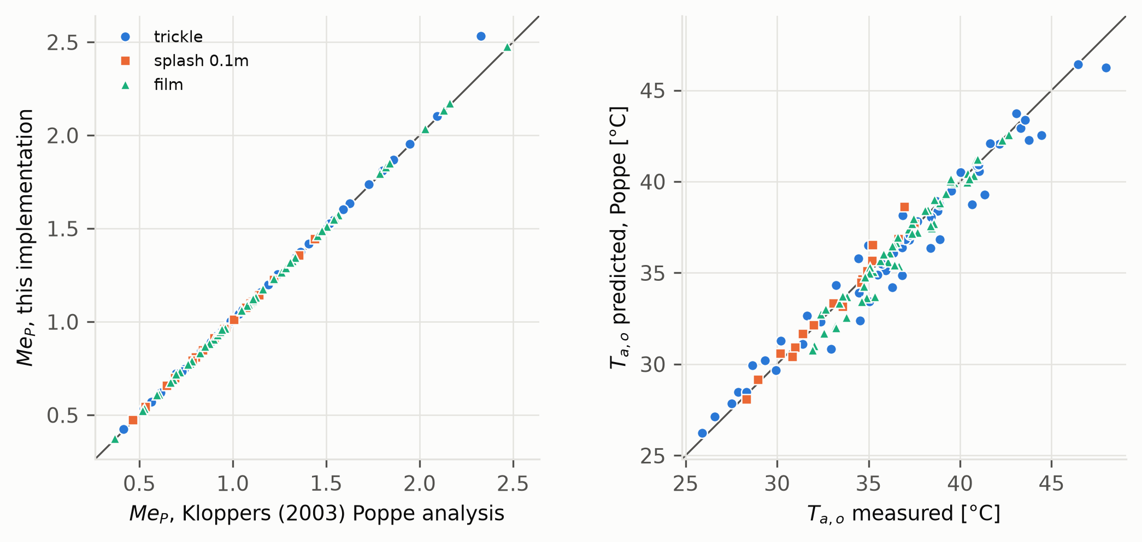
Figure 1. Poppe implementation against the fill tests of Kloppers [52]. Left: Merkel number vs Kloppers’ Poppe analysis of the same tests. Right: predicted vs measured outlet-air temperature.

5 Case studies
Three buildings were simulated in the same 14 climates (Table 5). The primary case is the large data center prototype developed by Lawrence Berkeley National Laboratory (LBNL) for the U.S. Department of Energy (DOE) [53], in its high-density version for ASHRAE Standard 90.1-2019 [54]. It was generated by the OpenStudio-Standards library [55]; the model used here is that library’s output for climate zone 3A as archived by the Stor4Build project [56], translated to EnergyPlus input with the OpenStudio 3.7 Python bindings and converted to EnergyPlus 22.2 (the two input dictionaries differ in one economizer field, which was dropped). The second case is the U.S. Department of Energy large office reference building [57] as distributed with EnergyPlus. Both prototypes use a single-speed, fan-cycling tower sized by EnergyPlus at fixed rating conditions, so the tower is the same at every site. They were changed in two respects only: the tower evaporation mode was set to EnergyPlus’ default saturated-exit formulation (the data center prototype uses the loss factor), which does not affect the thermal solution, and the office was set to simulate the weather year (the distributed file simulates design days only). The prototypes’ envelopes, internal loads and controls were kept as published, including the 3A envelope of the data center and the Chicago constructions of the office at every site, because the purpose is to obtain realistic tower operating patterns rather than site-optimised buildings.
The third case is a 1 MW data center with a three-cell variable-speed tower, developed in earlier work for this study (supplementary file https://github.com/TensorBuildLab/EnergyPlus-HeatRejection-Water/blob/main/models/DATACENTER_MODEL.md). It represents the variable-speed towers common in new large facilities and the other tower model of EnergyPlus, and it is the basis of the operating-point and sensitivity analyses of Sections 6.7 and 6.8. Design days and site data were replaced with each site’s ASHRAE values. Weather is TMYx 2011–2025 for 14 sites in ASHRAE climate zones 0A to 6A (zones from the weather files’ design conditions). EnergyPlus 22.2.0 was used.
Table 5. Case-study buildings. LBNL: Lawrence Berkeley National Laboratory; DOE: U.S. Department of Energy; COP: chiller coefficient of performance. Tower operating hours, heat rejected and the share of heat rejected from October to April are ranges over the 14 sites.
 | Data center prototype | Office prototype | Data center, variable-speed tower
Source | LBNL/DOE large data center, high IT density, 90.1-2019 [53,55] | DOE large office reference building, new construction [57] | This study (supplementary model documentation)
Size and load | 557 m$​^{2}$, 3.0 MW design IT, monthly IT schedule, 16,480 MWh/yr IT | 46,320 m$​^{2}$, 12 floors and basement, office schedules | 1,000 m$​^{2}$, 1.0 MW design IT, 70–90 % utilisation
Chilled-water plant | 1 centrifugal chiller (COP 6.3), 6.7 °C supply, integrated water-side economizer | 2 centrifugal chillers (COP 5.5), 6.7 °C supply | 3 $×$ 50 % variable-speed centrifugal, 10 °C supply
Tower | single speed, 2 cells, fan cycling; fan power at the 90.1-2019 minimum efficiency (40.2 gpm/hp) | single speed, 1 cell, fan cycling | variable speed, 3 cells, approach 3.9 K at the site’s 0.4 % wet-bulb
Condenser setpoint | $T_{wb}$ + 4.3 K, 5.6–29.4 °C | $T_{wb}$ + 0 K (fan at full speed in 96–99 % of operating hours) | $T_{wb}$ + 3.9 K, 18–29.4 °C
Tower operation | 8,760 h; 22,800–23,700 MWh; 59–62 % | 1,840–6,090 h; 1,320–15,330 MWh; 2–56 % | 8,760 h; 9,250–9,590 MWh; 57–58 %

6 Results

6.1 The open-source plugin
The models are distributed as an EnergyPlus Python plugin with scripts that prepare any EnergyPlus model and analyse its output (Fig. 2). The core is plain Python without third-party packages, so it runs in the Python interpreter embedded in EnergyPlus. Using it takes three steps, which the repository’s tutorial (https://github.com/TensorBuildLab/EnergyPlus-HeatRejection-Water/blob/main/docs/TUTORIAL.md) walks through with the data center prototype.
- Install: clone the repository from https://github.com/TensorBuildLab/EnergyPlus-HeatRejection-Water; EnergyPlus with Python plugin support (tested with version 22.2) is the only requirement (the analysis scripts additionally use NumPy, pandas and Matplotlib).
- Prepare: python tools/prepare_model.py --idf building.idf --epw weather.epw --out run/ runs a design-day sizing simulation to obtain the tower’s design flows, reads every supported tower (CoolingTower:SingleSpeed, :VariableSpeed and :VariableSpeed:Merkel), and writes a model with the plugin objects (PythonPlugin:SearchPaths, :Instance, :Variables and :OutputVariable) and output requests, plus a configuration file that names the makeup-water source, the treatment limits and the chemistry mode (fixed cycles, constituent limits, or limits evaluated every timestep). Options select the models, the loss factor and the climate-specific design days.
- Run and analyse: run EnergyPlus on the prepared model as usual. The results are ordinary output variables per tower and timestep (Table 6); tools/analyze.py summarises a run and tools/scenarios.py recomputes blowdown and makeup for other water sources and treatment programs without re-simulation. tools/run_climates.py runs one model in many climates in parallel.
For the data center prototype the plugin with all eight models increases the run time of an annual simulation from 7 s to 109 s (about 2 ms per timestep on one core), most of it in the Poppe integrations; selecting fewer models reduces it proportionally. The repository documents every equation with its source and code location (https://github.com/TensorBuildLab/EnergyPlus-HeatRejection-Water/blob/main/docs/METHODS.md), contains 60 unit tests and reproduces every figure and table of this paper with one script. Appendix A lists the plugin class and the input objects that the preparation step adds to a model.
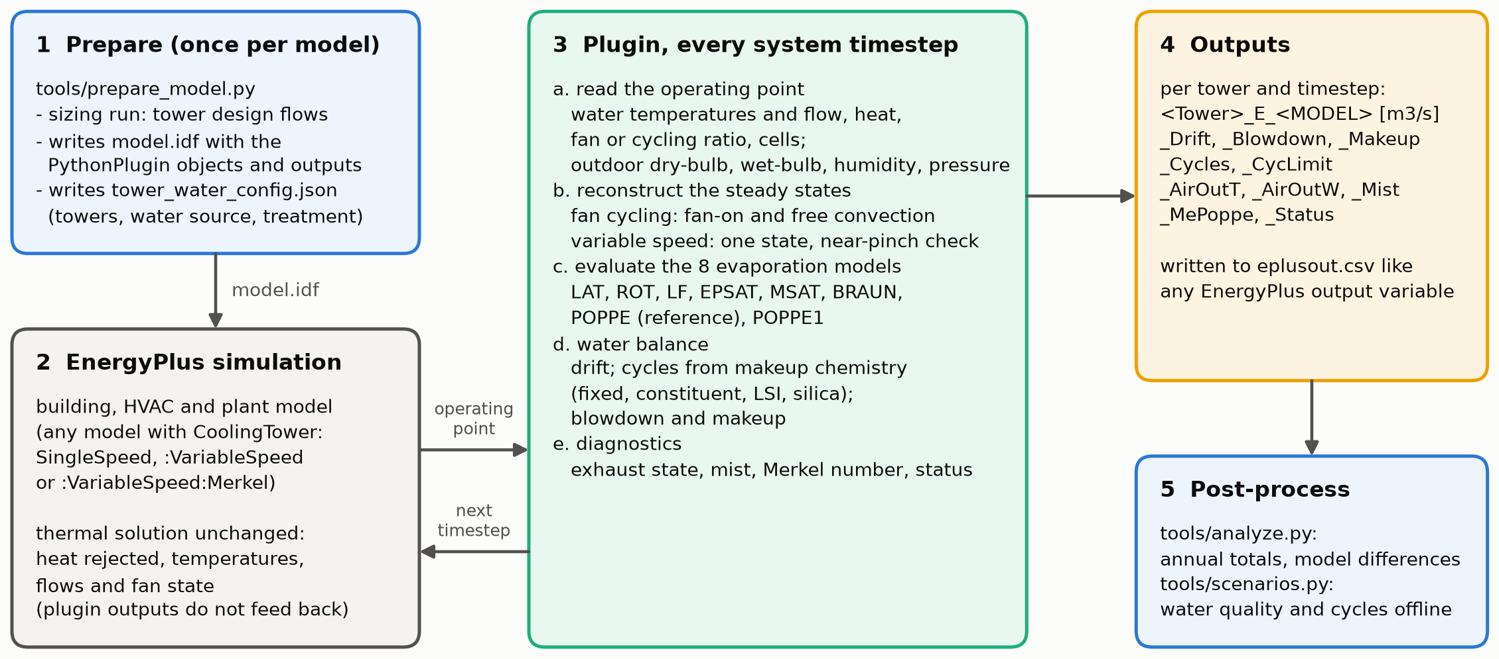
Figure 2. Workflow of the plugin. The model is prepared once; during the simulation the plugin reads the operating point of each tower in every system timestep, reconstructs its steady states, evaluates all evaporation models and the water balance, and writes the results as output variables without changing the thermal solution.
Table 6. Output variables written by the plugin for each tower (prefix = tower name), per system timestep.
Output | Content
_E_LAT … _E_POPPE1 | evaporation of each model [m$​^{3}$/s]
_Drift, _Blowdown, _Makeup, _MakeupVol | water balance of the reference model [m$​^{3}$/s, m$​^{3}$]
_Cycles, _CycLimit | cycles of concentration and the limiting constituent
_AirMass, _AirOutT, _AirOutW | dry-air flow; exhaust temperature and humidity (Poppe)
_Fog, _Mist | supersaturated exhaust flag; liquid mist in the exhaust [m$​^{3}$/s]
_MePoppe, _MeMerkel, _NTU | Merkel numbers and transfer units implied by the operating point
_AirScale, _Status | near-pinch air-flow factor; solution status

6.2 Where simplified models depart from Poppe
To separate the physics from any building, a counterflow tower was sized with the Poppe model for a 3.9 K approach and 5.6 K range at 35 °C/25.6 °C and $L/G=1.2$ ($Me_{P}=1.27$). With fill, $L/G$ and range fixed, the cold-water temperature was solved with Poppe over a grid of dry-bulb (-5 to 46 °C) and relative humidity (5–100 %, wet-bulb below 32 °C), and all models were evaluated at each point (Fig. 3).
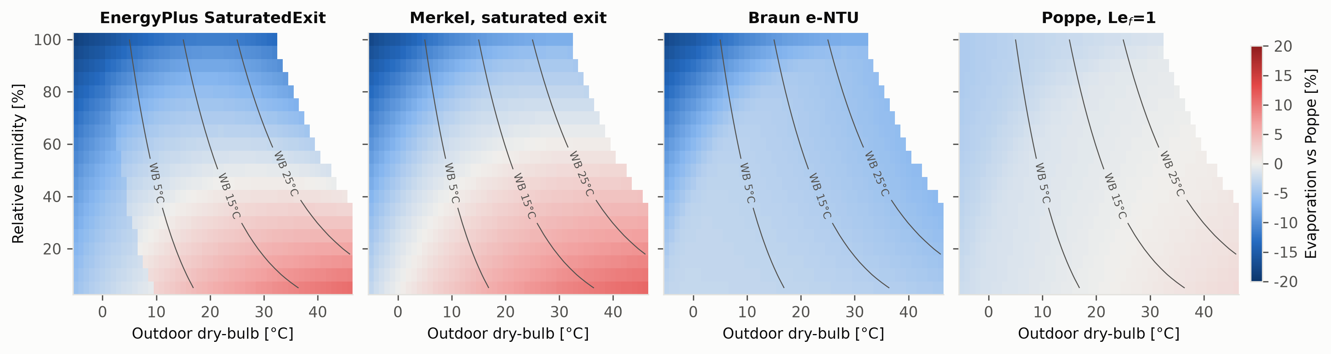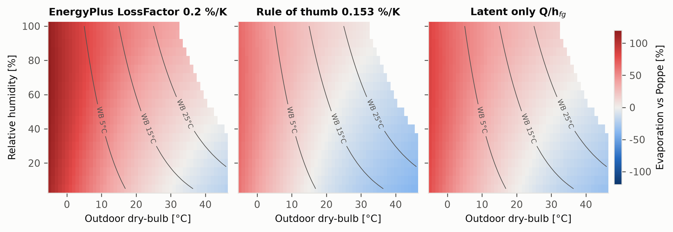
Figure 3. Evaporation of each model relative to Poppe for a fixed tower at full load (top: $±$20 % scale; bottom: $±$120 %). Lines: outdoor wet-bulb. Blank: wet-bulb above 32 °C (not simulated). The step in the EnergyPlus panel follows the 0 °C wet-bulb line, where EnergyPlus switches its saturation-pressure formula from ice to water.
Saturated-exit models differ from Poppe by -19 to +11 % (EnergyPlus’ formulation -18.5 to +10.5 %, Merkel -17.5 to +11.0 %). The sign follows the exhaust state predicted by Poppe. In hot, dry air the Poppe exhaust is unsaturated, so a model that forces it to saturation adds water that does not evaporate, and saturated-exit models overpredict. In cold, humid air the Poppe exhaust is supersaturated and carries liquid mist, which a saturated exhaust cannot hold, and they underpredict. The Braun model gives 2.8–6.2 % less than Poppe where it can represent the exhaust state, and down to -18 % where it is limited to saturated exit. The Lewis factor alone changes evaporation by -4.2 to +1.8 %. Empirical models range from -39 to +117 %: they scale with the heat rejected or the range and ignore the sensible share of the heat transfer. The latent-heat bound, for example, ranges from -32 % in hot, dry air, where the air gives sensible heat to the water and more water evaporates than the heat rejected requires, to +84 % in cold air, where much of the heat leaves as sensible heat.
The exhaust state also depends on the tower’s operating point. At a given inlet state, more air per unit of water (a lower $L/G$) leaves the exhaust further from saturation, which favours overprediction by saturated-exit models; less air brings it closer to saturation or into supersaturation, which favours underprediction. At 40 °C and 21 °C wet-bulb with the map’s approach and range, the EnergyPlus formulation gives 2 % more evaporation than Poppe at $L/G=1.2$ but 5 % less at $L/G=1.64$. The annual results below follow directly from where each building’s tower operates in this space.

6.3 Annual evaporation by building, tower control and climate
Table 7 and Fig. 4 compare the three buildings. The difference between the EnergyPlus default and Poppe changes sign between them. For the variable-speed data center it is negative at every site, -3.7 % (Phoenix) to -9.3 % (Montreal, Stockholm). For the office it ranges from -4.7 % (Singapore) to +15.9 % (Las Vegas), and for the data center prototype from +2.4 % (Singapore) to +37.5 % (Riyadh). Within each building the ranking of the climates is the same, from the largest overprediction in hot–dry climates (Riyadh, Las Vegas, Phoenix, Madrid) to the smallest, or to underprediction, in hot–humid (Singapore, Mumbai, Houston) and cold climates (Stockholm, Montreal).
The Merkel saturated-exit model (MSAT), which uses the physical air flow of each state, shows the physics alone. It is -2.2 to -7.3 % for the variable-speed tower and -1.9 to +16.0 % for the two single-speed towers. The reason is the air-to-water ratio. The variable-speed tower slows its fan at part load and runs at a median $L/G$ of 1.4–2.5, with exhaust close to or beyond saturation; the single-speed towers run at their design $L/G$ of about 1.2–1.4 whenever the fan is on, so in hot, dry air their exhaust leaves unsaturated (Section 6.2). The Braun model is 1.1–7.3 % below Poppe in all three buildings, and the Lewis factor alone accounts for -2.1 to +4.5 %.
Evaporation per unit heat rejected (Poppe) is 1.04–2.13 L/kWh$​_{th}$ for the data center prototype, 1.42–2.76 L/kWh$​_{th}$ for the office and 1.05–1.65 L/kWh$​_{th}$ for the variable-speed data center, against about 1.48 L/kWh$​_{th}$ if all heat left as latent heat. The office evaporates the most per unit heat in dry climates because its tower runs at full air flow at part load and also cools the hot outdoor air, whose sensible heat is added to the evaporation. Consequently, the empirical rules, which scale with heat or range, are wrong in a building-dependent way: the 0.2 %/K loss factor deviates from Poppe by -19 to +65 % for the data center prototype and -38 to +22 % for the office, and the rule of thumb by -38 to +26 % and -52 to -7 %.
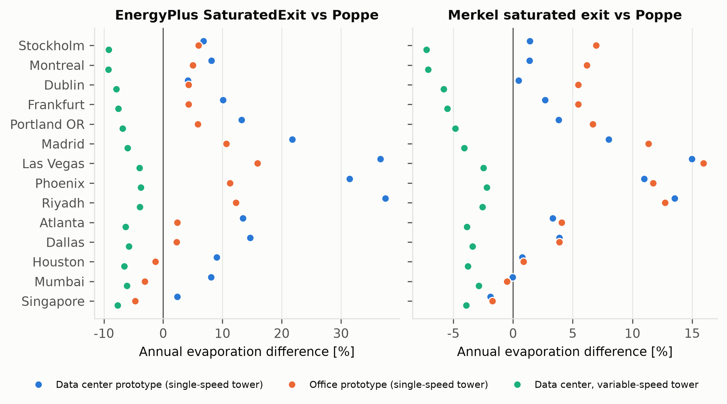
Figure 4. Annual evaporation of the EnergyPlus default (left) and of the Merkel saturated-exit model (right) relative to Poppe, for the three buildings in 14 climates (sites sorted by mean wet-bulb of the data center sites). The left panel contains the physics and EnergyPlus’ averaging of fan cycling; the right panel the physics only.
Table 7. Annual evaporation per heat rejected with Poppe (L/kWh$​_{th}$) and annual evaporation of the EnergyPlus default (EPSAT) and of the Merkel saturated-exit model (MSAT) relative to Poppe [%], by building and site (sorted by mean wet-bulb; CZ: ASHRAE climate zone). VS: variable speed.
 |  | Data center prototype |  |  | Office prototype |  |  | Data center, VS tower
3-5(lr)6-8(lr)9-11 Site | CZ | L/kWh$​_{th}$ | EPSAT | MSAT | L/kWh$​_{th}$ | EPSAT | MSAT | L/kWh$​_{th}$ | EPSAT | MSAT
Stockholm | 6A | 1.04 | +6.8 | +1.4 | 1.71 | +6.0 | +7.0 | 1.05 | -9.2 | -7.3
Montreal | 6A | 1.08 | +8.2 | +1.4 | 1.80 | +5.0 | +6.2 | 1.09 | -9.3 | -7.1
Dublin | 5A | 1.05 | +4.1 | +0.5 | 1.53 | +4.3 | +5.5 | 1.05 | -7.9 | -5.8
Frankfurt | 4A | 1.17 | +10.1 | +2.7 | 1.72 | +4.3 | +5.5 | 1.11 | -7.6 | -5.5
Portland OR | 4C | 1.23 | +13.2 | +3.8 | 1.88 | +5.8 | +6.7 | 1.13 | -6.8 | -4.8
Madrid | 3B | 1.45 | +21.8 | +8.0 | 2.17 | +10.7 | +11.4 | 1.25 | -6.0 | -4.1
Las Vegas | 2B | 2.03 | +36.6 | +15.0 | 2.76 | +15.9 | +16.0 | 1.50 | -4.0 | -2.5
Phoenix | 1B | 1.95 | +31.4 | +11.0 | 2.58 | +11.3 | +11.7 | 1.54 | -3.8 | -2.2
Riyadh | 1B | 2.13 | +37.5 | +13.5 | 2.49 | +12.3 | +12.7 | 1.65 | -3.9 | -2.6
Atlanta | 3A | 1.32 | +13.4 | +3.3 | 1.66 | +2.4 | +4.1 | 1.22 | -6.3 | -3.9
Dallas | 2A | 1.41 | +14.7 | +3.9 | 1.74 | +2.3 | +3.9 | 1.27 | -5.8 | -3.4
Houston | 2A | 1.33 | +9.0 | +0.8 | 1.54 | -1.3 | +0.9 | 1.25 | -6.6 | -3.8
Mumbai | 0A | 1.45 | +8.1 | -0.0 | 1.51 | -3.1 | -0.5 | 1.35 | -6.1 | -2.9
Singapore | 0A | 1.36 | +2.4 | -1.9 | 1.42 | -4.7 | -1.7 | 1.30 | -7.7 | -3.9
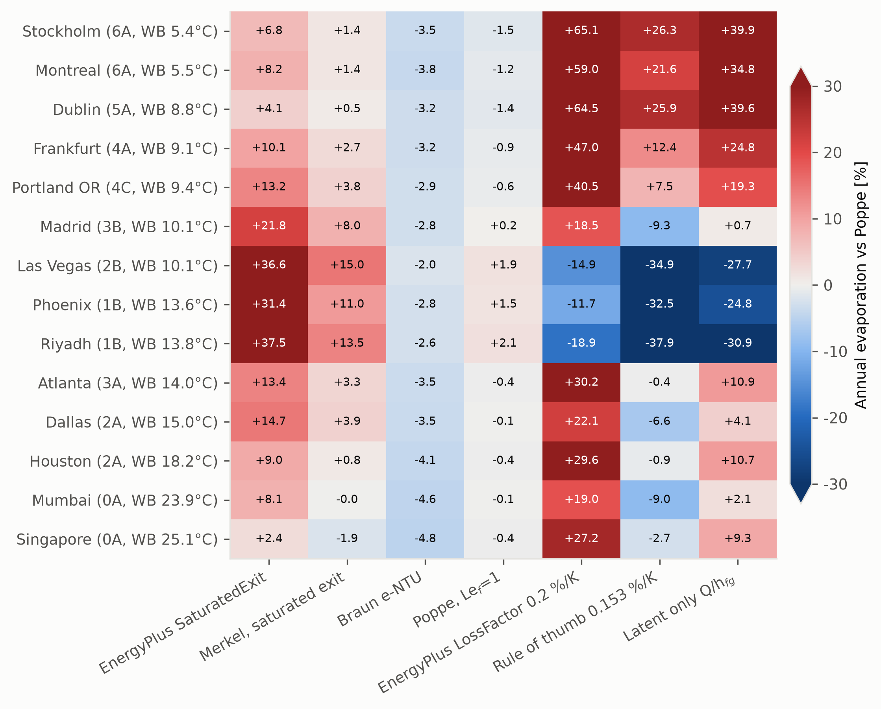
Figure 5. Annual evaporation of each model relative to Poppe (vapour and mist) for the data center prototype in 14 climates, sites sorted by mean wet-bulb. The colour scale is limited to $±$30 %; values are printed in each cell.

6.4 Averaging fan cycling over a timestep
The tower of the data center prototype cycles its fan in 96–99.9 % of all hours, with the fan on for 68–79 % of the time on average, because the integrated water-side economizer and the low condenser setpoint keep it working at part load all year. The office tower cycles in only 1–4 % of its operating hours. For the data center prototype the difference between the EnergyPlus default and Poppe splits into two parts. Applying the saturated-exit formula to each of the two states and time-weighting the result, instead of applying the average heat to the full air flow, lowers evaporation by 5.2–21.8 % of the Poppe value; this part is EnergyPlus’ averaging convention. The remaining saturated-exit physics contributes -5.1 to +14.2 %. For the office the averaging accounts for 0.6–2.1 % and the physics for -6.1 to +13.7 %. Averaging matters because, at the full air flow, the saturated-exit formula assumes the whole air stream is humidified to saturation even though the fan ran for only part of the timestep; in dry air this humidification of air that did not pass through the tower is large. Poppe itself is insensitive to how the timestep is represented: evaluating it once at the time-averaged air flow instead of at the two states changes annual evaporation by -1.5 to -0.2 %.

6.5 Vapour and liquid mist
In cold and mild climates Poppe predicts supersaturated exhaust in many hours. The liquid share of Poppe evaporation is 0.1–4.9 % for the variable-speed data center, largest at Stockholm, Montreal, Dublin and Frankfurt, but at most 1.5 % for the data center prototype and 0.1 % for the office, whose towers run with more air per unit water. Whether this mist is consumed depends on how much of it the drift eliminators capture and return to the basin, so vapour-only Poppe evaporation is a lower bound and total evaporation an upper bound. Against vapour-only Poppe the EnergyPlus default differs by -7.4 to -3.5 % (variable-speed data center), +2.5 to +37.5 % (data center prototype) and -4.7 to +15.9 % (office).

6.6 Seasonal and timestep pattern
Because the data center towers run all year, 57–62 % of their heat is rejected between October and April, and up to a quarter below 0 °C at Montreal; the office rejects 2–56 % of its heat in those months. At the timestep level the largest underpredictions of the EnergyPlus default occur below 0 °C, where Poppe exhaust is supersaturated, and the largest overpredictions in hot, dry hours (Fig. 7). Empirical models do not follow this climate signal (Fig. 6): the loss factor gives nearly the same evaporation in every month.
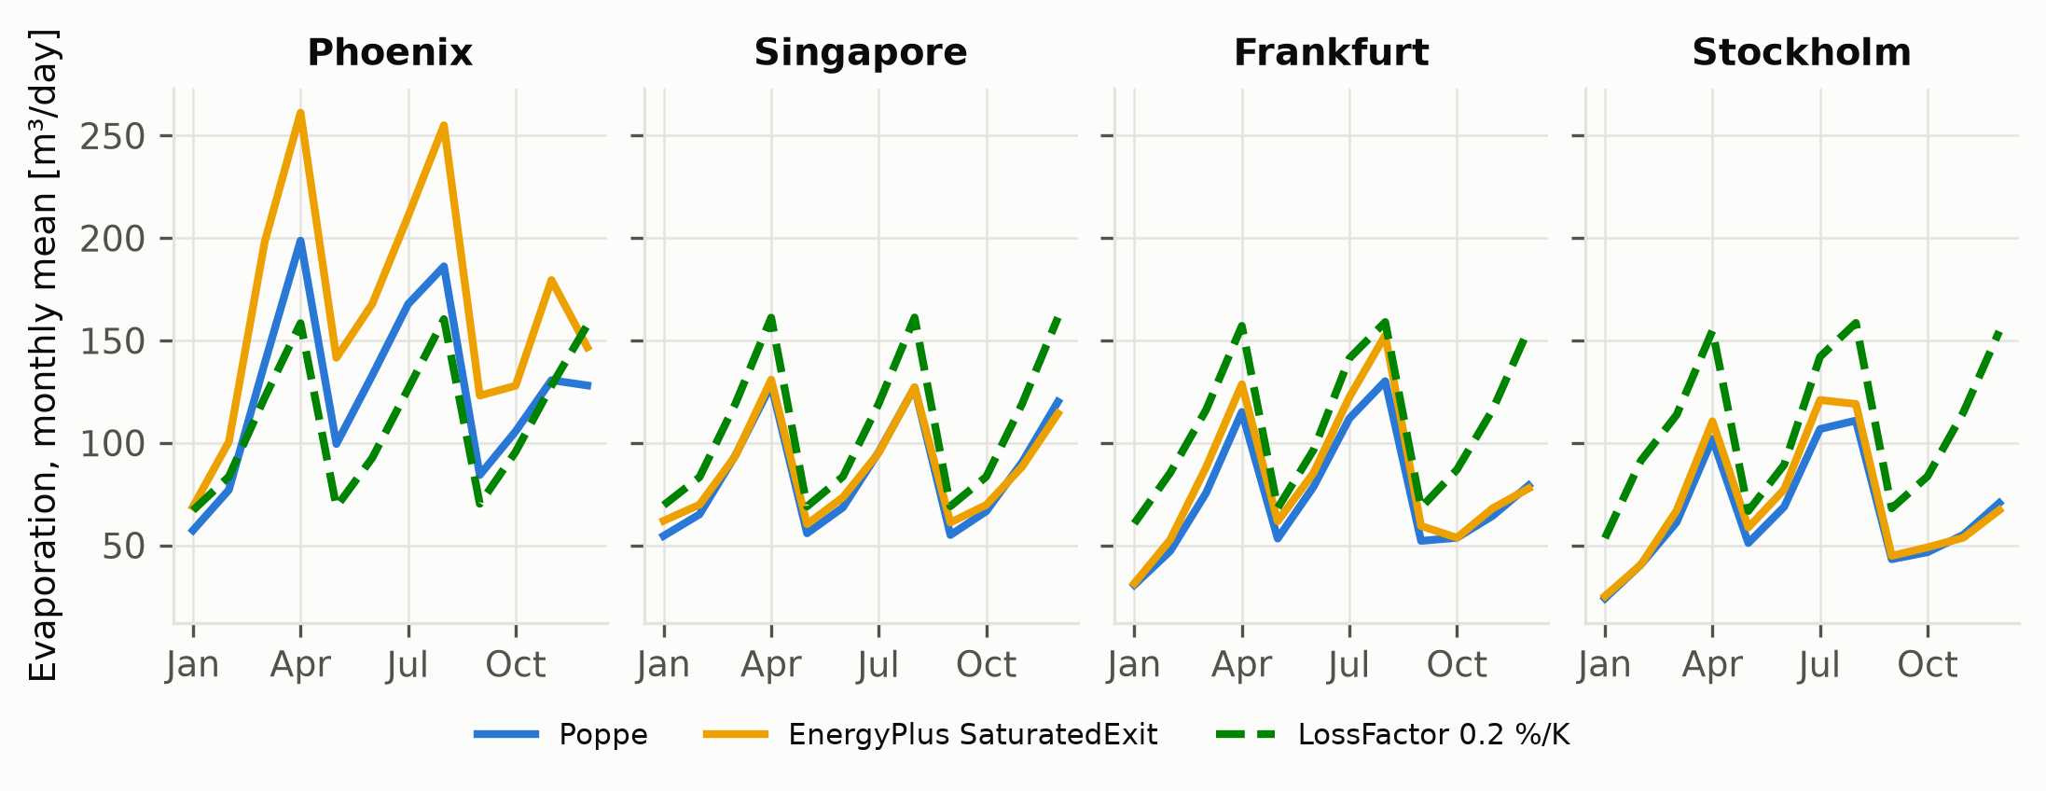
Figure 6. Monthly mean daily evaporation of the data center prototype: Poppe, EnergyPlus saturated exit and the 0.2 %/K loss factor.
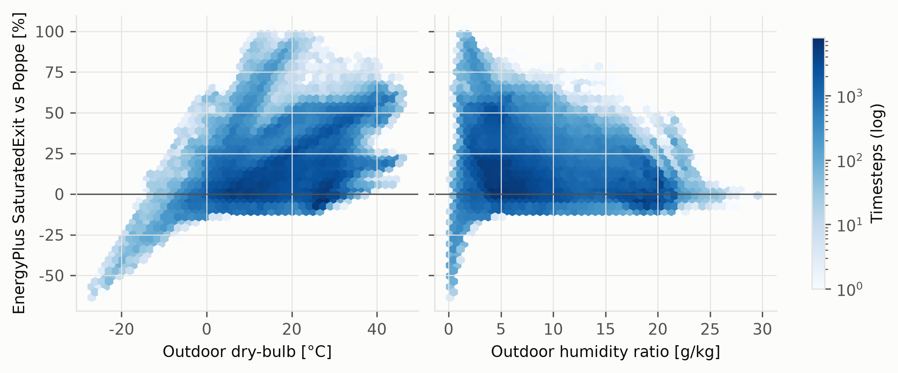
Figure 7. Timestep difference of the EnergyPlus default from Poppe (vapour and mist) against outdoor dry-bulb and humidity ratio, data center prototype, all 14 sites.

6.7 Dependence on the tower’s thermal operating point
Every model is evaluated at the air flow of EnergyPlus’ tower model (Section 3.1), so the results depend on how EnergyPlus sizes and operates the tower. This was tested on the variable-speed data center, whose tower is autosized for a 3.9 K approach at each site’s 0.4 % design wet-bulb with the condenser flow of three chillers (design $L/G$ 1.6–1.8). Where the design wet-bulb is 21 °C or lower (Dublin, Frankfurt, Madrid, Portland, Stockholm) this design point is itself close to the pinch, with design Merkel numbers of 5.4–7.6 against 1.5–3.3 elsewhere (Table 8); at these sites the near-pinch correction of Section 3.3 was needed in 66–100 % of hours, with a mean air-flow factor of 1.02–1.03, and elsewhere in fewer than 0.3 % of hours.
The tower was then replaced by one with an ordinary fill: a design $L/G$ of 1.0, 1.2 or 1.4 (design $Me_{P}$ 1.0–2.7) at the same design water flow and conditions, with $Me_{P}∝(L/G)^{−0.6}$. For every loaded hour the air flow that this tower needs to deliver EnergyPlus’ leaving-water temperature was solved with Poppe, so the heat rejected is unchanged and only the air flow differs; hours in which even the design air flow cannot reach that temperature are excluded (up to 14 % at Houston and Mumbai). The ordinary tower runs with 11–45 % more air (median, design $L/G$ 1.2), and its Poppe evaporation differs from the value at EnergyPlus’ air flow by -0.1 to +6.4 %, most at hot–dry sites. At its operating point the EnergyPlus formula differs from Poppe by -9.1 to -3.4 % at Stockholm, Montreal, Dublin, Frankfurt and Portland, by -6.0 to +3.0 % at Madrid and the warm–humid sites, and by -2.0 to +10.9 % at Phoenix, Las Vegas and Riyadh, where the sign depends on the design $L/G$. This is the same mechanism that separates the variable-speed and single-speed towers in Section 6.3: in cold and mild climates the underprediction is robust to the tower model, whereas in hot, dry climates the sign depends on the tower’s air-to-water ratio.
Table 8. Variable-speed data center: design point of the EnergyPlus tower and the ordinary-fill check (sites sorted by mean wet-bulb). $T_{wb,d}$: design wet-bulb; $Me_{P,d}$: Poppe Merkel number at the design point; corr.: share of loaded hours with the near-pinch air-flow correction; EP vs P: EnergyPlus saturated exit vs Poppe annual evaporation. Ordinary fill: design $L/G$ = 1.2, and range over design $L/G$ = 1.0–1.4; P shift: Poppe evaporation with the ordinary fill vs EnergyPlus’ air flow; capped: hours excluded because the ordinary tower cannot reach EnergyPlus’ leaving-water temperature.
 | EnergyPlus tower (base plant) |  |  |  | Ordinary fill, design $L/G$ = 1.0–1.4
2-5(lr)6-10 Site | $T_{wb,d}$ | $Me_{P,d}$ | corr. | EP vs P | $Me_{P,d}$ | EP vs P | EP vs P | P shift | capped
 | [°C] |  | [% h] | [%] | ($L/G$=1.2) | ($L/G$=1.2) [%] | range [%] | [%] | [% h]
Stockholm | 20.0 | 7.6 | 100 | -9.3 | 2.05 | -8.9 | -9.1 to -8.5 | +0.3 | 0.0
Montreal | 23.5 | 2.8 | 0 | -9.3 | 1.51 | -7.9 | -8.6 to -6.6 | +0.5 | 0.1
Dublin | 20.0 | 7.2 | 99 | -7.9 | 2.07 | -7.7 | -7.8 to -7.3 | -0.0 | 0.0
Frankfurt | 21.0 | 6.5 | 66 | -7.6 | 1.85 | -6.5 | -7.2 to -5.1 | +1.0 | 0.0
Portland OR | 20.8 | 7.2 | 95 | -6.8 | 1.87 | -5.3 | -6.2 to -3.4 | +1.5 | 0.0
Madrid | 20.0 | 5.4 | 66 | -6.0 | 2.01 | -4.0 | -5.4 to -1.3 | +2.4 | 0.0
Las Vegas | 22.5 | 2.7 | 0 | -4.0 | 1.60 | +1.5 | -2.0 to +7.1 | +3.2 | 0.0
Phoenix | 24.1 | 2.4 | 0 | -3.7 | 1.42 | +4.0 | -0.4 to +10.9 | +3.4 | 0.3
Riyadh | 21.8 | 3.3 | 0 | -3.9 | 1.69 | +2.5 | -1.6 to +9.5 | +4.9 | 0.0
Atlanta | 25.1 | 2.0 | 0 | -6.3 | 1.33 | -3.4 | -5.0 to -0.7 | +1.1 | 2.7
Dallas | 25.8 | 2.0 | 0 | -5.8 | 1.26 | -1.6 | -3.9 to +2.0 | +1.5 | 8.5
Houston | 26.8 | 1.8 | 0 | -6.7 | 1.17 | -3.2 | -5.1 to -0.3 | +1.1 | 13.1
Mumbai | 28.4 | 1.5 | 0 | -6.3 | 1.05 | -0.9 | -3.5 to +3.0 | +1.4 | 13.8
Singapore | 28.0 | 1.6 | 0 | -7.9 | 1.08 | -4.4 | -6.0 to -1.8 | +1.0 | 1.7

6.8 Sensitivity
For the variable-speed data center, sizing the tower for the two duty chillers instead of all three or lowering the condenser floor to 15 °C changes the EnergyPlus–Poppe difference by up to 1.1 percentage points (Table 9). A plant built from the specifications of chillers and towers common in data centers (supplementary file https://github.com/TensorBuildLab/EnergyPlus-HeatRejection-Water/blob/main/docs/EQUIPMENT_SPECS.md; 15.5 °C chilled water, ASHRAE 90.1 centrifugal-chiller curves [58], a 15.5 °C condenser floor, a tower heat-transfer coefficient that scales with the air- and water-flow ratios to the powers 0.7 and 0.58, fitted to the fill data of Kloppers [52], a 0.25 minimum fan speed and 50 % cell turndown) gives -8.4 to -2.5 %, 0.4–1.2 points smaller than the base plant. Plant variants of the same tower type therefore preserve the sign and the ranking of the sites; changing the tower’s air-to-water ratio, through an ordinary fill or a single-speed tower, does not at hot–dry sites. Fill exponents of 0.5, 0.6 and 0.78 change evaporation per unit heat by at most 0.17 % in a fixed-fill rating check at EnergyPlus’ operating points. Over the documented loss-factor range (0.15–0.27 %/K) the loss-factor estimate spans -22 to +122 % of Poppe across sites. Drift (0.001 %) is below 0.2 % of makeup in all cases. Weather-year variability was not studied; a single typical year per site was used.
Table 9. Variable-speed data center: EnergyPlus saturated exit vs Poppe annual evaporation [%] for plant variants. $​^{a}$15.5 °C chilled water and condenser floor, ASHRAE 90.1 chiller curves, fill-data heat-transfer curves, 0.25 minimum fan speed, 50 % cell turndown. $​^{b}$Same simulations as the base plant, tower replaced by an ordinary fill (Section 6.7); hours the ordinary tower cannot meet are excluded. Variants with “–” were run only at the four sites shown.
Plant variant | Phoenix | Singapore | Frankfurt | Stockholm | All sites ($n$)
Base (tower for 3 chillers, 18 °C floor) | -3.7 | -7.9 | -7.6 | -9.3 | -9.3 to -3.7 (14)
Tower sized for duty (2 chillers) | -4.4 | -8.4 | -7.7 | -9.3 | –
Condenser floor 15 °C | -3.1 | -7.9 | -6.6 | -8.2 | –
Both | -4.1 | -8.4 | -6.9 | -8.4 | –
Equipment-informed plant$​^{a}$ | -2.5 | -7.5 | -6.7 | -8.3 | -8.4 to -2.5 (14)
Ordinary fill, design $L/G$ = 1.2$​^{b}$ | +4.0 | -4.4 | -6.5 | -8.9 | -8.9 to +4.0 (14)

6.9 Makeup-water quality and water usage effectiveness
At four cycles, the WUE of the data center prototype is 1.93–4.08 L/kWh$​_{IT}$ with Poppe evaporation and 2.03–5.62 L/kWh$​_{IT}$ with the EnergyPlus default; for the variable-speed data center it is 1.72–2.74 and 1.57–2.63 L/kWh$​_{IT}$. With each site’s own makeup water the allowable cycles, and hence blowdown, differ widely (Table 10, Fig. 8). Soft supplies (Atlanta, Portland, Madrid, Singapore, Dublin, Stockholm) reach 5.7–10 cycles; at Atlanta, Portland and Madrid every limit set reaches the model’s 10-cycle cap (-17 %), partly because sulfate, chloride or silica data are missing, so these results reflect the cap rather than the chemistry. Supplies with moderate alkalinity (Dallas, Houston, Montreal, Mumbai) are limited by alkalinity unless acid is fed (-14 to +3 % without capped cases). Frankfurt’s hard water allows 2.3–4.7 cycles (-4 to +31 %) and Riyadh’s chloride 2.1–4.1 cycles (-1 to +44 %). Colorado River water at Phoenix and Las Vegas already carries 210–240 mg/L sulfate, so the 250 mg/L sulfate limits of two galvanized-steel sets allow about one cycle, which the model raises to its 1.5-cycle floor (+125 %); such sites use stainless steel, acid feed or side-stream treatment, and the other three sets give 2.5–3.3 cycles (+7 to +25 %). Excluding cases at the cap or floor, site water changes makeup by -16 to +44 % relative to four cycles. This is comparable to the evaporation-model effect, and the two multiply: the cycles of concentration are an operating set-point, so site cycles, or the water quality and treatment program behind them, should be reported with any simulated WUE. Soft, low-alkalinity waters are in practice limited by corrosion, which the model does not represent, so their high-cycle results are optimistic. Data confidence is low for Atlanta, Madrid and Mumbai and low to medium for Dallas.
Table 10. Data center prototype: site makeup water and cycles of concentration. Data: confidence of the water-quality data (H high, M medium, L low); $​^{†}$sulfate, chloride or silica missing (treated as non-limiting). $N_{c,eff}$: effective annual cycles $E/(B+D_{r})+1$, range over the five limit sets. $Δ$WUE: Poppe makeup per IT energy relative to four cycles, over all sets ($​^{c}$lower end at the 10-cycle cap; $​^{f}$upper end at the 1.5-cycle floor) and over the sets at neither bound (“–”: none). “min.”: raised to the 1.5-cycle minimum.
Site | Ca | Alk. | SO$​_{4}$ | Cl | Data | $N_{c,eff}$ | Limit (lowest $N_{c}$) | WUE$​_{N=4}$ | $Δ$WUE, all sets | $Δ$WUE, unclamped
 | [mg/L; Ca, Alk. as CaCO$​_{3}$] |  |  |  |  |  |  | [L/kWh] | [%] | [%]
Atlanta | 8 | 12 | 4 | 3 | L | 10.0–10.0 | cap (10) | 2.47 | -17$​^{c}$ to -17 | –
Dallas | 105 | 110 | 33 | 20 | L–M | 3.6–7.6 | alkalinity | 2.66 | -14 to +3 | -14 to +3
Dublin | 47 | 28 | 35 | 25 | M$​^{†}$ | 7.1–10.0 | sulfate | 1.95 | -17$​^{c}$ to -13 | -13 to -13
Frankfurt | 170 | 171 | 45 | 22 | M | 2.3–4.7 | alkalinity | 2.20 | -4 to +31 | -4 to +31
Houston | 97 | 95 | 21 | 38 | M | 4.2–7.8 | alkalinity | 2.52 | -14 to -2 | -14 to -2
Las Vegas | 187 | 112 | 209 | 99 | H | 1.5–3.2 | sulfate (min.) | 3.80 | +9 to +125$​^{f}$ | +9 to +21
Madrid | 40 | 40 | – | – | L$​^{†}$ | 10.0–10.0 | cap (10) | 2.74 | -17$​^{c}$ to -17 | –
Montreal | 77 | 93 | 22 | 26 | H | 4.3–10.0 | alkalinity | 2.00 | -17$​^{c}$ to -2 | -11 to -2
Mumbai | 35 | 97 | – | 10 | L$​^{†}$ | 4.1–10.0 | alkalinity | 2.70 | -17$​^{c}$ to -1 | -10 to -1
Phoenix | 188 | 132 | 239 | 90 | M–H | 1.5–3.3 | sulfate (min.) | 3.72 | +7 to +125$​^{f}$ | +7 to +25
Portland OR | 5 | 29 | – | – | H$​^{†}$ | 10.0–10.0 | cap (10) | 2.30 | -17$​^{c}$ to -17 | –
Riyadh | 146 | 80 | 88 | 120 | M$​^{†}$ | 2.1–4.1 | chloride | 4.08 | -1 to +44 | -1 to +44
Singapore | 39 | 35 | 7 | 30 | H | 8.3–10.0 | chloride | 2.52 | -17$​^{c}$ to -15 | -15 to -15
Stockholm | 65 | 45 | 44 | 16 | M–H$​^{†}$ | 5.7–10.0 | sulfate | 1.93 | -17$​^{c}$ to -9 | -16 to -9
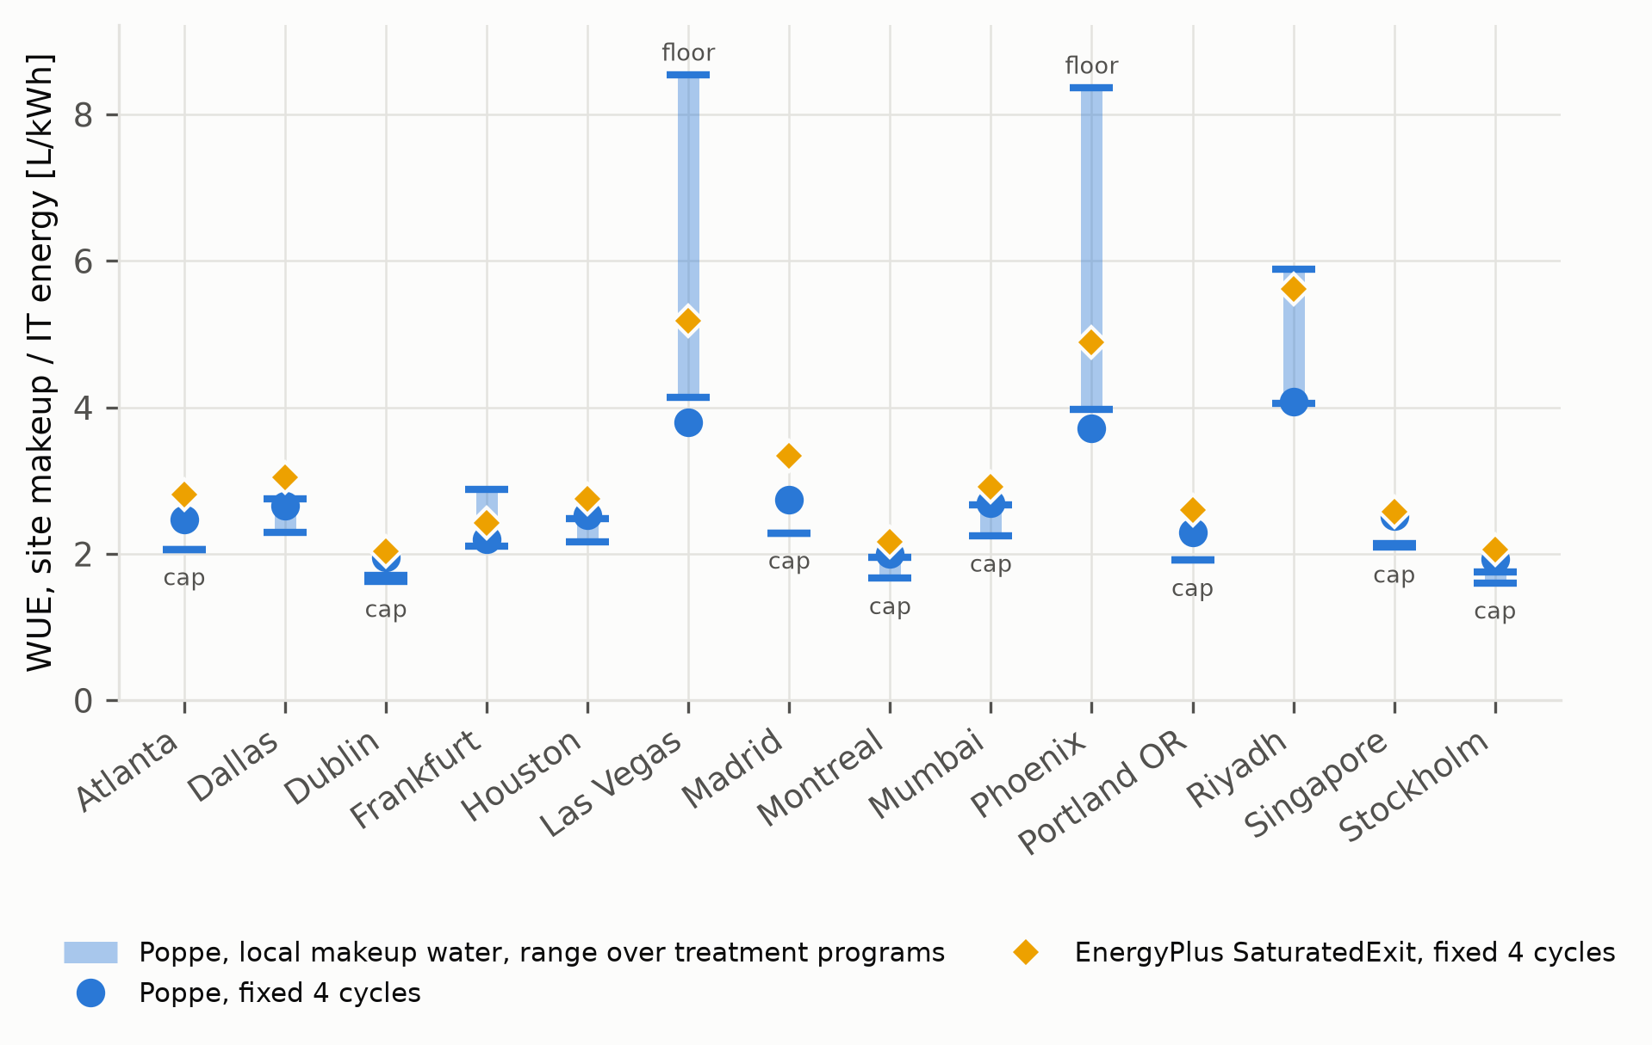
Figure 8. WUE of the data center prototype by climate. Diamonds: EnergyPlus default (saturated exit, 4 cycles). Circles: Poppe, 4 cycles. Bars: Poppe with each site’s makeup water, range over five treatment limit sets; “cap” and “floor” mark range ends set by the model’s 10-cycle cap or 1.5-cycle floor.

7 Discussion

7.1 What determines the error of simplified models
The results reduce to one physical statement: the error of a simplified evaporation model is set by the state of the air leaving the tower, and that state is set jointly by the weather and by how much air the tower moves per unit of water. Climate alone does not determine the sign. The same hot, dry climate gives a 4 % underprediction for a variable-speed tower that slows its fan and a 37 % overprediction for a single-speed tower that cycles at full air flow. For a building model this means that the tower’s part-load control and sizing are as important for the water estimate as the evaporation model itself, and that a correction factor derived for one tower type or climate does not transfer to another.

7.2 Which model to use
For annual totals in cold and mild climates, saturated-exit and e-NTU models are within about 10 % of Poppe and consistently lower for variable-speed towers. In hot, dry climates, and for any fan-cycling tower, their error can exceed 30 % and its sign depends on the tower, so neither under- nor overestimation can be assumed; a model that resolves the exhaust state, such as Poppe, and a timestep representation that resolves fan cycling are needed. At the timestep level the differences are largest in freezing and in hot, dry weather, so hourly and peak water estimates need the full model. Loss-factor and rule-of-thumb estimates scale with heat or range, deviate from Poppe by up to 65 % in either direction depending on building and climate, and do not follow the seasonal signal; they should not be used for siting or permitting. Because the mist share depends on drift eliminators, reporting vapour-only and total Poppe evaporation as a range is recommended.

7.3 Recommendations for data center water modeling
Data centers are the case in which the choice of model matters most, because their towers reject heat in every hour, 57–62 % of it between October and April, and economizers keep them at part load for most of the year. The results lead to six recommendations. (i) For a fan-cycling tower, such as that of the LBNL/DOE prototype and of many plants with water-side economizers, the EnergyPlus default should not be used for water estimates: it exceeded Poppe by 2 to 38 %, largely because of its averaging of fan cycling. Poppe, evaluated at the fan-on and free-convection states, is needed; a saturated-exit model evaluated at the two states removes the averaging part of the error but not the physics part. (ii) For a variable-speed tower in a cold or mild climate, the saturated-exit and e-NTU models give annual totals within 10 % of Poppe and consistently below it, which is acceptable for early-stage estimates if this bias is stated. (iii) Comparisons of WUE across sites, siting decisions and the choice between air-cooled, hybrid and evaporative heat rejection should use Poppe, because the error of the simplified models changes by tens of percentage points between climates and can change the ranking of sites. (iv) Hourly and peak water demand, which determine the size of the water connection and the exposure to drought restrictions, should use Poppe, since the largest timestep differences occur in freezing and in hot, dry hours. (v) Loss-factor and rule-of-thumb estimates should not be used for data centers: they differed from Poppe by up to 65 % and do not follow the seasonal pattern of year-round operation. (vi) Simulated WUE should be reported with the evaporation model, the tower control and the cycles of concentration or the makeup-water quality and treatment program assumed, since site water alone changed makeup by -16 to +44 %.

7.4 Beyond data centers and beyond EnergyPlus
The physics is not specific to data centers. What distinguishes the building types is when and how the tower operates: the data centers reject heat in every hour, including the freezing and humid hours in which saturated-exit models underpredict, and the prototype’s economizer keeps the tower at part load all year; the office tower runs mainly in warm weather at full air flow. The same reasoning applies to hospitals, laboratories, district plants and industrial process cooling, whose operating patterns lie between these cases. The method of evaluating all models at the simulated operating point, with fan cycling resolved into its states, applies to any simulation program that reports the tower’s operating point, and the open-source implementation can be used directly with existing EnergyPlus models, including the prototype buildings used in code development and in national building-stock studies.

8 Conclusions
This study asked how much the choice of evaporation model changes the simulated water use of cooling towers, why, and what this means for data centers. Eight models, from empirical rules to the Poppe model, were evaluated at the same simulated operating point in every timestep, with the fan-on and free-convection states of fan-cycling towers resolved, in an open-source EnergyPlus plugin. The implementation was verified against an independent solution and 126 measured fill tests and applied to the LBNL/DOE large data center prototype, a data center with a variable-speed tower and the DOE large office prototype in 14 climates.
The error of simplified models follows the state of the exhaust air. Saturated-exit models overpredict where hot, dry air leaves the fill unsaturated and underpredict where cold air leaves it supersaturated; for a fixed tower at full load they differ from Poppe by -19 to +11 %, and empirical rules by -39 to +117 %. Which regime dominates in a building is decided by the tower’s air-to-water ratio, that is, by its part-load control. In the 14 climates the EnergyPlus default differs from Poppe by -9 to -4 % for the variable-speed tower, -5 to +16 % for the office prototype and +2 to +38 % for the data center prototype. For fan-cycling towers, applying the timestep-average heat to the full air flow, as EnergyPlus does, adds 5 to 22 % of the Poppe value to the evaporation of the data center prototype; resolving the two states removes this, and Poppe itself is insensitive to how the timestep is represented. The Poppe implementation agrees with the independent solution within 0.01 % and reproduces the measured outlet-air temperatures of the fill tests better than saturated-exit analyses (0.84 against 1.10 K root-mean-square error). With each site’s own makeup water, cycles of concentration set by sourced treatment limits change makeup by -16 to +44 % relative to four cycles, an effect of the same order as the choice of evaporation model.
For practice, the results mean that data center water estimates used for design, siting, permitting and the choice between air-cooled and evaporative heat rejection should use a model that resolves the exhaust-air state and the part-load operation of the tower, such as Poppe, and should be reported together with the tower control and the cycles of concentration assumed. Simplified saturated-exit models are adequate for annual totals of variable-speed towers in cold and mild climates if their bias of up to -10 % is stated, whereas loss factors and rules of thumb should not be used for data centers. Because the plugin works with existing EnergyPlus models, including the prototype buildings used in code development and building-stock studies, these estimates can be obtained without changing the thermal model.
The study has limitations. All models are evaluated at the thermal operating point of EnergyPlus’ tower models; with an ordinary fill, Poppe evaporation for the same heat and leaving-water temperature differs from that value by up to 6.4 % at hot, dry sites. The fill tests measured outlet-air temperature rather than evaporation and covered only mild inlet air with supersaturated exhaust, so the case-study comparisons are model to model, with Poppe as the most complete model rather than ground truth. The prototypes were used as published, with one envelope for all sites and the office’s unreachable condenser setpoint, and one typical weather year was used per site. Makeup-water data are of low confidence at four sites and incomplete at five; corrosion limits are not modelled; cycles are assumed to follow the water temperature instantly; and the recirculating pH without acid feed is assumed.
Future work should therefore compare the models with metered makeup and blowdown of operating data center towers, in particular in hot, dry and in freezing climates; couple a tower model with a Poppe thermal solution and a characterised fill to the building simulation; and extend the analysis to multi-year and future weather, to corrosion-limited water treatment and to hybrid and air-cooled heat rejection, so that the long-term water and energy consequences of the cooling system chosen for a new data center can be compared on a consistent basis.

CRediT authorship contribution statement
Liang Zhang: Conceptualization, Methodology, Software, Validation, Formal analysis, Investigation, Data curation, Visualization, Writing – original draft, Writing – review & editing, Funding acquisition.

Declaration of competing interest
The author declares no known competing financial interests or personal relationships that could have appeared to influence the work reported in this paper.

Declaration of generative AI and AI-assisted technologies in the manuscript preparation process
During the preparation of this work the author used Claude (Anthropic) in order to assist with software development, data analysis scripts, literature and reference checking, and drafting and language editing of the manuscript. After using this tool, the author reviewed and edited the content as needed and takes full responsibility for the content of the published article.

Acknowledgements
This material is based upon work supported by the U.S. National Science Foundation under Award No. 2623038. Any opinions, findings, and conclusions or recommendations expressed in this material are those of the author and do not necessarily reflect the views of the National Science Foundation.

Data availability
The plugin, a tutorial, the building models, weather metadata, makeup-water data, run archive and the scripts that reproduce every figure and table are openly available at https://github.com/TensorBuildLab/EnergyPlus-HeatRejection-Water under the MIT licence; reproduce.sh regenerates all results with EnergyPlus 22.2.0. Implementation issues in EnergyPlus’ tower water accounting found during this work are documented, with reproductions, in the repository (https://github.com/TensorBuildLab/EnergyPlus-HeatRejection-Water/tree/main/bugreports).

Appendix A. Plugin code
The plugin is a Python class derived from EnergyPlus’ EnergyPlusPlugin. EnergyPlus calls its method on_end_of_system_timestep_before_hvac_reporting at the end of every system timestep. The method reads the tower and weather output variables through the EnergyPlus application programming interface, evaluates the models and writes the results to plugin variables, which EnergyPlus reports like its own output variables. The listing below is abridged from src/tower_water/eplus_plugin.py in the repository (error handling, the handle look-up and the model evaluation in compute_tower are omitted).
from pyenergyplus.plugin import EnergyPlusPlugin
class TowerWaterPlugin(EnergyPlusPlugin):
CONFIG_PATH = None # set by tools/prepare_model.py
def __init__(self):
super().__init__()
with open(self.CONFIG_PATH) as fh:
self.cfg = json.load(fh) # towers, design flows, water, treatment
self.towers = [setup_tower(t, self.cfg) for t in self.cfg["towers"]]
self.ready = False
def on_end_of_system_timestep_before_hvac_reporting(self, state):
x = self.api.exchange
if not self.ready: # look up variable handles once
if not x.api_data_fully_ready(state):
return 0
self._get_handles(state)
self.ready = True
site = {k: x.get_variable_value(state, h)
for k, h in self.site.items()} # dry-bulb, wet-bulb, w, p
dt_s = x.system_time_step(state) * 3600.0
for t in self.towers:
v = {k: x.get_variable_value(state, h) # temperatures, flow,
for k, h in t["_in"].items()} # heat, fan state
out = compute_tower(t, v, site, self.cfg, self.methods)
out["MakeupVol"] = out["Makeup"] * dt_s
for name, h in t["_out"].items(): # E_POPPE, Makeup, ...
x.set_global_value(state, h, out[name])
return 0
The preparation step adds input objects of the following form to the EnergyPlus model (shortened; CT1 stands for the tower name, and one PythonPlugin:OutputVariable is written for every output of Table 6):
PythonPlugin:SearchPaths, TowerWater Paths, Yes, Yes, No,
<repository>/src, <run directory>;
PythonPlugin:Instance, TowerWater, No,
tower_water_model_plugin, ModelTowerWater;
PythonPlugin:Variables, TowerWater Vars 1,
CT1_E_LAT, CT1_E_ROT, CT1_E_LF, CT1_E_EPSAT, CT1_E_MSAT,
CT1_E_BRAUN, CT1_E_POPPE, CT1_E_POPPE1, CT1_Drift, CT1_Blowdown;
PythonPlugin:OutputVariable, CT1_E_POPPE, CT1_E_POPPE,
Averaged, SystemTimestep, m3/s;
Output:Variable, CT1_E_POPPE, PythonPlugin:OutputVariable, Timestep;

References
[1] U.S. Environmental Protection Agency, WaterSense at work: Best management practices for commercial and institutional facilities, U.S. EPA Office of Wastewater Management, Washington, DC, 2012.
[2] D. Mytton, Data centre water consumption, Npj Clean Water 4 (2021) 11. https://doi.org/10.1038/s41545-021-00101-w.
[3] A. Shehabi, S.J. Smith, D.A. Sartor, R.E. Brown, M. Herrlin, J.G. Koomey, E.R. Masanet, N. Horner, I.L. Azevedo, W. Lintner, United states data center energy usage report, Lawrence Berkeley National Laboratory, Berkeley, CA, 2016. https://doi.org/10.2172/1372902.
[4] A. Shehabi, S.J. Smith, A. Hubbard, A. Newkirk, N. Lei, M.A.B. Siddik, B. Holecek, J.G. Koomey, E.R. Masanet, D.A. Sartor, 2024 united states data center energy usage report, Lawrence Berkeley National Laboratory, Berkeley, CA, 2024. https://doi.org/10.71468/P1WC7Q.
[5] M.A.B. Siddik, A. Shehabi, L. Marston, The environmental footprint of data centers in the United States, Environmental Research Letters 16 (2021) 064017. https://doi.org/10.1088/1748-9326/abfba1.
[6] The Green Grid, Water usage effectiveness (WUE): A green grid data center sustainability metric, The Green Grid, 2011.
[7] N. Lei, E. Masanet, Climate- and technology-specific PUE and WUE estimations for U.S. Data centers using a hybrid statistical and thermodynamics-based approach, Resources, Conservation and Recycling 182 (2022) 106323. https://doi.org/10.1016/j.resconrec.2022.106323.
[8] B. Ristić, K. Madani, Z. Makuch, The water footprint of data centers, Sustainability 7 (2015) 11260–11284. https://doi.org/10.3390/su70811260.
[9] P. Li, J. Yang, M.A. Islam, S. Ren, Making AI less “thirsty,” Communications of the ACM 68 (2025) 54–61. https://doi.org/10.1145/3724499.
[10] L. Karimi, L. Yacuel, J. Degraft-Johnson, J. Ashby, M. Green, M. Renner, A. Bergman, R. Norwood, K.L. Hickenbottom, Water-energy tradeoffs in data centers: A case study in hot-arid climates, Resources, Conservation and Recycling 181 (2022) 106194. https://doi.org/10.1016/j.resconrec.2022.106194.
[11] L. Karimi, R. Shinh, C. Laisure-Pool, M. Green, L. Yacuel, J. Ashby, K.L. Hickenbottom, Energy and water dynamics in data center cooling: Insights from a modeling study in hot-arid climates, Applied Thermal Engineering 276 (2025) 126802. https://doi.org/10.1016/j.applthermaleng.2025.126802.
[12] U.S. Bureau of Reclamation, Reclamation announces 2022 operating conditions for Lake Powell and Lake Mead: Historic drought impacting entire Colorado River basin, (2021). https://www.usbr.gov/newsroom/news-release/3950.
[13] U.S. Bureau of Reclamation, Interior department announces actions to protect Colorado River system, sets 2023 operating conditions for Lake Powell and Lake Mead, (2022). https://www.usbr.gov/newsroom/news-release/4294.
[14] Office of the Arizona Governor, Governor Hobbs unveils 100-year study to protect Valley groundwater supplies and announces $40 million investment in Arizona water resiliency fund, (2023). https://azgovernor.gov/node/6097.
[15] Kyl Center for Water Policy at Morrison Institute, New Phoenix AMA model shows limits of groundwater as an assured water supply, (2023). https://morrisoninstitute.asu.edu/sites/default/files/kyl_center_phoenix_ama_groundwater_model_explainer_062023.pdf.
[16] ASHRAE, Owning and operating costs, in: 2015 ASHRAE Handbook—HVAC Applications, ASHRAE, Atlanta, GA, 2015.
[17] O. Van Geet, D. Sickinger, Best practices guide for energy-efficient data center design, National Renewable Energy Laboratory for the U.S. Department of Energy Federal Energy Management Program, Golden, CO, 2024. https://www.energy.gov/sites/default/files/2024-07/best-practice-guide-data-center-design.pdf.
[18] D.B. Crawley, L.K. Lawrie, F.C. Winkelmann, W.F. Buhl, Y.J. Huang, C.O. Pedersen, R.K. Strand, R.J. Liesen, D.E. Fisher, M.J. Witte, J. Glazer, EnergyPlus: Creating a new-generation building energy simulation program, Energy and Buildings 33 (2001) 319–331. https://doi.org/10.1016/S0378-7788(00)00114-6.
[19] U.S. Department of Energy, EnergyPlus engineering reference, version 22.2.0, U.S. Department of Energy, 2022. https://github.com/NREL/EnergyPlus/tree/v22.2.0/doc/engineering-reference.
[20] A. Powers, A new polynomial based model for determining cooling tower evaporation water loss, in: Proceedings of SimBuild 2016: Building Performance Modeling Conference (ASHRAE/IBPSA-USA), Salt Lake City, UT, 2016: pp. 9–16. https://doi.org/10.26868/25746308.2016.C002.
[21] F. Merkel, Verdunstungskühlung, VDI-Verlag, Berlin, 1925.
[22] M. Poppe, H. Rögener, Berechnung von rückkühlwerken, in: VDI-wärmeatlas, 6th ed., VDI-Verlag, Düsseldorf, 1991: pp. Mi 1–Mi 15.
[23] A. Klimanek, R.A. Białecki, Solution of heat and mass transfer in counterflow wet-cooling tower fills, International Communications in Heat and Mass Transfer 36 (2009) 547–553. https://doi.org/10.1016/j.icheatmasstransfer.2009.03.007.
[24] J.C. Kloppers, D.G. Kröger, A critical investigation into the heat and mass transfer analysis of counterflow wet-cooling towers, International Journal of Heat and Mass Transfer 48 (2005) 765–777. https://doi.org/10.1016/j.ijheatmasstransfer.2004.09.004.
[25] J.C. Kloppers, D.G. Kröger, Cooling tower performance evaluation: Merkel, Poppe, and e-NTU methods of analysis, Journal of Engineering for Gas Turbines and Power 127 (2005) 1–7. https://doi.org/10.1115/1.1787504.
[26] H. Jaber, R.L. Webb, Design of cooling towers by the effectiveness-NTU method, Journal of Heat Transfer 111 (1989) 837–843. https://doi.org/10.1115/1.3250794.
[27] D.G. Kröger, Air-cooled heat exchangers and cooling towers: Thermal-flow performance evaluation and design, PennWell, Tulsa, OK, 2004.
[28] J.C. Kloppers, D.G. Kröger, The Lewis factor and its influence on the performance prediction of wet-cooling towers, International Journal of Thermal Sciences 44 (2005) 879–884. https://doi.org/10.1016/j.ijthermalsci.2005.03.006.
[29] J.-R. Khan, S.M. Zubair, An improved design and rating analyses of counter flow wet cooling towers, Journal of Heat Transfer 123 (2001) 770–778. https://doi.org/10.1115/1.1376395.
[30] P. Navarro, J. Ruiz, M. Hernández, A.S. Kaiser, M. Lucas, Critical evaluation of the thermal performance analysis of a new cooling tower prototype, Applied Thermal Engineering 213 (2022) 118719. https://doi.org/10.1016/j.applthermaleng.2022.118719.
[31] B.A. Qureshi, S.M. Zubair, Prediction of evaporation losses in wet cooling towers, Heat Transfer Engineering 27 (2006) 86–92. https://doi.org/10.1080/01457630600846372.
[32] M. Lucas, P.J. Martínez, A. Viedma, Experimental study on the thermal performance of a mechanical cooling tower with different drift eliminators, Energy Conversion and Management 50 (2009) 490–497. https://doi.org/10.1016/j.enconman.2008.11.008.
[33] F. Bošnjaković, Technical thermodynamics, Holt, Rinehart; Winston, New York, 1965.
[34] D.W. Green, R.H. Perry, eds., Section 12: Psychrometry, evaporative cooling, and solids drying, in: Perry’s Chemical Engineers’ Handbook, 8th ed., McGraw-Hill, New York, 2008.
[35] J.E. Braun, S.A. Klein, J.W. Mitchell, Effectiveness models for cooling towers and cooling coils, ASHRAE Transactions 95 (1989) 164–174.
[36] ASHRAE, 2021 ASHRAE handbook—fundamentals, ASHRAE, Atlanta, GA, 2021.
[37] R.W. Hyland, A. Wexler, Formulations for the thermodynamic properties of the saturated phases of H$​_{2}$O from 173.15 K to 473.15 K, ASHRAE Transactions 89 (1983) 500–519.
[38] B. Henderson-Sellers, A new formula for latent heat of vaporization of water as a function of temperature, Quarterly Journal of the Royal Meteorological Society 110 (1984) 1186–1190. https://doi.org/10.1002/qj.49711046626.
[39] G.S. Kell, Density, thermal expansivity, and compressibility of liquid water from 0° to 150°C: Correlations and tables for atmospheric pressure and saturation reviewed and expressed on 1968 temperature scale, Journal of Chemical and Engineering Data 20 (1975) 97–105. https://doi.org/10.1021/je60064a005.
[40] ASHRAE, Water treatment: Deposition, corrosion, fouling, and biological control, in: 2023 ASHRAE Handbook—HVAC Applications, ASHRAE, Peachtree Corners, GA, 2023.
[41] S.J. Altman, R. Jensen, M.A. Cappelle, A.L. Sanchez, R.L. Everett, H.L. Anderson, L.K. McGrath, Membrane treatment of side-stream cooling tower water for reduction of water usage, Desalination 285 (2012) 177–183. https://doi.org/10.1016/j.desal.2011.09.052.
[42] M.N. Soliman, F. Eljack, M.-K. Kazi, F. AlMomani, E. Ahmed, Z. El Jack, Treatment technologies for cooling water blowdown: A critical review, Sustainability 14 (2022) 376. https://doi.org/10.3390/su14010376.
[43] W.F. Langelier, The analytical control of anti-corrosion water treatment, Journal AWWA 28 (1936) 1500–1521. https://doi.org/10.1002/j.1551-8833.1936.tb13785.x.
[44] R.O. Fournier, Chemical geothermometers and mixing models for geothermal systems, Geothermics 5 (1977) 41–50. https://doi.org/10.1016/0375-6505(77)90007-4.
[45] EVAPCO, Operation and maintenance instructions for EVAPCO induced draft and forced draft cooling towers (bulletin TWR19OM), (2019). https://www.evapco.com/sites/evapco.com/files/2019-10/O&M-TWR19AOM-10.2019.pdf.
[46] Baltimore Aircoil Company, Baltibond corrosion protection system, product sheet PRD1201v04EN, (2020). https://www.BaltimoreAircoil.eu/sites/default/files/uploads/media/document/BAC_Baltibond_PRD1201v04EN.pdf.
[47] International Code Council, GEW174-14, proposed IgCC table 703.7.7, cooling tower water chemistry limits, (2014). https://www.iccsafe.org/wp-content/uploads/GEW174.pdf.
[48] K.D. Demadis, Water treatment’s “Gordian knot,” Chemical Processing (2003). https://www.chemicalprocessing.com/environmental-protection/water-wastewater/article/11380085/water-treatmentsgordian-knot.
[49] U.S. Department of Energy, EnergyPlus input output reference, version 22.2.0, U.S. Department of Energy, 2022. https://github.com/NREL/EnergyPlus/tree/v22.2.0/doc/input-output-reference.
[50] D. Meyer, D. Thevenard, PsychroLib: A library of psychrometric functions to calculate thermodynamic properties of air, Journal of Open Source Software 4 (2019) 1137. https://doi.org/10.21105/joss.01137.
[51] W. Wagner, A. Pruß, The IAPWS formulation 1995 for the thermodynamic properties of ordinary water substance for general and scientific use, Journal of Physical and Chemical Reference Data 31 (2002) 387–535. https://doi.org/10.1063/1.1461829.
[52] J.C. Kloppers, A critical evaluation and refinement of the performance prediction of wet-cooling towers, PhD thesis, University of Stellenbosch, 2003. http://hdl.handle.net/10019.1/1476.
[53] K. Sun, N. Luo, X. Luo, T. Hong, Prototype energy models for data centers, Energy and Buildings 231 (2021) 110603. https://doi.org/10.1016/j.enbuild.2020.110603.
[54] ASHRAE, ANSI/ASHRAE/IES standard 90.1-2019: Energy standard for buildings except low-rise residential buildings, ASHRAE, Atlanta, GA, 2019.
[55] National Laboratory of the Rockies, OpenStudio-Standards: A library of building energy standards and DOE prototype building models, (2026).
[56] Stor4Build consortium, stor4build: Models and tools for building thermal energy storage studies, (2024).
[57] M. Deru, K. Field, D. Studer, K. Benne, B. Griffith, P. Torcellini, B. Liu, M. Halverson, D. Winiarski, M. Rosenberg, M. Yazdanian, J. Huang, D. Crawley, U.S. Department of Energy commercial reference building models of the national building stock, National Renewable Energy Laboratory, Golden, CO, 2011. https://doi.org/10.2172/1009264.
[58] ASHRAE, ANSI/ASHRAE/IES addendum bd to ANSI/ASHRAE/IES standard 90.1-2019: Normative appendix J, chiller performance curves, (2022). https://www.ashrae.org/file%20library/technical%20resources/standards%20and%20guidelines/standards%20addenda/90_1_2019_bd_20220531.pdf.

