Thermonaut: auditing and adapting the EnergyPlus engine for building energy simulation on the Moon and Mars

Abstract
Building energy simulation engines encode the Earth in many places: in the hour and the motion of the Sun, in one air pressure shared by zone and outdoors, and in convection, sky and ground models that assume an atmosphere. This paper presents Thermonaut, a research fork of EnergyPlus v26.2 with a planetary mode for sealed lunar and Martian habitats. A traced audit recorded 252 Earth-specific assumptions. The planetary mode adds 2,178 lines that move the Sun at the body's rate, separate cabin from ambient pressure, apply vacuum, thin-CO2 and cabin-gas boundaries, start regolith-covered walls consistently and refuse objects that need outdoor air. Earth results stay bit-for-bit identical for the tested files in two climates. Off-Earth, the Sun agrees with JPL Horizons within 0.4°, the regolith with Diviner data, the Martian sky with rover infrared data and the boundaries with closed-form balances. Validation against thermal-vacuum tests remains necessary.
Keywords: EnergyPlus; building performance simulation; lunar habitat; Mars habitat; software verification; code audit

1. Introduction
Crewed surface habitats on the Moon and Mars will be buildings in a literal sense: enclosed, occupied volumes whose heating, cooling and power systems must be sized for a climate, a schedule and an envelope [1, 2]. Building performance simulation answers these questions on Earth, and EnergyPlus is its most widely used open-source engine, with a heat-balance formulation tested against analytical, comparative and empirical benchmarks for two decades [3–7]. A planetary habitat violates assumptions built into such engines: the Moon's day lasts 29.5 Earth days and it has no atmosphere; Mars has an 88,775-second sol and a 600–800 Pa CO2 atmosphere; and the cabin air is at a pressure unrelated to the outdoors [8–10].
One route is to write a new, compact model of the planetary heat balance [11]; it is quick to build and easy to verify but gives up most of what a full engine offers. This paper takes the other route and modifies the engine. Its subject is less the planetary physics, whose models are established, than how to find and change every Earth assumption in a large production engine without disturbing it on Earth, and how to verify such a change.
The paper makes four contributions. (i) A protocol-based, line-level audit of Earth-specific assumptions in EnergyPlus v26.2, with every finding traced to its disposition in the code. (ii) The design of a planetary mode in a fork named Thermonaut, built on three rules that keep Earth results identical, with an explicit supported domain. (iii) A verification hierarchy: Earth regression in two climates and the unit-test suite; planetary software tests; numerical and component checks against independent references (JPL Horizons, Diviner and Apollo data, Martian rover infrared data, closed-form boundary balances and NIST gas properties); a weather-file round trip on two habitats; and sensitivity to numerics and uncertain inputs. (iv) Lessons for adapting engines, notably a warm-up-aware start-up for walls whose time constants exceed the warm-up period and the humidity conventions of ideal loads in a sealed cabin. None of this evidence validates a complete habitat; that requires thermal-vacuum tests of a habitat-scale article, for which the verified engine is a precondition. Section 2 reviews how EnergyPlus meets its environment and the routes to off-Earth simulation, Section 3 the audit, Section 4 the planetary mode, Section 5 the verification and Section 6 its scope and limits.

2. Background

2.1 Where EnergyPlus meets its environment
EnergyPlus advances a nested loop over run periods, days, hours and zone time steps [3, 5]. Each day the weather manager reads the weather file, computes the Earth solar declination and equation of time from Fourier fits and interpolates hourly records to the time step; the solar routines advance the hour angle at 15° per hour. The surface heat balance applies convection correlations for air, splits long-wave exchange among sky, air and ground, conducts through walls with conduction transfer functions (CTF) [12] or conduction finite differences (CondFD) [13], couples inside faces to the zone air and passes the load to HVAC, plant and electric models whose air properties come from the outdoor barometric pressure. The Earth thus enters in many places at once, often as literals (3600 s, 15°/h, 1 atm, 9.81 m/s²) or as conventions (the ground is at air temperature; the zone is at outdoor pressure) that are not visible in the input. A lunar habitat therefore cannot be modelled correctly by editing the weather file alone.

2.2 Routes to off-Earth thermal simulation
Spacecraft and habitat thermal control is designed with lumped-parameter tools such as SINDA/FLUINT and Thermal Desktop, which solve radiation exchange, conduction and fluid loops for worst-case hot and cold cases, with component temperature limits as design drivers [14]. They are the right tools for radiators, coolant loops and electronics, but they are not organized around what building simulation provides: mission-long, schedule-driven energy accounting of an occupied zone with internal gains, humidity, controls, HVAC and electric systems in one model. The two are complementary; building simulation supplies the loads and energy budgets that a thermal-control design then has to meet. Building-simulation work for Mars has so far kept an Earth engine and replaced its weather [15–17], coupled climate output to design tools [18], or built new models, such as a semi-empirical heat balance [11]. Table 1 compares the routes. This paper takes a third: modifying the EnergyPlus engine itself, so that a sealed habitat can use the engine's zone, control and output machinery. The difficulty is less the planetary physics, whose models are established [8, 9, 19], than finding every place where a large engine silently assumes the Earth and changing those places without disturbing terrestrial results.
Table 1. Routes to building energy simulation of planetary habitats.
Aspect | Mars weather in stock EnergyPlus | New planetary model | Engine modification (Thermonaut)
Earth physics replaced | No (Earth sun, air convection, sky and ground) | Yes, in a new code | Yes, inside EnergyPlus
EnergyPlus features | All, driven by wrong physics | Those the new code re-creates | Zones, schedules, EMS, ideal loads, PV, storage, outputs (Table 4)
Verification | None reported | Specific to each model | Sections 5.1 and 5.2 and 5.3 and 5.7
Typical use | Early climate studies | Early design, parametric studies | Detailed design in EnergyPlus workflows

EnergyPlus is distributed under a BSD-3-Clause licence with a clause from the U.S. Department of Energy: a modified version may not be called EnergyPlus or imply endorsement. The fork is therefore named Thermonaut, keeps the licence and notices, and states that it is neither EnergyPlus nor endorsed by its developers.

3. Auditing the engine for Earth assumptions

3.1 Audit protocol
The audit covered EnergyPlus v26.2.0 (git tag v26.2.0), about 721 thousand lines of C++ in src/EnergyPlus, in six areas that together cover every path from input to output: (1) time, calendar, weather input and sizing; (2) solar geometry, sky and ground radiation; (3) psychrometrics, pressure, gravity and airflow; (4) surface heat balance, conduction, convection and ground contact; (5) windows; (6) HVAC, plant, heat rejection and electric power. For each area a written brief listed the symbols through which the Earth can enter: time constants (rSecsInHour, 3600, 86400), solar literals (15°/h, 1353 and 1367 W/m², Fourier coefficients), pressure and density (OutBaroPress, StdBaroPress, StdRhoAir), gravity (9.81, 9.807), gas constants and psychrometric ratios, outdoor-air temperature used as a sky or ground proxy, and empirical correlation coefficients and validity limits. One large-language-model code agent per area searched the source for these symbols, followed the call graph from each hit, separated bookkeeping (an hour used as an index) from physics (an hour converting a rate to energy), and recorded file and line, the Earth value, the consequence on the Moon and Mars, a proposed change and a priority: P0 if needed for a first single-zone opaque habitat with ideal loads, P1 for windows, HVAC, plant, PV or outputs, P2 for rarely used modules better refused than fixed.
Every finding that led to a code change was checked against the source during implementation. Afterwards a separate agent pass traced every row of the six reports to the current code: it re-located the cited file and line in v26.2.0 and assigned a disposition from the actual Thermonaut changes (Table 3). Of the 271 rows (252 prioritized findings and 19 notes without a priority), 264 citations were at the stated line, 3 nearby in the same file, 0 not found and 4 cited no line. The tracing also exposed gaps between the documented and the implemented refusals (for example windows, SimpleCombined outside convection and several air-cooled and outdoor-air components), which were closed in the version reported here (M2e). The inventory with the disposition of each row is supplementary material S1. The audit is a search under a stated protocol: an assumption that passes through none of the searched symbols, such as a correlation calibrated to Earth conditions without a telltale constant, can be missed, so the count is a count of findings, not a proof of completeness.

3.2 What the audit found
The audit recorded 252 findings: 76 P0, 97 P1 and 79 P2 (Fig. 1, Table 2). The P0 findings cluster in time and weather, solar and sky radiation, pressure and air properties, and the exterior boundary; windows have none because no window code runs without fenestration.
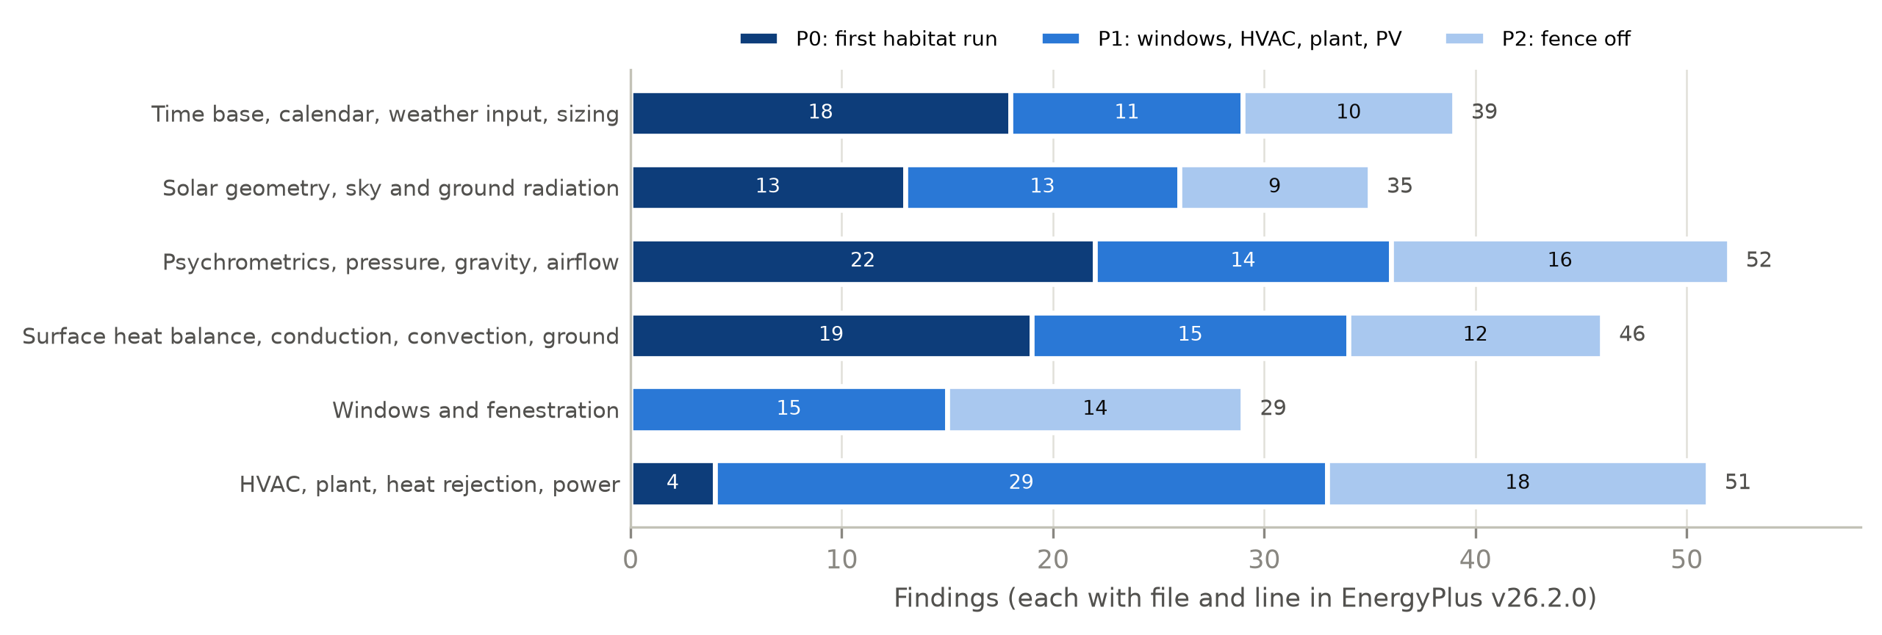
Fig. 1. Earth-specific assumptions found in EnergyPlus v26.2.0 by area and priority (252 findings).
Table 2. Representative audit findings and their treatment.
Area | Earth assumption in v26.2 | Effect off-Earth | Thermonaut
Time base | 1 h = 3600 s is constexpr; 65 of 118 uses of rSecsInHour are physical; CTFs in Earth hours | A longer hour would rescale part of the physics only | Earth clock kept; sun rate generalized
Weather | EPW checks treat ≥ 99.9 °C as missing and replace pressures ≤ 31 kPa | Lunar 120 °C and Martian 700 Pa silently altered | Planetary weather file, values set after the EPW read
Sun | Earth Fourier fits for declination and equation of time; 15°/h | Wrong sun on any other body | Daily fit to Mars24 or lunar ephemeris
Sky, ground | Part of the sky view sees air; ground long-wave = outdoor air (10 sites) | No air on the Moon; regolith swings 290 K | All sky view to the sky; regolith column
Pressure | One OutBaroPress for zone, HVAC and outdoors (509 uses in 75 files) | Moon: zero air capacity, NaN humidity | OutBaroPress = cabin; new ambient pressure
Convection | Air at 1 atm and 1 g with a non-zero floor; TARP inside | Heat loss to absent air; cabin convection ~2.3× too high on the Moon | Zero or CO2 mixed convection; cabin-gas correlation
Conduction | CondFD clamps at −100 °C; walls start at 23 °C | Lunar nights near −180 °C; regolith time constants of years | −270 °C; steady start with correction
PV | NOCT, Sandia and PVWatts cell temperatures assume Earth air | Modules in vacuum cool only by radiation | Radiative (and CO2) cell balance

Table 3. Disposition of every audit row in Thermonaut M2e: changed by a hook, refused by the input validator, made correct by a design decision, deferred to a later milestone, or without effect off-Earth.
Audit area | Modified | Refused | Avoided | Deferred | Harmless | Total
Time base, calendar, weather input, sizing | 13 | 4 | 20 | 0 | 3 | 40
Solar geometry, sky and ground radiation | 16 | 9 | 7 | 6 | 2 | 40
Psychrometrics, pressure, gravity, airflow | 10 | 20 | 11 | 8 | 7 | 56
Surface heat balance, conduction, convection, ground | 20 | 9 | 12 | 3 | 5 | 49
Windows and fenestration | 1 | 23 | 3 | 0 | 5 | 32
HVAC, plant, heat rejection, power | 2 | 26 | 12 | 5 | 9 | 54
All areas | 62 | 91 | 65 | 22 | 31 | 271
of which P0 | 42 | 10 | 21 | 2 | 1 | 76

Three findings shaped the design. Time is the most pervasive assumption: 52 uses of the hour constant are genuine unit conversions that must stay 3600 s while the physical uses would follow a longer hour, and the CTF generator works in Earth hours. The engine has one air pressure: about 350 of the 509 uses of OutBaroPress describe air inside the pressure shell and about 133 outdoor air, which is absent on the Moon. And the exterior boundary hides air in the long-wave split, the ground temperature and the PV cell temperature, not only in convection. Most findings are therefore resolved not one by one but by a few decisions (Table 3): keeping the Earth clock avoids the time findings, letting OutBaroPress carry the cabin pressure makes the zone and HVAC uses correct without edits, and refusing outdoor-air objects removes whole modules from the planetary domain. The deferred rows are mostly windows and the Mars sol clock (Section 6.4).

4. Planetary mode

4.1 Design rules and supported domain
Three rules guided every change (Fig. 2):
- Earth stays identical. Planetary mode is active only with a Site:PlanetaryBody object for the Moon or Mars; every change is behind that switch or replaces a literal by a variable with the same Earth value.
- Reuse, do not rewrite. Planetary values enter where EnergyPlus already reads its environment; the heat balance, conduction solvers, shading, view factors, ideal loads, electric load centre and reporting run unchanged.
- Refuse what cannot be right. Objects that need outdoor air or Earth weather stop the run with an error instead of producing plausible-looking wrong numbers.
Version M2e adds 2,178 lines of C++ and input definition and changes 13 in 18 files: a PlanetaryBody module (1,780 lines), the input object (157 lines) and 241 lines of hooks in 15 existing files (0.3% of the engine). Table 4 states what the planetary mode supports: envelope, load and power studies of sealed, windowless habitats with prescribed set-points (version history in supplementary material S6).
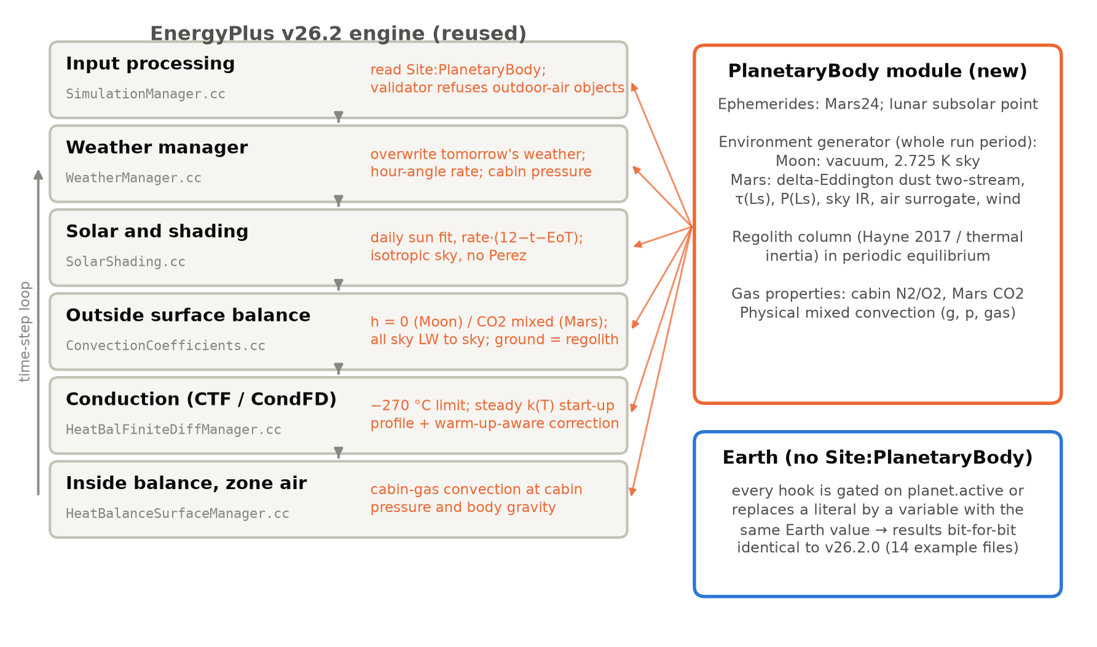
Fig. 2. Where Thermonaut enters the EnergyPlus engine. Grey: unchanged stages and the files that carry the hooks; orange: what each hook does off-Earth. The PlanetaryBody module supplies ephemerides, the environment, regolith temperatures, gas properties and the PV cell temperature.
Table 4. Feature coverage of the planetary mode. On Earth every element is that of EnergyPlus v26.2.
EnergyPlus element | Thermonaut planetary mode | Status
Time loop, schedules, EMS, outputs | Inherited unchanged (Earth clock) | Sol clock for Mars planned
Weather | Planetary weather file or internal generator | Generalized
Sun position and shading | Body's hour-angle rate, daily ephemeris fit, disk visibility | Generalized
Exterior surface balance | Vacuum or thin-CO2 convection; sky and regolith long-wave; regolith ground | Generalized
Conduction (CTF, CondFD) | Unchanged solvers; −270 °C limit; regolith start-up | Generalized
Interior convection, zone air | Cabin gas at cabin pressure and body gravity | Generalized; moist-air psychrometrics
Ideal loads with humidistat | Inherited unchanged | Supported (Section 5.5)
PV, batteries | One-diode PV with planetary cell temperature; Li-ion in a zone | Generalized
Water-cooled chillers, plant loops | Inherited unchanged; no heat sink available | Space radiator planned
Windows; infiltration, ventilation, outdoor-air and air-cooled equipment; design days and sizing; Kiva; AirflowNetwork | Refused with a severe error | Windows and planetary sizing planned

4.2 How a planetary run is coordinated
Thermonaut adds no second simulation loop. At input, Site:PlanetaryBody sets the body, gravity and cabin pressure, which is stored in OutBaroPress; a planetary weather file, if named, is read and checked, and a calendar-only EPW keeps the weather manager's day bookkeeping unchanged. A validator then refuses unsupported objects (Section 4.10). Before the first day the environment of the whole run is interpolated from the file or generated, the regolith column is brought to periodic equilibrium and CondFD walls start from a steady profile (Section 4.8). Each day the planetary module overwrites every weather value and fits declination and equation of time to the ephemeris, and shading is recomputed. Each time step then runs the stock sequence of outside faces, conduction, inside faces, zone air, ideal loads and electric load centre with the planetary coefficients of Fig. 2.

4.3 Input and planetary weather files
Site:PlanetaryBody selects the body, a reference year and habitat parameters: gravity, cabin pressure and oxygen mole fraction, cabin air velocity and a convection length; optional fields set a uniform horizon elevation, regolith properties and, for Mars, mean pressure, dust model and wind. The last field names a file in the Planetary Weather Format (PWF 1.0), whose versioned specification defines every column, unit and convention (supplementary material S8): a key–value header (body, site, start time in UTC, record length, solar-day length, gravity, atmosphere) and one record per interval with solar zenith and azimuth, visible fraction of the solar disk, direct normal, diffuse and global irradiance, air temperature (nan in vacuum), effective sky, regolith surface and deep temperatures, albedo, ambient pressure and wind. Solar quantities refer to the middle of each interval, state quantities to its end. The engine rejects a file for another body, with a missing column, unequal spacing or incomplete coverage of the run period, or with any non-physical value (negative irradiance, temperatures below 2.7 K, albedo outside 0–1, negative pressure or wind; only the air temperature may be nan), reporting the record number; Earth range checks are not applied. Values are interpolated linearly to the time step. The engine does not use the zenith and azimuth columns: it computes the solar position itself, so that shading and incidence follow its own geometry, and takes only the irradiance magnitudes from the file. A script in the repository writes such a file from the engine's own generator, so a generated environment can be inspected, replaced by data from another source or read back as a check of the reader (Section 5.2).

4.4 Time base and sun position
A planetary hour would touch the physical uses of the hour constant and the CTF generator. Thermonaut therefore keeps the Earth clock (3600 s hours, days from 00:00 UTC), so crew schedules are written as on Earth, and changes the rate at which the Sun moves. The hour angle becomes
$$H=r\left[12 − \left(t + E\right)\right]+\left(λ_{TZ} − λ\right),r=\frac{{360}^{∘}}{P_{d}/3600s}$$ | (1)
where t is the clock hour, E the equation of time in hours, λ_{TZ} and λ the time-zone meridian and longitude, and P_{d} the solar day: 86,400 s on Earth (r = 15°/h), the synodic month on the Moon (0.508°/h) and the sol on Mars (14.6°/h). Each day the declination is taken from Mars24 [9] or the selenographic subsolar point [20] at 12:00 UTC, and E is chosen so that Eq. (1) reproduces the ephemeris hour angle H⊙ at mid-day,
$$E_{d}=\frac{H_{⊙}\left(12h\right)+λ_{TZ}−λ}{r}$$ | (2)
Because the hour angle is linear in time over a day on both bodies, the fit holds through the day. The hour angle is wrapped to ±180° before the sunrise test, and the visible fraction of the solar disk above the horizon is its area fraction.

4.5 Planetary environment
Without a weather file the environment comes from an internal generator. On the Moon there is no diffuse light, the sky is at 2.725 K and the ground is a one-dimensional regolith column [8]. On Mars a delta-Eddington two-stream solution with a seasonal dust optical depth and an optional global storm gives the irradiance [19, 21]; pressure follows the seasonal CO2 cycle; the sky emits as a dusty-CO2 layer calibrated to MEDA infrared data and the 2018 dust storm [22, 23]; and the near-surface air follows the ground with a lag. Regolith columns are brought to periodic equilibrium over a year of forcing. Lunar Earthshine (below 0.2 W/m²) and Earth's thermal emission seen from the Moon (about 0.07 W/m²) are neglected; both are below 0.1% of the long-wave exchange of a sunlit surface. The verified domain is equatorial and mid-latitude sites with a uniform horizon: the ground view factor is (1 − cos β)/2, and terrain slopes, polar illumination, permanently shadowed regions and terrain eclipses are outside it.

4.6 Cabin and ambient pressure
Of two ways to split the single pressure, adding a cabin pressure and editing the roughly 350 zone and HVAC uses, or letting OutBaroPress carry the cabin pressure and editing the outdoor uses, Thermonaut takes the second: zone balances, psychrometrics, ideal loads and HVAC components see the gas they contain without edits, and a new ambient pressure (zero on the Moon, 600–800 Pa on Mars) serves the exterior model and outputs. The cabin is a nitrogen–oxygen mixture defined by its oxygen mole fraction. Its convection properties are those of the mixture, but the zone moisture balance keeps EnergyPlus's moist-air psychrometrics at cabin pressure. At 26.5% O2 the mixture's gas constant is 0.4% below that of air and its specific heat 0.1% below; at 34% O2 they are 1.4% and 1.0% below, so the volumetric heat capacity of the zone gas is 0.4% too low and the humidity ratio at a given relative humidity 1.4% too high (molar-mass ratio 0.613 instead of 0.622). Both errors are small next to the input uncertainties of Section 5.7.

4.7 Exterior and interior boundaries
Outside, the convection coefficient is zero in vacuum, bypassing EnergyPlus's lower limit. On Mars, natural convection (Churchill–Chu for vertical faces, McAdams/Lloyd–Moran for horizontal ones, blended by tilt) and laminar or turbulent flat-plate forced convection are computed for CO2 at the ambient pressure and the body's gravity and combined as [24, 25]
$$h={\left(h_{n}^{3} + h_{f}^{3}\right)}^{1/3},h_{n}=\frac{k}{L}Nu\left(Ra\right),Ra=\frac{gβΔTL^{3}ρ^{2}c_{p}}{μk}$$ | (3)
with the vertical length from the input, A/P for horizontal faces and √A for forced flow. Over the Mars verification run Ra on the top facet spans 8e+02 to 8e+04, Re 2.0e+04 to 2.8e+04 (laminar) and Pr 0.77–0.77. The mean free path of CO2 is 7–9 µm, a Knudsen number below 2e-05, so continuum correlations apply without slip correction. The lower Rayleigh numbers fall below the fitted range of the horizontal-plate correlation, but there forced convection dominates the blend. All of the sky view goes to the sky, the ground view sees the regolith skin temperature, ground contact uses the deep-regolith temperature, an isotropic sky replaces the Perez model [26] and outdoor moisture exchange is off. Inside, the TARP correlation for air at 1 atm and 1 g [27] overestimates natural convection about 2.3 times at lunar gravity; the same mixed model is applied to the cabin gas with the body's gravity and the cabin air velocity. Surfaces are grey, with one thermal emissivity and the solar absorptance of the input.

4.8 Conduction and the start-up of regolith covers
CTF and CondFD run unchanged on the Earth clock; the CondFD node limit of −100 °C becomes −270 °C. The start-up had to be reconsidered. EnergyPlus starts every wall at 23 °C and repeats the first day until the zone converges, which suits walls with time constants of hours, not a metre of regolith, whose time constant is months on Mars and years on the Moon. Off-Earth, each CondFD construction starts from its steady conduction profile between the period-mean outer-face temperature T̄_{o} and the initial inside temperature T_{in},
$$T_{i}={\overline{T}}_{o}+\left(T_{in} − {\overline{T}}_{o}\right)\frac{R_{i}}{R_{tot}},R_{i}=\sum_{j<i}{\frac{Δx_{j}}{k_{j}\left(T_{j}\right)}}$$ | (4)
iterated six times for the temperature-dependent conductivity (the sixth iteration changes the profile by 2e-06 K). T̄_{o} solves the mean radiative–convective balance of the outer face. After warm-up the inside faces sit at their real temperature, and the profile is recomputed with it. The difference Δ_{i} between the two profiles must not be added in full, because the nodes near the inside face have already moved during warm-up (Fig. 3). Node i receives Δ_{i}(1 − g_{i}), where g_{i} is the response of the construction's own node network to a unit step of the inside-face temperature over the warm-up period t_{w},
$$C_{i}\frac{dg_{i}}{dt}=G_{i−1}\left(g_{i−1} − g_{i}\right)+G_{i}\left(g_{i+1} − g_{i}\right),g_{N}=1,g_{1}=0,g_{i}\left(0\right)=0$$ | (5)
with conductances G = k/Δx and capacities C = ρc_{p}Δx as CondFD discretizes the construction (no-mass layers enter as resistances), integrated implicitly in hourly steps with the outer node fixed. Because no-mass layers have no capacity, an MLI blanket blocks the step as it should: the panel inside it receives no correction and the regolith behind it nearly all. Like warm-up itself, the method assumes that the deep layers respond linearly over t_{w}; it has not been tested with phase-change or moisture-dependent materials. Thin, light envelopes need none of this and are best run with CTF.
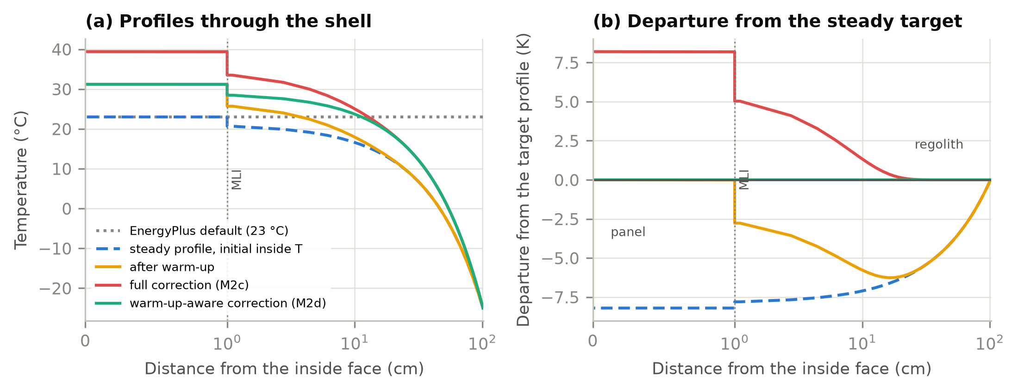
Fig. 3. Start-up of the lunar regolith-module shell (regolith 1 m, beta cloth, MLI, interior panel) from Eqs. (4)–(5) for six warm-up days: (a) temperature profiles; (b) departure from the steady profile with the real inside temperature. The full correction overshoots the inner panel; the warm-up-aware correction does not.

4.9 Photovoltaics and storage
Every EnergyPlus PV cell-temperature model assumes Earth air. Off-Earth, Thermonaut computes the cell temperature of the equivalent one-diode model [5] in Decoupled mode from the steady balance of a thin, free-standing module with both faces exposed,
$$\left(τα − η\right)G=ε_{f}σ\left(T^{4} − T_{f}^{4}\right)+ε_{b}σ\left(T^{4} − T_{b}^{4}\right)+2h\left(T − T_{a}\right)$$ | (6)
where G is the plane-of-array irradiance, η the electrical efficiency, ε_{f} = ε_{b} = 0.85, T_{f}⁴ and T_{b}⁴ the view-weighted fourth powers of the sky and regolith temperatures seen by each face (front sky view (1 + cos β)/2), and h the coefficient of Eq. (3) on Mars (zero on the Moon). The balance is solved by Newton iteration inside the engine's efficiency loop, which restarts every time step and repeats until η changes by less than 0.1%. Mutual shading and radiative coupling within an array are not modelled. The steady balance neglects heat capacity: for a module of about 4 kJ/(m²K) and a radiative conductance of about 14 W/(m²K) the time constant is about 5 min, close to the 3-min step. Because T ∝ ε^{−1/4} in sunlight, a 10% change in emissivity changes the sunlit cell temperature by about 2.5% (8 K). The Li-ion battery model runs unchanged but must sit in a zone, so that its losses become cabin heat.

4.10 Refusing what cannot be right
After input processing a validator stops the run if any refused object type is present, whether or not it is used: windows; infiltration and ventilation; outdoor-air controllers, mixers, nodes and outdoor-air zone units; air- and evaporatively cooled condensers, chillers and coils; cooling towers and fluid coolers; heat-pump water heaters with outdoor-air inlets; combustion and wind generators; ground heat exchangers, EcoRoof and solar collectors; Sandia, PVWatts and dynamic PV models; batteries without a zone; Kiva and AirflowNetwork; design days and sizing; SimpleCombined outside convection; one time step per hour (at which EnergyPlus evaluates the sun at mid-hour); and water use without a scheduled mains temperature (full list with reasons in supplementary material S9). As a backstop, a planetary run stops at the start of the next day if any component has registered an outdoor-air node, whether or not its type is listed.

5. Verification
Each result below is reported at the level of evidence it supports (Table 5). No system-level validation exists: there is no measured habitat-scale dataset, and none of the checks should be read as validation of a complete habitat's thermal response.
Table 5. Verification and validation evidence by level.
Level | What it shows | Evidence | Where
1 Software regression | Earth results unchanged | 14 example files, two climates; 2,379 upstream unit tests | Section 5.1
2 Planetary software tests | Inputs accepted and refused as specified | 23 end-to-end tests | Section 5.1
3 Numerical verification | Implemented equations satisfied | Closed-form boundary balances; PV residual; weather-file round trip | Sections 5.2 and 5.6
4 Component checks | Components agree with independent references | JPL Horizons; Diviner and Apollo; NIST CO2; MEDA sky | Section 5.2
5 Sensitivity | Effect of numerics and uncertain inputs | Start-up, spin-up, grid, step; regolith, envelope, dust | Sections 5.4 and 5.7
– System validation | Prediction of a real habitat | Not available | Section 6.2

5.1 Earth regression and planetary software tests
14 example files from the EnergyPlus distribution, chosen to exercise every hook (CTF and CondFD with k(T), every convection path, ground contact and Kiva, windows and daylighting, sizing, VAV, DX, plant, PV and batteries, moisture models and solar collectors), were run with an unmodified v26.2.0 build and with Thermonaut, both release builds from the same compiler (MSVC 14.44, Windows 11), and every number of the complete output time series was compared: about 4.7 million values per climate. With Chicago TMY3 weather 14 of 14 runnable files and with Phoenix TMY3 weather 14 of 14 were bit-for-bit identical; one further file does not run with either weather file in either build. The upstream unit tests (2,379 in 33 suites) pass unchanged, but they do not exercise the planetary mode. The claim is therefore bit-for-bit identity for the tested files, climates and build, which every patch set from M1 to M2e was required to pass (per-file record in supplementary material S3). The planetary mode is covered by 23 end-to-end tests (supplementary material S4): valid habitat inputs with and without a weather file; weather files for the wrong body, with a missing column, negative irradiance, missing ground temperature, albedo above 1, unequal spacing, short coverage or no PWF header; refusal of infiltration, Earth-fitted PV models, a battery without a zone, a negative horizon, SimpleCombined convection, one step per hour, unscheduled water mains, EcoRoof, windows and an air-cooled chiller; and a Site:PlanetaryBody object with Body = Earth, whose output is identical to that of the same file without it. All 23 pass.

5.2 Numerical and component checks against independent references
Table 6. Numerical and component checks against references independent of this work.
Quantity (level) | Independent reference | Thermonaut
Solar altitude, lunar equator, 59 d (4) | JPL Horizons [28] | RMSE 0.11°; sunlit hours 710 vs 712
Solar altitude, Jezero, 31 d (4) | JPL Horizons [28] | RMSE 0.40° (sunlit bias -0.26°)
Lunar equatorial surface, noon / pre-dawn (4) | ≈385–390 K / ≈95 K, Diviner [29] | 388 K / 94 K
Lunar regolith at 1 m (4) | ≈252–256 K, Diviner-constrained model, Apollo heat flow [8, 29] | 253.2 K (0.5 m 252 K; 2 m 256 K; 3 m 258 K)
Convection in vacuum, every outer face (3) | Zero | Zero over 201,600 face-steps
Net long-wave on outer faces in vacuum (3) | εσ[F_{sky}(T_{sky}⁴ − T⁴) + F_{g}(T_{g}⁴ − T⁴)] | RMSE 0.65 W/m² (mean magnitude 82 W/m²)
Martian exterior convection (4, properties) | Same correlations with NIST CO2 at 700 Pa [30] | -1.8% (RMSE 1.9%)
Mars downwelling long-wave, Jezero, Ls 30–150 (4, fit target) | ≈30 W/m², MEDA [22] | 30.1 W/m²
Sol-mean air temperature in a global dust storm (4, fit target) | ≈ −4 K, 2018 storm [23, 31] | -4.5 K (optical depth 6)
Weather-file round trip, cooling energy (3) | Zero (same environment) | Moon +0.0000%, Mars -0.23%, habitat -0.0002%

The sun follows the Horizons ephemeris within 0.11° on the Moon and 0.40° on Mars; the Martian bias comes from the EnergyPlus convention of evaluating the sun at the end of each 3-min step, during which the Sun moves 0.7°. The regolith reproduces the Diviner noon and pre-dawn temperatures and, at the depth of the reference, gives 253 K at 1 m against ≈252–256 K, itself uncertain by a few kelvin. In vacuum the exterior boundary satisfies its defining equations; the few larger long-wave residuals occur in the step in which sunlight reaches or leaves a wall and its temperature jumps by 30–37 K, because EnergyPlus linearizes long-wave exchange about the previous temperature, on Earth as here. The Martian convection check confirms the implemented calculation and the engine's gas-property fits, not the correlations themselves, whose applicability is discussed in Section 4.7. The two Martian sky rows are the targets to which the three long-wave parameters were fitted, so they confirm that the engine reproduces the fit over a full Martian year rather than validate it. In the round trip, the generated environment of each case is written to a planetary weather file and the case is run again reading it: on the Moon the results agree to within 0.0002% in cooling and 0.0002 K in surface temperature, and on Mars the cooling differs by -0.23% because the file stores solar quantities as interval means, which smooths the rapid Martian sunrise and sunset by half a step.

5.3 Verification cases
Two habitats were used (Fig. 4). The first is a regolith-shielded module: a horizontal cylinder (radius 3 m, length 10 m, 16 facets) under 1 m of regolith over MLI (Moon) or 20 mm of aerogel (Mars), with a 70.3 kPa, 26.5% O2 cabin, 3,240 W of gains and ideal loads at 18–27 °C, at 3-min steps, for two lunations at the lunar equator and 31 days at Jezero from 1 January 2030. CondFD cannot resolve the 4 mm aluminium wall at this step, so its capacity was lumped into the panel. The second is the NASA-informed lunar habitat of Section 5.5. Every case was run with the engine's own environment generator and again reading the weather file exported from it.
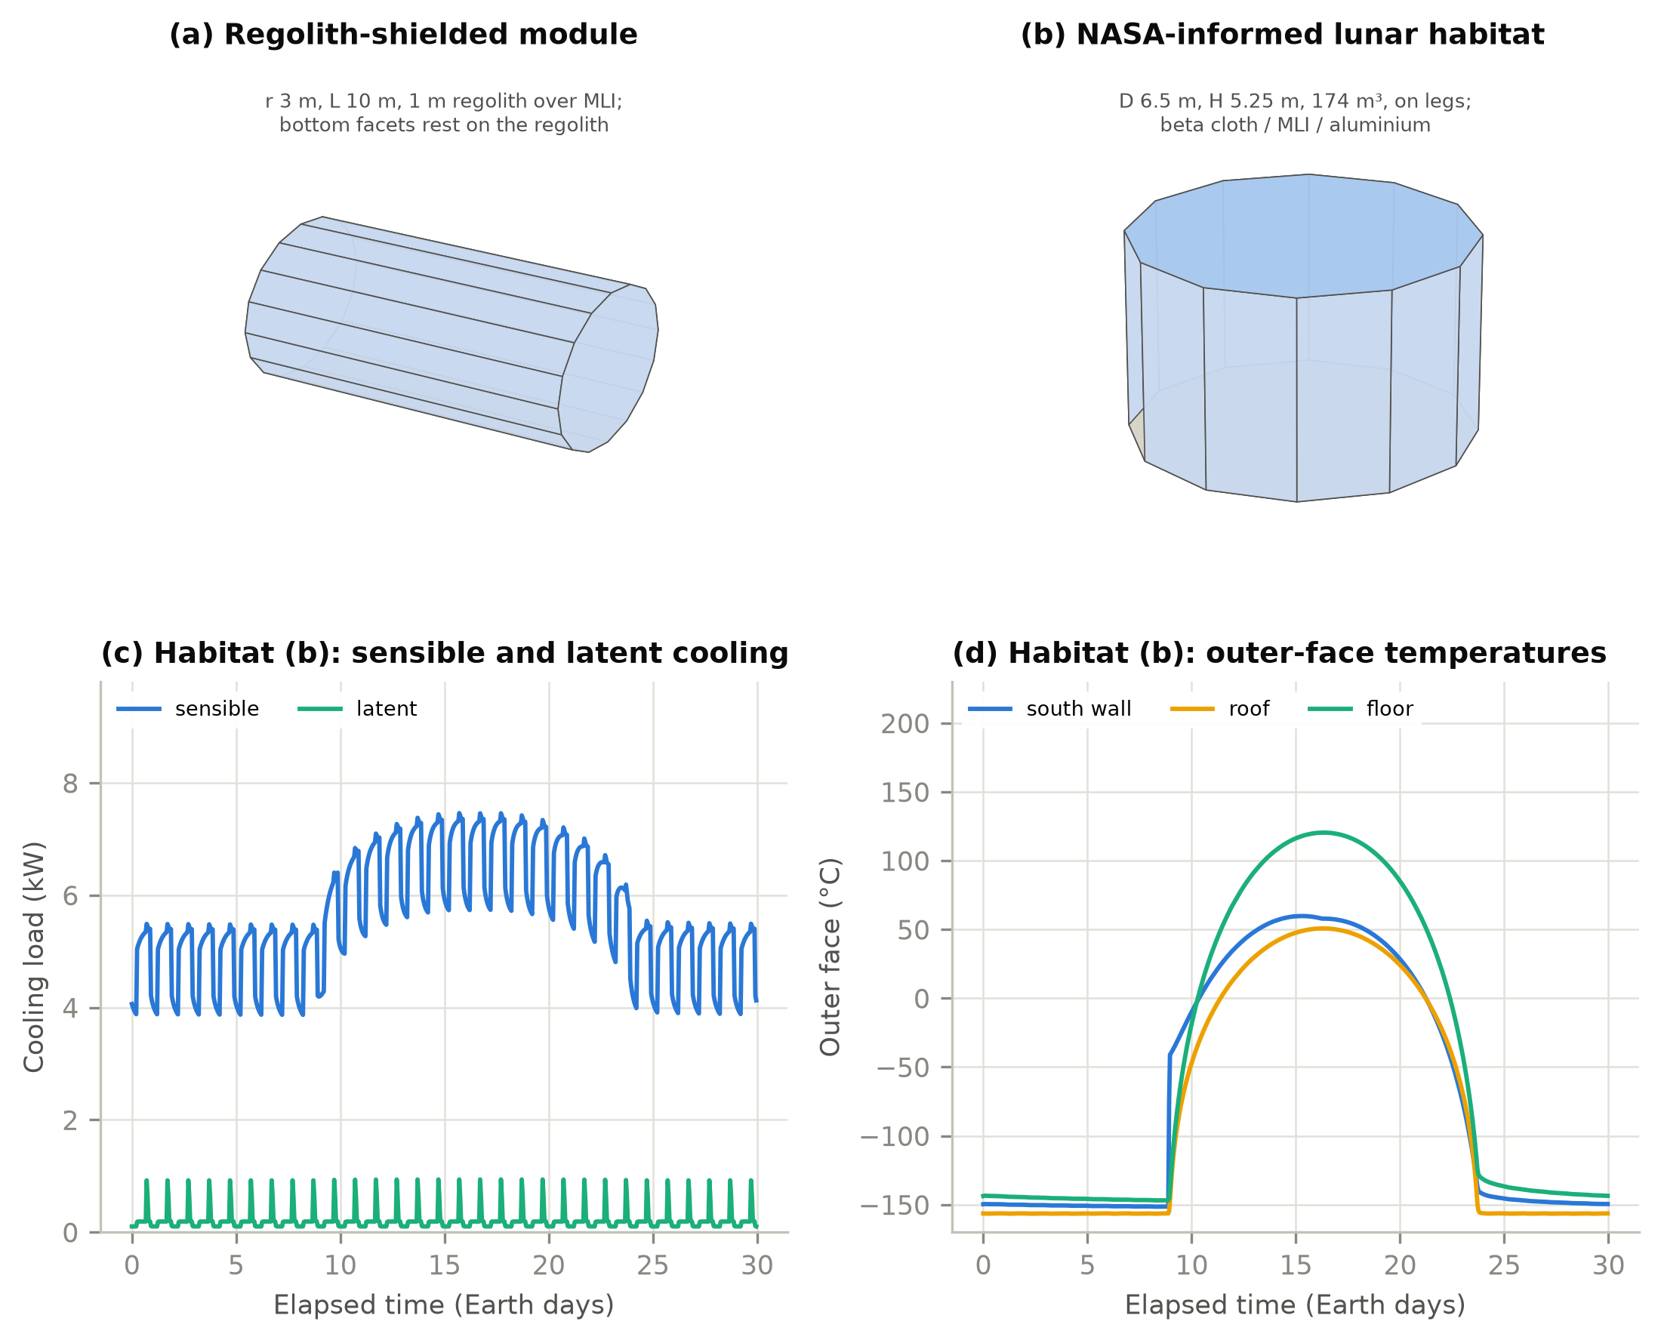
Fig. 4. The two habitats, drawn from the input-file vertices: (a) the regolith-shielded module; (b) the NASA-informed four-crew lunar habitat. (c, d) Habitat (b) at the lunar equator over 30 days: sensible and latent cooling and outer-face temperatures.
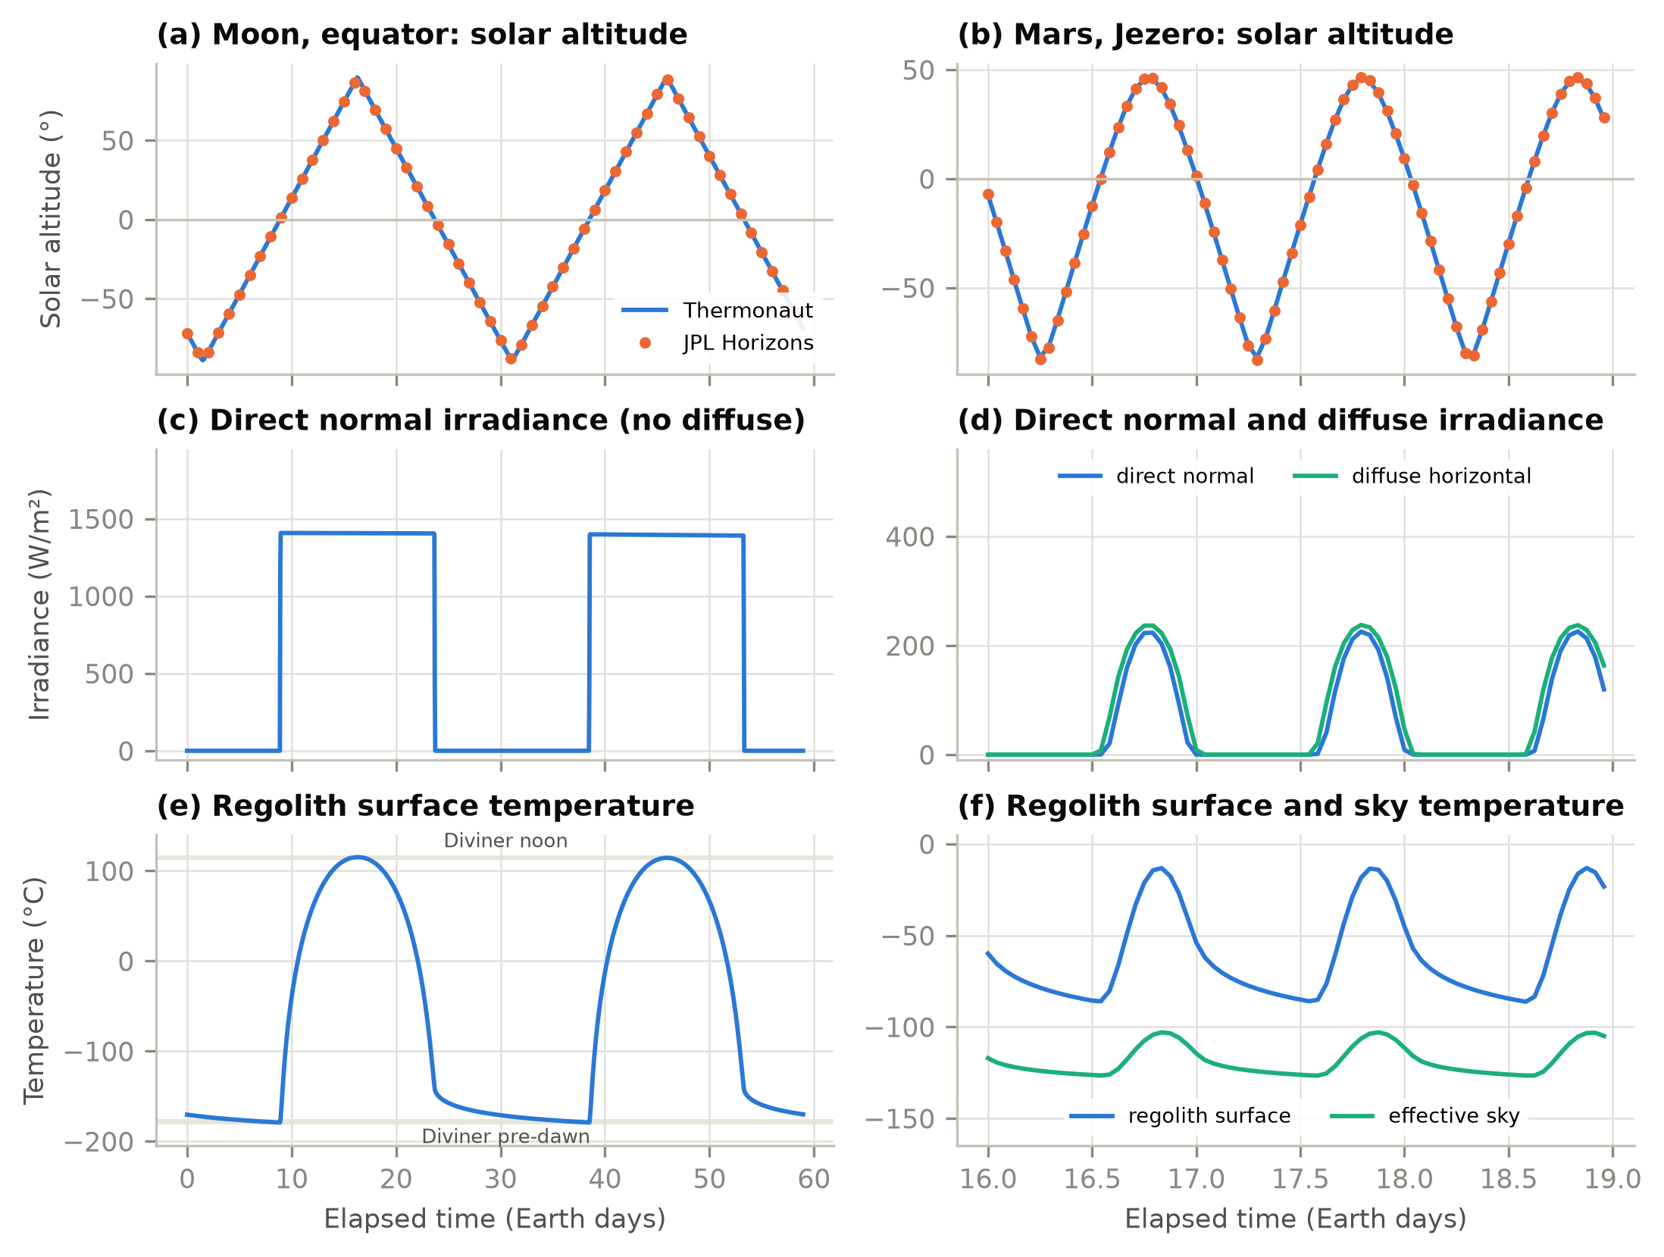
Fig. 5. Environment generated by Thermonaut at the lunar equator (left) and Jezero (right): (a, b) solar altitude with JPL Horizons (points), (c, d) direct normal and diffuse irradiance, (e, f) regolith surface and sky temperatures, with the Diviner noon and pre-dawn range on the Moon (band).
On the Moon the sky is the 2.7 K background, the regolith swings between 94 and 388 K, and the module's sensible cooling over the second lunation is 2,302 kWh, a mean of 3.20 kW against 3.24 kW of gains: through 1 m of regolith and MLI the shell loses little, and the cover damps the lunar day to a slow drift (Fig. 6). On Mars the cover damps the daily cycle of a sky at about 145–170 K and a ground swinging by some 75 K in the same way, but 20 mm of aerogel insulates far less than MLI in vacuum, so days 16–31 need 719 kWh of cooling, a mean of 1.87 kW: the shell loses about 1.4 kW to the colder surroundings. The run that reads the exported weather file overlies the generator run in every panel (Table 7).
Table 7. Regolith-shielded module: cooling over the comparison window and the weather-file round trip.
Quantity (hourly values) | Moon, 2nd lunation (720 h) | Mars, days 16–31 (384 h)
Sensible cooling over the window, generator (kWh) | 2,302.4 | 719.4
Weather-file run: cooling difference (%) | +0.0000 | -0.23
Weather-file run: hourly cooling RMSE (W) | 0.0004 | 4.3
Weather-file run: top facet outer / inner face RMSE (K) | 0.0000 / 0.0000 | 0.011 / 0.015

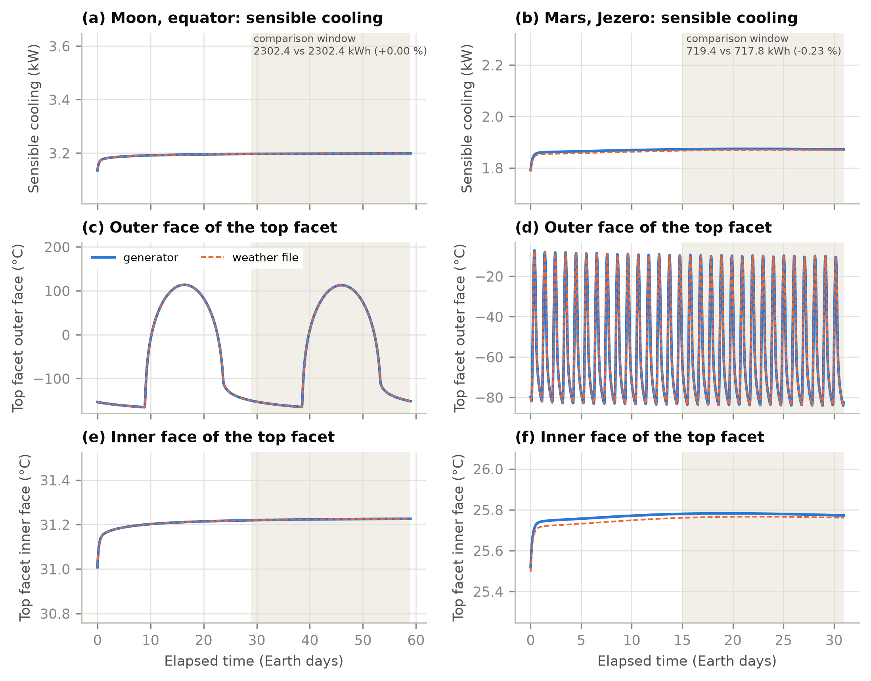
Fig. 6. Response of the regolith-shielded module, Thermonaut with its own generator (solid) and reading the exported weather file (dashed): (a, b) sensible cooling, (c, d) outer and (e, f) inner face of the top facet. Shading: comparison window.

5.4 Start-up of regolith-covered walls
The regolith cover makes the start-up the most consequential numerical choice. With k = 0.0034 W/(m·K) and ρc = 0.37 MJ/(m³K) its diffusivity is about 9×10⁻⁹ m²/s, so 1 m of cover has a time constant L²/α of about 3.4 years, while the six warm-up days reach only about 7 cm into it. Started from the EnergyPlus default of 23 °C, the cover would exchange the difference to its periodic state with the cabin for years, through the very construction whose heat flow is computed. Thermonaut therefore starts CondFD walls from a steady k(T) profile and corrects only the part of it that warm-up cannot reach (Section 4.8, Fig. 3). Table 8 bounds what remains.
Table 8. Start-up, spin-up and numerical tests of the regolith-shielded module (generator mode).
Test (base value) | Change in cooling energy
Mars: 31-day run vs 25-month spin-up, days 16–31 | -0.88%
Moon: two lunations vs 36-month spin-up, final lunation | +1.07%
Mars: minimum warm-up 1 / 20 days (6) | -0.25% / +0.83%
Mars: CondFD space-discretization constant 10 / 90 (30) | +0.010% / -0.020%
Mars: time step 2 min (3 min) | +0.0018%
Moon: k(T) start-up profile, change at the 6th iteration | 2e-06 K

Against a long spin-up that needs no correction, the corrected short runs differ by -0.88% on Mars and +1.07% on the Moon: the correction removes the large error of an arbitrary start, but a cover whose time constant is years keeps about 1% of start-up memory after a month on Mars or two lunations on the Moon. Extending warm-up to 20 days changes the Mars result by +0.83%, because it repeats the first day's forcing long enough to shift the deep state; the CondFD grid and a shorter step barely matter (a step longer than 3 min is not possible, because EnergyPlus requires at least 20 steps per hour with CondFD). For design studies a spin-up of a year or more is therefore advisable on both bodies. The lesson applies beyond planetary habitats: any construction whose time constant exceeds the warm-up period, such as an earth-sheltered wall or a thick slab, inherits its initial state for months.

5.5 NASA-informed lunar habitat
The second case is a representative four-crew lunar habitat informed by NASA surface-habitat studies [2, 32, 33]: a vertical cylinder of 6.5 m diameter and 5.25 m height (174 m³) on legs, with beta cloth, MLI (R 19.2 m²K/W), 4 mm aluminium and a 10 mm panel; a 56.5 kPa, 34% O2 cabin at 20–25 °C and 30–60% relative humidity; about 14 kW of electric power inside the shell, partly removed by cold plates and partly leaving as electrolysis products; BVAD crew heat and moisture [10]; and internal mass. It is a design benchmark, not an official NASA configuration: supplementary material S7 gives the source of each input, separating values from NASA documents, values derived from them (the MLI resistance, calibrated to NASA's night-time heat leak) and the authors' assumptions (life-support share of the load, cold-plate fractions, lighting density). Leakage of 0.05% of the cabin mass per day and two airlock cycles a week need about 0.3 kg/day of make-up gas; heating it from storage to cabin temperature takes less than 1 W, so the sealed cabin carries no outdoor-air load. Compression and oxygen generation are life-support electric loads inside the 14 kW.
The habitat was run for 30 days at the lunar equator with the engine's own generator (CTF; crew latent heat as an OtherEquipment latent fraction; cold-plate and chemical shares as its lost fraction; humidistat ideal loads). Over days 4–30 it needs 3,723 kWh of sensible and 138 kWh of latent cooling, a mean sensible load of 5.75 kW with a peak of 7.46 kW (Table 9, Fig. 4). The load follows the internal gains and the crew schedule and rises by about 2 kW during the lunar day, when the sunlit shell and the hot regolith under the floor add heat through the MLI; the outer faces swing between about −150 °C at night and up to 120 °C at noon. Reading the exported weather file changes the cooling by -0.0002%.
Table 9. NASA-informed lunar habitat at the lunar equator. The last column evaluates the humidity quantities for a cabin held at its upper humidity limit, with the engine's air and surface temperatures.
Quantity (days 4–30) | Ideal loads with humidistat | Cabin at its 60% limit
Sensible / latent cooling (kWh) | 3,723 / 138
Mean / peak sensible load (kW) | 5.75 / 7.46
Outer face, south wall / floor (°C) | -151 to 60 / -147 to 120
Cabin relative humidity (%) | 47–50 | 60
Cabin dew point (°C) | 13.1–13.7 | 16.7
Coldest inside surface minus dew point, minimum (K) | 12.1 | 8.5
Run time, 30 days at 3-min steps (s) | 0.5

EnergyPlus's ideal-loads system dries the supply air while it cools, so the cabin settles at 47–50% instead of the 60% limit that a condensing heat exchanger controlled to that limit would hold. At 60% the dew point would be 16.7 °C and the margin of the coldest inside surface 8.5 K instead of 12.1 K, so ideal loads overstate the margin by 3.6 K. Neither state predicts condensation for this well-insulated habitat, but the engine models neither condensation, frost nor moisture storage in the envelope, so condensation risk should not be judged from ideal-loads results.

5.6 PV cell temperature in vacuum
Two one-diode modules (horizontal and east-facing) on detached shading surfaces of the lunar module case were checked against Eq. (6) at every step: a check of numerical closure, not a comparison with measured module temperatures. The 99th-percentile residual is 0.014 W/m² (horizontal) and 0.070 W/m² (east); larger residuals occur only below the engine's 30 W/m² insolation threshold or when its efficiency loop exits after one pass. Sunlit cells reach 336–359 K and fall to 79 K at night, when a horizontal module faces the 2.7 K sky with its front and the 94 K regolith with its back, so that T⁴ ≈ T_{g}⁴/2.

5.7 Sensitivity to uncertain planetary inputs
Table 10. One-at-a-time sensitivity of the cooling energy (internal generator; lunar habitat days 4–30, Mars module days 16–31).
Case | Input changed (base) | Change in cooling energy
Lunar habitat (MLI shell) | Regolith albedo 0.07 / 0.17 (0.12) | +0.2% / -0.2%
Lunar habitat (MLI shell) | Regolith emissivity 0.90 / 0.99 (0.95) | +0.3% / -0.2%
Lunar habitat (MLI shell) | Horizon elevation 5° (0°) | -0.3%
Lunar habitat (MLI shell) | Beta-cloth solar absorptance 0.3 / 0.5 (0.4) | -0.6% / +0.6%
Lunar habitat (MLI shell) | Beta-cloth emissivity 0.80 (0.90) | +0.5%
Lunar habitat (MLI shell) | MLI resistance −25% / +25% | -3.4% / +2.2%
Mars regolith module (1 m cover) | Regolith thermal inertia 250 / 450 (350 SI) | -0.6% / +0.4%
Mars regolith module (1 m cover) | Regolith albedo 0.10 / 0.18 (0.14) | +0.5% / -0.5%
Mars regolith module (1 m cover) | Dust optical depth 0.3 / 1.5 (seasonal) | +2.9% / -2.6%
Mars regolith module (1 m cover) | Mean wind 1 / 6 m/s (3.2) | +0.1% / -0.1%

The numerical differences above, from the weather-file round trip and the start-up, are fractions of a percent and are not the uncertainty of a prediction. Table 10 varies the least certain inputs. For the lunar habitat the MLI resistance dominates and the beta cloth's optical properties follow, while regolith properties and a modest horizon barely change the load, because internal gains dominate and the shell sees the regolith only through its floor and lower walls. For the Mars module the dust optical depth dominates; regolith thermal inertia and albedo matter at the half-percent level, and wind hardly at all, because the regolith cover isolates the module from surface convection. Exposed Martian surfaces are more sensitive: on a horizontal facet h rises from 0.19 to 0.46 W/(m²K) as wind goes from 0 to 10 m/s and changes by about ±7% for ±100 Pa of pressure, a correction to a radiation-dominated balance. Several of these sensitivities exceed the numerical differences, so design studies should treat such inputs as ranges.

6. Discussion

6.1 What the planetary mode can be used for
The current version supports envelope, load and power studies of sealed, windowless habitats at equatorial and mid-latitude lunar sites and on Mars, with prescribed set-points, ideal loads, scheduled internal gains, PV and batteries, using any EnergyPlus zone, schedule, EMS and output feature that does not need outdoor air. A user can compare envelopes, regolith shields, set-points, gain schedules and PV and storage sizes, and obtain the loads that the thermal control system must handle. A user cannot yet design the heat-rejection loop or radiators, judge condensation risk, model windows, size equipment with design days or model polar terrain, and should treat results as verified computations of a model that has not been validated against a real habitat. That validation needs thermal-vacuum tests of a habitat-scale article.

6.2 Limitations
- Earth clock on Mars. Hours are 3600 s, so the Martian day drifts by about 40 min per Earth day against the clock; the physics is right, but schedules cannot follow local solar time.
- Systems. No space-radiator component, condensing heat exchanger, windows or planetary design days; heat rejection is represented by ideal loads.
- Cabin gas and moisture. Moist-air psychrometrics at cabin pressure (errors up to 1.4% at 34% O2); no envelope condensation or frost.
- Terrain and radiation. Uniform horizon, (1 − cos β)/2 ground view, no Earthshine; polar and shadowed terrain outside the verified domain.
- Numerics and controls. Exterior long-wave coefficients are linearized about the previous step's surface temperature, as on Earth, which matters most in the step when sunlight reaches a wall; controls that read outdoor conditions see the Martian air or, on the Moon, the regolith skin temperature.
- PV. Emissivity 0.85 on both faces, free-standing modules, no soiling, temperature dependence of optics or array self-shading.
- Evidence. Checks against independent references are at component level; there is no system-level validation, and no independent group has yet reproduced the cases.

6.3 Tracking EnergyPlus releases and upstreaming
Every change is applied by an idempotent patch script that finds a short, unique anchor in a stock source file and inserts a hook; a script stops with an error, rather than patching the wrong place, if its anchor has moved. The scripts have so far been applied only to v26.2.0, so the procedure for a new release is proposed rather than demonstrated: check out the release tag, run the scripts in order, update moved anchors, review the refusal list against new object types, and rerun the Earth regression against an unmodified build of the same release, the unit tests and the planetary tests. Because the 241 lines of hooks sit at a few interfaces rather than inside the solvers, most releases should need only anchor updates, and upstream fixes arrive with each rebase. Releases are tagged by milestone (M2e for this paper). Because every change is gated on the planetary object and Earth results are unchanged in the tested files, the planetary mode could be offered upstream as an optional feature through the EnergyPlus new-feature-proposal process. The intention is to propose it once the sol clock and the space-radiator component of milestone M3 complete the changes to the time base and plant, so that the proposal covers a stable interface.

6.4 Roadmap
M3 introduces a sol clock by making the hour length a run-time variable (the audit identified the four lines that set the time-step lengths, the 65 physical uses of the hour constant that must follow it and the 52 unit conversions that must not), a cabin gas-mixture block for psychrometrics, body gravity in every buoyancy model, planetary design days and sizing, a space-radiator plant component, a planetary condensing heat exchanger that holds the cabin at its humidity limit, terrain horizons, PV soiling, and windows with vacuum-compatible solvers.

7. Conclusions
A mature building simulation engine can be adapted to the Moon and Mars with a small, well-placed change, provided the Earth is found first. The audit of EnergyPlus v26.2 recorded 252 Earth-specific assumptions, hidden in time constants, a single shared pressure, exterior boundary conventions, PV cell-temperature fits and empirical correlations, and tracing each to the code exposed refusals that had been documented but not implemented. Once they are known, a planetary mode of 2,178 lines suffices for sealed, windowless habitats with internal gains, humidity control, ideal loads, PV and batteries, while Earth results stay bit-for-bit identical in the tested files and climates. Off-Earth, the changed components agree with independent references, and a weather file exported from the engine's generator reproduces its results within 0.23%. The verification exposed what mattered most: walls with time constants longer than the warm-up period must start from a consistent state, and even then a regolith cover keeps about 1% of start-up memory after a month, so design studies need a long spin-up; and ideal loads dry a sealed cabin more than a condensing heat exchanger held at the humidity limit would. Sensitivity to uncertain regolith, envelope and dust inputs exceeds the numerical differences, and validation against thermal-vacuum tests of a habitat-scale article remains the missing step.

Data availability statement
The Thermonaut source code, the audit reports and inventory, the planetary tests, the verification cases, the scripts that compare it with EnergyPlus v26.2.0, and the data behind every figure and table are openly available in public repositories (links withheld for anonymous review; they are given on the title page).

Disclosure statement
The authors report there are no competing interests to declare.

Supplementary material
S1 audit inventory and traceability; S2 planetary factors; S3 Earth regression per file; S4 planetary tests; S5 start-up and spin-up robustness; S6 version history; S7 habitat input provenance; S8 planetary weather format; S9 refused objects; S10 worked example.

References
[1] G. Schunk, S. Babiak, D. Naville, B. Evans, Conceptual thermal control system design for a lunar surface habitat, in: Thermal & Fluids Analysis Workshop (TFAWS), NASA, 2021. https://ntrs.nasa.gov/citations/20210020015
[2] R.G. Schunk, S.D. Babiak, B.W. Evans, Thermal control system architecture and technology challenges for a lunar surface habitat, in: 2022 IEEE Aerospace Conference, IEEE, 2022. https://ntrs.nasa.gov/citations/20210026557
[3] D.B. Crawley, L.K. Lawrie, F.C. Winkelmann, W.F. Buhl, Y.J. Huang, C.O. Pedersen, R.K. Strand, R.J. Liesen, D.E. Fisher, M.J. Witte, J. Glazer, EnergyPlus: creating a new-generation building energy simulation program, Energy Build. 33 (2001) 319–331. https://doi.org/10.1016/S0378-7788(00)00114-6
[4] R.K. Strand, C.O. Pedersen, D.B. Crawley, Modularization and simulation techniques for heat balance-based energy and load calculation programs: the experience of the ASHRAE Loads Toolkit and EnergyPlus, in: Proc. Building Simulation 2001, IBPSA, Rio de Janeiro, 2001, pp. 43–50.
[5] U.S. Department of Energy, EnergyPlus Version 26.2.0 Documentation: Engineering Reference, U.S. DOE Building Technologies Office, 2026.
[6] ANSI/ASHRAE, Standard 140-2020: Standard Method of Test for the Evaluation of Building Energy Analysis Computer Programs, ASHRAE, Atlanta, GA, 2020.
[7] R. Judkoff, J. Neymark, International Energy Agency Building Energy Simulation Test (BESTEST) and Diagnostic Method, NREL/TP-472-6231, National Renewable Energy Laboratory, Golden, CO, 1995.
[8] P.O. Hayne, J.L. Bandfield, M.A. Siegler, A.R. Vasavada, R.R. Ghent, J.-P. Williams, B.T. Greenhagen, O. Aharonson, C.M. Elder, P.G. Lucey, D.A. Paige, Global regolith thermophysical properties of the Moon from the Diviner Lunar Radiometer Experiment, J. Geophys. Res. Planets 122 (2017) 2371–2400. https://doi.org/10.1002/2017JE005387
[9] M. Allison, M. McEwen, A post-Pathfinder evaluation of areocentric solar coordinates with improved timing recipes for Mars seasonal/diurnal climate studies, Planet. Space Sci. 48 (2000) 215–235. https://doi.org/10.1016/S0032-0633(99)00092-6
[10] M.S. Anderson, M.K. Ewert, J.F. Keener, Life Support Baseline Values and Assumptions Document, NASA/TP-2015-218570/REV1, NASA Johnson Space Center, Houston, TX, 2018.
[11] S. Ross, Development of an open source modelling package for thermal balance of crewed Mars habitats, in: 73rd International Astronautical Congress, IAC-22-A5.IP.4, Paris, 2022.
[12] J.E. Seem, Modeling of Heat Transfer in Buildings, Ph.D. thesis, University of Wisconsin–Madison, 1987.
[13] P.C. Tabares-Velasco, B. Griffith, Diagnostic test cases for verifying surface heat transfer algorithms and boundary conditions in building energy simulation programs, J. Build. Perform. Simul. 5 (2012) 329–346. https://doi.org/10.1080/19401493.2011.595501
[14] D.G. Gilmore (Ed.), Spacecraft Thermal Control Handbook, Volume I: Fundamental Technologies, 2nd ed., The Aerospace Press, El Segundo, CA, 2002.
[15] T.J.-R. Lagarde, Using computational techniques for the optimal design of evolving habitats, in: 72nd International Astronautical Congress, IAC-21-B3.7.10, Dubai, 2021. https://spacearchitect.org/pubs/IAC-21-B3.7.10.pdf
[16] G.N. Aydemir, An Integrated Framework for Mars-Based Building Performance Simulations (M-BPS): From Site Selection to Habitat Assessment, PhD dissertation, Middle East Technical University, Ankara, 2026. https://hdl.handle.net/11511/118421
[17] E. Millour, F. Forget, A. Spiga, et al., The Mars Climate Database (version 5.3), in: From Mars Express to ExoMars Scientific Workshop, ESA-ESAC, Madrid, 2018.
[18] A. Jadeja, M.M. Jaiswal, S. Ghosh, P. Sanghavi, Thermal comfort analysis of a proposed design for a sustainable living space on Mars, Intell. Build. Int. 8 (2016) 215–233. https://doi.org/10.1080/17508975.2015.1120185
[19] J. Appelbaum, D.J. Flood, Solar radiation on Mars, Sol. Energy 45 (1990) 353–363. https://doi.org/10.1016/0038-092X(90)90156-7
[20] J. Meeus, Astronomical Algorithms, 2nd ed., Willmann-Bell, Richmond, VA, 1998.
[21] J.H. Joseph, W.J. Wiscombe, J.A. Weinman, The delta-Eddington approximation for radiative flux transfer, J. Atmos. Sci. 33 (1976) 2452–2459. https://doi.org/10.1175/1520-0469(1976)033<2452:TDEAFR>2.0.CO;2
[22] G.M. Martínez, E. Sebastián, A. Vicente-Retortillo, M.D. Smith, J.R. Johnson, E. Fischer, H. Savijärvi, et al., Surface energy budget, albedo, and thermal inertia at Jezero crater, Mars, as observed from the Mars 2020 MEDA instrument, J. Geophys. Res. Planets 128 (2023) e2022JE007537. https://doi.org/10.1029/2022JE007537
[23] D. Viúdez-Moreiras, C.E. Newman, M. de la Torre, et al., Effects of the MY34/2018 global dust storm as measured by MSL REMS in Gale crater, J. Geophys. Res. Planets 124 (2019) 1899–1912. https://doi.org/10.1029/2019JE005985
[24] S.W. Churchill, H.H.S. Chu, Correlating equations for laminar and turbulent free convection from a vertical plate, Int. J. Heat Mass Transf. 18 (1975) 1323–1329. https://doi.org/10.1016/0017-9310(75)90243-4
[25] F.P. Incropera, D.P. DeWitt, T.L. Bergman, A.S. Lavine, Fundamentals of Heat and Mass Transfer, 6th ed., John Wiley & Sons, Hoboken, NJ, 2007.
[26] R. Perez, P. Ineichen, R. Seals, J. Michalsky, R. Stewart, Modeling daylight availability and irradiance components from direct and global irradiance, Sol. Energy 44 (1990) 271–289. https://doi.org/10.1016/0038-092X(90)90055-H
[27] G.N. Walton, Thermal Analysis Research Program Reference Manual, NBSIR 83-2655, National Bureau of Standards, Washington, DC, 1983.
[28] J.D. Giorgini, D.K. Yeomans, A.B. Chamberlin, et al., JPL's on-line solar system data service, Bull. Am. Astron. Soc. 28 (1996) 1158. Service: https://ssd.jpl.nasa.gov/horizons/
[29] A.R. Vasavada, J.L. Bandfield, B.T. Greenhagen, P.O. Hayne, M.A. Siegler, J.-P. Williams, D.A. Paige, Lunar equatorial surface temperatures and regolith properties from the Diviner Lunar Radiometer Experiment, J. Geophys. Res. 117 (2012) E00H18. https://doi.org/10.1029/2011JE003987
[30] E.W. Lemmon, I.H. Bell, M.L. Huber, M.O. McLinden, Thermophysical properties of fluid systems, in: P.J. Linstrom, W.G. Mallard (Eds.), NIST Chemistry WebBook, NIST Standard Reference Database 69, National Institute of Standards and Technology, Gaithersburg, MD. https://doi.org/10.18434/T4D303
[31] S.D. Guzewich, M. Lemmon, C.L. Smith, et al., Mars Science Laboratory observations of the 2018/Mars Year 34 global dust storm, Geophys. Res. Lett. 46 (2019) 71–79. https://doi.org/10.1029/2018GL080839
[32] P. Kessler, T. Prater, T. Nickens, D. Harris, Artemis deep space habitation: Enabling a sustained human presence on the Moon and beyond, in: 2022 IEEE Aerospace Conference (AERO), Big Sky, MT, 2022, pp. 1–12. https://doi.org/10.1109/AERO53065.2022.9843393
[33] C. Burke, R.L. Howard Jr., P. Kessler, Internal layout of a lunar surface habitat, in: ASCEND 2022, AIAA, Las Vegas, NV, 2022. NASA NTRS 20220013669. https://ntrs.nasa.gov/citations/20220013669

